DS 1 Template

My Screenshots/Photos
- Please add 4–6 screenshots or photos of your digital life.
- You can use your phone or laptop.
- For each screenshot, write one or two sentences explaining what it shows.

Screenshot/Photo 1
[Insert Photo/Screenshot below]
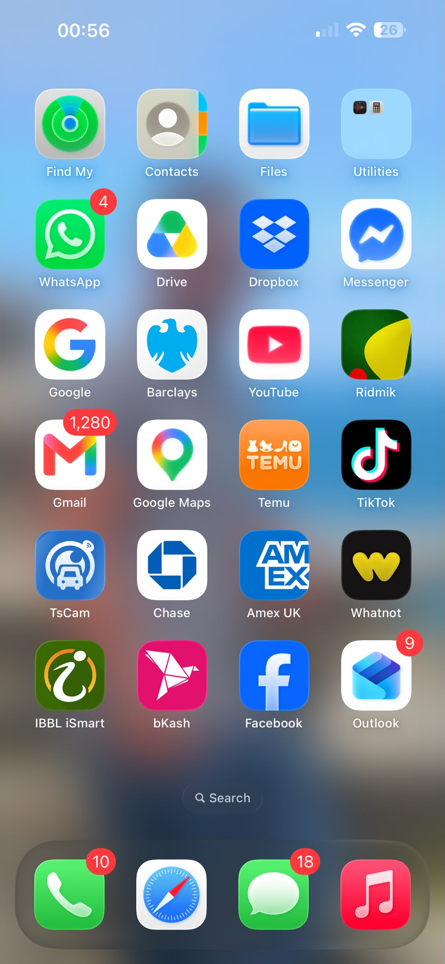
Description: I use my phone's home screen daily to access essential communication, utility, and navigation apps quickly.

Screenshot/Photo 2
[Insert Photo/Screenshot below]
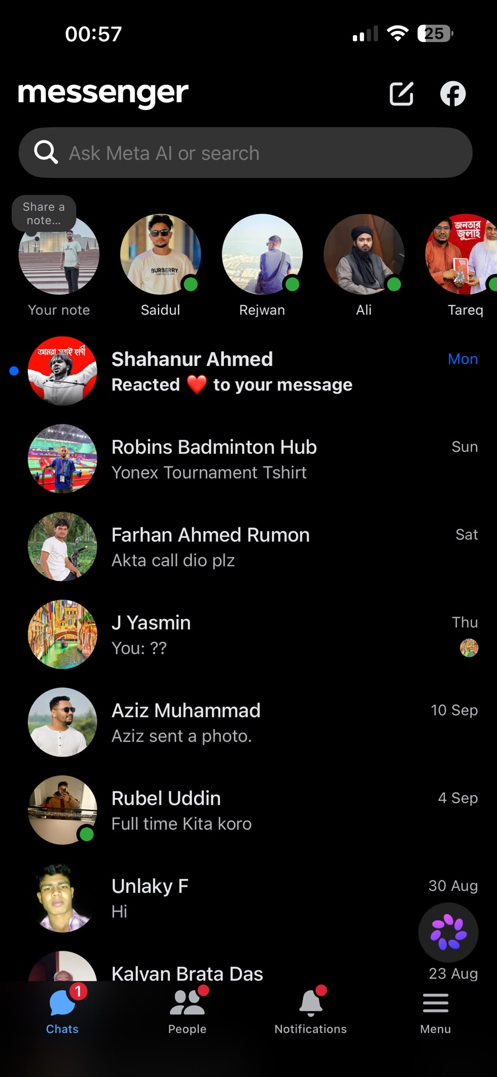
Description: I use messaging apps to maintain regular contact and communicate with my family, friends, and peers.

Screenshot/Photo 3
[Insert Photo/Screenshot below]
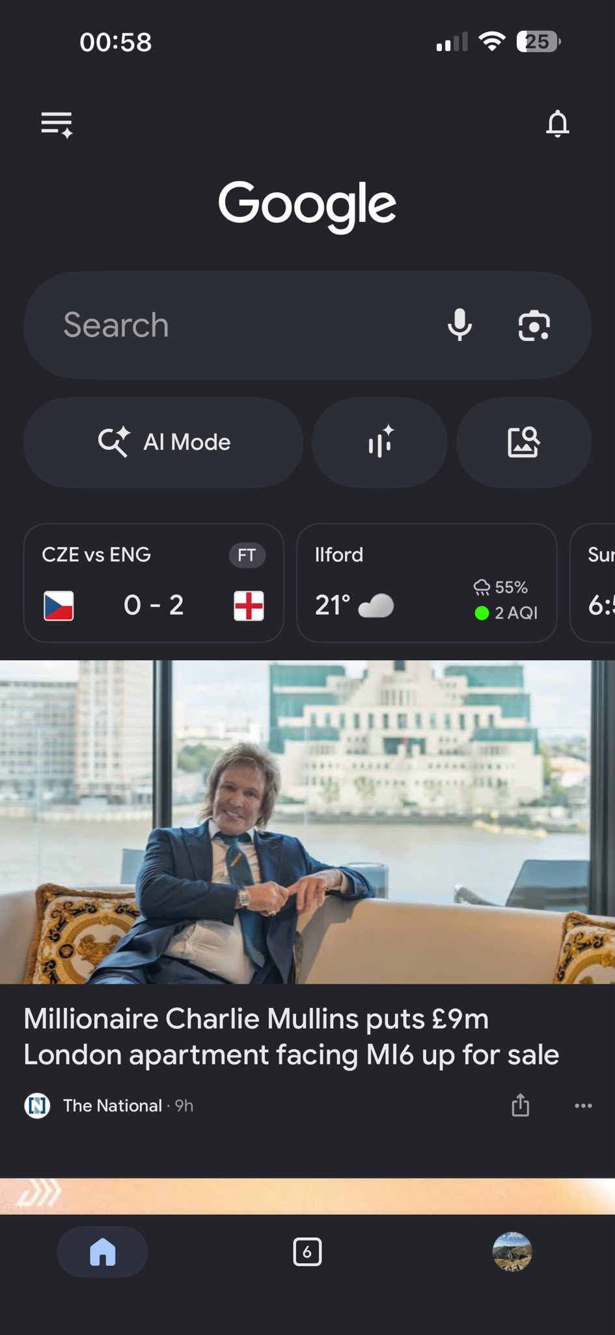
Description: I use web search engines to research information, look up academic topics, and check daily updates.

Screenshot/Photo 4
[Insert Photo/Screenshot below]
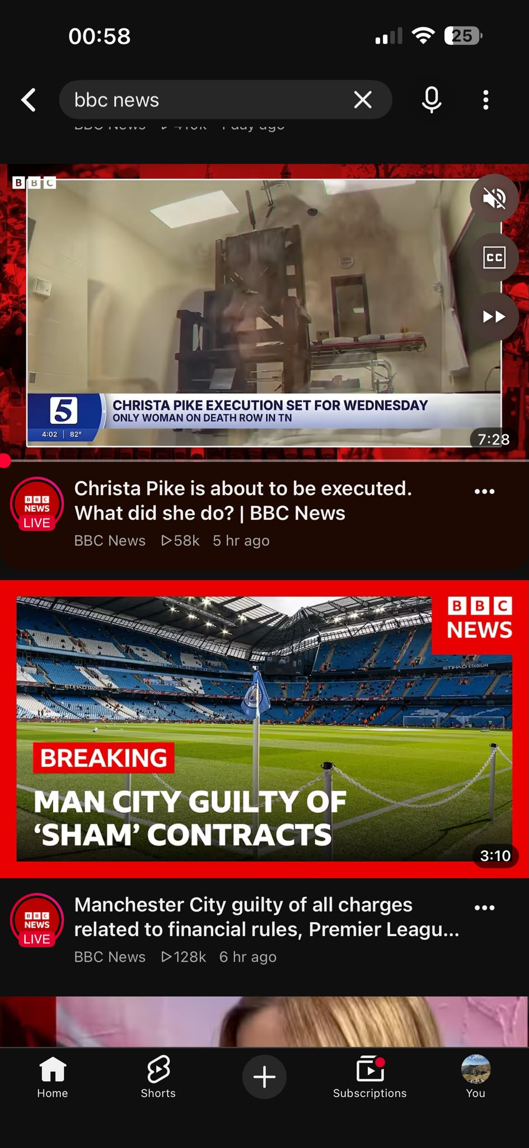
Description: I use digital media platforms and news applications to stay informed about current global events and sports.

Screenshot/Photo 5
[Insert Photo/Screenshot below]
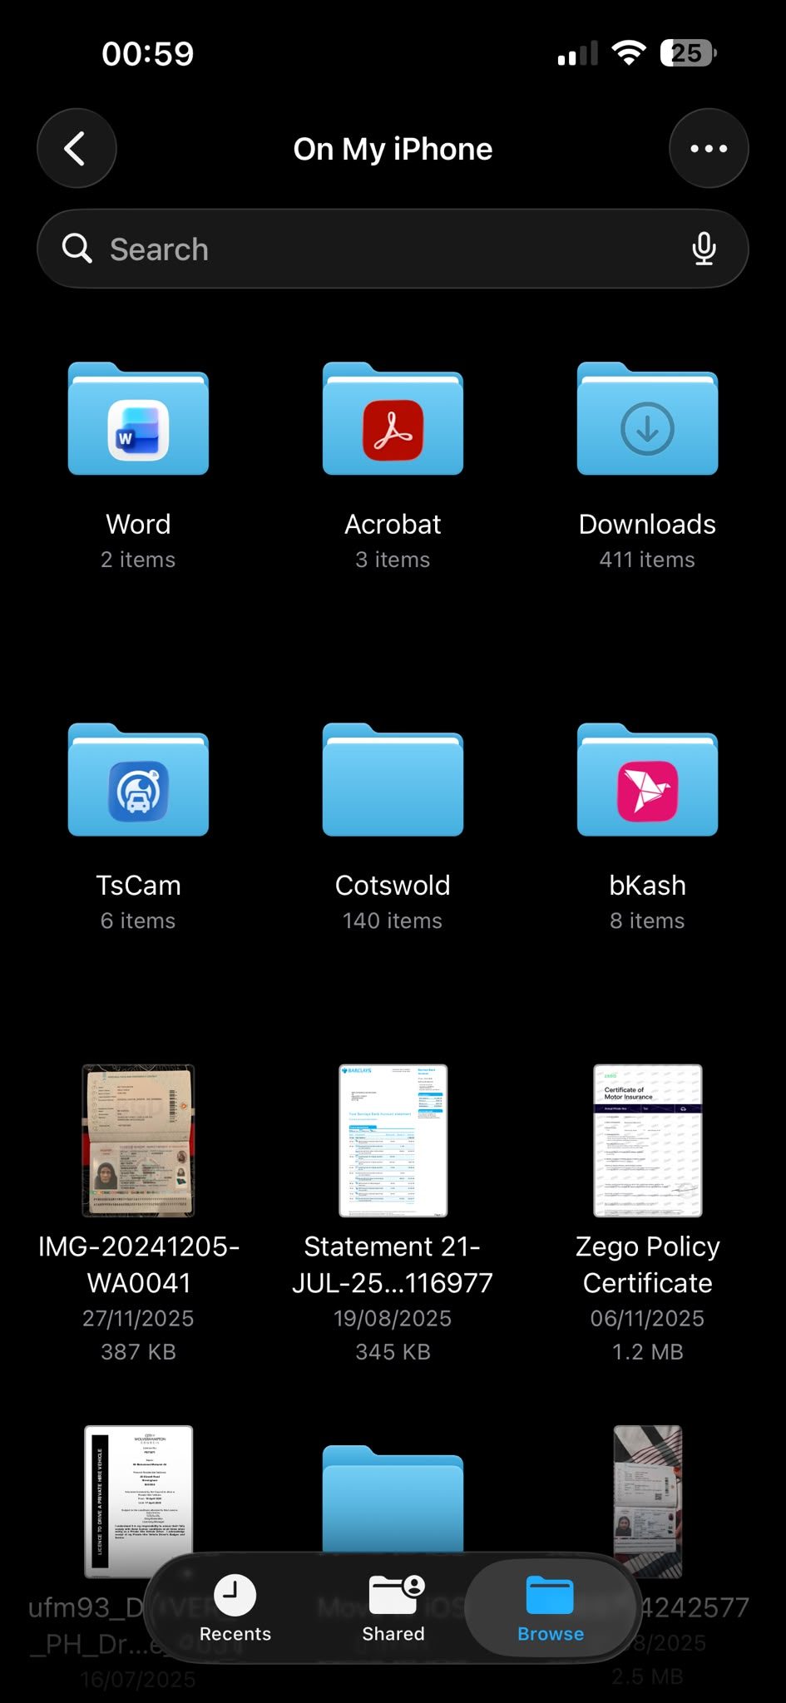
Description: I use digital storage folders to organize, secure, and manage important personal documents and coursework efficiently.

Screenshot/Photo 6
[Insert Photo/Screenshot below]
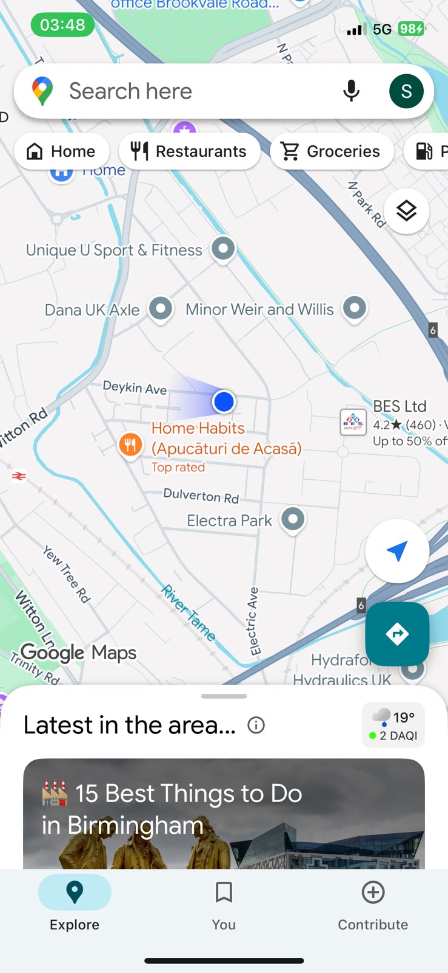
This screenshot shows a digital map application tracking my current location and daily travel routes in the city."

My Short Reflection
- Write 5–8 simple sentences about your digital life.
- You can use the sentence starters below if helpful.
My Short Reflection
• I use digital tools to manage my everyday tasks, study efficiently, and stay connected with people.
• I feel confident when I use applications like Microsoft Office and web browsers for my academic work.
• I want to improve my digital skills further to handle complex software and data more effectively.
• Digital skills are important for me because they help me succeed in both my university coursework and daily life.
• I use map and GPS applications daily to check live traffic updates and navigate my travel routes efficiently.
• I regularly use messaging apps and social media platforms to stay connected with family, friends, and check daily news updates.

Sentence starters
- I use digital tools to …
- I feel confident when I …
- I want to improve …
- I often use these tools: …
- I sometimes feel nervous about …
- I hope this module will help me …
- Digital skills are important for me because …
You can write more if you want.

Submission Checklist
Before you submit, please check:
​​​ ☐ I added 4–6 screenshots
☐ I wrote short sentences for each screenshot
☐ I wrote my short reflection
☐ My work is my own
☐ My file opens correctly
​​☐ My file opens correctly

