

COMPONENT 2 RESEARCH REPORT

Karen Dayana Oña Limones
Student Number: 2225180  Lecturer Name: Zahida Khan | LCHS4002_BIRM  Digital Skills and Research Methods
TABLE OF CONTENTS
1.Introduction.................................................................................................3

2.Research Design........................................................................................ 3
2.1.Research Question...............................................................................3/4 2.2.Method .....................................................................................................4 2.3.Ethical Considerations….........................................................................5

3.Results............................................................................................... 5/6/7/8

4.Discussion............................................................................................. 9/10

5.Conclusion ............................................................................................... 10

6.Reference List .......................................................................................... 11

7.Appendix A – A blank copy questionnaire ........................................ 12/13
1.INTRODUCTION
This report's main goal is to inform readers of the findings of our data gathering, which were based on a question we selected and examined in our presentation.
This document will reflect the results, displaying graphs for each question and going deeper into the results of the responses we have obtained using our questionnaire, in addition to talking about other points that are also important, such as our research design, the methods we have used, what types of questions we have used in our questionnaires, as well as Ethical Considerations and the impact that digital scepticism has on society.
The research question we have chosen is:
“Which digital skills do UWTSD student think is most important?”

Prior to doing our data collection, we hypothesised that the purpose of this research would be to identify the digital skill that UWTSD students used the most frequently and to rank those skills in terms of importance to those users.

As Moodle is a platform, that enables students to interact with the topics covered in class and upload completed work, my hypothesis was that it would be the application that students used the most, (Amorós Poveda, L. 2007).
Lastly, you can read the conclusion I came to after examining the responses to our questionnaire. The reader can also find a blank copy of the questionnaire at the end of this report.

2.RESEARCH DESIGN
2.1 Research Question
Which digital skills do UWTSD students think are most important? was one of our possibilities out of a number from which to choose the question that we would evaluate.

We selected this question because the objective of our research was to determine which digital skill was the most used, and after we received the findings, we would be able to determine which one the UWTSD students favoured and if they recommended employing any skill-specific techniques.

We thought this is a question that can help us learn more specifically about the requirements that students could have when they are studying.

2.2 Method
The method we used to investigate our research was through a form. We are informed that there are various types of research methods, but the method we used for our results search was qualitative, as we were interested in knowing what the students thought about the questions we asked them.
This method allows us to learn how UWTSD students feel or what they think about the topic we have proposed to them (C.R. Kothari, 2014).

We used closed questions, rank order questions, and likert scale questions for the questions that we added to our questionnaire.
The closed questions that we asked the students were intended to have a closed answer, that is, the answer was going to be "yes" or "no", with this we were going to be able to have an exact count of the people who answered with a yes and another exact count of people who said no.
Another type of question that we have added to our questionnaire is "rank order," with this type of question, we wanted students to list the answers in order of importance to each student, and this type of question gives us It will be very useful when comparing the answers because seeing an answer that is repeated a lot will help us identify that this answer is the most important for the students and seeing an answer that is not repeated a lot will mean that the students do not place as much importance on the indicated answer.

Finally, we added a type of question defined as "likert scale questions." The purpose of this type of question was to find out how the students felt, whether they agreed or disagreed with the proposed questions. We didn't just want to know if they agreed or not, but also how strongly they agreed, whether they strongly agreed, agreed, neutrally agreed, disagreed, or strongly disagreed.
We thought that with these types of questions we would be able to obtain a specific result of the needs that students have in UWTSD.

We recruited our questionnaire participants face to face, asking them if they were willing to participate in our form. Once we received an affirmative response from the participants, we provided them with a QR code that would direct them directly to the questionnaire with the questions that we had proposed.
The majority of the students were interested in taking part in our questionnaire and answered all of the questions we posed to them.

2.3 Ethical Considerations
We must remember that we are required to inform and obtain permission from the participants of our questionnaire, with the purpose of protecting each person who participates in each questionnaire carried out (Connelly, L.M, 2014) and allowing them to carry it out safely.
It is critical to understand that informing about consent is an important part of the research process and that we must consider several factors, including:
- The consent of the participant must be given voluntarily.
- Participants must comprehend what is being requested of them.
- Participants must be competent to give consent.
(Connelly, L.M, 2014).
We recruited our questionnaire participants by asking them face to face if they were willing to participate and then including a question in our questionnaire in which consent was given to participate in the questionnaire.

3.RESULTS

1. In this question, each participant was given the option of consenting to take part in our questionnaire. As we can see in blue, most participants agreed to take part in the questionnaire; on the other hand, 0% of participants said they did not consent.

2. The following are the results of our investigation into this question: seven of the participants in this survey indicated that using MS Teams is an important digital skill for them, while one indicated that MS Teams is not an important digital skill for them.

3. As we can see from the answers of this question, four respondents indicated that OneDrive is one of the most often used online tools, while two respondents disagreed and two respondents stated it is not the most commonly utilized tool.

4. According to how each participant feels about their digital skill level, we can see that MS Word and Moodle are the digital tools with which the participants feel the most confident, while OneDrive has 0%, indicating that the participants are not confident when using it.

5. In this case, participants were asked how frequently they used the previous mentioned programmes. The results revealed that the participants' favourite programmes are MS Word, MS Excel, and MS Streams. MS Forms and MS PowerPoint are the programmes that participants use the least.

6. The results of this question revealed that 50% strongly agree with Outlook, 37.5% agree, and 12.5% are neutral.

In the final question, 40% of participants strongly agree with the use of social media, 20% agree, 20% are neutral, and 20% disagree.

4. DISCUSSION

There have been a total of eight people who have decided to participate in our questionnaire. We have complied with informing and obtaining consent from each participant as they have all provided their consent to take part in this questionnaire.
The questionnaire results that we obtained were similar to what I had initially discussed in the introduction. I expected the participants to select the Moodle platform as the most commonly used, because it is a tool that's frequently used in the student environment, facilitating class organisation and allowing students to remember the lessons.
As a result, we can say that the questionnaire results confirm in some ways the hypothesis that we were going to have at the end of this project.

Each question in our questionnaire is different, but when we look at the results of each question individually, we can see that the results are very equal, which means that the participants agreed with their answers on many occasions.
In our hypothesis, Moodle would be one of the most popular platforms, and it was, but what surprised us was that the WhatsApp application received a lower percentage than expected, despite the fact that WhatsApp is one of the most popular social networks in the world; in fact, in some global rankings of social networks, WhatsApp is the third most popular application in the world (Jiménez, N, 2022), indicating that our hypothesis was correct.

If we start focusing on the following In the question "Rank these programmes in order of how frequently you have used them as a worker or student," we can see some percentages that are assimilated, but also draw attention.
According to the participants, 12.5% use PowerPoint and MS Forms frequently, while 25% use MS Word, MS Excel, and MS Streams. This result is also somewhat surprising, because we expected the top three tools used by students to be MS Word, MS Forms, and MS PowerPoint, because these are the tools that have been used the most, both to teach classes and to do work, reports, presentations, and so on.
In response to the question, "Do you suggest OneDrive to be the most popular online skill?" We can see how the results were more equitable; 50% of the answers were "maybe," which means that of the 8 people, 4 do not know if they would recommend OneDrive as the most popular skill, 25% (2 people) said they do not consider it a more popular skill, and the remaining 25% (2 people) said they do consider OneDrive to be the most popular skill.

Another response that piqued our interest and that we'd like to highlight is that in the question "Do you consider MS Teams to be an important digital skill?" because one of the eight people who asked this question stated that the MS Teams tool does not appear to be an important digital skill to them.
This surprised us because we consider MS Teams to be the most important tool because it is the most practical way to communicate with teachers and view classes online, among other features.

If we ask ourselves what the results meant to us and if they surprised us, we would say yes, the results surprised us because we had a preconceived notion of the answers we could get and, with the exception of one question, the others were somewhat different than we expected.
According to the findings, all or the vast majority of students who completed the survey provided the same answers.

The majority of participants in this study (40%) strongly agree that successful use of social networks is one of the digital skills that should be prioritised, especially now that digital platforms are the most commonly used. The remaining respondents were divided into three groups: agree (20%), neutral (20%), and disagree (20%). In this question, our hypothesis was that the participants would strongly agree with the importance of social networks, indicating that our hypothesis was correct.

5. CONCLUSION

According to this research, even if social media platforms example WhatsApp are currently the most popular globally (Jiménez, N., 2022), students still like Moodle, Microsoft Word, Microsoft Excel, and Microsoft Forms, among other tools, since they help them perform better academically.
Since students believe that Moodle is the most important platform, we could say, in my opinion, that we have answered the question we posed at the outset of this study. However, as the study progressed, we realised that, despite the fact that social networks have taken over the world, platforms that raise students' educational levels are still preferred.
What digital competency do UWTSD students consider to be most crucial? in my answer, Moodle is the most important platform for students because it is a place where we can find the given topics, be able to remember what has been done in class, etc. Although today there are various platforms and technologies that assist us better our educational level, I think Moodle is the most crucial for students.
My suggestion to students is to always use platforms that make life easier for them and to ensure that they understand how to use them correctly in order to get a good grade at the end of the degree.
“An effective application of digital skills can lead to better outcomes in our careers and at work.”

6. REFERENCE LIST
- Amorós Poveda, L. (2007) Comunicación: “MOODLE como recurso didáctico". tech. Available at: https://d1wqtxts1xzle7.cloudfront.net/31423378/150-libre.pdf?1392446686=&response-content-disposition=inline%3B+filename%3DMOODLE_como_recurso_didactico_Amoros_L_2.pdf&Expires=1679354519&Signature=BXKP0yB7JrBG2sK1W1fX4V0k5tgAoRg9UYYY7GdfQJZ1tcjEAQhBJDhAZfyN~ygLFwy19zRU5A80YRKD1oG11YLQruwle-zKpiIlVKkcx~J6u3rMvb2cwLU6rpO-r3sIcnrFc31R6m2vrJcPzlZSzSuwpFH9i3zRaz~HyGCFrl-CraYtJOsFUTAcqCTku5dMcoYhTE6uWQo2vG9jPMjX-Lly7nRwoEABvE7M-klPn4LElGN8zq7-HCzE53vshAPhfV2ggDt5euf5nQAmmDirl~jE3jU9ZbkN2ezLBusyOa8oGKilALrUFDP9LTo9Q~E6-adgBpo7ibcRW-5YvYGKfA__&Key-Pair-Id=APKAJLOHF5GGSLRBV4ZA
- Connelly, L.M. (2014) 'Ethical considerations in research studies', MedSurg Nursing, 23(1), 54+, available
- Jiménez, N. (2022) “Las redes sociales más utilizadas del mundo en 2022,” INBOUND, 30 June. Available at: https://www.inboundcycle.com/blog-de-inbound-marketing/redes-sociales-mas-utilizadas
- Kothari, C.R. (2014) Research methodology methods and techniques. New Delhi: New Age International.

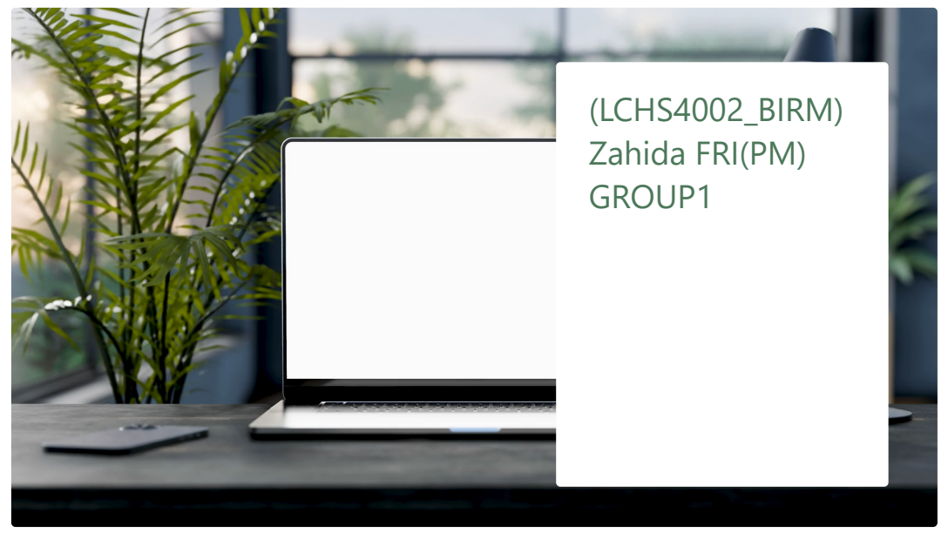
6. APPENDIX A – A blank copy questionnaire



