Business Plan for

Bean Motion Pop-Up (A Mobile Coffee Truck)

Produced By:

Raluca Georgiana Chiparus Zosan

Module Name: Leading Restaurant Strategy
Module Code: BMGM6001
Student Name: Raluca Georgiana Chiparus Zosan
Student Number: 2239463
Lecturer’s Name: Jemma Smith

CONTENTS
 |  |  | PAGE
1. | Executive Summary |  | ………………… 2
2. | The Business Idea |  | ………………… 3
3. | The Team |  | ………………… 4
4. | Market Research |  | ………………… 6
5. | Marketing Plan |  | ………………… 8
6. | Key Resources |  | ………………… 9
7. | Finances & Start-Up Support |  | ………………....10
APPENDICES:
Appendix A |  |  | SWOT Analysis
Appendix B |  |  | PEST Analysis
Appendix C |  |  | Pricing Strategy
Appendix D |  |  | A Coffee Trailer

1. EXECUTIVE SUMMARY
The business idea is a mobile pop-up coffee truck called Bean Motion Pop-Up that serves coffee at events around Stoke-On-Trent. Bean Motion mobile pop-up coffee truck will sell coffee and other assorted beverages to events such as football games over the weekends, music concerts, food markets, and high-volume commuter areas and busy parks and urban places such as the train station and bus parks. While one of its biggest threats comes from instant coffee mix, one of the product offerings is instant coffee mix to expand my customer base to older people. Also, a major challenge is fatigue from sole business ownership by is countered by hiring a barrister with business growth. The main marketing avenue is through social media to reach commuters, event visitors, revellers and students. In the first year, due to high capital investment, the business is expected to break even with small profit margins.
2. THE BUSINESS IDEA
2.1 The Product/Service
The business idea is a mobile pop-up coffee truck called Motion Bean Pop-Up that serves coffee at events around Stoke-On-Trent. Link (2022) highlights that historically, mobile food trucks originated from a simple concept: street vendors selling their merchandise on marketplaces or at events where they can access large crowds. Then, there evolved pop-up stores or temporary stores, especially in the UK, that connected to customers, such as ice cream vans that would move to different locations, such as around schools or carnivals that would attract clientele (Alshaheen et al., 2025). Similarly, the business idea of a mobile pop-up coffee shop follows a similar strategy. The mobile pop-up coffee truck will sell different types of coffee at events such as football games over the weekends, music concerts, food markets, and high-volume commuter areas and busy parks and urban places such as the train station and bus stops. Gosalvitr et al. (2024) highlight that the global coffee demand grows by 8.28% yearly, which makes coffee a viable business opportunity, and the UK has one of the largest coffee demands in Europe. Other than that, event goers and visitors need coffee with its caffeine to keep them alert and awake during events. On the mobile food truck, only five of the nine types of coffee will be served: instant coffee mix, Americano, espresso, cappuccino, and latte
2.2 SWOT Analysis Summary
The success of mobile food trucks is their affordability and accessibility. A core strength of my business is that it is accessible to event goers and has access to different locations. In addition, Bean Motion Pop-Up's business model is built on delivering affordable coffee since the business has no costs from expensive rents and a wide customer base (Appendix A). Additionally, the start-up costs of a coffee shop are relatively lower than operating a physical coffee store. However, some of the possible weaknesses are that since the business is a sole proprietorship, one of the largest weaknesses of the business is fatigue and the limited capacity of the coffee truck operations. This is a problem because it might affect service delivery, leading to slow service. Another challenge is that the business depends on good weather and high health and safety standards. While one of its biggest threats comes from instant coffee mix, one of the product offerings is instant coffee mix to expand my customer base to older people. Additionally, since there is a great demand for coffee, the plan is to expand my locations to include corporate events, wedding events and even business events such as launches. Also, to counter the weakness of a sole owner, the plan is to hire a barrister as soon as the business begins to pick up.

3. THE TEAM
3.1 Key Personnel
Name and Company Position: Raluca, the Founder and Sole-Operator
Skills and Experience:
- Highly responsible and problem solver.
- Strong interpersonal and communication skills
- Training as a barrister
- Proper knowledge of food safety and handling procedures
Role and Responsibilities:
- Running the financial operations of the business
- Sourcing and preparing the ingredients.
- Ensuring compliance to environment and safety standards, conducting health and safety audits, and reporting all incidents.
- Preparing and serving all coffee beverages and drinks, and ensuring a clean and tidy working station, including the counters.

3.2 Skills Gaps & Key Partners
3.2.1 Additional Staff Requirements (Roles and Responsibilities):
Role: A Barrister
Skills and Experience
- Two years working as a barrister in a reputable coffee store
- At least two months of operating or working on a food truck or coffee truck
- Strong communication skills.
Roles and Responsibilities
- Preparing and serving all coffee beverages and drinks
- Interacting with customers at the counter customer touch point.
- Following the required standard operating procedures to provide consistent food service
- Stock keeping, taking and ensuring timely delivery of ingredients.
- Developing a comprehensive coffee menu and other menu improvements.
- Ensuring a clean and sanitary kitchen and serving points, and compliance with safety standards.
3.2.2 Training and Development:
Training: Barrister Training
Who will use: The barista
What Training: Advanced Barista Skills and Latte Art
Why: According to Stokes Tea and Coffee, barrister training is important even to people who can make good coffee. Barristers can receive SCA-certified roasting courses, which help them improve their roasting, sensory and even brewing skills. These training programs not only provide the practical skills but also equip barristers with business skills critical for coffee shops.
3.2.3 Outsourced Support / Key Partners:
Who: Social Media Marketing Agency
What Training: social media marketing strategies and social media management
Why: Nyamboli (2021) highlights that small business fails to effectively implement social media marketing because they lack the capital and even the expertise to run successful campaigns. However, Nyamboli (2021) highlights that small organisations can employ social media marketing agencies that can help small business curate their content, design their content, engage with customers and even select and manage the platforms that will be most responsive to the business’s customers. In addition, Appel et al. (2020) confirm that social media agencies help small businesses manage their marketing team workforce because they provide several services and tools that can help analyse business marketing performance and inform decisions.
4. MARKET RESEARCH
4.1 Market Information, Trends and External Factors
According to Allegra World Coffee Portal (2025), there were 11,456 coffee shop outlets in the UK, and of these, 6,306, almost half of these outlets were coffee-focused only, and the rest included food offerings. This was 5.2% increase in the number of outlets in the UK over the last 12 months. This implies that the demand for coffee in the UK is growing, and the majority are coffee-focused, just like the Bean Motion Pop-Up. Consequently, the UK’s coffee market was about £ 6.1 billion. The largest coffee chains with the most stores in the UK was Coster Coffee with 2671 stores, Greggs with 2610 stores and Starbucks with 1354 stores. According to Lumina Intelligence, the most consumed variety of Coffee in the UK was a latte, then Hot Coffee and an Americano. Additionally, Lumina Intelligence highlights that in 2025, 15% of UK residents took out-of-home coffee, which can be exploited by the mobile coffee shop. In the context of market penetration, only branded coffee makes the coffee reports, which implies that there is a huge opportunity for mobile coffee stores. In fact, Lumina Intelligence highlights that there is high net coffee expansion to high football locations because of evolving customer habits and preferences towards coffee in ready-to-drink formats.
4.2 Customer Profiles
- Event goers
The event goers’ demographics are youths and young adults who attend events. Maulina et al. (2025) describes events goers as ‘leisure-oriented’ customers because they are seeking out a place for social gathering, connecting with friends and taking breaks during events. These customers are seeking a place to unwind, relax, chat and even replenish during events (Appendix B).
- Students
The students' demographics are young adults. Siburian et al. (2025) highlight that students were most likely to purchase coffee from mobile coffee trucks because of accessibility, the affordable costs and the short time taken to prepare the drinks. The students were also likely to purchase drinks from mobile coffee shops because they seem ‘cool,’ or trendy. Siburian et al. (2025) would rather consume coffee from mobile trucks than expensive and premium coffee from branded cafes because of the functionality the mobile trucks offer.
- Commuters
The final set of customers is commuters. Food trucks have historically thrived in high-traffic areas, particularly at locations such as commuter stations. The typical customer in these situations is often rushed and pressed for time, making them less likely to shop. As a result, they seek easily accessible beverages to help replenish their energy. Loh and Hassan (2022) note that customer purchase intention to purchase from a food truck is guided by their sense of perceived benefits. In the case of Bean Motion Pop-Up, customers can get their coffee during their commute to work.
4.3 Competitor Profiles
- AMT Coffee
It is a coffee chain in the UK with 52 Gourmet coffee shops located along railway lines. AMT coffee is a major competitor because it is one of the leading coffee stores in Stoke-on-Trent. One of its strengths is that it is a coffee chain following its administration’s dissolution and being sold out to SSP Group (AMT Joint Administrators' progress report). However, Bean Motion Pop-Up will have a competitive advantage because it has access to a larger customer base, beyond commuters. Additionally, Bean Motion Pop-Up aims to capture event goers, too.
- Popup Joes
It is a mobile bar solution that offers many types of beverages from coffee to alcoholic drinks during weddings, sporting events and corporate events. One of its major strengths is that it not only offers coffee but also cocktails, alcoholic and non-alcoholic drinks (popupjoes.co.uk). However, Bean Motion Pop-Up is more competitive because it will exclusively focus on coffee, yielding high-quality service delivery. Additionally, since customers can hire the mobile bar, it might jeopardise the quality of products, leading to a damaged reputation. Finally, the mobile bar has premium charges on its products, while Bean Motion Pop-Up strives for affordable coffee.
- Nescafé
Nescafé produces a Ready-to-Drink coffee which is popular among event goers. Its main strength lies in the growing and changing market demand for iced coffee, which is provided by the ready-to-drink coffee. However, Bean Motion Pop-Up offers social stimulus which allows people to chat, unwind, catch-up and rest between events. In addition, it provides an assortment of coffee beverages, including RTD, thus fulfilling customer needs.

5. MARKETING PLAN
5.1 Price
Awaly et al. (2026) highlight that affordable pricing is the key factor that create competitive advantage for mobile coffee shops over competitors. Therefore, unlike gourmet and premium coffee, the aim is to serve high-quality yet affordable coffee. Motion Bean Pop-Up’s prices will begin at £3 for the Ready to Drink Iced coffee (Appendix C).
5.2 Product
Awaly et al. (2026) note that product differentiation is the backbone for mobile coffee shops. The mobile pop-up coffee shop will be a small, modified trailer that will be attached to my car. The trailer will be modified to serve as a kitchen with an elegant yet very simple design. However, the outlook will be based on the event themes. Bean Motion Pop-Up will print new stickers and car wraps to match the theme of the event so that they can blend with the event (Appendix C).
5.3 Placement
Awaly et al. (2026) found that the effective placement strategy for mobile coffee shops is strategic location selection. Since Bean Motion Pop-Up will be catering to events, the idea is to bid for a spot at the vendors' section because they are often placed at strategic places where revellers can have access to meals and other merchandise at events. However, for commuter customers, the strategic location will be at entrances and exits to train stations or bus stations.
5.4 Promotion
Louhelainen (2023) highlights that mobile coffee shops are using gamification in their social media strategies to attract and engage their customers. On this note, Bean Motion Pop-Up might leave clues for customers about the next destination and include the customers in a form of ‘treasure-hunt’ for the next location, and the winners get discounts on their coffee. This will allow engagement of customers (Appendix B). In addition, the coffee truck will use social media to create awareness about the mobile coffee truck's routes, stopping points and destination. Finally, the coffee shop will apply traditional advertisement by decorating the coffee trailer with attractive colours and car wraps to increase its visibility to commuters and pedestrians. Finally, the mobile coffee store will have an engagement session where customers can take pictures in the Instagram frame props, which, when posted on social media, improve engagement (Jurinka, 2025).

6. KEY RESOURCES
6.1 Premises
For this business idea, no rent is required, but a retrofitted and modified trailer is required to act as a kitchen and a serving counter (Prima Coffee Equipment). Since Bean Motion Pop-Up will be located all over Stoke-on-Trent, there will be a need to acquire a food business license from the Stoke-on-Trent Environmental Health Department (Appendix B). In addition, there is a Street Trading Consent licence required, and a food hygiene inspection and certification from the Environmental Health Officer (EHO), Food Ratings from the Food Hygiene ratings, Gas & LPG Safety approval, insurances and vehicle and Trailer Standards from Vehicle Registrations (Appendix D), applying for food business license is free while other licenses such as Food Hygiene Certificate (£10.99 + VAT), marketing which includes branding approximately £500, and street trading license and other miscellaneous charges costs £1,000.
6.2 Equipment
The supplier for my food Truck business is Prima Coffee Equipment traders. Some of the machines Bean Motion Pop-Up will require are an espresso machine, a grinder, a water filtration setup, a mini fridge, a point of sale system, a power source, a waste tank and a sink system (Prima Coffee). According to Prima Coffee, a high-volume espresso coffee setup, including all the above equipment, will cost me £16,923 and a food truck trailer from Rolling Stock at £10,050.
6.3 Key Suppliers
The main suppliers will be coffee wholesalers who will provide coffee beans high quality coffee stock. The supplier for wholesale coffee stock is Iron and Fire Roasters Limited, which is in Stoke-on-Trent. The suppliers sell about 8 kg of coffee beans at £160 that will last a week.

7. FINANCES AND START-UP SUPPORT

EXPENDITURE | Year 1 £
Company Registration | 1,010
Rent/Rates | Nil
Staff Wages | 45,000
Travel/Fuel | 1,200
Telephone (mobile) | Nil
Broadband | Nil
Utilities | 1000
Marketing and materials | 500
Insurance | 500
Capital Expenditure/Equipment | 16,923
Training & Development | Nil
Accounting/Legal | Nil
Outside Services | Nil
Stock/Materials Purchases | 8,000
Bank Charges | Nil
Office Consumables | Nil
Loans Repayments | 2,588
Total Expenditure | 79,721

INCOME | Year 1  £
Sales Lattes | 27,000
Sales Ready to drink | 16,200
Sales Americano | 27,000
Capital Introduced
Funding
Loans/Borrowing | 10,000
Total Income | 80,200
YEAR ONE PROFIT/LOSS | £
Total Income | 80,200
Total Expenditure | 79,721
Profit | 479

7.1 Financial Summary
As explained in the key resources section, the cost of the trailer, business registration and applicable licenses and capital expenses are well justified in the key resources section. Additionally, since this is a food truck, other expenses will come from travel or fuelling the car. According to the sole proprietor’s Mazda Demio, it consumes 1 litre per 25 km. Currently, a litre of fuel in the UK retails at about 134.90p (Carter, 2026). Consequently, Bean Motion Pop-Up won't move around a lot except for the normal commute; it will cover approximately 300 kms every week. This means that the owner will spend about £1200 (adjusted for miscellaneous). On the income side, my ready-to-drink will retail at £3 while the Americano and Expresso at £5. Suppose I serve 20 clients for each commodity every day for five days a week, then the annual income from the three initial commodities will be £70200. The owner currently banks with Barclays and has access to an unsecured business loan of up to £10,000. Since Barclays 11.2% APR on a £10,000 loan over 60 months is £215.73 per month (Barclays), the interest paid to the bank is £2588 in year 1. On this merit, the total annual income will be £80,200. Consequently, my total expenditure will be £79,721, which implies that Bean Motion Pop-Up's profit will be £479.

APPENDICES
Appendix A – SWOT Analysis
Strengths
Wallace (2021) highlights that the success of mobile food trucks is their affordability and accessibility. A core strength of my business is that it is accessible to event goers and locations where it pops up. Event goers don’t have to commute or order their drinks online. In addition, customers don’t have to wait for long periods for the coffee. In addition, the entire business model is built on delivering affordable coffee since the business has no costs from expensive rents and a wide customer base. On the issue of affordability, the start-up costs for operating a mobile coffee bar are relatively lower than those for a physical coffee store.
Opportunities
Mobile pop-up coffee shops are increasingly expanding into corporate spaces and even banqueting services. Kraus (2022) argues that food truck businesses’ main clientele is millennials. This is important because corporates are tapping into millennial buyer behaviour that prefers a brand that provides engagement and a sense of originality. In fact, many UK mobile coffee brands such as Vaarista set up coffee bars for the corporates, wedding events, business launches and many other official events. This is an opportunity to scale and expand the business. Another opportunity is that the UK’s demand for coffee is increasing exponentially. The British Coffee Association highlights that 98 million cups of coffee are drunk in the UK daily. In addition, the coffee industry generates £9.1 billion for the economy and employs 210,000 people. This growing demand makes it a perfect business venture.
Threats
One of the biggest threats to mobile pop-up stores is established coffee brands. According to Statista, Costa Coffee is one of the largest coffee chain shops in the UK, followed by major brands such as Starbucks and Caffè Nero. These coffee brands have very large market shares, and the financial capital for hiring the best baristas and their marketing initiatives. Other threats to pop-up coffee shops are instant coffee, which is consumed by many coffee consumers in the UK (British Coffee Association).
Weakness
Since the business is a sole proprietorship, one of the largest weaknesses of the business is fatigue and the limited capacity of the coffee truck operations. Link (2022) highlights that the limited capacity of sole business owners makes it difficult to effectively operate a food truck. This might lead to slow service and even poor service delivery. In addition, Alkaabi and Mehmood (2025) highlight that one of the major factors that affect food truck business are extreme weather conditions. In addition, there are often concerns over health and safety concerns when operating food trucks, which might bar customers of older demographics.

Appendix B – PEST Analysis
Political
According to the City of Stoke-on-Trent, there are several legal requirements for setting up a food vending service. These legal safeguards serve to protect the business owner from a legal standpoint. For a sole proprietor, there is a need to register the business, then apply for the food business license from the Stoke-on-Trent Environmental Health Department. In addition, there is a Street Trading Consent licence required, and a food hygiene inspection and certification from the Environmental Health Officer (EHO), Food Ratings from the Food Hygiene ratings, Gas & LPG Safety approval, insurances and vehicle and Trailer Standards from Vehicle Registrations.
Economic
According to the BBC, the UK is facing increased inflation in 2026. The inflation rates in the UK are currently at 3.4% despite the government, through the Bank of England, intervening six times since 2024. These inflation rates have contributed to the hike in prices of equipment and even stock coffee beans. In addition, people are no longer spending on commodities such as coffee because they are considered basic.
Social
People are increasingly developing a taste for gourmet experiences with coffee, which makes their preferences for coffee rise constantly in the UK. Additionally, as people are increasingly attending social events, the need for refreshing coffee drinks to replenish revellers increases dramatically. In fact, Maulina et al. (2025) confirm that these customers are seeking a place to unwind, relax, chat and even replenish during events.
Technological
In the UK, businesses are increasingly using social media for marketing purposes. The entire marketing plan is pegged on social media marketing and gamification. On this note, my mobile coffee shop might leave clues for customers about the next destination and include the customers in a form of ‘treasure-hunt’ for the next location, and the winners get discounts on their coffee. This will allow engagement of customers (Louhelainen, 2023).
Appendix C- Pricing Strategy
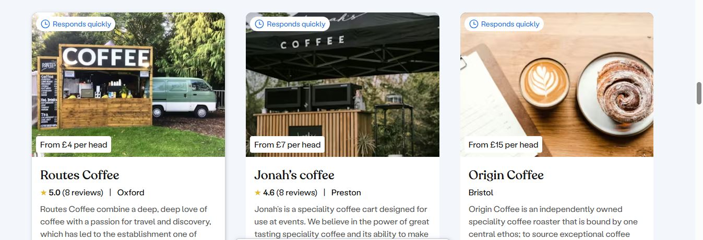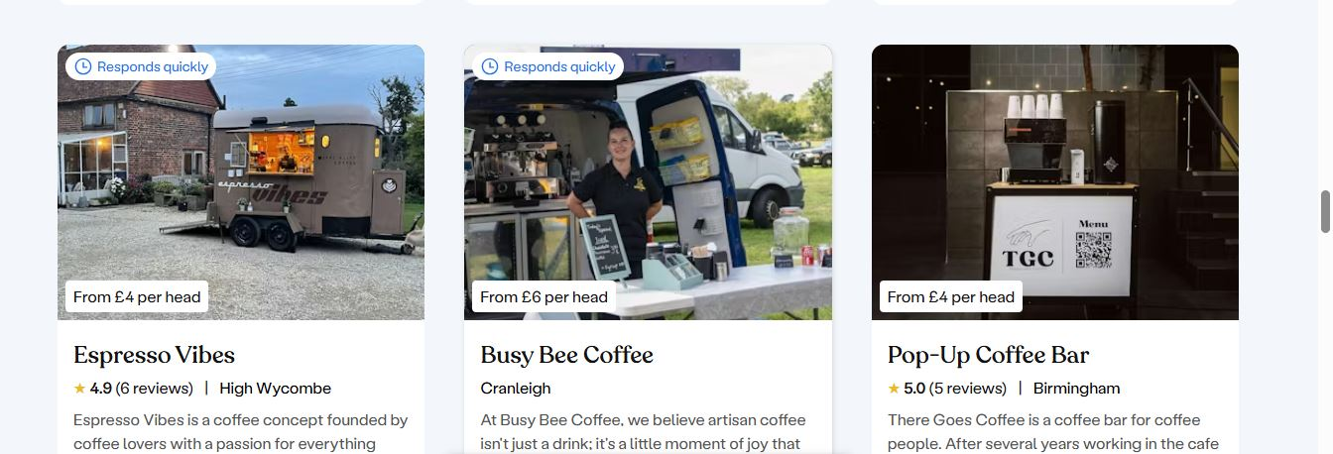
Appendix D- The Coffee Trailer
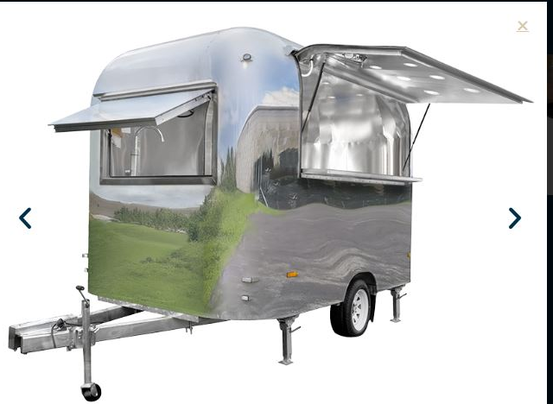

REFERENCE LIST:
Alkaabi, K. and Mehmood, K., (2025) ‘Exploring key factors influencing food truck businesses' success: a case of the UAE’, European Business Review, 37(4), pp.637-665. Available at: https://doi.org/10.1108/EBR-05-2024-0157 (Accessed: 17 February 2026).
Allegra World Coffee Portal (2025). Value in the spotlight as competition heats up in £6.1bn UK branded coffee shop market. Available at: https://www.worldcoffeeportal.com/news/value-in-the-spotlight-as-competition-heats-up-in-6-1bn-uk-branded-coffee-shop-market/ (Accessed: 17 February 2026).
Alshaheen, R., Alajmi, M., Alharoun, Y. and Al-Saqobi, A., (2025) ‘Food trucks as temporary place-makers: insights from Qurtoba, Kuwait’, Archnet-IJAR: International Journal of Architectural Research, pp.1-20. Available at: https://doi.org/10.1108/ARCH-04-2025-0163 (Accessed: 17 February 2026).
Amanda, C.D., Anggraini, D., Sari, D.P., Surbakti, R., Siburian, F. and Ginting, H. (2025) ‘Analysis of Consumer Attitudes Towards the Purchase of Mobile Coffee Among Students at Medan Area University’, International Journal of Economic, Agribusiness and Development Studies, 2(3), pp.81-87.Available at: https://doi.org/10.65142/ijeads.v2i3.110 (Accessed: 17 February 2026).
AMT Coffee Limited (2024) Joint Administrators' progress report for the period 18 November 2023 to 17 May 2024. Available at: https://find-and-update.company-information.service.gov.uk/company/02857483/filing-history (Accessed: 17 February 2026).
Appel, G., Grewal, L., Hadi, R. and Stephen, A.T. (2020) ‘The future of social media in marketing’, Journal of the Academy of Marketing Science, 48(1), pp.79-95. Available at: https://doi.org/10.1007/s11747-019-00695-1 (Accessed: 17 February 2026).
Awaly, K.R. and Prasetyo, S.A.D. (2026) ‘Analysis of the Marketing Strategy of Mobile Coffee Sellers Using Electric Bicycle Cart with Marketing Mix (4P) on Sales Increase (Case Study of Mobile Coffee Sellers in Semarang City)’, Journal of Economic Management and Accounting, 1(1), pp.46-61. Available at: https://doi.org/10.31538/mjifm.v5i3.546 (Accessed: 17 February 2026).
Barclays. Business loans. Personal banking. Available at: https://www.barclays.co.uk/business-banking/borrow/loans/#business-loan-calculator (Accessed: 17 February 2026).
British Coffee Association. Coffee consumption. Available at: https://britishcoffeeassociation.org/coffee-consumption/ (Accessed: 17 February 2026).
Carter, O. (2026). Petrol and Diesel Prices. Available at: https://www.gocompare.com/motoring/guides/petrol-prices/ (Accessed: 17 February 2026).
City of Stoke-on-Trent. Starting a food business. Available at: https://www.stoke.gov.uk/info/20058/food_businesses/130/starting_a_food_business (Accessed: 17 February 2026).
CPD. (2026) ‘Level 2 food hygiene certificate training online’, Food Hygiene Certificate Online. Available at: https://www.foodhygienecertificate.co.uk/product/level-2-food-hygiene-certificate (Accessed: 17 February 2026).
Gosalvitr, P., Cuellar-Franca, R.M., Smith, R. and Azapagic, A. (2024) ‘Environmental and economic sustainability assessment of the production and consumption of different types of coffee in the UK’, Sustainable Production and Consumption, 49, pp.144-162. Available at: https://doi.org/10.1016/j.spc.2024.06.004 (Accessed: 17 February 2026).
Gosalvitr, P., Cuéllar-Franca, R.M., Smith, R. and Azapagic, A. (2024) ‘Eco-efficiency of coffee production and consumption in the UK at the product and sectoral levels’, Cleaner Environmental Systems, 15, p.100231. Available at: https://doi.org/10.1016/j.cesys.2024.100231 (Accessed: 17 February 2026).
Iron & Fire Coffee Roasters Limited (2024) Wholesale Coffee Beans, Coffee Supplies & Barista Training in Stoke-On-Trent, West Midlands. Available at: https://ironandfire.co.uk/fresh-roasted-coffee-supplier/stoke-on-trent/ (Accessed: 17 February 2026).
Jurinka, J. (2025) ‘How Food Truck Marketing Transforms Brand Activations’, Field and Event Marketing Agency. Available at: https://www.attackmarketing.com/post/how-food-truck-marketing-became-the-new-sampling-powerhouse (Accessed: 17 February 2026).
Kraus, S., Sen, S., Savitskie, K., Kumar, S.K. and Brooks Jr, J. (2022) ‘Attracting the millennial customer: the case of food trucks’, British Food Journal, 124(13), pp.165-182. Available at: https://doi.org/10.1108/BFJ-09-2021-099 (Accessed: 17 February 2026).
Link, S.A. (2022) ‘Mobile Truck Entrepreneurship: Motivations and Strategies of Non-food Mobile Retail Truck Entrepreneurs in the United States’, Doctoral dissertation, University of Missouri-Columbia. Available at: https://www.proquest.com/openview/998b2b25e9165efca1e574f002c35f3b/1?pq-origsite=gscholar&cbl=18750&diss=y (Accessed: 17 February 2026).
Loh, Z. and Hassan, S.H. (2022) ‘Consumers’ attitudes, perceived risks and perceived benefits towards repurchase intention of food truck products’, British Food Journal, 124(4), pp.1314-1332. Available at: https://doi.org/10.1108/BFJ-03-2021-0216 (Accessed: 17 February 2026).
Louhelainen, I. (2023) ‘Gamification and modern digital tools as the main methods of coffee truck business concept’, Haaga-Helia University. Available at: https://www.theseus.fi/bitstream/handle/10024/811523/Louhelainen_Iliya.pdf?sequence=2&isAllowed=y (Accessed: 17 February 2026).
Lumina Intelligence. (2025) UK coffee market: Size, growth and share statistics 2025. Available at: https://www.lumina-intelligence.com/blog/foodservice/uk-coffee-market-size-growth-share-statistics-2025/ (Accessed: 17 February 2026).
Maulina, H., Novita, M. and Rahmany, M. (2025) ‘Analysis of coffee truck consumer segmentation in Banda Aceh city’, In IOP Conference Series: Earth and Environmental Science, 1510(1), p. 012031). Available at: https://doi.org/10.1088/1755-1315/1510/1/012031 (Accessed: 17 February 2026).
Nyamboli, T.I. (2021) ‘Strategies to Implement Social Media Marketing in Small Businesses’, Doctoral dissertation, Walden University. Available at: https://scholarworks.waldenu.edu/cgi/viewcontent.cgi?article=12668&context=dissertations (Accessed: 17 February 2026).
Popup Joe's Mobile Bar Solutions. About. Available at: https://popupjoes.co.uk/about (Accessed: 17 February 2026).
Prima Coffee Equipment. (2026) ‘Brew What You Love’, Prima Coffee Equipment Available at: https://prima-coffee.com/ (Accessed: 17 February 2026).
Rolling Stock UK. (2025). Explore catering trailers for sale. Available at: https://rollingstock.uk/catering-trailers-for-sale/ (Accessed: 17 February 2026).
Rushden Lakes. (2026) Plan your visit. Available at: https://www.rushdenlakes.com/plan-your-visit (Accessed: 17 February 2026).
Statista. (2025) Leading coffee shop chains in the UK 2025. Available at: https://www.statista.com/statistics/297863/leading-coffee-shop-chains-in-the-united-kingdom-uk-store-number/ (Accessed: 17 February 2026).
Stokes Tea and Coffee UK. Barista Training & Courses. Available at: https://stokescoffee.com/collections/barista-training (Accessed: 17 February 2026).
Together. Extraordinary mobile coffee vans. Available at: https://togather.com/listings/mobile-bars/coffee (Accessed: 17 February 2026).
Wallace, E.V. (2021) ‘Urban mobile food truck policies: reducing disparities and building a culture of health in the United States’, Journal of Public Health Policy, 42(2), p.271. Available at: https://doi.org/10.1057/s41271-021-00274-1 (Accessed: 17 February 2026).

