Kamil Kazimierz Lenczowski
Student number 2120445

Effective Team Working and Communication (BMSW4002_BIRM)

Yohan Mendis
Component 1
Report Effective Teamworking for team success

Executive summary

Table of contents

Introduction
The purpose of this report is based on clearly states models of effective teamwork, it includes relevant examples and theories of particular segments regarding teamwork, however, it is also going to demonstrate achievements in this branch of science by using different models or diagrams to support visualization.
The teamwork process is long and hard in overcoming. This magnificent toll is adopted by many corporations and involves the owner to adopt it into their team leaders and develop their knowledge regarding their team roles. The report contains Tuckman’s model of team development but also the models like wheelman’s model of development which is very similar. These models reveal the specific pieces of information, and clearly the picture of the strategy and how the certain stages look like in the above models.
The report will define differences in aspects of team and group relatives.
This work also includes six different characteristics of team roles by using Belbin’s team roles model.

Overview of Team working
In many environments, there are existing formulas, definitions, schematics, etc.
In this particular discussion is necessary to extract two concepts that are fundamental to understanding and providing business with high performance.
In order, this work is supported and accordable to a few sources. According to an article written by a Team Asana and available online which explains the definition of team and group and the main differences but also advantages and disadvantages.
Summarising teamwork overview there are two separate formations. To be looking at the aspects and definition of teamwork, the formulation of teamwork is divided into two groups one of them is a group.
Group is a collection of people who are strangers in most cases they do not know each other however, they share a common purpose. The majority of that is that they do not depend on each other. They coordinate their effort as an individual. In order to improve a good working strategy and relationships, it is good to understand it and develop working dynamics. In business is important to implement workplace communication and be able to see differences between leading a group or leading a team. The group also can be divided into two aspect it can be formal group or informal.
The formal group can be lunched by the organisations by giving a special task and the group needs to contribute with their task given by delegate all of the members and achieve the goal.
Example of formal groups are;
- Command group
- Task group
- Project group
- Committees
Command group is usually a manager or supervisor and it is clearly visible along with the corporation’s structures where the organizational chart is applied. All the staff got different obligations and tasks to do and they can collaborate and form groups at lover grades and different offices and instance.
Task group is a group of individuals to achieve a common goal however it can cross a command line at some point.
Project group is a group of people lunched to do a special task it can be a project, for example, lunch a new line of children’s wear across next Plc stores around the world.
Committees are a short or longer period time formed group out of the standard one, most of the time it appears when is about solving a disciplinary problem.
The informal group this kind of group is this which seems to be not formal. None of the organizations can control them. this type of group can also form in the work environment.
The informal groups can also divided to different groups.
Informal group;
- Friendship group
- Interest group
- Reference group
Friendship group is when people find similarities such as political beliefs, religious values, hobbies, or other shared characteristics.
Interest group is a group of people who don’t have to be a friend or back up in different tasks but in some particular situation or sociology issue they can co operating as one group with the same goal , for example, scientists or professors.
Reference group is a group of people who are gathering together, for example, it could be students talking about experiences, courses, suggestions, or anything that brings them to consider the same topic.
Group advantage ;
- Efficiently is visible in any aspect
- Every member is focused on personal productivity
Group disadvantages;
- Some members can feel alone and behind which build up anxiety and alienate
- There is no goal to work towards
The team is The second divided phrase according to teamwork overview.
A team is very similar to a group but in the teamwork aspect, it is slightly different in meaning. Comparing it to a group, the team demonstrates sharing and putting the whole effort to work together and achieve a goal together not as an individual unit. While the phrases are similar but when it comes to decision making it brings us to see differences. The team will always depend on each other and back the member up when needed.
Team advantage:

- When it comes to problem-solving there is better performance
- The team is more focused on their task and everybody is supporting each other they are independent and interrelationship is supplied within the team. All these aspects support effective team working and communication.

Team disadvantages

- It can dismiss possible individual growth as a single unit in the team
- It can block the full strange of the efficient teamwork suspect

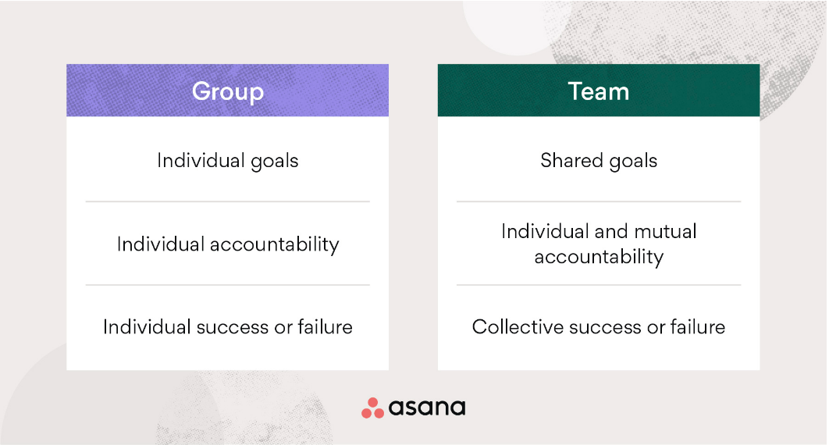

Bringing up and according to the book written by Ronald B Beach the teamwork concept, we do not even know how deeply it has been ingrained in our society. This author shows how the teamwork and compares that to prehistoric cave drawings. The pictures tell us how important is to have a high performance of skills such as collaborating well within the group, in this example the author uses a hunters team to express that only good teamwork, and team management brings up the success of great results. Many types of research are based on experiences. Theories are based on observation of our society. Over the years there were a few people interested in this instant. One of them is Meredith Belbin, R first of all his theory and concepts is used in current society regarding teamwork.

Belbin’s team role model has been applied generally most to the European countries and used as a counseling and development tool (Beach, Ronald B. 2009).
There are several models of teamwork and the purpose of this is to find contributes to effective teamwork and apply them into the teamwork.

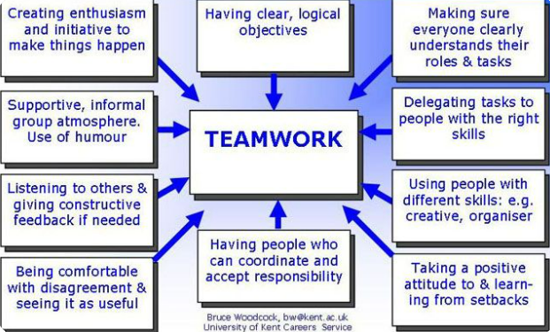

To understand Teamwork relative to the business, the well-performing management needs to see the impact of effective teamwork and identify advantages and disadvantages while the tasks are assigned to the team.

Models of team development
According this work to the sources regarding different team development models. The most known model of team development is:

Tuckman’s model

This is not the only one.
The majority of the team development model is to implement a plan on how to improve the team work as one single independent unit.
According to Dan McCarthy who recommends using team development tools for leaders .only one of them if consistently used, can cure teamwork on high performance.
The fundamental model of team development is Tuckman’s model.
Tuckman’s model presents five stages. Each of the stages is different and each of them is important equally. To imagine the power it is necessary to compare it to human life beginning from born, going thru the next steps till we achieve our goals.

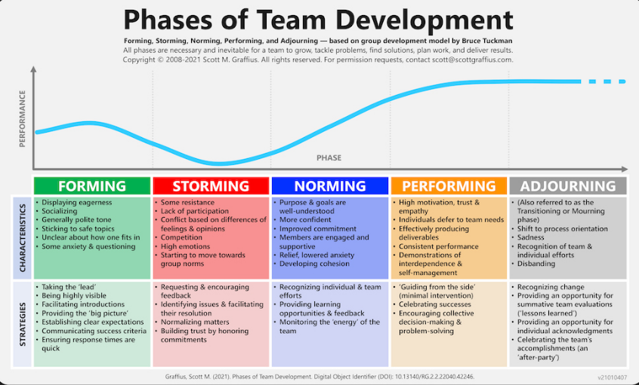

- FORMING (gathering together and knowing each other forming the frames of achievements)
- STORMING (people showing and seeing differences between them, possible some conflicts, the leader can be chosen)
- NORMING (settle down and focus on the group task ,the leader is still needed)
- PERFORMING (the leader is not that important in this stage, the group is performing great. It is the highest level of performing. Members feel belonging to what they created)
- ADJOURNING(individual efforts, disbanding, the group feels, ,,lesson learned ’’)

Models of team development are directly connected to a leadership process.
Tucuman’s model is the only hypothesis that has been created himself and it can be divided into different variations of environment not only as a strategy for the leadership process.
Tuckman’s model is only a base for others who try to define their framework proposes. The whole process is relatively difficult as the time is changing, with the passage of time the perception slightly different
The purpose of generating a tool is to help in the process but it needs to be connected to the current expectations and should involve every aspect of society.
Tuckman’s model has been improved in 1977 and we can know it now as five stages, which means that everything is improving and fits a more modern reality and business aspect. According to a job written by Kate Cassidy, it is improving the theory and the author explains more about tacksman’s research, the effect of studies of the therapy, and his therapy group.
Mainly thinking about the exact model the leader needs to choose the appropriate model and upgrade teamwork.

Wheelan’s integrated model of group development
This model is based on the previous Tuckman’s model and collectively it has been built up with whole empirical sources.
The wheelan’s academic group put whole afford to get the results and the most important was an individual perception of the group.
This model seems to be a bit different
Based on the published Wheelan’s model at: https://www.oreilly.com/library/view/the-little-book/9780273785262/html/chapter-045.html

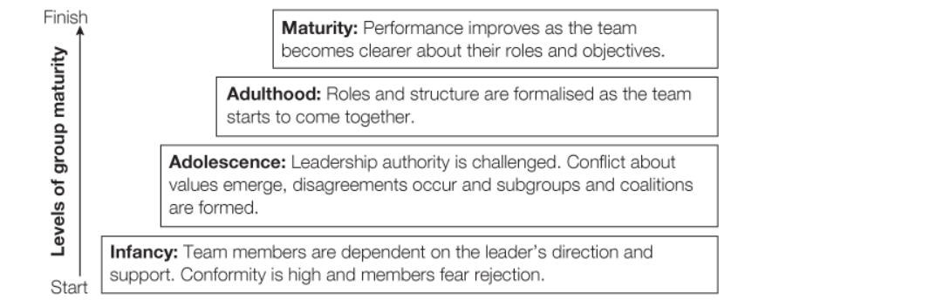
In summarising there is more than one model development, this involves more than one option, essential is to be able and apply the right one and adopt it within the group.

Team roles
accordable to Belbin’s team roles, the team role has to be defined as nine roles. The Whole amount of the above roles needs to be divided into three categories.
To be looking at these roles, it has a numeral impact on coordinating, as people have got a different range of behaviour which implements into the teamwork.
Is crucial to know the team roles. It comes up with incredible profits when is about team management and creating teamwork.
Specific skills and character traits contribute to reliable profit in achieving a goal.

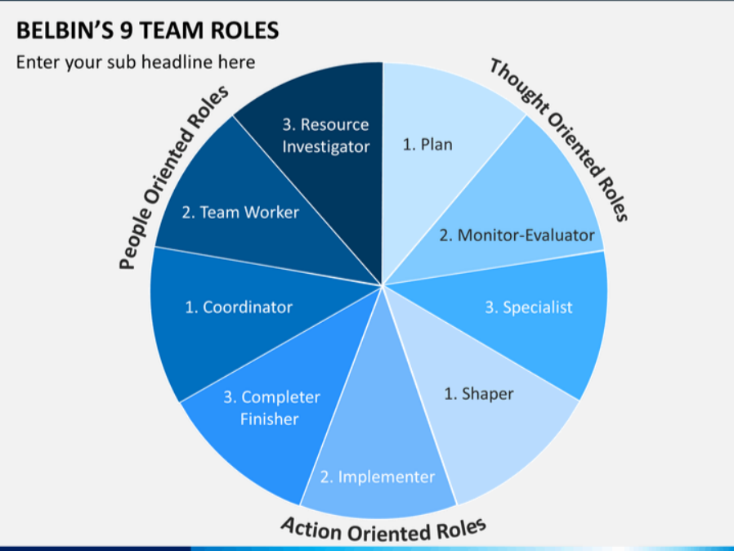

Many resources and collective literature are vividly depictured Belbin’s team role.
Following Belbin’s role aspect, this begs the question of what roles are needed to create a cohesive and effective team?
A good team should possess the best candidates under their character traits, which would accelerate the whole process of solving or creating and achieving the goal.
Belbin assumes nine roles but it does not mean that every group has to have a number of nine members The ideology of Belbin is to show that every aspect is the same important.
These nine roles have been divided into three separate formations:
- ACTION-ORIENTED ROLES
- PEOPLE- ORIRENTED ROLES
- THOUGHT-ORIENTED ROLES
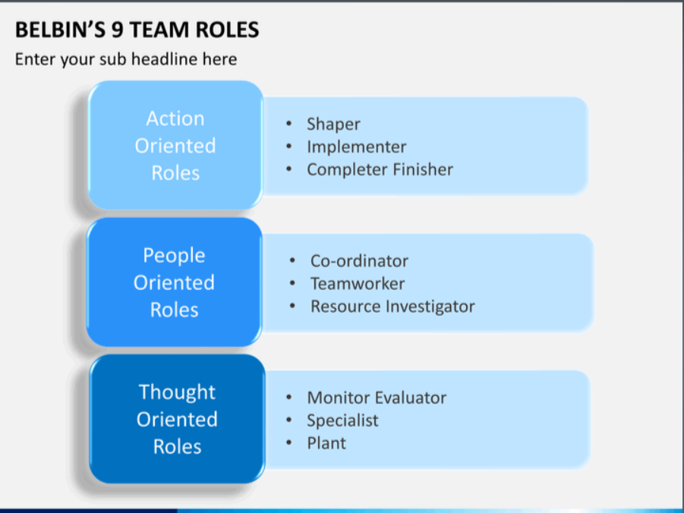
According to a study (Journal of Management Development 1 November 1999), it seems that Belbin’s proposal has not been fully scanted yet. Following it up there are still people seeking to find the best satisfactory proposal. Belbin’s role model can be an efficient tool when the workplace considering hearing a new staff.it is highly recommended for leaders to bring it up before the institution is hiring the staff and make sure they will get the best sort of people for particular tasks.

Discussion.
This work is about an alternative tools ,used in leadership ,while we are creating groups, teams.
This kind of purpose is effecting many of aspects .many researches come with a results , many of them directly crossing with teamwork, managing guides and involve new or previous strategies be used.
This job is directly passed to establish a term such as:

- Tuckman’s model of development
- Wheelan’s model of development
By using these two examples we can see that there is a full range of different tolls while the team process is launched. It is important to gather knowledge about team development and being able to achieve performance at the highest grades. According to literature the segment as leadership, different institutions are seeking to achieve the best standard in their development. It is highly recommended to follow the existing relevant programs. One of the advantages for the business is that it helps with correct and effective teamwork. Referring to Daniel Coyle it is good to think about habits and step by step try to change them and become more powerful in ourself. The purpose of becoming more educated in this instance becoming to be measurable which is visible in achieving the goals. The point of view is that the team can go up and down but the team needs to be open to adopting more. In the way how Daniel Coyle supportively suggests to us is that we need to find the toll in ourselves to control successes or failure and be able to balance it and could see indicators of whether something will help or not.
- The way how humans connect each other is by creating safety
- Share vulnerability
- Establish purpose
These three aspects would be the key for good teamwork ,they are connected as it becomes to team

Conclusion

Referencing
https://whelf-uwtsd.alma.exlibrisgroup.com/leganto/readinglist/citation/6527115350002421?institute=44WHELF_UWTSD&auth=SAML
https://asana.com/resources/group-vs-team

Jane S. Prichard Neville A. Stanton Journal of Management Development
ISSN: 1 November 1999 available at: https://www.emerald.com/insight/content/doi/10.1108/02621719910371164/full/html?fullSc=1&fullSc=1&fullSc=1&mbSc=1&fullSc=1&fullSc=1

Meredith Belbin, R. (2000) ‘Beyond the Team’, Team performance management, 6(3/4), pp. 73–76. doi:10.1108/tpm.2000.6.3_4.73.4. available at https://librarysearch.uwtsd.ac.uk/discovery/fulldisplay?docid=cdi_emerald_primary_10_1108_tpm_2000_6_3_4_73_4&context=PC&vid=44WHELF_UWTSD:44WHELF_UWTSD_VU1&lang=en&search_scope=MyInst_and_CI&adaptor=Primo%20Central&tab=Everything&query=any,contains,Beyond%20the%20Team%20R.%20Meredith%20Belbin&offset=0
BEACH, R.B., 2009. Employee acceptance of team role profiling as a management tool: A survey of a high technology manufacturing environment, Capella University. Available at https://www.proquest.com/pagepdf/305161349/Record/643B364BCE1E4A58PQ/2?accountid=130472
Martine Hass, Mark Mortensen June 2016 Harvard business review . The secrets of great teamwork available at https://hbr.org/2016/06/the-secrets-of-great-teamwork
Rickards, Tudor & Moger, Susan. (2002). Creative Leadership Processes in Project Team Development: An Alternative to Tuckman's Stage Model. British Journal of Management. 11. 273 - 283. 10.1111/1467-8551.00173. available online at : https://www.researchgate.net/publication/227644219_Creative_Leadership_Processes_in_Project_Team_Development_An_Alternative_to_Tuckman's_Stage_Model

Rickards, T. and Moger, S. (2000) ‘Creative Leadership Processes in Project Team Development: An Alternative to Tuckman’s Stage Model’, British journal of management, 11(4), pp. 273–283. doi:10.1111/1467-8551.00173. available at : https://librarysearch.uwtsd.ac.uk/discovery/fulldisplay?docid=cdi_proquest_journals_229486803&context=PC&vid=44WHELF_UWTSD:44WHELF_UWTSD_VU1&lang=en&search_scope=MyInst_and_CI&adaptor=Primo%20Central&tab=Everything&query=any,contains,Creative%20Leadership%20Processes%20in%20Project%20Team%20Development:%20An%20Alternative%20to%20Tuckman%27s%20Stage%20Model%20Tudor%20Rickards,Susan%20Moger&offset=0

‘The enemy of engagement; put an end to workplace frustration--and get the most from your employees’ (2011) Reference & Research Book News. Portland: Ringgold, Inc. available at: https://librarysearch.uwtsd.ac.uk/discovery/fulldisplay?docid=cdi_proquest_reports_906484230&context=PC&vid=44WHELF_UWTSD:44WHELF_UWTSD_VU1&lang=en&search_scope=MyInst_and_CI&adaptor=Primo%20Central&tab=Everything&query=any,contains,The%20Enemy%20of%20Engagement:%20Put%20an%20End%20to%20Workplace%20Frustration--and%20Get%20the%20Most%20from%20Your%20Employees%20Hardcover%20%E2%80%93%20October%2028,%202011&offset=0
Cassidy, K. (2007) ‘Tuckman Revisited: Proposing a New Model of Group Development for Practitioners’, Journal of Experiential Education, 29(3), pp. 413–417. doi: 10.1177/105382590702900318. Available at; https://journals.sagepub.com/doi/abs/10.1177/105382590702900318

Åkerlund, M., Jacobsson, C. and Tilin, F. (2021) ‘The Legacy of Susan Wheelan’, Small group research, 52(1), pp. 103–109. doi:10.1177/1046496420956713. Available online at: https://librarysearch.uwtsd.ac.uk/discovery/fulldisplay?docid=cdi_swepub_primary_oai_gup_ub_gu_se_299297&context=PC&vid=44WHELF_UWTSD:44WHELF_UWTSD_VU1&lang=en&search_scope=MyInst_and_CI&adaptor=Primo%20Central&tab=Everything&query=any,contains,Wheelan%E2%80%99s%20Integrated%20Model%20Of%20Group%20Development
Belbin, R.M. and Jay, A. (1981) Management teams : why they succeed or fail. Oxford: Butterworth-Heinemann.
BULLOCK, J., 2004. Management Teams: Why They Succeed or Fail. Leadership & Organization Development Journal, 25(5), pp. 477-479.available at: https://www.proquest.com/docview/226915547?accountid=130472
PARTINGTON, D. and HARRIS, H., 1999. Team role balance and team performance: an empirical study. The Journal of Management Development, 18(8), pp. 694-706.
Griffith, BA, & Dunham, EB 2014, Working in Teams : Moving from High Potential to High Performance, SAGE Publications, Incorporated, Thousand Oaks. Available from: ProQuest Ebook Central. [18 June 2022].chapter 7 available at: https://ebookcentral.proquest.com/lib/trinity/reader.action?docID=5165231

