Models on reflection

Reflective thinking is looking back on an activity or situation and considers the potential outcomes of and is impacted by a practitioner’s abilities or practices. This process allows one to make significance of their experience, including expository and studying components, and can be verbalised through spoken, composed or different types of expression. 'Investigation' in this setting is the way toward breaking a difficult point into parts to increase ones comprehension of it and studying includes looking at this information in a questioning approach. A person who takes part in reasoning reflective thinking needs to question their points of view and decisions. Reflective thinking can be created through training, however it includes understanding, disguising and applying some key ideas to assess ones own learning.

Reflective practice is viewed as significant for professional learning. It is where the practitioner stops to consider their practice, deliberately examinations the decisions made, using theory, to compare to what they do practically. Dewey and Schön. Dewey (1910) said that reflective practice 'enables us to direct our actions with foresight … it enables us to know what we are about when we act'. Schön (1983) extended this to incorporate two perspectives: appearance in real life and reflection-on-activity.
Another way to deal with reflection is the work by Schön. Schön (1991) recognizes appearance in real life and reflection-on-activity.
Reflection in action is reflection during the activity, meaning that, thinking about the activity while it can still improve the learning. This is done during the activity as opposed to thinking about how the practitioner would do things any other way later on. This is a productive technique for reflection as it permits them to respond and change an occasion at the time it occurs. An example of this would be that a practitioners sees that an activity isn’t being well received or understood by the children and decides to make the changes there and then to improve the learning experience for the children.
Reflection on action means the practitioner is able to look back on the activity and critically reflect on what happened and why, looking back at what went well and what perhaps did not. It permits them to be mindful and creative, drawing on ones own insight and permitting them to apply it to activities in the future. It likewise takes into consideration customized learning as, as opposed to assumptions about what one ought to do in a specific circumstance, one would reflect on what works best for the children in the group and how to move forward with their findings.
Reflection-on-activity, then again, includes pondering how practice can be created after the exercise has been instructed. Schön perceives the significance of reflecting back ‘in order to discover how our knowing-in-action may have contributed to an unexpected outcome’ (Schön, 1983).
Reflection-on-activity means the practitioner considers after the occasion how ones insight into past instructing may have guided them to the experience they had.
Schön’s reflective practice is different to that of Gibbs. Graham Gibbs (1998) uses the more complex six stage model of reflection. With Gibbs cycle he starts with a diagram of the experience that is being reflected on. At the next stage in the cycle that it asks that the practitioner concentrate on their emotions about the experience, both during it an after. The following stage includes assessing the experience - what worked well and what did not about it from their perspective? This is where they would then be able to look in depth in this assessment to break down the circumstance and attempt to understand it. By analysing this it will bring about a decision about what different activities (assuming any) could have taken. The last stage includes creating an activity plan of steps which one can use in the future.
Griggs (2015) states that critical reflective practice may offer organisations a better way of operating and of functioning more ethically, equitably and inclusively, however Mon, Gordon and McLeod (2009) believe that the benefit of reflective practice is theoretical as they as well as Moon (2004) say there is lack of data that shows any long term benefits for learners from reflective practice.
Maria Grant (2007) says that by reflecting in action they are seeing only their own point of view and therefor it is important to be able to follow up by reflecting on action in order to be able to critically reflect on the activity. Ghaye and Lillyman (1997) found that Gibbs’ model was useful as it is interactive with each section of the model needing to be answered before being able to move onto the next stage of the cycle. The advantages of Gibbs cycle is that it is simple and easy to follow whilst also allowing the learner to continue to learn over time. Forrest (2008) suggests that one of the disadvantages of using the reflective cycle is that it is reactive not proactive and doesn’t move forward. Atkins and Murphy (1993) criticised Gibbs’ model saying that it is superficial as it does not refer to analysis or critical thinking, which can also be argue with Schon’s reflective practice as his doesn’t have a cycle to follow as such. Erout (1994) stated ‘When time is extremely short, decisions have to be rapid and the scope of reflection is extremely limited’. This would make Gibbs’ reflective a disadvantage as it would take time to complete, practitioners would need to be able to have some time allocated after each activity in order to reflect in this way Griggs (2015). While Schön’s work was one of the first reflective thinking works to be used he has come under much criticism. Moon (1999) says Schon’s concept of reflection-in-action is unachievable. To achieve real self-reflection, she asserts, one needs to step out of the situation and reflect retrospectively (van Manen, 1990).
Both cycles have had much criticism, however both are used in many fields including education and health care to this day.

What is reflective thinking?

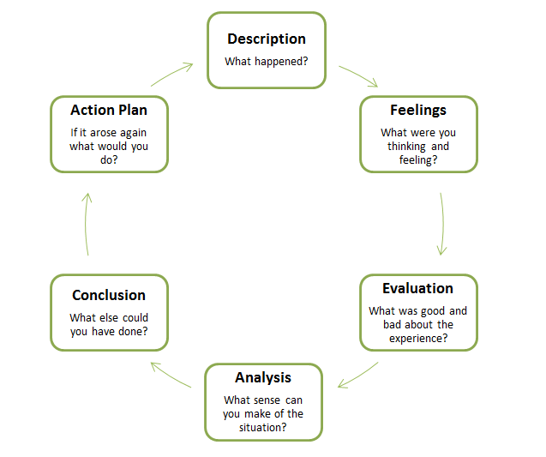
‘Reflective practice is an active, dynamic action-based and ethical set of skills, placed in real time and dealing with real, complex and difficult situations’ Moon, (1999).
Reflective thinking in practice is the process of looking back on an activity or session and critically evaluate it. This can be done using a range of reflective cycle model tools to assist the practitioner, such as Gibbs reflective cycle (1988) or Atkins and Murphy Model (1993). Reflection is seen as personal learning Dewey (1933). It is thinking about what happened, what worked and what didn’t and what can be learned from the experience and improved on for future activities.

Image: Google Image (2020).
John Dewey (1910) recognised that there are key component skills that practitioners need in order to be able to reflect. These are the ‘Look, listen, learn’ skills. Through observing what is is going on during activity practitioners can get an idea of what is happening and how the children are responding. This will help the practitioner to acknowledge the true success of the activity through the perspective of the children not only on how they themselves perceived the activity to have been. Donaldson (2015) said reflection is important for professional development. Practitioners need to be knowledgeable and be able to reflect in order to identify further development needs.

The Nutbrown report (2012) reports in depth the importance of the qualifications that practitioners should have, however does not dismiss the importance of knowledge and experience learned through years of working within the sector. This knowledge is built upon through reflecting on the way a practitioner has dealt with an activity or situation. Nutbrown says ‘staff need time to reflect on their practice, to link it to their understanding of theory, and the time to be able to discuss this with more experienced practitioners’. The benefit of collaborative reflection is being able to come together with peers to get support and ideas on what you as a practitioner has independently reflected upon. Glazer et al. (2004) noted multiple rewards through collaborative reflection including being able to express emotion as a positive outcome.

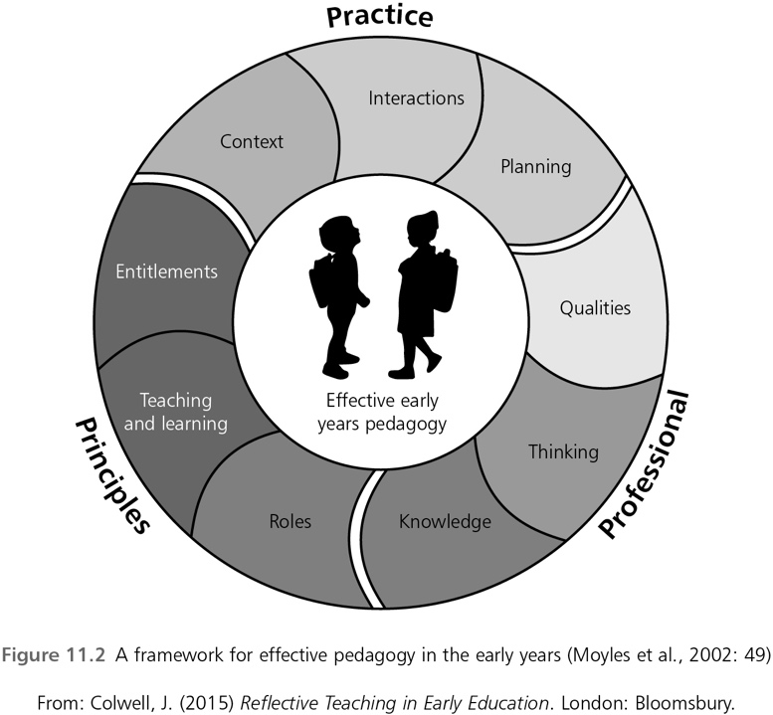
Observations during activities are not only important for documenting the individual progress of each child. Vygotsky (1962) believed observations were vital in providing the practitioner with information that would enable them to support the child with their learning and evidently the learning within the zone of proximal development. The ZPD is the learning that a child can do with and without help, also known as scaffolding.
Observation is crucial in reflection to get an understanding of what works and what does not and how we can improve.
Kolb’s Learning Cycle (1984) has the second stage as observation, this is because through observing the activity we have evidence of how we perceived the activity to be understood and how well it went in action (Schön, 1983) and not only how we think we remember it working out.
Paige-Smith and Croft (2011) tell us that how we reflect on a child’s experience can depend on our view of the child. It is important to not label a child in any way and to be able to see and recognise the child as an individual whilst ensuring inclusion to all children.
The Foundation Phase Framework (2015) states that the curriculum is flexible, enabling practitioners to plan appropriate curriculum for the children. It also suggests this is done with the use of continuous observations. This can also assist practitioners in their reflection.

Reflective practice goes hand in hand with the way in which we teach. Effective pedagogy is how we educate, ‘It refers to the interactive process between teacher and learner and to the learning environment” (Siraj-Blatchford et al. 2002). A pedagogy should be child centred (gov.uk, 2015) which coincides with the Foundation Phase Framework (2015) that practitioners work from. Being a reflective thinker will not only benefit the knowledge and understanding of the practitioner but also the development of the individual child and ensure that we adhere to regulations and frameworks. In setting deemed excellent in the ‘The Effective Provision of Pre-school Education’ project (2004) the staff would regularly have development sessions and these practitioners offered a more positive pedagogical approach. Practitioners reflecting on their own work and also reflecting collaboratively gives them the opportunity to develop further and to gain knowledge. Schon (1987) was keen to acknowledge the importance of the theory of what practitioners did and what practitioners actually did in practice, this is where he thought reflecting either in or on practice would close that gap.

“... learning is lifelong, and constructed not only within her [teaching] team, but along with the children she teaches” (Moran, 1998, p. 408)

Elfen 3 Log adfyfyriol – Element 3 Reflective log
Disgrifiad byr o’r gweithgaredd (dim mwy na 50 o eiriau
Brief description of the activity (no more than 50 words)
This activity has one adult (myself) with 6 children all of 3 years of age and it was a indoor activity. My activity is a language activity which involves welsh history, where I read the story of Gelert to the children.

Nod/Amcan y gweithgaredd Aim/Objective of the activity
The aim of this activity is to develop the children’s language, literacy and communication skills as is required through the Foundation Phase Framework Wales (2015). The areas of development are to ‘Access and share a variety of nonfiction texts, stories and traditional tales from Wales and around the world including those written by significant authors’ (Foundation Phase Wales, 2015).
I am aiming to develop listening skills with the children being able to ‘listen and respond with growing attention and concentration’ (Foundation Phase Wales, 2015).
And also, their welsh language development by being able to ‘follow stories read to them and respond as appropriate’ (Foundation Phase Wales, 2015).
My aim here is to create an activity for the children that is appealing whilst also being knowledgeable to the children. I wanted that they would be interested in the history behind the story and perhaps encourage them to listen to other welsh history stories and to make their own decision to choose welsh books from the reading area themselves. I wanted that they would see that the welsh books are as fun to read/ listen to as the other books we have available to them. The foundation phase (2015) and Curriculum Cymreig (2003) write about the importance of celebrating cultures and languages. My aim links with both of these.
Eich rôl chi Your role
I planned the activity and organised the activity. The group of children I worked with are my keyworker children, therefor they work mostly with me especially for tasks in development. I worked with the children alone as there weren’t any that had one to one or any additional learning needs.
Agweddau cadarnhaol – pam? Sut gellid datblygu’r rhain ymhellach?
Positive aspects – why? How could these be developed further?
The children seemed to enjoy it, from my perspective. They engaged well with the story and listened intently. They asked a number of questions during and after I had read the book and asked to hear it again. The book itself was a small child friendly version of the story with bright pictures. It’s a big book which mean I was able to hold the book up so they could see the pictures whilst also being able to read the writing which I believe was more appealing to the children than to just sit and listen whilst I read. I think the children enjoyed the story mostly because of the big wolf and they seemed especially interested in the outcome of the fight between the wolf and Gelert. There were many questions after the story such as “is Llewelyn sad”, “why was the wolf naughty?” I think I did achieve the aims I was following from the framework and I think I would recommend this activity to other practitioners in future to maintain good practice.

Agweddau heriol – pam? Cysylltwch a’ch arfer eich hunan. Challenging aspects – why? Link to your own practice.
The challenging factor was that I hadn’t thought about how excitable the story would make the children, at time one or two would get too close which was restricting the view of the children behind them. Also, on occasion there was questions being asked during the story which meant that it was being interrupted and frustrating the other children. Perhaps having a second member of staff to assist would be something I would change in the future.

Pa wybodaeth wnaethoch chi arddangos?
What knowledge did you demonstrate?
I used knowledge of the Foundation Phase Wales (2015) that as the deputy leader and head of planning I had to know and use on a daily basis. I used knowledge from play workshops through mudiad meithrin and also from workshops that visited the meithrin. I used knowledge gained in my qualifications on the development of children to understand the importance of the children being unique and understanding that they as individuals might have different views on what is fun and exciting and what is not. I used this knowledge to work out what I thought would be inclusive and enjoyable to all of the children.
Pa sgiliau wnaethoch chi arddangos?
What skills did you demonstrate?
I demonstrated fun communication skills in keeping the children engaged which I have learned through many mudiad workshops. The workshops demonstrate how to make activities exciting and fun for children through initially showing you how they do it and then getting people into groups to do the same and then give feedback on how we thought the children would react to the activity and what changes we would make in our own settings. I used organisation and planning skills that I have developed through regularly creating the planning sheets for the meithrin with the support of staff from Estyn that visit the meithrin to monitor the planning and the way in which we implement the planning. This helped me to understand the areas of learning that I wanted to develop with the children and how to best do that in a way in which they would enjoy.

Pa werthoedd wnaethoch chi arddangos?
Which values did you demonstrate?
I ensured that the activity was inclusive and had I had a child with additional learning needs they would have been included in the activity. I had a second copy of the book as on occasion some children in different groups respond better to a listening/reading activity if they have their own copy of the book to turn the pages themselves. The activity had room for any changes that needed to made last minute that might be needed by any of the children. As I had the book mabinogion available which would have given the children other choices of stories had they not wanted to listen to this one. There was no time frame set out for this activity, the children were able to ask questions during and also had plenty of time after the story to ask questions and talk about their favourite prts and the parts they did not like.

Beth allai cael ei wneud yn wahanol yn y dyfodol? Pam?
What could be done differently in future? Why?
I did this as an indoor activity, however I think that it could possibly have been done outside and maybe with costumes so that the children could dress up and act out the scenes, if they would want to. This would be fun and exciting especially for the children that were getting excited during certain parts of the story meaning instead of sitting down during they could be taking part in the story. I could also have found puppets to be used as the characters of the book and act the book out myself with the added props. This would be beneficial for children who perhaps have difficulty sitting to listen to a book and prefer to see things in action and is beneficial for most young children to see the book in action not just from my voice.

Element 4 Personal Development Plan

Area for further development (provide further details) | Why? | How? | Who/Where? | When?
Mental Health awareness. | In the 11 years I have worked in education I have noticed a rise in the struggles of children and young people with mental health and I would like to be able to understand the ways in which I can support them. | I will need to do a course at a minimum. There are different levels of courses. | St Johns training Wales have a mental health awareness course which is valid for 3 years and gives an overview of mental health and signs to look for and ways to support. It is as free course and is for half a day. They have courses around wales. | June 2020
Paediatrics first aid training. | I had this training some years ago and would like to maintain it. I feel its my responsibility to be able to care for children in my care in every way. It will benefit the children in my care by providing me with the tools needed to remain calm in a situation whilst also having the knowledge of what to do and how in a situation that requires first aid. It is also a qualification that employers look favourably on. | I will need to complete a two day training course to qualify as paediatrics first aider. | Pacey offer this course over two days. The course costs £90 per person. To find out locations I need to contact them through phone or email and they will tell me where they are holding workshops | I would like to be able to do this training before summer of 2021.
PGCE | I would like to look into the PGCE as it would be the next step I would take in qualification to become a primary school teacher. It would give me better knowledge and understanding of classrooms and children and how to teach effectively. | The PGCE is a 1 year intensive university course. I would need to be able to have financial funding as it is a completely full time course with no room for additional employment. | UWTSD offers the course and I would need to apply in the October after I have completed my degree. I will need to check if I need to complete the equivalency test before this as I might need to do this before or along side the PGCE. I would also need to decide on a chosen subject before being able to do this course | October 2021
Safeguarding/ child protection. | I have had this training previously, however it was a number of years ago. Things change regularly and policies and procedures on how to deal with safeguarding measures are an important skill to maintain. Not only do it provide me with the knowledge to understand what to look for and the steps to take it means any children in my care that might be in any form of harm would have a qualified practitioner to support them to the correct procedures. | There is a “keeping our children safe’ 2 day programme that I could complete. | The course is provided by Children in Wales and is a two day programme in Cardiff that costs between £170 and £245 per person. This can be booked on the website through the book now button. | September 2020.
Psychological wellbeing practitioner apprenticeship. | I have always had an interest in wellbeing and mental health and would be interested to see if it is something I could do. Wellbeing is widely acknowledged now and I would like to know more about it and how I can help support people and children who are struggling. | To become a PWP I have to find a placement to do an apprenteship either through the nhs, through a Improving Access to Psychological Therapies setting or through an organisation such as mind. | Through one of these organisations I would work through an apprenteship and do 45 days of academic work, which would be one day a week along side supervised work. I would have to apply for the post and if successful a job and training would be provided. A degree is desirable entry requirement, however they do take into account life experience. | September 2021
Computing and IT. | The world of technology is always expanding, and my knowledge is limited. Children are generally computer, iPad fluent at a young age. I think it is beneficial to be computer literate and be able to support students with IT. | Coleg sir gar have 3 computing and IT level qualification courses I could apply for. They are one year courses and can be done part time or full time. | I can do this in the Llanelli Graig campus through coleg sir gar at a cost of £45. Entry requirements are 5 GCSE’s at A-C level including English and maths. | September 2021.

Reference

Children in Wales. (no date) “Keeping Our Children Safe” Training for the Designated Child Protection Lead. Available at: https://www.childreninwales.org.uk/item/keeping-children-safe-training-designated-child-protection-lead-5/ (Accessed: 6th June 2020).

Colegsirgar. (no date) Computing and IT level 3. Available at:
https://www.colegsirgar.ac.uk/index.php/en/computing?view=course&layout=course&id=162 (Accessed: 6th June 2020).

Colewell, J. (2015) Reflective Teaching in Early Education. London: Bloomsbury.

Dawson, P. (2012) Reflective Practice. [YouTube] Available at:
https://www.youtube.com/watch?v=r1aYWbLj0U8 (Accessed: 29th May 2020).

Department for Education. (2015) Pedagogy in early childhood education and care (ECEC): an international comparative study of approaches and policies. Available at: https://assets.publishing.service.gov.uk/government/uploads/system/uploads/attachment_data/file/445817/RB400_-_Early_years_pedagogy_and_policy_an_international_study.pdf (Accessed: 9th June 2020).

Donaldson, G. (2015) Successful Futures. Available at: https://www.ewc.wales (Accessed: 8th June 2020).

Estyn. (2015) Supplementary guidance. Available at:
https://www.estyn.gov.wales/sites/www.estyn.gov.wales/files/documents/Supplementary%20guidance%20-%20inspecting%20care,%20support%20and%20guidance%20in%20FE.pdf (Accessed: 9th June 2020).

Finlay, L. (2008) Reflecting on ‘Reflective practice’. Practice-based Professional Learning Paper 52, The Open University.

Forrest, M. (2008) On becoming a critically reflective practitioner. Available at: https://doi.org/10.1111/j.1471-1842.2008.00787.x (Accessed: 28th May 2020).

Ghaye, T. and Lillyman, S. (1997) Learning Journals and Critical Incidents: Reflective Practice for Health Care Professionals. Dinton: Quay

Griggs, V. et all. (2015) From reflective learning to reflective practice; assessing transfer. Studies in Higher Education, Vol.43(7), p.1172
Available at: http://eprints.whiterose.ac.uk/104326/3/GriggsFrom%20reflective%20learning%20to%20reflective%20practice%3B%20assessing%20.pdf (Accessed: 28th May 2020).

Hallett, E. (20130 The reflective early years practitioner. London: Sage.

Lindon, J. (2012) Reflective practice and early years professionalism. (2nd ed) Hodder Education: Great Britain.

Marshik, T. (2015) Learning styles and the importance of critical self-reflection. Available at: https://www.youtube.com/watch?v=855Now8h5Rs (Accessed: 25th May 2020).

Miller-Young, J. (2016) ‘How did I get here? Reflections on learning from multidisciplinary communities of practice’. Transformative Dialogues: Teaching and Learning Journal, 9, 1, pp1-5.

Mitchell, H. and Lloyd, I. (2013) Professionalism- raising the stakes in the early years: “She’s only going to work with little children”, In M. Wild and A. Street (2013) ‘Themes and debates in early childhood’. Sage: London. Pp126-140.

Nhs. (no date) Entry requirements and training. Available at:
https://www.healthcareers.nhs.uk/explore-roles/psychological-therapies/roles/high-intensity-therapist/entry-requirements-and-training-high-intensity-therapist (Accessed 7th June 2020).

Nutbrown, C. (2012) Foundations of quality review of early education and childcare qualifications: final report. Available at:
https://assets.publishing.service.gov.uk/government/uploads/system/uploads/attachment_data/file/175463/Nutbrown-Review.pdf ( Accessed: 2nd June 2020).

Pacey. (2020) First aid training in Wales. Available at: https://www.pacey.org.uk/training-and-qualifications/training-from-pacey/paediatric-first-aid-training/first-aid-training-in-wales/ (Accessed: 7th June 2020).

Paige-Smith, A. and Croft, A. (2011) Developing Reflective Practice in Early Years. (2nd ed) Maidenhead: Open University Press.

Schleicher, A. (2015) Engaging Young Children: Lessons from research and quality in early childhood education and care. Available at: https://www.youtube.com/watch?v-rbbznrqOc (Accessed: 27th May 2020).

Siraj-Blatchford et al. (2002) ‘Researching Effective Pedagogy in the Early Years’. Moodle (Accessed: 1st June 2020).

Smith, M. (2013) Reflection, Learning and Education. Available at: https://www.infed.org/mobi/reflection-learning-and-education/ (Accessed: 26th May 2020).

Sylvia, K. et al. (2004) The Effective Provision of Pre-School Education [EPPE] Project. Available at: https://discovery.ucl.ac.uk/id/eprint/10005309/1/sylva2004EPPEfinal.pdf (Accessed: 6th June 2020).

Sylva, K. et al. (2020) Developing 21st Century Skills in Early Childhood: the contribution of process quality to self-regulation and pro-social behaviour. Available at: https://doi.org/10.1007/5611618-020-00945-x (Accessed: 25th May 2020).

Uni Compare. (2019) PWP.
Available at: https://universitycompare.com/advice/postgraduate/pwp-train (Accessed: 6th June 2020).

Venninene et al. (2012) ‘Creating conditions for reflective practice in early childhood education’. International Journal of Child Care and Education Policy, 6:1, pp.1-15.

Verenikina, I. (2008) Scaffolding and learning: its role in nurturing new learners . Available at: https://ro.uow.edu.au/cgi/viewcontent.cgi?article=1043&context=edupapers (Accessed: 6th June 2020).

Welsh Assembly Government. (2003) Developing the Curriculum Cymreig. Available at: http://www.wasacre.org.uk/publications/wag/E-developingthecurriculumcymreig.pdf (Accessed: 8th June 2020).

Welsh Government. (2015) Foundation Phase Framework. Available at: https://gov.wales/sites/default/files/publications/2018-02/foundation-phase-framework-revised-2015.pdf (Accessed: 3rd June 2020).

Welsh Government. (2016) National Minimum Standards for Regulated Childcare for children up to the age of 12 years. Available at: https://careinspectorate.wales/sites/default/files/2018-01/160411regchildcareen.pdf (Accessed: 9th June 2020).

Welsh Government. (2017) Play and Early Years in Wales Workforce Plan. Available at: https://gov.wales/sites/default/files/publications/2019-07/early-years-workforce-plan.pdf (Accessed: 8th June 2020).

