‘Describe a learning event which has happened during your recent school
experience. Reflect upon what took place, connecting events to theories of learning and teaching. Make recommendations about how you could improve your own practice in the light of this. Produce a poster to illustrate how you would develop the elements of an effective learning environment.’

Word Count: 4967

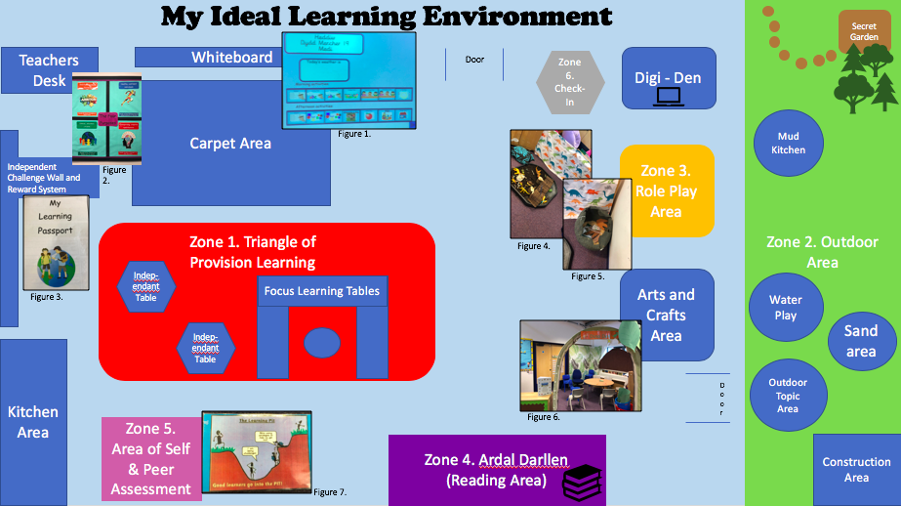

There are many different types of “learning” and it is for this reason that it is difficult to describe it in simple terms. Notwithstanding this, however, the Oxford English Dictionary (online) defines “learning” as ‘the acquisition of knowledge or skills through study, experience, or being taught.’ The concept of learning has been studied by numerous academics over hundreds of years but this essay will focus in particular on how behaviour management, using the underpinnings of behaviourism, influences our learning, using observations taken from an event witnessed during a recent school experience.

The Curriculum in Wales is changing. By 2022, all schools throughout Wales will be using the New Curriculum. Some chosen schools in Wales have been given the task of undertaking testing and helping to develop this New Curriculum and provide feedback. These schools are known as Pioneer Schools. There are six new Areas of Learning and Experience (AoLE) and four new purposes of this New Curriculum (Figure 1), all suggested by Professor Donaldson in ‘Successful Futures’ (2015). The six new Areas of Learning and Experience are:-

- Expressive arts
- Health and Wellbeing
- Humanities
- Maths and Numeracy
- Science and Technology
- Languages, Literacy and Communication.

It should be stated however that Successful Futures is more of a blue-print of how to transition from the current Curriculum to the New Curriculum rather than being the New Curriculum.

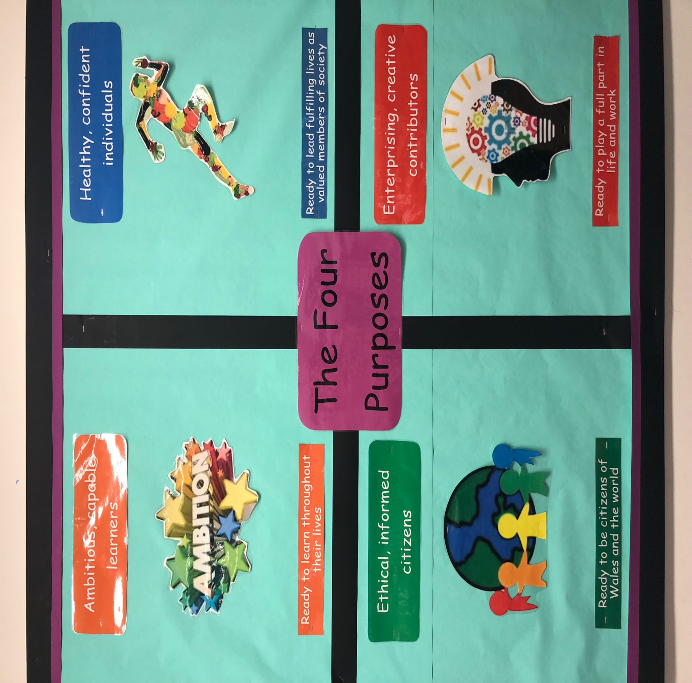
Figure 1. The Four Purposes of the New Curriculum taken at the school where the learning event was witnessed. Photographer: Myself

The learning event referred to in this essay took place in a large Primary School in West Wales. Currently, there are 626 pupils on the roll and 60 pupils enrolled with Flying Start. The Primary school visited currently falls into the Green Support Category and in 2017, 30.5% of the school received free school meals (My Local School, 2018). The learning event that was witnessed took place in a Year 2 class with 28 pupils. The area in which the school is situated and where the observations took place has been recently ranked in the top 70 most deprived areas of Wales out of a possible 1,909. Due to ethical considerations, I obtained written consent from the Deputy Head Teacher to ensure that I was allowed to use photographs taken of classrooms and displays exhibited around the school (Appendix 1). In addition, the name of the class teacher and the name of the pupil involved in the learning event I witnessed will be kept anonymous for reasons of respect and safeguarding.

Observation

Hughes (2000:7) defines learning as an action which occurs in a human. In turn, teaching then becomes a process attempting to change this. It is for this reason that both learning and teaching are “interrelated”. She also stated that learning can occur on four sperate occasions:
- Learning occurs without direct teaching meaning that children can try and attempt to understand things without the help of a teacher
- Learning occurs with direct teaching – that which often occurs in school.
- Learning arises despite teaching. This can happen in both a positive and negative way.
- Learning is different from that which the teacher predetermined. This can occur through misconceptions or the child failing to understand what was meant.

The learning event I witnessed took place after a pupil had been misusing some of the equipment in the technology area of the classroom. I used non-participant observation to gain my data. I did this in an unstructured manner as I felt that this would give me more data due to the flow of conversation. I also considered this to be less formal with the hope of putting all those involved at ease. Furthermore, it gave me a greater opportunity to observe events such as the behaviour event witnessed. However I am very aware of the disadvantages of using this method. For example, the pupils behaviour may have been altered as they were aware of an outside researcher being present. Figure 2 is the transcript observed between the pupil and the class teacher.

19/09/18

Teacher [_pupil name_] please remove a pom-pom from the bucket.

Pupil But…[pause]…why?

Teacher You have been misusing the equipment in the Tech area and you are well aware of the rules on the Behaviour Charter on the wall.

Pupil Ok fine

(Noted that the pupil removed the pom-pom from the individual pom-pom bucket without any further questions or trouble. Proving that they too are also aware of the rules of the learning environment)

Figure 2. A typed transcript taken of the learning event witnessed.

I selected this significant event as I had not seen this method used in any other classroom learning environment in which I had been present. This is notwithstanding the fact that I have gained classroom experience in four other Primary Schools in West Wales. Additionally, although being aware that this is not a learning event including specific subjects or exercises, it was still a learning event as the child learnt from their behaviour. Furthermore, I knew that I would be able to link this event to the behaviourist school, behaviourism and operant conditioning, all three being key concepts that we had studied during this current module.

The teacher informed me that they used a ‘pom-pom system’ in class. If a pupil did something regarded by the class teacher or teaching assistant as “good”, the pupil could pick a pom-pom out of a jar and put it in their own individual pom-pom bucket hanging on the classroom display (Figure 3). However, if the pupil did something considered to be a breach of the classroom rules, pom-poms would then be removed from the pupils individual pom-pom bucket. At the end of the week, all pom-poms in the individual buckets were counted and the child or children with the most pom-poms in their individual bucket would receive a prize and a certificate. Consequently, those pupils that had had been asked to remove a pom-pom from their individual buckets on several occasions during the week would not be in with the chance of receiving a certificate or prize on the Friday of that week. The teacher informed me that they used this system in class as they found it worked best when trying to control classroom behaviour and also for attempting to get the children to use their voice in the classroom with regards to answering questions posed. Furthermore, the teacher stated that this may be the only time that some children in a learning environment would have the opportunity of receiving a certificate as many did not participate in any other extra-curricular activities such as swimming or playing sports

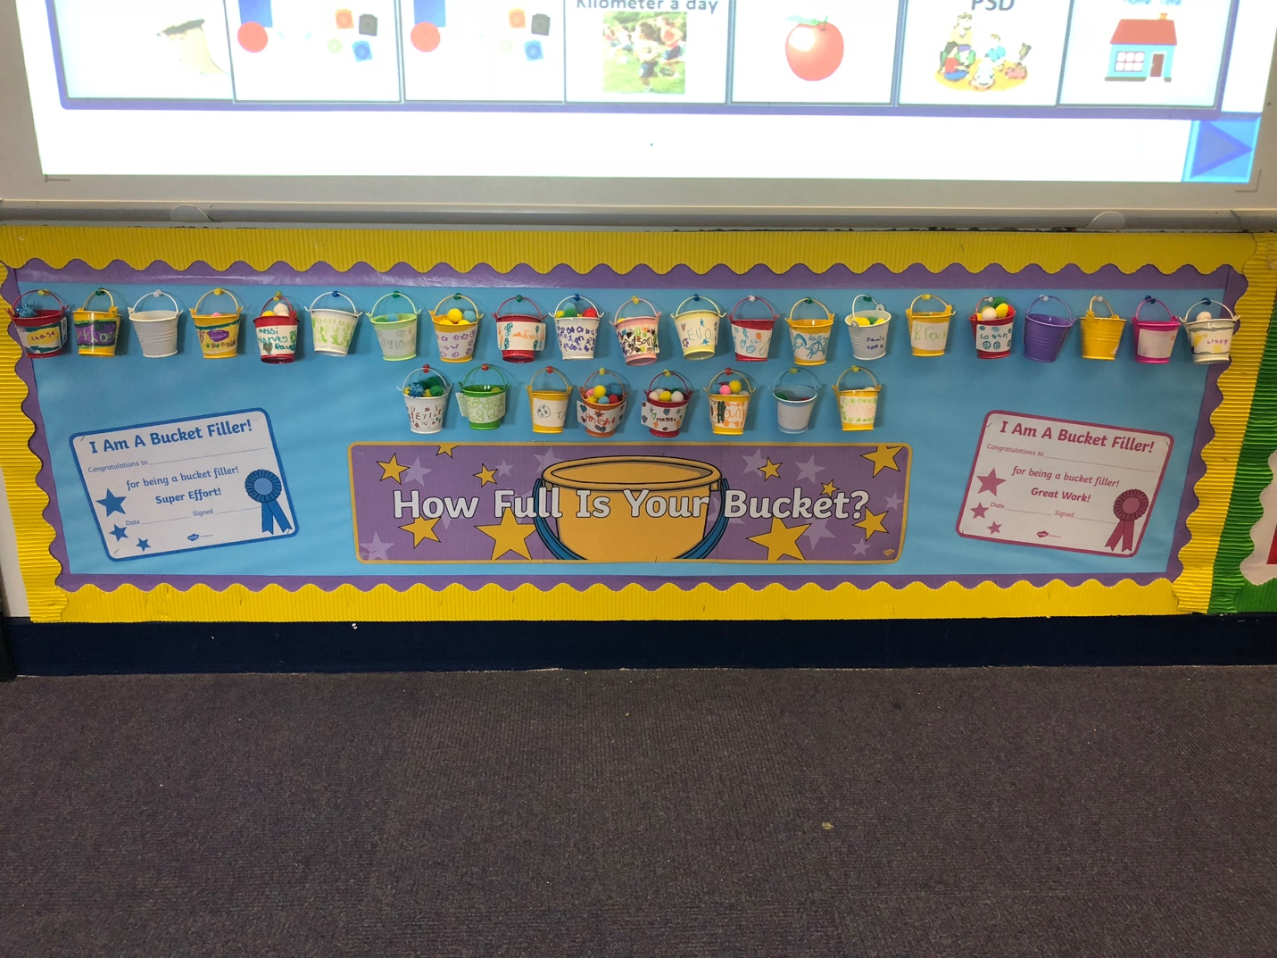
Figure 3. The ‘Pom-Pom System’ display in the learning environment in which the event was witnessed. Photographer: Myself

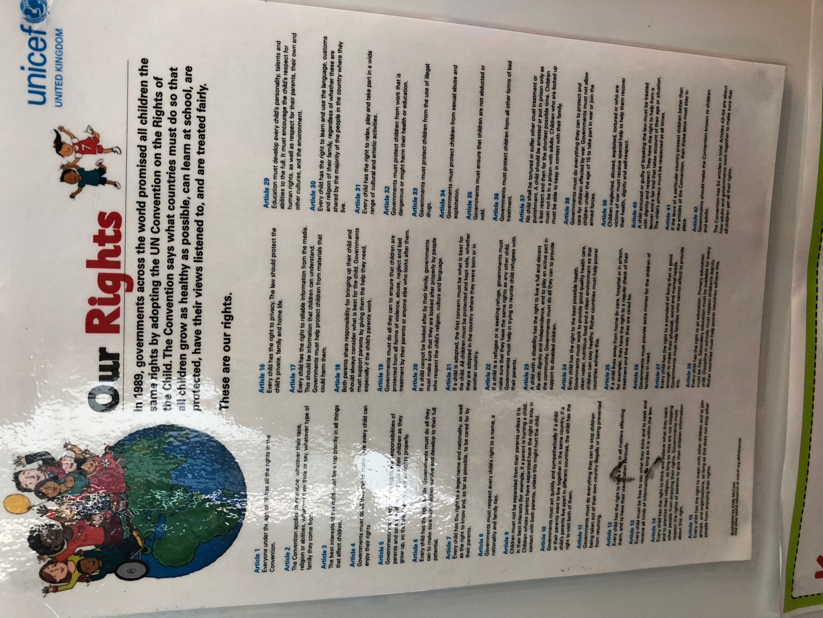
Figure 4. The United Nations Convention on the Rights of the Child 54 Articles taken in the learning environment classroom. Photographer: Myself

During the event it was evident that the pupils respected the teacher and the rules of the classroom and did as the teacher asked without any qualms. The classroom rules are based around the Articles set out by United Nations Convention on the Rights of the Child (UNCRC), 1989 (Figure 4). These rights were enforced in the United Kingdom in 1992 and teachers follow 42 of the 54 Articles which make up the UNCRC. It should always be remembered that Article 28 of the UNCRC states “discipline in schools should respect children’s human dignity”. Also, the Year 1 and 2 Behaviour Charter (Figure 5) is also based around the 42 Articles. In addition, the Department for Education (2016:7) stated that by law “Teachers can discipline pupils whose conduct falls below the standard which could reasonably be expected of them. This means that if a pupil misbehaves, breaks a school rule or fails to follow a reasonable instruction the teacher can impose a punishment on that pupil”.

During this event, learning took place under what Hughes (2000) considered to be point number 3. Pupils learn positive behaviour through gaining a pom-pom in their individual bucket on the classroom display and negative behaviour when they are asked to remove a pom-pom from their individual bucket.

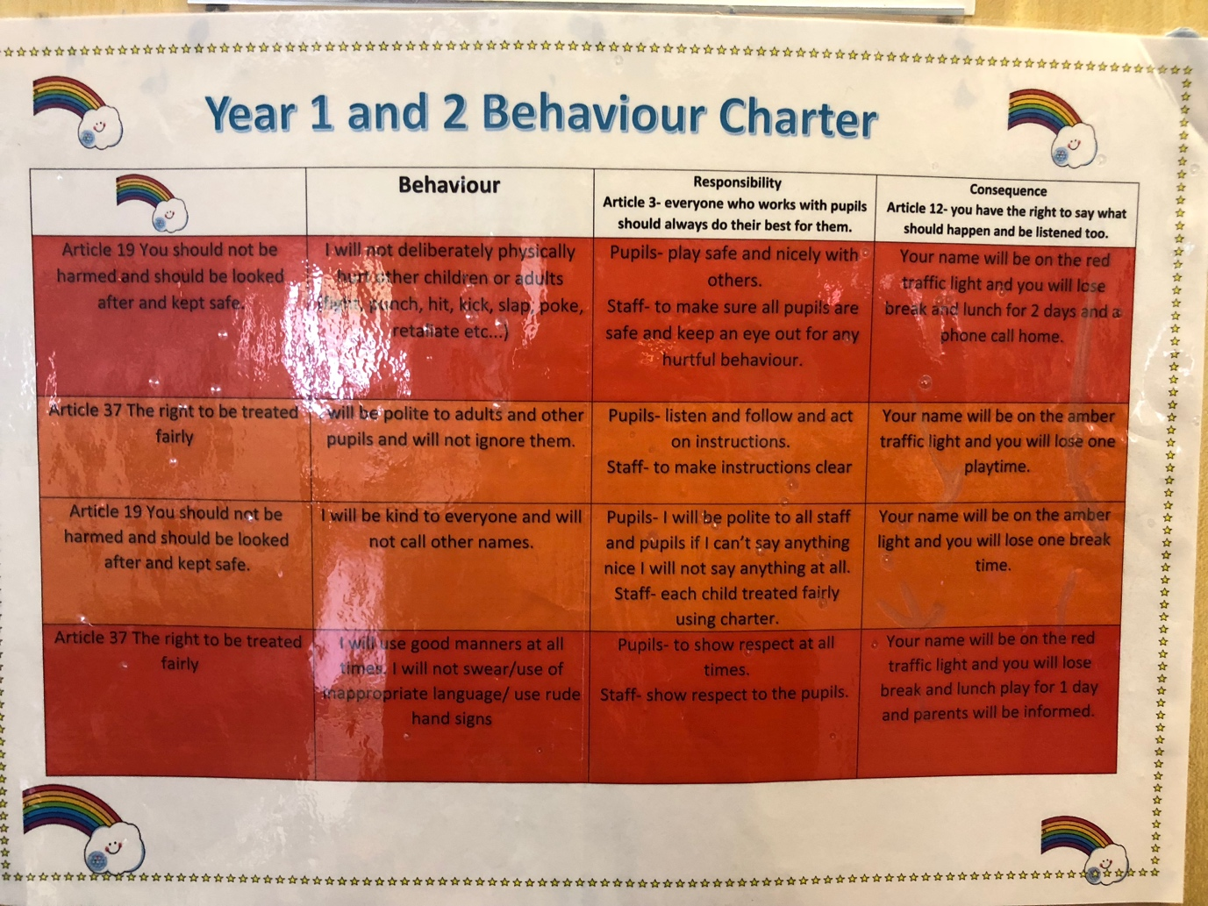
Figure 5. The Year 1 and 2 behaviour charter on display in the learning environment. Photographer: Myself.
Connection

Behaviourists focus on events considered to be observable, much like the learning event I witnessed, along with events that can be measured. During the late 19th and early 20th Century, Freud and Jung, both psychologists, stated the importance of understanding the mind. However, Burnett and Cremin (2018) are of the opinion that behaviourists argue that it is not possible to observe what happens in the mind and it is for this reason that we have to observe behaviour in particular as this will give us an insight into the mind. In 1976, Skinner stated that we do not use knowledge to guide our actions but that we use knowledge as our rules for action. The Behaviourist approach has been criticised as it is often stated that the use of animal-based research has resulted in a simplistic and often misunderstood representation of learning (Graham-Matheson, 2014). Furthermore, some believe that the behaviourist approach does not take the children’s individual learning needs into consideration.

The most famous experiment explaining behaviourism was Pavlov’s in 1927. Ivan Petrovich Pavlov was a Russian physiologist best known for his discovery and explanation of classical conditioning. Pavlov examined the rates of salivations amongst dogs. Pavlov learned that when a noise was made at the same time that food was given to a dog, the dog would salivate when the food was presented. The dog would come to associate the noise with the food and so would later salivate merely by hearing the noise without being presented with the food. Pavlov therefore demonstrated the link between learning to respond to an unconditioned stimulus that brings about an automated response (i.e. a reflex) with a new (conditioned) stimulus. The new stimulus brought about the same result, that is salivation, as there had been to the unconditioned stimulus.

Canter (2010) determined that, much like can be seen with the use of the ‘pom-pom system’ I witnessed during the learning event at the Primary School I attended, the learning theory of behaviourism is behind the majority of classroom management practices. They use the term ‘Assertive Discipline’. ‘Assertive Discipline’ is considered to be the ‘take-control’ approach to teaching. It is when a teacher controls their classroom in a firm but positive manner. It is, to some degree, what is happening in the classroom where the learning event was observed, as by using the ‘pom-pom system’, the teacher had complete control over her class by simply asking them to ‘put a pom-pom in the bucket’ or ‘remove a pom-pom from the bucket’. The teacher was able to do this without shouting and without the children having to ask any questions or retaliating in some such way.

When considering disciplining the children, much like when a pom-pom is removed from the individual bucket of the child, Wagenhals (2006) believes that healthy and effective discipline emerges from the use of establishing and maintaining reasonable rules, boundaries and expectations. As previously mentioned, in the event witnessed, the rules of the classroom were based on the Year 1 and 2 Behaviour Charter. This then links to Skinner’s theory of operant conditioning. Additionally, healthy and effective discipline may prove to some children in the learning environment that they are in a safe and secure place and this may be the only environment to do so. Furthermore this may also prove to children that structure will develop their skills and teach them to be respectable as well as responsible. The way that the child was disciplined during the learning event witnessed was certainly in a respectable and reasonable manner. By using the pom-pom system in the classroom, the child’s dignity is also maintained as there is a limit on the embarrassment that may be experienced.

In 1913, psychologist, Watson began the classical conditioning behaviourist movement after producing an article entitled “Psychology as the Behaviourist Views It”. In this article he stated that there was a connection between a stimulus and a response. Classical conditioning focuses on a behaviour following a particular event.

In 1966, Skinner termed the thesis of ‘operant conditioning’. He believed, along with Thorndike that the learning of the behaviour operated on the environment. Both stated that often people would behave in a particular way to gain something that they considered to be desired. He determined that classical conditioning was too simplistic when attempting to understand human behaviour. He studied this by conducting experiments on animals which he placed in a ‘Skinner box’. He discovered 3 different types of responses, or operant, that can follow behaviour:

- Neutral operants – responses gained from the environment that do not increase or decrease the probability of behaviour occurring again.
- Reinforcers – responses from the environment that increase the probability that behaviour will occur again.
- Punishers – responses from the environment that decrease the likelihood that certain behaviour will occur again.

The concept of operant conditioning would explain why the teacher used the ‘pom-pom system’. The pom-poms were being used as an object in order to reinforce the probability of the children in the class behaving in accordance with the Year 1 and 2 Behaviour Charter. In addition, the pom-poms were also being used as a way to prompt the pupils to answer questions from both their teacher and their peers. The ‘pom-pom system’ was also being used to punish those pupils considered to be breaking classroom rules. However, behaviour considered by the teacher to be punishable is not forgotten but only supressed when a pom-pom is removed from the individual bucket. Undesireable behaviour can always return if punishment, that being the removal of the ‘pom-pom system’ entirely, is no longer present.

Burnett and Cremin (2018) stated that positive reinforcements are a key factor of behaviourism. These positive reinforcements can come in many forms including praise and good marks, or, in the event I witnessed, pom-poms. In the learning event witnessed, positive behaviour was rewarded with pom-poms but in contrast to some behaviourist views, negative behaviour was given a consequence (the removal of a pom-pom from the individual bucket) and was not ignored. This was done in order for pupils to repeat acceptable behaviour and to discourage pupils from continuing unacceptable behaviour. Slavin (2003) supports this view stating that it is possible to condition behaviour by offering punishment as well as reward. This is an extended view of Thorndike’s Law of Effect (1898).

The Law of Effect declares that behaviour followed by something pleasant or a reward (pom-pom added to individual bucket) is more than likely to be repeated . Behaviour followed by an unpleasant consequence is less likely to be repeated (pom-pom removed from individual bucket).

However, Burnett and Cremin (2018) believe that unacceptable behaviour which is likely to receive a negative response, much like the pupil being asked by the teacher to remove a pom-pom out of their individual pom-pom bucket, may be perceived by the pupil as being rewarded as the pupil gains the attention of the teacher and sometimes that of the class. We must be sure to remember that for some pupils, any form of attention can be considered to be better than no attention at all. Therefore, this behaviour will then be unlikely to diminish and will continue. It should be stated however that this was not the case during with the learning event I witnessed. Additionally, behaviour considered to be unacceptable could have the effect of reaping reward from other pupils in the class. Again this did not happen during the learning event I observed but the potential for this to happen should be taken into consideration.

It is important for the critics of behaviourism to be considered. Furnham (2008) concluded that behaviourism does not take into consideration both the creativity and diversity of human behaviour. Additionally, there are those that state that behaviourism ignores the free will of human life and does not take into account the thought processes and feelings of people. This then links to the Humanist learning theory which opposes the Behaviourist learning theory of operant conditioning.

We should also take into account variable ratio reinforcement. This can often be considered superior as behaviour or reward is reinforced after an unpredictable number of times. When using variable ratio reinforcement, response rate is fast as, in the case of the learning event I observed, pupils would not know how many times they had correctly followed the Year 1 and 2 Behaviour Charter or used their voice in a positive way in class, they would be rewarded with a pom-pom. Additionally, when using this method, extinction rates are low compared to other methods. However, when using the ‘pom-pom system’ as a method of punishment, for obvious reasons, variable ration reinforcement could not be used. For this, we would have to refer back to Skinner’s operant conditioning.

The Welsh Government (2010) stated that when using a reward system for positive behaviour, classroom involvement or practice, it should be used correctly. However, it could be argued that if rewards, much like the teacher asking the child to put the pom-pom in an individual bucket, could lead to students believing that they can gain a pom-pom by completing a particular activity or task instead of gaining a sense of achievement for doing so. Payne (2015) agrees with this as she declares that when used inconsistently, rewards and sanctions in the learning environment can cause some children to not be able to differentiate between incentives and discipline methods, their task based work and social behaviour.

Evaluating and controlling behaviour is important in the learning environment. Again, however, there are always competing views, theories and philosophies. For example, Payne (2015) declares that despite the use of rewards and sanctions in a learning environment having advantages, the use of this system could “represent competing theoretical ideas when considered alongside current approaches to teaching and learning”.

To conclude, the event described relating to my recent school experience illustrates the fact that there are both advantages and disadvantages of using the ‘pom-pom system’ in the learning environment. This is notwithstanding the fact that the ‘pom-pom system’ is derived from the theory of Behaviourism,. I have highlighted these throughout the section of this essay entitled ‘Connection’. As previously stated, other types of schooling such as Humanism and Constructivism, should perhaps be considered when discussing Behaviourist approaches in the learning environment. When taking all schooling approaches into consideration, the learning environment produced would be safe, secure, encouraging and beneficial to learning. By doing so, this will have a positive influence on my future as a teacher as it takes into account all theories related to schooling which will therefore benefit all pupils in the learning environment despite the way in which they learn and their ability.

My Ideal Learning Environment

Barrett et al. in The Holistic Evidence and Design Project (2015) discovered that classrooms considered to be effectively designed are able to boost learning in the Primary School environment by 16%. This figure is during a single year. All elements of my ideal learning environment are important but I have decided to identify 6 zones to talk about in this section. The 6 zones all work with each other to produce a productive, fun and safe learning environment. Before I explain my ideal learning environment it should also be emphasised that Teaching Assistants would also be utilised in my ideal learning environment. My ideal learning environment has been designed for a Foundation Phase Year 1 or Year 2 Classroom. Kids Matter stated in Managing Behaviour (2018) that when considering behaviour in the learning environment, children benefit from being aware that their environment is stable and that they are in the care of a responsible adult.

Zone 1. Triangle of Provision

Figure 6. The Triangle of Provision. Figure created by myself.

It is important that children have the opportunity to complete both teacher lead and independent activities while in the learning environment. The ‘continuous provision’ element of the triangle is child led and aims to continue the provision for learning in the absence of an adult. In my ideal learning environment, I have included an independent learning challenge wall and learning passports. This is to encourage children to be independent and choose a challenge from the wall relating to their topic. Once they have completed this challenge, the teacher can then sign off that particular challenge in their learning passport.

The ‘enhanced provision’ element is when you add themed resources to continuous provision, meaning that it is still child led. For example, if the topic is dinosaurs, adding laminated pictures of dinosaurs or fossils around the arts and crafts or construction areas help to provide inspiration. However, there are many possible ways children may interact with enhanced provision areas.

The ‘focused tasks’ element of the Triangle of Provision is teacher led. The teachers lead activities possibly relating to the topic in a small group while the rest of the groups take part in other activities, both independent and with a teaching assistant.
Zone 2. Outdoor Learning

Heick (2018) stated that “learning has to leave the classroom because the children do”. It has also been stated that “outdoor environments that are fun, stimulating and safe promote children’s development and natural curiosity to explore and learn through first-hand experience”. (Welsh Assembly Government, 2010:0.2) There are many benefits of outdoor learning including inclusivity, the diminishment of classroom boundaries, the relaxation of nature, the opportunity of gaining new experiences and the exploration of emotions and feelings.

There are several elements of outdoor learning that I have included in my ideal learning environment and some relate to play. When discussing outdoor learning we must consider the ‘Theory of Flow’. This theory was advanced by Csikszentmihalyi in 1975 and he stated that flow was one of the eight mental states which are possible to happen when attempting to learn something new. Flow is more likely to occur when the learner has both high skill and high challenge and should be considered when in the learning environment whether that is inside or outside. The diagram below represents the ‘Theory of Flow’.

Figure 7. A representation of the Theory of Flow. Exciting Curiosity [Online]

Zone 3. Role Play Area

The role play area in my ideal learning environment highlights the importance of play in any learning environment. Montessori (1949), Piaget (1976), Vygotsky (1978), Bruner (1986), Gardner (1999) and Laevers (2000) in Grigg (2015), all educational theorists, wrote about and provided strategies that promote play as they all believe that it is of key importance in a child’s learning. Additionally, Grigg (2015) explained that play gives children the opportunity to understand their world. Furthermore, it gives children the chance to develop their confidence and learn new social skills. Using their imagination, children are able to create new ideas that perhaps they would not be able to if they did not have the opportunity to play, both inside and outside of the classroom environment. As Wood and Attfield (2005) declared, in my ideal learning environment I want play to be considered by both staff and pupils as a positive learning experience and this will be done in many ways. For example as Huizinga (1995) stated, play is often the “blurring of boundaries”, meaning that work and play become the same activity. To some extent, this is true, however, children need the opportunity to play without the pressures of work. I must recognise that for some children, play in the learning environment may be the only time they are able to play. For example, if a child in the class is also a young carer. This may be the only time that the pressures of their outside world disappear. I believe that every child should always have the right to be a child no matter what their home or other outside circumstances.

Zone 4. Ardal Darllen (Reading Area)

Reading is essential for personal development. Grigg (2015) declared that “illiteracy is a worldwide crisis”. Reading can help develop and links to all 4 purposes that Donaldson (2015) set out in order to achieve the transition from the Current to New Curriculum. It is important that children have stories that are easily accessible to them as they are key in a child’s learning environment. Stories have the ability to link to whatever the teacher is talking about or whatever topic is being covered. Good stories also help to engage and motivate pupils, help pupils to develop their vocabulary and give them a window on the world which they might not have had the opportunity to experience.

In my Ardal Darllen I would include both English and Welsh reading books as Donaldson (2015) stated that we must “communicate effectively in different forms and settings, using both English and Welsh”. Furthermore in 2016, the Welsh Government declared that their aim is to have 1 million Welsh speakers in Wales by 2050.

Notwithstanding that however, in my ideal learning environment I must also take into consideration the prospect of having pupils in the class that are learning English as an additional language (EAL). If this were to happen, I would also need to include books in the Ardal Darllen in the native language of those pupils. Reading should be inclusive and not exclusive.

Zone 5. Area of Self and Peer Assessment

Children need to self-assess in order for them to develop their self-awareness skills. Self-assessment also develops the pupils listening, questioning and their ability to manage their feelings. Children also need to learn how to peer assess in order to understand their own learning objectives set by the teacher. By undertaking both self and peer assessments, children are then able to achieve all of Donaldson ‘s (2015) 4 purposes which can be seen in Figure 1.

In my ideal learning environment, I have used James Nottingham’s model of the ‘Learning Pit’. This model promotes and enhances both challenge and enquiry. It is of utmost importance that my ideal learning environment promotes a ‘growth mindset.’ Dweck (2007) stated that there are two types of mindset; a fixed mindset and a growth mindset. When pupils believe they can gain intelligence, they understand that effort is needed and makes them stronger. They then learn that by using their time wisely and putting in more effort, they can achieve higher levels. This ‘growth mindset’ then links to Article 29 of the UNCRC. This can be seen in Figure 4.

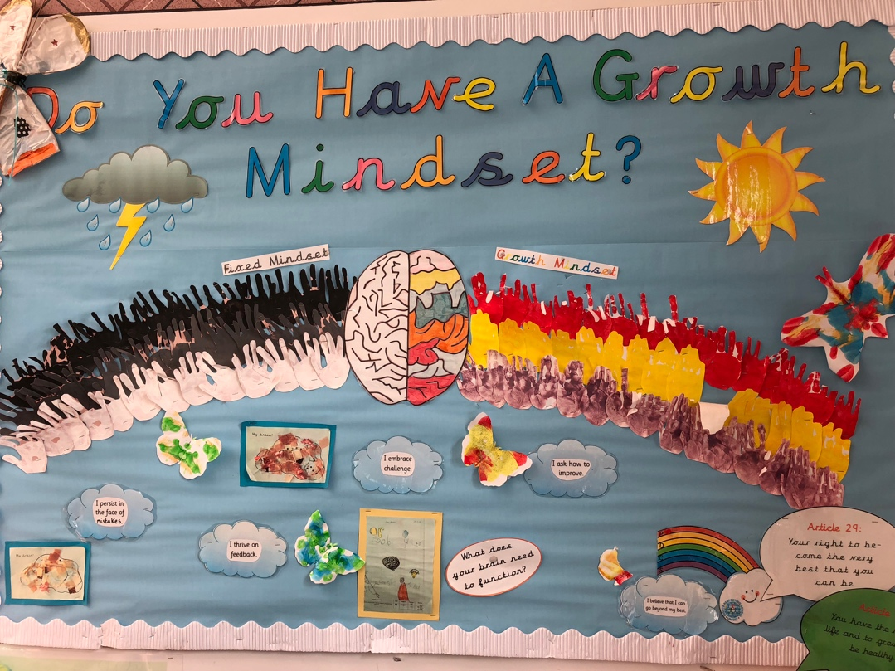
Figure 8. The ‘Growth Mindset’ display at the learning environment school. Photographer: Myself.

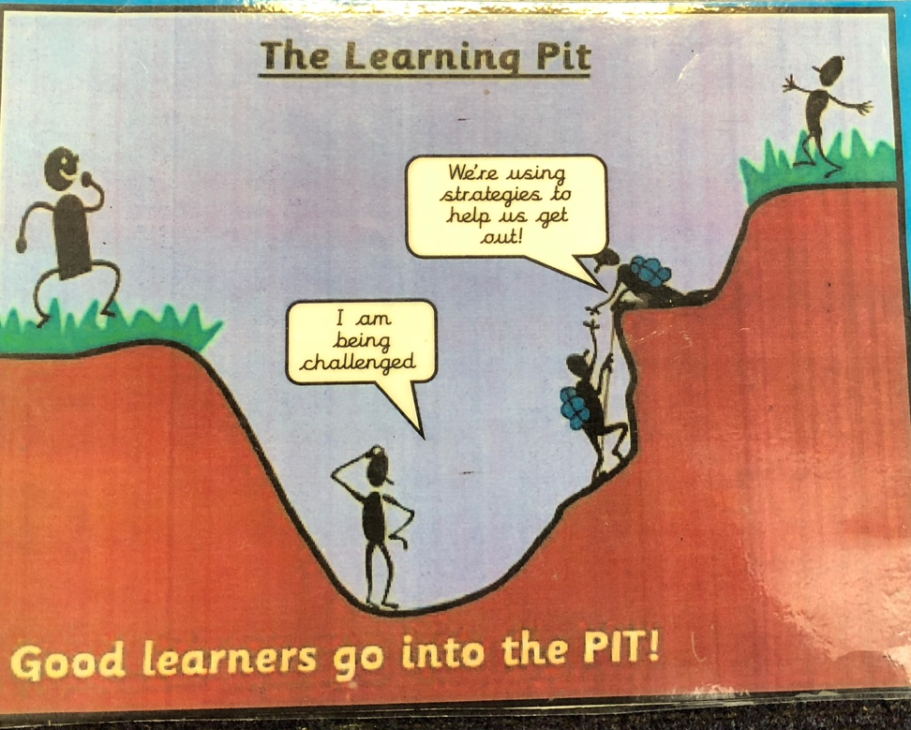
Figure 9. The Learning Pit taken in the classroom where the learning event was witnessed. Photographer: Myself.

Stage 1 of the Learning Pit is the concept stage. In terms of solo taxonomy, this is the uni-structural stage. Pupils should have some understanding of the concept but should be willing to develop it.

Stage 2 of the Learning Pit is the conflict stage. This is an attempt to get pupils into the so called “pit” and help develop a Growth Mindset (Dweck, 2007). In solo taxonomy this is called the multi-structural stage.

Stage 3 is the construct area. This is when pupils construct and develop meaning about what is presented to them at the concept stage for themselves. In solo taxonomy, this is considered to be the relational stage of understanding.

Stage 4 of the Learning Pit is consideration. When the pupil comes out of the Learning Pit, they should be encouraged to reflect on the previous 3 stages of the Learning Pit in order to determine what they have been through. In solo taxonomy, this is the extended abstract stage.

Zone 6. Check-In

Well-being is defined as “the state of being comfortable, healthy or happy” (Oxford English Dictionary Online).

The check-in area of my ideal learning environment is extremely important. The teacher would ask the children their check-in numbers in Welsh, referring to bilingualism or multilingualism, when calling the register, with 1 being happy and 5 being sad. If the child wishes to tell the teacher in the presence of other pupils, they are allowed to do so but if they would rather tell the teacher in private then this too is perfectly acceptable. This form of check-in is one way of ensuring safeguarding in the learning environment. When the teacher becomes aware of the emotional wellbeing of the children in their learning environment, they are then more aware of what they need to do in order to support these pupils. Furthermore, if this check-in system was not in place, some children may be displaying behavioural issues which without the check-in system the teacher would not know the reason for but with the check-in system in place, these issues may be more understandable.

Bywater and Sharples (2012) stated that there are specific school based programmes that are implemented to promote social and emotional well-being in the classroom environment. I would consider the ‘check-in system’ to be one of these.

In recent times, mental health issues in younger children are becoming more increasingly diagnosed. It has been calculated that children spend over 7,800 hours in their learning environment over the course of their education (Young Minds, 2018). It is for this reason that the ideal learning environment must also promote and encourage good emotional well-being and that children learn that it is acceptable to talk about their feelings.

In conclusion, all areas of my ideal learning environment link in order to promote a safe, secure, inclusive and an encouraging learning environment. Furthermore, all 6 areas and all other elements of my ideal learning environment link to the 4 Purposes of the New Curriculum which can be seen in Figure 1. Additionally, I believe that my ideal learning environment will be effective when the New Curriculum is introduced in Wales.

Reference List

Barrett, P. et al. (2015) Clever Classrooms. Summary Report of the Head Project. University of Salford, Manchester. [Online] Available at: https://www.kidsmatter.edu.au/mental-health-matters/social-and-emotional-learning/managing-behaviour (Accessed: 15th October, 2018)

Burnett, C. and Cremin, T.(2018) Learning to Teach in the Primary School. 4th Edition. Routledge, London.

Bywater, T. and Sharples, J. (2012) Effective Evidence-Based Interventions for Emotional Well-Being: Lessons for Policy and Practice. Research Papers in Education. Volume 27. Issue 4. [Online] Available at: https://www.tandfonline.com/doi/abs/10.1080/02671522.2012.690242 (Accessed: 15th October, 2018)
Canter, L. (2010) Assertive Discipline: Positive Behaviour Management for Today’s Classroom. 4th Edition. Solution Tree Press.

Department for Education, (2016) Behaviour and Discipline in Schools-Advice for Headteachers and School Staff. [Online] Available at: https://assets.publishing.service.gov.uk/government/uploads/system/uploads/attachment_data/file/488034/Behaviour_and_Discipline_in_Schools_-_A_guide_for_headteachers_and_School_Staff.pdf (Accessed: 15th October, 2018)

Donaldson, G. (2015) Successful Futures: Independent Review of Curriculum and Assessment Arrangements in Wales. [Online] Available at: https://gov.wales/docs/dcells/publications/150225-successful-futures-en.pdf (Accessed: 15th October, 2018)

Dweck, C. (2007) Mindset: The New Psychology of Success. Ballantine Books.

Exciting Curiosity. [Online] Available from: https://www.google.co.uk/search?q=theory+of+flow+in+education&source=lnms&tbm=isch&sa=X&ved=0ahUKEwij_Kv5-undAhUlKcAKHbeUD3MQ_AUIDigB&biw=1440&bih=728#imgdii=yt3cxkRYWEwLDM:&imgrc=h795APcmZWpt8M: (Accessed: 15th October, 2018)

Furnham, A. (2008) 50 Psychology Ideas That You Really Need to Know. Quercus, London.

Graham-Matheson, L. (2015) Essential Theory for Primary Teachers-An Introduction for Busy Trainee. Routledge, London.

Grigg, R. (2015) Becoming an Outstanding Primary School Teacher. 2nd Edition. Routledge, London.

Heick, T. (2018) The Characteristics of a Highly Effective Learning Environment. Teach Thought. [Online] Available at: https://www.teachthought.com/learning/10-characteristics-of-a-highly-effective-learning-environment/ (Accessed: 15th October, 2018)

Hughes, P. (2000) Principles of Primary Education Study Guide. David Fulton Publishers Ltd.

Huizinga, J. (1955). Homo Ludens: A Study of the Play Element in Culture. Boston: Beacon Press.

Kids Matter. (2018) Managing Behaviour. [Online] Available at: https://www.kidsmatter.edu.au/mental-health-matters/social-and-emotional-learning/managing-behaviour (Accessed: 15th October, 2018)

My Local School. [Online] Available at: https://beta.gov.wales/my-local-school-guide (Accessed: 15th October, 2018)

Payne, R. (2015) ‘Using Rewards and Sanctions in the Classroom: Pupils’ Perceptions of Their Own Responses to Current Behaviour Management Strategies’. Educational Review. Volume 67. Issue 4. [Online] Available at: https://www.tandfonline.com/doi/full/10.1080/00131911.2015.1008407 (Accessed: 15th October, 2018)

Slavin, R. (2003) Educational Psychology. Longman, New York.

The Oxford English Dictionary Online. [Online] Available at: https://en.oxforddictionaries.com/definition/learning (Accessed: 15th October, 2018)

The Oxford English Dictionary Online. [Online] Available at: https://en.oxforddictionaries.com/definition/well-being (Accessed: 15th October, 2018)

Wagenhals, D. (2006) Preventing Violence Through Effective Discipline. [Online] Available at: https://pdfs.semanticscholar.org/presentation/e4f5/ee48db50d074c370ea3c3a02a1be8c943564.pdf (Accessed: 15th October, 2018)

Welsh Assembly Government. (2010) First Steps Outdoors: Making the Most of Your Outdoor Spaces. [Online] Available at: http://learning.gov.wales/docs/learningwales/publications/141013-first-steps-outdoors-en.pdf (Accessed: 15th October, 2018)

Welsh Government. (2010) Practical Approaches to Behaviour Management in the Classroom. [Online] Available at: http://learning.gov.wales/docs/learningwales/publications/121128practicalen.pdf (Accessed: 15th October, 2018)

Wood, E. and Attfield, J. (2005) Play, Learning and the Early Childhood Curriculum. 2nd Edition.

Young Minds. (2018) Wise Up to Well-Being in Schools. [Online] Available at: https://youngminds.org.uk/media/1428/wise-up-prioritising-wellbeing-in-schools.pdf (Accessed: 15th October, 2018)

APPENDIX

APPENDIX 1


