Student Self Evaluation Form

This section repeats in brief the common assessment criteria detailed on previous pages. The extent to which these are demonstrated by you determines your mark. Using these criteria, tick the box that best indicates the level of achievement you feel you have achieved with regard to each of them.

Common Assessment Criteria Applied
Common Assessment Criteria Applied | REFER |  | D |  | C |  | B | A
 | OUTRIGHT FAIL | UNSATISFACTORY | SATISFACTORY | GOOD |  | VERY GOOD |  | EXCELLENT
1. Subject Knowledge and Understanding (which includes using research-informed literature and knowledge and understanding of the subject)
 |  |  |  |  |  | B
2. Intellectual Skills (Analysis)
2. Intellectual Skills (Analysis) |  |  |  |  |  |  |  | A
3. Pedagogic and Professional Applications (Practical Application and Deployment)
 |  |  |  |  |  |  |  | A
4. Key Transferable Skills
4. Key Transferable Skills |  |  |  |  |  | B

PLEASE COMMENT ON AREAS IN WHICH YOU FEEL THAT YOU HAVE PERFORMED WELL | PLEASE COMMENT ON AREAS you feel that you need TO DEVELOP
- Analysis of learner  - Applying pedagogy in attempt of meeting the learner’s needs | - Subject knowledge across the curriculum

A detailed analysis of one child’s holistic development, with justification for the next steps in learning
A critical analysis and evaluation of a pupil’s development, following reflection to improve personal Primary School practice.

School Development and Pupil Progress (SDDP)
Level 7; M7X02153

Word Count: 4,560

Introduction:

The purpose of this study is to specifically analyse a child’s holistic development, justifying their next steps in learning. The pupil will be referred to as pupil A (CT in each appendix), who will remain anonymous, alongside the school, as confidentiality and anonymity are ethically crucial. Respect for protection and preservation of identity is crucial, as represented by The United Nations Convention on the Rights of the Child (UNCRC, 1992: ARTICLE 8). The school in which this research was conducted, is a small school in Neath Port Talbot, containing 150 pupils. The entitlement to free school meals is 17%, below the national average of 21%, whilst 14% of pupils are identified as having additional learning needs (ESTYN, 2015).
Within the study, the mosaic approach was followed, collecting data to support pupil A’s learning, specifically focusing on his physical, intellectual, linguistic, emotional and social development. Pupil A is an 8-year-old boy, who requires additional educational support due to his hearing difficulties. He has two hearing aids fitted and the school has an individualised education programme (IEP) in place, to accommodate his needs in the most effective way possible. Pupil A completes personal targets along with the class teacher and parent, who review his progress each term. Consequently, he is having to catch up with curriculum objectives and areas of learning due to his absence for vital operations. Nonetheless, his emotional well-being development is currently the key focus, combined with emphasising a warm and supportive classroom ethos to ensure safety, social and esteem needs, in order to fulfil self-actualization, as represented by Malsow’s hierarchy of needs (Maslow,1968).

Data:

As the purpose of this study is to carefully analyse a child’s holistic development, the mosaic approach, outlined by Clark and Moss (2011) was followed in pursuit of creatively listening to pupil A’s interests and needs, to determine the next steps in his learning. Within the mosaic approach, a multitude of observations, child conferences, photographs and tours, are used to confirm the child’s perception of places, people, and resources. This was of great purpose to this research, using each element to analyse the child’s perception of the educational context. Thus, each different component within the data serves as a language tool, conveying feelings and purpose in a variety of ways. The strenght of this approach, is that we are drawn in to the child’s world, and can really try to understand their constructions of meaning (Vygotsky, cited in Gray and Macblain, 2012). Allowing the child to take photographs and create tours in particular, suggest an authentic perspective in which the child has ownership of their thoughts and experiences, with less direction or influence exposed by the researcher. Conversely, this approach shifts from an imbalance of power, usually dominated by adults in which hypothesis and structured questions are generated from a stand point of ‘looking down’ when researching children (Mayall, 2002).
For children, photographs are valued within the adult world, displayed in family albums, which ultimately generates feelings of pride. Giving children this control over their experiences to aid the purpose of the research, asserts them with a sense of power. Similarly, tours led by the child can reveal hidden spaces that are significant, whilst allowing the pupil to execute knowledge of their school environment. Likewise, priorities exhibited by the child can also show features of daily life that aren’t regarded as important, revealing to practitioners, what learning environments and resources should be incorporated into planning. Retrospectively, this will encourage the child’s best efforts, potentially boosting their progression (Clark and Moss, 2011).
The exploration of how children learn is crucial for tailoring pedagogical, behavioural and well-being strategies to the individual. Vygotsky indicates observation as an essential learning apparatus, providing learners with rich experience, that is culturally evolving, according to values and beliefs (Gray and MacBlain, 2012). As a result, children’s construction of meaning is continually changing, implying that practitioners must remain reflective, highlighting the need for child conferencing. Child conferencing requires flexibility, sensitivity but also time. It was ensured that conversations were conducted in a comfortable place so that the child felt as relaxed as possible. The effectiveness of talk as a learning tool is further supported by Alexander (2006), who states that, “it is through… spoken language that teachers teach and children learn,” (Alexander, 2006, p.5). Subsequently, not only is talk a tool that fosters progression but instantly, captures context specific dialogue and assessment responses.
However, child conferring is regarded as a reflective tool where questions need to be readdressed to signify potential change or maintain continuum of thoughts and feelings. But, the timescale for this study was small, meaning that reflections and conclusions drawn must be appreciated as interpretations and assessment, realistic to the timeframe available. In order to analyse materials gathered more effectively, additional time needs to be allocated, listening to learners more constant and consistent, so that practitioners can meet learners needs and keep up with changing views. Despite this, the culturally evolving institutions which we work in, respects children’s rights and views, meaning that new ways of recording qualitative data needs to be established, to assist the interpretative nature of listening to learners. In addition, the fact that the mosaic approach is a multimethod is complex and interpretation is subjective, susceptible to personal bias whilst being extremely time consuming (Clark and Moss, 2011).
Furthermore, listening to learners is fundamental, supported by, The United Nations Convention on the Rights of the Child (UNCRC, 1989). Article 12 clearly states, that every child has the right to express their view on any aspect of their lives. As a result, whilst addressing ethical issues based on BERA Ethical Guidelines for Educational Research, researchers need to respect children’s views and knowledge about their lives, which should not be used to criticise practitioners; a potential challenge of listening to children. It was ensured that confidentiality was valued and that information obtained, contributed towards the child’s holistic development, solely benefitting the child and informing practice (Clark and Moss, 2011). Another ethical issue to consider is gaining informed consent. Participants can choose freely whether or not they want to participate, and Munford and Saunders (2001) note, how researchers need to devise creative and interesting ways to ensure that children can give their ascent in a competent manner. They illustrate how this itself, opens up opportunities for researchers to ask questions that effectively stimulates children’s voices. Whilst gaining ascent by the child, consent was accepted by the class teacher (see appendix 1), who discussed the child as a suitable participant, free from any prejudice, eliminating feelings of inequality (Munford and Saunders, 2001).
A problem with informing the child of the research illustrates that behaviours may have been modified to present himself in the most favourable light, which is regarded as the ‘reactive effect’ (McCall, 1984). That aside, the longer the researcher spends observing, the easier the pupil will become accustomed to their presence, feeling a sense of comfortability with less invasion. Equally important, it is the researchers desire to acquire the best results, wanting pupil A to perform at their best. Hence, a number of strategies within the mosaic approach present a natural feel, helping the child forget that research was being conducted.

Analysis of learner:

The analysis of Pupil A’s learning will be divided into areas of learning, including: literacy, numeracy and well- being. Each area of learning will be further assessed and justified with next steps for development.

Literacy:

During a learning walk, with pupil A, it was expressed that reading was his favourite and that if he completed the main and extended tasks, then reading is what he would ask to do. His interest in reading was confirmed to me through observations, as he was characterised by excitement and enthusiasm when reading (see appendix 2). He completes RAPID reading daily, an intervention in the school that helps engage and interest struggling readers. Leading a school tour, he highlighted the room in which this intervention takes place, as a favoured part of the school, suggesting this environment as a significant learning place. As an intervention for underachieving pupils, potential negative attitudes may arise, widening achievement gaps, implied by Mitchell (2014). However, Pupil A’s persistency and desire to succeed through his interest of reading, demonstrates his positive attitude that can be reflected in the A.S.K Model, addressed by Nottingham (2013). Nottingham values the importance of attitude, skills and knowledge as pivotal factors in the learning process and that education should focus on the development of all three for each individual. Regardless of needing extra support, such resilience and open-mindedness reflects a growth mindset, accentuated by Dweck (2017). Excluding the notion of a fixed mindset; assuming intelligence is predetermined and that certain individuals are unable to achieve the same as those more able and talented, growth mindset is the belief in developing your basic qualities, through personal efforts, strategies and help from others, as evidenced by pupil A.
In contrast, he didn’t signify the library as a preferred learning environment and added that, “In RAPID reading, I can talk to my friends which I love”, implying collaboration as an essential strategy for pupil A’s engagement but also, emotional well- being. Peer collaboration also creates environments where pupils can formulate new ideas and offers pupil feedback, essential in planning to certify effective teaching (Donaldson, 2015). Similarly, Professor Hattie explicitly concludes the encouraging impact of collaboration on learners’ motivation (Hattie, 2012). Understanding pupils’ motivation and emotional needs is imperative for practitioners’ pedagogical application, to advocate successful learning and fulfil an inclusive curriculum (Donaldson, 2015). His participation in group work combined with his reading preference, allows him to make sense of texts and identify context-specific words in the classroom context, verifying the effectiveness of the intervention (see appendix 3).
Based on the idea of collaboration, Vygotsky proposes how meaning is constructed through social interactions and interconnection, deducing how through intrinsic motivation, children actively discuss and accept meaning through a shared goal; thus, not an individual process but a collaborative effort (Berk and Winsler, 1995). Wells (1989), compliments how children make sense of the world around them and construct meaning through stories or ‘story telling’. As pupil A perpetuates motivation through collaborative reading and discussion of stories, this momentously strengthens his social and communication skills within the A.S.K model, including: to work individually and as a team, listen and respond appropriately to others, pay full attention to the speaker and understand body language and tone of voice (Nottingham, 2013). This is of crucial importance for pupil A in particular, who because of his hearing difficulties needs to continuously review joint listening targets (see appendix 4). His recognition of what he needs to do to aid his hearing difficulty, again, reflects his attitude to succeed (Nottingham, 2013). His progress in oracy skills has also been strengthened in oracy-based lessons, underlining how his specific needs are integrated into planning and further confirms his acknowledgement of what needs to be done. For example, his involvement in collaboratively creating the success criteria with the whole class is visible in appendix 5. Pupil A’s attitudes and skills obtained through reading strategies is crucial for knowledge application, reiterating the coexistence of all three elements of the A.S.K model, that learners must acquire to ensure outstanding learning.
Whilst this is the case for reading, pupil A contradicts his attitude towards spelling, scoring less on spelling than reading tests but having a slightly higher spelling age than reading (see appendix 6). Despite this, he lacks the enthusiasm he expresses towards reading and observations certified his aspiration to complete the task or ‘wish’ extension quickly, rather than concentrating on his spelling. Consequently, this was discussed with pupil A as feedback (a weekly personal and professional target of mine) to aid progression in his spelling (see appendix 7). When discussing feedback and using this time to generate feelings through child conferencing, pupil A was asked about his choice to not use the resources on his table which contained the correct spelling for his note taking. He replied with, “I did have a quick look to start me off”. His attempt can be appreciated even if it results in inaccuracies. This notion of learning through discovery and action reflects Piaget’s notion of a ‘lone scientist’. Pupil A can be viewed as an active participant in his own learning, attempting spelling with little input from a teacher or dictionary (Piaget, cited in Sutherland, 1992). Going forward, a classroom culture which promotes pupils to take more time when rechecking their work, rather than racing to finish would be more beneficial. Nonetheless, the quality of work could be consolidated when spelling mistakes are revisited, as learning from mistakes is a characteristic of an outstanding learner, valuing errors as a route to mastery (Dweck, 2017; Nottingham, 2013).

Numeracy:

Pupil A stated that he preferred literacy to numeracy which was also recited by the class teacher. Interestingly, Hutchinson et al (2002), believe that the gender gap in literacy between girls and boys is established by the age of 7, adding how English is conventionally a female subject. Here, pupil A’s preference of literacy (especially reading and oracy-based work) can be linked to his responsibility of fulfilling his listening target, to enhance his learning and accommodate his hearing difficulty. He went on to state, “I’m no good at maths and times tables” suggesting that, collaborative discussion-based problem solving, could potentially boost his confidence in multiplication as it has in literacy. Even though he seems to lack confidence in mathematics, his fixed mindset could be connected to a lack of understanding, when learning mathematics as separate entities, further hinders his belief of being unable to become numerate (Dweck, 2017; Cotton, 2017). The daily task of completing maths work out of a textbook (see appendix 8) could also be argued as lacking creativity, potentially creating feelings of disengagement (Donaldson). This disseminates the significance of alternative learning contexts and using concrete materials to aid engagement and learning (McNeil & Jarvin, 2007).
When asked to take photographs of their favourite places in the school, Pupil A took three photographs of the outside environment (see appendix 9). He said, “play time is my favourite because I like running and playing outside with my friends”. Friends is a key theme, and after covering duties to observe him in the outside environment, it was made clear that he was most comfortable and confident with his friends. Reinforcing his preferred strategy of collaboration, this could be combined with the outside environment, which has been integrated into numeracy lessons. Bilton (2002) addresses how the outdoor learning environment allows for exploration and the creation of meanings in diverse ways, therefore aiding application of number by applying it in different contexts.
Addressing this consideration can be substantiated by appendix 10, taking learning outdoors to understand coordinates, direction and graph features, but linking to angles, turns, and fractions in a cross-curricula manner. Incorporating physical activities to engage pupil A, by tailoring the lesson to his interest of running, whilst establishing links between different areas of mathematics, exemplifies a connectionist teacher approach, a pedagogy that had been proven to progress learners (Cotton, 2017). This lesson plan consists of physical activities and a game off ‘Miss MacDonald says’, promoting reward of self-regulation, a key attitude within the A.S.K model (Nottingham, 2013). Hattie (2012) in visible learning, reinforces becoming your own teacher through self-control as a central attribute of becoming a lifelong learner.
Furthermore, the use of human graphs, to foster deeper understanding by manipulating mathematical concepts using symbols of mathematics, is favoured by McNeil & Jarvin (2007). Whilst Thompson (1992) criticises the effectiveness of concrete manipulatives, using concrete representations to transfer understanding from concrete to abstract, was discussed with the class teacher as most purposeful for pupil A, helping him connect with real-wold knowledge, using non-standard units of measure (see appendix 11). Using strategies encouraged by the teacher through discussions, joined with personalising the lesson to pupil A’s interests, could pursue the attitudes he articulates for literacy and skills developed through collaboration, to ensure knowledge progression.
Pupil A, conveyed positive attitudes towards succeeding in reading, contesting the perspective of ability grouping, contributing towards negative attitudes (Mitchell, 2014). However, with such low confidence in mathematics, mixing ability groups could aid pupil A’s numeracy development. Cotton (2016) underlines the importance of varying grouping as lower attaining pupils can be provided the opportunity to shine, rather than being limited and self-fulling a prophecy of not understanding, as a ‘lower ability pupil’. Support for this is expressed by Hattie (2009) in his meta-analysis of ability grouping, generating an effect size of 0.2. Concluding this as a low impact, generated injustice as pupils weren’t being challenged enough, expressing feelings of alienation. These pupils, such as pupil A, can attain more if they are given interesting and challenging activities. This notion of mixed ability grouping was tested in a lesson, using concrete representations (see appendix 12). The results were outstanding as pupil A’s group (consisting of 2 pupils in the top ability group, 1 in the middle and 2 with additional learning needs) worked fantastically, communicating effectively but creatively and flexibly, using pictures to construct the Eiffel Tower after realising that the instructions alone, were too complex. More importantly, the pupils in the top group were feeling more anxious, initially unwilling to comply with the creative method; rather fixated on the rigorous steps (see appendix 13). This scenario brings to light, impressive qualities of learners who are considered to be underachieving but open to taking risks, with a burning desire to succeed, appreciating different ways of thinking and learning visually (Nottingham, 2013).

Well-being:

As demonstrated, emotional development and well-being support is the core focus for pupil A, ensuring that he feels safe and loved (Maslow, 1968; Glasser, 1985). Glasser (1985) explains how we can control behaviours and feeling for healthier and productive lives. He emphasises five needs which teachers must meet, including belonging and love, in which practitioners must give pupils attention, and create meaningful, collaborative and inclusive tasks. As pupil A has experienced serious operations and has consequently missed time in school, supporting his emotional development by incorporating strategies that ensure love and belonging, alongside his interests, remain vital. Pupil A plays for Swansea football club and even won player of the year in his presentation. Using physical education as a cross-curricula lesson caters for the talents of all individuals, like pupil A, whilst preparing pupils as healthy and confident citizens of society (Donaldson, 2015).
Pupil A has a desire for football and running, proposing integration of physical activities into lessons as purposeful. Appendix 10 demonstrates the use of physical activities in numeracy, supporting cross-curricula activities in diverse learning environments. Research points towards the impact PE has on children’s general health by alleviating stress levels and reducing symptoms of hyperactivity according to Taylor et al (2001). Correspondingly, Donaldson (2015) presents the health and well-being Area of Learning, facilitating progression of knowledge and skills to independently deal with difficult issues. In his review of successful futures, he accentuates how acquiring knowledge about health and fitness, will contribute towards reducing health inequalities and help pupils thrive in emotional, social and physical well-being.

Next step for learner:

Pupil A, has a love for reading and is comfortable in RAPID reading. With the growth mindset that he embodies towards reading, challenging him in a mixed ability group for shared reading would be effective for teacher assessment, receiving only verbal feedback from the teaching assistant who leads the intervention. He enjoys the activities within the intervention, recognising words on the computer. The use of digital technology could therefore, be used to practise spelling. But, with a target recognised by himself, the teacher and peers, handwriting also needs to be a focus for improvement (see appendix 14). Thus, integrating spelling and handwriting activities within the intervention would benefit pupil A. Also, practising spellings at home in preparation for a test every Friday is a KS2 policy within the school. Connecting academic work between the school and home in light of uniting both institutions, to support pupils’ learning outside the school context is fundamental. Respecting the school spelling policy, and pupil A’s lack of engagement, an activity to enhance enjoyment could be devised. Taking account of pupil A’s interest, comprising an outdoor physical activity that sparks his competitive nature in sport, whilst incorporating the focus of improving handwriting and spelling could be an option. For example, a timed race to develop struggling spellers in the form of a treasure hunt. Pupils must individually race to each treasure chest that can only be unlocked if the spelling word at each station is spelled correctly with correct letter formation, before moving up a level. An engaging activity in the outdoor learning context could potentially progress pupil A’s spelling ability and alter his attitude of wanting to succeed (Nottingham, 2013)
This would be effective as a Friday assessment and incentive for pupil A. However, to fulfil his target of improving spelling and handwriting in class, he needs to intrinsically accept this himself as a personal target. He needs to take responsibility for his work and independently use a dictionary and other resources to aid his spelling or use it as a learning tool to recheck over his work. Doing this, will ultimately improve his intellectual skills and enhance application of knowledge, a gap identified in his spelling, due to a lack of desire. By becoming self-regulatory and evaluating his work, he can support the development of his spelling and writing skills, reflected in a self-regulation approach: ‘Self-Regulated Strategy Development’. Supported by research, this strategy is believed to boost progress by over 9 months (Education Endowment Fund, 2018). The requirement of pupil A, to acknowledge his intentions, represents a learning to learn approach, promoting metacognition, as put forward by Flavell (1976). Thus, attitudes, skills and knowledge complement each other in which knowledge cannot be reached without developing a positive and personal attitude towards a target (Nottingham, 2013). If pupil A complies with this, he could move from a comfortable 2b to a 2a (see appendix 15).
To improve understanding in numeracy, pupil A illustrated enthusiasm and evidenced his creative thinking during collaborate tasks, grouped by mixed ability, using concrete materials. To better assess the effectiveness of pupil A’s understanding, tasks with these elements should be conducted in future practice which could also alter grouping and learning context, so assess the impact of each variable on pupil A’s progression. Discussion based lessons for problem solving could also be meaningful so that pupil A feels supported and comforted by pupils in his group, who could aid his understanding of multiplication in activities which include, developing skills of working as a part of a team. For example, to plan a party for a specific number of people would instruct pupils to practise multiplication and division within a real life, problem solving context.
In order to tackle the negative stereotyping of ability groups, as stated, mixed ability grouping would be effective, whilst eliminating feelings of negative equity and isolation. Additionally, to combat such negative feelings and consequently negative attitudes towards numeracy, like pupil A, ability grouping does not need to be mixed for every mathematics lesson. Instead, rather than offering the top ability more work, that moves them onto to a different strand in the curriculum, a school should follow a mastery approach. This would stretch pupils’ ability to apply their understanding in a different context that encompasses new ways of thinking, for example, through worded sums and reasoning, boosting metacognition in learning how to learn (Flavell, 1976).
As pupil A loves physical education, a discipline consisting of a variety of physical activities, this ensures not only his physical development but emotional and social; further developing skills of collaboration, communication and endorsing leadership skills, essential for the workplace (Hoy and Clover, 2007). Donaldson (2015) stresses the importance of preparing pupils for the future as healthy and confident individuals, therefore integrating physical activities into the curriculum in an enjoyable manner, increases engagement, whilst alleviating stress, in support of emotional well-being (Taylor et al, 2001).
Fortunately, pupil A has a strong family support in which his mother establishes joint targets with him and the class teacher to ensure his IEP progress. Also, he consistently completes homework, evidencing his family life as a strong unit, firmly encouraging his academic process. Nevertheless, the link between school and the home could be stronger, in which the school could use technological advancements to connect with pupils’ parents or caregivers. For example, initiatives such as the ‘Class Dojo’ application, is a cost-free initiative that has been implemented in schools as a reward system, reinforcing positive behaviour to assist personal and social development, and well-being (Atherton, 2018). This initiative not only strengths the bond between the two most important institutions in pupils’ lives, but intensifies growth mindset. Pupils recognise their current skills and knowledge but accept the challenge of growing as a learner, crucial in Nottingham’s (2013) A.S.K model, to become an outstanding learner. Highlighting academic progress by safely broadcasting pupils work to their parent or caregiver through Class Dojo, promotes praise, ensuring a sense of pride and accomplishment, across all areas of the curriculum (Atherton, 2018). The implementation of Class Dojo, could aid pupil A’s well-being and boost his confidence in areas of the curriculum that he feels less confidence in. The use of technology would also compensate for his enjoyment in RAPID reading. Changing his attitudes to consequently, increase skills and knowledge, especially in numeracy and writing, could certify progression, form a comfortable 2b (see appendix 15) to 2a (Nottingham, 2013).

Conclusion:

Upon reflection, my assessment of pupil A must be perceived as a ‘best fit judgement’, concluding with possible next steps in learning as suggestions, based on the gaps identified in his work. I have definitely bonded with pupil A, becoming aware of his physical, intellectual, linguistic, and emotional/ social needs, but over a small timescale (Clark and Moss, 2011). Therefore, my judgment must be appreciated as realistic. With time as a significant constraint, my evaluations are based on short-term progress, in hope of potentially increasing long-term progression. Confirming his emotional and well-being development, remains the key focus in support of his additional learning need. However, achieving the skills and learning objectives of the curriculum by tailoring activities to his interests, personalises his learning in an engaging way, in an attempt of boosting his confidence and aiding growth mindset (Dweck, 2017; Nottingham, 2013).
This research has helped me grow as a practitioner from my Professional Teaching Experience (part 1), by focusing on an individual in more detail to better inform my assessment, planning and preparation. Listening to learners can be concluded as crucial to understanding a child’s holistic development. The beauty of the mosaic approach, acknowledges differences in culture, identity, ethnicity and gender at a specific level, highlighting that not one style of teaching fits all. Each individual has different needs and learning capacities, implying social inclusion for all as fundamental within a school ethos. I have learnt that I can flexibly alter my pedagogy in a changing curriculum with the individual as the central focus, aided by theory, to ultimately improve my subject knowledge. Furthermore, I am dedicated to creating rich learning environments in light of Donaldson; embedding the philosophy of helping pupils become ambitious and capable learners, creative contributors, ethically informed citizens, and healthy and confident individuals of Wales and the rest of the world (Donaldson, 2015).

References:

Alexander, R. (2006) Towards Dialogic Teaching: Rethinking classroom talk. (3rd ed) Yorkshire: Dialogos.

Atherton, P. (2018) 50 ways to use Technology Enhanced Learning in the Classroom. Practical Strategies for Teachers. London: Sage Publications.

BERA (2011) ‘Ethical Guidelines for Education Research’ Available at: https://www.bera.ac.uk/wp-content/uploads/2014/02/BERA-Ethical-Guidelines-2011.pdf [Accessed on: 20th May 2018].

Berk, L.E., and Winsler, A. (1995) scaffolding Children's Learning: Vygotsky and Early Childhood Education. NAEYC Research into Practice Series. Volume 7. Washington: National Association for the Education of Young Children.

Bilton, H. (2002) Outdoor Play in Early Years. (2nd Ed) London: David Fulton publishers Ltd.

Clark, A. Moss, P. (2011) Listening to Young People. The Mosaic Approach. (2nd ed) London: NCB.

Cotton, T. (2016) Understanding and Teaching Primary Mathematics. (3rd ed.) London: Routledge.

Donaldson, G. (2015) Successful Futures: Independent Review of Curriculum and Assessment Arrangements in Wales. Available at: http://gov.wales /topi cs/ed ucati ona ndski l ls/sc hools ho me/c ur ri culum - for- wales- curri culum-for- li fe/ w hy-we -are-c ha ngi ng /success f ul -f ut ures/?lang=en [Accessed: 22nd May 2018].

Dweck, C. (2017) Mindset - Updated Edition: Changing The Way You think To Fulfil Your Potential. London: Robinson, an imprint of Constable & Robinson Ltd.

Education Endowment Fund. (2018). Available at: https://educationendowmentfoundation.org.uk/projects-and-evaluation/projects/

[Accessed 23.05.2018]

Estyn. (2015) ‘A Report on Blaengwrach Primary School.’ Available at: https://www.estyn.gov.wales/sites/default/files/documents/Inspection%20report%20Blaengwrach%20Primary%20School%202015%20%28English%20only%29.pdf.pdf.pdf.pdf.pdf.pdf.pdf.pdf.pdf.pdf.pdf.pdf.pdf.pdf.pdf.pdf.pdf.pdf.pdf.pdf.pdf.pdf.pdf.pdf.pdf.pdf.pdf.pdf.pdf.pdf [Accessed 20.05.2018]

Flavell, J. (1976). ‘Metacognitive Aspect of Problem Solving’, in L.B Resnick cited in, (ed), The Nature of Intelligence. Hillsdale, NJ: Erlbaum.

Glasser, W. (1985) Control Theory: a new Exploration of how We Control Our Lives. Los Angeles: HarperCollins

Gray, C. and MacBlain, S. (2012) Learning Theories in Childhood. London: Sage publications Ltd.

Hattie, J. (2009) Visible Learning: A Synthesis of Over 800 Meta-analyses Relating to Achievement London: Routledge.
Hattie, J. (2012) Visible Learning for Teachers. Maximising impact on Learning. London: Routledge.
Hoy, W.K. and Clover, S.I.R. (2007) ‘Elementary school climate: a revision of the OCDQ’, in W. Hoy and M. Di Paola (ed) Essential Ideas for the Reform of American Schools: A Volume in Research and Theory. New York: Information Age Publishing.

Hutchinson, S. Moon, B. and Mayes, A. S. (2002) Teaching, Learning and the Curriculum in Secondary Schools. London: Routledge.
Maslow, A. H. (1968). Toward a Psychology of Being. New York: D. Van Nostrand Company.
Mayall, B. (2002) Towards a sociology for childhood: Thinking from children’s lives. Maidenhead: Open University Press.

McCall, G.J. (1984) ‘Systematic Field Observation’ Annual Review of Sociology, 10, pp.263-282.
McNeil, N.M. & Jarvin, L. (2007). When theories don’t add up: Disentangling the manipulatives debate. Theory into Practice, 46,4, pp.309-316.
Mitchell, D. (2014) What really works in special and inclusive education. (2nd ed). London: Routledge.

Munford, R. and Saunders, J. (2001) in. Harcourt, D. Perry, B. and Walker, T. (ed), (2011) Research Young Children’s Perspectives: debating the ethics and dilemmas of educational research with children. London: Routledge.

Nottingham, J. (2013) Encouraging Learning: How you can help children learn. London: Routledge.

Sutherland, P. (1992) Cognitive Development Today: Piaget and his Critics. London: Paul Chapman Publishing.
Thompson, P. W. (1992). Notations, conventions, and constraints: Contributions to effective uses of concrete materials in elementary mathematics. Journal for Research in Mathematics Education, 23, 123-147.
The United Nations Convention on the Rights of the Child (1989) Article 12. Available at: https://www.unicef.org.uk [Accessed 20.05.2018]

Wells, G. (1989) The Meaning Makers. Portsmouth, NH: Heinemann.

Appendices:

Appendix 1:


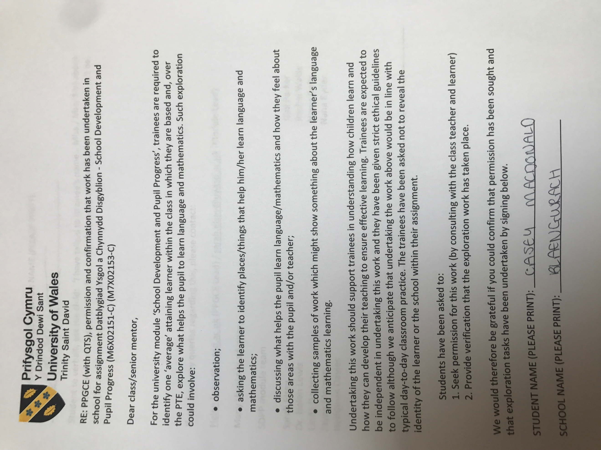

Appendix 2:

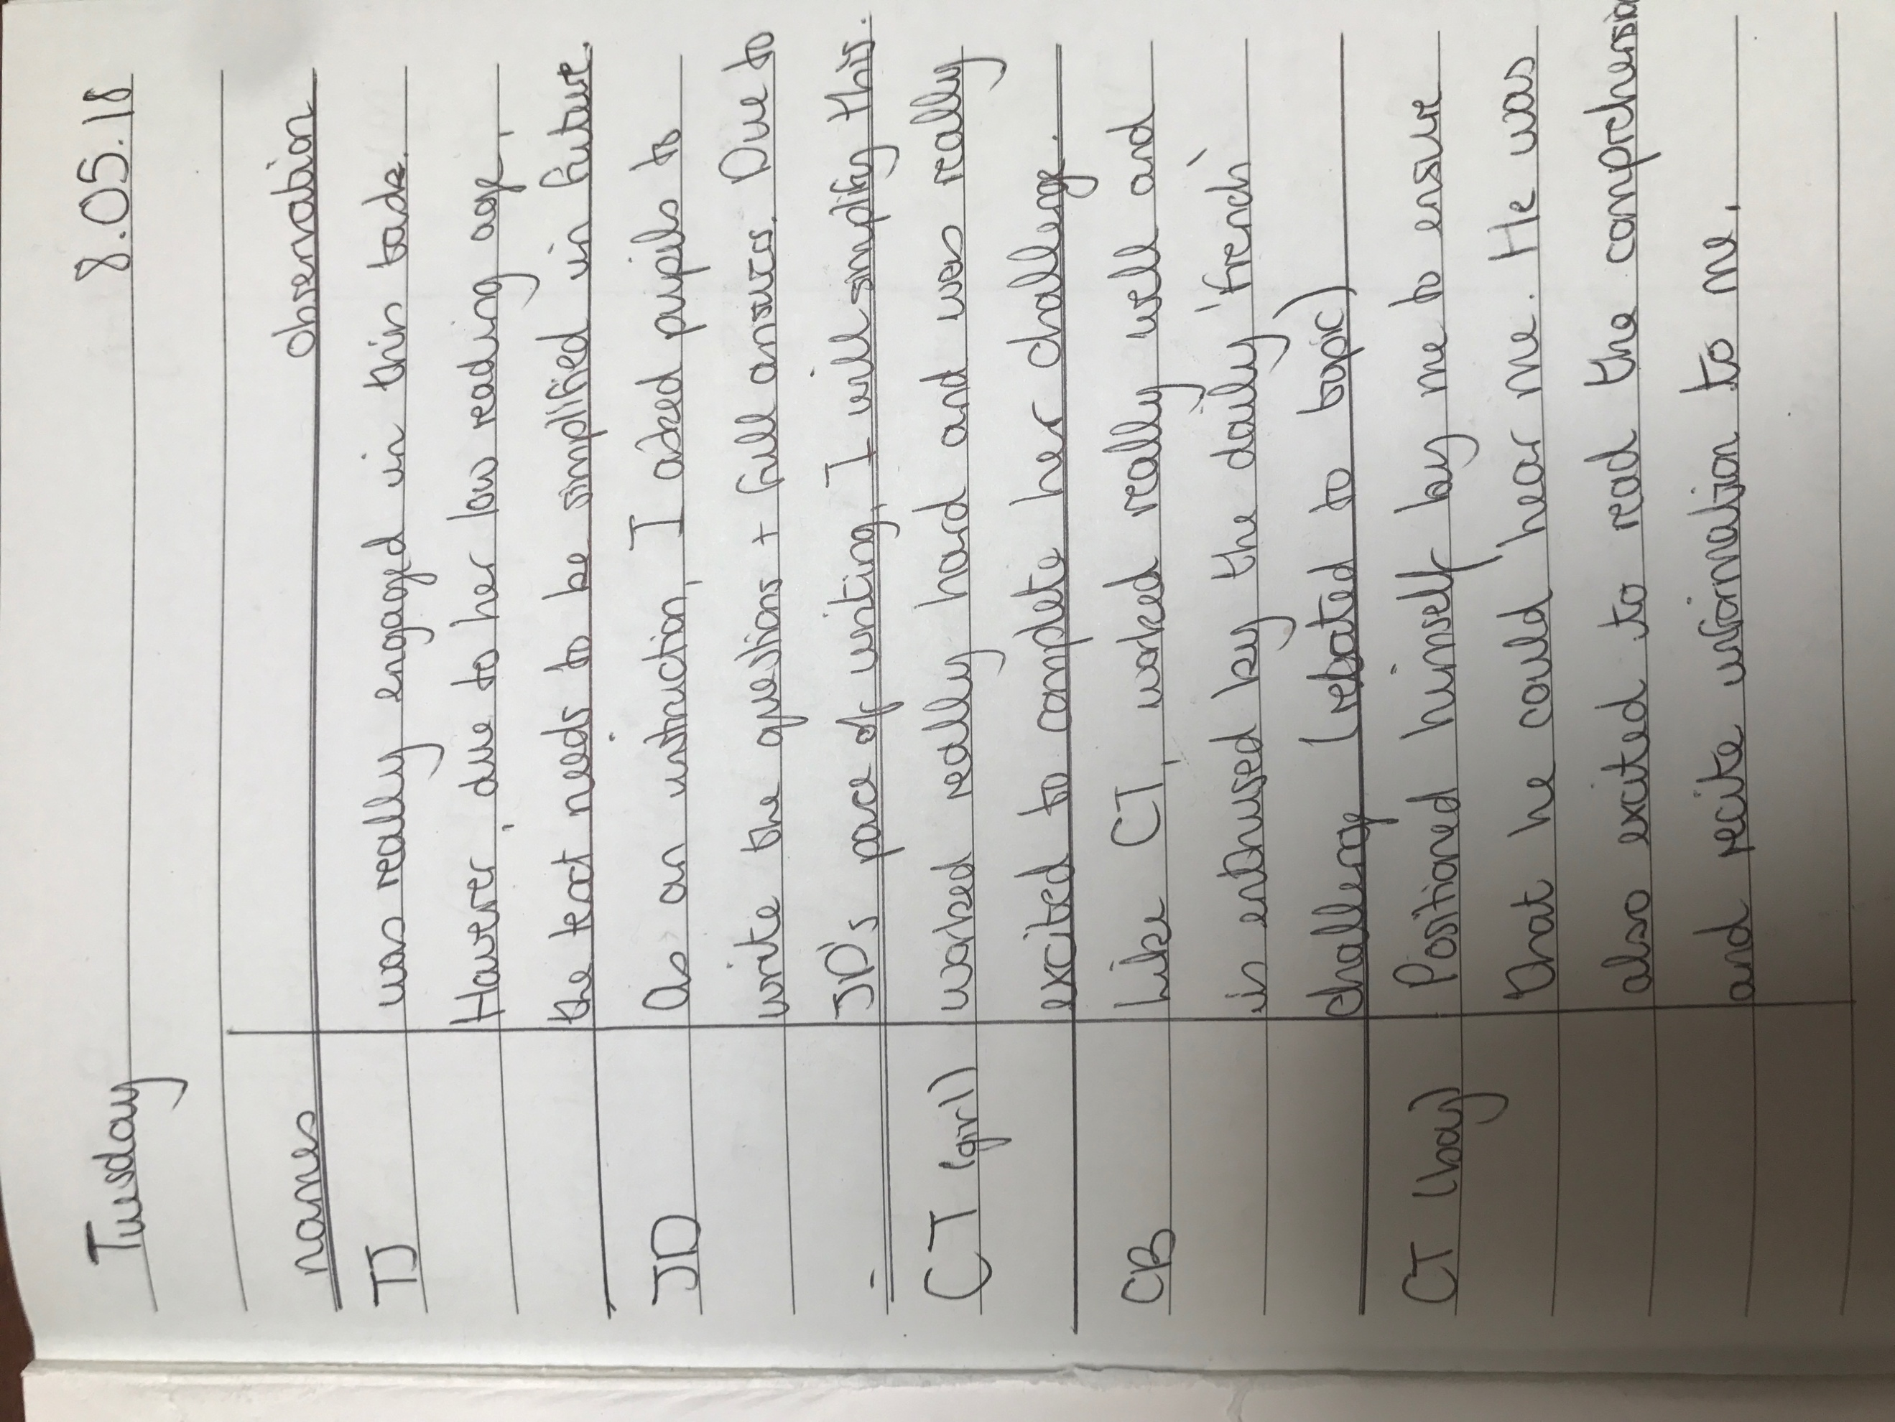

Appendix 3:

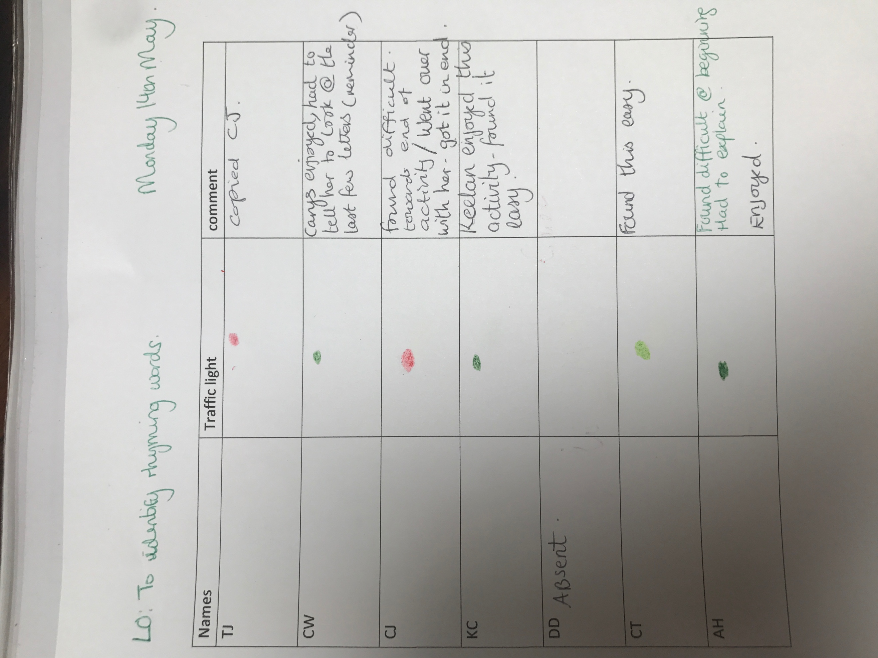

Appendix 4:

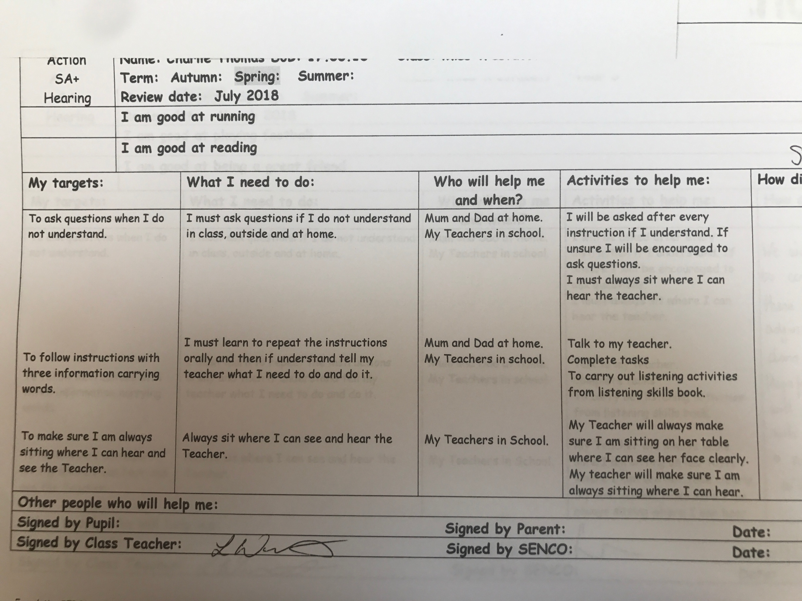

Appendix 5:

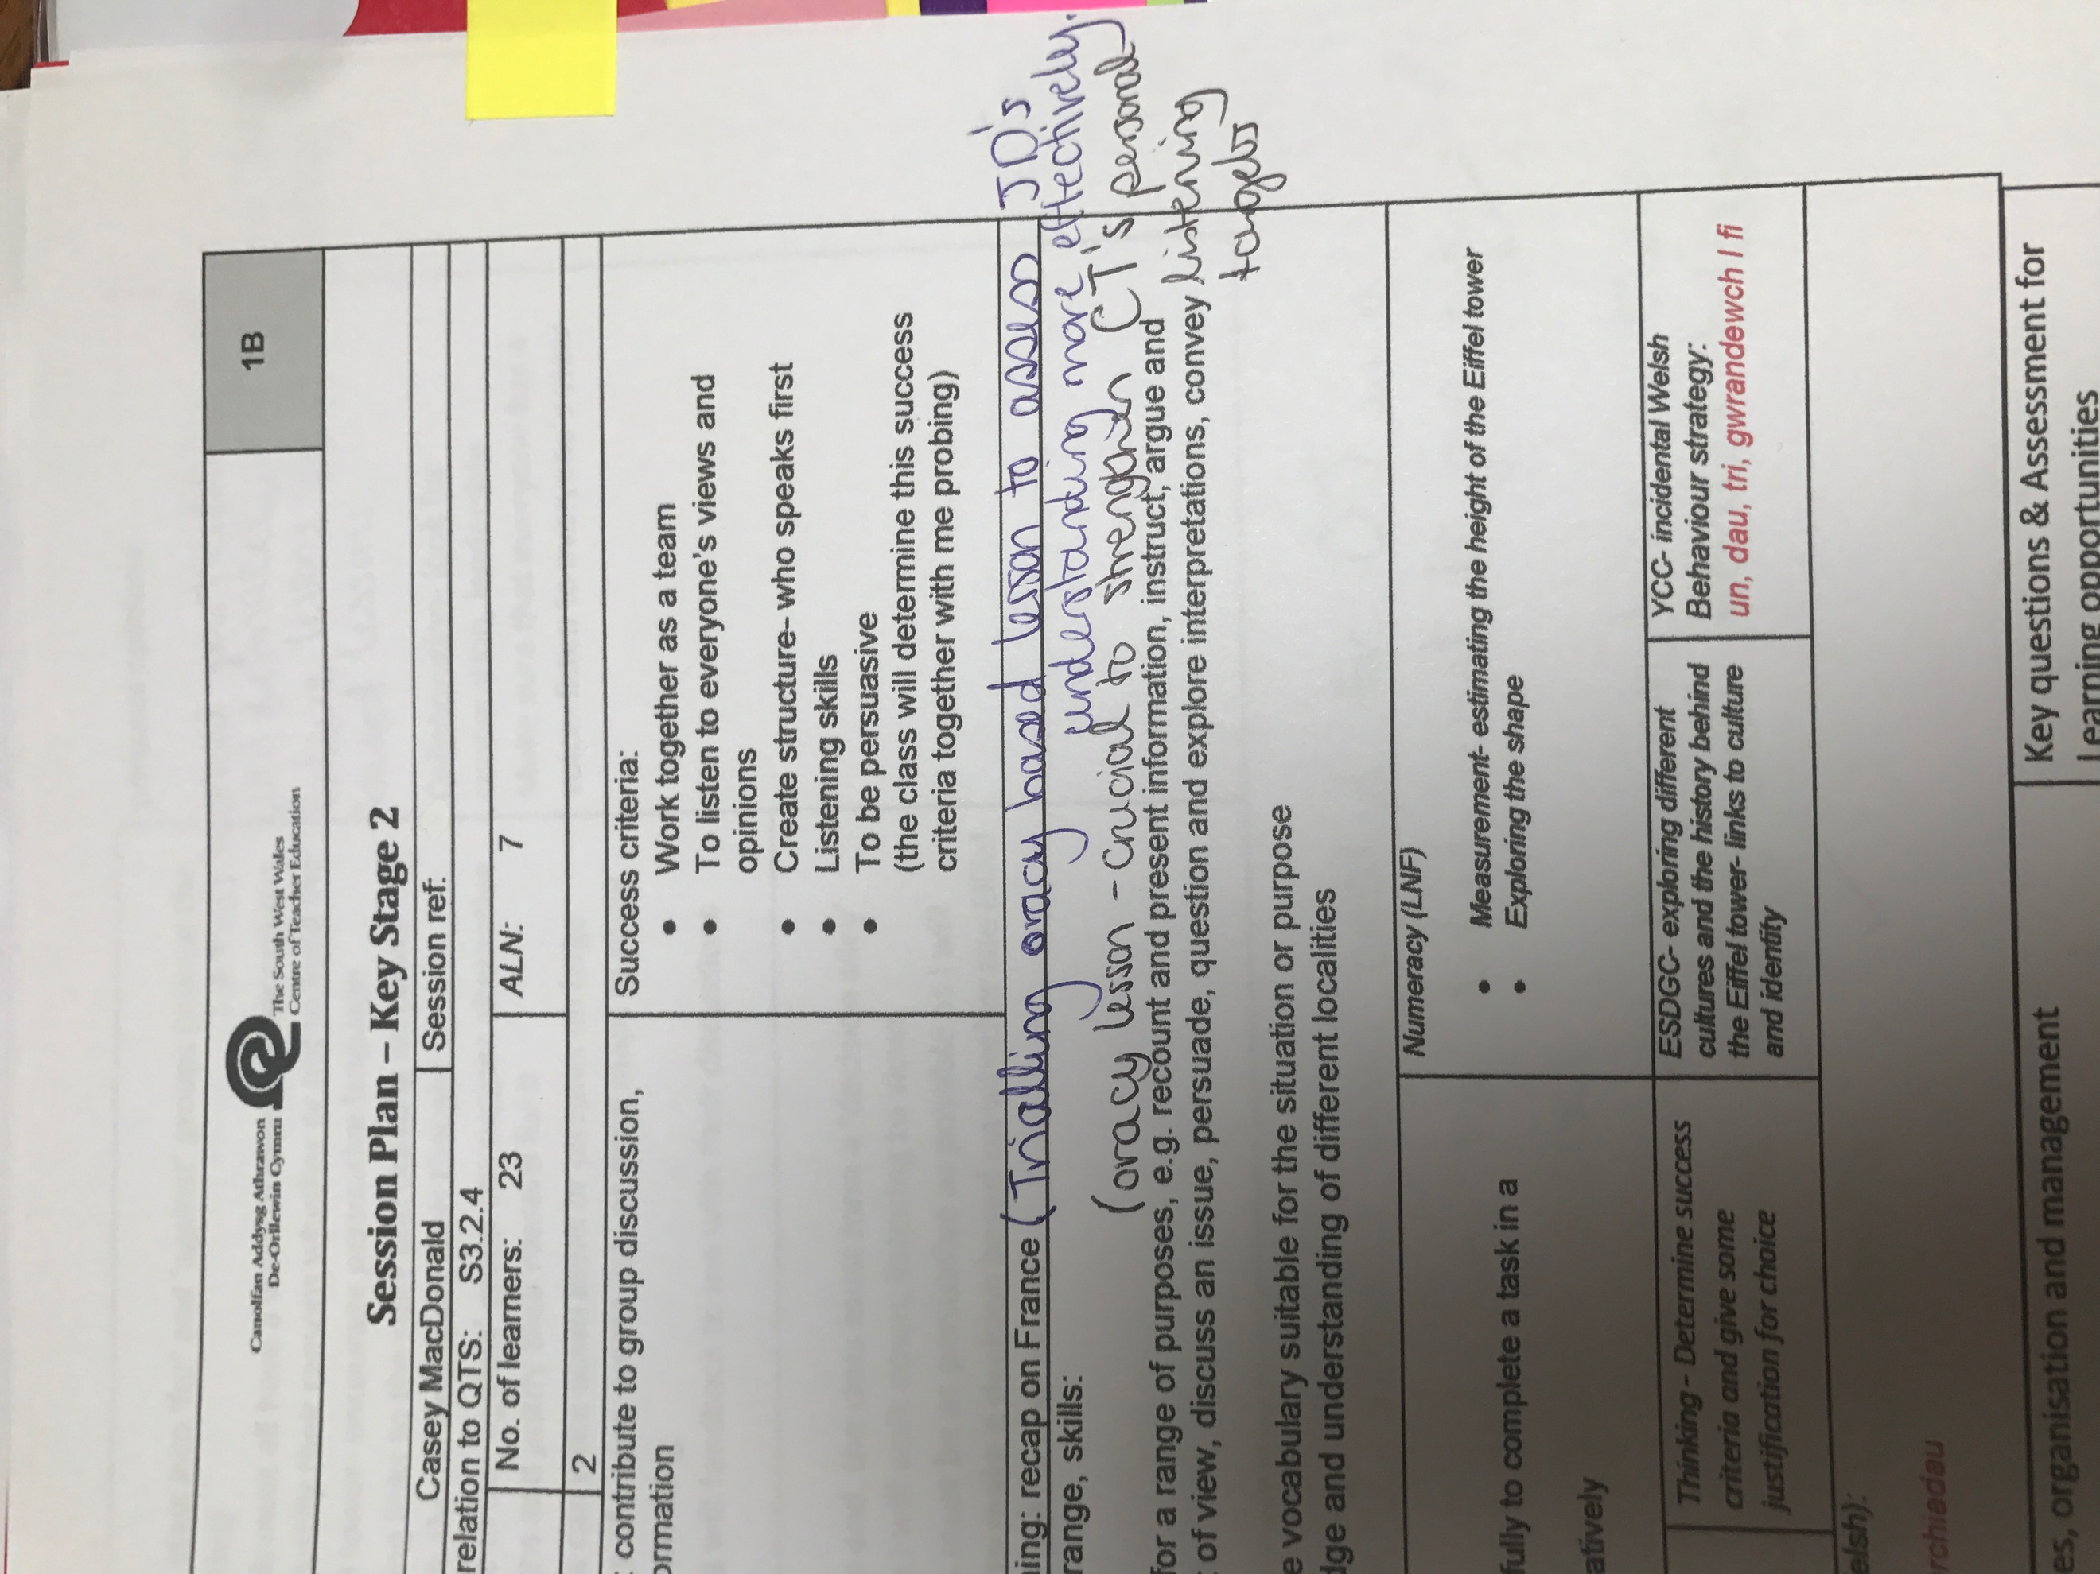

Appendix 6:

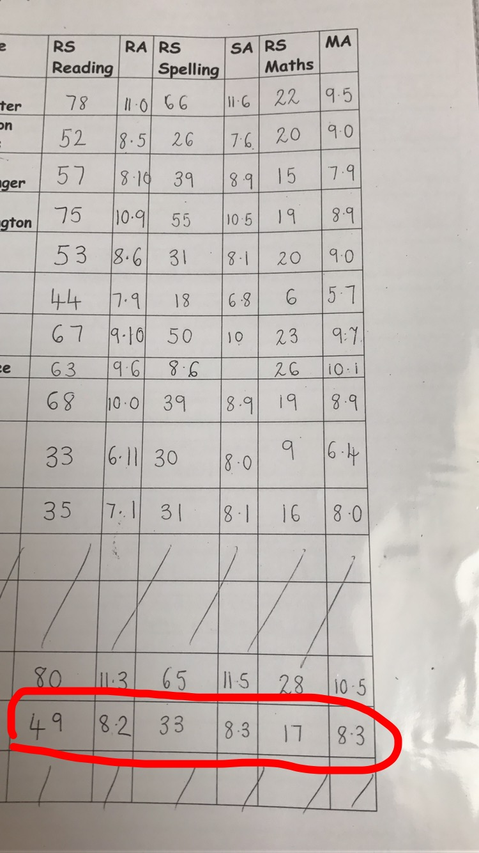

Appendix 7:

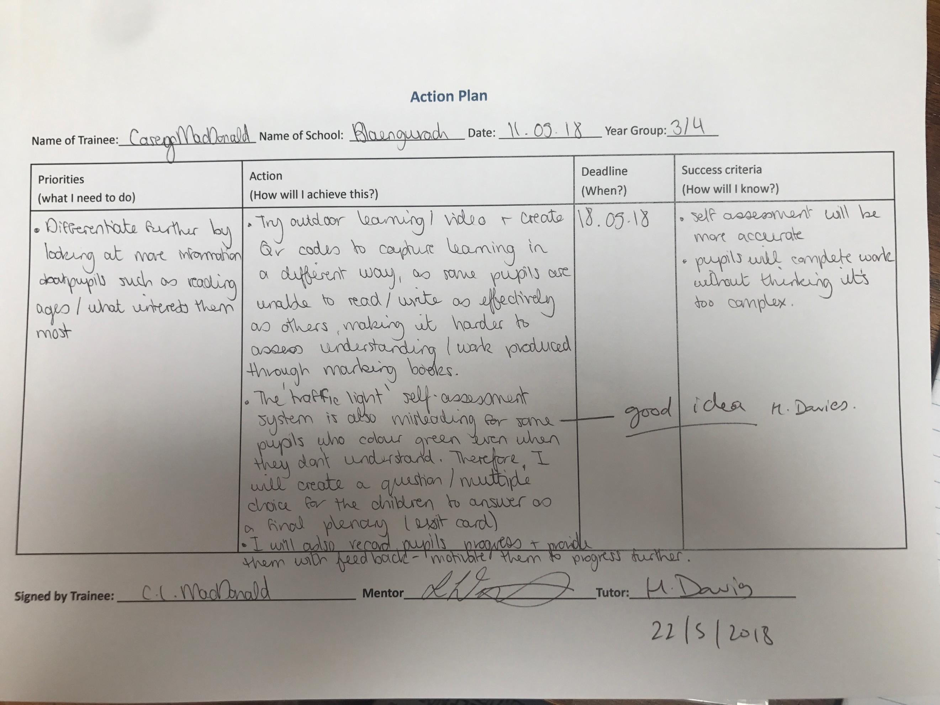

Appendix 8:

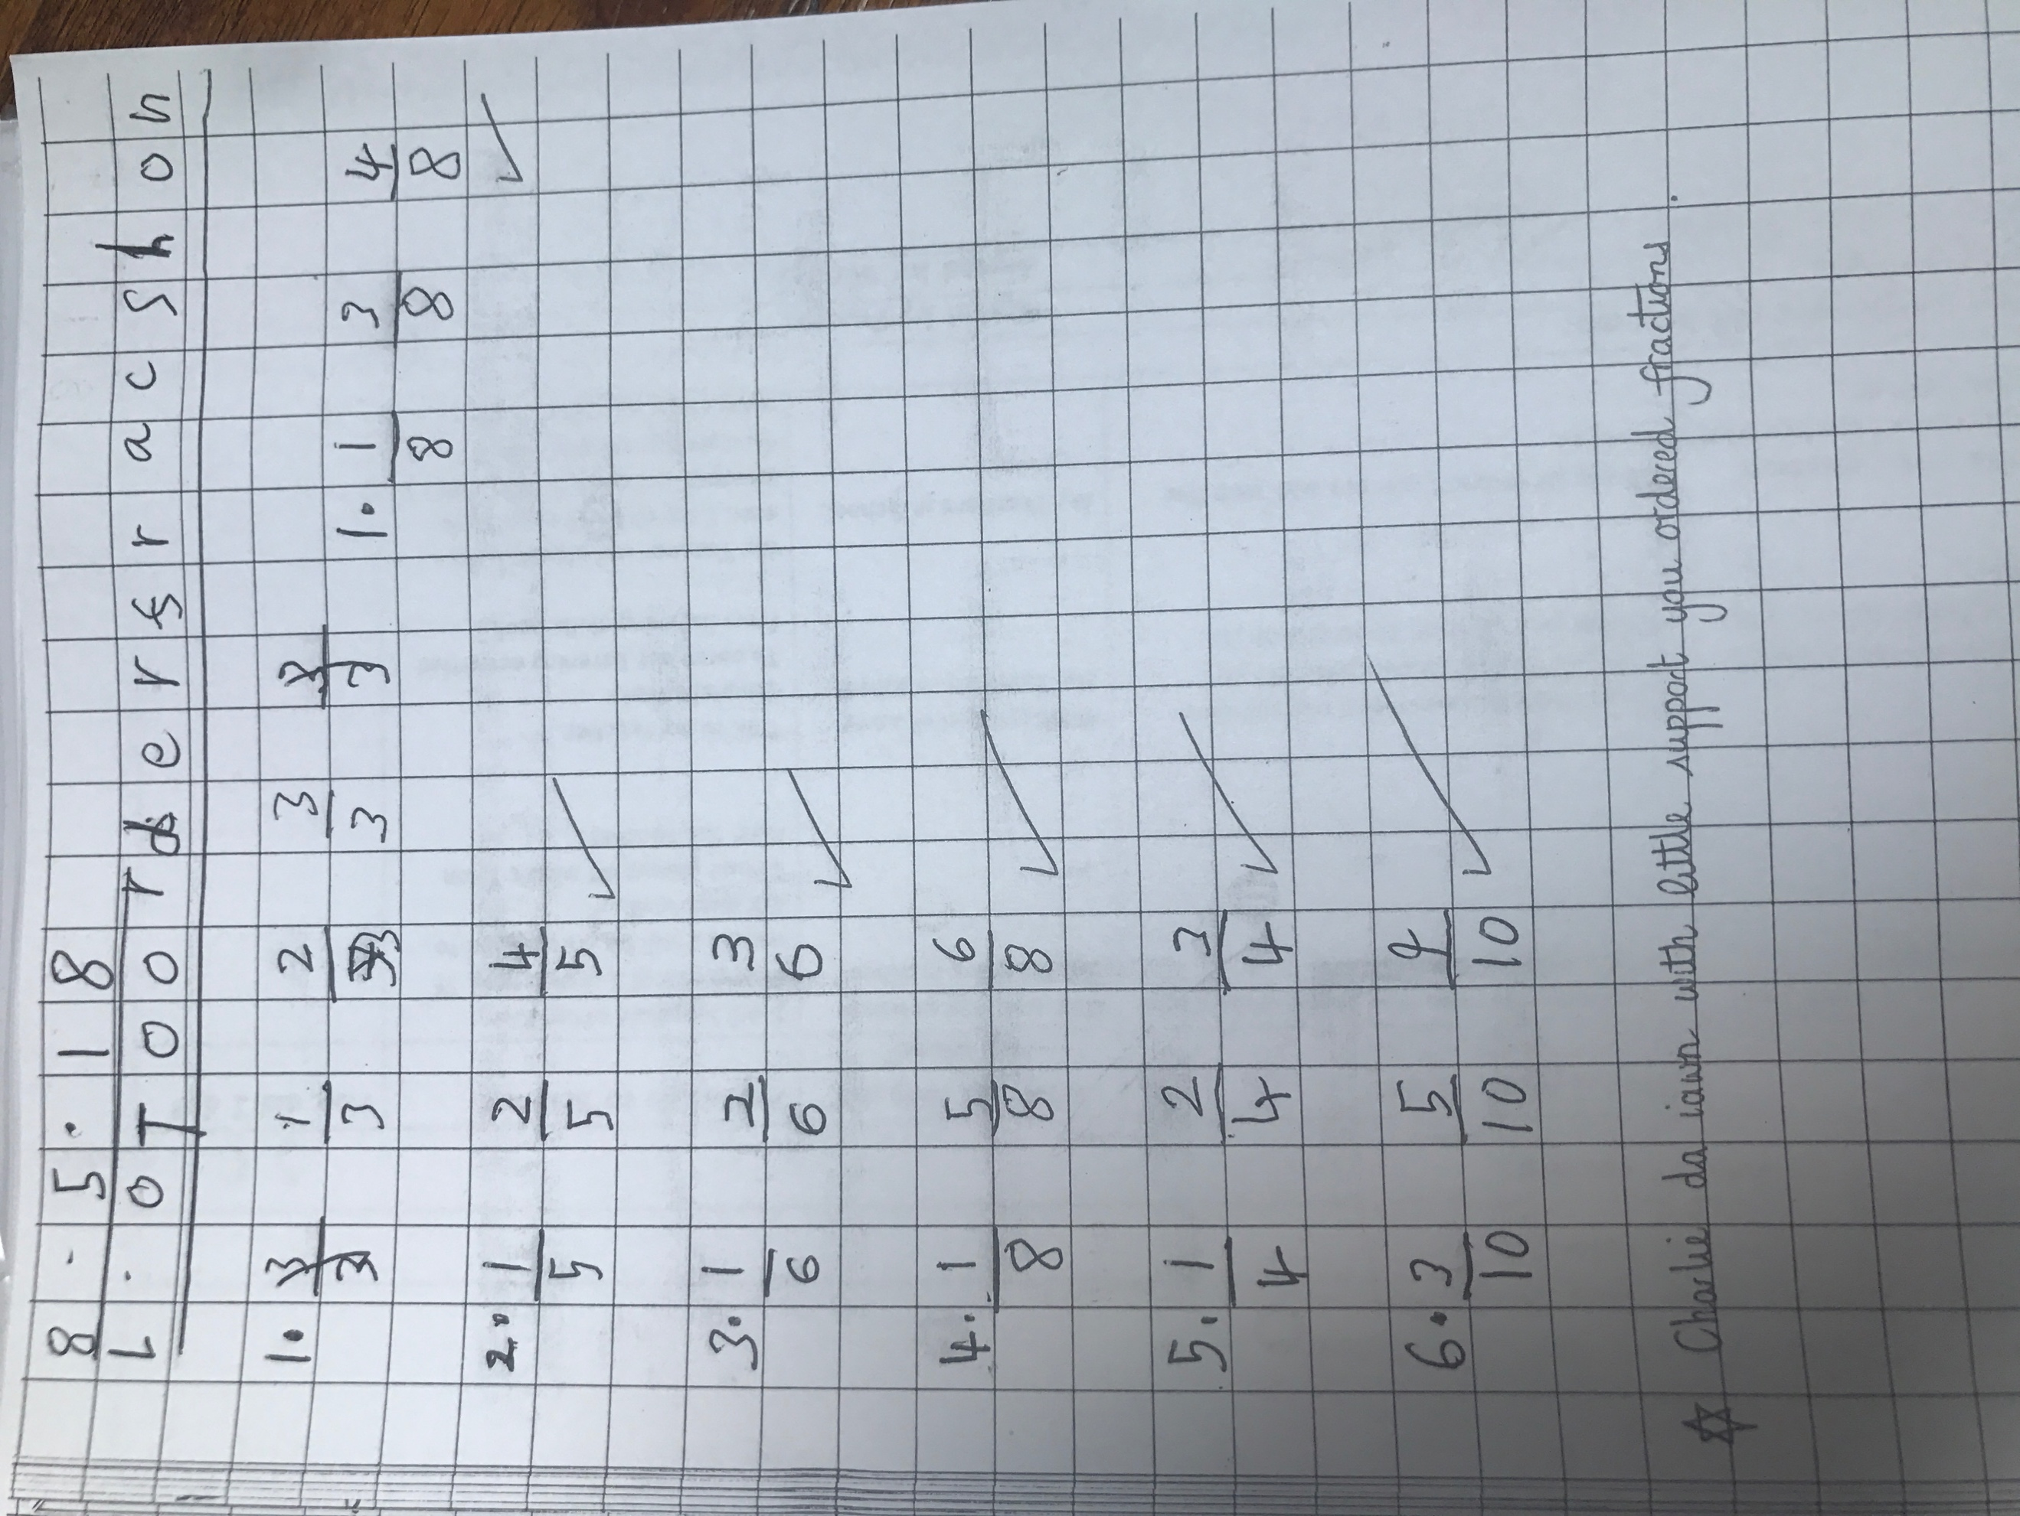
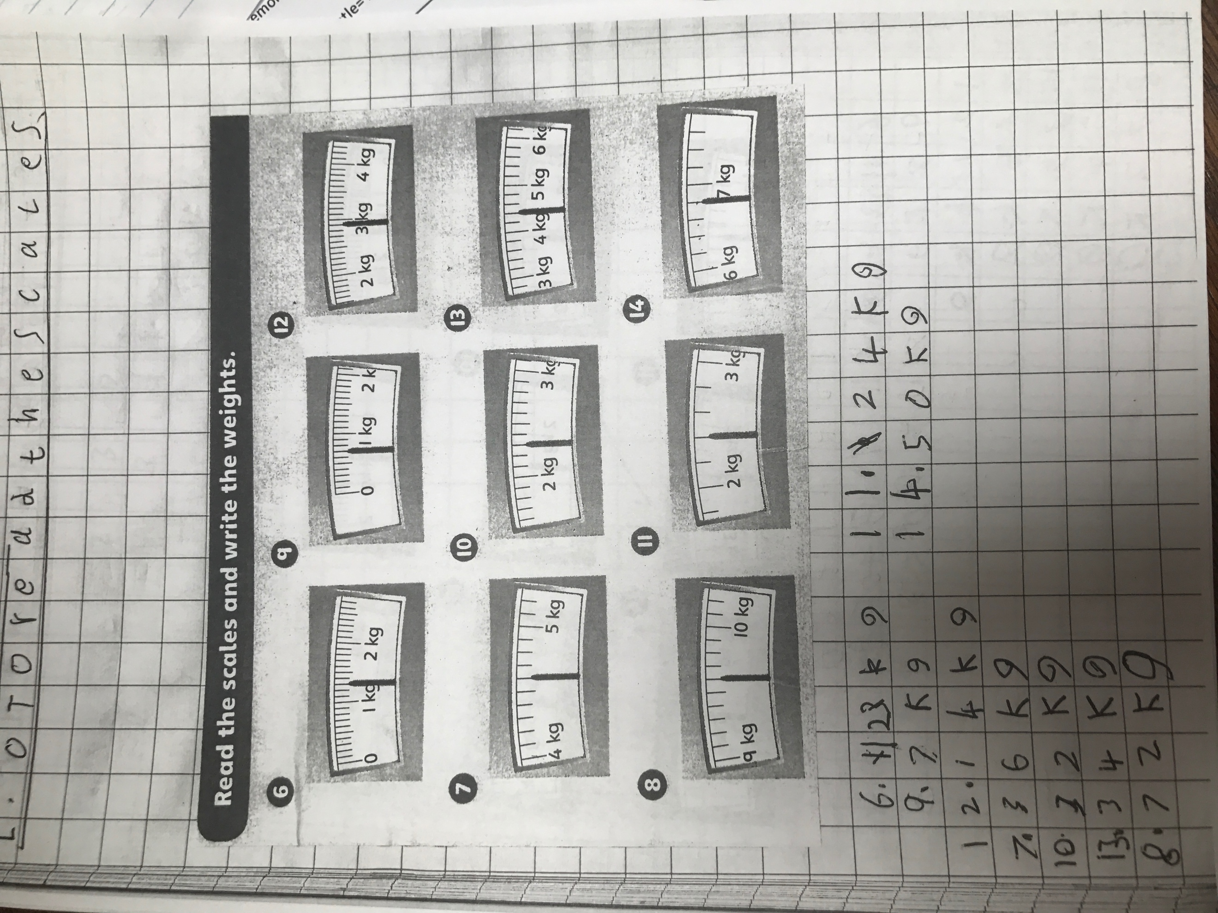

Appendix 9:

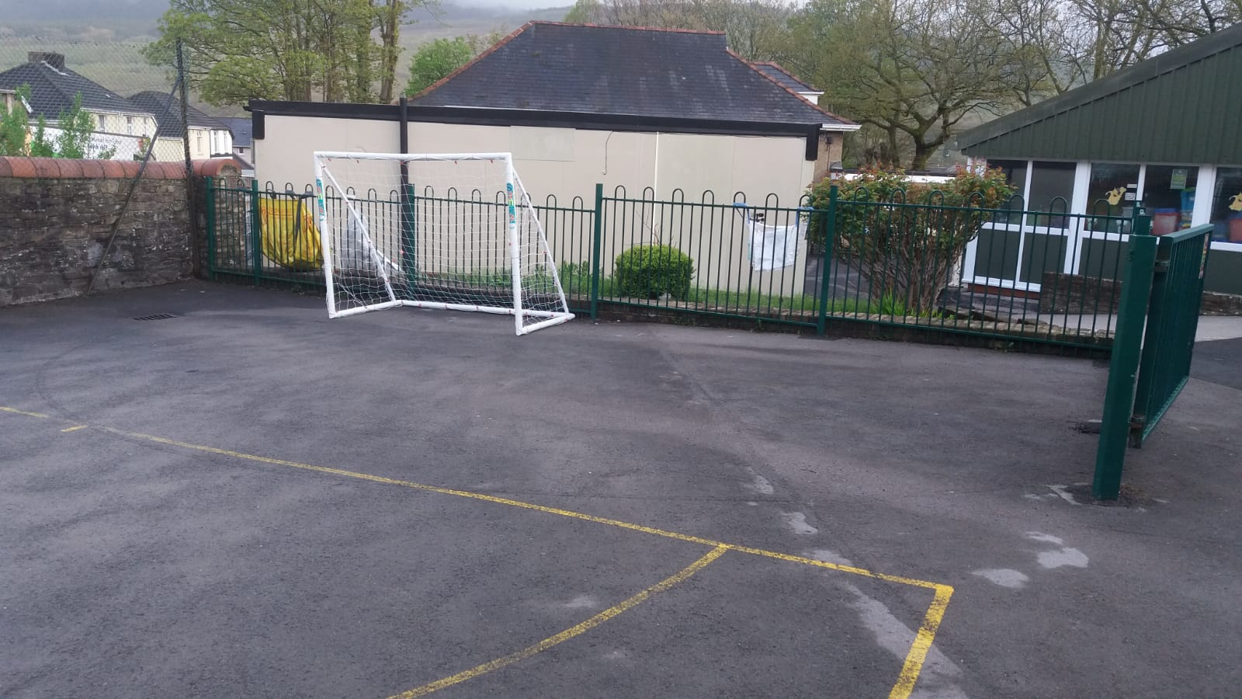

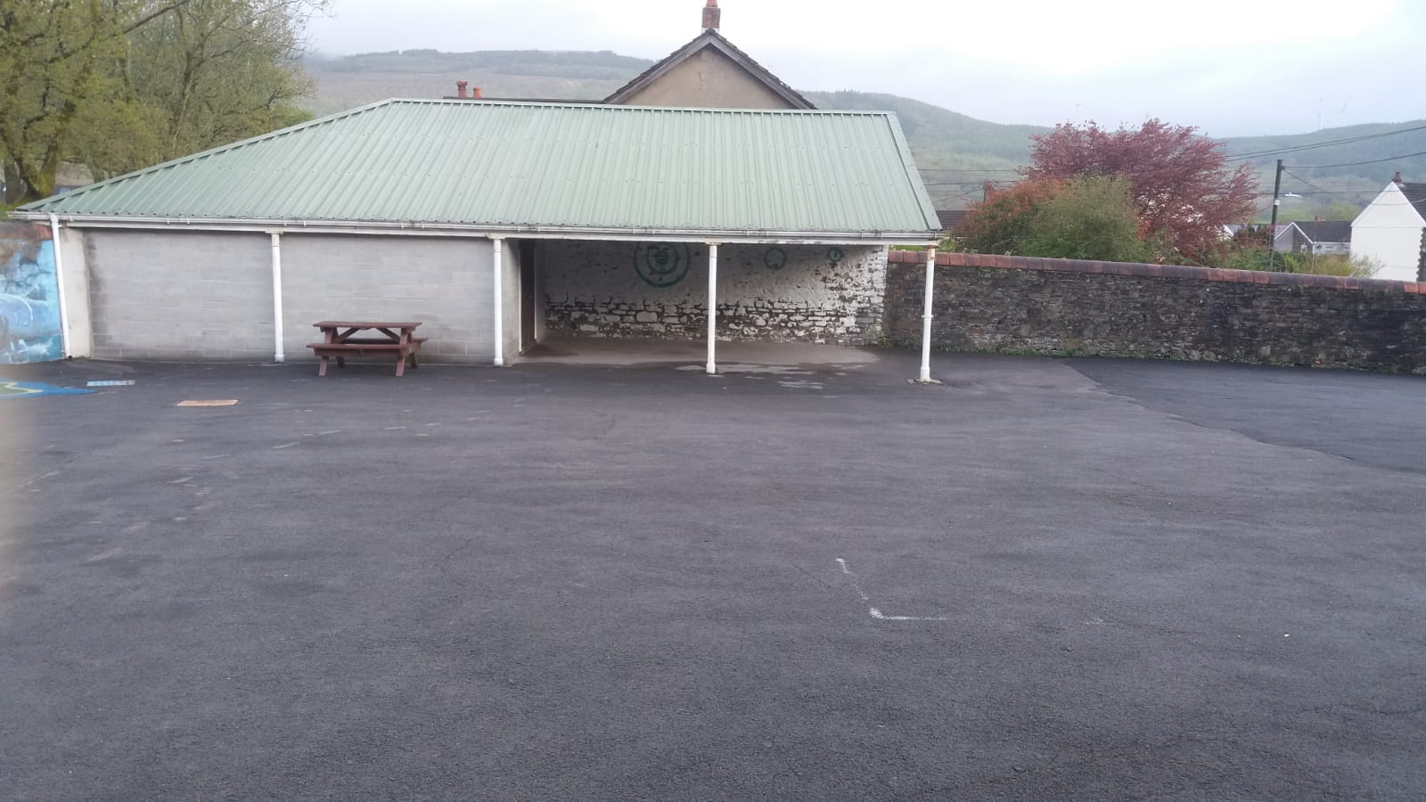

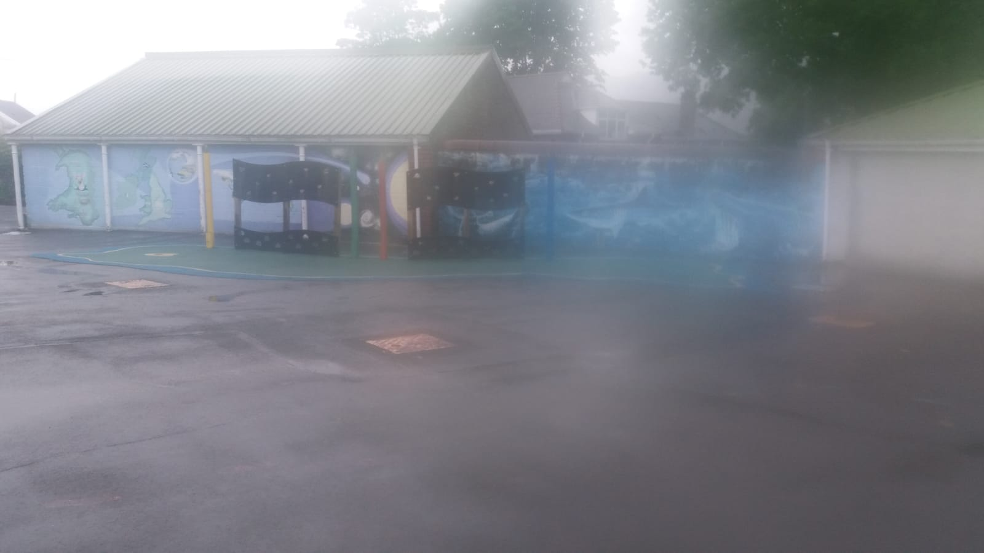

Appendix 10:

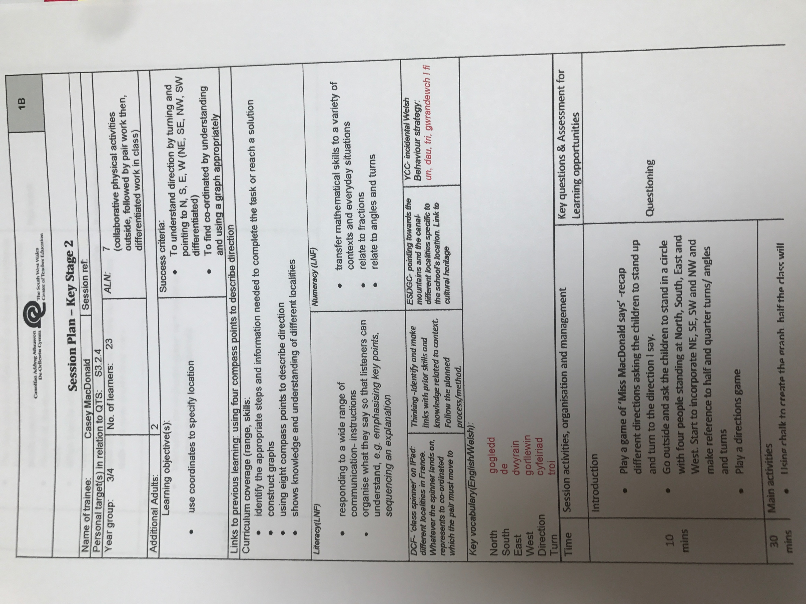

Appendix 11:

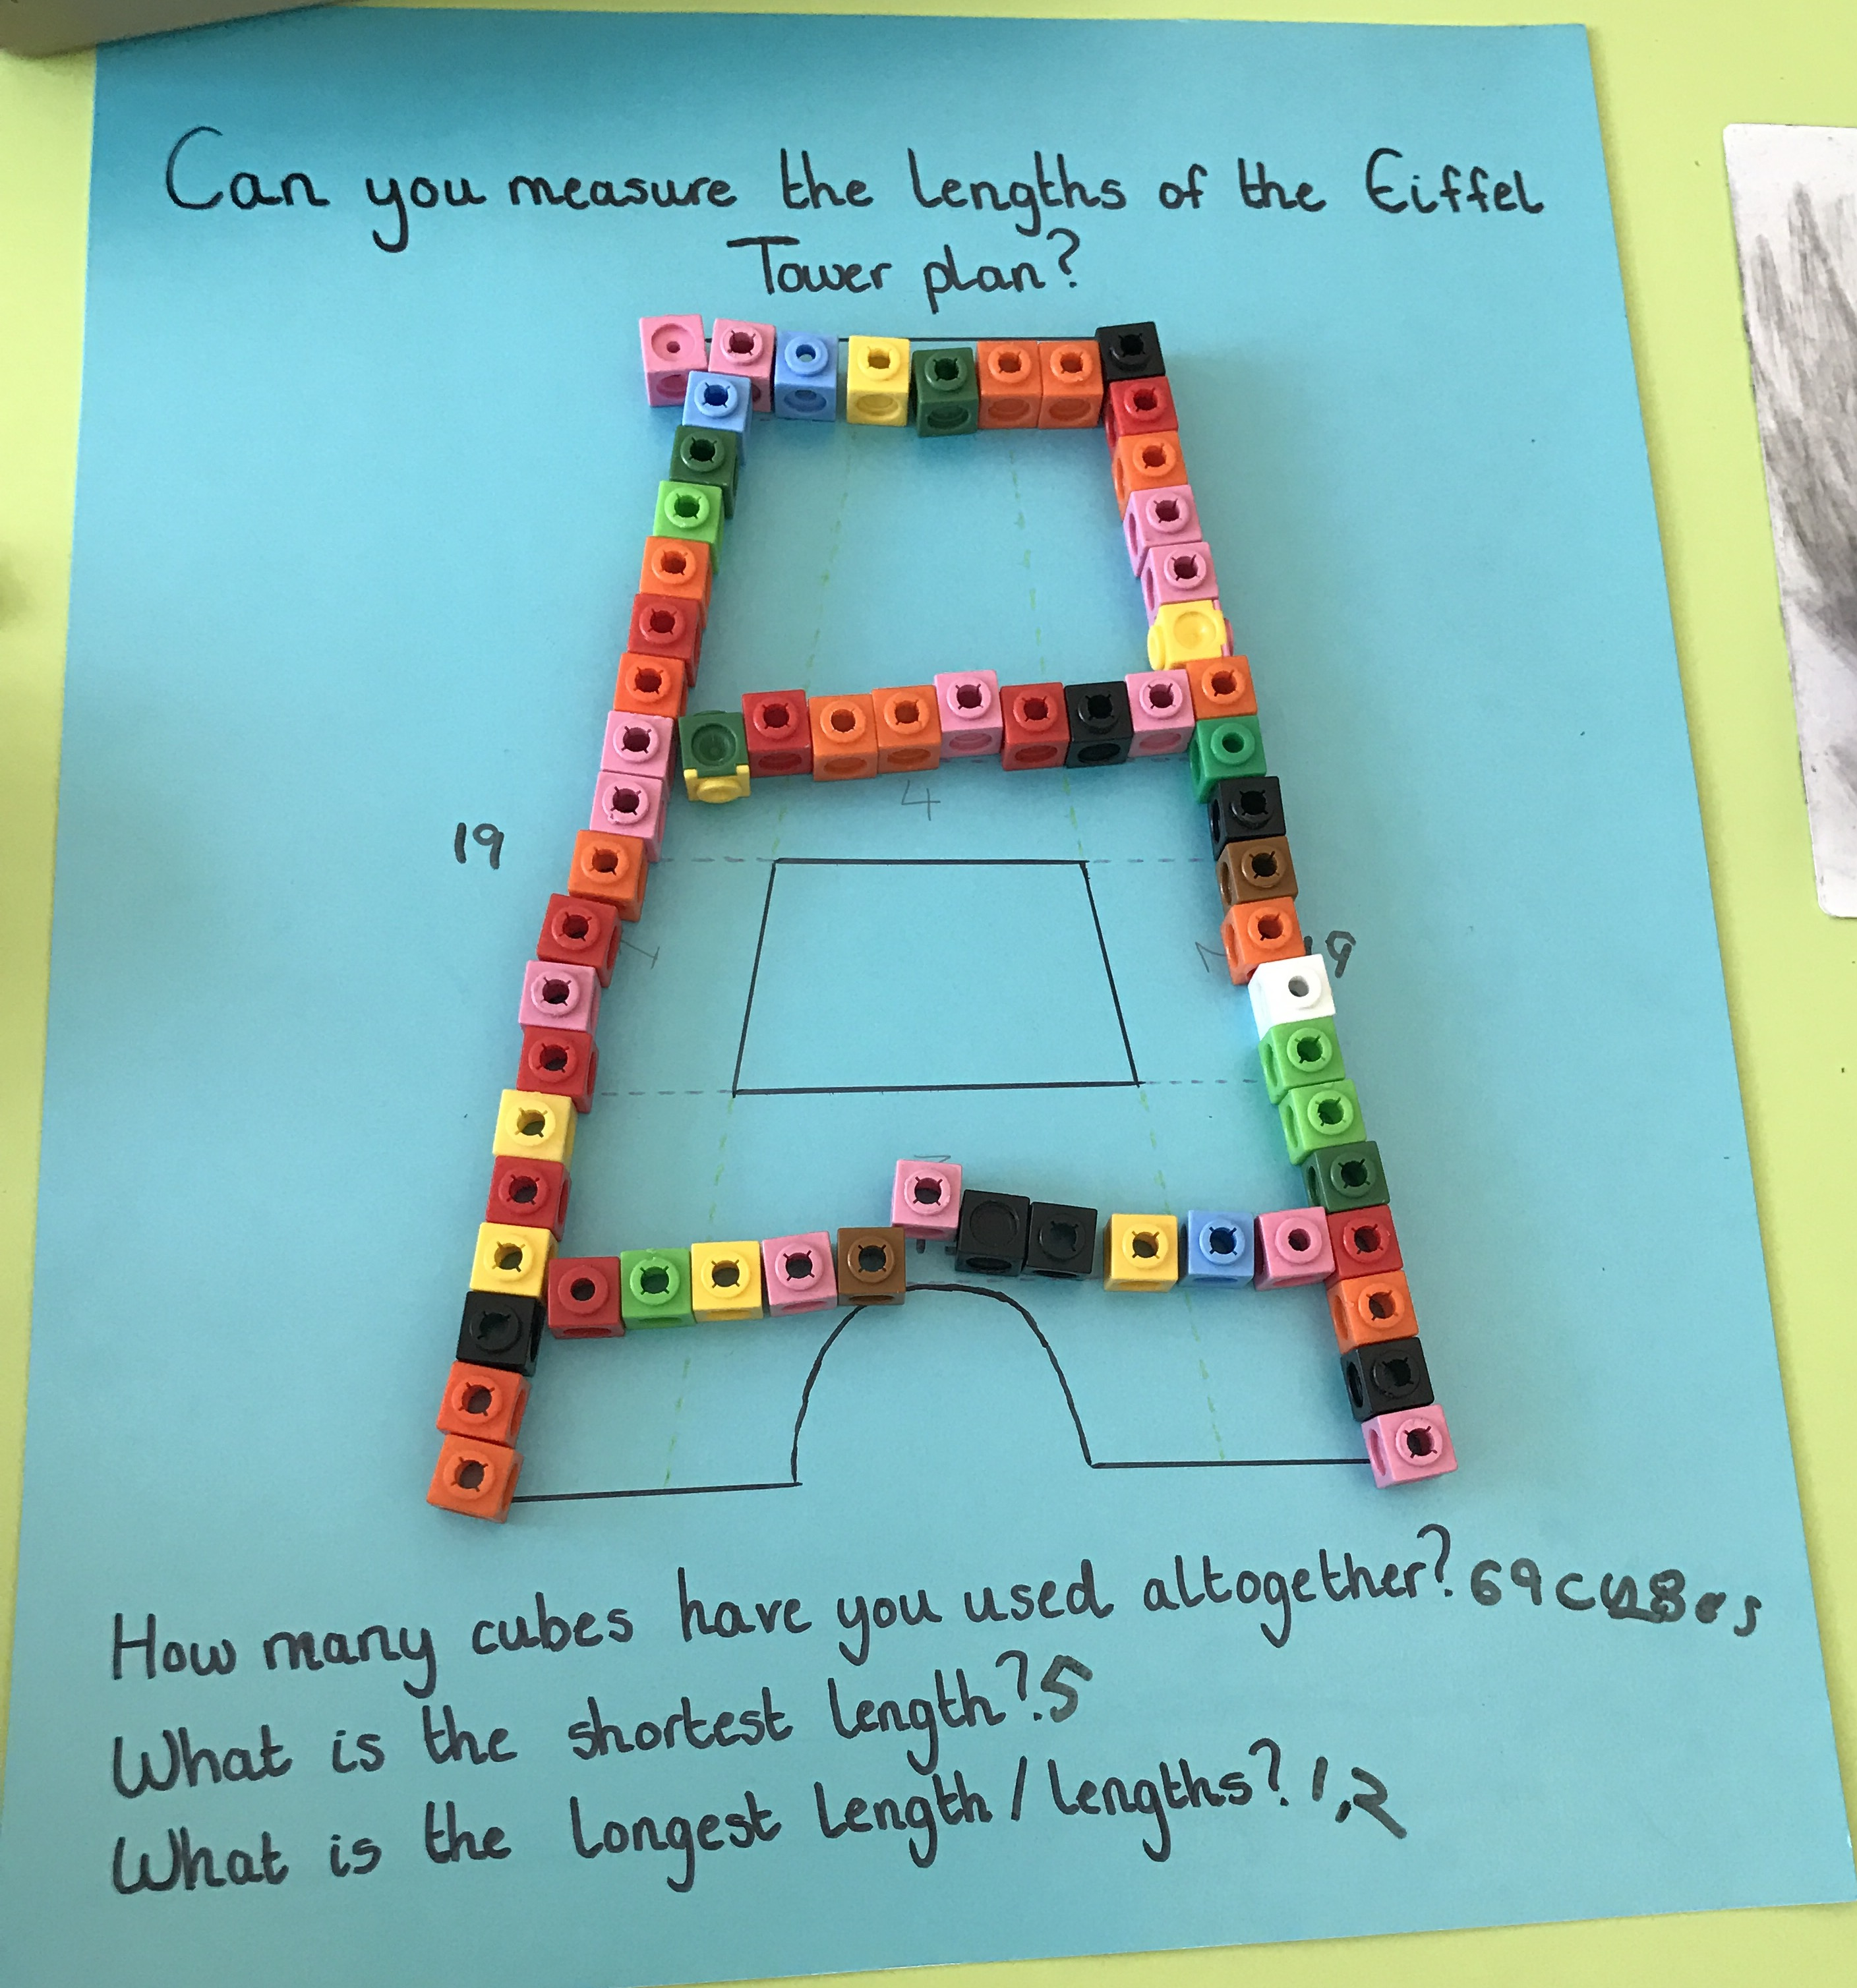

Appendix 12:
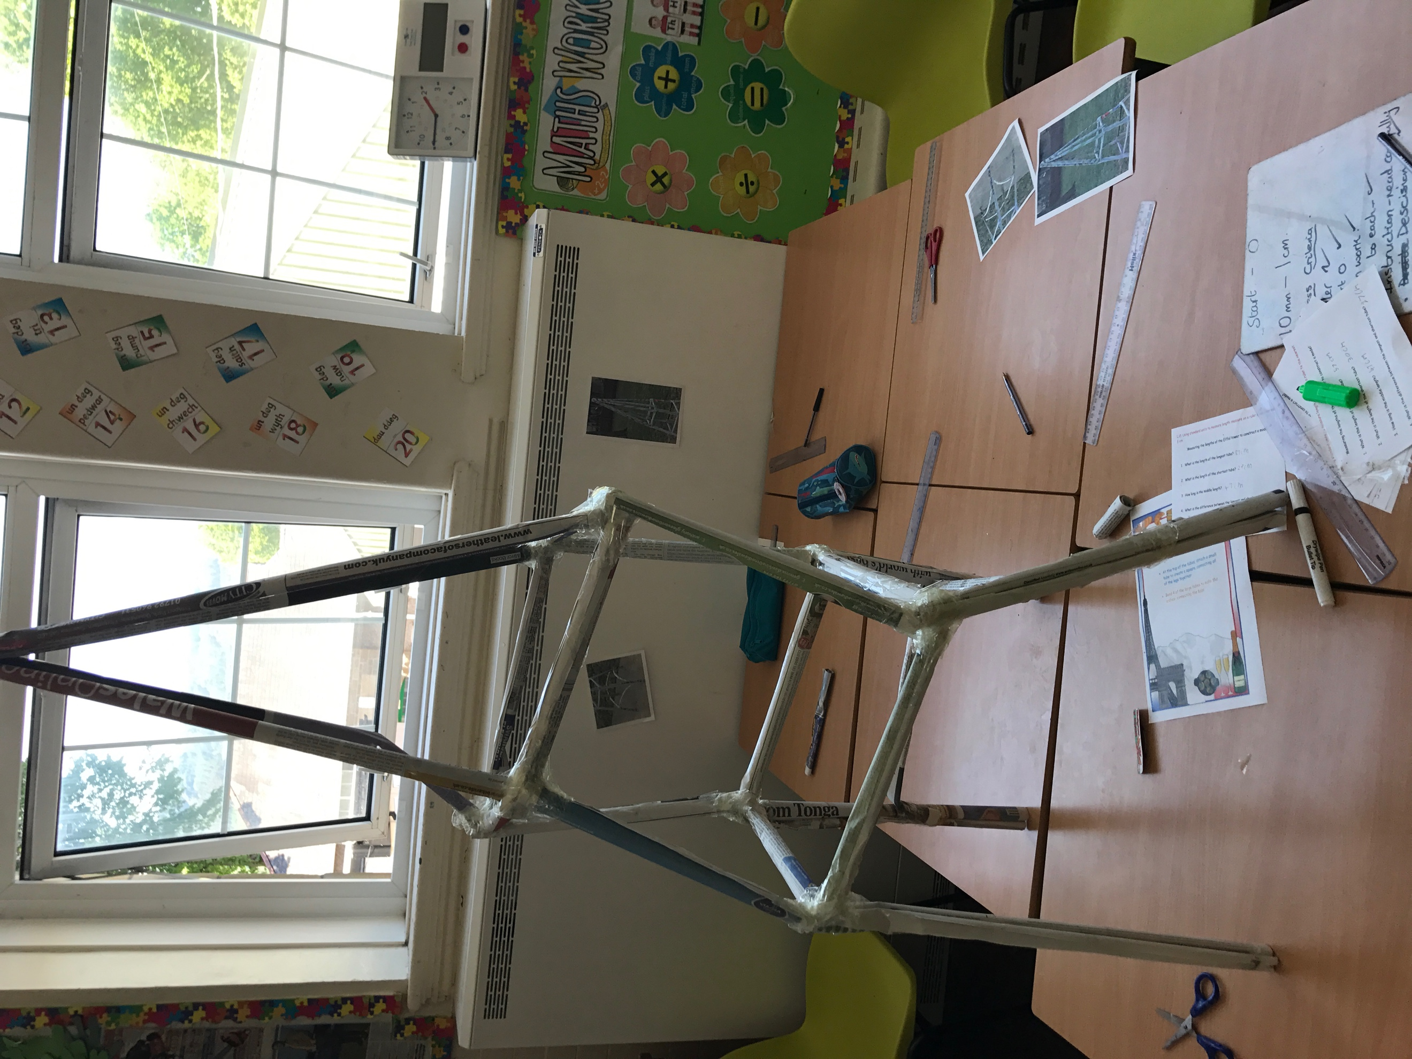

Appendix 13:

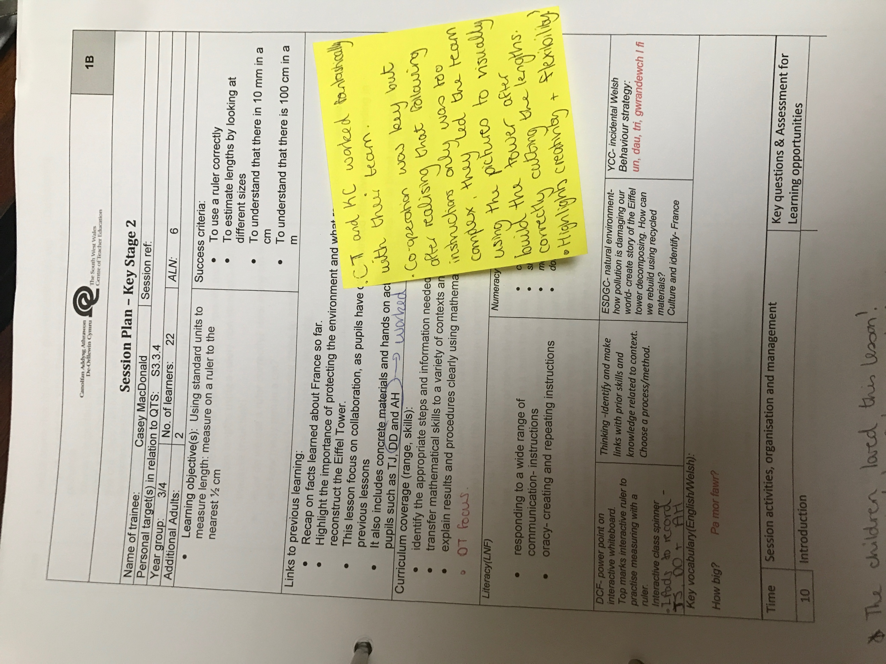

Appendix 14:

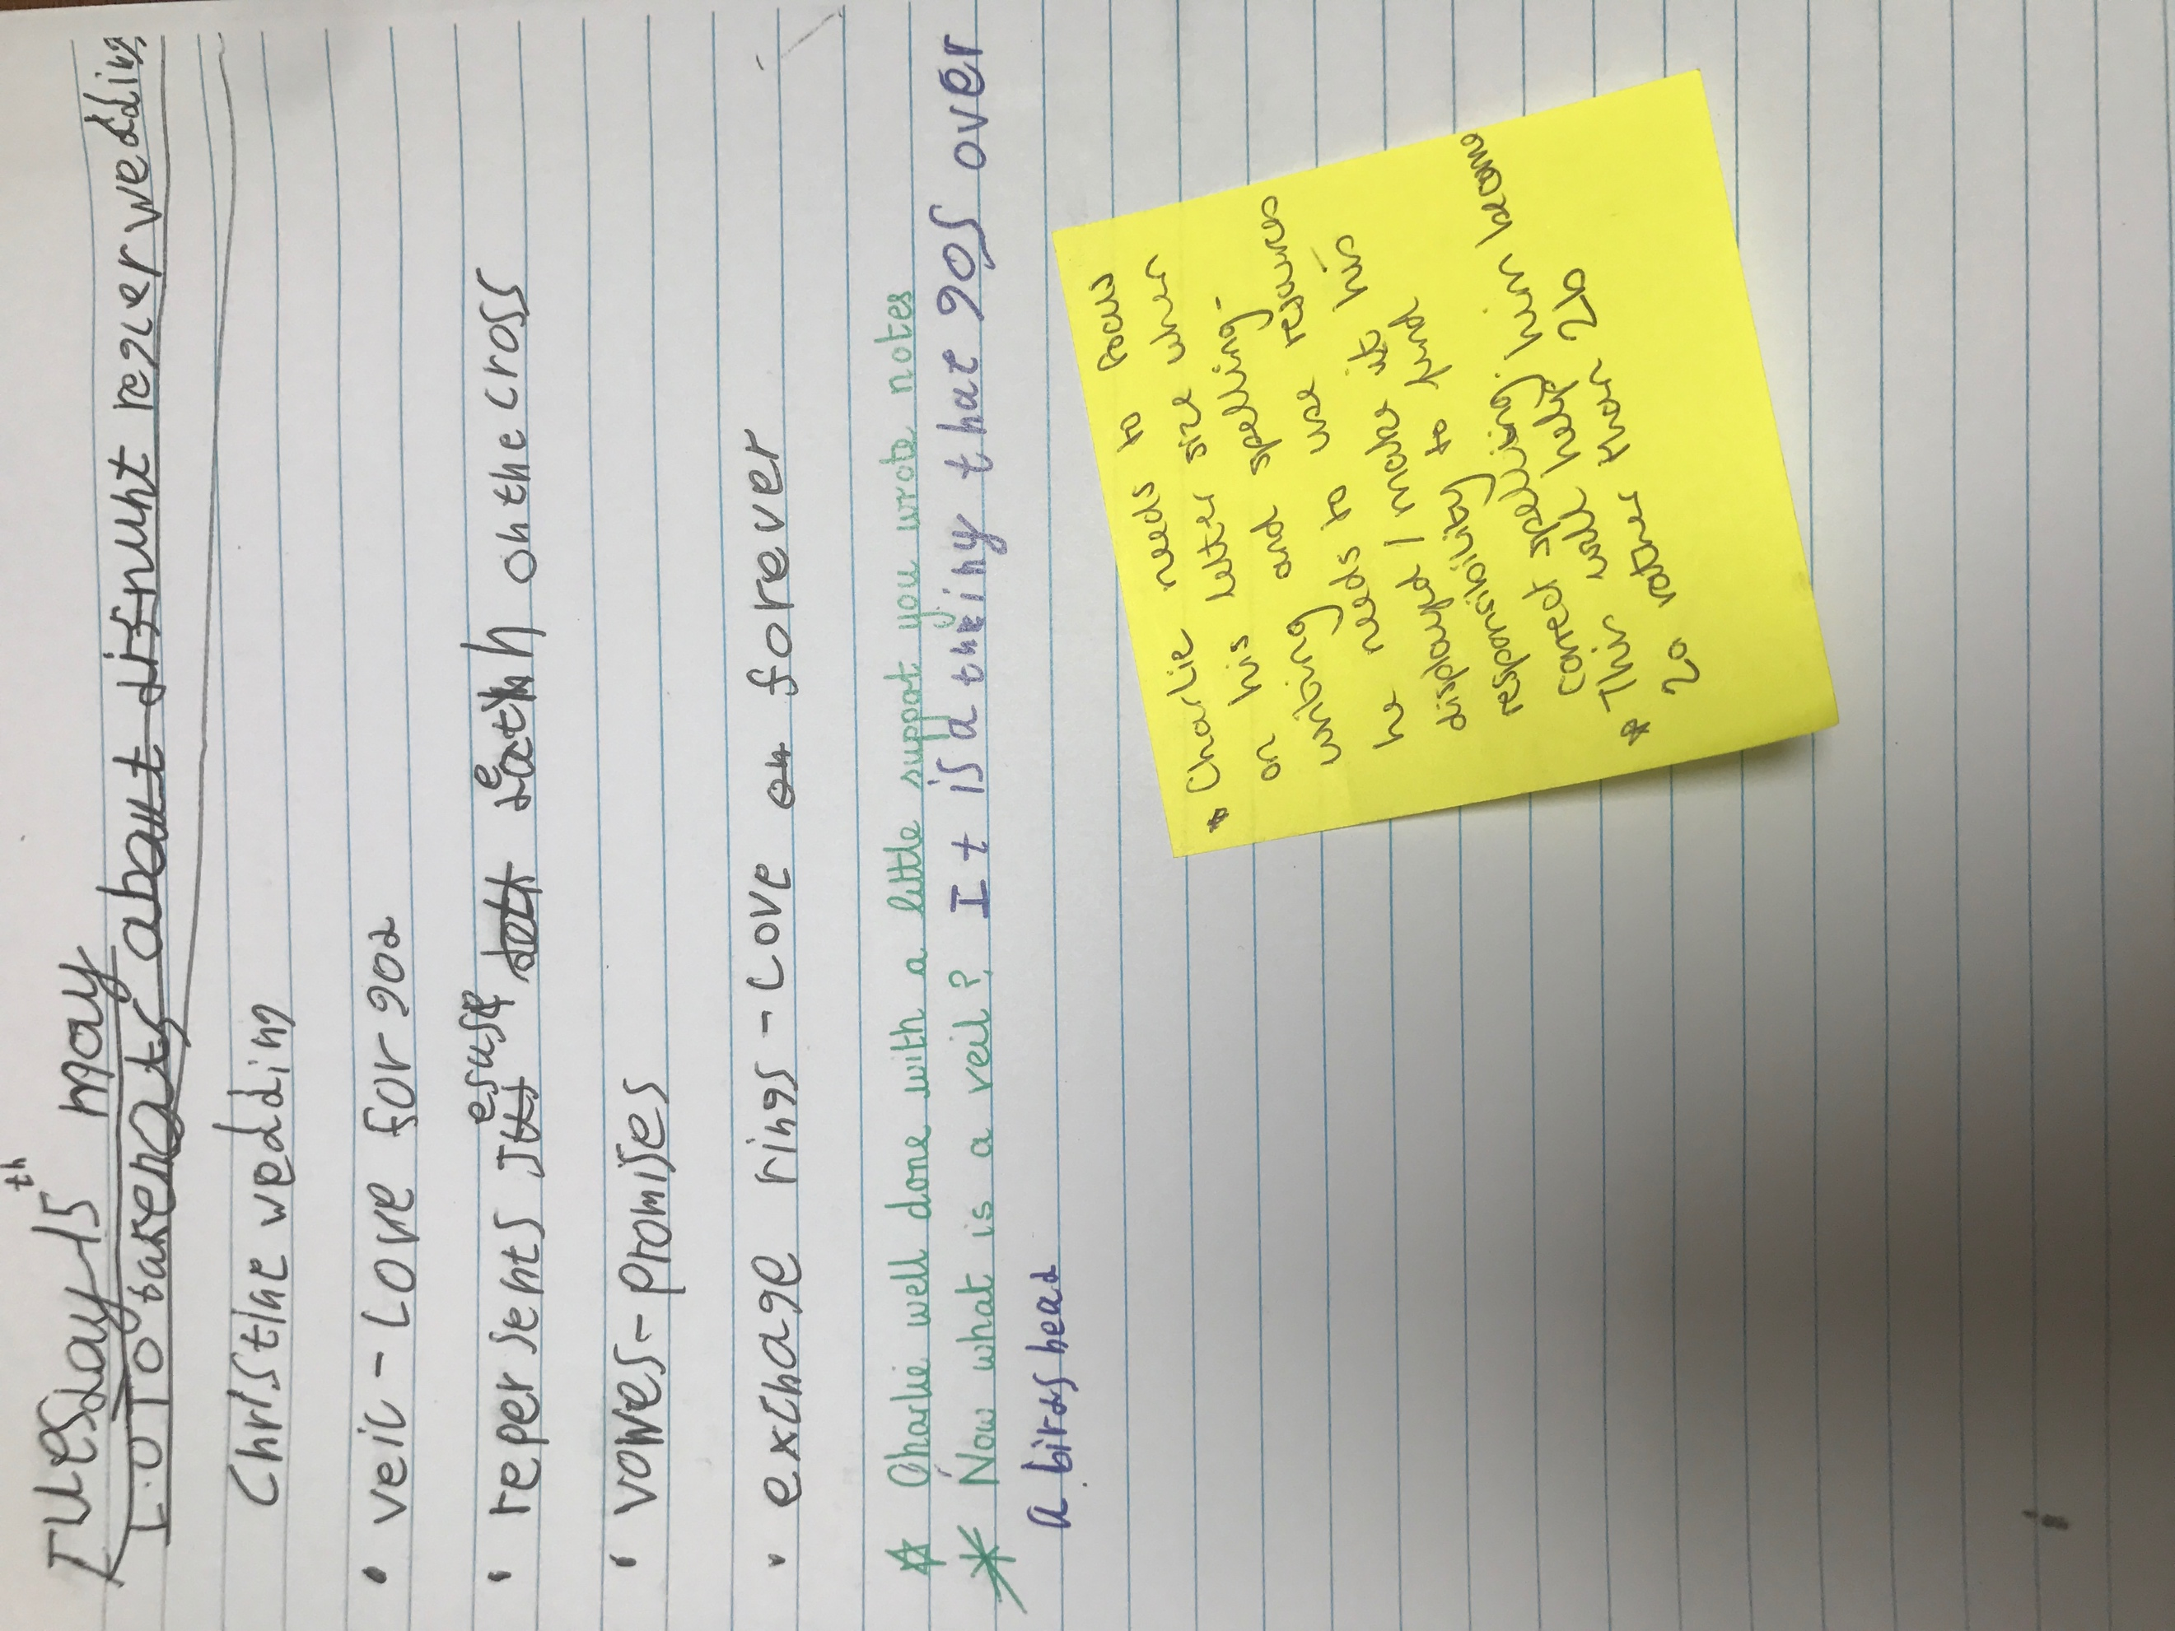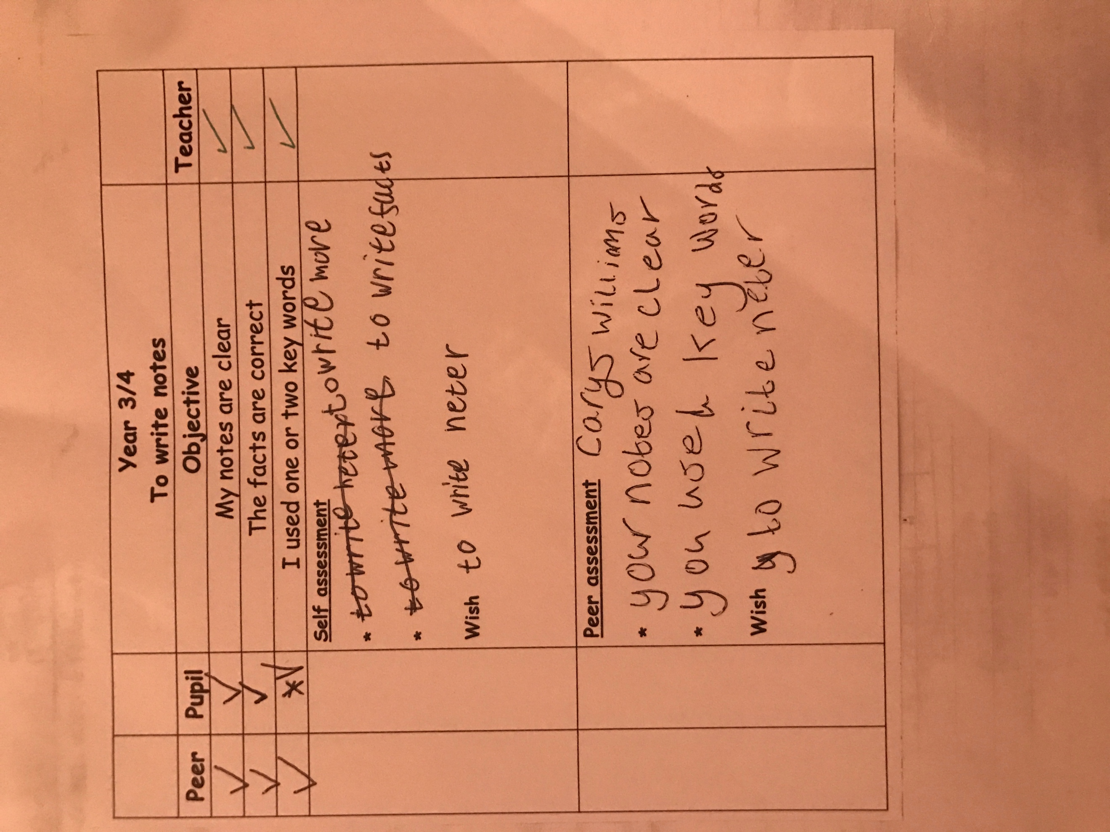

Appendix 15:



