FLORIN TALOS

FLORIN TALOS
1908806
Assessment 2 market research & website
BMSW4003 Digital Skills & Research Methods

Website login details
Email address: uwtsd1908806f@gmail.com
Password: madalina2015

Hello , my name is Florin Talos. Student nr is 1908806.I want to open a Business which will help me fulfill my desire to be my own boss. I create a questionnaire to find out a good business idea. I will examinate the questionnaire to see wat businesses are good. I am verry disappointed because I didn’t received to many answer, but I will see probably some god ideas .

Primary research its verry important because I can understand what customers looking for. If you want to hear something from customers questionnaire are the best option. Questionnaire can create a god dialog whit my target audience, gathering customer intelligence and transform their intelligence into action and marketing . I can build a bank of information that will make me more well informed.

At my questionnaire I receive 14 answers. I was expecting more people to help build my business and to listen their thoughts .

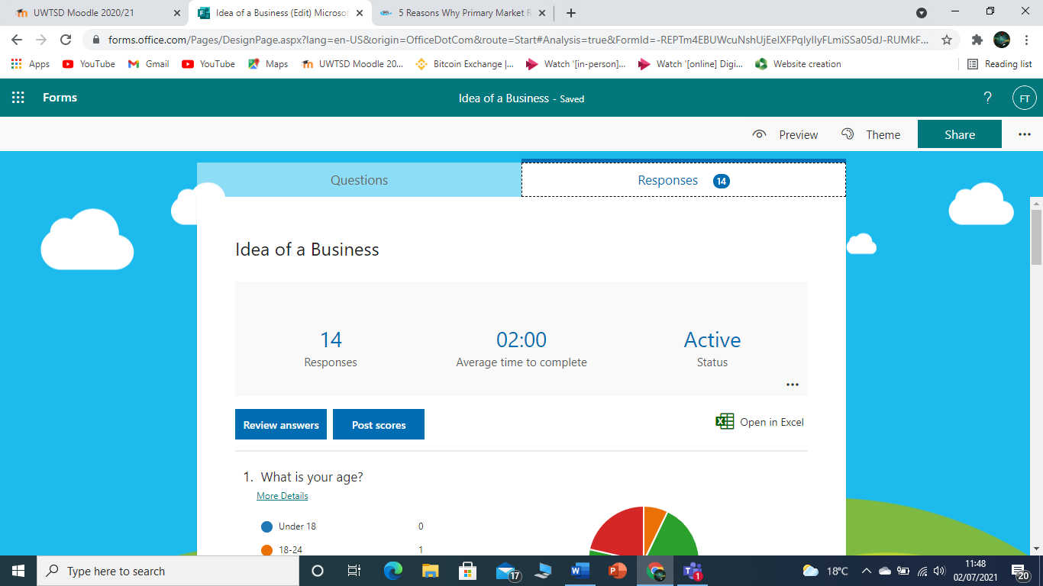

Age
Analyzing the finding from the below questionnaire I can clearly see that people under 18 years old didn’t want to answer. Age between 18-24 only 1. Age between 25-34 10 people .
And 35-44 was 3 people. The age is one of the most important in a questionnaire . this help determinate what age ideal is to determinate target . it is very unlikely that a retired person will answer to this questionnaire . The age is a criteria to build a business base.

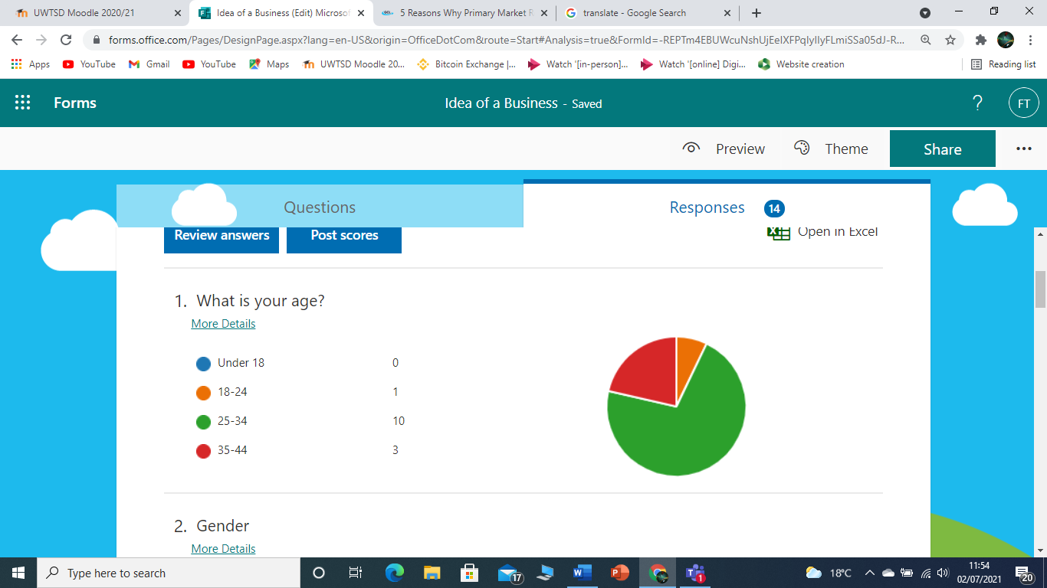

Gender
Gender survey in a questionnaire can have a huge effect on their way of thinking . Man can have a left hemisphere will women can have both . Women are more aware of their emotion than men .
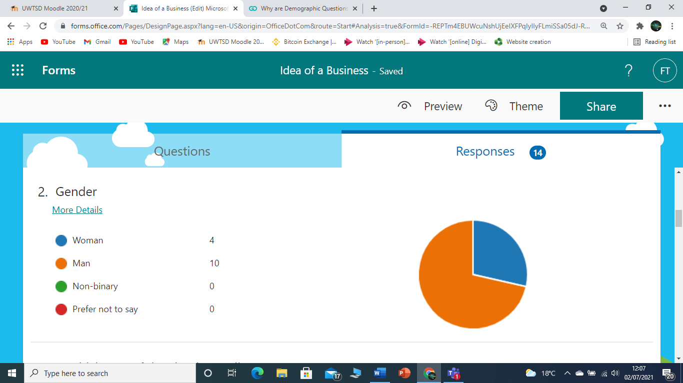

Marital status

Marital status can affect the way he answer to the survey . If you ask a single woman about her priorities ,her answers will circulate around her and her parents , but if you ask a married woman her answers will be around her husband and home .

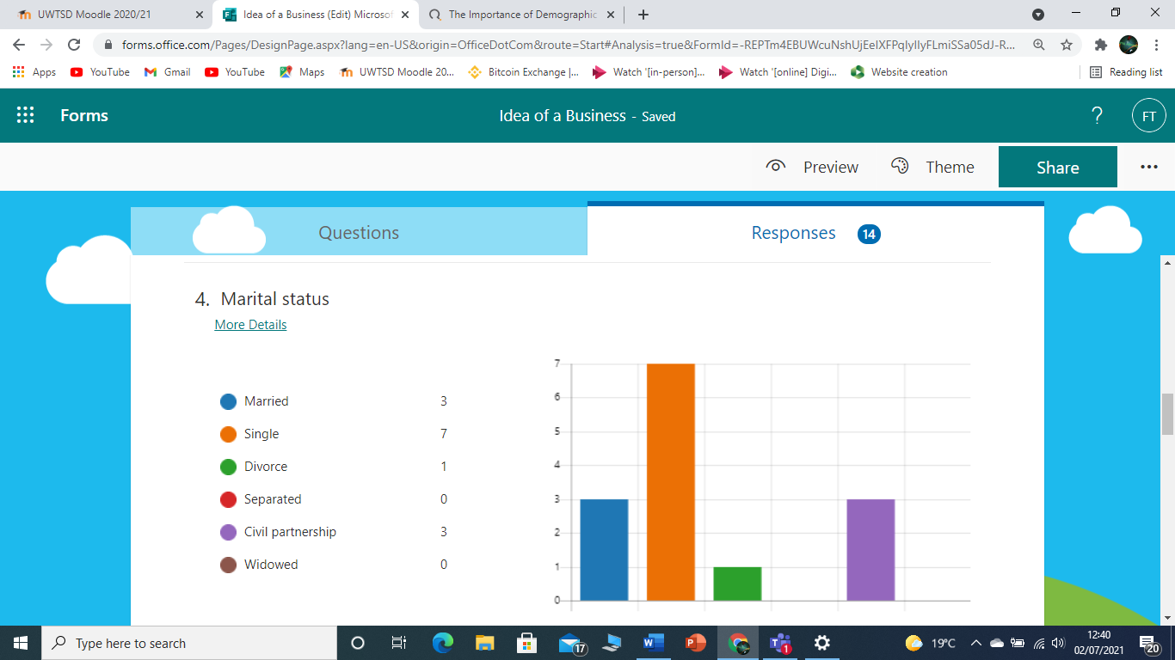

Website design

The questionnaire help me easy and free for collecting data for my business .
But unfortunately this time didn’t help . So I start doing by myself .

I chose to do a website about Local burgers done right . I chose this type of business because I am a food delivery driver for Uber and I collect a lots of order from burgers shop. I notice that this business its verry god. This type of business is more and more popular . I chose this image because its locks so tasty. Done whit natural ingredients , I even include a local craft beer whit over 20 type of beers . To help and promote local communities .



