

International BusinessLCMB7014
HARLEY DAVIDSON INTERNATIONAL BUSINESS IN AUSTRALIA
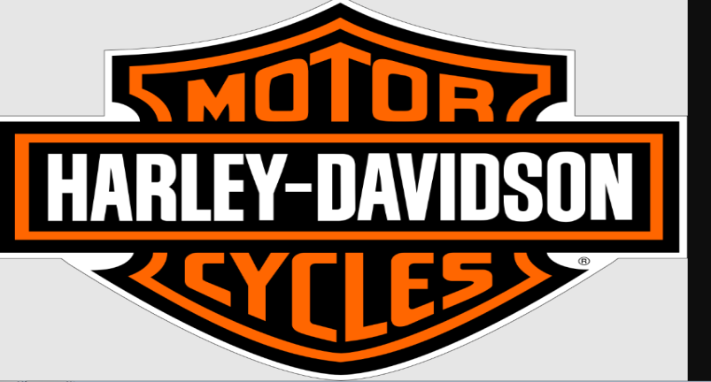

Student name: Dishant moradiya
Student Number: 2213506
Lecturer: Dr Hossein Shokri
Submission Date: 3 may 2023
Table of Contents
Introduction 1
Company Background 2
Company’s Objectives and Strategies 3
Countries’ Specifications 4
Home Country 4
Australia 4
External Analysis 5
A Comparative PESTEL Analysis 5
Industry Five Forces 7
Market Analysis 9
Australia Analysis 12
Country’s National Diamond 12
Country Business Risks 12
Internal Analysis 13
Global value chain 13
SWOT analysis 14
International Strategies 15
Entry Modes 16
Corporate Social Responsibility 17
Conclusion 18
References 19

Introduction
An international strategy can be defined as the first approach that most businesses consider before global expansion with various types of entry mode strategies such as exporting or importing goods and services by maintaining a head office in their home country. In this competitive business world, every business wants to make a full proof plan for the internationalisation strategy by assessing the market risk and opportunities involved with the host or targetted country on which the business or the organisation would try to expand its business outlets (Hesterly and Barney, 2014). However, proper external and market analysis is highly significant in order to create a potential internationalisation strategy as proper analysis of the industry or the market helps marketers to assess its associated opportunities and key weaknesses before making any potential investment in this Australia or market. In this study, the organisationHarley Davidsonhas been taken into account as the case study organisation in order to analyse its internationalisation strategy. Moreover, different theoretical frameworks such as PESTLE, SWOT and Porter's five forces have been applied to assess the industry as well as market analysis both for the home country (USA) as well as for the Australia.

Company Background
Harley Davidsonis a renowned motorcycle manufacturer in America which is headquartered in Milwaukee, Wisconsin, United States. The company is famous for its unique style of customization that provides an increase to the chopper motorcycle style. In addition, the company is found to traditionally market their air-cooled cruiser, heavyweight motorcycles with engine displacements greater than 700 cc. However, now the company has broadened its market offering in order to be relevant to the contemporary market which includes middle-weight Street (2015) platforms and VRSC (2002). Harley Davidson has survived various subsidiary arrangements, ownership arrangements, strong global competition, and periods of poor economic health which helped the company to become one of the world's leading motorcycle manufacturers. Moreover, the company has become an iconic brand due to its loyal following. Apart from that, the company has a wide range of manufacturing units in different countries like Thailand, India, Manaus, Brazil, York, Pennsylvania, Milwaukee, Wisconsin and Pluak Daeng. Based on the global motorcycle-associated retail sales of the company Harley Davidson, it has been observed that globally the company shipped around 178,500 'hogs' in 2022, among them most of the retail sales were in the US, following Canada, Europe, the Middle East and African countries (Harley-davidson, 2023d). Around 109,190 units of motorcycles are sold in the US market which is the highest sales among all the markets in which the company deals (Harley-davidson, 2023d). However, it can be noticed from the below-graphical representation that the company has witnessed around 7.7% of retail sales decline between 2021 and 2022.
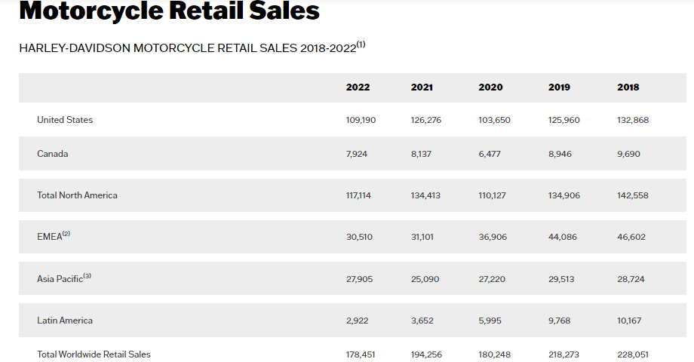
Figure 1: Harley-Davidson's global motorcycle-associated retail sales between FY 2018 and FY 2022, by country or region
(source:Harley-davidson, 2023d)

Company’s Objectives and Strategies
Objectives of Harley Davidson
The company Harley Davidson has sharpened its objective outside the US through 2027 by planning to grow its international business to 50% of its annual revenue (PRNewswire, 2019). However, in the US, the company has aimed to create around 2 million new riders by focusing on the riders only who have associated with the brand in the current year. In the US, based on the data from 2017, there were approximately around 3 million riders who use motorcycles manufactured by the company Harley Davidson. Thus, the company is planning to expand to 4 million Harley Davidson riders in total in its home country through the year 2017. Thus, in simple words, the overall objective of the business of Harley Davidson has been found that it is trying to amplify its brand power in order to attract its global customers. In addition, the aforementioned objectives of the organisation show its broader efforts in relation to attracting new customers as well as retaining its old customers each year.
Strategies of Harley Davidson
In terms of company strategy, it has been identified that Harley Davidson is mainly focused on the long-term business strategy as it prioritises people, profit and the planet at the same time. The company is striving to render long-term value to its all associated stakeholders (customers, employees, dealers, suppliers, society and investors), profit and the planet (Harley-Davidson, 2023a). Moreover, the company mainly relies on the aspect of inclusive stakeholder management to promote their role in society which gives them a strong purpose beyond the conventional financial performance (Harley-Davidson, 2023a). Within the company strategy, some highlights are building a diverse and inclusive workforce, creating a path towards reaching the goal of net zero emission, driving shared prosperity, and making an impactful contribution to society through community investment (Harley-Davidson, 2023a).

Countries’ Specifications
The company Harley Davidson is an American motorcycle manufacturer which is in its home country but now the company is trying to expand its business to another Australia. In this context, the company Harley Davidson is trying to expand in Australia so it is the host or targetted country.
Home Country(US)
The US is the home country of the organisation Harley Davidson where the company witnessed the highest number of retail sales among all its key markets in 2022 which was around 125,713 (Harley-davidson, 2023d). Moreover, based on the home country revenue, it has been found that the Revenue of the company Harley-Davidson from its US market is estimated to reach $233.51 billion by 2031(Alliedmarketresearch, 2023). In addition, Revenue is hoped to exhibit an annual growth rate (CAGR 2023-2027) of 8.6% which results in an anticipated market volume of US$3.06bn by 2027(Alliedmarketresearch, 2023). Thus, the revenue and potential market growth forecast is highly showing the strong possibilities of its US market. Apart from that, the government of the United States is also supporting the automotive industry in order to generate more revenue as well as to encourage FDI flow in the nation’s automotive sectors (Researchandmarkets, 2023).
Australia(Australia)
As the company, Harley Davidson has aimed to expand its business in Australia so it is the Australia here. Based on the automotive market size of Australia, it can be measured by its revenue generated by the automotive industry of Australia which would be $165.8bn in 2023. Moreover, the market size of the country’s automotive sector is projected to grow by 6.3% in 2023 (Ibisworld, 2023). Moreover, based on the technological aspects of the host nation Australia is known for its research and development area which attracts most international students as well as business people to expand their business line over there. In this regard, a better research and development facility in the Australia would allow the business of Harley Davidson to facilitate its production as well as supply chain management strategies in order to have a more improved internationalisation strategy at the same time. Moreover, in terms of the application of blockchain based technologies, the country has gained a well-position in the global market which also attracts business people to start their businesses over there due to greater financial management opportunities.

External Analysis
In order to analyse the external market of Harley Davidson, the US market on which the company mainly operates its majority of business has been investigated. As opined by Anderson et al. (2019), the PESTLE framework is a vital tool for marketers as it helps to figure out different market factors from economic and political aspects to technical and legal aspects as well. In order to manage proper external market analysis, the PESTLE framework has been applied in this section:

A Comparative PESTEL Analysis
Factors | Comparative PESTEL Analysis of US and Australia
Political | - The political environment of the US is stable  - The country has good international relations with Europe and China which provide assistance to business people to spread business over the global market  - The political condition of Australia is stable and freen tarde agreement of Australia with New Zealand and several Pacific Island countries makes this nation growth on high peak (GOV, 2023a).
Economic | - The inflation rate in the US has amplified by 7.7% as compared to October 2021. Moreover, the annual inflation rate in the US has improved to 6.5% in 2022 from 3.2% in 2011 (CNBC, 2023).in recent years, US dollar purchasing power can be noticed as weak as compared to previous years. It means, purchasing power of US people may impact heavily due to weak dollar value in recent years which may hit the automotive market of the US severely.  - The real gross domestic product (GDP) of the US enhanced at an annual rate of 2.6% in 2022. This value shows an enhancement in consumer spending as well as in the nation's export (Bea, 2022)  - Mining and fuel sector of Australia accounted for 8.5% and 50.9% of the nation GDP (GOV, 2023a).
Social | - The disposable personal income of US people increased by $268.3 billion in the third quarter of 2022 (bea, 2022). This means customer spending in the US has increased to a large extent which is a good sign for the growth of the automatic sector to have high customer demand in the automotive segment as well.  - High living standard of Australian people as same as US people.
Technological | - Government support in the technological segment of the US is highly notable which is the key factor of growth of the automotive industry of the US. Based on the statistics from the report of BBC, (2022), the US has invested around $280bn in the high-technology segment in order to compete with the global technology leader China. Thus, huge investment from the US government in the field of the high-tech segment would help automotive organisations like Harley Davidson to leverage the benefits of the nation's technological advancements.  - The Commonwealth Scientific and Industrial Research Organisation is most trusted research institution of Australia which helps to facilate innovation in the country (GOV, 2023a).
Environmental | - The sustainability concern among the US people forces business organisations to ensure more responsible business activities to ensure a healthy planet to survive. In this regard, the strategies of Harley Davidson to prioritise people, profit and the planet is highly appealing to the mass of the US (Harley-Davidson, 2023a).  - Austrailian government is investing $1.9 billion in low emission technologies to support environment (GOV, 20233a).
Legal | - The government of the US formulated the “American Technology Leadership Act of 2022” which emphasizes making the nation a global leader in the field of technology and innovation (Congress, 2022). The strong legal support of the Us government in terms of fostering new and innovative business opportunities has helped Harley Davidson to explore different areas of technology to produce new and innovative products.  - The Fair Work Act 2009 is applied in the Australian organistions to manage their wporkplace system (GOV, 2023b).
Figure 2: The PESTLE framework
(source: self-developed)

Industry Five Forces
As per the identification of Mugo (2020), Porter's five forces are useful in identifying the potential of the competitive landscape before entering that industry or market. In this regard, in order to analyse the automotive industry of the US, Porter's five force framework has been implemented in this study.
Factors | Strategy | Impacts
Competitive rivalry | As per the view of Anastasiu et al. (2020), competitive rivalry implies rivalry among the market competitors. The automotive market of the US is highly competitive due to presence of leading market players like Polaris inc and Yamaha Motor. The company Polaris is known for making power sports vehicles. On the other hand, Yamaha Motor is popular for producing robotics, marine and land mobility solutions. | High
Suppliers power | As identified by Perera (2020), Suppliers power can be defined as dominance of suppliers in bargaining. The company Harley Davidson has multiple supplier bases which helps the organisation in managing bargaining power of suppliers effectively. In addition, in order to better manage the efficiency of the supply chain and enhance the production line, the company has around 350 outside suppliers. Moreover, the inclusive stakeholder management framework of Harley Davidson is also useful to make a healthy relationship with all its key stakeholders from suppliers to retailers which also contribute to better supplier and business relationship. | Low
Buyers power | As suggested by Baxter (2019), customer’s bargaining power while purchasing products from a respective brand is called buyer's power. In this context, the iconic brand of Harley Davidson has long-term market reputation which helps customers to be their loyal followers. Moreover, consumers of automotive vehicles often prefer purchasing from highly reputed brands as they deemed car investment as a long-term investment. However, low switching costs of automotive customers may increase the bargaining power of buyers at the same time. Moreover, as in the US market, there are so many motorcycle manufacturers which may influence the vehicle buyers to enhance their bargaining power of bargaining. | Low
Threats of substitution | Threats of substitution in the automotive industry are very very high. New car models can replace the old one due to their advanced features and stylish outlook as compared to the old one. Thus, the company Harley Davidson sometimes faces these issues of threats of substitution due to higher customer inclination towards new car models. | High
Threats of new entry | threats from new entries increased when new players came into the market with new and innovative products. In this context, the growth of the electric car industry segment can be a threat for Harley Davidson due to the high craze of eco-friendly cars. As opined by Shanmugavel and Micheal (2022), electric vehicles are highly eco-friendly and efficient which have a huge positive impact on the customer minds. | Moderate

Figure 3: Porter’s five forces
(source: self-developed)
Market Analysis (competitors in the market, market size, key success factors, etc.)
In terms of market competition, the company Harley Davidson is competing with high market competition from other automotive industry players. The Polaris inc and Yamaha Motor have been found as the major competitors of Harley Davidson in the US market. Yamaha Motor is a key player in the automotive industry which manufactures land mobility, robotics and marine products. On the other hand, another leading player in the Us automotive industry is Polaris inc which design, manufactures and engineers power sports vehicles. In terms of market revenue, the below-mentioned graph shows the total sales revenue of the Polaris industries of the year of 2021. It is evident from the graphical representation that the company's sales revenue has been rapidly increasing since 2003 and the company Polaris has reached its highest revenue margin in the year 2021 with $ 760 million or around eight billion U.S. dollars in sales revenue (Ir.polaris, 2021).
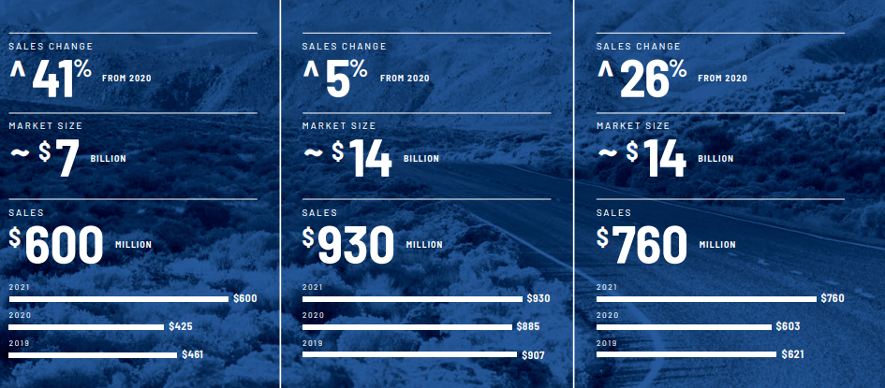
Figure 4: Polaris’s company sales revnue of FY 2021
(source:Ir.polaris, 2021)
On the contrary, the sales revenue of Yamaha Motor in the financial year of 2021 was reported around 2,248.5 billion yen. However, this shows a year-on-year inceaseof 23.2 % as compared to the sales revenue of 2020 (Businesswire, 2022). Moreover, it is the second consecutive year that the popular Japanese motorcycle manufacturer experienced a fall in sales revenue. Apart from that, based on statistics, it has been found that Harley Davidson generated approximately 5.3 billion U.S. dollars in sales revenue in the financial year of 2021. Moreover, in the year of 2020, the sales revenue was around 4.05 billion U.S. dollars (Macrotrends, 2023). Thus, overall statistics show that the company Harley Davidson has witnessed an increase of 32% in global sales revenue as compared to its previous year's sales value (Macrotrends, 2023).
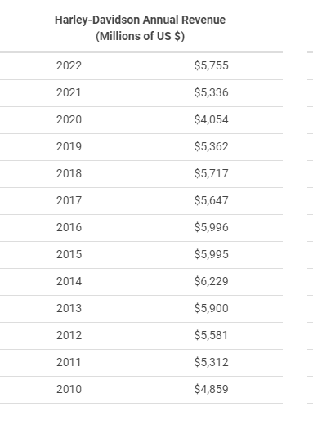
Figure 5: worldwide revenue of Harley Davidson from the financial years 2010 and 2022
(source:macrotrends, 2023)
However, based on a comparison of the sales revenue of both companies with the sales revenue of Harley Davidson, it can be evaluated that although the market competitors like Polaris and Yamaha motors are much more ahead of Harley Devidson in terms of sales revenue yet the company Harley Davidson has huge potential to flourish in its targeted market which reflected from its 32% enhancement of sales revenue.
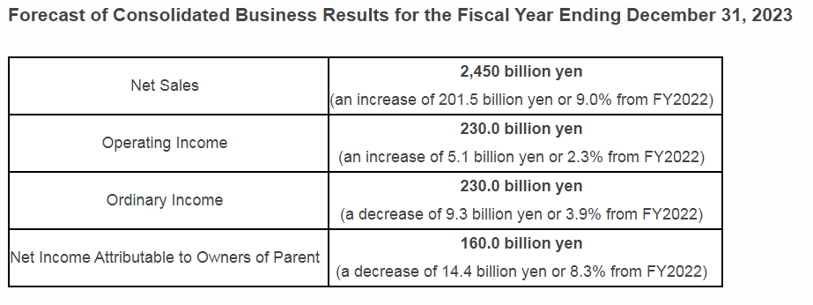
Figure 6: business result forcast of Yamaha Motor between for the financial years of 2023
(source:Businesswire, 2022)
Apart from that, based on the market size, it has been observed that Revenue from the Motorcycles market is anticipated to reach $233.51 billion by 2031. Moreover, Revenue from the motorcycle market is expected to exhibit an annual growth rate of 8.6% within the period of 2022-2031, which would result in an anticipated motorcycle market volume of US$7.22bn by 2027 (Alliedmarketresearch, 2023). Thus, a high potential of the motorcycle market has been noticed in the US which is highly significant for the growth of Harley Davidson and ensures its well-position in the competitive automotive landscape at the same time. Apart from that, in terms of key success factors, the quality and innovation are the vital aspects that help automotive companies to flourish on the comparative edge. In this regard, reliable and innovative and robust products of Harley make the brand lifestyle and desirable motorcycle brand in the world.

Australia Analysis
Country’s National Diamond (Australia)
As per the view of Vlados (2019), the country's national diamond talks about the theory of national advantage which is related to the porter diamond theory. Porter Diamond is a highly effective model that stresses on the competitive advantage related to any business or industry that makes it highly competitive as compared to other market competitors in a specific country or region. Moreover, the model of porter diamond is capable of explaining why certain industries flourish in specific countries. In addition, It seeks to demonstrate that in which manner any nation’s government acts as a catalyst in order to foster growth of that nation and improve that nation’s position on the global level. Thus, with the help of the porter national diamond model, the potential in relation to the Australia can be analysed effectively. In this regard, in the AustraliaAustralia, “The Automotive Transformation Scheme (ATS)” has been introduced by the government to offer assistance towards the automotive industry from 2008–09 to 2020–21. The main objective behind this Australian government's efforts is to enhance innovation and encourage investment in the automotive industry along with positioning the automotive industry on an economically sustainable footing. Under this scheme, Approximately $1.0 billion was funded over five years from 2013-14, in order to provide support to automotive supply chain organisations and vehicle manufacturers at the same time (aph.gov, 2023). Moreover, the Australian government funded around $20.0 million over five years in order to build the Automotive Diversification Programme which aimed at supporting automotive components suppliers (aph.gov, 2023).
Country Business Risks (Australia)
International business may be confronted with several risk factors which may have an unprecedented negative impact on the overall business. Henec, it is highly significant to analyse the risk factors before expanding business over the overseas market. In this regard, political risk is one of prominent ones that could be faced by the company Harley Davidson while expanding in the Australiaaustralia. Political risk takes place when countries make alterations in their existing policies, rules and legislations which might negatively affect the whole business. In this regard, it has been found that US exporters many times find it complicated to comply with the requirements of Australia’s import quarantine measures (Trade, 2023). As the government of Australia has set a strong measure of quarantine amid the covid-19 outbreak, the exporter of Harley Davidson may face some issues in managing their supply chain. On the contrary, as suggested by Hampden-Turner et al. (2020), cultural issues in foreign nations are one of the major barriers of global business. Due to cultural issues, global business may face some language difficulties which result in communication barriers. Due to ineffective communication with the employees of foreign nations, managing global projects becomes a headache for company’s project managers. However, most Australian people speak in English, which is also the main language of the US. Thus, it is expected that cultural issues in terms of language barriers would not happen.

Internal Analysis

Global value chain
Global Production
Global production helps companies to ensure management of the supply chain properly by locating production facilities across the globe. In terms of global production, the company Harley Davidson produces its innovative products at various locations worldwide. In the US, the company has three production facilities where they manufacture which are located in York, Pennsylvania, USA, Tomahawk, Wisconsin, USA. and Menomonee Falls, Wisconsin, USA. Moreover, the company has 1400 dealerships which are independently owned by Hraley Davidson in over 100 countries (Harley-davidson, 2023c). In addition, different factories across the world are there where Harley Davidson manufactures its motorcycles which are in Thailand, Pluak Daeng, Pennsylvania, Wisconsin, India, Bawal, Brazil, and Manaus.
Global Marketing
As articulated by John et al. (2019) in order to grab a strong presence over the global business arena, the global marketing strategies are highly significant to look over by the marketers. As making a strong presence over the oversea market requires high brand recognition and awareness, proper execution of global marketing and positioning strategies are highly important to be considered. In this regard, Harley-Davidson's strategies related to global marketing are mainly focused on rendering a personalised experience to their customers which helps to allow them to make positive association with the brand. Allowing customers of Harley Davidson to customise or modify their motorcycle is one of the prominent features that the organisation offers to their customer base throughout its inception.
Global HRM
Managing human resources globally can be referred to as determining in which manner HR related capabilities would be rendered internationally (Dirani et al. 2020). There are two approaches to manage global HRM such as scaling of global operations from a specific central location or building a localised HR process and system. Moreover, as identified by Yusoff et al. (2020), it has been found that the global HRM plays vital roles in international business by recruiting skilled employees, maintaining compliance with the employees laws, managing development of employees and promoting inclusion and diversity in the workplace. Thus in view of the significant function of global HRM, it can be stated that managing HR globally is highly required for global business management. In this regard, the company Harley Davidson with its inclusive stakeholder management approach have successfully managed their global stakeholders from suppliers and dealers to customers and employees at the same time. The company also encourages sharing values and knowledge though setting proper diversified and inclusive work culture to manage global HRM activities. Henceforth, it can be said that Harley Davidson strategy of managing global HRM is highly satisfactory to manage global team and customers at the same time.

SWOT analysis
As opined by Elavarasan et al. (2020), The SWOT framework is a highly effective tool to analyse internal competitive advantage of any firm by assessing its key strengths, weaknesses, market opportunities as well as market threats.
Strength | Weakness
- The company Harley Davidson is a leading automotive player in the US motorcycle market as well as in the global arena  - Well-build brand equity and loyalty  - The company has well-financial position due to sold worldwide sales  - Around 5.3 billion U.S dollars have been generated by the company in revenue which is around 32% increment from the previous year sales value (macrotrends, 2023).  - Large customer base in US, Canada and Europe, middle east and Africa | - The company mainly operates in the medium to heavy segments (macrotrends, 2023). However, the brand has only recently approached to include car models of medium weight.  - The company has lower sales revenue as compared to its key competitors like Polaris inc and Yamaha motors.
Opportunities | Threats
- The company has loyal customer base in the US  - The company has high market revenue from the US market  - The company has potential to grow in the Asia pacific market (macrotrends, 2023). The Asian market growth would be useful to support the business of the Australian market as it is in proximity. | - High market competition is one of the major threats for Harley Davidson due to the presence of Polaris inc, Yamaha motors and many more.  - Threats from the new electric vehicle automotive players like Lightning Motorcycle Corp.
Table 3: the SWOT analysis
(source: self-created)

International Strategies
As per the view of Shenkar and Luo (2008), international strategies are the planning and plotting of ideas before expanding operations in the overseas market. In order to gain a competitive edge, many automotive brands have been planning to expand their target market on a global level to get the high exposures and greater customer base at the same time (Hamilton and Webster, 2018). In terms of international strategies, the company has a sharpened vision of expanding in the global market and through 2027, the company has aimed to enhance ist global businesses to 50% of its annual revenue (Prnewswire, 2019). Moreover, the company has been showing positive efforts to grow its ridership across the world. In terms of changing market dynamics, the company has been intended to effectively predict, react and analyse the market changing conditions so that they can properly adjust with the ever shifting global customer’s interest and needs at the same time. In addition, in their international strategies, the company has taken a rider-centric approach through extensive consumer centric research and investigation so that gap in between new riders along with keeping all riders can be minimised. Furthermore, in order to build committed riders in the global market, the company is forced on improving brand experience by stressing on advancing rider’s each journey.

Entry Modes
Exporting
As per the view of Samiee and Chirapanda (2019), The act of selling products or services made in the domestic market in the oversea market is known as exporting. This is the easiest way of entering into the business of foreign nation. Exports can be done in two ways directly or indirectly. In direct exports, the organisation directly sells its products to the buyers of foreign nations which give them a firsthand knowledge over the oversea market transactions. On the other hand, in indirect exporting, selling of goods or services happens with the help of third parties who are skilled in facilitating foreign transactions.
Franchising
As suggested by Alon et al. (2020), in this franchising model of business, any company of a foreign nation can use the brand name, or trademark of a different organisation which is known as the franchisor company. Moreover, companies having high brand recognition at the global level are found to use these types of strategies to enter into the new market. In this model of international business, franchisor companies provide business assistance, raw materials and other necessities to ease the business of franchise operators to make an impactful footprint over the foreign nation.
Joint ventures
As identified by Nippa and Reuer (2019), joint ventures are another preferred way of entering into the business of a foreign nation. In this way, organisations make ties with local companies of foreign nations which have well-expertise to operate a business in that market. In this joint venture approach, the businesses of both companies have to share both business risks as well as business-related opportunities. Thus, the brand, expertise and knowledge of both companies local and foreign are shared to generate some fruitful results. In addition, in this joint venture approach, as per the predetermined ratios, business profit, investment amount and losses are allocated to both business units.
Selecting the preferred entry mode
Based on the assessment of the aforementioned entry mode strategies to enter into the global market, it can be evaluated that a joint venture initiative would be more preferable for the company Harley Davidson. As the company Harley Davidson has well-experienced and long-time experience in this field and operating business in other foreign countries as well, with this joint venture efforts, Harley Davidson would be able to have a strong grip over the Australian market by partnering with local automotive companies.

Corporate Social Responsibility
The business resilience of Harley Davidson is majorly based on the success of its strategies and programs related to corporate social responsibilities (CSR). the company has been able to effectively understand the value and importance of stakeholders and their immense impact on the overall business. For instance, the inclusive stakeholder management approach of Harley Davidson helps them to manage sustainability with profitable growth at the same time (harley-davidson, 2023b). Moreover, the company focuses on long-term value generation for their people, planet and profit. The company has committed to achieving net zero carbon emissions by the year 2050. Moreover, the company achieved 4.1% waste landfill for the organisation (Harley-davidson, 2023b). In terms of profit, the company has contributed around $700M in terms wages and associated taxes to the economy. Moreover, to spread the helpful hand towards societal development, the foundation of Harley Davidson has provided around $2M in grants (harley-davidson, 2023b). In this context, Harley-Davidson’s Supplier Diversity Policy has been found to be helpful in promoting healthy development of society with inclusiveness. Apart from that, the company also has been identified to prioritise customer’s value as their key business stakeholder. This prioritization enables the company to fulfil their customer expectation and preferences effectively which also helps the company to properly market their products in the targeted customer segments. Thus, it can be stated that the CSR program of Harley Davidson is satisfactory in terms of supporting business success in the long run as well as addressing key stakeholder’s associated needs and interest at the same time (Panmore, 2017).

Conclusion
Based on the overall assessment, it can be concluded that international business is highly challenging due to ever changing customer needs and due to the influence of changing market conditions. The US-based motorcycle manufacturer Harley Davidson has been investigated to understand its international strategies. In this regard, it has been noticed that the company has a long-term objective to expand into the global market and enhance global business by 50% of its annual revenue by the year of 2027. Moreover, it has been found that the company has well-positioned and holds over the US automotive market. In terms of market sales revenue of 2021, the company has generated over 5.3 billion U.S. dollars. However, the company has strong competitors in the US market because of the presence of other motorcycle manufacturers like Yamaha motors and Polaris Inc. apart from that, based on the analysis related to the market of Australia, it has been found that automotive market of Australia is highly growing due to significant government support and funding. However, some political and cultural risks have been found which may be faced by the company while expanding business over there. Moreover, joint venture initiative has been found as the best entry mode strategy for the company. In addition, the company has been found to manage its corporate responsibility sustainability with an inclusive stakeholder management approach.

References
alliedmarketresearch, 2023, “Motorcycle Market by Type (Standard, Sports, Cruiser, Adventure), by Propulsion Type (Internal Combustion Engine (ICE), Electric), by Price Range (Low, Mid, High): Global Opportunity Analysis and Industry Forecast, 2021-2031” online] available at: https://www.alliedmarketresearch.com/motorcycle-market-A31857[accessed on: 24.04.2023]
Alon, I., Apriliyanti, I.D. and Parodi, M.C.H., 2020. A systematic review of international franchising. Multinational Business Review, 29(1), pp.43-69.
Anastasiu, L., Gavriş, O. and Maier, D., 2020. Is human capital ready for change? A strategic approach adapting Porter’s five forces to human resources. Sustainability, 12(6), p.2300.
Anderson, J.E., Hughes, M.Ü. and Nguyen, C., 2019. The highs and lows of startups in the Cannabis industry: A PESTLE analysis of the current issues. In Business Forum (Vol. 27, No. 2, p. 26).
Aph.gov, “Automotive industry package” online] available at: https://www.aph.gov.au/About_Parliament/Parliamentary_Departments/Parliamentary_Library/pubs/rp/BudgetReview201415/Automotive[accessed on: 25.04.2023]
Baxter, G., 2019. A strategic analysis of Cargolux Airlines International position in the global air cargo supply chain using Porter’s Five Forces Model. Infrastructures, 4(1), p.6.
BBC, 2022, “US invests $280bn in high tech to compete with China” [online] available at: https://www.bbc.com/news/business-62482141 [accessed on: 25.04.2023]
BEA, 2022, “Gross Domestic Product, Third Quarter 2022 (Advance Estimate)” online] available at: https://www.bea.gov/news/2022/gross-domestic-product-third-quarter-2022-advance-estimate[accessed on: 25.04.2023]
businesswire, 2023, “YAMAHA MOTOR: Consolidated Business Results Summary — Full Fiscal Year Ending December 31, 2022” online] available at: https://www.businesswire.com/news/home/20230212005030/en/YAMAHA-MOTOR-Consolidated-Business-Results-Summary-%E2%80%94-Full-Fiscal-Year-Ending-December-31-2022-%E2%80%94[accessed on: 24.04.2023]
cnbc, 2023, “Here’s the inflation breakdown for December 2022 — in one chart” online] available at: https://www.cnbc.com/2023/01/12/heres-the-inflation-breakdown-for-december-2022-in-one-chart.html[accessed on: 24.04.2023]
Congress, 2022, “American Technology Leadership Act of 2022” online] available at: https://www.congress.gov/bill/117th-congress/senate-bill/4368
Dirani, K.M., Abadi, M., Alizadeh, A., Barhate, B., Garza, R.C., Gunasekara, N., Ibrahim, G. and Majzun, Z., 2020. Leadership competencies and the essential role of human resource development in times of crisis: a response to Covid-19 pandemic. Human Resource Development International, 23(4), pp.380-394.
Elavarasan, R.M., Afridhis, S., Vijayaraghavan, R.R., Subramaniam, U. and Nurunnabi, M., 2020. SWOT analysis: A framework for comprehensive evaluation of drivers and barriers for renewable energy development in significant countries. Energy Reports, 6, pp.1838-1864.
Hamilton, L. and Webster, P., 2018. The international business environment. Oxford University Press.
Hampden-Turner, C., Trompenaars, F. and Hampden-Turner, C., 2020. Riding the waves of culture: Understanding diversity in global business. Hachette UK.
harley-davidson, 2023, “Our Strategy” online] available at: https://investor.harley-davidson.com/our-strategy/default.aspx#:~:text=At%20Harley%2DDavidson%2C%20we%20strive,%2C%20and%20profit.... [accessed on: 23.04.2023]
Harley-davidson, 2023b, “ an inclusive stakeholder approach” online] available at: https://www.harley-davidson.com/in/en/about-us/sustainability.html[accessed on: 25.04.2023]
Harley-Davidson, 2023c, “OUR DEALERSHIPS” online] available at: https://www.harley-davidson.com/us/en/about-us/careers/locations.html#:~:text=We%20have%20more%20than%201%2C400,that%20can%20last%20a%20lifetime. [accessed on: 26.04.2023]
harley-davidson, 2023d, “Motorcycle Retail Sales” online] available at: https://investor.harley-davidson.com/resources/motorcycle-retail-sales/default.aspx[accessed on: 24.04.2023]
Hesterly, W. and Barney, J., 2014. Strategic management and competitive advantage. Pearson/Education.
Ibisworld, 2022, “Global Car & Automobile Manufacturing - Market Size 20052028” online] available at: https://www.ibisworld.com/global/market-size/global-car-automobile-manufacturing/[accessed on: 25.04.2023]
ir.polaris, 2021, “Financial Information” online] available at: https://ir.polaris.com/financial-information/annual-reports/default.aspx[accessed on: 24.04.2023]
John, J., WILD, W. and Kenneth, L., 2019. INTERNATIONAL BUSINESS: The Challenges of Globalization, Global Edition. Pearson Education Limited.
macrotrends, 2023, “Harley-Davidson Revenue 2010-2023 | HOG” online] available at: https://www.macrotrends.net/stocks/charts/HOG/harley-davidson/revenue[accessed on: 24.04.2023]
Mugo, P., 2020. Porter’s five forces influence on competitive advantage in telecommunication industry in Kenya. European Journal of Business and Strategic Management, 5(2), pp.30-49.
Nippa, M. and Reuer, J.J., 2019. On the future of international joint venture research. Journal of International Business Studies, 50, pp.555-597.
Panmore, 2017, “Harley-Davidson’s Stakeholders: A CSR Analysis” online] available at: https://panmore.com/harley-davidson-stakeholders-csr-analysis[accessed on: 25.04.2023]
Perera, R., 2020. Understanding Porter’s Five Forces Analysis. Nerdynaut.
Prnewswire, 2019, “Harley-Davidson To Amplify Brand Power To Attract Riders; Sharpens Long-Term Objectives To Support Building The Next Generation Of Riders” online] available at: https://www.prnewswire.com/news-releases/harley-davidson-to-amplify-brand-power-to-attract-riders-sharpens-long-term-objectives-to-support-building-the-next-generation-of-riders-300924231.html#:~:text=As%20previously%20stated%2C%20the%20company's,to%2050%25%20of%20annual%20revenue. [accessed on: 25.04.2023]
Researchandmarkets, 2023, “United States Automotive Market, Size, Share, Outlook and Growth Opportunities 2022-2030” online] available at: https://www.researchandmarkets.com/reports/5713253/united-states-automotive-market-size-share#:~:text=United%20States%20automotive%20market%20is,CAGR%20between%202023%20and%202030. [accessed on: 25.04.2023]
Samiee, S. and Chirapanda, S., 2019. International marketing strategy in emerging-market exporting firms. Journal of International Marketing, 27(1), pp.20-37.
Shanmugavel, N. and Micheal, M., 2022. Exploring the marketing related stimuli and personal innovativeness on the purchase intention of electric vehicles through Technology Acceptance Model. Cleaner Logistics and Supply Chain, 3, p.100029.
Shenkar, O. and Luo, Y., 2008. International business. Sage.
Trade, 2023, “Trade Barriers” online] available at: https://www.trade.gov/country-commercial-guides/australia-trade-barriers[accessed on: 24.04.2023]
Vlados, C., 2019. Porter’s diamond approaches and the competitiveness web. International Journal of Business Administration, 10(5), pp.33-52.
Yusoff, Y.M., Nejati, M., Kee, D.M.H. and Amran, A., 2020. Linking green human resource management practices to environmental performance in hotel industry. Global Business Review, 21(3), pp.663-680.
GOV, 2023b, “Legislation” [online] available at: https://www.fairwork.gov.au/about-us/legislation#:~:text=The%20Fair%20Work%20(State%20Referral,a%20national%20workplace%20relations%20system. [accsed on: 29.04.2023]
GOV, 2023a, “About Australia” [online] available at: https://www.dfat.gov.au/about-australia[accsed on: 29.04.2023]

