

Intelligent Vehicle Path Planning And Path Following Research

By: Yan Zhang

Supervisor: Dr Mabrouka Abuhmida

Second Marker: Dr Archie Watt

Project submitted as part of the requirements for the award of the M.Sc. Applied Computing degree

University of Wales Trinity Saint David

August 2019

DECLARATION

I, Yan Zhang declare that I am the sole author of this Project; that all references cited have been consulted; that I have conducted all work of which this is a record, and that the finished work lies within the prescribed word limits.

This work has not previously been accepted as part of any other degree submission.

Signed: ..............Yan Zhang................ Date: ..............22/08/2019................

FORM OF CONSENT

I, Yan Zhang hereby consent that my Project, submitted in candidature for the M.Sc. Applied Computing degree, if successful, may be made available for inter-library loan or photocopying (subject to the law of copyright), and that the title and abstract may be made available to outside organizations.

Signed: ..............Yan Zhang................ Date: ..............22/08/2019................
.

Abstract
Unmanned vehicles are safe, reliable and convenient, and are the development direction of future automotive technology. Therefore, this paper will study the path planning and path following technology of driverless vehicle. The research contents include the following aspects:

Firstly, in view of the problem that the traditional A* algorithm cannot avoid obstacles in the dynamic obstacle environment, poor real-time performance as the number of grids increases and the planned path is not smooth, this paper proposes an optimized A*algorithm. The traditional A* algorithm is optimized by recording the historical trajectory of the obstacle to predict the next possible motion point of the obstacle, adding the search direction restriction and expanding the search neighborhood. The simulation experiment result shows that the real-time performance and reliability of optimized A* algorithm are improved.

Then, in order to guarantee the vehicle can track the path accurately and stably, this paper proposes a compensation type following algorithm. A vehicle kinematics model is established, and the pure pursuit algorithm is compensated by distance deviation and heading angle deviation. Then the effectiveness of the optimized pure pursuit algorithm under different vehicle speeds is verified in Matlab, and the result shows that the optimized pure pursuit algorithm has better robustness, better path following control effect, smaller vehicle slip and stable driving.
Finally, a joint simulation experiment is performed on the above two algorithms. The experiment result shows that the optimized A* algorithm and the optimized pure pursuit algorithm can be used for path planning correctly and can follow the planned path accurately and stably.

Table of Content
Table of Figures 1
Table of Tables 3
1. Introduction 4
1.1. Contribution to knowledge 4
1.2. Problem statement 5
1.3. Aim and objectives 6
1.4. Theoretical framework 6
1.5. Assumptions, limitations, and delimitation 8
2. Literature review 10
2.1. Development status 10
2.2. Related literature work 13
2.2.1. Path planning 13
2.2.2. Path following 21
2.3. Summary 25
3. Methodology 26
3.1. Research method 26
3.1.1. Philosophy 26
3.1.2. Research type and method 27
3.1.3. Research design and strategy 28
3.2. Data analysis 29
3.3. Development method 30
3.4. Ethical issues 31
3.5. Gannt chart 32
4. Path planning 33
4.1. Algorithm selection 33
4.2. Traditional A* algorithm 37
4.2.1. Basic rationale 37
4.2.2. Evaluation function 38
4.3. Dynamic obstacle avoidance of A* algorithm 38
4.3.1. Problem statement 38
4.3.2. Theoretical method 40
4.3.3. Experiment and data analysis 42
4.4. Real-time optimization of A* algorithm 43
4.4.1. Problem statement 43
4.4.2. Theoretical method 43
4.4.3. Experiment and data analysis 46
4.5. Path smoothing optimization of A* algorithm 47
4.5.1. Problem statement 47
4.5.2. Theoretical method 47
4.5.3. Experiment and data analysis 49
4.6. Summary 51
5. Path following 52
5.1. Establish vehicle kinematics model 52
5.2. Pure pursuit algorithm 53
5.2.1. Introduction of pure pursuit algorithm 53
5.2.2. Forward distances 56
5.3. Optimization of pure pursuit algorithm 57
5.3.1. Problem statement 57
5.3.2. Theoretical method 57
5.3.3. Experiment and data analysis 59
5.4. Summary 62
6. Joint simulation experiment 63
6.1. Design simulation experiment 63
6.2. Analyze the data 64
6.3. Summary 65
7. Conclusions and reflection 66
References 69
Appendix 77

Table of Figures
Figure 1-1: Technical route 7
Figure 2-1: NavLab 11 Intelligent Vehicle 11
Figure 2-2: Shelley Intelligent Vehicle 11
Figure 2-3: Waymo Intelligent Vehicle 12
Figure 2-4: The Toyota e-palette concept car 13
Figure 2-5: RRT path planning algorithm 14
Figure 2-6: Ant colony 0ptimization path planning algorithm 15
Figure 2-7: Artificial potential field algorithm. 16
Figure 2-8: Dijkstra path planning algorithm. 17
Figure 2-9: A* path planning algorithm. 18
Figure 2-10: Artificial neural network 19
Figure 2-11: Structure of fuzzy control 23
Figure 2-12: Structure of model predictive control 24
Figure 3-1: FDD development method lifecycle 30
Figure 3-2: Gannt chart of the project 32
Figure 4-1: The result of the RRT algorithm 34
Figure 4-2: The result of the ACO algorithm. 34
Figure 4-3: The result of the APF algorithm. 35
Figure 4-4: The result of the Dijkstra algorithm. 35
Figure 4-5: The result of the A* algorithm. 36
Figure 4-6: Path in a static environment. 39
Figure 4-7: Path in a dynamic environment 39
Figure 4-8: Prediction of the next movement point 41
Figure 4-9: Experimental result of dynamic obstacle avoidance 42
Figure 4-10: Reference direction 44
Figure 4-11: No search direction restrictions 44
Figure 4-12: Add search direction restrictions 45
Figure 4-13: 8-connectivity 48
Figure 4-14: 24-connectivity 48
Figure 4-15: Smoothness experimental results of original A* algorithm 50
Figure 4-16: Smoothness experimental results of optimized A* algorithm 50
Figure 5-1: Linear 2-dof vehicle model 52
Figure 5-2: Schematic diagram of the pure pursuit algorithm 53
Figure 5-3: Geometric analysis of pure pursuit algorithm 55
Figure 5-4: The following model of the compensated follower algorithm 58
Figure 5-5: Original pure pursuit algorithm driving following 60
Figure 5-6: Optimized pure pursuit algorithm driving following 61
Figure 6-1: Path of obstacles 62
Figure 6-2: The results of joint simulation experiment 65

Table of Tables
Table 4-1: Run Time of algorithm 46
Table 4-2: Number of nodes traversed 46
Table 4-3: Neighborhood extension table 49
Table 4-4: Comparison of operation results 50
Table 5-1: Vehicle parameters 59
Table 5-2: Statistical results of path following error at different vehicle speeds 61
Table 6-1: Vehicle parameters of joint simulation experiment 64

Introduction
Intelligent vehicle is a new type vehicle with both environmental awareness and behavioral decision-making consciousness. It can sense the vehicle's own state, surroundings and manipulate its own actuator through computer compilation program, so that to realize the purpose of forward, backward and steering of the vehicle.

Contribution to knowledge
As the future research direction of the vehicle, autonomous vehicles are considered to significantly improve traffic safety, improve transportation efficiency, and reduce environmental pollution [1]. In terms of driverless technology, it is a large-scale integrated system integrating environment sensing, vehicle state measurement, planning decision and chassis control. The subsystems complement each other to achieve efficient, stable and safe automatic driving of the intelligent vehicle.

Intelligent vehicle path planning refers to finding an executable safe path from the current point to the target point according to the surrounding environment information [2]. In a complex environment, moving or stationary obstacles are randomly distributed. In order to guarantee vehicles can travel safely, vehicles need to communicate with the external environment and react to threats in real-time. Therefore, higher requirements are placed on the reliability and real-time performance of path planning algorithm.

Intelligent vehicle path following refers to calculating the control quantity according to the vehicle’s real-time status and the reference path to make the vehicle travel along the reference path [3]. In complex environments, path following errors and obstacles often cause path following failure and the planned path cannot be continued. At the same time, as two core modules closely connected in the planning decision-making subsystem, path planning and path following need to be able to coordinate and cooperate to build a reliable unmanned driving system and realize unmanned driving.

Based on this background, the topic studied in this paper has great theoretical significance and practical value. First of all, it is one of the key technologies to solve traffic jam problems, reduce traffic accidents and improve driving safety. Secondly, it can promote the development of the driverless car.

Problem statement
In the field of path planning, traditional A* path planning algorithm can better plan the driving path in static obstacle environment. However, the path is difficult to be planned in dynamic obstacle environment. Besides, the planned path planned is often not smooth enough, which will affect the riding comfort of passengers.

In the field of path following, the path following algorithm based on preview control theory has been widely used in robots. However, automobiles are time-varying and non-linear complex systems. Therefore, autonomous vehicles have higher requirements for the selection of preview points and the accuracy of path following.
Based on the above problems, this paper will optimize tradition A* algorithm and pure pursuit algorithm. The specific details will be introduced in chapter 4 and chapter 5.

Aim and objectives
The aim of this paper is to improve the real-time performance and reliability of path planning algorithm and path following algorithm. There are some detailed objectives:
- Read and collect some literature about path planning algorithm and path following algorithm.
- Compare different algorithms, then choose the suitable path planning algorithm.
- Establish vehicle models for path following algorithm.
- Design a more accurate and reliable path following controller.
- Design experiment to test the effectiveness of the optimized algorithm.

Theoretical framework
This paper will study path planning and following technology of autonomous vehicle, including research on A* algorithm and pure pursuit algorithm strategy, and joint simulation experiment of these two optimized algorithms. The technical route adopted in this paper is shown in figure 1-1.

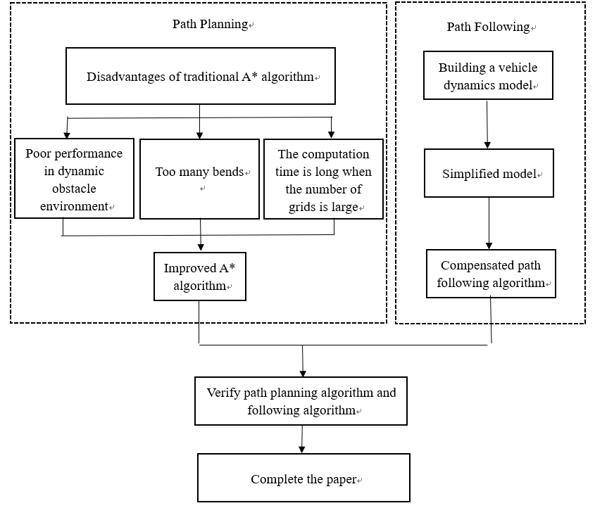
Figure 1-1 Technical route
The main content includes:
- The common path planning algorithms are analyzed and compared in the same obstacle environment, and A* algorithm is selected as the path planning method. Then, optimize the traditional A* algorithm to solve the problems such as cannot avoid obstacles in the dynamic obstacle environment, poor real-time performance as the numbers of the grid increases, many inflection points in the path.

- In view of the problem that the pure pursuit algorithm has a large path following error and cannot correct the vehicle heading angle, the vehicle kinematics model is established, and the distance and heading angle deviation is used to compensate the improved path following algorithm. Then, simulation software is used to verify the accuracy of path following control algorithm under different vehicle speeds.

- Finally, combine with the above two optimized algorithms to verify their effectiveness in Matlab [4].

Assumptions, limitations, and delimitation
The research conclusions of this paper mainly rely on experimental data, so we can assume that the experimental data are representative and authentic. In order to make the hypothesis come true, multiple experiments will be conducted to take the mean value, and conclusions will be analyzed strictly according to the experimental data, so as to ensure the representativeness and authenticity of the experimental data and make the final conclusion more convincing.

However, risks are inevitable in the research process of this paper:
- Unable to complete the code
- Incomplete literature reading
- Poor time management results in research not being completed on time
- Computer failure

In order to solve the above problems, first make arrangements in advance, such as use Gantt charts to develop a research plan and strictly abide by it. In addition, read more literature to understand the relevant knowledge about driverless car and expand the scope of knowledge. The biggest risk of this paper is that the code writing cannot be completed, because if this part cannot be completed, the following research will not be able to be carried out. If this problem happens, it is possible to ask the teacher for help, and this can greatly reduce the risk that research cannot be performed because the code cannot be completed.

The research results of this paper will not affect other interests, and the research results can be freely used by researchers, teachers and students in the field of autonomous vehicle or artificial intelligence.

Literature review
This chapter will introduce the development status and related literature work in the field of autonomous vehicles.

Development status
Barrett Electronics [5] Company developed the world's first automated guided vehicle system, which marked the birth of autonomous vehicles. However, the rise of autonomous vehicles in the real sense is due to the emergence of intelligent transportation system. The intelligent transportation system was proposed by Western developed countries to solve the deteriorating road traffic capacity and reduce the number of road traffic accidents [6]. The intelligent transportation systems currently being implemented include the smart road system plan in the United States and the efficient and safe road transportation system in Europe [7].

In the 1980s, Carnegie Mellon University began to develop NavLab series of intelligent vehicles [8]. After years of development, many autonomous vehicles based on different platforms such as minivans, large trucks, off-road vehicles and trains have been launched. The latest model is Navlab-11 (as shown in figure 2-1), and it includes laser radar, GPS system, CCD camera and other sensors [9].
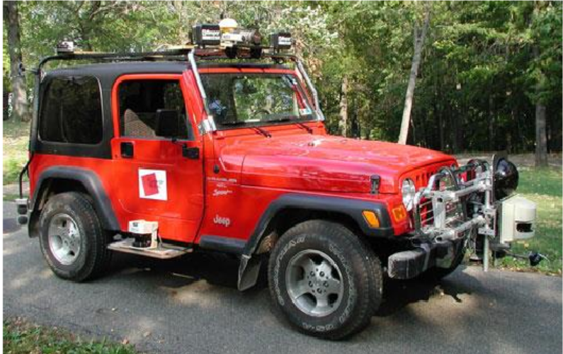
Figure 2-1 NavLab 11 Intelligent Vehicle [10]
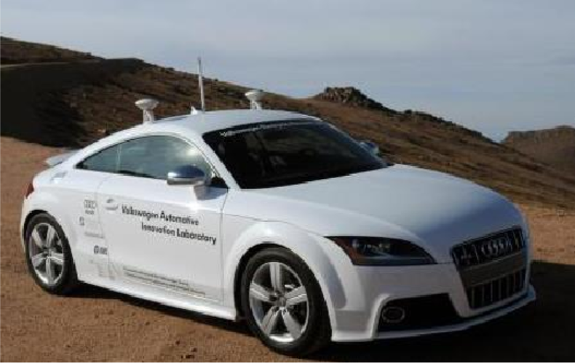
Stanford University and the Volkswagen Electronics Research Laboratory and Oracle jointly developed the intelligent vehicle Shelley (as shown in figure 2-2). On the basis of Stanley and Junior, Shelley no longer relies on lidar and cameras to perceive the surrounding environment, but relies on high-precision GPS to complete vehicle positioning and path planning, and relies on wheel speed sensors, gyroscopes and accelerometers to monitor the vehicle state [11].
Figure 2-2 Shelley Intelligent Vehicle [12]

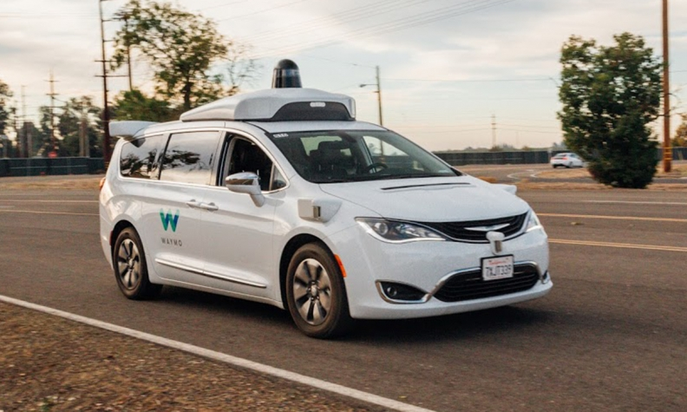
Google Waymo's intelligent vehicle system is based on Fiat-Chrysler Pacifica (as is shown in figure 2-3). This smart car is equipped with the latest developed long-range lidar and visual sensors [13]. Waymo smart cars have completed more than 4 million miles of driverless testing in 25 cities across the United States, with an average of 1,000 miles traveling only 0.18 times with manual intervention [14].
Figure 2-3 Waymo Intelligent Vehicle [15]
Toyota unveiled the e-palette concept vehicle in 2018 (as shown in figure 2-4). This car embodies Toyota's vision of combining transportation and life in the future. The types of cars include mobile wardrobes, mobile shoe stores, dining cars, express cars and mobile hotels to meet people's needs for life [16]. Besides, Toyota will cooperate with Amazon, Uber, Mazda and Pizza Hut to build a perfect "mobile ecosystem" by relying on the mobile service platform developed by Toyota [17].
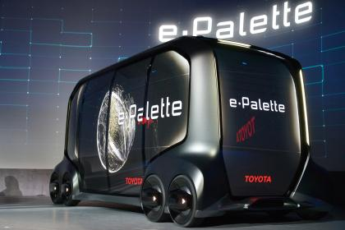
Figure 2-4 The Toyota e-palette concept car [18]

Related literature work
There are many critical technologies for driverless vehicles. Among these critical technologies, path planning and path following technology have always been the key points in the field of autonomous vehicles. In this chapter, we are going to discuss the more related work to our study.

Path planning
Path planning plays a connecting role in driverless vehicles. Firstly, the road condition information and vehicle status information are obtained through environmental awareness technology and positioning and navigation technology [19]. Secondly, a safe path is planned according to above information. Finally, the motion control technology can realize the safe and accurate path following of the driverless vehicle.

The common algorithms in the research of path planning mainly include rapidly-exploring random tree, ant colony optimization algorithm, artificial potential field algorithm, Dijkstra, A*, bionic intelligent algorithm [20].
- Rapid-exploration Random Tree Algorithm
Lavalle [21] proposed the RRT algorithm, and it is a typical representative of the sampling-based incremental search algorithm. As is shown in figure 2-5, the blue point represents the starting point and the red represents the obstacle [22]. The RRT algorithm in the figure does not directly divide the minimum raster resolution on the grid map. On the contrary, the starting point represents the root node of the random tree. By randomly determining the sampling points on the map, it is possible to quickly search for the current environment and generate path [23].
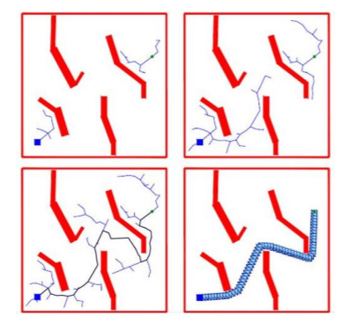
Figure 2-5 RRT path planning algorithm [22]
Although this random sampling-based planning algorithm has higher real-time performance, the randomness introduced by random sampling is a major fatal flaw [24]. Therefore, when using it for path planning, the result of each planning cannot be predicted, which makes it impossible to be widely used in the automotive field where extreme reliability is pursued.

- Ant Colony Optimization Algorithm
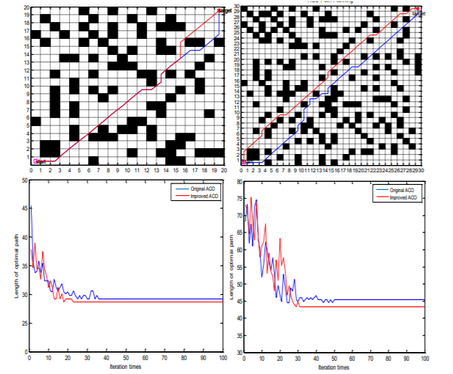
Ant Colony Optimization simulates the process of ant colony searching for food [25]. As is shown in figure 2-6, it simply improved the ant colony algorithm pheromone allocation mechanism, path selection strategy, heuristic function, and simulated in 20x20 and 30x30 raster map environments [26].
Figure 2-6 Ant colony 0ptimization path planning algorithm [26]
Although the planned shortest path can avoid falling into local optimum and can reduce the number of iterations during convergence, it is difficult to address the motion constraint problem of driverless cars in a grid environment, and computing time of the algorithm complexity will increase sharply as the number of grids increases [27].
- Artificial Potential Field Algorithm
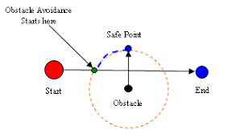
Khatib [28] proposed artificial potential field method, and the principle of this method is: assuming that there is a force field at the obstacle and the target point, the robot is regarded as a mass point, as shown in figure 2-7. The obstacle acts on the virtual force field as a repulsive field, and the repulsion value decreases as the increase of the distance between the vehicle and the obstacle [29]. The gravitational field is around the target point, and the gravitational value increases with the decrease of the distance between the vehicle and the target point [30].
Figure 2-7 Artificial potential field algorithm [31]
The final motion direction of the robot depends on the combined forces of gravity and repulsion, as shown in the following formula:
$\vec{F}=\vec{F_{α}}+ \vec{F_{γ}}$ (1-1)
The artificial potential field algorithm has fast convergence speed, less computation and less computing time [32]. However, in the complex dynamic environment, the net force may be zero and the vehicle may stop moving [33].
- Dijkstra Algorithm
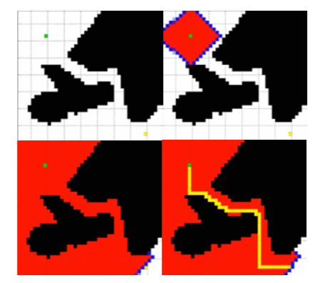
Dutch computing scientist Dijkstra [34] proposed Dijkstra algorithm to find a shortest path between two points with obstacles. Its core idea is realized by setting the node set $G_{n}$ which has searched the shortest path and the node set $T_{n}$ which has not yet searched the shortest path. At the beginning of the planning algorithm, $G_{n}$ only contains the starting point, then the point in $T_{n}$ that selects the shortest path to the starting point is continuously placed in $G_{n}$. Each time a new node is placed in $G_{n}$, the current shortest path value of the remaining nodes from the starting point to $T_{n}$ should be modified in the same way. This process is repeated until all the nodes in $T_{n}$ are placed in $G_{n}$. As is shown in figure 2-8, the green point represents the starting point, the black part represents the obstacle, the yellow point represents the target point, and the red part is the feasible field formed after extending to the target point [35]. The yellow line represents the shortest path.
Figure 2-8 Dijkstra path planning algorithm [35]
However, the computing time increases sharply with the number of grids increases and the planned path is not smooth enough [36].
- A* Algorithm
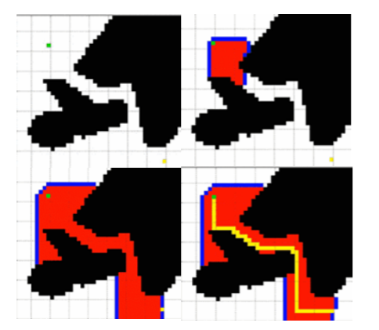
The heuristic search algorithm is improved by the Dijkstra algorithm, and the most notable feature is the inclusion of heuristic functions in the search process [37]. The heuristic function is set to comprehensively evaluation algorithm in the extended search process. By comparing the magnitude of these generation values, the most suitable points are expanded. Therefore, it is no need to expand all directions, which reduces the search time (as is shown in figure 2-9). Compared with figure 2-8, the search efficiency is improved [35].
Figure 2-9 A* path planning algorithm [35]
However, the planned path is still not smooth enough, and the computational time increases sharply with the number of nodes n increases [38].
- Bionic Intelligent Algorithm
Genetic algorithm simulates the evolution of natural biology [39]. It solves the path plan by describing the road segment as a series of halfway points and converting it into a binary string. First, the path group is initialized, followed by genetic operations (such as selection, crossover, replication, and mutation) [40]. Then, after several generations of evolution, evolution is stopped, and the solution space search is completed according to the planning requirements, and the current optimal individual is output. However, when the planning path is long, the convergence speed is slow and the calculation amount is large, so it is not suitable for solving complex path planning problems.

The fuzzy logic method uses the reflection mechanism to simulate the driver's driving experience to achieve local path planning. Chang H [41] established a fuzzy inference model to address the robot path planning problem. Through using fuzzy logic to plan the path, the effective path can be quickly planned in the dynamic environment. However, the calculation time will increase as the number of obstacles increases.

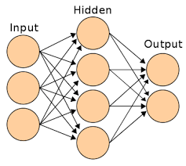
Artificial neural network simulates the interconnected neural networks in the brain, with parallelism and distributed features (as shown in figure 2-10) [42]. The most mature and widely used are the three-layer perceptron model and the god based on back-propagation algorithm through the network [43]. At present, it has been applied in the field of path planning, but it has some problems, such as slow convergence speed and difficulty to solve a specific defect in the network [44].
Figure 2-10 Artificial neural network [45]

- Curve interpolation algorithm
The application of the curve interpolation algorithm in path planning is mainly to interpolate the known path points to obtain a continuous smooth path that can be executed by the car [46]. Commonly used smooth path curves in path planning include Bezier curve and B-spline curve.

The Bezier curve is controlled by a control point, which is based on a Bernstein polynomial. Han [47] and Gonzalez [48] mentioned the application of three or four Bezier curves to intelligent vehicle trajectory planning according to different situations. In the 2005 DARPA Smart Car Competition, Cornell University's smart car used a third-order Bezier curve to generate a smooth path that satisfies the kinematics and dynamics of the vehicle [49]. Skrjanc I and Klancar G [50] proposed a cooperative obstacle avoidance method for multi-robot based on the fourth-order Bezier curve. However, in practical applications, it is also found that the increase in the number of Bezier curves will lead to the curve deviate significantly, which requires re-collision detection of the curve.

The B-spline curve is derived from the Bezier curve. It has local support and the curvature at the joint between adjacent curved segments is continuous [51]. For example, Koyuncu E and Inalhan G [52] proposed to use the RRT algorithm to quickly search for a line path that can reach the target in the free space, and then fit the line path through the B-spline curve. Finally, make a small adjustment to the fit curve in a small range to get the path that can be executed.

Path following
In order to guarantee that the intelligent vehicle can travel according to the planned path, motion control technology is required [53]. There are mainly two control types: The longitudinal control mainly realizes the control of the vehicle speed through the accelerator pedal and the brake pedal, and can realize acceleration and braking to guarantee that the vehicle is in a safe position in the longitudinal direction [54]. The lateral control is to control the steering wheel to ensure that the vehicle is in a safe lane during driving and to accurately follow the path.

At present, research on path following control can be roughly divided into two types: path following control based on preview theory and path following control based on model prediction theory [55].
- Path following control based on preview theory
This kind of control algorithm is mainly designed based on the optimal preview control theory proposed by MacAdam [56]and Guo Konghui [57]. The basic principle is to set one or more preview points at a certain distance in front of the vehicle, and obtain the position and attitude deviation at the preview point, the desired path curvature and other information. Then the intelligent vehicle is controlled according to above information and the current motion state of the vehicle to achieve effective following of the expected path. The theory has been widely used because it accurately reflects the driver's control process on the vehicle and has a good practical verification effect. However, it is an unconstrained optimization control method, which rarely takes account into the constraints of the vehicle itself and the environment, so it cannot guarantee that the intelligent vehicle can have good adaptability under any working conditions.

Path following control based on preview theory can be roughly divided into preview following control based on vehicle kinematics model or dynamic model and preview following control based on fuzzy control theory [58].

Based on vehicle kinematics model or dynamics model, preview and following control mainly adopts the following two implementation schemes [59]. The first one is to directly take preview deviation as the control variable to follow the intelligent vehicle. The second one is to solve the corresponding expected kinematics or dynamics parameters according to the expected driving path between the current position of the vehicle and the preview point, thereby transforming the following control problem of the path into the following control problem of kinematics or dynamics parameters. At present, the commonly used algorithms are optimal control, adaptive control and PID control [60]. The preview following controller based on kinematics model or dynamic model relies heavily on vehicle model. When the model is different from the actual driving characteristics of the vehicle, it may be difficult to achieve satisfactory tracking control results [61].

Fuzzy control is based on fuzzy sets, and its core idea is to express the control experience and knowledge of experts or skilled workers as language rules to achieve effective control of controlled objects (as is shown in figure 2-11) [62]. Because it does not depend on the mathematical model, therefore, this theory can effectively compensate for the problem that the path following effect becomes worse due to the inaccurate mathematical model of the vehicle. The fuzzy control theory also has two implementation schemes: following the desired path itself and following kinematics or dynamics parameters [63]. The most commonly used scheme is the first one. However, because the rules of fuzzy control are difficult to establish, therefore, the control process is more complex and difficult to achieve [64].
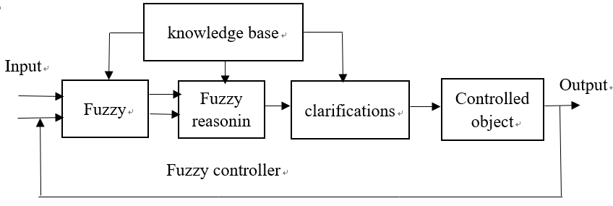
Figure 2-11 Structure of fuzzy control [64]
- Path following control based on model prediction theory
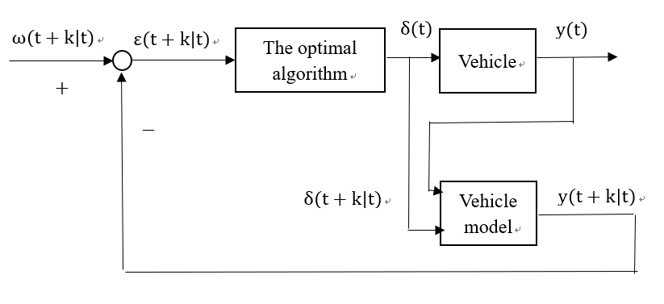
Model predictive control (MPC) [65] was initially applied to industrial process control and is essentially an optimization method based on objective function (as is shown in figure 2-12) [66]. The concrete implementation steps can be divided into three parts [67]. The first part is model state prediction, which is based on the built system model and predicts the future time according to the current state information of the controlled object. The second part is the optimization with constraints, that is, according to the prediction information obtained in the previous step, the control sequence in the future finite time domain is optimized according to the set objective function and constraints, and the first control variable in the optimal control sequence is obtained after optimization. The third part is feedback correction, which regards the actual control effect of the first control variable in the optimal control sequence as feedback information, carries out state prediction operation again to revise the predicted value, and then carries out a new round of optimization, so as to reciprocate.
Figure 2-12 Structure of model predictive control [64]
Because path following control algorithm based on model predictive theory can deal with vehicle kinematics and dynamics constraints online, effectively reduce the impact of time-varying, uncertainties and external environmental disturbances on the control effect of autonomous vehicles. Therefore, it has gradually become a research hotspot in the field of path following control. However, it also has shortcomings such as slow solution speed and high accuracy requirements [67].

Vehicle model
The vehicle model of intelligent vehicle path following includes three types: steering geometry model, vehicle kinematics model and vehicle dynamics model [68] [69]. The geometric model of automobile steering is Ackerman steering model. The model neglects the roll and pitch motion, assumes that the longitudinal speed is constant, and the tire works in the linear region during the vehicle movement without side slip. At this point, the angle of the front wheel and the trajectory of the rear wheel has a simple geometric relationship, and a set of differential equations is used to describe the relationship among vehicle position, heading angle and speed in general [70]. The dynamic model of a vehicle describes the relationship between the external forces acting on the vehicle and its kinematic parameters, and the basis theoretical is Newtonian mechanics and analytical mechanics [71]. Because of the different degree of simplification, the dynamic model has at least 2-degrees-of-freedom and at the highest 18-degrees-of-freedom.

Summary
This chapter introduced the development status of autonomous vehicles, reviewed related literatures, pointed out the advantages and disadvantages of these algorithms, which lays a theoretical foundation for subsequent research.

Methodology
This chapter will study the research method and development method adopted in this project. First of all, this chapter introduces the selection of research methods and the reasons for selection. Then the methods of data analysis are discussed. Next, the selection of development methods was introduced. Finally, the ethical position of the project and the problems encountered in the research process are indicated.

Research method

Philosophy
Research philosophy means that researchers use philosophical thinking to conduct research. At present, there three types of philosophical thinking include epistemology, ontology and value theory [72]. The conclusions of this paper come from experimental results, so the epistemology is adopted. Besides, the three research philosophy positions of epistemology include positivism, realism and interpretivism [73].

Positivism is a philosophical thought that emphasizes facts and quantitative data. It believes that all assumptions or theories must be tested by facts and that all knowledge comes from facts [74]. Realism relies on the independence of human thought. Unlike positivism, realism believes that human society has some deep structural factors that cannot be directly observed through observation. Interpretivism holds that the world is the result of man's subjective construction, and it emphasizes understanding the world through differences and integrating people's interests into research [75]. Because the project aims to analyze the results based on reliable experimental data (obtain conclusions through facts), so the positivism method will be adopted.

Research type and method
Research types mainly include two types: basic research and applied research [76]. Basic research is a kind of research aiming at exploring knowledge innovatively, which usually has no specific purpose and cannot solve specific problems [77]. Applied research is a kind of research that uses research conclusions to address specific problems [77]. Because this project has specific problems to be solved, so the research type of this project is applied research.

There are three research methods: induction research method, deduction research method and abductive research method [78]. Inductive research method is a general rule obtained from a special case, which reflects the commonality and fundamental law of things. The goal is to obtain results from the collected data sets to determine a relationship and establish a theory [79]. The deductive research method is to derive specific results from the general rules, which can reflect the characteristics of things [80]. Abductive method refers to finding the most likely explanation in some observations [81]. This project will use the deductive research method to realize the research aim.

Research design and strategy
There are two research design types: Exploratory research aims to explore the research question, but does not provide the final valid evidence for the research question [82]. Conclusive research usually adopts deductive method and achieves the research goal through hypothesis testing [83]. Because this project uses a deductive method to conduct research and expects to provide the final solution to the problem, so this project is a conclusive research. Besides, this paper will use both qualitative research method and quantitative research method, and will collect data through literature review and experiments.

The main research site of this project is University of Wales Trinity Saint David, where can provide the software resources needed for the development of the project and free document download rights. First of all, this topic will comprehensively understand the development status and future development trend of autonomous through literature review, analyze the problems by reading a large number of articles, and summarize the research methods and typical cases in the literature. Then, select the appropriate algorithm to optimize, and verify the optimization results through experimental data.

The physical and human resources required to complete the project include:
Physical resources:
• A laptop - for running programs and writing
• Matlab / Sumlink software - used to write project code (mainly programming using Matlab language and Sumlink moudle)
• Microsoft Word and Microsoft Project - for paper writing and scheduling
• Related books and literature - for reading and searching for documents

Human Resources:
A 20 – 30 minutes meeting will be held with the supervisor every week. The supervisor will check the completion of the weekly tasks and give suggestions based on the completion of the tasks to help the project leader to complete the project better.

Data analysis
Data collection will use literature review and experimental methods. The literature review is to collect the mainstream path planning algorithm and path following algorithm through literature. The experimental method is to simulate these algorithms and select the appropriate algorithm to optimize. Finally, the optimization effect of the algorithm will be verified in Matlab.

The quality of data affects the final results of research [84], so the literature data must be from a regular book or website (such as Google Scholar). The data obtained from the experiment will be obtained by the mean method. The data will be obtained by running the program multiple times, and the average value of the data is calculated to obtain the experimental data, so as to avoid data errors caused by different operating environments of the program, thereby ensuring the reliability of the data. Besides, the validity of experimental data needs to be verified. For example, verify that the data obtained is logical, and whether the data type meets the requirements to ensure the validity of the data.

All the experimental data generation procedures of this project are run by Matlab, which is directly used for data analysis. Therefore, Spss and other analysis software will not be used in this project. The analysis results of the data will be displayed using tables and graphs. The graphs are mainly used to visualization the running effect of the procedures (the types include the running results of the optimized algorithm and the original algorithm), and the specific data will be displayed using a table.

Development method
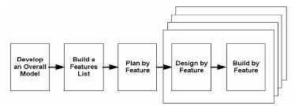
The development method adopted in this project is feature driven development method. This approach includes five processes (as is shown in figure 3-1), in which design and build by feature are iterative processes [85]: develop an overall model, build a features list, plan by feature, design by feature and build by feature.
Figure 3-1 FDD development method lifecycle [86]

The advantages of FDD include [87]:
- Can achieve rapid development of the project
- Having a clear goal to help the team move quickly
- Allow larger teams to continue to develop products and achieve continued success

Ethical issues
Ethics is a common social phenomenon, and the project leader must pay attention to its impact (such as honest, objective, respect others, protect privacy and so on). Attention to ethical issues during project research can help researchers [88]:
- Expand knowledge.
- Embodies values
- Avoid unnecessary conflicts of interest
- Get popular support

The ethical issues that may be encountered during the research of this paper include [89]:
- The source of the data is illegal
- There is no guarantee of data privacy
- Possible conflict of interest
- Some misleading information

In order to avoid these ethical issues and successfully complete this research topic, I will conduct the research in an honest, objective, fair and impartial manner, and be practical and realistic in the research process of this paper. I will strictly abide by the ethical and moral standards, and will not produce ethical issues. Besides, the data used in this paper all come from the published literature and the data generated by the program written by myself, and it does not harm anyone's interests. Finally, it is worth emphasizing that all information collected in this paper is for research purposes only and will be kept confidential.

Gannt chart
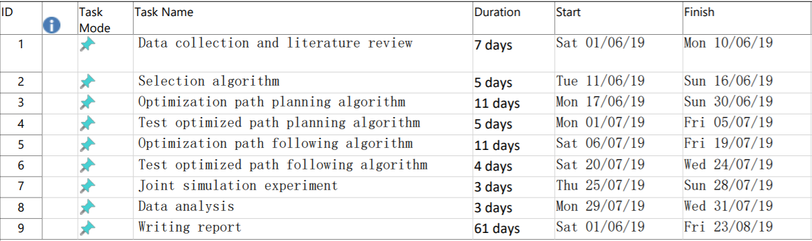
In order to reduce the risk of this research and ensure the smooth progress of the project, the Gannt chart is used in this paper (as is shown in figure 3-2).
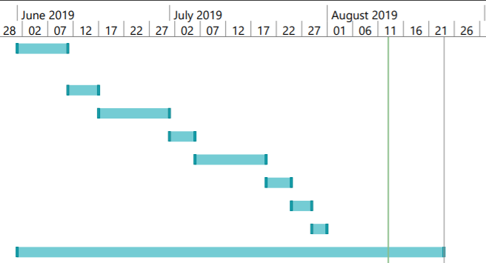
Figure 3-2 Gannt chart of the project

Path planning
In this chapter, common path planning algorithms are firstly compared, and A* algorithm is selected according to its real-time performance and reliability. Then this paper makes improvement on the problem that the traditional A* algorithm cannot avoid obstacles in the dynamic obstacle environment, poor real-time performance as the number of grids increases and the planned path is not smooth. Through simulation experiment analysis, it is proved that the optimized A* algorithm can plan a safe path in dynamic environment, and has better real-time performance and smoother path.

Algorithm selection
Path planning is the premise of studying intelligent vehicle path following, and its core lies in the design of algorithm. In the second chapter of this paper, it has been introduced that the commonly used path planning algorithms mainly include rapidly-exploring random tree (RRT), artificial potential field algorithm (APF), ant colony optimization algorithm (ACO), Dijkstra and A*. In this section, the path planning algorithm with good real-time performance and reliability will be selected through experiments (conducted in the same obstacle environment in Matlab software), and the following research will be focused on the selected algorithm.
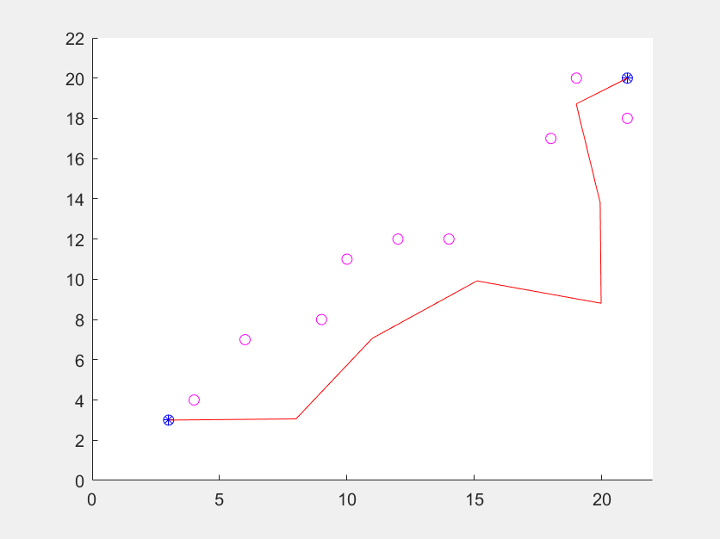
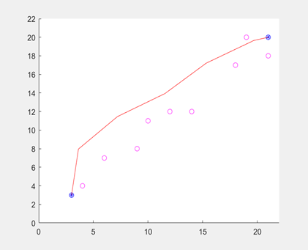
- RRT algorithm
Figure 4-1 The result of the RRT algorithm
The running results show that the algorithm can successfully avoid obstacles, and the time used by the algorithm in the obstacle avoidance phase is 0.0241s. Another point worth noting is that because of the random nature of the algorithm itself, the path obtained by this algorithm is different every time.
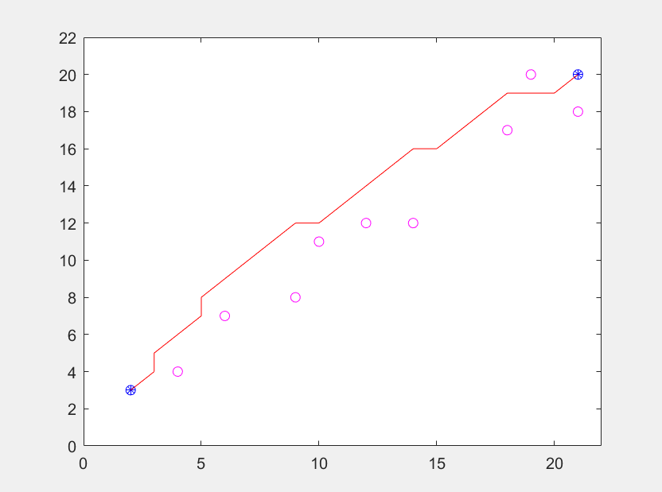
- ACO algorithm
Figure 4-2 The result of the ACO algorithm
The running results show that the algorithm can successfully avoid obstacles. However, the time used by the algorithm in the obstacle avoidance phase is 10.9312s.
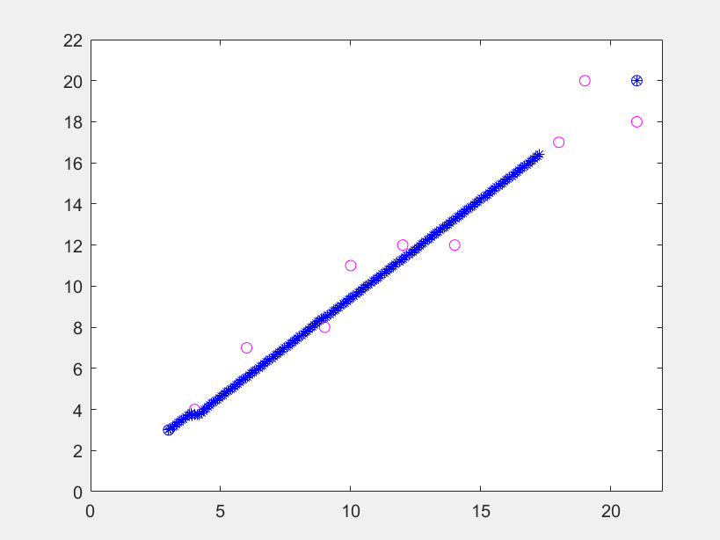
- APF algorithm
Figure 4-3 The result of the APF algorithm
The running results show that the algorithm cannot avoid obstacles successfully.
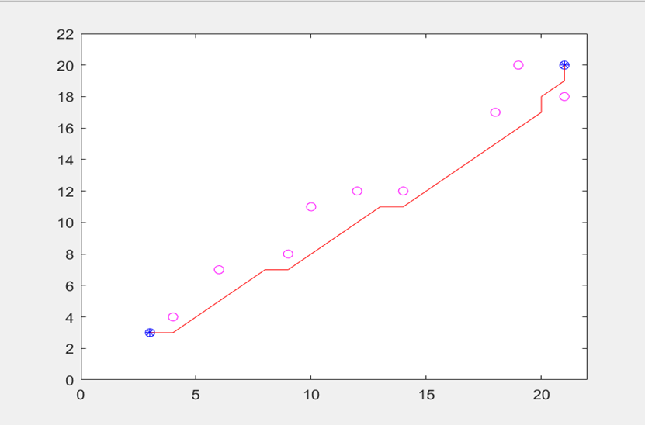
- Dijkstra algorithm
Figure 4-4 The result of the Dijkstra algorithm
The running results show that the algorithm can successfully avoid obstacles. However, the time used by the algorithm in the obstacle avoidance phase is 5.1544s.
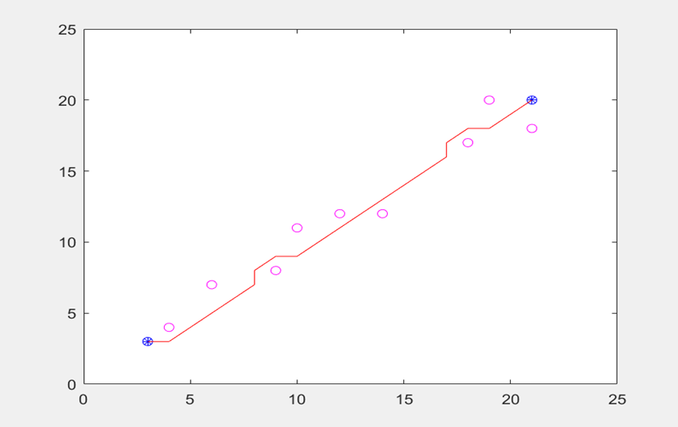
- A* algorithm
Figure 4-5 The result of the A* algorithm
The running results show that the algorithm can successfully avoid obstacles. Besides, the time used by the algorithm in the obstacle avoidance phase is 0.0011s.
- Summary
From the above operational results, the artificial potential field method cannot successfully avoid the obstacle because its algorithm has two shortcomings [24]: the local minimum and the target unreachable. Besides, because of the random nature of the algorithm itself [33], the path obtained by the RRT algorithm is different every time it is run. Therefore, the reliability of these two algorithms are not as good as the A* algorithm, so these two algorithms will not be used.

The other three algorithms have successfully avoided obstacles, indicating that all three algorithms have good reliability. However, the real-time performance of ACO algorithm and Dijkstra algorithm is worse than the A* algorithm. Therefore, the A* algorithm has good real-time and reliability compared with other algorithms, and the following research will focus on this algorithm.

Traditional A* algorithm

Basic rationale
The basic rationale of traditional A* algorithm is as follows [90].
- First create an openlist list, which is used to store the traversal node, but the list is empty when it is first created. After the initial node A is specified, the A node is placed in the openlist list.
- View the 8 nodes adjacent to node A. If they are reachable, put them in the openlist list.
- Create a list of closelists, put the node A into the list of closelists, choose the node B which has the smallest F value, and set node A as the parent node.
- Take node B out of the openlist list and put it into the closelist list. Traverse all nodes adjacent to it, if the node is not in the openlist list, put it in the openlist list.
- If an adjacent node is in the openlist, check the path again, that is, wether the node reached by the current node has a smaller G value. If not, do not do anything. Conversely. If the G value is smaller, the parent node of that node will be set as the current node, and then the F value and G value of that node are recalculated.
- Repeat the steps from 1 to 5 until the target node is put in the openlist list, indicating that the traversal is completed under the condition of the heuristic function, and all the parent nodes are connected as the optimal path under the current condition, and the path is saved.

Evaluation function
The cost function of A* algorithm is calculated using formula 4-1:
$F\left(n\right)=G\left(n\right)+H(n)$ (4-1)
$G\left(n\right)$ represents the cost of moving from the starting point to the specified point, $H(n)$ represents the estimated cost of moving from the specified point to the target point, and $F\left(n\right)$ represents the final cost from the starting point to the target point after passing through the specified point.

The key to the value of $F\left(n\right)$ is the selection of the valuation function H(n). The main valuation functions currently used include [91]: Euclidean distance, diagonal distance, Manhattan city distance, Chebyshev distance. This paper will use the traditional diagonal distance formula to calculate H(n).

Dynamic obstacle avoidance of A* algorithm

Problem statement
According to whether the path planning environment changes with time, the path planning of autonomous vehicles can be divided into dynamic path planning and static path planning [92]. Static path planning is to find feasible path from starting point to target point according to existing environmental models. Dynamic path planning is to obtaining the environment information through sensors in a partially unknown or completely unknown environment, avoiding obstacles encountered during the movement process intelligently and reaching the target point.
Thi Thoa Mac [93] pointed out in his article that the static path planning algorithm usually generates the driving path based on the known environment map. However, the response to unknown or dynamic obstacles is inadequate. It may cause the planned path to be unable to avoid moving obstacles, resulting in collision.

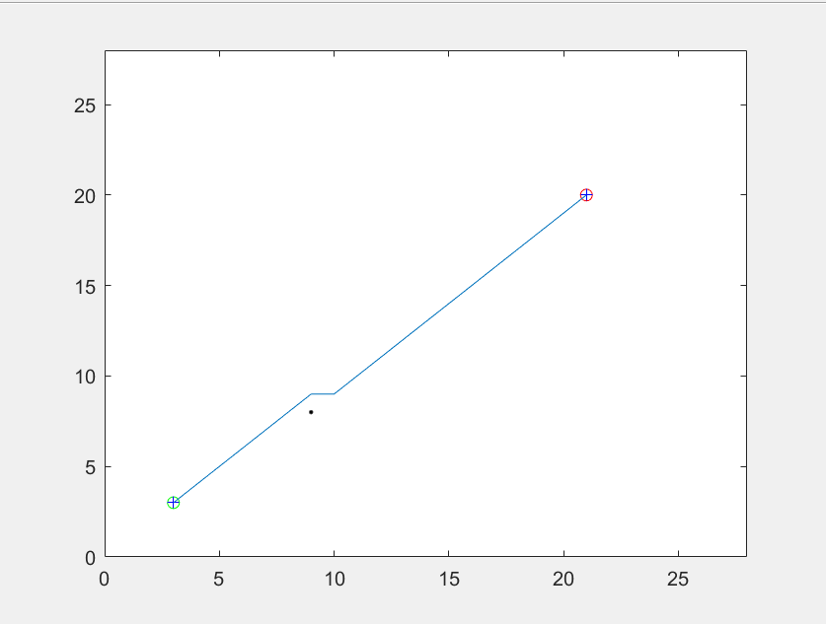
As shown in figure 4-6, there is a static obstacle at (9, 8). By using the original A* algorithm, a reasonable path can be planned to avoid obstacles.
Figure 4-6 Path in a static environment
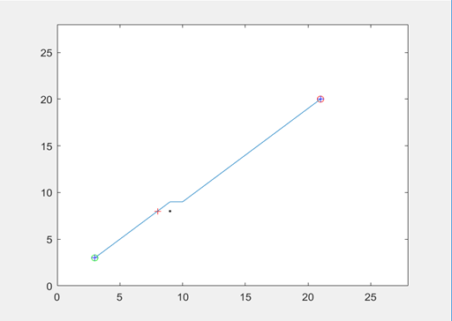
However, if the obstacle is not stationary but constantly moving, the planned path may have a crash with the obstacle. It can be seen from figure 4-7, if the obstacle at (9,8) (black point) continues to move to (8,8) (red point), then the planned path will collide with the obstacle.
Figure 4-7 Path in a dynamic environment

Theoretical method
In order to avoid dynamic obstacle and improve the reliability of the algorithm, this paper will use real-time update map method for dynamic path planning. The main process is as follows:
- Enter the initial map information.
- Set the starting point and target point.
- Real-time monitoring of path information (this step is usually done by onboard sensors).
- If the obstacle enters the extended neighborhood of the current node, this point will be set as the obstacle node. Then predict the next moving node according to the obstacle historical trajectory, and set the predicted node as the obstacle node.
- Update map information.
- Plan the path using the A* algorithm.
- Repeat the above steps until reach the target point.

The detailed principle of the map updating method based on obstacle motion direction prediction is shown as follows.
- Expand its monitoring range. When the obstacle enters the detection range, record its historical movement trajectory.
- When the obstacle enters the neighborhood node of the current node, the algorithm will predict its next movement point through its historical trajectory. If the obstacle is stationary, the node where the obstacle is current located will consider as an obstacle node. If the obstacle moves, the current point of the obstacle and its next possible moving point in the extended neighborhood will be regarded as the obstacle node.

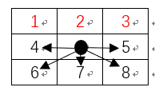
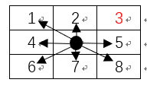
As shown in figure 4-8(a), the current node of the obstacle is point 3. If the obstacle is predicted to be stationary by its historical moving trajectory, at this time, point 3 will be regarded as an obstacle node. As shown in figure 4-8(b), in the extended neighborhood, if the next movement point of the obstacle is predicted to be 2 and 1 by its historical movement trajectory, then point 3, point 2 and point 1 will all be regarded as obstacle node.
- (b)
Figure 4-8 Prediction of the next movement point
The prediction of obstacle motion points uses a method of calculating the slope (as is shown in formula 4-2).
$K=\frac{\operatorname{atan}\left(\frac{y2-y1}{x2-x1}\right)}{pi}*180$ (4-2)
Supposing that the obstacle trajectory is detected as (3, 3), (2, 3):
$$K=\frac{\operatorname{atan}\left(\frac{3-3}{2-3}\right)}{pi}*180=0$$
Because x2 < x1, so the motion direction is going from right to left along the X-axis, and in the extended neighborhood, the next motion point is predicted to be point 2 and point 1.

Experiment and data analysis
In order to verify the effect, the optimized dynamic A* algorithm is run with the dynamic obstacles. Usually the detection step of the obstacle is completed by the onboard sensor, but due to the limitations of the experimental conditions, the obstacle trajectory of this experiment will be manually set. Suppose the obstacle moves from right to left along the X-axis ( (10,8) (9,8) (8,8) (7,8)), and when the obstacle moves to (9, 8), the obstacle will enter the extended neighborhood of the current node.
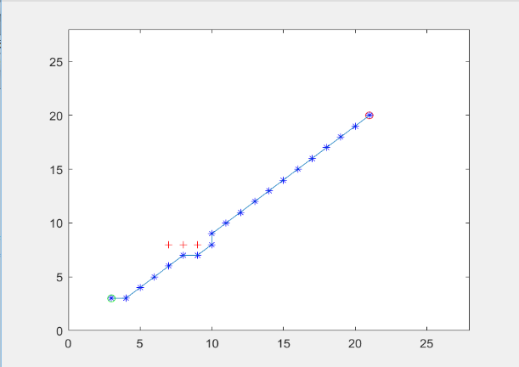
The running result is shown in the following figure 4-9 (the red dots represent the current position and the possible next motion point in the extended neighborhood of the obstacle, the blue dots are the planned paths).
Figure 4-9 Experimental result of dynamic obstacle avoidance
As can be seen from figure 4-9, the planned path can avoid the original position of the obstacle and its possible next motion point in the extended neighborhood of the obstacle. Therefore, experimental results show that this method can realize A* algorithm for path planning in dynamic obstacle environment.

Real-time optimization of A* algorithm

Problem statement
In the process of driving, autonomous vehicles need to plan a reasonable driving path quickly. Therefore, autonomous vehicles need a higher real-time response to the path planning algorithm to cope with different tasks [94]. In many traditional path planning processes, the shortest path planning is often more focused, while the response time is ignored. As far as the A* algorithm, when the algorithm finds the shortest path, the algorithm takes a lot of time and sacrifices efficiency. For example, M.S.Ganeshmurthy and Dr.G.R.Suresh [90] pointed out in their article that because the A* algorithm is based on a grid, so the search time will increase as the number of grids increases.

Theoretical method
- Adding search direction
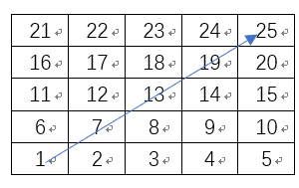
When selecting the next possible point for the current point a, consider the actual direction of motion (the vector direction from the current point to the next possible node point) and the reference direction (the vector direction from the starting point to the target point). If the actual motion direction is within the allowable error of the reference direction, it can be calculated as the next possible point. Otherwise, this point is not used as the next possible point. As is shown in figure 4-10, suppose that the starting point is 1 (1,1) and the ending point is point 25 (5,5).
Figure 4-10 Reference direction
Therefore, the reference direction of motion is
$$XL=\frac{\arctan\left(\frac{5-1}{5-1}\right)}{pi}*180=45°$$
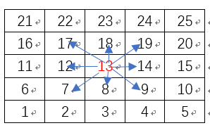
As is shown in figure 4-11, suppose that the current point is point 13, a total of 8 nodes may be the next possible mobile node.
Figure 4-11 No search direction restrictions
The reference direction of motion is $45°$, when we limit the actual direction of motion, for example, we can set the actual direction of motion can only be within $±45°$ of the reference motion direction, so the actual motion direction is between $0°$and $90°$. As is shown in figure 4-12.

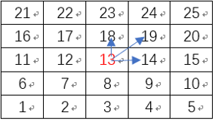
Figure 4-12 Add search direction restrictions
By adding a direction vector, the number of nodes that the A* algorithm needs to traverse in path planning can be reduced. Therefore, this method can reduce the running time and also make the search process more purposeful and directional.
- Change the strategy to select the next mobile node for the current node
When selecting the next possible motion node for the current node, the A* algorithm will traverse the all possible next motion nodes of the current point, then the A* algorithm will traverse the F values of these possible next motion nodes again to select the smallest F to as its next motion node [90]. Therefore, this will take a certain amount of time.

This paper proposes a method for selecting the next motion node. First, calculate the F value of the next possible motion node, and save the F value and its coordinates to the variable f_nextpoint and nextpoint. Then, continue to calculate the next possible motion node. When the next possible node with a smaller F exists value in the neighborhood of a, the variable f_nextpoint and nextpoint are updated. Otherwise, the variables remain unchanged (so the variable nextpoint always hold the next motion node coordinate with the smallest F value). Finally, after traversing all the neighborhood nodes of the current point, the coordinates in the variable nextpoint are selected as the next motion node of the current point.

Experiment and data analysis
In order to test the optimization effect, the original algorithm and the optimization algorithm were tested for three times under the same obstacle environment, and the running time of each time was recorded. Finally, the average running time of the two algorithms was obtained, and the experimental results are as follows.

As is shown in table 4-1, the average running time of the original A* algorithm is 438.00ms, and the average running time of the optimized A* algorithm is 345.74ms. Therefore, the optimized A* algorithm is improved by 21% compared with the original A* algorithm.
 | 1 | 2 | 3 | Average runtime
Original A* algorithm | 451.42ms | 419.53ms | 443.04ms | 438.00ms
Optimized A* algorithm | 348.63ms | 353.52 | 335.06ms | 345.74ms
Table 4-1 Run Time of algorithm
As is shown in table 4-2, the original A* algorithm traverses 124 nodes in the planned path, and the optimized A* algorithm traverses 85 nodes in the planning path. Therefore, the number of traversing nodes required by the optimized A* algorithm is reduced by 31.45% compared with the original A* algorithm.
 | Number of nodes traversed
Original A* algorithm | 124
Optimized A* algorithm | 85
Table 4-2 Number of nodes traversed

Through experiments, it can be concluded that the time efficiency of the optimized algorithm is improved by 21% compared with the original A* algorithm, and the traversal number of nodes is reduced by 31.45%. Therefore, this method can optimize the real-time performance of A* algorithm.

Path smoothing optimization of A* algorithm

Problem statement
Grid method can transform the environment information around autonomous vehicles into grid for storage, so it has significant advantages in environmental modeling [90]. However, because A* algorithm is affected by node search strategy, so there are too many sharp angles in the path. František Duchoň [95] pointed out in his article that the grid-based A* path planning algorithm has a problem: it is based on the center point of the grid and can be searched as a node, that is, it can search for 8-connectivity. However, the path search direction is limited, because the search angle is an integer multiple of 0.25 π. Therefore, there are a lot of path sharp corners.

Theoretical method
The original A* algorithm searches for the next node to be extended using the 8-connectivity algorithm, as shown in figure 4-13. The angle between each search direction is 0.25 π, and the node turning angle is an integral multiple of 0.25 π. For this reason, the planned path of the original A* algorithm has more sharp corners, resulting in a path that is not smooth enough.
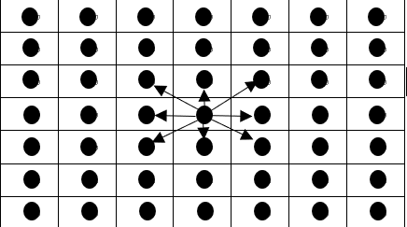
Figure 4-13 8-connectivity
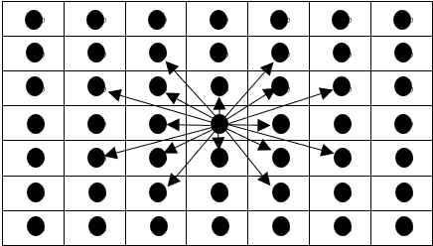
In order to eliminate the defect of 8-connectivity search, this paper proposes an improved algorithm to expand the current node search neighborhood range of A* algorithm. Take the 7×7 non-obstructed raster map (in figure 4-13) as an example, the center node is the current node n, and the 8 nodes on the first layer around it are the original A* algorithm to be extended. In addition to the 8-connectivity search algorithm, the algorithm in this paper also includes 16 nodes in the second layer around the current node n (as shown in figure 4-14) to be extended in the next step of the algorithm. At this time, the number of neighborhood nodes to be searched by the algorithm is 24, and the movement direction of nodes is 16.
Figure 4-14 24-connectivity
Similarly, the number of extensible search neighborhood nodes and movable directions of A* algorithm keeps increasing with the expansion of the number of search layers. L represents the number of node layers to be expanded when the current node n searches for the next node, NL represents the number of neighbor nodes to be searched, and DL represents the number of movable directions with the node, so the formula is:
$NL=8×\frac{L(L+1)}{2}$ (4-3)
$DL=8×[1+\frac{L\left(L-1\right)}{2}]$ (4-4)
Number of search layer (L) | 1 | 2 | 3 | 4
Number of neighborhoods to be searched (NL) | 8 | 24 | 48 | 80
Movable direction (DL) | 8 | 16 | 32 | 56
Table 4-3 Neighborhood extension table

Experiment and data analysis
In order to test the effect of the optimization method, the original A* algorithm and the optimized A* algorithm run under the same obstacles, and the running results are shown in the figure 4-15, figure 4-16 and table 4-4.
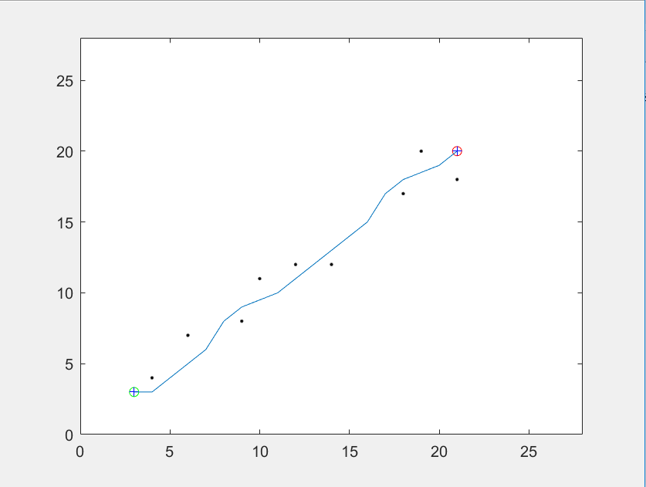
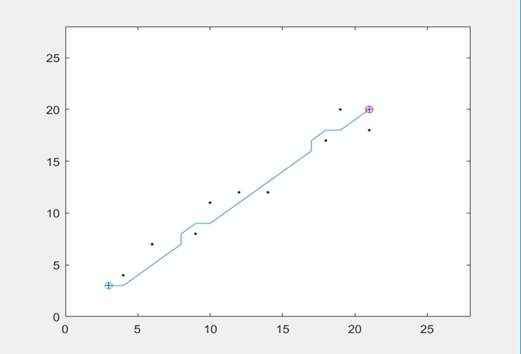
Figure 4-15 Smoothness experimental results of original A* algorithm
Figure 4-16 Smoothness experimental results of optimized A* algorithm
 | Runtime | Number of path node
Original A* algorithm | 0.0011s | 21
Optimized A* algorithm | 0.0012s | 17
Table 4-4 Comparison of operation results
It can be seen from the above figures and table, the search node of the optimized algorithm is reduced by 20%. This is because the optimized A* algorithm has more movable directions than the original A* algorithm when performing path search. Therefore, the sharp corners of the planned path are reduced, the path is smoother, and it is more suitable for the driving condition of the vehicle.

Summary
This chapter firstly analyzed and compared common path planning algorithms, and selected A* algorithm as the path planning method of this paper. Through simulation experiments and literature reading, the problem that the traditional A* algorithm cannot avoid obstacles in the dynamic obstacle environment, poor real-time performance as the number of grids increases and the planned path is not smooth were found. Then this paper realized to predict the possible moving points of obstacles by recording the historical trajectory of obstacles, added the restriction of searching direction of nodes, expanded the search neighborhood to solve these problems. Finally, the target path that meets the driving requirements of the car is planned.

Path following
In order to guarantee that the intelligent vehicle can travel along the desired path, this chapter proposes a compensation type following algorithm. By establishing a vehicle kinematics model of longitudinal and yaw, the distance deviation and heading angle deviation are used to compensate the pure pursuit algorithm. The simulation result shows that the compensation type following algorithm has better robustness, better path following control effect, smaller vehicle side slip and stable driving.

Establish vehicle kinematics model
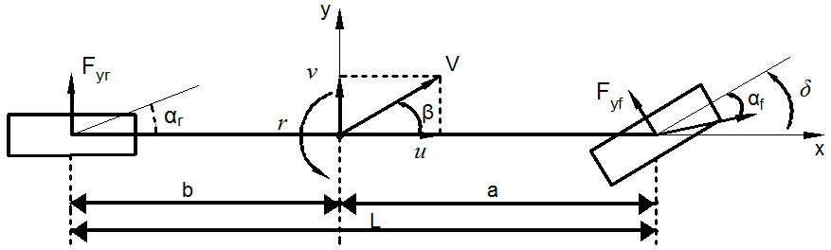
A linear vehicle dynamics model can be used to describe the vehicle's handling characteristics when the vehicle is turning on a well-attached road surface. The vehicle is simplified into a two-wheeler model, lateral and yaw [96]. It can be seen form figure 5-1, the longitudinal and lateral velocities of the vehicle are $u$ and $v$, the centroid side declination is $β$, the vehicle yaw rate is $γ$, the distance from the centroid to the front and rear axles is $a$, $b$, and the front wheel angle is$δ$, the lateral forces of the front and rear wheels are $F_{yf}$ and $F_{yr}$ respectively, and the equivalent lateral stiffness of the front and rear wheels is $K_{f}$ and $K_{r}$ respectively, the vehicle’s total mass is $M$, and the vehicle’s moment of inertia around the z-axis is $I_{z}$.
Figure 5-1 Linear 2-dof vehicle model [96]
Linear vehicle motion differential equation:
$\left\{\begin{aligned}&(K_{f}+K_{r})β+\frac{(aK_{f}-bK_{r})}{u}r-K_{f}δ=M(\overset{∙}{v}+ur) \\ &(aK_{f}-bK_{r})β+\frac{a^{2}K_{f}+b^{2}K_{r}}{u}r-aK_{f}δ=I_{z}\overset{∙}{r}\end{aligned}\right.$ （5-1）

Pure pursuit algorithm

Introduction of pure pursuit algorithm
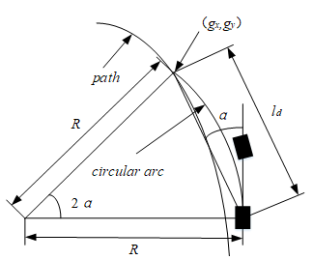
Pure pursuit algorithm is a method based on geometric calculation, which aims to calculate the arc length of vehicle from the current point to the target point [97]. The algorithm is simple and intuitive, and mainly adjusts the wheel angle by determining the appropriate forward distance to help the vehicle can follow the target path stably.
Figure 5-2 Schematic diagram of the pure pursuit algorithm [97]
According to the vehicle model (as is shown in figure 5-2), the pure pursuit algorithm uses the vehicle’s rear axle as the entry point, and the connecting line between the center of the front wheel and the center of the rear wheel serves as tangent to control the corner of the front wheel.

In the figure 5-1, $(g_{x},g_{y})$ is the next target path point to be tracked. In order to make the intelligent vehicle track the expected path smoothly, it is necessary to control the corner of the vehicle to ensure the vehicle’s rear axis can pass the path point. $l_{d}$ represents the distance between the current vehicle rear axle position and the target path point, and $α$ represents the angle between the current body tangent and $l_{d}$. The following formula can be derived from the triangular sine theorem:
$\frac{l_{d}}{\sin{(}2α)}=\frac{R}{\sin{(}\frac{π}{2}-α)}$ （5-2）
$\frac{l_{d}}{2\sin{α}\cos{α}}=\frac{R}{\cos{α}}$ （5-3）
$\frac{l_{d}}{\sin{α}}=2R$ （5-4）
Formula (5-4) can also be written as:
$κ=\frac{1}{R}=\frac{2\sin{α}}{l_{d}}$ 5-5）
Where $κ$ is the curvature of the arc, and according to the simplified Ackerman vehicle model, the front wheel angle is expressed as：
$δ=\arctan{(}κL)$ （5-6）
Combined with formulas (5-5) and (5-6), you can get:
$δ=\arctan{(}\frac{2L\sin{(}α)}{l_{d}})$ （5-7）
Because the vehicle wheelbase $L$ is fixed, the front wheel angle $δ$of the vehicle can be calculated.

Vehicle heading angle change rate [98]：
$\dot{θ}=\frac{\tan{δ}}{L}u$ （5-8）

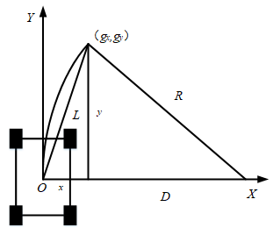
Figure 5-3 Geometric analysis of pure pursuit algorithm [97]
Figure 5-3 is a geometric analysis of the pure pursuit algorithm. The point $\left(g_{x},g_{y}\right)$is the next path point to be followed, and from the figure 5-2, the point $l_{d}$is the length between the center of mass and this point, that is, the chord length of the arc, and $R$ is the arc. Therefore, the relationship between $l_{d}$ and R can be expressed as:
$D+x=R$ （5-9）
$D^{2}+y^{2}=R^{2}$ （5-10）
$x^{2}+y^{2}=l_{d}^{2}$ （5-11）
Where, x and y are the transverse and longitudinal distances from the path point to the center of mass of vehicle respectively.

According to equations (5-9), (5-10) and (5-11), it can be deduced that:
$R=\frac{l_{d}^{2}}{2x}$ （5-12）
Finally get:
$δ=\arctan{(}\frac{2Lx}{l_{d}^{2}})$ （5-13）
This formula embodies the relationship between the front wheel angle of the vehicle and the pure pursuit algorithm, and it is the basis for establishing a follow-up control system. The vehicle’s steering angle can be obtained by $x$ and $l_{d}$, and $l_{d}$ affect the accuracy of the steering angle.

Forward distances
The pure pursuit controller is essentially a $P$ controller that controls the vehicle’s lateral rotation angle. The $P$ coefficient is $2/l_{d}^{2}$. The $P$ controller is greatly affected by the forward viewing distance $l_{d}$. There is a certain mathematics relationship between the forward viewing distance$l_{d}$ and the vehicle speed. The formula for calculating the forward distance $l_{d}$ is [99]:
$l_{d}=Av^{2}+Bv+C$ （5-14）
Where $v$ is the vehicle speed, $A$ is a constant, and $Av^{2}$ represents the braking distance of the vehicle in the case of the maximum deceleration $a_{max}$, B represents the distance traveled by the vehicle between the time it encounters an emergency and the time it responds (suppose B is 0.2).$C$ represents the minimum turning radius of the vehicle, and it is related to the vehicle's own parameters (suppose C is 5).

$A$ can be expressed as:
$A=\frac{1}{2a_{max}}$ （5-15）
Therefore, the forward distance can be expressed as:
$l_{d}=\frac{1}{6}v^{2}+\frac{1}{5}v+5$ （5-16）
Therefore, the formula for the front wheel angle of the vehicle is:
$δ=\arctan{(}\frac{2L\sin{α}}{Av^{2}+Bv+C})$ （5-17）
In general, the maximum and minimum forward viewing distance $l_{d}$ is adopted to restrict and constrain the forward viewing path. The larger the current viewing distance $l_{d}$ is, the smoother the path follows. The smaller the forward looking distance $l_{d}$ is, the more accurate the following path will be, but it will also cause the vibration of the following vehicle.

Optimization of pure pursuit algorithm

Problem statement
However, the pure pursuit algorithm has the problem of selecting the preview point, and when the vehicle reaches the target path, the direction angle of the vehicle has a large deviation from the path direction. For example, CitlalliGámezSerna [100] pointed in his article that the pure pursuit algorithm does not take account into the curvature of the road, so it cannot select the proper preview point, which affects the precision of path following.

Theoretical method
The pure pursuit model is already shown in figure 5-2, when the vehicle travels to a, both the vehicle’s heading angle and the vehicle’s rotation angle are inclined to the desired path. The angle of the front wheel calculated according to formula (5-7) will be smaller than that at the previous moment, but it can be seen from formula (5-8) that the heading angle of the vehicle will continue to increase. This causes the vehicle to cross the expected path, increasing the following error.

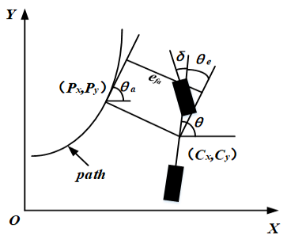
In order to address the above problems, this paper proposes an improved path following algorithm. Considering the distance deviation of the vehicle's current position and expected path to select the preview point, and combining the angle deviation of the vehicle's heading angle and expected heading angle to calculate the control quantity of the front wheel angle, so as the vehicle can follow the expected path stably.
Figure 5-4 The following model of the compensated follower algorithm
Figure 5-4 is the following model of the compensated follower algorithm, $(Cx,Cy)$ is the center of mass coordinate of the vehicle; $(Px,Py)$ is the coordinates of the preview point; $θ$ is the angle between the front and rear lines of the wheel and the x-axis, that is, the vehicle's heading angle; $θ_{a}$ is the angle between the tangent to the x-axis and the x-axis; $θ_{e}$ is the vehicle’s deviation heading angle from the tangential angle of the pre-point; $v$ is the longitudinal speed of the vehicle; $e_{fa}$ is the distance deviation between the vehicle's center of mass and the pre-picked point, so get:
$θ_{e}=θ-θ_{a}$ （5-18）
$e_{fa}=-\sin{θ_{a}}(C_{x}-D_{x})+\cos{θ_{a}}(C_{y}-D_{y})$ （5-19）
When the center of mass of the vehicle is on the desired path during driving, let the front wheel angle $δ$ =$θ_{e}$. When the vehicle's travel path does not coincide with the expected path, that is, $e_{fa}$ is not zero, the front wheel angleneeds to be adjusted to realize the following of the path. The final front wheel angle is:
$δ=θ_{e}+\arctan{(}\frac{e_{fa}}{u})$ （5-20）
When the vehicle approaches the expected path, the front wheel angle is controlled by calculating the direction deviation and the distance deviation between the vehicle and the path, so that the two deviations approach 0.

Experiment and data analysis
In order to test the effectiveness of the path following algorithm proposed in this paper, the above mentioned linear 2-dof vehicle dynamics model is adopted in Matlab software to carry out the path following simulation of the intelligent vehicle. Vehicle parameters adopted in the simulation experiment are shown in table 5-1.
Sign | Number
/ | 1573
/m | 1.1
/m | 1.58
/ | 80000
/ | 80000
/ | 2873
Table 5-1 Vehicle parameters
In the table, M represents the vehicle's mass, a and b represent the vehicle’s front axle distance and vehicle’s rear axle distance, $K_{f}$,$K_{r}$represent the vehicle's front wheel lateral stiffness and vehicle's rear wheel lateral stiffness, $I_{z}$ represent the vehicle's moment of inertia.

In the simulation experiment, the initial vehicle’s position and vehicle’s heading angle are set as (0,0) and 0. The front wheel angle obtained according to formula (5-20) is used as the input of the vehicle model, and the information such as vehicle’s driving position and vehicle’s heading angle are calculated according to the model, so as to simulate the current position and heading angle information of vehicles fed back by GPS.

The lane change curve adopted in this paper is:
$$Y=\left\{\begin{aligned}& 4.5 0≤X<40 \\ &2.25*\sin{(}\frac{π}{80}*X)+2.25 40≤X<120 \\ & 0 120≤X<160\end{aligned}\right.$$

Optimized pure pursuit algorithm and original pure pursuit algorithm proposed in this paper were adopted to conduct lane changing simulation of the intelligent vehicle at speeds of 5m/s, 10m/s and 20m/s. The simulation results are shown in figure 5-5 and figure5-6, and the path following errors are shown in table 5-2.
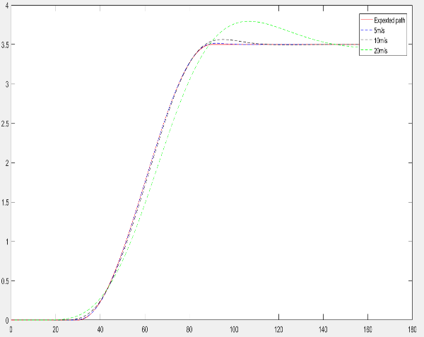
Figure 5-5 Original pure pursuit algorithm driving following
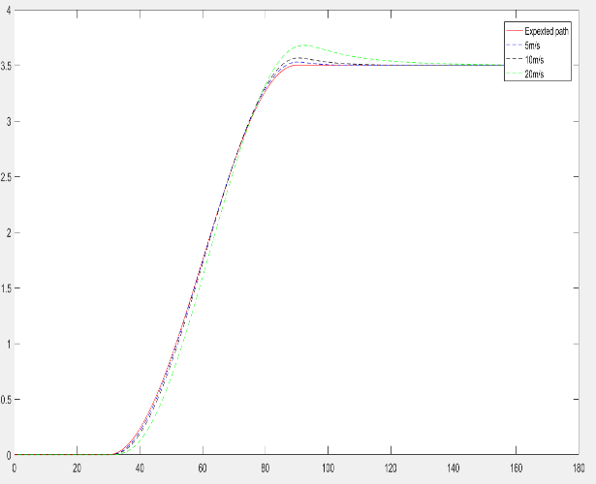
Figure 5-6 Optimized pure pursuit algorithm driving following
Algorithm | Maximum error /m | Average value /m | Standard deviation /m
Original pure pursuit algorithm（5m/s） | 0.0134 | 0.0022 | 0.0030
Original pure pursuit algorithm（10m/s） | 0.0621 | 0.0165 | 0.0191
Original pure pursuit algorithm（20m/s） | 0.3203 | 0.1268 | 0.1127
Optimized pure pursuit algorithm（5m/s） | 0.0033 | 0.0008 | 0.0011
Optimized pure pursuit algorithm（10m/s） | 0.0225 | 0.0062 | 0.0072
Optimized pure pursuit algorithm（20m/s） | 0.1786 | 0.0622 | 0.0630
Table 5-2 Statistical results of path following error at different vehicle speeds
It can be seen from figure 5-5 that the traditional pure pursuit algorithm causes a large path following error for vehicles in the middle and later stages of lane change, making it difficult to accurately follow the expected path of lane change. From figure 5-6, although this method makes the vehicle in the middle and later produced a small path following error, but it can quickly converge to the expected path. This shows that the method under different speed when finish the expectation path following control has good robustness and better control effect.

According to table 5-2, the average following error of the optimized pure pursuit algorithm is reduced by 63.6%, 62.4% and 50.9% respectively compared with the original pure pursuit algorithm, maximum error were reduced 0.0101 m, 0.0396 m, 0.1417 m, the standard deviation is reduced, so the proposed method is more accurate than original pure pursuit algorithm.

Summary
This chapter established a vehicle kinematics model and introduced the pure pursuit algorithm. In view of the shortcomings of the algorithm, a compensation type following algorithm is proposed to compensate the distance and heading angle deviation. The simulation experiment of the given path was carried out in Matlab. And the experimental result shows that the compensated path following algorithm can be smoothly and accurately followed when the vehicle makes a turn, which is more reliable than the traditional pure pursuit algorithm.

Joint simulation experiment
In order to test whether the optimization algorithm is more suitable for the application scenario of intelligent vehicles, this chapter will perform joint simulation experiment on the optimized path planning algorithm in chapter 4 and the optimized path following algorithm in chapter 5 to achieve driverless driving in a simple environment.

Design simulation experiment
This simulation experiment will be performed on Matlab software, and the expected result is that a safe driving path can be planned, and the following error of vehicles to the planned path is less than 0.8m (average half width of a family car [101]). The specific experimental content is as follows:
- Set the obstacle environment
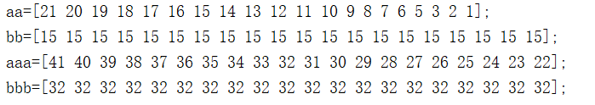
First, set the starting point of the path to (3, 3) and the target point to (50, 50). Besides, two moving obstacles will be set on this road. Usually the detection step of the obstacle is completed by the onboard sensor, but due to the limitations of the experimental conditions, the obstacle trajectory of this experiment will be manually set. The movement path of the first obstacle and the second obstacle are shown in figure 6-1. After the process of path planning is completed, the points of the planned path will be saved and sent to the path following algorithm for use.
Figure 6-1 Path of obstacles
In the figure 6-1, aa is the X coordinate of the first obstacle and bb is the Y coordinate of the first obstacle, aaa is the X coordinate of the second obstacle, and bbb is the Y coordinate of the second obstacle.
- Set vehicle parameters
When following the path, the parameters of the vehicle need to be set. The parameters of vehicle in this experiment are as follows:
Sign | Number
u / m/s | 10
M / kg | 1573
a / m | 1.1
b / m | 1.58
/ | 80000
/ | 80000
/ | 2873
Table 6-1 Vehicle parameters of joint simulation experiment
In the table 6-1, u represents the vehicle's speed, M represents the vehicle's mass, a and b represent the vehicle’s front axle distance and vehicle’s rear axle distance, $K_{f}$,$K_{r}$represent the vehicle's front wheel lateral stiffness and vehicle's rear wheel lateral stiffness, $I_{z}$ represent the vehicle's moment of inertia.

Analyze the data
The experimental results are shown in figure 6-2. The red line represents the expected driving path, the black line represents the actual driving path, the red point represents the point where the obstacle may collide with the vehicle in the moving process. As is shown in figure 6-2, the optimized A* algorithm plans a safe driving path in a dynamic obstacle environment. Besides, the maximum error of path following is 0.5727m, and the average following error is 0.1295m, so all of these errors are within the allowable error range. Therefore, the optimized path following algorithm can follow the planned path accurately and reach the target point successfully.
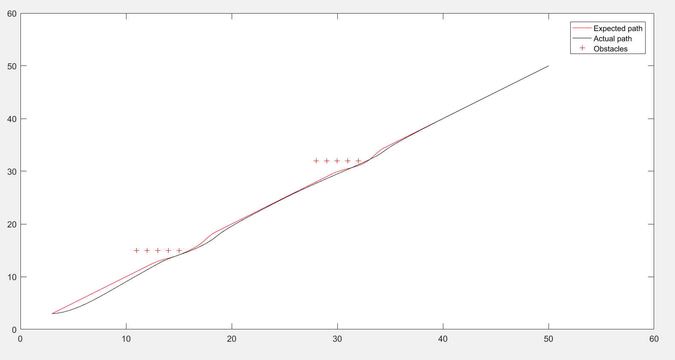
Figure 6-2 The results of joint simulation experiment

Summary
This chapter used the optimized A* algorithm to plan a driving path, and then followed the path by the optimized pure pursuit algorithm. The experimental result shows that these two algorithms can achieve driverless driving in a simple environment.

Conclusions and reflection
This paper researches on autonomous vehicle and studies its path planning and path following technology. The traditional A* algorithm is optimized to achieve path planning in dynamic obstacle environment, with better real-time performance and smoother path. In view of the pure pursuit algorithm, the optimized algorithm based on distance deviation and heading angle deviation compensation is designed, and the simulation experiment is performed in Matlab software. The research work of this paper is summarized as follows:
- The traditional A* algorithm has the problem that cannot avoid obstacles in the dynamic obstacle environment, poor real-time performance as the number of grids increases and the planned path is not smooth. In this paper, the historical movement trajectory of obstacles is recorded to predict the motion direction of obstacles and predict the next possible movement point, and then this point will be set as the obstacle point, which realizes the path planning under the dynamic obstacle environment. Besides, by adding the limitation of the search direction and expanding the search neighborhood, the real-time performance and path smoothness of A* algorithm are optimized. Finally, the experimental results show that the optimized A* algorithm has better real-time and reliability, and can plan a safe path in a dynamic obstacle environment.
- A compensation-type following algorithm is proposed, and vehicle kinematics model is established. The pure pursuit algorithm is compensated by distance deviation and heading angle deviation compensation. Besides, different vehicle speeds are used in the simulation software to test the optimized effect. The experimental results show that the compensating following method has better robustness, better path following control effect, smaller vehicle slip and stable driving.
- The optimized A* algorithm and the optimized pure pursuit were used for joint simulation experiment. Simulation results show that the path planning and following control method can plan a path correctly in simple traffic scenarios and follow the planned path accurately and stably. Therefore, the research results of this paper have certain practical significance in the field of autonomous vehicles.

The path planning algorithm and path following studied in this paper are the key technologies to realize unmanned driving. Although this paper has some research results, because the limitations of the author's knowledge, time and programming ability, there are still deficiencies in the research, and the following aspects need to be improved:
- In this paper, although the traditional A* algorithm has been optimized and achieved good results, the adaptability of the algorithm in complex environment needs to be optimized. Therefore, the following work should focus on the path planning in a complex dynamic obstacle environment, such as considering the speed of obstacles in the path planning process.
- As for vehicle path following control, this paper chooses to establish a vehicle kinematics model, which is relatively simple compared with the dynamic model but takes less consideration. Therefore, the following work can establish a dynamics vehicle model to control the input and output.
- Due to the limitation of time and resource, this paper does not carry out the actual vehicle experiment. Therefore, the further work will apply the research results of this paper to the actual vehicle and carry out an actual vehicle experiment.

References

[1] | M. T. A. O. Saeed Asadi Bagloee, "Autonomous vehicles: challenges, opportunities, and future implications for transportation policies," Journal of Modern Transportation, p. 284–303, 12 2016.
[2] | X. Du, X. Li, D. Liu and B. Dai, "Path planning for autonomous vehicles in complicated environments," in 2016 IEEE International Conference on Vehicular Electronics and Safety, Beijing, China, 2016.
[3] | R. P. ,. R. S. Kristijan Macek, "Path Following for Autonomous Vehicle Navigation Based on Kinodynamic Control," Journal of Computing and Information Technology, pp. 17-26, 2009.
[4] | [Online]. Available: https://www.mathworks.com/products/matlab.html.
[5] | [Online]. Available: https://www.agvsystems.com/faqs/.
[6] | MOBILITY AND TRANSPORT, "Intelligent transport systems," [Online]. Available: https://ec.europa.eu/transport/themes/its/road_en. [Accessed 22 7 2019].
[7] | MOBILITY AND TRANSPORT, "Intelligent transport systems," [Online]. Available: https://ec.europa.eu/transport/themes/its_en. [Accessed 22 7 2019].
[8] | M. Reilly, "In the 1980s, the Self-Driving Van Was Born," 8 11 2016. [Online]. Available: https://www.technologyreview.com/s/602822/in-the-1980s-the-self-driving-van-was-born/. [Accessed 22 7 2019].
[9] | R. J. K. D. e. a. Mason R, "NavLab11-The newest platform vehicle of the project," 10 2001. [Online]. Available: http://www.cs.cmu.edu/~tyata/Project/NavLab11.html. [Accessed 22 7 2019].
[10] | Carnegie Mellon University, "Navlab: The Carnegie Mellon University Navigation Laboratory," [Online]. Available: https://www.cs.cmu.edu/afs/cs/project/alv/www/. [Accessed 22 7 2019].
[11] | T. P. H. R. e. a. Funke J, "Up to the limits: Autonomous Audi TTS," Intelligent Vehicles Symposium, pp. 541-547, 2012.
[12] | "Audi drops more photos and info on "Shelley", the autonomous TT-S," 8 11 2009. [Online]. Available: https://www.autoblog.com/2009/11/08/audi-drops-more-photos-and-info-on-shelley-the-autonomous-tt/?guccounter=1&guce_referrer=aHR0cHM6Ly93d3cuZ29vZ2xlLmNvbS8&guce_referrer_sig=AQAAADAz23EBSNI5A2bhWBfGeEMIuEUfn_ufg4VmX0yJluTCTjVUEQq1hvr8IVTBl7PkjtWEb25WVyyq. [Accessed 22 7 2019].
[13] | T. Randall, "Waymo Starts Selling Sensors to Lower Cost of Self-Driving Cars," 6 3 2019. [Online]. Available: https://www.bloomberg.com/news/articles/2019-03-06/waymo-starts-selling-sensors-to-lower-cost-of-self-driving-cars. [Accessed 22 7 2019].
[14] | Google, "“WAYMO”," [Online]. Available: https://waymo.com/tech/. [Accessed 22 7 2019].
[15] | E. B. David Welch, "In self-driving car race, Waymo leads traditional automakers," 8 5 2018. [Online]. Available: https://europe.autonews.com/article/20180508/ANE/180509829/in-self-driving-car-race-waymo-leads-traditional-automakers. [Accessed 22 7 2019].
[16] | M. Moon, "Toyota's e-Palette concept is edging closer to reality," 4 10 2018. [Online]. Available: https://www.engadget.com/2018/10/04/toyota-softbank-monet/?guce_referrer=aHR0cHM6Ly93d3cuZ29vZ2xlLmNvbS8&guce_referrer_sig=AQAAADqX7PpKxJ6VhMHpmqmhCljavc0qmqYBSkgLUXBojqX_5vfLxcFF274dyZaEkD-Uive9Bi3HJ-7od14kPEw5yXTyj2RG9Hike9b47wky-FDCJHdEtMHysqbllopBK5e1. [Accessed 22 7 2019].
[17] | TOYOYA, "Toyota Launches New Mobility Ecosystem and Concept Vehicle at 2018 CES®," [Online]. Available: https://global.toyota/en/newsroom/corporate/20546438.html. [Accessed 22 7 2019].
[18] | "Self-driving Toyota e-Palette Concept EV and mobility Alliance revealed," 2018. [Online]. Available: https://www.autoexpress.co.uk/toyota/102237/self-driving-toyota-e-palette-concept-ev-and-mobility-alliance-revealed. [Accessed 22 7 2019].
[19] | J. A.-M. D. R. Wilko Schwarting, "Planning and Decision-Making for Autonomous Vehicles," Annual Review of Control, Robotics, and Autonomous Systems, pp. 187-210, 12 1 2018.
[20] | Z. C. ,. S. Y. ,. X. Y. ,. W. S. Wang Jianfeng, "Research on Key Technologies for Urban Unmanned Intelligent Vehicle," in 2010 Second WRI Global Congress on Intelligent Systems, Wuhan, China, 2010.
[21] | L. S. M, "Rapidly-Exploring Random Trees: A New Tool for Path Planning," Algorithmic & Computational Robotics New Directions, pp. 291-308, 1998.
[22] | S. M. L. James J. Kuffner, "RRT-connect: An efficient approach to single-query path planning," Robotics and Automation, 2000.
[23] | L. Y. ,. G.-Y. P. ,. S.-H. Y. e. a. Yu Tian, "Application of RRT-based local Path Planning Algorithm in Unknown Environment," in 2007 International Symposium on Computational Intelligence in Robotics and Automation, Jacksonville, FI, USA, 2007.
[24] | D. W. J. G. a. F. L. Zhen Zhang, "A Path-Planning Strategy for Unmanned Surface Vehicles Based on an Adaptive Hybrid Dynamic Stepsize and Target Attractive Force-RRT Algorithm," Marine Science and Engineering, 8 5 2019.
[25] | C. Blum, "Ant colony optimization: Introduction and recent trends," Physics of Life Reviews, pp. 353-373, 12 2005.
[26] | Y. H. H. M. Yuan Zhongrui, "Improved Ant Colony Optimization Algorithm for Intelligent Vehicle Path Planning," in 2017 International Conference on Industrial Informatics - Computing Technology, Intelligent Technology, Industrial Information Integration, 2017.
[27] | 1. Y. L. Y. L. Chenxi Huang, "A New Dynamic Path Planning Approach for Unmanned Aerial Vehicles," Hindawi, pp. 17-21, 11 2018.
[28] | 0. Khatib, "REAL-TIME OBSTACLE AVOIDANCE FOR M.ANIPULATORS AND MQUIEE ROBOTS," The International Journal of Robotics Research, pp. 90-98, 1 3 1986.
[29] | N. Sariff and N. Buniyamin, "An Overview of Autonomous Mobile Robot Path Planning Algorithms," in 2006 4th Student Conference on Research and Development, Selangor, Malaysia, 2006.
[30] | S. M. H. R. K. Sangaiah, "Obstacle avoidance of mobile robots using modified artificial potential field algorithm," Wireless Communications and Networking, 18 3 2019.
[31] | [Online]. Available: https://www.researchgate.net/figure/Obstacle-Avoidance-path-of-the-artificial-potential-field-algorithm_fig10_241176446.
[32] | J. Q. L. K. M. H. H. Z. Zhou Pan *, "Intelligent Vehicle Path Planning Based on Improved Artificial Potential Field Method," Applied Mechanics and Materials, pp. 349-354, 2015.
[33] | H. R. D. R. P. Priyadarshi Biplab Kumar, "Path planning of humanoids based on artificial potential field method in unknown environments," Expert Systems, 21 12 2018.
[34] | E. W. DIJKSTRA, "A Note on Two Problems in Connexion with Graphs," Numerische Mathematik , pp. 269-271, 1959.
[35] | M. QingJian, "Introduction to path planning," 4 9 2017. [Online]. Available: https://blog.csdn.net/dazhushenxu/article/details/77833023?utm_source=copy. [Accessed 26 7 2019].
[36] | R. K. A. H. Masoud Nosrati, "Investigation of the * (Star) Search Algorithms: Characteristics, Methods and Approaches," World Applied Programming, pp. 251-256 , 4 2012.
[37] | N. N. J. R. B. Hart P E, "A Formal Basis for the Heuristic Determination of Minimum Cost Paths," Transactions on Systems Science & Cybernetics, vol. 4, pp. 100-107, 2007.
[38] | Z. Z. Zhanying Zhang, "A Multiple Mobile Robots Path planning Algorithm Based on A-starand Dijkstra Algorithm," International Journal of Smart Home, pp. 75-86, 2014.
[39] | K. Sedighi, K. Ashenayi, T. Manikas, R. Wainwright and H.-M. Tai, "Autonomous local path planning for a mobile robot using a genetic algorithm," in Proceedings of the 2004 Congress on Evolutionary Computation (IEEE Cat. No.04TH8753), Portland, OR, USA, USA, 2004.
[40] | S. ChaymaaLamini, "Genetic Algorithm Based Approach for Autonomous Mobile Robot Path Planning," Procedia Computer Science, pp. 180-189, 2018.
[41] | J. T. CHANG H, "Command fusion based fuzzy controller design for moving obstacle avoidance of mobile robot," in FutureIn-formation Communication Technology and Application, Springer Netherlands, 2013.
[42] | Y. J, "Tracking control of a nonholonomic mobile robot using compound cosine function neuralnet works," Intelligent Service Robotics, pp. 191-198, 2013.
[43] | I. M. SYED U A，KUNWAR F, "Guided Autowave Pulse Coupled Neural Network (GAPCNN) based real time path planning and an obstacle avoidance scheme for mobile robots," Robotics and autonomous systems, vol. 62, no. 474-486, 2014.
[44] | G. H. Istvan Engedy, "Artificial neural network based mobile robot navigation," in 2009 IEEE International Symposium on Intelligent Signal Processing, Budapest, Hungary, 2009.
[45] | T. SRIVASTAVA, "How does Artificial Neural Network (ANN) algorithm work? Simplified!," 20 10 2014. [Online]. Available: https://www.analyticsvidhya.com/blog/2014/10/ann-work-simplified/. [Accessed 28 7 2019].
[46] | A. A. R. K. Abhijeet Ravankar, "Path Smoothing Techniques in Robot Navigation: State-of-the-Art, Current and Future Challenges," Sensors, 19 9 2018.
[47] | Y. H. N. H. T. N. e. a. Han L, "Bézier curve based path planning for autonomous vehicle in urban environment," Intelligent Vehicles Symposium, pp. 1036-1042, 2010.
[48] | P. J. L. R. e. a. Gonzalez D, "Continuous curvature planning with obstacle avoidance," International Conference on Intelligent Transportation Systems, pp. 1430-1435, 2014.
[49] | L. S. Z. N. e. a. Miller I, "Cornell university's 2005 DARPA grand challenge entry," Journal of Field Robotics, pp. 625-652, 2006.
[50] | K. G. Skrjanc I, "Cooperative Collision Avoidance between Multiple Robots Based on Bézier," 007 29th International Conference on Information Technology Interfaces, pp. 451-456, 25 6 2007.
[51] | A. B. ,. H. J. ,. M. S. ,. I. S. Tomas Berglund, "Planning Smooth and Obstacle-Avoiding B-Spline Paths for Autonomous Mining Vehicles," IEEE Transactions on Automation Science and Engineering , pp. 167 - 172, 27 5 2009.
[52] | I. G. Koyuncu E, "A probabilistic B-spline motion planning algorithm for unmanned helicopters lying in dense 3D environments," International Conference on Intelligent Robots and Systems, pp. 815-821, 2008.
[53] | P. E. ,. A. P. A. Tiago Oliveira, "Moving path following for autonomous robotic vehicles," in 2013 European Control Conference (ECC), Zurich, Switzerland, 2013.
[54] | M. T. Hyeongcheol Lee, "Coordinated Longitudinal and Lateral Motion Control of Vehicles for IVHS," Journal of Dynamic Systems, Measurement, and Control, pp. 535-543, 24 3 1998.
[55] | "On model predictive path following and trajectory tracking for industrial robots," in 2017 13th IEEE Conference on Automation Science and Engineering , Xi'an, China, 2017.
[56] | M. C. C, "An optimal preview control for linear systems," Journal of dynamic systems, measurement and control, pp. 188-190, 1980.
[57] | G. K. W. F. e. a. DING H, "An analytical driver model for arbitrary path," International journal of vehicle autonomous systems, pp. 204-218, 2007.
[58] | CSDN, "Driverless control," 29 10 2018. [Online]. Available: https://blog.csdn.net/He3he3he/article/details/83178376. [Accessed 29 7 2019].
[59] | F. A. G. T. C. e. a. RAINS G C, "Evaluation of a simple pure pursuit path-following algorithm for an autonomous, articulated-steer vehicle," Applied engineering in agriculture, pp. 367-374, 2014.
[60] | C. H. Y. ZHAO X J, "Optimal control of the automatic steering system," in Vehicular Electronics and Safety, New York, 2011.
[61] | S. D. D. R, "A two—point visual control model of steering," Perception, pp. 1233-1248, 2004.
[62] | K. Passino, "Intelligent Control:An Overview of Techniques," Department of Electical Engineering, 2015.
[63] | M. R. H, "Path tracking control of a mobile robot using fuzzy logic," in International Multi-Conference on Systems, Signals and Devices, New York, 2016.
[64] | C. S.-p. J.-w. CHEN Hui-yan, "A Review on the Research of Lateral Control for Intelligent Vehicles," Acta Armamentarii, 2017.
[65] | G. Y, Model predictive control for autonomous and semiautonomous vehicles, Berkeley: University of California, 2014.
[66] | D. D. S. S. Che Kun Law, "Robust Model Predictive Control for Autonomous Vehicles/Self Driving Cars," Systems and Control, 2018.
[67] | J. V. F. Mario ZanonEmail, "Model Predictive Control of Autonomous Vehicles," Optimization and Optimal Control in Automotive Systems, pp. 41-57, 21 3 2014.
[68] | DataGenetics, "Ackerman Steering," [Online]. Available: http://datagenetics.com/blog/december12016/index.html. [Accessed 29 7 2019].
[69] | M. P. ,. S. ,. B. Jason Kong, "Kinematic and dynamic vehicle models for autonomous driving control design," in 2015 IEEE Intelligent Vehicles Symposium (IV), Seoul, South Korea, 2015.
[70] | "The Ackermann Principle as Applied to Steering (Automobile)," what-when-how, [Online]. Available: http://what-when-how.com/automobile/the-ackermann-principle-as-applied-to-steering-automobile/. [Accessed 29 7 2019].
[71] | K. Liu and ，. Gong, "Dynamic Modeling and Control of High-Speed Automated Vehicles for Lane Change Maneuver," IEEE Transactions on Intelligent Vehicles, 9 2018.
[72] | R. P. a. R. Design. [Online]. Available: https://www.goodfellowpublishers.com/free_files/Chapter%203-5e3198d92e6df4cd3acdc6df35ea3dce.pdf. [Accessed 30 7 2019].
[73] | 123HELPME, "Research Philosophy," [Online]. Available: https://www.123helpme.com/research-philosophy-view.asp?id=221251. [Accessed 30 7 2019].
[74] | Admin, "Difference Between Positivism and Constructivism," 24 4 2015. [Online]. Available: https://www.differencebetween.com/difference-between-positivism-and-constructivism/. [Accessed 30 7 2019].
[75] | P. Halfpenny, "Laws, Causality and Statistics: Positivism, Interpretivism and Realism," Sociological Theory, vol. 5, no. 10.2307/201992, pp. 33-36, 1987.
[76] | Difference Between Similar Terms and Objects, "Difference Between Basic Research and Applied Research," [Online]. Available: http://www.differencebetween.net/science/difference-between-basic-research-and-applied-research/. [Accessed 30 7 2019].
[77] | g. balinggan, "Difference Between Basic Research and Applied Research," 22 5 2018. [Online]. Available: http://www.differencebetween.net/science/difference-between-basic-research-and-applied-research/. [Accessed 30 7 2019].
[78] | Epigeum Ltd, "Deductive, inductive and abductive approaches," Research method in the social science, 2009. [Online]. Available: http://elearning.net.marjon.ac.uk/research-skills/researchmethods/researchsocsci_mo_251110/html/course_files/deductive_4_2.html. [Accessed 30 7 2019].
[79] | D. Gabriel, "Inductive research method," [Online]. Available: https://deborahgabriel.com/2013/03/17/inductive-and-deductive-approaches-to-research/. [Accessed 30 7 2019].
[80] | L. K. Soiferman, "Compare and Contrast Inductive and Deductive," University of Manitoba, 2010.
[81] | Butte College, "Deductive, Inductive and Abductive Reasoning," [Online]. Available: Deductive, Inductive and Abductive Reasoning. [Accessed 30 7 2019].
[82] | A. Bhat, "EXPLORATORY RESEARCH: DEFINITION, METHODS, TYPES AND EXAMPLES," [Online]. Available: https://www.questionpro.com/blog/exploratory-research/. [Accessed 30 7 2019].
[83] | Nargundkar，R, Marketing Research: Text and Cases, Tata McGraw-Hill Educational, 2008.
[84] | B. L. Jr, "Data Reliability and Analytic Validity for Non-Dummies," [Online]. Available: https://www.predictiveanalyticsworld.com/patimes/data-reliability-and-analytic-validity-for-non-dummies/9623/. [Accessed 31 7 2019].
[85] | S. W. Ambler, "Feature Driven Development (FDD) and Agile Modeling," 2015. [Online]. Available: http://agilemodeling.com/essays/fdd.htm. [Accessed 31 7 2019].
[86] | [Online]. Available: https://www.researchgate.net/figure/FDD-Process-Adapted-from-1_fig2_228701907.
[87] | ProductPlan, "Agile: Feature Driven Development (FDD)," [Online]. Available: https://www.productplan.com/glossary/feature-driven-development/. [Accessed 31 7 2019].
[88] | SKILLS YOU NEDD, "Ethical Issues in Research," [Online]. Available: https://www.skillsyouneed.com/learn/research-ethics.html. [Accessed 31 7 2019].
[89] | A. ,. B. E. Bryman, Business Research Methods, 2nd edition, Oxford University , 2007.
[90] | D. M.S.Ganeshmurthy, "Path Planning Algorithm for Autonomous Mobile Robot in Dynamic Environment," in 2015 3rd International Conference on Signal Processing, Communication and Networking, 2015.
[91] | "Heuristics From Amit’s Thoughts on Pathfinding," [Online]. Available: http://theory.stanford.edu/~amitp/GameProgramming/Heuristics.html. [Accessed 7 8 2019].
[92] | F. B. ,. C. L. H. Mahjoubi, "Path Planning in an Environment with Static and Dynamic Obstacles Using Genetic Algorithm: A Simplified Search Space Approach," in 2006 IEEE International Conference on Evolutionary Computation, Vancouver, BC, Canada, 2006.
[93] | C. C. D. T. T. D. K. T. T. Mac, "Heuristic approaches in robot path planning: A survey," Robotics and Autonomous Systems, vol. 86, pp. 13-28, 2016.
[94] | J. A.-M. a. D. R. Wilko Schwarting, "Planning and Decision-Making for Autonomous Vehicles," Annual Review of Control, Robotics, and Autonomous Systems, pp. 187-210, 5 2018.
[95] | F. D. B. K. BeĖo, "Path planning with modified A star algorithm for a mobile robot," Procedia Engineering, vol. 96, pp. 59-69, 2014.
[96] | J. W. Y. W. H. C. Shuyou Yu, "Disturbance Observer Based Control for Four Wheel Steering Vehicles With Model Reference," IEEE/CAA Journal of Automatica Sinica, pp. 1121-1127, 2018.
[97] | Y. C. s. h. Duan jianmin, "Intelligent vehicle path tracking based on Pure Pursuit algorithm," Journal of Beijing university of technology, pp. 1301-1306, 9 2016.
[98] | S. J. M, "Automatic Steering Methods for Autonomous Automobile Path Tracking," 2009, Pittsburgh: Carnegie Mellon University.
[99] | L. K, Study of architecture system and navigation, Beijing: Beijing : Beijing Institute of Technology (in chinese).
[100] | C. G. Serna, "GPS-Based Curve Estimation for an Adaptive Pure Pursuit Algorithm," in Mexican International Conference on Artificial Intelligence, 2016.
[101] | Kevin, "Understanding Car Size and Dimensions," 3 2 2017. [Online]. Available: https://www.nationwidevehiclecontracts.co.uk/blog/understanding-car-size-and-dimensions. [Accessed 13 8 2019].

Appendix
- Path Planning algorithm:
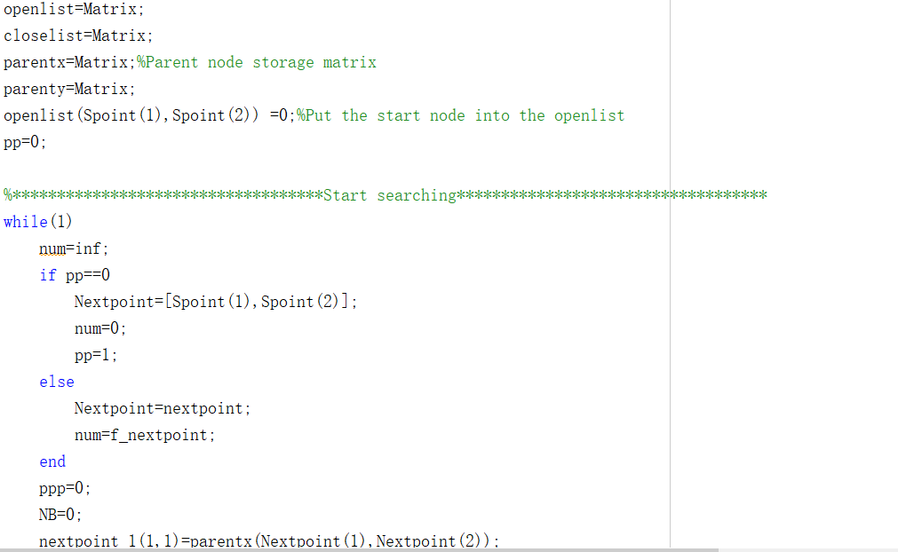
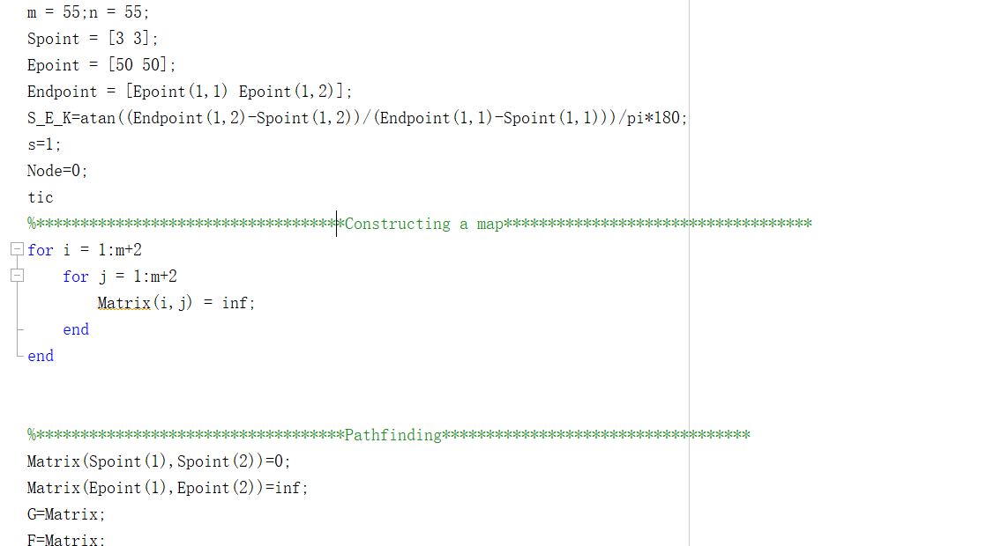
  - Optimized A* algorithm code：
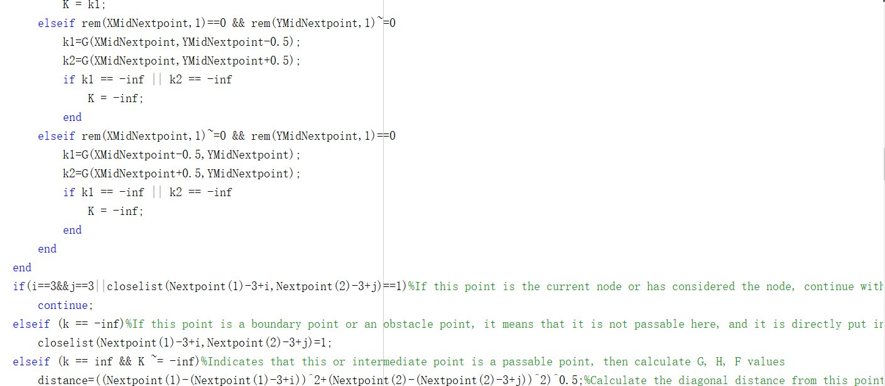
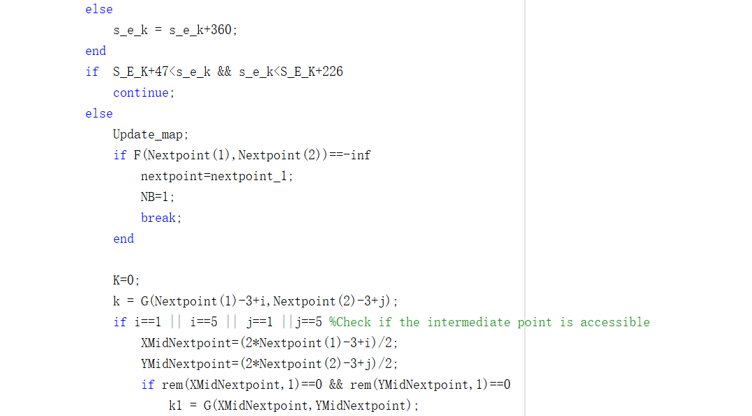
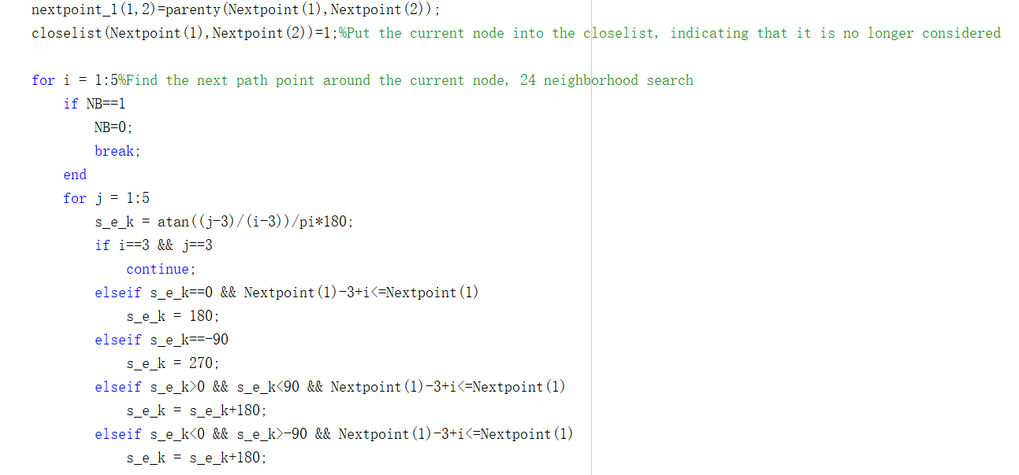

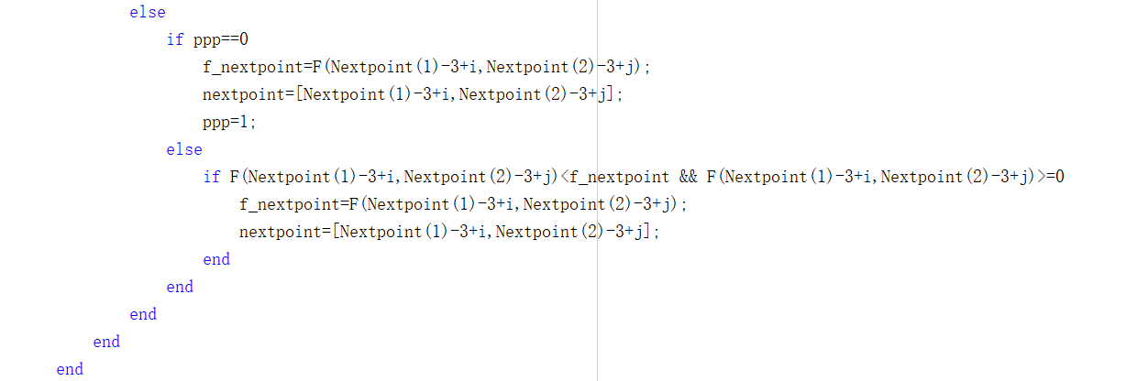
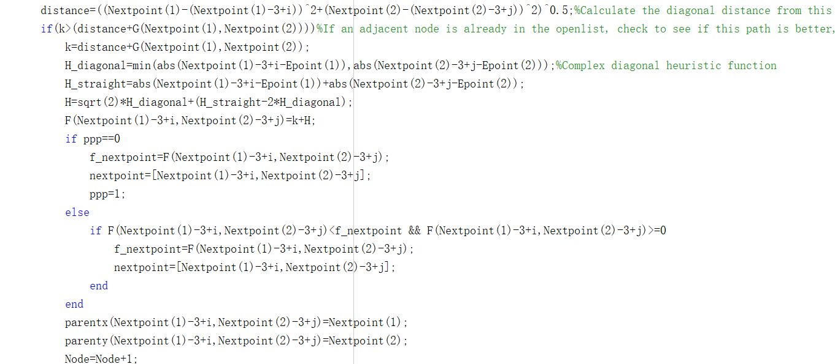
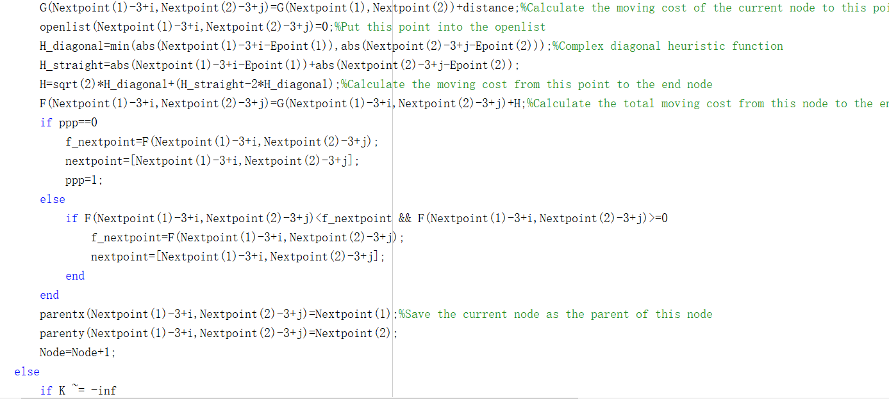
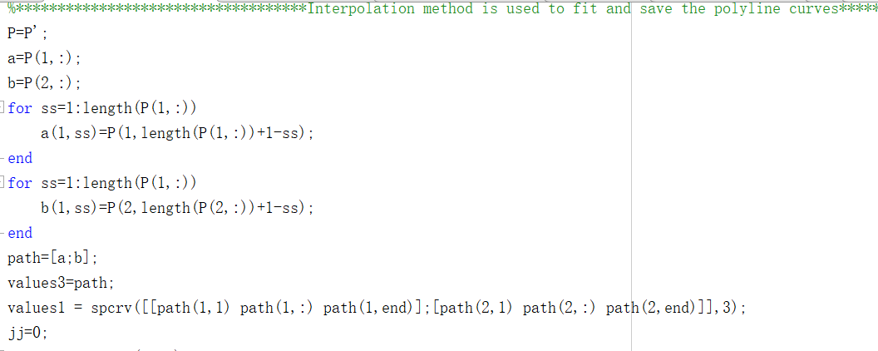
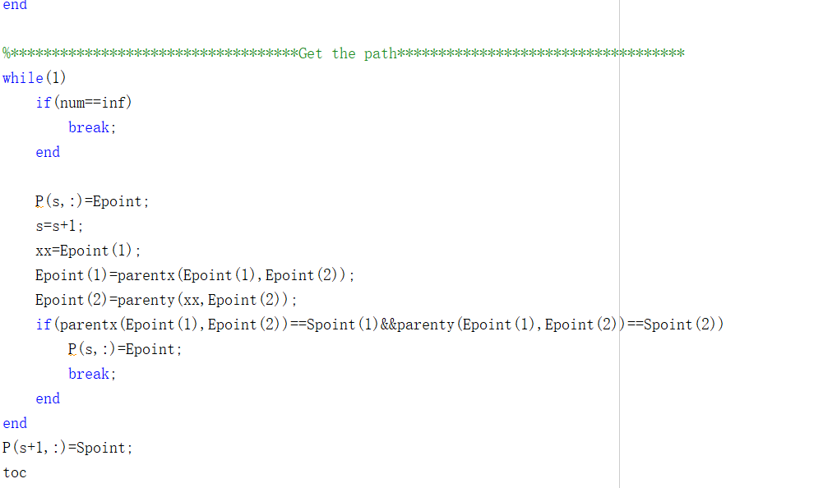
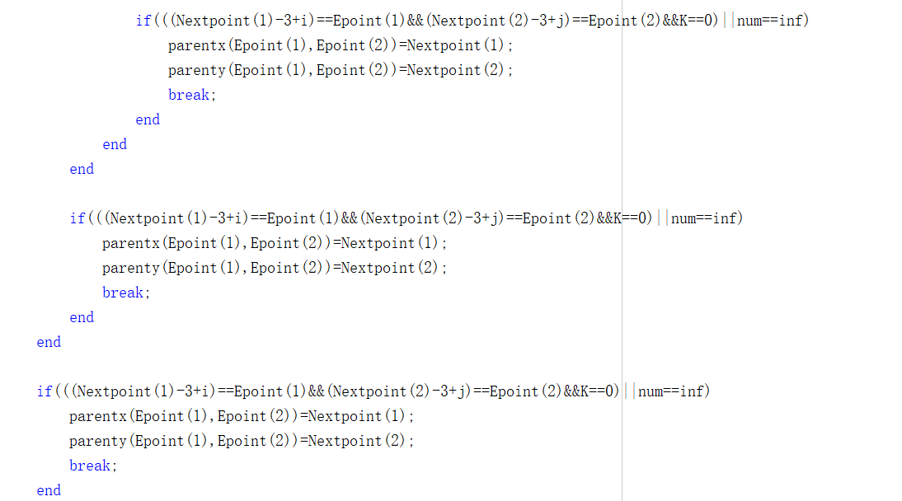
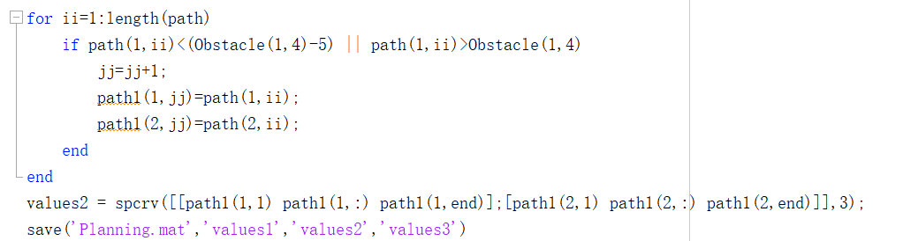
  - Update map code：
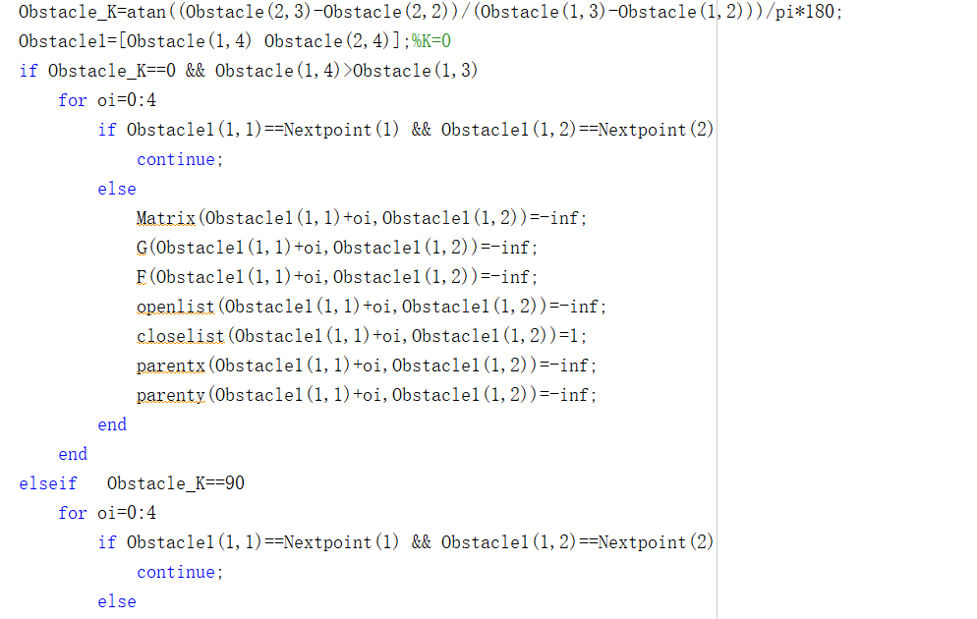
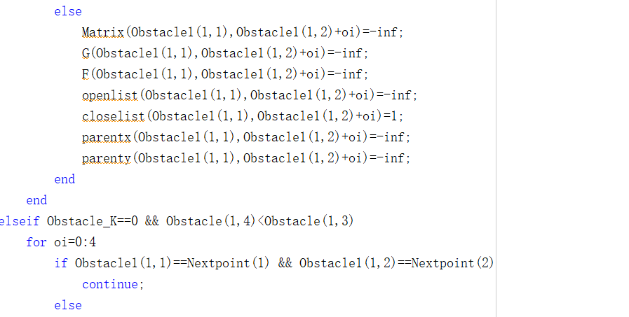
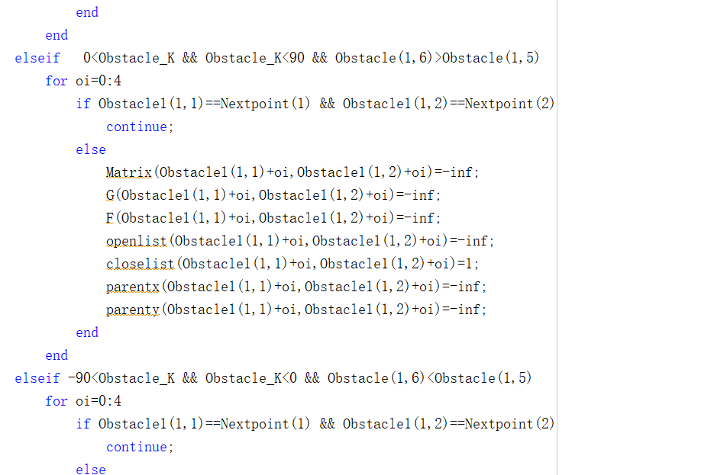
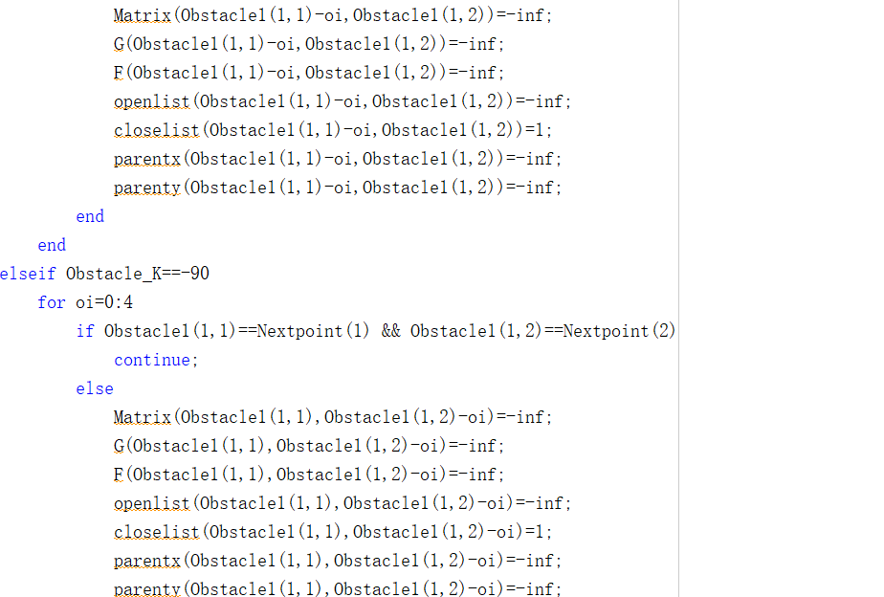

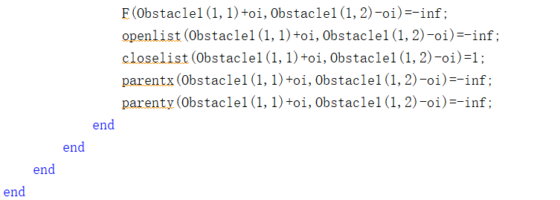
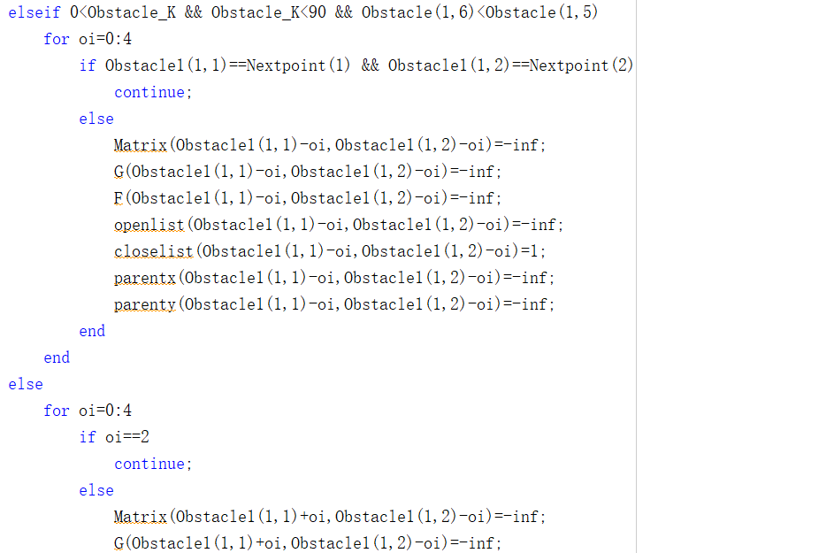
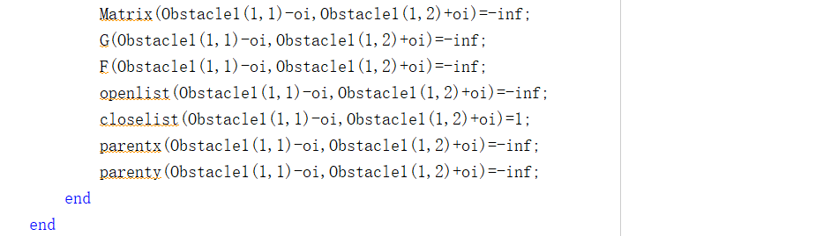

  - Variable
The constants and variables used in the code are shown below:

- Constants:
Spoint: One-dimensional matrix. It is used to store the starting point.

Epoint: One-dimensional matrix. It is used to store the target point.

Matrix: Multidimensional matrix. It is used to store map information and obstacle information.

kk: Allowable error between actual motion direction and reference motion direction.

- Variables:
XMidNextpoint: The x-coordinate point of the first level points it needs to pass through when searching to the second layer point.

YMidNextpoint: The y-coordinate point of the first level points it needs to pass through when searching to the second layer point.

k: The distance between the start node to the current node.

K1: The k value of the first layer points it needs to pass through when searching to the second layer point.

K2: The k value of the first layer points it needs to pass through when searching to the second layer point. (It is used when it needs to pass through two secondary neighborhood points).

K: The sum of k value of the first layer points it needs to pass through when searching to the second layer point. When it is infinite, the second layer point is unreachable. When it is not infinite, it means the point of the second layer is reachable, which can be used as the next node for the next step calculation.

parentx: One-dimensional matrix. It is used to store the x coordinate of the previous node of the current node.

parenty: One-dimensional matrix. It is used to store the y coordinate of the previous node of the current node.

distance: Store the distance between the current node and the intermediate point.

Nextpoint: The next node that the current node may pass through.

Runtime: The time it takes to get the path.

H: Store the distance between the target node and the intermediate point.

G: Multidimensional matrix. Store the distance between the start node to the current node.

F: Multidimensional matrix. It is used to store the total distance from the start node through the intermediate points to the target point.

openlist: Multidimensional matrix. It is used to store points that have not been checked.

closelist: Multidimensional matrix. It is used to store points that have been checked.

P: Multidimensional matrix. It is used to store the planned path nodes.

XL: Record the direction vector from the starting point to the target point.

SL: Record the direction vector from the current point to the next point.

Node: Record the number of nodes traversed.

f_nextpoint: Record the smallest F value in the extended neighborhood of the current point.

nextpoint: Record the coordinates of the point with the smallest F value.

Obstacle_K: The direction of movement of the obstacle.

Obstacle1: The coordinates of the obstacle when it first appears in the extended neighborhood of the current node.

- Path Following algorithm:
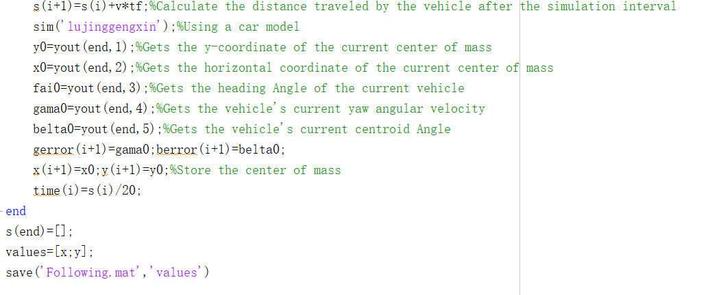
2.1 Optimized pure pursuit algorithm code：
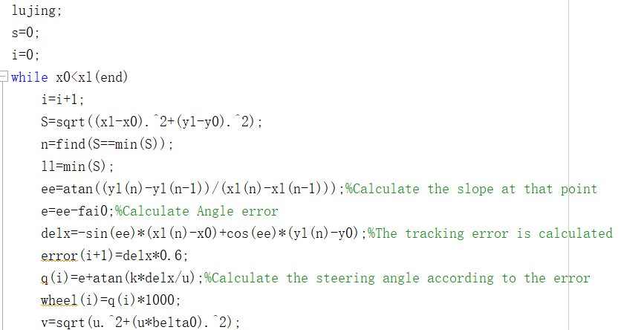

2.2 Vehicle parameter setting
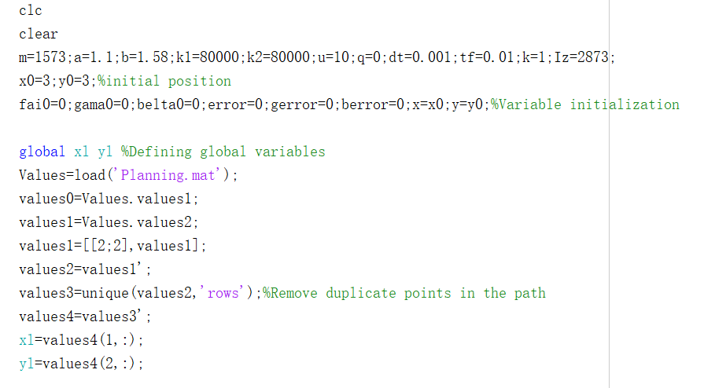
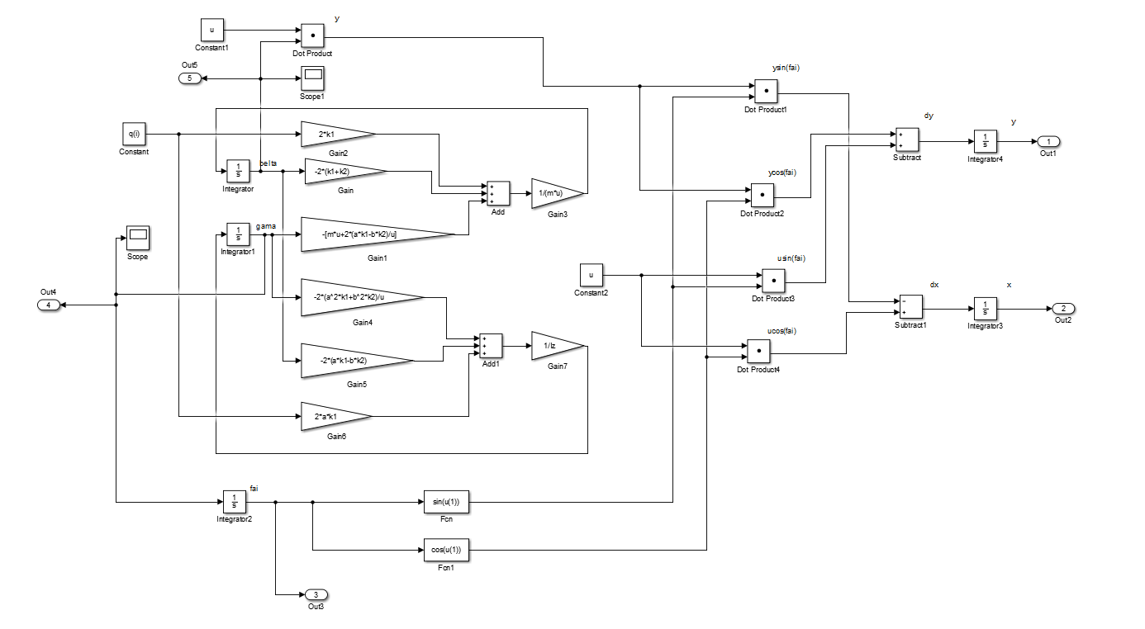
2.3 Vehicle kinematics model
2.4 Variable
The constants and variables used in the code are shown below:

- Constant
lujing: Store vehicle parameters and desired driving path.

- Variables:
S: The distance between the vehicle's current point and the desired driving path.

n: The coordinates of the closest point to the vehicle on the expected driving path.

ll: The minimum distance between the vehicle's current point and the desired driving path.

ee: The slope between the current point and the next target point of the vehicle.

e: The angular error between the vehicle's current point and the next target point.

delx: Cumulative error between vehicle and expected travel path.

q(i): Vehicle heading angle.

v: Vehicle speed.

s: The distance traveled by the vehicle after the simulation interval.

y0: The ordinate of the current center of mass of the vehicle.

x0: The horizontal coordinate of the current center of mass of the vehicle.

fail0: Current vehicle heading angle.

gama0: Current vehicle yaw angular velocity.

belt0: Lateral deflection angle of the current vehicle center of mass.

gerror: Record the vehicle yaw angular velocity after each calculation.

berror: Record the deviation angle of vehicle centroid after each calculation.

