Neve Stone 2201093

Illustration Ways of Thinking (ADAD4018)
Word count: 1590
Gwenllian beynon
german expressionism

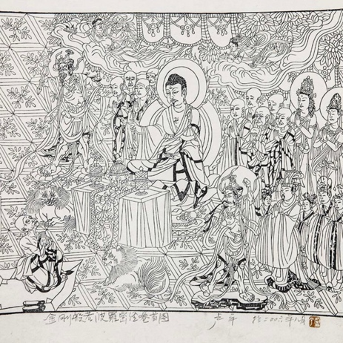
From researching the history of woodcut and German expressionism I have come across that Woodcut is an relief process that uses sharp tools to cut away pieces of wood to form a design, once ink is rolled on and pressed into paper or fabric leaving the design you carved. Woodcut is the first printing method which originated in china in the ninth century. And used on textile pieces like tapestries and fabrics.for example this tapestry made in Qing dynasty between 1644–1911.
1911 Lu Ping's Diamond Sutra

Woodcut appeared in Europe in 1400 and was used as a cheaper option to print on fabric and to mass produce books in the 16th century. It was very popular during 1910-1920 during the German expressionism era, where they used woodcut to voice their political views and new ways of living including religious freedom. They used a very expressive art style which was the opposite taught in the art academies. (Ford,2017)

German expressionism is a movement in the 1920s that challenged tradition as it focuses on;
Emotion- this was a main focus through the movement as most artworks were challenging certain ways of being for example politics and government was a popular topic.it is also shown through the emotions on people, mainly portraits as they often exaggerated expressions to showcase emotion.
Religion-In the movement Both art and religion involved a devotion to an inner, spiritual energy and a focus with the human soul. Despite living in an era of intellectual scepticism and philosophical nihilism, the Expressionists were frequently drawn to the Christian themes and symbols.
Urban life- it is a big part of the movement due to the industrialisation during the 19th century. Through the movement they expressed both positive and negative aspects of urban life.
Other main themes include; sexuality, war , post war life, death and nature.

The Brücke group
(Heckel,1910) The Brücke Group Was made up of young 4 architecture students that wanted to become artists after their parents wanted them to go into a creative profession and still make money, because of this they attempted to overturn structured art as they wanted to impact the way society viewed art. This lead them to start living bohemian lifestyles which wasn’t a popular thing in 1910 Germany as their lifestyles valued relaxation and freedom. The movement wanted to Over turn strict expectations of ways of living and how they were to express emotion and spirituality.
artists embraced printmaking and drawings which helped defined the movement and to let their movement be well known as the style was very flat and simplified and was during a time where politically Germany and Austria were going through change print making was useful to criticise the government and politics.(kiama art gallery, 2017)
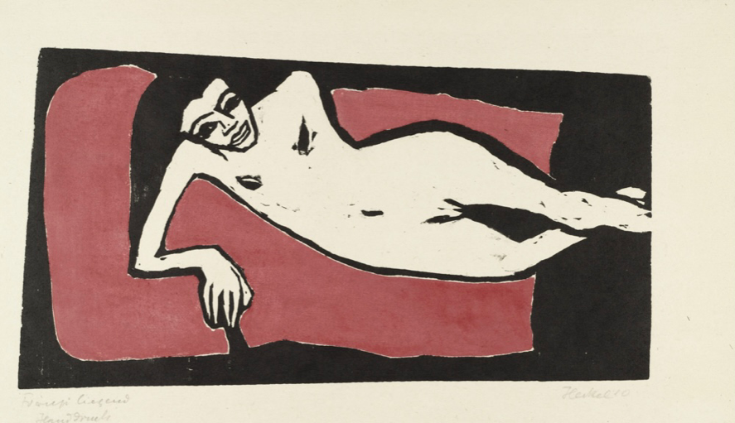
Franzi reclining,Erich Heckel,1910
(Hess,figura, jelavich,2011,p.30-55)
In this print it shows a woman laying down in a very natural way which shows exaggerated lines and curves of the woman’s body he has simplified the background of the chair into two red shapes which helps showcase the focus point of the image, the woman. It has a very rough appearance as the bold, harsh lines draw your attention to the woman. The harshness of the lines of her face I think look like African tribal art mainly masks, in particular The Bakongo tribe from the Congo River region know for their wooden masks. (Tabalia,2022)
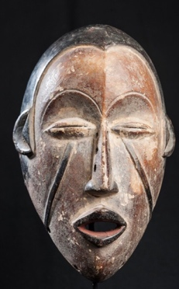

Bakongo ,Kongo Carved timber, African tribal sculpture from democratic republic of Congo

(Lloyd,1991,p.85-101)
and had their most obvious origins in French nineteenth-century art, beginning with Daumier and continuing through Manet, Degas, Toulouse-Lautrec, and Seurat to Van Dongen and the Fauvists.

The Brücke group is known for their work being heavily inspired by urban life for example cabaret and circus. This type of entertainment has influenced their art since 1908. Its seen to have origins from 19th century french art in the beginning with Honore Daumier and continuing through Manet, Degas, Toulouse-Lautrec, and Seurat to Van Dongen and the Fauvists.
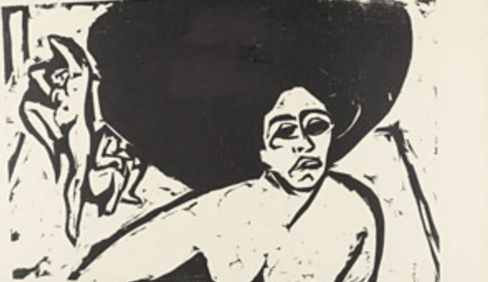
Some of Manet's subjects include Seurat, who represents the deception of both modern life and painting, and urban entertainment with strong Baudelairean undertones of Prostitutes, clowns, and bohemians.this includes drifting characters on the outskirts of society who served as a symbolism for the modern artist's position as an outsider and Seurat, who exemplify the artifice of modern life and painting, respectively - intersected with the concept of outsiders in Toulouse- Lautrec's work. Outsiders in Toulouse- Lautrec's work were prostitutes, clowns, and bohemians - wandering figures on the edges of society who served as a metaphor for the modern artist's vocation as an outsider.( World art foundations, 2018)

Ernst ludwig kirchner, nude dancers, woodcut,1909

Personally The Brücke groups woodcuts are some of the best examples of the German expressionism movement as they include everything the movement represents; religious freedom, not having to conform to societies standards of sexuality and relationships. Their work also shows mood and the atmosphere they were aiming for with just black ink and the white of the page.

One artist in particular Emil Nolde, watercolorist, printmaker, and painter. Originally trained in woodcarving, he eventually studied painting and developed a style characterised by vibrant colour and thick, expressive impasto.The work of emil Nolde builds a link between Germany's distant aesthetic past and its more radical future. From the Middle Ages until the beginning of Romanticism in the early 19th century, the northern heritage, especially in Christian religious pictures, was characterised by an emotive aspect that was later tempered by didactic features under the influence of Protestantism. Traditional sacred iconography changed under the influence of Romantic artists into secular representations that were thought to have mystical, spiritual undertones.
(MoMa,2019)

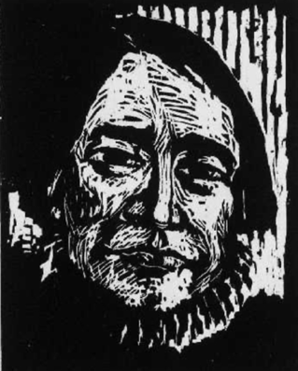
His work in particular is interesting to me as he uses Simplified shapes, vivid colours, mark making and expressive lines or brushstrokes which were hallmarks of this style, which prioritised his inner sentiments or ideas over accurately representing reality. In particular the woodcuts more specifically the portraits as they are all expressive and use mark making techniques to create shadows and add texture the bold lines create relaxed prints which is best shown through this woodcut.
Emil Nolde,Anders, woodcut,1906

This woodcut shows emil noldes style of woodcut, the use of crosshatching to create texture and to shade the face to exaggerate the facial features and the expression on their face. The black ink really contrasts the white of the paper creating a more exaggerated look.on the forehead you can see what is known as noise, the marks left from carving the wood that have been picked up by the ink roller adds even more texture which plays a big part in his art.

Emil Nolde Was once a Member of Brücke group was a very expressive painter in this particular piece (Emil Nolde, Dancer, 1913 ) it is using very expressive lines and brushstrokes which shows what movement he was in as it embodies Free movement and the flowing arms which embodies everything the expressionist movement was for eg.spiritual freedom, unconstrained.(the Scotsman,2018)
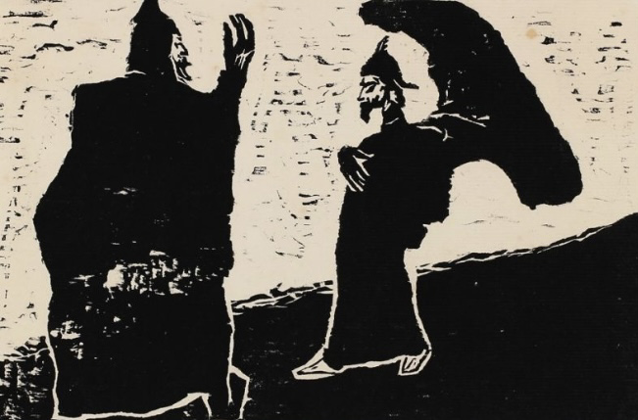
He had friends in modern dance which influenced his work. you can also see the African tribal art once again influenced his work which can be seen on the dancers face it looks like it was influenced by the African masks.which also links into his belief that more remote cultures are more authentic and don’t have corrupted means of expression compared to European art which was more refined.
Emil Nolde general and servant woodcut, 1906

from this woodcut it shows that the figure on the left is in a position of power which is shown through his body language for example the mans posture is more authoritative along with his hand in the air which seems to be dominant and commanding. The man on the right seems to be less dominant and more weary again shown through his posture, he has shifted his weight onto his back leg which makes him look like he’s about to run away at any moment. He is also a lot smaller which gives into the feeling that the man on the left is in a position of power.the man on the rights hand is also signifying obedience as it seems to add to the mood of him being the less authoritative figure. His stance gives I’m a more cowardly mood to it as he looks like he’s afraid to come close to the figure on the left. the image has a very serious undertone to it which is shown by the harshness of the black ink against the tan paper along with the texture from carving the print from wood which adds to the dramatic and serious tone that adds to the feeling of the main on the left being in the power position. The ground seems to be slanted and the figure on the left seems to be in a more authoritative even though usually a height difference suggests a position of power but in this case the man on the left still seems more in power because of all the combined body language and posture which suggests he is in a higher authoritative position to the figure on the right.

The book German Expressionism: The Graphic Impulse (Published May 31st 2011) by Museum of Modern Art by Museum of Modern Art (New York) ,Heather Hess, Starr Figura, Peter Jelavich.

2 MomaLearning,(2019)
Available at https://www.moma.org/audio/playlist/256

(Accessed: 2019)

Jill Lloyd, “Urban Exoticism in the Cabaret and Circus,” from German Expressionism: Primitivism and Modernity (New Haven: Yale University Press, 1991): 85-101

University libraries (2022) German Expressionism Collection available at:
https://lib.guides.umd.edu/c.php?g=326833&p=2194181
(Accessed:2022)

Erich heckle (1910) franzi reclining [printmaking] available at: https://www.artic.edu/artworks/29975/franzi-reclining

Art Ukraine (2011) German Expressionism: The Graphic Impulse available at:
https://artukraine.com.ua/eng/n/iskusstvo-otkrytyh-emociy-i-byuschaih-po-nervam-hudozhestvennyh-sredstv-na-vystavke-nemeckogo-ekspressionizma-v-moma/#.Y4Ltvi-nyfB
( Accessed :2011)

Stephanie Barron, “Introduction” to Barron (ed.), German Expressionism: The Second Generation (Los Angeles: Los Angeles County Museum of Art, 1988): 10-37.

James ford(2017) Celebrating the Diamond Sutra available at : https://www.patheos.com/blogs/monkeymind/2017/05/celebrating-diamond-sutra.html
(Accessed: may 11 2017)

Julia daunt culture trip (2017) An Introduction To Expressionist Art In 12 WorkAvailable at:
https://theculturetrip.com/europe/germany/articles/an-introduction-to-expressionist-art-in-12-works/
(Accessed:2017)

ideel art Phillip Barcio (2016) “Can We Find an Abstract Element in German Expressionist Art ?” [blog] available at:
https://www.ideelart.com/magazine/german-expressionist-art
(Accessed: 2016)

Alexxa gotthardt (2018)“the German expressionists shocking raw work exploded bourgeois values and reinvented art”
Available at :
https://www.artsy.net/article/artsy-editorial-german-expressionists-shockingly-raw-work-exploded-bourgeois-values-reinvented-art
Accessed:2018

invaluable (2019)“German Expressionism: A Break From Tradition”Available at :

https://www.invaluable.com/blog/german-expressionism/

(Accessed: 2019)

Shawn Roggenkamp,(2022) "Expressionism, an introduction," in smart history , October 2, 2016, Available at :

https://smarthistory.org/expressionism-intro/

(accessed November 27, 2022)

Kiama art gallery (2017) german expressionism- Ernst Ludwig kirchners Berlin street scenes available at: https://kiamaartgallery.wordpress.com/tag/german-expressionism/
(Accessed: September 6, 2017)

jedidah tabalia and adrianna simwa (2022) Types of African tribal masks, their meanings and pictures available at: https://briefly.co.za/48029-images-african-tribal-masks-meanings.html
(Accessed : November 29, 2022)

World art foundations (2018) musem frieder burda: “die bruke 1905-1914” available at: https://www.worldartfoundations.com/museum-frieder-burda-die-brucke-1905-1914/
(Accessed: November 17, 2018)

The Scotsman (2018) Art review: Emil Nolde: Colour is Life, Scottish National Gallery of Modern Art, Edinburgh available at: https://www.scotsman.com/whats-on/arts-and-entertainment/art-review-emil-nolde-colour-life-scottish-national-gallery-modern-art-edinburgh-1427412
(Accessed:July 31 ,2018)

Highbrow magazine (2019)Ernst Ludwig Kirchner: A German Expressionist on Fire available at:

https://www.highbrowmagazine.com/10283-ernst-ludwig-kirchner-german-expressionist-fire

(Accessed:December 3,2019)

