Student name: | Nayem Mia | Student ID: | 2514695
Programme: | MBA
Module: | Managing Marketing Change
Module code: | BMMB7026 | Contribution to Overall Module Assessment (%): | 75%
Lecturer: | Gwyneth Jones | Internal Verifier: | Marie Pitson
Assignment Title: | Future Developments in the Field of Marketing  (Individual Report) | Word count (or equivalent): | 3,750 words  (+/- 10%)
Submission deadline: | Wednesday 7th January 2026 | Return date of provisional marks & written feedback: | Wednesday 4th February 2026

Executive Summary
This report is a critical analysis of Tesla's marketing in the electric vehicle business. An analysis is conducted focusing on the macro-environmental aspects using the PESTEL framework, Porter’s five forces, internal capabilities using the SWOT analysis, and marketing implementation using the segmentation, targeting, positioning, marketing mix variables and Ansoff Matrix. Results indicate Tesla capitalizes on the technology leadership and brand equity, making use of non-traditional approaches in attaining dominance in the market without the need to spend on conventional advertisements. Nonetheless, major weaknesses are uncovered, such as excessive reliance on CEO's persona, high premium pricing limits, and the growing threat of competitors such as the Chinese manufacturers. The evaluation of marketing metrics shows that there are gaps in measurement that restrict strategic optimization. The suggestions are to diversify communication channels, increase its accessibility by financing innovation, develop faster service networks, and increase its analytics capacity by applying the Kotter change management framework.

Table of Contents
Executive Summary 2
1.0 Introduction 4
2.0 Critical Evaluation of Tesla's Marketing Activities 5
2.1 Marketing Concept and Resource Investment 5
2.2 PESTEL Analysis: Macro-Environmental Impact on Marketing Strategy 5
2.3 Five Forces of Porter 8
2.4 SWOT Analysis: Capabilities and Market Position 10
2.5 Segmentation, Targeting, and Positioning Strategy 15
2.6 Marketing Mix (7Ps) Critical Analysis 17
2.7 Communications and Media Mix Evaluation 19
2.8 Ansoff Matrix: Growth Pathways for Tesla 21
3.0 Measurement of Marketing Performance and Success 23
4.0 Change Management and Marketing Transformation in Tesla 24
5.0 Conclusion 26
6.0 Recommendations for Marketing Strategy Improvement 27
6.1 Diversify Communications Channels 27
6.2 Implement Flexible Financing Programs 27
6.3 Accelerate Service Network Expansion 27
6.4 Strengthen Marketing Measurement Capabilities 27
7.0 References 29

1.0 Introduction
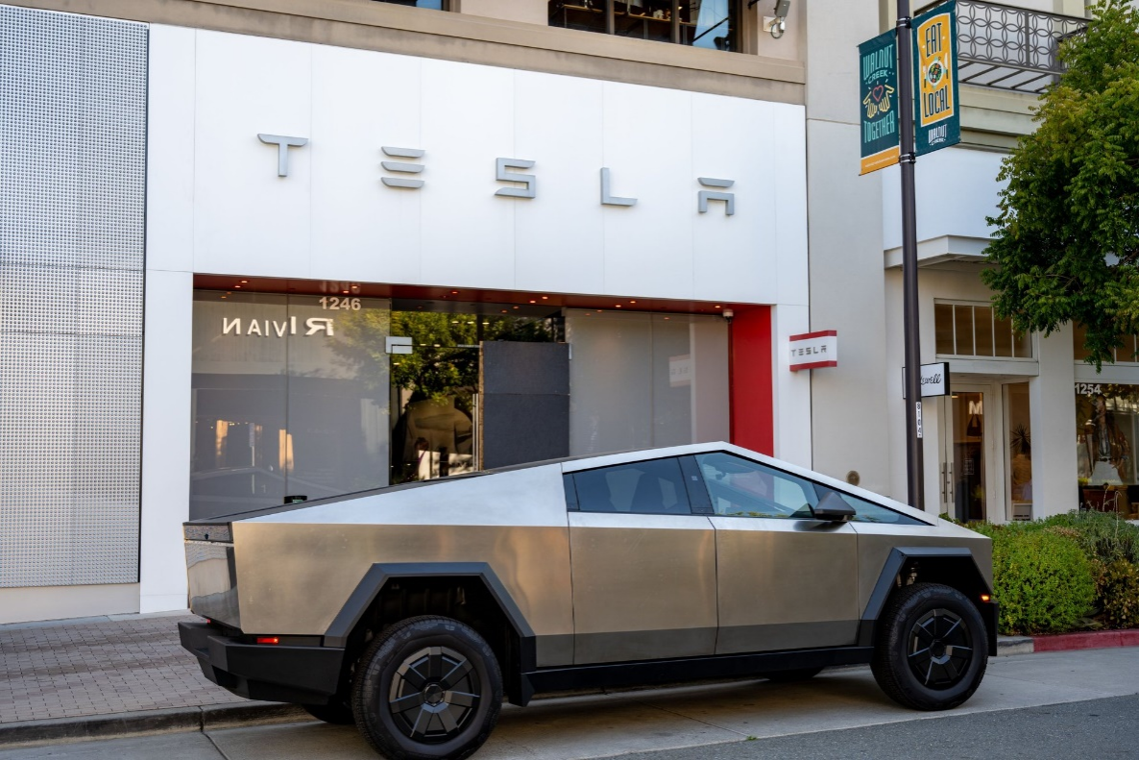
Tesla is a paradigm shift in marketing automobiles, which is essentially disruptive to the industry practices by differentiating based on technology. Tesla was founded in 2003 with the mission of helping to fast-track the transition to sustainable energy, and today is a revenue business of over 97.7 billion, and employs more than 9,000 people spread all over the world (Tesla, 2025). This report critically analyses Tesla in the context of its marketing operations, which is based on the presence of several critical sources of external impetus, such as government incentives, technological progress, and increase in competitive intensity. Digital transformation is a radical change in the marketing paradigms, which demands quick adjustment to technological upheaval (Teece, 2018). The analysis shows that Tesla managed to alter the attitude of the population towards sustainable innovations by using the approach of creating effective product designs. This report will move forward to the analysis of the environment, evaluation of marketing activities, measurement of performance, implications of change management, and finally, will offer possible recommendations to strategic improvement in order to fill the identified shortcomings.
Figure 1: Tesla (Carroll, 2025)

2.0 Critical Evaluation of Tesla's Marketing Activities

2.1 Marketing Concept and Resource Investment
The Tesla marketing philosophy is quite different and nonconformist to the usual automotive standards, and it does not spend much on traditional advertising but invests a lot in research and development. The company is known to spend close to zero on paid advertising and invest in product innovation (Autonews.com, 2025). This is customer-centric orientation where the excellence of the product is the main marketing instrument. Scholarly literature claims that companies that strike a balance between customer and competitor orientation record better performance results (Foreman et al., 2014). The brand equity formation is in the form of personality, which focuses on innovation and environmental responsibility (Aaker, 2015). The digital marketing innovation has a substantial influence on firm performance in which marketing capability mediates the relationships. Tesla makes use of digital platforms in an organic way, producing a lot of earned media value, both in launches and customer advocacy. Nevertheless, this strategy has scalability and control risks because competition increases.

2.2 PESTEL Analysis: Macro-Environmental Impact on Marketing Strategy
- Political Factors
The government policy also plays an important role in determining the position and value proposition of Tesla. The 100 percent tariffs on Chinese electric vehicles by the Section 301 Trade Act 1974 give them competitive advantages that allow it to price aggressively without a loss of margin. Government incentives form the main electric vehicle adoption powers in the entire world (Qadir et al., 2024). Tesla is a strategic company that focuses on the alignment of American manufacturing with political priorities. The recent evaluation of the effects of the Inflation Reduction Act shows prospects and limitations. Tesla makes good use of IRA tax breaks of up to 7500 dollars in marketing communication, enhancing overall pricing against competition (Zhang and Shi, 2025).
- Economic Factors
Macroeconomic factors have a direct impact on pricing strategy and target accessibility. The economy of the United States improved at a rate than expected in 2025, which favors premium demand. The level of fluctuations in interest rates affects the level of attractiveness of financing significantly. Fiscal incentives have a significant impact on penetrating the market by means of cost improvements (Lévay, Drossinos and Thiel, 2017). Tesla has countered by providing strategic price cuts in 2023-2024 and is still competitive. Evidence of dynamic pricing complexities is discussed, focusing on positioning maintenance tension and volume goals tension (Jia, Chen and Xu, 2024). Costs on the batteries were cut, bringing maintenance to the margin and reducing the prices.
- Social Factors
There exists a significant opportunity due to the cultural transformation into environmental awareness. About 79% of adults in the United States are literate at a level that allows them to perform information tasks, which have enhanced content-intensive digital strategies. Through an analysis, the mainstream market characteristics are identified, and environmental values, interest in technology and consideration of status are found to be the motivators to purchase (Zarazua de Rubens, 2019). These are highly effective psychographic factors that Tesla brand identifies with. Experience quality and brand reputation are found to play a significant role in purchase intention (Xu et al., 2024). Tesla also enjoys quality word-of-mouth promotion as owners are brand ambassadors.
- Technological Factors
The major differentiator of Tesla is technological leadership. In the year 2023, United States invested 3.45% GDP in innovation. Complete analyses discuss battery technological developments such as enhanced energy density and lowering of cost. The 4680 cell architecture can be used in Tesla to achieve better performance (Li et al., 2023). Autonomous driving capabilities are called as the key future differentiators in literature (Abro et al., 2023). The ability to drive in Full Self-Driving is transformative marketing regardless of regulatory constraints. Moderate innovation strategies are the best in terms of development. Automatic updates generate constant involvement and appreciation of value (Blankesteijn, Jong and Bossink, 2019).

- Environmental Factors
Regulatory policies and awareness of climate provide favourable conditions. The study looks at the net-zero efforts in the world with electric vehicles (Raja Rajendra Timilsina et al., 2025). Inflation Reduction Act also offers huge incentives that are heavily featured in messages (Niri et al., 2024). There are sustainability issues across battery value chains that are identified. The promise of Tesla to recycle its batteries makes them authentic. Lithium mining, however needs close reputation management.
- Legal Factors
The legal frameworks affect the distribution strategy and substantiation of the claims. Evidence of the UK infrastructure policies indicates that range anxiety is decreased by regulatory support (Sun et al., 2024). The existence of Clean Air Act and CAFE regulations brings about regulatory benefits. Strategic flexibility requirements focus on the aspect of regulatory uncertainty (Shahzad and Jasińska, 2024). Direct-to-consumer model is legally limited, making access to the market difficult. Tesla has to operate in complicated environments with coherent positioning.

Figure 2: PESTEL Analysis (Lawson, 2023)

2.3 Five Forces of Porter
The Five Forces model of Porter explains the ways of how outside circumstances become competitive forces on Tesla in the international electric vehicle market to be added to the PESTEL analysis, and as inputs to the SWOT.
- Threat of new entrants
The entry barriers are high, and EV production is innovated with a big amount of capital, powerful technology, and branding (Li et al., 2023). Nevertheless, the barriers in certain segments are being reduced progressively by supportive policies, contract manufacturing and technology-led start-ups particularly in China.
- Supplier bargaining power
Tesla relies on the suppliers of the key inputs including lithium, cobalt, nickel, Semiconductors and specialised software and hardware. The mining and chip production concentration increases supplier power, but internalisation of major activities in vertical integration and Gigafactory investments counterpart this to some extent.
- Bargaining power of buyers
With the entry of more brands and models of EVs into the market, buyers have a better selection and visibility of information (Benzidia, Luca and Boiko, 2021). Easy online comparison and price sensitivity make buyer power strong and Tesla has to employ price reduction, financing, and experience improvement to protect the volume even when the brand equity is robust.
- Threat of substitutes
Some alternatives are hybrids, efficient internal combustion vehicles, public transport, shared mobility and micro-mobility. The better transport systems and shared transport (reading between the lines) in large cities and towns can make car ownership less desirable, which will push Tesla to focus on the performance, convenience, and status advantages rather than functionality.
- Competitive rivalry
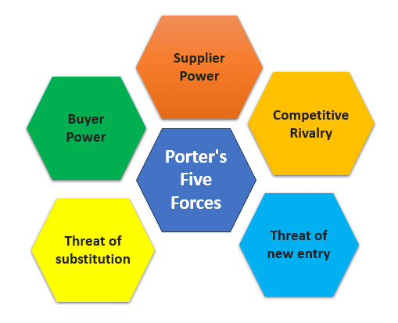
Competition is fierce and Chinese makers and the old school automakers are fast growing EV portfolios, capitalizing on existing plants, dealer networks, and low prices (Fernández and Oliver, 2025). This dilutes the share and pricing strength of Tesla, and it becomes critical at this point to keep innovating and positioning uniquely and execute the marketing with effectiveness.
Figure 3: Five Forces of Porter (Hessing, 2021)

This industry analysis further refines the PESTEL results and is the foundation of the threats in the SWOT and subsequent analysis of the pricing, service, and performance measurement.

2.4 SWOT Analysis: Capabilities and Market Position
The SWOT analysis is the true, realistic, fact-driven, data review of an organization. It aids in the determination of a competitive status of a company, evaluates internal and external problems, and examines the existing and future possibilities.
- Strengths
Tesla boasts of impressive marketing strengths that lie in brand equity and technological differentiation. The firm has positioned itself as the most precious automotive brand in the world, at a premium price with high customer loyalty. Vertical integration in battery manufacturing, car manufacturing, software development, and charging infrastructure provides special value propositions that are difficult to imitate by competitors. Environmental, social, and governance performance has a major positive role to play in brand credibility and consumer reactions (Koh, Burnasheva and Suh, 2022). The sustainability stance of Tesla is very authentic due to its real engagement in renewable energy and emission cuts. The Supercharger network shows a significant amount of physical evidence of a promise of delivery of a brand, mitigating range anxiety and increasing ownership experience. The innovation potential of Tesla in terms of thermal management systems and energy systems, ongoing with technological improvement. Gigafactory is the capacity of production that facilitates economies of scale, and at the same time controllable supply chain and flexibility in manufacturing. Good customer loyalty is reflected in the high Net Promoter Scores and in the repeat purchase rates, which mark successful relationship marketing. The technology of battery efficiency, autonomous driving development, and over-the-air updates that the company has led in establishes a continued differentiation because the capabilities of the products grow after sales. This ecosystem strategy creates switching costs and further involvement of customers in post-sale transactions (Hu et al., 2023).
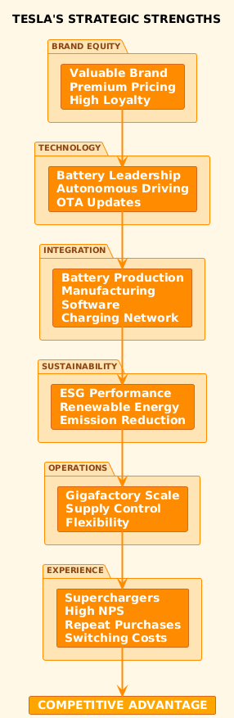
Figure 4: Tesla's strategic strengths
Source: Self-Made
- Weaknesses
The major marketing weaknesses are connected to the high-pricing strategy of Tesla and operational factors. The latest reports indicate that the United States electric vehicle market share of Tesla has been decreasing despite the overall market expansion which implies that the competitive pressure is increasing and Tesla may be vulnerable to positioning. High Price will limit the target market size and therefore will not access the mass market despite the positioning of the Model 3 and Model Y as a more affordable and accessible product. The aggressive growth strategy in the company has at times led to production bottlenecks and quality control issues which tarnish the name of the brand (Liu, Boothman and Graham, 2025). The reliance on raw materials, especially lithium and cobalt to produce batteries, poses a weakness in the supply chain as well as unstable prices. Service network restrictions are the key service weaknesses in the customer experience, with long queues and the inability to access the service centres irritating the owners. Sales have been reported to be facing difficulties in the face of regulatory headwinds, so the growing paths may be derailed by any political uncertainty and alterations in policies. The reliance on the personal brand of the CEO, Elon Musk, is also a source of reputation risk, since controversial remarks and political actions of this figure may cause the loss of customers in several segments (L, 2025). The United States and Chinese markets are geographically concentrated, and Tesla is vulnerable to regional economic crises and changes in policies (Surya et al., 2021). The lack of diversification of the marketing channels limits access to the demographics that are less active on digital media and social networks. These are some of the weaknesses which limit the capacity of Tesla to reach the mass market penetration goals without compromising on premium brand positioning.
- Opportunities
There are areas of great growth prospects in the form of market expansion and product diversification strategies. There is a study of the prospects of autonomous vehicle development, and it is expected that the robotaxi services would essentially change the business models and revenue flows of the automotive industry. The Full Self-Driving technology development at Tesla means that the company will be in a position to leverage autonomous mobility services as regulatory frameworks shift. Geographic diversification in emerging markets, and significantly in India, Southeast Asia, and South America, can provide significant growth in volumes as electric vehicles take over the world (Fernández and Oliver, 2025). It is analyzed that large companies need to pursue opportunities systematically in order to commercialize them. The energy storage and solar product lines by Tesla develop cross-sell opportunities and position sustainable energy ecosystems. The strategic collaboration with other manufacturers to gain access to Supercharger networks provides income and increases the impact on setting the industry standards. The more affordable models of the vehicles that may have prices as less as under 30,000 would open the mass market segments that would not have been reachable because of the pricing limitations. The business-to-business marketing channel can be developed with alternative value propositions than consumer segments by providing opportunities via commercial vehicles using Semi and Cybertruck fleet sales. The software and service business is provided by subscriptions based on Full Self-Driving access and connectivity functionality, which provides high-margin growth to complement the sale of vehicles.
- Threats
The greatest threat to Tesla in the market in terms of competitive power and price is intensity. It is still on record that Chinese electric vehicle producers, especially BYD, are transforming world automotive markets with high prices and fast innovation. It has been reported that Tesla is losing its market share to Chinese electric cars that are taking a leading role in the world market due to the large government subsidy programs and economies of scale (Punit and Bhattacharya, 2025). Conventional automotive companies, such as Ford, General Motors, and Volkswagen, are investing billions in the development of electric vehicles, utilizing its existing network of dealerships and brand visibility (Meredith, 2025). Competitive pressure of electric vehicle is analysed to be on the rise posing challenges of maintaining Tesla premium positioning. Disruption in the supply chains, especially the shortage of semiconductor and battery components, endangers the reliability of production and reliability of promise in delivery (Rudolph, 2025). The disruptive innovation and threat of encroachment of a business model that suggests that new entrants can essentially disestablish the positioning of an incumbent with an alternative value creation. Recession risks in the economy would seriously shrink the demand of premium vehicles, and changes in the policy like elimination of subsidies would worsen the overall cost of ownership benefits. Tesla may lose its technological edge due to the disruption of technology in the form of battery breakthrough technologies or alternative powertrains (Sanguesa et al., 2021). Brand equity that has been generated over years is threatened by reputational harm caused by safety accidents, quality of production or scandals involving the CEO (Benzidia, Luca and Boiko, 2021). Such threats demand defensive marketing as well as constant innovation to remain competitive.
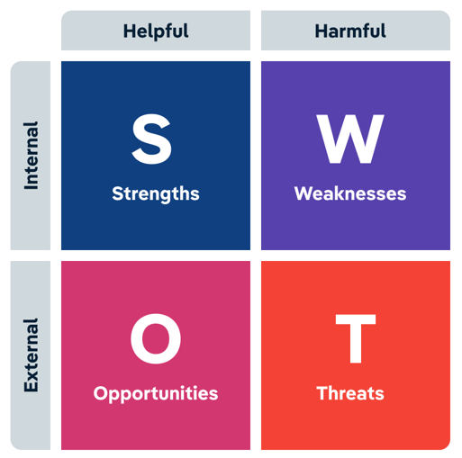
Figure 5: SWOT Analysis (SWOT, 2024)

2.5 Segmentation, Targeting, and Positioning Strategy
The segmentation strategy at Tesla has been significantly changed since the early adopting market to the mass market accessibility. The company first served the high-income early adopters of technology who can afford high prices to purchase innovative electric vehicles. The methods of machine learning reveal the market characteristics of mainstream electric vehicles in areas outside of pioneer segments, which indicate that the demographic, psychographic, and behavioral variables are all predictors of the probability of adoption (Zaino et al., 2024). Tesla currently targets the markets with the help of various parameters such as geographic location, income levels, environmental values, technology affinity, and vehicle usage patterns. Demographic targeting will be mainly on high-income professionals aged between 30-55 years and of good education and disposable income to buy high-end products. Psychographic segmentation focuses on environment awareness, technology love, innovation, and status-seeking preferences.
Geographic targeting focuses on markets that have conducive infrastructure, regulatory benefits and awareness of the environment. It has been reported that Tesla is dominating the markets in the United Kingdom with Model Y and Model 3 being the top sale, which is a good result of geographic targeting and localization. The company ranks market entry consideration by charging infrastructure availability, regulatory environment where it is favourable, and concentration of purchasing power (Klender, 2025). Behavioral segmentation is a mode of usage which covers aspects such as daily commuting, long-distance travel, and performance driving, with various models fulfilling various needs. The effect of new energy vehicle product features on consumer purchasing intentions where performance features, environmental outcomes, and technology features were found to play an important role (Wang and Tian, 2023). Tesla product range also meets the various behavioural segments with a focus on Model S performance, Model 3/Y utility and Cybertruck efficiency.
The key focus of the positioning strategy is sustainable luxury technology with both environmental responsibility and high performance and advanced innovation. The connection between brand strength and achievement of competitive advantage is mediated by effective positioning (Rua and Santos, 2022). Tesla stands apart in the traditional luxury automotive brands with technology focus over heritage or craftsmanship, and the mainstream manufacturers with high quality and performance advantage. The perceptual mapping indicates that Tesla holds its own niche between sustainability, technology, and performance, unlike mainstream luxury brands and the electric vehicle newcomers. Literature concerning the marketing strategy effects indicates that effective communication of the value proposition and brand credibility has a significant effect on consumer buying intention and buying decisions (Wei et al., 2024). Nonetheless, there arise challenges of positioning when Tesla tries both premium and mass market positioning at the same time by expanding its product lines. Being brand-consistent and yet focusing on more and more distinct segments cannot be done without the careful management of marketing mixes, not to dilute the perceptions of premium and not to lose the core enthusiast segments. As can be analyzed, Tesla was able to control the transformation of the perception of the community with the use of the product design-related strategies since the consistent narrative of innovation helps to maintain the authenticity of positions regardless of its changes in the market (Palmié et al., 2024).

2.6 Marketing Mix (7Ps) Critical Analysis

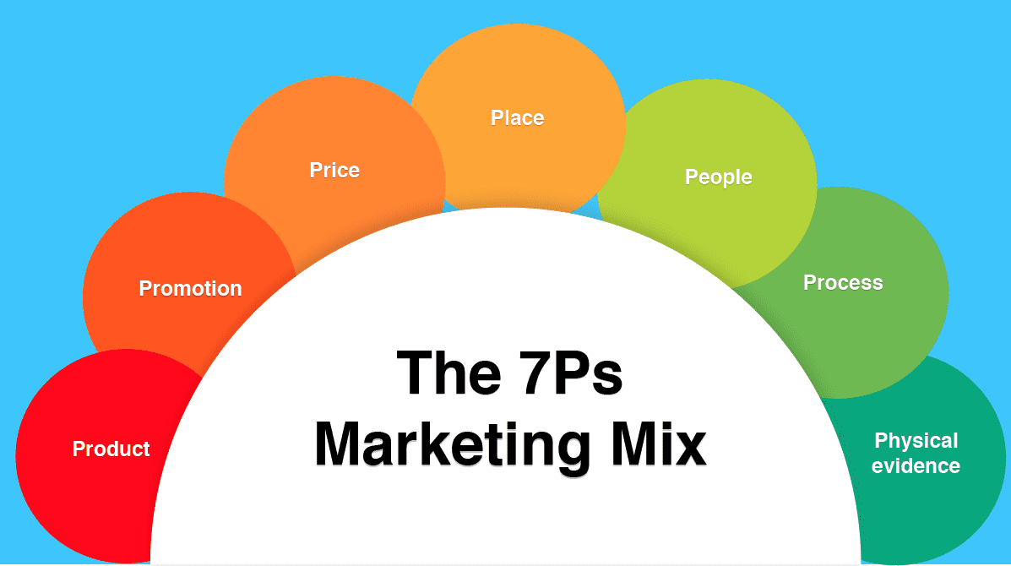
Figure 6: Marketing Mix (7Ps) (Hanlon, 2023)

- Product Strategy
Portfolio reveals the strategic breadth based on covering the various segments, and at the same time retaining coherence. The range includes high-end Model S/X and affordable Model 3/Y, with additional Cybertruck and Semi. It has been found that product characteristics play a key role in intentions. Tesla is distinguishing itself with the best range, acceleration, autonomous, and over-the-air features. The threats are the complexity of production, issues regarding the quality, and cannibalization.
- Pricing Strategy
Premium positioning allows the maximization of margins at the expense of penetration. The complexity of dynamic pricing with a focus on maintaining a position or having a volume tension. Large 2023-2024 cuts were a reaction to competition, indicating the ability to be tactical. The constant changes are likely to jeopardize the residual perceptions. Complete cost messaging is trying to justify premiums by saving in operations.

- Place Strategy
Differentiation is the basic difference of the direct-to-consumer distribution. Vertical integration gives them control of the unique experience and margin optimization. The model does away with dealer bargaining, offering clarity and online shopping. Nonetheless, legal limitations curtail abilities at the same time service constraints compromise the quality of experience.
- Promotion Strategy
The production of organic media replaces conventional advertising. The effects of advertising and incentives, and recommends that strategies should be segment-based (Miller et al., 2021). Tesla takes advantage of launches, communications by the CEO, testimonials, and coverage to create awareness in a cost-effective manner. The huge performance influence of digital marketing. There is also a limitation of limited access to non-digital demographics and a lack of control over messaging.
- People
The Tesla employees in the showrooms and service centres are not salespersons, but product educators. Due to the rapid expansion and the lack of network, the quality and promptness of service vary among the markets (Sharabati et al., 2024).
- Process
The online setup to delivery experience is meant to be digital, easy, and quick, but post-sales activities like ordering a repair and waiting time to receive it, after-sales activities tend to cause friction and frustration in customers.
- Physical evidence
Tesla supports its brand with limited showrooms, noticeable technology in the cars, and the global Supercharger network that offers physical evidence of its innovativeness and removes range anxiety to current and potential consumers (Lukin, Krajnović and Bosna, 2022).

2.7 Communications and Media Mix Evaluation
The communications strategy propagated by Tesla takes an alternate approach in terms of zero paid advertisement dependence. With digital innovation, research shows that performance is affected by capability mediating deployment. Tesla creates a lot of earned media due to announcements, Twitter of Elon Musk with 200 million followers, and the content of its clients. This will provide impressive cost efficiency. Nevertheless, high levels of over-dependence and a lack of control can arise.
Researchers believe that the use of all-encompassing digital strategies is more successful. The strategy of Tesla relies on the content of the sites, social interaction, demonstrations on YouTube, and online communities. Direct interactions are developed through experiences of marketing via delivery events and test drives (Orazalin, Ntim and Malagila, 2023). Non-price communication is significant in luxury maintenance.
The effectiveness check displays weaknesses and strengths. The analysis will show that perceived environmental performance increases the credibility mediating persuasiveness. True sustainability enhances openness. Referral programs are strategic and motivate advocacy. Nonetheless, messages are not diversified in terms of channels, that restrict the population reach. It is documented that Musk made controversial statements that pose a reputation risk. The excessive dependence also opens vulnerability in case the personal harm is carried over to the corporate harm. Minor conventional presence inhibits mass consciousness. Due to the increase in competition, diversification of channels seems the way to go.

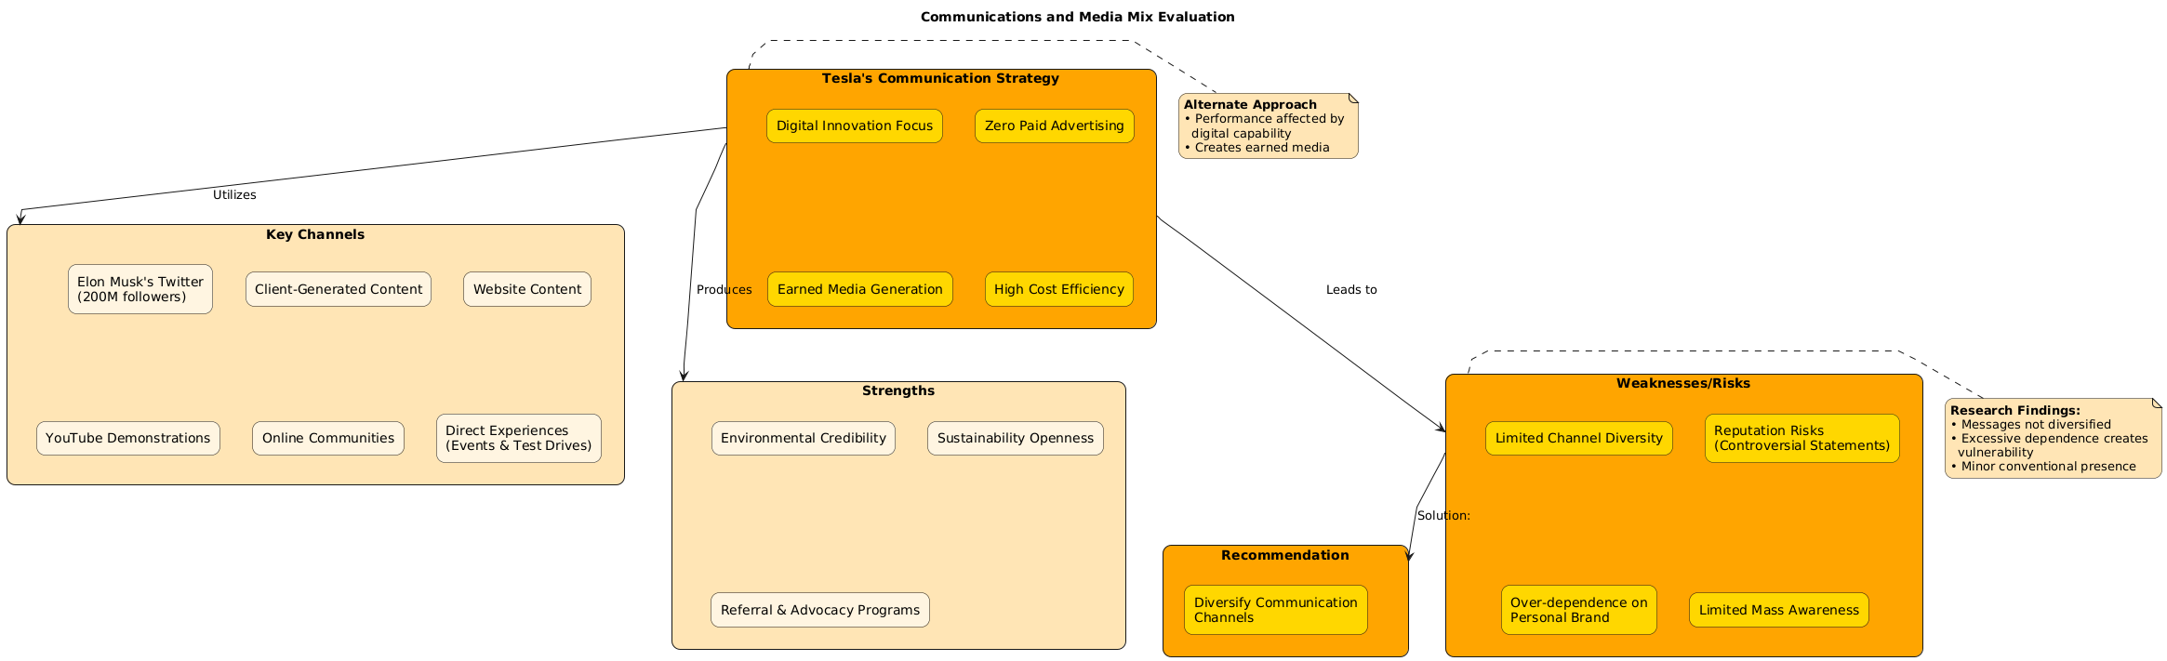
Figure 7: Communications and Media Mix Evaluation
Source: Self-Made

2.8 Ansoff Matrix: Growth Pathways for Tesla
The Ansoff Matrix maps out growth opportunities of Tesla within the existing or new products and markets connecting the situation analysis with the strategic recommendations.
- Market penetration
Growing the sales of existing models in the existing markets by adjusting prices, reinforcing communications, referral programme and access to better services and charging (Lévay, Drossinos and Thiel, 2017). This goes right in terms of fending share as rivalry and buyer power increase.
- Market development
Expanding new markets, including India, Southeast Asia and South America, with existing vehicles and energy products. Success also demands that one acquires flexibility to the local regulation, infrastructure and income level, and matches with opportunities presented in the SWOT.
- Product development
Developing new products in current markets, such as cheaper models, work vehicles such as Semi and Cybertruck, and software products such as Full Self-Driving service and connectivity subscriptions. This extends value reaped out of existing markets by riding on technological strengths and brand equity.
- Diversification
Growing into related energy solutions like solar and stationary storage and new customer segments and even new industries (Lukin, Krajnović and Bosna, 2022). These operations are considered to expand the sustainability energy system of Tesla but demand different risk management and marketing strategies.
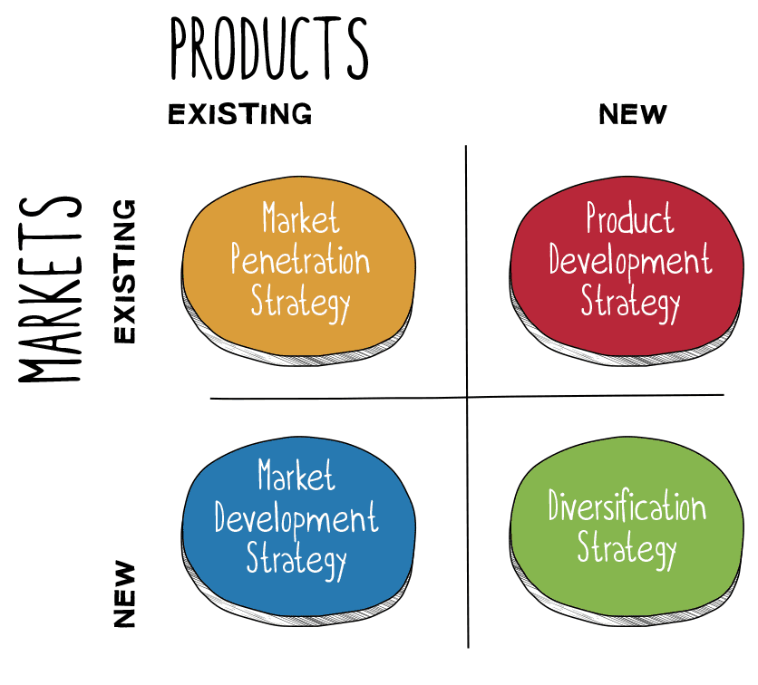
Figure 8: The Ansoff Model (Hanlon, 2021)
Market penetration and market development are operated mainly at the recommendations on communications and financing and service expansion and measurement, and assists the continuous product development and corresponding diversification.

3.0 Measurement of Marketing Performance and Success
The measurement methods used by Tesla are still rather secretive due to the lack of disclosure, but financial, operational, and market metrics can give insights into its effectiveness. Financial indicators involve revenue growth, gross margins, and achievement of delivery. Innovation performance in terms of profitability and market share is mediated by marketing capability. Tesla records quarterly deliveries as the key success metrics, which are not sufficient to isolate marketing performance.
The evaluation of the customer metrics shows the strengths and gaps. Tesla is characterized by high Net Promoter Scores of satisfaction and the probability of advocacy. Implications of customer orientation in the literature are also not limited to the implications of transaction but relationship value. The cost of acquiring customers is probably good since there is little advertising (L, 2025). Lifetime value of customers becomes valuable as the services and subscriptions present recurrent opportunities. Nonetheless, journey analytics and attribution modelling do not seem to be well-developed.
Tactical indicators are digital metrics, such as web traffic, configuration interaction, test drive referral, and social reach. Recent reporting indicates a deteriorating share yet a promising brand data, which implies that the conventional measures fail to forecast sustainability. Referral participation denotes strength advocacy. Sustainability efforts affect the market value and authentic commitments boost investor confidence. The stock valuation is significantly higher than those implying perceived sustainable benefits.
Critical analysis displays problems in measurements that limit optimization. Far-ranging marketing return on investment analysis seems to be lacking avoiding efficiency assessment. Refinement of targeting would be made possible by segmentation profitability analysis. Positioning effectiveness would be informed by competitive benchmarking of awareness, consideration metrics, preference metrics. Evolution should be evolution-guided by brand health tracking due to changes in dynamics. The variability of geographic performance implies the necessity of measuring it locally. The returns to experience would be measured as service quality linkage to retention. State of the art analytics with predictive modeling may be used to improve forecasting. These would reinforce optimization and remain agile in a complex competitive world that demands agility that is data driven.

4.0 Change Management and Marketing Transformation in Tesla
The marketing development of Tesla indicates a great change in the niche luxury focus on early adopters to mass accessibility. Literature suggests that effective change processes need holistic programs that focus on structural, cultural, and strategic aspects at the same time. Transformation includes expansion of portfolio, development of prices, geographical diversification and maturation of communications (Cameron, E. & Green, M, 2015). Starting with a market of wealthy amateurs only, Model S created the viability of high-end, and Model 3 acted as the stepping stone of strategic change to volume penetration.
The 8-step model introduced by Kotter offers a good insight on the understanding of transformation requirements (Hayes, J., 2014). The studies focus on how the effectiveness relies on the involvement of the stakeholders, the communicated vision, and the comprehensive planning. The establishment of urgency is based on intensification of competitiveness and share pressures that have been recorded in the recent analysis. Construction of guiding coalition involves marketing congruence with development, manufacture, and service with guaranteed wholesome delivery. Formulation of vision entails the expression of the growth of differentiation of premium pioneer to mainstream leader. Vision communication requires intra-company communication that ensures consistency of delivery. Action empowerment needs to be in terms of resource allocation to enlarge capabilities such as diversification and sophistication of measurements. Confidence is created by creating short-term wins in pilot programs to prove effectiveness. The process of consolidating gains entails systematic expansion of winning efforts with an element of refinement on the basis of response. The anchoring strategies entail incorporating customer focus and responsibility in processes.
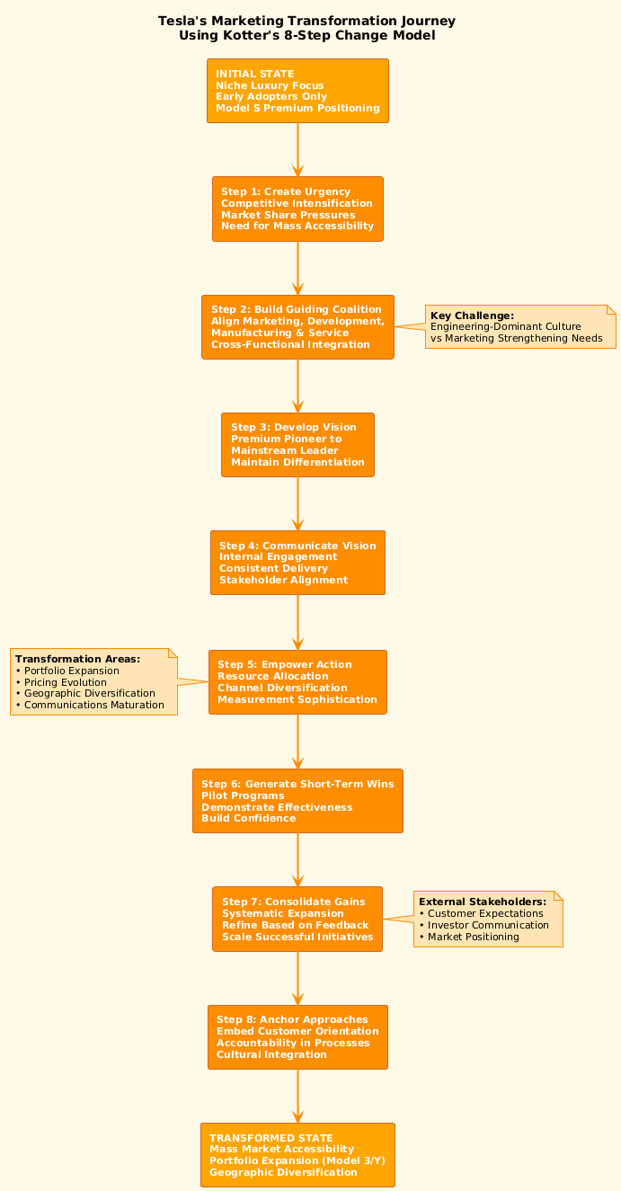
Literature focuses on power and politics pointing at the sources of resistance. Tesla is experiencing conflict between culture of engineers supremacy and marketing fortifying needs. Investment was historically replaced by product excellence, which is not sufficient in a competitive context, and complex development of capability is necessary (Buchanan, D. A. & Badham, R.J., 2008). Some of the challenges are resource allocation debate, development of measurement system, evolution of the structure and acquisition of talents. The success of transformation needs executive dedication through perceptions that growth of investment indicates erosion of differentiation (Moghrabi et al., 2023). External stakeholder management includes management of customer expectations on price development and communication of investors on increase in expenditure. The ability to manoeuvre these dimensions successfully will lower the chances of Tesla being disadvantaged as it adapts its strategies.
Figure 9: Tesla's Marketing Transformation Journey
Source: Self-Made

5.0 Conclusion
The marketing efforts of Tesla are impressive based on the brand equity, technology differentiation, and cost-effectiveness. The company positioned itself as the ultimate electric vehicle brand with premium positioning that was attained with genuine innovation as opposed to spending on advertisement. Vertical integration can also allow distinctive propositions that competitors will find difficult to copy. The generation of organic media generates awareness in a scaled manner without a proportional cost. High loyalty implies effectiveness of relationships. Nevertheless, there are severe weaknesses that limit the growth opportunities. Premium pricing restricts accessibility. Too much dependence on CEO brand establishes reputation weaknesses. Demonstrations monopoly limit demographic. Regional risks are revealed to geographic concentration. Poor quality of experience is compromised by service inadequacies. Increasing competition demands and cost. Sophistication in measurement is a constraint to optimization. These deficits provide a need of strategic response to allow maintenance of differentiation and meet scalability and resilience needs.

6.0 Recommendations for Marketing Strategy Improvement

6.1 Diversify Communications Channels
Tesla needs to apply the selective investment in traditional media with an underrepresented group, especially older audiences and the mainstream markets. Integrated communications produce a great deal of reinforcement on intentions by using multiple touchpoints. Create brand ambassador program with a variety of owners other than Musk, which will reduce the dangers of concentrating the reputation. Introduce systematic content marketing of sustainability, creativity and customer narrative. This specialization enhances accessibility, minimizes vulnerability of the CEO and helps fulfill mass penetration goals and still keep its costs low.

6.2 Implement Flexible Financing Programs
Create broad-based financing options such as reduced deposits, longer terms and subscription, less-purchase presentation models. The total cost perceptions have a strong impact on adoption choices, with the implication that financing innovation is an effective way to increase access. Develop a trade-in program that facilitates smooth changes that capture the residual value. Collaborate with financial organizations with favorable rates. Those measures take care of the issues of accessibility without compromising the positioning by lowering the base price.

6.3 Accelerate Service Network Expansion
Focus more on service centre growth in terms of appointment time and consistency. Innovation needs to be properly allocated resources according to literature. Introduce mobile service fleet in which maintenance is brought to the sites. Establish detailed quality indicators that are related to retention behaviours. Relaxed capabilities lower the negative word of mouth risk, increase loyalty, and assist in the justification of positioning.

6.4 Strengthen Marketing Measurement Capabilities
Implement detailed dashboard that integrates financial, customer, operational, and competitive data so that it can be optimized based on data. Systematic measurement improves the quality of decisions made. Adopt segmentation profitability analysis to be informed on targeting prioritization. Competitive benchmarking Market awareness, consideration, preference, loyalty tracking. Implement predictive analytics to make advanced predictions. Such additions make it possible to improve continuously and be strategic.

7.0 References
Aaker, D. (2015). Brand personalities are like snowflakes, Marketing News, 49(7), pp. 20-21. Full text available at: EBSCOhost Business Source Complete. [online] Business Transformation Consultants | Prophet. Available at: https://prophet.com/2015/06/135-three-models-of-how-a-brand-personality-impacts/ [Accessed 1 Jan. 2026].
Abro, G.E.M., Zulkifli, S.A.B.M., Kumar, K., El Ouanjli, N., Asirvadam, V.S. and Mossa, M.A. (2023). Comprehensive Review of Recent Advancements in Battery Technology, Propulsion, Power Interfaces, and Vehicle Network Systems for Intelligent Autonomous and Connected Electric Vehicles. Energies, [online] 16(6), p.2925. Available at: https://www.mdpi.com/1996-1073/16/6/2925.
Autonews.com. (2025). Don’t bet against Elon Musk: How extreme risks shook the auto industry. [online] Available at: https://www.autonews.com/tesla/an-elon-musk-disruptive-figures-0907/.
Benzidia, S., Luca, R.M. and Boiko, S. (2021). Disruptive innovation, business models, and encroachment strategies: Buyer’s perspective on electric and hybrid vehicle technology. Technological Forecasting and Social Change, 165(2), pp.120–520. doi:https://doi.org/10.1016/j.techfore.2020.120520.
Blankesteijn, M., Jong, F.D. and Bossink, B. (2019). Closed-open innovation strategy for autonomous vehicle development. International Journal of Automotive Technology and Management, 19(1/2), p.74. doi:https://doi.org/10.1504/ijatm.2019.098507.
Buchanan, D. A. & Badham, R.J. (2008). Power, Politics and Organisational Change, 2nd edn., London: Sage Publications.
Cameron, E. & Green, M (2015). Making Sense of Change Management: A Complete Guide to the Models, Tools and Techniques of Organisational Change, 4th edn. London: Kogan Page.
Carroll, S. (2025). Tesla Cybertruck sales tanked 62% in a single quarter. [online] Quartz. Available at: https://qz.com/cybertruck-sales-tanked-q3-tesla-elon-musk.
Fernández, D.L. and Oliver, M. (2025). Methodology, strategies, and Factors for Business Innovation in Large Companies. International Journal of Innovation Studies, [online] 9(2). doi:https://doi.org/10.1016/j.ijis.2025.02.002.
Foreman, J., Donthu, N., Henson, S. and Poddar, A. (2014). The Performance Implications of Planning, Implementation, and Evolution of Firms’ Customer and Competitor Orientations. Journal of Marketing Theory and Practice, 22(4), pp.349–366. doi:https://doi.org/10.2753/mtp1069-6679220401.
Hanlon, A. (2021). The Ansoff Model. [online] Smart Insights. Available at: https://www.smartinsights.com/marketing-planning/create-a-marketing-plan/ansoff-model/.
Hanlon, A. (2023). How to Use the 7Ps Marketing Mix. [online] Smart Insights. Available at: https://www.smartinsights.com/marketing-planning/marketing-models/how-to-use-the-7ps-marketing-mix/.
Hayes, J. (2014). The Theory and Practice of Change Management, 4th edn. Basingstoke: Palgrave Macmillan.
Hessing, T. (2021). Porter’s Five Forces. [online] Six Sigma Study Guide. Available at: https://sixsigmastudyguide.com/porters-five-forces/.
Hu, J., Coleman, K., Zhang, D., Lee, E.B., Humam Kadara, Wang, L. and Li, M. (2023). Deciphering tumor ecosystems at super resolution from spatial transcriptomics with TESLA. Cell systems, 14(5), pp.404-417.e4. doi:https://doi.org/10.1016/j.cels.2023.03.008.
Jia, Z., Chen, Q. and Xu, Q. (2024). The Art of Balancing Price and Plug: Developing a Theoretical Model for Dynamic Pricing in the Electric Vehicle Market. Sustainability, [online] 16(21), pp.9325–9325. doi:https://doi.org/10.3390/su16219325.
Klender, J. (2025). Tesla dominates in the UK with Model Y and Model 3 leading the way. [online] TESLARATI. Available at: https://www.teslarati.com/tesla-dominates-uk-model-y-3-leading-way/ [Accessed 1 Jan. 2026].
Koh, H.-K., Burnasheva, R. and Suh, Y.G. (2022). Perceived ESG (Environmental, Social, Governance) and Consumers’ Responses: The Mediating Role of Brand Credibility, Brand Image, and Perceived Quality. Sustainability, [online] 14(8), p.4515. doi:https://doi.org/10.3390/su14084515.
L, J. (2025). Tesla at a Crossroads: Sales Slump Meets Regulatory Headwinds But Stock Rises, Why? [online] Carbon Credits. Available at: https://carboncredits.com/tesla-at-a-crossroads-sales-slump-meets-regulatory-headwinds-but-stock-rises-why/.
Lawson, R. (2023). How To Use A PESTEL Analysis For ISO Context Analysis. [online] Medium. Available at: https://ideasdistillery.medium.com/how-to-use-a-pestel-analysis-for-iso-context-analysis-23a0b99ba0e1.
Lévay, P.Z., Drossinos, Y. and Thiel, C. (2017). The effect of fiscal incentives on market penetration of electric vehicles: A pairwise comparison of total cost of ownership. Energy Policy, [online] 105, pp.524–533. doi:https://doi.org/10.1016/j.enpol.2017.02.054.
Li, W., Yang, S., Chen, Y., Li, C. and Wang, Z. (2023). Tesla valves and capillary structures-activated thermal regulator. Nature Communications, 14(1). doi:https://doi.org/10.1038/s41467-023-39289-5.
Liu, C.C., Boothman, S.G. and Graham, J.D. (2025). The Rise and Recent Decline of Tesla’s Share of the U.S. Electric Vehicle Market. World Electric Vehicle Journal, [online] 16(2), pp.90–90. doi:https://doi.org/10.3390/wevj16020090.
Lukin, E., Krajnović, A. and Bosna, J. (2022). Sustainability Strategies and Achieving SDGs: a Comparative Analysis of Leading Companies in the Automotive Industry. Sustainability, 14(7), p.4000.
Meredith, S. (2025). How China’s electric vehicle juggernaut is reshaping the global car market. [online] CNBC. Available at: https://www.cnbc.com/2025/08/28/autos-chinas-electric-vehicle-juggernaut-is-reshaping-the-car-market.html.
Miller, C.J., Brannon, D.C., Salas, J. and Troncoza, M. (2021). Advertising, incentives, and the upsell: how advertising differentially moderates customer- vs. retailer-directed price incentives’ impact on consumers’ preferences for premium products. Journal of the Academy of Marketing Science, 49(6). doi:https://doi.org/10.1007/s11747-021-00791-1.
Moghrabi, I.A.R., Bhat, S.A., Szczuko, P., AlKhaled, R.A. and Dar, M.A. (2023). Digital Transformation and Its Influence on Sustainable Manufacturing and Business Practices. Sustainability, 15(4), p.3010. doi:https://www.mdpi.com/2071-1050/15/4/3010.
Niri, A.J., Poelzer, G.A., Zhang, S.E., Rosenkranz, J., Pettersson, M. and Ghorbani, Y. (2024). Sustainability challenges throughout the electric vehicle battery value chain. Renewable and Sustainable Energy Reviews, 191(114176), p.114176. doi:https://doi.org/10.1016/j.rser.2023.114176.
Orazalin, N.S., Ntim, C.G. and Malagila, J.K. (2023). Board Sustainability Committees, Climate Change Initiatives, Carbon Performance, and Market Value. British Journal of Management, 35(1). doi:https://doi.org/10.1111/1467-8551.12715.
Palmié, M., Miehé, L., Mair, J. and Wincent, J. (2024). Valuation entrepreneurship through product‐design and blame‐avoidance strategies: How Tesla managed to change the public perception of sustainable innovations. The Journal of Product Innovation Management, 41(3), pp.644–676. doi:https://doi.org/10.1111/jpim.12732.
Punit, I.S. and Bhattacharya, A. (2025). Tesla loses ground as Chinese EVs dominate global markets. [online] Rest of World. Available at: https://restofworld.org/2025/tesla-loses-ground-chinese-ev-dominate-global-markets/.
Qadir, S.A., Ahmad, F., Al-Wahedi, A.M.A.B., Iqbal, A. and Ali, A. (2024). Navigating the Complex Realities of Electric Vehicle adoption: a Comprehensive Study of Government strategies, policies, and Incentives. Energy Strategy Reviews, [online] 53(53), pp.101379–101379. Available at: https://www.sciencedirect.com/science/article/pii/S2211467X24000865.
Raja Rajendra Timilsina, Zhang, J., Rahut, D.B., Kaewupsorn Patradool and Tetsushi Sonobe (2025). Global drive toward net-zero emissions and sustainability via electric vehicles: an integrative critical review. Energy Ecology and Environment. doi:https://doi.org/10.1007/s40974-024-00351-7.
Rua, O.L. and Santos, C. (2022). Linking brand and competitive advantage: The mediating effect of positioning and market orientation. European Research on Management and Business Economics, [online] 28(2), p.100194. Available at: https://www.sciencedirect.com/science/article/pii/S244488342100053X.
Rudolph, A. (2025). ​​Tesla’s faces stiff automotive challenges amid intensifying EV competition​. [online] IG. Available at: https://www.ig.com/en/news-and-trade-ideas/_tesla-s-faces-stiff-automotive-challenges-amid-intensifying-ev--250603.
Sanguesa, J.A., Torres-Sanz, V., Garrido, P., Martinez, F.J. and Marquez-Barja, J.M. (2021). A Review on Electric Vehicles: Technologies and Challenges. Smart Cities, [online] 4(1), pp.372–404. doi:https://doi.org/10.3390/smartcities4010022.
Shahzad, S. and Jasińska, E. (2024). Renewable Revolution: A Review of Strategic Flexibility in Future Power Systems. Sustainability, 16(13), pp.5454–5454. doi:https://doi.org/10.3390/su16135454.
Sharabati, A.-A.A., Ali, A., Allahham, M.I., Hussein, A.A., Alheet, A.F. and Mohammad, A.S. (2024). The Impact of Digital Marketing on the Performance of SMEs: An Analytical Study in Light of Modern Digital Transformations. Sustainability, [online] 16(19). doi:https://doi.org/10.3390/su16198667.
Sun, J., Sun, S., Chen, B. and Hu, Y. (2024). Charging change: Analysing the UK’s electric vehicle infrastructure policies and market dynamics. Energy policy, [online] 191, pp.114178–114178. doi:https://doi.org/10.1016/j.enpol.2024.114178.
Surya, B., Menne, F., Sabhan, H., Suriani, S., Abubakar, H. and Idris, M. (2021). Economic Growth, Increasing Productivity of SMEs, and Open Innovation. Journal of Open Innovation: Technology, Market, and Complexity, [online] 7(1), p.20. doi:https://doi.org/10.3390/joitmc7010020.
SWOT (2024). How To Do a SWOT Analysis. [online] Industry Insider | IBISWorld. Available at: https://www.ibisworld.com/blog/how-to-do-a-swot-analysis/1/1127/.
Teece, D.J. (2018). Tesla and the Reshaping of the Auto Industry. Management and Organization Review, [online] 14(3), pp.501–512. doi:https://doi.org/10.1017/mor.2018.33.
Tesla (2025). Electric cars, solar panels & clean energy storage. [online] Tesla.com. Available at: https://www.tesla.com/.
Wang, Y. and Tian, Y. (2023). The Impact of New Energy Vehicle Product Attributes on Consumer Purchase Intention in the Backdrop of Sustainable Development Goals. Sustainability, 15(3), p.1989. doi:https://doi.org/10.3390/su15031989.
Wei, S., Xu, H., Zheng, S. and Chen, J. (2024). Research on the Impact of New Energy Vehicle Companies’ Marketing Strategies on Consumers’ Purchase Intention. Sustainability, 16(10), pp.4119–4119. doi:https://doi.org/10.3390/su16104119.
Xu, Y., Shan, X., Guo, M., Gao, W. and Lin, Y.-S. (2024). Design and Application of Experience Management Tools from the Perspective of Customer Perceived Value: A Study on the Electric Vehicle Market. World Electric Vehicle Journal, [online] 15(8), pp.378–378. Available at: https://www.mdpi.com/2032-6653/15/8/378.
Zaino, R., Ahmed, V., Alhammadi, A.M. and Alghoush, M. (2024). Electric Vehicle Adoption: A Comprehensive Systematic Review of Technological, Environmental, Organizational and Policy Impacts. World Electric Vehicle Journal, [online] 15(8), p.375. doi:https://doi.org/10.3390/wevj15080375.
Zarazua de Rubens, G. (2019). Who will buy electric vehicles after early adopters? Using machine learning to identify the electric vehicle mainstream market. Energy, 172, pp.243–254. doi:https://doi.org/10.1016/j.energy.2019.01.114.
Zhang, L. and Shi, W. (2025). The Impacts of the US Inflation Reduction Act on EV Supply Chains. Sustainability, [online] 17(2), p.653. doi:https://doi.org/10.3390/su17020653.

