

LOCATION: Swansea | LLEOLIAD: abertawe
LEVEL 4 | LEFEL 4
EXAMINATION PERIOD | CYFNOD ARHOLIADAU
Jan 2023 | IOnawr 2023

MODULE CODE: ACDA4004
Micros Peripherals and Interfaces
TIME: 2 HOURS
answer all questions

Marking Scheme

ANSWER ALL QUESTIONS

- The following comprise a number of mnemonics from the PIC16F887 microprocessor instruction set. Give the meaning of what each mnemonic stands for and explain what the instruction actually does:
  - BCF
[2 Marks]
Bit Clear File – Sets a given single bit to ‘0’ in a given file.
e.g. BCF PORTB, 1
  - BTFSS
[2 Marks]
Bit Test File Skip if Set – Tests a given bit in a given file and only skips the next instruction if bit is set to 1
e.g. BTFSS PORTA,0
CALL SomeFunction

  - ADDLW
[2 Marks]
ADD Literal to Working - adds the literal value supplied to the value in the W register and places the result in the W regisiter
e.g. ADDLW 0x20
  - NOP
[2 Marks]
No Operation – Performs no actual operation, but ‘wastes’ a fixed number of clock cycles so can be used to create delays etc.
e.g. NOP
  - DECF
[2 Marks]
DECrement File – Subtracts 1 from the value in the given file.
e.g. DEF COUNT

- What is the resolution of an 8 bit ADC with a maximum input voltage of 5V? Give your answer in mV.
[4 Marks]

$$resolution=\frac{Vin Max}{2^{n}-1}=\frac{5}{2^{8}-1}=19.6 mV$$

- For the binary weighted DAC shown in Fig Q3, explain the general principle of operation of the circuit based around the op-amp and subsequently calculate the output voltage, Vout, assuming the reference voltage is 5V.

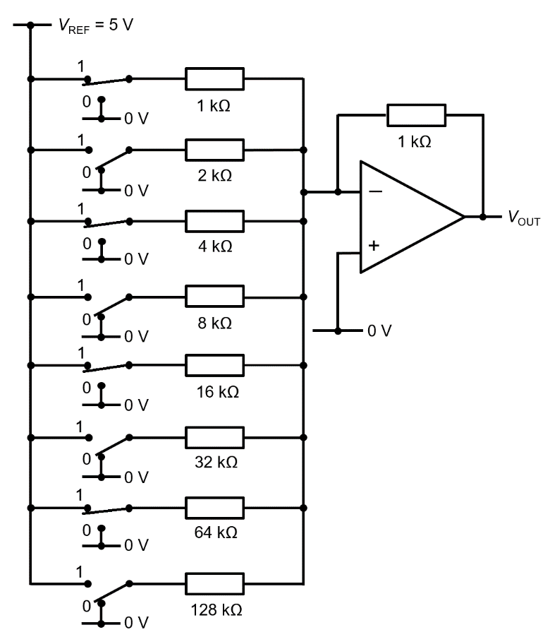
Fig Q3
[6 Marks]

Op amp is configured as a summing amplifier, using the -ve input, meaning the output voltage is a negated sum of the individual switched inputs * the gain factor (which in this case will be approx. 2 with all switches ‘on’

$$V_{out}=-\left(\frac{VH}{1}+\frac{VG}{2}+\frac{VF}{4}+\frac{VE}{8}+\frac{VD}{16}+\frac{VC}{32}+\frac{VB}{64}+\frac{VA}{128}\right)$$

$$V_{out}=-\left(\frac{5}{1}+\frac{0}{2}+\frac{5}{4}+\frac{0}{8}+\frac{5}{16}+\frac{0}{32}+\frac{5}{64}+\frac{0}{128}\right)=-6.64 V$$

- Draw the logic symbol for an XOR gate and provide the truth table for it.
[4 marks]
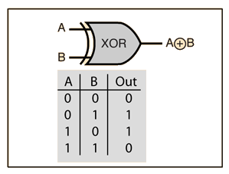

- The following circuit comprises two inputs, A and B. Construct a truth table, showing the output states of all the intermediate logic gates as well as the final, overall output.

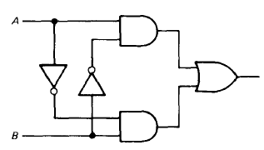

Fig Q5
[8 Marks]
A | B | $$\overline{A}$$ | $$\overline{B}$$ | $$A∙\overline{B}$$ | $$\overline{A}∙B$$ | $$\left(A∙\overline{B}\right)+\left(\overline{A}∙B\right)$$
0 | 0 | 1 | 1 | 0 | 0 | 0
0 | 1 | 1 | 0 | 0 | 1 | 1
1 | 0 | 0 | 1 | 1 | 0 | 1
1 | 1 | 0 | 0 | 0 | 0 | 0

- You are required to drive an LED from a PIC output port. Sketch a typical circuit configuration that you could use, explaining your reasoning for any choice of components you use and include any calculations made.
You are told that the PIC is powered from +5V, the LED will require 10mA and its forward voltage drop is 2.0V (8 marks)

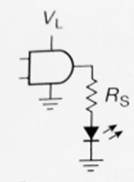
Voltage drop is 2V therefore Rs needs to drop 5-2=3V
Current is 0.01A,
Therefore R=3/0.01 = 300 ohms
(4 marks for circuit, 4 marks for calculation)

- Compare and contrast the Harvard and Von Neumann processor architectures. Use diagrams to support your answer.
Give one example scenario for each where you would typically find that architecture type used.
[10 Marks]

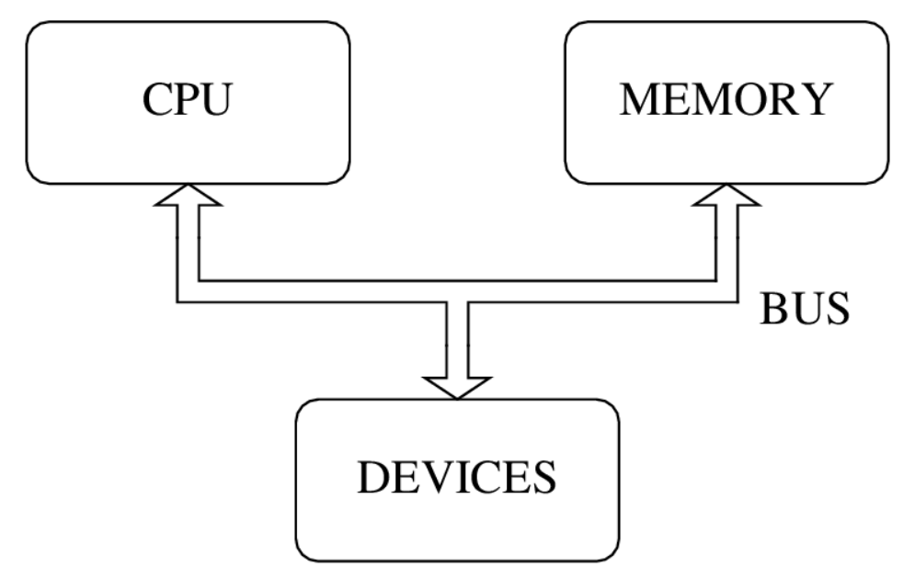  Von Neumann | 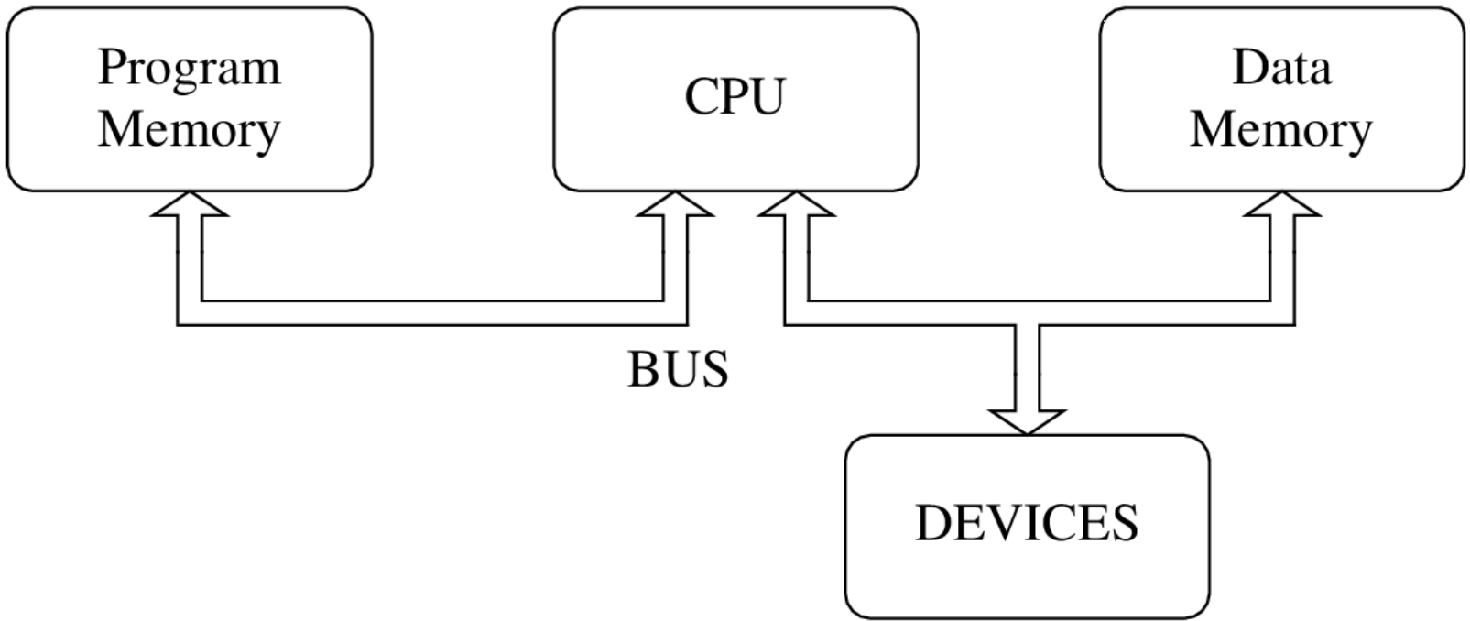  Harvard

Von Neumann architecture uses buses to move information between CPU, memory and peripheral devices. Program instructions and data are stored in same memory. Program instructions can be accidentally overwritten. A single bus can cause a bottleneck in data transfers. Von Neumann architecture is used for desktop computers

Harvard architecture separates program memory from data memory and adds a separate bus for the program memory. This second bus adds complexity and cost but protects program memory from accidental overwriting. Harvard architecture is used for embedded applications.
Diwedd/End

