

A Seamless Transition: Migrating On-Premises Reporting Solutions to The Cloud for Agility and Scalability

By
Iwan Dyke

Supervisor: Divya Chandrakam

Project submitted as part of the requirements for the award of BSc (Hons) Computing (Data and Information Systems)

July 2024

DECLARATION FORM AND FORM OF CONSENT

DECLARATION

I, Iwan Dyke declare that I am the sole author of this Project; that all references cited have been consulted; that I have conducted all work of which this is a record, and that the finished work lies within the prescribed word limits.

This work has not previously been accepted as part of any other degree submission.

FORM OF CONSENT

I Iwan Dyke hereby consent that my Project, submitted in candidature for the B.Sc. (Hons) Computing (Data & Information Systems) degree, if successful, may be made available for inter-library loan or photocopying (subject to the law of copyright), and that the title and abstract may be made available to outside organisations.

Abstract
This project explores the feasibility and benefits of transitioning on-premises reporting solutions to a cloud-based infrastructure using Databricks and Azure Data Lake, focusing on enhancing data management processes within the water network development sector. The implementation of a Lakehouse Architecture aimed to integrate data warehouse analytics with data lake flexibility, providing a unified platform for structured data analysis and high-performance reporting. Key objectives included evaluating current data management practices, designing and implementing a prototype Lakehouse Architecture, and analyzing processing times, scalability, and cost efficiency compared to traditional on-premises systems. The project demonstrated significant improvements in data processing efficiency, cost savings, and enhanced data governance through Unity Catalog. The findings revealed a 70% reduction in processing time and substantial cost savings, affirming the advantages of cloud migration. The project's success highlights the potential of cloud-based solutions for scalable, efficient, and secure data management, setting a foundation for future enterprise-wide data platform implementations. Recommendations for future work include implementing data quality checks using Unity Catalog and enhancing real-time data processing capabilities to ensure continuous data accuracy and reliability. The project underscores the importance of robust data governance, scalable infrastructure, and cost-efficient cloud solutions in modern data management.

Contents
DECLARATION FORM AND FORM OF CONSENT 2
Abstract 3
Contents 4
Chapter 1: Introduction 7
1.1 Overview of the Project 7
1.2 Aims and Objectives 7
1.3 Structure of the Report 8
Chapter 2: Research and Review of Literature 9
2.1 Relevant Studies 9
2.1.1 Data Lakehouse: Next Generation Information System [1] 9
2.1.2 Databricks- Data Intelligence Platform for Advanced Data Architecture [2] 10
2.1.3 Review of Cloud Migration Strategies: Exploring Advantages, Challenges and Cost Analysis [3] 10
2.2 Theoretical Frameworks 11
2.2.1 Cloud Computing Models 11
2.2.2 Data Management Theories 11
2.3 Key Findings and Gaps 12
2.3.1 Summary of Findings 12
Chapter 3: Development Methodology 13
3.1 Development Methodology 13
3.1.1 Research Methods 13
3.1.2 Justification of Chosen Methods 13
3.1.3 Chosen Software Development Methodology 13
3.1.4 Tools and Techniques Used 15
3.1.5 Hardware/Infrastructure Requirements 17
3.1.6 Justification and Advantages of Chosen Methodology 18
3.1.7 Challenges and How They Were Addressed 18
Chapter 4: Design and Implementation 19
4.1 Design 19
4.1.1 Design Decisions 19
4.1.2 Process Overview 21
4.1.3 System Models 21
4.2 Implementation 24
4.2.1 Coding Challenges and Solutions 24
4.2.2 Code Snippets and Techniques 26
4.2.3 Testing Strategies 28
Chapter 5: Evaluation 32
5.1 Data Analysis 32
5.2 Comparison with Objectives 34
5.2.1 Objective 1: Evaluate Data Management Practices in Water Network Development 34
5.2.2 Objective 2: Design and Implement a Prototype Lakehouse Architecture Using Databricks and Azure Datalake 34
5.2.3 Objective 3: Conduct an Analysis of Processing Times, Scalability, and Cost Efficiency Between On-Premises Data Warehouse Technologies and Cloud-Based Solutions 35
5.3 Insights and Findings 35
5.3.1 Unity Catalogs Importance in Data Governance 36
5.3.2 The Flexibility of Databricks Notebooks 37
5.3.3 The Lakehouse Architecture and Data Integration 38
5.3.4 Advantages of Cloud Over On-Premises Systems 38
Chapter 6: Conclusions and Recommendations 39
6.1 Summary of Work 39
6.2 Conclusions 39
6.3 Recommendations for Future Work 40
Chapter 7: Reflection 40
7.1 Personal Development 40
7.1.1 Technical Skills 41
7.1.2 Project Management Skills 41
7.1.3 Critical Thinking Skills 42
7.2 Lessons Learned 42
7.2.1 Importance of Clear Requirements 42
7.2.2 Effective use of Tools and Technologies 42
7.2.3 Scalability and Performance 43
Chapter 9: Bibliography 47
Chapter 10: Appendix 48
10.1 Source Code 48
10.1.1 TMR Populate Case Dimensions 48
10.1.2 TMR Populate Task Dimensions 56
10.1.3 Populate Task Bridge Dimension 73
10.1.4 TMR Populate Task Facts 77
10.1.5 TMR populate Case Fact 83
10.2 Unit Testing Tables 96
10.2.1 TMR Populate Case Dimensions Unit Test 96
10.2.2 TMR Populate Task Dimensions Unit Test 97
10.2.3 TMR Populate Task Bridge Dimension Unit Test 98
10.2.4 TMR Populate Case Facts Unit Test 98
10.2.5 TMR Populate Task Facts Unit Test 99

Figure 1 (Evolution of Data Storage Processes) 7
Figure 2 (Software and Programming Languages Used) 16
Figure 3 (Hardware and Infrastructure Utilised) 18
Figure 4 (High Level TMR Solution Design) 19
Figure 5 (Task Management Reporting Data Mart Entity Relationship Diagram) 23
Figure 6 (Generated Always as Identity Code Snippet) 24
Figure 7 (Error Inserting Value into Surrogate Primary Key Field) 24
Figure 8 (Generated by Default as Identity Code Snippet) 25
Figure 9 (INSERT INTO Statement for Dimension Tables) 25
Figure 10 (Successful INSERTion of Default Values) 25
Figure 11 (Developed Method of Error Handling) 26
Figure 12 (Type 1 Dimension Population Script) 27
Figure 13(FACT Table Population SELECT Statement) 28
Figure 14 (TMR Populate Case Dimension) 30
Figure 15 (End-to-End Process Run) 30
Figure 16 (Table of Raw Data Before any Processing Takes Place) 31
Figure 17 (Full Notebook Flow for End-to-End Process) 31
Figure 18 (Completed View of Data Mart Extraction Tool Ready for Reporting) 31
Figure 19 (Standard Databricks Cluster Configuration) 33
Figure 20 (Unity Catalog Data Quality Insights Page) 36
Figure 21 (Unity Catalog Lineage Page Detailing Upstream and Downstream Objects) 37
Figure 22 (TMR Cloud Migration Solution Architecture Diagram) 41
Figure 23 (Potential Medallion Architecture) 43
Figure 24 (Databricks Managed Table Optimisation Example) 44
Figure 25 (TMR Populate Case Dimensions Unit Test) 97
Figure 26 (TMR Populate Task Dimensions Unit Test) 97
Figure 27 (TMR Populate Task Bridge Dimension Unit Test) 98
Figure 28 (TMR Populate Case Facts Unit Test) 99
Figure 29 (TMR Populate Task Facts Unit Test) 99

Chapter 1: Introduction

Overview of the Project
The project “A seamless transition: migrating On-premises reporting solutions to the cloud for agility and scalability” aims to explore the feasibility and potential benefits of implementing a Lakehouse Architecture to enhance data management processes within the water network development sector. The focus will be on transitioning from an on-premises data warehouse solution to a more scalable and efficient cloud-based infrastructure using Databricks and Azure Data Lake. This is a meaningful change as it moves from using Relational Database Management Systems (RDBMS) which require data in tabular formats to Binary Large Object (BLOB) and Not Only SQL Databases (NoSQL) which are more flexible in the datatypes stored.
Figure 1 (Evolution of Data Storage Processes)

1.2 Aims and Objectives

Aim
To demonstrate the feasibility and benefits of a Lakehouse Architecture in enhancing data management processes for water network development.

Objectives
- Evaluate data management practices in water network development.
- Design and implement a prototype Lakehouse Architecture using Databricks and the Azure Datalake
- Conduct an analysis of processing times, scalability and cost efficiency between On-premises Data Warehouse technologies and cloud based.

1.3 Structure of the Report

Chapter 2: Research and Review of Literature:
This chapter explores existing studies, theoretical frameworks and identifies gaps in the current knowledge related to cloud-based architecture.

Chapter 3: Development Methodology:
Describes the methodologies used in the project, including the Kanban approach, tools and techniques employed.

Chapter 4: Design and Implementation:
Detailing the design decisions, process overview, system models, interfaces and prototypes along with code snippets and relevant testing strategies.

Chapter 5: Evaluation:
An analysis of the project’s outcomes, comparisons of the initial objectives and highlighting key findings.

Chapter 6: Conclusions and Recommendations:
Summarises the work done, draws conclusions based upon the projects finding, and provides recommendations for future improvements.

Chapter 7: Reflection:
A reflection on personal development, lessons learned throughout the process and how the project has influenced professional growth and skills.

Chapter 8: References:
A list of all references citied throughout the report.

Chapter 9: Bibliography
A list of background reading undertaken and sources that informed the project but were not directly cited.

Chapter 10: Appendices:
Supplementary materials such as program source code, unit testing tables and extra documentation.

Chapter 2: Research and Review of Literature
This chapter presents a comprehensive review of existing studies, theoretical frameworks, and key findings related to the migration of On-Premises reporting solutions to cloud-based infrastructures, specifically focusing on the implementation of the Lakehouse Architecture. The review is structured into sections covering relevant studies, the theoretical frameworks which underpin data management and key findings. This provides the necessary background for understanding the rationale behind the design approach.

2.1 Relevant Studies

2.1.1 Data Lakehouse: Next Generation Information System [1]
The Data Lakehouse Architecture offers significant benefits by seamlessly integrating Data Warehouse analytics with data lake schema flexibility, thereby providing enhanced processing capabilities for structured data analysis, complex queries, and high-performance reporting. Cherradi (2024) emphasises that this transformative model overcomes the limitations of traditional data management practices by establishing a unified platform, setting a new standard for sophisticated data management. The architectures uniqueness lies in its combination of analytical strengths with schema flexibility, which is an inherent paradigm shift in data management from previous solutions. This approach is particularly noted for its adaptability and performance in a constantly evolving data landscape.
The challenges discussed in this study focus on the limitations of conventional data management frameworks, specifically when trying to integrate the flexibility of Datalakes with the restrictive nature of (RBDMS) Data Warehouses. The objectives outlined in this study was to establish a unified platform which can overcome the limitations of traditional data management by integrating the strengths of Data Warehouses with the flexibility of Datalakes, setting a new benchmark for advanced data management.

2.1.2 Databricks- Data Intelligence Platform for Advanced Data Architecture [2]
Databricks offers a unified platform that provides scalable cloud-based solutions for data science and data analytics. Bussu (2024) highlights that the platform boasts benefits including data-driven decision-making, supporting advanced analytics techniques, facilitating big data processing with Apache Spark and offering native support for various programming languages. The platforms scalability, efficiency and user-friendly solutions drive insights and add value across various industries.
Bussu discusses challenges related to constantly growing data volume and complexity of data, emphasising how platforms such as Databricks harness the power of Data Science and machine learning to derive insights and value from data. The main objectives of this study were to explore the journey of Databricks as a company ensuring data-driven decision-making through advanced analytics techniques and examining the progression of Data Science and data management from initial implementation to current state-of-the-art techniques.

2.1.3 Review of Cloud Migration Strategies: Exploring Advantages, Challenges and Cost Analysis [3]
The paper “Review of Cloud Migration Strategies: Exploring Advantages Challenges and Cost Analysis” by Kumar (2024) provides a comprehensive exploration of various cloud migration strategies, including rehosting, re-platforming, refactoring, retiring and retaining. Each strategy aimed around facilitating the transition from On-Premises infrastructure to cloud-based solutions offering distinct advantages tailored to specific business needs. Rehosting which is the main method used in the project often referred to as “lift-and-shift” involved moving applications to the cloud with minimal changes providing quick scalability and improved resource utilisation. Re-platforming is also discussed and is still quite relevant as it entails making slight optimisations to leverage cloud benefits without altering the core architecture of the solution.
The paper highlights several key benefits of cloud migration, including enhanced scalability, which allows organisations to adjust resources based on demand, optimising cost and improving efficiency. Improved resource utilisation is another significant advantage as cloud platforms often offer better resource management tools compared to traditional On-Premises systems. This feeds into accelerated time to market due to the ability to quickly provision resources and deploy applications.

2.2 Theoretical Frameworks

2.2.1 Cloud Computing Models

Infrastructure as a Service (IasS)
IaaS provides virtualised computing resources over the internet. Vivekanandam explains that IaaS is a type of cloud sharing service that provides computing, networking and data storage applications over the internet [4]. This model offers This model offers significant flexibility and control, allowing organisations to quickly scale up and down based on demand without the need for substantial upfront investments in physical hardware. IaaS is particularly beneficial for organisations transitioning for On-Premises data centres, as it provides a straightforward path to migrate existing applications with minimal changes [5].

Platform as a Service (SaaS)
PaaS provides a platform allowing customers to develop, run, and manage applications without dealing with the underlying infrastructure. PaaS offers a higher level of abstraction compares to IaaS, providing a complete development and deployment environment in the cloud [6]. PaaS solutions include infrastructure (servers, storage and networking), middleware (databases, messaging and queuing), development tools (runtime environments, IDEs and frameworks) and finally management services (monitoring, management and security) in this project the Databricks platform and Azure DevOps are key examples of PaaS. Databricks offers an integrated development environment for data processing, storage and analytics [7]. Whereas Azure DevOps provides tools for project management, version control and continuous integration and deployment (CI/CD) [8].

2.2.2 Data Management Theories

Kimball Methodology
The Kimball dimensional model introduced by Ralph Kimball, is the cornerstone in the field of Data Warehouse design. It emphasises a user-centric approach to Data Warehouse design, focusing on creating structures that are easy for business users to navigate. The main objective is to optimise data retrieval and reporting performance by organising data into FACT and dimension tables. The FACT tables store quantitative data for analysis such as integers, flags, keys and dates. These tables are characterized by large volumes of data and contain keys that relate to dimension tables. Dimension tables however contain descriptive attributes providing context to the FACTs. These are typically de-normalised tables to enhance query performance and simplify the user’s interaction with the data [9].
One of the key advantages of the dimensional model is its ability to support complex queries and provide high performance for analytical tasks. The dimensional approach aligns closely with the ways business users consider and understand their data, making it easier to construct meaningful reports and analytics. A star schema is a type of data modelling in which the FACT tables are situated at the centre with the dimension tables located around the edges resembling a star. While “star schemas” are the most common and efficient method of modelling, “snowflake schemas” are a more complex version of a star schema with one or more of the dimensional tables normalised to improve data integrity. This can be used to deal with many-to-many relationships to remove duplicates. Although “snowflake schemas” can deal with more complex relationships this does come at the cost of query performance [10].
Kimball emphasises the importance of understanding the business processes and ensuring the design reflects the real-world scenarios users need to analyse. With this user-oriented design and encouragement of user collaboration with stakeholders ensure the data models meet requirements. This approach has been widely adopted in industry due to its simplicity, scalability and value it brings to decision-making processes [11].

2.3 Key Findings and Gaps

2.3.1 Summary of Findings
The literature review has revealed several critical insights when considering a migration from an On-Premises solution to cloud-based infrastructure. Particularly through the implementation of a Lakehouse Architecture.

Enhanced Performance and Scalability
Studies consistently show that cloud-based solutions offer significant improvements in performance and scalability compared to traditional On-Premises systems. Platforms like Databricks enable faster data processing can manage larger volumes of data with greater efficiency, due to the scalable nature of cloud infrastructure, which allows resources to be dynamically allocated based on demand.

Cost Efficiency
The transition to cloud platforms also results in considerable cost savings according to research. Emphasising the pay-as-you-go model of cloud services like Databricks eliminates the need for upfront substantial investments in hardware and reduce ongoing maintenance costs.

Data Management and Governance
Robust data governance and management capabilities are critical benefits of adopting cloud solutions. Features like Unity Catalog within Databricks ensures centralised access control, auditing and data lineage capabilities.

Chapter 3: Development Methodology

3.1 Development Methodology

3.1.1 Research Methods
In the initial phases of this project exploratory and investigatory research was employed to gather information on current technological industry trajectories when it comes to development and data analysis and storage. This involved meetings with customer advisors of potential products including Databricks and Microsoft which explained how their services would be the best host for a potential solution. Attending data centric events highlighting how others have utilised products and services while sharing best practices and general documentation scouring understanding what is available in each service and how it could compare to the existing on-premises solution.

3.1.2 Justification of Chosen Methods
Exploratory and investigative methodologies were employed as they catered for qualitive analysis with a flexible and open-ended approach to gathering data [12]. This was essential for understanding the different potential features of various products and services a how they can aid in improving and updating the chosen solution into cloud-based infrastructure. The insights gained from this research were critical in shaping the development process and ensuring that the final product would match the needs of the existing system while improving performance and highlighting technologies for other solutions.

3.1.3 Chosen Software Development Methodology
Kanban boards are a visual representation of an agile workflow with small work items focusing on continuous delivery and development. Work items are created with detailed requirements and an estimation of how long it will take to complete the work. Once created they are added to the backlog and can be planned into a sprint [13]. A sprint is a set amount of time to complete work focusing on iterative development. In the case of this project a sprint lasted around four weeks. With six hours equating to one day of work. This means that only a certain number of work items can be assigned to a developer per sprint based on the estimations of how long a ticket will take to complete.
Kanban has several principles aimed at improving efficiency in iterative development teams:
- Visualise Workflow:
A kanban board visualises the workflow, making it easy to understand the status of each task. A digital kanban board from DevOps was used with each task represented as a card which can be moved through the development states.

- Limit Work in Progress:
Limits the number of tasks in progress and ensures the focus is maintained on prioritised tasks. A sprint planning session was held at the beginning of every month with a set capacity for how many tasks could be planned in.

- Manage Flow:
Continuous monitoring of the workflow helps identify bottlenecks and optimise processes. Mid-sprint checkpoints were held, and board stand-ups held every other day allowing for blockers to be raised or progress to be shared.

- Make Policies Explicit:
Rules are defined clearly for moving tasks between stages maintaining consistency and transparency. Planned but un-started tasks were marked as “to-do,” tasks which have been worked on were moved into “in-progress” and tasks which could be considered as completed were finally moved into “done.”

- Promotes Feedback and Process Improvement:
Regular retrospectives ensure continuous improvement and issue resolution. Retrospectives were held on the final day of each sprint in which points were raised for the three following areas: “What went well, “things to improve” and “Ideas to raise.” Allowing the team to comment and assist each other while identifying areas for improvement.

- Improve Collaboratively:
Collaborative issue resolution is encouraged by visualising the work items for all people on a team. This helped with fostering a supportive team environment with a no-blame culture increasing team productiveness and happiness.

3.1.4 Tools and Techniques Used
Several Tools and Techniques were employed to facilitate the development of this project and ensure quality outcomes.

Tools/Software
Tool | Description | Usage | Justification
Azure Portal | The Azure portal is a graphical user interface providing tools to managing all services held within the Azure Portal. | The Azure Portal is the main access point and management interface for the storage account and the Databricks service. Facilitating cost management, understanding of permissions and architecture and region availability. | All chosen tools and services function on the Azure Platform, which is why Azure Portal must be used as the management interface.
Azure DevOps | Azure DevOps is a product which provides a myriad of tools aimed at developers such as version control, requirements management, project management and automated builds and testing. | Azure DevOps was used as the project management tool and code repository for the solution. Giving the team visibility on work completed while also providing version control functionality. | Azure DevOps was the main project management tool for the team while also being the version control and automated build agent for the platform this solution would finally be held on. It integrates well with all other tools used in this platform and facilitates integrated CI/CD (Continuous Integration/Continuous Delivery) pipelines.
Azure Storage | Azure Storage is a cloud storage solution which offers durable, scalable and secure blob (binary large object) storage. This is also known as a data lake. | Azure Storage was planned as the landing zone for the raw data file before it was imported to Databricks and transformed. | Azure Storage is the data lake offered on the Microsoft Azure platform and integrates with all other services. It should be used as a landing zone for raw files and can also be used as a backup area where transformed and aggregated data can be stored as parquet files.
Databricks | Databricks is a cloud-based platform offering a collaborative environment for big data processing and analytics. | Databricks was the analytics and final storage solution used to hold a copy of the raw, clean and aggregated data in Unity Catalog. While also being the tool of choice for transformations with Databricks notebooks. | Databricks is one of the leading data management and analytics platforms in the industry. It is a centralised location for data professionals providing services for data ingestion, transformation and machine learning models or report and dashboard integration.
SQL (Programming Language) | SQL (Structured Query Language) is a programming language specifically oriented at data management and storage. | SQL is used for the data management, transformation and aggregation within unity Catalog on the Databricks environment. | SQL is the leading standard on data manipulation language and is used in different forms in a myriad of the most popular database systems.
PySpark  (Programming Language) | PySpark is the python API for Apache spark. It is a combination of pythons’ learnability with the power of Apache spark to enable large processing of data. | PySpark has been used as the main code language within the Databricks notebooks. It allows for more programmatic functions while SQL was used specifically for data manipulation. | PySpark is one of four languages available on the Databricks platform. With python being one of the most widely known and used languages it made sense to begin the new platform using it.
Figure 2 (Software and Programming Languages Used)

Techniques
A small list of coding techniques was utilized in the development of this project:
- Code Reviews:
Regular peer reviews of code developed ensure high quality and standards, with a second person having a more objective view and fresh perspective on methods employed.

- Pair Programming:
Pair programming is the act of solving complex problems through close collaboration with a colleague. It allows two developers to use each other as sounding boards. An try different methods of problem solving to resolve issues quicker.

3.1.5 Hardware/Infrastructure Requirements
Hardware/Infrastructure | Description | Usage | Justification
High Powered PC/Laptop | A high specification PC with at least 16GB of Ram, an Intel I5 CPU or more and integrated graphics card for use in multithreading code runs. | The PC is the main point of development for all work in this project. It gives access to the cloud software providers and is a high enough specification to be able to open and process larger datasets locally when required. | The high specification PC is essential for managing the process intensive tasks of coding, testing and debugging efficiently. It ensures smooth performance and supports development practices of multitasking and parallel processing which is essential for larger datasets.
Databricks Spark Cluster | A scalable cloud-based cluster provided by data bricks designed for large scale data processing using Apache spark. | Used for large data processing and running complex queries. The cluster provides distributed computing handling big data workloads efficiently. | The spark cluster is crucial for handling large datasets as queries/code can only be run with an active cluster. These are configurable and scalable. Leveraging distributed computing and virtual machines for efficiency and cost management.
Databricks Serverless SQL Warehouse | A serverless scalable data warehouse provided by Databricks that simplifies data management and query execution. | Used for executing SQL queries on large datasets without the need to manage infrastructure. It provides functionality for data integration, analysis and reporting. | The serverless SQL warehouse was essential as it was a contender for the new cloud data platform at Welsh Water. This projects aim was to understand the systems available within Databricks and if it would meet the requirements for an enterprise data platform.
Databricks Unity Catalog | Unity Catalog is a centralised access control, auditing, lineage, and data discovery capability across the workspace. | Used as the governance tool to highlight data management and governance for the enterprise platform. It ensures standard data governance and security within Databricks, providing comprehensive data management capabilities. | Unity Catalog is essential for maintaining data governance and security allowing for effective access control, auditing, data lineage and ensuring data is used appropriately and securely. All essential qualities for building a regulated enterprise data platform.
Figure 3 (Hardware and Infrastructure Utilised)

3.1.6 Justification and Advantages of Chosen Methodology
Kanban was chosen for the development methodology as it is highly flexible with management of tasks and priorities allowing for issues and risks to be managed and addressed more effectively and timely. Its visual approach not only helps with staying organised and focused on priority tasks but ensures transparency in the workflow for management and stakeholders. Kanban’s emphasis on continuous delivery and improvement aligned well with creating a proof-of-concept solution in a recent technology where learning occurred alongside development.

3.1.7 Challenges and How They Were Addressed
There were no major challenges brought up by using the kanban methodology. One small issue which is prevalent in all methodologies which have agile as the main basis is estimation of timeframes. Many of the tasks were planned to a set number of hours. However, if any development problems occurred this could increase the allotted time taken to complete a task. Pushing the other planned tasks into the next sprint.
If ever this issue occurred it was highlighted in the stand-ups with the team and support was offered or a plan was made on how to resolve the issue. This was communicated upfront and direct, and if needed work could be re-allocated to another member of the team or moved into the next sprint early.

Chapter 4: Design and Implementation

4.1 Design
The design for the solution followed the existing solutions design except using cloud technologies and the addition of PySpark in the ETL (Extract Transform Load) process [14]. The final output needed to be the same with a dimensionalised Kimball Data Mart which can be used for reporting purposes.
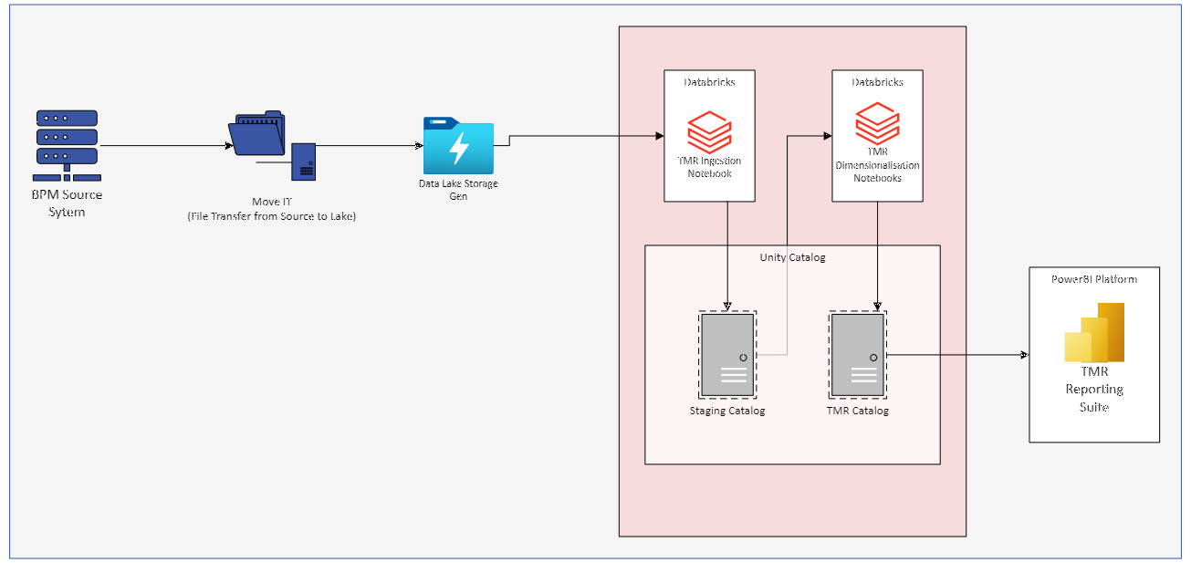
Figure 4 (High Level TMR Solution Design)

4.1.1 Design Decisions
Several key design decisions were made during the development of the solution to ensure the output met the requirements laid out at the beginning.

Choosing Databricks Lakehouse Architecture:
The decision to use the Lakehouse Architecture pioneered by Databricks was its ability to oversee both data warehousing and data lake functionalities seamlessly in conjunction with one another. This architecture supports a unified approach to data management, enabling scalable efficient data processing, storage and analytics. While also being the current best practice architecture for cloud-based solutions [15].

Data Ingestion Strategy:
A choice needed to be made on the method of data ingestion if the Data Lake needed to be used at all or if it could all be done within Databricks. However, a compromise was taken to incorporate elements of the existing cloud ingestion strategy while introducing the new elements in the form of Databricks serverless warehouses. Data would be taken from the source BPM system, and MoveIT which is a SFTP (Simple File Transfer Protocol) software would then deliver the .txt file into the raw Azure Storage Account (Data Lake) [16]. This would be integrated with the Serverless Warehouse through Unity Catalog so that the file would be queryable as if it were a table in server. This would then be used as a backup raw file, while the data was transferred to a staging Catalog within the serverless warehouse itself. Allowing the staging Catalog data to be refreshed from existing historical files if needed.

Scalable Infrastructure:
While this specific project does not have larger volumes of data enough to be considered “Big Data” by industry standards [17]. By ensuring that the system can efficiently manage larger data, the infrastructure will be in place and can be replicated for other solutions if the POC is successful. A smaller cluster was provisioned initially, but this can be edited and changed at any time. The POC allowed for initial pricing to be conducted and estimates to be established.

Integration with Existing Systems:
Databricks integrates with many of the software’s and technologies which were employed at Welsh Water at the time. Some of these include the Azure Stack, Power BI and SQL Server. While this POC was done on a separate testing network. Databricks was chosen as the platform to host this POC solution as it integrated with many of the technologies listed above. Showcasing that it will only benefit the business and provide more flexibility and efficiency in making data available in a secure governed environment. Not only to the Data Team but to the business.

Security and Governance with Unity Catalog
The existing Welsh Water architecture did not have Unity Catalog enabled. This means that all data must be stored within one central location called the Hive Metastore. While this provided row level access control and a data storage capability. None of the governance functionalities or advanced security features previously mentioned are available without Unity Catalog enabled. While the project was supposed to take place on Welsh Water systems there was pushback from Architecture on enabling Unity Catalog as they did not understand the implications of enabling this feature. So, to prove the importance of this feature and complete the project in a timely manner it was done on new provisioned testing environment within Azure, with test data based on the original data format for development purposes. The solution developed in this environment has since been used in meetings as a business case study of why it should be enabled and what the impact of the new features would have on the systems in place [18].

4.1.2 Process Overview

Requirements
The project at hand was an internal project for the Data Engineering team. While the solution in question was for an external (to the team) customer, they did not instigate the POC project. One of the KPIs for the Data Engineering team was to migrate two solutions from the On-Premises SQL Server to the Cloud. With Databricks becoming one of the industry’s leading Data and Analytics platforms it was decided that it would be used as the main infrastructure to migrate the solution.
The required DevOps tasks were created by the Data Engineering team and tickets were created on the Kanban board. The external customers were included in this session to ensure that any improvements which could be thought of or known issues which had not been resolved could be dealt with as part of the migration process.
No significant changes to the solution were identified so the requirements were established as follows:
- Identify the source location for the raw .txt file. So that an automated file drop can be created.
- Create a folder structure as per the standards within the Azure Storage Account (Data Lake)
- Create a MoveIT process to automate the feeding of the raw data into the Data Lake.
- Recreate the required Dimension and FACT tables within Unity Catalog.
- Create a set of Databricks notebooks to populate the Dimension and FACT tables.
- Create a report view collating all the data into human readable format.
- Create an automated job to run all notebooks to populate the data mart.

4.1.3 System Models
Two entity relationship diagrams [19] were created for this solution based on the different grains of the data. One being task, and one being case. It is possible to have many tasks within one case, therefore it was pertinent to have two levels of data granularity identified. However, they can easily be merged to create a holistic view of the data as per the requirements.
An entity relationship diagram is used to visualise the connections between the tables. As the Kimball Dimensional Model was used the ERDs below detail that of a star schema, and a snowflake schema. Snowflake schemas are not as efficient as star schemas however are necessary in some instances to deal with many to many relationships such as this. The bridge dimension forces a relationship to be one to one based on a set of business logic and allows the data to be displayed in a non-duplicated reportable format.
Dimensional Modelling created by Ralph Kimball aims to improve the efficiency of data retrieval. Where normalisation aims to reduce data redundancy for data ingestion, dimensional models can be considered the opposite. Data redundancy is intentionally introduced to the data model improving query performance for data retrieval. Dimension tables contain contextual information such as strings and other attributes. For optimisation purposes FACT tables should only hold integers, keys, flags and dates. This is because a JOIN on an integer or primary key is infinitely faster than on a string due to how strings are comprised. Some would argue that dates should be contained within a separate date dimension however this is left to personal preference in industry.
Figure 5 (Task Management Reporting Data Mart Entity Relationship Diagram)

4.2 Implementation

4.2.1 Coding Challenges and Solutions

Auto-Generated Integers for Dimension Surrogate Keys
One of the major coding challenges with creating a Data Mart in Databricks was the slightly different syntax of Databricks SQL, compared to SQL Server [20]. When developing a Data Mart dimension tables should have surrogate primary keys assigned to provide structural stability to the ETL. SQL Server provides an auto incrementing integer function for its table columns by adding “IDENTITY” to any column. This is not the case in Databricks, a larger command is required to assign identity to a column. My initial version of the tables used the below code snippet to generate tables.
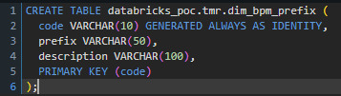
Figure 6 (Generated Always as Identity Code Snippet)
However, this created an issue when attempting to INSERT default values into the Dimensions. Dimension tables should have default values such as -1 equating unknown to remove all NULL values from final reports. But due to the command “GENERATED ALWAYS AS” no INSERTs could be made on that Code column whatsoever. So, this would not be applicable, however that would mean that a function would need to be created in the ETL to auto increment the field potentially causing a performance bottleneck.
Figure 7 (Error Inserting Value into Surrogate Primary Key Field)
Research was conducted and it was concluded that a function existed which offered the exact requirement for the dimension tables. “GENERATED BY DEFAULT” will auto-increment the column values on any new records inserted, while also allowing manual INSERTs to be made for the default values as shown in the figures below [21].

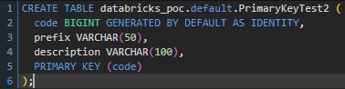
Figure 8 (Generated by Default as Identity Code Snippet)
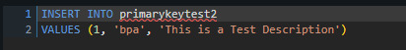
Figure 9 (INSERT INTO Statement for Dimension Tables)
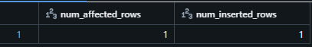
Figure 10 (Successful INSERTion of Default Values)

Error Handling Techniques Incompatible with Databricks
The existing solution created for the On-Premises system used an error dictionary and a mixture of @@ERROR and @@ROWCOUNT global server variables to efficiently manage any errors occurred while the ETL was running. These however are not available in Databricks, so a new method of error handling needed to be constructed.
Using the new functionality of being able to use multiple coding languages within the same cell, a method was devised of encasing the SQL statement containing the data manipulation code within a PySpark [22] variable. This then allowed for greater functionality within the software aspect of the code.
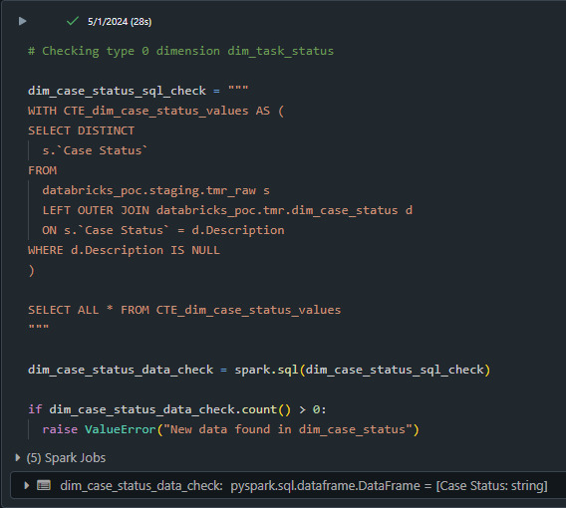
Figure 11 (Developed Method of Error Handling)
As can be seen in the figure above SQL code has been assigned to the variable ‘dim_case_status_sql_check.’ Once it is run a PySpark if statement checks if there are any new values which have been identified in the ETL and raises an error if true. A successful run of this cell would occur if no new values were identified by the SQL statement.
Type zero dimensions in the Kimball architecture should be static and unchanging. Therefore, if any new values are identified in the source data this is considered an illegal value and should be checked within the system administrator. If it is a valid value, it should be added to the dimension manually.

4.2.2 Code Snippets and Techniques

Populating Type 1 Dimensions
Type 1 Dimensions unlike type zero, allow new values [23]. Any new values identified should either be appended or replace existing values based on the primary key. The below code snippet picks out the task owner values delimited by a comma and removes any leading or trailing spaces. Testing values are removed from the dataset and finally an INSERT statement appends all data into the dimension if it does not already exist.
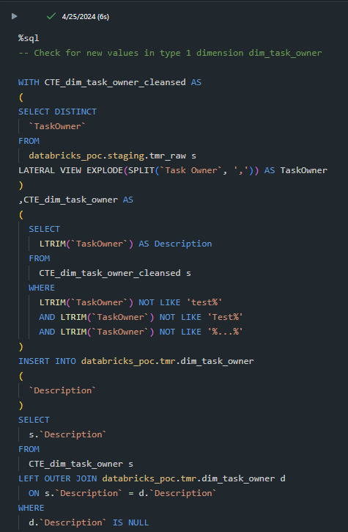
Figure 12 (Type 1 Dimension Population Script)
The LEFT OUTER JOIN in the final select statement uses a WHERE d(imension) equals NULL. This is the clause that checks if the data already exists within the table to not introduce duplicates [24].

FACT Table Population
Populating the FACT table is the final part of the ETL process. The main section of code which showcases this can be seen below. This SQL statement JOINs all dimensions onto the FACT table and INSERTs the primary key values, dates and flags. There is a small amount of preprocessing done before this statement to correctly format the dates before a final insert.
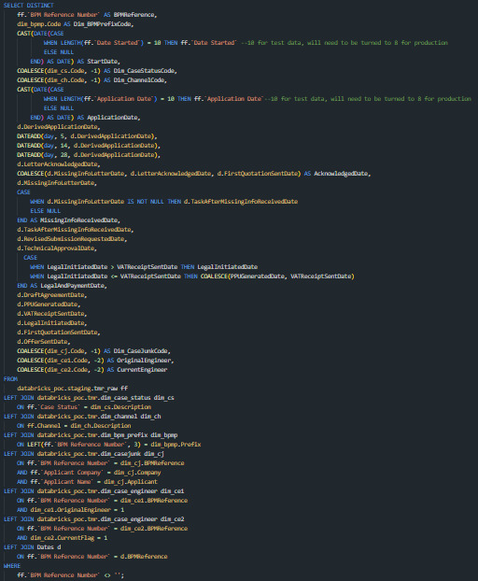
Figure 13(FACT Table Population SELECT Statement)
LEFT JOINs should always be used for the final INSERT on a FACT table so that unknown values are still present in the data. This allows for analysis to be conducted on why the JOINs failed and can potentially be resolved. The COALESCE functions prevalent within the code will change any failed primary key JOINs to -1 which is the default value unknown within the dimension tables. As per Kimballs Architecture NULLS should never be INSERTed into a FACT table.

4.2.3 Testing Strategies
Testing is a vital part of any development process and ensures code quality and reliability in a production environment. Two main strategies were used in the development of this solution, unit testing and end-to-end testing.

Unit Testing
Unit testing is the process of verifying the functionality of individual code units. Within Databricks notebooks code is split via cells. Each cell can be run in isolation to ensure it performs as expected. When treating each cell individually, the data aggregations and transformations can be validated at every step of the process [25].
Each cell was evaluated for a successful run, or alternatively in the case where an error was expected and oversaw, a failure run was also evaluated to ensure that all eventualities were covered.
Test ID | Test Description | Expected Outcome | Actual Outcome | Status
1 | Import necessary Python libraries | Libraries imported successfully | Libraries imported successfully | Passed
2 | SQL query to check new data in `dim_case_status` | No new data found in `dim_case_status` | No new data found in `dim_case_status` | Passed
3 | SQL query to check new data in `dim_channel` | No new data found in `dim_channel` | No new data found in `dim_channel` | Passed
4.1 | Delete records from `dim_case_engineer` where `Code > 0` | Records deleted successfully | Records deleted successfully | Passed
4.2 | Create or replace temporary view `ProjectEngineer` | View created successfully | View created successfully | Passed
4.3 | Create or replace temporary view `ProjectEngineerOriginalRecords` | View created successfully | View created successfully | Passed
4.4 | Create or replace temporary view `ProjectEngineerUpdated` | View created successfully | View created successfully | Passed
4.5 | Insert into `dim_case_engineer` from `ProjectEngineerUpdated` | Records inserted successfully | Records inserted successfully | Passed
Figure 14 (TMR Populate Case Dimension)

End-to-End Testing
End-to-End testing validates the entire data processing pipeline from ingestion to output. A Databricks Job was created to automate the execution of all notebooks in order. This ensures that data smoothly flows through each stage of the ETL process [26].
The GUI (Graphical User Interface) below shows several complete ETL runs [27]. This details how the job was triggered, the progress at each step and the allotted time taken to run. The two runs shown below have a slight disparity in the time taken to run. This is due to the cluster needing to be enabled the first run took over double the time to run. If the cluster is already enabled the average run time is around 2 minutes for the entire process to run for a thousand rows of data [28]. This time should not significantly increase by adding more rows as the SQL code runs on batches of data.
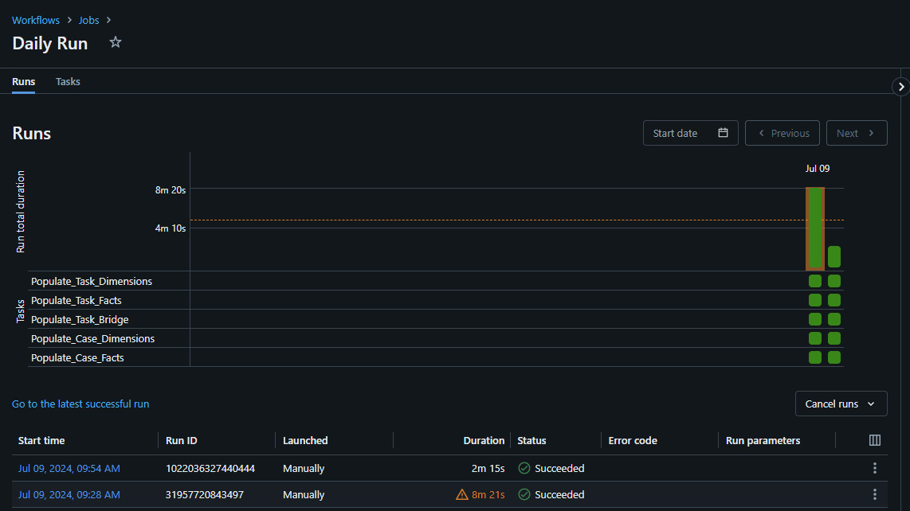
Figure 15 (End-to-End Process Run)
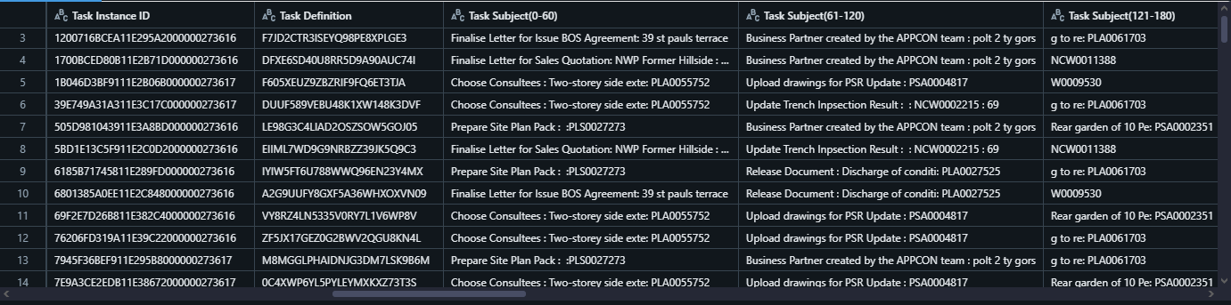
Figure 16 (Table of Raw Data Before any Processing Takes Place)
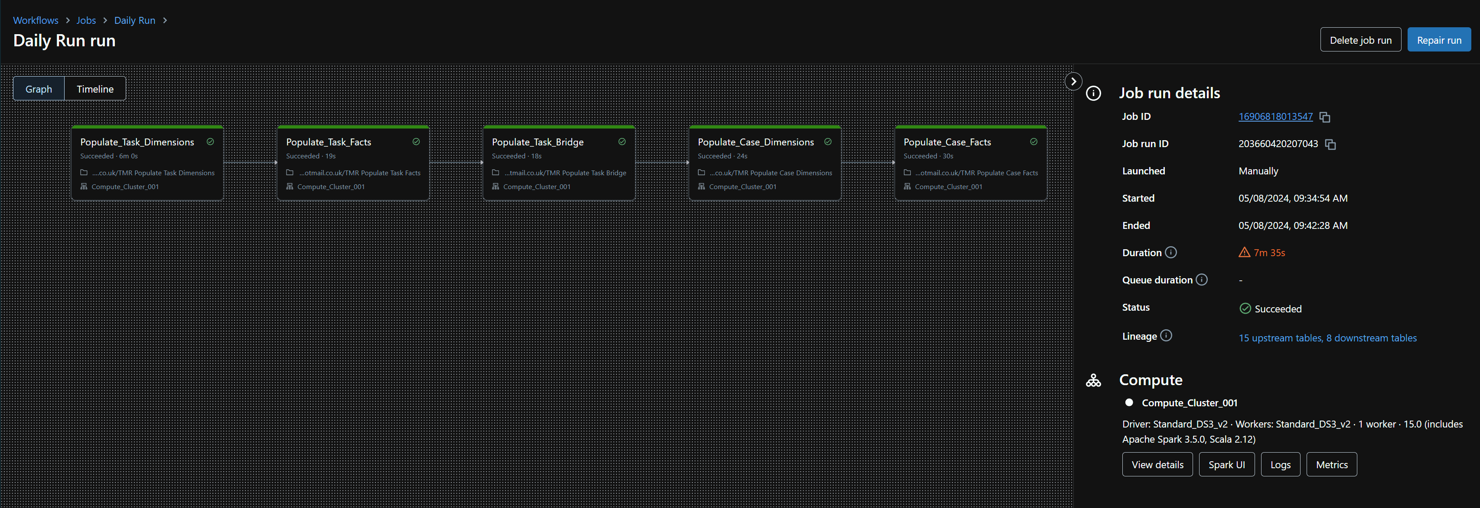
Figure 17 (Full Notebook Flow for End-to-End Process)
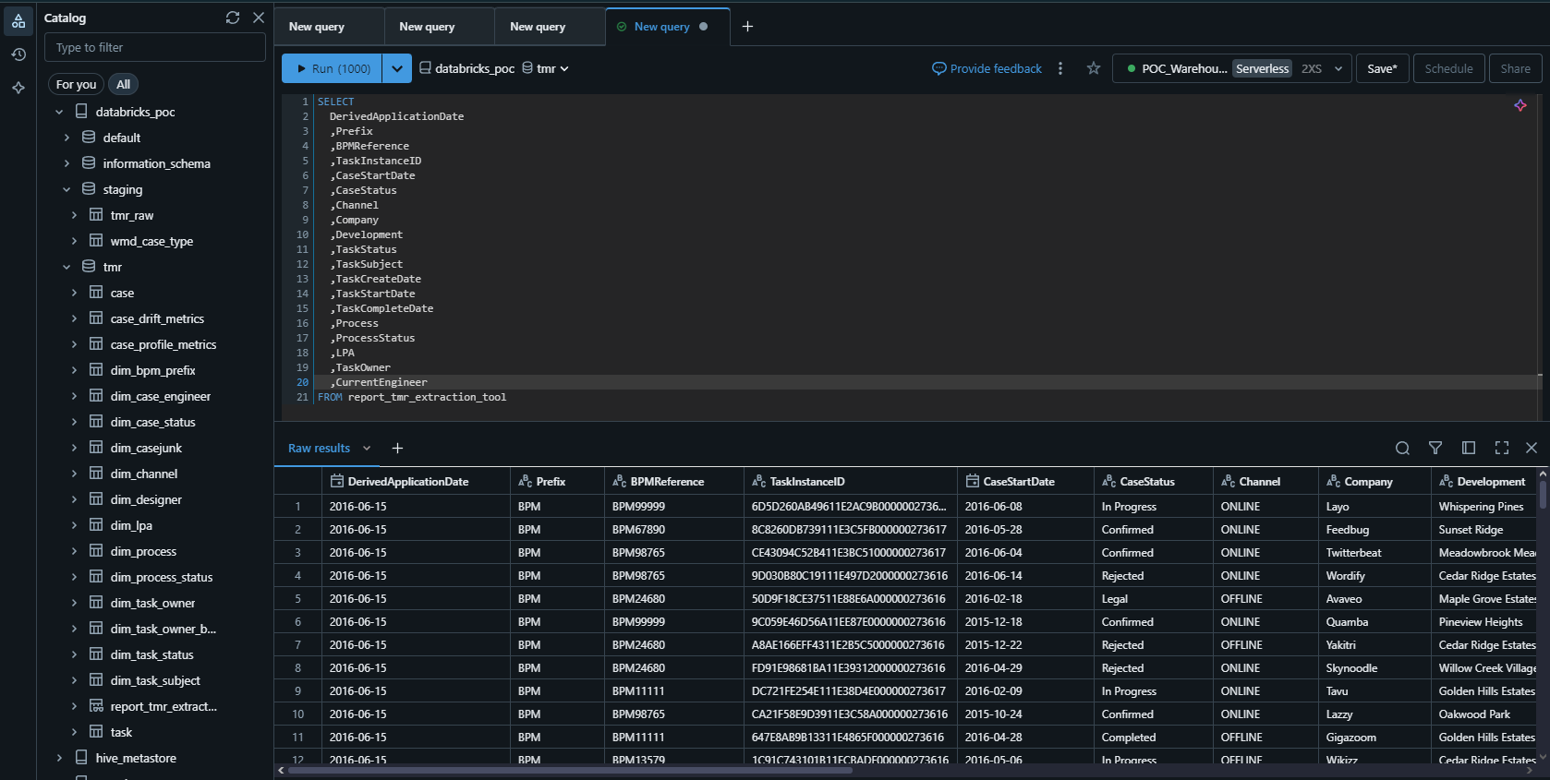
Figure 18 (Completed View of Data Mart Extraction Tool Ready for Reporting)

Chapter 5: Evaluation
Evaluation of the project is a crucial step ensuring that the outcome meets intended goals and provides actionable insights for improvements. Comparing the outcome with the objectives, detailing the insights gained from completing the development and analysing any data collected aids in improving processes going forward.

5.1 Data Analysis
Compiling the quantitative outputs of the notebook and job runs helps evaluate the efficiency and effectiveness of the new solution. Providing an accurate comparison with the existing system.

Efficiency Comparison
The complete Job run between to two systems had over a 70% reduction in runtime. The existing solution would on average take around 54 minutes to complete. The new system on an average run with an enabled cluster takes around 2 minutes to run for one thousand rows of data. To estimate the time required to process a larger dataset with the new system, the linear scalability and parallel processing capabilities of Databricks were considered. The average new rows to process each day is around 32,000.
To estimate the time for processing 32,000 without parallelism is as follows:
$$\frac{2 Minutes}{1000 Rows}=0.002 Minutes Per Row$$
$$32, 000 Rows*0.002 Minutes=64 Minutes$$
However, Databricks offers parallelism by distributing workloads across multiple workers in a cluster. A standard configuration for a cluster has between 2 and 8 workers, assuming eight workers are used for this instance the workload can be perfectly parallelized:
$$\frac{64 Minutes}{8 Workers}=8 Minutes$$
The above calculations assume that the data processing tasks are distributed evenly across all workers and there is no significant overhead form data shuffling or task coordination. There are three potential risks which will cause variation in runtime:
- Overhead of distributing tasks and collecting results
- Potential bottlenecks in data shuffling and network communication
- Resource contention and availability of compute resources
In summary by leveraging the distributed computing nature of Databricks infrastructure over a 70%-time saving can be made in data processing.

Cost
The benefits of scalable and pay-as-you-go models such as Databricks have a significant cost advantage compared to on-premises systems [29]. While on-premises systems have an initial set-up cost as well as the general running and maintenance costs. Scalable virtual infrastructure such as Databricks clusters do not have any initial costs or maintenance costs as the platform provider maintains it. There is simply the cost of the cluster to run when it is turned on. This is measured by Databricks units and estimates can then be made based on running times.
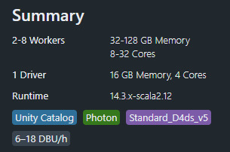
Figure 19 (Standard Databricks Cluster Configuration)
With the new system taking around 8 minutes to process the daily average rows, we know that at the current moment in time a single Databricks Unit or DBU stands at around £0.22 per hour. A crude equation can be used to estimate how much it would cost to process this data daily depending on the number of workers used.
Lower limit (6 Databricks Units – 2 Workers)
$$Cost = Price per unit per hour × Time in hours × Number of Units$$
$$Cost=£0.22 ×0.1667 ×6$$
$$Cost=£0.22 ×1.0002$$
$$Cost=£0.22$$

Upper Limit (18 Databricks Units – 8 Workers)
$$Cost = Price per unit per hour × Time in hours × Number of Units$$
$$Cost=£0.22 ×0.1667 ×18$$
$$Cost=£0.22 ×3.0006$$
$$Cost=£0.66$$

The cost to process the data daily using the DBU rate of £0.22 per hour with a usage range of 6-18 would be between £0.22 and £0.66 daily. The on-premises system had an average running cost of around £88 a month, which equates to around £3 a day. Again, showing a 70% cost saving alongside the time efficiency. These findings confirm that the project successfully met its data processing efficiency and cost saving objectives.

5.2 Comparison with Objectives

5.2.1 Objective 1: Evaluate Data Management Practices in Water Network Development

Findings
The project evaluated the current data management practices within water network development. Certain inefficiencies were discovered such as prolonged data processing times, and excessive costs associated with maintaining and on-premises infrastructure. This analysis provided a clear foundation for improvements in an updated cloud solution.

Comparison
The objective was fully met, with the evaluation highlighting significant improvements informing the modern design and implementation on a new platform. The analysis of the existing systems shortcomings provided a clear justification for the migration and objectives to complete to improve.

5.2.2 Objective 2: Design and Implement a Prototype Lakehouse Architecture Using Databricks and Azure Datalake

Findings
The project successfully designed and implemented a prototype Lakehouse Architecture. This new system leverages the strengths of Databricks and Azure Datalake showcasing what a unified data storage, management and analytics platform could look like in the cloud. The prototype included the use of Unity Catalog, for Data Governance, Databricks Notebooks for processing and Spark Clusters for scalable infrastructure that significantly reduced the data processing times.

Comparison
This second objective was fully achieved. The cloud-based solution demonstrated the benefits of the migration including improved data processing efficiency, enhanced Data Governance and significant cost savings. The prototype provided a practical demonstration of how these technologies can be integrated with Welsh Waters existing Architecture using a proof-of-concept migration from an actual existing solution.

5.2.3 Objective 3: Conduct an Analysis of Processing Times, Scalability, and Cost Efficiency Between On-Premises Data Warehouse Technologies and Cloud-Based Solutions

Findings
As part of the project a thorough analysis comparing the On-Premises solution with the prototype needed to be conducted to understand if the project was a success. The new system reduced data processing times from an average of fifty-four minutes to around eight minutes based on predicted distributed computing estimates. The cost analysis also showed a rough savings of near seventy percent with the older system costing near three pounds a day and the new system costing between twenty-two to sixty-six pence a day. Additionally, the scalability of Databricks allows for efficient handling of increasing volumes of data with no performance degradation.

Comparison
This final objective was comprehensively met. The analysis conducted provided straightforward evidence of the advantages the cloud-based solution has over the traditional on-premises system in both cost, and processing efficiency. The findings clearly support the decision to adopt Databricks and Lakehouse Architecture for an enterprise-wide data platform.

5.3 Insights and Findings
Several key insights and findings were derived through the course of the project providing valuable lessons and improvements which can be made in future work.

5.3.1 Unity Catalogs Importance in Data Governance
Unity Catalog played an invaluable role in the project creating an emphasis on the importance of robust Data Governance within data management. Unity Catalog facilitates centralised access control, auditing, lineage, and data discovery, ensuring that data was securely managed.

Benefits:
- Centralised Data Management: Unity Catalog provided a unified interface for managing access permissions, ensuring that only authorised users can access data.
- Enhanced Data Security: Enabling detailed auditing and data usage tracking helps to maintain compliance with regulatory requirements and internal access and data retention policies.

- Improved Data Discovery: Unity Catalogs metadata management capabilities allow users to easily discover and understand available datasets in the same way a maintained data dictionary would. Promoting data understanding and dissolving silos and duplicated data storage [30].

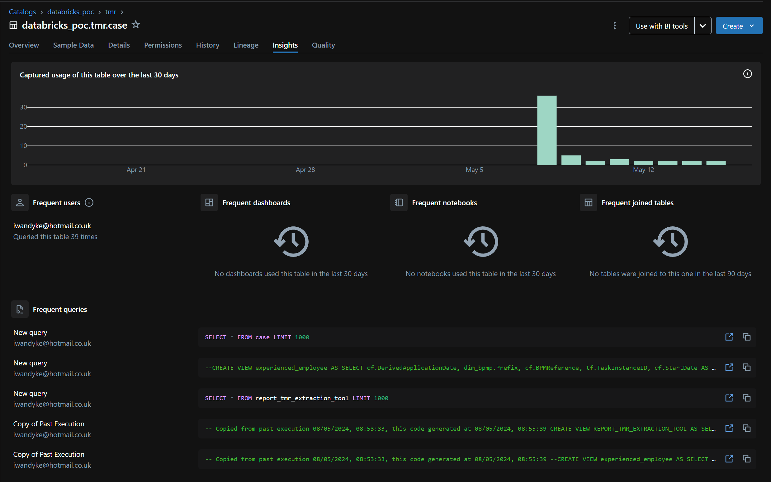
Figure 20 (Unity Catalog Data Quality Insights Page)
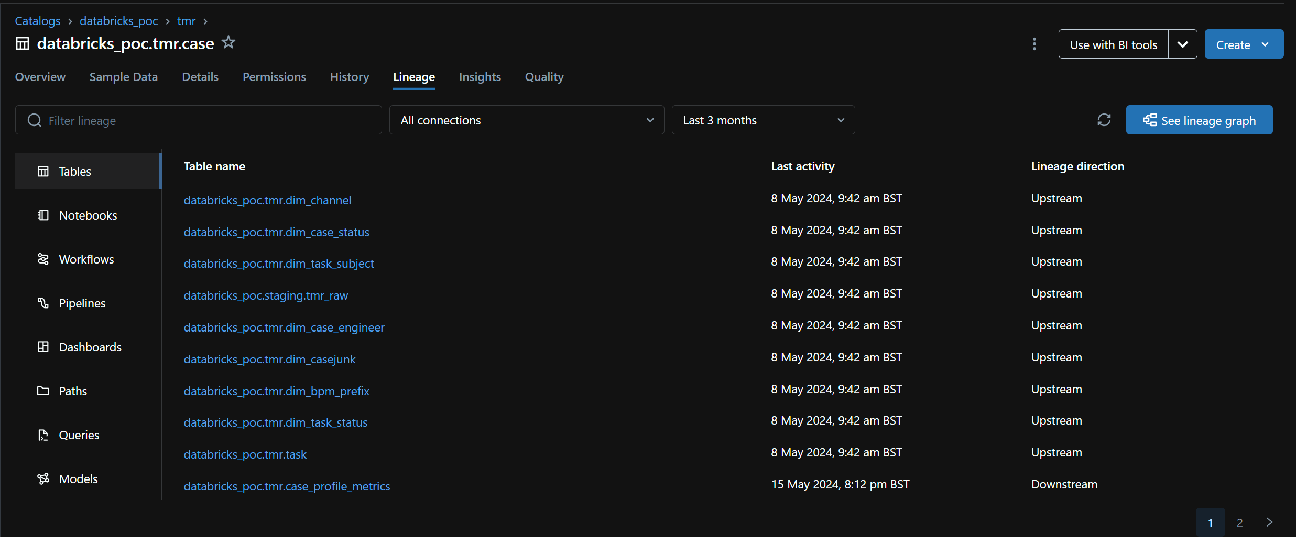
Figure 21 (Unity Catalog Lineage Page Detailing Upstream and Downstream Objects)
This project has been a useful proof of concept showing how leveraging Unity Catalog provides a myriad of benefits which should be used by the business when considering an enterprise-wide data storage solution.

5.3.2 The Flexibility of Databricks Notebooks
One of the standout features of Databricks Notebooks is the flexibility of operating with multiple programming languages within a single environment. This capability streamlined the development process while also allowing for improved software development functionalities to be implemented in code.

Benefits:
- Multi Language Support: With users being able to develop in SQL, Python, R and Scala in the same notebook. It facilitates seamless integration of different tools and libraries. In this project SQL was used for the data manipulation code while PySpark was implemented for more software development functionalities.

- Efficient Workflow: The ability to use multiple languages in one environment reduces the need to switch between different tools, reducing context switching errors.

- Improved Collaboration: Team members with different programming skills can easily collaborate within the same notebook, for example Data Engineers writing SQL and Data Scientists writing PySpark.

5.3.3 The Lakehouse Architecture and Data Integration
The Lakehouse Architecture demonstrated significant technological advantages of using cloud-based platforms for an enterprise-wide data storage solution with its ability to easily ingest data from multiple sources [31].

Benefits:
- Unified Data Platform: The Lakehouse Architecture seamlessly integrates data from disparate sources, including structured, semi-structured and unstructured data onto a single platform [32]. Promoting master data management and a centralised data repository.

- Simplified ETL Process: The new architecture supports efficient ETL/ELT processes enabling seamless data ingestion, transformation and storage within the platform. With the cloud platform being supported and constantly updated technologies such as Delta Live Tables which facilitate constant live streaming data in a real time format it provides functionality for multiple requirements and data solution flexibility.
- Scalable and Flexible: The systems scalability can manage increasing data volumes and code complexity without compromising performance based on the distributed nature of the Databricks platform.
The future of data management sits on cloud platforms and the Lakehouse Architecture should be used for future data solutions The ability to integrate a diverse variety of data sources, simplify the ETL process to a single pipeline and provide a scalable flexible data platform are all vital components in the modern data landscape.

5.3.4 Advantages of Cloud Over On-Premises Systems
Migrating to a cloud-based solution provided several advantages over traditional On-Premises systems with enhanced performance, scalability and cost efficiency.

Benefits
- Scalability: Cloud infrastructure allows for easy scaling of resources up or down based on demand, ensuring optimal cost and performance efficiency.

- Cost Savings: The pay-as-you-go pricing model eliminates the need for an upfront investment in hardware and reduced ongoing maintenance costs.
- Accessibility and Collaboration: Cloud-based solutions facilitated remote access and enables team members to work from anywhere and share resources seamlessly.
The future of Data Engineering is all projects hosted on the cloud-platform to benefit from the rapidly expanding data centric industry focus [33].
The insights derived from this project highlight the significant benefits of using Databricks and the Lakehouse architecture. Providing a successful proof of concept while also leaving room for improvement to consider data-vaulting or medallion architecture. Ensuring continued robust Data Governance and a platform ready to oversee an enterprise level of data.

Chapter 6: Conclusions and Recommendations

6.1 Summary of Work
The project aimed to explore the feasibility and benefits of transitioning to a cloud-based data platform using Databricks and the Azure Datalake. This project was driven by a key performance indicator of the Data Engineering team in Welsh Water to migrate at least one solution from its on-premises infrastructure to the cloud. As part of the proof of concept a comparison between the two solutions to understand if the potential benefits are substantial.
Key objectives included evaluating the current data management practices, designing and implementing a prototype Lakehouse Architecture, analysing the performance and scalability and comparing that to the existing SQL Server solution. This project took place over multiple stages such as requirements gathering, system design, development, testing and evaluation.
The new system demonstrated significant improvements in data processing efficiency, cost savings and overall system performance. Facets such as Unity Catalog for Data Governance, Databricks Notebooks for flexibility in programming and the advantages of having an integrated Data Lake for access to different data sources and formats ensured the project successfully met its objectives. Providing a robust, efficient and scalable data processing solution.

6.2 Conclusions
Based on the findings and outcomes of the project several key conclusions can be drawn:
- Enhanced Data Governance: Unity Catalog provided a pivotal functionality for robust Data Governance, providing centralised access control, auditing, and data lineage capabilities. This enhanced data security and compliance, ensuring that data was managed in a securely with efficient practices.
- Scalable and Integrated Data Management: The Lakehouse Architecture proved to be highly effective in integrating data from any source, simplifying the ETL process, and providing a scalable platform capable of handling large datasets with no performance degradation.
- Cost and Performance Benefits of Cloud Migration: Migrating to a cloud-based solution provided significant advantages over traditional on-premises systems, including reduced data processing times, and substantial daily cost savings. The cloud infrastructures pay as you go pricing model ensures optimal resource utilisation and cost-efficiency.

6.3 Recommendations for Future Work
There are two significant recommendations for future work. The first is to implement data quality checks using Unity Catalog insights page. This feature can help identify and address data issues in real-time, ensuring continuous reliability and accuracy of the data. When reducing the need for manual interventions, overall data quality and consistency will improve, making the system more robust and dependable.
Another important recommendation is to enhance the integration and use of real-time data processing capabilities. By incorporating real-time data streaming and processing features potentially with Databricks new feature DLTs (Delta-Live Tables). The system will actively check the source table and the destination table and any time a delta (change) is identified then the ETL pipeline would run ensuring the most up to date data is processed and available for reporting.

Chapter 7: Reflection

7.1 Personal Development
This project has been a significant journey in personal and professional development. It had countless opportunities for me to enhance my technical skills, gain a fuller understanding of the Azure and Databricks platforms and develop my project management skills.

7.1.1 Technical Skills
One of the biggest improvements as part of this project was my technical skills particularly using Databricks and the Lakehouse architecture. Due to the constraints of development environment I also vastly improved my knowledge of cloud-based infrastructure architecture.
Databricks as a platform is vastly different to SQL Server which was the standard method of Data Storage in the team at the time. Databricks works off a file-based structure storing different versions of the tables as historical files which can be reverted. This has its own drawbacks and advantages of which considerable research needed to be conducted.
Databricks also uses its own specific dialect of SQL which caused certain issues while developing [34]. Research had to be conducted utilising Databricks inbuilt generative AI ‘Databricks Assistant’ and manual research of the Databricks documentation.
I was also able to develop my solution architecture skills. Producing complete process flow diagrams for the states of the data and what technologies will be used. Detailing the source system, which file transfer systems will be used and what storage technologies should be used.
Figure 22 (TMR Cloud Migration Solution Architecture Diagram)

7.1.2 Project Management Skills
Managing the project from inception to completion doing both the BA (Business Analyst) work and the development work provided a holistic view of the project. By continuously practicing project management I was able to improve my time management skills, prioritisation and ensuring delivery of milestones while maintaining realistic expectations from stakeholders [35].

7.1.3 Critical Thinking Skills
Due to my lack of experience with the cloud platforms prior to undertaking this project, there were quite a few challenges which required significant research and critical thinking skills. Understanding the cloud infrastructure enough to correctly request cores from Azure to set up a spark cluster. Why that is necessary and how this affects cluster management was all added information needed to be learned for this project, which will assist me when managing Databricks Platforms in job roles in the future.
How data management practices and Kimball data modelling architecture translates from SQL Server to Databricks infrastructure was also a significant pain point in development. Critical thinking skills were developed here by mapping out potential different techniques for generating surrogate primary keys for dimensions. I continued to develop a resilient and adaptable approach to potential challenges.

7.2 Lessons Learned

7.2.1 Importance of Clear Requirements
After working on many projects with loose requirements I found that being able to project manage myself with clear cut defined requirements vastly improved the development process and the sprint planning times. Having unchanging agreed upon objectives and requirements allowed for an on-time development schedule. Improved enthusiasm to complete work and limited the potential for burnout.

7.2.2 Effective use of Tools and Technologies
Researching and choosing the correct software to meet requirements thoroughly aided in meeting the project objectives. Lakehouse architecture has been in development and has only recently started being adopted by different organisations over the past few years.
With Databricks being the patented owners of the Lakehouse idea, it was inevitable that a proof of concept should be conducted on their platform opposed to Azure Synapse or other competitors. As per the solution design multiple integrated technologies were listed as these were adopted and supported within the Welsh Water infrastructure.
With Databricks being a recent technology to myself there were aspects which could be changed in the solution to improve its usage. One of the main changes being a medallion architecture which could have been used.
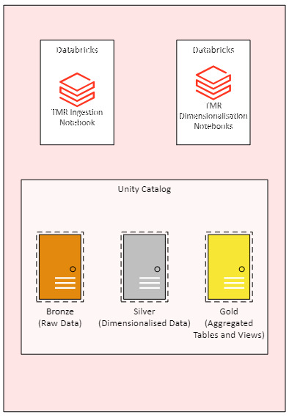
Figure 23 (Potential Medallion Architecture)
A medallion architecture is the process of pushing data through distinct stages called bronze, silver and gold [36]. Bronze data is raw untouched and imported into the Databricks environment. Silver is a de-duplicated dimensionalised model of the data which can be used for data extracts in a near to raw format. With gold being aggregated tables and views made specifically for reporting purposes with business logic included.

7.2.3 Scalability and Performance
As previously stated, while there was not a large volume of data involved in this project there is a considerable amount of pre-processing required for dates and therefore takes time to run. One of the main aspects of this project was improved efficiency. While almost a 70%-time saving has been estimated to be achieved there is potential for maintenance tasks to be created which not only maintains this on each ETL but also with the constantly expanding dataset.

Optimise Task
Databricks offers an optimise function on persisted managed tables within Unity Catalog. As table data is kept within versioned files, there is potential for a form of fragmentation like that which can occur on SQL Server tables. Tables in Databricks are indexed automatically up to thirty-two rows. An when data is deleted, or columns are added or subtracted fragmentation can occur slowing the query performance on that dataset. Optimise, removes the spaces which have been created from fragmentation and orders things so the query engine can return data more efficiently [37].
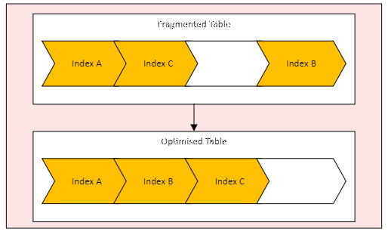
Figure 24 (Databricks Managed Table Optimisation Example)

Chapter 8: References
[1] | M. Cherradi, “Data Lakehouse: Next Generation Information System,” 2024.
[2] | V. R. R. Bussu, “Databricks- Data Intelligence Platform for Advanced Data Architecture,” 2024.
[3] | Y. K. C, “Review of Cloud Migration Strategies: Exploring Advantages, Challenges and Cost Analysis,” 2024.
[4] | M. B. Vivekanandam, “Implementation of a Security System in IaaS Cloud Server through an Encrypted Blockchain,” Journal of Soft Computing Paradigm, 2022.
[5] | T. L. Pierangelo Rosati, “Measuring the Business Value of Infrastructure Migration to the Cloud,” 2020.
[6] | M. S. G. M. E. K. P. G. I. V. Nick Bassiliades, “A semantic recommendation algorithm for the PaaSport platform-as-a-service marketplace,” Expert Systems With Applications, 2017.
[7] | Y. C. B. F. Wenhao Ruan, “On Development of Data Science and Machine Learning Applications in Databricks,” 2019.
[8] | N. Muppa, “Informatica Intellegent Cloud Services Code Deployment with Azure DevOps,” 2022.
[9] | M. R. Ralph Kimball, The Data Warehouse Toolkit: The Definitive Guide to Dimensional Modeling, 2013.
[10] | “Performance of NoSQL Graph Implementations of Star vs. Snowflake Schemas,” 2022.
[11] | I.-Y. S. Mary Elizabeth Jones, “Dimensional modeling: identifying, classifying & applying patterns,” 2005.
[12] | N. P. Mimansha Patel, “Exploring Research Methodology: Review Article,” International Journal of Research, 2019.
[13] | A. S. L. M. L. A. M. Z. Crismerlyn Pereira, “How developers feel about tools: an investigation on software startup professionals experience with virtual kanban boards,” 2022.
[14] | L. X. W. S. L. Q. C. W. -. S. l. Zhou Daliang, “ETL (extraction-transformation-loading) process execution system and ETL process execution method”. 02 July 2014.
[15] | Д. Волков, “LakeHouse,” Otkrytye sistemy, 2023.
[16] | N. S. F. S. K. P. inesh Kalla, “Hybrid Scalable Researcher Recommendation System Using Azure Data Lake Analytics,” Journal of data analysis and information processing, 2024.
[17] | L. D. Biasotto, “Big Data,” International Journal For Science Technology And Engineering, 2022.
[18] | d.-p.-b. i. j. m. P. l. a. mssaperla, “What is Unity Catalog?,” Microsoft, 07 03 2024. [Online]. Available: https://learn.microsoft.com/en-us/azure/databricks/data-governance/unity-catalog/. [Accessed 2024].
[19] | S. S. P. G. T. H. Kashmira, “Generating Entity Relationship Diagram from Requirement Specification based on NLP,” 2018.
[20] | R. Zolfaghari, “SQL Server Versions in Distribution, Parallelism and Big Data,” International Journal of Computer Applications, 2016.
[21] | d.-p.-b. i. j. m. mssaperla, “Delta Lake generated columns,” Microsoft, 18 04 2024. [Online]. Available: https://learn.microsoft.com/en-us/azure/databricks/delta/generated-columns. [Accessed 2024].
[22] | K. R. C. G. K. S. K. S. N. I. M. K. S. N. T. Chandra, “Predictive Meteorology with PySpark: Analyzing and Forecasting Weather Data,” 2023.
[23] | R. Kimball, “Type 1: Overwrite,” Kimball Group, [Online]. Available: https://www.kimballgroup.com/data-warehouse-business-intelligence-resources/kimball-techniques/dimensional-modeling-techniques/type-1/. [Accessed 2024].
[24] | A. A. Farshad Delavarpour, “An Algorithm for Optimizing Small-Large Outer Join in Cloud Computing Environment,” 2021.
[25] | M.-Á. S. U. I. A. C. P. D. P. Elena García Barriocanal, “An experience in integrating automated unit testing practices in an introductory programming course,” 2002.
[26] | K. R. K. R. R. Manukonda, “Leveraging Robotic Process Automation (RPA) for End-To-End Testing in Agile and Devops Environments: A Comparative Study,” Design of Single Chip Microcomputer Control System for Stepping Motor, 2023.
[27] | M. K. Tom Fellmann, “A command line interface versus a graphical user interface in coding VR systems,” 2007.
[28] | M. Z. C. L. Q. D. Y. L. L. -. S. l. SenXing Lu, “Time-Aware Data Partition Optimization and Heterogeneous Task Scheduling Strategies in Spark Clusters,” The Computer Journal, 2023.
[29] | M. M. S. P. R. S. R. S. S. -. S. l. Dheeraj Chahal, “Pay-as-you-Train: Efficient ways of Serverless Training,” 2022.
[30] | G. Weikum, “Data Discovery,” Data Science Journal, 2021.
[31] | J. H. J. O. Dipankar Mazumdar, “The Data Lakehouse: Data Warehousing and More,” arXiv.org, 2023.
[32] | S. A. Byrapu Reddy, “Unified Data Analytics Platform For Financial Sector Using Big Data,” 2023.
[33] | Y. W. H. Y. Z. X. Han Tao, “Engineering project management cloud platform system based on Internet”. 30 November 2016.
[34] | d.-p.-b. i. j. m. a. l. P. mssaperla, “SQL language reference,” Microsoft, 07 01 2024. [Online]. Available: https://learn.microsoft.com/en-us/azure/databricks/sql/language-manual/. [Accessed 2024].
[35] | R. Y. Sunindijo, “Project manager skills for improving project performance,” International Journal of Business Performance Management, 2015.
[36] | d.-p.-b. i. m. j. mssaperla, “What is the medallion lakehouse architecture?,” Microsoft, 01 03 2024. [Online]. [Accessed 2024].
[37] | d.-p.-b. i. m. j. l. a. mssaperla, “OPTIMIZE,” Microsoft, 11 06 2024. [Online]. Available: https://learn.microsoft.com/en-us/azure/databricks/sql/language-manual/delta-optimize. [Accessed 2024].

Chapter 9: Bibliography
J. Cahoon, W. Wang, Y. Zhu, K. X. Lin, S. Liu, R. Truong, N. Singh, C. Wan, A. Ciortea, S. Narasimhan, and S. Krishnan, "Doppler: Automated SKU Recommendation in Migrating SQL Workloads to the Cloud," *Proc. VLDB Endowment*, vol. 15, no. 9, pp. 2009-2022, Aug. 2022.
A. C. M. de Paula, "Evidence from the Literature on Database Migration to the Cloud," first ed, Jan. 2018.
M. Ansar, "Data Migration in Cloud: A Systematic Review," *American Scientific Research Journal for Engineering, Technology, and Sciences*, Oct. 2018.
P. Antonopoulos, A. Budovski, C. Diaconu, A. H. Saenz, J. Hu, H. Kodavalla, D. Kossmann, S. Lingam, U. F. Minhas, N. Prakash, V. Purohit, H. Qu, C. S. Ravella, K. Reisteter, S. Shrotri, D. Tang, and V. Wakade, "Socrates: The New SQL Server in the Cloud," Jun. 2019.
Á. Hajnal, E. Nagy, P. Kacsuk, and I. Márton, "Data Migration for Large Scientific Datasets in Cloud", Aug. 2018.
R. Senapati and D. A. Kumar, "A Survey on Data Warehouse Architecture," *International Journal of Innovative Research in Computer and Communication Engineering*, Jan. 2014.

Chapter 10: Appendix

10.1 Source Code

10.1.1 TMR Populate Case Dimensions
# Databricks notebook source
# MAGIC %md
# MAGIC ## TMR Populate Case Dimensions
# MAGIC <p><b>Description: </b>This notebook aims to populate all Case dimensions needed for the TMR reports A.K.A Developer Services.</p>
# MAGIC <b>Parent Process: </b>PL_FactPrism
# MAGIC <table class="table table-striped table-hover">
# MAGIC <thead>
# MAGIC <tr>
# MAGIC <th>Contributor</th>
# MAGIC <th>Date</th>
# MAGIC <th>Version</th>
# MAGIC <th>Comment</th>
# MAGIC <th>WorkItem No</th>
# MAGIC </tr>
# MAGIC </thead>
# MAGIC <tbody>
# MAGIC <tr>
# MAGIC <td>Iwan Dyke</td>
# MAGIC <td>18/04/2024</td>
# MAGIC <td>1.0</td>
# MAGIC <td>Create initial release</td>
# MAGIC <td></td>
# MAGIC </tr>
# MAGIC </tbody>
# MAGIC </table>

# COMMAND ----------

# MAGIC %md
# MAGIC ## Import Python Libraries

# COMMAND ----------

from pyspark.sql.types import *
from pyspark.sql.functions import *
from pyspark.sql.window import Window
import pandas as pd
import numpy as np
import os # Joining filenames.
import datetime as dt # Adding today's date to exports.
from datetime import datetime
import glob

# COMMAND ----------

# MAGIC %md
# MAGIC ## Populating Type 0 Task Dimensions

# COMMAND ----------

# Checking type 0 dimension dim_task_status

dim_case_status_sql_check = """
WITH CTE_dim_case_status_values AS (
SELECT DISTINCT
s.`Case Status`
FROM
databricks_poc.staging.tmr_raw s
LEFT OUTER JOIN databricks_poc.tmr.dim_case_status d
ON s.`Case Status` = d.Description
WHERE d.Description IS NULL
)

SELECT ALL * FROM CTE_dim_case_status_values
"""

dim_case_status_data_check = spark.sql(dim_case_status_sql_check)

if dim_case_status_data_check.count() > 0:
raise ValueError("New data found in dim_case_status")

# COMMAND ----------

# Checking type 0 dimension dim_lpa

dim_channel_sql_check = """
WITH CTE_dim_channel_values AS (
SELECT DISTINCT
s.`Channel`
FROM
databricks_poc.staging.tmr_raw s
LEFT OUTER JOIN databricks_poc.tmr.dim_channel d
ON s.`channel` = d.`Description`
WHERE d.Description IS NULL
)

SELECT ALL * FROM CTE_dim_channel_values
WHERE channel IS NOT NULL
"""

dim_channel_data_check = spark.sql(dim_channel_sql_check)

if dim_channel_data_check.count() > 0:
raise ValueError("New data found in dim_channel")

# COMMAND ----------

# MAGIC %md
# MAGIC ## Populating Type 2 Task Dimensions

# COMMAND ----------

# MAGIC %sql
# MAGIC -- Delete records from Dim_CaseEngineer
# MAGIC DELETE FROM databricks_poc.tmr.dim_case_engineer
# MAGIC WHERE Code > 0;
# MAGIC
# MAGIC -- Capture all technical assessments
# MAGIC CREATE OR REPLACE TEMPORARY VIEW ProjectEngineer AS
# MAGIC (
# MAGIC SELECT
# MAGIC `BPM Reference Number` AS BPMReference,
# MAGIC `Task Instance ID` AS TaskInstanceID,
# MAGIC CAST(`Date Started` AS DATE) AS CaseStartDate,
# MAGIC 0 AS OriginalEngineer,
# MAGIC CAST(`Date Task Created` AS DATE) AS OpenDate,
# MAGIC CAST(NULL AS DATE) AS CloseDate,
# MAGIC CASE
# MAGIC WHEN LENGTH(`Task Owner`) = 0 THEN 'Unassigned'
# MAGIC ELSE `Task Owner`
# MAGIC END AS TaskOwner,
# MAGIC ROW_NUMBER() OVER (PARTITION BY `BPM Reference Number` ORDER BY `Date Task Created`, `Task Instance ID`) AS Ordering
# MAGIC FROM databricks_poc.staging.tmr_raw s
# MAGIC WHERE --`Task Subject(0-60)` LIKE 'Technical assessment%'
# MAGIC `Task Owner` NOT LIKE 'Test%'
# MAGIC AND LENGTH(`Task Owner`) > 0
# MAGIC );
# MAGIC
# MAGIC -- Derive CloseDate for original records
# MAGIC CREATE OR REPLACE TEMPORARY VIEW ProjectEngineerOriginalRecords AS
# MAGIC (
# MAGIC SELECT
# MAGIC o1.BPMReference,
# MAGIC o1.TaskInstanceID,
# MAGIC o1.CaseStartDate,
# MAGIC CASE
# MAGIC WHEN o1.Ordering = 1 THEN 1
# MAGIC ELSE o1.OriginalEngineer
# MAGIC END AS OriginalEngineer,
# MAGIC o1.OpenDate,
# MAGIC o2.OpenDate AS CloseDate,
# MAGIC o1.TaskOwner,
# MAGIC o1.Ordering
# MAGIC FROM
# MAGIC ProjectEngineer o1
# MAGIC JOIN ProjectEngineer o2
# MAGIC ON o1.BPMReference = o2.BPMReference
# MAGIC AND o1.Ordering = o2.Ordering - 1
# MAGIC );
# MAGIC
# MAGIC -- Create temporary view for updated CloseDate (in ProjectEngineer) from original records
# MAGIC CREATE OR REPLACE TEMPORARY VIEW ProjectEngineerUpdated AS
# MAGIC (
# MAGIC SELECT
# MAGIC o.`BPMReference`,
# MAGIC o.`TaskInstanceID`,
# MAGIC o.`CaseStartDate`,
# MAGIC CASE
# MAGIC WHEN c.`OpenDate` = c.`CloseDate` THEN c.`CloseDate`
# MAGIC ELSE DATE_SUB(c.`CloseDate`, 1)
# MAGIC END AS `CloseDate`,
# MAGIC CASE
# MAGIC WHEN o.`Ordering` = 1 THEN 1
# MAGIC ELSE o.`OriginalEngineer`
# MAGIC END AS `OriginalEngineer`,
# MAGIC o.`OpenDate`,
# MAGIC o.`TaskOwner`,
# MAGIC o.`Ordering`
# MAGIC FROM
# MAGIC ProjectEngineer o
# MAGIC JOIN ProjectEngineerOriginalRecords c
# MAGIC ON o.`TaskInstanceID` = c.`TaskInstanceID`
# MAGIC );
# MAGIC
# MAGIC -- Insert into Dim_CaseEngineer from ProjectEngineerUpdated
# MAGIC INSERT INTO databricks_poc.tmr.dim_case_engineer
# MAGIC (
# MAGIC BPMReference
# MAGIC ,TaskOwner
# MAGIC ,CaseStartDate
# MAGIC ,OriginalEngineer
# MAGIC ,OpenDate
# MAGIC ,ClosedDate
# MAGIC ,CurrentFlag
# MAGIC )
# MAGIC SELECT
# MAGIC `BPMReference`,
# MAGIC `TaskOwner`,
# MAGIC `CaseStartDate`,
# MAGIC `OriginalEngineer`,
# MAGIC `OpenDate`,
# MAGIC `CloseDate`,
# MAGIC CASE
# MAGIC WHEN `CloseDate` IS NULL THEN 1
# MAGIC ELSE 0
# MAGIC END AS `CurrentFlag`
# MAGIC FROM
# MAGIC ProjectEngineerUpdated;
# MAGIC

10.1.2 TMR Populate Task Dimensions
# Databricks notebook source
# MAGIC %md
# MAGIC ## TMR Populate Task Dimensions
# MAGIC <p><b>Description: </b>This notebook aims to populate all task dimensions needed for the TMR reports A.K.A Developer Services.</p>
# MAGIC <b>Parent Process: </b>PL_FactPrism
# MAGIC <table class="table table-striped table-hover">
# MAGIC <thead>
# MAGIC <tr>
# MAGIC <th>Contributor</th>
# MAGIC <th>Date</th>
# MAGIC <th>Version</th>
# MAGIC <th>Comment</th>
# MAGIC <th>WorkItem No</th>
# MAGIC </tr>
# MAGIC </thead>
# MAGIC <tbody>
# MAGIC <tr>
# MAGIC <td>Iwan Dyke</td>
# MAGIC <td>18/04/2024</td>
# MAGIC <td>1.0</td>
# MAGIC <td>Create initial release</td>
# MAGIC <td></td>
# MAGIC </tr>
# MAGIC </tbody>
# MAGIC </table>

# COMMAND ----------

# MAGIC %md
# MAGIC ## Import Python Libraries

# COMMAND ----------

from pyspark.sql.types import *
from pyspark.sql.functions import *
from pyspark.sql.window import Window
import pandas as pd
import numpy as np
import os # Joining filenames.
import datetime as dt # Adding today's date to exports.
from datetime import datetime
import glob

# COMMAND ----------

# MAGIC %md
# MAGIC ## Populating Type 0 Task Dimensions

# COMMAND ----------

# Checking type 0 dimension dim_task_status

dim_task_status_sql_check = """
WITH CTE_dim_task_status_values AS (
SELECT DISTINCT
s.`Task Status`
FROM
databricks_poc.staging.tmr_raw s
LEFT OUTER JOIN databricks_poc.tmr.dim_task_status d
ON s.`Task Status` = d.SourceValue
WHERE d.SourceValue IS NULL
)

SELECT ALL * FROM CTE_dim_task_status_values
"""

dim_task_status_data_check = spark.sql(dim_task_status_sql_check)

if dim_task_status_data_check.count() > 0:
raise ValueError("New data found in dim_task_status")

# COMMAND ----------

# Checking type 0 dimension dim_lpa

dim_lpa_sql_check = """
WITH CTE_dim_lpa_values AS (
SELECT DISTINCT
s.`lpa`
FROM
databricks_poc.staging.tmr_raw s
LEFT OUTER JOIN databricks_poc.tmr.dim_lpa d
ON s.`lpa` = d.`Description`
WHERE d.Description IS NULL
)

SELECT ALL * FROM CTE_dim_lpa_values
WHERE lpa IS NOT NULL
"""

dim_lpa_data_check = spark.sql(dim_lpa_sql_check)

if dim_lpa_data_check.count() > 0:
raise ValueError("New data found in dim_lpa")

# COMMAND ----------

# Checking type 0 dimension dim_task_status dim_bpm_prefix

dim_bpm_prefix_sql_check = """
WITH CTE_dim_bpm_prefix_values AS (
SELECT DISTINCT
LEFT(s.`BPM Reference Number`, 3) AS Prefix
FROM
databricks_poc.staging.tmr_raw s
LEFT OUTER JOIN databricks_poc.tmr.dim_bpm_prefix d
ON LEFT(s.`BPM Reference Number`, 3) = d.`Description`
WHERE d.Description IS NULL
)
SELECT * FROM CTE_dim_bpm_prefix_values
"""

dim_bpm_prefix_data_check = spark.sql(dim_bpm_prefix_sql_check)

if dim_bpm_prefix_data_check.count() > 0:
raise ValueError("New data found in dim_bpm_prefix")

# COMMAND ----------

# Checking type 0 dimension dim_process_status

dim_process_status_sql_check = """
WITH CTE_CleansedDimensionData AS (
SELECT
CASE
WHEN d.Description = 'Cancelled' THEN 'CANCELED'
WHEN d.Description = 'In Progress' THEN 'IN_PROGRESS'
WHEN d.Description = 'Completed' THEN 'COMPLETED'
WHEN d.Description = 'Suspended' THEN 'SUSPENDED'
ELSE d.Description
END AS Description
FROM
databricks_poc.tmr.dim_process_status d
)
,CTE_dim_process_status_values AS (
SELECT DISTINCT
s.`Root Process Status`
FROM
databricks_poc.staging.tmr_raw s
LEFT OUTER JOIN CTE_CleansedDimensionData d
ON s.`Root Process Status` = d.Description
WHERE
d.Description IS NULL
AND s.`Root Process Status` <> ''
)

SELECT ALL * FROM CTE_dim_process_status_values
"""

dim_process_status_data_check = spark.sql(dim_process_status_sql_check)

if dim_process_status_data_check.count() > 0:
raise ValueError("New data found in dim_process_status")

# COMMAND ----------

# Checking type 0 dimension dim_process

dim_process_sql_check = """
WITH CTE_CleansedDimensionData
(
SELECT DISTINCT
SPLIT(`Current Sub Process Subject(0-60)`, ' : ')[1] AS Process
FROM
databricks_poc.staging.tmr_raw
WHERE
LENGTH(`Current Sub Process Subject(0-60)`) > 0
)
SELECT DISTINCT
Process
FROM
CTE_CleansedDimensionData s
LEFT OUTER JOIN
databricks_poc.tmr.dim_process d
ON s.Process = d.Description
WHERE
d.Description IS NULL;
"""

dim_process_data_check = spark.sql(dim_process_sql_check)

if dim_process_data_check.count() > 0:
raise ValueError("New data found in dim_process")

# COMMAND ----------

# MAGIC %md
# MAGIC ## Populating Type 1 Task Dimensions

# COMMAND ----------

# MAGIC %sql
# MAGIC -- Check for new values in type 1 dimension dim_task_owner
# MAGIC
# MAGIC WITH CTE_dim_task_owner_cleansed AS
# MAGIC (
# MAGIC SELECT DISTINCT
# MAGIC `TaskOwner`
# MAGIC FROM
# MAGIC databricks_poc.staging.tmr_raw s
# MAGIC LATERAL VIEW EXPLODE(SPLIT(`Task Owner`, ',')) AS TaskOwner
# MAGIC )
# MAGIC ,CTE_dim_task_owner AS
# MAGIC (
# MAGIC SELECT
# MAGIC LTRIM(`TaskOwner`) AS Description
# MAGIC FROM
# MAGIC CTE_dim_task_owner_cleansed s
# MAGIC WHERE
# MAGIC LTRIM(`TaskOwner`) NOT LIKE 'test%'
# MAGIC AND LTRIM(`TaskOwner`) NOT LIKE 'Test%'
# MAGIC AND LTRIM(`TaskOwner`) NOT LIKE '%...%'
# MAGIC )
# MAGIC INSERT INTO databricks_poc.tmr.dim_task_owner
# MAGIC (
# MAGIC `Description`
# MAGIC )
# MAGIC SELECT
# MAGIC s.`Description`
# MAGIC FROM
# MAGIC CTE_dim_task_owner s
# MAGIC LEFT OUTER JOIN databricks_poc.tmr.dim_task_owner d
# MAGIC ON s.`Description` = d.`Description`
# MAGIC WHERE
# MAGIC d.`Description` IS NULL

# COMMAND ----------

# MAGIC %sql
# MAGIC -- Check for new values in type 1 dimension dim_designer
# MAGIC
# MAGIC WITH CTE_dim_designer_cleansed AS (
# MAGIC SELECT DISTINCT
# MAGIC s.`Designer First Name`
# MAGIC ,s.`Designer Last Name`
# MAGIC ,s.`Designer First Name` || ' ' || s.`Designer Last Name` AS FullName
# MAGIC FROM
# MAGIC databricks_poc.staging.tmr_raw s
# MAGIC LEFT OUTER JOIN databricks_poc.tmr.dim_designer d
# MAGIC ON s.`Designer First Name` = d.`FirstName`
# MAGIC WHERE
# MAGIC d.`FirstName` IS NULL
# MAGIC AND s.`Designer First Name` <> ''
# MAGIC )
# MAGIC INSERT INTO databricks_poc.tmr.dim_designer
# MAGIC (
# MAGIC `FirstName`
# MAGIC ,`Lastname`
# MAGIC ,`FullName`
# MAGIC )
# MAGIC SELECT
# MAGIC `Designer First Name`
# MAGIC ,`Designer Last Name`
# MAGIC ,`FullName`
# MAGIC FROM
# MAGIC CTE_dim_designer_cleansed

# COMMAND ----------

# MAGIC %md
# MAGIC ## Populating Type 2 Task Dimensions

# COMMAND ----------

# MAGIC %sql
# MAGIC --Dim_TaskSubject
# MAGIC -- Split up to first colon
# MAGIC CREATE OR REPLACE TEMPORARY VIEW StringSplit_Subject AS
# MAGIC (
# MAGIC SELECT
# MAGIC f.`Task Instance ID`,
# MAGIC TRIM(x.`value`) AS value,
# MAGIC row_number() OVER (PARTITION BY f.`Task Instance ID` ORDER BY f.`Task Instance ID`) AS RN
# MAGIC FROM
# MAGIC databricks_poc.staging.tmr_raw f
# MAGIC LATERAL VIEW explode(split(concat(f.`Task Subject(0-60)`, f.`Task Subject(61-120)`), ':')) x AS value
# MAGIC );
# MAGIC
# MAGIC -- Remove unwanted rows (excess text) following colon
# MAGIC CREATE OR REPLACE TEMPORARY VIEW StringSplit_Subject_II AS
# MAGIC (
# MAGIC SELECT
# MAGIC f.`Task Instance ID`,
# MAGIC TRIM(f.`value`) AS value,
# MAGIC row_number() OVER (PARTITION BY f.`Task Instance ID` ORDER BY f.`Task Instance ID`) AS RN
# MAGIC FROM
# MAGIC StringSplit_Subject f
# MAGIC WHERE f.RN = 1
# MAGIC );
# MAGIC
# MAGIC -- Remove post "-"
# MAGIC CREATE OR REPLACE TEMPORARY VIEW StringSplit_Subject_III AS
# MAGIC (
# MAGIC SELECT
# MAGIC `Task Instance ID`,
# MAGIC CASE
# MAGIC WHEN t1.value LIKE 'Release Re-Inspection%' THEN t1.value
# MAGIC WHEN t1.value LIKE '%R8-Request%' THEN t1.value
# MAGIC WHEN t1.value LIKE '%Kick-off%' THEN t1.value
# MAGIC WHEN t1.value LIKE '%Pre-maintenance%' THEN t1.value
# MAGIC WHEN t1.value LIKE '%single-story%' THEN t1.value
# MAGIC WHEN t1.value LIKE '%two-story%' THEN t1.value
# MAGIC WHEN t1.value LIKE '%-y-%' THEN t1.value
# MAGIC WHEN t1.value LIKE '%-yr-%' THEN t1.value
# MAGIC --WHEN t1.value LIKE '%[0-9]-[0-9]%' THEN t1.value
# MAGIC ELSE s.value
# MAGIC END AS Value,
# MAGIC row_number() OVER(PARTITION BY `Task Instance ID`, t1.value ORDER BY t1.value) AS RN
# MAGIC FROM
# MAGIC StringSplit_Subject_II t1
# MAGIC LATERAL VIEW explode(split(t1.Value, '-')) s AS value
# MAGIC );
# MAGIC
# MAGIC --Final Preprocessing
# MAGIC CREATE OR REPLACE TEMPORARY VIEW StringSplit_Subject_IIII AS
# MAGIC (
# MAGIC SELECT
# MAGIC CASE
# MAGIC WHEN INSTR(Value, 'NCS00') > 0 THEN LEFT(Value, (INSTR(Value, 'NCS00') -2))
# MAGIC ELSE Value
# MAGIC END AS Description
# MAGIC FROM StringSplit_Subject_III
# MAGIC WHERE Value <> ''
# MAGIC GROUP BY
# MAGIC CASE
# MAGIC WHEN INSTR(Value, 'NCS00') > 0 THEN LEFT(Value, (INSTR(Value, 'NCS00') -2))
# MAGIC ELSE Value
# MAGIC END
# MAGIC EXCEPT
# MAGIC SELECT
# MAGIC Description
# MAGIC FROM
# MAGIC databricks_poc.tmr.dim_task_subject
# MAGIC );
# MAGIC
# MAGIC INSERT INTO databricks_poc.tmr.dim_task_subject
# MAGIC (`Description`)
# MAGIC SELECT Description FROM StringSplit_Subject_IIII
# MAGIC

# COMMAND ----------

# MAGIC %md
# MAGIC ## Populating Junk Task Dimensions

# COMMAND ----------

# MAGIC %sql
# MAGIC -- Checking for new values in dim_case_junk
# MAGIC
# MAGIC DELETE FROM databricks_poc.tmr.dim_casejunk
# MAGIC WHERE Code > 0;
# MAGIC
# MAGIC CREATE OR REPLACE TEMPORARY VIEW JunkCleanse AS
# MAGIC (
# MAGIC SELECT DISTINCT
# MAGIC tmr.`BPM Reference Number`,
# MAGIC tmr.`Applicant Name`, -- Applicant
# MAGIC tmr.`Applicant Company`, -- Company
# MAGIC tmr.`Development Name`, -- Development
# MAGIC tmr.`Site House Number`, -- SiteHouseNumber
# MAGIC tmr.`Site Building Name`,
# MAGIC tmr.`Site Street 1`,
# MAGIC tmr.`Site Street 2`,
# MAGIC tmr.`Site Town`,
# MAGIC tmr.`Site Post Code`,
# MAGIC COALESCE(ct.`Connection Type`, 'WMD') AS `Connection Type`
# MAGIC FROM
# MAGIC databricks_poc.staging.tmr_raw tmr
# MAGIC LEFT OUTER JOIN databricks_poc.staging.wmd_case_type ct
# MAGIC ON tmr.`BPM Reference Number` = ct.`BPM Reference Number`
# MAGIC WHERE
# MAGIC tmr.`BPM Reference Number` <> ''
# MAGIC );
# MAGIC
# MAGIC CREATE OR REPLACE TEMPORARY VIEW JunkCleanse_II AS
# MAGIC (
# MAGIC SELECT
# MAGIC `BPM Reference Number`,
# MAGIC `Applicant Name`, -- Applicant
# MAGIC `Applicant Company`, -- Company
# MAGIC `Development Name`, -- Development
# MAGIC `Site House Number`, -- SiteHouseNumber
# MAGIC `Site Building Name`,
# MAGIC `Site Street 1`,
# MAGIC `Site Street 2`,
# MAGIC `Site Town`,
# MAGIC `Site Post Code`,
# MAGIC `Connection Type`
# MAGIC FROM JunkCleanse
# MAGIC WHERE `Site Post Code` NOT LIKE '%Test%'
# MAGIC OR `Applicant Name` NOT LIKE '% Test %'
# MAGIC OR `Applicant Company` NOT LIKE '% Test %'
# MAGIC OR `Site Town` NOT LIKE '% Test %'
# MAGIC OR `BPM Reference Number` NOT IN ('PLS0027047')
# MAGIC );
# MAGIC
# MAGIC INSERT INTO databricks_poc.tmr.dim_casejunk
# MAGIC (
# MAGIC `BPMReference`
# MAGIC ,`Applicant`
# MAGIC ,`Company`
# MAGIC ,`Development`
# MAGIC ,`SiteHouseNumber`
# MAGIC ,`SiteBuildingName`
# MAGIC ,`SiteStreet1`
# MAGIC ,`SiteStreet2`
# MAGIC ,`SiteTown`
# MAGIC ,`SitePostcode`
# MAGIC ,`WMDCaseType`
# MAGIC )
# MAGIC SELECT
# MAGIC `BPM Reference Number`,
# MAGIC `Applicant Name`, -- Applicant
# MAGIC `Applicant Company`, -- Company
# MAGIC `Development Name`, -- Development
# MAGIC `Site House Number`, -- SiteHouseNumber
# MAGIC `Site Building Name`,
# MAGIC `Site Street 1`,
# MAGIC `Site Street 2`,
# MAGIC `Site Town`,
# MAGIC UPPER(`Site Post Code`),
# MAGIC `Connection Type`
# MAGIC FROM JunkCleanse_II

10.1.3 Populate Task Bridge Dimension
# Databricks notebook source
# MAGIC %md
# MAGIC ## TMR Populate Task Bridge
# MAGIC <p><b>Description: </b>Populate junction tables for Task Management Report (TMR).</p>
# MAGIC <b>Parent Process: </b>
# MAGIC <table class="table table-striped table-hover">
# MAGIC <thead>
# MAGIC <tr>
# MAGIC <th>Contributor</th>
# MAGIC <th>Date</th>
# MAGIC <th>Version</th>
# MAGIC <th>Comment</th>
# MAGIC <th>WorkItem No</th>
# MAGIC </tr>
# MAGIC </thead>
# MAGIC <tbody>
# MAGIC <tr>
# MAGIC <td>Iwan Dyke</td>
# MAGIC <td>18/04/2024</td>
# MAGIC <td>1.0</td>
# MAGIC <td>Create initial release</td>
# MAGIC <td></td>
# MAGIC </tr>
# MAGIC </tbody>
# MAGIC </table>

# COMMAND ----------

# MAGIC %md
# MAGIC ## Import Python Libraries

# COMMAND ----------

from pyspark.sql.types import *
from pyspark.sql.functions import *
from pyspark.sql.window import Window
import pandas as pd
import numpy as np
import os # Joining filenames.
import datetime as dt # Adding today's date to exports.
from datetime import datetime
import glob

# COMMAND ----------

# MAGIC %md
# MAGIC ## Populate Task Owner Bridge

# COMMAND ----------

# MAGIC %sql
# MAGIC -- Clear down bridge table
# MAGIC TRUNCATE TABLE databricks_poc.tmr.dim_task_owner_bridge;
# MAGIC
# MAGIC -- Collect data for preprocessing
# MAGIC CREATE OR REPLACE TEMPORARY VIEW Bridge AS
# MAGIC SELECT DISTINCT
# MAGIC `Task Instance ID` AS `TaskInstanceID`,
# MAGIC CAST(NULL AS INT) AS `Code`,
# MAGIC LTRIM(`Value`) AS `Value`,
# MAGIC ROW_NUMBER() OVER (PARTITION BY `Task Instance ID` ORDER BY `Task Owner`) AS `Ordering`
# MAGIC FROM
# MAGIC databricks_poc.staging.tmr_raw f
# MAGIC LATERAL VIEW explode(split(`Task Owner`, ',')) split AS `Value`
# MAGIC WHERE
# MAGIC LTRIM(`Value`) NOT LIKE 'test%'
# MAGIC AND LTRIM(`Value`) NOT LIKE '%...%';
# MAGIC
# MAGIC -- Join back to the dimension to collect the code
# MAGIC CREATE OR REPLACE TEMPORARY VIEW BridgeWithCode AS
# MAGIC SELECT
# MAGIC b.`TaskInstanceID` AS TaskInstanceID,
# MAGIC dim.Code AS Code,
# MAGIC b.Value,
# MAGIC b.Ordering
# MAGIC FROM
# MAGIC Bridge b
# MAGIC JOIN databricks_poc.tmr.dim_task_owner dim
# MAGIC ON dim.Description = b.Value;
# MAGIC
# MAGIC -- INSERT into the junction table
# MAGIC INSERT INTO databricks_poc.tmr.dim_task_owner_bridge
# MAGIC SELECT DISTINCT
# MAGIC `TaskInstanceID`
# MAGIC ,`Code`
# MAGIC ,`Ordering`
# MAGIC FROM
# MAGIC BridgeWithCode;

10.1.4 TMR Populate Task Facts
# Databricks notebook source
# MAGIC %md
# MAGIC ## TMR Populate Task Facts
# MAGIC <p><b>Description: </b>Add notebook description</p>
# MAGIC <b>Parent Process: </b>PL_FactPrism
# MAGIC <table class="table table-striped table-hover">
# MAGIC <thead>
# MAGIC <tr>
# MAGIC <th>Contributor</th>
# MAGIC <th>Date</th>
# MAGIC <th>Version</th>
# MAGIC <th>Comment</th>
# MAGIC <th>WorkItem No</th>
# MAGIC </tr>
# MAGIC </thead>
# MAGIC <tbody>
# MAGIC <tr>
# MAGIC <td>Iwan Dyke</td>
# MAGIC <td>18/04/2024</td>
# MAGIC <td>1.0</td>
# MAGIC <td>Create initial release</td>
# MAGIC <td></td>
# MAGIC </tr>
# MAGIC </tbody>
# MAGIC </table>

# COMMAND ----------

# MAGIC %md
# MAGIC ##Derive Dim_TaskSubjectCode FK
# MAGIC
# MAGIC The same logic is to be used in TMR.Dim_TaskSubject. Any changes need to be reflected there also.

# COMMAND ----------

# MAGIC %sql
# MAGIC -- Split up to first colon
# MAGIC CREATE OR REPLACE GLOBAL TEMPORARY VIEW StringSplit_Subject AS
# MAGIC (
# MAGIC SELECT
# MAGIC f.`Task Instance ID`,
# MAGIC TRIM(split_values.value) as value,
# MAGIC ROW_NUMBER() OVER (PARTITION BY f.`Task Instance ID` ORDER BY f.`Task Instance ID`) AS RN
# MAGIC FROM
# MAGIC databricks_poc.staging.tmr_raw f
# MAGIC LATERAL VIEW explode(split(concat(f.`Task Subject(0-60)`, f.`Task Subject(61-120)`), ':')) split_values AS value
# MAGIC );
# MAGIC
# MAGIC -- Remove unwanted rows
# MAGIC CREATE OR REPLACE GLOBAL TEMPORARY VIEW StringSplit_Subject_II AS
# MAGIC (
# MAGIC SELECT
# MAGIC `Task Instance ID`
# MAGIC ,`value`
# MAGIC ,`RN`
# MAGIC FROM
# MAGIC global_temp.StringSplit_Subject
# MAGIC WHERE RN = 1
# MAGIC );

# COMMAND ----------

# MAGIC %md
# MAGIC ##Populate TMR Task
# MAGIC

# COMMAND ----------

# MAGIC %sql
# MAGIC TRUNCATE TABLE databricks_poc.tmr.task;
# MAGIC
# MAGIC -- Final look up CTE used in populating TMR Task
# MAGIC WITH TaskSubject AS
# MAGIC (
# MAGIC SELECT
# MAGIC `Task Instance ID`,
# MAGIC CASE
# MAGIC WHEN INSTR(`value`, 'NCS00') > 0 THEN SUBSTR(`value`, 1, (INSTR(`value`, 'NCS00') - 2))
# MAGIC ELSE `value`
# MAGIC END AS TaskSubject
# MAGIC FROM global_temp.StringSplit_Subject_II
# MAGIC WHERE `value` <> ''
# MAGIC GROUP BY `Task Instance ID`, TaskSubject
# MAGIC )
# MAGIC --Populate TMR Task FACT
# MAGIC INSERT INTO databricks_poc.tmr.task
# MAGIC SELECT
# MAGIC ff.`Task Instance ID` AS `TaskInstanceID`
# MAGIC ,ff.`BPM Reference Number` AS `BPMReference`
# MAGIC ,COALESCE(dim_bpmp.Code, -1) AS `Dim_BPM_Prefix`
# MAGIC ,CAST(CASE
# MAGIC WHEN TO_DATE(ff.`Date Task Created`, 'yyyyMMdd') IS NOT NULL THEN TO_DATE(ff.`Date Task Created`, 'yyyyMMdd')
# MAGIC ELSE NULL
# MAGIC END AS DATE) AS `CreateDate`
# MAGIC ,CAST(CASE
# MAGIC WHEN TO_DATE(ff.`Date Task Started`, 'yyyyMMdd') IS NOT NULL THEN TO_DATE(ff.`Date Task Started`, 'yyyyMMdd')
# MAGIC ELSE NULL
# MAGIC END AS DATE) AS `StartDate`
# MAGIC ,CAST(CASE
# MAGIC WHEN TO_DATE(ff.`Date Task Completed`, 'yyyyMMdd') IS NOT NULL THEN TO_DATE(ff.`Date Task Completed`, 'yyyyMMdd')
# MAGIC ELSE NULL
# MAGIC END AS DATE) AS `CompleteDate`
# MAGIC ,COALESCE(dim_ts.Code, -1) AS `Dim_TaskStatusCode`
# MAGIC ,COALESCE(dim_cj.Code, -1) AS `Dim_CaseJunkCode`
# MAGIC ,COALESCE(dim_tsub.Code, -1) AS `Dim_TaskSubjectCode`
# MAGIC ,COALESCE(dim_pr.Code, -1) AS `Dim_ProcessCode`
# MAGIC ,COALESCE(dim_ps.Code, -1) AS `Dim_PrcoessStatusCode`
# MAGIC ,COALESCE(dim_des.Code, -1) AS `Dim_DesignerCode`
# MAGIC ,COALESCE(dim_lpa.Code, -1) AS `Dim_LPACode`
# MAGIC FROM
# MAGIC databricks_poc.staging.tmr_raw ff
# MAGIC LEFT OUTER JOIN TaskSubject tsub
# MAGIC ON ff.`Task Instance ID` = tsub.`Task Instance ID`
# MAGIC LEFT OUTER JOIN databricks_poc.tmr.dim_bpm_prefix dim_bpmp
# MAGIC ON LEFT(ff.`BPM Reference Number`, 3) = dim_bpmp.Prefix
# MAGIC LEFT OUTER JOIN databricks_poc.tmr.dim_task_status dim_ts
# MAGIC ON ff.`Task Status` = dim_ts.SourceValue
# MAGIC LEFT OUTER JOIN databricks_poc.tmr.dim_casejunk dim_cj
# MAGIC ON ff.`BPM Reference Number` = dim_cj.BPMReference
# MAGIC AND ff.`Applicant Company` = dim_cj.Company
# MAGIC AND ff.`Applicant Name` = dim_cj.Applicant
# MAGIC LEFT OUTER JOIN databricks_poc.tmr.dim_process dim_pr
# MAGIC ON SPLIT(`Current Sub Process Subject(0-60)`, ' : ')[1] = dim_pr.Description
# MAGIC LEFT OUTER JOIN databricks_poc.tmr.dim_designer dim_des
# MAGIC ON ff.`Designer First Name` = dim_des.FirstName
# MAGIC AND ff.`Designer Last Name` = dim_des.LastName
# MAGIC LEFT OUTER JOIN databricks_poc.tmr.dim_lpa dim_lpa
# MAGIC ON ff.LPA = dim_lpa.Description
# MAGIC LEFT OUTER JOIN databricks_poc.tmr.dim_process_status dim_ps
# MAGIC ON CASE
# MAGIC WHEN ff.`Root Process Status` = 'CANCELED' THEN 'Cancelled'
# MAGIC WHEN ff.`Root Process Status` = 'IN_PROGRESS' THEN 'In Progress'
# MAGIC ELSE ff.`Root Process Status`
# MAGIC END = dim_ps.Description
# MAGIC LEFT OUTER JOIN databricks_poc.tmr.dim_task_subject dim_tsub
# MAGIC ON tsub.TaskSubject = dim_tsub.Description
# MAGIC WHERE
# MAGIC ff.`BPM Reference Number` <> ''

# COMMAND ----------

# MAGIC %md
# MAGIC ##Exit and Cleanup

# COMMAND ----------

# MAGIC %sql
# MAGIC DROP TABLE IF EXISTS global_temp.StringSplit_Subject;
# MAGIC DROP TABLE IF EXISTS global_temp.StringSplit_Subject_II;

10.1.5 TMR populate Case Fact
# Databricks notebook source
# MAGIC %md
# MAGIC ## TMR Populate Case Facts
# MAGIC <p><b>Description: </b>Add notebook description</p>
# MAGIC <b>Parent Process: </b>PL_FactPrism
# MAGIC <table class="table table-striped table-hover">
# MAGIC <thead>
# MAGIC <tr>
# MAGIC <th>Contributor</th>
# MAGIC <th>Date</th>
# MAGIC <th>Version</th>
# MAGIC <th>Comment</th>
# MAGIC <th>WorkItem No</th>
# MAGIC </tr>
# MAGIC </thead>
# MAGIC <tbody>
# MAGIC <tr>
# MAGIC <td>Iwan Dyke</td>
# MAGIC <td>18/04/2024</td>
# MAGIC <td>1.0</td>
# MAGIC <td>Create initial release</td>
# MAGIC <td></td>
# MAGIC </tr>
# MAGIC </tbody>
# MAGIC </table>

# COMMAND ----------

# MAGIC %md
# MAGIC ##Derive Case Dates Into Temporary View

# COMMAND ----------

# MAGIC %sql
# MAGIC CREATE OR REPLACE TEMPORARY VIEW Dates AS
# MAGIC SELECT DISTINCT
# MAGIC f1.BPMReference,
# MAGIC (
# MAGIC SELECT MIN(f0.CreateDate) AS ApplicationDate
# MAGIC FROM databricks_poc.tmr.task f0
# MAGIC JOIN databricks_poc.tmr.dim_task_subject dim_ts1
# MAGIC ON f0.Dim_TaskSubjectCode = dim_ts1.Code
# MAGIC --AND dim_ts1.Description = 'Review New Application' --Commented out for test data
# MAGIC WHERE f0.BPMReference = f1.BPMReference
# MAGIC ) AS DerivedApplicationDate,
# MAGIC (
# MAGIC SELECT MIN(f2.CompleteDate)
# MAGIC FROM databricks_poc.tmr.dim_bpm_prefix dim_bpmp
# MAGIC JOIN databricks_poc.tmr.task f2
# MAGIC ON dim_bpmp.Code = f2.Dim_BPMPrefixCode
# MAGIC JOIN databricks_poc.tmr.dim_task_subject dim_ts1
# MAGIC ON f2.Dim_TaskSubjectCode = dim_ts1.Code
# MAGIC --AND dim_ts1.Description = 'Calculate Application Fee' --Commented out for test data
# MAGIC WHERE f2.BPMReference = f1.BPMReference
# MAGIC ) AS TechnicalApprovalDate,
# MAGIC (
# MAGIC SELECT MIN(f3.CreateDate)
# MAGIC FROM databricks_poc.tmr.task f3
# MAGIC JOIN databricks_poc.tmr.dim_task_subject dim_ts
# MAGIC ON f3.Dim_TaskSubjectCode = dim_ts.Code
# MAGIC --AND dim_ts.Description = 'Send Payment To PPU' --Commented out for test data
# MAGIC WHERE f3.BPMReference = f1.BPMReference
# MAGIC ) AS PPUGeneratedDate,
# MAGIC (
# MAGIC SELECT COALESCE(MIN(f4.CompleteDate), MIN(f5.CreateDate))
# MAGIC FROM databricks_poc.tmr.task f4
# MAGIC JOIN databricks_poc.tmr.dim_task_subject dim_ts1
# MAGIC ON f4.Dim_TaskSubjectCode = dim_ts1.Code
# MAGIC --AND dim_ts1.Description = 'Finalise Letter for VAT Receipt' --Commented out for test data
# MAGIC LEFT OUTER JOIN databricks_poc.tmr.task f5
# MAGIC ON f4.BPMReference = f5.BPMReference
# MAGIC LEFT OUTER JOIN databricks_poc.tmr.dim_task_subject dim_ts2
# MAGIC ON f5.Dim_TaskSubjectCode = dim_ts2.Code
# MAGIC --AND dim_ts2.Description = 'Print and Post' --Commented out for test data
# MAGIC WHERE f4.BPMReference = f1.BPMReference
# MAGIC ) AS VATReceiptSentDate,
# MAGIC (
# MAGIC SELECT MIN(f6.CreateDate)
# MAGIC FROM databricks_poc.tmr.dim_bpm_prefix dim_bpmp
# MAGIC JOIN databricks_poc.tmr.task f6
# MAGIC ON dim_bpmp.Code = f6.Dim_BPMPrefixCode
# MAGIC JOIN databricks_poc.tmr.dim_task_subject dim_ts1
# MAGIC ON f6.Dim_TaskSubjectCode = dim_ts1.Code
# MAGIC --AND dim_ts1.Description = 'Initiate Legal Process' --Commented out for test data
# MAGIC WHERE f6.BPMReference = f1.BPMReference
# MAGIC ) AS LegalInitiatedDate,
# MAGIC (
# MAGIC SELECT COALESCE(MIN(f7.CompleteDate), MIN(f2.CompleteDate))
# MAGIC FROM databricks_poc.tmr.task f7
# MAGIC JOIN databricks_poc.tmr.dim_task_status dim_ts1
# MAGIC ON f7.Dim_TaskSubjectCode = dim_ts1.Code
# MAGIC --AND dim_ts1.Description = 'Finalise Letter for Acknowledgement' --Commented out for test data
# MAGIC LEFT OUTER JOIN databricks_poc.tmr.task f2
# MAGIC ON f7.BPMReference = f2.BPMReference
# MAGIC AND f7.CompleteDate = f2.StartDate
# MAGIC LEFT OUTER JOIN databricks_poc.tmr.dim_task_subject dim_ts2
# MAGIC ON f2.Dim_TaskSubjectCode = dim_ts2.Code
# MAGIC --AND dim_ts2.Description = 'Print and Post' --Commented out for test data
# MAGIC WHERE f7.BPMReference = f1.BPMReference
# MAGIC ) AS LetterAcknowledgedDate,
# MAGIC (
# MAGIC SELECT COALESCE(MIN(f8.CompleteDate), MIN(f2.CompleteDate))
# MAGIC FROM databricks_poc.tmr.task f8
# MAGIC JOIN databricks_poc.tmr.dim_task_subject dim_ts1
# MAGIC ON f8.Dim_TaskSubjectCode = dim_ts1.Code
# MAGIC --AND dim_ts1.Description = 'Finalise Letter for Request Missing Application Info' --Commented out for test data
# MAGIC LEFT OUTER JOIN databricks_poc.tmr.task f2
# MAGIC ON f8.BPMReference = f2.BPMReference
# MAGIC AND f8.CompleteDate = f2.StartDate
# MAGIC LEFT OUTER JOIN databricks_poc.tmr.dim_task_subject dim_ts2
# MAGIC ON f2.Dim_TaskSubjectCode = dim_ts2.Code
# MAGIC --AND dim_ts2.Description = 'Print and Post' --Commented out for test data
# MAGIC WHERE f8.BPMReference = f1.BPMReference
# MAGIC ) AS MissingInfoLetterDate,
# MAGIC (
# MAGIC SELECT MIN(f12.CreateDate)
# MAGIC FROM databricks_poc.tmr.task f12
# MAGIC JOIN databricks_poc.tmr.dim_task_subject dim_ts1
# MAGIC ON f12.Dim_TaskSubjectCode = dim_ts1.Code
# MAGIC /*AND dim_ts1.Description = CASE --Commented out for test data
# MAGIC WHEN BPMReference LIKE 'PSA%' THEN 'Create Scheme'
# MAGIC WHEN BPMReference LIKE 'PSD%' THEN 'Assign Project Engineer'
# MAGIC WHEN BPMReference LIKE 'NCW%' THEN 'Select Correspondence Contact for VAT Receipt'
# MAGIC WHEN BPMReference LIKE 'WMD%' THEN 'Create Scheme'
# MAGIC WHEN BPMReference LIKE 'WMR%' THEN 'Create Scheme'
# MAGIC END*/
# MAGIC WHERE f12.BPMReference = f1.BPMReference
# MAGIC ) AS TaskAfterMissingInfoReceivedDate,
# MAGIC (
# MAGIC SELECT COALESCE(MIN(f10.CompleteDate), MIN(f2.CompleteDate))
# MAGIC FROM databricks_poc.tmr.task f10
# MAGIC JOIN databricks_poc.tmr.dim_task_subject dim_ts1
# MAGIC ON f10.Dim_TaskSubjectCode = dim_ts1.Code
# MAGIC --AND dim_ts1.Description = 'Finalise Letter for Request Revised Submission' --Commented out for test data
# MAGIC LEFT OUTER JOIN databricks_poc.tmr.task f2
# MAGIC ON f10.BPMReference = f2.BPMReference
# MAGIC AND f10.CompleteDate = f2.StartDate
# MAGIC LEFT OUTER JOIN databricks_poc.tmr.dim_task_subject dim_ts2
# MAGIC ON f2.Dim_TaskSubjectCode = dim_ts2.Code
# MAGIC --AND dim_ts2.Description = 'Print and Post' --Commented out for test data
# MAGIC WHERE f10.BPMReference = f1.BPMReference
# MAGIC ) AS RevisedSubmissionRequestedDate,
# MAGIC (
# MAGIC SELECT MIN(f11.CompleteDate)
# MAGIC FROM databricks_poc.tmr.task f11
# MAGIC JOIN databricks_poc.tmr.dim_task_subject dim_ts1
# MAGIC ON f11.Dim_TaskSubjectCode = dim_ts1.Code
# MAGIC --AND dim_ts1.Description = 'Draft Agreement' --Commented out for test data
# MAGIC WHERE f11.BPMReference = f1.BPMReference
# MAGIC ) AS DraftAgreementDate,
# MAGIC (
# MAGIC SELECT COALESCE(MAX(f2.CompleteDate), MAX(f12.CreateDate))
# MAGIC FROM databricks_poc.tmr.task f12
# MAGIC JOIN databricks_poc.tmr.dim_task_status dim_ts1
# MAGIC ON f12.Dim_TaskSubjectCode = dim_ts1.Code
# MAGIC --AND dim_ts1.Description = 'Finalise Letter for Sales Quotation' --Commented out for test data
# MAGIC LEFT OUTER JOIN databricks_poc.tmr.task f2
# MAGIC ON f12.BPMReference = f2.BPMReference
# MAGIC AND f12.CompleteDate = f2.StartDate
# MAGIC LEFT OUTER JOIN databricks_poc.tmr.dim_task_subject dim_ts2
# MAGIC ON f2.Dim_TaskSubjectCode = dim_ts2.Code
# MAGIC --AND dim_ts2.Description = 'Print and Post' --Commented out for test data
# MAGIC WHERE f12.BPMReference = f1.BPMReference
# MAGIC ) AS FirstQuotationSentDate,
# MAGIC (
# MAGIC SELECT MIN(f14.CompleteDate)
# MAGIC FROM databricks_poc.tmr.task f14
# MAGIC JOIN databricks_poc.tmr.dim_task_subject dim_ts1
# MAGIC ON f14.Dim_TaskSubjectCode = dim_ts1.Code
# MAGIC --AND dim_ts1.Description = 'Finalise Letter for Offer' --Commented out for test data
# MAGIC WHERE f14.BPMReference = f1.BPMReference
# MAGIC ) AS OfferSentDate
# MAGIC FROM databricks_poc.tmr.dim_bpm_prefix dim_bpmp
# MAGIC JOIN
# MAGIC databricks_poc.tmr.task f1
# MAGIC ON dim_bpmp.Code = f1.Dim_BPMPrefixCode;
# MAGIC
# MAGIC -- Clear DLT table
# MAGIC TRUNCATE TABLE databricks_poc.tmr.case;
# MAGIC
# MAGIC -- Populate TMR.Case FACT
# MAGIC INSERT INTO databricks_poc.tmr.case (
# MAGIC BPMReference,
# MAGIC Dim_BPMPrefixCode,
# MAGIC StartDate,
# MAGIC Dim_CaseStatusCode,
# MAGIC Dim_ChannelCode,
# MAGIC ApplicationDate,
# MAGIC DerivedApplicationDate,
# MAGIC DerivedApplicationDatePlus5,
# MAGIC DerivedApplicationDatePlus14,
# MAGIC DerivedApplicationDatePlus28,
# MAGIC LetterAcknowledgedDate,
# MAGIC AcknowledgedDate,
# MAGIC MissingInfoLetterDate,
# MAGIC MissingInfoReceivedDate,
# MAGIC TaskAfterMissingInfoReceivedDate,
# MAGIC RevisedSubmissionRequestedDate,
# MAGIC TechnicalApprovalDate,
# MAGIC LegalAndPaymentDate,
# MAGIC DraftAgreementDate,
# MAGIC PPUGeneratedDate,
# MAGIC VATReceiptSentDate,
# MAGIC LegalInitiatedDate,
# MAGIC FirstQuotationSentDate,
# MAGIC OfferSentDate,
# MAGIC Dim_CaseJunkCode,
# MAGIC OriginalEngineer,
# MAGIC CurrentEngineer
# MAGIC )
# MAGIC SELECT DISTINCT
# MAGIC ff.`BPM Reference Number` AS BPMReference,
# MAGIC dim_bpmp.Code AS Dim_BPMPrefixCode,
# MAGIC CAST(DATE(CASE
# MAGIC WHEN LENGTH(ff.`Date Started`) = 10 THEN ff.`Date Started` --10 for test data, will need to be turned to 8 for production
# MAGIC ELSE NULL
# MAGIC END) AS DATE) AS StartDate,
# MAGIC COALESCE(dim_cs.Code, -1) AS Dim_CaseStatusCode,
# MAGIC COALESCE(dim_ch.Code, -1) AS Dim_ChannelCode,
# MAGIC CAST(DATE(CASE
# MAGIC WHEN LENGTH(ff.`Application Date`) = 10 THEN ff.`Application Date`--10 for test data, will need to be turned to 8 for production
# MAGIC ELSE NULL
# MAGIC END) AS DATE) AS ApplicationDate,
# MAGIC d.DerivedApplicationDate,
# MAGIC DATEADD(day, 5, d.DerivedApplicationDate),
# MAGIC DATEADD(day, 14, d.DerivedApplicationDate),
# MAGIC DATEADD(day, 28, d.DerivedApplicationDate),
# MAGIC d.LetterAcknowledgedDate,
# MAGIC COALESCE(d.MissingInfoLetterDate, d.LetterAcknowledgedDate, d.FirstQuotationSentDate) AS AcknowledgedDate,
# MAGIC d.MissingInfoLetterDate,
# MAGIC CASE
# MAGIC WHEN d.MissingInfoLetterDate IS NOT NULL THEN d.TaskAfterMissingInfoReceivedDate
# MAGIC ELSE NULL
# MAGIC END AS MissingInfoReceivedDate,
# MAGIC d.TaskAfterMissingInfoReceivedDate,
# MAGIC d.RevisedSubmissionRequestedDate,
# MAGIC d.TechnicalApprovalDate,
# MAGIC CASE
# MAGIC WHEN LegalInitiatedDate > VATReceiptSentDate THEN LegalInitiatedDate
# MAGIC WHEN LegalInitiatedDate <= VATReceiptSentDate THEN COALESCE(PPUGeneratedDate, VATReceiptSentDate)
# MAGIC END AS LegalAndPaymentDate,
# MAGIC d.DraftAgreementDate,
# MAGIC d.PPUGeneratedDate,
# MAGIC d.VATReceiptSentDate,
# MAGIC d.LegalInitiatedDate,
# MAGIC d.FirstQuotationSentDate,
# MAGIC d.OfferSentDate,
# MAGIC COALESCE(dim_cj.Code, -1) AS Dim_CaseJunkCode,
# MAGIC COALESCE(dim_ce1.Code, -2) AS OriginalEngineer,
# MAGIC COALESCE(dim_ce2.Code, -2) AS CurrentEngineer
# MAGIC FROM
# MAGIC databricks_poc.staging.tmr_raw ff
# MAGIC LEFT JOIN databricks_poc.tmr.dim_case_status dim_cs
# MAGIC ON ff.`Case Status` = dim_cs.Description
# MAGIC LEFT JOIN databricks_poc.tmr.dim_channel dim_ch
# MAGIC ON ff.Channel = dim_ch.Description
# MAGIC LEFT JOIN databricks_poc.tmr.dim_bpm_prefix dim_bpmp
# MAGIC ON LEFT(ff.`BPM Reference Number`, 3) = dim_bpmp.Prefix
# MAGIC LEFT JOIN databricks_poc.tmr.dim_casejunk dim_cj
# MAGIC ON ff.`BPM Reference Number` = dim_cj.BPMReference
# MAGIC AND ff.`Applicant Company` = dim_cj.Company
# MAGIC AND ff.`Applicant Name` = dim_cj.Applicant
# MAGIC LEFT JOIN databricks_poc.tmr.dim_case_engineer dim_ce1
# MAGIC ON ff.`BPM Reference Number` = dim_ce1.BPMReference
# MAGIC AND dim_ce1.OriginalEngineer = 1
# MAGIC LEFT JOIN databricks_poc.tmr.dim_case_engineer dim_ce2
# MAGIC ON ff.`BPM Reference Number` = dim_ce2.BPMReference
# MAGIC AND dim_ce2.CurrentFlag = 1
# MAGIC LEFT JOIN Dates d
# MAGIC ON ff.`BPM Reference Number` = d.BPMReference
# MAGIC WHERE
# MAGIC ff.`BPM Reference Number` <> '';
# MAGIC
# MAGIC -- FullApplicationReceivedDate
# MAGIC UPDATE databricks_poc.tmr.case
# MAGIC SET FullApplicationReceivedDate =
# MAGIC CASE
# MAGIC WHEN MissingInfoReceivedDate IS NOT NULL THEN TaskAfterMissingInfoReceivedDate
# MAGIC WHEN DerivedApplicationDate > '20141101' THEN DerivedApplicationDate
# MAGIC END;
# MAGIC
# MAGIC /*
# MAGIC -- FullApplicationReceivedDate for WMR
# MAGIC WITH CTE AS
# MAGIC (
# MAGIC SELECT
# MAGIC f12.BPMReference,
# MAGIC MAX(CreateDate) AS CreateDate
# MAGIC FROM
# MAGIC databricks_poc.tmr.task f12
# MAGIC JOIN databricks_poc.tmr.dim_process dim_ts1
# MAGIC ON f12.Dim_ProcessCode = dim_ts1.Code
# MAGIC AND dim_ts1.Description = 'Application Confirmation'
# MAGIC GROUP BY f12.BPMReference
# MAGIC )
# MAGIC UPDATE databricks_poc.tmr.case
# MAGIC SET FullApplicationReceivedDate = CTE.CreateDate
# MAGIC FROM
# MAGIC databricks_poc.tmr.case c
# MAGIC JOIN CTE
# MAGIC ON c.BPMReference = CTE.BPMReference
# MAGIC JOIN databricks_poc.tmr.dim_bpm_prefix p
# MAGIC ON c.Dim_BPMPrefixCode = p.Code
# MAGIC WHERE p.Prefix in ('WMR','NCW');
# MAGIC */
# MAGIC

10.2 Unit Testing Tables

10.2.1 TMR Populate Case Dimensions Unit Test
Test ID | Test Description | Expected Outcome | Actual Outcome | Status
1 | Import necessary Python libraries | Libraries imported successfully | Libraries imported successfully | Passed
2 | SQL query to check new data in `dim_case_status` | No new data found in `dim_case_status` | No new data found in `dim_case_status` | Passed
3 | SQL query to check new data in `dim_channel` | No new data found in `dim_channel` | No new data found in `dim_channel` | Passed
4.1 | Delete records from `dim_case_engineer` where `Code > 0` | Records deleted successfully | Records deleted successfully | Passed
4.2 | Create or replace temporary view `ProjectEngineer` | View created successfully | View created successfully | Passed
4.3 | Create or replace temporary view `ProjectEngineerOriginalRecords` | View created successfully | View created successfully | Passed
4.4 | Create or replace temporary view `ProjectEngineerUpdated` | View created successfully | View created successfully | Passed
4.5 | Insert into `dim_case_engineer` from `ProjectEngineerUpdated` | Records inserted successfully | Records inserted successfully | Passed
Figure 25 (TMR Populate Case Dimensions Unit Test)

10.2.2 TMR Populate Task Dimensions Unit Test
Test ID | Test Description | Expected Outcome | Actual Outcome | Status
1 | Import necessary Python libraries | Libraries imported successfully | Libraries imported successfully | Passed
2 | SQL query to check new data in `dim_task_status` | No new data found in `dim_task_status` | No new data found in `dim_task_status` | Passed
3 | SQL query to check new data in `dim_lpa` | No new data found in `dim_lpa` | No new data found in `dim_lpa` | Passed
4 | SQL query to check new data in `dim_bpm_prefix` | No new data found in `dim_bpm_prefix` | No new data found in `dim_bpm_prefix` | Passed
5 | SQL query to check new data in `dim_process_status` | No new data found in `dim_process_status` | No new data found in `dim_process_status` | Passed
6 | SQL query to check new data in `dim_process` | No new data found in `dim_process` | No new data found in `dim_process` | Passed
7 | SQL to insert new values into `dim_task_owner` | Values inserted successfully | Values inserted successfully | Passed
8 | SQL to insert new values into `dim_designer` | Values inserted successfully | Values inserted successfully | Passed
9 | SQL to insert new values into `dim_task_subject` | Values inserted successfully | Values inserted successfully | Passed
10 | SQL to insert new values into `dim_case_junk` | Values inserted successfully | Values inserted successfully | Passed
Figure 26 (TMR Populate Task Dimensions Unit Test)

10.2.3 TMR Populate Task Bridge Dimension Unit Test
Test ID | Test Description | Expected Outcome | Actual Outcome | Status
1 | Import necessary Python libraries | Libraries imported successfully | Libraries imported successfully | Passed
2 | SQL to truncate `dim_task_owner_bridge` table | Table truncated successfully | Table truncated successfully | Passed
3 | Create temporary view `Bridge` for preprocessing | View created successfully | View created successfully | Passed
4 | Create temporary view `BridgeWithCode` by joining `Bridge` with `dim_task_owner` | View created successfully | View created successfully | Passed
5 | Insert distinct values into `dim_task_owner_bridge` from `BridgeWithCode` | Values inserted successfully | Values inserted successfully | Passed
Figure 27 (TMR Populate Task Bridge Dimension Unit Test)

10.2.4 TMR Populate Case Facts Unit Test
Test ID | Test Description | Expected Outcome | Actual Outcome | Status
1 | Import necessary Python libraries | Libraries imported successfully | Libraries imported successfully | Passed
2 | Create temporary view `Dates` with derived case dates | View created successfully | View created successfully | Passed
3 | SQL to truncate `databricks_poc.tmr.case` table | Table truncated successfully | Table truncated successfully | Passed
4 | SQL to insert new values into `databricks_poc.tmr.case` | Values inserted successfully | Values inserted successfully | Passed
5 | SQL to update `FullApplicationReceivedDate` in `databricks_poc.tmr.case` | Values updated successfully | Values updated successfully | Passed
Figure 28 (TMR Populate Case Facts Unit Test)

10.2.5 TMR Populate Task Facts Unit Test
Test ID | Test Description | Expected Outcome | Actual Outcome | Status
1 | Import necessary Python libraries | Libraries imported successfully | Libraries imported successfully | Passed
2 | Create temporary view `StringSplit_Subject` | View created successfully | View created successfully | Passed
3 | Create temporary view `StringSplit_Subject_II` | View created successfully | View created successfully | Passed
4 | SQL to truncate `databricks_poc.tmr.task` table | Table truncated successfully | Table truncated successfully | Passed
5 | Insert new values into `databricks_poc.tmr.task` table | Values inserted successfully | Values inserted successfully | Passed
6 | Drop temporary views `StringSplit_Subject` and `StringSplit_Subject_II` | Tables dropped successfully | Tables dropped successfully | Passed
Figure 29 (TMR Populate Task Facts Unit Test)

