

Penetration testing on a live website

Module: Security Analysis Techniques and Procedures
Name: Mingyu LI
Student ID:2006612
Date:2022.01.17

Part 1 Website penetration testing

Abstract:
The development of technology has brought virtualization technology, using virtualization technology, network security technicians Members can virtualize various platforms and simulate different network environments and devices. In addition, due to network penetration technology
With the continuous development of technology and research on related technologies, technical experts have proposed a penetration framework and constructed a penetration framework.
The penetration testing platform is convenient for security technicians to conduct modular testing of various vulnerabilities and simulate the realization of various Attack behavior, which provides a reference for preventing attacks, so as to prevent problems before they happen.
One of them is penetration testing. It is aimed at successfully infiltrating the inside of the system, which is revealed through penetration testing Security issues in the system. It can evaluate whether the security measures and strategies of the network system are effective, and can
In order to discover and prevent potential security risks, it has high application value. At present, the use of the network is becoming more and more extensive, and network security issues are also more and more concerned by the public . back here
In this context, Kali Linux was released in March 2013. According to the definition of the official website, Kali Linux is a Debian-based Linux distribution for advanced penetration testing and security auditing that integrates multiple penetration tests and security auditing tools, mainly used by penetration testers and security designers, also known as platforms or
The author framework. In current penetration testing, Kali Linux plays an increasingly important role and is often Test personnel or security personnel for various forensics or infiltrations..

Research status
(1) Technical Guide to Information Security Testing and Assessment (NIST)
SP800.115, which is a new information security test and evaluation released by NIST in September 2008
Standard, which replaces the original NIST SP800.42, this standard describes the practice of the entire information security testing and evaluation
The present process, and the techniques used.
(2) A Penetration Testing Model (BSI), which is the German Federal Office for Information Security (BSI)
A penetration testing standard published by SI), which introduces the definition, objectives, testing process, etc. of penetration testing.
(3) ISACA, IT Standards, Guidelines, and Tools and Techniques for Aud
it and Asma’ance and Control Professionals, a standard developed by the International Association for Auditing of Information Systems
published by ISACA. This is an information system security audit, assurance and control technology
This standard contains a lot of content, of which penetration testing is only the -d, part of it, which is not introduced much.

Method
2.1 Port Scanning and Service Type Detection
Port information is very important for security testers. In the initial stages of penetration testing, usually
It is necessary to collect information on the test target, and port scanning is a crucial part of the information collection process.
Steps are cited. Through port scanning, you can understand the network port information of the target host in great detail, which is the next step.
Conduct penetration testing to lay a solid foundation. At present, the common port scanning methods are: TCP Connect scanning,
TCP SYN scan, TCP ACK scan, TCP FIN scan.
(1) Use Nmap to scan ports[1]
When using Nmap to identify the operating system in the previous -d, section, it was found that the information of the open end 13 was obtained.
In order to obtain more detailed port information, Nmap's port 13 scanning function is used exclusively.
The parameters of Nmap can be divided into scan type parameters and scan option parameters. The scan type parameter specifies
Nmap scan implementation mechanism, and scan options determine the specific actions of Nmap scan.
The commonly used Nmap scan type parameters are: . sT, TCP Connect scan;. sS, TCP
SYN scan;. sP, by sending an ICMPecho request to detect whether the host is alive, the principle is the same as Ping;. sA,
TCPACK scan.
The commonly used Nmap scanning options are: . Pn, before scanning, do not send ICMPecho request
Test whether the target is active; . 0, enable the fingerprint feature of the TCP/IP stack to obtain the operating system class of the host
type and other information; F, quick scan mode, only scan the default port.
By combining different scan types and scan options, you can perform port scans on targets in the test environment.
scan, the scan results will be given in the next section.
(2) Python programming implements port scanning
Like most modern programming languages, Python also provides access to BSD (Berkeley Software
Distribution, Berkeley Software Suite) socket interface. BSD sockets provide an interface for application programming
interface (API), which enables programmers to write applications that communicate over a network between hosts, through a series of
Socket API functions that can create, bind, listen, connect, or send data on a TCP/IP socket.

Experience
Query Whois
Domain Name: HEALIOS-PHARMA.COM
Registry Domain ID: 2570004120_DOMAIN_COM-VRSN
Registrar WHOIS Server: whois.name.com
Registrar URL: http://www.name.com
Updated Date: 2021-10-31T18:56:41Z
Creation Date: 2020-11-03T16:31:47Z
Registry Expiry Date: 2022-11-03T16:31:47Z
Registrar: Name.com, Inc.
Registrar IANA ID: 625
Registrar Abuse Contact Email: abuse@name.com
Registrar Abuse Contact Phone:*****92374
Domain Status: clientTransferProhibited https://icann.org/epp#clientTransferProhibited
Name Server: NS-1076.AWSDNS-06.ORG
Name Server: NS-1812.AWSDNS-34.CO.UK
Name Server: NS-416.AWSDNS-52.COM
Name Server: NS-873.AWSDNS-45.NET
DNSSEC: unsigned
URL of the ICANN Whois Inaccuracy Complaint Form: https://www.icann.org/wicf/
>>> Last update of whois database: 2022-01-17T07:29:10Z <<<

3.1 Test environment preparation
Use Virtual Box virtualization software to build Kali Linux
host and Windows Server 2008 target for testing
research work. Relevant server version and IP address parameter settings
24 Inner Mongolia Petrochemical 2021 Issue 7
To ensure that the network can communicate with each other, set the IP addresses of the two servers to
set to the same network segment. Since it is only an experimental environment, the CPU is configured as a single
core, memory 4G. It can also be changed according to the specific conditions of the physical machine.
Affect the operation of the operating system.
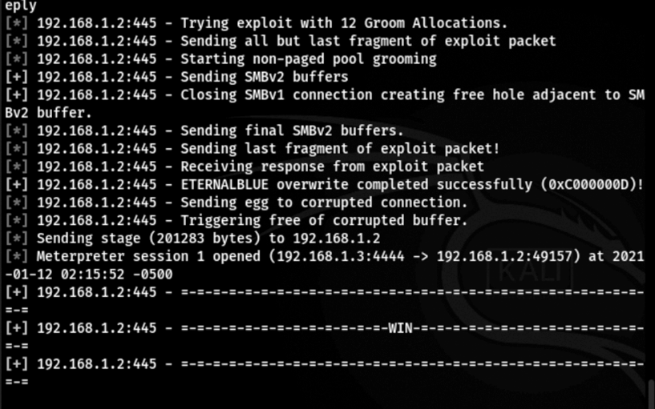

Through testing, we know that the application of this site is written in php, the web server is Apathe/2.2.22, and the operating system is Ubuntu.
Next, we use the fingerprint recognition tool to identify.
Start nmap in the terminal and enter the following command:

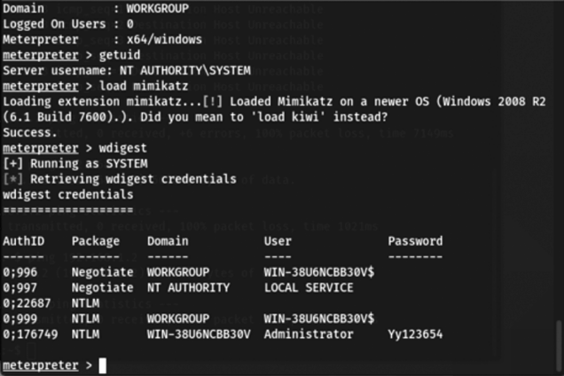

port scan
Execute the following command in the terminal to use nmap's tcp half-open scanning method to scan for open ports.

nmap -sS

Conclusion
The penetration testing method used in this paper is similar to gray box testing.
(1) Use tools (mainly Nmap and Nessus) to obtain important information about hosts in the test environment, including open The port, the port corresponding to the service version information, vulnerability information, etc., use these useful information to The machine implemented a penetration attack and achieved good results.
The penetration testing research carried out in this paper is mainly divided into two parts: (1) Penetration testing research for Web;
(2) Penetration testing for end hosts. As web security is the most common and important
The most important security issues, in this article, focus on the most common several typical Web attack methods, through examples
Carry out the analysis of theories, principles and methods, combine theory with practice, not only familiar with relevant theoretical knowledge, Relevant techniques are also mastered, which will help in future work. When conducting end-host penetration testing,
Three different typical operating systems use vulnerabilities to infiltrate the target host, and also The control right is obtained, the penetration attack effect is obvious, and the penetration test on the target host is completed.

References
[1] Mukhopadhyay I, Goswami S, Mandal E. Web penetration testing using nessus and metasploit tool[J]. IOSR Journal of Computer Engineering, 2014, 16(3): 126-129.
[2] Denis M, Zena C, Hayajneh T. Penetration testing: Concepts, attack methods, and defense strategies[C]//2016 IEEE Long Island Systems, Applications and Technology Conference (LISAT). IEEE, 2016: 1-6.

Part 2 Key Technology of Computer Forensics

Abstract
In the information age, all kinds of malicious or unintentional operations on computers may bring huge threats to human beings. Once the case or accident occurs, obtaining meaningful information from the computer storage device will help to analyze the problem, learn the cause of the accident, and facilitate the next steps to reduce the loss to a minimum, and even investigate the corresponding The responsibility of the personnel is to provide clues and even evidence for the investigation of the case. That’s what computer forensics is all about. Evidence analysis is the core step of computer forensics, which is the process of analyzing the electronic evidence in hand and determining the type of evidence, such as file content inspection and recovery of deleted files. Among them, the analysis of visible information can follow the conventional method. In the face of common situations such as target files or specific information being deleted, or even the hard disk being formatted and re-partitioned, only with data recovery technology can more evidence be extracted as much as possible. Therefore, this paper studies the data recovery technology, and implements a data recovery system, which is specially suitable for evidence analysis in the process of forensics. The system includes data recovery modules based on the file system level, file content level, and the combination of the two levels under the common file system. The modules at all levels complement each other, providing diversified support for computer forensics. By analyzing the operation principle of hard disk and file system and the mechanism of file deletion and partition formatting, this paper not only realizes the general deleted file recovery function, but also proposes a data recovery algorithm (AMCF) based on the minimum content feature at the file content level. Resists destructive operations such as formatting. The core idea of ​​the algorithm is to perform a fine-grained in-depth scan on the disk, and determine how to match and extract the required sensitive information according to the characteristics of the smallest unit content of files that store sensitive information, such as index.dat, registry, and thumbnail cache. The system currently has the functions of recovering deleted files of specified types under the Windows system, recovering computer users’ online records, and USB storage device usage records. The experimental data show that the file recovery module of the data recovery system can successfully scan and recover deleted files. Several major specific sensitive information recovery modules can also recover specific sensitive data very quickly and comprehensively. The most important thing is that they all have extremely high recovery success rate and scanning speed in the face of data recovery after formatting, which makes them have certain advantages in the industry.

Research status
Computer forensics is the use of software and tools to comprehensively examine calculations in accordance with some predefined procedurescomputer systems to extract and protect evidence about computer crime. But generally speaking, we
Said computer forensics also includes forensics in computer peripherals and embedded systems. Due to these devices andComputer systems are more or less related, and the principles of forensics are similar. We will not make a clear distinction here.
The forensics of all relevant electronic systems are collectively referred to as computer forensics.Computer forensics is generally divided into two stages: Physical evidence acquisition and information discovery. physical evidence acquisitionRefers to investigators going to the scene of a crime or intrusion to find and detain relevant computer hardware; information discovery refers to Find electronic evidence from raw data (including documents, logs, etc.) that can be used to prove or disprove
.
Computer forensics related technologies are mainly concentrated in the second stage, such as extracting and preserving data from physical devices. data, recover deleted data, decrypt encrypted data, and extract and evidence of crime. Among them, trace detection, correlation analysis technology, high-efficiency search algorithm.

2 Method
The meaning of each entry of FDT in FAT32 partition
Offset Size (bytes) Data meaning
00H 8 File name of the file
08H 3 File extension
00000000 (read and write)
00000001 (read only)
00000010 (hidden)
00000100 (system)
00001000 (Volume Label)
00010000 (subdirectory)
00100000 (file)
0CH 1 Only useful for long filename directory entries, save filename byte checksum
0DH 3 File creation time, the upper 5 digits are hours, the second 6 digits are minutes, and the second 5 digits
The multiples of bits are seconds, the last 8 bits are the creation seconds to the nearest 10ms
10H 2 File creation date, the upper 7 digits are the year relative to 1980, the second 4 digits
is the month, the last 5 digits are the day of the month
12H 2 Last access date of the file, as defined above
14H 2 The upper 16 bits of the starting cluster number of the file
16H 2 The last modification time of the file, the upper 5 digits are hours, the second 6 digits are minutes,
Again multiples of 5 digits for seconds
18H 2 The last modification date of the file, the definition is the same as 10H
1AH 2 The lower 16 bits of the starting cluster number of the file
1CH 4 file size (in bytes)
In the hard disk, files are stored in clusters, and the size of a cluster is generally 4K bytes. in FAT32
In the partition, each cluster corresponds to an entry in the FAT table. The length of a FAT entry is determined by It is determined by the version of FAT. For example, the length of the FAT entry of FAT32 is 32 bits.
When a file is created, the corresponding FDT entry is created, and the FDT entry is offset 0x12 And 0x1A saves the high 16 bits and low 16 bits of the first cluster number of the file on the disk. FAT corresponding to the first cluster The record item saves the cluster number of the next cluster of the same file, and the FAT record item corresponding to the next cluster saves the Then the cluster number of the next cluster, thus forming a cluster chain. The FAT entry corresponding to the last cluster of the file is a specific value 0xFFFFFF0F, while the corresponding position of the unallocated cluster is written with zero, and the corresponding position of the bad cluster is filled with a specific value.
In the FAT32 file system, if the file or directory name exceeds 8 bytes, it will be recorded with multiple FDTs. record to save. There are multiple extended directory entries to save long file names, and the last main directory entry to save 8.3 cells format short filename

Method
1.1 Law enforcement process model
Namely Law Enforcement Process Model, LEPM.
This model was developed by the U.S. Department of Justice (DOJ) in 2001 in "Electronic
The crime scene investigation guide is divided into preparation, collection,
There are five stages of Examination, Analysis, and Reporting.
Sub-evidence and how to handle it safely are described. The object-oriented objects of this model are mainly engaged in physics
Criminal forensics (non-digital forensics) judicial personnel, with an emphasis on meeting their needs, analysis of systems
Less involved.
1.2 Process abstraction model
Namely Abstract Process Model, APM.
The model is divided into two types:
AIRFORCE process abstraction model.
Presented by the U.S. Air Force Research Institute. The model includes Identification, Preparation,
Approach Strategy, Preservation, Collection, Inspection
(Examination), analysis (Analysis), submission (Presentation) and other 8 stages. However, the "inspection
"Experiment" and "Analysis" are often confused due to their similar names, and this model is used in specific applications
Less practical.
DOJ Process Abstraction Model
Proposed by the U.S. Department of Justice. The model includes Collection, Examination, Analysis
(Analysis), reporting (Reporting) and other processes. The model has a good understanding of the types of evidence that may exist in various electronic devices
types, potential storage locations and crime types are classified and predicted, touching the heart of digital forensics research
part. However, the disadvantage of this model is the same as that of the AIRFORCE model, and the practicability is not high.
1.3 Comprehensive Forensics Model
Namely The Integrated Digital Investigation Model, IDIM.
This model was developed by Brian Carrier and Eugene H. Spafford in their 2003 paper "Getting
Physical with the Investigative Process”
proposed in. which mainly includes the preparation stage
Readiness, Deployment, Physical Crime
Scene Investigation, Digital Crime Scene Investigation,
Summary stage (Review) and other parts. The relationship of each part is shown in the figure below. page 54
Chapter 5 Computer Forensics Model and Its Credibility Research
1 Overview of Computer Forensics Models
In the study of computer forensics technology, some scholars found that there is no unified standard for related technologies.
Fan came to be constrained, resulting in the forensic results not being very convincing. So, in the late 1990s,
Some researchers have put forward the theory of computer forensics model, which abstracts the process of computer forensics and forms a model.
A series of theoretical foundations of computer forensics
.
Among the more typical ones are the following
.
1.4 Basic Process Model
Namely Basic Process Model, BPM.
The representative of this model was proposed by Farmer and Venema in 1999, and it includes some of the following basic
Forensic steps: "guarantee security and isolate, record on-site information
the scene), conduct a systematic search for evidence, and
Collect and package evidence, maintain chain of custody”.
Their research played a leading and foundational role in the development of digital forensics during this period, but their proposed
The granularity of the forensics process is relatively coarse, and the preparation stage before the forensics is not fully considered.
1.5 Incident response process model
Namely Incident Response Process Model, IRPM.
This model was introduced by Chris Prosise and Kevin Mandia in Incident Response in 2001:
Investigating Computer Crime
The book proposes that the attack prevention phase (Pre-incident
Preparation), Incident Detection Phase (Detection of the Incident), Initial Response Phase (Initial)
Response), Response Strategy Formulation, Duplication, Adjustment
Investigation, Security Measure Implementation, Network Monitoring
(Network Monitoring), recovery (Recovery), reporting (Reporting), supplementary (Follow-up) and other stages.
It creatively proposes the "attack prevention" phase as a step in the forensics process. However in this
The phases mainly focus on operating procedures and are not well analyzed from the perspective of system architecture.

Experience
To recover the file, the starting sector of the file's contents must be known
and end sector. The object to be restored is a doc file with a file signature
Head FFD8 and tail FFD9, so open the partition with WinHex,
In the DATA area, search the header and trailer of the file signature to locate the file
content. First, locate the starting position of the DATA area

The starting sector number of the DATA area is determined to be 8320.
Jump to this sector in Winhex, according to the file to be recovered is the doc class
type, can search its file signature header FFD8
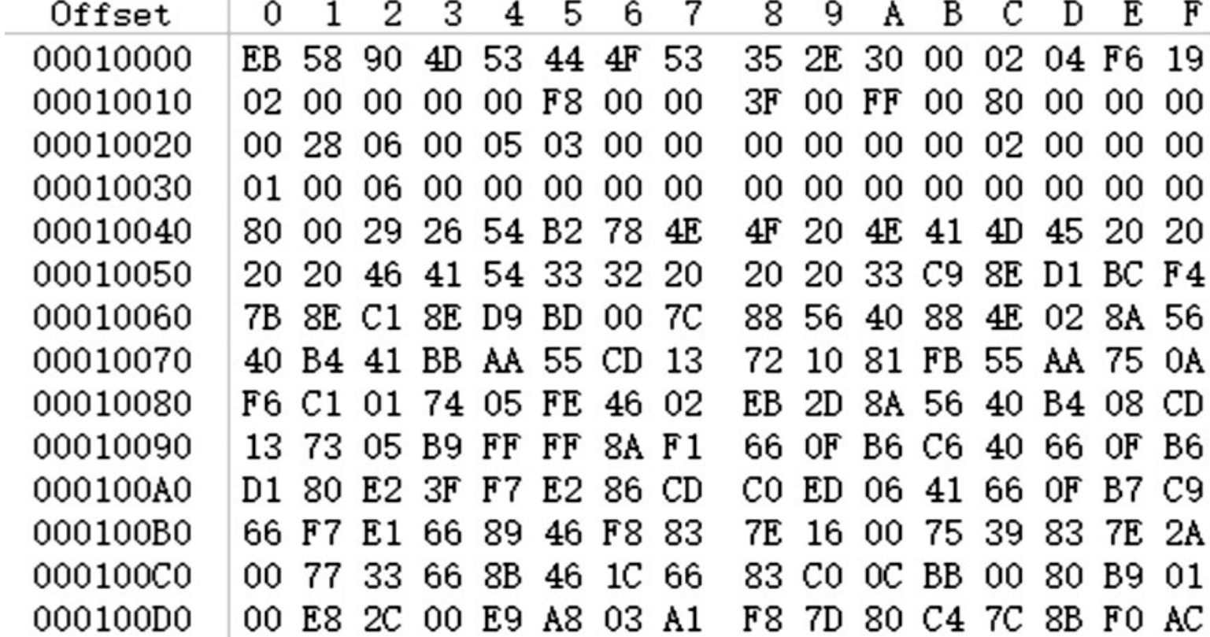
Right-click to select the byte where FF is located, and select "Select Block Start".
Then search for the file signature tail FFD9 of the doc file, as shown in Figure 5
shows that FFD9 was found in sector 8392.
Figure 5 Results of searching for file signature tail FFD9
The approximate size of this piece of data is (8392-8336+1)*
512B=28KB, which is basically the same as the file size, so in FFD9
Right-click on the location and select "End of Select Block", and the contents of the file are all selected.
Then right click Edit - Copy Selection - Insert New File, give
The file is named, pay attention to manually enter the suffix doc, and save it to a
Location. Then open the file and see that the file has been successfully recovered, as shown in Figure 6.
Because the file name is saved in the directory entry of the root directory instead of the file data
In the storage cluster, only the file content can be obtained by this recovery method.
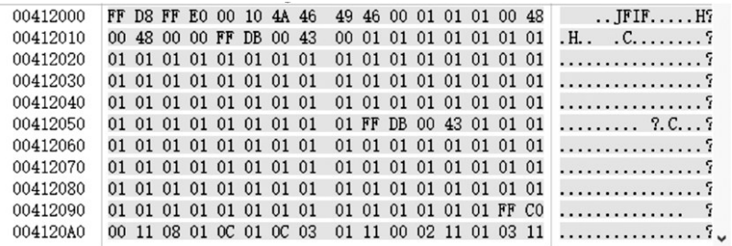
Searching FFD8
If the partition is quick formatted, the file system will also
The corresponding location of the FAT table of all files and the directory entry of the directory where it is located
Modify, but the file content in the data area is also not modified
Erase. Therefore, you can also use the same file signature-based method to enter
row data recovery.
During file recovery, if the file type to be recovered is not
If there is a file signature tail, you need to use the file size to estimate the file storage.
end position of the store. For example, in this example, the size of the file is 28KB,
Then according to the experience that a sector is 512B, it can be calculated that the file should be
This occupies 28KB/512B=56 sectors, and according to the files found
If the signature header is in sector 8336, you can know the end of the file content.
It should be sector 8336+56=8392, and the file can also be recovered smoothly.
In addition, when searching for the file signature header, in order to avoid other
It is not that the "FFD8" of the file signature header is mistaken for the beginning of the file, but also
Judging by whether FFD8 appears at the beginning of the cluster, using
Whether the amount of data between FFD8 and FFD9 matches the file size
to judge. In addition, if the directory entry for the file is not
file directory entry coverage, you can also search the directory entry to get the starting cluster number
Then go to calculate the starting sector number. If there are multiple FFD9s, you can also use
Whether the amount of data between FFD8 and FFD9 matches the file size to judge. If you can't judge, you can export the tentatives one by one recover.

Conclusion
Because the suspect will deliberately delete criminal evidence,vIt is very important to restore data during authentication work, and many mobile The storage media all use the FAT32 file system.
Files that have been completely deleted in the system are recovered. According to the document The signature header finds the starting position of the content of the file, and then according to the text The end of the file signature, find the end of the file content, you can put the
The file contents are completely recovered. If the type of file to be recovered There is only the file signature header and no file signature tail. size to estimate where the file content ends. So, in the file On the premise of continuous storage, as long as the content of the file is not overwritten by the new file Cover, the chance of recovery is very high. Some individual file types do not If there is a file signature, the recovery method in this article cannot be used.
Required if file storage is fragmented in FAT32 file system Recovery is performed according to the structural characteristics of the file and the association of data.
In cases where file recovery will be much more difficult.

Reference
[1] Larry Gottschalk， Jigang Liu， Brahma Dathan， Sue Fitzgerald， Michael Stein. Computer
forensics programs in higher education: a preliminary study[J]. ACM SIGCSE Bulletin. 2005，
37(1)：147-151.
[2] ] R. Hankins, T. Uehaa, J. Liu. A comparative study of forensic science and computer forensics[C]. Secure Software Integrration and Reliability Improvement, 2009. SSIRI2009. Third IEEE International Conference on. IEEE,2009:230-239.

