

STUDENT’S NAME: SIADATINA DUARTE
STUDENT’S NUMBER:2511206
MODULE CODE AND TITLE: LCHS4003 HEALTH AND SOCIAL
LECTURER’S NAME: MUMTAZ GOOLAM
ASSIGNMENT TITLE: TASK 1 POSTER RESIDENTIAL CARE HOMES

Table of contents

Task 1: Poster 3
References 4
Part 1 5

Task 1: Poster
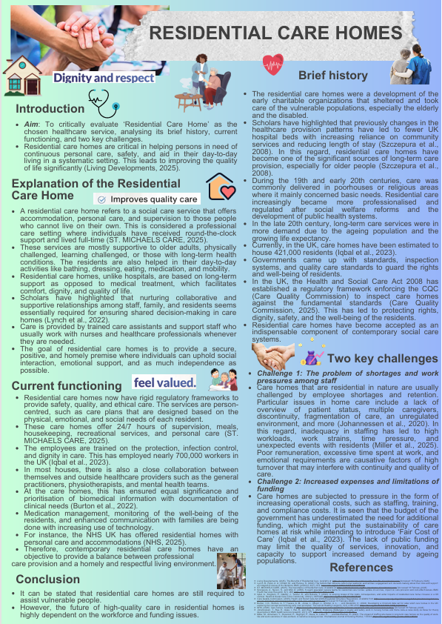

References

Part 1
Burton, J. K., Wolters, A. T., Towers, A. M., Jones, L., Meyer, J., Gordon, A. L., ... and Goodman, C. (2022). Developing a minimum data set for older adult care homes in the UK: exploring the concept and defining early core principles. The Lancet Healthy Longevity, 3(3), e186-e193. https://doi.org/10.1016/S2666-7568(22)00010-1
Care Quality Commission, (2025). Health and Social Care Act 2008 (Regulated Activities) Regulations. Available from https://www.cqc.org.uk/guidance-regulation/providers/regulations-service-providers-and-managers/health-social-care-act/regulation-12 [Accessed 18 February 2026]
Iqbal, A., Kinghorn, P., Glasby, J., Tanner, D., and Roberts, T. (2023). A scoping review of the costs, consequences, and wider impacts of residential care home closures in a UK context. Health & Social Care in the Community, 2023(1), 8675499. https://doi.org/10.1155/2023/8675499
Johannessen, T., Ree, E., Aase, I., Bal, R., and Wiig, S. (2020). Exploring challenges in quality and safety work in nursing homes and home care–a case study as basis for theory development. BMC health services research, 20(1), 277. https://doi.org/10.1186/s12913-020-05149-x
Living Developments, (2025). The Benefits of Residential Care. Available at: https://livingdevelopments.com/news/the-benefits-of-residential-care [Accessed 18 February 2026]
Lynch, B., Ryan, A. A., O’Neill, M., and Penney, S. (2022). The factors that influence care home residents’ and families’ engagement with decision-making about their care and support: an integrative review of the literature. BMC geriatrics, 22(1), 873. https://doi.org/10.1186/s12877-022-03503-8
Miller, M., Almomani, Y., Hopwood, P., Haghighi, P., Davis, A., Littler, E., ... and MacEachen, E. (2025). The impact of staffing structures in long-term care homes on the quality of work-life and work outcomes of care-workers: A narrative scoping review. International Journal of Nursing Studies, 105304. https://doi.org/10.1016/j.ijnurstu.2025.105304
NHS, (2025). Care homes. Available at: https://www.nhs.uk/social-care-and-support/care-services-equipment-and-care-homes/care-homes/ [Accessed 18 February 2026]
ST. MICHAELS CARE, (2025). The Importance of Residential Care. Available at: https://stmichaelscare.org/the-importance-of-residential-care/ [Accessed 18 February 2026]
Szczepura, A., Nelson, S., and Wild, D. (2008). In-reach specialist nursing teams for residential care homes: uptake of services, impact on care provision and cost-effectiveness. BMC Health Services Research, 8(1), 269. https://doi.org/10.1186/1472-6963-8-269

STUDENT’S NAME: SAIDATINA DUARTE
STUDENT’S NUMBER:2511206
MODULE CODE AND TITLE: LCHS4003 HEALTH SOCIAL CARE
LECTURER’S NAME: MUMTAZ GOOLAM
ASSIGNMENT TITLE: TASK 2 PHARMACY SERVICES

Table of contents

Task 2: Essay 4
Introduction 4
Critical discussion 4
Conclusion 5
References 6
Part 2 7

Task 2: Essay

Introduction
The current discussion aims to critically evaluate “Pharmacy services” as the chosen service. Pharmacy services are considered an essential part of healthcare, which has changed the role of providing medicine to patient-oriented services that enhance safety, access, and quality of living.
Thesis statement
Despite the expansion of clinical roles, pharmacy services seem to remain constrained by systematic pressure limiting their potential for delivering high-quality, equitable patient-centred care.

Critical discussion
Investigating the origins
Pharmacy services had their roots in the early apothecaries who seemed to be skilled at preparing and dispensing medicines (Feng, 2023). They also processed and dispensed medicinal ingredients based on natural sources. These professionals were highly crucial in delivering medical care during the early years, as medical professions were not yet established. The profession of pharmacy has evolved towards patient-oriented care from product-oriented care (Khan et al., 2020). Gradually, the rise in scientific knowledge gave way to the standardisation of medicines and the professionalisation of pharmacy practice. Thus, this has made pharmacists responsible professionals in the provision and dispensing of medicines and advice safely. Pharmacists seem to be at the forefront of healthcare advancements, offering essential patient care services that are crucial for fighting against chronic diseases (Thorakkattil et al., 2024).
Exploring the historical context
Industrialisation, pharmaceutical science, and the reform of public health contributed to the development of pharmacy services. With the beginning of mass-produced medicines in the 19th and 20th centuries, there was a need to regulate these medicines to guarantee safety and quality. In the 19th century, pharmacy evolved into a distinct profession, where evidence from industrialisation and the mass production of medicines became a reality, ensuring the growth and development of this profession (Siddiqui et al., 2023). The reforms in the healthcare system and the government policies increased the duties of the pharmacists beyond drug dispensing to encompass patient counselling and the role of the pharmacist as a public health educator. The role of pharmacists has shifted to provide the right medicine, to the right patient, and at the right time (WHO, 2024). The increasing pressure on primary care accessibility also made pharmacies one of the healthcare centers of the communities.
Evaluating how it functions
In the present day, pharmacy services are governed by regulated structures that focus on patient safety, clinical effectiveness, and accessibility. Pharmacists offer medication dispensing, clinical services, the provision of vaccines, and the support of chronic diseases (Peletidi et al., 2025). Electronic health records and digital prescribing have improved efficiency, and error rates have decreased. However, the growing workloads and commercial demands may reduce time to interact with patients, which creates an issue related to service sustainability and quality.
Discussion on its significance
Pharmacy services contribute to a high quality of life by increasing access to healthcare and safe use of medication. The FIP and WHO have recognised the significance of developing pharmacy services in order to meet the fast-growing demands for quality and safe usage of medicine, and offering affordable healthcare service provision (Atif et al., 2020). Community pharmacies provide non-appointment-based, easy access advice to help early treat and self-manage illnesses. Pharmacists are instrumental in minimising medication errors, enhancing adherence, and implementing other public health programs like smoking cessation and immunisation programmes. In the last few decades, pharmacists have been practising pharmaceutical care to improve treatment outcomes of patients by maximising the benefits of medication therapy to patients (Khan et al., 2020). Such services also decrease hospital and GP workloads, as well as enable people to be more in charge of their health, especially in older adults and people with chronic conditions.

Conclusion
Pharmacy has transformed into a fundamental, patient-centred health care service whose availability and clinical functions have continually enhanced population health and general living standards.

References

Part 2
Atif, M., Razzaq, W., Mushtaq, I., Malik, I., Razzaq, M., Scahill, S., and Babar, Z. U. D. (2020). Pharmacy services beyond the basics: a qualitative study to explore perspectives of pharmacists towards basic and enhanced pharmacy services in Pakistan. International journal of environmental research and public health, 17(7), 2379. https://doi.org/10.3390/ijerph17072379
Feng, M., (2023). The Evolution and Impact of Pharmacy: An Detailed Overview. Available at: https://www.jbclinpharm.org/articles/the-evolution-and-impact-of-pharmacy-an-detailed-overview-12568.html [Accessed 18 February 2026]
Khan, N., McGarry, K., Naqvi, A. A., Iqbal, M. S., and Haider, Z. (2020). Pharmacists' viewpoint towards their professional role in healthcare system: a survey of hospital settings of Pakistan. BMC health services research, 20(1), 610. https://doi.org/10.1186/s12913-020-05459-0
Peletidi, A., Petrides, M., Birlirakis, V., Klimentidis, D., Liaras, K., and Petrou, C. (2025). Advanced clinical services in community pharmacies: training challenges and real-world applications–a focus on Greek-speaking countries. Journal of pharmaceutical policy and practice, 18(1), 2455066. https://doi.org/10.1080/20523211.2025.2455066
Siddiqui, A. W., Singh, D., Samanta, R., Das, A. M. and Chhetri, P., (2023). Prescription Chronicles: A Journey Through Pharmacy. Tuijin Jishu/Journal of Propulsion Technology, 44(3). Available from: https://www.propulsiontechjournal.com/index.php/journal/article/download/1287/902/2208 [Accessed 18 February 2026]
Thorakkattil, S. A., Parakkal, S. A., Salim, K. M., Arain, S., Krishnan, G., Madathil, H., ... and Unnikrishnan, M. K. (2024). Improving patient safety and access to healthcare: The role of pharmacist-managed clinics in optimizing therapeutic outcomes. Exploratory Research in Clinical and Social Pharmacy, 16, 100527. https://doi.org/10.1016/j.rcsop.2024.100527
WHO, (2024). Advancing the role of pharmacists to meet changing patient and health system needs. Available at: https://www.who.int/europe/news-room/feature-stories/item/advancing-the-role-of-pharmacists-to-meet-changing-patient-and-health-system-needs [Accessed 18 February 2026]

