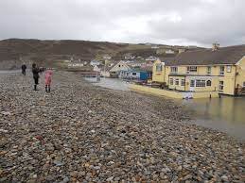

Newgale Road Relocation
EIA Analysis

Trace King | Sustainable Construction | 2021
Table of Contents
Table of Figures 1
Abstract 2
1.0 Introduction 2
2.0 What is an Environmental Impact Assessment? 3
2.1 Stages of EIA 4
2.2 EIA Case Study 6
3.0 Newgale Road Mitigation Proposal 7
3.1 Why is The Project Proposed? 7
3.2 Impact on Local Community 8
3.3 Future Risks and Health Implications. 9
4.0 Evaluation of EIA 9
4.1 Strengths 11
Noise Levels. 14
Air Quality 16
GreenHouse Gas Emissions 17
Landscape and Townscape 18
4.2 Weaknesses 19
5.0 Conclusion 20
References 21

Table of Figures

Figure 1 EIA Process (Thomas, n.d.) 5
Figure 2 Shingle Bank Toppled Over Road (House, n.d.) 9
Figure 3 Existing Land Use and Proposed Route Options (Atkins, 2017) 15
Figure 4 Current Road Diversion 15

Abstract

The issue of global warming is having an increasing effect on coastline towns and cities, as a result local authorities and Governments are enacting plans to mitigate the effects of Rising Sea Levels (RSL) without some form of plan many places will be inundated by 2050. This report focuses on the Pembrokeshire County Council and Atkins Ltd Environmental Impact Assessment for Newgale beach road relocation plan, how they carried out their surveys, if they were in depth enough and whether they factored in seasonal surveys to observe wildlife and consideration to and their public interaction through their research.
The report found that whilst extensive the EIA could have further identified species habitat, and that the decision to not bolster the defenses could be detrimental in the long term.

1.0 Introduction

Climate change is one of the most dominant topics in the world right now. With the UK committed to Zero Carbon by 2050, to prevent temperature increases rising above 1.5°C, as one of the first countries to pass this as law they continued their drive to reduce damage done since the Industrial Revolution, which was highly pioneered by UK. (Skidmore, 2019)
A large part of climate change is rising sea levels, with predicted levels rising by up to 3ft or higher by 2050, SLR was an important factor when developing the Paris Agreement for many island countries and developing nations (Nicholls, 2018) With the possibility of between 0.5m and 2m by the end of the century this would result in many coastal towns being underwater by 2100. (Kulp, 2019)
By examining the Environmental Impact Assessment (EIA) prepared for PCC by Atkins Ltd the process will be looked at against the EIA legislation to understand compliance with planning applications to local government bodies. In addition, it will be used to highlight when an EIA is required and the stages of the assessment process, both prior to and between planning applications.
This report will discuss the Environmental Impact Assessment (EIA) process, the steps involved, and the progress made toward the effectiveness and implementation of such policies. For the purpose of this report, a case study of the Newgale Beach road relocation in Pembrokeshire will be used to illustrate the theories and how policies such as Planning Policy Wales (Gov.Wales, 2021) can be implemented. Additionally, the report will consider any changes in policy and the industry's perspective on current changes.

2.0 What is an Environmental Impact Assessment?

EIA is a comprehensive information gathering exercise carried out by the developer that allows a local planning authority to understand the environmental effects of a development before deciding whether the project can go ahead or not.
Introduced to EU in 1988 and developed over time each member state of the EU has adapted the European Directive EIA to best suit their countries needs and laws. (Commission, 2014)
The emphasis on using the best available sources of objective information and for developers to compile information in a systematic, holistic, and robust manner is crucial to EIA. In theory, a well-researched and objective EIA submission should enable the entire community to fully comprehend the true impact of the proposed development.
An EIA should result in higher development standards and, in some cases, no development at all. EIA also aids in determining the effectiveness of mitigation measures proposed for a development and whether they will ensure that no significant impact occurs.
To ensure the validity of the EIA, they should be conducted over an extended period to observe seasonal animal migration habits, as short-term observational studies frequently produce skewed data and miss species occupation.
In the United Kingdom, EIA is mandated by the European Union's EIA Directive. The Town and Country Planning (Environmental Impact Assessment) Regulations 2017 (Gov.UK, 2017) in England implement the Directive. Wales, Scotland, and Northern Ireland all have similar regulations. Official guidance on the interpretation of Regulations and the procedures for evaluating ESs is available online.
Separate legislation governs EIA for development not covered by town and country planning laws, such as highways, power plants, water resources, land drainage, forestry, pipelines, and harbour works. Several of these will be classified as nationally significant infrastructure projects, which the Planning Inspectorate will oversee on behalf of the Secretary of State under the 2008 Planning Act. (Gov.UK, 2008)
To determine whether an Environmental Impact Assessment is required, a project is classified into Schedule 1 or Schedule 2.
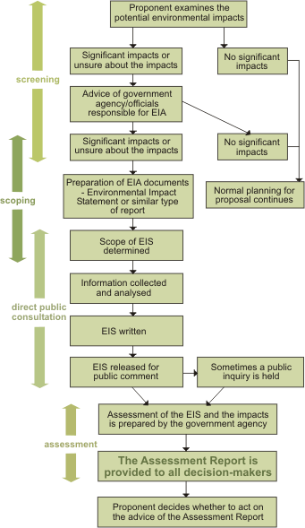
Schedule 1 developments or projects are generally those with the potential for the greatest environmental impact, coastal flood defenses, new roads, large industry, power generation, asbestos handling, chemical . This scale of development always requires an EIA, and if one is not completed, the project will be automatically denied planning permission.
Schedule 2 developments do not always require an EIA; this is dependent on factors such as the size and location of the project. Wind farms, small industrial developments, golf courses, and larger housing proposals are all examples of Schedule 2 development. Other examples include vacation villages and other tourism-related items. If your development falls under Schedule 2, it is recommended that it be screened to determine whether an EIA is required. This would be handled by the local government. (Examchum, 2017)

2.1 Stages of EIA

The government specifies five stages that must be completed in order to complete an Environmental Impact Assessment.
Figure 1 EIA Process (Thomas, n.d.)
Screening
Determining whether a proposed project fits within the scope of the Schedule 1 or 2 regulations and whether it is likely to have a significant environmental impact
Scoping
Including all relevant environmental problems identified in the evaluation, described in the Environmental Statement An applicant may request a 'scoping opinion' from the local planning authority, concerning the material to be included.
The Town and Country Planning Regulations 2017 (gov.uk, 2017) requires that EIA scoping opinions be made accessible for public view. This will allow people of the local community to voice their concerns about a development and to view the evaluation and final opinion on whether an EIA will be performed.
Environmental Statement Preparation
Applicants that have a required assessment must complete and submit an Environmental Statement. The development's potential substantial environmental impact must be assessed and meet regulation 18. (3).(4)
The developer should ensure that the Environmental Statement is drafted by competent professionals. A declaration from the developer detailing the developer's skills or qualifications is required to accompany the Environmental Statement.
Consultation and Submission
Environmental statements and development applications must be made available electronically and via public notice. Development will be contingent on consultation with statutory ‘consultation bodies' and the general public. It is important that an environmental statement is registered on Part I of the planning register as soon as feasible following publication (Gov.uk, 2020)

Decision Making
All relevant information and any comments or representations must be examined by the local planning authority and/or the Secretary of State when deciding whether to give authorisation for the development. The public must be notified of the decision electronically and through public notice.

Legislation of EIA UK
The Town and Country Planning Act of 1990 “An Act to consolidate certain enactments relating to town and country planning (excluding special controls in respect of buildings and areas of special architectural or historic interest and hazardous substances) with amendments to give effect to Law Commission recommendations” is a significant law (legislation.gov.uk, 1990) it establishes policies for development and land use changes in an area, considering the area’s appearance, physicality and environmental impact as a result. The act also establishes guidelines for local planning and granting permission to construct projects of all types. Revisions are made regularly to this act to ensure it is current and relevant to current circumstances and to provide a framework for new uses that may have environmental impacts. This is especially important in relation to this chosen project as it sits within a National Park which has even further regulations and legislations governing construction to protect the environment and focus on enhancing the existing natural environment (Legislation.gov.uk, 2021 updated)
The UK’s regulations have been criticized for not fully interpreting the EIA Directives spirit. Individual cases involving large-scale development proposals have sparked debates about the quality of the EIA conducted, with third parties complaining to the European Commission about the UK’s failure to fully implement the Directive on EIA, which are being litigated in courts. (Perraudeau, 2019)

2.2 EIA Case Study

This case study in this report is one which EIA data is exceptionally important both to monitor current damages being caused to the area, residents, and wildlife, as well as the proposed development to alleviate the inconvenience of those effected by the current frequent storm and flood damages.
The report will critique the EIA submitted to Pembrokeshire County Council by Atkins Development for the development of a new road to bypass Newgale beach which will result in fewer road closures, and inconvenience to the residents. Several options were presented in order to provide the most suitable solution for an alternative to the current A487 (Atkins, 2017)
Newgale Beach is on the West Coast of Wales in the Pembrokeshire National Park and a direct route from the County Town of Haverfordwest and Roch, to small towns like Solva, and the tourist town of St. David’s.
Due to the proposed development being in a National Park the permissions for all development falls under The National Parks and Access to the Countryside Act 1949 (Gov.uk, 2019) and as a result all construction must conserve the natural beauty of the area, without damaging the habitats, heritage, and ensure that all efforts are made to enhance an area after such developments.

3.0 Newgale Road Mitigation Proposal

A route redirection removing through access at the point of Newgale Village to mitigate future modelled issues with loss of existing road due to RSL and continued failure of existing flood defenses. A choice of proposals were presented for discussion from raising the current road height to bolstering existing flood defenses.
This will provide residents and commuters with an alternative route when the road floods and a permanent road when the existing road is finally abandoned due to forecasted RSL, high tides, and storm surges.
The proposal and report were prepared by Atkins Ltd. for Pembrokeshire County Council ready for consultation with the public.

3.1 Why is The Project Proposed?

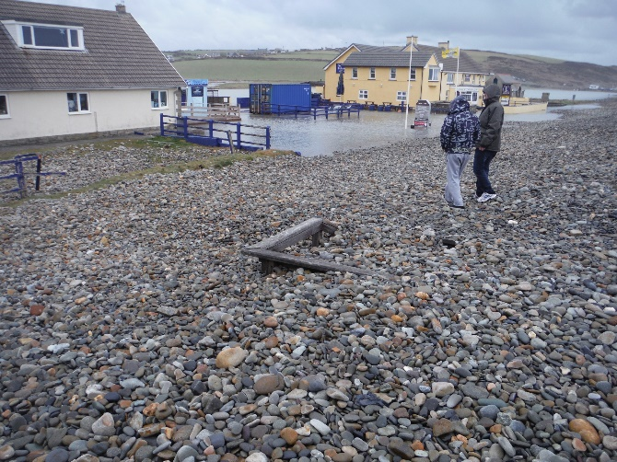
Inundation flood models are showing countries all over the world are going to lose many miles of coastline by the year 2050, the Paris Agreement 2015 has set carbon emissions targets to attempt to minimize the sea temperature increase, this could potentially slow the melting of the glaciers and the rising sea levels. If this is not addressed like many climate control agreements previously then the modelled data shows many areas in west Wales would cease to exist. (UNFCCC, 2015)
As one such low lying sea front village Newgale is extremely susceptible to storm surges and predicted SLR, the road is currently protected by an inadequate shingle bank. This regularly gets toppled over, and in recent years this has become more regular occurrence with sea flood waters reaching further back into the nearby Brandy Brook River (NRW, 2015)
Figure 2 Shingle Bank Toppled Over Road (House, n.d.)
Without considerable investment required to implement highly developed robust the flood defenses the most suitable method for the short term would be to reroute the existing road preventing on-going continued road closures which has the repercussion of creating excessive traffic on alternative routes. Many of these alternative routes are single track roads, unsuitable for traffic other than the agricultural vehicles that use them most.
The Residential area of Newgale is safely above sea level and rising on a hill to further higher altitudes, however much of the local tourist activities and retail area are positioned squarely in the area which is most prone to flood damage from rising sea waters.
This proposal is a mediatory measure and with predicted sea level rises by 2050 it is entirely feasible that there may not be a viable beach front area as coastal erosion intensifies and tides retreat less.
The shingle bank at Newgale, Pembrokeshire Coast National Park, protects the A487 and the village of Newgale from the sea. The shingle bank was overtopped and the A487 was flooded during the winter storms of 2013/14, and during Storm Dennis in 2020 being the most notable occasions.
This results in road closures, and with sea levels predicted to rise, this type of event is expected to become more and more frequent and severe. When the road is closed, a 6.2-kilometer detour via single-lane rural roads through Roch and Penycwm is used. This route is incapable of carrying a high volume of traffic, necessitating the provision of a transportation solution.
The developer for this project will be Atkins Ltd, they wrote the report for PCC who then presented it to the public, which enabled them to reduce the possible

3.2 Impact on Local Community

As a small immediate community, the loss of the main road to Haverfordwest could result in transport connection issues via bus services, reduced passing trade, logistics issues delivering goods to residents and retailors alike and as time passes those businesses will be left to the mercy of the sea without sufficient construction proposals to hold back the sea.
As a wider community of Newgale, Roch, Pen Y Cwm, St David’s, Solva improved roads would greatly benefit the local area, helping to prevent long detours, with less through traffic having to take the beach front road through Newgale noise and pollution levels would be significantly reduced vastly improving the quality of life for the residents.
The new road could also provide access to areas currently inaccessible and provide long term future areas for development of new towns and villages along its route.

3.3 Future Risks and Health Implications.

The adjacent Brandy Brook River flows directly onto Newgale beach, future loss of the road, and failure to adequately address and maintain the failings of the current shingle bank may well result in relocation of the shale. The shale relocation could well cause a whole host of further problems and issues if it were to have a dam like effect upon the river. With the natural flow of the river being disturbed this may cause serious flooding issues further upriver, and dramatically expanding modelled flood plain and disturbing other villages and rural areas. Flooding can have the two-tier effect of overloading sewerage transport systems which can result in waste matter making its way into solid and potentially onto the beach, into the sea. This would create very unhealthy and unsanitary conditions, which would have a severe detrimental effect on the local tourism economy for which much of the area is reliant but may well also extend out to the houses in the area leaving residents without adequate sanitation.
The public house and surf shop directly adjacent to the road which have already suffered water damage on several occasions in the past are predicted to be completely under water at low tide by 2050 estimations of up to 8ft water level increase.

4.0 Evaluation of EIA

To critically evaluate the Environmental Impact Assessment, the process will be compared the EIA legislation as it currently stands, and considered problems and solutions identified by the developer prior to the project's design.

In this evaluation the strength and weaknesses of the depth of testing will be explored and discussed, and the accuracy of the produced results, providing recommendations for improvement, while developing a greater knowledge of the intricacies of EIA. It is critical to assess the threats, risks, sustainability, and social impact that a proposal of this scale will have on the local community, and to critique the developer's strategy for avoiding, eliminating, or mitigating negative impacts on the area, their plans for compensatory measures, as well as their methods for overcoming issues such as national park construction limitations. However, the definitions of strength, weakness, and effectiveness are subjective to the stakeholder, who may have divergent interests and opinions, values, or even morals. To evaluate an Environmental Impact Assessment, it is critical to maintain objectivity in order to make clear recommendations and conclusions.
Table 1 Studies of Proposed Area
Stages EIA | Newgale Case Study | Observations or Suggestions
Scoping
Consultation | February 2015 public consultation resulted in development of Newgale Adaptation Plan
 | 20/21 October 2016 to explain the reasoning for shortlisting of the 4 options
 | 8 February 2017 public exhibition with stake holders
 | 9/10 February 2017 with the public 243 people attending
 | 3 Feb – 20 March 2017 period for public responses | The public interaction for this project was regular and for the area well attended. Taking public opinion into consideration and altering plans shows the developer willing to provide the best scheme for those most effected by it.
Surveys
Landscape and townscape | Observation of highest points 105m to lowest at sea level. Detailed observation of the surrounding areas and land usages including coastal paths, woodlands, peaks and valleys, farms and exceptional views. | No mention of plant species,
 | Individual area surveys highlighting both land values and the cause for them for the 4 areas effected by the proposed developments.
Designations | Areas of importance surveyed making points of areas of outstanding beauty, national parks, sites of scientific interest and special area of conservation.  Assumptions made to rate unclassified land as SSSI even though NRW hasn’t given it status | Giving enhanced status to an area shows the contractor is aware of the importance of the area.
 | Listed designation sites for all proposal options as far as 25km
 | Sought data on Non-Statutory Designations
Habitats | Phase 1 habitat mapping and phase 2 botanical surveys obtained from Lle and NRW | Relying on existing studies by reputable sources is beneficial as long as they are in date.
Species | Species survey records obtained through WWBIC
Contamination | Survey of historical data to identify possible sources of contamination. | As historical data this is unlikely to change unless archeological digs are conducted.
Flood Risk | Survey done of possible locations likely to flood along the proposed routes at several locations of each proposal.

4.1 Strengths

The EIA shows that a reasonable effort was made to best gather relevant data to provide the public with a detailed reference point for future works and to highlight the effect of those works on species and habitat, along with proposed enhancement as required by legislation.
The EIA explains its requirement for public funds at the beginning of the report, and how using 2 appraisals would provide the most suitable list of possible proposal. When a project of this nature includes the use of public funds, full disclosure must be given; if not a project can be halted if details are found to being withheld at any point, as explained in Managing Welsh Public Money, 2.1 (Gov.Wales, 2016) The writer highlights the current ongoing issues faced by councils maintaining the Newgale road to an adequate and sufficient standard, which is repeatedly draining money from public funds and will continue to do so as the storms worsen in the period of time until the road is replaced which leads clearly into the reasoning for developing a proposal to best combat it. The report introduces the legislation, regulations and Welsh Transport Planning and Appraisal Guidance (WelTAG, 2017) as its guidance in a clear manner to ensure the reader can easily understand it and conduct their own research to clarify what it means.
The EIA uses species and habitat reports prepared by CIEE Registered associations WWBIC, NRW. While this shows they did not conduct any research of their own on these topics, they have approached the most reliable source with the largest amount of collected data.
By producing traffic forecasts for a range of difference scenarios they presented high levels of information from no change to minimum change to extensive change, as a forecast this is only an estimation but the level of their observations and testing areas shows they aim for the success of this project on a social, economic and environmental front.
The assessment also presents the masterplan strategy for Newgale, without going into further detail but it does give an idea that further works to protect the area may be put in place in the future.
It presents all the initial options as highlighted in the list below. To anyone not from the local area this would not make sense, this could have been highlighted with more maps, but to residents who are used to using many of these routes when the beach is closed, they can easily visualize how the proposals would affect the area.
The Planning Stage Report recommended the following route alternatives for further consideration:
Table 2 Proposed Actions (Atkins, 2017)
Option | Action
2B | Bolstering Sea Defenses
2C | Putting existing road on an embankment
2D | Putting existing road on a bridge, viaduct or culverted causeway
3B | building a bridge, viaduct, or culverted causeway behind the Duke of Edinburgh Inn.
4 | Newgale Farm to Wood Farm
5 | Southwood Farm to Newgale Farm
7 | partially on existing road and track: 'Penycwm – Llethr – (Site of) Brawdy Mill' – new road including Brandy Brook crossing
8 | an embankment or viaduct further inland to connect to the existing A487
9 | Departing from Roch, skirting the marshy land, crossing Brandy Brook at its eastern terminus, and rejoining the A487 at Penycwm
11 | Maintain existing route but upgrade Diversion Route (C3062-C3063-C3010) over time to accommodate increased traffic
Table 3 Proposed options for development (Atkins, 2017)
The proposals considered every possible method to cross Newgale seafront as well as routes much further back from the area. Which were then narrowed down by an environmentally based TPO.
‘TPO2 - To conserve and enhance the natural beauty, wildlife and cultural heritage of the Pembrokeshire Coast National Park avoiding, or at least minimising, adverse effects on the natural environment caused by traffic and associated infrastructure’.
Figure 1 shows the proposed alternative route the council has considered the most plausible course of action, over a variety of developments including a viaduct directly over the valley of Newgale. This route would be the most disruptive to the countryside and required the most research and observation

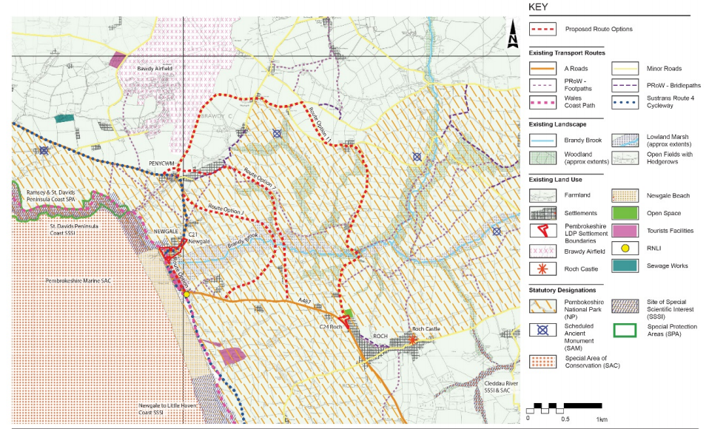 Figure 3 Existing Land Use and Proposed Route Options (Atkins, 2017)

Figure 2 highlights the current diversion road that residents and commuters must take when the shingle is displaced over the road due to sea water tidal flood surges. The route itself is time consuming and drivers are often not made aware of diversions until they reach Newgale itself.
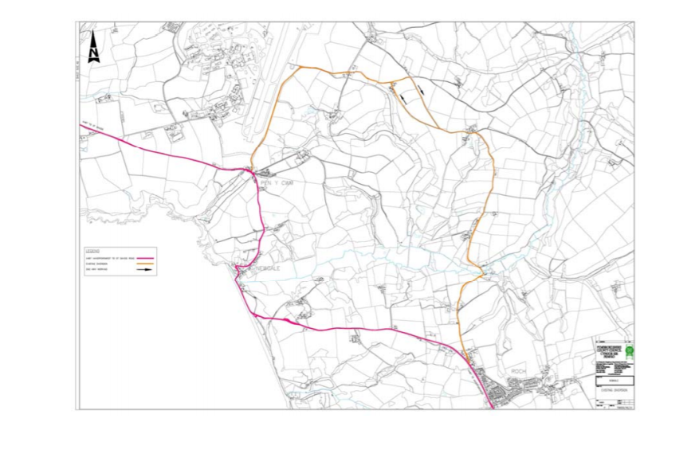
Figure 4 Current Road Diversion

Noise Levels.

As with all road expansion projects there are some considerations to be made. First, there is the initial increase in noise as a direct result of road construction and then there is the everyday operational noise of having motor vehicle traffic in an area where there once was none in small towns and villages where houses front onto roads very closely some without the protection of even a pavement or planting. Increasing heavy freight traffic through areas like this is more than likely to cause high levels of noise disturbance, many of the existing roads in the area are single track roads and are often occupied by slow moving agricultural traffic.
Tables 1-3 highlight a range of data collected by Atkins to determine the most effective proposal with the least effect on the residents and wildlife through noise pollution. Increases in noise are a major contributing factor in resident refusal to accept new proposals, they may be willing to accept short term construction noise but increased noise pollution and vibration from traffic can be detrimental to the residents in the immediate area and may even be a cause of long-term health issues (Groschel, et al., 2014). With such highly detailed levels of transparency in the preliminary testing process residents can see how much impact the project will have on their lives going forward from start of construction, completion, and long-term use.

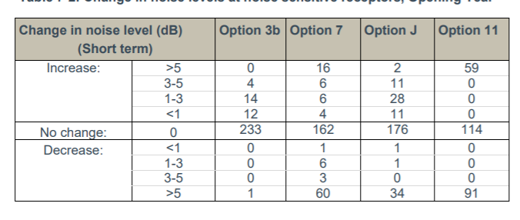
Table 4 Short Term Noise Change
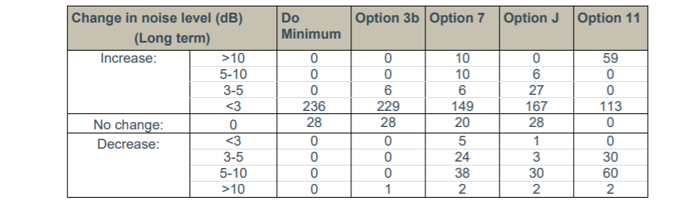
Table 5 Long Term Noise Change

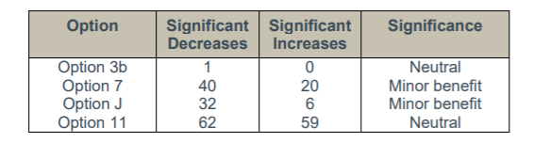
Table 6 Significant Changes to Areas
The tests and data analysis revealed that, on completion, the noise levels will be demonstrated to be either neutral or positive for the community.
Option 3b would yield the most similar noise climate to the existing one. Option J and 7 offer greater noise benefits than downsides, and it is expected that the number of downsides could be lessened by employing noise mitigation measures. Option 11 presents the most problems and is the most difficult to lessen.
However, utilising testing in all regions to check all choices would have offered a considerably deeper understanding, allowing the potential for expansion in the area. As the absence of any noise regulations is cited in the paper, the primary worry would be construction-related noise.

Air Quality

As an area of outstanding natural beauty and a much sought-after area for getting away into fresh air, clean air is a large part of the attraction to Newgale, Solva, St. David’s. Any new development cannot interfere with that too much or risk reducing the areas income as incoming tourism plays a significant part in theses' areas local economy.
With carbon emissions currently at the forefront of much legislation and the driving force behind many construction projects, improving air quality is seen as a vital component to any new proposals. When that proposal involves increasing traffic through previously quiet towns, villages, and hamlets it is especially vital that as much is done as possible to mitigate any increased air pollution that comes from the increased number of motor vehicle through traffic. As the through traffic that will be diverted from Newgale will be largely commuters, tourists, and traffic that would be diverted should other roads be closed due to accidents which happen frequently on some roads in the area.
Each option had their vehicle emissions calculated using the DMRB21 method, detailed emission functions for various vehicle types and pollutants were used that were dependent on average traffic speed, road type, and composition (percentage heavy duty vehicles [HDV]). The proposed options and the surrounding local road network were assessed using traffic data. For the opening year, the data included annual average daily traffic (AADT) flows, average daily speed, and percentage HDV for four options (Option 3b, Option 7, Option 11, and Option J) (2022).
As shown in Table 4 enough data was recorded to formulate a substantial level change both positive and negative.
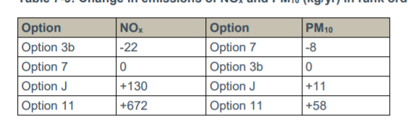
Table 7 Gas Emissions Changes for Each Option

Highlighting the increased air quality due to less traffic at the existing road would have been beneficial, and their chart is incorrectly formatted. Is this a mistake? It would appear so. This may have resulted in decisions being made incorrectly if it was not highlighted at consultation stage meetings.

GreenHouse Gas Emissions
The assessment was carried out in accordance with WelTAG guidance (June 2008)20. There is a requirement to assess changes in CO2 emissions over a 60-year appraisal period beginning in 2022 and ending in 2081, and to calculate a Net Present Value (NPV) for this period. Traffic data for four different scenarios (Option 3b, Option 7, Option 11, Option J, and a 'Do Minimum' (DM) scenario) were provided for the years 2022 and 2037.
Outside of construction, transport is the second highest contributor to c carbon emissions, 15% of the greenhouse gases in the atmosphere are from road vehicular transport (Ritchie, 2020), and in small villages with no industry, this is often the only source of pollution they encounter. The Climate Change Act of 2008 lays out a strict legally binding contract to its commitment to reduce greenhouse gas emissions by 2050.
The Atkins EIA emphasises the additional mileage that the new routes would result in for residents over a 60-year period. As shown in Table 5, the extra mileage increases CO² emissions; however, only Option 3b benefits those residents and road users.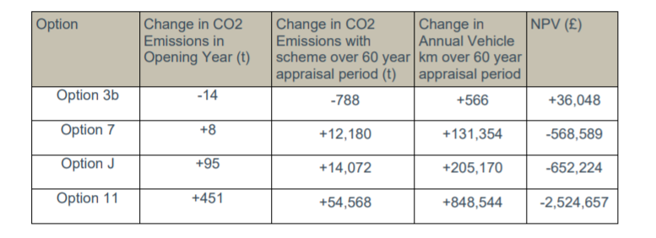
Table 8 CO2 Emissions and milage changes

As a county with higher levels of poverty than the national average, this data is extremely important to the public in order to make the best possible decision that will have the least impact on their already limited incomes, and with more people becoming aware of their carbon footprint, the increase in CO2 emissions will also drive many decisions, 14,000 miles extra per year would seem untenable to many people.

Landscape and Townscape

With much legislation required for construction seeing a report highlight that they have used methods created via using multiple sources and guidelines, to develop a proposal that was usable and inclusive for all.
By giving a short explanation of the short-term immediate effects of the project, and again highlighting that if no change were to take place, the report shows that the contractor is willing to absorb the loss of hedgerow and amount of cut and fill work associated with any of the options for development.
In the long term the effects are much greater and indicating they may possibly move the existing hedgerow to new roadside locations to fulfill compensatory measures is a clear benefit as the wildlife that use those hedges would return soon after construction activity ceased.
Seemingly careful thought to the visual impact a new road would have on the extensively rural area, and its level of mitigation shows the contractor aims to provide a transport link that is in keeping with the existing roads in the area.

4.2 Weaknesses

While the report makes it abundantly clear that the primary objective, aside from providing a new futureproof transportation link, is to preserve the rural aesthetic, it falls short of adequately considering how to construct more robust flood defenses that would largely prevent flooding and loss of coastal lands. The road will be impassable by 2036, and the public house, as well as the surf shop, are on the same level as it. Permanent flooding of that road would also result in the closure of the buildings adjacent to it, resulting in a loss of tourist revenue each year. Saltwater inundation will eventually force its way upriver and have a severely detrimental effect on the local eco system, harming fragile wildlife habitats, altering soil pH levels and dramatically altering the size and mapping of the current floodplain.
The proposed road is too long, it winds out too far to then return on itself, and while it is accepted that is how local roads are built, it will result in excessive extra miles and unacceptable increases of levels of excess CO2 emissions at a time when the UK is committed to drastically reducing them. The longer road would increase both construction time and cost, as well as cause additional and unwanted traffic congestion on the existing narrow roads used by many logistics vehicles to deliver supplies and materials to local businesses and farming industry
The new roads also border on an active military base, which has its own artillery traffic on a regular basis.
No mention is made of any inclusion of cycle paths, and options to decrease the number of cars on the road by increasing other clean transport options. As an area now long standing with the triathlon community the inclusion or development of safe places to cycle to and from the surrounding areas would seem to be a major oversight.
Their CO2 testing did not allow for the shift that is being observed from combustion engines to electric vehicles which the government are now actively seeking legislation to gradually eliminate combustion engines. As the report was in 2017 before the recent spearhead toward carbon neutrality this may have been less prevalent at the time, but some mention toward the decline of the combustion engine may have shown a marked reduction in the CO2 measures.

5.0 Conclusion

EIA are vitally important for the construction of any project through an area with dedications, such as NP and SSSI. As shown in the EIA for the M4 relief road, despite in depth reports and surveys, public consultation and environmentalist have an important role in accepting the project.
Atkins surveyed traffic noise levels despite no legislation, this could possibly have been due to the areas affected by the proposals being small quiet villages that would be sensitive to noise more than towns and cities.
The public consultation for this EIA was highly attended by local population which highlights great public opinion on the outcome of the research and the final agreed proposal.
The level of enhancement is not deeply enough considered, more would need to be done to enhance such a large area after the proposed road was completed, merely planting new hedgerow would not be deems sufficient enough enhancement.
The UK is surround by towns and village like Newgale, and it simply cannot be justified to suggest moving a road every time the water gets close. As the effects of climate change grow greater, there will be more of these EIA’s planning retreat or mitigation, the EIA is a good example of how to conduct and write a survey report, by using detailed survey reports from registered officials Atkins’ saved time, and funding, but may have missed any new species.

References
Atkins, 2017. Newgale A487: £30m new route for storm-ravaged road. [Online]
Available at: https://www.bbc.co.uk/news/uk-wales-45641147
[Accessed 23 May 2021].
Atkins, 2017. Newgale WelTAG Stage 1 Assessment Report. [Online]
Available at: https://www.pembrokeshire.gov.uk/objview.asp?object_id=3835&language=
[Accessed 1 May 2021].
CFW, 2015. Well-being of Future Generations (Wales) Act 2015. [Online]
Available at: https://www.futuregenerations.wales/about-us/future-generations-act/
[Accessed May 19 2021].
Commission, E., 2014. Environmental Impact Assessment - EIA. [Online]
Available at: https://ec.europa.eu/environment/eia/eia-legalcontext.htm
[Accessed 19 May 2021].
Examchum, 2017. What are Schedule 1 and Schedule 2 categories in EIA?. [Online]
Available at: https://www.examchum.uk/landscape-architecture/eia-schedule-1-and-schedule-2/
[Accessed May Month 2021].
Gov.UK, 2008. Planning Act 2008. [Online]
Available at: https://www.legislation.gov.uk/ukpga/2008/29/contents
[Accessed 23 May 2021].
Gov.uk, 2017. legislation.gov.uk. [Online]
Available at: https://www.legislation.gov.uk/uksi/2017/571/contents/made
[Accessed 18 May 2021].
Gov.UK, 2017. The Town and Country Planning (Environmental Impact Assessment) Regulations 2017. [Online]
Available at: https://www.legislation.gov.uk/uksi/2017/571/contents/made
[Accessed 23 May 2021].
Gov.uk, 2019. legislation.go.uk/nationalparksandaccesstothecountrysideact. [Online]
Available at: https://www.legislation.gov.uk/ukpga/Geo6/12-13-14/97
[Accessed 18 May 2021].
Gov.uk, 2020. https://www.gov.uk/guidance/environmental-impact-assessment. [Online]
Available at: https://www.gov.uk/guidance/environmental-impact-assessment
Gov.Wales, 2016. Managing Welsh Public Money. [Online]
Available at: https://gov.wales/sites/default/files/publications/2018-10/managing-welsh-public-money.pdf
[Accessed 19 May 2021].
Gov.Wales, 2021. Planning Policy Wales Edition 11. [Online]
Available at: https://gov.wales/sites/default/files/publications/2021-02/planning-policy-wales-edition-11_0.pdf
[Accessed 18 May 2021].
Groschel, M. et al., 2014. Health effects of environmental noise pollution. [Online]
Available at: https://www.hindawi.com/journals/bmri/2014/909260/
[Accessed 23 May 2021].
House, C., n.d. Newgale Shingle Bank after storm. s.l.:s.n.
Kulp, S. A., 2019. New elevation data triple estimates of global vulnerability to sea-level rise and coastal flooding. [Online]
Available at: https://www.nature.com/articles/s41467-019-12808-z
[Accessed 23 May 2021].
legislation.gov.uk, 1990. Town and Country Planning Act 1990. [Online]
Available at: https://www.legislation.gov.uk/ukpga/1990/8/contents
[Accessed 23 May 2021].
Legislation.gov.uk, 2021 updated. National Parks and Access to the Countryside Act 1949. [Online]
Available at: https://www.legislation.gov.uk/ukpga/Geo6/12-13-14/97/contents
[Accessed 23 May 2021].
Nicholls, R. J., 2018. Stabilization of global temperature at 1.5°C and 2.0°C: implications for coastal areas. [Online]
Available at: https://royalsocietypublishing.org/doi/10.1098/rsta.2016.0448
[Accessed 18 May 2021].
NRW, 2015. Cleddau and Pembrokeshire Coastal Rivers Management Catchment Summary. [Online]
Available at: https://cdn.cyfoethnaturiol.cymru/media/679390/2016-updated-pembrokeshire_catchment_summary_nrw.pdf?mode=pad&rnd=131596369400000000
[Accessed 23 May 2021].
Perraudeau, M., 2019. Back to the future: Brexit, EIA and the challenge of environmental judicial review. [Online]
Available at: https://journals.sagepub.com/doi/10.1177/1461452918810144?icid=int.sj-abstract.similar-articles.2&
[Accessed 23 May 2021].
Ritchie, H., 2020. Cars, planes, trains: where do CO2 emissions from transport come from?. [Online]
Available at: https://ourworldindata.org/co2-emissions-from-transport
[Accessed 23 May 2021].
Skidmore, C., 2019. UK becomes first major economy to pass net zero emissions law. [Online]
Available at: https://www.gov.uk/government/news/uk-becomes-first-major-economy-to-pass-net-zero-emissions-law
[Accessed 18 May 2021].
Thomas, I., n.d. Environmental Management. [Online]
Available at: https://www.dlsweb.rmit.edu.au/conenv/envi1128/focus3/f3_t10_q58.htm
[Accessed 23 May 2021].
UNFCCC, 2015. The Paris Agreement. [Online]
Available at: https://unfccc.int/process-and-meetings/the-paris-agreement/the-paris-agreement
WelTAG, 2017. Welsh transport appraisal guidance. [Online]
Available at: https://gov.wales/welsh-transport-appraisal-guidance-weltag
[Accessed 19 May 2021].

