

Lab: IPv4, Subnetting, VLSM and IPv6 Addressing

- Understanding IPv4 and IPv6 addressing (word count 1000)
This part of lab worksheet require you research and write a report on “Features of IPv6”. You may discuss but not limited to structure, address types, advanced functionalities and security.

Introduction
The purpose of this report is to describe the “Features of IPv6”. The author draws comparisons from the existing IPv4, and any improvements made in the new version.

Main Body
Internet Protocol Version 6 (IPv6) came about after concerns in the early 1990’s of the address pool of IPv4 depletion. IPv4 is still in use as people regenerate (sell or trade their IP addresses) and utilise NAT (Network Address Translation) to postpone or delay their transition to IPv6. NAT being a way of hiding multiple IP addresses behind a single address. The current IPv4 addressing structure allows around 4.3 billion addresses. ‘In 2019 IANA considered all RIR.s expect AFRINIC to have exhausted their supply of IPv4 addresses.’ (Odom, 2019) worrying recent news indeed for people running legacy (IPv4) infrastructure.

The Internet Engineering Task Force (IETF) saw a need for a replacement of IPv4 and in 1998 the document RFC 2460 became official. IPv6 improves on IPv4 in many ways. First and foremost, having a 128 bit address space allows 340 undecillion addresses. So, this should take a lot longer to exhaust. Put another way, for every square meter on earth, there are 1564 addresses. Also, there were other concerns about routing, broadcasting and security which are addressed later on in this report.

Structure – there is a simplification in the IPv6 header. Address source and destination stay the same (although the size does increase with IPv6). Figure 1 below shows the old IPv4 against IPv6.

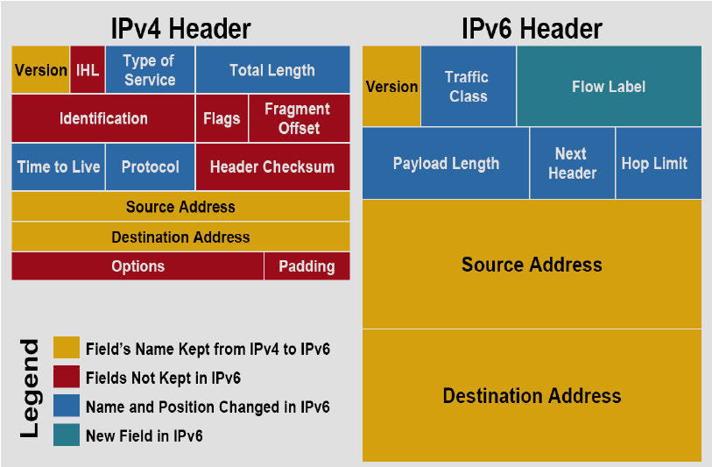Fig. 1
(Ani & Haddad, 2012)
The IPv6 header is defined as follows:

- Indicating which version of IP used is the ‘Version’ field.
- Traffic class defines the priority of the packets.
- Flow label is designed to order packets the same flow in routers.
- Payload defines the total size of the packet.
- Indicating extension headers is the ‘Next Header’ as well as TCP and UDP protocols.
- Replacing the Time-To-Live (TTL) is the Hop Limit and is a counter for the max number of jumps to a destination before being dropped.
- Source and destination addresses are replaced with the new IPv6 format, totaling 128 bits each.

Also note that with a simplified header, the routing becomes quicker. Without repeatedly running the checksum and other unnecessary fields, this will ultimately leader to a quicker processing time.

Replacing the need for Dynamic Host Configuration Protocol to give a device its address to be introduced to a new network, IPv6 introduces Stateless Address Autoconfiguration (SLAAC) giving the ability for hosts to discover and define their own addresses. Using a Router Solicitation message, a new IPv6 capable device requests subnet information, sent back is the Router Advertisement which contains network information which the host can then use to calculate its address.

Multicasting not broadcasting – this feature allows uninterested hosts not to listen to messages being sent to it and send unnecessary traffic replying to it. ‘Multicast allows bandwidth-intensive packet flows (like multimedia streams) to be sent to multiple destinations simultaneously, saving network bandwidth.’ (Bulknull, 2011) In short; multicasting allows high bandwidth data streams to be sent to many destinations at the same time. As an additional benefit, IPv6 features a new field called Flow Label allowing packets to become identified as part of another.

There are 2 different types of address autoconfiguration; Stateful Autoconfiguration Dynamic Host Configuration Protocol (DHCP) and Stateless Address Auto-configuration (SLAAC). The hosts are empowered to make the configuration by themselves. IPv6 having 128 bits, the first 64 of which are defined by the router or host and the later 64 bits are defined by the router or host via EUI process.

This is mandatory in IPv6, although used in IPv4 already it allows for authentication and/ or encryption of the data. There are two main protocols involved in IPsec; Authentication header (AH) and Encapsulating Security Payload (ESP) protocols. AH is a connectionless authentication only, by use of a hashed function, a fixed value checked via a secret shared key which is authenticated at the receiving end for the entire of the IP packet, this is ‘..Commonly by SHA or MD5.’ (Willis, 2001) This will provide no confidentiality and its primary purpose is to protect against attacks like replay attacks (a method of resending or misdirecting messages) and the origin of the sender. When traversing a Network Address Translation (NAT’ed) network this can cause issues as the hash is altered.

ESP is designed to provide confidentiality by encrypting the data providing protection for the data on a network. Like the AH method it also provides authentication of the data using a hashing algorithm. The hash does not include the header of the network and therefore it will work through a NAT’d network.

Tunnel and transport modes are modes of traversing the internet in differing encrypted and/ or authenticated ways. Transport mode means that the IP packet is encrypted or authenticated. Layers 4 and 7 of the OSI (Open Source Interconnection) Layer model (Transport and Application) are hashed meaning that the end point they can be validated, conversely some of the information (i.e. the IP address) cannot be hashed. This causes problems when going across NAT’d networks. According to (Bajrami, 2019) this is because ‘…NATs would translate addresses, resulting in an invalid ICV.’ (Integrity Value Check.).

In tunnel mode the whole packet is secured via authentication and encryption. Commonly used to create VPN’s (Virtual Private Networks) the whole IP packet is authenticated and encrypted. The issue with transport mode going across NAT’d networks is not the same in tunnel mode so NAT can go across the networks.

Operating at the link layer of the OSI, Neighbour Discovery Protocol (NDP) is used to communicate with other IPv6 devices on the same L2 subnet. NDP acts as a replacement for Address Resolution Protocol (ARP) the joining of L2 and L3 addresses. ARP could be spoofed and a weakness of IPv4. IPv6 addresses this when it creates its address from the network its connected to in the first part and the individual address of itself in the second half.

In IPv6, broadcasts are removed, according to (Goralski, 2017) ‘There are no broadcast addresses at all in IPv6, even directed broadcasts (these were favourites of IPv4 hackers)’ in their place instead are Unicast (single interface), Anycast (single interface from a specific group of interfaces) and Multicast (all interfaces within a group). Previously in IPv4 broadcasts were used so that all nodes off a switch or hub would receive the same messages, inherently this created additional traffic not to mention security implications. By targeting specific groups IPv6 makes the routing of directed messages more efficient.

Mobility- This allows the same internet address to be kept by the client regardless if they roam between different networks. An example of this would be an agile worker maintain their connection when moving from WI-FI to an ethernet connection. This is best summed up by (Clarke, 2018) who says ‘IP mobility now allows a host to roam around different links without losing connection with its IP address. This avoids the tear down when moving across different networks….’.

Conclusion
IPv6 allows for the continued (and seemingly) unstoppable growth of the internet. As more and more devices are enabled for internet use, IPv6 appears to be a smart, long-term solution. Addressing the issues of old, limiting unnecessary broadcasts to nodes which require it, rationalising unnecessary fields in the header and speeding up the routing process. SLAAC gives IPv6 devices the freedom to work out their own addresses and removes the administration burden of DHCP.

Security elements are addressed in IPv6, IPsec becoming mandatory, depending on tunnel or transport mode Depending on which mode is selected, defines the level of coverage received. ARP becomes a thing of the past being replaced with NDP and again, another potential IP to name spoof removal. Broadcasts are removed, with anycast, multicast and unicast replacing them. This means less traffic on the network and less potential for people to be eavesdropping.

When creating a new standard inevitably there are always shortfalls, New threats emerge in the mobility of IPv6 in that certain ranges of addresses can now be targeted, or certain targets repeatedly hit from the outside world. With Multicast, certain vendors of products can be targeted, combing with the mobility of IPv6 to create a different beast entirely.

References

Ani, D. M., & Haddad, R. A. (2012). IPv4/IPv6 Transition. International Journal of Engineering Science and Technology (IJEST), 4817.
Bajrami, V. (2019, Sept 19). An introduction to IPv6 packets and IPSec. Retrieved from Redhat.com: https://www.redhat.com/sysadmin/ipv6-packets-and-ipsec
Bulknull, F. (2011, June 08). Six Benefits Of IPv6. Retrieved Dec 06, 2019, from Networkcomputing: https://www.networkcomputing.com/networking/six-benefits-ipv6
Clarke, P. (2018, May 22). Why Ipv6 is becoming the next big thing in mobility. Retrieved from itproportal: https://www.itproportal.com/features/why-ipv6-is-becoming-the-next-big-thing-in-mobility/
Goralski, W. (2017). The Illustrated Network. In The Illustrated Network (Second Edition) (p. 139). London: Morgan Kaufmann.
Odom, W. (2019). CCNA 200-301 Official Cert Guide. Hoboken, New Jersey, USA: Ciscopress.
Willis, P. (2001). Carrier-Scale IP Networks: Designing and Operating Internet Networks. UK: BTexact Technologies.

- Subnetting and VLSM

NOTE: To complete this part you would need full understanding of Lab 10 to 14.



Using the Network address 172.16.2.0/24, VLSM the network to support the following requirements:
Subnet A: 16 hosts
Subnet B: 2000 hosts
Subnet C: 6 hosts
Subnet D: 500 hosts
Subnet E: 60 hosts
Subnet F: 180 hosts and Serial links between routers

Table 1
Subnet | Network Address | Subnet mask | First Address | Last Address | Broadcast Address
B | 172.16.2.0 | 255.255.248.0 | 172.16.2.1 | 172.16.9.254 | 172.16.9.255
D | 172.16.10.0 | 255.255.255.254 | 172.16.10.1 | 172.16.11.254 | 172.16.11.255
F | 172.16.12.0 | 255.255.255.0 | 172.16.12.1 | 172.16.12.254 | 172.16.12.255
E | 172.16.13.0 | 255.255.255.192 | 172.16.13.1 | 172.16.13.62 | 172.16.13.63
A | 172.16.13.64 | 255.255.255.224 | 172.16.13.65 | 172.16.13.94 | 172.16.13.95
C | 172.16.13.96 | 255.255.255.248 | 172.16.13.97 | 172.16.13.202 | 172.16.13.203
G* | 172.16.13.204 | 255.255.255.252 | 172.16.13.205 | 172.16.13.206 | 172.16.13.207
H* | 172.16.13.208 | 255.255.255.252 | 172.16.13.209 | 172.16.13.210 | 172.16.13.211
*Assumption made that 2 IP’s per serial link in own subnet

