University Of Wales Trinity Saint David
London Campus

Managing Projects in the Organisation
BMSK5004
Luzidia Tangal 1605821
Lecturer Dr Rexon Nting

Contents
Title | Page Number
“Introduction” | 3
1-“Provide a critical assessment of the usefulness of project management tools and techniques” | 5
2-“Plan the implementation of a project within the workplace. Communicate the project plans with appropriate colleagues and stakeholders. Implement the project plan.” | 8
3-“Critically evaluate your ability to manage a project. Use feedback from others to evaluate your own ability to plan and implement a project, identifying strengths and weaknesses. Create a self-development plan to improve your own performance in managing projects.” | 23
Conclusion | 26
Reference | 27

Introduction
There are several techniques and tools that an organization can use to managing a project. A project needs to be managed by the skilled individuals of the organization. Sainsbury’s is the second largest chain of supermarkets in the UK (Pedler, 2011). The management of the Sainsbury’s use several techniques and tools to manage their all type of project. Agile and Waterfall methodology one of the most common type of project management techniques that Sainsbury’s use in their business management process. In this assignment, the policy and plan to manage a project are discussed (Jarvis, 2009). The Project management tendency is estimated to produce at a sharp rate in the upcoming years. It would go away with its diverse disciplines in the dissimilar method. So as to maintain an efficient discipline, diverse project management has its individual arrangement, for example, its individual body of Learning, Investigation Principles, Submission Method, Education Scheme, and Authorisation. This report would discuss new project of Sainsbury’s that they want to increase visitors of their websites.

AGILE
Agile was initially established for the software business to modernize and progress the improvement procedure in a determination to quickly classify and regulate for subjects and flaws. It offers a method for designers and groups to carry well merchandise, in a quicker way, through short, iterative, collaborating sprints. For creating a digital workplace, agile can be a good choice for Sainsbury project. Agile can aid confirm companywide procedure and procedural arrangement.

Waterfall
The Waterfall project management Model, so called on account of the nature of the workflow procedure, is categorised through the following:
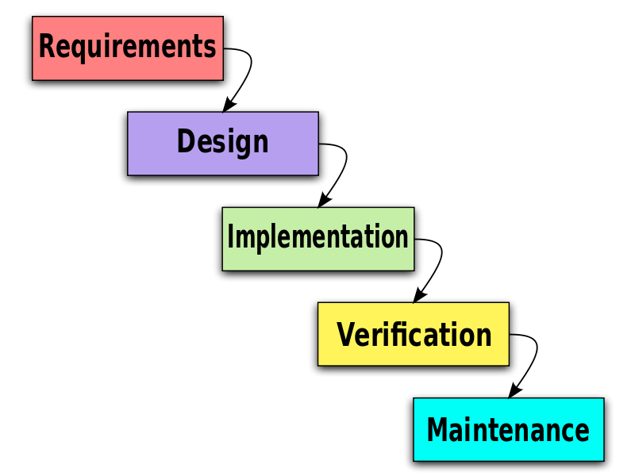
Source: (Nicholls, 2014)

(1) Provide a critical assessment of the usefulness of project management tools and techniques Project management tools and techniques and usefulness for managing a project

1.1 Project Initials
Successful initialization of the projects gives the best start for project management. The stakeholders and the performer should develop some process thus an effective and profitable initialization of the projects can be done (Jarvis, 2009). As it is said that, every project need a good initials. Whenever the manager can develop effective project initials after managing the required resources and time periods, then they can hope for the better success of the projects (Hopkinson, 2014). On the other hand, human resources who are assigned for this project, plays important role to complete the projects. If they can perform effectively in the period of project initials then it could be more helpful for the managers to develop successful project management.
1.2 Work Breakdown Structure (WBS)
Work Breakdown Structure is a kind of activities to break the whole projects into small pieces or activities thus anyone can simply understand it. WBS strategies help to understand the meaning and reason of the activities (Jarvis, 2009). This kind of business strategy gives the information of the purpose of performing the activities and whenever the working employees can easily understand the reason and way of performance, they can easily get motivation to perform.
1.3 Gantt Charts
Using Gantt Charts to perform project management is really essential. The authority and responsible managers easily can stick and figure about the daily performances after developing and analysing the Gantt charts which are like a horizontal bar diagram (Jarvis, 2009). It is more effective for the small projects than larger projects. The working employees can manage their daily needs after evaluating the Gantt charts.

1.4 Critical path analysis
Critical Path Analysis is a kind of route to perform the project management process is most significant way. It gives the direction of activities that should be done for the better success of the projects. Whenever the work breakdown of the project is managed, developing a critical path analysis becomes the essential part. This path gives the sequences of the activities (Jarvis, 2009). The managers need to be more conscious thus the process maintains the sequences. A proper synchronization is required here (Hopkinson, 2014). On the other hand, every single project activity needs to be finished within the given period of time. Critical path analysis also helps to manage the time duration.
1.5 Project Evaluation and Review Technique (PERT)
Project Evaluation and Review technique is important because it provides the performance of the projects. PERT technique can be developed in every spare of the projects to evaluate the performance. The manager can evaluate the initialization process to check if the initialization was accurate or not. They also can check the performance of the projects in the middle of it. Evaluation of the projects after the ending of the project and reviewing it provides greater importance (Hopkinson, 2014). The authority and managers can check the positive and negative asset of the projects. They can check the required time period, necessary equipment, applied human and financial resources and their performances. PERT technique is more helpful to evaluate the internal and external factors (Jarvis, 2009). Now-a-days, project evaluation and review technique is highly monitored because lack of evaluation and review system can harm the whole project process and internal business performances.
1.6 Resources
Project success is largely depends on the successful implementation of resources because lack of resources in the project activity can beak the project process. On the other hand, project initials are depend on the allocation of resources. Every part of process is needed the best application of financial and human resources (Hopkinson, 2014).
Both the financial and human resources are needed for the better success of the organization. Developing effective business strategy needs more financial support. On the other hand, quality of the projects is much important of project management process. Financial support and human resource’s activity helps the organization to perform successful project management and develop quality of projects (Jarvis, 2009). The better understanding of human resources and effective compensational packages motivates the human resources to perform both the organization. Better performance by human resources and stakeholders can helps the authority to impose less financial resources for the projects.
1.7 Milestone
Milestone is a kind of business property which gives every explanation which may help for the managers to implement further business strategies (Jarvis, 2009). It gives the accurate information regarding the maintained project management process, the required human and financial resources, the time periods needed to complete each part of activities and so on (Hopkinson, 2014). To summarize the whole organizational process management activities, milestone is developed. Milestone is the explanation which has done form the starting to end of the project management journey. Gates of the milestones are effective because those provide the stages of the projects. Any anonymous can understand the project management process by analysing the milestone of the projects.
1.8 Project Planning Document (PID)
For the better success of the project management process, the managers need to develop project planning documents. Because this kind of PID documents stores the data about the resources, activities, risks factors of the process. Every process needs better initialization and it should be well planned (Jarvis, 2009). More importantly, the whole project needs well planning. Planning and initialization can motivate the process management process positively. Project planning document helps the managers to overview and evaluate the current and previous performances (Hopkinson, 2014). This could be more helpful whenever the managers and the whole organization will operate the same projects in future. It is a collection of some important information. The authority can force the responsible thus they can practice of managing PID during working.
1.9 Risk Assessment
Risk assessment is a kind of managerial task to reduce the loss as it is early stated. Besides, successful assessment of risk can helps the organizations to understand for applying the different business strategies for the project management (Hopkinson, 2014). All of the working managers need to assess the possible risk and uncertain issues which could provide the challenges to the project management process. Whenever the organization and authority can be able to asset the whole risk of the projects then they could be able to gain more productivity.
(2) Plan the implementation of a project within the workplace. Communicate the project plans with appropriate colleagues and stakeholders. Implement the project plan.

The implementation stage is where the project team mainly organize the project effort to make the deliverables. The term “deliverable” means something about the project brings. The deliverables for the project comprise all of the merchandises or facilities that the project team is carrying out for the customer, buyer, or sponsor, comprising all the task management papers that the members of the project put together. Businesses are continually facing new challenges and chances. The world and market are fast-paced as well as occupied with worries and chances for development. Deprived of the put into practice of project organization, businesses will find themselves sinking in a marine of unsuccessful projects and procedures with rare choices of rescue. The whole process depends on the type of project that supposed to be completed.
Project aim: The aim of the project is increasing the number of guests to the website of Sainsbury.
Project objectives
- The prime objective of this project is increasing a number of visitors of their websites.
- They need to develop IT skills of their department
- The project manager wants to increase also online selling
Reason for the project: Sainsbury is one of the famous organizations in the UK market. They are selling high quality of the product. But now they want to engage their customer in an online network where they can share their thoughts, ideas, complain. It could be increased online sell.
Roles and responsibilities: The project will engage the IT department and marketing department to enhance the capability of their project. But they have some own roles and responsibilities. These are given below:
- IT manager will provide all kinds of facilities to attain the aim of the project
- The marketing manager will help to provide all kinds of data
- Accounting and finance manager will record all kinds of cost regarding the project.

Work Breakdown Structure (WBS) - A Work Breakdown Structure is a categorized breakdown of the deliverables required to finish a task. It breakdowns the deliverables down into wieldy task correspondences that can be arranged and have persons allocated to them. A WBS tool is a typical project management instrument besides the foundation for ample task arrangement. A work breakdown structure in project management is a deliverable-oriented breakdown of a task into minor modules. A work breakdown structure is an important project deliverable that arranges the group's effort into controllable units. The Project Management Figure of Information describes the effort breakdown arrangement. The WBS method visually describes the possibility into controllable chunks that a project group can recognize, as all level of the effort breakdown assembly offers further explanation and fact (Nicholls, 2014).

Figure 01: Work breakdown structure
The project manager of Sainsbury has categorized the work of the overall project. They divide the project into four categories and some sub categories. Gantt Chart- A Gantt chart is a standard project management chart that tracks responsibilities across time. At first, there are no relations with the tasks but after few years Gantt chart has developed its capacity to track both interdependencies as well as time among projects, which is nowadays all organization can use to manage their project. Now Gantt charts have become a business norm. Gantt Charts are a vital project management instrument used for presenting the stages, responsibilities, milestones, and possessions required as a portion of a project (Nicholls, 2014).
Project Activities | 2019
Project Activities | June |  |  |  | July |  |  |  | August |  |  |  | September |  |  |  | October |  |  |  | November
Project Objective | 1
Find out new web link |  |  | 3
Allocate resources |  |  |  |  | 1
Cost profit analysis |  |  |  |  |  | 1
Risk Management |  |  |  |  |  |  | 1
Communication |  |  |  |  |  |  |  | 1
Select and Recruit staff |  |  |  |  |  |  |  |  |  | 2
Train staffs |  |  |  |  |  |  |  |  |  |  |  | 2
Marketing |  |  |  |  |  |  |  |  |  |  |  |  |  |  |  | 4
Communicate with customers |  |  |  |  |  |  |  |  |  |  |  |  |  |  |  |  |  |  |  |  | 4
Collect Data and analyse |  |  |  |  |  |  |  |  |  |  |  |  |  |  |  |  |  |  |  |  |  | 3
Criticism the project |  |  |  |  |  |  |  |  |  |  |  |  |  |  |  |  |  |  |  |  |  |  |  | 1

In this Gantt chart shows that the manager emphasizes perform marketing and communication with customers. In this report the manager spends 8 weeks per activity.
Critical path analysis:
 | Task | Weeks | Proceeding
a | Project Objective | 1
b | Find out new web link | 3
c | Allocate resources | 1 | B
d | Cost profit analysis | 1 | C
e | Risk Management | 1 | D
f | Communication | 1 | E
g | Select and Recruit staff | 2 | F
h | Train staffs | 2 | G
i | Marketing | 4 | H
j | Communicate with customers | 4 | J
k | Collect Data and analyse | 3 | I
l | Criticism the project | 1 | L

Critical Path

h
g
f
e
d
c
b
a
i

l
k
j

Longest path:
a+b+c+d+e+f+g+h+i+k+l= 1+3+1+1+1+1+2+2+8+3+1=24 weeks
Resources:
It is very much important part of any project. The resource indicates employee of the organization here. In this stage, it is necessary to find out members who are capable of doing this type of projects. The successes of the project directly depend on the skills and knowledge of the individuals that are involved with the project. Hence, it would be beneficial to have both experience and a new workforce in the project.
Milestone:
 | Project Activities | Responsible Person | Start Date | End Date | Duration | 2019
 |  |  |  |  |  | June |  |  |  | July |  |  |  | August |  |  |  | September |  | October |  |  |  |  |  | November
A | Project Objective | Marketing manager | 01/06/2019 | 06/06/2019 | 1
B | Find out new web link | Estate Officer | 01/06/2019 | 31/06/2019 | 3
C | Allocate resources | IT manager | 01/07/2019 | 07/07/2019 | 1
D | Cost profit analysis | Finance Manager | 08/07/2019 | 14/07/2019 | 1
E | Risk Management | HRM Manager | 15/07/2019 | 21/07/2019 | 1
F | Communication | HRM Manager | 22/07/2019 | 28/07/2019 | 1
G | Select and Recruit staff | HRM Manager | 02/08/2019 | 14/08/2019 | 2
H | Train staffs | HRM Manager | 15/08/2019 | 31/08/2019 | 2
I | Marketing | Marketing manager | 01/09/2019 | 31/09/2019 | 8
J | Communicate with customers | Marketing manager | 01/09/2019 | 30/10/2019 | 8
K | Collect Data and analyse | Marketing manager | 01/10/2019 | 21/10/2019 | 3
L | Criticism the project | Director of Marketing | 22/10/2019 | 30/10/2019 | 1

PID:
Project Initiation Document (PID) | Tick when complete
Section 1 – What is the project all about?

Project Title:
Increasing visitors of Sainsbury’s website
Background:
It is necessary to clearly describe the responsibilities complicated toward complete the plan. For instance, if the individual are planning on introducing a content marketing movement, main responsibilities will comprise opening a blog, engagement authors, investigating the content that the viewer’s discover pertinent, and encouraging and sharing the project content.
Purpose
The aim of the project is increasing the number of guests to the website of the organization or the project website.
Objectives
- The prime objective of this project is increasing number of visitors of their websites.
- They needs to develop IT skills of their department
- The project manager wants increase also online selling

Project scope
Employees would participate for business expansion

Exclusions from scope
None

Deliverables
The monthly update needs to present to the ‘Project manager’ for every month by,
- IT Department
- Marketing department
- Accounts department
Constraints
Required skilled employees to perform marketing activities appropriately.

Assumptions
Not Applicable

Section 2: Why should this project go ahead?

Business case: Project Benefits
This project helps the Sainsbury to get some more customers. If the customer visits their website then they could be informed about different product and features and discount. So they can get a good idea about it.

Options
- Acquire new customer
- Develop online store or virtual shop.

Cost and Timescale

Cost/Benefit Analysis
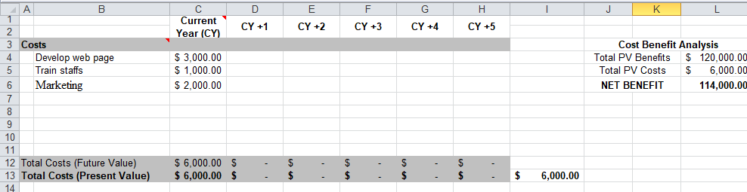
Risk Analysis: Risk Identification
Risk is an unavoidable element of any project. But it is measurable and removable so the employee and manager should take proper action to find out risk about the project.
Risk prevention
Engaging Professionals for increasing new visitors of their website and provide training to the employees to perform all activities appropriately.

Risk Management
N / A

Risk Monitoring
The project manager will analyse the risk and take care to prevent risk.

Section 3: Who will work on the project?
Roles and Responsibilities
The project will engage IT department and marketing department to enhance the capability of their project. But they have some own roles and responsibilities. These are given below:
- IT manager will provide all kinds of facilities to attain the aim of project
- Marketing manager will help to provide all kinds of data
- Accounting and finance manager will record all kinds of cost regarding project.
Project Organization Chart/Structure diagram

Names of: Project Sponsor
Senior Management Team

Project Manager (PM)
Director of IT
Section 4: How and when will the project are delivered?

Initial Project Plan
The project will be start very soon at the beginning of 1st June of 2019 and end will at 30th November of 2019. It will be a six month project.

Schedule (Gantt Chart)
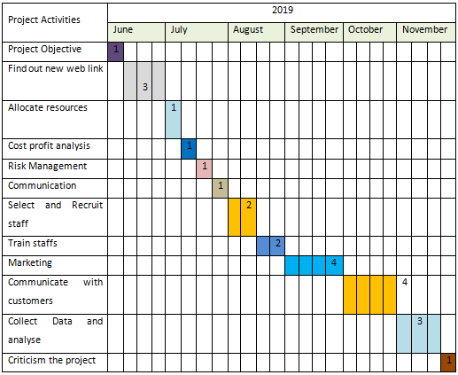
Human Resource Requirements
Need to recruit employees for increasing visitors of their website. HRM department will recruit some permanent and part-time employees for this project.

Support Staff
N/A
Additional Staff
N/A
Project Control: Monitoring mechanisms
The project manager will monitor the project and gets feedback from the employee regarding various issues.
Communication channels and schedules
The performance of the employees would be analysed at the end of the 2019 and new strategies will select for improving the performance of the employees and the development of the organizational activities.

Quality Control
At the time of implementation of the project the monthly performance of the project needs to analyse. And after the date of start opening the total performance of the project would be analyse after six months of time.

Risk assessment: Risk could be identified and the manager also should find out solution of that risk. The project manager should engaged expertise for their project to analyse the performance of the employee and take corrective action to solve this risk. Though it is an IT issue so that the manager should concern about hacking problem also.
Quality Control
To ensure all project activities performed with quality needs to ensure the appropriate control of the project with ensuring the quality.
Project evaluation technique: There are several ways to evaluate the project. Some are financial and some are non-financial. Financial techniques are given below:
NPV (Net present value): NPV identifies the total present value of the project. It helps the organization to find out present value of future cash flows.
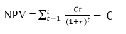
IRR (Internal rate of return): IRR is another important capital budgeting tools. It helps the organization to identify the percentage of profitability.
Identify the financial saving of the project
The financial issue of this project are much concerning matter for the organization. It is issue of sustainability and achieves competitive advantage. There are several financial issues that need be properly managers:
- The manager should use less data and unnecessary information to their project so that they could minimize the data cost.
- The IT manager should use JAVA system to minimize the cost of the project.
Non-financial issue of evaluating project:
Non-financial issue indicates that part of this project which is not measured by money such as quality of product, competitive advantages and so on.
Communication with Colleagues and Stakeholders
Presentation has developed for communication. The presentation is given below:
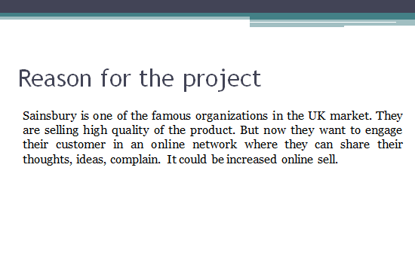
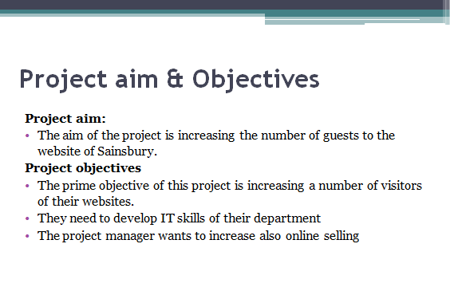
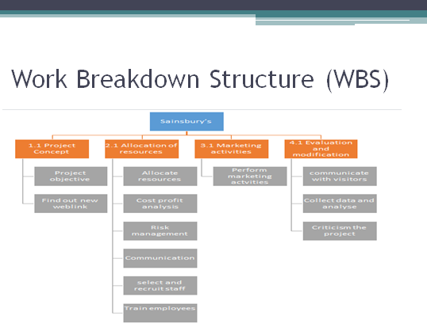
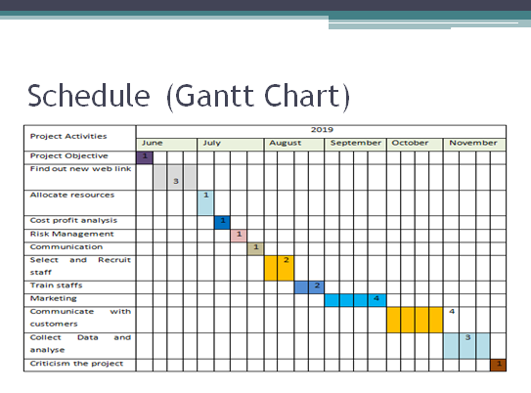
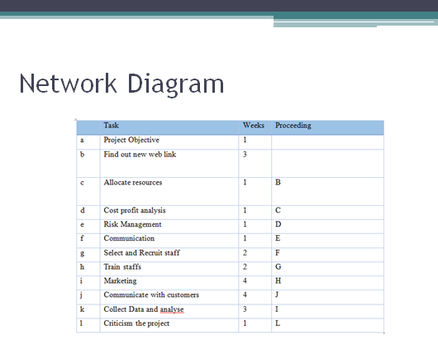

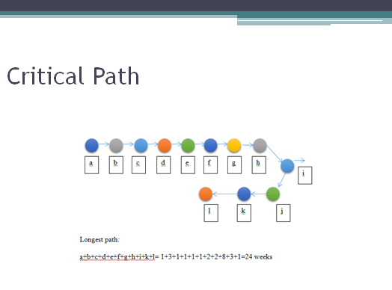

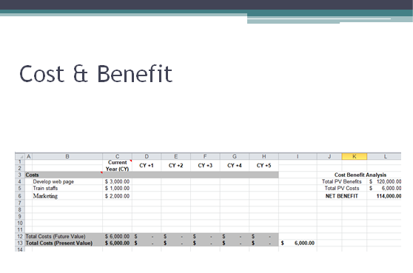

3 “Critically evaluate your ability to manage a project. Use feedback from others to evaluate your own ability to plan and implement a project, identifying strengths and weaknesses. Create a self-development plan to improve your own performance in managing projects.”

After taking several stages for implementing a project or plan a project it is necessary to seek feedback from the other members of the project as this process helps an individual to develop his or her ability to complete the project. An individual can take a chart of feedback form to seek feedback from other members. I use the following evaluation form to collect feedback from the staffs of my area. This helps me to evaluate my skills and knowledge.

After taking feedback from the co-workers of the organization it is the time to find out the weakness and strength of my ability to complete a project. I have taken several strategies to find out my weakness and strength to do a project. I have all kind of information and knowledge about project management techniques and tools (Calderhead.et.al. 2012). I have also experience to apply those skills and knowledge within the business, this experience helps me to take any kind of project without any dilemma. I have several courses relating to the project management to gain my knowledge in this sector. I have experiences to perform under tremendous pressure. There are several weakness such communication, working within a specific time period, communicating with other department is the main weakness of mine. It is necessary to overcome that weakness and perform better in a project. Sometimes I find it difficult to define a project and implement the project in an accurate way. SWOT analysis is the most appropriate way to improve my skills to perform a project management as this study find out the weakness and possible threats.
Strengths | Weaknesses
I have all kind of information and knowledge about the project management techniques and tools. I have also experience to apply those skills and knowledge within the business, this experience helps me to take any kind of project without any dilemma. I have several courses relating to the project management to gain my knowledge in this sector. I have experiences to perform under tremendous pressure (Calderhead.et.al. 2012). | There are several weakness such communication, working within a specific time period, communicating with other department is the main weakness of mine. It is necessary to overcome that weakness and perform better in a project. Sometimes I find it difficult to define a project and implement the project in an accurate way.

Development plan: - after analysis of the weakness of my skills it is necessary to take action for developing the plan. A plan can be developed after starting the project and analysis of the drawbacks of the project. It is necessary to reflect all the development plan with the staff's current accomplishment objectives, the date of accomplishing these skills, appraisal dates, and also the individual learning abilities. Project managers and the individuals essential to deal with persons. Simply in very few businesses can the project manager select their group members. Typically accessible group members are allocated toward the project, in addition possibly not all of them are expert enough (Calderhead.et.al. 2012).
Identify and plan relevant training and development activities.
What are my development  objectives | Priority | What activities do I need to undertake to achieve my objectives? | What support/resources do I need to achieve my objectives | Target date for achieving my objectives | Actual date of achieving my objectives
IT skills | High | Need to receive short training | Need support from trainer | 01-06-2019 to 15-06-2019 | 01-06-2019 to 20-06-2019
Problem Solving Ability | High | Need to read different case studies | Need laptop to study | 01-06-2019 to 30-05-2019 | 01-06-2019 to 30-05-2019
Knowledge in JAVA, PHP, HTML | High | Need to find knowledge on ethics | Need to gain ability to find out right ethics | 01-06-2019 to 25-05-2019 | 01-06-2019 to 25-05-2019
Knowledge in various coding and boosting | Moderate | Need to read different case studies | Need laptop to study | 01-06-2019 to 25-05-2019 | 01-06-2019 to 25-05-2019
E-marketing | Moderate | Need to receive short training | Need support from trainer | 01-06-2019 to 15-06-2019 | 01-06-2019 to 15-06-2019

Conclusion
Businesses are continually facing new challenges and chances. The world and market are fast-paced as well as occupied with worries and chances for development. Deprived of the put into practice of project organization, businesses will find themselves sinking in a marine of unsuccessful projects and procedures with rare choices of rescue. All businesses essential to proceeds project management extremely so as to stay active and thrive. Deprived of a clear track to track when it comes to handling tasks, the mission of attaining their anticipated purposes will prove very challenging. Constraints for example period, assets, finances, possibility, and superiority are all too important to merely pass over deprived of put on a methodical method. Project management offers precisely that: a technical method that aids to safeguard effective results through assembly and organisation.

Reference
Ababa University’s Tikur Anbessa Specialized Hospital (Ethiopia). Globalization and health, 10(1), p.1.
Alexandra, D. & Britton, A. (2014). International Financial Reporting and Analysis. Andover: South-Western Cengage Learning. Retrieved from http://lib.myilibrary.com/ProductDetail.aspx?id=549474.
Alexandra, D. & Britton, A. (2014). International Financial Reporting and Analysis. Andover: South-Western Cengage Learning. Retrieved from http://lib.myilibrary.com/ProductDetail.aspx?id=549474
Berry, A. & Jarvis, R. (2011). Accounting in a Business Context. South-Western Cengage Learning. Retrieved from http:// http://lib.myilibrary.com/ProductDetail.aspx?id=328474
Busse, H., Aboneh, E.A. and Tefera, G., 2014. Learning from developing countries in strengthening health systems: an evaluation of personal and professional impact among global health volunteers at Addis
Bunderson, J.S. and Boumgarden, P., 2010. Structure and learning in self-managed teams: Why “bureaucratic” teams can be better learners.Organization Science, 21(3), pp.609-624.
Calderhead, J., Denicolo, P. and Day, C. 2012. Research on Teacher Thinking (RLE Edu N): Understanding Professional Development. Routledge.
Cummings, T. and Worley, C., 2014. Organization development and change. Cengage learning.
Fink, L.D., 2013. Creating significant learning experiences: An integrated approach to designing college courses. John Wiley & Sons.
Ho, L.A., 2011. Meditation, learning, organizational innovation and performance. Industrial Management & Data Systems, 111(1), pp.113-131.
Hopkinson, C. 2014. Personal and professional development: A Textbook for Professional Practice. 383.
Jarvis, P. 2009. The Routledge international handbook of lifelong learning. Routledge.
Jarvis, P. 2009. The Routledge international handbook of lifelong learning. Routledge.
Kop, R. and Fournier, H. 2011. New dimensions to self-directed learning in an open networked learning environment. International Journal of Self-Directed Learning. 7(2). Pp. 2-20.
Larson, E.W. and Gray, C.F., 2011. Project management : The managerial process
Kop, R. and Fournier, H. 2011. New dimensions to self-directed learning in an open networked learning environment. International Journal of Self-Directed Learning. 7(2). Pp. 2-20.
Larson, E.W. and Gray, C.F., 2011. Project management : The managerial process
Walton, P. & Walter, A. (2013). Global Financial Accounting and Reporting: Principles and Analysis. Andover: South-Western Cengage Learning. Retrieved from http://lib.myilibrary.com/ProductDetail.aspx?id=458683

