

Module Name: Managing Enterprise
Module Code: BMSW4011
Assignment Name: Business Plan and Reflection
Student Name: Vera Yasmin Ahmed
Student Number: 2432984
Lecturer: Jaliya de Silva
Deadline: Friday 6th March 2026 23:59PM

AI Acknowledgement
Examples of statements If you have not used AI
I confirm that I have not presented any AI generated materials as my own work.
I confirm that I have copies of my drafts, notes, and other resources I used, which I may be asked to provide in evidence.
Examples of AI statements if you have used AI
Example 1:
I confirm that I have not presented any AI generated text as my own work. I confirm that I have copies of my drafts, notes, and other resources I used before, and after the use of AI tools which I may be asked to provide in evidence.
Example 2:
I confirm that I have not presented any AI generated text as my own work. I confirm that I have copies of my drafts, notes, and other resources I used before, and after the use of AI tools which I may be asked to provide in evidence.
Example 3:
I confirm that I have not presented any AI generated text as my own work. I confirm that I have copies of my drafts, notes, and other resources I used before, and after the use of AI tools which I may be asked to provide in evidence.
*You must provide an AI statement
*AI was used only for the creation of the flyer and business card, following discussion with my lecturer and with his permission. The image was generated based on my own drawing to produce a usable form.

Contents:
- Introduction …………………………………………………….1-2
- Business Concept and Product Offer ………………….2
- Business Ownership ………………………………………….2
- Mission, Aim and SMART Objectives …………………2
- Unique Selling Proposition (USP) ………………………2
- SMART Objectives …………………………………………….2-3
- Location and Operations ………………………………….3
- Marketing and Branding ……………………………………3
- Market Research ……………………………………………….3
- Financial Resources and Forecast …………………… 3-4
- SWOT Analysis ……………………………………………….4
- Conclusion …………………………………………………….4
- Individual Reflection ……………………………………… 5-6
- Reference List ………………………………………………. 7-8
- Appendices ………………………………………………….9 - 15

Business Plan for Hashira House Café

Word count: 1002

Business Name: Hashira House Café
Business Type: Sole Trader
Location: Swansea City Centre
Owner: Vera Yasmin Ahmed

Introduction
Hashira House Cafe is an Anime inspired cafe located in Swansea city centre, combining Japanese cuisine with anime entertainment. Guests will enjoy high quality food alongside experiences like a VR “Infinity Castle” and battle simulations inspired by Demon Slayer (Advanced Television, 2025). The business idea reflects on my personal passion for anime and the growing interest in Asian pop culture, Japanese Anime what is significantly growing in the UK (Business Research, 2026). Events such as Comic Con and local anime conventions regularly draw thousands of fans, showing strong demand for anime themed entertainment experiences.
Business Concept and Product Offer
Hashira House Cafe is an anime themed cafe locate it in Swansea city centre. The concept of this cafe combines food, entertainment, and interactive experiences inspired by Japanese anime and Asian pop culture (Grylls, 2025). The cafe is to provide customers with a unique dining environment and experience that goes beyond traditional cafes with its extraordinary atmosphere (Japan Centre, 2022). The menu will include ramen, sushi, rice bowls, bento boxes, and themed desserts and drinks. A key feature of the café will be an immersive virtual reality experience inspired by the “Infinity Castle,” allowing visitors to enjoy an interactive anime-style environment (Japan Expo,2005).

Business Ownership
Hashira House Cafe will operate under a sole trader ownership structure. This type of business structure is commonly used by small startups businesses because it has easy process to register, involves lower startup costs, and allows the owner to have complete control over business decisions and operations (Whittington et al., 2023). However, being a sole trader also means that the owner has unlimited liability and is personally responsible for any financial debts or obligations of the business (Marriott and Williams, 2018).
"Please see Appendix 2 for an image of the business cards."
Mission, Aim and SMART Objectives
The mission of Hashira House Cafe is to provide a unique and extraordinary cafe experience in Swansea. Swansea is well known for dining experiences what attracts visitors, students and locals (Morning Advertiser, 2025). The business is to become a popular destination for students, families, and anime fans by offering an unforgettable experience (Alibaba Product Insights, 2026). To achieve this, the café will target at least 1,500 customers within the first three months of opening. It also aims to maintain an average customer satisfaction rating of 4.5 stars. These objectives are specific, measurable, achievable, relevant, and ensuring clear direction for the growth of the business.
Unique Selling Proposition (USP)
Hashira House Cafes USP is its combination of immersive entertainment and high quality Japanese inspired dining, creating a unique experience in Swansea. The cafe offers a virtual reality (VR) Infinity Castle experience, cinematic anime style battle simulations, and themed decor, transforming visits into Disneyland like experience and memorable events (Rocha, 2025). It also provides family friendly activities, such as cosplay nights with opportunities to meet favourite characters, anime screenings, selfies and voice character meet and greets, appealing to both anime fans and general visitors.
SMART Objectives
Attract at least 1,500 customers within the first three months
Maintain an average customer rating of 4.5 stars
Break even within the first 12 months of operation through controlled costs and steady revenue growth.
Host at least two themed events per month, including cosplay nights, anime screenings, birthday parties.
Launch marketing campaigns and community engagement initiatives within the first month of opening to achieve targets
Location and Operations
Hashira House Cafe will employ a team of 2–4 staff: an owner-manager, a chef, cook and a part-time assistant. Staff will manage food preparation, customer service, and VR experiences, ensuring high-quality service and operational efficiency. Café will be located in the City Centre, next to main shops and city main Library (Brooks,2026).
Marketing and Branding
Hashira House Cafe will promote its immersive experiences via social media platforms including Instagram, TikTok, and YouTube, alongside local university collaborations and cosplay/community events. Loyalty schemes, themed menus, and merchandise will encourage repeat visits. Branding focuses on creating an extraordinary café with experience that never been seen before (Flor,2025).
"Please refer to Appendix 1 for an image of the Flyer."
Market Research
Primary research was conducted using a Microsoft Forms survey which received 18 responses from individuals in Swansea, Cardiff and nearby areas (Ponto, 2015). The results suggest there is a strong interest in an anime themed cafe. Out of the participants, 11 respondents identified as students, which significant shows Swansea’s large university population. In terms of behaviour, 7 people stated they visit cafes a few times per month, indicating regular demand for cafe spaces. When asked about the concept, 12 respondents said they would likely visit an anime themed café. Popular features included themed decor (9 responses), Japanese-inspired food (7 responses) and social media photo opportunities (8 responses).
"Please see Appendix 3-6 for images of the questionnaire responses."
Financial Resources and Forecast
Hashira House Cafe requires approximately £60,000 startup capital for premises, decor, equipment, VR technology, stock, and marketing. Funding will come from personal savings, a Start Up Loan, and local grants (Development Bank of Wales, 2026). Monthly operating costs are projected at £20,500, covering rent, staff wages, utilities, and maintenance. Revenue is expected to grow from £18,000 in the first month to £28,000 by month 12, with breakeven around month four. VR experiences, events, and merchandise will supplement income.
"Please see Appendix 7 for an image of the Excel financial table."
SWOT Analysis
Hashira House Cafe offers a unique and an extraordinary concept that combines anime culture with themed dining and entertainment. This type of cafe is not common in Swansea. As a startup, the business may take time to build awareness and a loyal customer base. A small team may also face pressure during busy periods. Anime events such as Comic Con in Swansea and Cardiff attract 8,000–18,000 visitors, showing strong interest in anime culture.
Competition from existing cafés and rising operating costs could affect the business (Asana,2026).
Conclusion
Strong attendance at Welsh anime conventions and growing interest in Japanese pop culture and market research shows clear demand.

Individual Reflection
Word count: 500 words
Developing this business plan for Hashira House Cafe has been extremely important step and experience for me as my long-time dream, I have gained a knowledge of how business really works and what is necessary to start one. From the start, the idea of a Japanese inspired cafe with anime themed entertainment felt exciting because it reflects my passion for anime and Asian culture and cuisine. I have always enjoyed attending conventions and Swansea Christmas parades and bring smiles to people faces, so creating a space that brings that feeling to others felt both natural and motivating. The process of researching the market was particularly interesting. I had been surprised by the interest in anime and Asian pop culture in the UK, when I looked at events like Comic Con and local conventions in Wales. Seeing that thousands of fans attend these events annually made it clear that there is a strong demand for themed entertainment experiences. It also helped me understand that the cafes success would depend not only on food and drinks but also on offering unique, interactive experiences like the VR “Infinity Castle” and cinematic battle simulations inspired by Demon Slayer. I strongly believe that my idea is very unique and expending this business will be just matter of time. As I do believe the cafe will have huge success and have big potential. Working on the financial sections of the plan was challenging but incredibly knowledgeable. Estimating startup costs, monthly operating expenses forced me to think practically what I will need to successfully open the cafe. I realized that ideas alone are not enough, what is a must is an understanding of cash flow, funding, and financial planning. Creating the Excel financial forecast was little bit difficult because of my low knowledge on how to operate in Excel but I have gained a clearer picture of how the cafe could perform month to month bases and the importance of careful budgeting. It also made me more aware of potential risks, like unexpected expenses or slower customer attendance. Reflecting on the work, I feel proud of how the creativity align with research and planning. It is a reminder, perhaps also an inspiration that personal passions can be a strong foundation for a business, but success depends also on research, strategy, and understanding your audience, market research and careful planning. I also learned that presenting an idea clearly through a structured business plan, customer demands and market research, helps communicate the potential to others, whether investors, partners, or customers. This project has also encouraged me to think about long term growth and adaptability. Trends in pop culture can shift quickly, so I have considered how the cafe might introduce new experiences or events to keep customers engaged with new trends and requirements and same time stay true to cafe identity. Developing this business plan has been both a personal and professional learning experience. I have gained knowledge and confidence in my ability to connect my passions with business.

References:
Advanced Television. (2025). Demon Slayer sets anime UK box office record. Available at: https://www.advanced-television.com/2025/09/19/demon-slayer-sets-anime-uk-box-office-record/ (Accessed: 23 February, 2026)
Business Research Insights. (2026). Anime Market Size, Share, Trends | Forecast to 2035. Available at: https://www.businessresearchinsights.com/market-reports/anime-market-118294 (Accessed: 28 February, 2026).
Grylls, B. (2025). Trends in Japanese cuisine in the UK 2025. Food Manufacture. Available at: https://www.foodmanufacture.co.uk/Article/2025/08/12/trends-in-japanese-cuisine-in-the-uk-2025/ (Accessed: 28 February 2026).
Japan Centre. (2022). Japanese café culture and dining trends in the UK. Available at: https://www.japancentre.com/ (Accessed: 28 February 2026).
Japan Cultural Expo (2025) Immerse in the worlds of anime, manga, and games. Available at: https://japanculturalexpo.bunka.go.jp/en/article/summary/202503/ (Accessed: 1 March 2026).
Whittington, R., Pettigrew, A., Peck, S., Fenton, E. and Conyon, M. (2023) Exploring strategy: text and cases. 12th edn. Harlow: Pearson Education.

Marriott, N. and Williams, M. (2018) Entrepreneurship and small business management. 3rd edn. London: Pearson Education.

Morning Advertiser. (2025). Gen Z reshapes UK hospitality with immersive experiences. Available at: https://www.morningadvertiser.co.uk/Article/2025/08/29/gen-z-reshapes-uk-hospitality-with-immersive-experiences (Accessed: 28 February 2026).

Alibaba Product Insights. (2026). Anime Cafe Aesthetics: Are themed cafes still popular in 2025? Available at: https://www.alibaba.com/product-insights/anime-cafe-aesthetics-are-themed-cafes-still-popular-in-2025.html (Accessed: 28 February 2026).
Rocha, A. (2025). Augmented Reality Cafés: The Rise of Interactive Coffee Experiences. Available at: https://famebst.com/augmented-reality-cafes-the-rise-of-interactive-coffee-experiences/ (Accessed: 3 March 2026).
Brooks, L. (2026). Why are anime cafes becoming popular in major cities. Available at: https://www.alibaba.com/product-insights/why-are-anime-cafes-becoming-popular-in-major-cities-cultural-appeal-explained.html (Accessed: 3 March 2026).

Flor R. (2025). Coffee Shop Branding: From Local Cafe to Iconic Brand. Available at: https://byflorr.com/coffee-shop-branding-from-local-cafe-to-iconic-brand/ (Accessed: 2 March 2026).

Ponto, J. (2015). Understanding and evaluating survey research. Journal of the Advanced Practitioner in Oncology, 6(2), pp. 168–171. Available at: https://pmc.ncbi.nlm.nih.gov/articles/PMC4601897/ (Accessed: 2 March 2026).

Development Bank of Wales. (2026). PPC – Government-backed business loans. Available at: https://developmentbank.wales/ppc-government-backed-business-loans (Accessed: 6 March 2026).

Asana. (2026). SWOT analysis: Examples and templates. Available at: https://asana.com/resources/swot-analysis (Accessed: 6 March 2026).

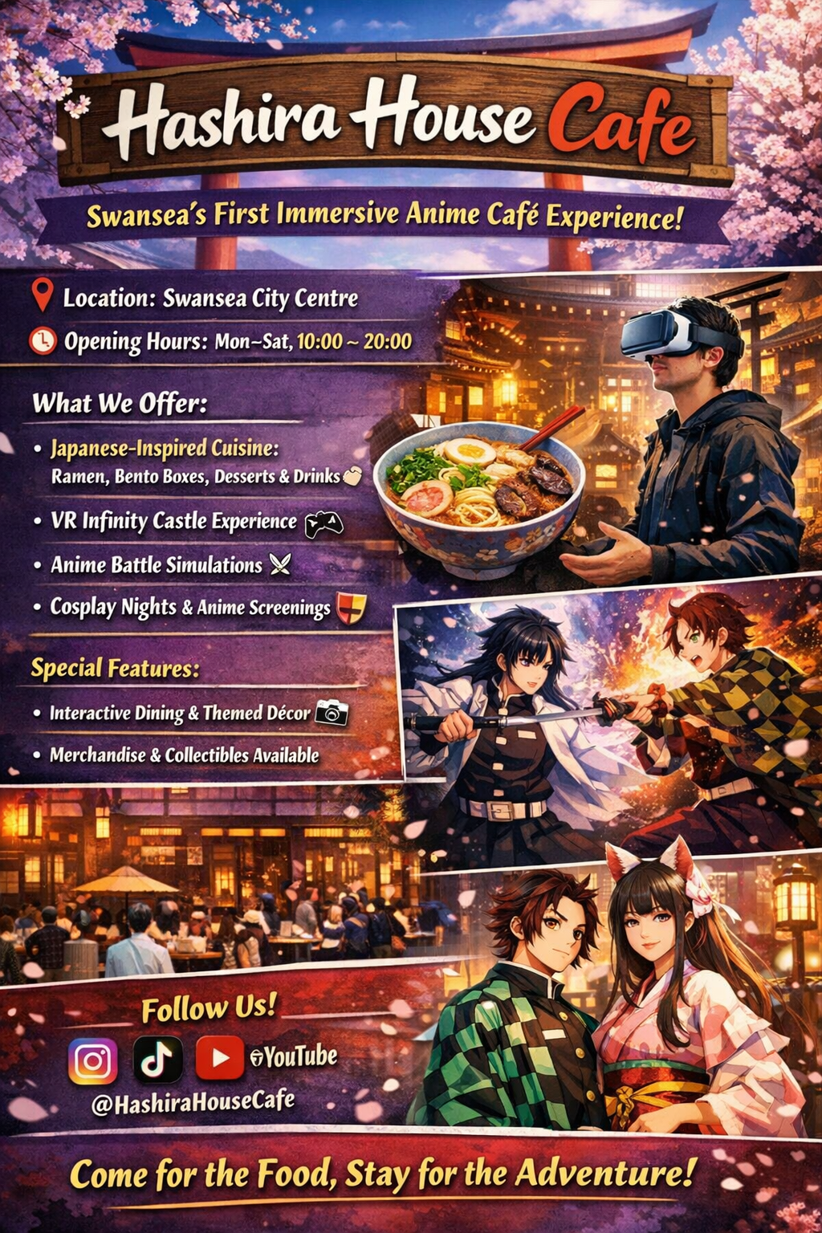
Appendix 1

Appendix 2
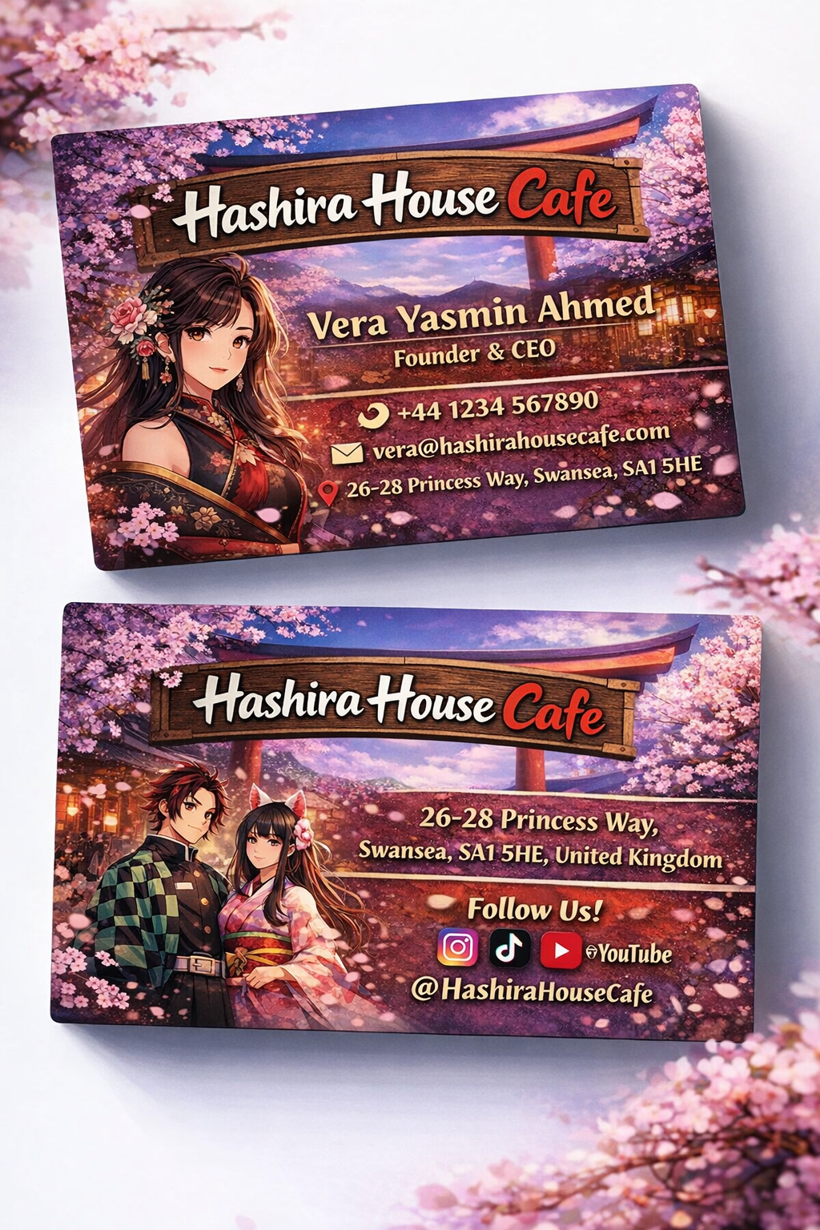

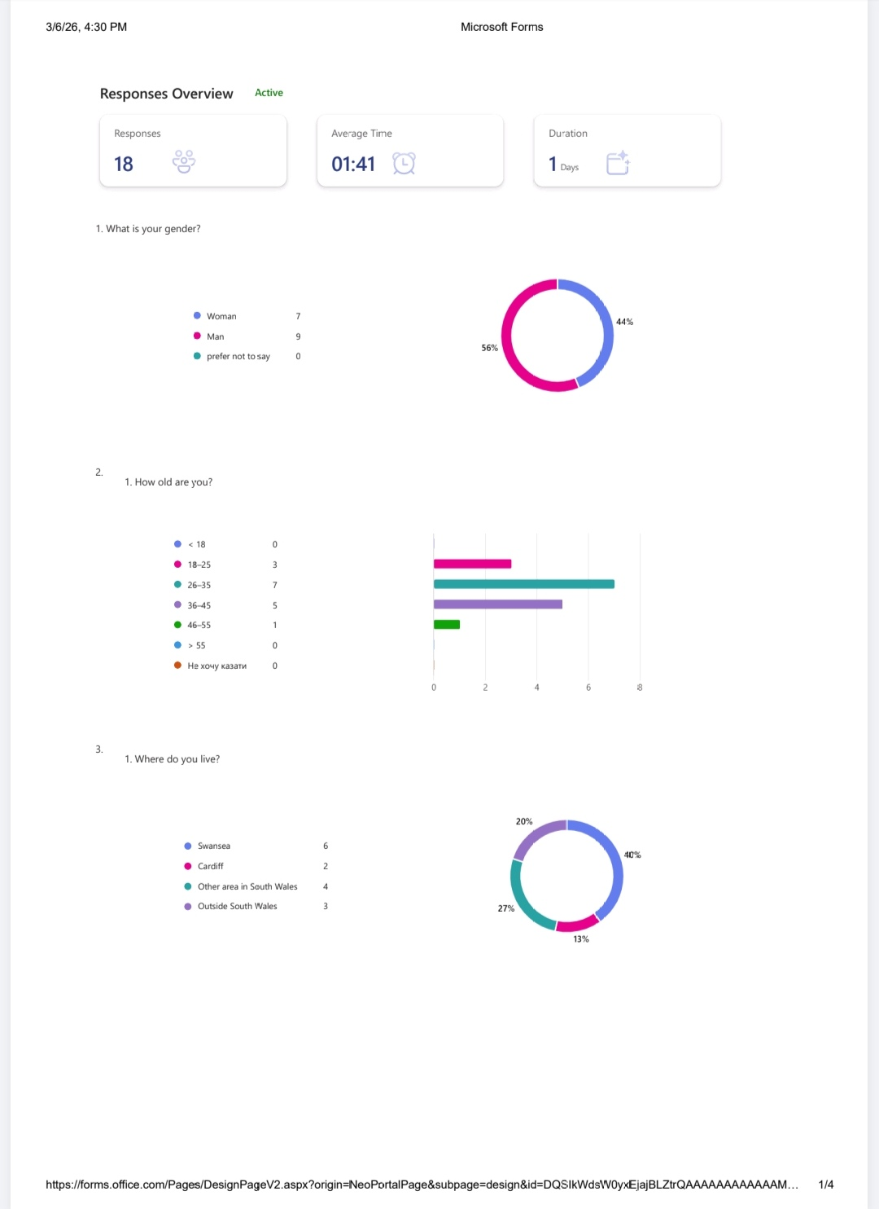
Appendix 3

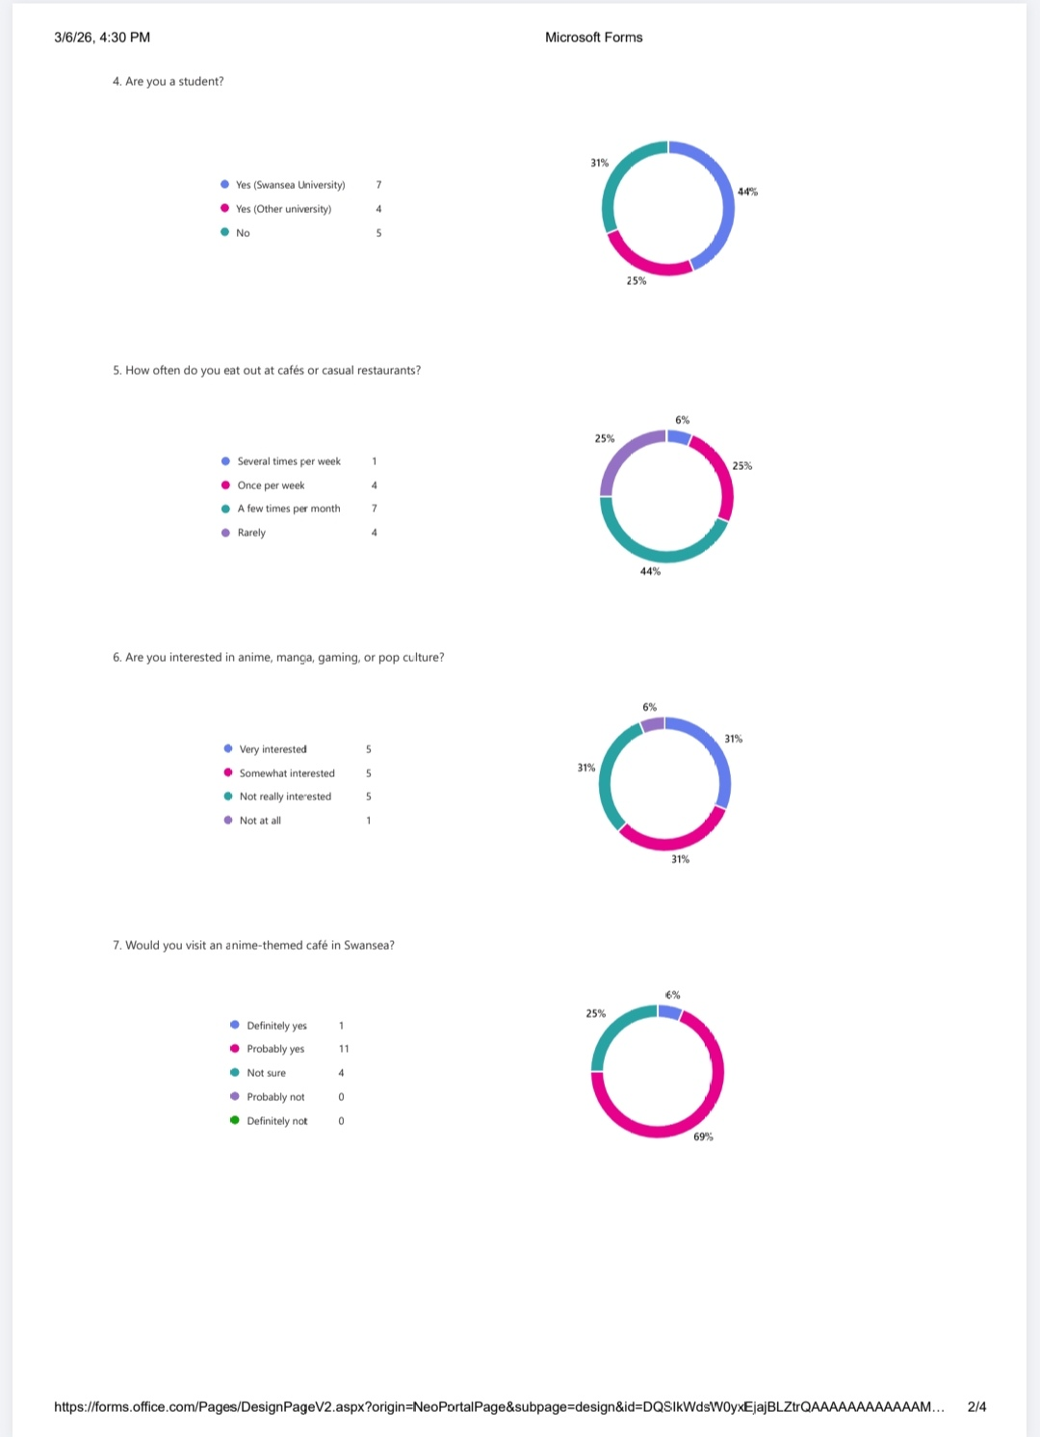
Appendix 4

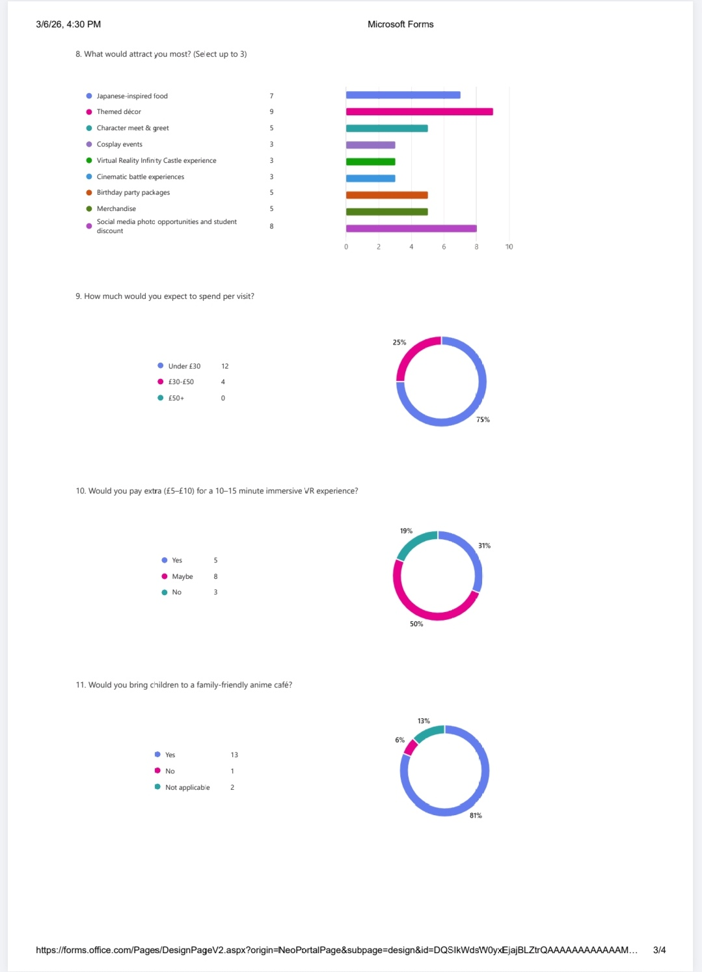
Appendix 5

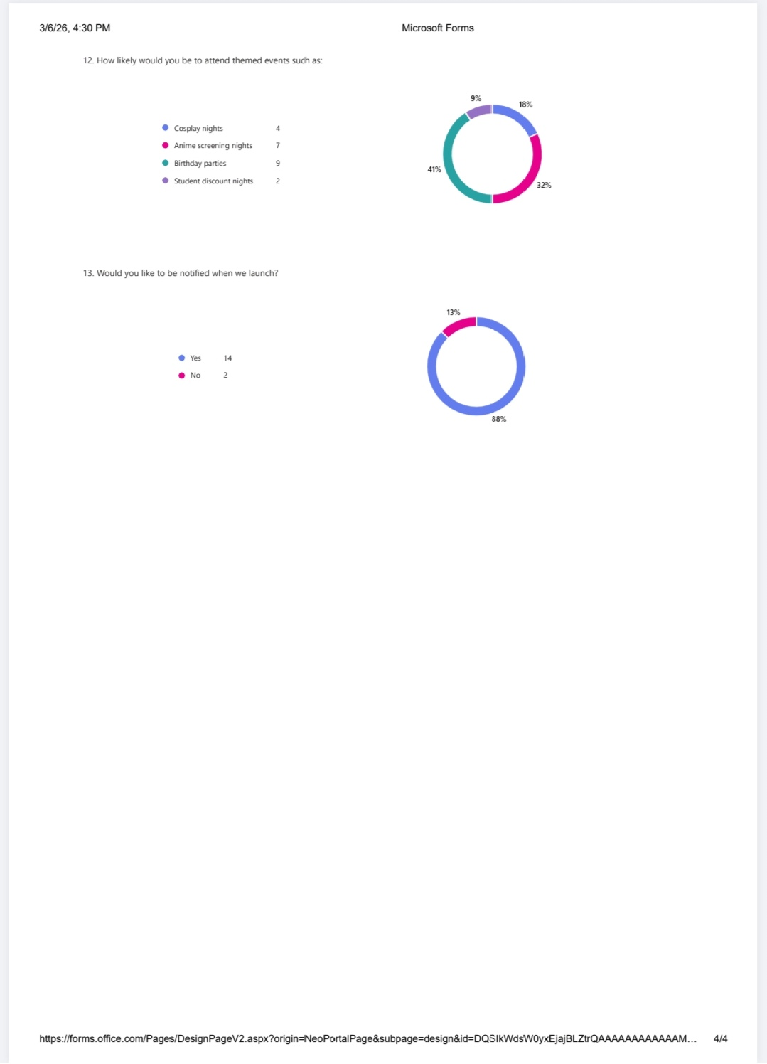
Appendix 6

Appendix 7

