

Course title: Six Sigma Green Belt

Course code: ACMA 5005

Lecturer: Andrew Thorn

Assignment title: Undertaking a Green Belt Project

Student name: Ryan Lewis

Student number: 2318511

Hand in date: 28-04-2025

Contents page

Title page 1
Contents page 2
List of figures and tables 3
Tables 3
Figures 3
Introduction 4
Define 4
Problem Statement 4
Voice of customer / Critical to quality 5
Selecting a team 7
Process flow 7
Project charter 8
Measure 10
Data Collection plan 10
Measurement variation 12
KPI’S 14
Machine downtime: 14
Percentage of downtime caused by lower turret 14
Mean Time Between Failures (MTBF): 14
Mean time to repair (MTTR): 14
Process capability 15
Analyse 15
Process Analysis Methods 15
Further investigation into causes 16
Ishikawa 17
FMEA 17
5 Whys 19
Improve 23
Condition monitoring 25
Pilot proposals 26
Improved FMEA phase 28
RPN value comparison 30
Control 30
References 32
Appendices 33

List of figures and tables

Tables

Table 1 Voice of customer / Critical to quality table……………………………………6
Table 2 Project charter…………………………………………………………………8-9
Table 3 Snapshot of table from job tickets taken from syteline……………………..11
Table 4 Metrics description and reasoning……………………………………………11
Table 5 Sum of individual machine metrics table…………………………………….12
Table 6 Ammount of defect occurrences and cumulative percentages……………13
Table 7 FMEA for lower turret issues………………………………………………16-18
Table 8 5 Whys of the highest scoring RPN values………………………………19-21
Table 9 Root cause table with umber of occurrences and percentages…………...21
Table 10 Estimation of time savings…………………………………………………….25
Table 11 Improved FMEA for lower turret issues…………………………………..26-27
Table 12 Actions put in place and targeted improvements……………………………29

Figures
Fig 1 Integrex defects pareto chart…………………………………………………..10
Fig 2 Chart of individual machine metrics…………………………………………..12
Fig 3 Chart of lower turret issues…………………………………………………….13
Fig 4 Pareto analysis of lower turret defects………………………………………..13
Fig 5 Ishikawa diagram of lower turret issues……………………………………...16

Introduction

Renishaw, a British manufacturer of precision engineering with locations all over the world, is well-known for its industry-leading products that are utilised by some of the largest corporations worldwide, Renishaw PLC, (2025).
At its Miskin facility in South Wales, Renishaw produces a wide range of goods, including high-precision scale, CMM machines, additive manufacturing machines, and numerous parts for machinery. More than 40 different automated machines are used in the machine shop on this site to assist in the manufacturing of specific components.

The project is being undertaken with an aim to improve the efficiency of the machines located within the Miskin site by way of reducing the occurrence of downtime and speeding up the downtime period. The project will focus on the Mazak Integrex I200 machines.

Define

Problem Statement
Renishaw’s Miskin facility faces productivity losses due to unplanned downtime in its Mazak Integrex I200 machines. The Mazak Integrex I200 is one of the most significant machines located at the Miskin site. With its five-axis machining capability, this CNC milling and lathe machine is used to create a variety of complex parts that other machines cannot, Mazak (2025).Due to the importance of these machines, which are influenced by customer demand and deadlines, they should ideally be kept operating as consistently and practically as possible. However, these machines do encounter many issues. Because of the large number of components and systems involved, these machines are susceptible to many problems, particularly when operating at their current extremes.

The objective has been to try and increase these machines' efficiency by lowering their downtime. The goal is to use data to determine the most effective strategies for reducing the number of breakdowns and to create and execute specific protocols that will help shorten breakdown times. By developing a more efficient process from both performance and maintenance standpoints, the project aims to create more efficient ways of dealing with breakdowns, implement strategies to address issues, and make changes to the machines to improve and monitor their performance.

According to reports that have been compiled by management, the 12-month average downtime across the 8 Integrex machines is 1149.67 hours (Thomas, 2024). This equates to an uptime percentage of 86.88% overall. According to Lange, (2025), the machines should be running at 90% capacity. The project will aim to improve the efficiency of the machines and help the company reach their targets. (See Appendix A and Appendix B).
[Fig 1]

lucidchart (2017).

This project will adhere to the Lean Six Sigma DMAIC framework. This methodical process involves identifying the problems, quantifying them, analysing the information, improving the systems, and finally managing them. By adhering to this framework as outlined by Pyzdek (2018, part II), the project should result in fewer breakdowns and significantly shorter repair times, which will raise customer satisfaction.

Voice of customer / Critical to quality
V.O.C. – The management team devised a strategy to identify areas for improvement. In order to gather qualitative information and identify some of the primary reasons why machines break down, discussions were conducted with both shop floor managers and machine operators. Problems with the lower turret and frequent leaks were among the numerous issues raised (Lange, Rayner, and Westall, 2024).
C.T.Q. - The conversations with the operators and management revealed the requirements for the machine are for them to run smoothly without failure. The primary needs were reduced downtime, uninterrupted machine operation, and quicker response and repair times (Lange, Rayner, and Wesrall, 2024).
Using Hessing (2025) as a helpful research resource, the collected data has been entered into a table.

Customer group | Voice of customer | Needs | Drivers | Critical to quality
Manufacturing team leaders (Lange, 2024).  (All data from this customer group was retrieved through spoken communication with Lange, 2024) | Less downtime, faster repair times and Increased uptime | Need the machine to breakdown less and be fixed quicker | More thorough PPM schedules (Lange, 2024). | To suffer less breakdowns and keep the machines running consistently whilst producing good parts so the workload doesnt fall behind.
 | Less downtime, faster repair times and Increased uptime | Need the machine to breakdown less and be fixed quicker | Having sufficient spare parts on stock.
 | Less recurring issues | Some issues with the machine keep reoccuring, such as the lower turret issues, ATC malfunctions and leaks. | Check the machines over more regular.
 | Less recurring issues |  | Take more care with PPM.
 | Less recurring issues |  | Repair root cause rather than initial issue.
Operators (Rayner and Westall, 2024).  (All data from this customer group was retrieved through spoken communication with (Rayner and Westall, 2024). | Leaks and lower turret issues are causing big delays in manufacturing. | Need the machine to breakdown less and be fixed quicker. | More thorough PPM schedules. | To suffer less breakdowns and keep the machines running consistently whilst producing good parts so the workload doesnt fall behind.
 |  | Need the machine to breakdown less and be fixed quicker. | Having sufficient spare parts on stock.
 | Less issues which cause parts to be scrapped. | Getting too much scrap parts caused by machine stopping mid cycle and poor coolant coverage. | Check alignments of turret on PPM.
 | Less issues which cause parts to be scrapped. |  | Make everyone on the same page when it comes to certain issues as some shifts dont repair the issues as good as others.
[Table 1]

Understanding where the focus needs to be placed has been made easier by the V.O.C. and C.T.Q. Now that the maintenance logs have been reviewed, a more thorough examination of the problems can be carried out during the measurement phase.

Selecting a team
A team was selected and put together to undertake the project. The members of the team are:
Dan Thomas, Works engineering plant maintenance manager.
Ryan Lewis, maintenance engineer who will be leading the project.
Owen Davies, senior maintenance engineer.
John Withey, maintenance engineer.

Process flow
A simple current process flow chart of the lower turret [Fig 2] was conducted to help visualise the areas of concern as the lower turret was an area of concern from the perspective of the operators and managers. Looking at the individual processes will help to reveal and understand where breakdowns and delays can frequently occur. Rotating the turret to the proper tool position is the most obvious step that could cause problems, according to the chart. These are crucial stages where enhancements can greatly lower downtime and boost productivity.
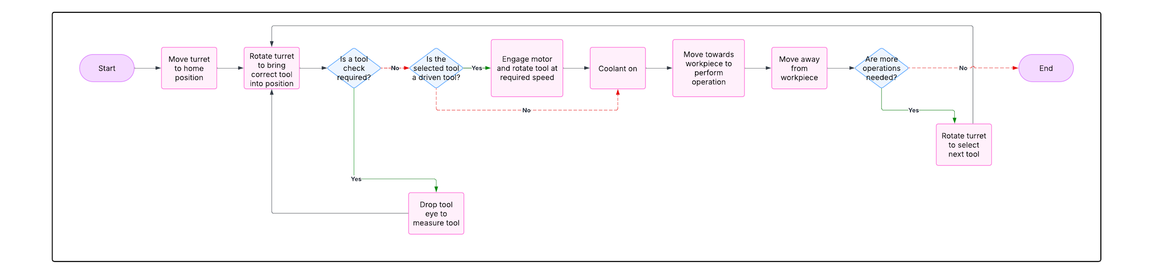

Project charter
A project charter based on the data collected thus far was carried out. According to Marthur (2023), a project charter is an essential tool for project guidance that establishes the groundwork for a successful project by precisely defining the goals, scope, and deliverables, among other things.
After conducting research and utilising information from Iyer (2021), the project charter table that follows was produced.
Project Title | Reducing downtime on Mazak Integrex I-200 machines
Project Sponsor | Renishaw PLC. | Date of project | 01-09-2024
Project Manager | Ryan Lewis | Project due date | 28-04-2025
Project description | Reducing the amount of downtime caused by issues with the lower turret which occurs on the Mazak I-200 CNC machines.
Team members | - Ryan Lewis, Project manager  - Dan Thomas, Works engineering manager  - Owen Davies, Senior maintenance Engineer  - John Withey, Maintenance Engineer  - Operators of Shift C  - Paul Lange, Machineshop manager
Project Objectives | - Reduce downtime,  - implement procedures for faster repair times,  - implement any changes to help prevent breakdown occurance,  - Implement more vigorous preventative maintenance and monitoring techniques.
Business Case | As the Integrex I-200 is a vital machine in the manufacturing process, producing hundreds of parts for customers daily, any downtime is very costly to the business. Any downtime is extremely expensive for the company because the Integrex I-200 is an essential machine in the manufacturing process that produces hundreds of parts for customers every day. Downtime interruptions have a negative impact on the business, leading to higher expenses, decreased productivity, and unhappy customers. Reducing downtime will boost productivity, cut expenses, free up maintenance personnel, and satisfy customers.
Project scope | - Conduct research and acquire data to confirm the issues  - Analyse the data and isolate core issues  - Develop ideas for faster repair times and standardise procedures  - Implement the Ideas and preventative maintenance procedures - Monitor project progress and performance  - Make adjustments where needed
Deliverables | - Create standardised procedures for maintenance personell  - Reduce the downtime by 30% or more from 1149 to 804 hours per 6 months  - Improve system monitoring techniques  - Ensure spare parts are always kept on stock and easily accessible
Constraints | - Work can only be conducted during periods of downtime due to failure or on monthly preventative maintenance.  - Higher management must approve any modifications. Proposals could be rejected due to costs.  - Maintenace teams workload may not allow for training or time spent on the project.
Risks | - Potentially more downtime due to work being carried out on machines.  - Some implementations get refused due to cost
Stakeholders | - Project sponsor  - Team members  - Project manager
[Table 2]

Measure

Data Collection plan
With help from the operators and managers, the qualitative data helped to understand where to collect the quantitative breakdown data from. Due to the many systems within the machine, the data helped to isolate the lower turret as a key fault which then made it easier to locate the data.
The quantitative data has been gathered over a six-month period from the lower turret of all 8 Integrex I200 machines in order to identify the primary reasons for malfunctions. Initially, a pareto analysis was conducted to help visualise the main cause of the issues and back up the claims made in the voice of customer research. The chart aligns with the findings from the research and shows that the majority of causes of downtime have occurred in the turret area of the machine. This downtime equates to 1157.4 hours of downtime over the previous 6 months (See Appendix A) The pareto analysis can be seen in [Fig 1] below.
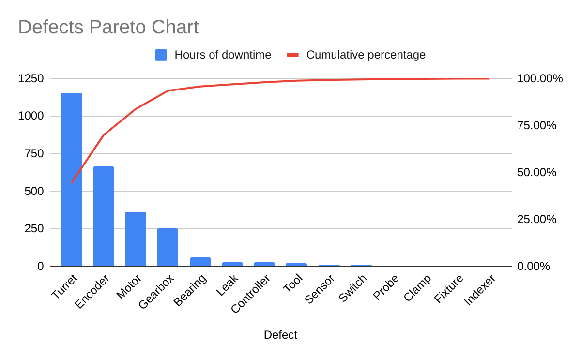
[Fig 1]
The information was gathered from Syteline, an online system that keeps track of when machines are initially scheduled for a breakdown. Other important metrics like total downtime, active repair time, waiting time for any required parts, and job completion time are also recorded by the system. When a machine malfunctions, such as when it goes into an alarmed state and the operator is unable to operate it, they use the relevant Seiki terminals to schedule maintenance and leave a brief note stating what they think the issue could be. This might simply be a statement of the alarm message displayed on the machine interface.
After this, every piece of information is entered into Syteline and updated each time a maintenance team member works on it. In order to provide an informative handover at the end of the shift, written information is included on the job ticket on Syteline, outlining exactly what progress each person has made.
All of the job tickets pertaining to the lower turret for the preceding six months were gathered using the system's filters after the data from Syteline was extracted (see appendix C). The job tickets that were gathered for the lower turret are shown in the snapshot below.

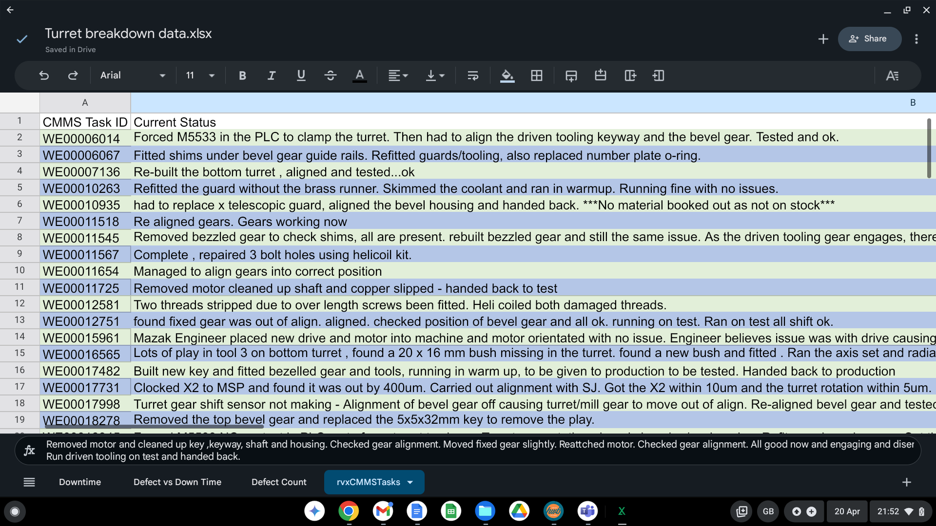
[Table 3]

The data from the job tickets has been divided into the chosen metrics and then put together in a table, which can be found in [Table 5] below. A chart has also been made in order to help visualise the problem [Fig 2]. The following list of metrics and their justifications is found in [Table 4].
Metric | Description | Reason
Labour hours booked | Time spent actively trying to fix the issue | To measure how long the work actually took
Total downtime | Total time the machine spent out of service. | To measure how long a machine was not running.
Time waiting parts | Downtime due to the unavailability of parts | To measure how much emphasis needs to be placed on stock control and highlight supply chain issues.
Down time (Other) | Time spent down, inbetween shifts and waiting for engineers | To measure time lost due to uncontrollables.
Reactivity time | The delay between booking and the maintenance team arriving at the job. | To measure the maintenance engineers responsiveness
[Table 4]

Machine | Sum of Labour Hours Booked | Sum of Total Down Time | Sum of Time Waiting Parts | Sum of Down Time (Other) | Sum of Reactivity Time
al37/02 | 75.2 | 731.17 | 426.39 | 153.25 | 12.99
AL37/03 | 3 | 8.76 | 0 | 0 | 5.43
AL37/04 | 306.7 | 1201.15 | 442.23 | 33.2 | 47.99
AL37/05 | 5 | 11.64 | 0 | 0 | 6
AL37/06 | 6 | 14.29 | 0 | 0 | 4.06
AL37/07 | 6 | 11.14 | 0 | 0 | 2.85
al37/08 | 173.62 | 627.11 | 71.88 | 192.84 | 186.52
Grand Total | 575.52 | 2605.26 | 940.5 | 379.29 | 265.83
[Table 5]
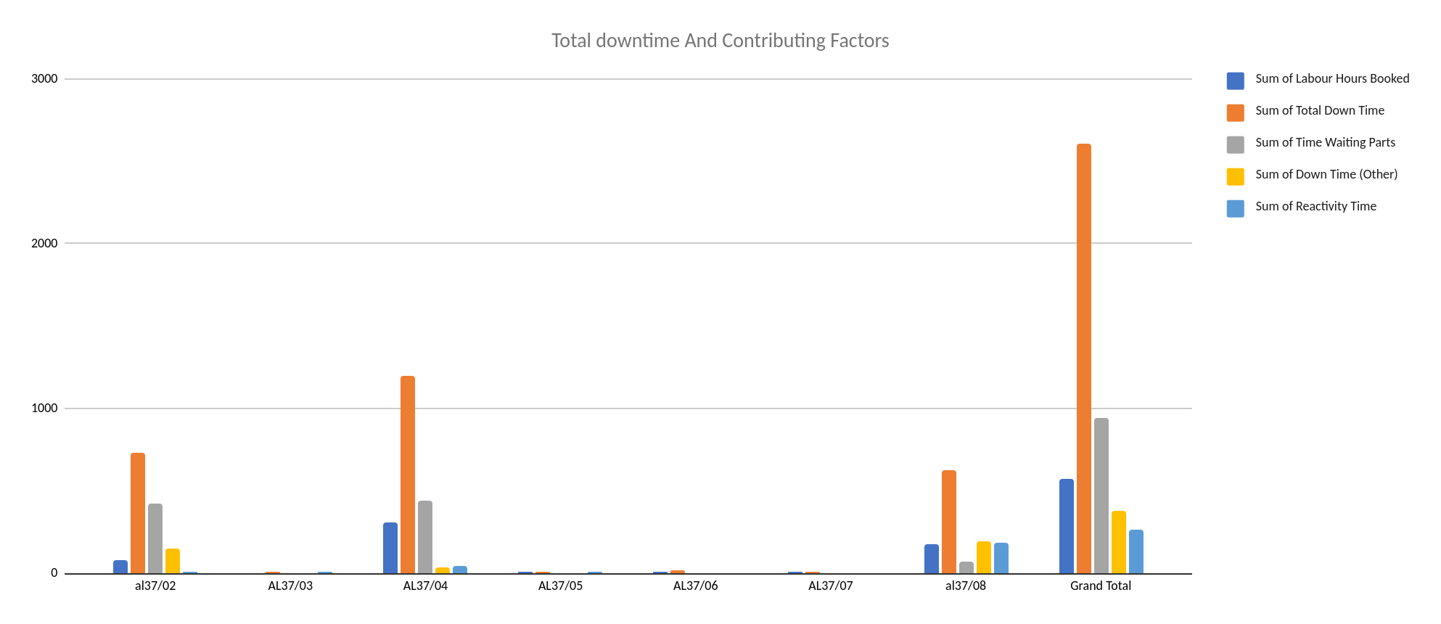

Measurement variation
[Fig 2]
To determine the underlying cause of each job, the data was further examined using qualitative information gathered from the maintenance teams. In order to verify that the quantitative breakdown data (extracted from Syteline) accurately represented the underlying causes, job ticket maintenance team notes were examined. At the conclusion of each shift, maintenance personnel record their findings on a ticket that is opened each time a machine is scheduled for maintenance. The qualitative data has been examined to look for any deviations or mistakes from the initial assumptions, in addition to analysing the quantitative data from these jobs. The underlying cause of the problem was either confirmed or refuted as a result.
This qualitative review revealed discrepancies between:
- Initial operator logs (often based on alarm messages or observable symptoms) and
- Final findings (determined after hands-on diagnosis).
Examples of Discrepancies Identified:
- A machine booked for a "faulty encoder" was later found to have misaligned gears.
- Some "electrical faults" were traced to mechanical wear after inspection.
Sources of Measurement Variation:
- Operator Bias: Initial fault logging varied depending on the operator’s familiarity with the system.
Interpretation of issue: Maintenance teams documented findings differently (one may note "bearing wear," while another labels it "turret misalignment").
- Time: Not all tickets are an accurate representation of the real time taken. Workload dependent, maintenance staff can be pulled from certain jobs for hours on end to tend to other areas, which do not get logged in the tickets.
- Misclassifying the issue could inflate MTTR
- The Pareto analysis was adjusted to reflect verified root causes, ensuring focus on the true priority areas (e.g., gear alignment over encoder errors).
The results from this can be seen below in [Fig 4].

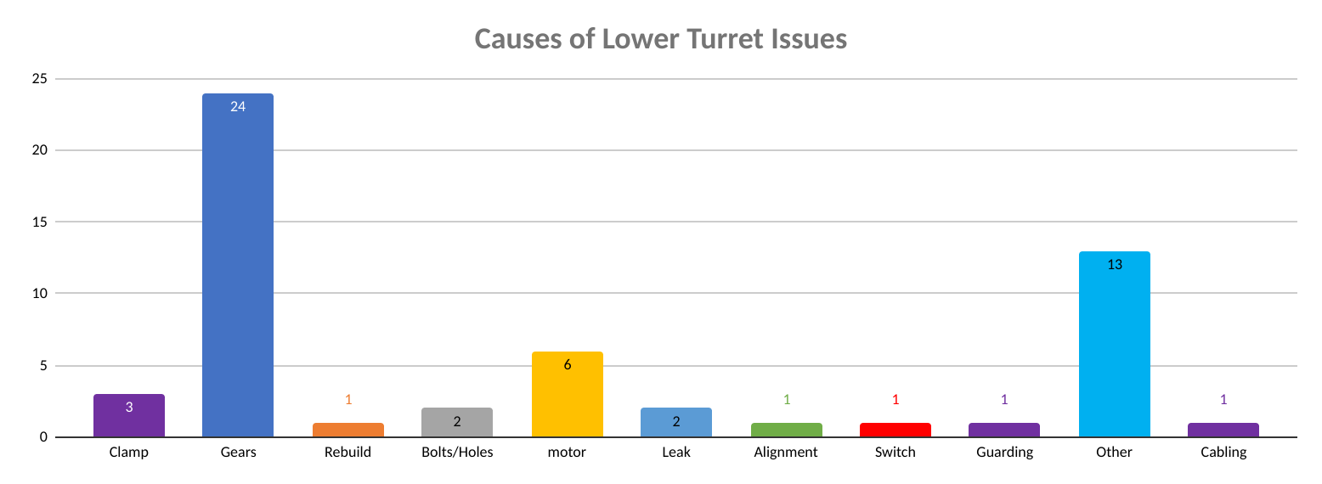
[Fig 3]

This chart has been further represented in a pareto analysis to help visualise the
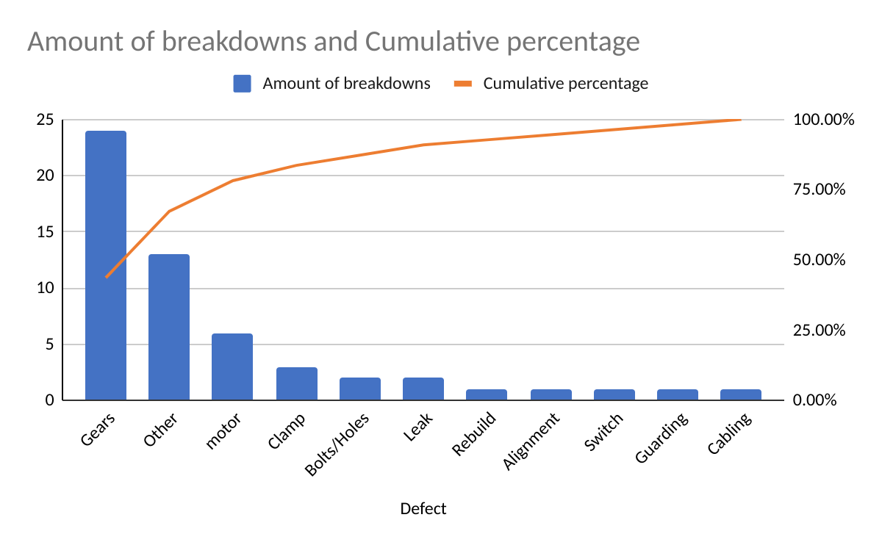
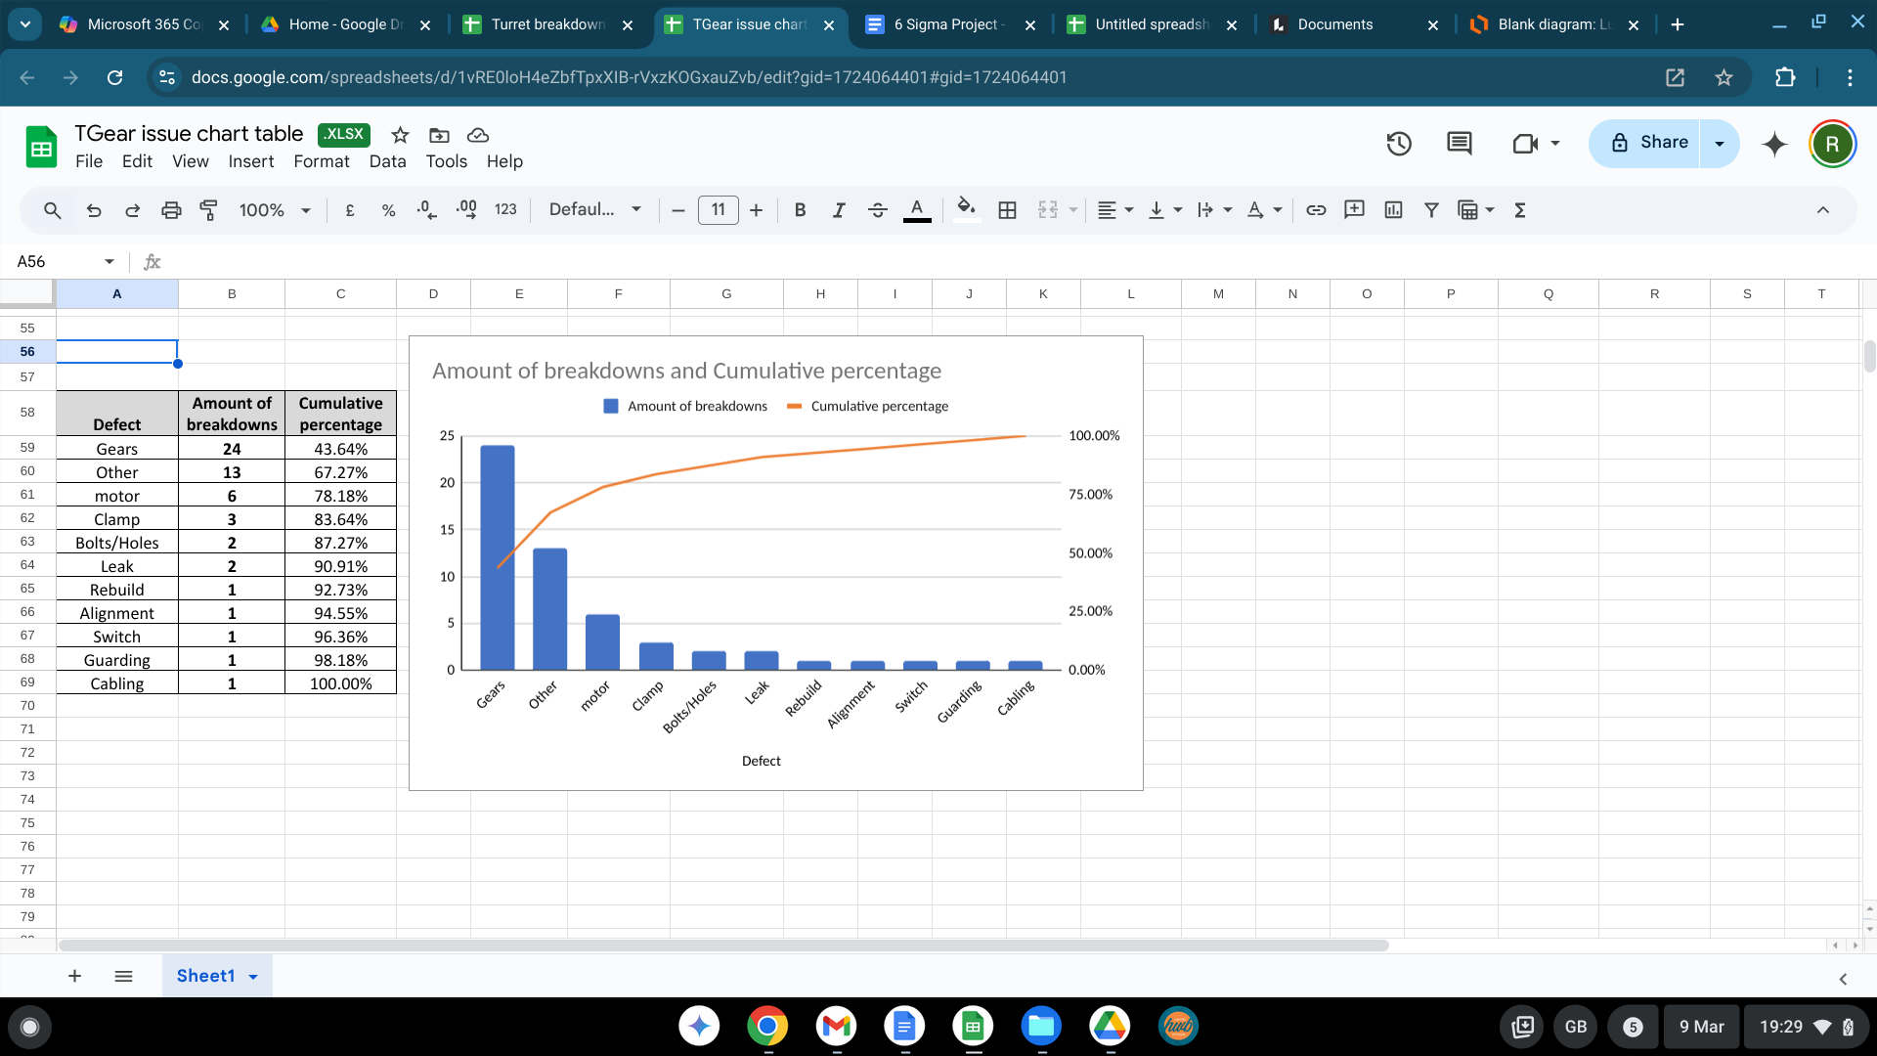
main causes of the issues within the turret.
[Table 6]
[Fig 4]

An anomaly is represented by the data range labelled "Other," which is the second-largest concern on the chart. One particular job took significantly longer than anticipated due to the need for extensive motor testing and the involvement of Mazak engineers on-site. Initially, the issue was identified as an encoder problem, but it escalated to a motor issue when the new encoders proved incompatible with the old motors, necessitating motor replacements. Additionally, this category includes issues with blocked coolant nozzles, which, although part of a different system, are integral to the process and located within the turret.

Based on the data, calculations have been made. All calculations have been based on the total operational hours for all 7 machines as a whole. Assumptions have been made that all machines will have been running 24 hours a day, 7 days a week. This is inclusive of time spent setting the machines and performing quality checks on parts.

KPI’S

Machine downtime:
The 7 machines had a total of 2605.23 hours of downtime. By comparing the 12 month average of overall downtime across the 7 machines as was stated in the introduction, an overall percentage of the lower turret downtime can be calculated as well as the subsequent KPI’s

Percentage of downtime caused by lower turret
- Average overall downtime: 1149.677865 hours
- Average of downtime caused by lower turret: 434.205 hours
- $\left(\frac{Monthly average Turret}{Monthly average overall}\right) =$$\left(\frac{434.205 }{1149.677865}\right) x 100 =37.77\%$
(See Table A)

Mean Time Between Failures (MTBF):
- Total operational hours: 30,240 hours
- Total breakdowns: 55
- MTBF: $\frac{Total operational hours}{Total breakdowns} = \frac{30,240}{55} = 549.82 hours$
(See Table D)

Mean time to repair (MTTR):
- Total repair time: 1781.85 hours
- Total breakdowns: 55
- MTTR: $\frac{Total repair time}{Total breakdowns} = \frac{1781.85}{55} = 32.40 hours$
(See Table D)

Process capability
A process capability study was undertaken using the data which has been acquired to check the level of improvements which need to be made to meet the Upper specified limit (USL) of 90% uptime. There is no lower limit.
As previously mentioned, the eight machines have an average uptime of 86.88% over a 12-month period. Their MTBF is 549.82 hours, and their MTTR is 32.4 hours.

Standard deviation:
$σ = \left(\frac{MTTR}{MTBF}\right) x Mean uptime →$$σ = \left(\frac{32.4}{549.82}\right) x 86.88 = 5.12\%$
Potential capability:
$Cpk = \frac{USL - mean uptime}{3 σ} → Cpk = \frac{90 - 86.88}{3 x 5.12 } = 0.203$

The machine has a very low ability to achieve 90% uptime, as indicated by its score of 0.203. This implies that in order to accomplish the goal, numerous adjustments will need to be made.

Analyse

Process Analysis Methods
A further process flow diagram was constructed to help analyse where the main issues could be caused (See Appendix E) By using this alongside the pareto analysis undertaken previously in [Fig 4], which states that the main cause of the breakdowns was due to gear issues, the processes of the gears can be isolated into their individual operations.
The driving gear connected to the motor, shifts between 2 gear trains, one for driving the rotation of the turret and one for driving the rotation of the driven tooling. Misalignment can occur between the shifting of the gears due to many factors. The most common cause is gear mesh alignment, where the gears fail to mesh correctly when shifting (See Table C). This can be caused by wear or damage to the gears, a worn key or keyway in the motor shaft, lack of lubrication or misalignment due to suffering a crash.
Another issue that can be seen is a misalignment from the bevel gear unit where the gear doesn’t stop in the correct position, not allowing the turret to rotate, causing it to crash and possibly causing further issues. This can also be caused by the same symptoms as previously stated.

Further investigation into causes

Further analysis has been conducted using the tables to understand where the majority of time has been spent on each job. (See table C)
The bevel gear unit needed to be replaced or refurbished seven times, according to the time-awaiting parts. In terms of waiting parts, all seven of the cases were among the top ten. The average amount of time they spent waiting was 65.13 hours. The order form (see appendix F) shows that, with the exception of the housing, which may take up to ten to fifteen days, the wait time for any part from Mazak can be as long as two days.
There were six instances of worn keys and keyways, totalling 69 hours of active repair time. These have an 11.5-hour MTTR, most of which will have been fault finding.
Being unable to free up the turret from a crash due to not knowing how to manually force the inputs occurred 3 times with a total active repair time of 48 hours. The MTTR for these 3 jobs was 16 hours.

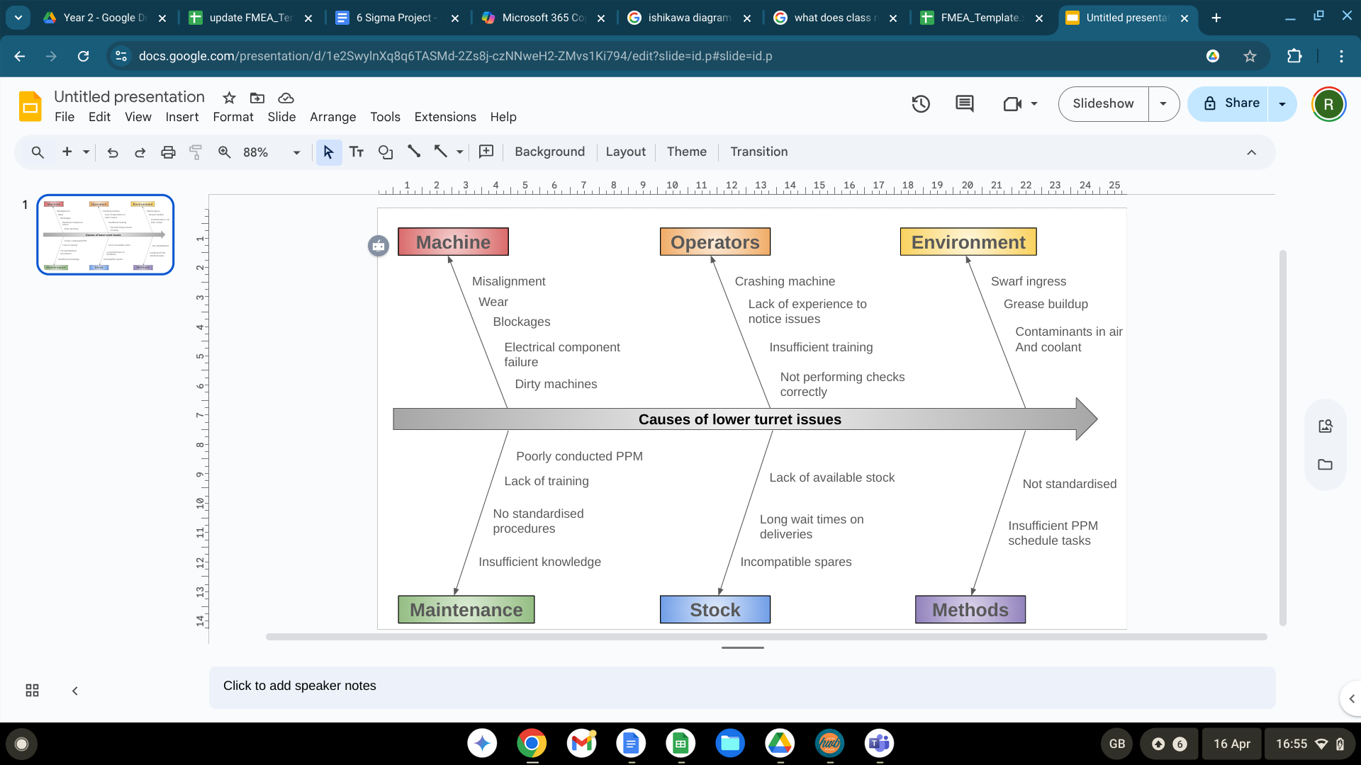
Ishikawa
[Fig 5]

FMEA
FAILURE MODE AND EFFECTS ANALYSIS
Item: | Lower turret | Responsibility: | Plant maintenance |  |  |  |  | FMEA number: 000001
Model: | Integrex I-200 | Prepared by: | Ryan Lewis |  |  |  |  | Page : 1
Core Team: | Plant maintenance |  |  |  |  |  |  | FMEA Date (Orig): 01-09-2024
Process Function | Potential Failure Mode | Potential Effect(s) of Failure | Sev | Potential Cause(s)/ Mechanism(s) of Failure | Occur | Current  Process  Controls | Detec | RPN | Recommended Action(s) | Responsibility and Target Completion Date
Clamp/ unclamp turret | Switch doesnt make | Machine alarms and fails to proceed | 7 | -Contaminants on the sensor. - Piston didnt extend or retract far enough -Electrical component failure | 5 | - Respond to action when machine breaksdown | 6 | 210 | Remove guard and clean sensors on every monthly PPM. | Ryan Lewis 28-04-2025
Clamp/ unclamp turret | Driven gear doesnt engage bevel gear | Machine alarms and fails to proceed | 7 | - Gear out of alignment -Motor not orienting properly  -Possible play in key or keyway. | 7 | - Respond to action when machine breaksdown | 6 | 336 | Remove guards on the monthly PPM and check the alignment and condition of the gears ensuring they clamp and unclamp .  Check for play in key and keyway. | Ryan Lewis 28-04-2025
Clamp/ unclamp turret | Driven gear doesnt engage idle gear | Machine alarms and fails to proceed | 8 | Locking gear is worn, doesnt mesh with driven gear | 7 | - Respond to action when machine breaksdown | 6 | 336 |  | Ryan Lewis 28-04-2025
Clamp/ unclamp turret | Driven gear doesnt engage idle gear | Machine alarms and fails to proceed | 8 | - Gear out of alignment -Motor not orienting properly, -Possible play in key or keyway. | 7 | - Respond to action when machine breaksdown | 6 | 336 |  | Ryan Lewis 28-04-2025
Turret rotation | Turret doesnt rotate | Machine alarms and fails to proceed | 4 | Misalignment of driven shaft on bevel gear unit. | 5 | - Respond to action when machine breaksdown | 3 | 60 | - Perform checks on monthly PPM - Inform operators to listen for clunky rotations. | Ryan Lewis 28-04-2025
Turret rotation | Turret doesnt rotate | Machine alarms and fails to proceed | 2 | Swarf or billet trapped behind the turret. | 7 | - Respond to action when machine breaks | 1 | 14 | Operators to perform more checks | Ryan Lewis 28-04-2025
Turret rotation | Turret doesnt rotate | Machine alarms and fails to proceed | 8 | key or keyway of bevel gear shaft is worn | 5 | - Respond to action when machine breaks down | 8 | 320 | Check for play by manually turning the shaft,. Remove the unit and measure | Ryan Lewis 28-04-2025
Coolant comes on | Coolant doesn't come on | Poor finish on parts, Damage to cutting tools, have to change tools and scrap parts | 7 | Coolant nozzle blocked | 6 | - Respond to action when machine breaks down | 8 | 336 | - Fit an inline filter to the inlet of the hose. - Create procedure for stripping turret | Ryan Lewis 28-04-2025
Coolant comes on | Coolant doesn't come on | Poor finish on parts, Damage to cutting tools, have to change tools and scrap parts | 8 | Pump not working | 3 | Check pumps on monthly PPM | 2 | 48 | - Keep checking pumps' operaton during PPM | Ryan Lewis 28-04-2025
Coolant comes on | Coolant doesn't come on | Poor finnish on parts, Damage to cutting tools, have to change tools and scrap parts | 7 | Leak in the line | 4 | - Respond to action when machine breaks down | 2 | 56 | -Ensure area is clean and not tangled and it has enough slack | Ryan Lewis 28-04-2025
Driven tooling starts | Driven tooling doesnt rotate | Machine alarms and fails to proceed | 8 | Misalignment of driven shaft on bevel gear unit. | 5 | - Respond to action when machine breaksdown | 3 | 120 | - Perform checks on monthly PPM - Inform operators to listen for clunky rotations. | Ryan Lewis 28-04-2025
Driven tooling starts | Driven tooling doesnt rotate | Machine alarms and fails to proceed | 8 | key or key way of bevel gear shaft is worn | 5 | - Respond to action when machine breaksdown | 8 | 320 | Check for play by manually turning the shaft, - Remove the unit and measure | Ryan Lewis 28-04-2025
Driven tooling starts | Driven tooling doesnt rotate | Machine alarms and fails to proceed | 8 | - Gear out of alignment -Motor not orienting properly | 7 | - Respond to action when machine breaksdown | 6 | 336 | Remove guards on the monthly PPM and check the alignment and condition of the gears ensuring they clamp and unclamp . | Ryan Lewis 28-04-2025
[Table 7]

5 Whys
Following the analysis of the FMEA results, the highest-risk failures found in the FMEA were examined using the 5 Whys technique. This approach "ensures root-cause analysis by iteratively probing deeper into failure mechanisms, avoiding temporary fixes," as Liker (2004, p. 252) explains. This strategy addresses systemic causes rather than symptoms, which is in line with the project's objective of removing turret breakdowns that occur frequently.

Driven gear doesn’t engage bevel gear (RPN 336)
Why? | Driven gear doesnt engage bevel gear
Why? | Gears are misaligned and dont mesh properly
Why? | - Lower turret has crashed and the gears have moved slightly  - Key or keyway of the motor shaft has worn  - Motor not orienting properly.
Why? | (1.1) Operator error  (1.2) Something impeding the turret  (2.1) Fatigue and wear over time  (2.2) Lack of lubrication  (3.1) Parameters set wrong  (3.2) Encoder failure or contamination
Why? | (1.1.1) Lack of training, or poor judgement  (1.2.1) Not performing checks regular enough  (2.1.1) High torsional shock loads on the key and keyway  (2.1.2) Misalignment  (2.2.1) Lubrication pipe not positioned correctly.  (3.1.1) Lack of knowledge and training  (3.2.1) Component failure  (3.2.2) Swarf, coolant or grease ingress.
Driven gear doesn’t engage idle gear (RPM 336)
Why? | Driven gear doesn’t engage idle gear.
Why? | Gears are misaligned and don’t mesh properly.
Why? | - Lower turret has crashed and the gears have moved slightly  - Key or keyway of the motor shaft has worn  - Motor not orientating properly.  - Locking gear is not aligned properly
Why? | (1.1) Operator error  (1.2) Something impeding the turret  (2.1) Fatigue and wear over time  (2.2) Lack of lubrication  (3.1) Parameters set wrong  (3.2) Encoder failure or contamination  (4.1) Locking gear has slipped out of position  (4.2) Locking gear not fitted correctly.  (4.3) Locking gear teeth are worn.
Why? | (1.1.1) Lack of training, or poor judgement  (1.2.1) Not performing checks regular enough  (2.1.1) High torsional shock loads on the key and keyway  (2.1.2) Misalignment  (2.2.1) Lubrication pipe not positioned correctly.  (3.1.1) Lack of knowledge and training  (3.2.1) Component failure  (3.2.2) Swarf, coolant, or grease ingress.  (4.1.1) Vibration or loose bolts  (4.1.2) Operator crashed machine.  (4.2.1) Lack of knowledge  (4.3.1) Fatigue and wear over time  (4.3.2) incorrectly fitted, gear hitting point of teeth.
Coolant doesn’t come on (RPN 336)
Why? | Coolant doesnt come on
Why? | - Blocked nozzles  - Issue with pump  - Split or kink in coolant hose
Why? | (1.1) Swarf blockage  (2.1) Pump has failed  (2.2) Inlet of pump is blocked  (3.1) hose has worn or bent
Why? | (1.1.1) Coolant has travelled through the line but got stuck at nozzle  (2.1.1) Electrical component failure  (2.2.1) Swarf has accumulated around the bottom of the pump  (3.1.1) Hose has been rubbing when being pressurised  (3.1.2) Hose is not secured sufficiently
Why? | (1.1.1.1) Nothing stopping small parts of coolant travelling in the hose  (2.1.1.1) Motor or pump needs replacing  (2.1.1.2) Seal has perished  (2.2.1.1) Larger pieces of swarf have accumulated and covered the inlet of the pump.  (3.1.1.1) Hose is fixed too close to sharp or hard objects.  (3.1.2.1) The hose has too much slack and can get twisted.
Driven tooling doesn’t rotate (RPN 336)
Why? | Driven tooling doesn;t rotate
Why? | - Gear misalignment  - Bearing seized  - Tooling has seized
Why? | (1.1) Lower turret has crashed and the gears have moved slightly  (1.2) Key or keyway of the motor shaft has worn  (1.3) Bevel gear shaft not orienting properly.  (2.1) Misalignment and Overloading  (2.2) Insufficient lubrication  (2.3) Contamination  (2.4) Fatigue and wear over time  (3.1) Repeated stresses/excessive loads  (3.2) Misalignment  (3.3) Programming
Why? | (1.1.1) Operator error  (1.2.1) Something impeding the turret  (1.3.1) Shaft has been pushed out of position  (2.1.1) Bearings not fitted correctly  (2.1.2) High shock loads / High cyclic loads  (2.2.1) not enough grease when fitted  (2.2.2) Grease has depleted over time.  (3.1.1) High shock loads / High cyclic loads  (3.2.1) Tooling not fitted correctly,  (3.3.1) Tools taking too deep cuts at at too high speed  (3.3.2) Programme not accounting for difference in hardness of material.
Why? | (1.1.1.1) Insufficient training, lack of care  (1.2.1.1) Operators not performing regular checks.  (1.3.1.1) Vibrations or collisions have loosened the clamp.  (2.1.1.1) Lack of training, no standard procedure.  (2.1.2.1) RPM acceleration is too high.  (2.1.2.2) Thermal effects  (2.2.1.1) Lack of training, no standard procedure  (2.2.2.1) Thermal effects and mechanical motion  (3.1.1.1) RPM acceleration is too high.  (3.2.1.1) Wrong bolts used cause the tool to be loose and not square.  (3.3.1.1) The programme is set to take certain cuts.  (3.3.2.1) The programme is set to a certain speed and depth of cut.
[Table 8]

From analysing the information that has surfaced from the 5 why’s, a breakdown of the most common root causes can be distinguished. The most common root cause is due to alignment issues. This is followed respectively by human error, (by both operators and maintenance personnel), mechanical stresses including bearing and tooling fatigue, and contamination within coolant lines and sensors/switches. A table was created to help add the numerical data to the root causes. This is in [Table 9 ] below.

Category | Occurrences | Percentage
Alignment Issues | 10 | 31%
Human Error | 8 | 25%
Mechanical Stresses | 7 | 22%
Contamination | 5 | 16%
Other | 2 | 6%
Total | 32 | 100%
[Table 9]

Improve

The company's machine problems have been addressed through the development of improvement options based on data collected during the analysis phase. These enhancements were firmly established by the 5 Whys analysis. During a brainstorming session, solutions to decrease misalignment-related malfunctions and speed up repair times were found. The top suggestions from the session are listed below.
Alignment Issues:
- Implement standard procedures.
- Ensure proper gear lubrication.
- Modify the PPM schedules.
Human Error:
- Provide additional training for operators.
- Expand PPM responsibilities and instruction on new procedures for maintenance staff.
- Inspect the machine's interior hourly and after feeding the final bar section.
Mechanical Stresses:
- Ensure components are properly aligned according to new procedures.
- Request soft starts or speed increases from the PED department for driven tooling.
- Update PPM to include checks on keys, keyways, tooling health, and bearing health.
- Create a hot-swap process for the bevel gear unit.
Contamination:
- Implement a standard procedure for cleaning nozzles.
- Introduce an inline filter to the system after the pump.
- Modify the PPM schedule to include filter inspection.
Standard procedures should be written in a poka-yoke style to speed up maintenance tasks and make the work "mistake-proof," claims Shingo (2006, p. 21). Procedures will be developed for jobs for which maintenance personnel are not adequately skilled or trained. These procedures will focus on:
- Removing the turret head to access the nozzles underneath.
- Forcing inputs on the PLC if the turret is stuck in rotation.
- Readjusting parameters and realigning gears when misaligned.
- Constructing and installing a complete bevel gear unit, including proper lubrication of bearings, for prompt replacement.
By removing the need to figure out the steps, the turret removal procedure saves time and attempts to reduce downtime by 50%. This process will eliminate the need for mechanical drawings and facilitate the prompt identification of difficult-to-see parts that must be removed in order to reach the nozzles. There are problems because the person who removes the turret head is not the one who refits it, which results in a lack of memory of part placement. Currently, this job takes an average of 16 hours to complete (2 full shifts). Currently, the lower turret's mean time to repair (MTTR) is 32.40 hours; this procedure attempts to lower it.
Since few members of the maintenance team are familiar with ladder diagrams and PLCs, the process for forcing inputs on the PLC should save a lot of time. A step-by-step poka-yoke procedure will expedite freeing the turret head if it gets stuck, allowing checks on the bevel gear unit alignment. This will eliminate the need for manual intervention or waiting for assistance, potentially reducing repair times by 30%.
The gear realignment procedure will need to be comprehensive, covering the four sections of the gear system: gear shift between clamping and unclamping, locking gear alignment, and bevel gear alignment. Limited knowledge in this area is a major issue, with few maintenance staff knowing the correct adjustment methods. The procedure will clarify the steps, including locating hard-to-find bolts for locking gear adjustment and listing motor orientation parameters. This will streamline the job, which currently takes around 8 hours, and potentially reduce the time by 50%.
Stocking a fully assembled bevel gear unit for quick replacement will save up to 2 days awaiting parts with a maximum of 15 days of downtime due to delivery and assembly times. (See appendix F). The bevel gear unit consists of several components that need to be located, assembled, and sometimes ordered if not in stock, which can take up to a week from a registered Mazak stockist. By creating a procedure for the assembly and fitting of the unit and keeping one on hand at all times, downtime will be significantly reduced, positively impacting the MTTR figure.
Additionally, this procedure should extend the MTTF figure (MTBF 549.82 hours) by detailing every aspect of the replacement, including greasing and correct fitting of bearings and shafts, thereby minimising stress on the bearings. This approach aims to reduce repair times by 75%.
The PPM schedules will be updated to include checks on the lower turret. Previously, no checks were made on the lower turret as part of the PPM schedule (See appendix G) Adding these checks aims to resolve minor issues before they lead to machine breakdowns. The current PPM schedule can be viewed in the. Training will be organised by lead engineers for all personnel with Integrex I-200 machines in their schedule. This training will provide knowledge on what to check for and where the highest-risk issues can occur, hopefully preventing breakdowns and greatly extending the MTBF metrics.
It will be suggested to Paul Lange, the machine shop manager, to create a rota for operators to perform routine inspections of the machine's interior. Occasionally, billets from bar part-offs and swarf accumulation become stuck behind the lower turret, preventing it from rotating and causing alignment problems in the event of a crash. The proposal will also include top-up training for operators to ensure they follow proper procedures for operating and controlling the machines.
Senior management in the maintenance department must first source and approve the in-line coolant filter. After confirmation, the filter can be installed, and the PPM schedule can be updated to include the filter's cleaning and replacement. Filters will be purchased from RS Components, a Renishaw contracted supplier, and can vary in price.

Condition monitoring

Senior management has recently decided to install a condition monitoring system during the course of this project Renishaw has chosen a Balluff monitoring system, which will provide a number of measured variables, including temperature, humidity, vibration, and ambient pressure (Balluff, 2025). (See appendix H). As a pilot programme, this is currently being implemented on a small number of machines. It will take some time for the system to become established before maintenance can benefit from it.

Pilot proposals

For high RPM applications, a programme modification proposal should be submitted to Chris Long, the group engineering manager, in order to implement a soft start or RPM ramp-up. Altintas (2012, pp. 215-218) states that the sudden change in speed from 0 RPM to 6000 RPM can result in high torsional shock loads on the keyway and shaft, causing the keyway to elongate and wallow, which can create alignment issues. Warnecke and Freitag (1998, pp. 333–336) note that in spindle motors, gradual acceleration (ramp-up) reduces torsional vibrations by 50–70%.
The proposal would recommend implementing a soft start process to reduce torsional vibration by around 50%, thereby reducing wear on components. This could be tested on one machine and then verified by analysing data from condition monitors to compare it with another machine. This will have to wait until the condition monitoring system has established itself and is giving up-to-date, reliable, accurate data.
The additional time needed to finish the necessary operations would first need to be calculated. The downtime experienced as a result of having to realign the machines and replace parts could then be compared to this.

An estimated value for the time savings from putting all of the suggested improvements into practice has been developed through calculations. The data has been retrieved from Table 5, Table 6 and Figure 4.

Defects | Total Downtime (Hours) | % of Total Downtime | Proposed Solution | Estimated Time Savings
Gear Misalignment | 500 | 19.20% | Standard alignment procedures | 250 hours (50%)
Human Error (Operator) | 400 | 15.40% | Additional training | 200 hours (50%)
Bevel Gear Unit Failures | 350 | 13.40% | Hot-swap procedure | 300 hours (85%)
Coolant Nozzle Blockages | 300 | 11.50% | Inline filters | 200 hours (67%)
Key/Keyway Wear | 250 | 9.60% | PPM checks and rpm ramp up | 150 hours (60%)
Other | 805.26 | 30.90% | General improvements | 400 hours (50%)
Total | 2605.26 | 100% |  | 1500 hours (57.6%)
[Table 10]

Improved FMEA phase
FAILURE MODE AND EFFECTS ANALYSIS
Item: | Lower turret | Responsibility: | Plant maintenance |  |  |  |  | FMEA number: 000002
Model: | Integrex I-200 | Prepared by: | Ryan Lewis |  |  |  |  | Page : 1
Core Team: | Plant maintenance |  |  |  |  |  |  | FMEA Date (Orig): 01-04-2025
Process Function | Potential Failure Mode | Potential Effect(s) of Failure | Sev | Potential Cause(s)/ Mechanism(s) of Failure | Occur | Current  Process  Controls | Detec | RPN | Recommended Action(s) | Responsibility and Target Completion Date
Clamp/ unclamp turret | Driven gear doesnt engage bevel gear | Machine alarms and fails to proceed | 5 | - Gear out of alignment -Motor not orienting properly | 5 | - Ensure PPM checks are completed - Follow standard procedure to ensure machine can be up and running quickly. | 2 | 50 | - Follow the standard procedures to quickly fault find and fix the issue. - Strictly adhere to the PPM schedules to prevent issues from occuring. | Ryan Lewis 28-04-2025
Clamp/ unclamp turret | Driven gear doesnt engage idle gear | Machine alarms and fails to proceed | 3 | Locking gear is worn, doesnt mesh with driven gear | 3 | - Ensure PPM checks are completed - Follow standard procedure to ensure machine can be up and running quickly. | 3 | 27 |  | Ryan Lewis 28-04-2025
Clamp/ unclamp turret | Driven gear doesnt engage idle gear | Machine alarms and fails to proceed | 5 | - Gear out of alignment -Motor not orienting properly | 5 |  | 4 | 100 |  | Ryan Lewis 28-04-2025
Turret rotation | Turret doesnt rotate | Machine alarms and fails to proceed | 5 | key or key way of bevel gear shaft is worn | 4 | - Ensure PPM checks are completed - Follow standard procedure to ensure machine can be up and running quickly. | 3 | 60 | - Follow the standard procedures to quickly fault find and fix the issue. - Strictly adhere to the PPM schedules to prevent issues from occuring. | Ryan Lewis 28-04-2025
Coolant comes on | Coolant doesn't come on | Poor finnish on parts, Damage to cutting tools, have to change tools and scrap parts | 6 | Coolant nozzle blocked | 1 | - Ensure PPM checks are completed - Follow standard procedure to ensure machine can be up and running quickly. | 8 | 48 | - Follow the standard procedures to quickly fault find and fix the issue. - Strictly adhere to the PPM schedules to prevent issues from occuring. | Ryan Lewis 28-04-2025
Driven tooling starts | Driven tooling doesnt rotate | Machine alarms and fails to proceed | 5 | key or key way of bevel gear shaft is worn | 4 | - Ensure PPM checks are completed - Follow standard procedure to ensure machine can be up and running quickly. | 3 | 60 | - Follow the standard procedures to quickly fault find and fix the issue. - Strictly adhere to the PPM schedules to prevent issues from occuring. | Ryan Lewis 28-04-2025
Driven tooling starts | Driven tooling doesnt rotate | Machine alarms and fails to proceed | 5 | - Gear out of alignment -Motor not orienting properly | 5 | - Ensure PPM checks are completed - Follow standard procedure to ensure machine can be up and running quickly. | 4 | 100 | - Follow the standard procedures to quickly fault find and fix the issue. - Strictly adhere to the PPM schedules to prevent issues from occuring. | Ryan Lewis 28-04-2025

RPN value comparison

There is a significant difference between the RPN values of the original FMEA and the RPN values from the revised, enhanced FMEA. On average, the scores have decreased from 336 to 63.6. This amounts to an 81.1% reduction.
The main justification for this is that standard procedures will eliminate any hesitation resulting from lack of knowledge and enable the maintenance staff to know precisely what to look for using a methodical approach.

Control

To be able to assess and control the actions that have been implemented, regular checks need to be conducted. Three standard procedures have already been draughted and handed out to the maintenance team. They were written by Ryan Lewis with the help of John Withey, who is the most knowledgeable engineer in terms of the Integrex I-200.
The misclassifying issues on Syteline will also be lessened by standard procedures since everyone will be aware of the precise location of the machine that needs to be noted in the handover. This can relate back to the measurement variation section.
Senior engineers are already delivering training to members of the team that will let the whole department know what is now expected of them in terms of maintenance and upkeep of the lower turret. The three procedures which have been draughted so far are:
- Bevel gear hot swap procedure, (See appendix I)
- Forcing inputs procedure, (See appendix J)
- Removing the turret head procedure, (See appendix K).
These have already been issued to staff
The turret hot swap procedure is the only one out of the three which has been used so far but that alone has proved successful, saving a total of 16 hours of downtime.

PPM schedules are yet to be updated but will be authorised soon when time permits.

A table has been created to show the plans of action, how they are going to be monitored and the target they are set to achieve.

Action | Linked Root Cause (From 5 Whys) | Metric to Track | Target
Implement standard alignment procedures | Misalignment from crashes (1.1.1.1, 1.3.1.1) | number of misalignment-related breakdowns | 50% reduction in repair time
Ensure correct lubrication of gears | Lack of lubrication (2.2.1, 2.2.2.1) | PPM task completion rate | 100% adherance
Adjust PPM schedules | Fatigue/wear (2.1.1, 2.4.1) | Downtime due to wear-related failures | 50% reduction in 6 months
Train operators on crash prevention | Operator error (1.1.1.1, 1.2.1.1) | Number of crashes caused by operator error | Less than 2 incidents in 6 months
Train maintenance on new PPM procedures | Incorrect component fitting (3.2.1.1, 4.2.1) | PPM task completion rate | 100% adherence
Hourly machine checks | Not inspecting machine (1.2.1.1) | Audit compliance sheet | 100% adherence.
Implement soft-start programming | Shock loads (2.1.2.1, 3.1.1.1) | Peak torque levels (via sensors) | 50% reduction of spike levels
Add bearing/keyway checks to PPM | Bearing seizure (2.1.1, 2.3.1) | Number of bearing failures | Less than 2 in 6 months
Develop hotswap procedure for bevel gear | Extended repair times (4.1.1, 4.3.1) | Mean repair time (MTTR) | Reduce downtime by 75%
Install inline coolant filter | Swarf contamination (1.1.1.1, 2.2.1.1) | Coolant nozzle blockages | Less that 1 incident in 6 months
Clean nozzles as per procedure | Swarf/coolant ingress (3.2.2.1) | Number of coolant flow failures | 0 in 6 months
[Table 12]

Over the next 6 months, these metrics will be checked on a regular basis, and further training will be given where necessary. The team will be kept up to date with the performance and most up-to-date metrics in the monthly team meetings to ensure that everyone has a shared understanding and is reminded of the targets that have been set out.

References
Renishaw plc (2025). Renishaw: Home. [online] Renishaw. Available at: https://www.renishaw.com/en/renishaw-enhancing-efficiency-in-manufacturing-and-healthcare--1030?srsltid=AfmBOorz75KoUI-MDVQd36fmxgAbLmGzCtIYg84-DtWT73i3kZBmPtyr [Accessed 20 Apr. 2025].

Mazak (2025). Products | Mazak UK. [online] Available at: https://www.mazak.com/uk-en/products/#integrex [Accessed 20 Apr. 2025].

‌Thomas, D. (2024), Integrex reliability [table], Unpublished manuscript

Pyzdek, T (2018) The Six Sigma Handbook, 5th Edition, McGraw Hill Education, United States

‌Mathur, S. (2023). Understanding the Importance of a Project Charter in Project Management - Project Management Path. [online] Project Management Path - Navigating Success: Unveiling the Art and Science of Project Management. Available at: https://projectmanagementpath.com/understanding-the-importance-of-a-project-charter-in-project-management/ [Accessed 20 Apr. 2025].

lucidchart (2017). The Ultimate Guide to the DMAIC Process. [online] Available at: https://www.lucidchart.com/blog/what-is-dmaic [Accessed 10 Apr. 2025].

Paul Lange, (2024), spoken communication to Ryan Lewis, October 2024.

Mark Rayner and Kyle Westall, (2024), spoken communication to Ryan Lewis, October 2025

Hessing, T. (2014). Critical to Quality Tree (CTQ). [online] Six Sigma Study Guide. Available at: https://sixsigmastudyguide.com/critical-to-quality-tree/. [Accessed 20 Apr. 2025].

‌Iyer, R. (2021). Project Charter: A Complete End-to-End Guide to Create an Impactful Project Charter for Any Type of Project. Amazon Digital Services LLC.

Shigeo Shingo (2006). Zero quality control : source inspection and the poka-yoke system. New York: Productivity Pr.

‌Warnecke, H.J. and Freitag, S. (1998) "Adaptive Control for Machine Tools to Reduce Dynamic Errors." CIRP Annals, 47(1), pp. 333-336.

Altintas, Y. (2012) Manufacturing Automation: Metal Cutting Mechanics, Machine Tool Vibrations, and CNC Design. 2nd ed. Cambridge University Press, pp. 215-218.

Balluff (2025). Condition Monitoring | Balluff. [online] Available at: https://www.balluff.com/en-gb/focus-topics/condition-monitoring [Accessed 24 Apr. 2025].

Appendices
Table A - Integrex reliability report
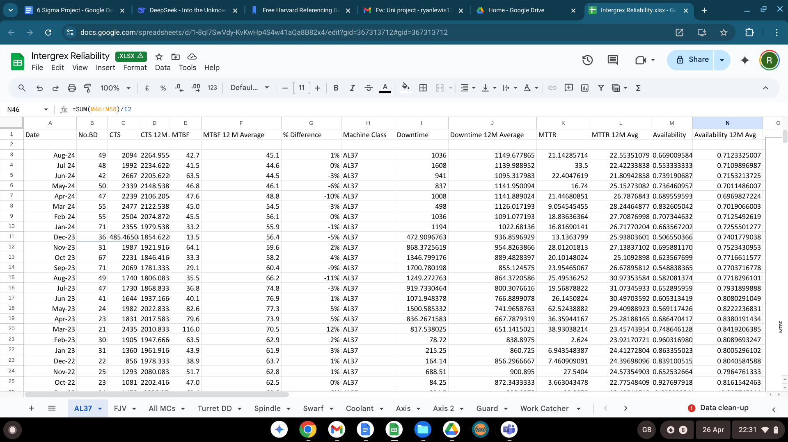

B - Trend line chart from Integrex reliability report
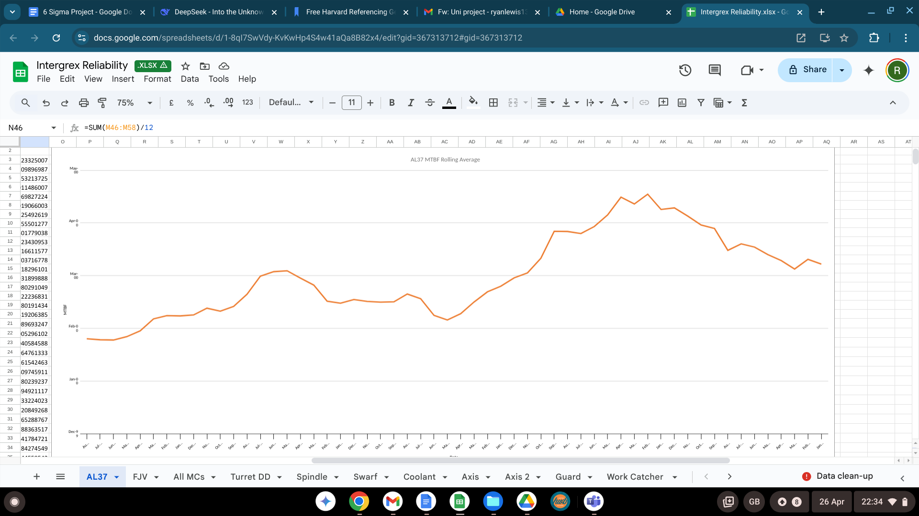
Table C - List of all job tickets over a 6 month period
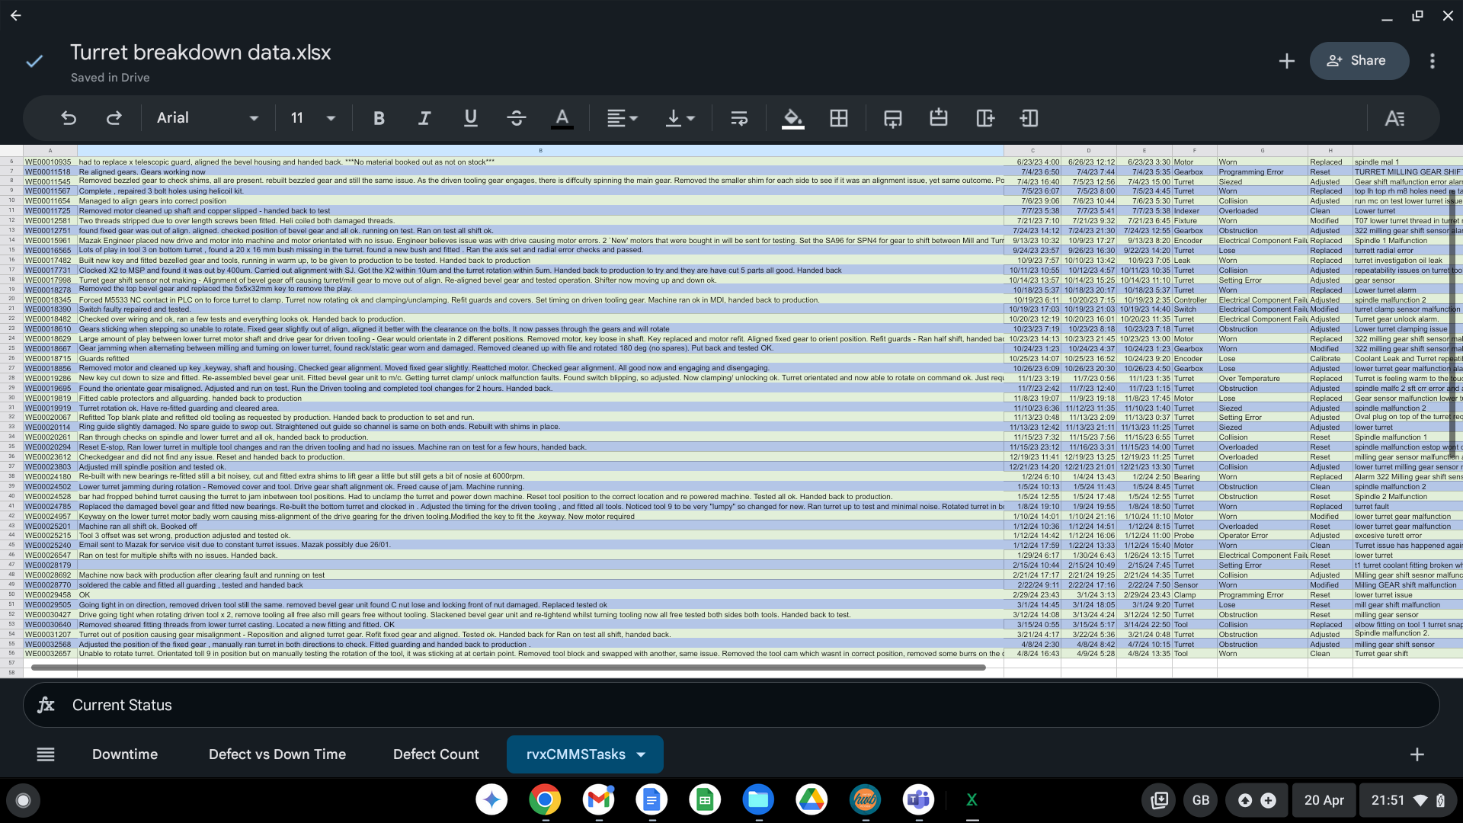

Table D - Sum of total downtime for the 8 machines.

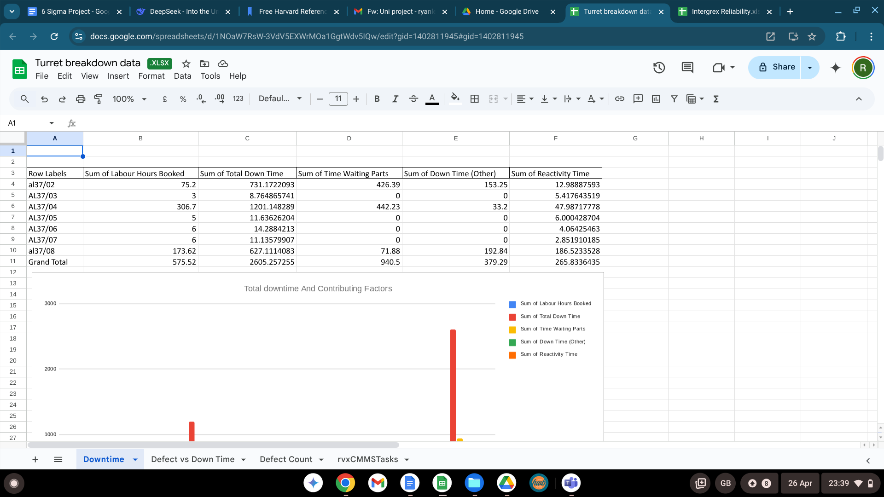
E - Process flow diagram for detailed lower turret processes.
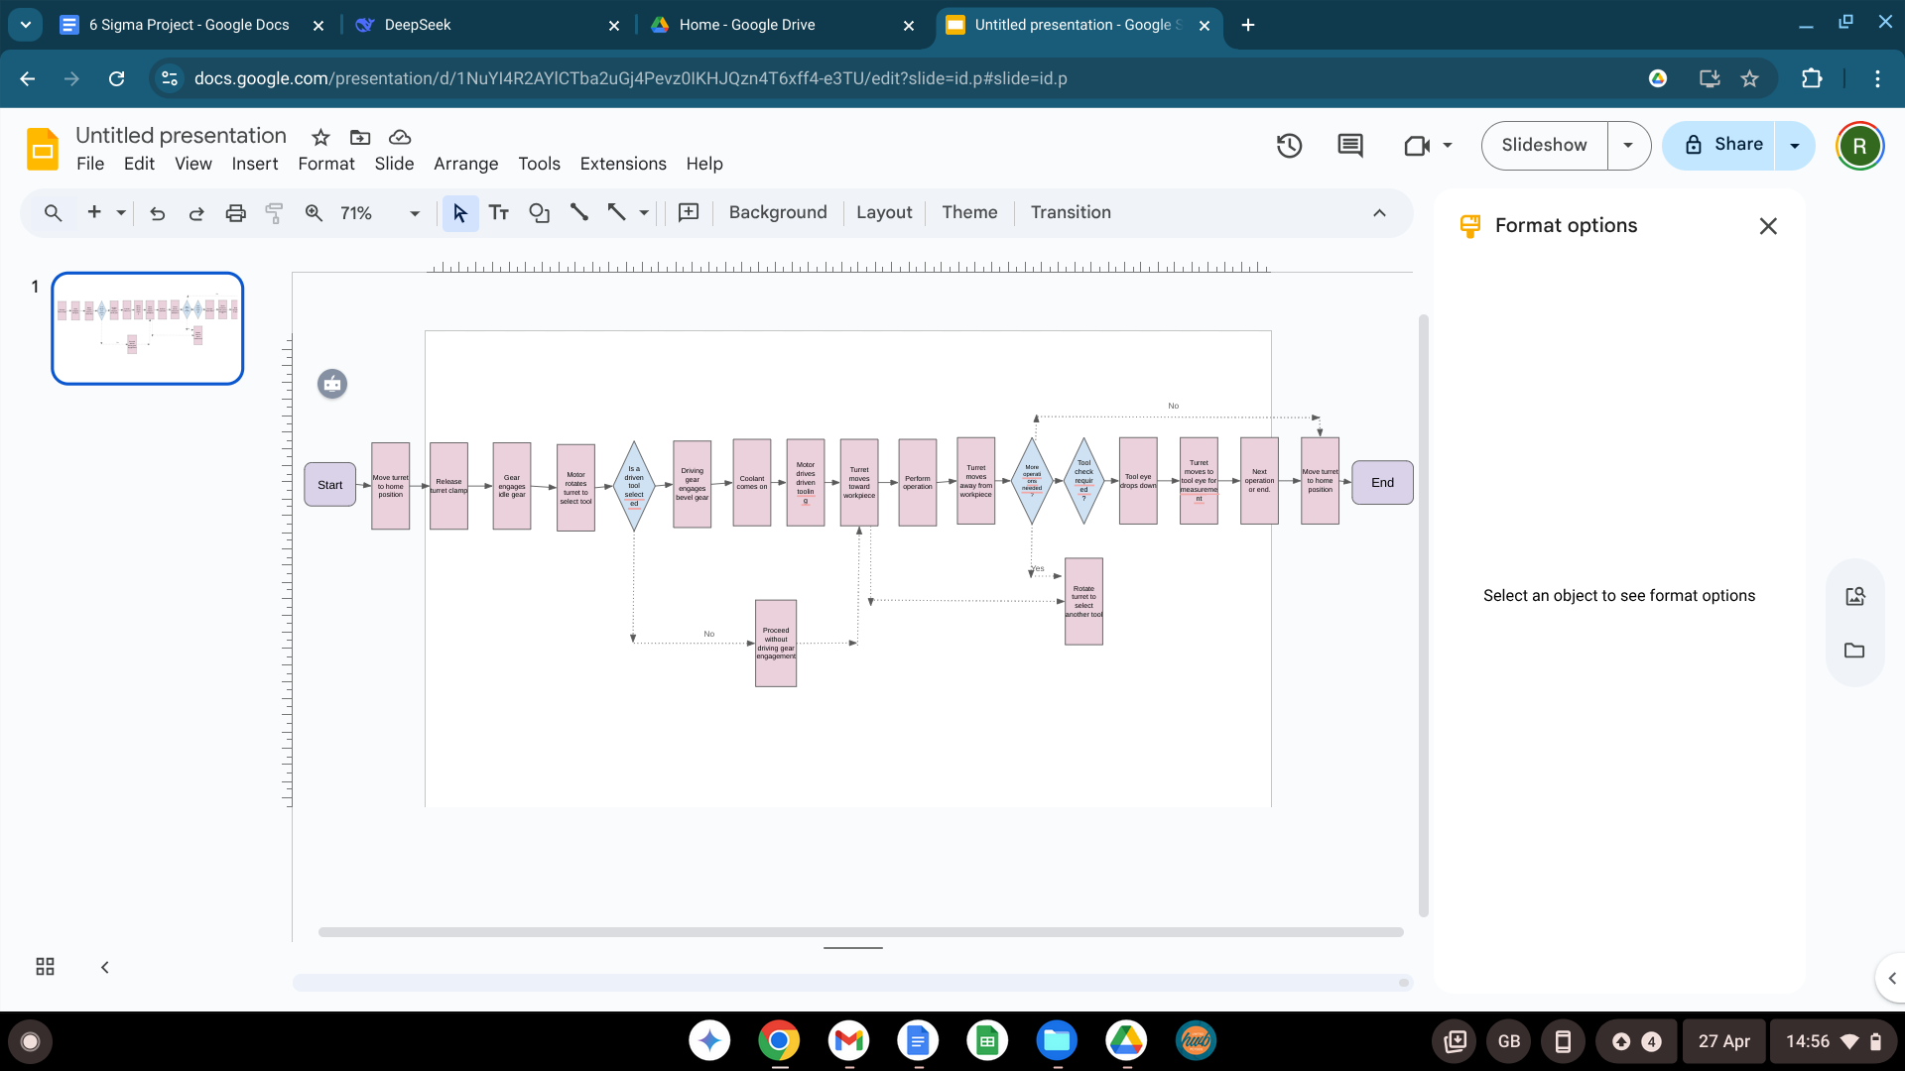

F - Parts order quotation from Mazak for bevel gear unit components.
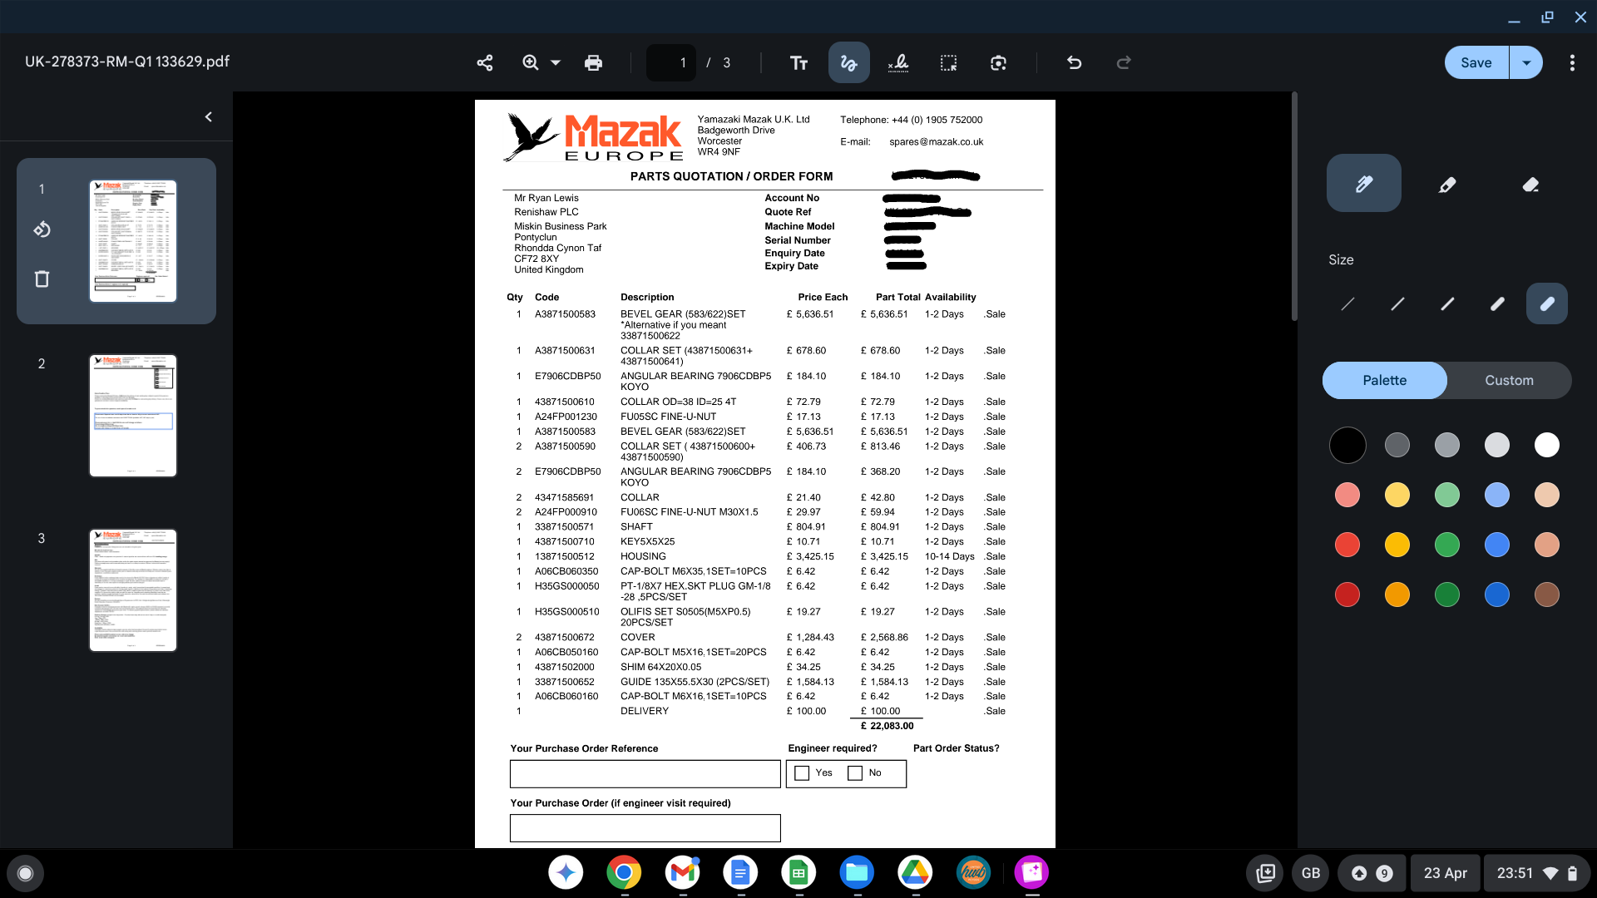

G - Old PPM schedule before it has been updated.
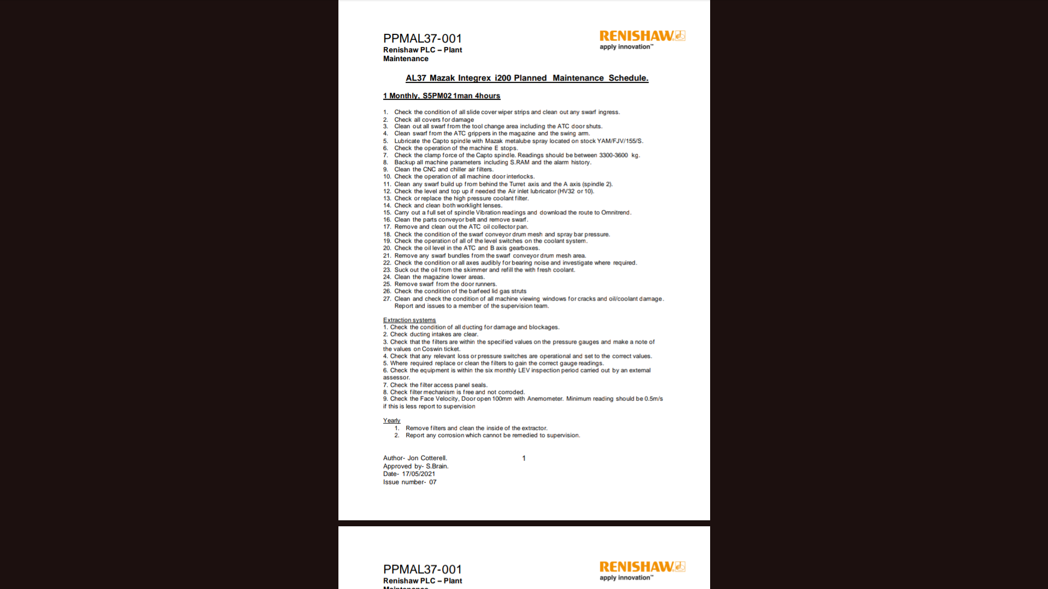

H - Screenshot of Baluff website detailing the capabilities of the condition monitoring system.


I – Bevel gear hot swap procedure

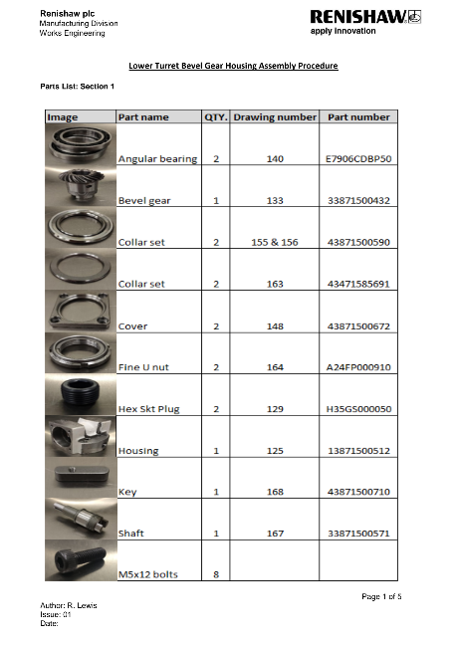
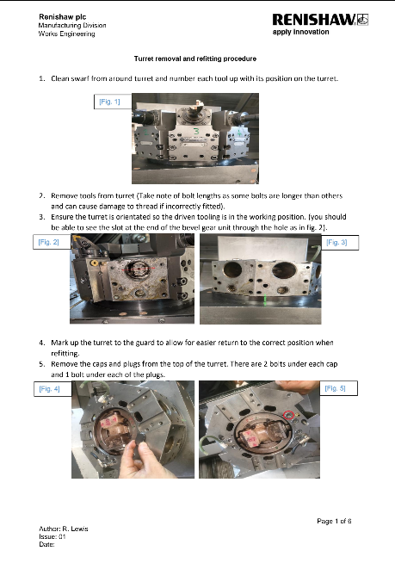

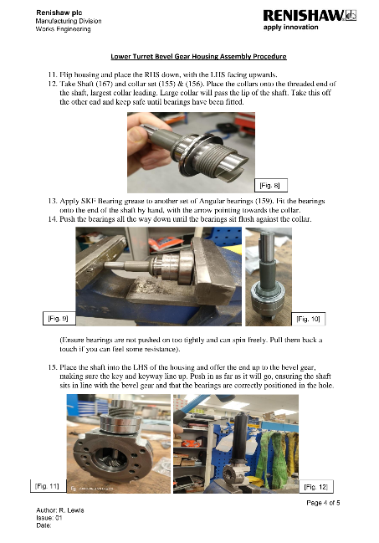
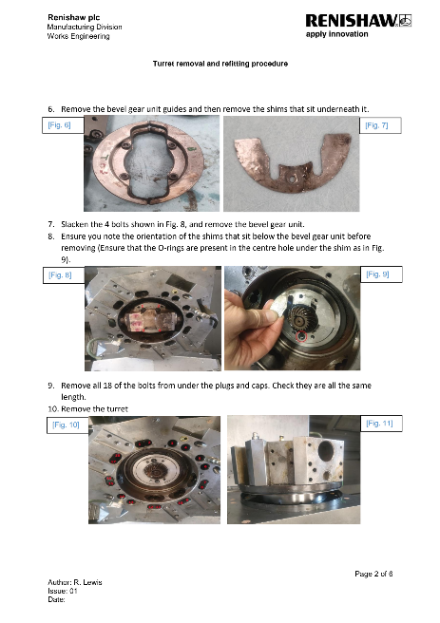

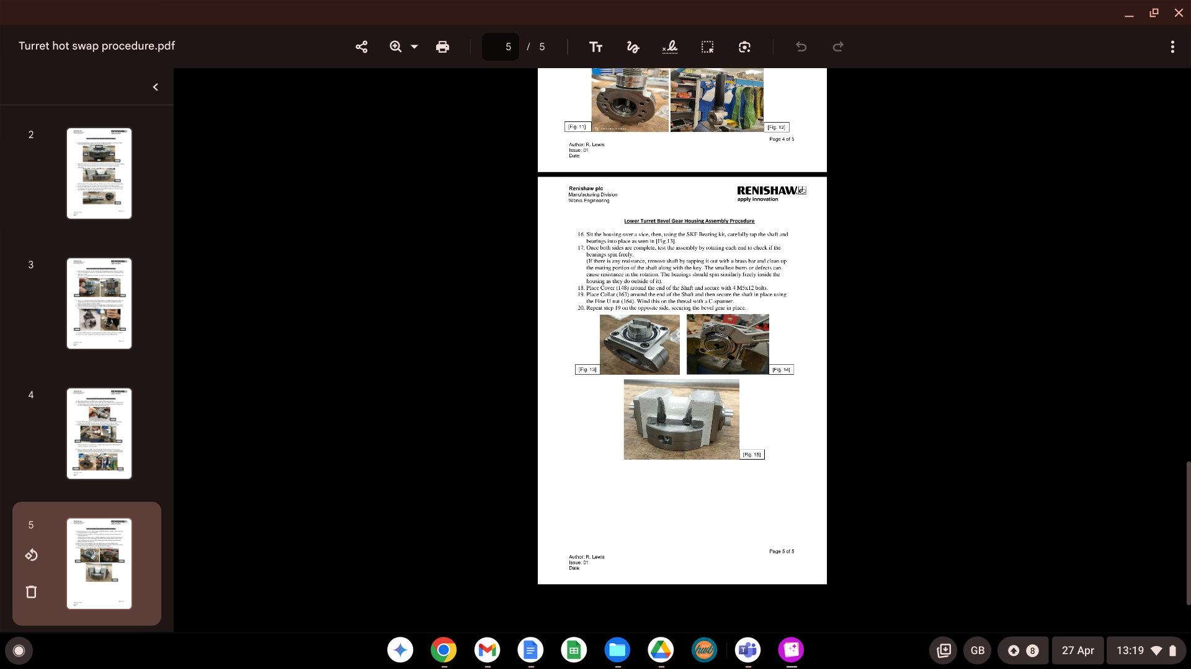

J – Forcing inputs procedure
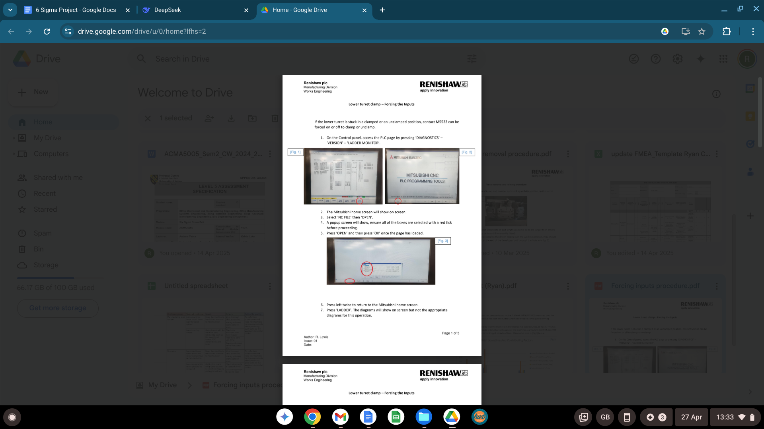
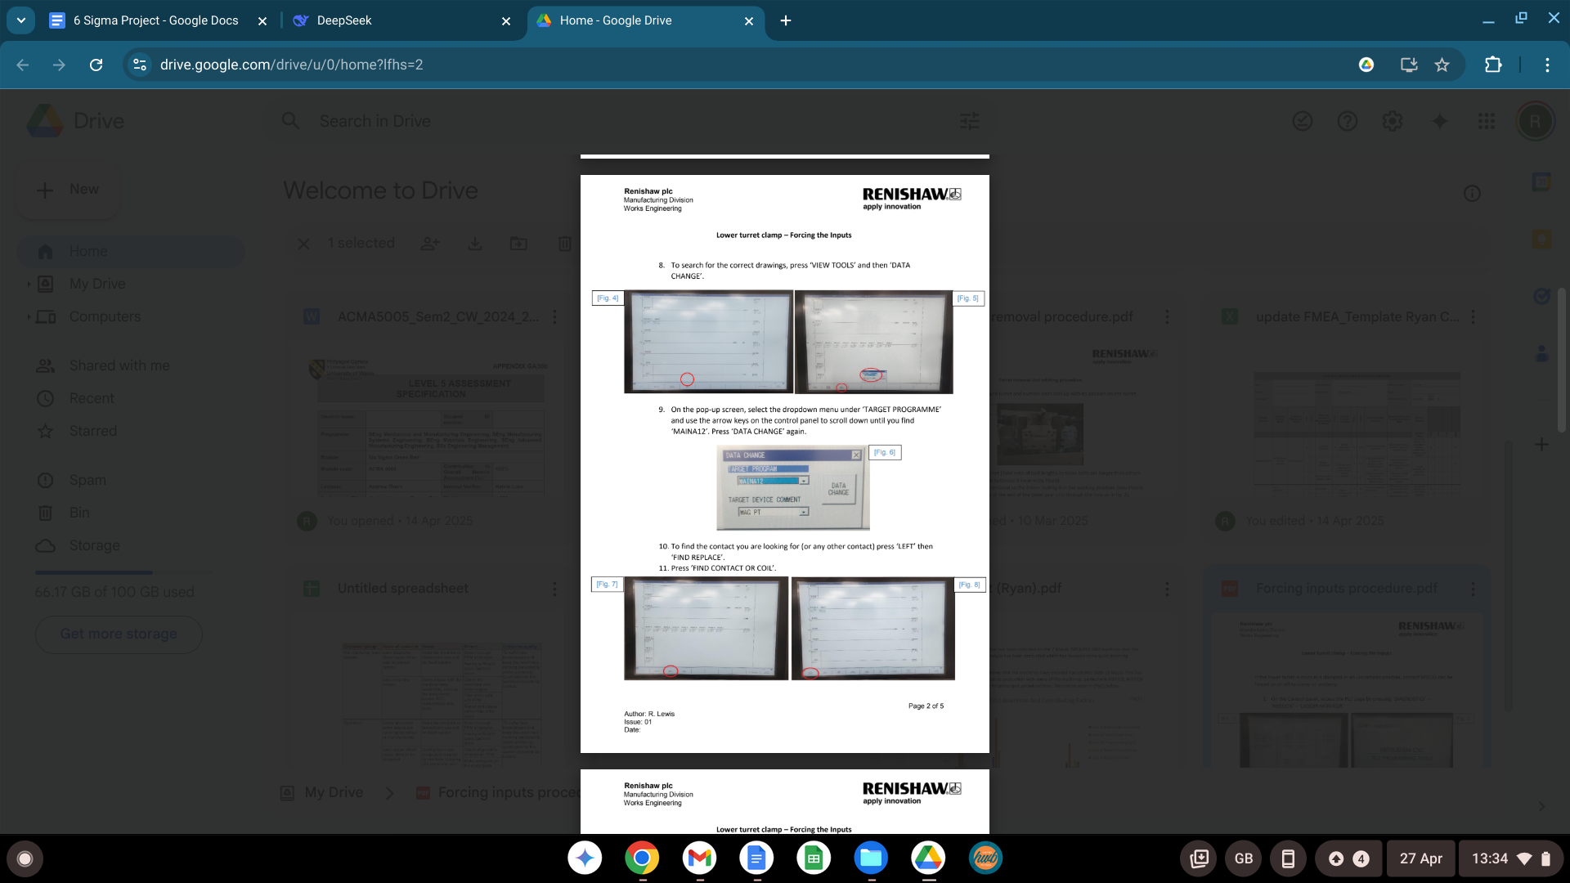

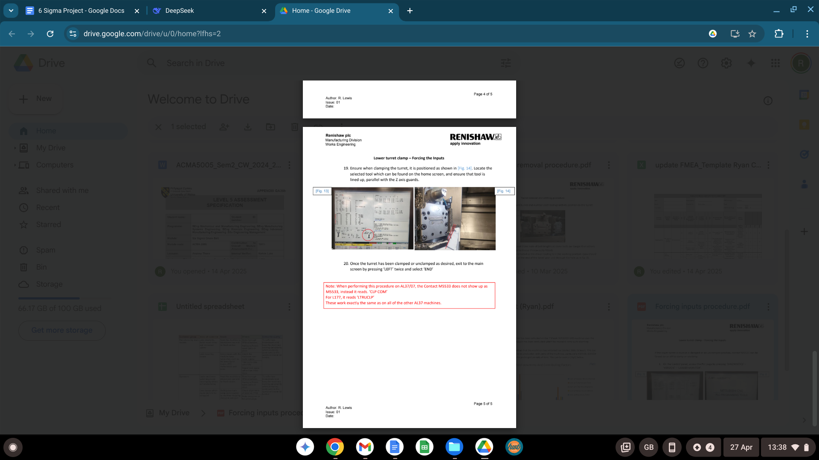
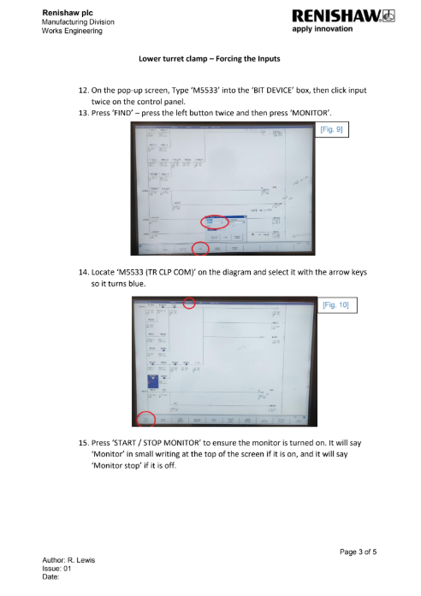
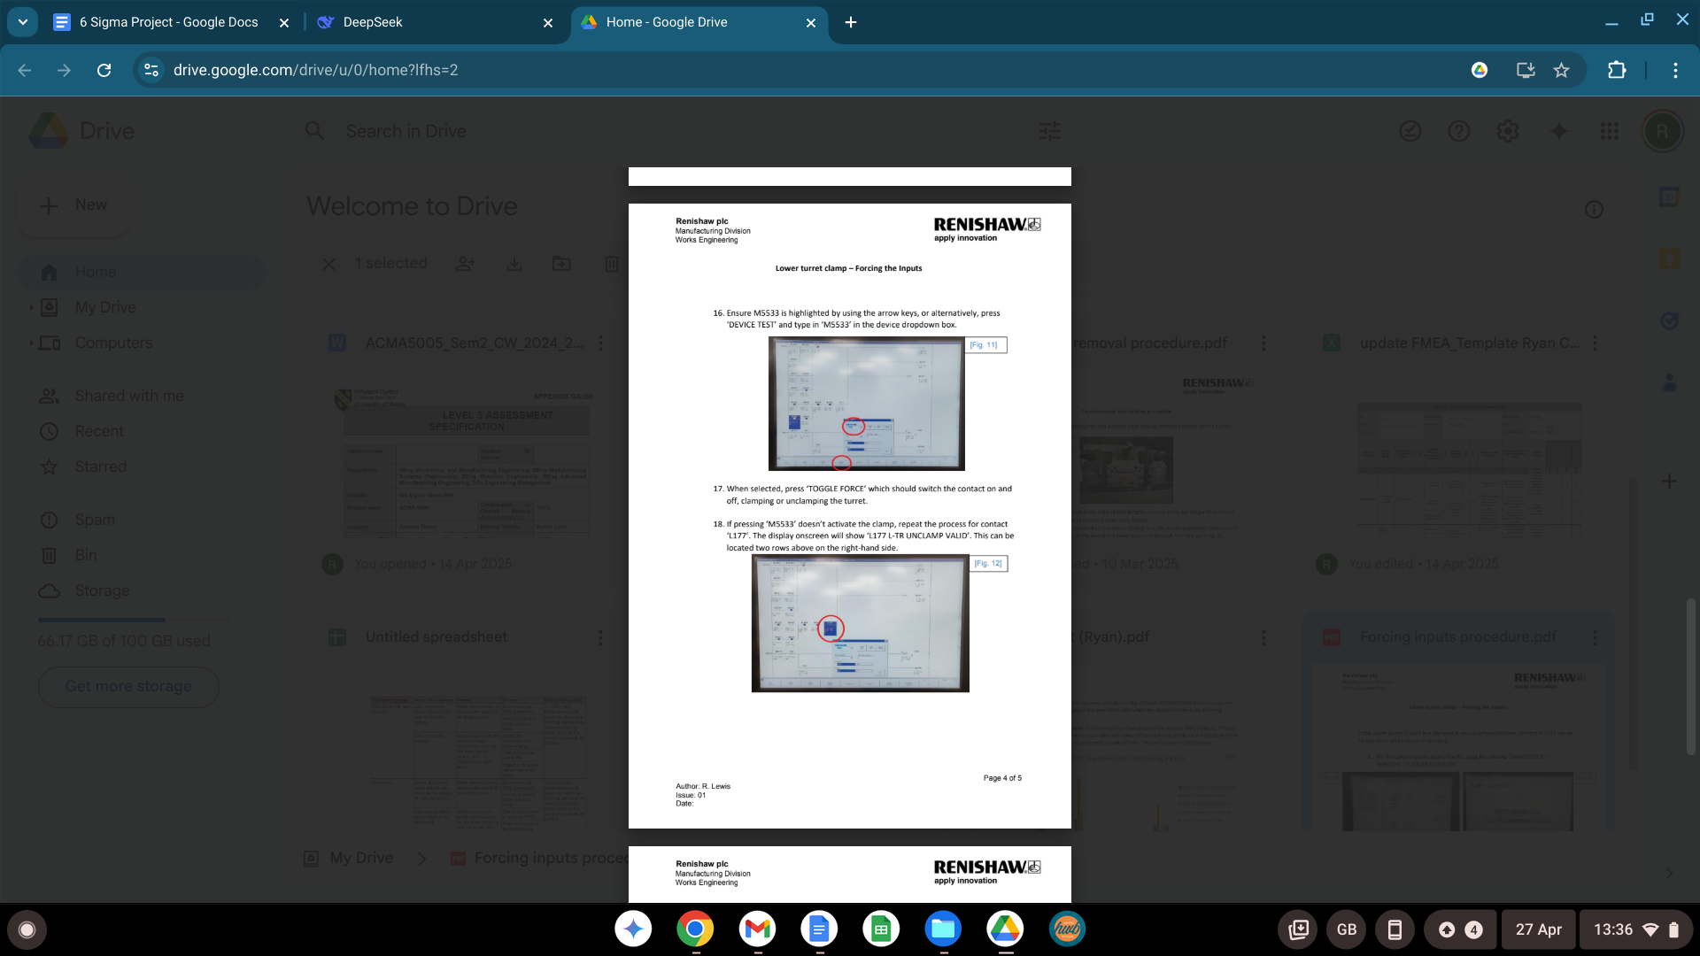

K - Turret hotswap procedure


