

International Financial Management

LCBB6002
A1

Lecturer: Dr. Rexon Nting
Student name: Yordan Gospodinov Gospodinov
Student ID: 2020080

Table of Contents
Introduction: 2
Analysis and evaluation of the chosen MNC’s approach on dividend distribution policy: 2
Analysis of efficient market hypothesis theory in the context of chosen MNCs operations: 4
Critical analyses of the methods of appraising projects at Tesco: 5
Conclusion: 6
Reference list: 7

Introduction:
The study entails a clear analysis of the evaluation of a chosen multinational corporation and the importance of International Financial Management (IFM) and all the relevant theories. In addition, the report will also entail a detailed discussion on the various challenges faced by the corporation at various international financial markets. The chosen MNC here is Tesco (Madura, 2020). It is to be noted that Tesco group tends to finance their operations via a combination of retained profits, long and medium term debt capital market issues, leases and bank borrowings and the main objective of their IFM is to ensure the continuity of funding. However, in the international financial markets, Tesco has encountered various issues such as accounting scandals, and regaining consumers’ trust (Wood et al., 2017). In order to mitigate the challenges, proper IFM processes must be in place for ensuring Tesco’s success in the international markets.

Analysis and evaluation of the chosen MNC’s approach on dividend distribution policy:
The company (Tesco) tends to pay dividends 2 times a year and it is important to note that Tesco group pay their dividends twice a year, in the months of November and June. As per the recent data as of March 2023, the company has paid dividends that totalled 0.15 US$ for each share in the last one year. It is also worth noting that as per the current stock prices of 3$, this tends to correspond to the dividend yield of 4.7 percent and the formula for the calculation of the dividend yield of Tesco group would be (0.15/3)$*100= 4.7 per cent (Chandra, 2017).

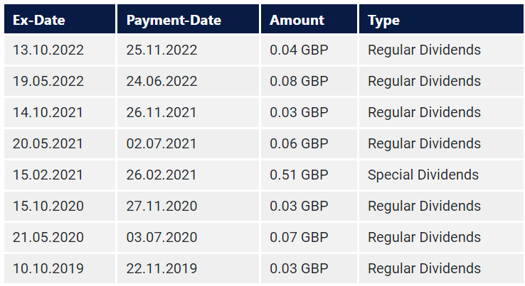

Figure: Dividend calendar
Source: Dividend Stocks (2023)
Again, referring to the statistical chart below, it can be said that Tesco group did not raise their dividends in the last year and and in the span of last ten years, it is also seen that Tesco group had lowered this by “-2.8 percent” on an yearly basis. Again, in the course of five years, the payout has further increased by 30.47 percent with 0 years of growth of dividends and hence it was found that the company has not yet earned a title as a “reliable dividend payer” (Chen, 2022). The payout ratio of Tesco on the basis of “free cash-flow” is 34.3 percent and on the basis of the earnings, the organisation tends to distribute 100 percent to the company’s shareholders. Based on the findings of the Tesco Dividend History by Dividend Stocks (2023), it can be said that the reliability of the dividend is -0.13 out of 1 (max). This further depicts an “unreliable dividend payer” earlier. Further analysis indicates a reduction of -8.3 percent of the dividends for the present business year.
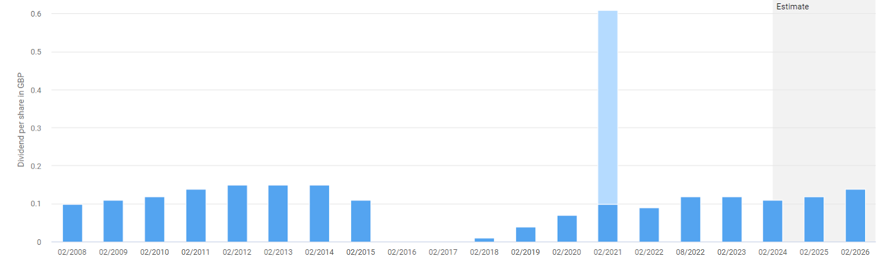
Figure: Dividend per share
Source: Dividend Stocks (2023)
If the stock quality remains the same, it can be said that an extraordinarily high dividend yield tends to indicate an undervaluation. On the contrary, a stock with “historically low dividend” tends to yield in spite of constant increase in dividends seems to be “overvalued”. Within the last one year, the mean “dividend yield” of the company had been 4.48 percent and at present it is 4.7 and hence can be considered to be “average” and thus can be said that the Tesco stock is fairly valued (Chen, 2022).

Analysis of efficient market hypothesis theory in the context of chosen MNCs operations:
It is to be noted that the as per Efficient Market Hypothesis (EMH) or Efficient Market Theory (EMT), is basically an hypothesis which states that the share prices tend to reflect all kinds of information and “consistent alpha generation” is impossible. In other words, as per the Efficient Market Hypothesis, the stocks generally trade at fair values on exchanges and hence make it impossible for the investors to buy the undervalued stocks or sell the stocks at greater prices (Wood et al., 2017). Thus, as per these hypotheses, it ought to be impossible to outperform the entire market via “expert stock selection” or “market training” and the only way an investor is able to obtain greater return is by buying investments that entail greater risks (Catalão, 2022). In the context of Tesco plc, taking under consideration the share prices of the organisation according to Efficient Market Hypothesis, it can be said that the EMH of Tesco group is “semi-strong” (Catalão, 2022). This is due to the fact that as per the chart below, the share prices of Tesco reflect all information from both public as well as private perspective, and hence no one can earn any “excessive returns” (Catalão, 2022).
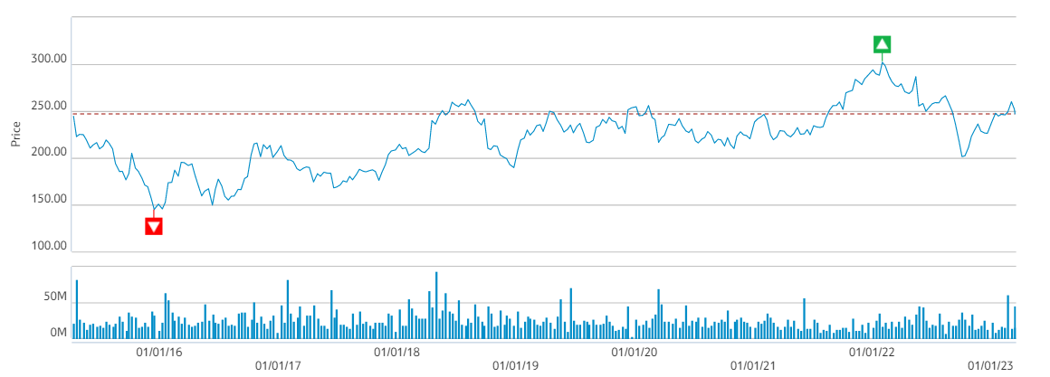
Figure: Share Price chart (2016-2023)
Source: (Tesco PLC, 2023)
Furthermore, it can be said that this can be further analysed from various events that had taken place within the organisation during 2016 and 2017 (Tesco PLC, 2023). For example, during 2016, a number of good steps have been taken by Tesco like “accepting the reports of GCA”, and “committing towards establishing trust partnerships” with the suppliers. In addition to that, another example that can be considered here is that the company had reduced its “fuel price” by 2 pounds per litre in 2016 (August) and also offered free fruits for the kids for pushing “healthy eating” and also a “non-executive director” has been appointed by Tesco on July 2016. All these events caused the increment of the share prices to 182 pounds (approx.) from 165 pounds (Moura, 2021). A number of events also occurred in 2017 like introduction of “authentic tasting new range” because of decreased wine demands on the month of November in 2017, on Oct-2017, the world bread awards was crumbled and prices of petrol and disease have been cut upto 3 pounds per litre and so on (Tesco PLC, 2023). It is important to note none of these events have significantly affected Tesco’s share prices and hence it justifies the strength of EMH. Again, the new releases of Tesco Plc like “Secret Santa Sales”, launching of “England’s fantastic festive fizz”, sales on “Olaf Disney” and so on further facilitated increase of the share prices and hence it can be said that EMH of Tesco assumes that the present stock price adjust to the launch of new public information rapidly and in an unbiased way and hence EMH is “semi-strong” (Tesco PLC, 2023; Di Toro, 2022).

Critical analyses of the methods of appraising projects at Tesco:
It is to be noted that project appraisal is referred to as the process of assessing the case of proceedings with a project or proposal or the viability of a project in a structured manner. The methods of project appraisals often tend to involve comparison of different options with the help of economic appraisal, and some other “decision analysis technique” (Catalão, 2022). It is worth noting that Tesco group is basically a “supermarket firm” within London Stock Exchange and it is utterly important to carry out a thorough evaluation of the financial approaches and the various techniques of the entities. It is important to note that for project appraisal, Tesco plc consider economic, financial, market, technical and managerial aspects. In the case of economic analysis of a project, Tesco considered the requirements of raw materials, capacity utilisation level, estimated sales and costs, and possible profitability (Moura, 2021).
In terms of financial analysis, project appraisal tends to involve assessment of fixed capital and needs for working capital of the business so as to establish the project viability (Davis, 2021). In terms of market analysis, Tesco always conducts polling methods and “life cycle segmentation assessment” to understand the trends and demand parameters of the market. Again, to assess technical feasibility of a project, Tesco assess the adequacy of the available equipment required to implement the project and in terms of managerial assessment, Tesco carries out a performance review of the managers to assess their capability to handle the project. For project appraisal, Tesco undertakes “capital budgeting techniques” of the entity so as to eventually plan for the capital assets (Di Toro, 2022).
It is worth noting that the decisions regarding capital budgeting tends to help in the determination of whether or not the money must be invested on “long term projects”. For example, taking into account the “research and development projects” of the company, in order to plan project appraisal, undertake evaluation techniques such as “pay-back period”, “NPV (Net Present Value)”, and “IRR (Internal rate of return). In terms of payback period, the main advantages include ease of calculation, and insights about recouping investments and determination of time when cash flow would become positive and hence offer an effective measure of liquidity. However, the drawback of payback period is that it does not consider cash flows after “payback period” and does not reflect “time value of money” (Evans, 2022). For IRR, the major advantage for the Tesco project includes its ease of use and accountabilities for depreciations; however, the limitation is that it does not reflect time value of money and risk and uncertainties of the project. Again, for NPV, the main strengths are that it considers the future financial scenario and hence cash flows of Tesco can be discounted by the period of capital costs (Coyle and Sensier, 2020). However, the imitation is that it is excessively sensitive to discount rates and typically focuses on short-term projects (Florio, 2018). However, taking into consideration the dynamic nature of the international financial market, NPV would be the most effective method for project appraisal at Tesco.

Conclusion:
The study had entailed a detailed analysis of the evaluation of Tesco Plc and it had shed light on the dividend policies and also the Efficient market hypothesis theory had been applied in the context of Tesco. Also, methods of project appraisals used by tesco were also evaluated. The study has demonstrated relevant theoretical frameworks and discussed different processes associated with the financing of “international businesses”. It can be concluded that Tesco pays dividends 2 times a year and the Efficient market hypothesis of Tesco is “semi-strong”. Also, the main project appraisal techniques used by the company include pay-back period”, “NPV (Net Present Value)”, and “IRR (Internal rate of return).

Reference list:
Catalão, I.D.P., 2022. Equity research: Tesco PLC (Doctoral dissertation, Instituto Superior de Economia e Gestão).
Chandra, P., 2017. Fundamentals of financial management. McGraw Hill Education.
Chen, J.J., 2022. Tesco Plc. In International Cases of Corporate Governance (pp. 27-44). Singapore: Springer Nature Singapore.
Coyle, D. and Sensier, M., 2020. The imperial treasury: appraisal methodology and regional economic performance in the UK. Regional Studies, 54(3), pp.283-295.
Davis, A., 2021. Secrets and lies. In Reckless opportunists (pp. 81-93). Manchester University Press.
Di Toro, M., 2022. The Effect of the Asymmetric Information on the Asset’s Price and the Strong Efficient Market Hypothesis. International Journal of Research and Review.
Dividend Stocks., 2023. TESCO DIVIDEND.Cash. Available at: https://dividendstocks.cash/dividend-profile/Tesco-Dividend#:~:text=Tesco%20pays%20a%20dividend%202,income%20for%20the%20whole%20year. (Accessed: March 20, 2023).
Evans, L., 2022. A Smart Data Ecosystem for the Monitoring of Financial Market Irregularities (Doctoral dissertation, Manchester Metropolitan University).
Florio, M., Morretta, V. and Willak, W., 2018. Cost-benefit analysis and European Union cohesion policy: Economic versus financial returns in investment project appraisal. Journal of Benefit-Cost Analysis, 9(1), pp.147-180.
Madura, J., 2020. International financial management. Cengage Learning.
Moura, M.B.L.D., 2021. Equity Research in Food & Retail Industry-TESCO PLC (Doctoral dissertation, Instituto Superior de Economia e Gestão).
Tesco PLC., 2023. Share price chart. Available at: https://www.tescoplc.com/investors/share-price-information/share-price-chart/ (Accessed: March 20, 2023).
Wood, S., Wrigley, N. and Coe, N.M., 2017. Capital discipline and financial market relations in retail globalization: insights from the case of Tesco plc. Journal of Economic Geography, 17(1), pp.31-57.

