
Programme Name: Master of Business Administration

Module Name: Human Capital Management

Module Code: LCMB7023

Title: Assessment component 1: Individual report

Lecturer’s Name: Nerys Dosseh

Student Name: Patel Naitik
Student ID: 2538069

Word Count: 2557

Submission Date: 17th July 2026

Table of Contents
1. Introduction 2
TASK A: Socialisation, Identity and Business Activism 3
2.1 Traditional Onboarding versus Strategic Organisational Socialisation 3
2.2 Designing a Socialisation Framework for Helios Urban Mobility 4
2.3 Organisational Identification 6
2.4 Ethical Professionalism 7
2.5 Business Activist Mindset 7
TASK B: Innovative Job Design Strategy 7
3.1 Critical Evaluation of Job Design Theories 7
3.2 Innovative Job Architecture for Helios 8
TASK C: Reflective Report 11
4.1 AI as a Decision-Support Tool 11
4.2 Personal Capability Development Plan 11
Conclusion 13
References 13

1. Introduction
Helios Urban Mobility (HUM) is a European Smart mobility start-up with around 450 employees based in London, Berlin and Singapore, which focuses on AI-powered electric mobility and smart infrastructure analytics. After the company has experienced a rapid organisational expansion, a number of human capital issues are encountered such as a low organisational socialisation, an average onboarding time of eight months, diminishing employee engagement (54%), and a high employee turnover amongst graduate talent. These problems suggest that there are strategic human capital architectures that are required to align people practices with the business objectives. Consequently, this report is formulated with evidence-based recommendations that would empower the organisational socialisation, redesign jobs and employee capability that would empower Helios to enhance engagement, innovation and long-term organisational performance.

TASK A: Socialisation, Identity and Business Activism

2.1 Traditional Onboarding versus Strategic Organisational Socialisation
The major aim of traditional onboarding is to assist new employees to fill in administrative prerequisites, learn about organisational guidelines and to be acquainted with their immediate job requirements. Although this method allows the employees to be operationalised within a short period, it can be characterised by low emphasis in long term commitment, organisational identification and cultural assimilation. As a result, employees can know what is required in their job but fail to see how their effort would lead to organisational success (CIPD, 2024).
Conversely, strategic organisational socialisation is an ongoing process that shapes employees into organisational committed members whose values, behaviours and identity are aligned to organisational goals. Van Maanen and Schein (1979) hold that structured socialisation strategies, including mentoring, sequential learning and collective induction, minimise uncertainties and hasten employee adaptation. Nevertheless, their model has been criticised to presuppose a comparatively stable organisational environment, in contrast to innovative organisations like Helios Urban Mobility, which must rely on flexible and customised socialisation to facilitate an ongoing learning process.
Psychological Contract Theory also elaborates that employees develop implicit expectations of organisational support, equity and career growth (Rousseau, 1995). Employees have higher chances of showing trust, engagement and organisational commitment when these expectations are met. However, psychological contracts vary among individuals, and organisations can hardly have them under control.
Identity Construction Theory builds on this idea by proposing that employees construct their professional identity in the workplace via work interactions, experiences and feedbacks (Pratt et al., 2006). On the same note, Social Identity Theory posits that people base part of their self-concept on belonging to desirable social groups, which enhance cooperation and organisational identification in cases where employees highly identify themselves with their organisation (Tajfel and Turner, 1979).
In the case of Helios Urban Mobility, the most powerful tactics should be a combination of Van Maanen and Schein structured socialisation tactics with Identity Construction and Social Identity Theory. This combined approach does not only hasten the adjustment of employees, but also builds a common organisational identity, which enhances increased engagement, decreased attrition of graduates and improved commitment to long-term strategic objectives of the organisation.
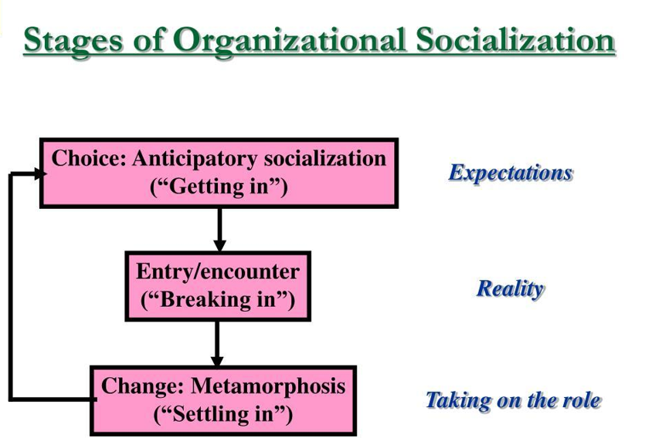
Figure 1: Strategic Organisational Socialisation Process
Source: Adapted from Van Maanen and Schein (1979).

2.2 Designing a Socialisation Framework for Helios Urban Mobility
Helios Urban Mobility needs to go through a systematic socialisation process that goes beyond the initial induction to facilitate employee learning, engagement and commitment in the long term. Considering the long onboarding process and high rate of attrition of graduates at the organisation, a staged structure is able to minimise unpredictability, enhance organisational identification and enhance performance. It has been found that socialisation works best when the responsibility is shared by the HR, the line managers, mentors and the employees during the employee journey and not as a one-off event of onboarding (CIPD, 2024).
Stage | HR Responsibilities | Manager Responsibilities | Mentor Responsibilities | Employee Responsibilities | Example KPI
Pre-boarding | Send welcome pack, provide system access, share company values | Contact new starter and explain role expectations | Introduce themselves and answer initial questions | Complete documentation and learning modules | 100% completion before start date
Day One | Deliver induction and compliance training | Introduce team, clarify objectives | Provide workplace guidance | Participate in induction activities | New hire satisfaction score
Week One | Schedule learning resources | Hold regular check-ins | Support integration into team | Build relationships and ask for feedback | Completion of mandatory training
Month One | Monitor onboarding progress | Review early performance | Offer coaching and advice | Demonstrate role competence | Time to productivity
First 90 Days | Gather feedback and evaluate progress | Conduct formal probation review | Encourage career discussions | Achieve agreed performance goals | Probation success rate
First Year | Plan continuous development | Identify future opportunities | Support career growth | Participate in learning and development | Retention and engagement rate
The purpose of each stage is different. Pre-boarding minimises uncertainty prior to employment and structured induction helps employees to know what is expected of them and workplace culture. Continued mentoring and frequent managerial feedback contribute towards professional growth and reinforced psychological commitment, minimizing the chances of premature turnover.
Generally, this framework favours Helios as it will decrease its current eight months adjustment phase, enhance the involvement of employees and a better pipeline of loyal employees who can play a role in the long-term organisational performance.
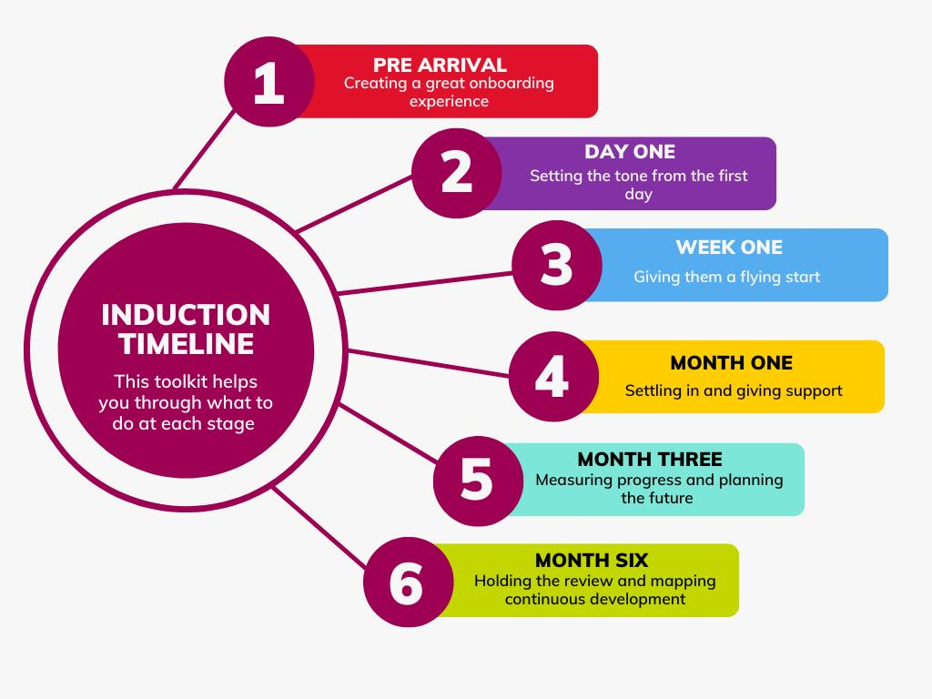
Figure 2: Employee Onboarding Journey
Source: Adapted from CIPD (2024).

2.3 Organisational Identification
Organisational identification is the degree of identification with the organisation and its mission and purpose that the employees have and whether they identify themselves as a part of the organisation and whether they share their personal values with the organisations (Ashforth and Mael, 1989). In the case of Helios Urban Mobility, organisational identification should be enhanced to enhance employee engagement and curb the high rate of graduate talent attrition. This can be done through communicating an effective organisational purpose, empowering voice of employees by having frequent feedback meetings, acknowledging the efforts of employees and promoting psychological safety where employees feel free to share ideas without being afraid of a backlash. Shared values should also be strengthened by leadership by making consistent behaviours and transparent decisions to develop trust and a sense of belonging.

2.4 Ethical Professionalism
Helios ought to incorporate ethical professionalism by enforcing ethical training, overt ethical leadership, a code of conduct and an anonymous reporting system that is periodically updated. A well-organised ethical decision-making framework should be used to support these initiatives as it will help employees to assess the legal, organisational and stakeholder consequences of workplace decisions. The psychological contract is also strengthened by ethical leadership, which demonstrates that organisational values are represented in daily managerial practices and motivates employees to act responsibly and uphold professionalism (Brown and Treviño, 2006; CIPD, 2023).

2.5 Business Activist Mindset
Contemporary organisations are putting increasing demands on employees to perform out of their official role in helping organisations in terms of innovation, sustainability and organisational enhancement. The HR model proposed by Ulrich makes HR professionals strategic partners that build the capabilities of the workforce according to the business goals instead of administrative work (Ulrich, 1997). At Helios, stakeholder capitalism and environmental, social and governance (ESG) principles can be embedded into daily work and motivate employees to see themselves as contributors to the broader organisational and societal outcomes. By fostering corporate citizenship via innovation projects, sustainability projects and cross-functional projects, one can engage employees as proactive business partners that generate value in the long term to customers, communities and the organisation (Ulrich and Dulebohn, 2015; World Economic Forum, 2024).

TASK B: Innovative Job Design Strategy

3.1 Critical Evaluation of Job Design Theories
Job design is necessary in enhancing employee engagement, innovation and organisational performance. According to the Job Characteristics Model (JCM) formulated by Hackman and Oldham (1976), skill variety, task identity, task significance, autonomy and feedback enhance intrinsic motivation. Although the model gives a solid foundation of enriching jobs, it presupposes that employees will react the same way to job redesign without considering individual preferences and altered work settings.
By contrast, Job Crafting Theory asserts that workers actively redefine their work and associations to render work more purposeful (Wrzesniewski and Dutton, 2001). This method is more flexible and offers more ownership than JCM, but it can lead to inconsistencies when the initiatives of the employees are not aligned with the organisational objectives.
A Skills-Based Organisation (SBO) is an organisation that pays attention to the skills of its employees instead of job titles, and this allows organisations to be able to adapt to the evolving needs of the business (Deloitte, 2023). Equally, Internal Talent Marketplaces (ITMs) rely on digital platforms to connect employees with projects and career opportunities based on their skills to raise internal mobility and lower the cost of recruitment (Gartner, 2023).
More collaboration, flexibility and continuous learning are also promoted by Agile working, Digital HR and Cross-functional Teams. In the example of Helios Urban Mobility, a combination of JCM and a Skills-Based Organisation and an Internal Talent Marketplace is the most appropriate solution as it implies meaningful work, ongoing capabilities development and workforce agility, which help foster innovation and the future expansion of the organisation.
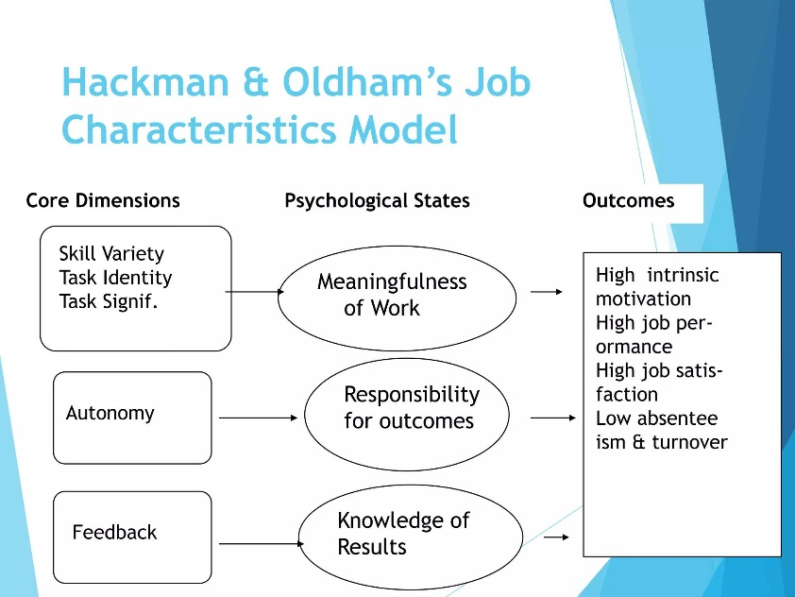
Figure 3: Job Characteristics Model
Source: Adapted from Hackman and Oldham (1976).

3.2 Innovative Job Architecture for Helios
Helios Urban Mobility needs to implement a mixed job structure, which would incorporate skills mapping, AI-assisted learning, inside mobility and project-based work. The skills of employees must be in an electronic database on skills and updated on a regular basis to be able to aid in workforce planning. The managers are therefore able to assign employees to cross functional projects depending on their competencies and also determine areas of development in the future. Personalised training can be suggested by AI-enabled learning platforms to fill in skill gaps and assist in career development (Deloitte, 2023).
Internal Talent Marketplace must advertise internal temporary projects, innovation and permanent job opportunities, and recruitment should be made externally. This, together with clear career pathways, allows employees to expand the experience, enhance teamwork and commitment to the organisation. Cross-functional teams also promote knowledge exchange and innovation in solving problems.
This should be implemented gradually by investing in digital HR systems, training managers and frameworks of competency. Risks that may occur are incorrect skills data, challenge in adopting technology, and employee resistance. They can be minimized by means of open communication, pilot programmes, frequent feedback, and constant tracking of employee involvement and internal mobility.
On the whole, this architecture can help Helios to enhance flexibility of the workforce, retain employee talents and promote strategic renewal by matching the skills of the employees with organisational goals.
Table 3.1: Proposed Innovative Job Architecture for Helios
Component | Implementation | Expected Benefit
Skills Mapping | Digital skills inventory | Better workforce planning
Internal Mobility | Internal recruitment first | Higher retention
AI Learning | Personalised learning | Faster capability development
Learning Platform | Online technical and leadership training | Continuous upskilling
Cross-functional Teams | Multidisciplinary projects | Greater innovation
Project Marketplace | Short-term strategic projects | Broader experience
Internal Talent Marketplace | Skills-based opportunity matching | Better talent utilisation
Career Pathways | Transparent progression routes | Higher engagement

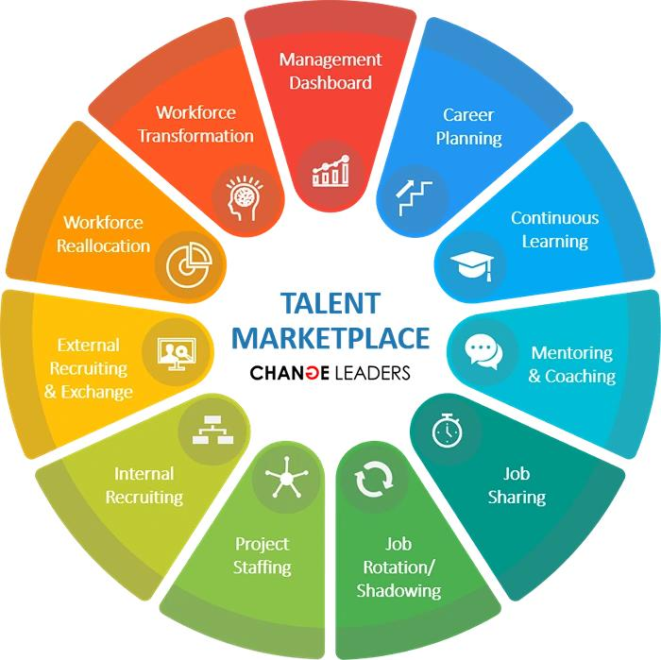
Figure 4: Internal Talent Marketplace Framework
Source: Adapted from Deloitte (2023).
3.3 Intrinsic Motivation
Employee engagement, creativity and retention cannot be enhanced without intrinsic motivation. Hackman and Oldham (1976) theorized that employees are more motivated when jobs have autonomy, skill, task significance and frequent feedback. The model however, does not give much consideration on individual differences. According to Pink (2009), autonomy, mastery and purpose are the main sources of motivation in knowledge-based organisations, though his model has a paucity of empirical data. Self-Determination Theory also proposes that employees will work optimally where their needs to autonomy, competence and relatedness are met (Deci and Ryan, 2000).
In the case of Helios Urban Mobility, a combination of these theories will enhance engagement as it provides employees with more decision-making power, learning opportunities are personalised, and career advancement is meaningful. Cross-functional initiatives, AI-assisted learning and moving inside promote knowledge sharing, creativity, and constant skill growth. Connecting the employee career objectives to the mission of Helios to provide sustainable urban mobility solutions will also enhance organisational commitment, wellbeing and long-term retention, as the company can create a skilled and flexible workforce that is able to help the company grow its business in the future (CIPD, 2024; Deloitte, 2023).

TASK C: Reflective Report

4.1 AI as a Decision-Support Tool
In this module, I applied artificial intelligence (AI) mainly to facilitate my research, finding pertinent academic literature, comparing HR theories and information organisation. First, AI was beneficial, as it saved me time spent on seeking sources and made it easier to grasp more complicated ideas. Nevertheless, I also realised that an excessive use of AI might result in a lack of critical thinking regarding the information (Dwivedi et al., 2023).
After this experience, when reflecting on it in terms of Gibbs Reflective Cycle (Gibbs, 1988), I understood that AI must not substitute human judgement but strengthen it. Even though AI can serve a fast idea generation, it might possess inaccuracies, outdated information or biased answers. Thus, I was taught to confirm evidence with peer-reviewed journal articles, CIPD publications and other reliable sources and to include information in my work. It reinforced my critical thinking and academic judgement and made sure that AI is used responsibly (CIPD, 2024; SHRM, 2024).
In general, this experience has demonstrated that the ethical application of AI involves transparency, independent analysis and close consideration of sources. I will still apply AI as a decision-support resource to research and brainstorming in the future assignments and professional practice, but still use my own critical thinking, ethical judgement and evidence-based decision-making to make balanced and responsible conclusions (World Economic Forum, 2025).

4.2 Personal Capability Development Plan
In order to enhance my career in strategic human resource management in the future, I have outlined some of the areas I will engage in lifelong learning. By enhancing my digital capability, leadership and strategic HR knowledge, I will be able to play a bigger role in organisational decision-making and the transformation of the workforce. To improve both technical and interpersonal skills, I will balance formal learning with the practical experience in the workplace and regular reflection. Ongoing professional growth will also enable me to keep up with the emerging technologies, and the trends and changes in the global workforce and HR practices, which will equip me with the duties of leading the company in a dynamic business environment (CIPD, 2024).
Table 4.1 Personal Capability Development Plan
Development Area | Current Level | Action | Timeline | Expected Outcome
Data Literacy | Intermediate | Complete HR analytics training | 6 months | Better data-driven decisions
AI in HR | Basic | Learn AI applications through online courses | 6–12 months | Improved HR technology skills
Leadership | Intermediate | Lead workplace projects | 12 months | Stronger leadership capability
Strategic HR | Intermediate | Study CIPD resources and HR journals | Ongoing | Better strategic decision-making
Communication | Good | Attend presentation and communication workshops | 6 months | More effective stakeholder communication
Influencing | Intermediate | Practise negotiation and coaching skills | 12 months | Greater ability to influence decisions
Global Mobility | Basic | Study international HR practices | 12 months | Improved global HR awareness
Digital Transformation | Intermediate | Learn digital HR systems and automation tools | Ongoing | Enhanced digital capability

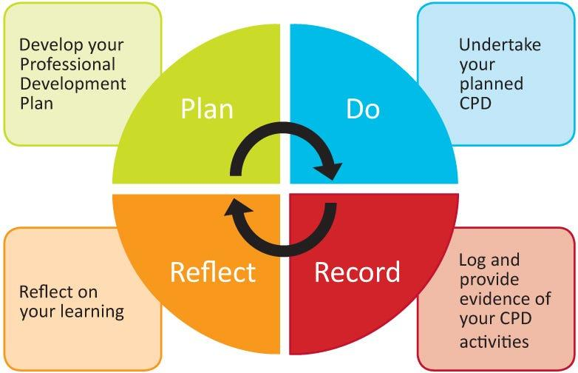
Figure 5: Personal Capability Development Roadmap
Source: Adapted from CIPD (2024).

Conclusion
Innovative job design and ongoing capability development, strategic organisational socialisation, are needed to enhance employee engagement and organisational performance at Helios Urban Mobility. Through the alignment of human capital practices with strategic goals, the organisation will be able to amplify human resource strength, promote innovation, employee loyalty and develop a sustainable competitive edge in the ever-changing smart mobility industry (Ulrich and Dulebohn, 2015; CIPD, 2024).

References
Ashforth, B.E. and Mael, F., 1989. Social identity theory and the organization. Academy of Management Review, 14(1), pp.20–39.
Brown, M.E. and Treviño, L.K., 2006. Ethical leadership: A review and future directions. The Leadership Quarterly, 17(6), pp.595–616.
CIPD, 2025a. Employee induction. London: Chartered Institute of Personnel and Development. Available at: https://www.cipd.org/en/knowledge/guides/employee-induction (Accessed: 11 July 2026).
CIPD, 2025b. Job design factsheet. London: Chartered Institute of Personnel and Development. Available at: https://www.cipd.org/uk/knowledge/factsheets/job-design-factsheet (Accessed: 11 July 2026).
CIPD, 2025c. Talent management. London: Chartered Institute of Personnel and Development. Available at: https://www.cipd.org/uk/topics/talent-management (Accessed: 11 July 2026).
Deci, E.L. and Ryan, R.M., 2000. The "What" and "Why" of goal pursuits: Human needs and the self‐determination of behaviour. Psychological Inquiry, 11(4), pp.227–268.
Deloitte, 2024. Global Human Capital Trends 2024. London: Deloitte. Available at: https://www2.deloitte.com/global/en/pages/human-capital/topics/human-capital-trends.html (Accessed: 11 July 2026).
Dwivedi, Y.K. et al., 2023. So what if ChatGPT wrote it? Multidisciplinary perspectives on opportunities, challenges and implications of generative AI for research, practice and policy. International Journal of Information Management, 71, p.102642. doi: 10.1016/j.ijinfomgt.2023.102642.
Edmondson, A.C., 2019. The Fearless Organization: Creating Psychological Safety in the Workplace for Learning, Innovation, and Growth. Hoboken: Wiley.
Gartner, 2023. Internal Talent Marketplace Research. Available at: https://www.gartner.com/en/human-resources (Accessed: 11 July 2026).
Gibbs, G., 1988. Learning by Doing: A Guide to Teaching and Learning Methods. Oxford: Oxford Polytechnic.
Hackman, J.R. and Oldham, G.R., 1976. Motivation through the design of work: Test of a theory. Organizational Behavior and Human Performance, 16(2), pp.250–279.
McKinsey & Company, 2024. People and Organizational Performance Insights. Available at: https://www.mckinsey.com (Accessed: 11 July 2026).
Pink, D.H., 2009. Drive: The Surprising Truth About What Motivates Us. New York: Riverhead Books.
Pratt, M.G., Rockmann, K.W. and Kaufmann, J.B., 2006. Constructing professional identity: The role of work and identity learning cycles in the customization of identity among medical residents. Academy of Management Journal, 49(2), pp.235–262.
PwC, 2024. Workforce of the Future. Available at: https://www.pwc.com/gx/en/issues/workforce.html (Accessed: 11 July 2026).
Rousseau, D.M., 1995. Psychological Contracts in Organizations: Understanding Written and Unwritten Agreements. Thousand Oaks: Sage.
SHRM, 2024. Artificial Intelligence in the Workplace. Available at: https://www.shrm.org (Accessed: 11 July 2026).
Tajfel, H. and Turner, J.C., 1979. An integrative theory of intergroup conflict. In: W.G. Austin and S. Worchel, eds., The Social Psychology of Intergroup Relations. Monterey, CA: Brooks/Cole, pp.33–47.
Ulrich, D., 1997. Human Resource Champions. Boston: Harvard Business School Press.
Ulrich, D. and Dulebohn, J.H., 2015. Are we there yet? What's next for HR? Human Resource Management, 54(2), pp.188–204.
Van Maanen, J. and Schein, E.H., 1979. Toward a theory of organizational socialization. Research in Organizational Behavior, 1, pp.209–264.
World Economic Forum, 2025. The Future of Jobs Report 2025. Available at: https://www.weforum.org/reports/the-future-of-jobs-report-2025 (Accessed: 11 July 2026).
Wrzesniewski, A. and Dutton, J.E., 2001. Crafting a job: Revisioning employees as active crafters of their work. Academy of Management Review, 26(2), pp.179–201.

