A Reflection on
Category5 and Category 6 Cable Standards
By
Mark Lawrence Edwin Vaughan
School of Computing
Module: Internet Architecture and Technology
Tutor: Dr Kapilan Radhakrishnan

Contents
1. Introduction 3
2.0 Cable Construction 3
2.1 Functional Considerations 3
2.2. Conclusion 4
3.1 Bibliography 5
4.0 Appendix A Wiring Diagram for EIA 563 A and B 6
4.1 Appendix B. 6

1. Introduction

This is a Brief report that will discuss the relative advantages of the two cables standards as defined in ANSI/TIA/EIA-568-A. Section one will describe the construction of the cables and section two will describe the functional differences

2.0 Cable Construction
In the original EIA563^{[1]} specification. The design for Category 5 (UTP) cable was for eight thin insulated cables to be encased in a tough PVC outer insulating sheath and terminated with eight pin RJ-45 connectors. Internally the colour coded cables were twisted in pairs of two with one wire marked with a white stripe that to denote the positive wire. Later Category 5e cable was implemented as an enhanced cable with improved specification. Category 6 Cables were introduced with a preformed separator that separated each twisted pair to further reduce internal interference and improve transmission speed. Both forms of cable benefit from improved performance when the internal conductors are provided with a shielding medium and are hither too known as STP or Shielded Twisted Pair cables.
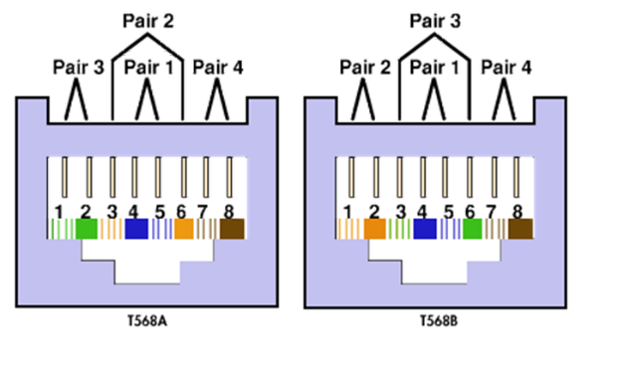
The Specification also defines how the connectors are wired. The specification declares that only four of the eight conductors are used. These are connected to pins 1,2,3 and 6 with pins 1 and 2 being concerned with transmitted signals and pins 3 and six being used to receive the transmitted signals. The specification has two main variations known as A and B the difference between them being the order of the pin-colour combination used. Seen appendix A for more detail.
Cables built to this specification can be constructed in two ways. These are in a ‘Straight’ configuration and in a ‘Crossed’ configuration. The use of these cables is dependent on their use. The straight cables typically are used to connect Data Terminal Equipment (DTE) to Data Communication Equipment (DCE). Conversely crossed cables are used to join either DTE-DTE or DCE-DCE equipment together. The use of the latter is typically used to connect routers in medium and large networks.
Figure 1

2.1 Functional Considerations
Since the creation of the Ethernet Standard in 1985^{[2]} and the yearly increase in performance of the connected hardware, the trend for increasing speeds within networks has invariably increased. From this it can be deduced that as the demand for faster networks increases then the quality and performance of the cabling must increase also. For example; the initial transfer rate for category 5 cable was around 10 MB per Second. Later category 5e increased this to 100MB per second and category 6^{[3]} is currently around 1Gb per second. Category 7 and higher being even faster still. In building networks there are two constraints at work – Cost and Speed.

In terms of speed, the following points are considered.:
- DTE equipment (PC’s etc) do not experience continuous high loads of traffic.
- DCE equipment do experience high volumes of traffic especially core devices such as backbone routers or signal multiplexors/demultiplexers.
- Switches can have up to 48 ports available for connection making them the major consumers of cables. Routers typically tend to use two or three connections in normal operation.
In terms of cost using the previous facts; the more basic 5e cables are better suited to endpoint connections on the basis of low cost. For routing and connectivity, the category 6 cables are better suited as their bandwidth restrictions are reduced and higher communication speeds can be maintained. For larger networks more, specialised cable types should be used for core connectivity.

2.2. Conclusion
The following conclusions can be formed:
- The extract from the RS Components Website in appendix B describes the advantages of category 6 cables over Category 5(e) briefly, the use of category six cables is said to be superior to previous versions in both bandwidth and operating frequency with typical performances of up to 1Gigabit per second at 250Mhz which is in excess of 150% improvement over category 5e cables. Category 5 cables are now obsolete.
- The cost differences in the manufacture of the cables is so minimal that the additional expense for Category 6 cables is far outweighed by the performance of the network when used throughout.
- In areas of high electrical and radio interference, STP* cables and shielded RJ-45 connectors are highly recommended to reduce the effect of external interference. In extreme conditions the use of Fibre optic cable and media converters is a better option.

For more technical specification’s please see appendix C
*Shielded Twisted Pair.

3.0 References
[1] Anonymous (). TIA/EIA-568 - Wikipedia. Available: https://en.wikipedia.org/wiki/TIA/EIA-568#T568A_and_T568B_termination
[2] Anonymous (). IEEE Standards for Local Area Networks: Carrier Sense Multiple Access with Collision Detection (CSMA/CD) Access Method and Physical Layer Specifications. DOI: 10.1109/IEEESTD.1985.82837.
Available: https://ieeexplore.ieee.org/stamp/stamp.jsp?tp=&arnumber=30707
[3] Anonymous (). CAT5 Networking Cable Standards Ethernet SSTP SFTP UTP Assemblies. Available: https://www.vpi.us/technical-articles/cat5-5e-6-standards-621.

3.1 Bibliography
Anonymous (). EIA/TIA 568A & 568B Standard. Available: https://www.utm.edu/staff/leeb/568/568.htm.
B. Shipley. B. Shipley. Cabling standards keep LANs up to speed. Cabling standards keep LANs up to speed. Business Communications Review Business Communications Review 2626(4), pp. 79. pp. 79. 1996. Available: https://search.proquest.com/docview/224973830.
Anonymous (). IEEE Std 802.3bq™ -2016. Available: https://www.mendeley.com/viewer/?fileId=3644c8f2-29c1-371d-7480-8601096147f6&documentId=f4225286-d8e9-3bbd-9ff4-687a373b5086.
Anonymous (). 8802-3:2017/Amd 3-2017 - ISO/IEC/IEEE International Standard for Ethernet Amendment 3: Physical Layer and Management Parameters for 25 Gb/s and 40 Gb/s Operation, Types 25GBASE-T and 40GBASE-T - IEEE Standard. Available: https://ieeexplore.ieee.org/document/8314569.
Anonymous (). 100BASE-T2: 100 Mbit/s Ethernet over two pairs of category-3 cabling - IEEE Conference Publication. Available: https://ieeexplore.ieee.org/document/610033.
Anonymous A brief history of computer networking. A brief history of computer networking. Windows Help & Advice Windows Help & Advice (119), pp. 61. pp. 61. 2016. Available: https://search.proquest.com/docview/1801839925.
] C. Matt. C. Matt. Fog computing. Fog computing. Business & Information Systems Engineering Business & Information Systems Engineering 6060(4), pp. 351-355. pp. 351-355. 2018. Available: https://doi.org/10.1007/s12599-018-0540-6. DOI: 10.1007/s12599-018-0540-6.
F. Hotie and J. Gordijn. F. Hotie and J. Gordijn. Value-based process model design. Value-based process model design. Business & Information Systems Engineering Business & Information Systems Engineering 6161(2), pp. 163-180. pp. 163-180. 2019. Available: https://doi.org/10.1007/s12599-017-0496-y. DOI: 10.1007/s12599-017-0496-y.

4.0 Appendix A
Wiring Diagram for EIA 563 A and B

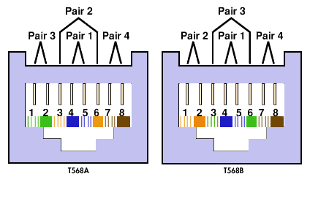
© University of Tennessee
(https://www.utm.edu/staff/leeb/568/rj45.gif)

4.1 Appendix B.
Extract from RS Components Website.
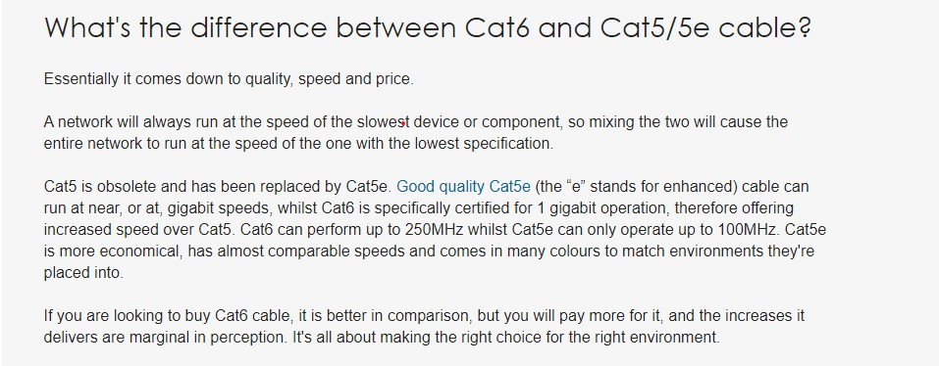

4.2 Appendix C
Further Reading

CAT5 Networking Cable Standards Ethernet SSTP SFTP UTP Assemblies. Available: https://www.vpi.us/technical-articles/cat5-5e-6-standards-621.
IEEE 802.3 Draft Handbook. Fifth revised print edn. Institute of Electrical and Electronic Engineers.
IEEE Std 802.3bq™ -2016. Available: https://www.mendeley.com/viewer/?fileId=3644c8f2-29c1-371d-7480-8601096147f6&documentId=f4225286-d8e9-3bbd-9ff4-687a373b5086.
SOORTY, B.K., KOLAHI, S.S., CHAND, N. and QU, Z., 2010. Performance comparison of category 5e vs. category 6 cabling systems for both IPv4 and IPv6 in Gigabit Ethernet, 2010, pp. 1525-1529.

