

Name: Meheret Zeleke
Student number: 2426669
Module code: BMHP5015
Module: Changemakers: Building your Personal Brand for Sustainable Employment
Assignment Title: Component 1: Online Portfolio of Set Exercises
Contents
Task 1 – Personal Brand 2
Task 2 - Network Map and Rationale 3
Task 3- Blog 5
Task 4- NHS Equality, Diversity and Inclusion Quiz (250 words equivalent) 6
Task 5- A Letter to Yourself 10
Task 6- GANTT Chart (200 words equivalent) 12
Task 7- Making Changes- Report 13

Task 1 – Personal Brand
My personal brand is compassionate, reliable, and evidence-informed. Gorbatov et al. (2018) define personal branding as a strategic process of creating, positioning, and maintaining a positive impression based on unique characteristics, signalling a promise to a target audience through narrative and imagery. With over 10 years of frontline experience and a health and social care degree, I aim to align my values with a visible, credible professional identity (Neis, 2025).
My strengths include clear communication, calmness under pressure, and person-centred care, consistent with Neis’s (2025) emphasis on language as a leadership tool. For example, I recently supported a new carer during a difficult family conversation, reinforcing psychological safety (Neis, 2025). My degree has deepened my understanding of reflective, values-based practice, supporting my professional identity development (Gorbatov et al., 2018).
My goal is to become a team leader in my care home. I lack formal leadership experience and visibility with management, so I need to build these areas (Neis, 2025).
I will gain leadership experience by mentoring, coordinating shifts, and deputising for the senior (Neis, 2025). I will seek feedback from my manager, colleagues, and residents’ families, as feedback-seeking closes the gap between desired and perceived identity (Gorbatov et al., 2018). I will reflect regularly using self-reflection to review my progress and set actions (Gorbatov et al., 2018). I will build an online presence on LinkedIn to enhance professional visibility, as Harris and Rae (2011) recommend for career development.
These steps will position me as a credible, values-driven leader ready for the team leader role (Gorbatov et al., 2018).

Task 2 - Network Map and Rationale

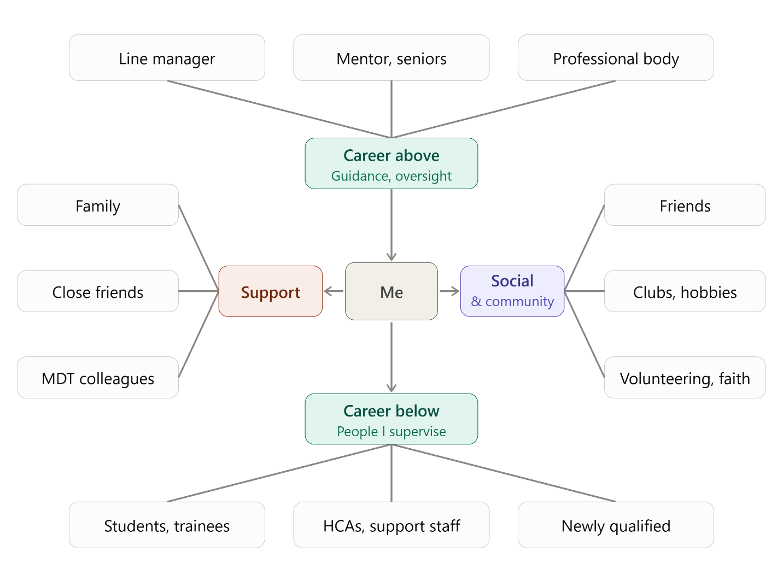

The network map illustrates an ego-centric network centred on "Me," compartmentalised into "Support," "Social & community," and hierarchical career domains. Mapping such professional relationships is crucial in healthcare, as network positions significantly influence knowledge translation and care delivery (Hu et al., 2021).
The explicit inclusion of "Support" (family, friends, MDT colleagues) and "Career above" (line manager, mentors) aligns with evidence that supervisor and coworker support are vital. Velando-Soriano et al. (2020) demonstrate that robust social support inversely correlates with emotional exhaustion and depersonalisation, mitigating burnout syndrome in nurses.
Structurally, "Me" occupies a central brokerage position. By maintaining connections across distinct clusters such as between "Career above" and "Social & community “the ego spans multiple structural holes. Burt (1992) argues that spanning nonredundant contacts yields significant information and control benefits, positioning the individual as a tertius gaudens. Furthermore, the peripheral nodes (e.g., "Professional body") likely function as Granovetter’s (1973) weak ties, bridging disconnected social worlds to provide novel information.
Critically, while the map implies a balanced network, Hu et al. (2021) caution that excessive reliance on central nodes can lead to "information overload" and communication bottlenecks. Additionally, the map’s rigid categorisation assumes all ties are equally significant, overlooking that relationship strength varies considerably (Granovetter, 1973). It also fails to capture the real-world overlap between domains, such as MDT colleagues who operate within both "Support" and "Career" networks.

Task 3- Blog

We know that working in adult social care is deeply rewarding, but it can also be incredibly draining. Burnout is a very real issue in our sector, defined by emotional exhaustion, feeling detached from your work, and a reduced sense of professional accomplishment (Jimenez-Garcia and Flor-Martinez, 2026).
Why does this happen? The evidence points to several key causes. High workloads, low staffing levels, and long shifts are major drivers of burnout (Dall'Ora et al., 2020). When you are constantly facing high job demands without enough managerial support, recognition, or clear guidance, your stress levels inevitably rise (Dima et al., 2021). Research also shows that a lack of social support, work-family conflict, and even workplace victimisation can significantly drain your emotional resources (Chaves-Montero et al., 2025).
The good news is that evidence-based interventions can help. A systematic review of healthcare workers found that targeted interventions such as mindfulness, relaxation techniques, and coping skills development can significantly reduce stress and burnout (Anger et al., 2024). Mindfulness and yoga programmes have been shown to be particularly effective for reducing emotional exhaustion (Jimenez-Garcia and Flor-Martinez, 2026). Simple, scalable options like digital mindfulness or brief positive-psychology exercises can also make a real difference in your daily routine (Jimenez-Garcia and Flor-Martinez, 2026).
However, it is not just about what you can do as an individual. Organisational support is vital (Dima et al., 2021). Having a clear self-care plan, access to flexible working, and strong support from your peers and supervisors can protect you against burnout (Chaves-Montero et al., 2025; Dima et al., 2021). Team-based reflective structures, such as Balint groups or reflective supervision, also provide a safe space to share experiences and build resilience (Jimenez-Garcia and Flor-Martinez, 2026).
If you are feeling overwhelmed, please know you are not alone. By combining personal self-care strategies with strong team support, we can protect our mental health and continue providing the high-quality care our residents deserve.

Task 4- NHS Equality, Diversity and Inclusion Quiz (250 words equivalent)
- What is the primary goal of the NHS Equality, Diversity, and Inclusion Improvement Plan?
(Answer in one or two sentences.)
The main goal of the plan is to make the NHS a fairer and more welcoming place to work, so every member of staff is treated equally and can do well. It also aims to improve staff experience, which leads to better care for patients.

- How does the NHS EDI Improvement Plan propose to tackle the gender pay gap?
(Answer in one to two sentences.)
The plan asks NHS organisations to make and follow a plan to close pay gaps, including the gender pay gap. They need to check their pay data and take action to fix any unfair differences.

- What is meant by the term ‘intersectionality’ as used in the NHS EDI Improvement Plan?
(Answer in one to two sentences.)
Intersectionality means that a person can face unfair treatment for more than one reason at once, such as being a woman and also being disabled or from an ethnic minority. The plan wants the NHS to understand how these things combine so staff get the right support.

- Why is it important for the NHS to create a psychologically safe work environment?
(Answer in one to two sentences.)
A psychologically safe workplace means staff feel able to speak up, share worries and make mistakes without fear of being blamed or treated badly. This helps staff feel happier and healthier, and it makes patient care safer.

- How does the NHS EDI Improvement Plan suggest improving the experience of internationally recruited staff?
(Answer in one to two sentences.
The plan says the NHS should give internationally recruited staff a proper welcome and a good induction, with training and support to settle in. This includes help with practical things like housing, as well as ongoing development.

- What role does leadership play in advancing EDI objectives according to the NHS Improvement Plan?
(Answer in one to two sentences.)
Leaders set the example and are responsible for making change happen. The plan asks senior leaders, including board members, to have clear EDI goals and to be held to account for meeting them.

- Identify one way the NHS EDI Improvement Plan aims to reduce health inequalities within the workforce.
(Answer in one to two sentences.)
The plan asks NHS organisations to improve the health of their staff by looking at where some groups have worse health than others. They then put support in place to help, such as access to health checks and services.

- Why does the NHS EDI Improvement Plan emphasise the importance of collecting and analysing data on protected characteristics?
(Answer in one to two sentences.)
Collecting and checking this data shows where some groups of staff are being treated unfairly or have worse experiences. This helps the NHS see what needs to change and check whether things are getting better.

- Explain how flexible working policies can contribute to equality and inclusion in the NHS workforce.
(Answer in one to two sentences.)
Flexible working, such as changing hours or working from home, helps staff fit work around things like caring for family, health needs or religious practice. This means more people can stay in work and have fair chances to progress.

- What is one strategy mentioned in the NHS EDI Improvement Plan to combat bullying and harassment in the workplace?
(Answer in one to two sentences.)
One strategy is to set up clear, fair ways for staff to report bullying and harassment, with action taken when they do. Organisations are also asked to put in place plans to stop it happening in the first place.

Task 5- A Letter to Yourself

Dear me 10 years before,

I’m writing to you from a position of growth, looking back at the night you found him. You’d done your checks, and when you went into his room, he was already gone but his body was stiff, his arms fixed where they lay. You panicked. You thought you’d missed something, that you should have checked sooner, that the rigidity meant something had gone terribly wrong. You went home shaking and replayed it for days.
What you didn’t know then and what this module on emotional intelligence and resilience has taught me is that rigor mortis is a normal, expected part of death. It isn’t a sign of failure or neglect. It’s simply biology. Emotional intelligence would have helped you name the fear and shock without letting them spiral into self-blame. You could have paused, taken a breath, and reminded yourself: This is normal. I am not responsible for death. I am responsible for care.
Resilience wasn’t about becoming hardened. It was about staying steady enough to do the small, dignified things. You could have gently covered him, adjusted his position as best you could, spoken softly, and treated his body with the same respect you’d shown his living self. That’s what giving dignity back looks like not erasing rigor mortis but responding to it calmly and kindly.
You were young and frightened. That’s human. But with these skills, you could have trusted yourself more and stressed less.

With love,

You 10 years onward

Task 6- GANTT Chart (200 words equivalent)
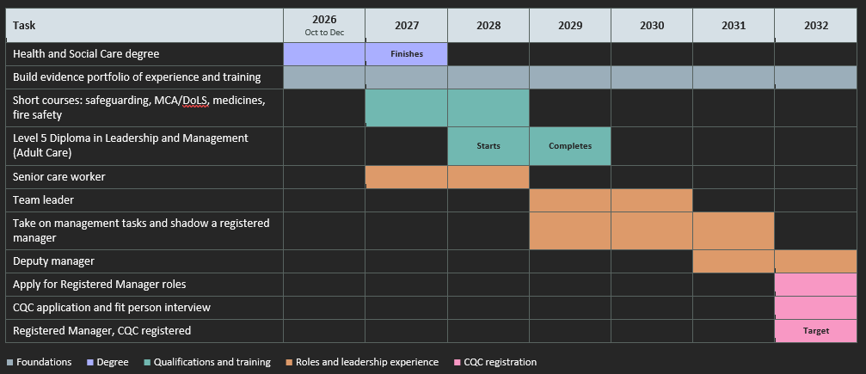

Task 7- Making Changes- Report
This report proposes a 10-minute stand-up safety huddle at the start of each shift in our care home, covering risks, residents of concern and staffing. Huddles are brief, structured, interdisciplinary meetings that enable teams to reflect on improvement opportunities and plan their resolution (Krassikova et al., 2024). Brief front-line stand-up huddles facilitate efficient information exchange and help staff identify residents at risk and develop individualised actions (Nash et al., 2024). Huddles can also improve information-sharing, accountability, empowerment and sense of community, supporting collective awareness (Goldenhar et al., 2013). They are feasible, relatively low-cost interventions for improving teamwork and safety culture (Lamming et al., 2021).
Implementation will begin as a pilot on one unit, then spread to other units after feedback (Nash et al., 2024). I will recruit a huddle champion and leadership team, and provide training in facilitation, communication and rapid-cycle quality improvement (Krassikova et al., 2024; Nash et al., 2024). Standard scripts and ground rules will ensure each huddle opens, reviews recent events, discusses current risks and closes with actions (Krassikova et al., 2024). A timer will protect the 10-minute limit, and a whiteboard or opportunity-for-improvement cards will let staff who cannot attend contribute topics (Krassikova et al., 2024). The huddle will maintain a simple “watch list” of residents at risk and a non-judgemental, fear-free tone (Lamming et al., 2021; Nash et al., 2024). I will review actions weekly and use staff feedback to refine the schedule and content (Krassikova et al., 2024).
Necessary skills include facilitation, concise communication, coaching and quality-improvement monitoring (Krassikova et al., 2024). Leadership presence and consistent scheduling are also needed to reinforce participation (Krassikova et al., 2024). Possible barriers are time pressure, workload and staffing shortages, difficulty finding a shift time that suits all staff, and scarce facilitator availability (Krassikova et al., 2024). Daily huddles may be perceived as excessive, so frequency should be adjusted after piloting (Krassikova et al., 2024). Fidelity may drift: in one evaluation, “who is at risk” was discussed in 95% of observed huddles, but run charts were never reviewed and only 9% were led by the most senior clinician (Lamming et al., 2021). I will therefore adapt criteria to what frontline staff find useful, rotate facilitation, use a timer, keep a visible action log, and ask managers to attend intermittently (Krassikova et al., 2024; Lamming et al., 2021). This should make the huddle feasible and sustainable (Lamming et al., 2021).

Reference List

Gorbatov, S., Khapova, S.N. and Lysova, E.I. (2018) ‘Personal branding: Interdisciplinary systematic review and research agenda’, Frontiers in Psychology, 9, 2238. doi: 10.3389/fpsyg.2018.02238.
Harris, L. and Rae, A. (2011) ‘Building a personal brand through social networking’, Journal of Business Strategy, 32(5), pp. 14–21. doi: 10.1108/02756661111165435.
Neis, F. (2025) ‘Your story, your brand: A career core competency for nurses’, Nursing, 55(1), pp. 1–5. doi: 10.1097/NSG.0000000000000450.
Burt, R.S. (1992) 'The Social Structure of Competition', in Structural Holes. Cambridge: Harvard University Press, pp. 57-91.
Granovetter, M.S. (1973) 'The Strength of Weak Ties', American Journal of Sociology, 78(6), pp. 1360-1380.
Hu, H., Yang, Y., Zhang, C., Huang, C., Guan, X. and Shi, L. (2021) 'Review of social networks of professionals in healthcare settings where are we and what else is needed?', Globalization and Health, 17(1), p. 139.
Velando-Soriano, A., Ortega-Campos, E., Gómez-Urquiza, J.L., Ramírez-Baena, L., De La Fuente, E.I. and Cañadas-De La Fuente, G.A. (2020) 'Impact of social support in preventing burnout syndrome in nurses: A systematic review', Japan Journal of Nursing Science, 17(1), p. e12269.
Anger, W.K., Dimoff, J.K. and Alley, L. (2024) 'Addressing health care workers' mental health: a systematic review of evidence-based interventions and current resources', American Journal of Public Health, 114(S2), pp. S213-S226.
Chaves-Montero, A., Blanco-Miguel, P. and Rios-Vizcaño, B. (2025) 'Analysis of the predictors and consequential factors of emotional exhaustion among social workers: a systematic review', Healthcare, 13(5), p. 552.
Dall'Ora, C., Ball, J., Reinius, M. and Griffiths, P. (2020) 'Burnout in nursing: a theoretical review', Human Resources for Health, 18(41), pp. 1-14.
Dima, G., Mesesan Schmitz, L. and Simon, M.-C. (2021) 'Job stress and burnout among social workers in the VUCA world of COVID-19 pandemic', Sustainability, 13(13), p. 7109.
Jimenez-Garcia, S. and Flor-Martinez, A. (2026) 'Interventions for preventing or reducing nurse burnout: a systematic review and meta-analysis', International Journal of Nursing Studies, 178, p. 105391.
Goldenhar, L.M., Brady, P.W., Sutcliffe, K.M. and Muething, S.E. (2013) ‘Huddling for high reliability and situation awareness’, BMJ Quality & Safety, 22(11), pp. 899–906. doi:10.1136/bmjqs-2012-001467.
Krassikova, A., Wills, A., Vellani, S., Sidani, S., Keatings, M., Boscart, V.M., Bethell, J. and McGilton, K.S. (2024) ‘Development and evaluation of a nurse practitioner huddles toolkit for long term care homes’, Canadian Journal on Aging / La Revue canadienne du vieillissement, 43(3), pp. 396–404. doi:10.1017/S0714980823000740.
Lamming, L., Montague, J., Crosswaite, K., Faisal, M., McDonach, E., Mohammed, M.A., Cracknell, A., Lovatt, A. and Slater, B. (2021) ‘Fidelity and the impact of patient safety huddles on teamwork and safety culture: an evaluation of the Huddle Up for Safer Healthcare (HUSH) project’, BMC Health Services Research, 21, 1038. doi:10.1186/s12913-021-07080-1.
Nash, P., Clark, V., McConnell, E., Mills, W., Morgan, R., Pimentel, C., Ritchey, K., Levy, C., Snow, A.L. and Hartmann, C. (2024) ‘Improving safety and preventing falls using an evidence-based, front-line staff huddling practice: protocol for a pragmatic trial to increase quality of care in State Veterans Homes’, BMJ Open, 14, e084011. doi:10.1136/bmjopen-2024-084011.

