The Manufacture of Dental Crowns Using Additive Manufacturing and Traditional Methods
Manufacturing assignment
Gavin John (1809103)
2020
Table of Contents
Introduction 2
Traditional Manufacturing 3
Materials 3
Metal Crowns – Add in what material is used 3
Ceramic Crowns 3
Porcelain Fused to Metal Crowns 4
Manufacture Process 5
Additive Manufacturing Methods 6
Types of Manufacturing Methods 6
Fitting the Crown 7
What This Industry Can Expect 7
Works Cited 8

Introduction
To date, dentistry is one of the oldest professions and is considered one of the most important. Dentistry dates back to 5000BC and since then, dentistry has evolved and developed. [1] As of the last century, dentistry has seen its most rapid expansion, with the aid of the new technology that is now available. Additive manufacturing has been revolutionary in almost every market. One of the major breakthroughs for additive manufacturing is the use of 3D printing in the dental industry. The dental industry covers a wide variety of products, from customised crowns to dentures and retainers. [2] The additive process that is used for the construction of dental crowns is 3D printing, which can often be referred to as rapid prototyping. A 3D file will be obtained providing description data which can be used to create the product in a Computer Aided Design/Computer Aided Manufacturing software. [2]

In this report, there is going to be a comparison, with regards to the manufacture of dental crowns using traditional methods and additive manufacturing techniques. This report will cover which materials are used in both processes and what the future possibilities are for additive manufacture within density, with the main focus being on dental crowns.

Traditional Manufacturing
The purpose of a dental crown is to cover a damaged tooth and act as a restoration cap. The crowns give support to badly broken teeth and permanently replace the missing teeth to provide a perfect smile which can improve the bite pattern. A crown can be made from many different materials which include metal, plastics, ceramics or a combined combination of all three materials. [3]

When manufacturing dental crowns from metals, there is a wide variety to choose from. The most common metals that are used are gold and metal alloys. [4]

Materials

Metal Crowns – Add in what material is used

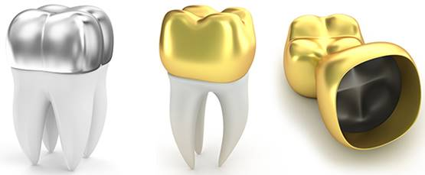
A metal type crown is considered the strongest crown available due to their structure being 100% metal. These crowns are able to be manufactured with a very thin layer, whilst keep all their solid and robust properties. This allows the existing tooth to keep the majority of its tooth structure, if possible, which keeps the core of the tooth at its maximum strength and retention. [5] Typically, metal crowns are the longest crown. This is because they are the more resistant to chewing and biting, with their superior strength and durability characteristics. [5] [6]
Fig. 1 http://www.vcdental.com.au/2019/11/26/dental-crowns/

Ceramic Crowns

All ceramic crowns are also known as porcelain crowns. Although these crowns haven’t got the same strength for biting or chewing as a metal crown, these crowns have the most natural colour compared to a natural tooth [6]. The predominant goal for this type of crown is to imitate the light characteristics to represent a natural tooth. However, this type of crown can wear down opposing more than a metal crown. The biggest risk associated with this crown is the potential to fracture or break which can lead to infections [5]. There are multiple different materials that are available for ceramic crowns. The two most popular ceramic crowns are porcelain and zirconia. Both these types of crowns provide a natural looking finish, however, zirconia crown typically tends to be the stronger of the two. Porcelain crowns have been an essential in the dental industry since the late 19th centaury and are most commonly for front teeth that are prone to wear. The use of zirconia crowns has been greatly used since the late 1990’s. These crowns get their strength from the material containing 90% zirconium oxide. [7]
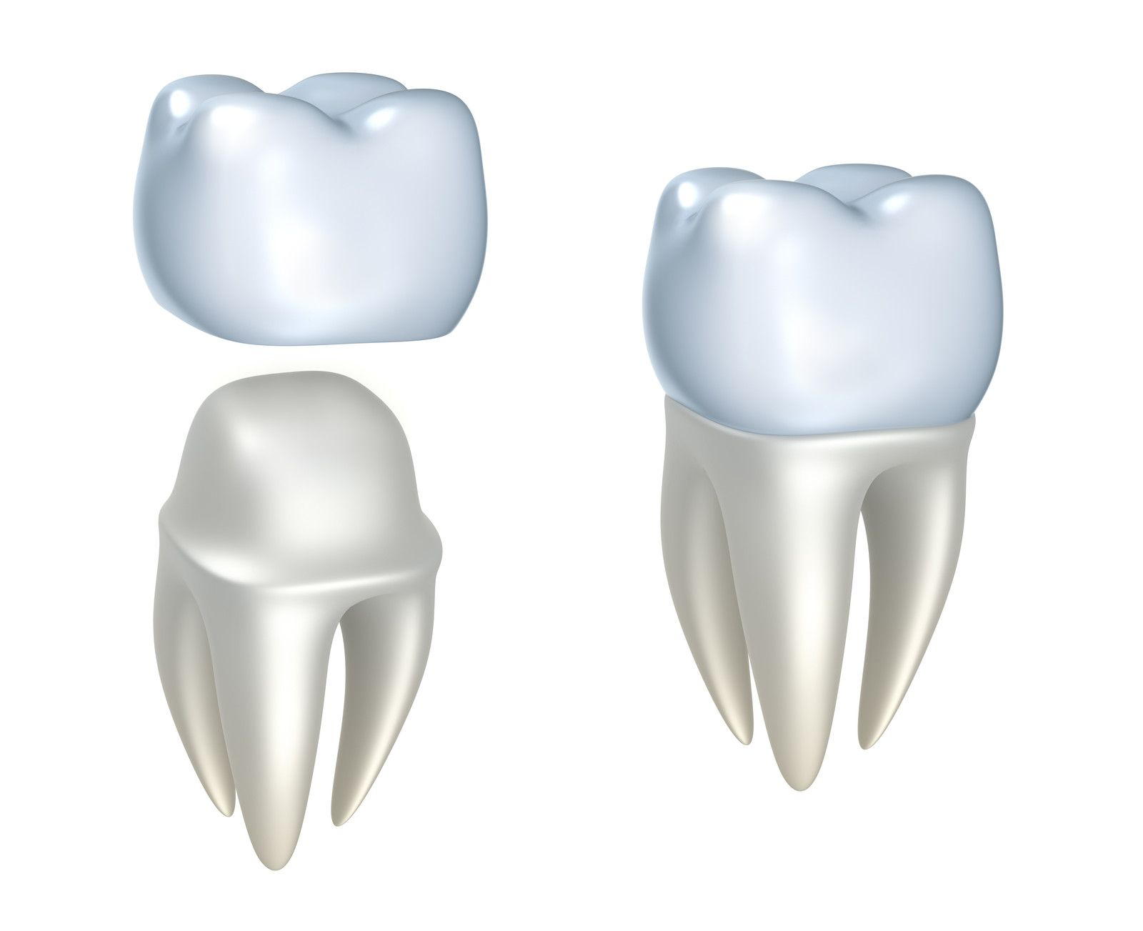
Fig. 2 https://mdentalclinic.eu/treatment/all-ceramic-crown/pros-and-cons

Porcelain Fused to Metal Crowns

Porcelain fused to metal crowns are also referred to as PMF. This type of crown is made of both metals and ceramics. The core of the crown is made of metal and then a porcelain layered and bonded over the top of the metal core to give the natural tooth like finish. [8]
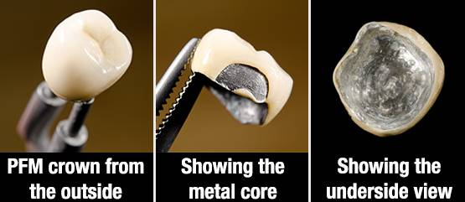
Due to the structure this crown gives, it can be suitable for all types of teeth. With PFM crowns, they have very limited transparency. This means that part of the metal can be seen. To rectify this, the crown needs to be covered in a very opaque porcelain. [5]
Fig. 3 http://www.vcdental.com.au/2019/11/26/dental-crowns/

Manufacture Process

For a traditional crown that is manufactured in a laboratory, it will generally require two appointments. The first appointment will be to prepare, make impressions and prep the tooth for the replacement. A temporary crown will also be fitted while the new crown is being manufactured. The second appointment will be for the new crown to be fitted. [5]

The first step is to numb the respective area. The tooth will then have to be prepared where the crown will be installed. This normally requires a removal of around two to three millimetres of the tooth structure. [3] However, this measurement is dependent on what material crown you are having, full metal crowns are the thinnest crowns, so they require less removal of the tooth compared to a ceramic or PFM crown. [5]

Now the tooth has been prepared, a mould impression will be taken. The plaster that is made for the impression will be mixed with a minimal amount of water to make it a watery putty like substance that is placed in a tray and fitted into the patients mouth. [3] An impression will be taken of the upper and lower teeth to ensure the crown fits comfortably in the mouth and with is adequate with the natural bite. [5] This is a negative impression of the tooth. Another plaster is then prepared, which is known as the model plaster, which is harder than the original plaster. This plaster follows a similar method as the first plaster by adding water to make a putty like substance. This slurry is poured into the negative mould and when the slurry hardens, creates a positive impression of the teeth. [3] The negative slurry must be carefully removed from the positive mould to give a true impression of the teeth. This mould is then sent off to a lab for manufacturing. The dentist will do a colour match of your existing teeth to ensure the right colour tooth is manufactured. This only applies for crowns with ceramics. While this crown is being manufactured, a temporary crown will be fitted to your existing tooth with temporary cement. [3], [4], [5]

Once the mould had been delivered to the lab, another impression is made to fill in the spaces and get the design of the crown. When manufacturing a metal crown, this has to be done at very high temperatures. These temperatures are at around 1300C which turns the metal into molten which is the only possibility to shape the crown. The molten metal is poured into the cast and quenched, this allows the cast to solidify and make the crown. [4] Ceramic crowns have an initial mixture of fluid but can require heat to allow the material to harden and cure. Once the materials have cooled, the mould is broken apart and the crown is ready. A polymer coating may be added to match the colour of the existing teeth. [3]
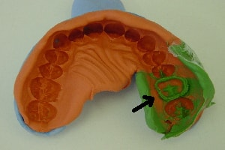
The crown is then installed by the dentist. This process takes around two weeks from start to finish. The price ranges on how much work is needed. The price usually varies between £250-£950. [9]

Fig. 4 https://www.infodentis.com/fixed-prosthodontics/dental-cast.php

Additive Manufacturing Methods

Additive manufacturing has majorly improved the dentistry industry. The purpose of additive manufacturing is to create a 3D solid object using a CAD package under computer aided control. The majority of materials used for this method are similar to the traditional manufacturing method. The main difference is that there are a wider range of metal alloys being used. [10]

Types of Manufacturing Methods

There are several different additive manufacturing technologies that are currently used to develop dental crowns, layer by layer. These are the following;

- Electron Beam Melting – This method is commonly used to manufacture crowns from non-ferrous metal alloys, mainly titanium. This method is proven to save material in very complex geometries, compared to traditional methods. Around 95%-98% of material not being used and be recovered and recycled. [11]
- Colour jet printing – A 3D model is created by using a powder as a core material and resin for the binder. Printing heads are layered at certain points which are specified from a CAD software. [10]
- Selective laser sintering – Powder from a metal form is used to melt or sinter powder which has been spread out evenly over the part bed. A laser beam is used to develop the part in multiple layers. The same process can be used for ceramics. [12]
- Direct metal laser sintering – The main materials used for this process are metal alloys. And these alloys can vary from Nickel to Titanium. This method is used to produce high quality products with increased strength properties when compared to traditional manufacturing methods. A laser bean is used to fuse powder which is manufactured layer by layer. [13]
- Stereolithography – Another known technique that this method falls into is rapid prototyping. This method can quickly change the morphology and overall design of the crown. A scan of the mouth will be conducted to create a 3D model in a CAD format where the design can be altered and 3D printed, layer by layer. This method can use all available materials and has very high production volume capabilities. [14]
- CNC Milling – To start, a scan of the mouth will be conducted. From here a CAD design can be made and altered to fit the mouth perfectly. The milling machine will move the axis bed in the x, y and z axis to create the shape of the tooth. For dry material like zirconium, no coolant is required, and a small amount of sintering is required to colour the tooth. For wet milling, coolant will be used to protect the cutter being used from the heat being produced. These materials will particularly be a range of metals. [15]

Fitting the Crown

The time taken to manufacture a crown will be dependent on the additive manufacture method that is chosen. A scan of the top and bottom teeth will create a point cloud file. This file will then be converted into a 3D model to allow alteration to the crown to get the perfect fit. Once modified, the CAD file will be sent to the 3D printer or milling machined, with the appropriate material, the crown will be manufactured. The crown can then be fitted, and the process will be complete. [10]

If the material being used is ceramic, then the average time to manufacture the crown takes 15 minutes. Plus 30 minutes preparation and 45 minutes for fitting, you can be in and out of the dentist within 90 minutes with a brand new crown fitted. However, for metal crowns, the process is slightly longer. The manufacturing can take up to 5 hours. This is still possible to have a new crown fitted the same day, if you have an appointment in the morning and then it can be fitted in the afternoon.

The cost is dramatically different for a manufactured dental crown, with the price per unit being a fraction compared to the traditional methods. However, you will still have to pay labour costs, and these could prove to be quite high.

What This Industry Can Expect

However, the cost of a 3D printer isn’t cheap. The cost is tens of thousands of pounds, and even into hundreds of thousands of pounds for high quality machines. The benefit of this is that the production time is majorly lower using additive manufacturing methods. It now takes a day to create any type of crown compared to the traditional method, where it takes two weeks. These prices will decrease as new technology comes into the market. Lastly, this industry has maintained a 35% increase in market sales, year by year from 2016 and is forecasted to see a market size of $9.5bn by 2027. [16]

Works Cited

[1] | T. M. A. Kohli, “ 3D Printing in Dentistry – An Overview,” ACTA SCIENTIFIC DENTAL SCIENCES, vol. 3, no. 6, pp. 35-41, 2019.
[2] | G. Additive. [Online]. Available: https://www.ge.com/additive/additive-manufacturing/industries/dentistry. [Accessed January 2020].
[3] | M. How, “Dental Crown,” vol. 4.
[4] | A. D. s.c., “How Are Dental Crowns Made?,” 25 March 2013. [Online]. Available: https://www.affiliateddentists.com/info/dental-crowns-and-how-they-are-made/. [Accessed January 2020].
[5] | V. Dental, “Dental Crowns: Everything you need to know,” 26 November 2019. [Online]. Available: http://www.vcdental.com.au/2019/11/26/dental-crowns/. [Accessed January 2020].
[6] | K. S. Braiman, “Process for making ceramic dental crowns”. United States Patent US5346397A, 15 June 1993.
[7] | R. Dental, “Zirconia Crown VS Porcelain Crown: Things You Should Know,” 30 July 2018. [Online]. Available: https://www.reigndental.com/blog/zirconia-crown-vs-porcelain-crown. [Accessed January 2020].
[8] | A. D. &. S. Center, “Advantages And Disadvantages Of Dental Crowns,” 3 May 2014. [Online]. Available: https://dentalscv.com/advantages-disadvantages-dental-crowns/. [Accessed January 2020].
[9] | J. Love, “Dental Crowns & Tooth Caps: Costs, Procedure,” 20 January 2020. [Online]. Available: https://www.electricteeth.co.uk/dental-crowns/#How_much_does_a_crown_cost. [Accessed January 2020].
[10] | M. Javaid and A. Haleem, “Current status and applications of additive manufacturing in dentistry: A literature-based review,” J Oral Biol Craniofac Res, vol. 9, no. 3, pp. 179-185, 2019.
[11] | V. P. Filipovic, “Powder recyclability in electron beam melting for aeronautical use,” Aircraft Engineering and Aerospace Technology, vol. 87, no. 2, pp. 147-155, 2015.
[12] | J. Butler, “Using selective laser sintering for manufacturing,” Assembly Automation, vol. 31, no. 3, pp. 212-219, 2011.
[13] | M. Salmi, J. Tuomi, P. Kaija-Stiina, R. Björkstrand and M. Paloheimo, “Patient-specific reconstruction with 3D modeling and DMLS additive manufacturing,” Rapid Prototyping Journal, vol. 18, no. 3, pp. 209-214, 2012.
[14] | P. R. Birajdar, S. S. Bammani and S. S. Metan, “Dental Crown Manufacturing using Stereolithography Method,” AMAE, Maharashtra, 2012.
[15] | J. Alonso, “Dental CAD/CAM – All You Need to Know,” 3 September 2019. [Online]. Available: https://all3dp.com/2/dental-cad-cam-all-you-need-to-know/. [Accessed January 2020].
[16] | 3. Natives, “Dental 3D Printing: how are 3D technologies revolutionising this sector?,” 25 March 2019. [Online]. Available: https://www.3dnatives.com/en/dental-3d-printing-250320194/. [Accessed January 2020].

