Roxanne Sara Preece – P128057 BA (Hons) Sports Management UWTSD Swansea 2014-2015.

Dissertation Research Proposal

A Critical Analysis of Female Participation and The Sporting Pathway Within The Welsh Rugby Union.

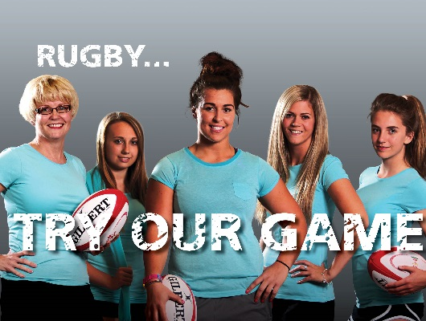

(Welsh Rugby Union, 2014).

Table of Contents

- Introduction
  - Rationale………………………………………………………………………………….2
  - Background and Literature Review……………………………………………………2
  - The Aim and Objectives………………………………………………………………...4

- Research Methodology………………………………………………………………………5
  - Research Design………………………………………………………………………….6
  - Data Analysis………………………………………………………………………….…6
  - Limitations………………………………………………………………………………..7

- Resources and Planning
  - Resources and Planning process…………………….…………………………………7
  - Gantt chart………………………………………………………………………………..8

- References…………………………………………………………………………………….9

- Appendices………………………………………………………………………………….11
5.1 Prospective survey and interview questions………………………………………...11
5.2 Ethics Form……………………………………………………………..……………….12

Dissertation Proposal
1.1 Rationale
The aim of this dissertation is to analyse female participation levels in Welsh rugby and the specific female sporting pathway within the Welsh Rugby Union. An evaluation of the player pathway available to females in Wales will be assessed; whilst comparing and contrasting against pathway models from other countries, specifically those who have a better success rate in women’s rugby. Rugby is no longer a sport just for males; women’s rugby is one of the fastest growing sports in Britain (Riach, 2014; Gillespie, 2012). The Welsh Women's Rugby Union employs distinctive development officers whose role is to encourage more girls to play rugby. Women’s rugby in Wales is continuing to gain acknowledgement having qualified and consequently achieving eighth place in the recent 2014 Women's Rugby World Cup; the highest ranking to date (IRB.com, 2013). In history female participation in sport has made crucial advancements by empowering women and girls whilst progressing for gender equality (United Nations, 2007). This dissertation will acknowledge the barriers still faced by women in rugby and whether or not the pathway offered to them can be improved.

1.2 Background and Literature Review
The history of women’s rugby
In Wales rugby can be described as “the people’s game” encompassing all, exceeding boundaries and is part of the countries National identity (Howe, 2003). This differs from their English neighbours who first developed the game in the 1800’s for the enjoyment of the male middle-upper class. However the expression “the people’s game” can be refuted by many, in Wales as mass participation in the sport by women has only become popular within the last 20 years (Howe, 2003). Women’s rugby in Great Britain was first played at a professional level in the 1970’s and has lived in the shadows of the men’s game for many years (Rule, 2012; Rugby Football Union, 2014).
Women’s rugby is now in a position to rival their male counterparts, holding its own tournaments including RBS Six Nations and Rugby World Cups. The First Women’s Rugby World Cup was held in Cardiff, the capital of Wales in 1991. It was the introductory and success of this tournament that paved the way for Women’s rugby (International Rugby Board, 2013).

Barriers faced by women in sport and rugby
In 2013 Helen Grant MP was appointed Minister for Sport and Tourism; she states “I am ever more determined to see women enjoying sport; playing, watching and working in sport, free from unnecessary obstacles or social prejudices” (Department for Culture, Media & Sport, October 2014). Women face emotional, capability and opportunity barriers in sport; yet in a survey carried out by Sports England in 2011 12 million women stated that they wished to play more sport (Sports England, 2011-2012). In a 6 year strategy published by Sports Wales women’s elite rugby was given targets to show continual improvement from tournament to tournament with continual investment from the WRU and Sports Wales (Sports Wales, 2010).
It has been suggested that with more women than ever before participating in contact sports the inequality between the sexes would elapse (Howe, 2003; Carle & Nauright, 1999). As with other contact related sports women who play rugby are seen to lose part of their femininity and symbolise masculinity, indicating that equality within the sport of rugby is disproportionate (Howe, 2003). Girls should have the opportunity to believe sport can be a career. However, there is still a huge difference in the levels of commercial investment into men and women’s sport; only this year (2014) were the England’s Women’s rugby players provided with contracts that meant they could financially focus on rugby fulltime (Department for Culture, Media & Sport, October 2014).
Women’s Rugby in Wales
Currently the WRU pathway model allows girls and boys to play together until the age of 13. Given that a third of girls are unhappy with their body it is possible more girls would continue to play if they stopped playing with boys at an earlier age (Department for Culture, Media & Sport, October 2014).
As an employee of the Welsh Rugby Union and appointed the Women’s and Girls Development Officer in the Cardiff Blues region. The knowledge and differences between male and female rugby which has already been learnt for the purpose of the job has led to a desire to examine, for the purpose of this dissertation the reasons for female participation in sport and rugby being lower than that of males.
Caroline Spanton is soon to be appointed the WRU National Women’s Rugby Manager in 2015. Caroline will be “developing all levels of women's and girls' rugby, up to and including the national team, and creating a greater equality of opportunity within rugby” (Jones, 2014). WRU Head of Rugby described her appointment as significant part of a crucial strategy as a rugby department (Jones, 2014). In partnership with Sport Wales Ms Spanton was chosen to transport enthusiasm and initiate a strategic area of growth for the WRU in women’s and girl’s rugby (Jones, 2014).
1.3 The Aim and Objectives
“The aim of a study is to clearly articulate what it is you wish to accomplish” (Munhall & Chenail, 2008). The aim of this dissertation is to achieve a critical analysis of female participation and the sporting pathway within the Welsh Rugby Union.
With the intention of classifying and acknowledging the barriers to females within rugby in Wales; comparing and contrasting with other sports and current rugby player pathways in different countries.
In order to achieve the specified aim three research objectives have been set. These as stated by (Clough & Nutbrown, 2002) are objectives from the original question; removing any obstacles leading to superior specificity. The three objectives are as follows –

- Objective 1 Identify current barriers and retention challenges for female participation in sport.
- Objective 2 Evaluate pathway models for female participation in rugby.
- Objective 3 Design a pathway model to increase female participation and improve retention within the Welsh Rugby Union.

2.0 Research Methods
Research can be defined as “a scientific and systematic search for pertinent information on a specific topic” (Kothari, 2006). The research process can be exemplified further by (Saunders, Lewis, & Thornhill, 2009) as shown below in the ‘Research Onion’.
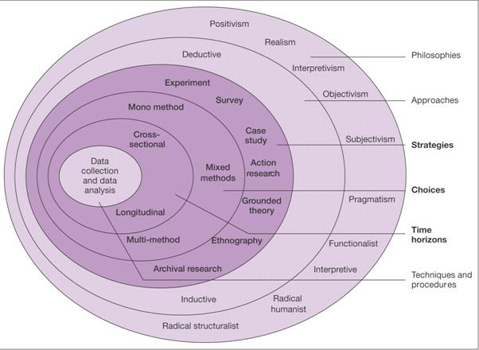

Figure 1 The Research Onion (Saunders, Lewis, & Thornhill, 2009).

Many pathways can be taken when conducting research; the ‘Onion’ will demonstrate the diverse phases the researcher will use when designing a research approach (Saunders, Lewis, & Thornhill, 2009). The research onion above identifies the selected pathway that will be used for the research process directed at this study.

2.1 Research Design
The relevance of research design “facilitates research to be as efficient as possible yielding maximal information” (Kothari, 2006). The techniques and procedures that will be used are as follows. This research will use two strategies Interviews and Questionnaires; this is a multiple method approach and will gather information which will harvest qualitative research; gaining perspectives and opinions as data (Saunders, Lewis, & Thornhill, 2009).
The study will be cross-sectional which involves gathering information from a certain group of people at one point in time. There will be no follow up questionnaires or interviews with the same participants (Bajpai, 2011). An inductive approach will be used; the benefit of this approach is that it does not rely on hypotheses and allows theories to be built on data collected (Crowther & Lancaster, 2008). This will be followed by the interpretive philosophy which allows the data to support the conclusion.
Having work contacts with individuals in the WRU women’s community workforce, it permits questions to be asked and data collected supporting the research methods used. Using an inductive approach interview questions will be open ended and particular to their positions which will provide in-depth findings aimed at this dissertations objectives.
Holding the position of assistant and team manager for the Senior Women’s and the Under 18’s Cardiff Blues Girls teams accessibility to female rugby players will be more readily available. The questionnaire will be semi structured in order to compare information but also collectively encompass personal opinions and thoughts.

2.2 Data Analysis
The procedure of data analysis contains calculating numerous summaries and resulting values from the particular assortment of data (Berthold & Hand, 2007). Interviews will be recorded, partnered with field notes. An analysis of their responses will be made with respect to the current position regarding female participation and pathway structure in women’s rugby in Wales.
Answers from the structured questions in the survey will be put into Excel and percentage charts will be made to summarise the data. The unstructured answers will be placed into two categories those with positive and those with less positive thoughts. This will produce a broad spectrum of data. All research gathered via interviews and questionnaires will be connected in order to find a medium to move forward.

2.3 Limitations
Consent will need to be given in the case of each questionnaire and interview so that the material gathered can be used for the purpose of this dissertation. “Judgement has to be exercised when deciding how the researcher ought to conduct him/herself if faced with moral choices during the research process” (Gregory, 2003).
Questionnaires will be personally sent to female players over the age of 16 so as to be completed individually and not in mass groupings; this will help encourage honest responses. The first sentence will inform the players that they do not have to participate if they do not wish to. The respondents must confirm they are over the age of 16 before continuing with the questionnaire. All questionnaires will be dealt with in the strictest of confidence. Assurance of confidentiality has been proven to be more operative in motivating responses (Singer, Hippler, & Schwarz, 1992).
Interviews will be conducted face to face in a private area; if the respondent wishes to be anonymous their name and job title will not be made exclusive. In the questionnaires and interviews questions will be concise to avoid any misunderstandings which could potentially lead to bias data (Denscombe, 2007).

3.1 Resources and Planning
The research and planning undertaken are a vital part of any research project (Armstrong, 2006). When conducting this study a various number of resources will be used to gain an understanding for the set aim and objectives. Both theory and practical measures will be untaken. Resources such as the internet, articles and libraries will aid my investigation. Business associates within the WRU Community Development team will enable primary research with interviews and with access to female rugby teams questionnaires will be used.
The intentional planning process will outline the proposed actions to be taken including activities undertaken and their anticipated time scales (Armstrong, 2006). A Gantt chart will be used to improve time management. This chart will aid the activities and research to be completed and gathered in the appropriate time scales given. “Effective time management has many benefits. These include a reduction in wasted time, mitigation of work overloads and higher levels of personal productivity” (Harvard Business School, 2005).

*Please find on the continuing page a Gantt chart delineating the dates that will be followed.

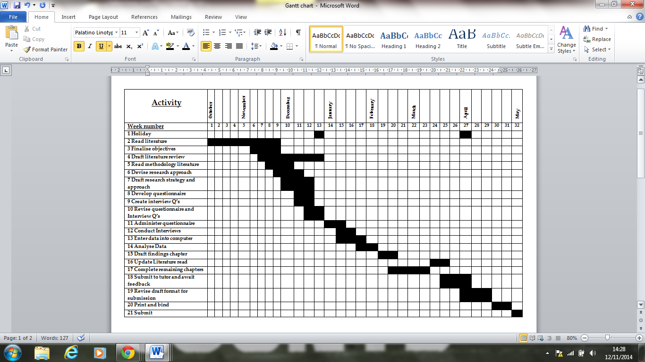
3.2 Gantt chart
4.0 References

Armstrong, M. (2006). A Handbook of Human Resource Management Practice. London: Kogan Page Limited.
Bajpai, N. (2011). Business Research Methods. India: Pearson Education.
Berthold, M., & Hand, D. J. (2007). Intelligent Data Analysis: An Introduction. New York: Springer.
Carle, A., & Nauright, J. (1999). A Man’s Game?: Women FlayingRugby Union in Australia. Football Studies, 55-71.
Chadwick, S., Semens, A., Schwarz, E. C., & Zhang, D. (2011, April 5). Economic Impact Report on Global Rugby, Part III: Strategic and Emerging Markets. Coventry: Centre for the International Business of Sport Coventry University.
Clough, P., & Nutbrown, C. (2002). A Student's Guide to Methodology: Justifying Enquiry. London: SAGE Publications.
Crowther, D., & Lancaster, G. (2008). Research Methods: A Concise Introduction to Research in Management and business consultancy. Oxford: Elsevier Butterworth-Heinemann.
Department for Culture, Media & Sport. (October 2014). Interim Report of the Government’s Women and Sport Advisory Board. London: Department for Culture, Media & Sport.
Gillespie, G. (2012, April 12). WRU GIRLS DEVELOPMENT CENTRES. Retrieved Nov 5, 2014, from WRU: http://www.wru.co.uk/eng/news/21832.php#.VGM18VBShP8
Gregory, I. (2003). Ethics in Research. London: Continuum.
Harvard Business School. (2005). Time Management: Increase Your Personal Productivity And Effectiveness. Massachusetts: Harvard Business School Publishing Corporation.
Howe, P. D. (2003). Kicking Stereotypes into Touch: An Ethnographic Account of Women's Rugby. In A. Bolin, & J. Granskog, Athletic Intruders: Ethnographic Research on Women, Culture, and Exercise (pp. 227-246). New York: State University of New York.
International Rugby Board. (2013). Women's Rugby World Cup history. Womens Rugby World Cup 2014.
IRB.com. (2013, March 17). Wales women qualify for WRWC 2014. Retrieved October 31, 2014, from IRB Rugby World Cup 2015: http://www.rugbyworldcup.com/home/news/newsid=2065803.html
Jones, L. (2008, November 7). RHIWBINA MOVE STEP CLOSER TO CLUBHOUSE. Retrieved October 31, 2014, from Welsh Rugby Union: http://www.wru.co.uk/eng/news/15292.php#.VFYzg1BShP8
Jones, L. (2014, Septemebr 30). WRU NATIONAL WOMEN'S RUGBY MANAGER APPOINTED. Retrieved October 21, 2014, from Welsh Rugby Union: http://www.wru.co.uk/eng/wales/news/women/31360.php#.VFZUi1BShP8
Kothari, C. R. (2006). Research Methodology: An Introduction. In C. R. Kothari, Research Methodology: Methods and Techniques (pp. 1 - 22). Delhi: New Age International Publishers Limited.
Munhall, P. L., & Chenail, R. (2008). Qualitative Research Proposals and Reports. London: Jones and Bartlett Publishers.
Riach, J. (2014, August 18). England World Cup win shows how far women’s rugby union has come. Retrieved Novemebr 6, 2014, from TheGuardian: http://www.theguardian.com/sport/blog/2014/aug/18/womens-world-cup-england-katy-mclean
Rugby Football Union. (Unknown). Women’s Rugby – Then and Now. Retrieved November 1, 2014, from RFU: http://www.rfu.com/womensrugbyportal/rfuwabriefhistory
Rule, M. (2012, June 1). Women's Rugby in Wales. Women's Rugby.
Saunders, M., Lewis, P., & Thornhill, A. (2009). Chapter 4: Understanding research philosophies and approaches. In M. Saunders, P. Lewis, & A. Thornhill, Research methods for business students (pp. 106-135). England: Pearson Education Limited.
Singer, E., Hippler, H., & Schwarz, N. (1992). "Confidentiality Assurances on Surveys: Reassurances or Threat.". International Journal of Public Opinion Research, 256-68.
Sports England. (2011-2012). Active Women. London: Sports England.
Sports Wales. (2010). Elite sport strategy 2010-2016. Retrieved November 2, 2014, from Sport Wales: http://www.sportwales.org.uk/media/514091/sw-elitestrategy_eng.pdf
Thomas, S. (2014, July 27). The 20 best international rugby teams of all time. Retrieved October 31, 2014, from WalesOnline: http://www.walesonline.co.uk/sport/rugby/rugby-news/best-rugby-teams-ever-20-7336351
United Nations. (2007). Division for the Advancement of Women. New York: Department of Economic and Social Affairs.
Welsh Rugby Union. (2014). WOMEN'S & GIRLS RUGBY. Retrieved 2014, from WRU: http://www.wru.co.uk/eng/club/womensleagues/try_our_game.php

5.0 Appendices
5.1 Prospective survey questions
Do you give your permission for the information given in this questionnaire will be used in relation to a dissertation in order to gain insight into female rugby in Wales?
Please confirm that you are over the age of 16 before continuing?
This questionnaire will be dealt with in the strictest of confidence, your name and personal details will not be attached to your answers.
What made you choose to play rugby over other sports?

What barriers have you faced whilst playing rugby?
Are you happy with the current rugby player pathway available to females in Wales? Yes or No

What changes would you make to the female player pathway, if any?
Why in Wales do you believe girls are put off playing rugby?

The current player pathway allows girls and boys to play rugby together up until the age of 13, is this age too old? Yes or No?

If Yes why?

Prospective interview questions
Do you give your permission for the information given in this interview to be used and analysed for a research project in order to gain insight into female rugby in Wales? YES or No

Please confirm you are over the age of 16 before continuing?
Do you give your permission for both your identity and job title to be used in this study? YES or NO
What obstacles do you believe female rugby players face in Wales?

Do believe females are on a level par with men in rugby regarding facilities and equipment?
Do you believe the structure laid out for female rugby players to become professional is as accessible to them as it is to their male counterparts?
What changes would you make to the current female rugby pathway that would encourage and retain more participants?

