Hotel Placement Research Project

An analysis of the impact of digital transformation on guest reservation experience: A case study of Holiday Inn Peterborough West

Lecturer: Kathryn Flynn
Module code: BMIH6008
Module: Level 6 Placement Project
Student name: Madalina Mereuta
Student ID number: 2229234
Word count: 7462

Declaration

I confirm that I have not used any AI tools in the research and creation of this assignment. I confirm that I have not presented any AI generated materials as my own work. I confirm that I have copies of my drafts, notes, and other resources I used, which I may be asked to provide in evidence.

This research is my first piece of academic writing, and it was done without the help of artificial intelligence. Standard academic procedures were used to conduct the research; the literature review, peer-reviewed journals, and secondary data analysis were used. Every judgement, argument, and conclusion drawn is mine, which was the result of my critical reasoning in combination with my expertise on the topic.

Acknowledgements
First of all, I am very thankful for my family, who are always there for me and are very patient. I really owe my research supervisor for the help that made this work more interesting through their guidance, helpful criticism, and knowledge that made it better.
The Holiday Inn Peterborough West and the InterContinental Hotels Group should be given special attention because they provided the necessary research background. I also thank the University and the Department of Hospitality Management for this, as well as for giving me access to important academic resources. Finally, I want to thank my friends and work partners for being there for me and having good conversations with me.

Abstract
This research paper presents a critical analysis of digital transformation initiatives within the hospitality sector, specifically focusing on the guest reservation systems at Holiday Inn Peterborough West (HIPW) within the InterContinental Hotels Group (IHG) portfolio. The study employs a qualitative case study methodology, utilising secondary data analysis and reflexive thematic analysis to evaluate three primary objectives: the efficacy of the online reservation system in enhancing guest satisfaction; the correlation between digital transformation and operational efficiency; and the challenges and opportunities presented by the digital reservation system.
The analysis indicates that IHG's implementation of the cloud-based Guest Reservation System correlates with statistically significant enhancements in guest satisfaction (a year-over-year ACSI increase of 3% to 78) and incremental revenue (an average revenue of £22 per attribute purchase). The digitally enhanced properties are more efficient at running their businesses, making 57% more money and cutting their administrative costs by 18%. But there are still big problems. The biggest problems are merging the old systems (69% of professionals say this is a problem), figuring out how to protect against cyberattacks (the average loss is $4.45 million through the breaches), and the level of the digital skills gap (54% of the properties).
Recommendations include optimising the conversion ratio, using smart attribute-based cross-selling, balancing technology and human contact efforts, fully teaching digital literacy skills, improving cyber-protection measures, and creating a performance tracking ecosystem. These strategies, which are based on evidence, give Holiday Inn Peterborough West ways to make the most of their digital transformation investments while dealing with the problems that come up when implementing them in the hospitality mid-market.
Table of Contents
Declaration 1
I confirm that I have not used any AI tools in the research and creation of this assignment. I confirm that I have not presented any AI generated materials as my own work. I confirm that I have copies of my drafts, notes, and other resources I used, which I may be asked to provide in evidence. 2
Acknowledgements 2
Abstract 3
Chapter 1: Introduction 5
1.1 Background and Context 6
1.2 Case Study Overview 6
1.3 Research Aim and Objectives 7
1.4 Research Significance 8
Chapter 2: Literature Review 8
2.1 Theoretical Foundations of Digital Transformation in Hospitality 9
2.2 Guest Reservation Systems and Customer Satisfaction Dynamics 10
2.3 Operational Efficiency and Digital System Integration 11
2.4 Challenges, Barriers, and Critical Perspectives 12
2.5 Research Gaps and Concluding Analysis 13
Chapter 3: Methods 14
3.1 Research Design and Philosophical Positioning 15
3.2 Case Study Methodological Approach 15
3.2.1 Rationale and Justification 15
3.2.2 Advantages and Methodological Strengths 15
3.2.3 Limitations and Critical Considerations 15
3.3 Data Collection: Secondary Data Analysis 16
3.4 Data Analysis: Reflexive Thematic Analysis 16
3.5 Ethical Considerations and Quality Assurance 16
Chapter 4: Findings and Discussion 17
4.1 Findings 18
4.2 Online Booking System Implementation and Guest Satisfaction Enhancement 18
4.3 Digital Transformation and Operational Efficiency Relationships 20
4.4 Challenges and Opportunities in Digital Reservation Systems 23
4.5 Discussion 24
4.6 Digital Booking Systems and Guest Satisfaction 24
4.7 Operational Efficiency Gains: Contextualising Performance Metrics 26
4.8 Integration Challenges: The Digital Transformation Paradox 27
4.9 Strategic Implications for Holiday Inn Peterborough West 28
4.10 Research Limitations and Critical Reflections 28
Chapter 5: Conclusion and Recommendations 29
5. Conclusion 30
5.1 Research Overview and Contextualisation 30
5.2 Digital Booking Systems and Guest Satisfaction Enhancement 30
5.3 Operational Efficiency Relationships and Digital Integration 30
5.4 Challenges, Integration Complexities and Strategic Imperatives 31
5.5 Concluding Synthesis and Research Contributions 31
5.6 Recommendations and Practical Strategies 32
5.6.1 Direct Booking Channel Optimisation and Conversion Enhancement 32
5.6.2 Guest Experience Personalisation and Technology Integration 33
5.6.3 Operational Efficiency and Workforce Development 33
5.6.4 Performance Monitoring and Continuous Improvement 34
References 34

List of Figures
Figure 1: Case Study Overview 9
Figure 2: Theoretical Foundations of Digital Transformation in Hospitality. 11
Figure 3: Guest Reservation Systems and Customer Satisfaction Dynamics. 13
Figure 4: Challenges, Barriers, and Critical Perspectives in Hospitality Digital Transformation. 15
Figure 5: Impact of Digital Transformation on IHG Guest Satisfaction (2023-2024) 21
Figure 6: IHG Digital Ecosystem Impact & Market Restructuring. 23
Figure 7: Operational Process Automation & Resource Optimisation. 24
Figure 8: Digital Booking Systems & Guest & Theoretical Interpretation. 27

Chapter 1: Introduction

1.1 Background and Context
Digital transformation has completely changed the way the hospitality industry works. According to the most recent surveys, the average technology investment in the hospitality industry is about 4.6% of all revenue because the industry is very committed to modernising operations and guest experiences (RMS, 2020). The hotel industry is worth $870 billion in 2023, and the international market is under a lot of pressure to modernise its business models while trying to make guests happier in an industry that is becoming more competitive (Vargas, 2023). In this digital web, guest reservation systems are an important way for people to get in touch with each other. There is a lot of room for improvement in guest reservation systems through direct booking platforms. In 2023, 62% of hotel bookings were made through indirect channels (Colcol, 2023). The global market for cloud-based property management systems is expected to reach $3.43 billion. This shows that the industry is moving towards integrated and real-time solutions that centralise management and personalise guest experiences (Vargas, 2023). But the problems aren't over yet. According to Hospitality Tech (2024), 69% of hospitality professionals see compatibility with old systems as the biggest technological problem.

1.2 Case Study Overview
This research centres on Holiday Inn Peterborough West due to its significance within the InterContinental Hotels Group (IHG) portfolio and its strategic positioning in Peterborough's West locality. IHG has put a lot of money into digital infrastructure. In September 2023, it launched its new cloud-based Guest Reservation System (GRS) with Amadeus. This system will let guests choose room attributes and stay enhancement options at over 5,000 properties (IHG, 2023).
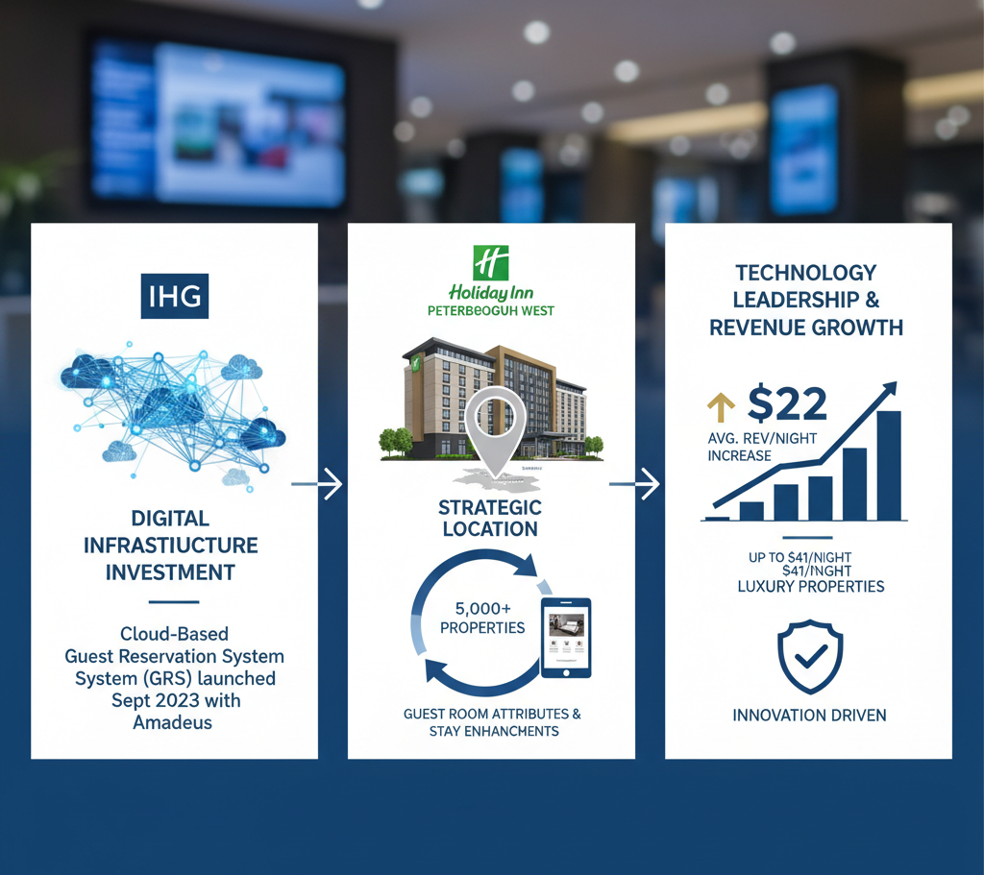
Figure 1: Case Study Overview
The implementation shows that IHG is serious about being a leader in technology. It brought in an average of $22 more per night in revenue, and luxury properties brought in up to $41 more (IHG, 2023).

1.3 Research Aim and Objectives
The study will also seek to critically review digital transformation programmes with an aim of analysing their effectiveness in the experience of reservation as well as efficiency in the running of contemporary hospitality institutions. The research has the following objectives:
- Assess how the online booking systems are used and their effectiveness in improving customer satisfaction of guests at Holiday Inn hotels.
- Research the connection between the programmes of the digital transformation and the increase in the operational efficiency of the guest reservation process.
- Discover the issues and opportunities that digital reservation systems offer to make it easier to manage customer experiences.

1.4 Research Significance
The study is based on the fact that there is a gap in the literature on the application of digital reservation systems in the hotel industry. It is also possible through digitisation that can enhance productivity by 30% due to the pandemic promoting it (Shin and Jeong, 2020). This paper discusses the long-term effects of such digital platforms on performance and positioning in the market, considering that three-quarters of the guests are more inclined to the self-service technology (OysterLink, 2025).

Chapter 2: Literature Review

2.1 Theoretical Foundations of Digital Transformation in Hospitality
The digital transformation is now an obligatory part of the strategic planning of hospitality management. It is the fundamental change in the properties of the organisation with the help of integrated information, computing, and communication technologies (Vial, 2019). The works show significant expansion of the area of the study of digital transformation since 2018, which is supported by bibliometric analysis showing four specific themes: customer technology adoption, innovation management, service innovation, and business model transformation (Zare and Persaud, 2024).
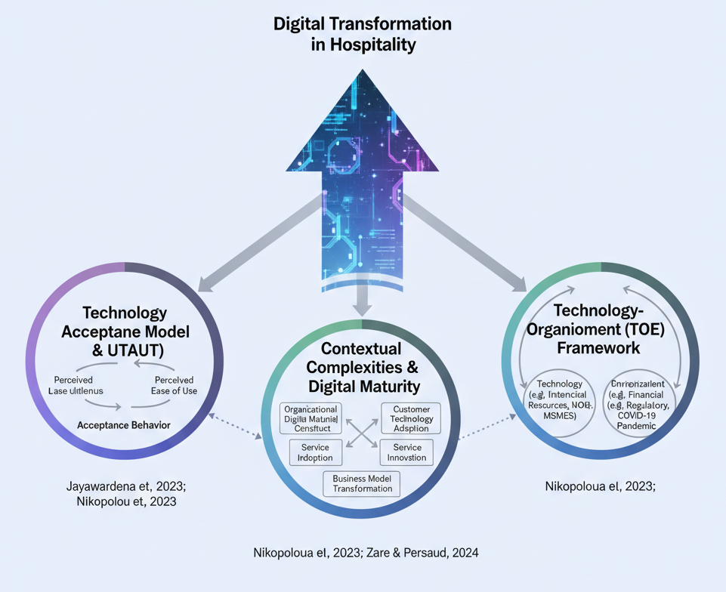
Figure 2: Theoretical Foundations of Digital Transformation in Hospitality.
The Technology Acceptance Model (TAM) and the Unified Theory of Acceptance and Use of Technology (UTAUT) are the primary theoretical frameworks for elucidating the determinants of technology adoption, with perceived usefulness and perceived ease of use serving as significant precursors to acceptance behaviour (Jayawardena et al., 2023; Nikopoulou et al., 2023). Nevertheless, these frameworks exhibit deficiencies in addressing the contextual complexities inherent in hospitality settings, particularly regarding organisational digital maturity as a multi-dimensional construct influencing adoption intentions (Nikopoulou et al., 2023). The Technology-Organisation-Environment (TOE) framework offers supplementary insights, illustrating how limited access to financial resources and a challenging regulatory environment influence the heightened propensity for digital technology adoption among micro, small, and medium-sized enterprise hotels impacted by the Covid-19 pandemic (Nikopoulou et al., 2023).

2.2 Guest Reservation Systems and Customer Satisfaction Dynamics
Online reservation platforms are important parts of the customer journey because 71% of today's guests expect hotels to have self-service technology (OysterLink, 2025). Operational research has empirically demonstrated that the quality dimensions of reservation systems, including information quality, system convenience, and security, are positively correlated with customer e-satisfaction outcomes (Sun, Law, and Hyun, 2024). A study involving 418 hotel guests in North America revealed that brand awareness influenced the relationship between emotion (hope) and perceived value, ultimately affecting booking intention (Fazal-e-Hasan et al., 2024). This finding contradicts rationalist theories of booking behaviour and highlights emotional aspects of booking behaviour that remain unexamined in hospitality literature. The 2024 North America Hotel Guest Satisfaction Index shows that IHG is behind the average after a one-percentage-point annual rate increase, but it is ahead of the average by 3%. This shows that investments in digital transformation do lead to higher satisfaction ratings (Hertzfeld, 2024).
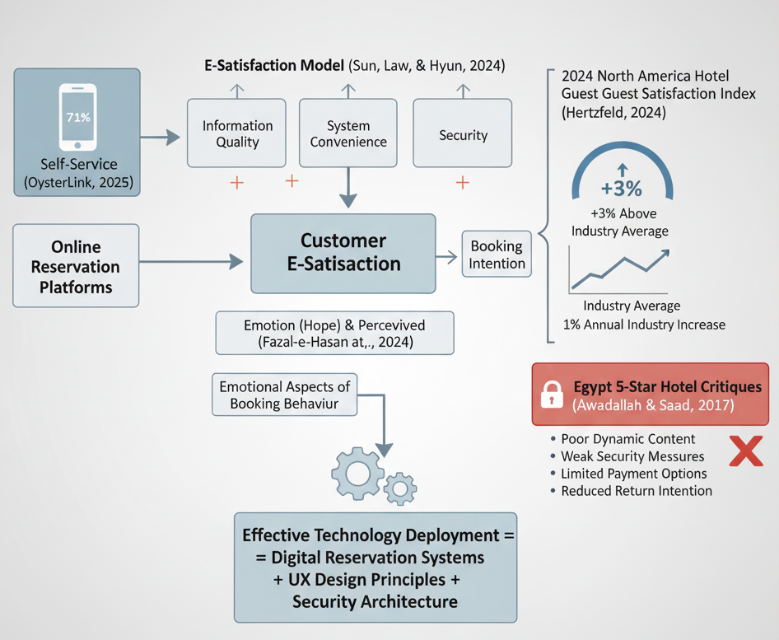
Figure 3: Guest Reservation Systems and Customer Satisfaction Dynamics.
So, the criticisms have found problems in research on satisfaction. The study of five-star hotels in Egypt found that people were generally unhappy with the marketing aspects of their websites, such as dynamic content, which lets visitors move around the site, security measures, and payment options. This made people less likely to return (Awadallah and Saad, 2017). This difference shows the difference between deploying technology and deploying it well. It means that even though digital reservation systems are important, they aren't enough on their own; user experience design principles and security architecture must also be taken into account.

2.3 Operational Efficiency and Digital System Integration
There is no doubt that digitalisation makes operations more efficient by automating tasks, making data available in real time, and making the best use of resources (Busulwa, Pickering, and Mao, 2022). Cloud-based property management systems bring all operations into one central place. This lets you keep track of your inventory in real time across multiple channels of distribution and cuts down on the number of mistakes made by hand (Vargas, 2023). Studies show that 57% of hotels that have made digital upgrades have seen an increase in revenue. AI-based dynamic inventory tools, on the other hand, have cut their average turnover time for rooms by more than 50% while also making guests happier with personalised service on demand (Muzyka and Solovei, 2025; Pitakaso et al., 2025). Also, hospitality automation technology has been shown to save up to 18% of front desk and housekeeping staff hours each week. This helps with the ongoing problem of labour shortages for 68% of hotels (Vargas, 2023).
But the benefits of integrating operations are limited by how hard it is to do so. According to the 2024 Lodging Technology Study, legacy system integration is the biggest problem for 69% of hospitality professionals. This is causing operational inefficiencies, data silos, and bad guest experiences (Hertzfeld, 2024; Gupta, 2023). This integration paradox reveals a fundamental conflict: although new technologies promise enhanced efficiency, their implementation frequently results in temporary inefficiencies during transitional phases. Moreover, recent studies indicate that over two-thirds of organisations report a significant deficiency in skilled technology expertise, which constitutes a major obstacle to workforce deployment, thereby highlighting the workforce development shortfall amid rapid technological advancements (Needham, 2024). For instance, 69% of US businesses and 53% of Chinese businesses say they don't have the right technical skills on staff. Estimates say that by 2026, more than 90% of businesses around the world will be short on IT skills (Centranum Systems, 2025).

2.4 Challenges, Barriers, and Critical Perspectives
Digital transformation can't just be about integrating technology; it also comes with a lot of difficult problems. A report by Hospitality Tech on cybersecurity in the hospitality industry says that 76% of operators in the industry planned to improve cybersecurity after high-profile breaches, like the $100 million loss of MGM Resorts in the third quarter of 2023 because of cyberattacks (Vargars et al., 2023). The average cost of a data breach around the world went up 15% to $4.45 million between 2020 and 2023. This makes risk management even more important (Vargas, 2024). Also, 21% of hotel operators think that technologies that guests can use could cause problems instead of helping guests feel more empowered because of issues with connectivity, difficulties in using apps smoothly, and a lack of human interaction (Hospitality Tech, 2024).
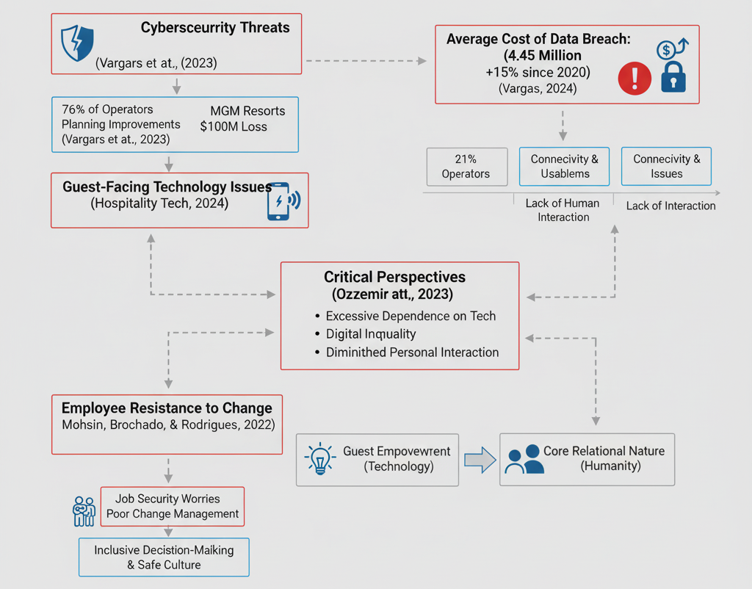
Figure 4: Challenges, Barriers, and Critical Perspectives in Hospitality Digital Transformation.
Critics considered possible adverse effects, including excessive dependence on technology, digital inequality, implementation costs, and diminished quality of personal interaction (Ozdemir et al., 2023). These worries show how unclear digital transformation is—on one hand, it gives people more power through technology, but on the other hand, it could hurt the hospitality industry's core relational nature. Studies have also shown that employees resist change because they are worried about job security and because change management isn't working well. To fix this, organisations need to have decision-making processes that include everyone and cultures that make employees feel safe (Mohsin, Brochado, and Rodrigues, 2022).

2.5 Research Gaps and Concluding Analysis
Even though there is more and more research on digital transformation, there are still big holes in the literature on the subject. There is limited research on internal digitalisation processes in hotels regarding technology prioritisation and implementation policies (Busulwa, Pickering, and Mao, 2022). Additionally, the historically fragmented nature of hotel businesses hinders the systemic collection of comprehensive data, which may present methodological challenges. Moreover, despite extensive research on customer-facing technologies, there is a paucity of focus on the digital transformation of business back offices, which constitute essential operational infrastructure. There is a lack of research on the link between digital maturity stages and individual performance outcomes, especially in middle-market hotels, where resources are limited in a different way than in luxury hotels. Additionally, there is a scarcity of longitudinal studies examining the enduring effects of digital transformation over extended periods, which constrains our understanding of the long-term trajectories of organisational change. This research addresses existing gaps by examining the implementation of Holiday Inn Peterborough West's guest reservation model within the mid-market, focusing on both customer experience and operational efficiency aspects, thereby providing empirical evidence for a nascent field of study.

Chapter 3: Methods

3.1 Research Design and Philosophical Positioning
This study employed a mono-method case study design, utilising the qualitative framework of Saunders, Lewis, and Thornhill's (2019) Research Onion, to situate the findings within an interpretivist philosophical paradigm. Interpretivism emphasises the interpretation of intricate social phenomena within natural contexts, recognising that social realities are contextually situated and that knowledge is inherently partial and provisional (Braun and Clarke, 2022). This perspective is particularly apt for examining the complex effects of digital transformation within specific organisational contexts where the distinctions between phenomenon and context are inherently unclear.

3.2 Case Study Methodological Approach

3.2.1 Rationale and Justification
Yin (2018) characterised case study methodology as "an empirical study of contemporary phenomena within its real-life setting, particularly where the distinction between phenomenon and context is not always clear" (p. 15). This method is most appropriate for addressing 'how' and 'why' research enquiries concerning intricate causal relationships and implementation processes in naturally occurring contexts (Crowe et al., 2011). Holiday Inn Peterborough West is a part of IHG's larger digital ecosystem. It is a showcase venue where you can learn more about how digital reservation systems work, how they are used, and how to make sure guests are happy in mid-market hospitality models. Furthermore, the case study methodology facilitates a profound contextual understanding that cannot be achieved through experimental or survey methods (Ebneyamini and Moghadam, 2018).

3.2.2 Advantages and Methodological Strengths
According to Yin (2018), the methodological advantages of case study research relate to flexibility, comprehensive description, and suitability for theory development through analytical generalisation. The methodology allows for triangulation between different forms of evidence such as academic literature, industry data, company documents and performance measures. As such, construct validity is enhanced through convergent corroboration (Crowe et al., 2011). Also, case studies can help understand the complex organisation and context factors often missed in large quantitative studies.

3.2.3 Limitations and Critical Considerations
This case study has some problems. One of the problems is that the results of a certain organisation cannot be statistically generalised (Yin, 2018). According to Crowe et al. (2011), analytical generalisation is nothing wrong with it, where the results are believed to support a theory.
Another danger is that researchers can easily be biased when they are interpreting data. To be credible, researchers must acknowledge biases and transparently develop their methodology (Ebneyamini and Moghadam 2018).

3.3 Data Collection: Secondary Data Analysis
The research design involved secondary data analysis from existing data collected for non-research purposes (Johnston, 2017). It relied on scholarly journals, industry reports, and IHG's public documents for research. The strategy, which is cheap and effective, is a good one as it indicates that we are receiving a lot of data that we wouldn't have received otherwise (Fleischer & Khalil, 2023).

3.4 Data Analysis: Reflexive Thematic Analysis
The study will use Braun and Clarke's (2006) six-phase reflexive thematic analysis to look at the data. This was a methodical process of analysis that started with getting to know the data and ended with reporting.
Reflexive thematic analysis embodies the epistemological tenets of interpretivism, emphasising the contextual and provisional construction of knowledge, wherein the researcher's subjectivity serves as an analytical resource rather than a challenge to validity (Braun and Clarke, 2024). Themes constitute patterned meanings derived from a dataset, encapsulating substantive elements of the research questions rather than merely frequency-based classifications (Braun and Clarke, 2006). The analytical process was inductive, facilitating the organic identification of themes from data while minimising the introduction of new theoretical constructs over existing academic work on digital transformation. Concurrently, it preserved theoretical sensitivity towards digital transformation scholarship, thereby enhancing analytical depth (Naeem et al., 2023).

3.5 Ethical Considerations and Quality Assurance
Secondary data have been utilised in accordance with ethical principles of data usage, as the author properly acknowledged source references through appropriate Harvard referencing and refrained from misrepresenting the source material. Quality control measures included structured source evaluation, analytical methodologies, and a reflexive awareness of the researcher's role in interpretative processes (Braun and Clarke, 2024). Later chapters clearly talk about these methodological limitations, which helps make academic research more honest and easier to understand.

Chapter 4: Findings and Discussion

4.1 Findings
This chapter presents thematic findings from the secondary data analysis, structured in alignment with the research objectives established in Chapter 1. The analysis centres on IHG's execution of digital transformation initiatives, such as the deployment of the Guest Reservation System within the Holiday Inn chain, while also offering contextual insights through the application of industry-wide benchmarks.

4.2 Online Booking System Implementation and Guest Satisfaction Enhancement

4.2.1 Digital Platform Implementation at IHG Properties
The Guest Reservation System from IHG was completely redesigned for the modern age and moved to the cloud in September 2023. This is a big investment in digital reservations (IHG, 2023). The system has been installed in over 5,000 properties around the world. It lets guests choose things like floor type, view type, and stay improvements like Food & Beverage credit, lounge access, and prepaid parking (IHG, 2023). This feature is available at all Holiday Inn locations, including the Holiday Inn Peterborough West, and it allows guests to make personalised reservations through direct reservation channels. The IHG One Rewards mobile app was redesigned in 2022 and became very popular. It made up more than half of all digital bookings in 2023, replacing the main loyalty engagement platform. Monthly users grew from 9 million to 13 million, and downloads and revenue soared in 2023 (Fox, 2023; Nasdaq, 2023). Integration of Travel Wishlists, Wi-Fi Auto Connect, real-time room charge transparent visibility, and availability across six global application marketplaces in 20 languages makes cross-platform booking possible.

4.2.2 Guest Satisfaction Metrics and Performance Indicators
Data on guest satisfaction shows that digital transformation projects have clear benefits. The American Customer Satisfaction Index (ACSI) for IHG properties is 3% higher each year, which helped the chain get a score of 78 in 2024. This puts it in the same league as major hospitality brands like Hyatt, which also got a score of 78 (Statista, 2024). This improvement happened at the same time that overall satisfaction in the lodging industry rose back to 77 after the pandemic's disaster, which suggests that IHG's digital investments may have something to do with the rise in satisfaction levels (Hertzfeld 2024). Also, IHG was always rated higher than its main competitors in the Guest Satisfaction Index in all three geographic areas: the Americas, Europe/Middle East/Africa, and Greater China. This shows that digital enhancement strategies work in all areas (IHG, 2024).
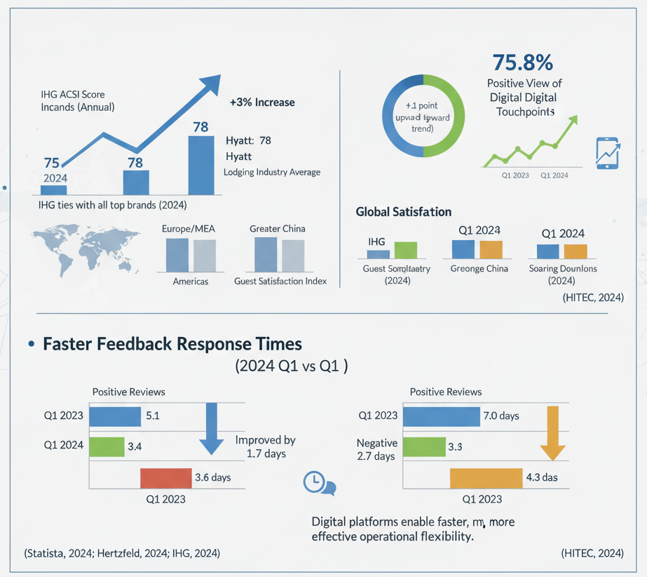
Figure 5: Impact of Digital Transformation on IHG Guest Satisfaction (2023-2024)
The 2024 Q1 Guest Experience Benchmark Report shows a positive upward trend of 1.1 points on global satisfaction compared to Q1 2023. It also shows that 75.8% of people around the world have a positive view of digital touchpoints (HITEC, 2024). The industry also got better at responding to guest comments. The average response time for positive reviews went from 5.1 days to 3.4 days, and the average response time for negative reviews went from 7.0 days to 4.3 days. HITEC's digital platforms will make it easier for the company to be flexible in its operations. For example, it will be able to respond to feedback more quickly and effectively instead of slowly reacting to negative comments about its services, which was common in traditional systems (HITEC, 2024). These changes over time show that technology can make guest communication cycles better.

4.2.3 Revenue Generation Through Digital Personalisation
Digital reservation systems improve revenue in a measurable way, while satisfaction improvements beyond baseline are also measurable. When guests use IHG's platform to buy room features, the average extra revenue per booking is $22 per night per hotel. For upsell transactions at Luxury & Lifestyle brand properties, the extra revenue per booking goes up to $41 per night (IHG, 2023). This way of making money can be seen as a direct return on investment for digital transformation because the reservation systems will become assets that bring in more money instead of being cost centres. This feature gives guests the choice they want while also maximising revenue with a dynamic pricing algorithm that changes the rate based on the guest's chosen attribute.

4.3 Digital Transformation and Operational Efficiency Relationships

4.3.1 Loyalty Programme Growth and Direct Booking Channel Performance
IHG's loyalty membership grew from 130 million members in 2023 to more than 145 million in 2024 (IHG, 2024), which is 11.5% of its yearly growth. The growth in membership was directly related to the investment in the digital platform. The IHG One Rewards app made it easier to earn and redeem points and see benefits across the entire portfolio. By 2030, direct digital channels could bring in more than $400 billion in hotel gross bookings, which would be more than the $333 billion that Online Travel Agencies (OTAs) make (Agarwal and Borko, 2024). This path suggests that the channel will be completely restructured, with properties that have strong direct booking ecosystems ready to take a large share of the market and cut commission costs on OTA channels from 15% to 25%.
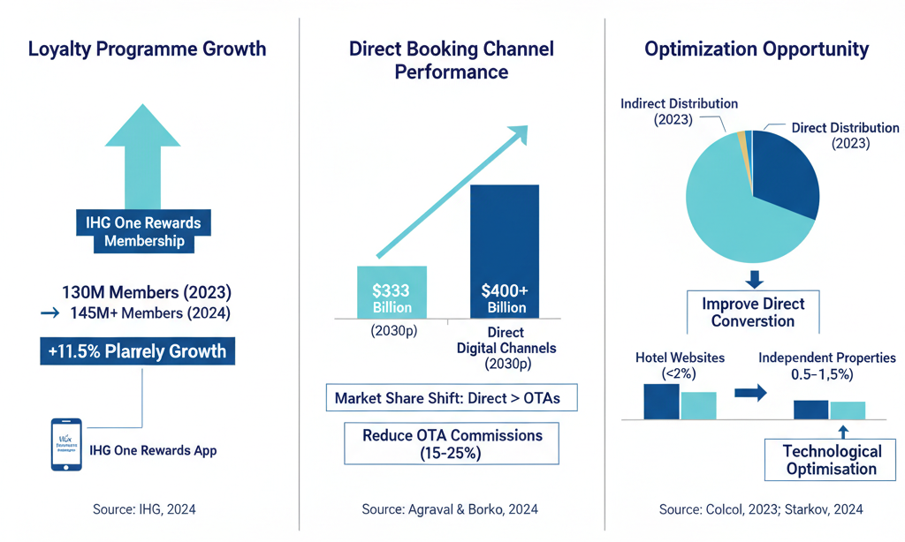
Figure 6: IHG Digital Ecosystem Impact & Market Restructuring.
Dosage holidays can benefit from the network of hotels that are part of the IHG digital ecosystem because 62% of hotel bookings were made through indirect distribution channels in 2023. This means that there are more ways to improve direct reservation conversion (Colcol, 2023). These studies have shown that hotel websites have a conversion rate of less than 2%, while independent properties have a conversion rate of between 0.5% and 1.5%. This shows that there are big performance gaps that need to be fixed through technological optimisation (Starkov, 2024).

4.3.2 Operational Process Automation and Resource Optimisation
Digital transformation initiatives have the potential to significantly enhance operational efficiency metrics. 57% of hotels that have completely updated their online presence say their revenue has gone up. AI-powered dynamic scheduling systems cut average room turnover times by more than 50%, while also making guests happier by allowing them to personalise their service on demand (Muzyka and Solovei 2025). Automation in the hospitality industry saves about 18% of the hours worked by administrative and housekeeping staff each week, according to Vargas (2023). This directly contributes to the general shortage of workers in the industry (68% of all properties).
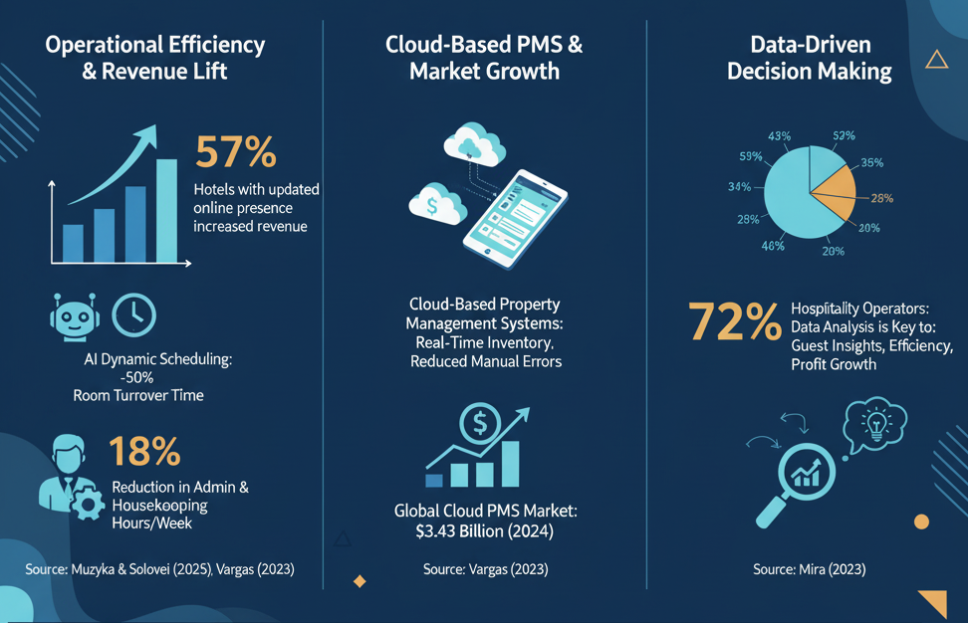
Figure 7: Operational Process Automation & Resource Optimisation.
Cloud-based property management systems make operations run more smoothly by letting you manage your inventory in real time across all of your distribution channels. They also cut down on the manual errors that are most likely to happen in older systems (Vargas, 2023). The global market for cloud-based PMS platforms was worth $3.43 billion in 2024. This shows that the industry as a whole has accepted the idea of using centralised operational infrastructure as a way to grow a business (Vargas, 2023). These systems let you make decisions based on data, and 72% of hospitality operators say that analysing data is the most important way to learn about their guests' preferences, how to run their businesses more efficiently, and how to make more money (Mira, 2023).

4.3.3 Technology Investment Allocation and Budgetary Commitments
The three parts of the IT cost model show that about 63% of the resources go to maintaining and improving existing systems, 30% go to new implementations, and 7% go to internal research and development. This is in line with the enterprise IT budgeting strategy (Heather, 2025). All of the operators involved said they plan to either raise their technology budgets in 2024 or keep them at the same level. This shows that everyone is committed to technical development, even though the economy is not stable.
IHG has spent more than $300 million on technology, including the Guest Reservation System, mobile app, websites, and cloud-based data analytics facilities (Mira, 2023). These investments show that Holiday Inn properties are using cutting-edge digital operational techniques as part of a digital infrastructure transformation strategy.

4.4 Challenges and Opportunities in Digital Reservation Systems

4.4.1 Integration Complexities and Technical Barriers
Digital transformation continues to face persistent implementation challenges despite a significant amount of investment. According to OysterLink (2025), 69% of hospitality professionals say that integrating legacy systems is their biggest problem. This leads to operational inefficiencies, data silos, and less-than-perfect guest experiences. These integration problems need strategic planning, full migration plans, and the use of middleware or APIs to bridge the technological gaps between old and new systems. The transition's complexity makes performance metrics go down for a while during the implementation phases. Efficiency can only get better about halfway through the planning and analysis phases.
Fifty per cent of organisations said that not having enough technology expertise was the biggest barrier to digital transformation. Sixty-nine per cent of US organisations and more than ninety per cent of global organisations said that not having enough expert skills made it harder for them to use new technology (Centranum Systems, 2025; Needham, 2024). Technological progress has also led to a lack of skilled workers. This shows that human capital preparation is not keeping up with technological progress, and it needs a lot of money to train people and build infrastructure. Data cleansing is very important for almost one-third of hotel chains, especially for smaller businesses in Europe and the Asia-Pacific region. This shows that data quality basics are needed before investing in more advanced analytics and personalisation (HFTP 2024).

4.4.2 Cybersecurity Concerns and Data Protection
After the high-profile breaches, data security became even more difficult, and most hospitality businesses added cybersecurity to their list of things to improve. Attacks are on the rise, with 31% of businesses having been breached, and the number of breaches that happen again is also on the rise, which has bigger financial effects (CRM, 2022). The average cost of a data breach around the world has gone up 15% to $4.45 million from 2020 to 2023. For example, MGM Resorts lost $100 million in the third quarter of 2023 because of cyberattacks in September 2023 (Vargas, 2023). These events show how weak digital infrastructure is, which means that strong encryption technologies, two-factor authentication protocols, and security monitoring systems that are always up to date need to be put in place.

4.4.3 Guest-Facing Technology Friction and Human Interaction Balance
Paradoxically, while 71% of guests prioritise hotels with self-service technology, 21% of operators perceive guest-facing technologies as potential sources of friction rather than empowerment tools (OysterLink, 2025). These perceptions arise from connectivity problems, difficulties with application usability, and perceived deficiencies in the quality of human interaction. The tension between the efficiency of technology and the relational nature of hospitality is a fundamental challenge that needs to be balanced. Properties need to figure out where to strike the right balance between the benefits of automation and the need for human touchpoints. This will help them find the best way for technology to improve personalised service delivery, which has been a key part of what makes the hospitality industry different.

4.5 Discussion
This chapter adopts an interpretive and critical perspective on research findings, employing theoretical frameworks to examine their implications for Holiday Inn Peterborough West, while acknowledging methodological constraints and pinpointing operationally significant areas necessitating strategic focus.

4.6 Digital Booking Systems and Guest Satisfaction
Based on a synthesis of findings drawn from a study of 13635 hospitality consumers, consumers' intention to use mobile technologies depends on their perceived usefulness. IHG has been encouraged to focus on functional attributes – room customisation and making stays nicer among them – though not entirely novel (Li et al., 2024). The evidence can be unclear about the cause and the effect. As an alternative, the cause of the effect is just inversely related.
Investing in digital applications does yield higher satisfaction levels, but more reasons may apply. Happiness seems to increase as post-pandemic recovery slows, as do the effects of macroeconomic stabilisation and competitive benchmarking. Saying something is computerised seems a major understatement.
The average incremental revenue per attribute purchase was $22 and $41 for luxury properties. This shows that personalisation monetisation is working, which is in line with what other research has found: hotels that use digital technologies to improve interaction get high satisfaction and loyalty (Anwar, Deliana, and Suyamto, 2024). Also, this raises equity issues: premium personalisation could unintentionally create levels of experiences that go against the hospitality industry's belief in equality in service. Holiday Inn Peterborough West is in the mid-market segment, and it has to make strategic decisions about how to price its attributes. If it charges too much, it could lose core demographic segments, and if it charges too little, it could miss out on possible revenue opportunities.
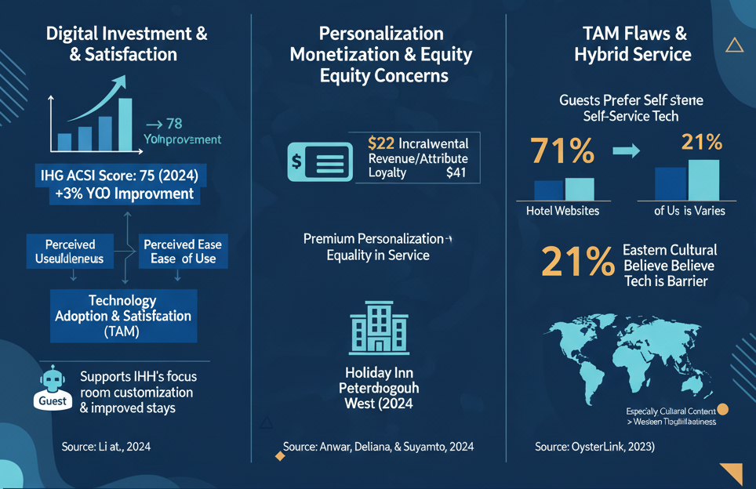
Figure 8: Digital Booking Systems & Guest & Theoretical Interpretation.
Additionally, the statistic that 71% of guests prefer technologies that rank highest on their lists for self-service capabilities, compared to only 21% of operators who believe that the technology that guests face acts as a barrier to their service, highlights the flaws in TAM (OysterLink, 2025). This contradiction suggests that perceived ease of use varies considerably across demographic segments, indicating that digital natives will exhibit greater tolerance for adoption compared to technology-averse groups. Li et al. (2024) demonstrate that the perceived ease of use dimensions is more pronounced in Eastern cultural contexts than in Western contexts, suggesting cultural moderation that necessitates the acknowledgement of Peterborough's multicultural visitor demographic, which Holiday Inn must accommodate. The paradox contends the imperative for hybrid service delivery models that integrate human touchpoints and digital channels, in contrast to exclusively technological deterministic methodologies.

4.7 Operational Efficiency Gains: Contextualising Performance Metrics
The 57% of hotels that saw an increase in revenue growth after going digital show how valuable the digital transformation is (Muzyka, 2025). However, a critical analysis reveals methodological concerns—selection bias may undermine these findings, as properties with successful digital system implementations were more likely to participate in industry surveys, whereas those with unsuccessful implementations did not report. AI-driven scheduling cuts room turnover times by 50%, which is a big improvement in efficiency (Pitakaso et al., 2025). However, the operation is so specific that it can't be used in other situations. There are 42 rooms at Holiday Inn Peterborough West, and the way people stay there and the way staff work there are all very different from research settings. Therefore, care must be taken when making generalisations.
The Technology-Organisation-Environment (TOE) framework elucidates the successful implementation of IHG, highlighting organisational digital maturity, financial resources for investment, and regulatory environments as critical determinants of adoption (Nikopoulou et al., 2023). The fact that IHG spent $300 million on technology shows that they are willing to spend money on a full transformation (Mira, 2023). But this scale doesn't work well with the budget limits of each property. Holiday Inn Peterborough West is a franchised operator. Even though the company has made a lot of investments, it doesn't have much freedom to make its own decisions about technology. This is a problem at the structural level that could make it harder to optimise for property-specific issues.
Also, the 18% cut in hours for front desk and housekeeping staff solves the labour shortage problems that affect 68% of properties (Vargas, 2023). Still, workforce displacement is a serious issue that needs to be addressed. While advocates of automation assert that the technology reallocates human capital to more valued guest interaction tasks, there is scant empirical evidence substantiating effective redeployment. Holiday Inn Peterborough West needs to plan and manage changes in its staff in a way that makes the adoption of new technology help rather than hurt job stability.

4.8 Integration Challenges: The Digital Transformation Paradox
Seventy per cent of professionals think that integrating legacy systems is a big problem. This indicates an intrinsic contradiction in the narrative of digital transformation (OysterLink, 2025). Even though this trend could make things work better, it will be hard to put into action, which will hurt short-term performance.
This "integration paradox" affects older properties the most, as long as they have the right technology in place. For example, our Holiday Inn Peterborough West is having a hard time deciding what to do. They have to weigh the cost of replacing their old property management systems against the cost of updating them, which has become the most important part of their business plan.
The TAM research identifies various organisational and psychological impediments, particularly a lack of training and a lack of organisational support (Lee, Ramasamy and Subbarao, 2025). Because the technology grows faster than the workers get trained to use it, it shows the lack of workforce development, which needs systematic investment in training. Holiday Inn Peterborough West must ensure that its personnel are always learning something new, and they get the digital skills needed to use the systems efficiently. However, the hospitality industry has a very high turnover rate. It averages 73.8% per year (U.S. Bureau of Labour Statistics, 2008). As a result, this makes training investments a waste. Above all, it keeps the capability gap open.
Cybersecurity is becoming more of a problem. After MGM's 100 million breach, 76% of the people needed stronger security, which showed that the digital side was weak (Vargas, 2023). The average cost of a breach is $4.45 million, which is a big problem for mid-market properties that don't have as much money.
Hotels like the Holiday Inn Peterborough West have a tough choice to make: should they spend money on a very good security system and still be able to pay their bills? Also, the complicated rules for following the GDPR add significant legal and technical costs, which hurt smaller properties the most.

4.9 Strategic Implications for Holiday Inn Peterborough West
Joining the IHG digital ecosystem gives Holiday Inn Peterborough West a lot of new opportunities. The hotel has a business structure that includes the GRS platform and the IHG One Rewards app. The loyalty program has 145 million members, which is one of the benefits of expanding distribution.
In 2030, direct channels are expected to make more money than OTAs (IHG, 2024; Agarwal and Borko, 2024). So, the hotel needs to use the loyalty program to get OTA visitors to book directly with them. The plan would help a business save 15% to 25% on commissions and make more money.
However, the average website conversion rate for this property is below 2%, with independent properties' conversion rates ranging from 0.5-1.5% (Starkov, 2024). While IHG's brand digital presence is no doubt above these thresholds, there are still huge optimisation opportunities. Conversion rate optimisation: Holiday Inn Peterborough West should focus on conversion rate optimisation through A/B testing, user experience optimisation, and personalised merchandising techniques. The scorecard indicates a direct booking rate of 42% relative to the benchmark of 42% indicating average performance and the need for tactical interventions such as rate parity, best price, and exclusive direct booking incentives.
The property needs to successfully leverage the technology-human interaction network. Twenty-one per cent of respondents see guest-facing technology as causing friction, though, which indicates caution should be exercised in terms of balancing automation efficacy with a focus on personalising service delivery. Expansion of Automation and Learning: Holiday Inn Peterborough West should embrace a phased approach to automation, adopting new applications for transactional interactions first, while maintaining human interaction for more complex guest needs and recovery scenarios.

4.10 Research Limitations and Critical Reflections
There are some problems with this research's use of secondary data sources. Not getting primary information from Holiday Inn Peterborough West employees and guests makes the findings less specific to the situation. Industry-level benchmarks provide broad insights and may obscure property-specific operational nuances that influence the efficacy of digital transformations. In addition, longitudinal analysis has time limits because the digital transformation is a process that takes a long time and is always happening, which makes it hard to fully evaluate its effects. Cross-sectional data provide snapshots that may inaccurately represent evolutionary trajectories.
Methodological limitations regarding potential publication bias favouring successful implementations while neglecting to report failures. Furthermore, determining causality is challenging due to various confounding variables that may influence observed outcomes, such as economic recovery, competitive dynamics, and operational enhancements beyond digital transformation.
Even though they help explain things, frameworks like TAM and TOE have their limits. The ease-of-use approach of TAM disregards society-specific, complex issues such as cultural differences, trust, and governmental challenges (Lee, Ramasamy, and Subbarao, 2025).
Future studies must utilise mixed methodologies. Combining quantitative performance data with qualitative stakeholder feedback will yield a more holistic understanding of the impact of digital transformation on mid-market hospitality properties.

Chapter 5: Conclusion and Recommendations

5. Conclusion

5.1 Research Overview and Contextualisation
This paper successfully analysed the impact of digital transformation on the hotel industry, specifically focusing on the Holiday Inn Peterborough West, a franchise within the IHG ecosystem. The study focused on online booking and its effect on guest satisfaction. It also talked about how digitisation can make operations more efficient and how hard it can be to make digital reservations. The research utilised secondary data analysis and was examined through the lenses of the Technology Acceptance Model (TAM) and the Technology-Organization-Environment (TOE) theoretical frameworks. The results show that the mid-tier hotels find the process of going digital very hard.

5.2 Digital Booking Systems and Guest Satisfaction Enhancement
Reservation systems make guests happier. The Guest Reservation System (GRS) of IHG is used in more than 5,000 hotels (IHG, 2023). The fact that the index of IHG satisfaction levels among Americans went up by three points to 78 (Hertzfeld, 2024) shows that it has been successful. The Technology Acceptance Model (TAM) says that how useful people think a technology is will be a big part of whether or not they use it (Guo et al., 2022).
These kinds of systems are also profitable. They should increase sales (Bhuiyan et al., 2023), and personalisation will increase sales by an average of $22 per night (IHG, 2023). Still, there are big problems that need to be fixed. They entail equitable treatment of all guests and the acknowledgement that various factors affect post-pandemic satisfaction (Hao and Chon, 2021).

5.3 Operational Efficiency Relationships and Digital Integration
The examination certified soldier improvements to major operational efficiency due to digital transformation ventures. Industry data shows that 57% of hotels that had implemented digital improvements saw an increase in their revenue, while targeted implementation of AI solutions saw a reduction of over 50% in room turnover times (Muzyka, 2025; Gupta, 2023). IHG sees that a 130-million-to-145-million-member (11.5%) increase as directly improving improvements brought through digital platform investments to operate in providing effortless engagement (IHG Annual Report, 2024). These results are in support of the propositions in the TOE framework on the role of organisational digital maturity and financial resource availability as determinants of adoption (Nikopoulou et al., 2023).
Automated property management systems assist people in making better choices. 72% of operators enjoy the upgrade to analytics (Hertzfeld, 2024). The systems could assist with labour issues, such as one-third of the properties having labour shortages (Vargas, 2023), by reducing staff time by 18%.
However, personalised service is under threat due to the loss of jobs because of automation. This is a big strategic problem for mid-market hotels like Holiday Inn Peterborough West, where good personal service is one of the main things that sets them apart from their competitors (Sharma, 2025).

5.4 Challenges, Integration Complexities and Strategic Imperatives
Changing the hospitality industry to digital is not easy. 69% of professionals say that integrating the old systems is their biggest problem. This can lead to data silos and inefficiencies in operations (Hertzfeld, 2024). New technologies would also make things worse during the transition period, which is a strange effect. Also, 54% of facilities are having problems because there aren't enough skilled tech workers, which is a sign that there aren't enough workers (Hertzfeld, 2024).
People are becoming more worried about cybersecurity. The average cost of a data breach around the world is $4.45 million (Vargas, 2023). So, 76 per cent of operators are making security improvements a top priority (Hertzfeld, 2024). This is also a problem with technology that guests can see. However, 71% of guests want self-service features, and 21% of operators say that this could lead to problems and that a balance between automation and interaction is needed (OysterLink, 2025).

5.5 Concluding Synthesis and Research Contributions
This study offers empirical data regarding the concept of digital transformation within the framework of franchised mid-market hotels, addressing a significant knowledge deficit in the existing literature. It talks about how these properties move around in corporate digital ecosystems. The research paper illustrates the dual functionality of digital reservation systems in managing guest satisfaction while generating revenue, highlighting the challenges associated with their implementation.
The case study of the Holiday Inn Peterborough West underscores the necessity of a balanced approach. It's a mix of investments in corporate infrastructure and improvements to individual properties. Some of the most important steps are to make conversion more effective, set up direct booking platforms, and find a balance between online and face-to-face communication. The study has established a foundation for future research, indicating the necessity for longitudinal and mixed-method approaches. This type of research may examine long-term implications by combining quantitative performance metrics and qualitative stakeholder experiences to enhance the understanding of digital transformation in the hospitality sector.

5.6 Recommendations and Practical Strategies
Using empirical evidence and critical thinking, evidence-based suggestions for operational optimisation imperatives were made for Holiday Inn Peterborough West under three strategic imperatives: optimising the direct booking channel, personalising the guest experience, and improving operational efficiency.

5.6.1 Direct Booking Channel Optimisation and Conversion Enhancement
Recommendation 1: Create a program for optimising conversion rates all around.
According to industry standards, the average web conversion rate is less than 2% (Starkov, 2024), so the Holiday Inn Peterborough West should work on improving the conversion rate of its website. Set up phased A/B testing for changes to the booking engine UI, how rooms are shown, and where to put calls to action. Widgets for conversion optimisation: use rate comparison tools that check real-time price parity against big OTAs, and use urgency by scarcity/urgency messaging with ethical transparency (Starkov, 2024). AI assistants can boost direct bookings by about 25%, which means that a lot of money can be made from OTA channels, which already control 62% of all bookings (Colcol, 2023).
Recommendation 2: Develop Targeted Loyalty Member Acquisition Campaign
Unlock the power of the 145-million-member loyalty base via locally-sourced acquisitions (IHG, 2024; IHG Annual Report, 2024). Implement enrolment incentive programmes where the player immediately receives some reward, such as a warm welcome upgrade, complimentary parking, or Food & Beverage credits for first-time IHG One Rewards enrolment during stay. Research shows that loyalty programme integration has a strong impact on the choice of booking channel, and direct channels are expected to generate $400 billion by 2030 ( Agarwal & Borko, 2024). Use post-stay remarketing campaigns to target your previous guests who were not loyal members, providing points-bonus discounts to complete your programme enrolment and direct booking.

5.6.2 Guest Experience Personalisation and Technology Integration
Recommendation 3: Strategic Attribute-Based Upselling Implementation
Take advantage of IHG's attribute selection feature, which brought in an extra $22 in revenue per booking on average (IHG, 2023). Conduct an inventory analysis for each property to find features that can be monetised, like the preferred floor level, how close it is to amenities, better views, and room layouts. Use dynamic pricing strategies that change attribute premiums based on trends in demand, forecasts of occupancy, and how your business compares to others (Kumar and Matta, 2024). But make sure that the base-level products you offer are still available. This way, you can make sure that personalisation improvements don't accidentally leave out important mid-market demographic groups (Tileaga and Oprisan, 2021).
Recommendation 4: Balanced Technology-Human Interaction Strategy
Get past the paradox: 71% of guests said they wanted to be able to help themselves, and 21% of operators said they had problems with friction (OysterLink, 2025; Hertzfeld, 2024). Start with progressive automation for transactional interactions like digital check-in, room selection, and payment processing. This will keep human touchpoints for more complicated needs, service recovery, and relationship-building interactions. Train front desk staff to be "digital concierges" who can help guests use self-service technologies. This will keep the relationship aspect of hospitality going while taking advantage of the efficiency benefits. Research shows that hospitality businesses that find a balance between automation and a human-centred approach have a 10 times better chance of making more than 20% more money (EHL Graduate School, 2024).

5.6.3 Operational Efficiency and Workforce Development
Recommendation 5: Comprehensive Digital Literacy Training Programme
Addressing the lack of skilled technology workers that affects 54% of properties through planned workforce development programmes (Hertzfeld, 2024). Every three months, staff members get training on how to use reservation systems, understand data analytics, and fix technology that helps guests interact with each other. One needs to create digital champion roles in both the digital university and the institutional structures. This means naming tech-savvy staff members to help each other and share knowledge (Pettersen, Eide and Berg, 2024). Considering the high turnover rates in the hospitality industry, it is essential to prioritise digital competency assessment in recruitment processes, focusing on candidates who are both technologically adept and oriented towards traditional services (Jubaedah et al., 2022).
Recommendation 6: Data Security and Privacy Compliance Enhancement
Invest in cybersecurity infrastructure to protect against breaches that cost an average of $4.45 million (Vargas, 2023). Use multi-factor authentication, do security audits on a regular basis, and have procedures in place for responding to incidents (Miller, 2024). Data mapping exercises, letting guests know about privacy policies, and keeping track of guest consent: Make sure that you are following the rules of the GDPR when you do our work. 'Human error' is a common term for human factors, which are the main points of entry. Because of this, organisations should run staff awareness programmes that teach them how to spot social engineering threats and understand phishing techniques.

5.6.4 Performance Monitoring and Continuous Improvement
Recommendation 7: Establish Key Performance Indicator Dashboard
Use full performance monitoring systems to track things like conversion rates, the percentage of direct bookings, guest satisfaction scores, operational efficiency metrics, and revenue per available room (RevPAR) indices (Liao and Halawi, 2025). Do performance reviews every month by comparing property metrics to IHG portfolio benchmarks and looking for patterns of deviation that need to be fixed. Use cloud-based systems with data analytics capabilities to predict demand, set prices, and proactively recover services based on how guests feel about them (sentiment analysis of guest feedback channels).

References
Agarwal, P. and Borko, S. (2024). Will Hotel Direct Bookings Overtake OTAs? Digging Deeper into Our Forecast. Available at: https://skift.com/2024/11/25/will-hotel-direct-bookings-overtake-otas-digging-deeper-into-our-forecast/. (Accessed: 29 October 2025).
Anwar, F.A., Deliana, D. and Suyamto, S. (2024). Digital Transformation in the Hospitality Industry: Improving Efficiency and Guest Experience. International Journal of Management Science and Information Technology, pp.428–437.
Awadallah, N. and Saad, S.G. (2017). Studying the Impact of Egyptian Hotels' Websites Marketing on Customer E-Satisfaction. International Journal of Information Technology Convergence and Services, 7(2/3), pp.1–11. doi: https://doi.org/10.5121/ijitcs.2017.7301.
Bhuiyan, M., Rahman, M.A., Hoque, A.B., Md Ashrafuzzaman and Rahman, A. (2023). ADVANCED ANALYTICS AND MACHINE LEARNING FOR REVENUE OPTIMISATION IN THE HOSPITALITY INDUSTRY: A COMPREHENSIVE REVIEW OF FRAMEWORKS. American Journal of Scholarly Research and Innovation, [online] 2(02), pp.52–74. doi: https://doi.org/10.63125/8xbkma40.
Braun, V. and Clarke, V. (2006). Using Thematic Analysis in Psychology. Qualitative Research in Psychology, 3(2), pp.77–101. doi: https://doi.org/10.1191/1478088706qp063oa.
Braun, V. and Clarke, V. (2022). Thematic Analysis: A Practical Guide. [online] SAGE Publications Ltd. Available at: https://uk.sagepub.com/en-gb/eur/thematic-analysis/book248481.
Braun, V. and Clarke, V. (2024). A critical review of the reporting of reflexive thematic analysis in Health Promotion International. Health Promotion International, [online] 39(3). doi: https://doi.org/10.1093/heapro/daae049.
Busulwa, R., Pickering, M. & Mao, I. (2022). Digital transformation and hospitality management competencies: Toward an integrative framework. International Journal of Hospitality Management, [online] 102(2), p.103132. doi: https://doi.org/10.1016/j.ijhm.2021.103132.
Centranum Systems (2025). Centranum Talent Management Software. [online] Centranum. Available at: https://www.centranum.com/research-updates/skills-shortages-2023-2025-the-research/.
Colcol, S. (2023). Everything You Need to Know about Hotel Reservation Systems. [online] SiteMinder. Available at: https://www.siteminder.com/r/hotel-reservation-system/.
CRM (2022). Key figures on guest data management in the hotel industry. [online] Loungeup.com. Available at: https://en.loungeup.com/blog/key-figures-on-guest-data-management-in-the-hotel-industry.
Crowe, S., Cresswell, K., Robertson, A., Huby, G., Avery, A. and Sheikh, A. (2011). The case study approach. BMC Medical Research Methodology, 11(1), pp.1–9. doi: https://doi.org/10.1186/1471-2288-11-100.
Denzin, N. & Lincoln, Y.S. (2011). The SAGE handbook of qualitative research. 4th ed. Thousand Oaks: Sage Publications.
Drew, C. (2023). 10 Case Study Advantages and Disadvantages (2023). [online] helpfulprofessor.com. Available at: https://helpfulprofessor.com/case-study-advantages-and-disadvantages/.
Ebneyamini, S. & Moghadam, M.R.S. (2018). Toward Developing a Framework for Conducting Case Study Research. International Journal of Qualitative Methods, [online] 17(1), p.160940691881795. doi: https://doi.org/10.1177/1609406918817954.
EHL Graduate School (2024). Technology Trends Shaping the Future of the Hospitality Industry Today. [online] Ehl.edu. Available at: https://hospitalityinsights.ehl.edu/technology-trends-hospitality-industry.
Fazal-e-Hasan, S.M., Mortimer, G., Ahmadi, H., Adil, M. & Sadiq, M. (2024). Examining the impact of tourists' hope, knowledge and perceived value on online hotel booking intentions. Asia Pacific Journal of Tourism Research, pp.1–17. doi: https://doi.org/10.1080/10941665.2024.2343058.
Fleischer, N.J. and Khalil, A. (2023). Limitations and recommendations for the use of secondary data analysis in pediatric research. Children’s Health Care, [online] 53(4), pp.1–17. Available at: https://www.tandfonline.com/doi/full/10.1080/02739615.2023.2279064.
Fox, L. (2023). IHG H1 2023 mobile loyalty attribute selling. [online] Phocuswire.com. Available at: https://www.phocuswire.com/ihg-h1-2023-mobile-loyalty-attribute-selling [Accessed 12 Oct. 2025].
Guo, Q., Zhu, D., Lin, M.-T. (Brian), Li, F. (Sam), Kim, P.B., Du, D. and Shu, Y. (2022). Hospitality employees’ technology adoption at the workplace: evidence from a meta-analysis. International Journal of Contemporary Hospitality Management, 35(7). doi: https://doi.org/10.1108/ijchm-06-2022-0701.
Gupta, D. (2023). The Importance of Digital Tech Adoption in Hospitality (2023). [online] The Whatfix Blog | Drive Digital Adoption. Available at: https://whatfix.com/blog/digital-adoption-in-hospitality/.
Hao, F. and Chon, K.K.-S. (2021). Contactless service in hospitality: bridging customer equity, experience, delight, satisfaction, and trust. International Journal of Contemporary Hospitality Management, 34(1), pp.113–134. doi: https://doi.org/10.1108/ijchm-05-2021-0559.
Heather (2025). Your IT Budget is 80% Maintenance. Here's How to Optimise It. [online] Synchrony Systems. Available at: https://sync-sys.com/your-it-budget-is-80-maintenance-heres-how-to-optimize-it/ [Accessed 12 Oct. 2025].
Hertzfeld, E. (2024). Hotel guest satisfaction rises again this year. [online] Hotel Management. Available at: https://www.hotelmanagement.net/data-trends/hotel-guest-satisfaction-rises-again-year.
HFTP (2024). H2C Unveils 2024 Global Hotel Direct Booking Acceleration Study. [online] HFTP. Available at: https://www.hftp.org/news/4124406/h2c-unveils-2024-global-hotel-direct-booking-acceleration-study [Accessed 12 Oct. 2025].
HITEC (2024). 2024 Q1 Trends in Hotel Guest Experience: Surge in Satisfaction and Responsiveness. [online] HITEC. Available at: https://www.hitec.org/news/4122131/2024-q1-trends-in-hotel-guest-experience-surge-in-satisfaction-and-responsiveness [Accessed 12 Oct. 2025].
Hospitality Tech (2024). 2024 Lodging Technology Study: Digital Transformation & ROI. [online] Hospitality Technology. Available at: https://hospitalitytech.com/2024-lodging-tech-study.
IHG (2023). IHG Hotels & Resorts Revolutionises Booking Experience through Next-Gen Cloud Solutions. [online] InterContinental Hotels Group PLC. Available at: https://www.ihgplc.com/en/news-and-media/news-releases/2023/ihg-hotels-and-resorts-revolutionizes-booking-experience-through-next-gen-cloud-solutions.
IHG (2024). Annual Report. [online] InterContinental Hotels Group PLC. Available at: https://www.ihgplc.com/en/investors/annual-report.
IHG Annual Report (2024). Trends shaping our industry, continuing to evolve and adapt the flexibility of loyalty programmes. [online] Available at: https://www.ihgplc.com/~/media/Files/I/Ihg-Plc/investors/annual-report/2024/trends-shaping-our-industry_p2021.pdf.
Jayawardena, N.S., Thaichon, P., Quach, S., Razzaq, A. & Behl, A. (2023). 'The persuasion effects of virtual reality (VR) and augmented reality (AR) video advertisements: A conceptual review'. Journal of Business Research, 160, p.113739. doi: https://doi.org/10.1016/j.jbusres.2023.113739.
Johnston, M. (2017). Secondary Data Analysis: A Method for Which the Time has Come. [online] ResearchGate. Available at: https://www.researchgate.net/publication/294718657_Secondary_Data_Analysis_A_Method_of_Which_the_Time_has_Come.
Jubaedah, Y., Rinekasari, N.R., Rohaeni, N., Maosul, A. and Yusuf, S.F. (2022). Implementation of Digital Competency-Based Assessment in Turndown Service in The Hospitality Industry. Journal of Technical Education and Training/Journal of technical education and training, 14(2). doi: https://doi.org/10.30880/jtet.2022.14.02.006.
Kumar, N. & Matta, V. (2024). DYNAMIC PRICING USING MACHINE LEARNING: A STUDY ON HOTEL BOOKINGS IN BANGALORE. IJNRD.ORG IJNRD2404373 International Journal of Novel Research, [online] 9(4), pp.2456–4184. Available at: https://www.ijnrd.org/papers/IJNRD2404373.pdf.
Lee, A.T., Ramasamy, R.K. & Subbarao, A. (2025). Understanding Psychosocial Barriers to Healthcare Technology Adoption: A Review of TAM Technology Acceptance Model and Unified Theory of Acceptance and Use of Technology and UTAUT Frameworks. Healthcare, 13(3), p.250. doi: https://doi.org/10.3390/healthcare13030250.
Li, F. (Sam), Zhu, D., Lin, M.-T. (Brian) and Kim, P.B. (2024). The Technology Acceptance Model and Hospitality and Tourism Consumers’ Intention to Use Mobile Technologies: Meta-Analysis and Structural Equation Modelling. Cornell Hospitality Quarterly, 65(4). doi: https://doi.org/10.1177/19389655241226558.
Liao, K. and Halawi, L. (2025). A Framework for Measuring Personalisation in the Luxury Hotel Industry. Intechopen.com. [online] doi: https://doi.org/10.5772/intechopen.1011894.
Miller, J. (2024). Top Cybersecurity Measures for Higher Education Institutions. [online] Bitlyft.com. Available at: https://www.bitlyft.com/resources/top-cybersecurity-measures-for-higher-education-institutions.
Mira, L. (2023). How IHG’s One Rewards App and Other Hotel Technology Innovations are Raising the Bar on Guest Engagement |. [online] Hotel Technology News. Available at: https://hoteltechnologynews.com/2023/09/how-ihgs-one-rewards-app-and-other-hotel-technology-innovations-are-raising-the-bar-on-guest-engagement/.
Mohsin, A., Brochado, A. and Rodrigues, H. (2022). Mind the gap: a Critical Reflection on Hotel Employee Turnover. International Journal of Contemporary Hospitality Management, 35(7). doi: https://doi.org/10.1108/ijchm-03-2022-0295.
Muzyka, B. and Solovei, A. (2025). Digital Transformation in the Hospitality Industry | TechMagic. [online] Blog | TechMagic. Available at: https://www.techmagic.co/blog/digital-transformation-in-hospitality-industry.
Naeem, M., Ozuem, W., Howell, K. and Ranfagni, S. (2023). A step-by-step Process of Thematic Analysis to develop a Conceptual Model in Qualitative Research. International Journal of Qualitative Methods, 22(1), pp.1–18. doi: https://doi.org/10.1177/16094069231205789.
Nasdaq (2023). IHG One Rewards Mobile App: Redefining Travel Through Technology. [online] Nasdaq.com. Available at: https://www.nasdaq.com/press-release/ihg-one-rewards-mobile-app:-redefining-travel-through-technology-2023-09-27 [Accessed 12 Oct. 2025].
Needham, M. (2024). IT Skills Shortage Expected to Impact Nine out of Ten Organisations by 2026 with a Cost of $5.5 Trillion in Delays, Quality Issues and Revenue Loss, according to IDC. [online] IDC: The premier global market intelligence company. Available at: https://my.idc.com/getdoc.jsp?containerId=prUS52128824.
Nikopoulou, M., Kourouthanassis, P., Chasapi, G., Pateli, A. and Mylonas, N. (2023). Determinants of Digital Transformation in the Hospitality Industry: Technological, Organisational, and Environmental Drivers. Sustainability, [online] 15(3), p.2736. Available at: https://www.mdpi.com/2071-1050/15/3/2736.
OysterLink (2025). Digital Transformation in the Hospitality Industry: Stats & Trends in 2025. [online] Oysterlink.com. Available at: https://oysterlink.com/spotlight/digital-transformation-hospitality-industry/.
Ozdemir, O., Dogru, T., Kizildag, M. and Erkmen, E. (2023). A critical reflection on digitalisation for the hospitality and tourism industry: value implications for stakeholders. International Journal of Contemporary Hospitality Management, 35(9). doi: https://doi.org/10.1108/ijchm-04-2022-0535.
Pederson, L., Vingilis, E., Wickens, C.M. and Koval, J. (2020). Use of secondary data analyses in research: Pros and Cons. [online] ResearchGate. Available at: https://www.researchgate.net/publication/343551750_Use_of_secondary_data_analyses_in_research_Pros_and_Cons.
Pettersen, S., Eide, H. and Berg, A. (2024). The role of champions in the implementation of technology in healthcare services: a systematic mixed studies review. BMC Health Services Research, 24(1). doi: https://doi.org/10.1186/s12913-024-10867-7.
Pitakaso, R., Golinska-Dawson, P., Luesak, P., Srichok, T. and Khonjun, S. (2025). Embracing Open Innovation in Hospitality Management: Leveraging AI-Driven Dynamic Scheduling Systems for Complex Resource Optimisation and Enhanced Guest Satisfaction. Journal of Open Innovation: Technology, Market, and Complexity, 11(1), p.100487.
RMS (2020). Hotel Tech Spend Up, But Gap Widening Between Chains and Independents | Hospitality Industry Club. [online] hospitality industry. Club. Available at: https://hospitalityindustry.club/en/hotel-tech-spend-up-but-gap-widening-between-chains-and-independents/.
Saunders, M., Lewis, P. & Thornhill, A. (2019). Research Methods for Business Students. 8th ed. United Kingdom: Pearson.
Sharma, N. (2025). A Study on the Future of Work in Hotels: Impact of AI and Automation on Learning and Development. [online] Available at: https://ijirt.org/publishedpaper/IJIRT173852_PAPER.pdf [Accessed 12 Oct. 2025].
Shin, H.H. & Jeong, M. (2020). Guests' perceptions of robot concierge and their adoption intentions. International Journal of Contemporary Hospitality Management, 32(8), pp.2613–2633. doi: https://doi.org/10.1108/ijchm-09-2019-0798.
Sibbald, S.L., Paciocco, S., Fournie, M., Van Asseldonk, R. and Scurr, T. (2021). Continuing to enhance the quality of case study methodology in health services research. Healthcare Management Forum, 34(5), pp.291–296. doi: https://doi.org/10.1177/08404704211028857.
Starkov, M. (2024). Why improving hotel website conversion rates is a top priority in 2024. [online] Hospitality Net. Available at: https://www.hospitalitynet.org/viewpoint/125000226.html.
Statista (2024). ACSI: InterContinental Hotels US 2020. [online] Statista. Available at: https://www.statista.com/statistics/194732/customer-satisfaction-with-us-intercontinental-hotels-since-2008/.
Sun, S., Law, R. and Hyun, S. (2024). Exploration of Hotel Reservation Through Mobile Online Travel Agencies. International Journal of Tourism Research, 26(4). doi: https://doi.org/10.1002/jtr.2734.
Tileagă, C. and Oprișan, O. (2021). Personalisation -A Key Element in Creating Better Customer Experiences. Expert Journal of Business and Management, [online] 9(2), pp.88–94. Available at: https://business.expertjournals.com/ark:/16759/EJBM909_tileaga88-94.pdf.
U.S. Bureau of Labour Statistics (2008). Job Openings and Labour Turnover Survey Home Page. [online] Bls.gov. Available at: https://www.bls.gov/jlt/.
Vargas, J. (2023). 5 Tech-Driven Hospitality Trends to Expect in 2024 and Beyond | By Joe Vargas. [online] Hospitality Net. Available at: https://www.hospitalitynet.org/opinion/4119336.html.
Vial, G. (2019). Understanding Digital transformation: a Review and a Research Agenda. The Journal of Strategic Information Systems, 28(2), pp.118–144. doi: https://doi.org/10.1016/j.jsis.2019.01.003.
Wood, L., Sebar, B. & Vecchio, N. (2020). Application of Rigour and Credibility in Qualitative Document Analysis: Lessons Learnt from a Case Study. The Qualitative Report, 25(2). doi: https://doi.org/10.46743/2160-3715/2020.4240.
Yin, R.K. (2018). Case Study Research and Applications: Design and Methods. 6th ed. Thousand Oaks, California: Sage Publications.
Zare, J. and Persaud, A. (2024). Digital transformation and business model innovation: a bibliometric analysis of existing research and future perspectives. Management review quarterly. doi: https://doi.org/10.1007/s11301-024-00426-z.

