

Name - Shivcharan Mistry

Student ID – 2244603
Research Title - Blockchain Integration in Trade Finance: Reshaping Transactions for the Future

Supervisor – Vasilios Tavlaridis

DECLARATATION
I declare that this dissertation has been written solely by myself and that it has not been submitted, in whole or in part, in any previous application for a degree in this university or any other institutions. In addition, I have acknowledged all main source/s-author/s appropriately in parts of this dissertation where I have quoted work from others.

ACKNOWLEDGEMENT

I would like to express my deepest appreciation to my supervisor, Professor Masud Ibrahim, for their invaluable guidance, insightful feedback, and unwavering support throughout this research journey. Their expertise in Finance and Management was crucial in refining my approach and their encouragement during challenging moments kept me motivated.

My heartfelt thanks extend to my family, whose unconditional love and unwavering belief in me have been my bedrock. Their patience and understanding, especially during long hours of research and writing, were truly invaluable. Finally, to my incredible wife, Dipeeka Mistry, thank you for being my constant source of strength, my sounding board, and my biggest cheerleader. Your love, support, and hard work made this journey possible.

Table of Contents
1. INTRODUCTION 1
1.1 Background and Problem Statement 1
1.2 Research Aim 4
1.3 Research Objectives 5
1.4 Research Questions 5
1.5 Relevance of Study 5
1.7 Structure of the research 6
2. LITERATURE REVIEW 8
2.1 Introduction 8
2.2 Research Topic 8
2.3 Overview of Blockchain 8
2.4 Key Concepts of Blockchain (Ledgers, Consensus, Immutability) 10
2.5 Types of Blockchain (Public, Private, Consortium) 11
2.6 Public Blockchain 11
2.7 Private Blockchain 12
2.8 Consortium Blockchain 12
2.9 Smart Contracts 13
3.1 Issues and challenges associated with blockchain technology in trade finance 17
3.2 Conclusion of Chapter 19
4. RESEARCH METHODOLOGY 20

List of Figures

Figure 1: Payment Process via Letter of Credit (L/C) 1
Figure 2 Marubeni Corporation's L/C process (conceptual overview) 3

INTRODUCTION

Background and Problem Statement

The international exchange of goods has strengthened human development for centuries. In the contemporary era, global trade remains a critical engine of economic growth and international cooperation. However, the financial infrastructures supporting trade are under strain. As highlighted in the 2023 Asian Development Bank (ADB) report, the global trade finance gap has widened to an alarming $2.5 trillion – a 47% increase since 2020 (Beck et al., 2023). This expansion stems from multiple factors, including the COVID-19 pandemic's lingering impact, heightened rejection rates for trade financing applications, and geopolitical instability exemplified by the Russia-Ukraine conflict. To address this challenge, the ADB advocates for global initiatives to accelerate the digitization of trade, focusing on standard management, stakeholder adoption, and enabling legal and policy frameworks – a theme this thesis will explore in depth. While traditional trade finance mechanisms have played a pivotal role, they face inherent limitations and remain susceptible to fraud due to their reliance on physical documents that are vulnerable to forgery and tampering.

Trade finance is a critical component of business operations that utilizes various financial instruments and mechanisms to facilitate international trade transactions. It involves activities aimed at ensuring the smooth flow of goods and services across borders while managing associated financial risks. One key element of trade finance is trade credit, which involves a supplier extending credit to a buyer to finance the purchase of goods or services. Trade credit serves as a short-term financing option that enables businesses to effectively manage their cash flow (Lei et al., 2019).

Trade credit assumes a pivotal role in fostering business growth, particularly within sectors characterized by a pronounced reliance on this form of financing. Empirical studies demonstrate that industries exhibiting greater trade credit dependence often experience accelerated growth rates, a phenomenon especially observable in regions where formal financial institutions are less robust (Fisman and Love., 2003). Furthermore, rapidly expanding firms frequently leverage trade credit as a financing mechanism when traditional sources of capital prove less accessible (Ferrando and Mulier., 2013).

Figure 1 illustrates the conventional Letter of Credit (L/C) process facilitating international trade transactions. This process involves exporters (sellers), importers (buyers), logistics providers (shippers), and banks mediating credit. International trade consists of interconnected flows of documents, finances, and goods. The process begins with a sales contract between the exporter and importer. To manage risk, various payment methods exist, including cash-in-advance, telegraphic transfer, open account, and L/C. The L/C is recognized for its superior trade finance security. Banks in the exporter's and importer's countries act as intermediaries, coordinating the transfer of funds and goods. The importer initiates the process by instructing their bank to issue an L/C to the exporter's bank, which then advises the exporter. Upon shipment of goods, the shipper provides the exporter with documentation, including the crucial bill of lading (B/L) as proof of title. Documents flow through banks, ultimately resulting in the exporter's bank receiving payment. The importer reimburses their bank, receiving the B/L in exchange, allowing them to claim the goods. While the traditional documentary L/C offers greater security than alternative payment methods, its complexity and reliance on manual processes create inefficiencies. Cross-border transactions with unfamiliar counterparties can lead to communication delays, increased costs, and reduced overall efficiency. This complexity in document handling limits the wider uptake of L/Cs.
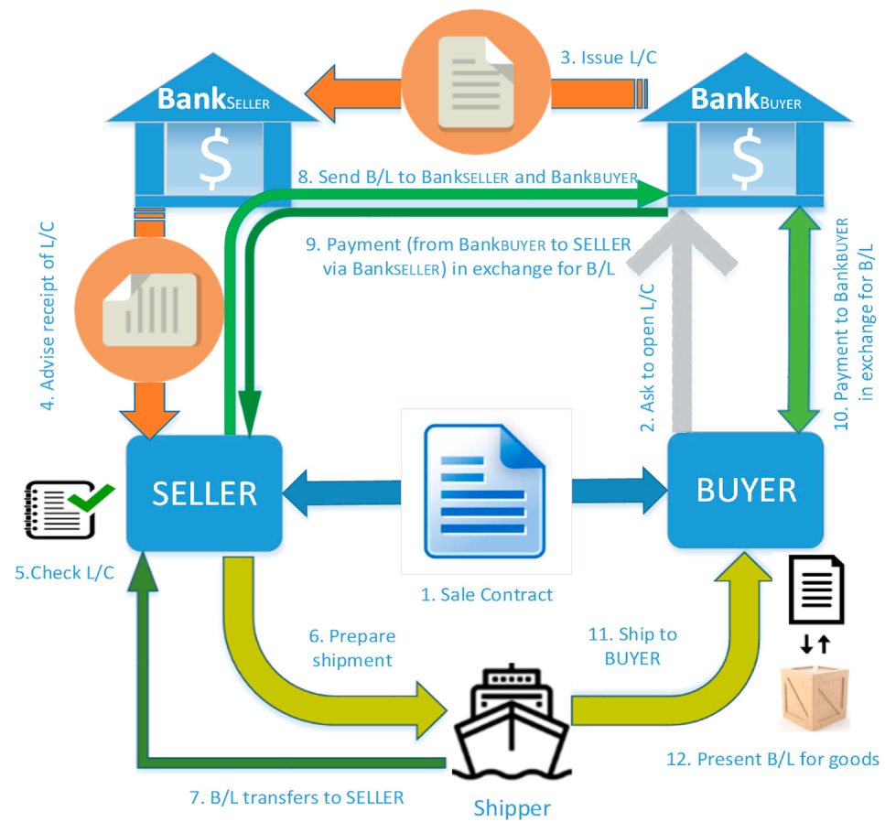

Figure 1: Payment Process via Letter of Credit (L/C) (Source: Chang, S et al., 2020)

Traditional trade finance processes are known for their inefficiencies, which include being paper-based, slow, expensive, and vulnerable to fraud (Ibrahim and Truby., 2021). These processes are often antiquated, inefficient, and lack digitization, leading to issues such as information latency, trust issues, and reliance on intermediaries (Chang et al., 2019). Moreover, traditional trade finance is centralized, which can hinder overall process efficiency (Chang et al. 2019).

Blockchain technology presents a promising solution to the inherent inefficiencies plaguing conventional trade finance processes. Its core attributes, including a tamper-proof, distributed ledger, foster trust amongst trading partners, thereby strengthening transaction security, and streamlining efficiency (Kowalski et al., 2021). This immutable record simplifies and strengthens the security of supply chain finance arrangements. By eliminating intermediaries and enhancing transparency, blockchain technology minimizes transaction friction (Xie and Li., 2021). Moreover, its ability to provide a shared, synchronized data repository for all participants diminishes the potential for fraudulent activities, further augmenting the efficacy of the trade finance process (Liu, 2021).

Furthermore, by facilitating the digital integration of the entire supply chain finance process, blockchain technology fosters enhanced efficiency and expedited communication and transactions. This demonstrably translates to faster settlement times, accelerating the flow of funds into enterprise accounts (Liu, 2021). Furthermore, leveraging blockchain in supply chain finance can improve the evaluation of financial risks within supply chains, particularly for small and medium-sized financing firms. This enhanced risk assessment capability contributes to a more secure financial environment (Wang, 2021).

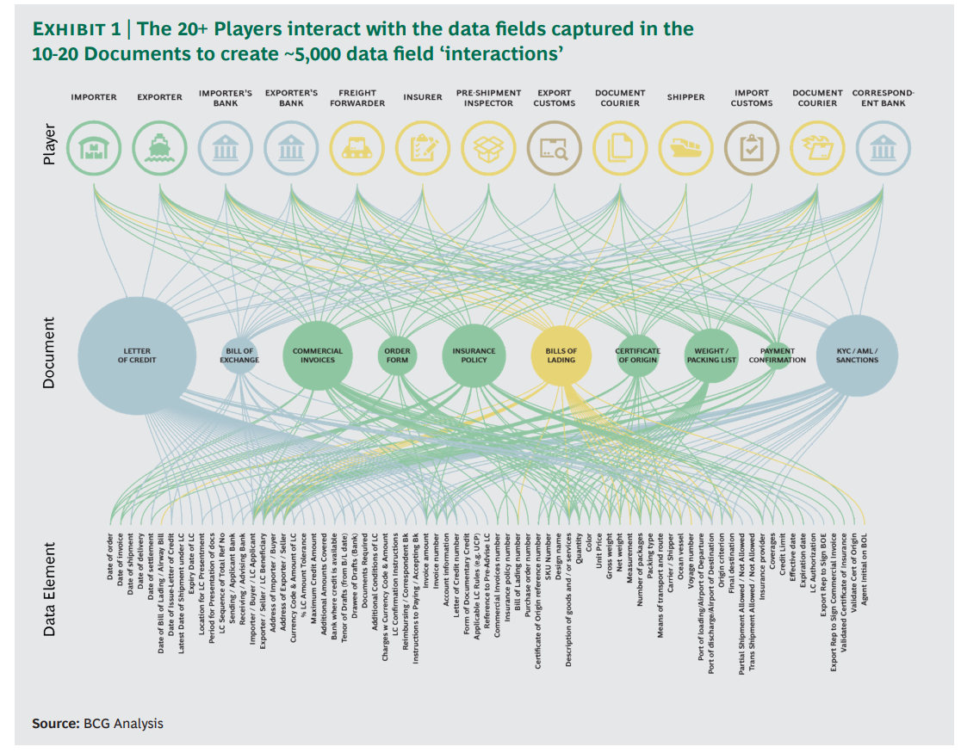
Figure 2: A trade finance transaction involves a multitude of parties, papers, and data pieces. (Source, BCG Group)
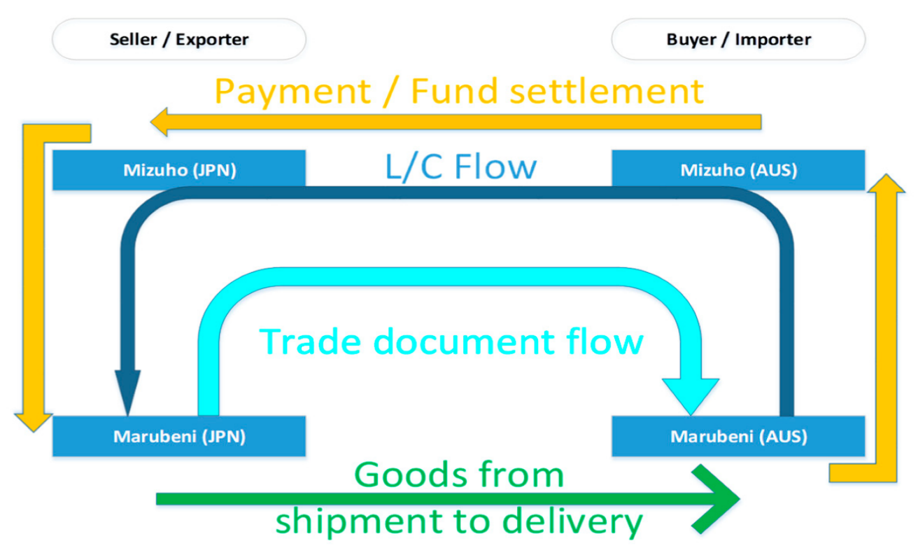
On July 6th, 2017, a landmark demonstration by Japanese firms Marubeni and Sompo showcased the transformative potential of distributed ledger technology (DLT) in streamlining international trade. By leveraging IBM's Hyperledger Fabric platform, they illustrated how DLT could replace the reliance on traditional Letters of Credit (L/Cs) and associated trade documents. This innovative transaction significantly reduced processing time from weeks to a mere two hours (Figure 3). The Hyperledger platform, by design, facilitates the secure digitization and automation of trade and shipping documentation traditionally handled through physical copies. The trial, from sales contract creation, through L/C issuance, document exchange (L/C and Bill of Lading), to final financial settlement, was successfully executed between the exporter's and importer's banks entirely on a blockchain network. While compelling, widespread blockchain adoption within the trade industry hinges on addressing key challenges. These include the establishment of unified technical protocols and fostering robust collaboration among industry stakeholders.
Figure 3: Marubeni Corporation's L/C process (conceptual overview)
(Source: Chang, S et al., 2020)

Overall, blockchain technology presents a transformative solution to the inefficiencies plaguing traditional trade finance processes. By introducing blockchain into trade finance, businesses can benefit from increased transparency, enhanced security, reduced costs, and improved efficiency in their financial transactions.

Research Aim

The overarching goal of this thesis is to investigate the transformative impact of blockchain integration on processes within trade finance. By delving into the intersection of blockchain technology and trade finance, this research aims to explore how the integration of blockchain reshapes traditional practices, enhances transparency, and streamlines operations in the realm of trade finance. Through a comprehensive analysis of existing literature and empirical studies, the study seeks to identify the key mechanisms through which blockchain technology revolutionizes trade finance processes, mitigates risks, and improves efficiency.

Furthermore, the research aims to provide insights into the challenges and opportunities associated with blockchain adoption in trade finance, shedding light on the implications for various stakeholders involved in international trade transactions. Ultimately, this thesis aspires to contribute to the academic discourse by offering a nuanced understanding of how blockchain integration is reshaping trade finance practices and paving the way for a more secure, efficient, and transparent global trade ecosystem.

Research Objectives

The objectives of the research are as follows:

- How can blockchain technology transform existing trade finance processes within the UK?

- What are the advantages of incorporating blockchain into trade finance for companies in the United Kingdom?

- What are the issue associated with blockchain technology in trade finance?

Research Questions

Q1. How does the adoption of blockchain technology specifically transform traditional trade finance practices within the United Kingdom?

Q2. What are the specific advantages that incorporating blockchain technology offers to companies engaged in trade finance within the United Kingdom?

Q3. The issue associated with blockchain technology in trade finance in the United Kingdom?

Relevance of Study

This study promises substantial benefits due to its potential to inform a wide range of stakeholders within UK. The research can guide governments, financial institutions, trade participants, and policymakers in optimizing trade finance practices through the strategic implementation of blockchain technology. Blockchain's inherent properties hold the potential to revolutionize trade finance by bolstering fraud prevention mechanisms, streamlining operations, and fostering greater trust among stakeholders.

The key beneficiaries include government bodies and policymakers, who can leverage findings to responsibly guide the adoption of blockchain for better processes and fraud reduction. Financial institutions will gain insights for optimizing operations, cutting costs, promoting efficiency, and increasing trust.

Additionally, the study will raise awareness of blockchain's functionality and add to the existing knowledge base on trade finance innovation. Scholars will find this research valuable, as it offers a foundation for further exploration into the transformative potential of blockchain and its applications within international trade.

  - Brief Research Methodology

Structure of the research

The structure of the research as follows:

Chapter 1: Introduction – This chapter provides the foundation for the thesis. It introduces the concept of trade finance, outlining its current processes and the potential inefficiencies involved. Blockchain technology is then presented as a promising solution that could significantly enhance the speed, security, and overall efficiency of trade finance transactions. The chapter also states the research aim, the central questions driving the study, and the broader relevance of this research to the field of trade finance.

Chapter 2: Literature Review – This chapter deals with literature review that elaborated the overview of blockchain, types of blockchain,

Chapter 3: Research Methodology

Chapter 4: Findings/ results, analysis, and discussion

Chapter 5: Conclusions and recommendations

LITERATURE REVIEW

Introduction

Traditional trade finance systems, particularly within the United Kingdom, are characterized by a reliance on paper-based processes, manual interventions, and a network of intermediaries (e.g. banks). These legacy systems contribute to inefficiencies, delays, heightened costs, and an increased vulnerability to fraud (Ibrahim and Truby., 2021). (Kowalski et al., 2021) The limitations inherent in these traditional systems create obstacles for businesses, particularly small and medium-sized enterprises (SMEs), hindering their ability to engage in international trade and access vital financing (Fisman and Love, 2003).

Blockchain technology, with its core attributes of decentralization, immutability, and the potential for smart contract functionality, has emerged as a transformative solution to address these persistent challenges (Xie and Li., 2021). Blockchain's ability to streamline processes, enhance transparency, and automate key trade finance functions holds the promise of revolutionizing the industry within the UK (Chang et al., 2019).

This literature review aims to critically examine the intersection of blockchain technology and trade finance within the UK. It will explore how blockchain has the potential to reshape traditional processes, mitigate risks, increase efficiency, and enhance accessibility for UK businesses. Furthermore, it will delve into the challenges and considerations associated with blockchain adoption in the context of the UK's regulatory and technological landscape.

Research Topic

Overview of Blockchain

Satoshi Nakamoto introduced blockchain technology in 2008, originally designed to underpin Bitcoin (Nakamoto et al., 2008), has sparked a revolution beyond its cryptocurrency roots. Blockchain inherent features, such as decentralization, immutability, and enhanced security, offer transformative potential across various industries (Peng et al., 2020). In supply chain management, for instance, blockchain enables the creation of transparent and tamper-proof ledgers for tracking goods, improving efficiency and traceability (Saberi et al., 2018). Similarly, in healthcare, it facilitates secure sharing of patient data, streamlining record-keeping and enabling collaboration (Ko et al., 2018).
(Ahluwalia et al., 2020) emphasize the potential of blockchain technology to reduce transaction costs within the realm of trade finance. This focus on transaction cost economics aligns with a growing body of research exploring how blockchain can streamline financial processes. By minimizing administrative burdens and streamlining data exchange, blockchain has the potential to significantly decrease costs associated with trade finance activities. (Francisco and Swanson., 2018) Robust security protects data against unauthorized access while participant identity authentication strengthens trust within the network. Finally, the blockchain's prioritization of immutability ensures that data, once added, resists alteration or manipulation, promoting the integrity of records within the system.

Several studies have explored blockchain technology's fundamental mechanisms and potential applications. (Jaoude and Saade., 2019) characterize blockchain as a distributed ledger, emphasizing its role in tracking transactions within a networked system. Similarly, (Wang et al., 2019) highlight its decentralized structure and the way it creates shared, immutable financial records. (Wang et al., 2019) Furthermore, it is worth noting that the advantages of blockchain technology extend beyond the realm of banking. In fact, it has the ability to address issues related to fraud in sectors like agriculture and manufacturing, where vulnerabilities arise due to the dependence on third parties.

(Chen et al., 2022) According to author decentralization is a cornerstone of blockchain technology, underpinning its design and functionality. This emphasis on distributed control stands in contrast to traditional, centralized systems. (Ahmed et al., 2022) By leveraging peer-to-peer networks and cryptography, blockchain creates an immutable public ledger, as described by (Davidson et al., 2018). This decentralized architecture offers several advantages, including enhanced transparency, security, and reliability across diverse applications (Ahmed et al., 2022).

(Cook et al., 2023) provide a detailed explanation of the main purpose of blockchain, which is to store data. Blockchain is sometimes compared to a conventional database, although it incorporates advanced security measures. (Sung and Park., 2021) emphasize decentralization as a fundamental role in identity management systems based on blockchain technology. This decentralization ensures that power over personal data is dispersed across network participants rather than being centralized. (Zubaydi et al., 2019) underline the advantages of blockchain's peer-to-peer distributed network, which offers increased computational power and network dependability.

While blockchain offers significant advantages, several studies have identified challenges that hinder its broader implementation. (Pillai et al., 2020; Wang et al., 2019) highlight concerns surrounding scalability, implementation, and the need for clearer regulatory frameworks. Furthermore, researchers like (Spencer-Hicken et al., 2023; Zhou et al., 2020) emphasize the complexity of blockchain, requiring thorough analysis and evaluation to ensure successful integration. Despite these hurdles, the technology continues to advance, with suggesting that ongoing development will unlock innovative solutions in various sectors.

Key Concepts of Blockchain (Ledgers, Consensus, Immutability)

The ledger is an essential fundamental of blockchain technology serving as the foundation for the system security, decentralisation, and transparency. It offers a safe, transparent, and decentralised database for registering transactions and maintaining the accuracy of data in many industries and applications (Konig et al., 2020). Blockchain technology utilises a distributed ledger to guarantee transparency, security, and trust among participants by documenting transactions in a form that can be verified and cannot be altered. Although blockchain technology has the potential to bring numerous advantages, there remain numerous misunderstandings and misconceptions around it. This underscores the significance of clarifying and explaining the concepts of blockchains and distributed ledgers.

Cryptographic hashing functions play a pivotal role in upholding the integrity and immutability of data within blockchain systems. By transforming data into fixed-length hash values using cryptographic algorithms, blocks of data are securely chained together (Jabarulla and Lee., 2021). This process ensures that any alteration to the data would result in a detectable change in the corresponding hash value, thus safeguarding the immutability of the ledger. Furthermore, asymmetric cryptography (also known as public-key cryptography) is vital for secure communication and transaction authorization on blockchain networks. Its use of paired public and private keys enables the authentication of digital signatures, encryption of data, and secure exchange of information among participants (Nugraha et al., 2021).

(Shafay et al., 2022) delve into the core attributes of blockchain technology, emphasizing not just decentralization but also its capabilities for smart contracts, data immutability, and the use of consensus mechanisms. These features, by enabling secure and transparent transaction platforms, contribute to improved business efficiency. (Yoon., 2019) further strengthens the case for blockchain adoption across various sectors, highlighting its advantages in finance and beyond. Specifically, (Yoon., 2019) commends its immutable audit trail, robustness, data provenance, and enhanced security and privacy features.

The importance of standardization for widespread blockchain adoption and interoperability has been emphasized by (Konig et al., 2020). They underscore the need for standardized principles, interoperability mechanisms, scaling solutions, auditing practices, and clear regulatory frameworks to maximize blockchain's potential. Moreover, (Dai et al., 2019) suggest that the integration of blockchain with emerging technologies like IoT and AI presents significant opportunities for innovation and optimization across various fields.

As per the findings of (Wang et al., 2018) While blockchain technology offers advantages like decentralization, persistency, anonymity, and auditability, it also presents significant challenges. Key obstacles include scalability, security, privacy, and legal compliance, all of which can hinder its widespread adoption and effectiveness. These challenges highlight the ongoing tension between blockchain's potential and the need to address technical limitations and regulatory concerns for broader implementation. They emphasize the necessity for continued research and development to ensure the technology is both scalable and secure for real-world use cases. (Kosmarski., 2020) highlights legal challenges as significant barriers to the broader adoption of blockchain technology. This is particularly relevant for blockchain in trade finance, where regulatory uncertainties can hinder successful implementation. Addressing issues such as the legal recognition of smart contracts, data privacy, and compliance with anti-money laundering (AML) regulations emerges as a critical area of focus for practitioners and researchers seeking to leverage the benefits of blockchain in trade finance.

Types of Blockchain (Public, Private, Consortium)

There are three types of Blockchain: Public, Private and Consortium

Public Blockchain

The concept of public blockchains enjoys widespread recognition as a foundational element of blockchain technology within the broader literature. Researchers such as (Meng et al., 2019) emphasize the permissionless aspect of public blockchains, granting open access for participation in the network, validation of transactions, and maintenance of the ledger. Well-known examples include Bitcoin and Ethereum, both leveraging public blockchains. This decentralized structure, lacking a central governing authority, is a key characteristic attributed to transparency and security in public blockchains (Tovanich et al., 2021).

Private Blockchain

Private (or permissioned) blockchains represent a distinct category of blockchain networks, where access and participation rights are controlled by a central authority or a consortium of selected members (Fiore et al., 2023). (Bezuidenhout et al., 2022) Within these systems, consensus mechanisms are managed by pre-authorized nodes, and participation is restricted accordingly. Platforms such as Hyperledger Fabric and Ripple provide frameworks for deploying private blockchains (Holbl et al., 2018). Their governance models often reflect centralized tendencies, prioritizing control, and efficiency over the broader decentralization principles of public blockchains (Kim et al., 2021). (Sidorov et al., 2019) emphasize that private blockchains enforce strict read and write permissions, ensuring exclusivity of network participation.

Consortium Blockchain

Consortium blockchains have emerged as a hybrid model within the literature, seeking to balance aspects of both public and private blockchain structures (Li et al., 2020). Rather than fully public access or centralized control, these networks are designed to function within a consortium of known and trusted organizations. This structure enables a degree of decentralization alongside efficiency and accountability. (Yu et al., 2020) notes that a typical consortium blockchain architecture employs a combination of super nodes and common nodes. This configuration aims to achieve a more equitable distribution of power and control within the network's governance.
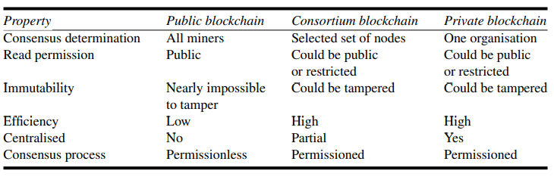
Figure 4: Comparison between public, consortium and private blockchain.
(Source: Wang et al., 2018)

Smart Contracts

Smart contracts hold the potential to revolutionize trade finance by enabling direct transactions between manufacturers and customers, facilitating a model based on disintermediation (Queiroz et al., 2019). This transformation aligns with the broader trend of blockchain technologies streamlining traditional trade processes and fostering direct supply chain relationships. A key feature of this transformation lies in smart contracts ability to automate and govern various trade transactions. For instance, smart contracts can verify trade-related documentation, reducing loan risks and automating delayed or installment payments, promoting greater efficiency and transparency throughout trade finance processes (Jihui et al., 2022).

Furthermore, smart contracts hold the potential to facilitate supply chain re-engineering through real-time process monitoring and control, potentially enhancing the efficiency of trade finance operations. This aligns with a growing body of research focused on blockchain's ability to optimize supply chain management, fostering traceability, transparency, and improved decision-making throughout trade processes (Chang et al., 2019).

(Yli-Huumo et al., 2016) highlight smart contracts as a key feature of blockchain technology, enabling a decentralized approach to contract execution. Their work reflects the increasing interest in blockchain at that time and underscores a crucial research gap: the need to explore technical challenges beyond the dominant focus on the Bitcoin system. Smart contracts, as suggest, deserved more attention as a promising application of blockchain technology. This perspective aligns with the subsequent growth of research on smart contracts, investigating their potential and limitations across various domains.
- Benefits of Blockchain-Powered Trade Finance for UK Companies

(Chang et al., 2019) emphasize the potential of blockchain technology to establish a transparent and secure platform for trade finance. This emphasis on transparency and security aligns with a core advantage of blockchain – its distributed ledger technology (DLT). DLT fosters trust by offering a decentralized record-keeping system that is resistant to tampering. This can significantly improve the efficiency and performance of trade finance processes by mitigating the risk of fraud and malicious modifications. Furthermore, the author highlights the transformative potential of blockchain for traditional financial instruments like letters of credit (L/Cs) and its potential integration with logistics monitoring. These features suggest that blockchain has the potential to fundamentally reshape trade finance operations.

(Bogucharskov et al., 2018) explore the potential benefits of integrating blockchain technology into trade finance processes. Their findings suggest that blockchain can streamline operations by reducing document processing times and transaction costs. Additionally, they highlight the potential for increased participation in trade finance and enhanced transparency throughout the process, which can be advantageous for companies involved.

(Queiroz et al., 2019) highlight the need for businesses to adapt existing practices to harness blockchain technology within supply chain management. This aligns with the growing recognition of blockchain potential to transform trade finance in several ways, including enhanced transparency, security, and efficiency (Queiroz et al., 2019). (Chod et al., 2020) further strengthen this argument by (Queiroz et al., 2019) demonstrating how blockchain-enabled transparency in supply chains can lead to improved financing conditions for businesses. Specifically, they suggest that increased transparency can reduce information asymmetry, allowing enterprises to secure better financing terms with lower signalling expenses.

(Kshetri., 2019) emphasizes the transformative potential of blockchain technology and smart contracts for international trade. These technologies offer several key advantages, including increased transparency, reduced fraud, and enhanced efficiency throughout trade finance processes. This aligns with a growing body of research exploring how blockchain can streamline complex trade transactions and foster trust among participants.
(Tijan et al., 2019) highlight the potential of blockchain technology to address inefficiencies within trade logistics. They identify challenges such as order delays, damaged goods, data errors, and redundant data entry, all of which can be mitigated through blockchain's capabilities. By streamlining logistics operations and enhancing transactional reliability, blockchain can ultimately lead to cost savings and increased trust among trading partners, thereby benefiting organizations engaged in trade finance.

However, (Ozili., 2019) cautions that while blockchain offers numerous advantages for financial intermediaries, challenges remain that could hinder wider adoption and regulatory approval. This balanced perspective, acknowledging both benefits and drawbacks, is crucial for understanding the potential impact of blockchain on trade finance.

Blockchain technology, still in its initial stages, sparks ongoing debates among researchers and practitioners regarding its optimal implementation within trade finance. Acknowledging its potential for revolutionizing the trade finance landscape, (Ibrahim and Truby., 2021) highlight significant advantages of blockchain. These include faster, secure, cost-effective, and streamlined processes, along with enhanced trust between importers and exporters. They further emphasize its potential to reduce paperwork, increase operational efficiency, and mitigate risks. Importantly, they also acknowledge challenges related to regulatory oversight and governance, aligning with ongoing discussions on effectively managing blockchain implementations. (Queiroz et al., 2019) identify a crucial barrier to blockchain adoption in trade finance: the limited understanding among academics and professionals of its potential to revolutionize traditional business models. This knowledge gap can contribute to ongoing discussions and debates regarding the feasibility and practical applications of blockchain within trade finance. (Saberi et al., 2018) argue that blockchain technology provides transparency and traceability in supply chain management. Companies may be hesitant to adopt blockchain technology in trade finance due to worries around scalability, interoperability, and regulatory issues, all of which are crucial considerations in this field.

(Chang et al., 2019) investigates the potential benefits of blockchain-based platforms for international trade participants. Their findings suggest that a key advantage lies in the technical reengineering of financial processes through smart contracts. This can lead to greater efficiency, reduced reliance on intermediaries, and enhanced transparency throughout trade finance. These factors can ultimately streamline trade operations and foster increased confidence among trading partners. (Ioannou and Demirel., 2022) emphasize the potential of blockchain technology to drive innovation in trade finance. They highlight its ability to reduce inefficiencies and increase visibility among supply chain participants, thereby addressing fundamental challenges within the field. Specifically, their work suggests that blockchain can reduce information asymmetry and improve the efficiency of information flows. These enhancements ultimately benefit businesses engaged in trade finance.

(Kim and Shin., 2019) investigate the impact of blockchain technology on partnerships within trade finance. While they acknowledge the potential benefits of blockchain characteristics, information transparency, immutability, and smart contracts and their findings suggest a potential disconnect between these features and actual growth in partnership efficiency. This implies that organizations implementing blockchain in trade finance may encounter challenges in fully leveraging these qualities to optimize both partnership growth and efficiency.

Issues and challenges associated with blockchain technology in trade finance

(Wang, 2022) At present, blockchain technology is in the theoretical stage and has not been extensively applied, the research has been going on and few companies like IBM, Deloitte, HSBC Bank have done few projects on it. There are still numerous issues to be resolved. Currently, the application of blockchain technology to address the issues in trade finance by companies and banks is still purely theoretical and has not yet been put into practice.

In literature, several authors (Ioannou and Demirel., 2022; Chang et al., 2019; Saberi et al., 2018; Ozili., 2019) revealed that there are multiple challenges involved while implanting the blockchain technology in trade finance. While some researchers express optimism about blockchain's capacity to revolutionize trade finance (Rijanto., 2021), others caution that practical implementation faces hurdles. These include a lack of technical expertise across the trade finance ecosystem, challenges in achieving collaboration among diverse stakeholders, and complexities in integrating blockchain with existing IT infrastructure (Kaur et al., 2022; Ioannou and Demirel., 2022). A significant barrier to the integration of blockchain technology within the trade finance sector, particularly for small and medium-sized enterprises (SMEs), is the prevalent lack of technical knowledge and expertise surrounding its implementation (Kaur et al., 2022).

(Hellwig and Huchzermeier, 2019) questioned 147 industry experts in the trade finance ecosystem who are familiar with trade finance, and the primary adoption barriers identified by the experts were a lack of subject matter expertise, as well as legal and jurisdictional uncertainties. Bryan Maloney of Stenn International, a trade finance investment fund, expressed concerns about jurisdictional uncertainty. Maloney stated that, in order to assure reliable operations, the company only transacts in nations with enforceable legislation.

While acknowledging the promise of blockchain technology in the trade finance sector, (Lipton., 2018) stresses the potential difficulties of its direct integration into trading processes. His work specifically addresses the obstacles associated with implementing blockchain solutions for clearing and settlement within trade finance. This suggests that the technology's applicability across all operational trade areas may be limited.

(Zhang et al., 2020) The blockchain technology encompasses various fields of advanced technologies that are merged together, resulting in high expenses and obstacles during development. The process of adding a new block to the blockchain typically requires approximately 10 minutes. Therefore, the capacity of each block is limited to 1 MB and the online capacity permits a maximum of eight transactions per second. The blockchain technology lags significantly behind the current third-party payment system called Alipay, which has the capability to process hundreds of transactions each second. Blockchain utilises a programmed algorithm to establish the credit guarantee of a trusted middleman. Nevertheless, the system's data is non-reversible, hence increasing the complexity of recovering it in the event of a lost or leaked private key or password. This could lead to an irreparable loss of customer assets. While the blockchain is theoretically resistant to violent cracking due to its explicit technological logic, there is still a chance of data breach through the exploitation of a large number of zombies or the operation mode of a trade unions cluster. Consequently, it is imperative to mitigate technical risks, such as the threat of hackers, when developing blockchain technology.

(Gupta et al., 2019) With the increase in cross nation trade, interoperability and compatibility are a few of the major hurdles the technology needs to overcome. The integration of the blockchain-based paradigm with the current system possesses a big issue. On the contrary, elimination of the current system is also not practicable, as the trading system will grind to a standstill. When it comes to privacy, not all traders would trust this new automatic method. The system may be hackable, data may be lost, or someone can tamper with the identity of an individual. It is vital for the blockchain network to guarantee data integrity.

(Gupta et al., 2020) While blockchain's layered security with encryption offers robust protection, it necessitates a more intricate approach to access control. Multiple employees or users require varying access levels depending on their roles within the network. This necessitates a well-defined permission structure to prevent unauthorized access and potential breaches. Furthermore, the private key, which serves as the cornerstone of user control and security, must be meticulously safeguarded. Leakage of the private key could have disastrous consequences, leading to complete loss of access and control over assets. Implementing and managing these safeguards adds a layer of complexity to blockchain network management. (Saihi., 2021) As discussed earlier, immutability is a core strength of blockchain technology, guaranteeing tamper-proof transaction records. This very feature, however, presents a challenge. Unlike traditional systems where errors can be rectified, blockchain transactions are irreversible. This creates a "point of no return" where mistakes or fraudulent activities become permanently etched onto the distributed ledger. Finding a balance between immutability and the ability to address errors or regulatory requirements like the "Right to be Forgotten" remains an ongoing area of exploration within blockchain research.

Conclusion of Chapter

A review of the literature demonstrates the potential benefits of blockchain technology within trade finance, particularly in enhancing security, transparency, and efficiency (Chang et al., 2019; Kowalski et al., 2021). However, a distinct research gap exists in examining the precise implications of blockchain integration for UK-based businesses, especially within the context of the UK's regulatory framework. Furthermore, while studies emphasize blockchain's potential (Xie and Li., 2021), few critically assess its scalability and interoperability limitations within the complex realities of UK trade networks. This thesis aims to address these gaps and explore how blockchain can be tailored to serve as a practical solution for UK companies, seeking to navigate the complexities of trade finance.

This chapter has highlighted the inherent inefficiencies of traditional trade finance processes within the UK and presented blockchain technology as a transformative solution. Through a critical examination of the literature, the transformative potential of blockchain in enabling secure, streamlined, and accessible trade finance has been established. However, specific challenges surrounding scalability, regulation, and adoption remain. This thesis will contribute to the field by exploring these challenges and proposing practical strategies for successful blockchain integration within the UK trade finance ecosystem. In doing so, this research aims to provide stakeholders with a roadmap for leveraging the benefits of blockchain to bolster UK trade competitiveness.

RESEARCH METHODOLOGY

  - Introduction

In this section, we will critically analyze the potential between blockchain technology and trade finance within the context of the United Kingdom. Furthermore, the research methodology that the researcher used to explore how blockchain technology can revolutionize trade finance will be succinctly outlined. This will encompass the chosen research design, data collection techniques, and the analytical strategies used to ensure the robustness of the research findings.

  - Research Philosophies and Assumptions

The case study method is particularly effective in exploring complicated phenomena that are influenced by a wide range of causes. This kind of approach is especially effective at addressing inquiries related to the (i.e., how we know and what we know) aspects, allowing researchers to produce comprehensive, situation-specific explanations based on empirical facts (Eisenhardt., 1989; Yin., 1981; Yin., 2003). The main purpose to choose multi-case study methodology because there has been research going on theoretically and practically, there has not been many papers in the realm of blockchain integration in trade finance. The implementation of blockchain technology in trade finance is a recent development that has promise for resolving various issues pertaining to trust, transparency, and the automation of transactions. There has been lots of academic research and pilot projects are going on in the filed-on trade finance. Thus, this research applied the multi-case study approach as its research methodology.

4.3 Research Design and approaches

Prior researchers have used multi- case study as their research methodology, focused on evaluating the potential benefits of blockchain technology in attaining important supply chain goals, such as reducing costs, increasing speed, ensuring reliability, and promoting sustainability, etc. (Kshetri., 2018; Chang et al., 2019; Kowalski et al., 2021; Kumar et al., 2023; Rijanto., 2021) By utilising multi-case studies, we can examine pilot projects obtained from webpages, news sources, and company papers to obtain comprehensive summaries (Chang et al., 2019) However, the research effort has especially focused on the utilisation of a blockchain technology in trade finance, how blockchain ledger can remove the traditional trade finance complex process and how company can benefit from using blockchain technology in trade finance by using empirical evidence drawn from multiple cases. In doing so, we have collected different scenarios of the blockchain application of trade related procedures.

Case study research technique has been a subject of attention across several fields, with writers providing differing opinions on its applicability and value. (Baxter and Jack, 2008) says it provides an extensive view of the research process from the researcher's perspective and acts as a tool for comprehending the dynamics seen in individual contexts. (Meyer, 2001) The author says case study as methodology entails analysing specific events in depth, often implementing qualitative research methods such as case studies, interviews, and observations.
According to (Thomas, 2011), a case study is a methodical analysis of a goal from multiple perspectives to gain a better understanding. However, the case study may also involve exploration to enhance comprehension. Case study results can help analyse competitive strategies, implement company projects establish theories, and evaluate system effectiveness.

General principles for case selection

Table 1 highlights the critical pain points plaguing traditional global trade processes and examines the transformative potential of leveraging blockchain technology for streamlining trade finance processes, particularly those involving Letters of Credit (L/C). The table identifies traditional trade finance's reliance on manual, paper-based systems, lack of transparency, and susceptibility to fraud as problematic areas. It proposes that blockchain technology, through its inherent features of secure, digitized records, distributed ledgers, and smart contract capabilities, can significantly address these prevalent issues. Specifically, it suggests that blockchain-based L/Cs can foster greater efficiency, trust, and security in global trade transactions by reducing reliance on intermediaries and fostering transparency throughout the process.

Table 1: Global trade pain points and blockchain solutions
(Source – Chang et al, 2019)
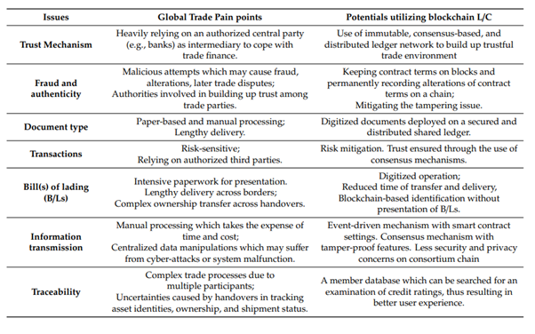

Selected Case

4.4.1. Case A: Ornua and HSBC (L/C)

Barclays announced its partnership with Wave, an innovative start-up. Wave revolutionary blockchain-based technology enables all parties to access, transfer title, transmit shipping documents, and other original trade data across a secure decentralised network, eliminating many of the current inefficiencies in international trade. On September 6, 2016, the world first worldwide trade was conducted using a blockchain-based L/C project. Traded items were butter and cheese, worth of $100,000. The Ornua-Seychelles trade agreement, handled by Barclays, provides a fascinating case study of blockchain technology's transformative potential in global trade finance (Barclays., 2016). Historically, the dairy trade has experienced issues due to slow, paper-based transactions and the possibility of fraud. Barclays pioneering use of a blockchain-based letter of credit solved these restrictions in a historic transaction between Ornua and the Seychelles Trading Company. Blockchain technology has substantially cut transaction times from an average of 20 days to 4 hours. This efficiency gain helps all players, including importers, exporters, and banks, while the technology inherent transparency improves security. This case study demonstrates blockchain's ability to improve trade finance processes and minimise risk across a variety of businesses and globally traded commodities (Ornua., 2016).

4.4.2 Case B: HSBC and Shenzhen MTC

HSBC co-founded Voltron, a shared blockchain platform. HSBC sent a digitised L/C on behalf of Shenzhen MTC to another Hong-based MTC their parent company. It was the world's first cross-border RMB-based blockchain L/C. The cargo included the export of raw materials to the parent firm. On behalf of MTC, HSBC evaluated, confirmed, and submitted the necessary trade papers to the platform, allowing transactions to be completed within 24 hours. Previously, utilising paper-based papers, the same procedure may take 5 to 10 days. The application of digital technologies makes trade financing easier, quicker, and more transparent. The transaction is the latest milestone in HSBC's attempts to promote RMB internationalisation using blockchain in trade financing (www.business.hsbc.com., 2019)

4.4.3 Case C. HSBC and Corda

