University of Wales Trinity Saint David
Wales Institute of Science & Art



Motorcycle Geometry Analysis and Dynamic Handling Investigation
Motorcycle Technology (ACHA4003)

Lewis Cox
2004098
Submission Deadline 07-Dec-2020
Table of Contents
1 Introduction 2
2 Experimental Procedure 3
2.1 Centre of Gravity 3
2.2 Resistance to Motion (F_{D}, F_{W}, F_{P}) 4
3 Results 6
3.1 Centre of Gravity & Geometry 6
3.2 Schematics 8
3.3 Driving Force & Resistance to Motion – Kawasaki ER6n 10
3.4 Driving Force & Resistance to Motion – Honda CBR400RR 11
4 Analysis 12
4.1 Centre of Gravity & Geometry 12
4.2 Resistance To Motion & Maximum Speed 14
5 Comparison - 2019 MotoGP & 2020 Dakar 15
5.1 Improvements To The CBR400RR and ER6n 17
6 Evaluation 19
7 Bibliography 20
8 Acknowledgements 22
9 Appendix 23
9.1 Gear Ratio Calculator 23
9.2 Dynamometer Graphs 24

Introduction
The aim of the task was to collect (through measurement) motorcycle geometry data to determine the centre of gravity of two motorcycles, and assess the geometry against the known handling characteristics of the motorcycles. Also, using gear ratio information, calculate the maximum possible speed of the fitted gear ratios and determine whether each motorcycle has enough power to reach this speed when considering forces resisting motion.
Additionally, the geometry data (through research) for two motorcycles that can be considered to be at the peak of their respective disciplines was required. This information would be related to the desired use of the motorcycle, and compared to the two measured motorcycles.

Experimental Procedure

Centre of Gravity
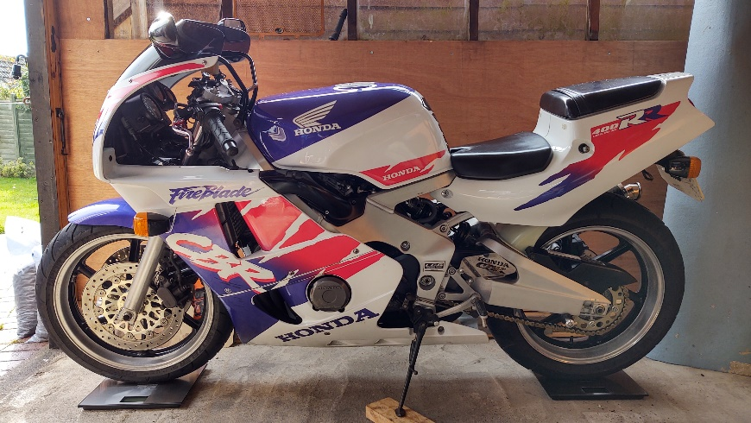
Figure 1 - CBR400RR on scales, showing the "level" weighing (Note that the side stand would not be used during the test).
The two motorcycles chosen for the test were the Honda CBR400RR (1994) and the Kawasaki ER6n (2011). Prior to performing the centre of gravity test, the motorcycle dimensions seen as key to handling and performance characteristics were measured (See Results section for data).
For the centre of gravity test, separate scales were placed underneath the front and rear wheels. The bike was held balanced upright with minimal input so as not to increase or decrease the force applied to the scales. The values from the scales were recorded in 4 different scenarios for each bike;
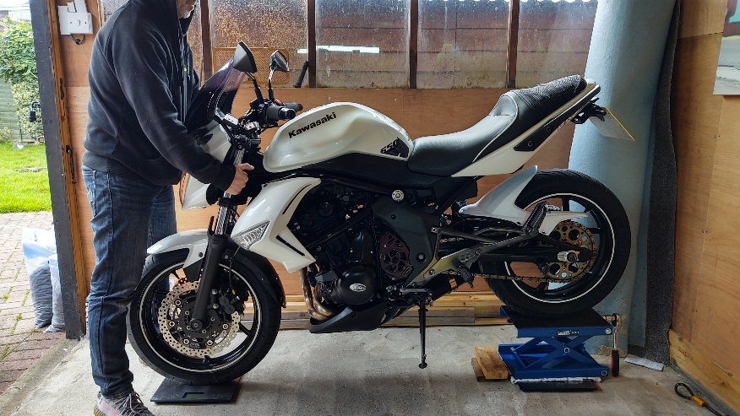
Level without a rider (Shown Figure 1), level with a rider, inclined without a rider (as shown in Figure 2) and inclined with a rider.
Figure 2 - Kawasaki ER6n in the “inclined” position.

In this case, the rear wheel was raised 0.23 m in order to give a significant angle of incline but still remain practical. The values recorded from the scales were used in the following calculations before excel was used to plot a schematic showing the centre of gravity of the motorcycles.
$$X_{CoG}={(W_{r}×L)}/{W_{t}}$$
$$Y_{CoG}=\frac{L × {(W}_{r}- W_{r Lifted)}}{W_{t} ×Tan∅}+ R_{Av}$$

Resistance to Motion (F_{D}, F_{W}, F_{P})
The aero drag forces, F_{D,} were calculated by aligning a grid over a picture of the front of each motorcycle, with a rider in a neutral position. The grid was aligned with a 0.0025 m² piece of tape attached to the most vertical part of the motorcycle. The total frontal area was then estimated using the grid overlay shown in figures 3 & 4 before being used in the following equation;
$$F_{D}= \frac{1}{2}.ρ.C_{D}.A.V^{2}$$
Typical drag coefficients for a faired and an unfaired motorcycle will be used, 0.35 m² and 0.5 m² respectively (Cossalter, 2006). Density of Air = 1.167 kgm⁻³.
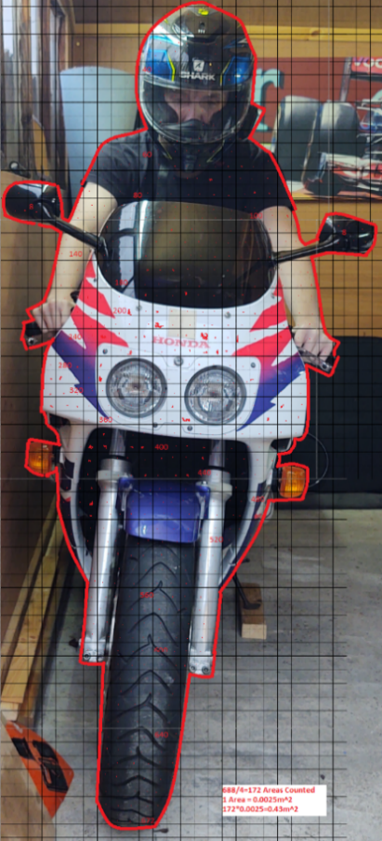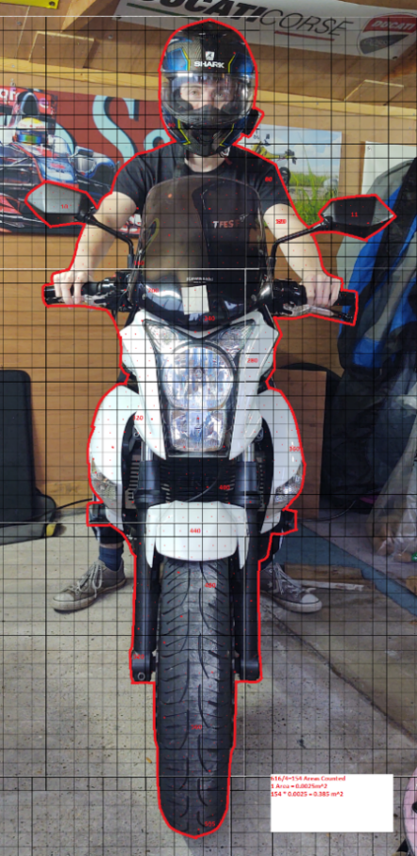
Figure 3 - Frontal area of ER6n (0.430 m²) Figure 4 - Frontal area of CBR400R (0.385 m²)

The rolling resistance , F_{W}, was calculated using the following equation;
$$F_{W}=0.02 ×mg$$
The resistive force due to the gradient, F_{P}, was calculated as follows (gradient Ɵ = 0, for this test);
$$F_{P}=m.g.sin⁡(∅)$$

Results

Centre of Gravity & Geometry
Table 1 - Kawasaki ER6n measured dimensions

Table 2 - Honda CBR400RR measured dimensions

Table 3 - Kawasaki ER6n Centre of Gravity Data
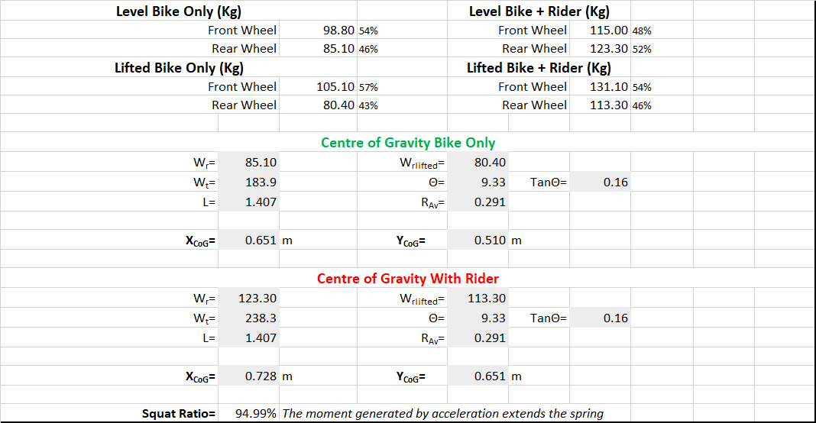
Table 4 – Honda CBR400RR Centre of Gravity data
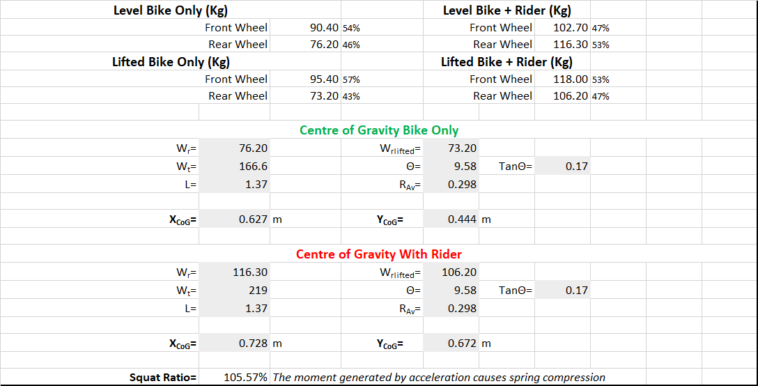

Schematics

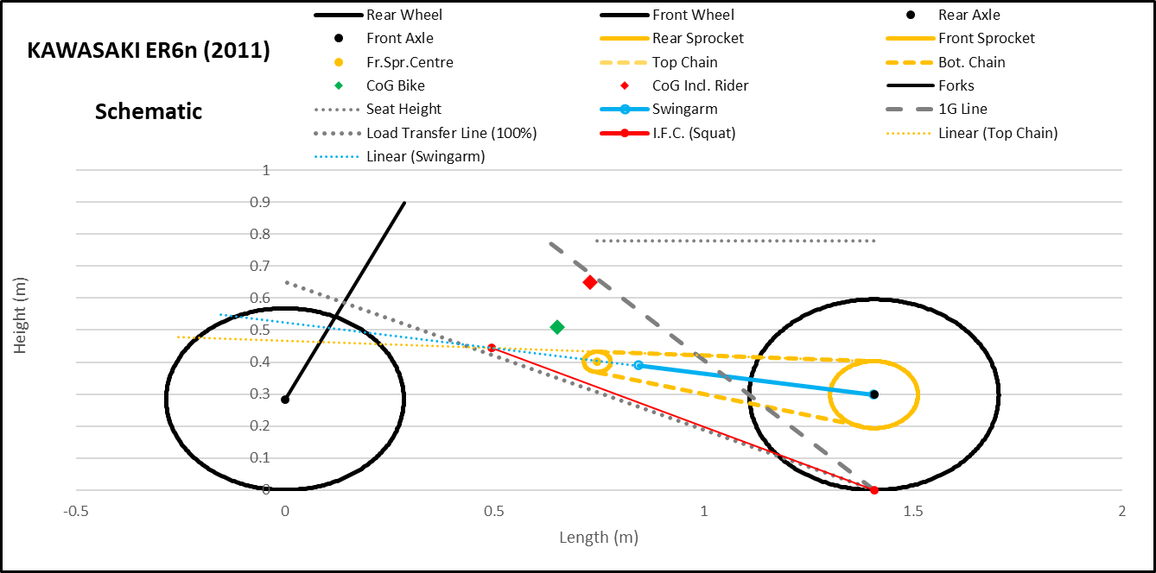

Figure 5 - Kawasaki ER6n Excel drawn schematic

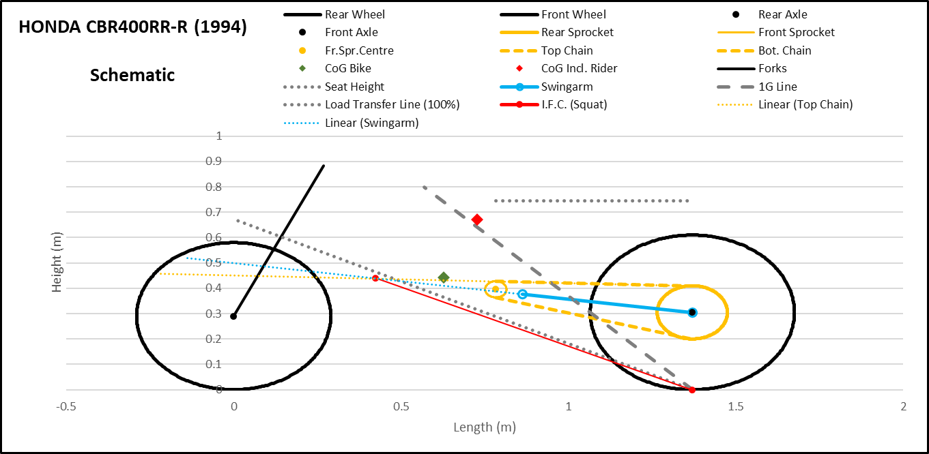

Figure 6 - Honda CBR400RR Excel drawn schematic

Driving Force & Resistance to Motion – Kawasaki ER6n
Table 5 - Driving Force of Kawasaki ER6n 4000-11000 RPM.
Table 6 - Resistance to Motion (Aero Drag, Rolling Resistance, and Gradient).
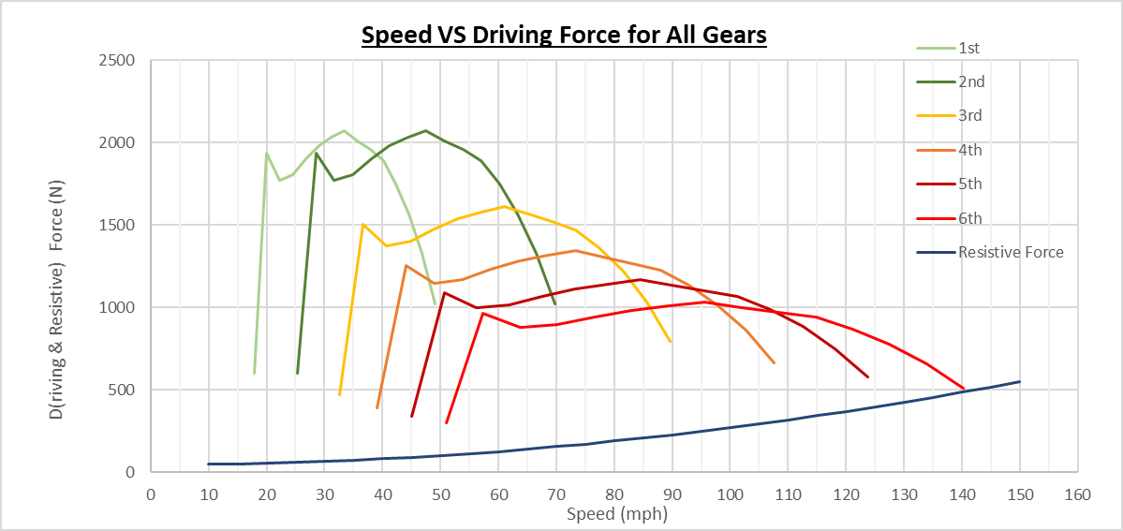
Figure 7 - Speed (mph) VS Driving force for each gear, with Resistive Forces curve.

Driving Force & Resistance to Motion – Honda CBR400RR
Table 7 - - Resistance to Motion (Aero Drag, Rolling Resistance, and Gradient).
Table 8 - Driving Force of Honda CBR400RR
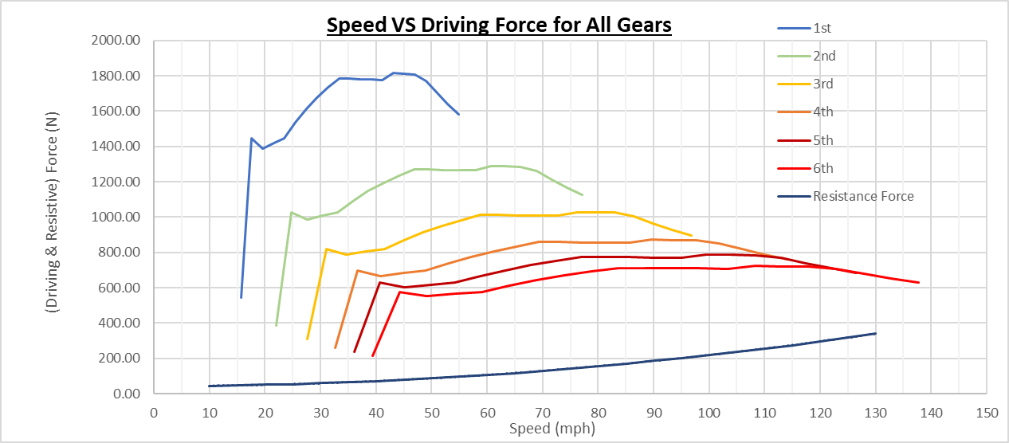
Figure 8- Speed (mph) VS Driving force for each gear, with Resistive Forces curve.

Analysis

Centre of Gravity & Geometry
- The calculated centre of gravity for both motorcycles shows similar weight distribution Fr / Re (tables 3 & 4);
Kawasaki Bike Only = 54 / 46 Honda Bike Only = 54 / 46
Kawasaki + Rider = 48 / 52 Honda + Rider = 47 / 53
- With calculated CoG positions X_{(from front axle)} / Y _{(from ground)} (m);
Kawasaki Bike Only = 0.651 / 0.510 Honda Bike Only = 0.627 / 0.444
Kawasaki + Rider = 0.728 / 0.651 Honda + Rider = 0.728 / 0.672
Δ (X / Y) = 0.077 / 0.141 Δ (X / Y) = 0.101 / 0.228

The even weight distribution in the X-axis provides a balance between acceleration and braking performance. Shifting the bias forwards is not necessary, as power wheelies are unlikely in all but first gear, given the power and gearing of the two motorcycles. Conversely, shifting the weight too far rearwards would make wheelies more likely, making front flip-overs during heavy braking less likely.
The Y_{CoG} values are within typical CoG heights (0.5 – 0.7 m with a rider) (Cossalter, 2006), and in similar positions relative to the wheelbase, as shown by the schematics, figures 5 & 6. The addition of a rider moves the Y_{CoG} significantly higher, particularly for the Honda. The lower motorcycle weight, means the addition of a rider weighing nearly one third of its mass, has a larger effect on the CoG.
Similarly for the X-axis weight distribution, the Y-axis distribution is balanced to reduce wheelies and front flip-overs. Both motorcycles are designed for the road, where traction is relatively high and large load transfers are not required to generate enough traction. Comparatively, off-road motorcycles have a higher Y_{CoG}, to account for lower traction coefficients (Cossalter, 2006), using the load transfer to each tyre to increase traction.

- Rake;
Kawasaki = 25.88˚ Honda = 25.18˚
- Trail;
Kawasaki = 0.105 m Honda = 0.095 m
The rake and trail values are similar, as shown in tables 1 & 2, both approximately 0.1 m with rake values of roughly 25˚.
Using the comparison parameter R_{n,} taking into account wheelbase (trail / (W_{b} + trail) ), the Honda has a ratio value of 6.5 %, which is on the upper limit of typical sports bike values of 6.0-6.5 %, where the Kawasaki has a ratio value of 6.9 %, falling into the sports touring values of 6.5-8.0%.
Both motorcycles require stability at high speed, however are primarily designed for urban use, necessitating agility for small and busy streets. The wheelbase and the trail values provide a balance between the two. In comparison, a small engine scooter or a cruiser, where high speeds are generally not achieved, the trail / wheelbase ratio is small, giving greater manoeuvrability at low speed but instability at high speed (Cossalter, 2006).

- Squat Ratios, R, were calculated using the equation;
R = $\frac{tan(Load Transfer Angle)}{tan(Instantaneous Force Centre Angle)}= \frac{\tan{τ }}{tan σ}$

Giving ratios of;
Kawasaki = 94.99 % Honda = 105.57 %
Whilst static, the geometry of both motorcycles offset close to 100 % of the weight transfer. The ratios would vary in a dynamic situation as the swingarm angle varies. Too much squat on corner exit, although giving rear wheel grip, would unload on the front wheel inducing understeer. Squat ratios above 100 % cause the rear to be unloaded upon acceleration, inducing oversteer.

Resistance To Motion & Maximum Speed
The driving forces, 𝐹 (𝑁), as shown in tables 5 & 7, were calculated using dynamometer (BHP converted to kW) measurements for power, 𝑃 (𝑘𝑊), and road speed calculated using gear ratios (see appendix), 𝑉 (𝑚𝑠⁻¹), results using equation;
𝐹=𝑃𝑉

Tables 6 & 7 show the calculated resistive forces working against the driving force at a given RPM/gear/velocity. The opposing forces at maximum speed are compared in tables 9 & 10.
Table 9 - Comparison of driving force and resistive forces for the Kawasaki at maximum speed
Table 10 - Comparison of driving force and resistive forces for the Honda at maximum speed

Both motorcycles reach maximum speed whilst the resistive forces are less than that of the driving force, showing that the limiting factor is gearing, and that both motorcycles can reach their max RPM in top gear. Figures 7 & 8 also show the available acceleration force, as the difference between the driving force and resistive force.

Comparison - 2019 MotoGP & 2020 Dakar
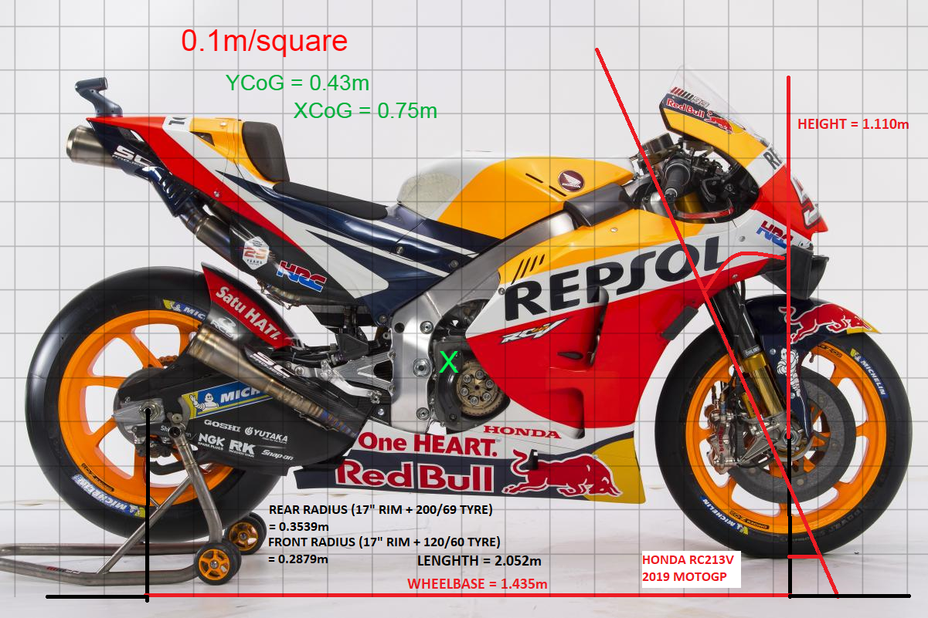
Figure 9 - Honda RC213V 2019 MotoGP (MotoGP.com, 2020)
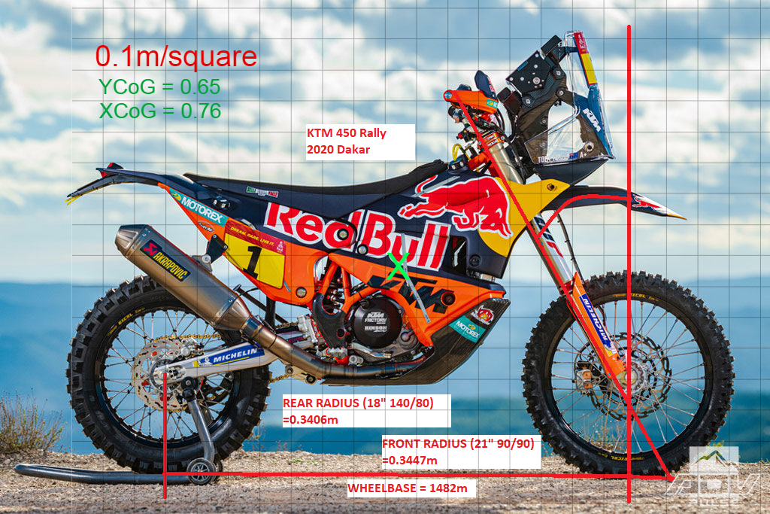
Figure 10 - KTM 450 Rally 2020 Dakar (advpulse.com, 2020)

- Using the overlayed grid (figures 9 & 10) for a visual comparison and using researched figures, the comparison between the Honda and the KTM shows the rake and trail for the KTM are larger than that of the Honda;

Honda Trail = 0.095 m KTM Trail = 0.120 m
Honda R_{n} % = 6.62 % KTM R_{n} % = 8.01 %
Honda Rake = 24.0 ˚ KTM Rake = 62.5 ˚
The KTM designed for off-road riding needs to make use of the self-aligning stability that rake and trail increases. The R_{n} values (trail as a percentage of wheelbase) show the difference between the MotoGP need for manoeuvrability and the Dakar requirement for stability. Modern MotoGP motorcycles gain some of their high speed stability aerodynamic means such as winglets (cycleworld, 2020) and steering dampers, allowing for lesser trail.
- Adding an estimated CoG (marked by the ‘X’ on figures 9 & 10), shows a large difference in Y_{CoG}, but similar X_{CoG} positions relative to wheelbase;

Honda X_{CoG} = 0.75 m KTM X_{CoG} = 0.76 m
Honda Y_{CoG} = 0.43 m KTM Y_{CoG} = 0.65 m
Due to the lack of traction available off-road compared to tarmac, the KTM has a higher CoG. This increases load transfer during acceleration and braking, increasing traction. The “open” seat design also enables the rider to position themselves forward or rearwards, moving the CoG depending on the terrain. The much lower CoG of the Honda, is designed to reduce load transfer minimising wheelies under acceleration, and rear lift during braking. The low CoG also makes for easier changes in direction, for instance through chicanes.

Improvements To The CBR400RR and ER6n
The CBR400RR measured and the RC213V MotoGP share similar geometry and both weigh approximately 160 kg (UltimateSpecs.com, 2020) (FIM Regulations, 2020). The CBR400RR is known as being very accurate and manoeuvrable which is not surprising given the similarities to the modern RC213V.
The ER6n would seem to be similar to the CBR400RR and RCV213V based on the measured geometry values, however the Kawasaki is heavier with a slightly longer trail, and whilst it does not have poor handling (in fact, they are used in the mini and super twin championships race series), it lacks the speed of directional changes that the two Hondas exhibit. Decreasing the weight and trail could improve this. Lowering the front or increasing rear ride height would achieve this.

Evaluation
The geometry measurements were close to the factory spec measurements as shown by tables 11 & 12. The largest difference was the Honda rake value. The rake was calculated after measuring headstock height (G7) and headstock to trail (G9) shown in figure 9. Particularly with the Honda and its fairing, measuring vertically from the headstock was difficult due to obstructions from other parts of the motorcycle. However, for this test, being within 1˚ of the specification is acceptable.
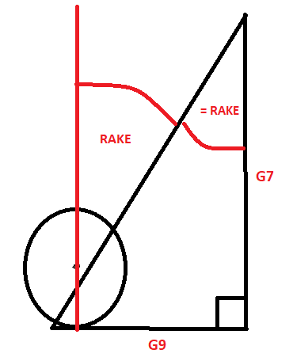
Figure 11 - Determining rake

Table 11 - Comparison of measured values and factory spec values - Honda
Table 12 - Comparison of measured values and factory spec values - Kawasaki

Bibliography
Romero, S. (2019), Closer Look: KTM’s 450 Rally Machine Racing in Dakar 2020, Available at https://www.advpulse.com/adv-bikes/closer-look-ktms-450-rally-machine-racing-in-dakar-2020/, (Accessed 29-Nov-2020).
Cameron, K. (2020), What Do MotoGP Winglets Do?, Available at https://www.cycleworld.com/sport-rider/all-about-geometry/ (Accessed 29-Nov-2020).
Cocco, G. (2013), Motorcycle Design and Technology, Third Reprint, Giunti.it, Italy.
Cossalter, V. (2006), Motorcycle Dynamics, Second Edition, Lulu.com.
FIM, (2020), FIM World Championship Grand Prix Regulations 2020, pg.104, FIM-Live.com.
Gavin, (2017), Road: On The Dyno, CBR400RR NC29, Lincolnshire UK, Available at http://gullarm.blogspot.com/2017/01/on-dyno.html (Accessed 28-Nov-2020)
Honda Motor Co., (1994), Honda CBR400RR Fireblade, Sales Brochure, Honda, Japan.
HRC, (2020), RC213V, Available at https://motogp.hondaracingcorporation.com/rc213v/, (Accessed (29-Nov-2020).
Kawasaki Motors Europe N.V., (2020), Kawasaki ER6n 2011 Specifications, Available at https://www.kawasaki.co.uk/en/products/archive/Sports/2011/ER-6n/overview?Uid=05FDWlhZXFhZWV5ZW1hZWFlQX1lfUVFZRg0GRT0j (accessed 28-Nov-2020).
KTM.com, (2020), KTM 450 Rally Replica, Available at https://www.ktm.com/en-gb/models/travel/ktm-450-rally-replica2021.html, (Accessed 29-Nov-2020).
Michelin Motorsport, (2020), Michelin MotoGP Range, Michelin Motorsport, Available at https://www.michelinmotorsport.com/Commitment/MICHELIN-MOTORSPORT-MOTOGP , (Accessed 29-Nov-2020).
Mike on Bikes, (2019), Motorcycle Geometry Explained, Video uploaded to Youtube.com, available at https://www.youtube.com/watch?v=Nmz1QJTDzO8 (Accessed 28-Nov-2020).
MotoGP.com, (2020), Repsol Honda Bike Evolution, Repsol Honda Team 2019, Available at https://www.motogp.com/en/gallery/2020/02/04/repsol-honda-bike-evolution/281828, (Accessed 29-Nov-2020).
Netting, D. (2020), Teach Me Suspension (Part 9): Rear End Squat, LifeAtLean.com. Available at https://lifeatlean.com/teach-me-suspension-part-9-rear-end-squat/ (Accessed 28-Nov-2020).
UltimateSpecs.com, (2020), Honda CBR400RR Specs (1994), Available at https://www.ultimatespecs.com/motorcycles-specs/honda/honda-cbr400rr-1994, (Accessed 29-Nov-2020).

Acknowledgements
Thanks to Andrew Harrison for guidance throughout this assignment and Chris and Beth for helping with the bike weighing.
Kawasaki ER6n dynamometer run performed by Black & White Bikes, 2018.

Appendix

Gear Ratio Calculator
Table 13 - Gear ratio / speed calculator for the Kawasaki at max RPM. (Gear ratios – Kawasaki Motors Europe, 2020)
Table 14 - Gear ratio / speed calculator for the Honda at max RPM (Gear ratios - Honda Motor Co., 1994).

Dynamometer Graphs
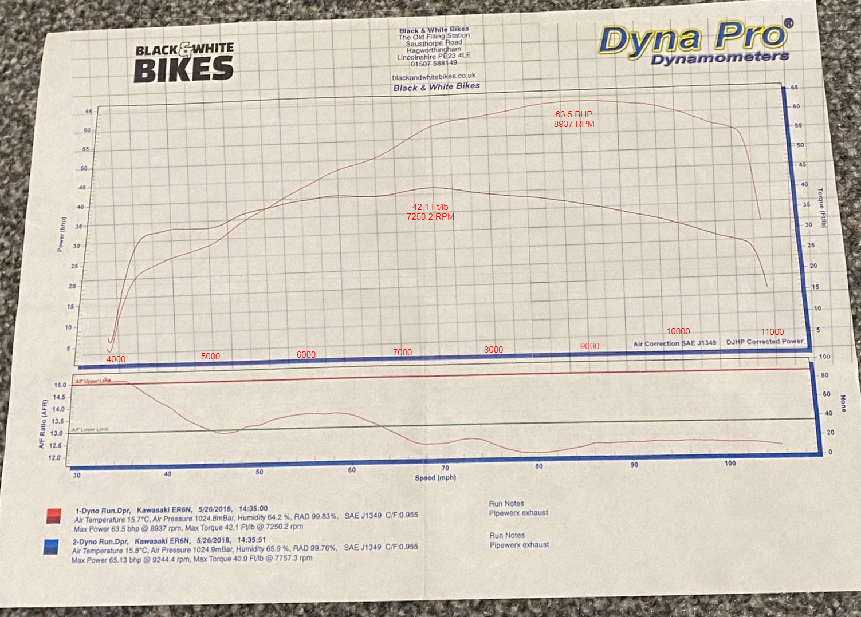
Figure 12 - Dyno chart for the actual Kawasaki ER6n used in the test, with gridlines/RPM added.
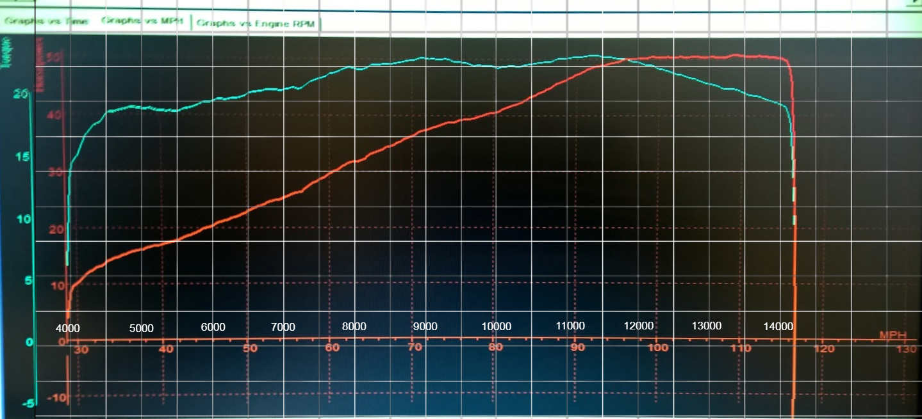
Figure 13 - Dyno chart sourced online for a Honda CBR400RR with gridlines/RPM added.
(Gavin, 2017)

