Student Name: | Enrique Quevedo Diaz
Student Number: | 1917750
Module No: | BMSK5006
Module Title: | Knowledge and Information Management Skills for the Workplace

Table of Contents
List of Abbreviations 3
Introduction 3
1. Provide an evaluation of the concept and importance of knowledge management in the context of an organisation's knowledge assets. 3
Broad vision of KM to the organisation 4
KM is the driver for an organisation. 4
KM process in organisations 5
Benefits of KM 5
A) Explain the relationship between data, information and knowledge. 5
Data 6
Information 6
Knowledge 6
Wisdom 7
B) Explain the relationship between personal knowledge and organisational knowledge. 7
The process of RCCL from Collecting Data to Framework. A customer-orientated organisation. 8
RCCL Customer information is the Critical Asset. 9
C) Apply analysis and modelling techniques to identify knowledge assets. Evaluate existing and potential knowledge assets. 9
D) Provide a rationale for capturing and managing knowledge. 10
3. Provide a framework for establishing a knowledge management culture 10
A) Explain the contribution knowledge assets have on an organisation 11
B) Evaluate the knowledge requirements for the organisation 11
C) Evaluate the organisation framework for enabling knowledge sharing. 12
GDPR 12
D) Recommend improvements to the current framework 12
E) Demonstrate that you understand the concept and importance of knowledge management in terms of an organisation's knowledge assets and their management (control/administration). Identify the key knowledge and information required for operational efficiency within the applicable organisation. 13
F) What factors specific to this particular workplace context should be considered? 13
Are there any key knowledge management processes currently not in operation that could be applied? 13
What steps would you take to develop further a framework for establishing a knowledge management cultur 13
References 14
Appendices 17

List of Abbreviations
CKM - Customer Knowledge Management
KA – Knowledge Asset
KM – Knowledge Managements
RCCL – Royal Caribbean International
SECI - Socialisation, Externalisation, Combination and Internalisation

Introduction
With the increasing growth of the knowledge economy and the power of customers, organisations have increased their performances radically. Knowledge is the critical asset in organisations and the most critical determinant of economic growth. It set the terms for Knowledge Management (KM), creating an engaging work environment where learning is the key for constant creation, aggregation, adding personal and organisational knowledge to create new business values.
We analyse the KM of Royal Caribbean International (RCCL)

1. Provide an evaluation of the concept and importance of knowledge management in the context of an organisation's knowledge assets.
In the 4th century BC, Plato described knowledge as "Justified true belief".
Management is determining goals, policies, planning, organising, activating employees and controlling processes, which together lead to achieving goals (Schieman et al., 1989).
Alfred Marshal (1920), one of the first authors to state the relevance of knowledge in an economic context, suggests that capital embrace a significant part, knowledge and organisation. He further emphasises that "knowledge is our most powerful engine of production". Pioneers in the organisational Knowledge management area, Nonaka and Takeuchi (1995) propose that knowledge is created via a spiralling process of interactions between explicit and tacit knowledge.
Knowledge is known as the critical asset in organisations and the most important determinant of economic growth. Knowledge-based economies challenge and determine the making of productive information that falls into the domain of Knowledge Management (Beijersy, 1999).
KM “is the discipline of creating a thriving work and learning environment that fosters the continuous creation, aggregation, use and re-use of both organisational and personal knowledge in the pursuit of new business value" (Cross, 2002)
KM “permits the creation, distribution, and exploitation of knowledge to create and retain greater value from core business competencies. The primary goal of KM in a business context is to facilitate the opportunistic application of fragmented knowledge through integration" (Tiwana, 2002)

Broad vision of KM to the organisation
The broad vision of KM related to RCCL, which is the organisation chosen for this research, is the Kandadi (2006), who indicates that "KM is a set of strategies, systems and processes that enable and simplify creation, capture, sharing, distribution and utilisation of organisation's knowledge".
KM aims to build main competencies based on business strategy knowledge. Therefore, the organisation's related knowledge processes must focus on market-oriented factors, such as customer needs, preferences, and other external elements, along with managing the internal knowledge of employees.
Companies value knowledge because it provides a mix of framed experience, contextual information, values, and expertise that supply a framework for evaluation, incorporating new experiences and information. It starts and is applied in the minds of people who know. In organisations, it often becomes embedded, written not only in documents, but posters and online websites, then become organisational routines, norms, processes, and practices. Davenport and Prusak (1998)
Information Management is the storage, collection of captions, dissemination, curation, archiving, and destruction of documents, images, drawings, and other information sources. APM (2021).
Talent Management is the human capital: recruiting, assessing, managing, maintaining, and developing an organisation's most valuable resource, people. Human Resources attract, develop, motivate, and retain high-performing employees, who are the most important asset of business (Deloitte, 2009).
Product innovation is the beginning of a good or service that is new or has remarkably improved characteristics. Process innovation is the implementation of a new or remarkably improved production or delivery method. (Innovation Policy Platform, 2020)

KM is the driver for an organisation
KM will boost the efficiency of the organisation's decision-making ability, making sure that employees have access to the overall expertise held within the organisation. Developing a more competent workforce, able to make quick, informed decisions that benefit the company. Moreover, as the marketplace becomes more competitive, one of the best ways to stay ahead of the curve is to build the organisation ability to spot issues from a distance and respond quickly to added information and innovations. (Lathi, 2019)

KM process in organisations
During the KM process in organisations, we observe that they encourage teams to share their expertise, knowledge. Also, the imminent retirement of key employees could demonstrate the need to capture their knowledge. And finally, an upcoming recruitment drive demonstrates the wisdom in using knowledge management to assist in training new employees. (Lathi, 2019)

Benefits of KM
The positive aspects of working on a KM environment are being part of an efficient workplace, faster, and better decision making, increased collaboration, building organisational knowledge, optimised training process, increased employee happiness and retention due to the valuing of knowledge, training, and innovation. (Lathi, 2019)
" The overall purpose of KM is to maximise the enterprise's knowledge-related effectiveness and returns from its knowledge assets and to renew them constantly… KM's role is to keep the body of knowledge alive and vibrant to secure the enterprise's well-being and long-term viability. The objectives of KM are 1. To make the enterprise act as intelligently as possible to secure its viability and overall success, and 2. To otherwise realise the best value of its knowledge asset." (Wiig 1997)

A) Explain the relationship between data, information and knowledge
The evidence shows that data leads to information, information leads to knowledge, and knowledge leads to wisdom. (Ackoff, 1989)
The data, information, knowledge and wisdom (DIKW) pyramid (Appendix A) represents the relationships between each block. Giving a step towards a higher level, starting with data, then information next is knowledge and finally wisdom. Each step answers nonidentical questions about the initial data and adds value to it. The more enriched data with meaning and context, the better knowledge and insights we obtain, then we can make informed and data-based decisions. (Ackoff, 1989)

Data
"Data is words, numbers, dates, images and sounds without context" BBC Bitesize.
According to Mensah and Goderre (2014), data is defined as raw facts, context-free numbers, statistics, where we can collect and retrieve symbols. These can contain numbers resulting from measurements or text-mining or analytics, images, sounds, survey outcomes, simulations, and many others. They can usually be organising in charts and depicted as graphs or displayed as figures. In general, data are qualitative or quantitative values of variables.
Shannon Kempe (2013) explains that "data are out of context and individual facts, without meaning, and are difficult to understand. Data in context are individual facts that have meaning and can be readily understood". We understand that data are raw facts wrapped with meaning, ready to become information.

Information
"Information is a collection of words, numbers, dates, images and sounds, put into context, i.e. to give them meaning" BBC Bitesize.
Information is a set of data that has been given meaning in a context of relational connection, explains Bellinger et al. (2004). For Mensah and Goderre (2014), information can be relevant to one or more people at a point in time or for some time, adding that this meaning can be helpful but does not have to be, because it will depend on how it will be used, when and where.
The site Ontotext.com suggests that by asking relevant questions about who, what, when and where? We can gain valuable information from the data and make it more useful for the reader. The how question makes the leap from information to knowledge, suggesting that in this step, we do not just see information as a description of collected facts; we are also able to understand how to apply it to achieve our goals, turning it into knowledge.

Knowledge
"Knowledge is the ability to understand information and to form judgements, opinions then, make predictions and decisions based on that understanding" BBC Bitesize.
Brackett, M. (2013) understand knowledge as the fact or condition of knowing something with familiarity comprehended through experience or association. It is the way we identify and read data, the fact or condition of being aware of something or apprehending facts. Knowledge includes gaining ideas by experience, study, familiarity, association, awareness, and comprehension.

Wisdom
Wisdom is understanding and intelligence and values, ethics, and effectiveness (Ackoff, 1989). Only proactive decisions are taken when we use the knowledge that has been gained from the information obtained, which is the knowledge applied in action. Wisdom is seen as at the pinnacle of the DIKW hierarchy and includes vision, foresight, the ability to see beyond the horizon (Awad and Ghaziri, 2004)

RCCL transition to wisdom
The transition from data to wisdom for RCCL is observed initially with the data from Appendix B. If we observe numbers only, we will not understand what we are talking about: raw data. When we read the title, the data becomes information following an explanation of the numbers. How we understand that information is knowledge. We observe that the revenue is growing consistently since 1998. The wisdom is the organisation's activities, as they have added bigger cruise ships to the fleet. In 1998 the ship capacity was up to 2000 passengers (Appendix C). Now the organisation knows that more people prefer to experience their holidays onboard a cruise. Therefore the organisation is building more extensive capacity cruises (Appendix C).

B) Explain the relationship between personal knowledge and organisational knowledge.
Knowledge belongs to individuals and their unique capabilities to carry out processes, in particular creation and sharing, and their ability to utilise available Intellectual Capital (IC) to drive organisational performance. Within the organisation, employees are knowledge holders, and key knowledge assets lead the organisation's efforts to create value, overcome challenges, and challenge uncertainty (Connelly et al., 2014).
Polanyi (1966), in his explanation about tacit knowledge, says that "we know much more than we can tell". At the same time, explicit knowledge can be expressed in words and numbers and shared in the form of data, scientific formula, specifications, manuals and other forms. It can be transferred across individuals formally and systematically.
In contrast to Polanyi's, Nonaka and Takeuchi's view is that these two types of knowledge are not separate. They suggest that tacit and explicit knowledge are complementary entities, which interact with each other. The assumption based on knowledge created through the interactions between explicit and tacit knowledge (Appendix E) proposes four modes of conversion knowledge: Socialisation, Externalisation, Combination and Internalisation (SECI).
Socialisation is the process of sharing experiences, and by that means, creating tacit knowledge such as ideas and technical skills. It is an alive, active and experiential flow. It involves capturing knowledge by interacting with everybody, customers and suppliers and people inside the organisation. It will depend on having a common shared experience. Socialisation is a process between individuals. (Nonaka & Takeuchi, 1995).
The Externalisation process requires the articulation of tacit knowledge into explicit conceptions. Along this process, tacit knowledge is transformed into explicit knowledge. Explicit knowledge has been captured in a tangible form. It has been codified and expressed knowledge in written, structured sources, a form of database, recordings, or documents. The combination process will involve the conversion of explicit knowledge into even more complex and systematic explicit knowledge. (Nonaka & Takeuchi, 1995).
Internalisation is a learning process where explicit knowledge becomes embodied into tacit knowledge (Nonaka & Takeuchi, 1995).
Dialogue is a crucial step for every stage of the process. During face-to-face communication, people talk about beliefs and understand how to articulate their thinking better, with instantaneous feedback and the exchange of ideas. The process happens between individuals and within a group. Once knowledge is explicit, information technology becomes their key because explicit knowledge must be transferred to documents, databases, email, as well as through briefings and meetings. The important steps of collecting relevant internal and external knowledge, processing, and editing make it more usable, allowing knowledge transfer among groups across organisations to finally become internalised. (Nonaka, 1997).

The process of RCCL from Collecting Data to Framework. A customer-orientated organisation.
For RCCL the process for individual and organisational knowledge was at the company's heart from the beginning. In the late 90's they produced a study to identify and capture knowledge. They noticed that call centres relied on the knowledge, ability and skills to answer the customers' requirements. Furthermore, they recognised that part of their initial knowledge came from experiential learning, where employees would come and go taking the knowledge with themselves when they leave the company. They looked for professional support to separate the knowledge from the employees and stored it within the organisation. The knowledge was then managed and transferred throughout the company. Converting something intangible into a company property able to be inventoried and transferred when needed. (Gonzalez, L. et al. 2001)
Fast-forward to the most recent years, and we observe that RCCL has a Director of Global Learning and Knowledge Management and Quality Assurance, who has been in the organisation since 2005 and is fully responsible for the internal knowledge base website, housing all policies, processes and promotions. He captures, saves and shares the knowledge. He has introduced leading-edge training practices tailored to the staff needs, which, according to him, has increased their learning opportunities. He manages a group of 35 Training and Quality Assurance Specialist across three remote locations. He focused on customer services and the guest's relations department, where he gets customer feedback. Then he processes and analyses the data, creating information and knowledge. He finally shares the information to the different departments via website and training, delivering the organisational knowledge, the know-how, understanding and processing the organisation's culture; from this process, the company goes from tacit to explicit knowledge. (Baker, 2021)
We can understand that the business value for RCCL has been created from the use of customer and product and service information. Appendix F demonstrates the Characteristics of customer-oriented knowledge.

RCCL Customer information is the Critical Asset
The organisation's highlight is the importance of the quality of the customer information infrastructure; they point out customer information as a critical asset and strongly focus on the training of front of house staff and the quality of the activities. (Baker, 2021)
We observed that RCCL worked from the late 90's gathering internal knowledge, and as soon as all the knowledge was stored, it became external knowledge, with information available to share (Gonzalez, L. et al. 2001), and then it moved to Customer Knowledge Management (CKM) with the expertise of the Director of Global Learning and Knowledge Management and Quality Assurance, who brings the knowledge from the customers (Baker, 2021)
Rollins and Halinen (2005) propose that CKM expertise should concern the following areas 1 particularly) Inter-functional cooperation, 2) supportive organisational systems, 3) cooperation with customers, 4) supportive IT and 5) organisational culture supporting learning and customer orientation.
CKM in general can be seen as a discipline that provides an integrated methodology of identifying, capturing, evaluating, retrieving, and sharing all of an organisation's knowledge assets to achieve efficiency, gain competitive advantage, and ensure innovation directed to customers. These assets contain explicit organisational knowledge as policies, databases and written documents, and tacit knowledge as uncaptured expertise and experience in individual employees. Customer knowledge management (CKM) leads to many improvements in the delivery of new products and services, such as customer service, customer respect, customer satisfaction, discovering essential needs of the customer, improved response and respect to the customers and for the organisation to increase profit and competitive advantage (N. Poorabas, H. Vazifehdost and B. Borhany Yazdani, 2009).

C) Apply analysis and modelling techniques to identify knowledge assets. Evaluate existing and potential knowledge assets
Knowledge asset (KA) is an organisation's accumulated intellectual resources. It contains information, ideas, understanding, insights, memory, technical skills, capabilities and learning. KA are hold in documents, databases, software, patents, policies and procedures. KA and information are the know-how the organisation has that has insights into where to invest and grow. KA management creates value for stakeholders and sustains organisational performance.
The focus must be on discerning which KA are critical for success and performance. Those assets are then mapped so management can analyse how to develop further to create growth. (Kohn, M. 2020).

D) Provide a rationale for capturing and managing knowledge
Understanding what knowledge is, "information combined with experience, context, interpretation and reflection" (Kulkarni et al., 2006).
In times of an ageing and retiring workforce, workers shortages, and a workplace that is evolving rapidly, a strategic asset management agenda is needed and is the practice of KM, the one that would help to define, capture, and share. Furthermore, to manage the knowledge, the organisation will need first to map and structure KA, disseminate knowledge within the organisation, contextualise knowledge, discover new knowledge, and motivate users to share information. It is key to identify quickly, capture, and make accessible the knowledge that matters, making information readily available to get things done more efficiently. (Kohn, M. 2020)
"Knowledge management as the identification, optimisation and active management of intellectual assets, either in the form of explicit knowledge held in artefacts or as tacit knowledge possessed by individuals or communities. Knowledge management is the developing body of methods, tools, techniques and values through which organisations can acquire, develop, measure, distribute and provide a return on their intellectual capital assets" D. Snowden 2000.

3. Provide a framework for establishing a knowledge management culture
The framework for the knowledge management culture is the CKM, where we have identified with the SWOT analysis (Appendix G) that RCCL has a CKM customer-driven, and it is the start of the strength of the organisation where we observe that they deliver an excellent quality customer experience. Because the teams collaborate, sharing their knowledge, their expertise. Moreover, that supports an efficient workplace, fast-paced, taking the right decisions. Furthermore, it is a place where training is valued.
The downside is that they depend on knowledge contributors, and if the knowledge shared is wrong, it could drive the organisation to failure.
The opportunities of organisations with KM are priceless. They can grow by sharing knowledge and increased employee happiness and retention due to valuing knowledge, training, and innovation.
For the Pestel analysis (Appendix H), only certain aspects of Pestel are suitable for this research, such as political stability; RCCL cannot visit Cuba because of the political sanctions and restrictions. Also, they have taken the ship that was sailing around Israel because of the conflict between Israel and Palestina.
Since 2020, the impact of global economic slowdown and recession is Covid-19 on the travel and tourism industry. The social point of view is that people would spend on desirable experiences seen on social media, where IT plays a significant role as a technological platform to transfer knowledge.
The customer knowledge scope involves the following: about, for and from customers (Salomann, et al., 2005).

A) Explain the contribution knowledge assets have on an organisation
The drivers of an organisation's success are the knowledge assets. They can have an unstructured and expanded tacit knowledge, for example, knowing about key employers who can perform better for specific tasks, and explicit knowledge, such as patents, copyrights and proprietary intellectual rights. Structured knowledge assets allow an easy knowledge share for both internal and external parts of the organisation. Structured knowledge can be shared with the Internet, whereas deep expertise or experience takes more time to share with other people. (Ihrig, M. 2015)

B) Evaluate the knowledge requirements for the organisation
Organisations KM must have the ability to harness and build upon their intellectual capital, and with the current economic climate, companies need to know what they know and must use this knowledge effectively. (Drucker, P. 2011)
Organisations must be constantly checked, evaluating their knowledge using different systems, for example, COBIT 5 (Appendix I), a process that analyses and keep in check organisations to maintain the availability of current, relevant, reliable and validated knowledge to support all process activities and to help with decision making. Plan to identify, gather, organise, maintain the use and retirement of knowledge. An evaluation would provide a structured approach to ensure optimal structure, placement, decisions, human resources rights and skills. Including the defined responsibilities and roles, growing plans and learning, performance expectations, and the support of competent and motivated people. (Delak, B. 2015)
With the COBIT 5 system, we can observe the four key processes through which tacit and explicit knowledge interact: the SECI management technique, the training and transferring the knowledge within the organisation.

C) Evaluate the organisation framework for enabling knowledge sharing.
Knowledge is the key to innovation and staying competitive in today's organisation's world. It is a crucial asset that enables them to gain a sustainable competitive edge over competitors. Improving and creating new ways in which enterprise knowledge is captured and shared amongst teams will determine if they are capitalising on this valuable, ready-to-read company resource. Organisational competitiveness is rooted in the mobility of knowledge that is realised through knowledge sharing and knowledge transfer. Knowledge sharing provides individuals, teams and organisations with the opportunity to improve their work performance and create new and innovative ideas. It clearly shows that sharing knowledge is a social, interactive, and complex process that includes tacit and explicit knowledge. (Cummins, J. 2004)
RCCL uses today the most potent sharing tools, social media, which are widely used in our daily lives to share and communicate with each other, with platforms such as Facebook, Twitter, Instagram, Snapchat, TikTok, and being readily available videos and images. These tools have emerged as mainstream communication channels for people to communicate and share their daily experiences worldwide like never.
At the same time, the organisation captures information from the social media users, operating with fan pages (webpages) in cooperation with technology companies. As an operator, RCCL is deemed to be a joint controller together with the technology company. For example, for their Facebook Fan Page, they would be joint controller together with Facebook. They place a notice where users can find information relating to the processing of personal data in connection with these types of webpages, to the extent that they are controlling the processing of people data, according to applicable data protection laws.

GDPR
GDPR is the world's most robust set of data protection rules, enhancing how someone can access information about others and places limits on what organisations can do with personal data. (Burgess, M. 2020)

D) Recommend improvements to the current framework
Directly related to KM, and sharing knowledge, I would encourage intrinsic motivation. Employees are more motivated to share knowledge when they find their work fun, engaging, stimulating and enjoyable. If they feel motivated is more likely that they will be sharing knowledge.
When the team has autonomy, instead of driving motivation through external feedback, which can leave workers feeling controlled or manipulated, they feel inspired. Autonomy is a fundamental part of motivation and job satisfaction. Therefore, employees who have some autonomy in what they do, are more likely to feel enthusiastic about their work.

E) Demonstrate that you understand the concept and importance of knowledge management in terms of an organisation's knowledge assets and their management (control/administration). Identify the key knowledge and information required for operational efficiency within the applicable organisation
The KM pinnacle of RCCL is the substance of the quality customer information infrastructure; they observe customer information as the most critical asset, and their training focuses strongly on the front of house staff.
The organisation has worked from the late '90s collecting internal knowledge, and as soon as all the knowledge passed from implicit to explicit, they develop written knowledge available to share. RCCL became a CKM that brings knowledge from the customers, which helps both customers and the organisation.

F) What factors specific to this particular workplace context should be considered?
The specific factors of this workplace should consider KM Strategy because the organisation value the administration of the knowledge. Information technology to develop the database and technological tools for knowledge, Information infrastructure. Rewarding, motivation, and training and education
Are there any key knowledge management processes currently not in operation that could be applied?
The acquisition, storage, distribution and use of the knowledge are in place.
What steps would you take to develop further a framework for establishing a knowledge management culture?
The KM will depend on the organisation's infrastructure and processes, if it fits accordingly, and achieve the organisation's goals.
I would first have to establish the goals and create a KM that provides a framework to the organisational knowledge infrastructure aimed at getting the proper knowledge to the people in the right way by focusing on a methodology able to provide a systematic and specified process for acquiring, organising, storing and communicating system.

References

APM (2021) What is information management? [online] Available at: https://www.apm.org.uk/resources/what-is-project-management/what-is-information-management/#:~:text=Information%20management%20is%20the%20collection,and%20others%20sources%20of%20information. Accessed 16.05.21

Ackoff RL. (1989) From data to wisdom. [online] Available at: https://softwarezen.me/wp-content/uploads/2018/01/datawisdom.pdf Accessed 12.05.21

Awad, E. Ghaziri, H. (2004), Knowledge Management, Pearson Education International.

Baker, Ch. (2021) Director, Global Learning, Knowledge Management, and Quality Assurance at Royal Caribbean Group [online] Available at: https://www.linkedin.com/in/chuck-baker-6174a97/ Accessed 14.05.21

BBC Bitesize (2021) Data, information and knowledge [online] Available at: https://www.bbc.co.uk/bitesize/guides/zkfbkqt/revision/1 Accessed 17.05.21

Bellinger, G. (2004) Data, Information, Knowledge, and Wisdom [online] Available at: https://d1wqtxts1xzle7.cloudfront.net/64110062/ Accessed 17.05.21

Beijerse, R. (1999), Questions in knowledge management: defining and conceptualising a phenomenon, Journal of Knowledge Management, Vol.3, No.2, pp.94 – 110

Burgess, M. (2020) What is GDPR exactly? [online] Available at: https://www.wired.co.uk/article/what-is-gdpr-uk-eu-legislation-compliance-summary-fines-2018 Accessed 15.05.21

Dammann O, Smart B. 2019 Making Population Health Knowledge, in Causation in Population Health Informatics and Data Science. [online] Available at: https://link.springer.com/chapter/10.1007/978-3-319-96307-5_5 Accessed 18.05.21

Connelly, C. E., Ford, D. P., Turel, O., Gallupe, B. & Zweig, D. (2014), 'I'm busy (and competitive)! Antecedents of knowledge sharing under pressure", Knowledge Management Research & Practice, Vol. 12, No. 1, pp. 74-85. [online] Available at: https://www-proquest-com.ezproxy.uwtsd.ac.uk/docview/1496827353?accountid=130472&pq-origsite=primo Accessed 16.05.21

Cross (2002), “Managing Knowledge”, Sage Publications, London, England.

Cummings, J.N., Work groups, structural diversity, and knowledge sharing in a global organization. Management science, 2004. 50(3): p. 352-364.

Davenport, T.H. (2007), "Managing customer knowledge" [online] Available at: http://www.cio.com/article/108404/_Managing_Customer_Knowledge Accessed 19.05.21

Delak, B. (2015) How to Evaluate Knowledge and Knowledge Management in the Organization Using COBIT 5 [online] Available at: https://www.isaca.org/resources/isaca-journal/issues/2015/volume-3/how-to-evaluate-knowledge-and-knowledge-management-in-the-organization-using-cobit-5 Accessed 18.05.21

Deloitte (2009) Creating value through HR [online] Available at: https://www2.deloitte.com/content/dam/Deloitte/de/Documents/human-capital/creating-value-through-hr.pdf

Drucker, P. (2011) The New Realities. Transaction Publishers.

Gonzalez, L. et al. (2001) Analysis of Applying Knowledge Management in an Information Technology Call Center [online] Available at: https://d1wqtxts1xzle7.cloudfront.net/35040708/gonzalez.pdf?1412748073=&response-content-disposition=inline%3B+filename%3DAnalysis_of_Applying_Knowledge_Managemen.pdf&Expires=1621740345&Signature=chFy67T07rW8woYWU--TESgaAyp97ZNO1e~C04uQJrOp9n45Kd2etZIrX7i-ll74nQZo~Ea8TWm13WOx8YPbFg0vSLFUk5D3nhXin-iiH4ZEo4VDbFZwoN0dd7T4o0~fuD3GOsADSDxNsNVMY0NQ2tHz01bNGAN3qBr3fJ9mBYnaSBGzPd630CdB6Ea0hWMXPAZSwFYmNhQqJBxw~zUB7NfLoIHLYeZcL9kdrkahtADZe7V31Tk8FJFekbUP5S0N2rt-jizHM5Y6W6dL8USkY33Of2bJUCIQ9wFUXWOvQr8I7tORAFU3MQeaZTI26pFrRPFR95wFISP~KiJR-SW4Zg__&Key-Pair-Id=APKAJLOHF5GGSLRBV4ZA Accessed 15.05.21

Ihrig, M. (2015) Do you understand your company’s knowledge assets? [online] Available at: https://www.weforum.org/agenda/2015/04/do-you-understand-your-companys-knowledge-assets/ Accessed 19.05.21

Innovation Policy Platform, (2020) Product and process innovation [online] Available at:
http://www.innovationpolicyplatform.org/www.innovationpolicyplatform.org/content/product-and-process-innovation/index.html#:~:text=A%20product%20innovation%20is%20the,improved%20production%20or%20delivery%20method. Accessed 17.05.21

Kohn, M. (2020) What Does a Managed Knowledge Asset Look Like? [online] Available at: https://www.kmslh.com/what-does-a-managed-knowledge-asset-look-like/ Accessed 13.05.21

Kempe, S. (2013) The Data – Information – Knowledge Cycle [online] Available at: https://www.dataversity.net/the-data-information-knowledge-cycle/#:~:text=Data%20in%20context%20are%20individual,they%20are%20not%20yet%20information.&text=Knowledge%20is%20information%20that%20has,the%20significance%20of%20that%20information. Accessed 15.05.21

Lathi, E. (2019) Why is Knowledge Management Important? [online] Available at: https://www.valamis.com/hub/knowledge-management Accessed .16.05.21

Marshall, A. (1920) Principles of economics [online] Available at: http://www.econlib.org/library/Marshall/marPCover.html Accessed 19.05.21

Mensah E, Goderre JL. Data sources and data tools, in Public health informatics and information systems [online] Available at: https://link.springer.com/chapter/10.1007/978-1-4471-4237-9_7 Accessed 14.05.21

Nonaka, I. & Takeushi, I. (1995). The Knowledge Creating Company. How Japanese companies create the dynamics of Innovation. New York: Oxford University Press.

Nonaka, I. (1997) Organizational Knowledge Creation, At the Knowledge Advantage Conference [online] Available at: http://www.uky.edu/~gmswan3/575/nonaka.pdf Accessed 15.05.21

Ontotext.com What is the Data, Information, Knowledge, Wisdom (DIKW) Pyramid? [online] Available at: https://www.ontotext.com/knowledgehub/fundamentals/dikw-pyramid/ Accessed 13.05.21

Plato, Plato on Knowledge in the Theaetetus (2005) [online] Available at: https://plato.stanford.edu/entries/plato-theaetetus/
Polanyi, M. (1966), “The Tacit Dimension”, Doubleday, New York, NY.

Poorabas, N. Vazifehdost, H. Borhany Y. (2009) Customer club and role of it in the development of customer relationships, Journal of Sanat and Karafarini, vol. 5, no. 51, pp. 49-52

Rollins, M. and Halinen, A. (2005), “Customer Knowledge Management Competence: Towards a Theoritical Framework”, Proceedings of the 38th Hawaii International Conference on Systems Sciences [online] Available at: https://www.computer.org/csdl/proceedings-article/hicss/2005/22680240a/12OmNqEAT8s Accessed 14.05.21

Salomann, H., Dous, M., Kolbe, L. and Brenner, W. (2005), Rejuvenating customer management: How to make knowledge, for, from and about customers work, European Management Journal, Vol. 23, No. 4, pp.392-403

Schieman et al (1989), "Questions in knowledge management: defining and conceptualising a phenomenon", Journal of Knowledge Management, Vol.3, No.2, pp.94 – 110

Snowden, D. (2000) Liberating knowledge, Caspian Publishing, pp. 6-19

Statista (2021) Revenue of Royal Caribbean Cruises Ltd. worldwide from 1988 to financial year 2020 (in billion U.S. dollars) [online] Available at: https://www.statista.com/statistics/224273/royal-caribbean-cruises-revenue/#:~:text=In%202019%2C%20the%20global%20cruise,billion%20U.S.%20dollars%20from%202019. Accessed 12.05.21

Tiwana, A. (2002), “The Knowledge Management Toolkit: Orchestrating IT, Strategy, and Knowledge Platforms”, 2nd Edition, Prentice Hall, Upper Saddle River, NJ.

Wics (2019) What is organisational knowledge and why is important? [online] Available at https://www.wics.co/quality-management/knowledge/what-is-organisational-knowledge-and-why-is-it-important/ Accessed 17.05.21

Wiig K. M. (1997). Knowledge Management. Where Did It Come From and Where Will It Go? Journal of Expert Systems with Applications, Vol. 13, No. 1, 1-14.

Wilde, S. (2011) Customer Knowledge Management: Improving Customer Relationship through Knowledge Application” Springer, Heidelberg, Germany.

Appendices

Appendix A.
Wisdom Hierarchy, the representation of the relationships between data, information, knowledge and wisdom in the DIKW Pyramid.
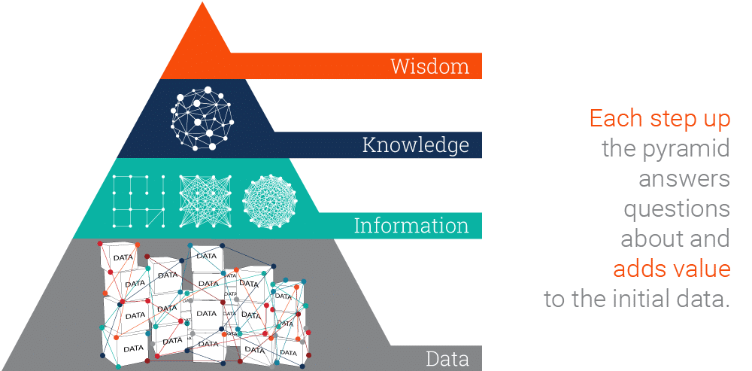

Appendix B
Organisation data with information, Statista (2021)
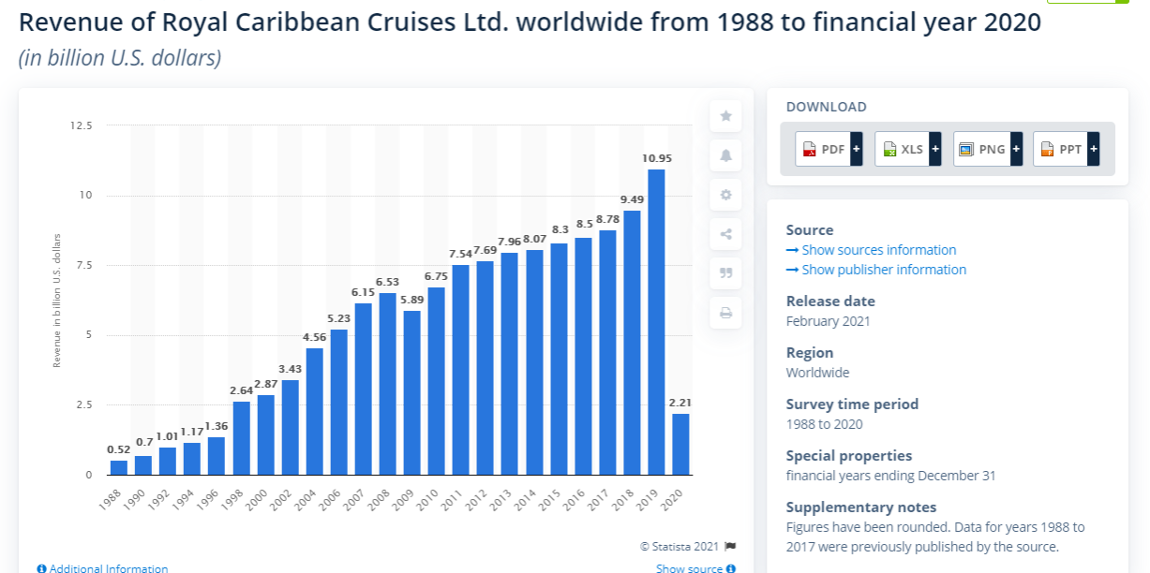
Appendix C
Fleet Data, older ship capacity
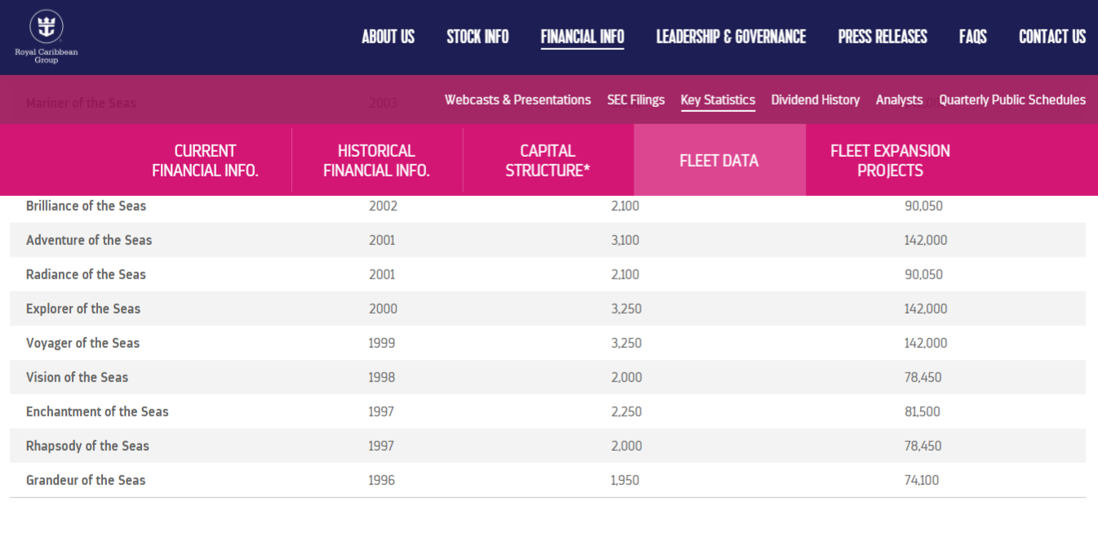
Appendix D
Fleet data, latest ship capacity
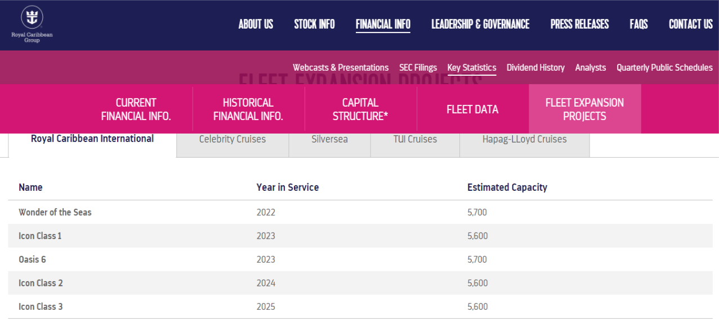

Appendix E
Four modes of knowledge conversion (Nonaka and Takeuchi, 1995)
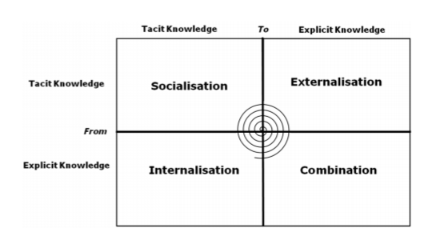

Appendix F
Characteristics of customer-oriented knowledge (Wilde 2011)
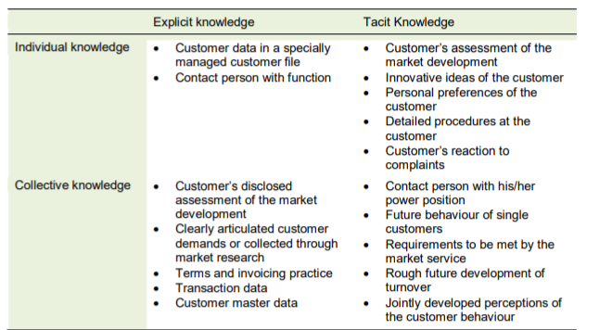

Appendix G
RCCL SWOT analysis based on CKM
Strengths | Weakness
Customer-centric strategy | Cannot access emerging market segments.
Clearly differentiated products. | Strong existing competitors
Great customer experience delivered. | Product-centric strategy
Clear value proposition
Clear segments targeted effectively.
High service levels
Access to a customer database
Success in creating engaging online content.
Strong social media engagement

Opportunities  Develop a broader customer relationship culture. | Threats  Consumers becoming more demanding.
Streamline internal processes. | Changes in consumer spending patterns
Build relationships with influencers. | Unpredictable trends and disruption
Expand geographic reach. | New international competitors emerging
 | Industry price-war
 | Competitors providing more added value.
 | Poor ratings on review websites

Appendix H
Pest Analysis of the CKM for RCCL
Political
- Impact of political sanctions such as the restriction of Cuba.
- Impact on the US-China trade battle on the tourism industry.
- Impact in the casinos where countries do not allow.
Economical
- Impact of global economic slowdown and recession due to Covid-19 on travel and tourism industry.
- Impact of cyclical factors on travel and tourism.
Social
- Increase in percentage of working population with access to online facilities.
- Increased consumer spending on desirable experiences.
Technological
- Advantages of technological platforms to transfer the knowledge.

Appendix I
Cobit 5 system


