Assignment

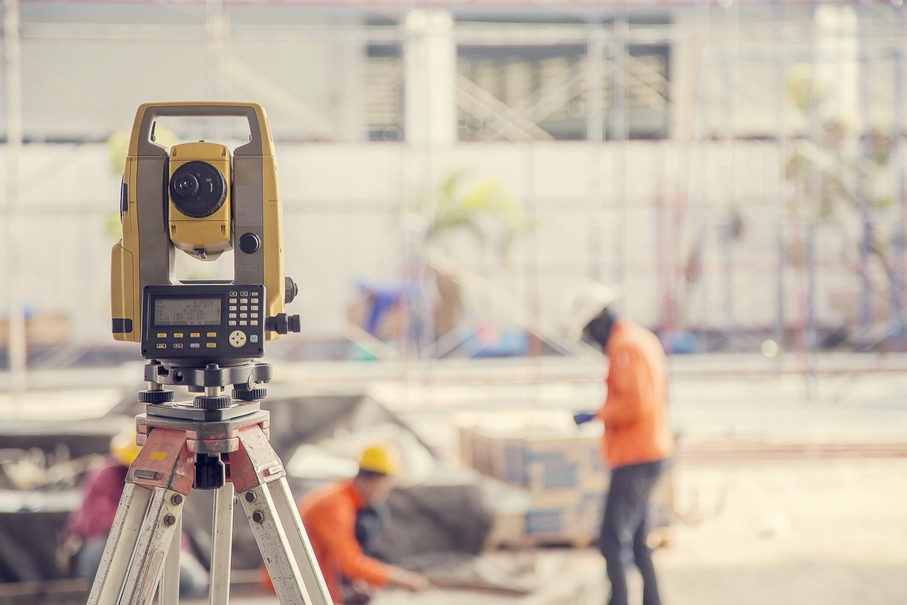

Digital Surveying

NAME: Thomas Stuart Poole
LECTURER: Dr Jamiu A. Dauda
MODULE CODE: ACBA4002

Contents Page

 |  | Page Number
Contents | : | 2
Task 1 : Outline a brief history of surveying, describing different measurement and surveying techniques from antiquity to the modern era.  - Egyptians 1400 BCE  - Greek 325 BCE  - Romans 15 BCE  - Europe 16th century  - Modern era | :  :  :  :  :  :  : | 3  3  4  4  5  6  7
Task 2 : Briefly describe the application of digital surveying technologies in surveying listed buildings, giving examples of appropriate tools to be used and the information to be collected from the survey.  - Photogrammetry  - Digital terrestrial photogrammetry  - Digital Aerial Photogrammetry  - UAV’S  - Laser Scanning  - GPS  - Lidar | :  :  :  :  :  :  :  : | 8  8  8  9  9  10  11  11
References | : | 13

Task 1: Outline a brief history of surveying, describing different measurement and surveying techniques from antiquity to the modern era.

Egyptians 1400 BCE

The fertile valleys and plains of the Tigris, Euphrates, and Nile rivers have evidence of some sort of boundary surveying dating back to 1400 BCE. Sumerian clay tablets contain land measurement records as well as city and agricultural area plans. Land plot boundaries have been maintained by preserving boundary stones. On the wall of a tomb at Thebes (1400 BCE), a depiction of land measurement depicts head and rear chainmen measuring a grainfield with what appears to be a rope with knots or markings at standardised intervals. Other people are visible. According to their clothes, two of them are of high status, most likely a land overseer and a boundary stone inspector.
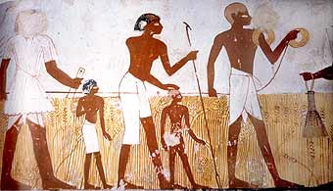

(Ck3llc.net. 2015)

There is evidence that the Egyptians used wooden rods for distance measuring in addition to a marked thread. There were no angle-measuring instruments to have been found around those times. There was, however, a level made up of a vertical wooden A-frame with a plumb bob supported at the top of the A so that its cord hung past a horizontal bar indicator, or index. The index can be properly placed by standing the system on two supports at about the same elevation, marking the location of the cable, reversing the A, and creating an identical mark. The index should be placed in the middle of the two marks.

The Egyptians were able to use simple instruments to measure large areas of land, build pyramids such as the pyramids of Giza to the exact measurement. The ancient Egyptians were also able to Substitute property corners that were lost During times of floods in the Nile River.
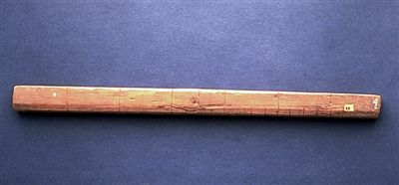

(lh3.googleusercontent.com,2019)

Greek 325 BCE

During their slow voyages from the Indus to the Persian Gulf about 325 BCE, the Greeks used a type of log line to record the distances run from point to point along the coast. Arab merchants introduced the magnetic compass to the West in the 12th century CE.
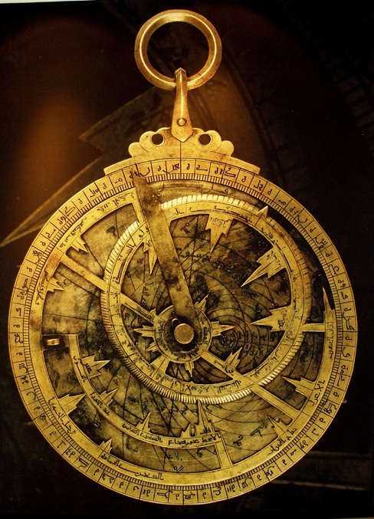

The Greeks invented the astrolabe in the 2nd century BCE. Before the invention of the sextant, the astrolabe was an instrument used to make astronomical measurements, usually in navigation for measuring latitude and it was also used for altitudes of celestial bodies.

(Beforenewton.files.wordpress.com. 2019)

Romans 15 BCE

Around 15 BCE, a Roman engineer and architect, engineered and developed a device that used a large mounted wheel of unknown diameter in a small frame, for example a wheel on a wheelbarrow. When this wheel was moved by hand It would drop a pebble into a sack per rotation of the wheel. This would give a measurement of the distance travelled. Archaeologists believe it was the odometer to have ever been invented.

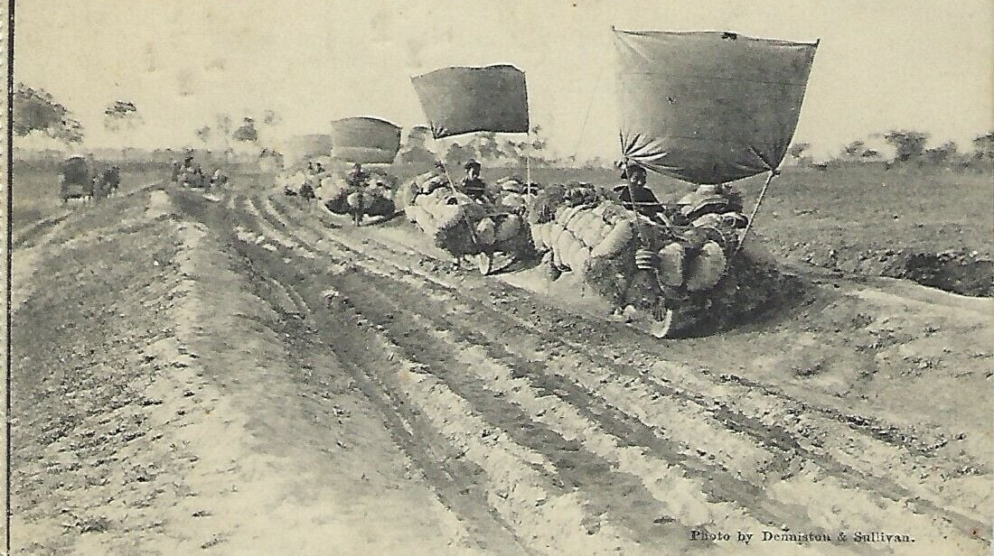
(1900, Richards, Engine and V, 2016)

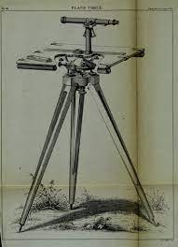
Plane table

Archaeologists are to believe that the Romans with the first people to use it plane table to map out their extensive Road systems. The plane table consisted of a drawing board supported by a wooden tripod or other stable support. It was the first unit that could record or determine angles. Magnetic compasses were added to later versions of the plane table.

(Encrypted-tbn0.gstatic.com. 2014)

Europe 16th century

Surveyors also used plane tables in the 16th century in Europe, and they used the concept of graphic triangulation and intersection. Willebrord Snellius, a Dutch mathematician, used instrumental triangulation to calculate an arc of meridian in 1615.

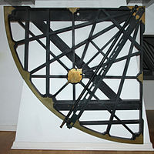

(Upload.wikimedia.org. 2020)

Edmund Gunter, an English mathematician, invented a surveying chain in 1620, which was only superseded by the steel tape in the late 19th century. Gunter's chain was eventually replaced by steel bands and invar tapes, then Electromagnetic Distance Measurement (EDM) equipment, and finally Global Positioning System (GPS) devices, all of which were capable of greater efficiency and measurement accuracies than the previous types. Compasses were also phased out in favour of transits, then theodolites, and finally Total Stations, which incorporated angular and distance measurements in a single survey instrument.

By around 1720, theodolites had adopted the vernier, an auxiliary scale that allowed for more precise readings (1631), the micrometre microscope (1638), telescopic sights (1669), and spirit levels (around 1700). James Watt was the first to use Stadia hairs in 1771. One of the most significant developments in surveying methods occurred around 1775, when the circle-dividing engine, a device for accurately dividing a circle into degrees, was created. It enabled angle measurements to be made with portable instruments much more accurately than had previously been possible.

Modern Era surveying
Modern surveying as we know it today dates back to the late 1800s. The measurement of the meridian from ‘Barcelona, Spain, to Dunkirk, France, by two French engineers, Jean Delambre and Pierre Méchain, to establish the basic unit for the metric system of measurement’. (surveying | Definition, History, Principles, Types, & Facts, 2021)

All of the basic surveying instruments have undergone numerous upgrades and refinements. As a result, precision and speed of operations have improved, and new approaches in the field have become possible. Two ground-breaking mapping and surveying improvements were made in addition to modifications to existing instruments.
Photogrammetry, or aerial photograph mapping (around 1920), and electronic distance measurement, which included the use of the laser for both this and alignment (in the 1960s). Satellites were used as reference points for geodetic surveys beginning in the late twentieth century, and electronic computers were used to speed up the processing and recording of survey data.
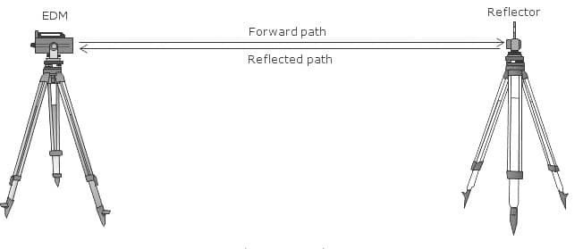
(Basiccivilengineering.com.2013)

For modern surveying, digital levelling systems use an automated laser to scan a level personnel with bar code markings. When interpreting graduation marks, this form of level decreases the risk of human error, and the digital display guarantees reliable readings.

Task 2: Briefly describe the application of digital surveying technologies in surveying listed buildings, giving examples of appropriate tools to be used and the information to be collected from the survey.

Surveying technology has been used to assess and preserve historic structures. Much new technology is now available for detailed surveys of the built environment in general, and heritage buildings in particular, thanks to recent developments in surveying. In addition to robotic complete stations and other surveying technology, these technologies include laser scanning, digital terrestrial photogrammetry, Remote Sensing Satellites, Lidar, Unmanned Aerial Vehicles (UAV), Digital Aerial Photogrammetry and Global Positioning Systems.

Photogrammetry
This is the science of taking accurate measurements with a camera. The photographs may be taken from the air with specially equipped aircraft and metric cameras, or from the ground with terrestrial cameras. Low level aerial photos are used for accurate 3D measurements in a variety of applications, such as topographic mapping, man-made and natural features, and city and town planning maps, archaeology, heritage documentation and preservation and engineering construction.

Photogrammetric measurements work on the basis of reconstructing a three-dimensional image of the flown site. This is accomplished by taking a series of overlapping photos in the direction of flight as well as sideways between strips.

Stereo models of the site are traditionally created using stereo metric aerial cameras. After photogrammetric restitution with stereo plotters, precise 3D data is measured from these models. The density and accuracy of this data (X, Y, and Z) will be affected by the aerial photography's flying height, topography, features measured, and processing techniques.
Digital terrestrial photogrammetry
Terrestrial photogrammetry is a significant branch of the photogrammetry science. It deals with images taken with cameras mounted on the earth's surface. Handheld cameras, tripod-mounted cameras, and cameras suspended from towers or other specially built mounts are all possibilities.
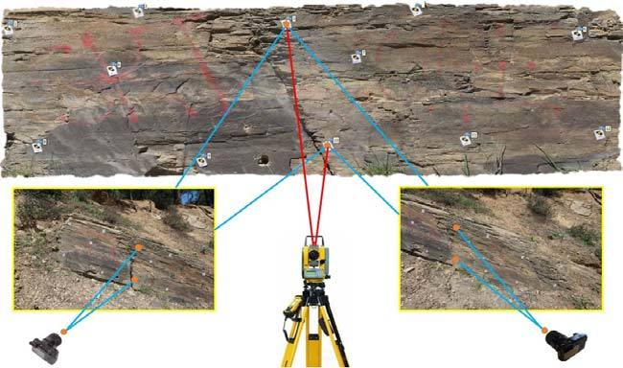

(Researchgate.net. 2021)

Digital Aerial Photogrammetry
Digital aerial photogrammetry (DAP) is the process of converting digital aerial images into spatially continuous, three-dimensional (3D) data. Image matching is used to extract 3D data, such as point clouds or digital elevation models (DEM), from overlapping images.
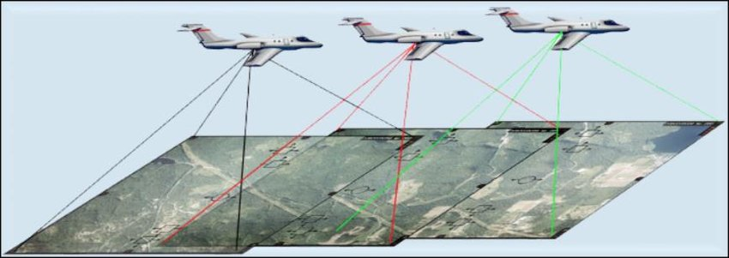
(Researchgate.net. 2018)
UAVs
Unmanned Aerial Vehicles (UAVs) are another option for flying a large field. Using appropriate computer programmes based on photogrammetric concepts, the overlapping images can be processed and transformed into scaled photographs (Ortho Photos). As a result, a 3D data collection of the area has been developed, which includes man-made features such as buildings and heritage site and buildings. This can be viewed as a site footprint or as a Digital Surface Model (DSM) plus a Digital Terrain Model (DTM).
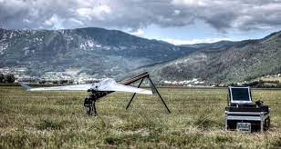

(Uasvision.com. 2017)

Laser scanning

Laser scanning devices emit light waves that bounce off surfaces and return to the sensor. The sensor then uses the time it takes for the light beam to complete its path to determine how far away the surface is. This is referred to as "time of flight" measurement. The calculated coordinate for the tiny section of the surface hit by the laser beam is based on the measured distance. All of this occurs in a matter of seconds, and a laser scanner will obtain millions of 3D coordinates in a single scan.

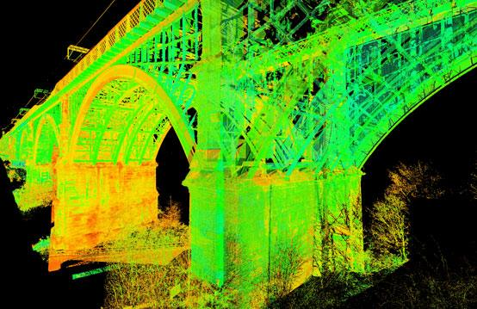

(Encrypted-tbn0.gstatic.com. 2010)
When laser scan point clouds are processed, a digital representation of the scanned surfaces is created, revealing the dimensions and spatial relationships of topographic features and structures.

Advantages of Laser scanning Surveying

- Laser Scanners Can Collect Data Quickly
- Systems Can Be Mounted to Vehicles
- Laser Scanning Can Reduce Health and Safety Risks
- 3D Scanning Systems Can Survey Inaccessible Areas
- Detailed 3D Models Can Be Created from Scan Data
- Spatial Scanning
- Road Surveying and Traffic Construction Analysis
- Urban Topography

Different types of Laser Scanning Devices
- FARO Focus320D
- Leica Scan Station P20
- RIEGL VZ-6000
Global positioning System (GPS)
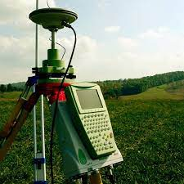
‘The widely known and used GPS (Global positioning System) is the Global Navigation Satellite System (GNSS).’ These satellites send out microwave signals that are picked up by GPS receivers on the ground. The receivers can use this information to measure their location, as well as the speed, direction, and time of the satellites. There must be a minimum of four satellites. Professionals may use GPS to position all of this data on the national grid (the UK's Ordinance Survey) or the world coordinates system. The condition and historical value of heritage sites, as well as their preservation, can be better understood with this unified scheme. The GPS combined with other survey technology is the most effective method for establishing control and detail site measurements for heritage building maintenance and preservation. The Geographical Information System (GIS) can efficiently store and handle data obtained for heritage projects.

(profile, 2019)

Lidar

Lidar (Light Detection and Ranging) is a remote sensing technique that uses laser in the form of a pulsed laser to measure ranges (variable distances) to the Earth. These light pulses, when combined with other data obtained by the airborne instrument, provide accurate three-dimensional details about the Earth's shape and surface characteristics.

A lidar device consists of three components: a laser, a detector, and a specialised GPS receiver. Planes and helicopters are the most popular platforms for collecting lidar data over wide areas. The two forms of lidar are topographic and bathymetric lidar.

A bathymetric lidar uses a near-infrared laser to measure the chosen land of the surveyor.

A topographic lidar uses a water-penetrating green light to measure the seafloor and riverbed elevations.

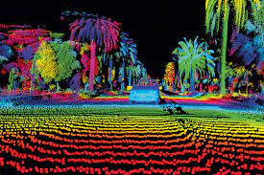

(Redirect Notice, 2019)

References

Ck3llc.net. 2015. [online] Available at: <http://www.ck3llc.net/Archives/2012/2ndQtr/images/LandMeasurementTombWalls.jpg> [Accessed 2 May 2021].

lh3.googleusercontent.com,2019. [online] Available at: <https://lh3.googleusercontent.com/proxy/ahDFzz_OnliL6vA3TPfqK4WADh0eAVhbdwJjEfDabvP5E_8s9BqZ5XDrYHuUec1QfgZeOvgAQd1D1ivXNJF92hbiPSDVjzLuXEkTXmyAVWCrzjqAshTt> [Accessed 2 May 2021].

Beforenewton.files.wordpress.com. 2019. [online] Available at: <https://beforenewton.files.wordpress.com/2017/02/astrolabe-fancy.jpg> [Accessed 2 May 2021].

1900, A., Richards, P., Engine, A. and V, R., 2016. WI : Ancient Romans used "wooden-ox" type wheelbarrow?. [online] alternatehistory.com. Available at: <https://www.alternatehistory.com/forum/threads/wi-ancient-romans-used-wooden-ox-type-wheelbarrow.465574/> [Accessed 2 May 2021].

Encrypted-tbn0.gstatic.com. 2014. [online] Available at: <https://encrypted-tbn0.gstatic.com/images?q=tbn:ANd9GcSdIxdmNSWAYXZVTonNsKBWhcOrhWAmQ3ijK40MAeGQlc8di5TUJGe9MD9Jsy3LbZ3RqRE&usqp=CAU> [Accessed 2 May 2021].

Upload.wikimedia.org. 2020. [online] Available at: <https://upload.wikimedia.org/wikipedia/commons/thumb/f/fb/Museum_Boerhaave_-_Snellius_quadrant.jpg/200px-Museum_Boerhaave_-_Snellius_quadrant.jpg> [Accessed 2 May 2021].

Encyclopedia Britannica. 2021. surveying | Definition, History, Principles, Types, & Facts. [online] Available at: <https://www.britannica.com/technology/surveying> [Accessed 2 May 2021].

Basiccivilengineering.com.2013. [online] Available at: <https://basiccivilengineering.com/wp-content/uploads/2017/05/edm-transit-time-measurement-reflector.jpg> [Accessed 2 May 2021].

Researchgate.net. 2021. [online] Available at: <https://www.researchgate.net/profile/Cem-Gazioglu-2/publication/320893671/figure/fig3/AS:557973148585989@1510042573254/12-control-point

Researchgate.net. 2018. [online] Available at: <https://www.researchgate.net/profile/Fanar-M-Abed/publication/334164581/figure/fig1/AS:776165459501056@1562063674202/Figure-12-Illustrate-the-geometry-of-aerial-photogrammetry-13.jpg> [Accessed 4 May 2021].

Uasvision.com. 2017. [online] Available at: <https://www.uasvision.com/wp-content/uploads/2020/03/landpointppk.jpg> [Accessed 4 May 2021].

Encrypted-tbn0.gstatic.com. 2010. [online] Available at: <https://encrypted-tbn0.gstatic.com/images?q=tbn:ANd9GcSHYGEtgaz1rc37CIiuAL12akwYXopailIl2A&usqp=CAU> [Accessed 4 May 2021].

profile, V., 2019. How to Use GPS to Survey Land Tips. [online] Trickntips4u.blogspot.com. Available at: <http://trickntips4u.blogspot.com/2011/05/how-to-use-gps-to-survey-land-tips.html> [Accessed 4 May 2021].

Google.com. 2019. Redirect Notice. [online] Available at: <https://www.google.com/url?sa=i&url=https%3A%2F%2Fwww.geospatialworld.net%2Fblogs%2Fwhat-is-lidar-technology-and-how-does-it-work%2F&psig=AOvVaw3zY_eype4VFxQ92jBBkV7z&ust=1620493231755000&source=images&cd=vfe&ved=0CAIQjRxqFwoTCJjRwO-FuPACFQAAAAAdAAAAABAD> [Accessed 4 May 2021].

