

Investigating Data Loss Prevention Techniques and Outcomes for the Protection of Sensitive Customer Data
by
Joseff Thomas

Supervisor: Carlene Campbell

Project submitted as part of the requirements for the award of
BSc (Hons) Computing

July 2023
DECLARATION FORM AND FORM OF CONSENT

DECLARATION
I, Joseff Thomas declare that I am the sole author of this Project; that all references cited have been consulted; that I have conducted all work of which this is a record, and that the finished work lies within the prescribed word limits.
This work has not previously been accepted as part of any other degree submission.

Date : 14/08/2023

FORM OF CONSENT

I Joseff Thomas hereby consent that my Project, submitted in candidature for the B.Sc.(Hons) Computing (stream) degree, if successful, may be made available for inter-library loan or photocopying (subject to the law of copyright), and that the title and abstract may be made available to outside organisations.

Date : 14/08/2023

ABSTRACT
This research project aims to address the critical issue of safeguarding personally identifiable information (PII) stored on cloud platforms. With the focus on preventing accidental or potential data breaches, the project proposes implementing a Cloud Data Loss Prevention (DLP) system. The system will efficiently identify and redact PII within plain-text documents by leveraging advanced detection mechanism. The study will assess the DLP solution's accuracy and effectiveness in a test environment using cloud storage but mimicking real-world scenarios. The outcomes of this research will contribute to the organisation's security and privacy of sensitive information stored on cloud platforms, ensuring continuous compliance with data protection regulations.
Contents
1. Introduction 6
2. Research Literature Review 8
2.1. Article 1 8
2.2. Article 2 9
2.3. Article 3 11
2.4. Article 4 13
3. Research Methodology 16
3.1. Experimental Hypothesis 16
3.1.1. Null Hypothesis (H0) 16
3.1.2. Alternative Hypothesis (H1) 16
3.2. Hardware & Software 17
3.3. Reliability in the Cloud DLP Project 17
3.4. How the Experiment was Conducted 18
4. Project Design 20
4.1. Test Environment 20
4.2. Test Data 21
4.3. Cloud Solution 24
5. Implementation 25
5.1. Selection of DLP Platform 25
5.2. Data Storage 26
5.3. The Custom Info-types 27
5.3.1. UK Driving License Syntax 27
5.3.3. UK Passport Syntax 30
5.4. Test Results 30
5.4.1. UK National Insurance Numbers 31
5.4.2. UK Driving Licenses 36
5.4.3. UK Passport Numbers 41
6. Project Evaluation 48
6.1. Meeting the Project Objectives 52
6.2. Meeting the Project Aim 54
6.3. Project Evaluation for Future DLP Research 54
7. Conclusion 56
8. References 58

Introduction
In today's digital age, marked by rapid technological evolution, confirming the security of sensitive data is of utmost importance. As organisations globally embrace cloud-based solutions for storage and collaboration, this allows for a mix of unparalleled convenience, scalability, and flexibility, but this also creates new vulnerabilities. These emerging risks make data protection increasingly complex [1]. The surge in cloud platforms' reliance on storing critical personally identifiable information (PII) has intensified the demand for robust security measures. In the United Kingdom (UK) businesses are increasing their spending on cloud computing by 82% in the next 12 months, 62% of European organisations responded to a Flexera research in 2023 were heavily using the cloud [2].

A government organisation initiated a project to review how efficiently cloud data loss prevention (DLP) can detect and remediate sensitive text-based data using pre-defined and customised rules. The primary focus of this project is to test DLP's specific functionalities in the context of detecting and removing sensitive text-based sensitive data by comprehensively evaluating the capabilities and shortcomings of DLP; the project intends to provide insight into the efficiencies of detection and remediation of pre-defined and customisable rules. To successfully accomplish this necessitates carefully examining DLP's mechanisms, understanding its operations, and outlining its effectiveness in real-world scenarios.

The objectives of this project are threefold: First, it entails researching and configuring a cloud based DLP system designed to scan and detect specific sensitive data, establishing a comprehensive understanding of current technological capabilities. This process involves not only understanding the theoretical knowledge of how DLP works, but also its practical implementation. This requires careful calibration to target specific types of sensitive information.

Secondly, the project strives to determine the success rate of DLP implementation in identifying and eradicating sensitive data, thus providing an empirical basis for its efficiency and effectiveness. By creating benchmarks and using a variety of test cases, the project will provide a granular analysis of DLP's performance, scrutinizing its accuracy, responsiveness, and overall reliability.

Lastly, while acknowledging that no system is infallible (even the most advanced systems may have vulnerabilities), the project will devise methods for circumventing specific DLP controls. This will include exploring potential weaknesses and vulnerabilities in the DLP system, followed by developing countermeasures to enhance resilience against potential threats.

In essence, this project is not just an academic exercise but an essential step towards fortifying the security landscape in the age of cloud computing. It builds on the necessity to develop more intelligent, adaptable, and resilient systems to protect sensitive data. In an age where data breaches can lead to significant reputational and financial damages, such as 147 million Equifax customer that were affected by the data breach costing the company $700 million in settlement claims [3] . There are also examples recently of the UK election watchdog being a victim of a cyber-attack that allowed access to 40 million names and addresses of registered voters between 2014 – 2022 and the Police Service of Northern Ireland (PSNI) accidentally uploading a spreadsheet of surnames, initial, rank or grade, location and the department of all current PSNI officers and civilian staff members [4]. The failure to secure and adequately maintain sensitive data can have a considerable negative impact on employees' and customers' lives. Such data breach incidents underscore the importance of investigating essential aspects of modern data management in cloud storage to strengthen data security in a cloud environment.

The following report will thoroughly examine cloud-based Data Loss Prevention (DLP) functionality, drawing on insights and findings from similar studies conducted in the field. The report aims to present the readers with a clear understanding of the underlying processes and outcomes. Investigating how the Data Loss Prevention scan works to identify and protect sensitive information. There will be a focus on the pre-defined and customisable rules cloud DLP vendors offer. Additionally, the report will detail the customisation process, illustrating how the custom rules are configured and subsequently compared to the pre-defined rules, thereby offering a tailored approach to data protection. The report also takes an analytical look at the ways in which circumventing worked to bypass the DLP detection, providing an insight into potential vulnerabilities and corresponding countermeasures. The section highlights if the DLP system is the flexibility of DLP systems and emphasises if it is adaptable to various organisational needs.

Research Literature Review

Article 1
The first literature review article that was researched is called ‘CloudDLP: Transparent and Scalable Data Sanitization for Browser-Based Cloud Storage’ [5] .

The article proposes a new approach for enterprises to automatically sanitise sensitive data in images and documents with various browser-based cloud applications. The proposed approach, called CloudDLP, is deployed as an internet gateway within the premises of an enterprise and uses JavaScript injecting techniques and deep learning methods to sanitise sensitive data.

The problem that the article addresses is the risk of data leakage in browser-based cloud storage. When users upload sensitive data to cloud storage, it is possible for this data to be intercepted and stolen by unauthorised individuals. This risk is exceptionally high for browser-based cloud storage, as it is often used in insecure environments, such as public Wi-Fi networks.

The article proposes CloudDLP, a new approach for enterprises to automatically sanitise sensitive data in images and documents before they are uploaded to cloud storage. CloudDLP is deployed as an internet gateway within the premises of an enterprise and uses JavaScript injecting techniques and deep learning methods to sanitise sensitive data.
CloudDLP has several advantages over existing approaches to data sanitisation in cloud storage:

- It is transparent to users, meaning they do not need to change their behaviour or workflow to use CloudDLP.

- CloudDLP is scalable and can be used with various browser-based cloud applications.

- CloudDLP effectively detects and sanitises sensitive data, including images and documents.

The article's authors evaluated CloudDLP with several real-world cloud applications. They found that it achieved automatic data sanitisation with minimal impact on application performance or functionality. The authors also found that CloudDLP could detect and sanitise a wide range of sensitive data, including social security numbers, credit card numbers, and bank account numbers.

Overall, the article "CloudDLP: Transparent and Scalable Data Sanitization for Browser-Based Cloud Storage" presents a promising new approach for enterprises that need to protect sensitive data in browser-based cloud storage. CloudDLP is transparent, scalable, and effective, and it has been evaluated with real-world cloud applications. CloudDLP can be a valuable tool for enterprises looking to protect their sensitive data in the cloud.

  - Article 2
The second literature review article that was researched is called ‘Cloud security framework and key management services collectively for implementing DLP and IRM’ [6]. The article delves into the intricacies of cloud security, addressing the novel opportunities and inherent challenges cloud computing poses. While cloud services offer myriad advantages, they simultaneously usher in potential security pitfalls. One prominent concern is safeguarding sensitive data, which, if left unprotected, can become vulnerable to theft or loss.

To this end, the authors advocate for key management services. These are critical in data protection because they oversee encryption keys' secure storage and handling. These keys are paramount as they encrypt sensitive data, and if they fall into the wrong hands, they can be weaponized to decrypt and access the data. Through key management services, the safekeeping of these keys is ensured, thereby preventing unauthorized decryption.
Venturing further, the article introduces a pioneering cloud security model, utilizing key management services in tandem with DLP (Data Loss Prevention) and IRM (Information Rights Management). The structure consists of:

- A cloud-driven DLP system enriched with machine learning capabilities to pinpoint sensitive data.
- An IRM mechanism enables users to customize policies determining data accessibility and usage criteria.
- The aforementioned key management service safeguards encryption keys.

The authors initiated a case study involving a major financial entity to corroborate their model. This empirical evidence indicated the framework's aptitude in thwarting data breaches and securing sensitive information.

Highlighting its novelty, the article contributes in several pivotal ways:

- Introduction of an innovative cloud security architecture incorporating key management services alongside DLP and IRM.
- An in-depth empirical assessment through a case study.
- An engaging discussion about cloud security challenges and the merits of adopting an open-source strategy.

Their case study was thorough and yielded persuasive outcomes. Their candid discourse on the pros and cons of cloud security, especially with respect to open-source frameworks, adds depth to their work. Evidently, their model is a commendable augmentation to the cloud security domain: it is scalable, flexible, economical, open-source, and, above all, proficient at forestalling data breaches and fortifying sensitive data.

However, certain aspects of the research calls for further research into:

- The sole reliance on a single case study might doubt the framework's broader applicability.
- The research did not discuss the economic implications of adopting the proposed model.
- Potential consequences on user efficiency due to the new framework should have been explored.

Article 3
The third literature review article analysed was ‘A Hybrid Framework for Data Loss Prevention and Detection’ [7]. The article begins by discussing the importance of data loss prevention (DLP) in protecting sensitive information from unauthorized disclosure. The authors then reviewed the two main approaches to DLP: signature-based and anomaly-based. Signature-based DLP solutions use a database of known attack signatures to detect attacks. Anomaly-based DLP solutions use machine learning to learn a model of normal user behaviour and then flag any transactions that deviate from that model.

The authors then argue that both signature-based and anomaly-based DLP solutions have limitations. Signature-based DLP solutions can only detect known attacks, which are ineffective against new or unknown attacks. Anomaly-based DLP solutions can detect new and unknown attacks, but often have a high false positive rate which can result in operators ignoring alerts.

The authors then propose a hybrid framework for DLP that combines signature-based and anomaly-based solutions. The hybrid framework uses a two-stage approach. In the first stage, the framework uses an anomaly-based engine to learn a model of normal user behaviour. In the second stage, the framework uses the model to flag anomalous transactions. If an abnormal transaction is flagged, the framework then uses a signature-based engine to check if the transaction matches a known attack signature.

The authors argue that the hybrid framework has several advantages over traditional signature-based and anomaly-based DLP solutions:

- The hybrid framework can detect both known and unknown attacks.

- The hybrid framework has a lower false positive rate than anomaly based DLP solutions.

- The hybrid framework is more scalable than signature based DLP solutions.

The article then presents the results of a case study that evaluated the performance of the hybrid framework. The case study involved a large financial services organisation that had experienced a data breach in the past. The organisation implemented the hybrid framework and monitored it for a period of six months. During that time, the framework detected several known and unknown attacks. The organisation was able to prevent the attacks from causing any damage.
The article concludes by discussing the future of DLP. The authors argue that the hybrid framework is a promising approach for DLP but that it is still under development. The authors also call for more research on hybrid DLP frameworks.

Here are some additional thoughts on the research:

- The hybrid framework proposed in the article is an excellent example of how different machine-learning techniques can be combined to solve a complex problem. The anomaly-based engine learns a model of normal user behaviour, which can be used to flag anomalous transactions. The signature-based engine then checks if the abnormal transactions match a known attack signature. This two-stage approach is more effective than using a single machine-learning technique.

- The hybrid framework is scalable, vital for organisations with large amounts of data. The anomaly-based engine can be used to monitor many users and transactions, while the signature-based engine can be used to check for known attacks.

- The hybrid framework is easy to use. The anomaly-based engine automatically learns a model of normal user behaviour, so operators do not need to configure the system manually. The signature-based engine also uses a pre-trained model, so there is no need for operators to have expertise in machine learning.

Article 4
The final researched literature review article is ‘Survey of Techniques on Data Leakage Protection and Methods to address the Insider threat’ [8]. The article offers a comprehensive overview of data leakage and the insider threat, starting with definitions: Data leakage is the unauthorised disclosure of confidential or sensitive information, while the insider threat pertains to the risk posed by authorised individuals, such as employees, contractors, or suppliers, who may intentionally or unintentionally disclose such information. The authors delve into the various techniques used to counteract these challenges, exploring the different types of data leakage scenarios and the motivations insiders might have for disclosing data.

The authors then discuss the different types of data leakage that can occur.

These include:

- Physical data leakage: This occurs when confidential or sensitive information is physically removed from an organisation's premises, such as by an employee taking a laptop home or by a contractor copying data to a USB drive.
- Logical data leakage: This occurs when confidential or sensitive information is transmitted electronically, such as by email, file sharing, or social media.
- Insider threat data leakage: This occurs when an authorised individual intentionally or unintentionally discloses confidential or sensitive information.

The authors also discuss the different motivations that insiders may have for leaking data.
These include:

- Financial gain: Insiders may leak data in order to be paid by a competitor or other third party.
- Revenge: Insiders may leak data to get revenge on an employer or colleague.
- Ideology: Insiders may reveal data to support a particular cause or ideology.

The authors then review the different techniques that can be used to protect against data leakage.

These techniques include:

- Encryption: the process of converting data into a secret format that can only be read by authorised individuals.
- Data loss prevention (DLP) software: This software can be used to monitor and control the flow of data within an organisation.
- Access control: This is the process of controlling who has access to what data.
- User awareness training: This training can help make employees aware of the importance of securing data and to avoid making mistakes that could lead to data leakage.
- Security auditing: This process can identify and correct security vulnerabilities that insiders or external attackers could exploit.

The authors also discuss the different methods utilised to address the insider threat.

These methods include:

- Background checks: This can help to identify individuals who may pose a security risk.
- Employee monitoring: This can be used to detect suspicious activity by employees.
- Separation of duties: This can help to prevent individuals from gaining unauthorised access to confidential or sensitive information.
- Whistleblower policies: These policies can encourage employees to report suspected data leakage to the appropriate authorities.
- Security incident response plans: These plans can help organisations to respond quickly and effectively to data breaches.

The article concludes by providing several recommendations for organisations looking to protect themselves against data leakage and the insider threat.

These recommendations include:

- Conducting regular risk assessments: This can help organisations to identify and prioritise their security risks.
- Implementing a layered security approach: This can reduce the risk of data leakage by using a combination of different security controls.
- Educating employees about data security: This can help employees to better understand the importance of data security and to avoid making mistakes that could lead to data leakage.
- Monitoring for suspicious activity: This can help organisations detect and respond to suspicious activity which might indicate data leakage.
- Having a plan to respond to security incidents: This can help organisations to respond quickly and effectively to data breaches.

Research Methodology

Experimental Hypothesis

Null Hypothesis (H0)

- The implementation of a cloud based DLP system will have no effect on the identification and protection of sensitive customer data.

- Implementing DLP controls will not increase the success rate of identifying and removing sensitive data.

- Circumventing measures against DLP controls will not significantly impact the ability to prevent unauthorized access or leaks of sensitive data.

Alternative Hypothesis (H1)

- The implementation of a cloud based DLP system will significantly improve identifying and protecting specific sensitive customer data.

- Implementing DLP controls will significantly increase the success rate of identifying and removing sensitive data.

- The development and implementation of measures to circumvent DLP controls will significantly affect the system's ability to prevent unauthorized access or leaks, and the recommendations against this will mitigate these effects.

Hardware & Software
The project hardware consisted of an Intel NUC 11 Extreme with an i7 processor, 64GB RAM, 3060 NVIDIA GPU, and 1TB of storage, and an Intel NUC 12 Extreme featuring an i9 processor, 64GB RAM, NVIDIA 3080ti, and 1TB of storage. While these devices provided substantial computational capabilities, the project's emphasis was not solely on the hardware but instead on the advantages of leveraging cloud Software as a Service (SaaS) solutions.
The main highlight of the project was cloud based DLP's flexibility and adaptability. With cloud SaaS, the specific hardware used becomes less critical, allowing for the project to be worked on seamlessly from different locations. This underscores the strength of SaaS solutions in providing reliable and scalable services without the need for constant hardware considerations.
The adoption of a cloud DLP platform negated the need for the installation of additional software. This decision streamlined the process and reinforced the project's efficiency. The cloud DLP platform provided all the necessary tools and services for the execution of the DLP functionality, thereby simplifying the setup and enabling a more focused approach to the objectives. Windows 10 Pro was the selected operating system (OS) using the default Edge browser.

This combination of the cloud DLP platform, Windows 10 Pro OS, and Edge browser facilitated a smooth implementation and emphasized the accessibility and effectiveness of contemporary cloud-based solutions. By avoiding additional software complexities, the project demonstrated the power of using integrated and well-recognized platforms in delivering robust and reliable data loss prevention solutions in a cloud environment.

Reliability in the Cloud DLP Project
The reliability of any research strives to ensure the validity and credibility of the results. To this end, the research project employs a comprehensive framework consisting of test-retest, parallel forms, and internal consistency methodologies. Each of these techniques has been carefully chosen to offer distinct insights into the reliability of the experimental outcomes.
The test-retest methodology, a commonly employed approach in research, involves repeating the test to evaluate the stability of the results over time [5]. In this project, the designated tests will be repeated a total of 26 times for each PII category, containing national insurance, driving license, and passport numbers. This repetitive testing aims to ascertain the outcomes' consistency when applying predefined and customised rules within the context of data loss prevention.
The utilisation of parallel forms constitutes another critical part of this research's reliability assessment, by gauging the effectiveness of distinct sets of rules on a cloud-based data loss prevention platform. Specifically, the project explores the application of both customised rules and predefined rules. This dual approach permits a comparative analysis of the platform's response to rule sets tailored to specific contexts versus standardised regulations. This methodology enables an in-depth evaluation of the platform's reliability in handling diverse data loss scenarios.
The internal consistency methodology further contributes to the comprehensive reliability assessment of the research project. Through this approach, the research probes the consistency of outcomes across different iterations of the experiments. For each PII category, the project examines a range of numbers presented in various plain text formats, encompassing different text-based file types. This systematic manipulation of variables enables the measurement of the same underlying construct data loss prevention efficacy across varied conditions. Consequently, internal consistency methodology enhances the research's overall reliability.

How the Experiment was Conducted
The data loss experiment was performed by connecting to the internet and using a web browser to access the DLP vendor's website. An account was created with the vendor, and a free trial was used to reduce the cost of the experiment.

The next step was to configure the DLP vendor's software to scan the cloud storage that contained the test data. A project was set up with the vendor to create the test environment and the cloud storage area to store the test data. The DLP software was configured to scan for specific sensitive PII data stored in plain text.

Once the DLP software was configured it was a manual scan of the cloud storage for sensitive data. Any detected sensitive data was transferred to another storage area on the cloud storage.
The experiment reviewed the results of each inspection scan to determine how much of the sensitive data was detected and if it could be remediated. The investigation also evaluated the performance of the DLP software and identified any areas where it could be improved.

The following is a more detailed description of each step in the experiment:

Connecting to the internet and using a web browser. The experiment was performed on a computer that was connected to the internet and had a web browser installed. The web browser was used to access the DLP vendor's website and create an account.

Setting up an account with the DLP vendor. The experiment required a free trial account with the DLP vendor. The account was created by providing the vendor with basic contact information and a credit card number.

Configuring the DLP software to scan the cloud storage. The DLP software was configured to scan the cloud storage for specific sensitive PII data. The sensitive data that was targeted for scanning included social security numbers, credit card numbers, and email addresses.

Creating the test environment and the cloud storage area. A project was set up with the DLP vendor to create the test environment and the cloud storage area to store the test data. The test environment was created on a virtual machine that was hosted by the DLP vendor. The cloud storage area was created in the vendor's cloud platform.

Transferring the test data to the cloud storage. The test data was transferred to the cloud storage area using a secure file transfer protocol. The test data included a variety of documents that contained sensitive PII data.

Starting the DLP scan. The DLP scan was created by clicking a button in the DLP software's user interface. Each scan took several minutes to complete.

Reviewing the scan results. The scan results were examined to determine how much of the sensitive data was detected and if it could be remediated. The experiment also evaluated the performance of the DLP software and identified any areas where it could be improved.

Project Design

Test Environment
The project will operate within a technical test environment separate from the organisation's primary network and storage systems. In order to maintain seamless and secure business operations, it was decided to execute the project outside of the organisation's primary network and data storage. This strategic choice emerged from evaluating how the project could impact the existing infrastructure's daily processes and data flows. The decision to isolate the project aims to establish a more concentrated development environment, minimising the risk of accidental disruptions while safeguarding the integrity of the core operations. The chosen setup will involve a standalone device, purposefully isolated to maintain its integrity and function. Additionally, it will incorporate cloud storage, providing a reliable and scalable data solution. This approach ensures a controlled testing atmosphere while optimising performance and safeguarding organisational resources.
Here are some of the benefits of using a standalone device and cloud storage for testing:
Increased flexibility: Test the software on various hardware configurations and operating systems.
Increased scalability: Can easily add more resources to the test environment as needed.
Increased reliability: The test data is stored in a secure and reliable location.
Reduced costs: There is only the need to pay for the resources that are used.

Test Data
The data selected for the experiment project focus on three specific types of PII: national insurance numbers, passport numbers, and driving license numbers. These inputs were strategically selected due to their extensive usage in government and local authority departments. Their inherent uniqueness makes them vital personal identifiers that are more likely to be a target for cybercriminals. Compared to other personal data such as financial information, home addresses, email addresses, or phone numbers, these three forms of identification are less likely to change over time. Additionally, they often serve as foundational keys in official documentation and verification processes [6].
However, this does not imply that other personal information such as addresses, telephone numbers, bank account details or debit/credit card numbers are not significant or worthy of protection [7]. The emphasis on national insurance, passport, and driving license numbers for this study results from the limited time available for the project, necessitating a narrowed focus. This triad of government identification numbers presents an essential case study for understanding vulnerabilities and strategizing protection against potential breaches.
By delving into the intricacies of these specific identifiers, the research aims to shed light on the broader landscape of personal data security, offering insights and solutions that could be adapted to other areas of personal information. A total of 635 customer personal identification instances will be analysed in this study, providing a substantial dataset to understand the patterns, risks, and opportunities for enhancing cybersecurity in the government. That is 255 instances of driving licenses, 233 national insurances and 147 passport numbers.
Test data is essential for validating the effectiveness of a data loss prevention (DLP) solution. It allows organisations to test their DLP policies and procedures to ensure that they are effective in detecting and preventing the unauthorized disclosure of sensitive data.
As mentioned previously, the test data consists of national insurance numbers, driving license numbers, and passport numbers.

This data was stored in plain text in a variety of formats, including:

- Merged: TAYLO543210VH5GD, taylo543210vh5gd, 263856289, BS521956A and bs521956a.

- With spaces: TAYLO 543210 VH 5GD, TAYLO 543210 VH5GD, taylo 543210 vh 5gd, taylo 543210 vh5gd, bs 52 19 56 a, BS 52 19 56 A and 2 6 3 8 5 6 2 8 9.

- With dashes: taylo-543210-vh5gd, taylo-543210-vh-5gd, TAYLO-543210-VH5GD and TAYLO-543210-VH-5GD and BS-52-19-56-A, bs-52-19-56-a.

This variety of formats was chosen to test the effectiveness of the DLP solution to detect and remediation of the sensitive PII. This was done because in real world scenarios the PII might be stored on the plain text in different forms.

The data was stored in two different forms within the text files. One was in a bulk form by storing the information all in one document, but in another, as shown in figure 1. This was to test the effectiveness of the DLP scan in detecting such a large amount of test data and if it could perform the required remediation process. The other way the sensitive data was stored within the file was within a fake template letter, as shown in figure 1 & 2. This was also to test the effectiveness of the DLP scan to detect the PII surrounded by other data.

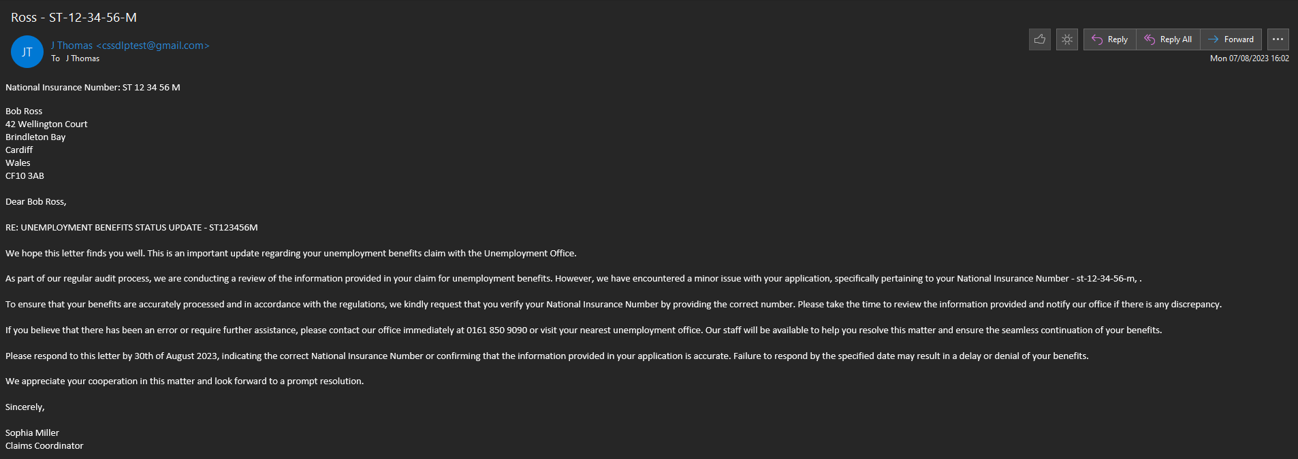
Figure 1

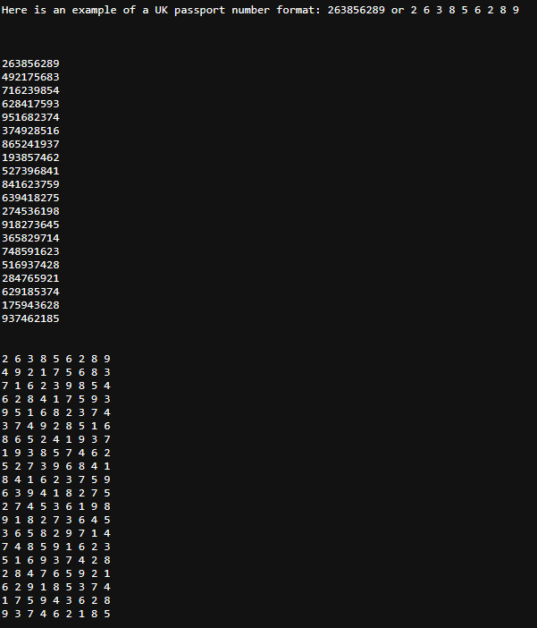
Figure 2

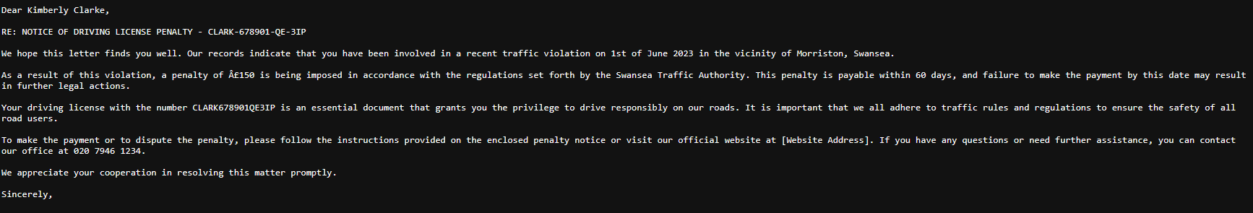
Figure 3

The test data was also stored in a variety of file formats, including TXT, EML, XML, and HTM. This was done to see if the test solution's ability to detect sensitive data in different types of file formats, but wasn’t the focus of the project.

The test data was used to test the performance of the DLP solution. The solution was able to detect and process the test data efficiently. This ensured that the solution was able to protect sensitive data in real-time. The test data was a valuable resource in validating the effectiveness of the DLP solution.

Cloud Solution
There are several requirements for a cloud DLP platform. The platform must be able to manually scan all the organisation's cloud storage. It must also be able to create and run inspection jobs to detect sensitive data. The platform must have pre-defined rules for identifying sensitive data. These rules should include PII data such as driving licenses, national insurance, and passport numbers. The platform must also be able to create custom rules for identifying sensitive data. It must be able to be configured through a web-based platform. The web-based platform should be easy to use and provide clear instructions for configuring the DLP platform.

Implementation

Selection of DLP Platform
Google Data Loss Prevention (DLP) was selected as the DLP platform for the organisation because it is a cloud-based solution that is compatible with cloud storage. One of the standout benefits leading to the selection of Google DLP was the vendor's promotional offer: a 90-day free trial accompanied by $300 in credit [5]. This was a significant factor in the decision, as it allowed evaluation of a cloud platform's performance without making any upfront commitments. The credit was also a major plus, especially given the pay-per-usage pricing model inherent to cloud-based DLP solutions like Google's. With such a model, the cost is dictated by the volume of processed or scanned data.
Notably, Google Cloud DLP's 150 built-in stored info-types warrants exploration [8] and the custom info-types that can be created [6]. These predefined sensitive data formats or templates empower the DLP tool to discern and respond to specific data categories. By harnessing these established stored info-types, this can seamlessly tailor the scans to pinpoint distinct types of sensitive data. This framework ensures that the evaluations transcend mere breadth, delving into depth by identifying potentially sensitive data points that conform to recognisable patterns or structures. Illustrative instances encompass credit card numbers, social security numbers, and email addresses, with dedicated stored info-types even catering to UK driving licenses, national insurance, and passport numbers.
A pivotal dimension aspires to explore extensively within Google Cloud DLP pertains to the comparative efficacy of stored info-types versus custom-designed ones. While stored info- types serve as predefined templates adept at detecting and handling prevalent data categories, such as personal identification numbers and email addresses, the interest lies in developing bespoke info-types tailored to the distinct requisites. This bespoke approach enables the definition of patterns or data structures unique to the project, thereby enhancing the comprehensiveness of data protection.
The aim of this undertaking centres around evaluating the performance of these custom info- types relative to the preset stored variants. This comprehensive analysis aims to highlight the optimal path forward, safeguarding the data with the utmost effectiveness.
By addressing financial constraints on the project, it was decided that Google Cloud DLP's 90-day free trial period would be used. The approach utilises a dedicated Google Cloud bucket to house the testing data. This centralised storage model guarantees convenient accessibility and streamlined management, all while upholding the segregation of this data from unrelated datasets.

Data Storage
Selecting a Google Cloud Storage (GCS) bucket to store test-sensitive data was a strategic decision, and one that significantly impacted the data protection and processing pipeline. The primary reason for utilising GCS is that its seamless integration with Google Cloud DLP. DLP can scan and identify sensitive information, such as personally identifiable information (PII), in the test data within the bucket. After identification, it can automatically transfer the detected data to another designated GCS bucket, which will hold the processed data. This automated workflow simplifies the data management process, ensuring data protection while maintaining processing efficiency.
The benefits of using Google Cloud Storage in this manner are manifold. Firstly, it offers robust security features like encryption at rest, Identity and Access Management (IAM) roles, and audit logs, ensuring that sensitive test data remains confidential [8]. Moreover, the direct integration between GCS and Cloud DLP makes setting up a comprehensive data protection strategy easily achievable without requiring third-party tools or extensive custom configurations. Utilising the bucket accelerates the project implementation and reduces potential points of failure.
However, there are drawbacks to consider [12]. As a managed service, GCS may offer different limited control compared to self-hosted solutions. Also, costs can escalate, especially with large data volumes and frequent DLP scans. The reliance on a single cloud provider can also raise concerns about vendor lock-in, limiting flexibility in future infrastructural decisions. While Google Cloud Storage offers an efficient and secure solution for storing test-sensitive data and integrating with Cloud DLP, evaluating its long-term implications and costs is essential to determine its suitability for a project's specific needs.

The Custom Info-types

UK Driving License Syntax
Figure 4 is a screenshot of the custom info-type for a UK driving license that matches the test data format. The rule uses Google re2 syntax.
Figure 4
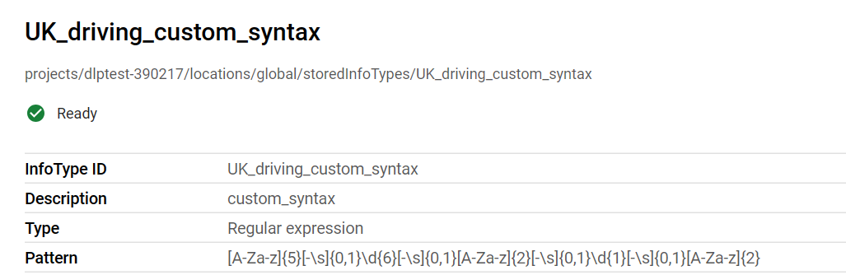
- [A-Za-z]{5}:

- [A-Za-z]: Matches any single alphabetical character, either uppercase (A-Z) or lowercase (a-z).
- {5}: The preceding pattern (in this case, the alphabetical character) must occur exactly 5 times. So, this matches five consecutive letters.

- [-\s]{0,1}: [-\s]: Matches either a hyphen (-) or a whitespace (\s). {0,1}: Specifies that the preceding pattern can occur 0 or 1 times, making it optional. This allows for the possibility of having (or not having) a space or a hyphen.

- \d{6}:\d: Matches any single digit (0-9). {6}: Specifies that the preceding pattern (a digit) must occur exactly 6 times. So, this matches six consecutive numbers.

- [-\s]{0,1}: This part looks for an optional space or hyphen.

- [A-Za-z]{2}: Matches two consecutive alphabetical characters, either uppercase or lowercase.

- [-\s]{0,1}: This part looks for an optional space or hyphen.

- \d{1}: Matches one single digit.

- [-\s]{0,1}: This part looks for an optional space or hyphen.

- [A-Za-z]{2}: Matches two consecutive alphabetical characters, either uppercase or lowercase.

    - UK National Insurance Syntax
Figure 5 is a screenshot of the custom info-type for a UK national insurance number that matches the test data format. The rule uses Google re2 syntax. It was essential to configure the rule so that neither of the first two characters can be D, F, I, Q, U or V. The second letter also cannot be O. The prefixes BG, GB, NK, KN, TN, NT and ZZ are not allocated to national insurance numbers.
Figure 5
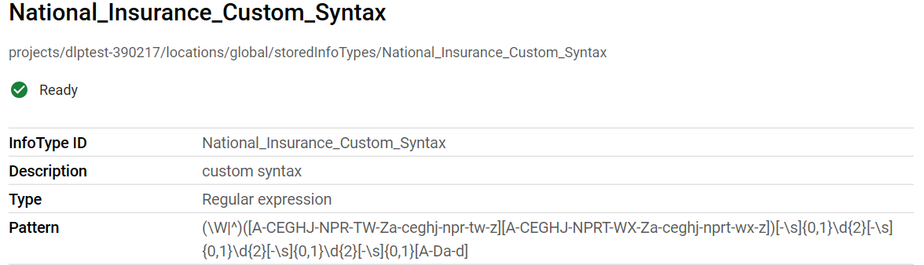
- (\W|^): \W: Any non-word character (not a letter, digit, or underscore). ^: The start of a line/string.

- [A-CEGHJ-NPR-TW-Za-ceghj-npr-tw-z]: Matches a single letter, either uppercase or lowercase, with some exclusions:

- Excludes: D, F, I, Q, U, V in uppercase and d, f, i, q, u, v in lowercase.

- [A-CEGHJ-NPRT-WX-Za-ceghj-nprt-wx-z]: Matches the second letter with similar constraints as the first but with additional exclusions for lowercase and uppercase:

- Excludes: D, F, I, O, Q, U, V in uppercase and d, f, i, o, q, u, v in lowercase.
- [-\s]{0,1}: Matches either a hyphen - or whitespace \s, occurring 0 or 1 times.

- \d{2}: Matches two consecutive digits.

- [-\s]{0,1}: Again, matches either a hyphen - or whitespace \s, occurring 0 or 1 times.

- \d{2}: Matches another two consecutive digits.

- [-\s]{0,1}: Matches either a hyphen - or whitespace \s, occurring 0 or 1 times.

- \d{2}: Matches yet another two consecutive digits.

- [-\s]{0,1}: Matches either a hyphen - or whitespace \s, occurring 0 or 1 times.

- [A-Da-d]: Matches a single letter, either uppercase or lowercase, from the set: A, B, C, D, a, b, c, d.

This is meant to match a specific pattern of letters and numbers, with particular constraints on which letters can appear and optional formatting characters like spaces or hyphens.

UK Passport Syntax

Figure 6 is a screenshot of the custom info-type for a UK passport that matches the format of the test data. The rule is using Google re2 syntax.
Figure 6
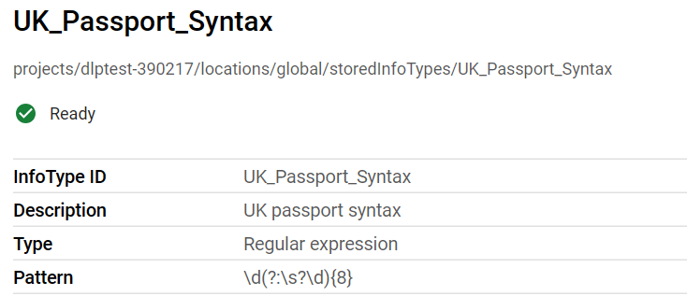
\d: Matches a single digit.
(?:\s?\d){8}: this matches eight occurrences of an optional space followed by a digit, for a total of nine digits.
This pattern is designed to match exactly 9 digits, whether they are spaced out or not to meet the format of the test data.

Test Results
A comprehensive testing phase was conducted. Each custom info-type underwent a series of 26 inspection jobs, for a total of 78 jobs across all custom info-types. The results were remarkably consistent, with each inspection job yielding identical results for every custom info-type. This reinforced the system's reliability of the detection mechanism. The stored info-types were also subjected to 26 inspection jobs, for a total of 78 jobs. The results were also consistent across all inspection jobs.

    - UK National Insurance Numbers
When redacting UK National Insurance Numbers, stored info-types were more successful than the created custom info-type. The results indicated that the custom info-type achieved redaction for 55 instances, whereas the stored info-type redacted 77 instances successfully. However, there were 51 instances where both custom and stored info-types failed to achieve redaction, potentially due to challenges in accessing and analysing the test data. The file types that were affected were .HTM and XML. It was notable that the instances where sensitive information went unredacted, with numbers of 127 and 105 for Custom and Stored Info-types, respectively. See below figure 7 for statistics and figure 8 for graph of results.
Figure 7
UK National Insurance Numbers
Action | Custom Info-type | Stored Info-type
Redaction | 55 | 77
Failure* | 51 | 51
No redaction | 127 | 105
Success Rate | 23.61% | 33.05%
Failure Rate | 76.39% | 66.95%
*Failure is due to being unable to open the file to analyse the test data. Issue might be corrupt file due to inspection job.
When comparing success rates, the custom info-type achieved a success rate of 23.61%, whereas the stored info-type demonstrated a higher success rate of 33.05%. Also, the failure rate for the custom info-type was 76.39%, while the stored info-type exhibited a lower failure rate of 66.95%.
Figure 8

Custom Info-type
The Figures are screenshots of examples of the before and after result of the inspection job. Figure 10 shows the data being replaced with <SENSITIVE_DATA_REMOVED>.

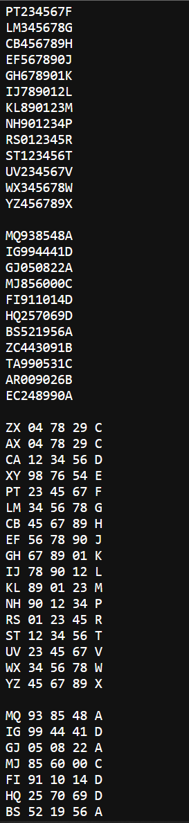
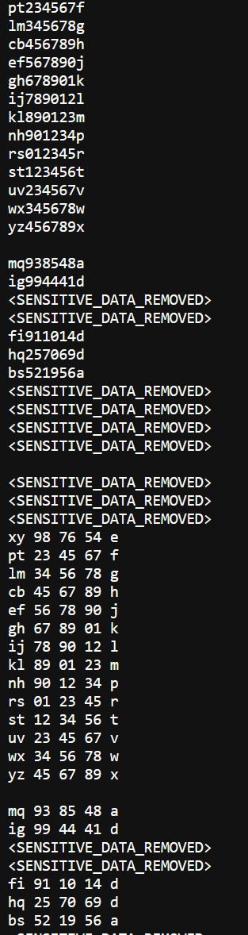
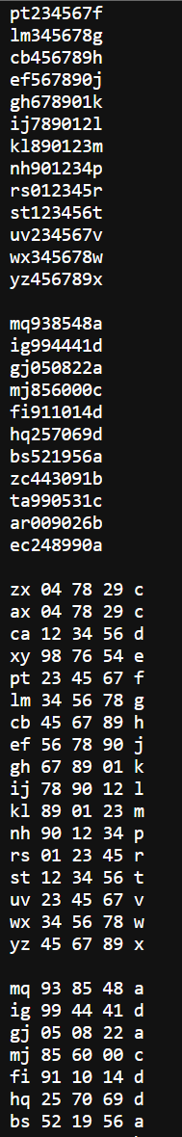
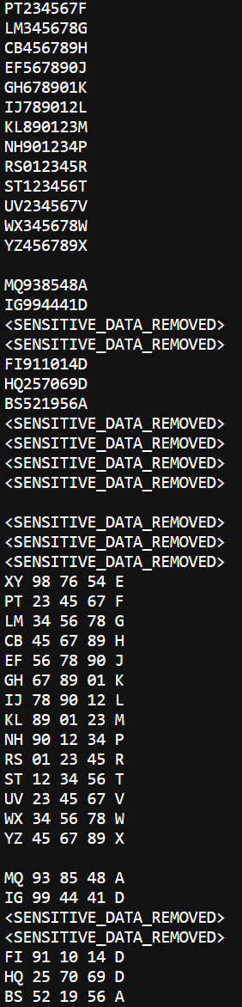
Figure 9 Figure 10 Figure 11 Figure 12

Stored Info-type
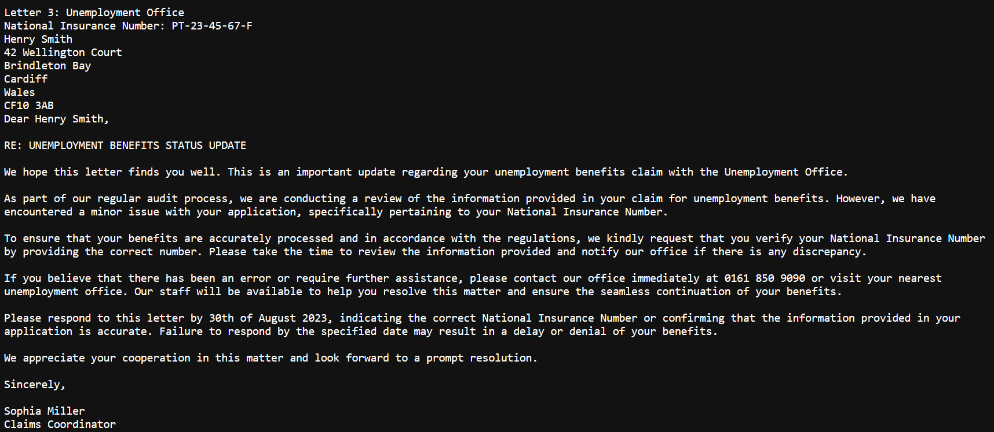
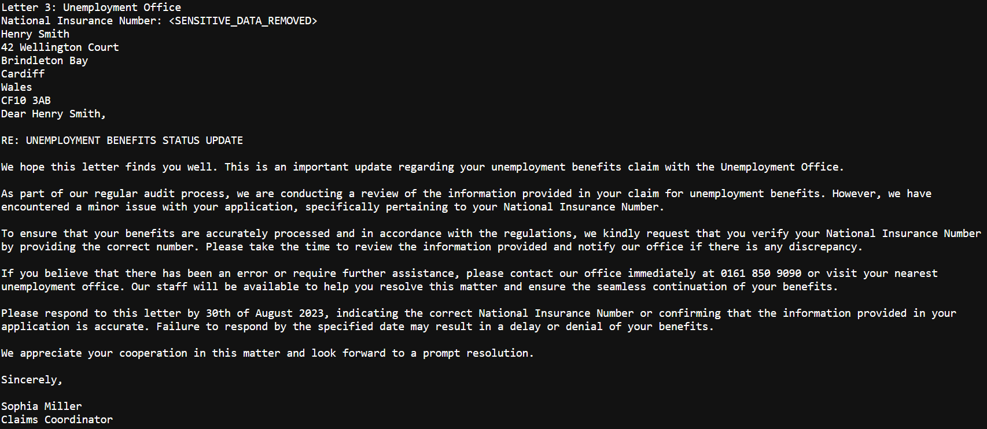
Figure 13

Figure 14

The Figures 15, 16, 17 and 18 are screenshots of the before and after result of the inspection jo on the test data stored in bulk. The screenshots show the data being replaced with <SENSITIVE_DATA_REMOVED>. The stored info-type below was not marginally successful in detection and removal.

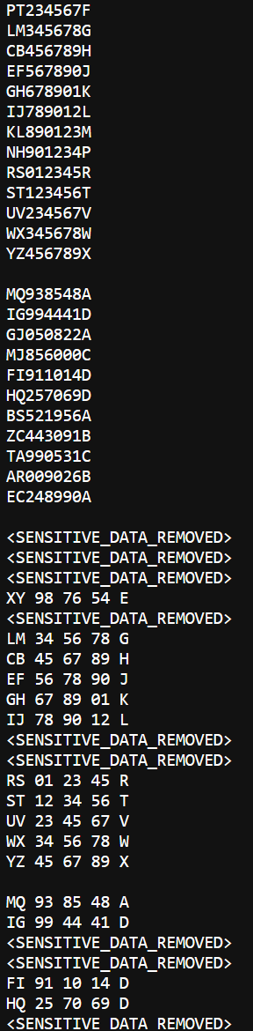
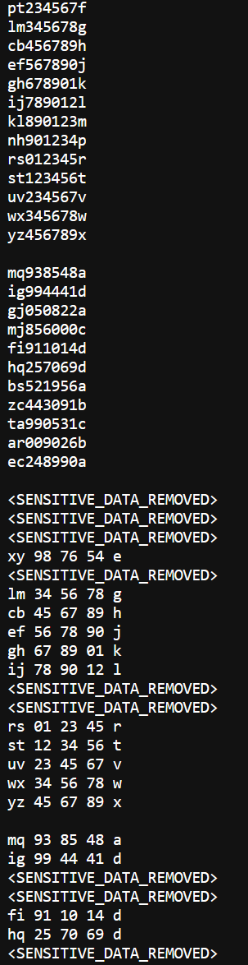
Figure 15 Figure 16 Figure 17 Figure 18
    - UK Driving Licenses

A sharp difference in the performance of both methods was observed for the redaction of UK Driving Licenses. The custom info-type excelled by redacting 213 instances, compared to the stored info-type's 19 instances of successful redaction. It is significant to note that the Stored Info-type left a large portion of data, 196 instances, without redaction, suggesting its unsuitability for this specific category. The custom info-type only failed to redact in two instances. See figure 19 for statistics and figure 20 for graph of results.
Figure 19
UK Driving Licenses
Action | Custom Info-type | Stored Info-type
Redaction | 213 | 19
Failure* | 40 | 40
No redaction | 2 | 196
Success Rate | 84.72% | 7.45%
Failure Rate | 15.27% | 92.54%
*Failure is due to being unable to open the file to analyse the test data. Issue might be corrupt file due to inspection job.

The success rate for the custom info-type was impressive at 84.72%, indicating its effectiveness in this context. On the other hand, the stored info-type achieved a relatively low success rate of 7.45%. The failure rate for the custom info-type stood at 15.27%, while the stored info-type's failure rate was notably higher at 92.54%. There were, however, 40 instances in which both custom and stored info-types failed to redact the sensitive data. This was the same issue encountered during the national insurance testing.

Figure 20

Custom Info-type
The below figures 21 and 22 are examples of redacted data from a custom info-type for UK driving licenses. The data being replaced with <SENSITIVE_DATA_REMOVED> in the subject and the body of the email has been removed but not replaced, so it shows as blank.

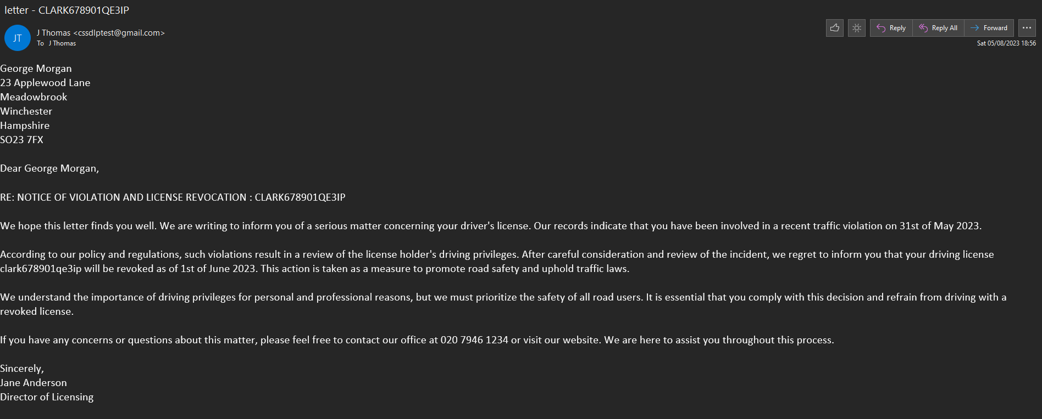
Figure 21

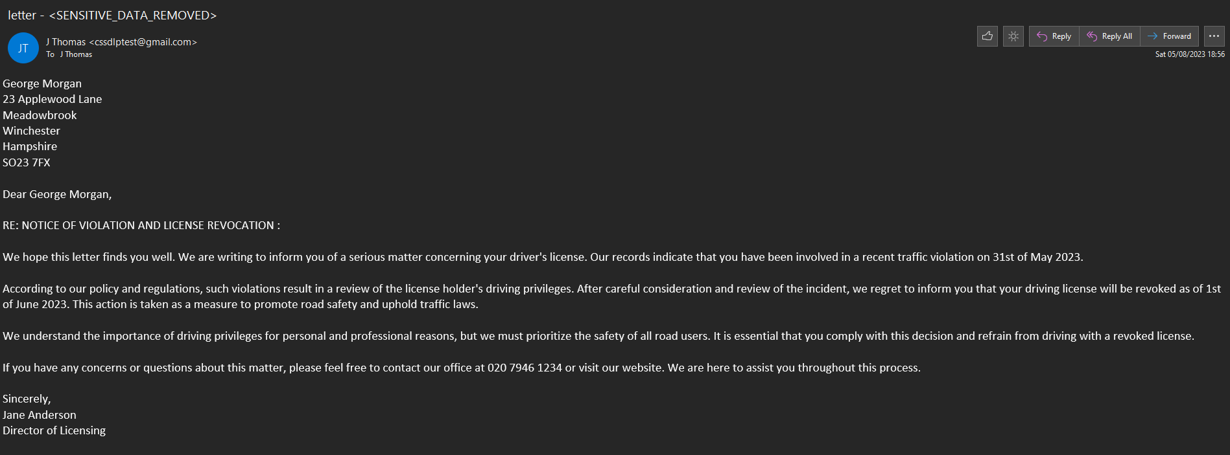
Figure 22

The bulk data sets in figures 23, 24, 25 and 26 shows the custom info-type has performed exceptionally well in removing and replacing the sensitive data.

Figure 23 Figure 24 Figure 25 Figure 26
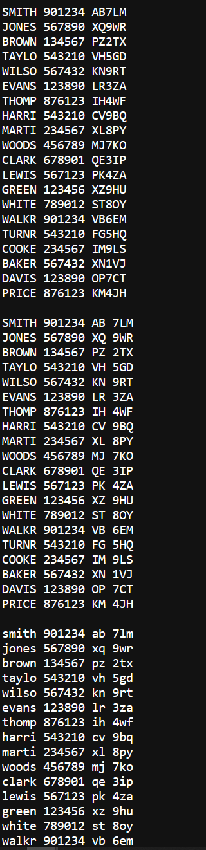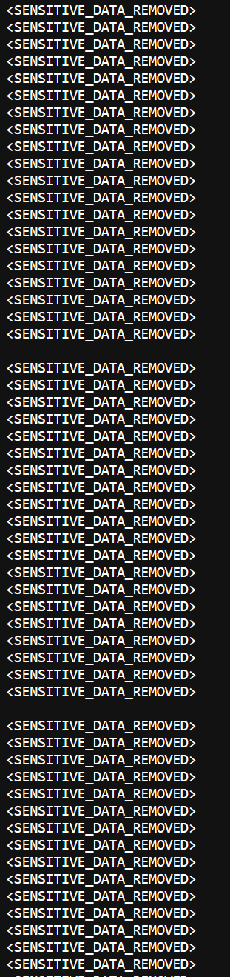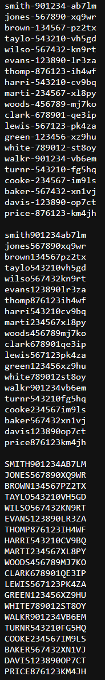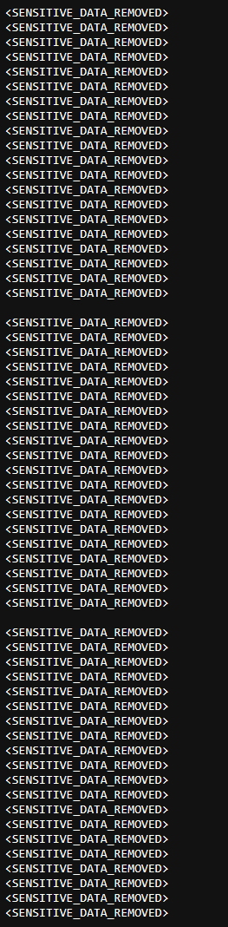

Stored Info-type
On the other hand, the stored info-type has performed poorly compared to the custom, as shown in bulk data sets in figures 27, 28, 29 and 30 below.

Figure 27 Figure 28 Figure 29 Figure 30
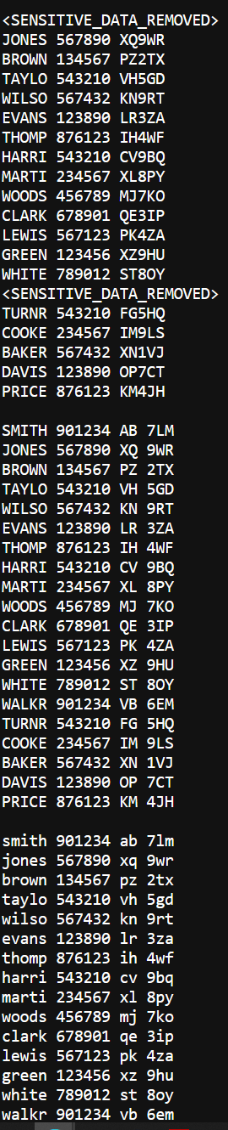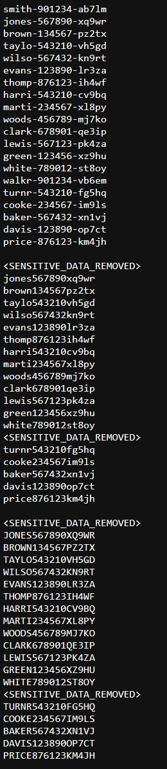

    - UK Passport Numbers

In the case of UK Passport Numbers, the custom info-type performed well, achieving redaction for 101 instances, while the stored info-type redacted nine instances. However, the stored info-type had 98 instances where the sensitive passport numbers remained unredacted, and the custom info-type failed only on six instances. Notably, the custom info-type was also associated with an "Incorrect Redaction" category for five instances, raising potential concerns about its precision. The info-type was picking up the phone number and was producing a false positive. See figure 31 for statistics and graph of result on figure 32.
Figure 31
UK Passport Numbers
Action | Custom Info-type | Stored Info-type
Redaction | 101 | 9
Failure* | 40 | 40
No redaction | 6 | 98
Incorrect Redaction | 5 | 0
Success Rate | 66.44% | 6.12%
Failure Rate | 33.55% | 93.87%
*Failure is due to being unable to open the file to analyse the test data. Issue might be corrupt file due to inspection job.

In terms of success rates, the custom info-type demonstrated a success rate of 66.44%, whereas the stored info-type had a success rate of 6.12%. The failure rates were 33.55% and 93.87% for the custom and stored info-types, respectively. Similar to the previous PII inspection job, 40 instances resulted in failed redactions due to issues accessing the test data.
Figure 32
Custom Info-type
The two screenshots below, figures 33 and 34 is an example of a successful redaction of passport number in a letter format.
Figure 33
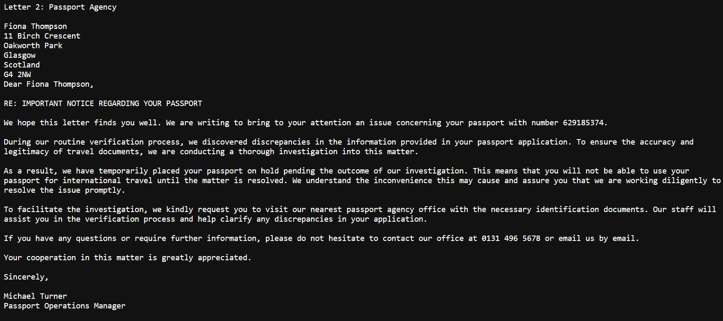
Figure 34
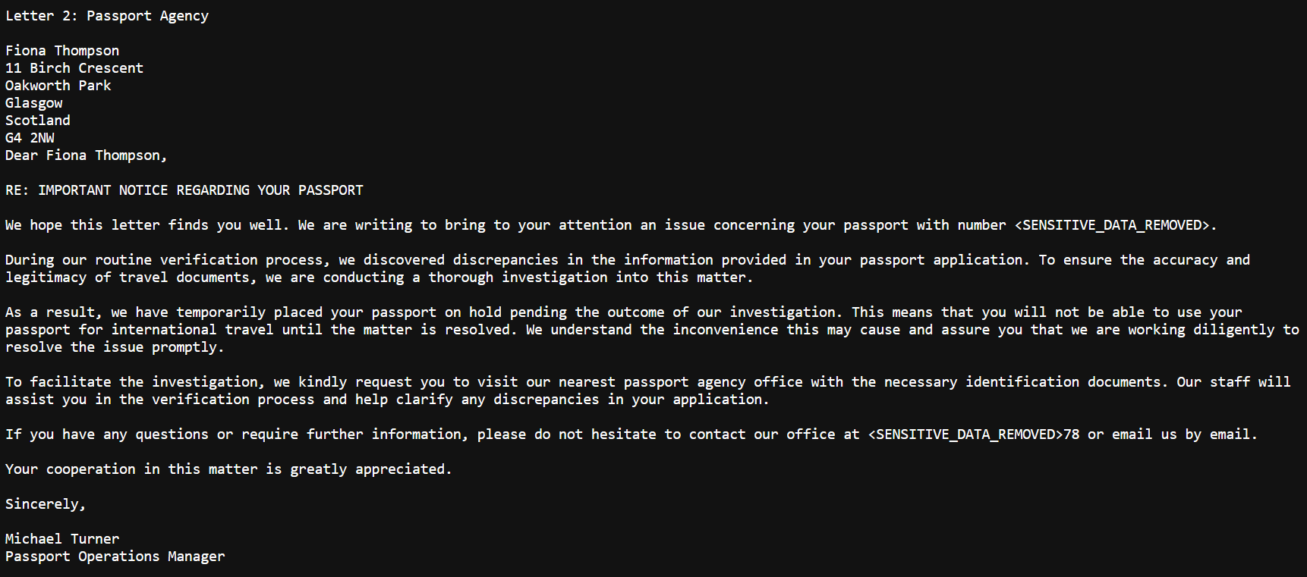

The custom info-type efficiently removed passport numbers from bulk storage on a plain text file, as shown in figures 35 and 36.
Figure 35
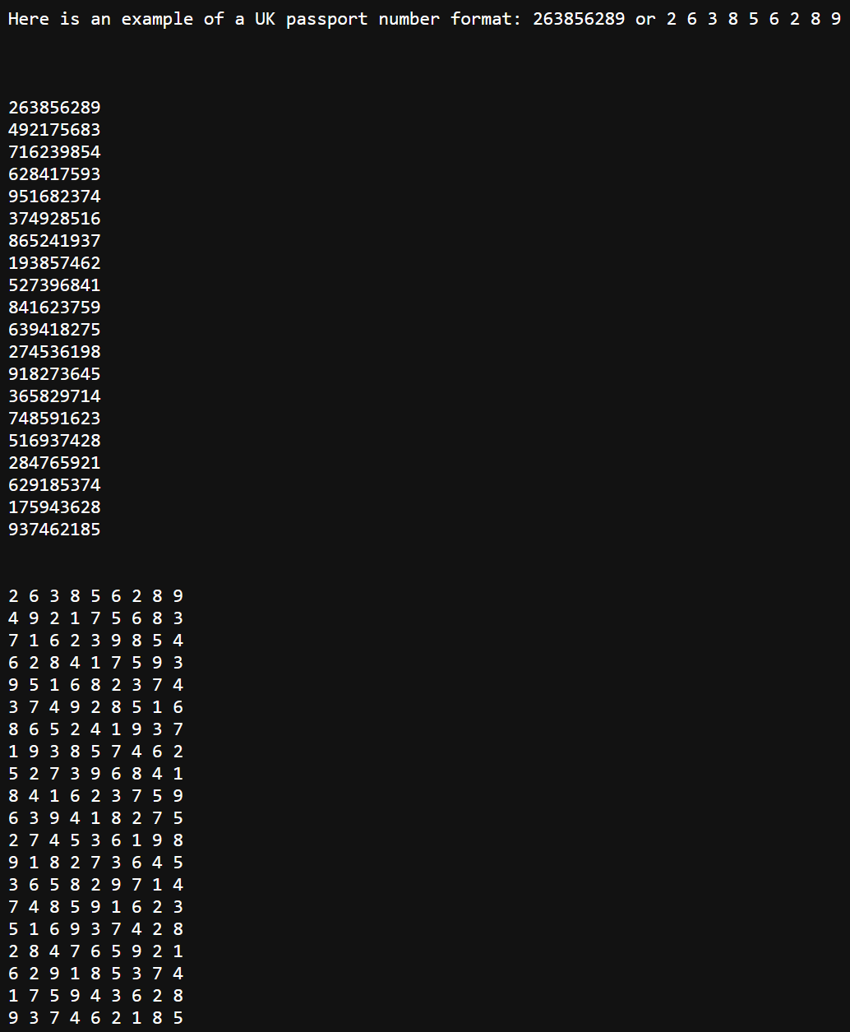
Figure 36
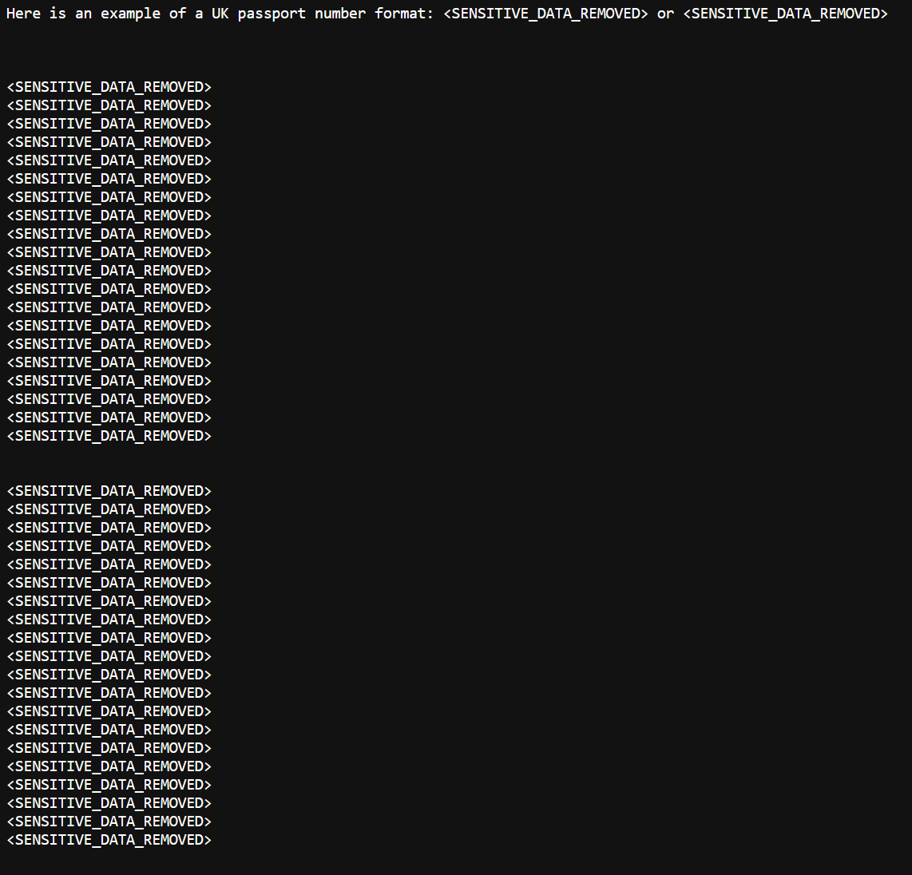
Stored Info-type
The custom info-type was not efficient at removing passport numbers as figures 37 and 38 shows only one data set being removed.
Figure 37
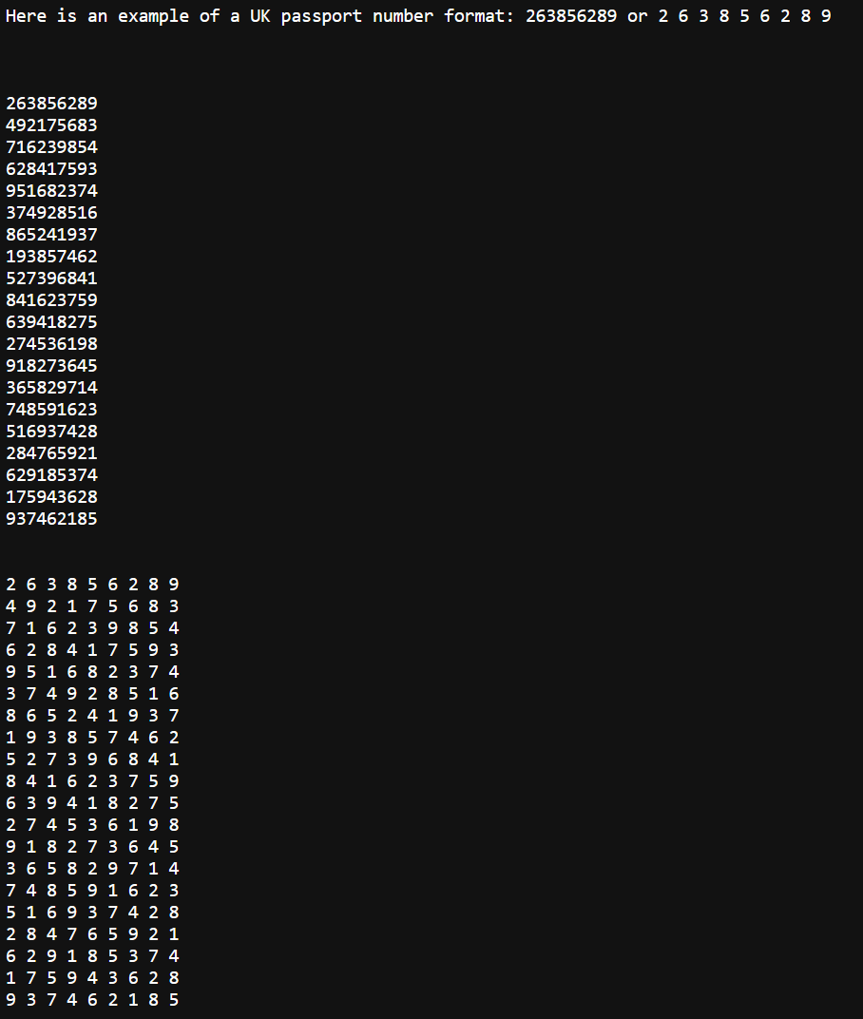

Figure 38
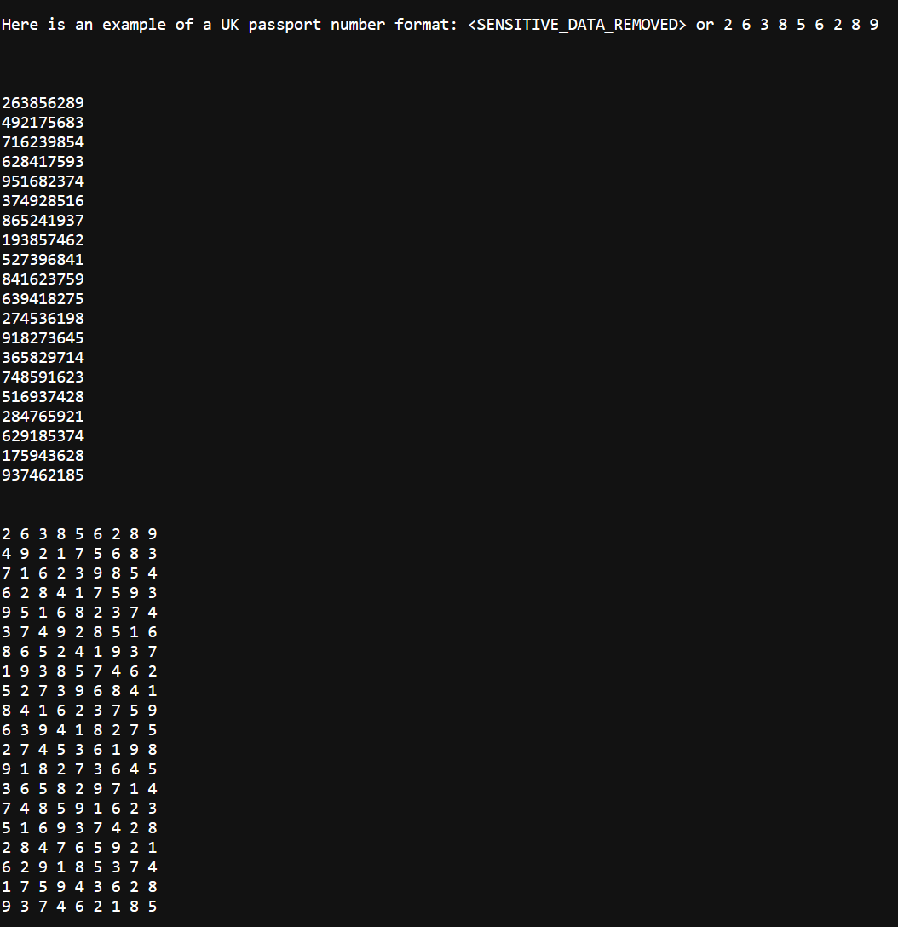
The results of the inspection jobs were mostly expected because the DLP solution was able to detect PII data from each of the three PII data types. The custom info-types performed better than the stored info-types. This was expected, as the custom info-types were configured specifically to UK formats.

One unexpected finding was how poorly the stored info-type for driving licenses performed. This was likely due to the fact that the stored info-type needed to be updated to reflect the latest changes to the UK driving license format.

Another unexpected finding was that the national insurance custom info-type performed marginally poorer than the stored info-type. Also, two file formats became corrupt after being scanned and copied for the inspection job to the scan result bucket. This resulted in a decrease in the success rate for both the custom info-types and the stored info-types.

Passport Numbers:

  - The success rate for redacting passport numbers using custom info-types is 66.44%, while the success rate for using stored info-types is 6.12%.

  - The failure rate for redacting passport numbers using custom info-types is 33.55%, while the failure rate for using stored info-types is 93.87%.

Driving Licenses:

  - The success rate for redacting driving licenses using custom info-types is 84.72%, while the success rate for using stored info-types is 7.45%.

  - The failure rate for redacting driving licenses using custom info-types is 15.27%, while the failure rate for using stored info-types is 92.54%.

National Insurance Numbers:

  - The success rate for redacting national insurance numbers using custom info-types is 23.61%, while the success rate for using stored info-types is 33.05%.

  - The failure rate for redacting national insurance numbers using custom info-types is 76.39%, while the failure rate for using stored info-types is 66.95%.

The outcomes from the analysis align coherently with the insights drawn from the literature review. The cloud-based Data Loss Prevention (DLP) system's efficacy is significantly enhanced when the DLP system is meticulously fine-tuned to cater to distinct data types that require protection. Rather than adopting a generalized approach, the emphasis on specific configurations proved pivotal, as supported by scholarly research. This symbiosis between observed evidence and theoretical research underscores the vitality of precision configuration in optimising the capabilities of cloud DLP systems.

Project Evaluation
There are several conclusions that can be drawn from the inspection job results. The custom info-types performed better than stored info-types for passport and driving license data sets. For the passport info-type, this is likely because the custom info-type was specifically designed to detect these types of data, while the stored info-types may need to be more comprehensive. The poor performance of the driving license stored info-type might be down to Google’s Cloud DLP not having the correct format for a UK driving license as shown in figure 39. This is something that should be investigated further to improve the accuracy of the DLP system. The opposite was true for national insurance numbers, with the stored info-type performing marginally better than the custom info-type.

Figure 39
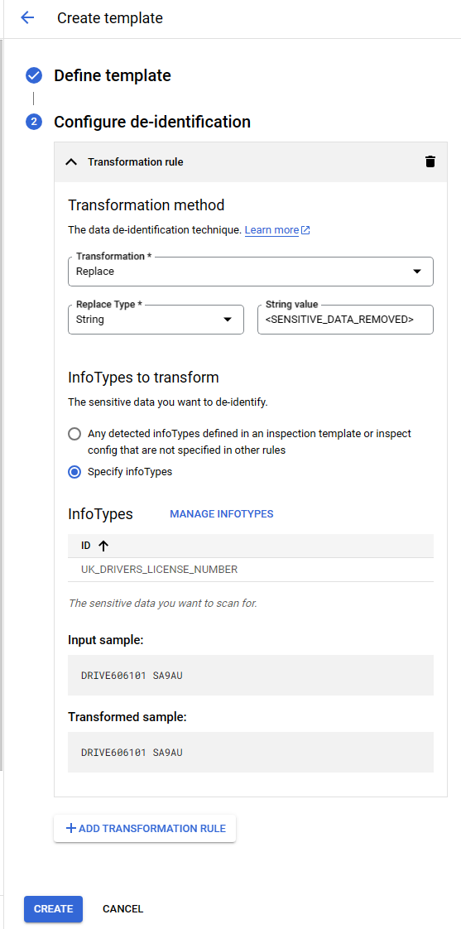

Each of the 156 inspection jobs was consistent in their results, with no inspection job result deviating from the others. This indicates that the DLP system performs consistently and that the results can be trusted. Corruption of the file formats, .HTM and .XML, caused a significant impact on the success and failure rates of each inspection job. See figure 40 for an example of an error encountered when trying to open the file.

Figure 40

The findings of each inspection job's custom and transformation were incorrect when each file was examined. See the below figures 41, 42 and 43 for examples of the incorrect findings/transformation.

Figure 41
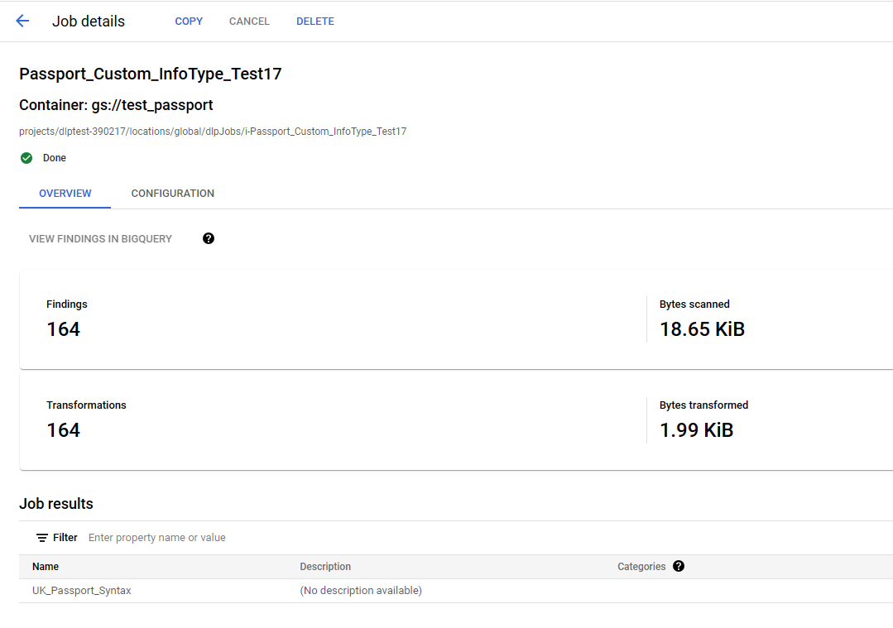

Figure 42
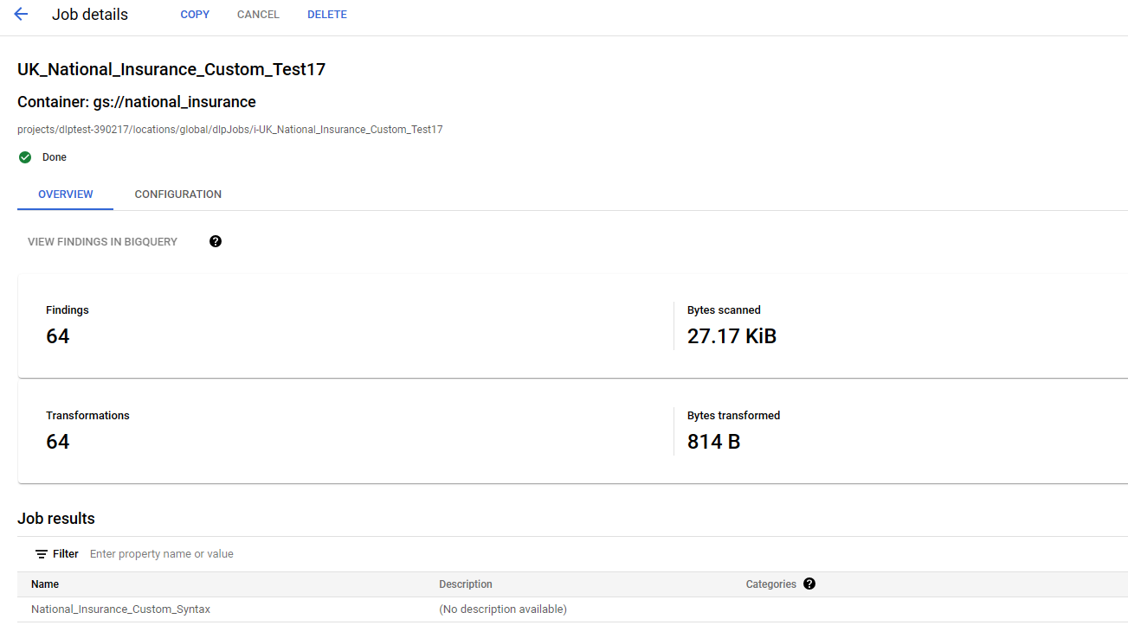

Figure 43
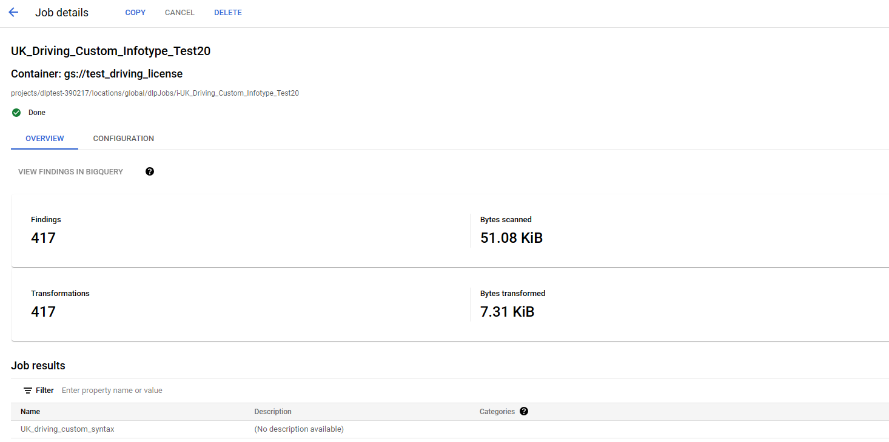

The literature review found that data loss prevention (DLP) can be an effective tool for mitigating the threat of data leaks. For example, article one concluded that cloud-based DLP can be an efficient way of spotting and remediating sensitive data. This was the case for some of the personally identifiable information (PII) that were tested, such as driving licenses. However, the performance of the DLP tool depended on the type of info-type used. A custom info-type performed well, but a stored info-type executed poorly.

Meeting the Project Objectives
The project met the objectives that were set out before implementing the cloud based DLP system.
To research and configure a cloud based DLP system to scan and detect specific sensitive data
A cloud-based DLP system was researched and configured to scan and detect specific sensitive data. The research identified a cloud DLP solution that met the project's requirements for functionality and cost. The cloud DLP system was successfully configured, deployed and has produced some positive results.
To determine how successful DLP implementation is at identifying and removing sensitive data.
The implementation of a DLP (Data Loss Prevention) solution was partially successful in identifying and removing sensitive data from a sample set of files. The DLP solution detected and removed 66.44% of passport numbers, 84.72% of driving licenses, and 23.61% of national insurance numbers from the sample set. The success rate for passport numbers and driving licenses was high, but the success rate for national insurance numbers was lower.
This is likely due to the fact that national insurance numbers custom and stored info-types require further tuning. Overall, the DLP solution successfully identified and removed sensitive data from the sample set, but there is room for improvement in the detection of national insurance numbers.
To devise methods for circumventing specific DLP control and construct recommendations against this.
The primary objective of was to develop effective methodologies for overcoming the Data Loss Prevention (DLP) info-types while generating recommendations to counteract such efforts. During the course of the project, there was a partial achievement in identifying instances where attempts were made to circumvent the DLP controls. The custom info-types were better at targeting data format irregularities, such as unexpected spaces and dashes. By identifying and rectifying these discrepancies, the system could disrupt patterns found in identifiers like driving licenses, national insurance numbers, or passport numbers.
However, it is essential to acknowledge that the project's scope only enabled the detection and counteraction of only specific circumvention techniques. While the custom info-types effectively addressed the identified irregularities, a more exhaustive examination is necessary to uncover alternative methods that could potentially be exploited to bypass DLP detection. In other words, the project's success in countering specific evasion techniques did not achieve a comprehensive solution against all potential threats.
Furthermore, the DLP system could encounter real world limitations in terms of tackling more intricate methods that could be employed to evade DLP detection. As the project's findings suggest, the employed custom info-types were proficient in managing straightforward anomalies in data patterns. Yet, it is crucial to recognise that adversaries aiming to breach DLP controls might devise more complex strategies to circumvent detection. Such sophisticated approaches could involve the utilisation of advanced obfuscation techniques or the exploitation of less apparent vulnerabilities.
The project's aim in detecting and addressing irregularities in data patterns highlights the potential of employing tailored solutions like custom info-types and stored info-types to mitigate specific threats. Nonetheless, the project's findings also underscore the necessity for continued research and development to uncover more elaborate evasion techniques that could pose challenges to DLP systems. While the current methodology represents a significant step toward safeguarding sensitive data, the pursuit of comprehensive solutions must remain ongoing to stay ahead of evolving threats in the realm of data security.

Meeting the Project Aim
The research project has successfully achieved its designated aim: to showcase the specific function of DLP to protect and remove sensitive data. This project's primary focus was emphasising DLP's efficacy in eradicating test data.
However, despite the project's overall success in achieving its intended purpose, certain limitations surfaced in the DLP system's performance. While the system demonstrated competence in removing the detected test data in most instances, it encountered difficulties and did not redact the test data. These instances revealed a gap in the DLP system's capabilities as it struggled to remove the PII data effectively. Despite these limitations, the project was successful in meeting its aim. This demonstrates that DLP systems can be effective in protecting sensitive data. However, it is important to note that DLP systems are not perfect, and they can miss sensitive data.

Project Evaluation for Future DLP Research
The results of the DLP evaluation were generally as expected. The DLP solution was able to detect sensitive data when the rules were configured correctly. The comprehensive evaluation underscores the anticipated pattern in most aspects, affirming the efficacy of meticulous rule customization in the DLP system's operational effectiveness. However, a few things could be done differently if the project was done again.

Firstly, it would be prudent to assign more time to the project to enable a more extensive review and customisation of the custom info-type rules, especially for national insurance numbers. The current rule is not effective at detecting and removing sensitive data types, but there could be further improvement by adding more specific patterns and keywords. This would ensure that the DLP system can catch even the most subtle attempts to exfiltrate this data.

Secondly, the expansion of the test so that more of the DLP's supported file formats could be included. The current test only covers a limited number of file types, so that the system efficiency may be affected by the different text-based formats. By expanding the test, the individual would better understand how the DLP system performs with varying types of data.

Thirdly, the exploration of the detection and removal of sensitive imagery. The current DLP system was only configured to detect and remove the loss of text-based data. Recognising that sensitive data can also be stored in images is essential. By exploring the detection and remediation of imagery, the project could make the DLP system more comprehensive and protect against a broader range of data loss threats.

Fourthly, investigating the issue that caused problems opening the files to review the test data impacted the results. More time to explore the reason for the file corruption would have allowed for a better analysis of the DLP performance in terms of scanning and taking action on PII that was identified.

Finally, the exploration of other forms of personally identifiable information (PII) that the DLP system could protect. The current system is only designed to protect passport and national insurance numbers. However, many other types of PII could be at risk of loss, such as credit/debit card information, financial information, addresses, and contact information. Exploring the detection and remediation of these other forms of PII would make the DLP system even more valuable to the organisation.

Overall, the DLP project and its test results were an essential contribution to the cyber security team. However, it is apparent that the project could have been even more far-reaching by instigating the changes noted below.

- Assign more time to the project to allow for a more extensive review and customisation of the custom info-type rules.

- Expand the test to include more of the DLP's supported file formats.

- Explore the detection and remediation of imagery.

- Explore issues encountered by file corruption on the data file scanned.

- Explore other forms of PII that the DLP system could protect.

By implementing these changes, the DLP system could have better protected the organisation's sensitive data from loss or exposure.

Conclusion
Overall, the project was successful in achieving its objectives of researching and configuring a cloud-based DLP system to scan and detect specific sensitive data, determining how successful DLP implementation is at identifying and removing sensitive data and devising methods for circumventing specific DLP controls and constructing recommendations against this.
The project results for passport numbers and driving licenses showed that custom info-types showcased a significantly higher efficiency. For passport numbers, the success rate for the custom info-type stood at 66.44%, compared to a poor 6.12% for the stored info-type. Similarly, the driving licenses data set recorded a success rate of 84.72% for the custom info-type, which was markedly higher than the 7.45% recorded for the stored info-type. A significant discovery was regarding the driving license format for the stored info-type. The poor performance of the stored info-type for driving licenses might be attributed to the DLP system's format not aligning with that of a UK driving license. Google needs to update the driving license pattern to match the actual pattern of a UK license number. This should be of high importance to Google UK as this could impact UK-based customers utilising DLP for their PII data.
However, it's noteworthy that for national insurance numbers, the stored info-type fared marginally better than the custom info-type, with success rates of 33.05% and 23.61%, respectively. There could be errors in the re2 regex syntax used for national insurance that requires further configuration.
The rigorous process comprised 26 inspection jobs, summing up to a total of 156. A respectable consistency was maintained as no variation was noted among the results of these inspection jobs. It was also discerned that corruption of specific file formats, notably HTM and XML, had a profound influence on the success and failure rates of each inspection job.
The project evaluated the efficiency of cloud-based data loss prevention (DLP) for text-based PII data. As the evaluation concluded, potential areas of exploration emerged that could provide a broader understanding of data protection in cloud environments.
One significant inquiry was the possible need for further investigation into the detection and remediation of imagery. While the current study concentrated primarily on textual PII data, imagery often contains sensitive information that, when left unprotected, poses risks to an organisation's data security. Delving deeper into the challenges and solutions of protecting images can offer a more comprehensive view of DLP's capability in cloud settings.
In addition, the expanding the scope of the PII that was used. It should be worth investigating how efficient cloud DLP could be in detecting and remediating financial details, addresses, email addresses, or contact numbers.
The key role of custom info-type rules within a DLP system warrants deeper exploration. The project highlighted the advantages originating from the examination and tailored adjustment of these rules. Tailoring these regulations enables organisations to sharpen the precision and operational efficacy of the DLP system. This ensures a tighter alignment with organisational requirements, thereby curtailing false positives. Researching the most effective methods for rule customisation could be vital for institutions aiming to harness the full potential of their DLP strategies.

References

[1] | M. K. Pratt, "The importance of data security in the enterprise," August 2022. [Online]. Available: https://www.techtarget.com/searchsecurity/feature/The-importance-of-data-security-in-the-enterprise. [Accessed 14 June 2023].
[2] | T. O. o. C. (Ofcom), "Cloud services market study - Interim report," The Office of Communications, 2023.
[3] | P. Schroeder, "Equifax's $700 million data breach settlement spurs criticism, calls for new rules," The Thomson Reuters, 22 July 2019. [Online]. Available: https://www.reuters.com/article/cbusiness-us-equifax-cyber-settlement-idCAKCN1UH16Y-OCABS. [Accessed 10 July 2023].
[4] | D. Milmo, "Electoral Commission and PSNI data breaches: what we know so far," The Guardian, 09 August 2023. [Online]. Available: https://www.theguardian.com/politics/2023/aug/09/electoral-commission-and-psni-data-breaches-what-we-know-so-far. [Accessed 09 August 2023].
[5] | P. a. L. C. a. C. J. a. D. S. a. P. H. a. C. Z. a. F. B. Han, "CloudDLP: Transparent and Scalable Data Sanitization for Browser-Based Cloud Storage," IEEE Access, vol. 8, pp. 68449-68459, 2020.
[6] | S. M. J. B. Shahnawaz Ahmad, "Cloud security framework and key management services collectively for implementing DLP and IRM," Materials Today: Proceedings, Vols. 62, Part 7, pp. 4828-4836, 2022.
[7] | E. a. F. D. a. E. S. a. d. H. J. a. Z. N. Costante, "A Hybrid Framework for Data Loss Prevention and Detection," 2016 IEEE Security and Privacy Workshops (SPW), pp. 324-333, 2016.
[8] | J. J. G. A. J. R. D. S. M. C. I. d. l. T. D. &. J. J. P. C. R. Isabel Herrera Montano, "Survey of Techniques on Data Leakage Protection and Methods to address the Insider threat," Cluster Computing, vol. 25, p. 4289–4302, 2022.
[9] | F. Middleton, "The 4 Types of Reliability in Research | Definitions & Examples," Scribbr , 26 August 2022. [Online]. Available: https://www.scribbr.co.uk/research-methods/reliability-explained/. [Accessed 01 July 2023].
[10] | UK Government, "Proof of identity checklist," UK Government, 23 September 2020. [Online]. Available: https://www.gov.uk/government/publications/proof-of-identity-checklist/proof-of-identity-checklist. [Accessed 01 July 2023].
[11] | C. Bernstein, "personally identifiable information (PII)," TechTarget, February 2023. [Online]. Available: https://www.techtarget.com/searchsecurity/definition/personally-identifiable-information-PII. [Accessed 19 July 2023].
[12] | Google, "Solve real business challenges on Google Cloud," Google, [Online]. Available: https://cloud.google.com/free. [Accessed 01 April 2023].
[13] | Google, "InfoType detector reference," Google, [Online]. Available: https://cloud.google.com/dlp/docs/infotypes-reference. [Accessed 01 April 2023].
[14] | Google, "Custom infoType detectors," Google, [Online]. Available: https://cloud.google.com/dlp/docs/creating-custom-infotypes. [Accessed 02 April 2023].
[15] | Google, "Default encryption at rest," September 2022. [Online]. Available: https://cloud.google.com/docs/security/encryption/default-encryption. [Accessed 20 July 2023].
[16] | NI Business Info, "Cloud computing," NI Business Info, [Online]. Available: https://www.nibusinessinfo.co.uk/content/disadvantages-cloud-computing. [Accessed 12 June 2023].

