  Component One:  What are the key skills required when working in the housekeeping team? | Student No: | 2126642
 | Module Title: | Operating Hotel Facilities
 | Module Code: | BMIH4006
 | Lecturer: | Kathryn Roberts
The provision of housekeeping services is an essential component of the hospitality industry. This is because it ensures that visitors have a nice and tidy setting in which to unwind during their stay. The cleaning crew is responsible for keeping the hotel clean, which can have an indirect yet direct impact on the level of satisfaction experienced by the hotel's guests. Because cleaning is such important work, the people who do it need to have a wide variety of specific skills in order to do their jobs well. This Journal will focus on the most essential characteristics that one must possess in order to be successful on a cleaning team (Ingram, 2019).
Attention to details
It is essential for every member of the cleaning team to have the capability of paying meticulous attention to detail. It is the first step in ensuring that guests have a pleasant stay and are able to unwind in a comfortable environment (Ingram, 2019). I have found that a watchful eye may spot even the tiniest of flaws and make sure that each and every one of them is addressed and remedied. Because of this ability, one may rest assured that the location is spotless and free of any debris that could harbor germs.
Time management and multitasking
Working in housekeeping requires multitasking skills because of the variety of tasks that need to be completed at once. As visitors check in and out throughout the day, the cleaning staff needs to be able to efficiently manage their time in order to keep up with the cleaning schedule and ensure that the rooms are cleaned on time. In order to do this successfully, one needs to be able to organize their priorities and switch between tasks effectively in order to maintain the hotel's regular high level of operation. In order to guarantee that everything is completed and that no part of the house is neglected, it is essential to create a schedule and keep track of one's responsibilities (Pongsiri, 2018).
Physical stamina
In the field of housekeeping, it is necessary to have the strength to move heavy objects and the stamina to stand for extended periods of time (Jones, 2019). To be able to tackle the challenges of their roles, employees need to be in good health and able to retain high levels of energy throughout the day. Because housekeeping is a physically demanding career, individuals who work in the industry are required to be in good physical shape in order to put in the required amount of time and effort each day (Sanon, 2019).
Effective communication
Workers in the housekeeping department are expected to have strong communication skills, not only with their immediate coworkers but also with their management and the consumers they serve. They have to have the ability to report issues, such as products that are missing or equipment that is not working properly. It is absolutely necessary for the staff to convey any specific demands that the guests may have in order for them to have a stay that is pleasant and pleasurable. It is vital to have the ability to communicate clearly with guests, coworkers, and management in order to successfully manage schedules, change cleaning schedules, and provide guests with all pertinent information (Brody, 2021).
Flexibility
In the hospitality industry, it is common practice to make last-minute adjustments to cleaning schedules as well as other schedules. If the hotel wishes to maintain its high standards, the housekeeping staff needs to be able to adapt to new situations in a prompt and efficient manner. You will need to be capable of working well both alone and cooperatively in order to complete everything within the allotted time (Ingram, 2019).
Customer Service Skills
The personnel in the housekeeping department may not have as many opportunities to make guests happy as the staff of other departments in the hotel, but they are nevertheless crucial to the provision of a satisfactory stay (Schneider and Tucker, 2020). The standard of the hotel's rooms can have a positive or negative impact on the establishment's overall reputation. Because of this, it is extremely vital for personnel who are responsible for cleaning to have exceptional people skills, so that customers who come to your business never feel anything other than welcome (Brody, 2021).
To summarize, the housekeeping crew is responsible for ensuring that the guest rooms and common areas are always clean and comfortable. This is a crucial duty in the hospitality industry. To be successful on a housekeeping crew, you will need to improve your skills in a number of critical areas, such as attention to detail, time management, physical stamina, the capacity to adjust, clear and effective communication, adaptability, customer service, and safety and security.

Word Count | 787

Component Two:
In this scenario – You have just been promoted to team leader for a floor within the hotel. A guest complains that on their arrival, their room had not been properly cleaned. Create an action plan and answer the following questions.
Action Plan

Problem | Why did it happen? | What are you going to do? | How will you prevent this from happening in the future? | What measures would you introduce to improve team effectiveness?
The visitor asserts that when they arrived, they discovered that their accommodation had not been cleaned. | It's possible that this was caused by the cleaning staff misinterpreting the instructions or failing to communicate effectively with one another. Also the lack of communication raise the situation where the staff was not informed (Brody, 2021). | As the head of the team, it is my duty to quickly extend an apology to the customer and make a suggestion that the room be cleaned in accordance with their particular requirements. I will check into it to determine what went wrong and then make the necessary adjustments (Sanon, 2019). | I will be putting together a cleaning team checklist in order to make certain that each and every room is immaculate before the arrival of our guests. I will be in charge of providing ongoing training for the staff, during which I will emphasize the significance of maintaining cleanliness and paying close attention to detail (Brody, 2021). | I have an idea for a program that would give bonuses and other forms of recognition to workers who consistently go above and above the requirements of their jobs. In addition, I believe it's essential for the members of the team to feel at ease approaching one another to discuss any issues that may crop up while they're working together (Ingram, 2019).
The guest stated that they arrived to find the accommodation in a less than clean condition. | It's likely that this is the result of the manager of the team not providing adequate leadership and monitoring for the group. And for the irresponsible of manager the staff got the chance to bunk their duty (Tuzon–Guarin, 2016). | As the head of the team, the first thing I will do is apologize to the customer and offer to have the room re-cleaned according to any specific instructions they may have provided. In addition, I will investigate the matter to determine what went wrong and then I will correct the problem. In addition to that, I shall not waste any time in having the obtainable staff members clean the room (Jones, 2017). | In order to forestall occurrences such to the one that just took place, I will implement a procedure for conducting routine checks on the members of the cleaning staff to ensure that they are adhering to the criteria that have been established. When it comes to the staff, I will make certain that they have everything they require in order to perform their duties to the best of their abilities (Sanon, 2019). | If it were up to me, I would make it a requirement for all employees to attend a mandatory training session once a month in order to ensure that everyone is current on the most recent developments in janitorial care. To that end, I believe it is essential for members of the team to communicate well with one another and to pitch in whenever assistance is required (Pongsiri, 2018).
The guest stated that they arrived to find the accommodation in a less than clean condition. | It's likely that the people in charge of cleaning aren't very motivated, or that the directions for cleaning aren't very clear. | As the head of the team, the first thing I will do is apologize to the customer and offer to have the room re-cleaned according to any specific instructions they may have provided. In addition, I will investigate the matter to determine what went wrong and then I will correct the problem. In addition to that, I shall not waste any time in having the obtainable staff members clean the room. | It is my intention to provide the employees with a comprehensive set of cleaning instructions so that we can prevent future incidents that are analogous to those we have experienced. In addition, I will provide them with motivation and guidance by emphasizing the relevance of their contribution to the success of the company as a whole, namely the satisfaction of the customers who pay to be there. Those customers are the ones whose presence is being paid for. | If it were up to me, I'd set up an evaluation and commenting system that would be standard across the board to ensure that every member of the team is pulling their weight. In addition, I would work to foster a culture of continuous improvement by encouraging people to expand their skill sets and take on larger responsibilities during their time with the company.

Component Three:
Presentation
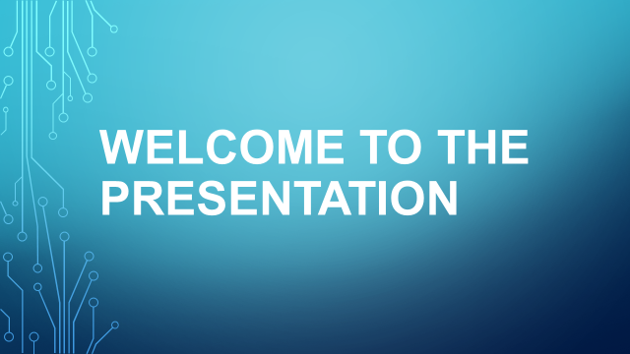
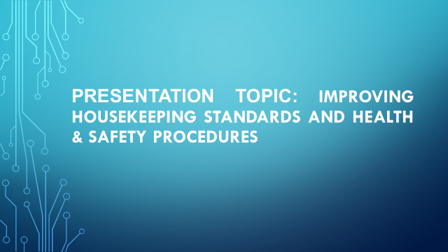
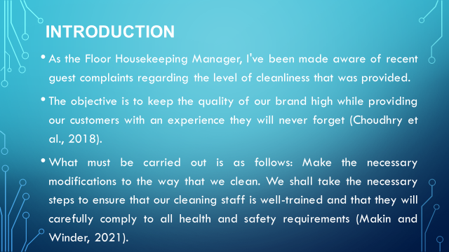
Training Notes: As the Floor Housekeeping Manager of our establishment, it has been brought to my notice that there have been recent guest complaints regarding the level of cleaning that is provided at our property. In order to uphold the standards of our brand and provide a stay that is enjoyable for our customers, it is essential for us to make the necessary improvements, provide our cleaning staff with extensive training, and strictly follow to all applicable health and safety requirements (Makin and Winder, 2021).
As the Floor Housekeeping Manager, I've been made aware of recent guest complaints regarding the level of cleanliness that was provided.
The objective is to keep the quality of our brand high while providing our customers with an experience they will never forget (Choudhry et al., 2018).
What must be carried out is as follows: Make the necessary modifications to the way that we clean. We shall take the necessary steps to ensure that our cleaning staff is well-trained and that they will carefully comply to all health and safety requirements. Benefits: increased levels of devotion and patronage. Enhanced opportunities for comments and ratings Because of this, the standing of our company has improved. In a nutshell, we are well aware that the key to our continued success is in our commitment to achieving and sustaining the highest attainable levels of cleanliness and hygiene. It is imperative that we give our best effort as a team in order to satisfy our guests (Makin and Winder, 2021).

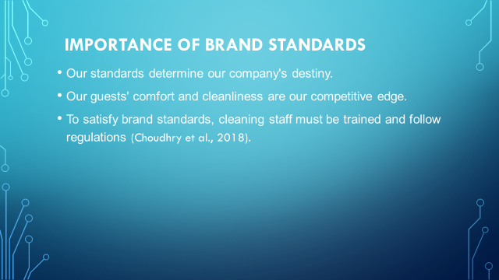
Training Notes: The maintenance of high standards for our brand is critical to the ongoing prosperity of our company. The fact that we give the highest standards of cleanliness and comfort to our guests is the primary differentiating factor between us and the other businesses in our industry. In order to maintain and meet the standards set for our brand, we need to make certain that our cleaning staff has received adequate training and that they consistently adhere to all of the necessary processes (Choudhry et al., 2018).
Maintaining High Standards for Our Brand
Our capacity to live up to our expectations will determine the trajectory of our company's future success. We believe that the best way for us to differentiate ourselves from other businesses is by offering our customers with the cleanest and most pleasant environment possible. If we want to keep up with and fulfill the requirements for our brand, the staff in the cleaning department need to receive the right training and continue to follow the guidelines.
Our quick expansion in this industry has been made possible, in large part, by the fact that we are committed to going above and beyond our clients' expectations in terms of comfort and cleanliness. We are aware that if we maintain our financial investment in the training and professional development of our maintenance staff, we will be able to ensure the continued prosperity of our business (Choudhry et al., 2018).

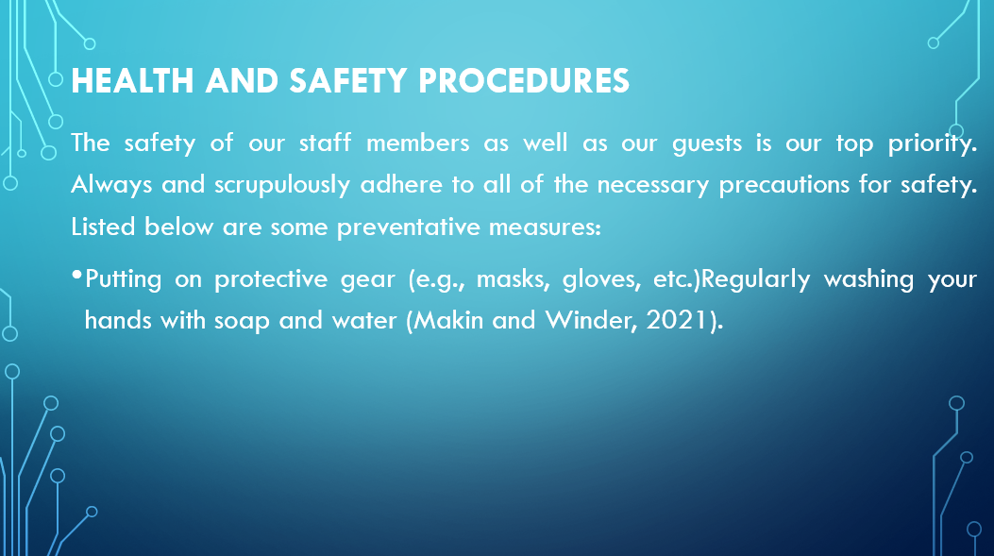
Training Notes: Guidelines for the Promotion and Protection of Everyone's Health and Safety Above all else, we prioritize the health and safety of our staff as well as the guests who come to our facility. It is imperative that we take and strictly adhere to any and all relevant precautions regarding health and safety at all times. Doing this step necessitates taking precautions such as putting on protective clothing, cleaning up after yourself, and disposing of rubbish in the appropriate containers (Makin and Winder, 2021).
According to the statement, the primary focus should be on ensuring the well-being and safety of both the workforce and the public. Every single precaution and safety step needs to be taken very carefully. If you want to steer clear of any issues, try doing these instead:
- The use of protective gear such as masks, gloves, and other things can be an effective method for reducing the risk of contracting dangerous bacteria and viruses.
To engage in practices that promote personal cleanliness, such as routinely washing one's hands with soap and water: Maintaining proper hand hygiene is among the most effective methods available to halt the propagation of disease.

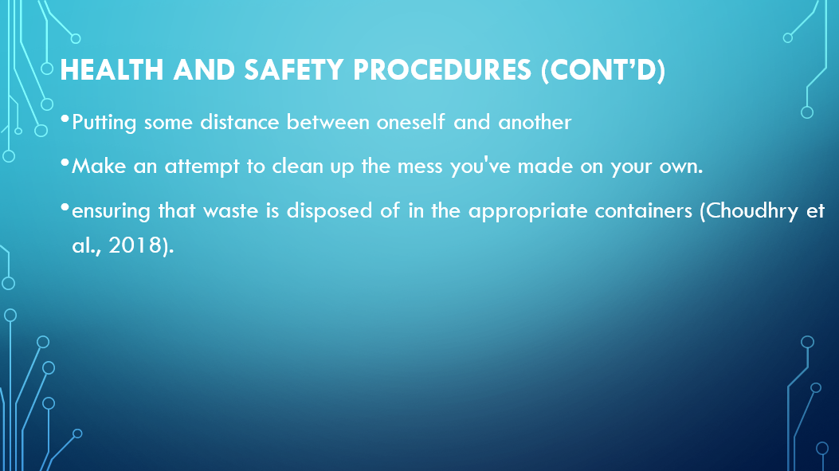
- Training Notes: Putting distance between oneself and another: A preventative measure that can be taken to reduce the risk of an infectious disease passing from one person to another is to physically isolate those who come into close contact with each other (Choudhry et al., 2018).
- Make an effort to find a solution on your own to the problems you've caused: In order to effectively combat infectious bacteria and viruses, it is essential to take this safety measure. By clearing up the debris, you reduce the likelihood that there will be more contamination.
- Assuring that trash is disposed of in the appropriate containers: This safety measure is absolutely necessary in order to put a stop to the spread of diseases that are carried by rubbish. People's risk of being exposed to toxic substances can be reduced if waste is disposed of in the appropriate containers (Choudhry et al., 2018).
- Following each of these steps will help to guarantee that your place of business is a safe and healthy environment for the people who work there as well as anyone who comes to visit (Choudhry et al., 2018). A stringent commitment to these regulations is required in order to ensure the health and safety of everyone engaged.

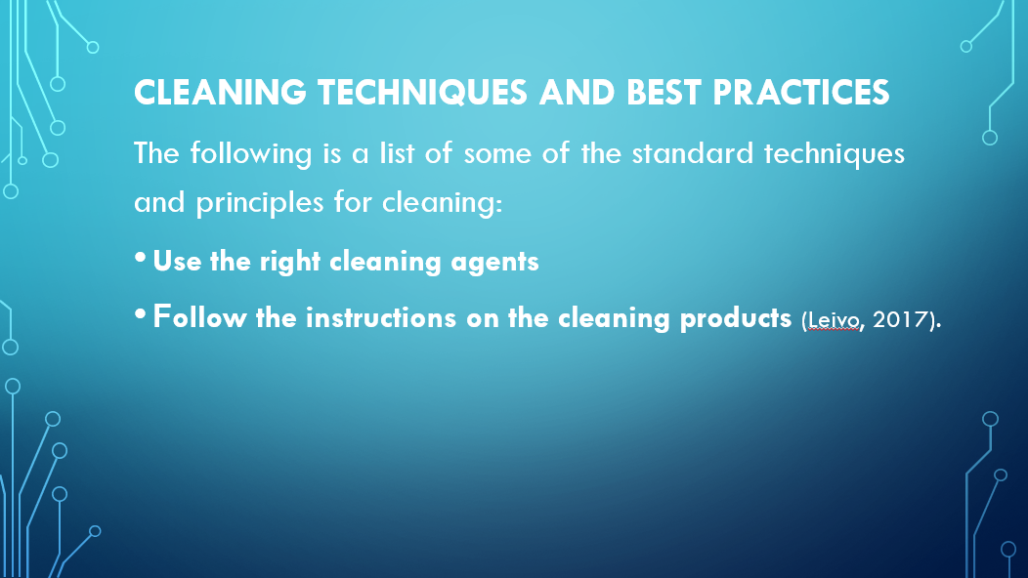
Training Notes: Using effective cleaning procedures and industry best practices is essential to delivering a high-quality experience to customers of a hospitality business. Every member of our crew is required to have an in-depth understanding of and make consistent use of these procedures. This involves cleaning the various components and areas of the hotel room, paying special attention to the details, and ensuring that everything has been scrubbed thoroughly (Leivo, 2017).
The methods of cleaning that are the most efficient and effective serve to ensure that locations are kept clean and risk-free for people to live in. The following is a list of some of the standard techniques and principles for cleaning:
- Use the Appropriate Cleaning Products Various sorts of filth or grime, as well as different surfaces, require different types of cleaning agents. The cleaning will then be comprehensive and risk-free for everyone concerned as a result of this action.
- Labels on cleaning goods should be carefully read and followed, since they provide crucial information about how to use the product in a way that is both safe and effective. Please make sure you follow these instructions to the letter so that there are no misunderstandings.

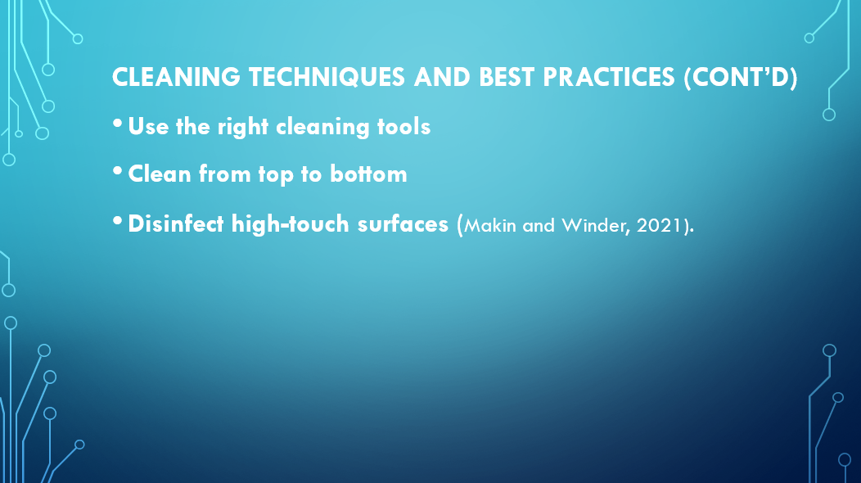
Training Notes:
- When selecting the tool that is best suited for the task at hand, it is important to take into consideration the kind of surface or area that has to be cleaned. For this task, it is imperative that you have the appropriate kind of brush or scrubber, as well as the appropriate kind of cloth or mop.
- When you start scrubbing the floor, you should first clean the ceiling and then work your way down to the floor. Surfaces that have just been cleansed will be safeguarded from additional soiling with this method (Leivo, 2017).
- In order to prevent the spread of bacteria and viruses, high-touch surfaces, such as door knobs, light switches, and worktops, ought to be disinfected on a regular

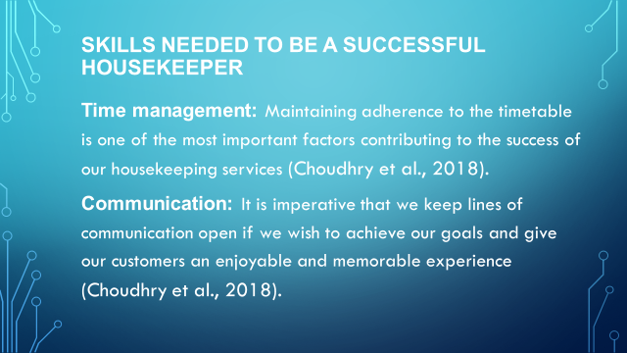
Training Notes:
Time management: Maintaining adherence to the timetable is one of the most important factors contributing to the success of our housekeeping services. Our team members need to be taught how to efficiently manage their time in order for them to be able to finish their assignments on time without compromising the quality of their work. Setting priorities, being able to work fast and effectively, and having good time management skills are all really necessary (Choudhry et al., 2018).
Communication: It is imperative that we keep lines of communication open if we wish to achieve our goals and give our customers an enjoyable and memorable experience. Each member of the team is responsible for effectively communicating their views and ideas to the other members of the team as well as to the guests. It is essential to have the ability to communicate effectively, to pay attention when guests are speaking, and to supply them with the information they require (Choudhry et al., 2018).

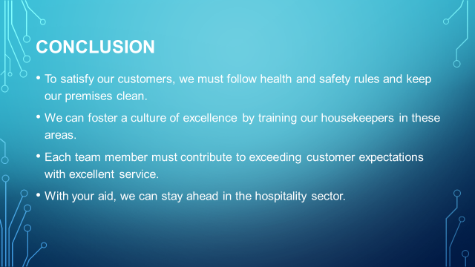
Training Notes: To summarize, if we want to live up to the expectations of our brand and provide a positive experience for our customers, we need to put top priority to health and safety rules and effective housekeeping practices. By concentrating on these facets of housekeeping and providing our employees with the right training, we will be able to cultivate an atmosphere that values excellence. It is the responsibility of each individual member of the team to do what they can to guarantee that the team constantly provides great service that goes above and beyond the requirements of the guests. With your assistance, we will be able to maintain our hotel's position in the vanguard of the hospitality sector.

References
Brody, D. (2021) A Textbook Case: Design, Housekeeping, and Labor. Design and Culture, 3(1), pp.25-49.
Choudhry, R.M., Fang, D. and Rowlinson, S. (2018) Challenging and enforcing safety management in developing countries: A strategy. International Journal of Construction Management, 8(1), pp.87-101.
Dufort, V.M. and Infante-Rivard, C. (2020) Measuring housekeeping in manufacturing industries. Annals of occupational hygiene, 43(2), pp.91-97.
Ingram, H. (2019) Housekeeping Management. International Journal of Contemporary Hospitality Management, 12(3), pp.218-220.
Jones, T.J. (2007) Professional management of housekeeping operations. John Wiley & Sons.
Leivo, A. (2017) Field study of the effects of a self-implemented feedback program on housekeeping performance. International journal of industrial ergonomics, 35(5), pp.471-485.
Makin, A.M. and Winder, C. (2021) A new conceptual framework to improve the application of occupational health and safety management systems. Safety Science, 46(6), pp.935-948.
Mehrez, A., Israeli, A.A. and Hadad, Y. (2000) A work measurement application for hotel housekeeping management. Tourism Economics, 6(4), pp.359-370.
Pongsiri, K. (2018) Housekeeping, Human Resources: Competency ServiceStandard Management for Hotel Business in ASEAN. International Journal of e-Education, e-Business, e-Management and e-Learning, 2(5), p.343.
Sanon, M.A. (2019) Hotel housekeeping work influences on hypertension management. American journal of industrial medicine, 56(12), pp.1402-1413.
Schneider, M. and Tucker, G. (2020) The professional housekeeper. The professional housekeeper., (Ed. 3).
Tuzon–Guarin, J.M. (2016) Housekeeping Management Practices and Standards of Selected Hotels and Restaurants of Ilocos SUR, Philippines. International Journal of Business Management & Research (IJBMR) ISSN (P), pp.2249-6920.
Wood, D.F., Moreo, P.J. and Sammons, G. (2015) Hotel housekeeping operational audit: A questionnaire approach. International journal of hospitality & tourism administration, 6(3), pp.1-10.

