HOTEL TRINITY ****
Valentine’s Menu
Our expert chefs have prepared an exquisite Valentine's aymenu that will make you fall in love all over again, so thank you for being here to discover how we'll help you reach new depths of love (and flavors).

Starters
Oysters with ginger Japanese dressing……………………………..……….15,00 GBT
(ginger , onion, Japanese soy sauce, Japanese rice vinegar, sugar, oysters, salmon roe)
Scallops with Vietnamese herb sauce …………………………….…………13,99 GBT
(scallops, red chilli, vegetable oil ) HERB SAUCE (coriander, mint, ginger, garlic, onion, lime, palm sugar)
Grilled oysters with garlic butter………………………………………………17,50 GBT
(butter, garlic, oysters, sea salt, coriander, hot sauce )
Chargrilled steak with Tabasco butter and avocado salad…….……..….16,00 GBT
(butter, Tabasco sauce, onion, sirloin steak, avocado, cumin, tomatoes, red onion, lime )
Mains
Grilled marinated chicken breast with pineapple spice……………..20,99 GBT
(pineapple, red onion, vinegar, garlic, chicken breasts, Oil,
Honey, cilantro leaves)
Roasted Salmon With Green Herbs…………………………………………….18,00 GBT
(salmon, olive oil, lemon juice, dill, parsley, white wine
Lemon wheels)
Pork chops with celery salad and almonds………………………..……….15,60 GBT
(dried cranberries, rice vinegar, pork rib chops, olive oil, sprigs of thyme, garlic, unsalted butter, celery, parsley, almonds, parmesan)

Desert
Strawberry Cheesecakes………………4,00 GBT
(graham crackers, butter, cream cheese, eggs, sour cream, sugar, vanilla, semi-sweet chocolate, strawberries )
Strawberry cake (a slice ).. ………..8,00 GBT
(strawberries, sugar, corn starch flour, baking powder, sugar, eggs, sour cream, unsalted butter, pure vanilla Vanilla ice cream)



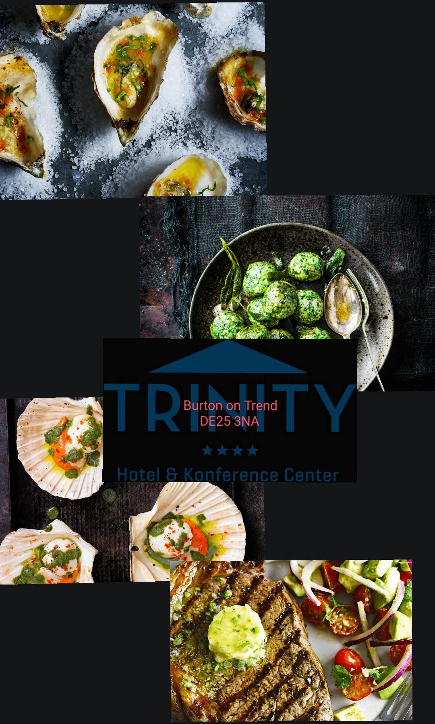
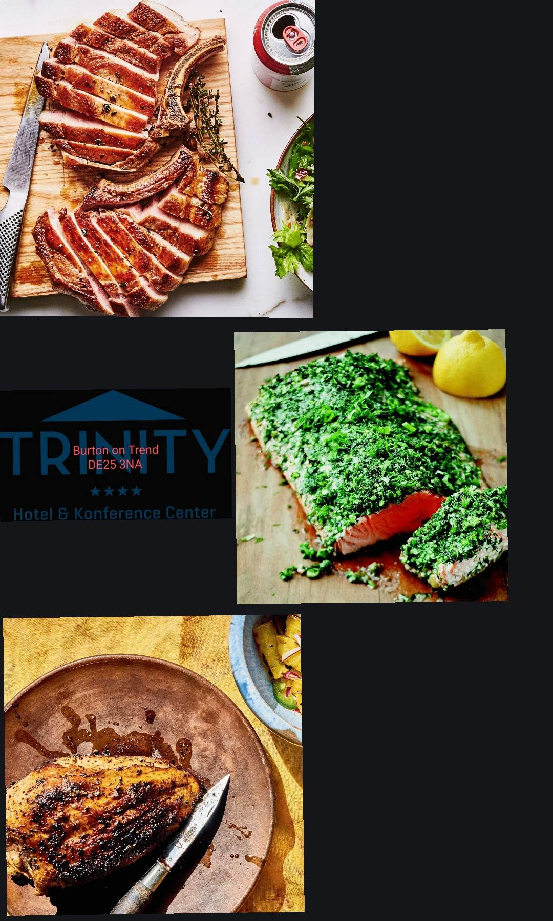

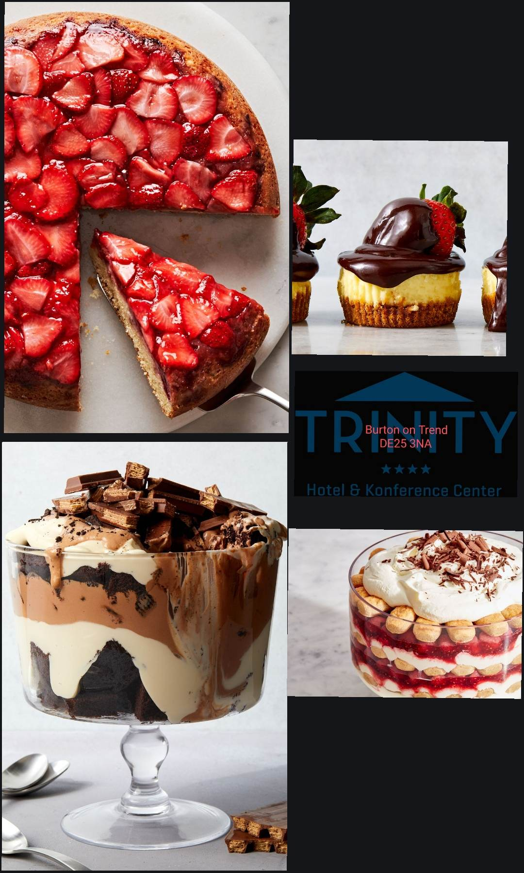


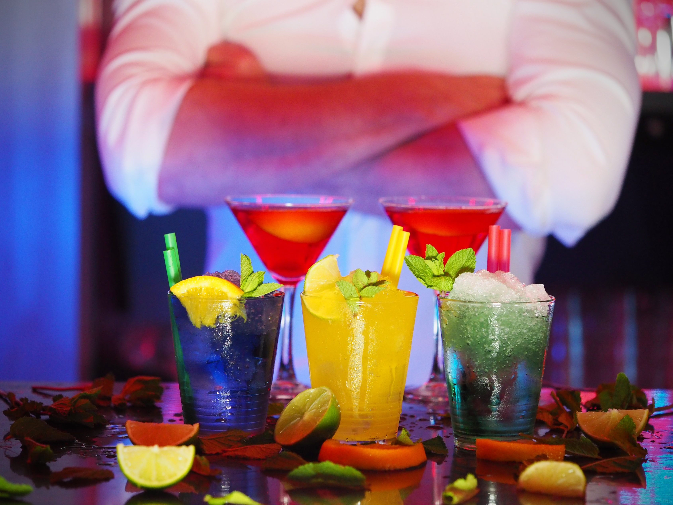

+150 P.P

PP
Book the table From +21056934988
On this price you can choose everything you want from the menu

starting with February 10, until February 15, we have live music after 5:00 p.m
drink 2 for 15 GBT
215
Cocktails without alcohol:
1. Hawaii ………………..6,00 GBT
(orange juice, peach juice, grenadine syrup, ice)
2. Green Apple………..5,00 GBT
(lime, blue curacao syrup, sugar syrup, apple juice, ice)
3. Electric Lemonade……5,99 GBT
(lemon, blue curacao syrup, sprite, S&S, ice)
Cocktails with alcohol:
1. Mojito………………..10,00 GBT
(rum, lime, mint, sugar syrup, mineral water, ice)
2. Tokyo Iced Tea ……..12,00 GBT
(vodka, rum, gin, watermelon liqueur, S&S, sprite, ice)
3. Lynchburg Lemonade …..10,99 GBT
(whisky, triple dry liquor, S&S, lime, sprite, ice)
4. Hugo…………………………..14,00 GBT
5. (elder liqueur, prosecco, lime, mint, mineral water, ice)
Triple Chocolate Trifle……….9,99 GBT
(dark chocolate, sugar, eggs, olive oil, tahini cream)
Raspberry Tiramisu……………7,99 GBT
(sour cream, vanilla extract, mascarpone, strong coffee, raspberry jam, fresh raspberries, Chocolate chips)
Drink
Champagne:
1. Moet & Chandon Brut Imperial Champagne 0.75L…………………..45,00 GBT
2. Champagne Devaux Grande Réserve | France | 12% |…………….33,00 GBT
3. Champagne Henriot Brut Souverain | France | 12% | VG………..37,00 GBT
4. Lamberti Prosecco Extra Dry | Italy | 11% | VG………………………..15,00 GBT
Wine white:
La Mécanique | Vermentino | Franța | 12,5% | VG………………………………………….23,50 GBT
Fuziune | Chenin Blanc, Grenache Blanc, Viognier | Africa de Sud | 12% |……..12,99 GBT
Ugarte Rioja Blanco Crianza | Tempranillo Blanco | Spania | 13% | VG…….…….12,00 GBT
La Mécanique | Vermentino | Franța | 12,5% | VG………………………………………….22,50 GBT
Wine red:
De Conti Appassimento | Primitivo, Negroamaro | Italia | 15%......................13,60 GBT
Balbo Estate | Malbec | Argentina | 14%........................................................22,00 GBT
Jaffelin | Pinot Noir | Franța | 12,5% | VG………………………………………….……….11,99 GBT
São Luiz Douro | Touriga Nacional | Portugalia | 13% | VG………………………...19,99 GBT
Shots:
1. Jagermeister
2. Kamikaze 5.00 GBT
3. After Eight Shot
Reference list:
- https://catine.ro/retete-de-cocktail-fara-alcool-patru-idei-pentru-orice-eveniment-40043.html
- https://www.epicurious.com/recipes-menus/dinner-party-main-course-recipes-gallery
- https://www.delish.com/cooking/recipe-ideas/a51437/chocolate-strawberry-cheesecakes-recipe/
- https://www.delish.com/cooking/recipe-ideas/a54083/strawberry-upside-down-cake-recipe/
- https://www.delish.com/cooking/recipe-ideas/a44588/triple-chocolate-trifle-recipe/
- https://www.delish.com/cooking/recipe-ideas/a39578398/raspberry-tiramisu-recipe/
- https://salut.co.uk/menu/
- https://www.olivemagazine.com/recipes/collection/valentines-day-recipes-best-romantic-meal-ideas/?fbclid=IwAR1iF21_NX5zxisSGDmA2hzd-SqbpNBR6jcuDpFCSN7tK7vTNkM4WADALYg

