

Coursework – Portfolio

Student Name: Daniela Voda
Student id: 2246662
Date 1/09/2024

Table of Contents
Introduction 3
Element 1: Community Outreach 3
Engagement with Stakeholders 3
Demographics and Considerations 4
Findings and Reflections 5
Element 2: Stakeholder Mapping Exercise 6
Element 3: Community Engagement Plan 6
Element 4: Practical Discussion 12
Key Findings and Benefits 12
Techniques and Principles 13
Addressing Community Challenges 14
Recommendations and Conclusion 15
Reference 16

Introduction
The portfolio brings out a holistic approach to community engagement concentrating on the Surrey Staines community. The work is divided into four main sections, making it ideal to address various angles of engagement. Element 1 focuses on the interaction with the community and describes the procedure for identifying and understanding key stakeholders and conditions such as demographic and cultural aspects. The second element is stakeholder mapping, where one notes the identification of the stakeholders and how they will be engaged. Specifically, element 3 is a community engagement plan that seeks to involve the diversity of the community in the project. Last but not least, Element 4 is more of an actionable analysis of the significance of stakeholders that proves quite informative with references to key insights, skills, and anecdotes.

Element 1: Community Outreach
The initial component in the process of engagement and development of a favourable reception with a community is to go out to the community. Hence, for this project, I decided to target the community of Surrey Staines. Furthermore, Surrey Staines is a historical and culturally sensitive social environment, so using it as an example of research communities is effective (Surrey, 2024). This type of outreach sought to target and secure the cooperation of important gatekeepers, assess the population’s demographics and characteristics, and gather information on the social, economic, and cultural background of the community. This first step alone is crucial for identifying key stakeholders establishing the proper framework for influencing community dynamics and finding suitable methods to address the populace’s concerns.

Engagement with Stakeholders

Figure 1 Engagement with Stakeholders
Source 1 (Tractivity 2024)
Some of the steps involved in the process of stakeholders’ engagement were finding out and communicating with the special persons and organisations in the community of Surrey Staines. To get a variety of opinions, I used direct questions by interviewing people and a questionnaire to supplement it with informal discussions. Potential respondents were officials of local governments, and leaders in the community Specifically, included business people and other residents of the community.
The officials from the local government shared opinions concerning the ongoing projects in the community and the effects of the policies. Local authorities, who actively participate in solving the problem, spoke about their activities and difficulties in strengthening multicultural communities. Employers and entrepreneurs also talked themselves into the matters of the economy, pointing at the opportunities and threatened zones. Ratepayers, cross-sectional, cited their experiences, requirements and expectations in the community’s daily life. Hence, these interactions helped achieve the primary objective of having a detailed understanding of the functioning of the community and possible points for engagement.

Demographics and Considerations

Figure 2 Surrey Staines
Source 2 (Dyckhoff, 2012)
Surrey Staines is one of the most populated regions that has a diversified group of customers regarding their age, ethnicity, and income level. Presenting the data from Surreyi, (2021); it has been noted that it comprises young people working in businesses, families and the aged. The demographic mix determines the characteristics of the community, and the needs that are most important in this case have to be taken into consideration in any engagement strategy.
Such factors as the cohesiveness of the society, cultural arts, and education contribute to the identity of the society. Other aspects influencing community characteristics are those related to the economy, such as employment status, the health of businesses, and income. On the social aspect, Staines appears to be culturally affluent and blessed with several cultural activities and a supportive history heritage that the community members and leadership take pride in.
Regarding ethical issues, every stage of the outreach process was given priority. When carrying out the research, it would be very important to maintain confidentiality and also, seek consent from the participants. Culturally it was important to pay attention to some cultural and social variables to form good trust consequently leading to good and free-flowing healthy discussion. The concept of reviewing the community’s views as well as concerns to provoke a courteous and empathetic response was critical to the outreach methodology.

Findings and Reflections
Community engagement and sampling done in Surrey Staines provided the following findings. It was observed that there exists a good feeling of pride in the sense of community and enhanced calls for stakeholders’ involvement and participation. Hence, economic development and cultural conservation were identified as some of the major goals and objectives. People said more needs to be done to open up forums for people to be heard and be involved in various projects in their communities. Looking back at this outreach experience, I learned the need to engage with stakeholders, and the significance of embracing other people’s views as knowledgeable. This process. highlighted the need for engagement approaches which is specific to the demographic and cultural characteristics of the community in question.
Surrey Staines community mapping was the initial step in creating awareness of the composition of the community and who are the influential players within the community. Interacting with the members of the society, I was able to identify numerous social, economic, as well as cultural indicators. These outcomes can be further utilised in the subsequent courses of this coursework developing efficient strategies for the engagement of set Desired and potential stakeholder groups: These findings will serve as a basis for the further elements of the presented coursework, particularly for the community engagement plan creation. From this experience, the values of a responsible approach, people’s diversity, and trust as significant factors for mutual and productive cooperation with communities were emphasised.

Element 2: Stakeholder Mapping Exercise
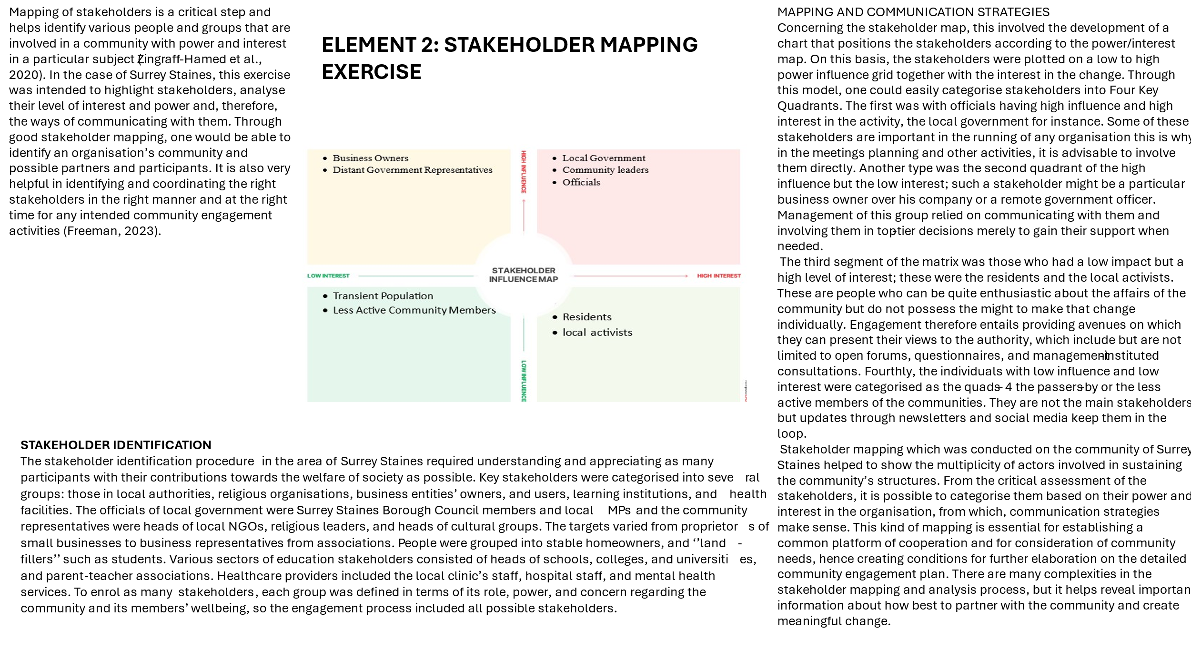

Element 3: Community Engagement Plan
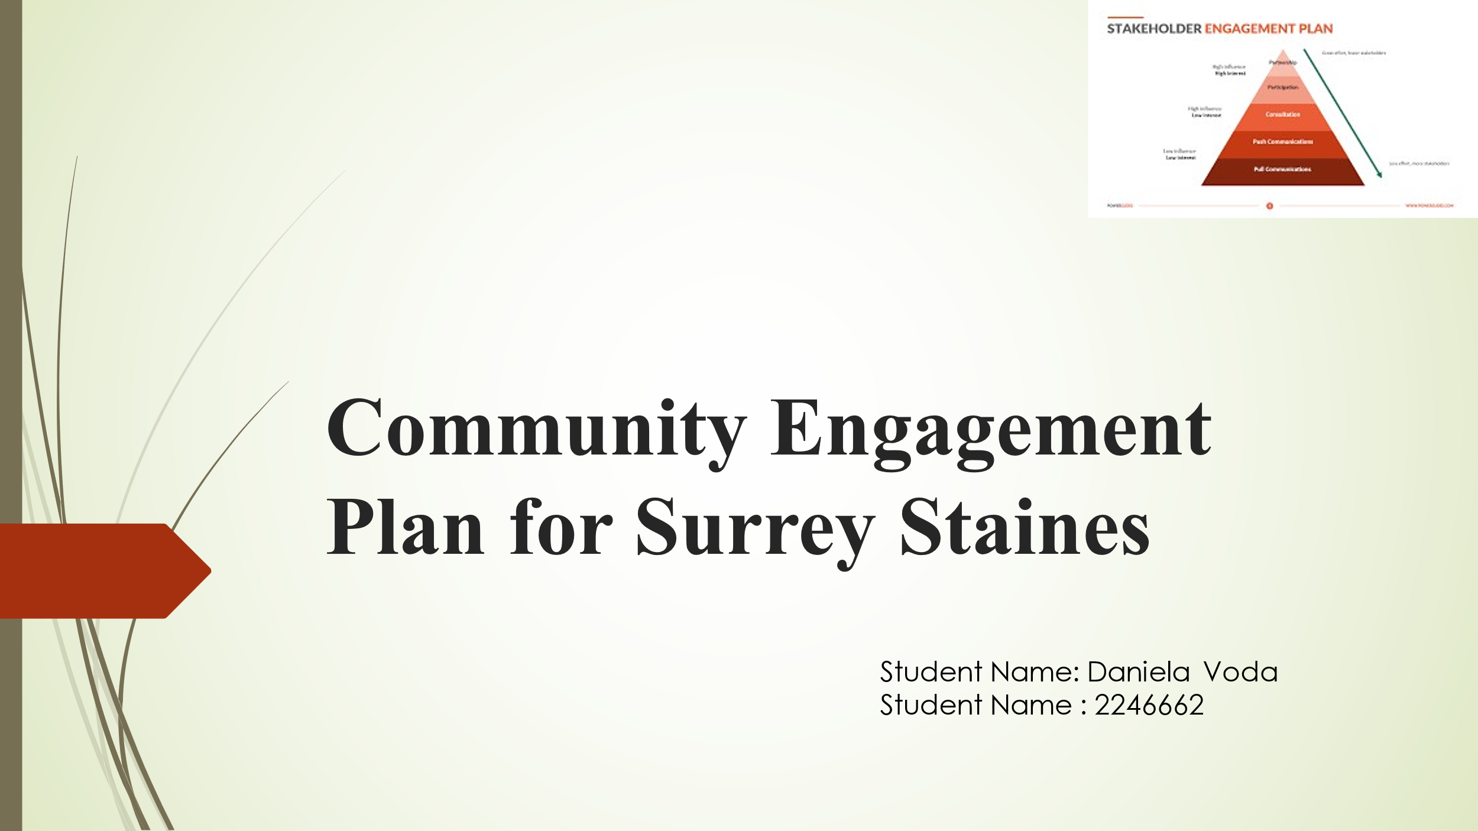
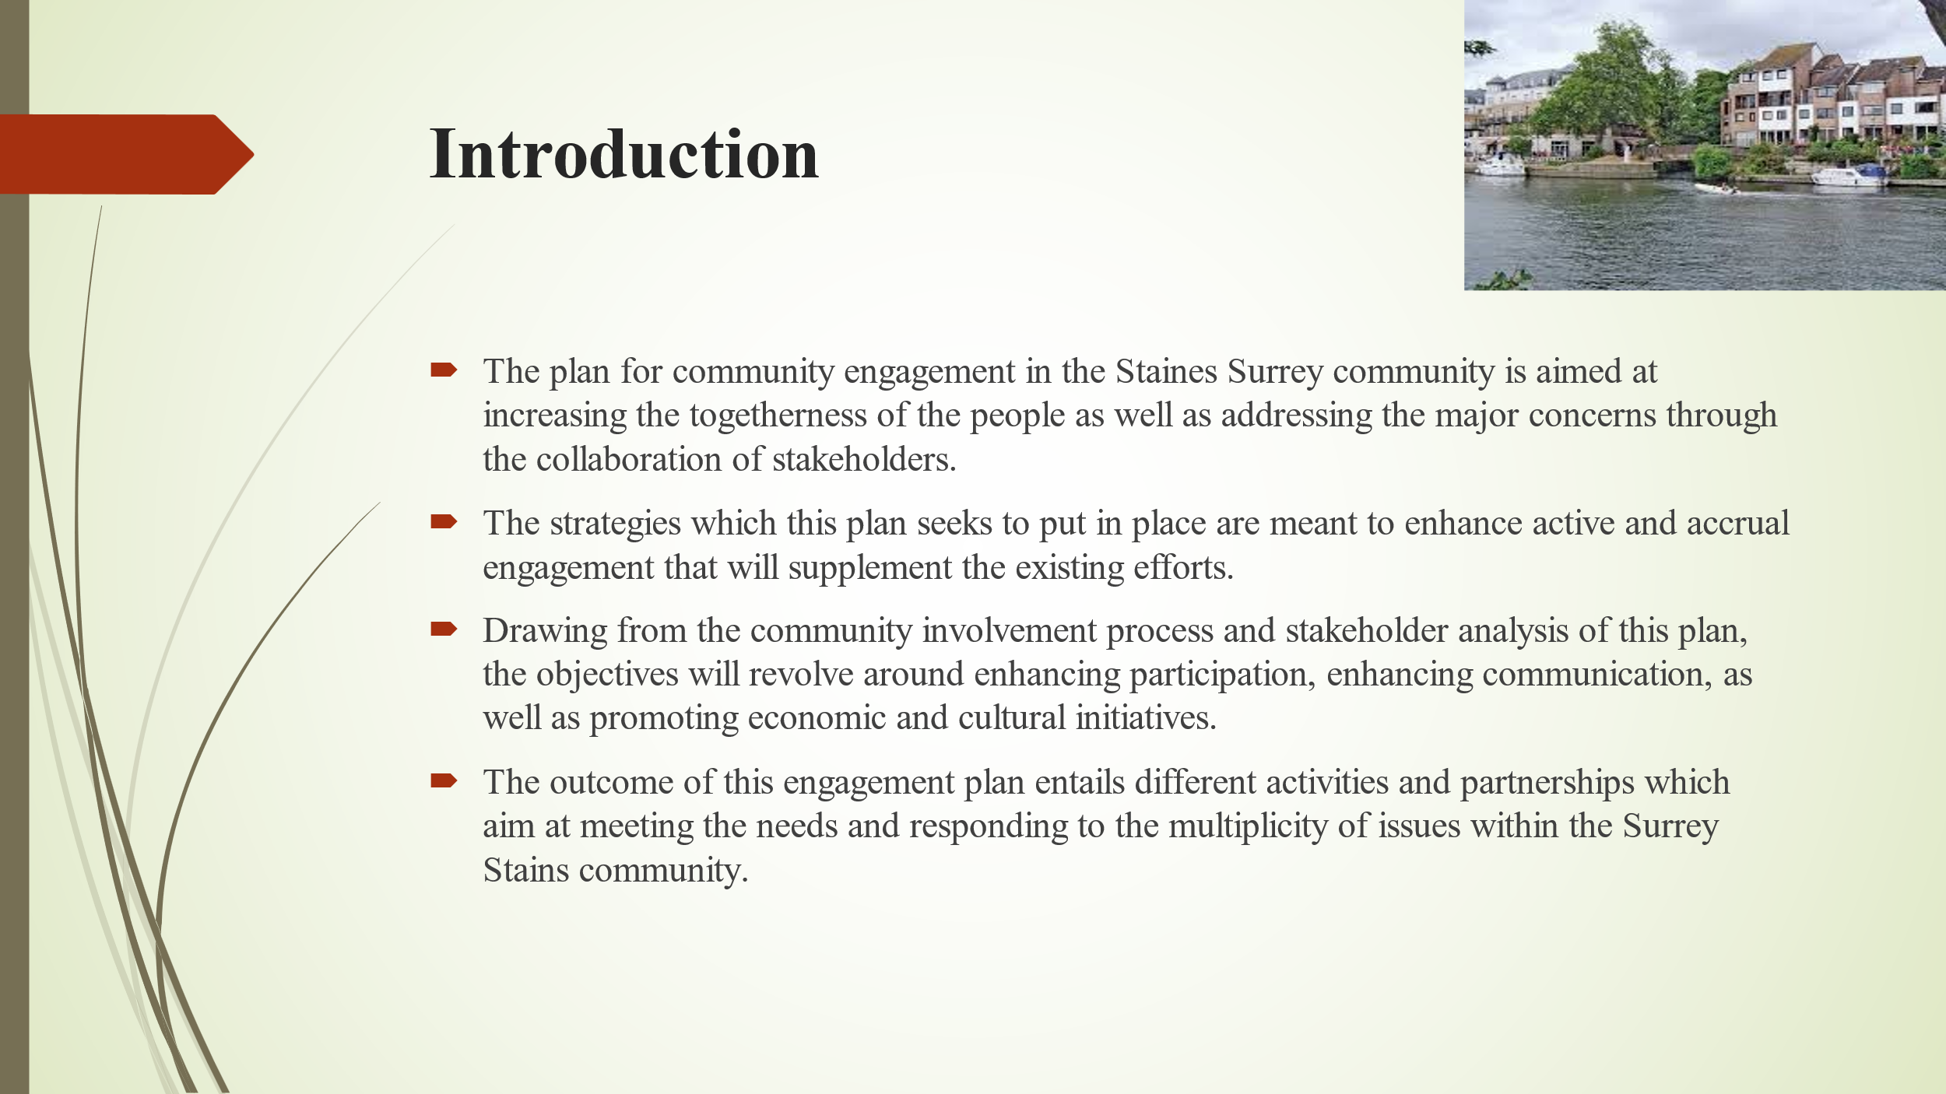
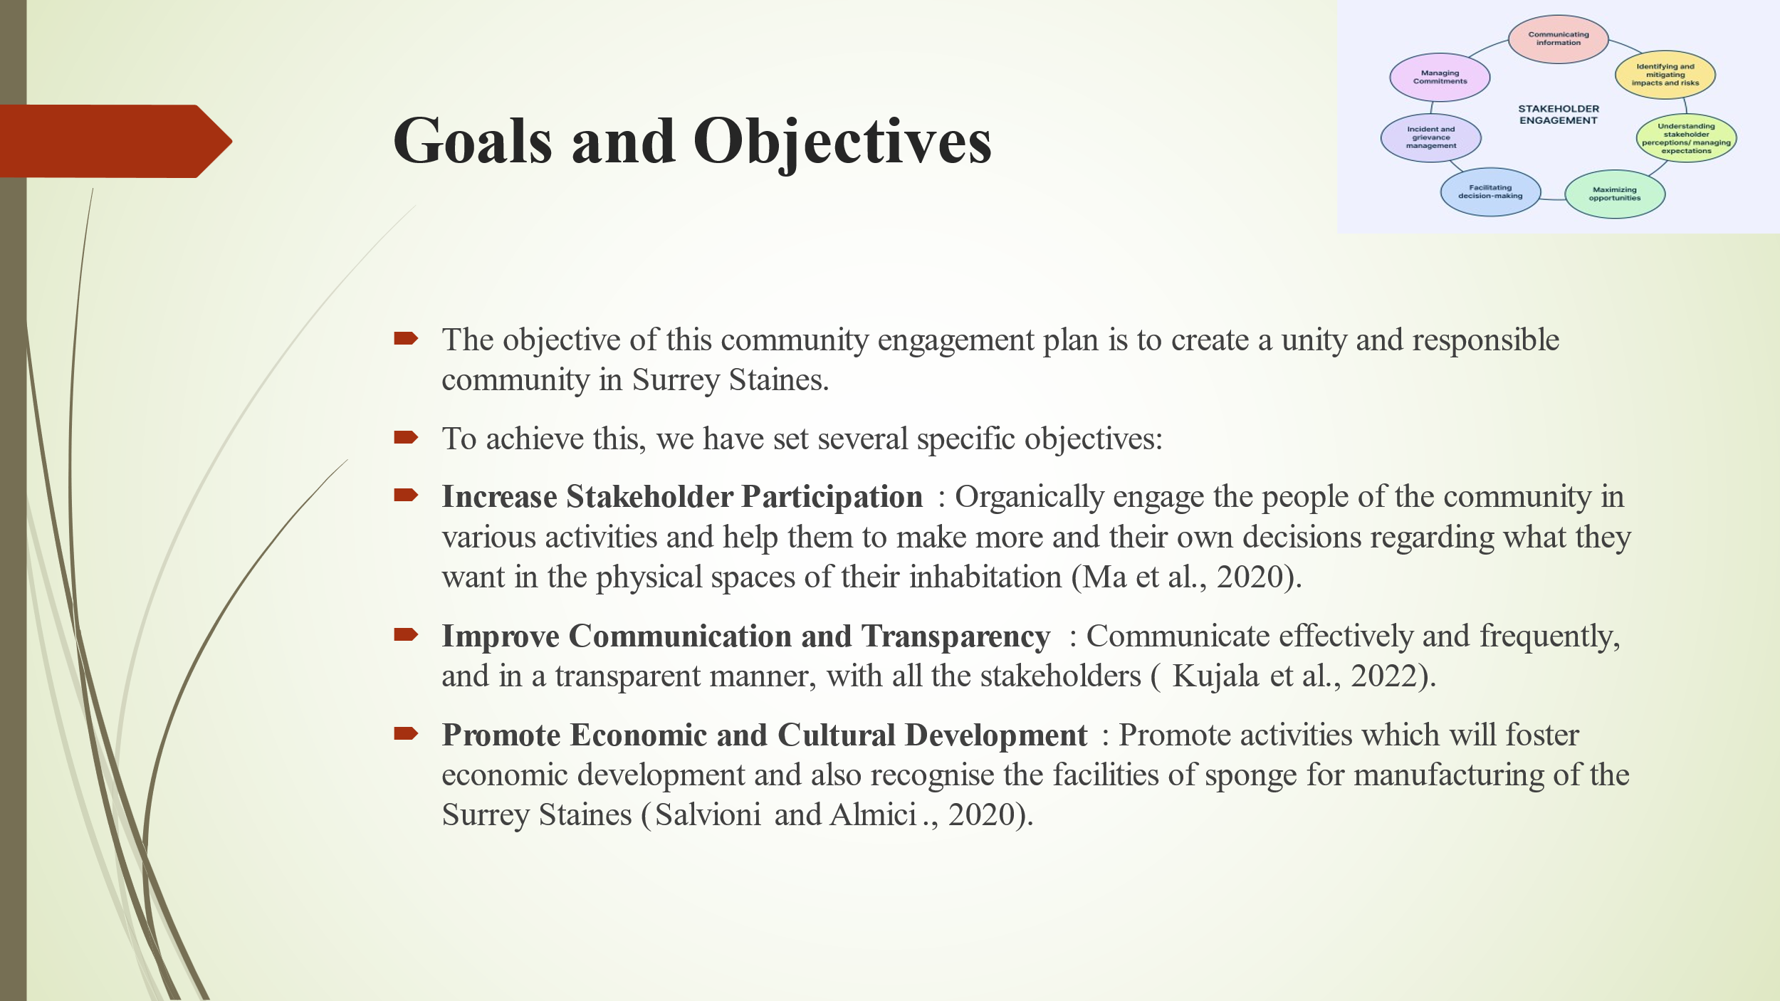
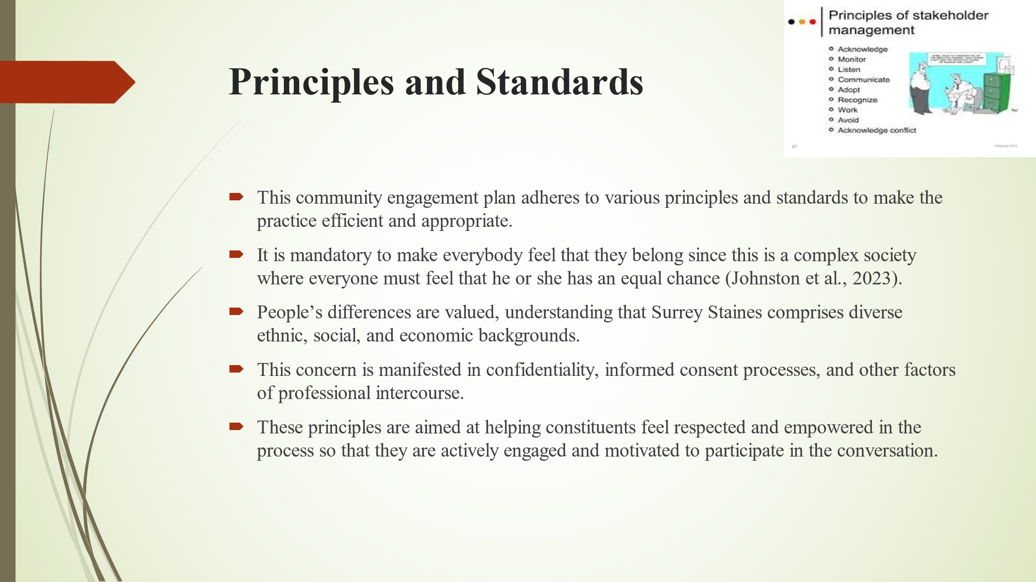
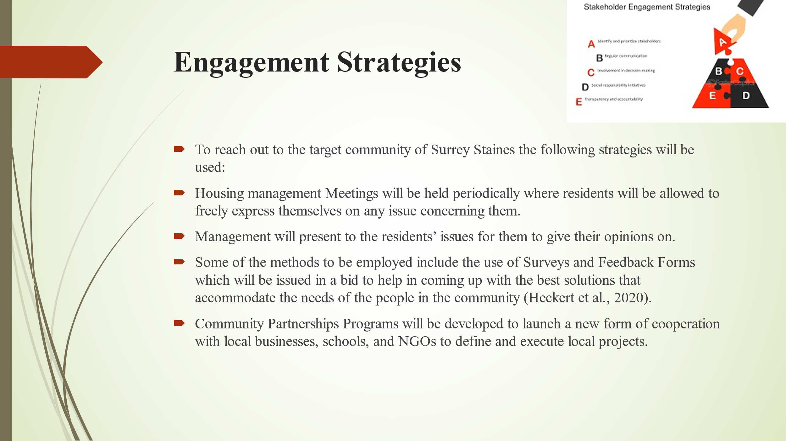
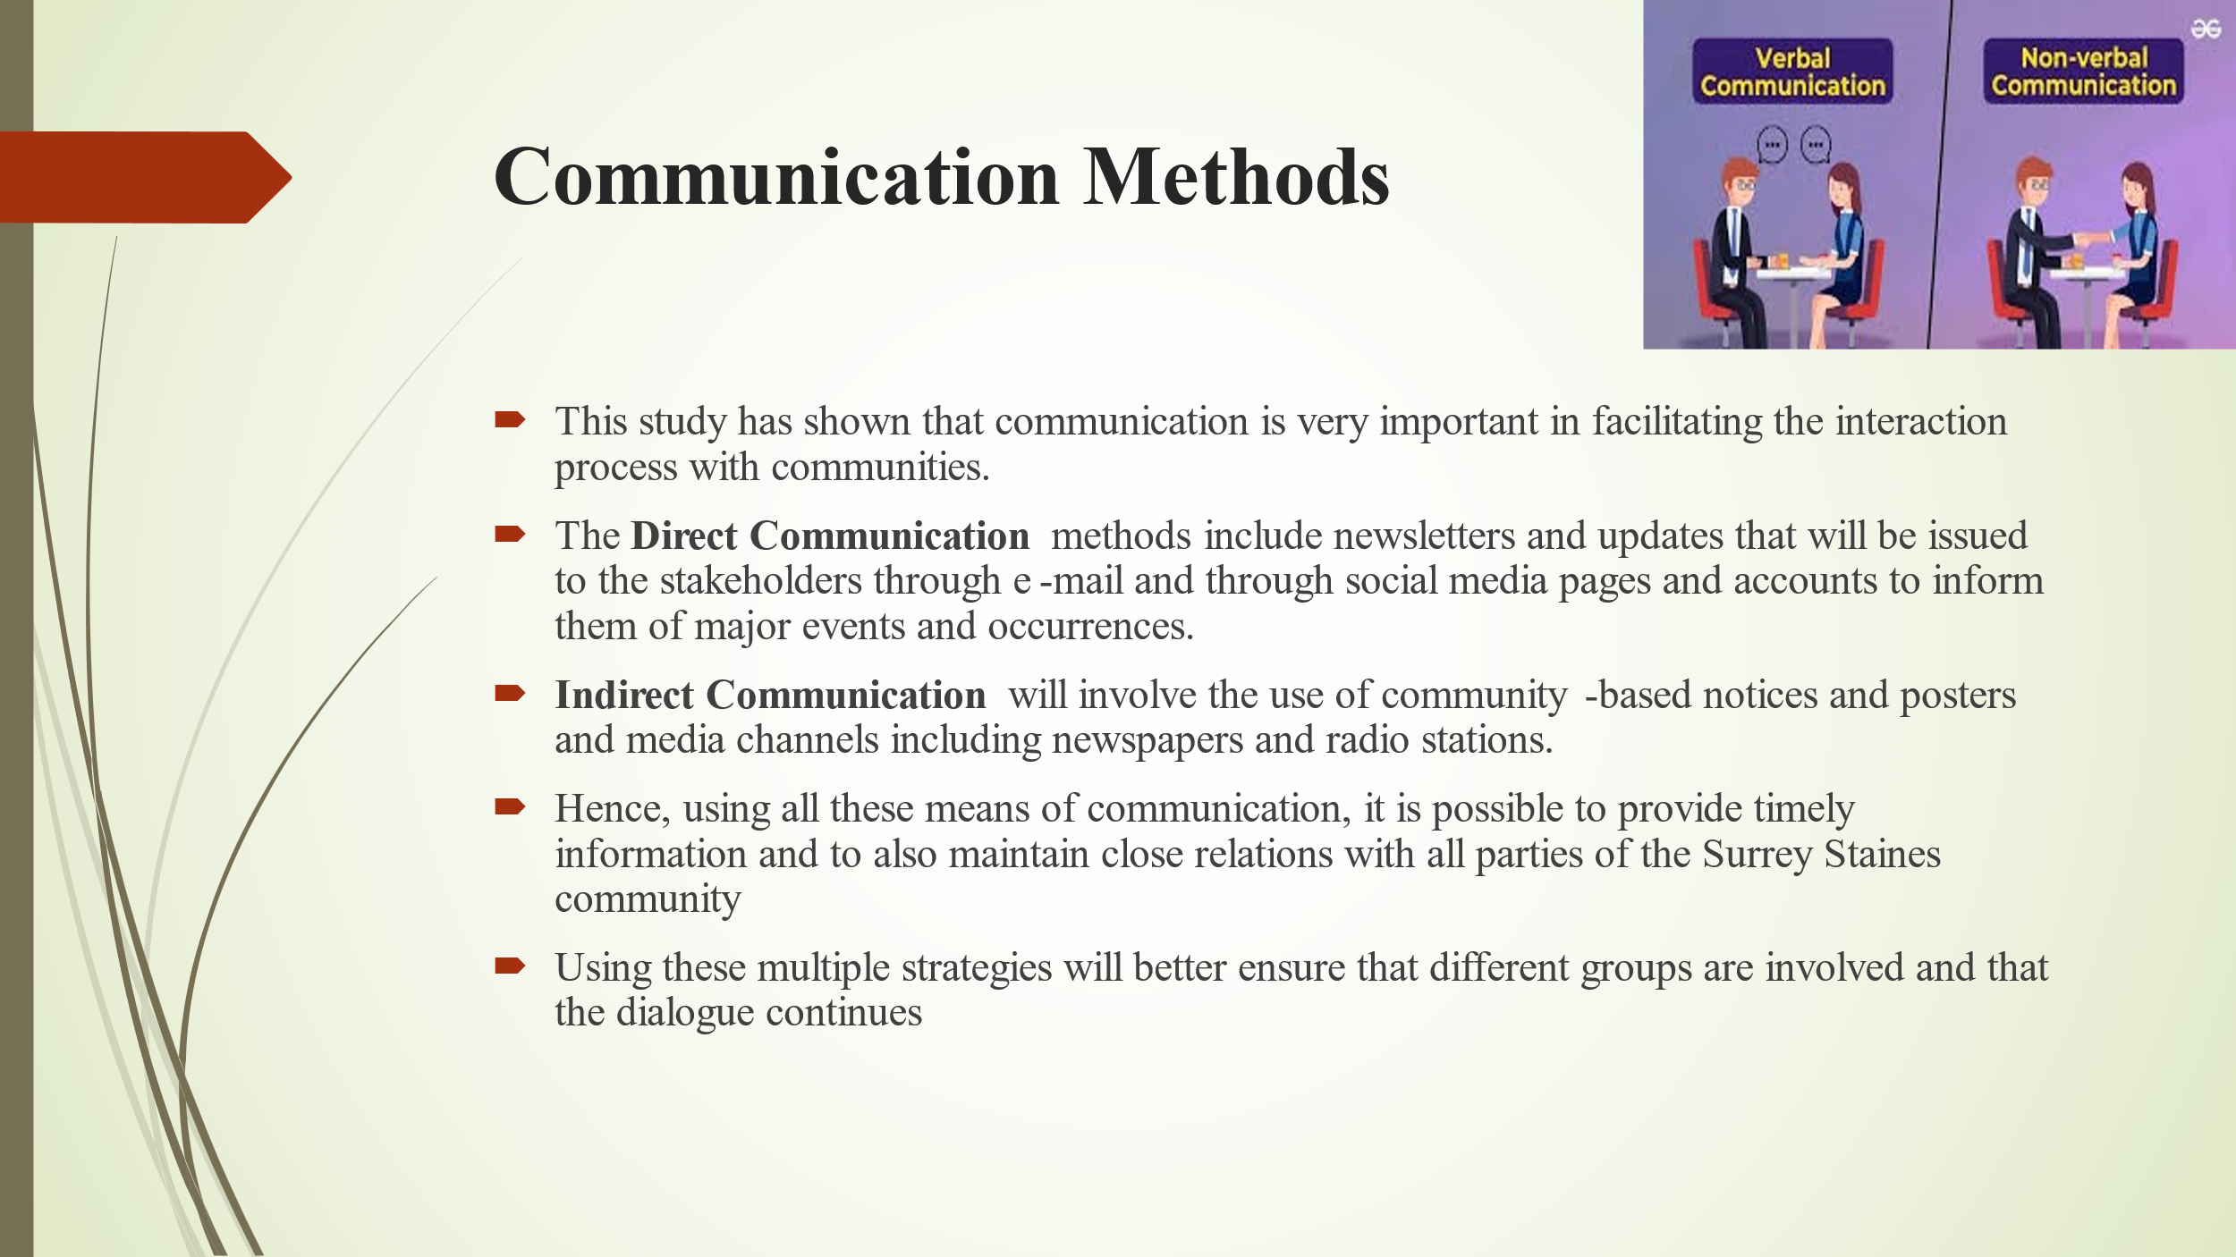
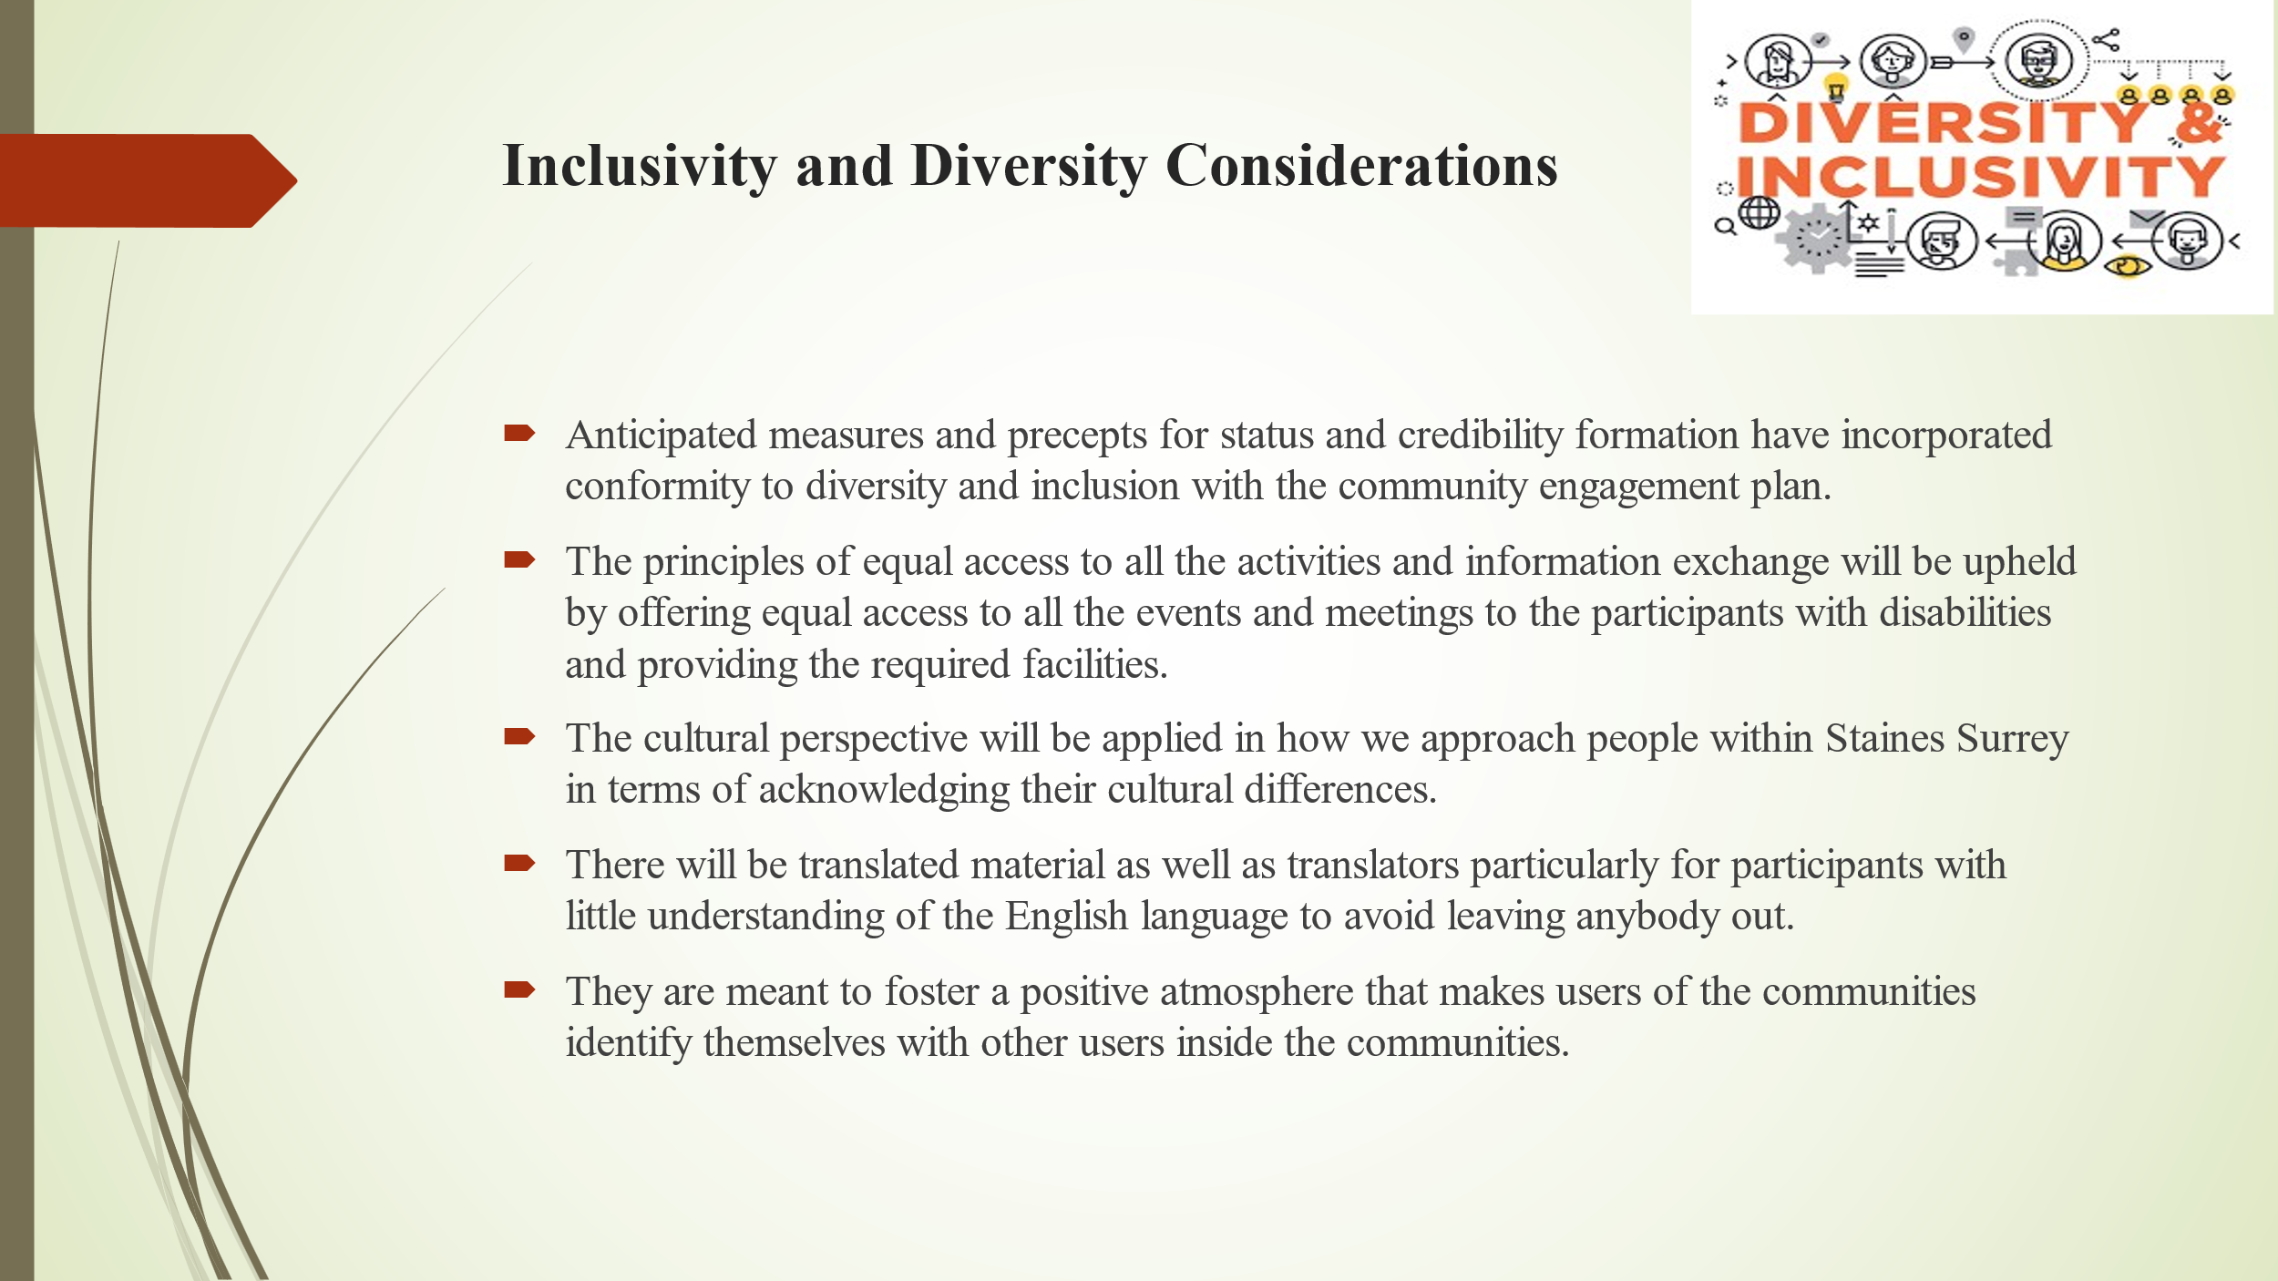
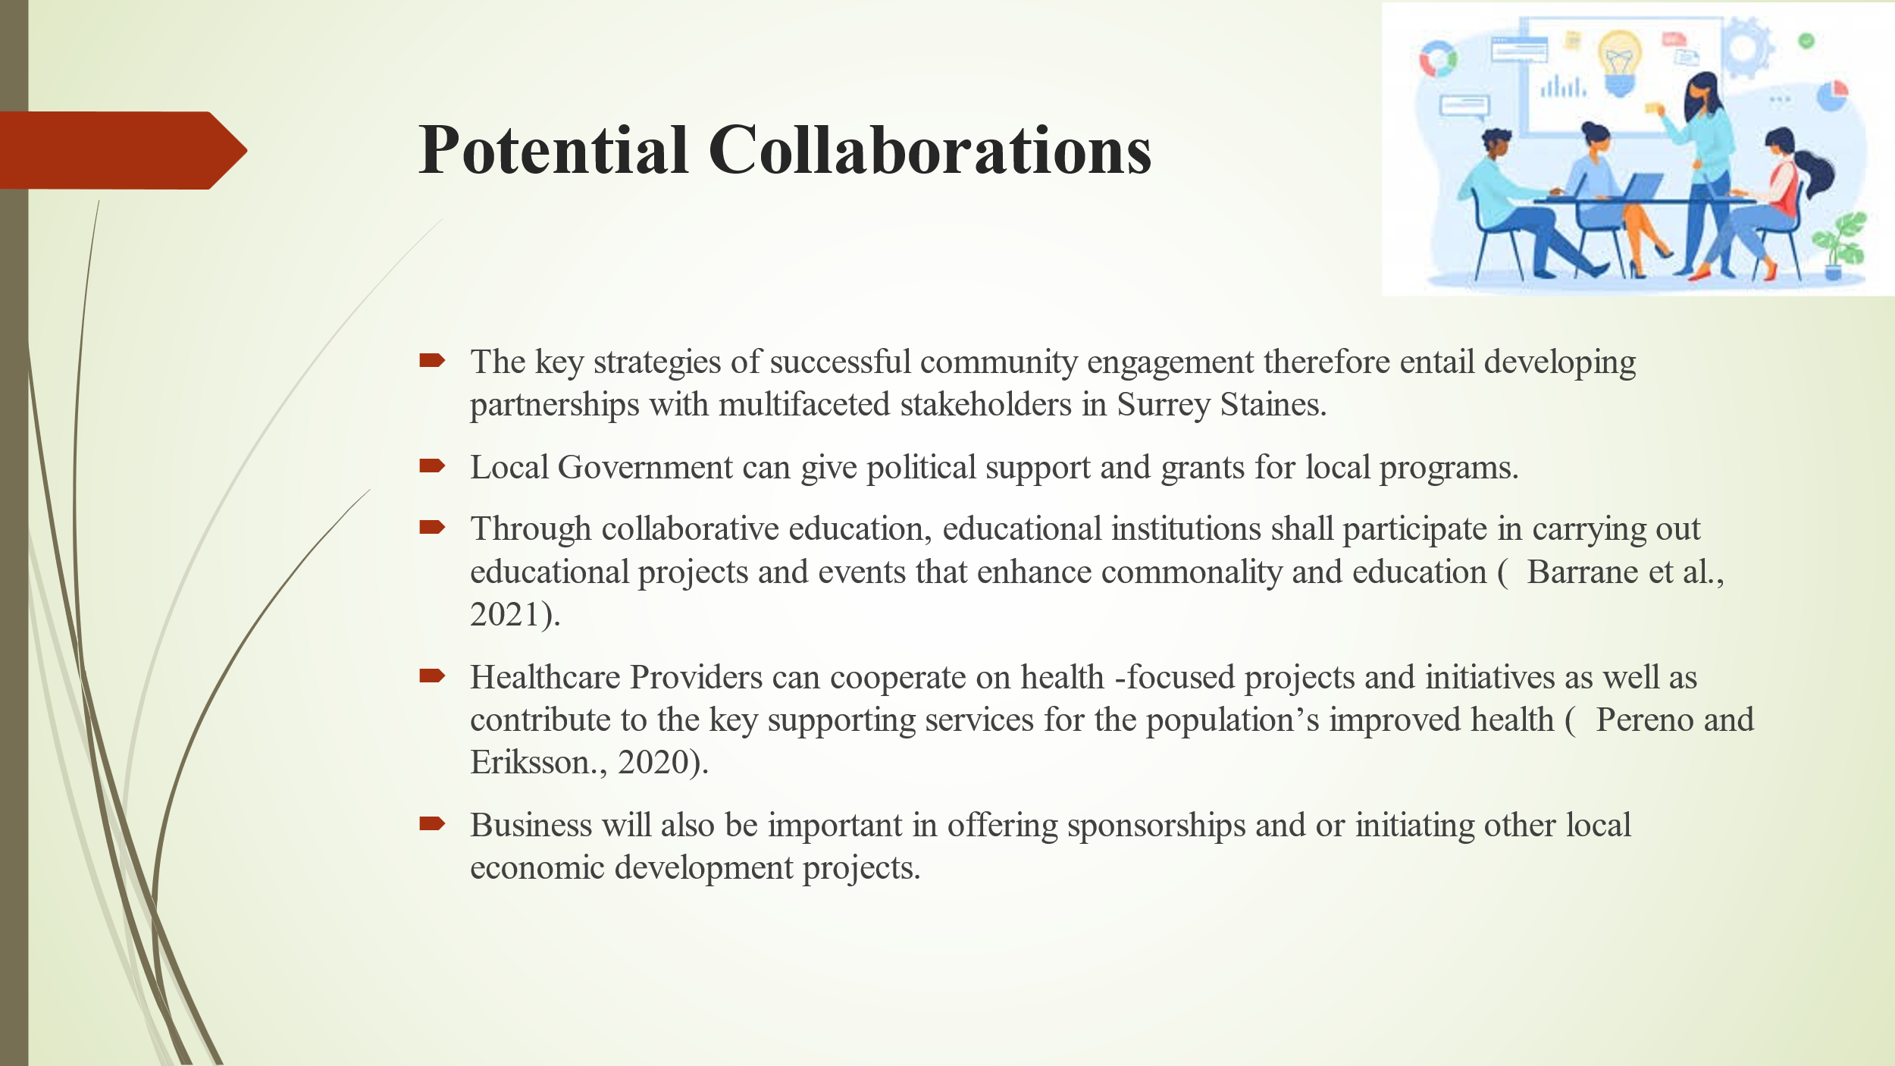
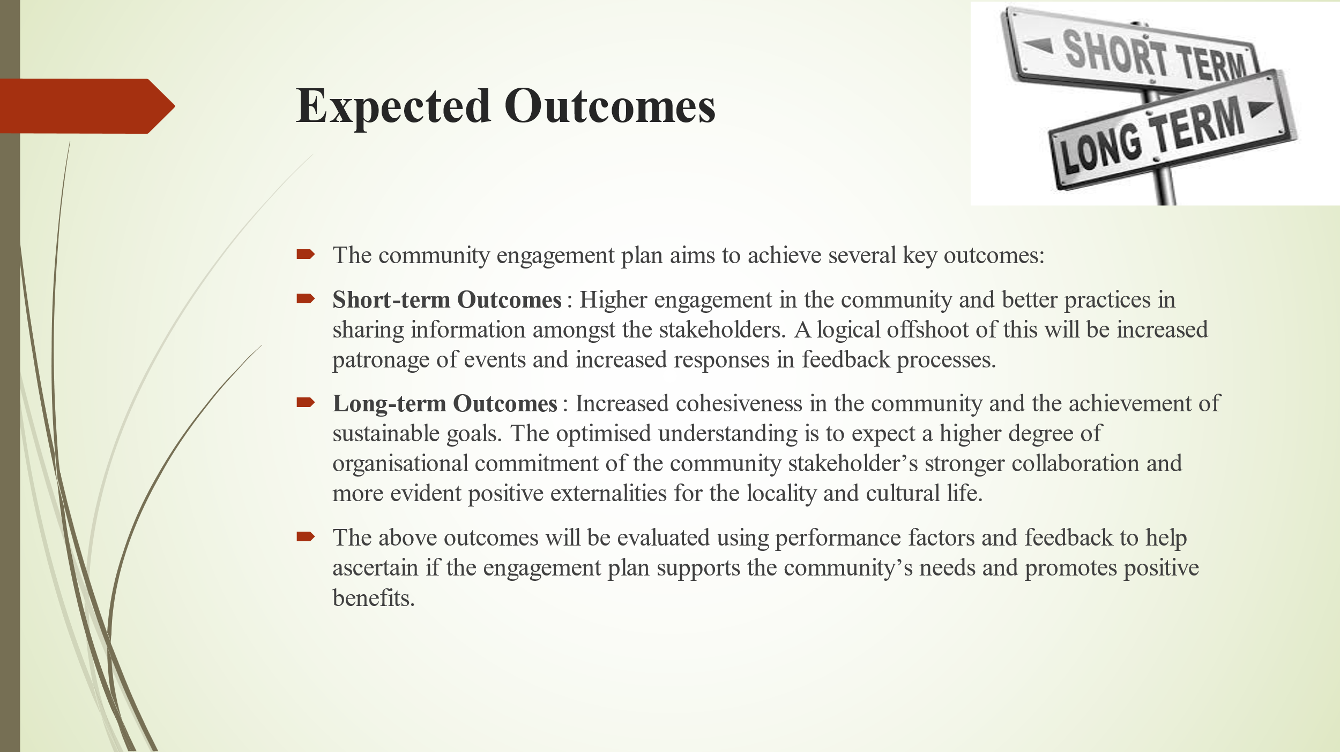
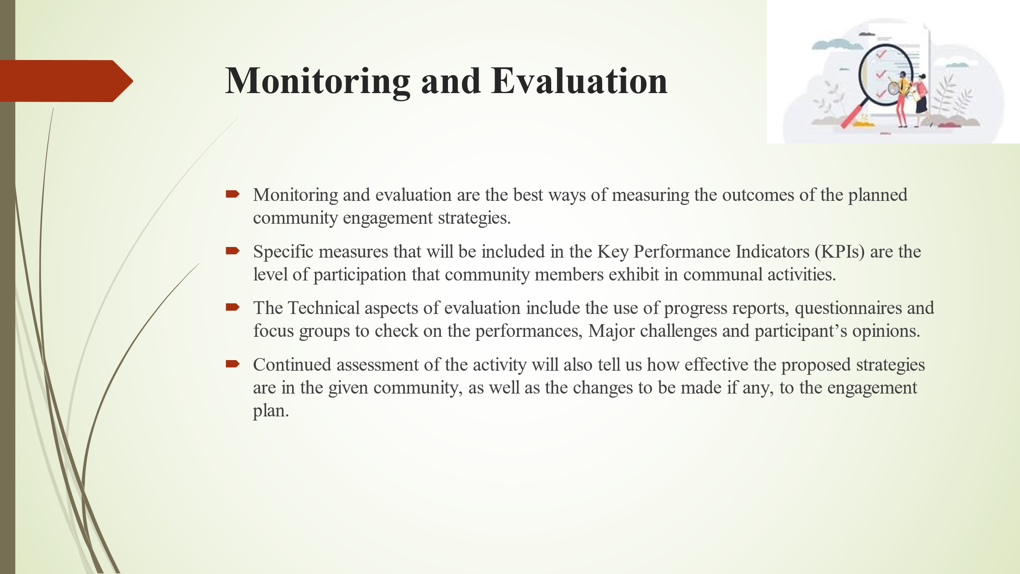
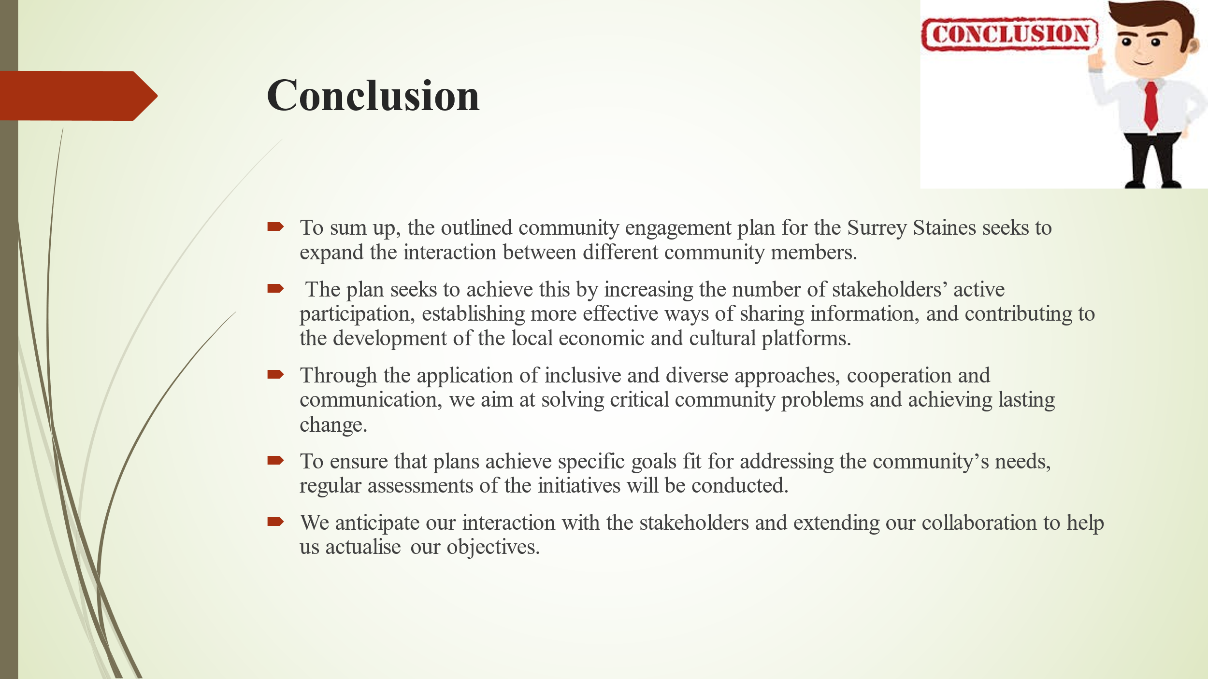
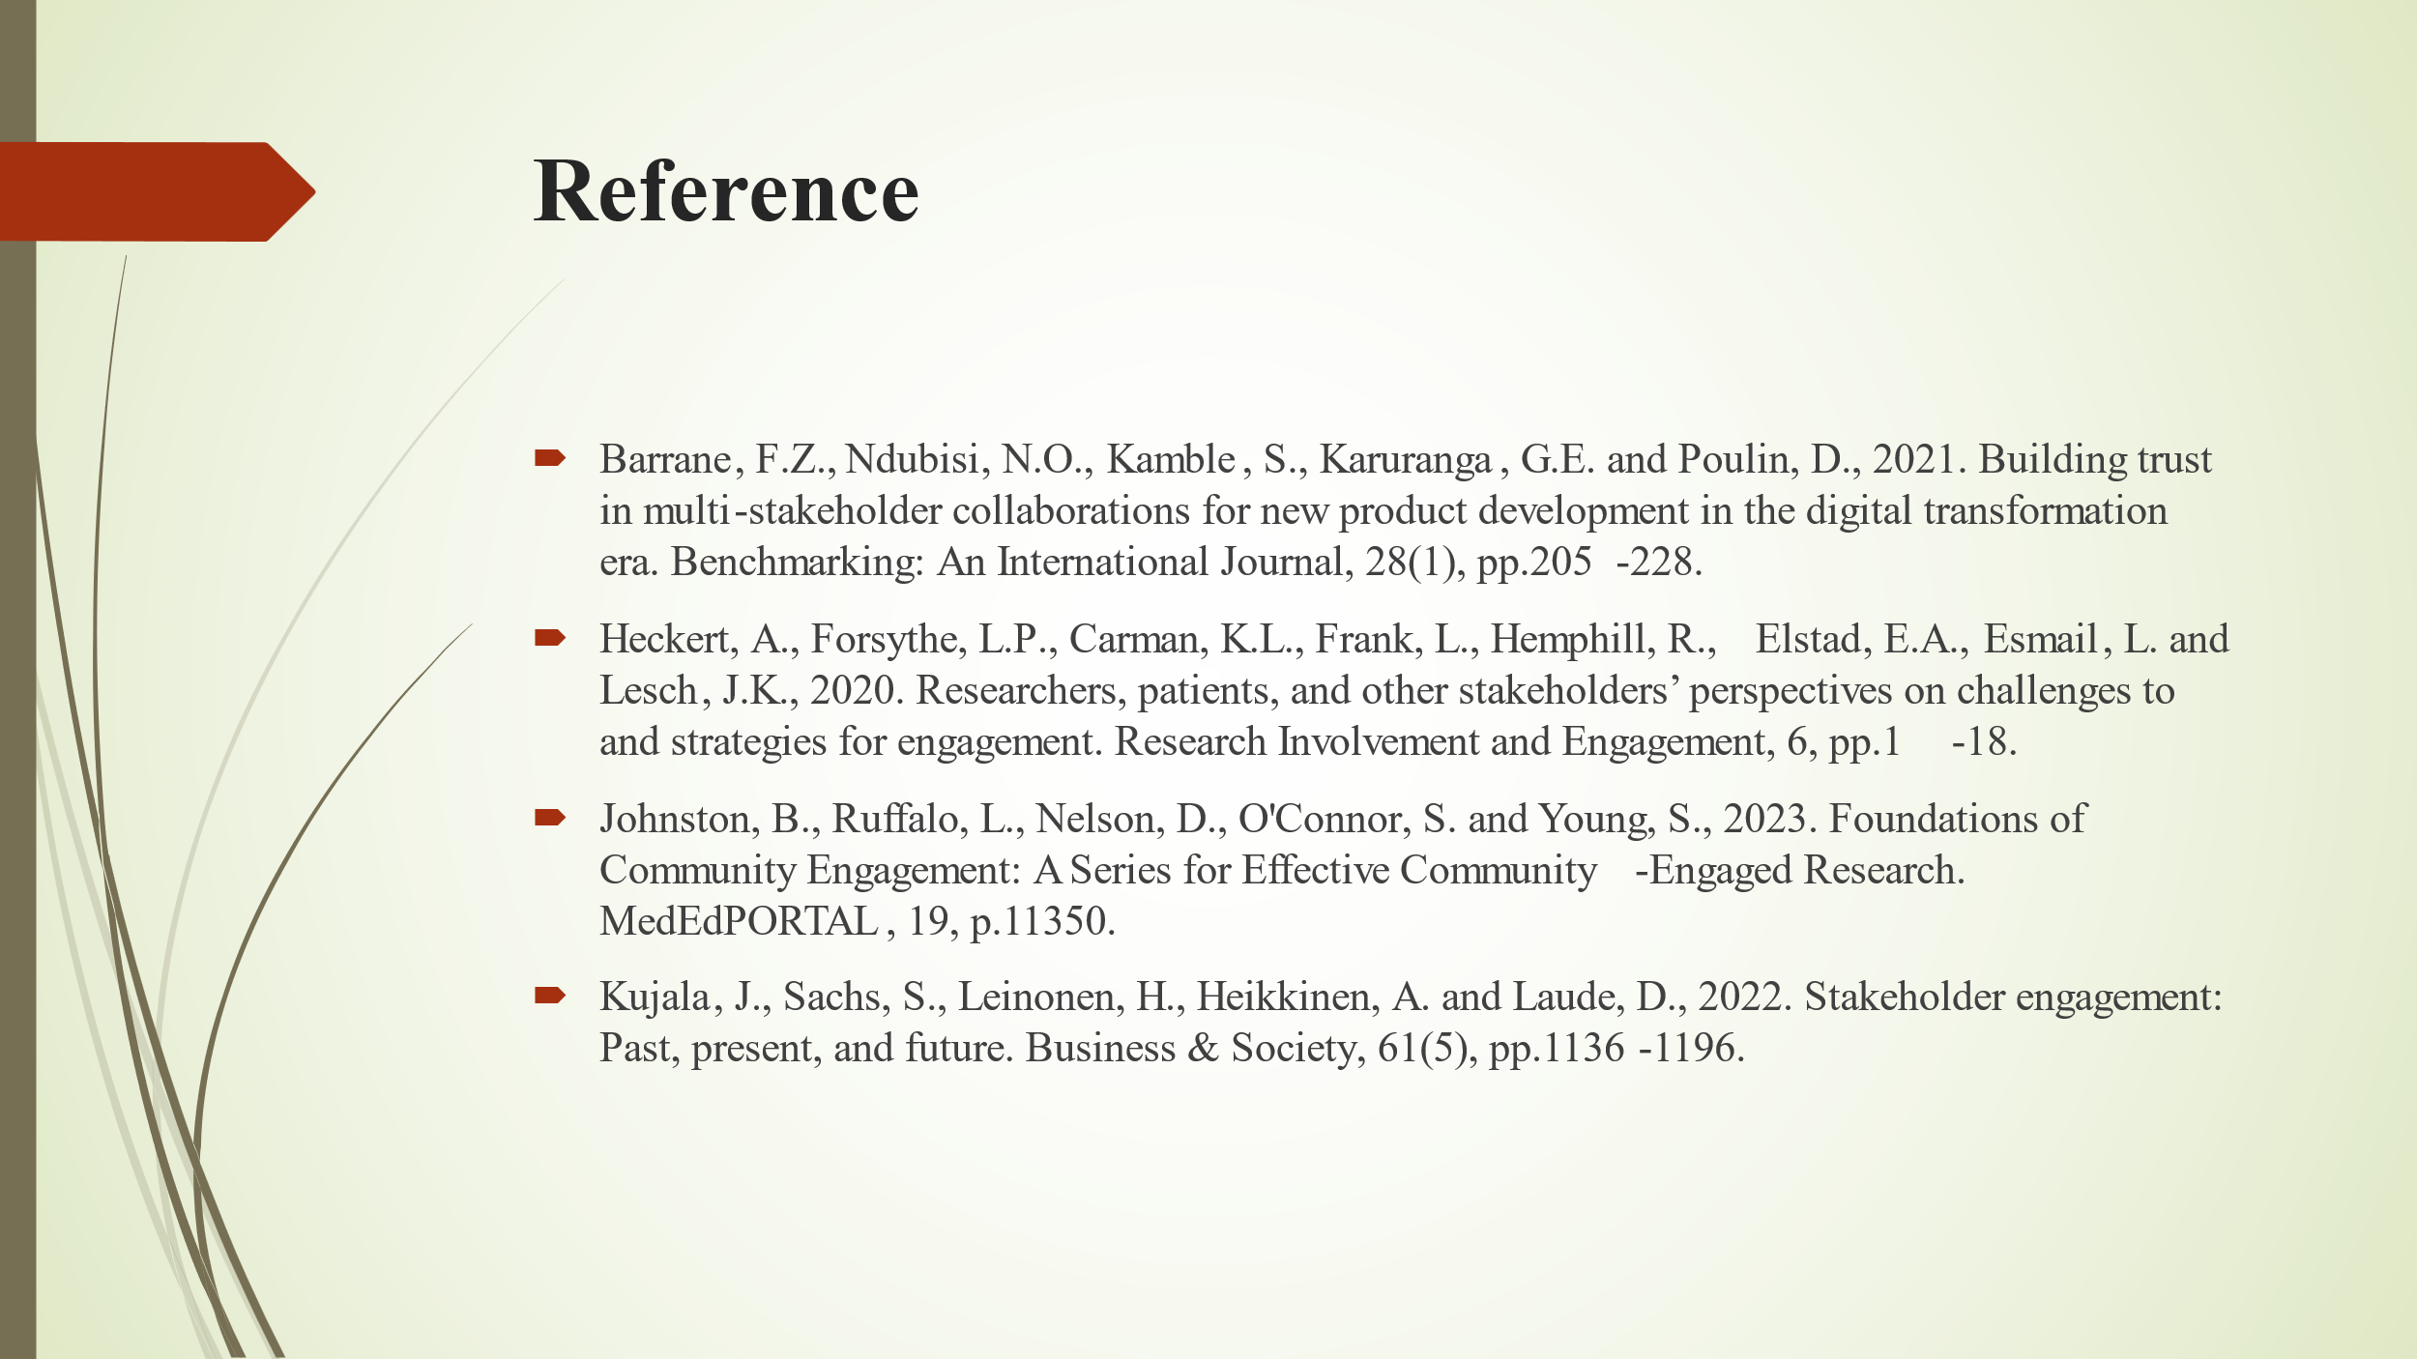

Element 4: Practical Discussion
It is very important to involve stakeholders when implementing any community project. As such, it guarantees consideration of the different opinions of the members of a community hence appropriate and sustainable solutions can be achieved (Kujala et al., 2022). The process of involving stakeholders actively encourages the creation of synergy, and trust, and ensures that communities’ work is done based on people’s needs and wants (Stocker et al., 2020). An example of the practical form of the discussion of Stakeholder Engagement is made by presenting the advantages of the approach, the effective working methods, and the example of its usage in the case of fighting against community problems. From that point, based on the examples of our practice and the principles received during the study, we will obtain a complete understanding of what actions are necessary for developing the desire for active participation and comprehending the problems of a community.

Key Findings and Benefits
This study seeks to discuss many advantages of stakeholder engagement that hugely help in improving community initiatives. The first significant benefit is the improvement of the decision-making process and increasing the representation of minorities. Community participation is essential in development because of the ability to have membership, commercial, and government organisations to have close communication and a perfect understanding of the needs of society (Kim et al., 2020). Such an approach is likely to receive more support and hence, projects that are most likely to be successful stand a better chance of being accomplished. For instance, based on managing local community projects, I initiated the key stakeholders’ involvement in the beginning, and this gave way to the early detection of problems that could be detrimental to the success of the project. This is, for example, one of the cases was with children in the planning of the new park in the neighbourhood, the changes had included additional playground and safety. This engagement not only popularised the park’s usage but also ensured the community felt that they owned the park as well as counted on it.
In addition to this, stakeholder engagement assists in fixing strong relations and networks with other stakeholders in the community. Such linkages can be used when undertaking other projects hence improving the chances of success and cooperation (Gerlak et al., 2023). For instance, an event such as the clean-up event with local businesses yielded partnerships that have followed one another to support other projects in the community. Overall, this shows that stakeholders’ engagement helps boost project efficiency, gain the public’s approval, and create worthwhile associations that are determinant to success.

Techniques and Principles
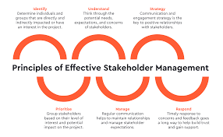
Figure 4: Principles of Effective Stakeholder Management
Source 3: (Theoriongroup, 2024)
There are distinct practical interventions and several basic principles for stakeholders’ management. One of the useful approaches is listening in an active way, which means not only the reception of the views and opinions of stakeholders but also their assessment of their needs and desires. This approach fosters trust and it guarantees that the stakeholders’ contribution is what has been incorporated by the business (Gearhart and Maben., 2021). A related technique is the routine reporting activity that informs the stakeholders about the activities and other important events in the project through the media such as newsletters, meetings and social media platforms. The continual discussion also establishes good governance because people feel involved in the project (Troise and Camilleri., 2021). Another technique is Inclusive Participation where all the stakeholders get to meaningfully contribute to a discussion or decision-making process. This can be done through such measures as the following which include: conducting surveys, discussion forums and workshops (Bell and Reed., 2022). In addition, designing feedback systems can facilitate ongoing feedback from stakeholders, which would result in the engagement process being sensitive to emerging issues.
Such steps are based on the course principles, such as diversity, openness, and reporting. Currently, assimilation entails that every person in a community is allowed to contribute to the process irrespective of colour or origin. Transparency means the unguarded manner in which one pursues the acquisition of information (Kujala et al., 2022). Critical success factors reflect this secret by ensuring that the information they release to the public is accurate and detailed. Engagement accountability relates to the ability of the officials to address the concerns of the stakeholders and to take responsibility for the effect yielded by any engagement activities (Franklin and Franklin., 2020). These techniques and principles can be implemented to ensure that stakeholders are engaged hence making any community endeavour more disproportionate and productive. Since this approach beefs up the relationship between all members of the community working on the project it guarantees the better result for the project and sustainable correspondence of the community’s goals with the expectations of all members.

Addressing Community Challenges

Figure 5 Addressing Community Challenges
Source 4 (Guy, 2018)
The application of engagement techniques to community challenges entails using the social science approaches by adapting suitable and functional strategies, where such strategies are made based on the challenges that are perceived by the stakeholders, after conducting some form of research and assessment. For example, one issue that is pervasive in most societies is the issue of poverty from which the issue of economic inequality stems. Approaches such as cooperation with the local enterprises and the provision of services to the special population will aim at the solution of this problem (NHS England, 2023).
Another example is community development work that focuses on the social reactivation of a certain area in Surrey (Armstrong, 2022). Due to contextual assessment and social participation of the project team with the residents, owners of the businesses and mayors, problems such as lack of adequate public areas and inadequate economic development were defined. Hence, with the help of strategies such as community forums and feedback surveys, the team drew up a clear plan with recommendations for the improvement of public amenities, boosting local businesses, and encouraging investment.

Recommendations and Conclusion
Several recommendations can be derived based on the findings in stakeholder engagement and practical experiences through field service. First, early and continuous stakeholder involvement will ensure that their needs and concerns are taken on board in project planning and implementation processes (Gupta et al., 2020). Second, apply multiple communication channels targeting different community segments to ensure consistency in getting the message across and updating the community in a transparent manner. Also, it should include feedback mechanisms that allow continuous input and the adaptation of strategies based on needs. Support collaborative partnerships with local organizations and businesses, driving resource development and support (Salvioni and Almici, 2020).
Conclusively, good stakeholder engagement is necessary to ensure solutions to community challenges and effective outcomes. Communities can improve their efforts in engagement, build bridges toward better relationships with related institutes, and form more effective initiatives by applying practical techniques and key principles. Reflecting on the approaches and integrating lessons learned will add up to the community's cooperative and inclusive development strategies.

Reference
Armstrong, J. (2022). Climate change among nine tough challenges facing Surrey County Council in 2022. [online] Surrey Live. Available at: https://www.getsurrey.co.uk/news/surrey-news/climate-change-plugging-17m-blackhole-22682402.
Bell, K. and Reed, M., 2022. The tree of participation: a new model for inclusive decision-making. Community Development Journal, 57(4), pp.595-614.
Dyckhoff, T. (2012). Let’s move to Staines-upon-Thames, Surrey. [online] the Guardian. Available at: https://www.theguardian.com/money/2012/aug/17/lets-move-staines-upon-thames
Franklin, A.L. and Franklin, A.L., 2020. Introduction to Stakeholder Engagement (pp. 1-17). Springer International Publishing.
Freeman, R.E., 2023. Stakeholder management: framework and philosophy. In R. Edward Freeman’s Selected Works on Stakeholder Theory and Business Ethics (pp. 61-88). Cham: Springer International Publishing.
Gearhart, C.C. and Maben, S.K., 2021. Active and empathic listening in social media: What do stakeholders really expect. International Journal of Listening, 35(3), pp.166-187.
Gerlak, A.K., Guido, Z., Owen, G., McGoffin, M.S.R., Louder, E., Davies, J., Smith, K.J., Zimmer, A., Murveit, A.M., Meadow, A. and Shrestha, P., 2023. Stakeholder engagement in the co-production of knowledge for environmental decision-making. World Development, 170, p.106336.
Gupta, K., Crilly, D. and Greckhamer, T., 2020. Stakeholder engagement strategies, national institutions, and firm performance: A configurational perspective. Strategic Management Journal, 41(10), pp.1869-1900.
Guy, P.P. [ T.C. (2018). 13 major challenges faced while building a community | Experts’ Roundup. [online] HackerNoon.com. Available at: https://medium.com/hackernoon/13-major-challenges-faced-while-building-a-community-experts-roundup-e3a59aa28fbf.
Kim, G., Newman, G. and Jiang, B., 2020. Urban regeneration: Community engagement process for vacant land in declining cities. Cities, 102, p.102730.
Kujala, J., Sachs, S., Leinonen, H., Heikkinen, A. and Laude, D., 2022. Stakeholder engagement: Past, present, and future. Business & Society, 61(5), pp.1136-1196.
NHS England (2023). Working in Partnership with People and communities: Statutory Guidance. [online] NHS England. Available at: https://www.england.nhs.uk/long-read/working-in-partnership-with-people-and-communities-statutory-guidance/.
O’Brien, J., 2020. The branding geography of Surrey craft breweries. The geography of beer: Culture and economics, pp.23-33.
Salvioni, D.M. and Almici, A., 2020. Circular economy and stakeholder engagement strategy. Symphonya. Emerging Issues in Management (symphonya. unicusano. it).
Stocker, F., de Arruda, M.P., de Mascena, K.M. and Boaventura, J.M., 2020. Stakeholder engagement in sustainability reporting: A classification model. Corporate Social Responsibility and Environmental Management, 27(5), pp.2071-2080.
Surrey (2024). New Community Hub for Staines - Surrey County Council. [online] Surreycc.gov.uk. Available at: https://www.surreycc.gov.uk/community/make-it-happen/your-local-area/spelthorne/community-hub-for-staines
Surreyi, (2021). Census 2021: Ethnic Group | Surrey-i. [online] Available at: https://www.surreyi.gov.uk/census-2021/ethnic-group/.
Theoriongroup, (2024). Effective Stakeholder Management, Communication and Relationships – Orion Group. [online] Available at: https://www.theoriongroup.au/news/effective-stakeholder-management-communication-and-relationships.
Tractivity (2024). The Levels of Stakeholder Engagement - Tractivity. [online] Available at: https://www.tractivity.co.uk/blog/levels-of-stakeholder-engagement.
Troise, C. and Camilleri, M.A., 2021. The use of digital media for marketing, CSR communication and stakeholder engagement. In Strategic corporate communication in the digital age (pp. 161-174). Emerald Publishing Limited.
Zingraff-Hamed, A., Hüesker, F., Lupp, G., Begg, C., Huang, J., Oen, A., Vojinovic, Z., Kuhlicke, C. and Pauleit, S., 2020. Stakeholder mapping to co-create nature-based solutions: who is on board?. Sustainability, 12(20), p.8625.

