_{Assignment 1}

Blog post 1

For this assignment we are using something called the ‘design thinking process’, here I will explain that. For each blog post I will be focusing on each step of the design thinking process and what I did to achieve that.

The design thinking process looks like this:
The design thinking process is a non-linear process that takes you through creative steps to help you work with your team to create your projects to prototype and test. There are 5 stages of this process which include: empathize, define, ideate, prototype, test. There is often a 6th stage which is implement.
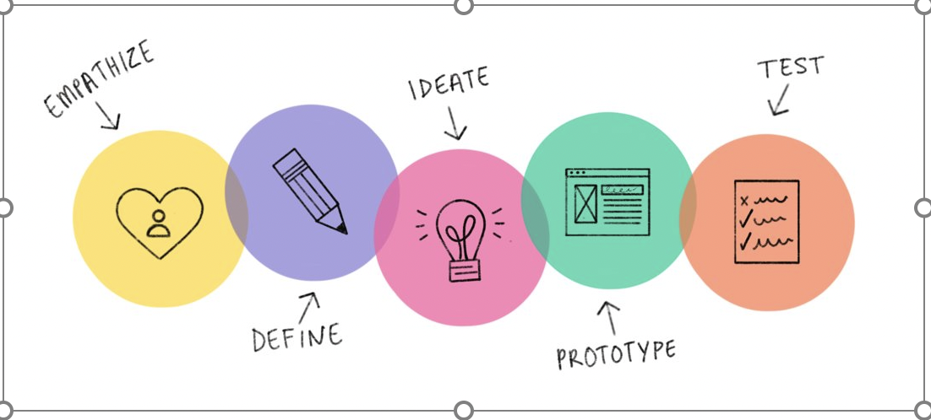
https://www.interaction-design.org/literature/topics/design-thinking

https://medium.com/swlh/how-to-use-design-thinking-in-the-ux-design-process-e33c4f11a6be

Blog post 2

In the first week we had to choose one of the 5 topics given to us which were:
Mindfulness and wellbeing- ancient paradigms and modern methodologies
An inconvenient truth- visions of the future
The future is human- rise of the machines
Disinformation- knowledge and ignorance
Dreams and psychodelia- beyond limitations

All of these topics seemed pretty big and I wasn’t sure I could pick settle on one. I really didn’t like the future is human- rise of the machines as this topic did scare me that this could actually be the reality.
I really like mindfulness and wellbeing as this topic is something that is personal to me, and I knew I could relate to it and create something that would help me as much as I would help other people
This then lead us on to the first stage of the design thinking process.

Empathise:
This is also called research so this is where we had to research our chosen topic. At this point my chosen topic was dreams and psychodelia and I did a lot of research on the different types of dreams and why we may dream more than the psychodelia side because I didn’t connect with it and found that a lot of research was based on being in s crazy state of mind. I did also try and link dreams and psychodelia to mindfulness and wellbeing and the effects that each one has on each other.
Blog post 3

Define:
We were put into groups, and we had to decide as a group which of the 5 topics we wanted to do together. I was lucky that me and Steph work well together and we were happy to discuss what we had researched and what we would like to do as a group. I did have to do some extra research as we did choose a separate topic to what I had already done my research on. I was excited to finally settle on a topic and by doing the research I did have an idea on what I would like to create.

We choose to do:
Mindfulness and wellbeing- ancient paradigms and modern methodologies.

What is mindfulness and wellbeing:

According to the NHS website it states that mindfulness is when we pay attention to what is happening inside and outside of ourselves all the time. Constantly thinking about what is happening and although it can be easy to lose touch with our senses and the world around us and how we are feeling.

Something else that I found interesting on the website was that part of mindfulness is that we need to be connected with our emotions and senses It states that this means we should be paying attention to the things we see, hear, smell and taste at that particular moment. It gives an example of when walking up the stairs to touch the banister. Another example I have personally used is when I am outside, I like to listen for the birds as this for me is something very special to listen to. When I was eight years old I had heard the birds sing for the first time as before this I was perfoundly deaf and I had had 3 operations and they ended up cauasing scaring on my ear drums and when I was eight years old I was offered hearing aids and as I walked out of the hospital with my hearing aids for the first time I got to experience my first bird song and it made me feel so grounded to earth and so happy to be able to hear things. I find it hard to be calm in noisy situations due to my now sensitive hearing and I like to listen out for the birds if imp outside or ill play birds on my phone through headphones so that I can be calm and reconnect to my surroundings.

One of the main things it says on the NHS website is that we should be intentional about how we are felling and what we are thinking every moment.

Being aware in the moment can help us enjoy our surroundings and understand what we are going though within ourselves. When we are aware of our surroundings, we are more likely to experience some of things that we may take for granted. Being aware like this can help us to notice signs of anxiety and stress and be able to deal with these feelings before they get too much to cope with.
https://www.nhs.uk/mental-health/self-help/tips-and-support/mindfulness/
nhs.uk. 2023. Mindfulness - NHS. [ONLINE] Available at: https://www.nhs.uk/mental-health/self-help/tips-and-support/mindfulness/. [Accessed 21 February 2023].

After doing some research I have found that when listening to bird songs there are multiple benefits these include:

- Helping you to relax to boost productivity
- To help you de-stress and switch off
- You could use it as a gentle way to wake up with an alarm clock
- You can use it to help you focus when you are doing some studying or while you are working
- You could use it as a soundtrack for meditation
- You could also use it to keep yourself calm whilst doing your daily commute.
https://www.rspb.org.uk/get-involved/campaigning/let-nature-sing/birdsong-radio/

Blog post 4

Ideate:
The third stage of the design thinking process is ‘ideate’. This is when as a group we start to think about who we are going to aim our project at and when we are going to place our sound scapes. As the other person in my group is not from Swansea and has to travel by train twice a week from Haverfordwest We brain stormed different locations and the possibility of these locations, who our target audience would be and why and how it would improve their mental health and wellbeing.

Some of our ideas for locations include:
- Port Eynon/Three Crosses/Caswell Bay/Gower beaches
- Folly farm
- Haverfordwest racecourse
- Tenby
- Llanelli wildlife wetlands centre
- Periswood archery and aviary
- Botanical gardens/singleton park/Clyne gardens/Clyne woods/Plantasia
- Swansea marina
- Mumbles pier

Some of the target audiences we looked at related to the locations in which we would choose.
We thought about
- Individuals recovering from addictions.
- Vulnerable adults.
- Single parents.
- Working parents.
- Individuals recovering from Mental Health conditions/In treatment.
- Ex-offenders.
- College and University students.
- General public.

We really liked the idea of recording birds and nature sounds as this has been proven to reduce anxiety and calm our minds. We also liked the idea of doing it in Haverfordwest as I could drive and the other person, Steph doesn’t and it’s hard for her to travel. The both of us are also wheelchair users and we must find accessible locations.

When we went to check the location, it was hard to get around and, we thought that people would just want to listen the natural sounds there and not the background sounds of that place.

So, we started thinking outside of that and where would people listen to things without it being the actual place. So, we thought about places we visit regularly. We decided on the train station, Swansea market and castle gardens. In these places we cover a wide range of our target audiences that we wanted to reach, and we hope that anyone who does listen to our map will be able to reconnect with their surroundings and enjoy a mindfulness experience.

We also had to think about what we were going to put on our sound files, and we discussed a few different things like
- Bird sound files
- Wave sound files
- Interviews about our own mental health
- Just a general chit-chat

Blog post 5

Prototype:
The fourth stage of the design thinking process is ‘prototype’. As we have reached this stage, we now start to plan out exactly the locations we have chosen and what the sound scape is going to be.
We have decided that we will use the train station, Swansea market and Castle Gardens.
I will cover castle gardens with a sound scape of both natural birds and gentle waves.
My aim is to create a gentle sound scape to help calm the mind and bring someone back to the reality of their surroundings. I hope to bring clearance, reality and a mindful experience to the individuals who may be listening to the sound files. This then will inturn help the wellbieng of the individuals.

Blog post 6

Test:
The fifth stage of the design thinking process is ‘test’.
With the sound files now on the map we have been out to test that they work and bring what we hoped to create for this projected.
With the sound files now up and running we have tested the echoes map to ensue that the sound files do work and if it creates the experience we were hoping for.
I know for me that when I did this, I felt very calm in going to these places as they do cause me anxiety and stress normally but this time my experience was different, and I felt like I could achieve what I. needed to in these environments.

Blog post 7

Implement:
The last stage of the design thinking process is ‘implement’. With everything now defined and working we are very happy with our end results and are now ready to publish our map and hope that even more individuals can enjoy the experience that we have created.

Blog post 8

Conclusion:
I have not really enjoyed this assignment of contemporary challenges- making a difference. (I also do not really like this design thinking process as I like to do a lot of my work solo and when I have an idea, I like to go with it, but I have had to learn that it’s not just my work and I need to incorporate the others with it. I also have had to learn to listen to other people’s ideas and not just make all the discissions.

Link to my site specific sound walk
https://explore.echoes.xyz/collections/Ta3VzL6G51nF8ee1

link to my Blog
https://assignmentoverload.wordpress.com

