The Nature and Direction of Archaeology as a Discipline
Humanity’s fixation on the past means that archaeology has long been a popular area of practice; however, it was not until modern times that it gained traction as an academic discipline. The term archaeology derives from the Greek ‘arkhaios’, meaning ‘discourse about ancient things’, but has progressed to refer more to the study of the human past through the lens of material traces of it. Archaeology as a discipline is entangled with not only historical study but also has influences from and upon social and political fields, and both theoretical and applied sciences. It is an ever-evolving subject in terms of both study and practice.
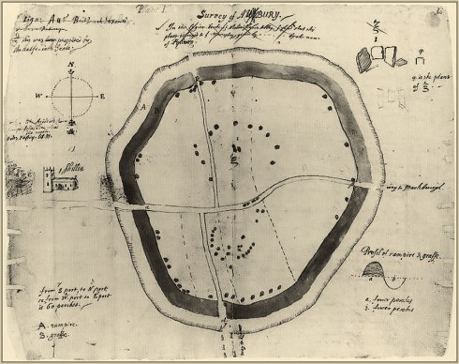
Humans have excavated and collected monuments and objects for thousands of years. Often, early excavators were not scholars or professionals, but grave robbers or looters seeking income. The term ‘archaeology’ was reinvented in the 17th century by Dr Jacques Spon of Lyons to denote a field of scholarly study, but it was in the 16th century that it was recognised that information could be discovered through the study of field monuments (Bahn, 2012, p.9). At this time, particularly in Northwest Europe, academics began to question Francis Bacon’s claim that, beyond scripture, most ancient times are ‘buried in oblivion and silence.’ Throughout the early modern period, it became popular practice for wealthy gentlemen to visit and excavate archaeological sites in the pursuit of leisure; however, there were some pioneers who began to legitimatise the industry with a more systematic approach. A key figure at this time was English antiquarian and writer John Aubrey, who recorded (most for the first time) several megalithic monuments. His analysis of his findings was ahead of much previous writing, attempting to chronologically chart the evolution of numerous subjects including handwriting and architecture. Aubrey’s 17th century writing ‘Monumenta Britannica’ is a pioneering manuscript on British antiquities and archaeology, containing early details of countless ancient monuments (Hunter, 1975, p.156-181).
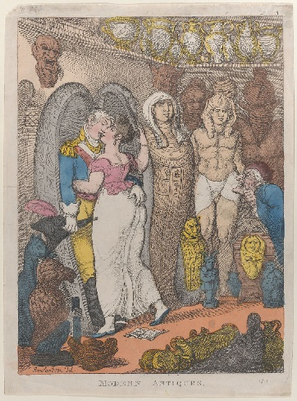
Antiquarianism, as practised by individuals like John Aubrey, is widely considered a significant precursor to archaeology as we know it today. Throughout the 15th to 17th centuries, antiquaries brought objects into scholarly domain and developed the modern study of the ancient world through material. American historian Peter N. Miller has written extensively regarding antiquarianism and posits that this area of study began out of the awareness that textual sources should be related to and confronted with material remains to be fully understood (Miller, 2017). This view is foundational to archaeology as a field, which focuses on material findings but uses a wide range of sources, including oral and textual, to reach conclusions. By the 19th century, antiquarians as a group were regarded as stereotypically middle-class, elitist men, often depicted as effeminate figures who were so pathologically obsessed with the past that they neglected events of the present as well as expectations for masculine behaviour. This is exemplified by Figure 2, where a satirical print from 1811 shows a grim-looking antiquary infatuated by shelves of Egyptian artefacts while a man in military garb embraces a young woman. This attitude meant that ‘antiquarian’ was increasingly used as an insult, with historians viewing antiquaries as narrow minded; intensely detailed oriented but lacking a view of the ‘big picture’ and lost in empirical data.
Figure 1; Aubrey's map of Avebury Henge from Monumenta Britannica c.1675
Figure 2: Thomas Rolandson's ‘Modern Antiques’
The emergence of the scientific method as a concept coincided with scholarly aspirations to be increasingly systematic and scientific about vestiges of the past. Antiquaries, as a specific, identifiable group of individuals experienced academic marginalisation towards the mid to late 19th century and their attitudes/practices began to be adopted into other areas of study such as history or archaeology. Antiquarian collecting and categorising are core tenets in archaeology, which goes further to systematise excavations, practice geological stratigraphy and use the scientific method to learn more about a given artefact and its historical contexts.
This period also saw major developments in fieldwork techniques and practices within archaeology. Alfred Kidder was a pioneer in utilising specialist teams of analysts to study artefacts, as well as establishing his “blueprint” strategy. This entails five main pillars that are still used in fieldwork today: reconnaissance, chronological ranking of remains, seriation into probable sequences, stratigraphic excavation followed by detailed regional surveys (Renfrew and Bahn, 1996, p.33). Today, archaeology is generally considered to use “material evidence, from molecules to monumental structures, to explore the human past and understand past societies” (Cambridge University). Archaeology in the 21st century has transformed into much more than manual excavation and analysis, branching off into a highly interdisciplinary and social field. As a multi-faceted subject, archaeology’s relation to other professional and academic subjects is key to its success and progress in both methodologies and findings. For example, disciplines such as chemistry and geology play a significant role in allowing archaeologists to date findings through nuclear and chemical methods and understand the utility of varied materials over time (Zahra, 2026).
Archaeological science has thus grown to incorporate a range of techniques that are grounded in all scientific sub-disciplines to add nuance to our understanding. In 1991, Oxford University researcher Michael Tite wrote that he did not consider archaeological science its own discipline but rather a “meeting ground” for collaboration as well as the integration of theory and method (Tite, 1991). Since the first instances of radiocarbon dating in the mid-20th century, there has been a drive to refine and improve methods to increase accuracy and gain the ability to analyse smaller sample sizes of organic material. Developments in accelerator mass spectrometry (MS) for radiocarbon dating in the 1980s and onwards have been key to this progression in dating technologies. Radiocarbon dating is, however, limited to dates up to 60,000 years and can only work on organic material. Techniques like amino acid racemisation (AAR), as reviewed by Penkman et al., have been used to expand the reach of scientific dating in archaeology by assessing a wider variety of material, and as stated in the review holds potential for advances in calibration and cross-checks to further improve dating techniques.
Ethical considerations, as in all disciplines, are a key factor to be considered both in terms of scientific and leisurely archaeological endeavours. Concerning periods where most excavations were done without academe by middle-class hobbyists, ethical issues were naturally focused on discussions of classism and fetishism of foreign culture. These discussions have only become more complex since then. In 1906, the Antiquities Act was created in the US as a response to the increasingly scientific discipline in order to help regulate archaeological discovery, allowing for federal protection of sites from looting. This act fundamentally failed to protect communities whose ancestral lands and objects were being seized (Chadwick, 2012). The rights native peoples worldwide have to their heritage properties have been discussed extensively, and repatriation and attribution are considered a crucial factor in archaeological research and the display of artefacts. Repatriation claims are often centred around contemporary ideas of politics and identity and aim to reverse illegal actions taken by colonialists and traffickers (Shehade and Fouseki, 2016). An example of repatriation for this reason is the return of the Tupinambá Indigenous Cloak to Brazil from Denmark in 2024. The Cloak had been displayed in Copenhagen since 1689 as an exotic artefact, arguably stripping it of its original context as sacred and ceremonial (Sirvent, 2025). Once the Cloak was returned to its original owners, indigenous leaders said its return “highlights the importance of demarcating their ancestral lands to keep their traditions alive” (Pomeroy, 2024).
Indigenous chief Sussu Arana Morubyxada Tupinambá (Pomeroy, 2024)
“Our ancestors say that when they [the Europeans] took it away, our village was left without a north.”
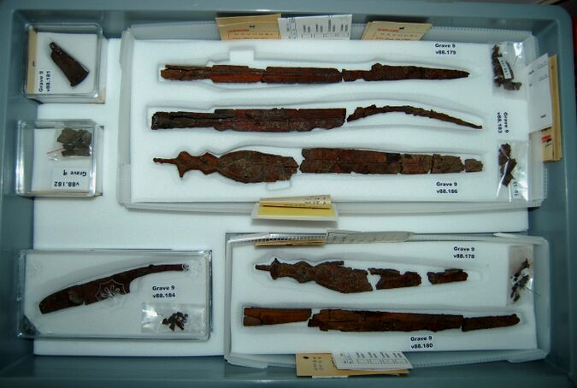
Professional membership organisations such as the Chartered Institute for Archaeologists play a significant role in setting standards and helping archaeologists maintain integrity. The CIfA’s published code of conduct goes beyond legal compliance, both morally and scientifically, and centres honesty and fairness. The code presents points including the sale of archaeological objects, protection of historic environments and accessibility of findings as significant ethical considerations for the industry (CIfA, 2025). This comprehensive list of guidelines is an example of the evolution of ethics as a concept within archaeology. Archaeology is an inherently social field, and the increased awareness of this fact has consistently altered the direction of the discipline. One of the earliest texts on archaeological ethics was John Ruskin’s 1849 work “The Seven Lamps of Architecture.” This text declared that it is a moral obligation to preserve heritage architecture and avoid restoration, as the removal of the effects of time would then remove context and character from the structure. This attitude is still prevalent and is a key consideration for technological advancements to preserve ethics. Methods of storage for artefacts, such as preventative conservation with temperature-controlled, acid-free casing, have become a popular philosophy for those concerned with restoration and preserving the effects of age and use on an object.
Figure 3: Preventive conservation measures taken for long-term storage of iron artefacts from the Late Geometric cemetery at Kavousi Vronda.
Bahn (2012, p.104) exemplifies the fast-paced, ever-changing nature of archaeology as a discipline using Josephine Flood’s Archaeology of the Dreamtime as a device. He writes that the book had three editions in only 12 years, each of which was remarkably different and filled with updates. This is true across archaeology and its many related disciplines – as artefacts are found, humanity’s ideas of the past evolve. Archaeological research is, simply, a higher-level and more purposeful continuation of human instinctual behaviours of information accumulation and preservation (Kindong, 2024).
As human life is increasingly centred around technology as a companion as well as a tool, the idea of digital archaeology as a sub-discipline becomes more prevalent. Kindong (2024) describes digital archaeology as having two facets, the first being the use of developing technology to aid traditional archaeology. He writes that many other fields have seen rapid advancement with the advent of innovative technology, using the progress of astrophysics after the invention of the Hubble Space Telescope as a key example. The second aspect of digital archaeology that Kindong details is the need for archaeological research and preservation of “digital-born” human behaviours like the culture surrounding cryptocurrency. The fast-moving nature of digital culture means that sites often get abandoned by their users and are left “lost” in cyberspace, meaning that a lack of archaeological interest and action can leave important evidence of human behaviour behind. The future of archaeology is inherently intertwined with the future of human behaviour and must progress alongside.
Another pressing debate in the future of archaeology is the need to address climate change, both as having an impact on the discipline's methodology and how archaeologists themselves can minimise negative effects on the environment. Archaeologists have, in recent years, successfully used environmental studies with models of prehistoric climate variation and long-term human impacts to discuss potential future trends and provide evidence about environmental change and human adaptive responses to past crises (Holtorf, 2023). It has been argued that, with reference to case studies in China, the Mediterranean and the UK, knowledge gained from landscape archaeology can aid stakeholders in planning future land-use and more sustainable management practice (Turner et al., 2020). Individual archaeologists and academic units like York and Oxford Archaeology are also actively taking measures to address climate change by altering their methodologies and practices, including setting Net Zero targets for office efficiency and lowering emissions from travel. Holtorf (2023) highlights that this awareness, combined with the use of archaeological methods to understand long-term trends, can lead to archaeologists becoming spokespeople for change. Pointing to the implications of climate change for emblematic and local heritage sites can help archaeologists communicate the urgency of advanced climate action.
To conclude, archaeology as a discipline is incredibly multi-faceted, and both feeds into and takes from several other fields, such as social, natural, and environmental sciences, humanities, and digital and computational spheres. Archaeology as we know it in the 21st century is vastly different from its early beginnings as the practice of treasure hunting, or the curiosity about ancient objects – evolving into a highly technological and systematic practice with a vested interest in not only humanity’s past but its future as well. Publications and methodologies consistently change in conjunction with new knowledge gained from all areas of study. For example, the practice of carbon dating originated from a chemist’s education about cosmic rays and atmospheric nitrogen. Material culture is a human behavioural constant but evolves constantly to encompass more abstract concepts like artificial intelligence and cultural footprints in cyberspace. This evolution of a key aspect of archaeology means that it is likely that the discipline will continue to change and progress indefinitely.

Word count: 2,075 (excluding captions, title and bibliography) 2,112 (including captions)
Bibliography
References:
Bahn, P (2012) Archaeology: A Very Short Introduction 3rd Edn. Oxford University Press
Hunter, M (1975) John Aubrey and the Realm of Learning London: Duckworth
Miller, P.N. (2017) History and Its Objects: antiquarianism and material culture since 1500 Ithaca, NY: Cornell University. Digitised by The Internet Archive, 2023.
Renfrew, C and Bahn, P (1996) Archaeology: Theories, Methods and Practice 2nd Edn. London: Thames & Hudson
Cambridge University (2026) Overview: Archaeology at Cambridge Available at: https://www.undergraduate.study.cam.ac.uk/courses/archaeology-ba-hons (Accessed: 8/10/2026)
Zahra, K (2026) Archaeology and Other Disciplines [online essay] Available at: https://www.scribd.com/document/1010187069/Archaeology-and-Other-Desciplines?doc_id=1010187069&order=700411252 (Accessed 8/10/2026)
Tite, M (1991) Archaeological science—Past achievements and prospects Archaeometry 33 pp. 139-151 Available at: https://onlinelibrary.wiley.com/doi/10.1111/j.1475-4754.1991.tb00695.x (Accessed 8/10/2026)
Penkman, K et al. (2002) ‘Dating the Palaeolithic: Trapped charge methods and amino acid geochronology’ PNAS Available at: https://www.pnas.org/doi/abs/10.1073/pnas.2109324119 (Accessed: 8/10/2026)
Chadwick, Ruth (2012) Encyclopaedia of Applied Ethics. Elsevier. pp. 179–188.
Shehade, M and Fouseki, K (2016) The Politics of Culture and the Culture of Politics: Examining the Role of Politics and Diplomacy in Cultural Property Disputes International Journal of Cultural Property 23 pp. 357-383 Available at: https://discovery.ucl.ac.uk/id/eprint/1529977/ (Accessed 13/10/2026)
Sirvent, M (2025) Repatriation of Artistic Artefacts: Back to the Origins Available at: https://contestedhistories.org/uncategorized/repatriation-of-artistic-artefacts-back-to-the-origins/ (Accessed 13/10/2026)
Pomeroy, G (2024) Denmark returns iconic indigenous cloak to Brazil BBC News World, 13th September. Available at: https://www.bbc.co.uk/news/articles/ce818y325d2o (Accessed: 13/10/2026)
Chartered Institute for Archaeologists (2025) Code of conduct: professional ethics in archaeology Available at: https://www.archaeologists.net/sites/default/files/2025-10/Code-of-conduct_revOct-2025.pdf (Accessed: 13/10/2026)
Kindong, B (2024) Future Archaeology in the Digital Age International Journal of Sustainable Building Technology and Urban Development, 30th June. Available at: https://www.sbt-durabi.org/articles/xml/Kz5Z/#idm633504296x (Accessed: 16/10/2026)
Holtorf, C (2023) The Climate Heritage Paradox – how rethinking archaeological heritage can address global challenges of climate change World Archaeology 55(3) pp. 268-281. Available at: https://doi.org/10.1080/00438243.2024.2320122 (Accessed 18/10/2026)
Turner, S et al. (2020) Landscape archaeology, sustainability and the necessity of change World Archaeology 52(4) pp. 589-606. Available at: https://www.tandfonline.com/doi/full/10.1080/00438243.2021.1932565 (Accessed: 18/10/2026)

Figures:
[1] Piggott, S (1978) Antiquity Depicted: Aspects of Archaeological Illustration p.41 London: Thames & Hudson
[2] Rolandson, T (1811) Modern Antiques Publisher: Thomas Tegg
[3] INSTAP Study Centre for East Crete (2025) Mission and History

