A
BBBBBBBBBBBBBBBBBBBBBBBBBBBBBBBBBBBBBBBB
Bbb\
BBB

6666

7777778888
AA
A
FONT FOR GEOMETRIC PATTERN DESIGN
Create 5 patterns with different letters or numbers using a combination of scale,
USE SANS-SERIF FONTS; please choose one or more of the following fonts to use!
placement and colour.

We will be using Adobe Photoshop to create digital brushes to do this.

ARIALFUTURA
TAHOMA A
HELVETICA
BBBBBBBBBBBBBBBBBBBBBBBBBBBBBBBBBBBBBBBB
Bbb\
BBB

6666

7777778888
AA A
A

1. File > NEW > A3 > 297mm x 420mm @ 300dpi
2. Use the TEXT tool and pick which font you would like to use.
3. Pick a letter that you connect with or WORD, place, space…………
4. Ensure your foreground colour is BLACK and type 1 letter at 150pt scale.
This letter we will make into a digital brush.
5. Use the magic wand tool to select the type and then Define this as a
Brush. EDIT > DEFINE BRUSH PRESET – this will be saved in the brush’s
Palette.
6. Create NEW LAYER. – LAYER > NEW LAYER
7. Choose the colour you would like to paint with. Red, Blue or Black!
8. Use the Brush Palette to change the direction of your letter; rotating; opacity; scatter etc.
9. With the designs, create different patterns.
FORMAL / DITSY / half-drop in different colourways.
BLACK, WHITE and 1 colour
10. Put in repeat.
11. Save as .jpg in the Documents Folder.
USE THE STEP-BY-STEP GUIDE TO HELP YOU!
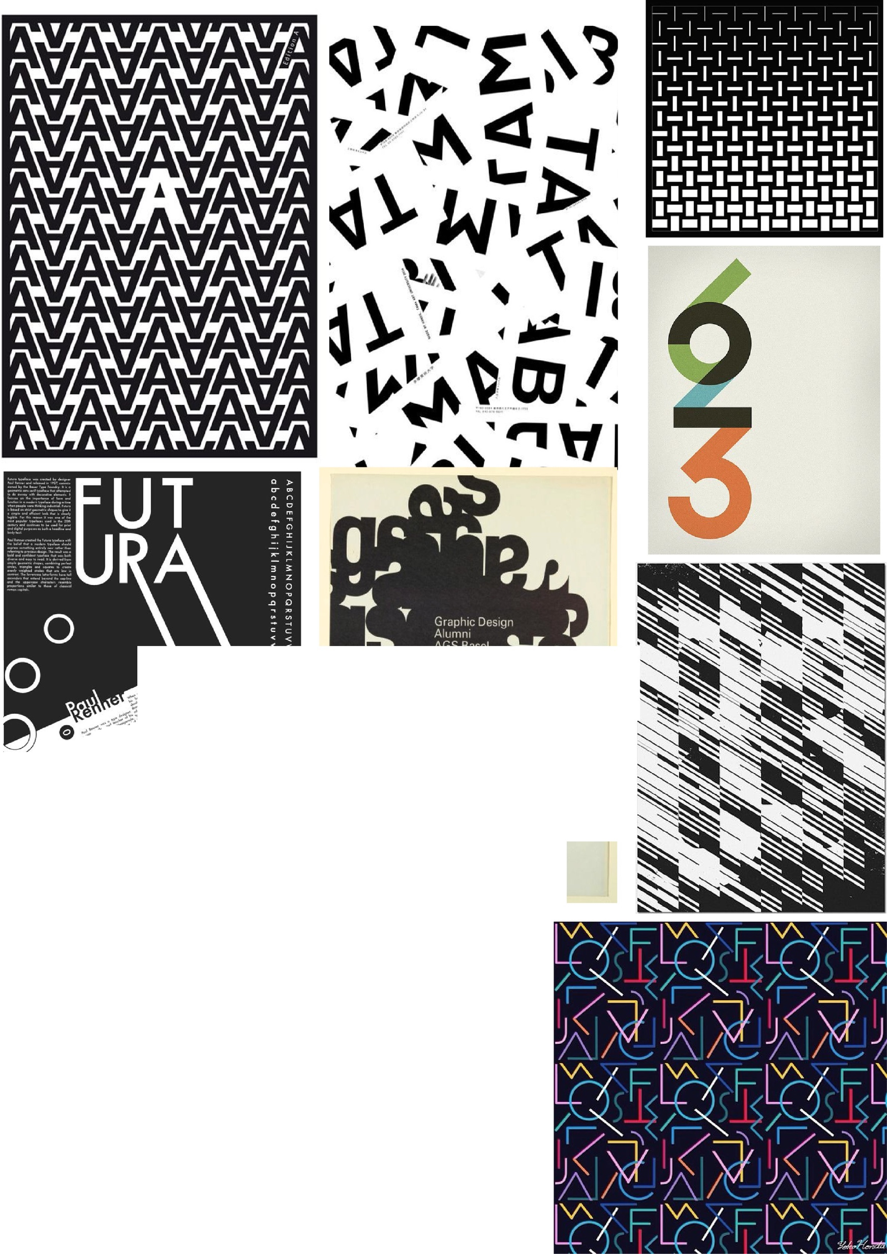
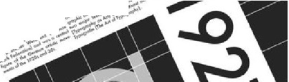
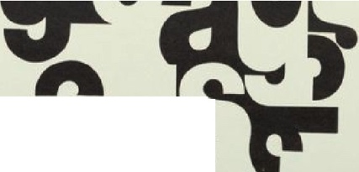
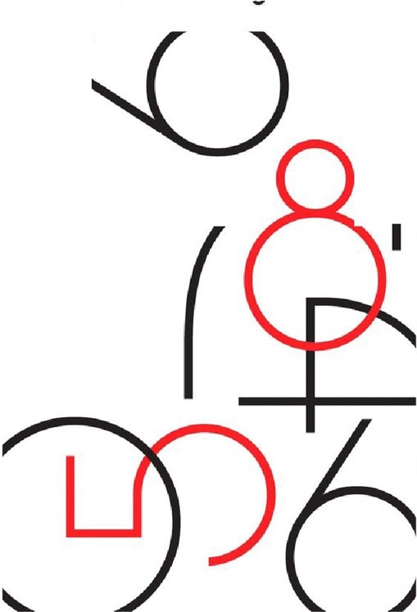
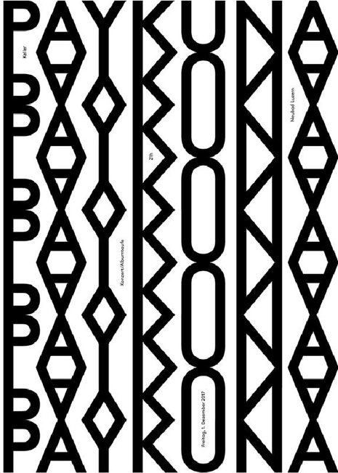

.
-r.1,-

