
LEVEL 7 ASSESSMENT SPECIFICATION

Student name: | Lovepreet Kaur | Student ID number: | 2234040
Programme: | MBA
Module: | Change & Stability Management
Module code: | BMMB7000 | Contribution to Overall Module Assessment (%): | 100%
Lecturer: | Marie Pitson | Internal Verifier: | Brynach Heffernan
Assignment Title: | Organisational Change  Case Study | Word count (or equivalent): | 5000  (1500- equivalent presentation  3500- report)
Submission deadline: | Presentation 10 minutes – Slide submission 27th February 2023  Individual Presentation slots during week commencing 27th February  Report 5th May 2023 | Return date of provisional marks & written feedback: | Presentation – Immediate verbal feedback  27th March (written)  Report – 5th June 2023
Submission method: | All written assessments, where practical and possible, must be submitted via Turnitin unless otherwise instructed by the Lecturer. (Please DO NOT put this assessment specification into Turnitin or it will match many similarities with other students’ submissions.)  Alternative submission method (if applicable):  Late submission of the assessment will result in a late penalty mark. Penalties for late submission: Up to one week late, maximum mark of 50%. Over one week late, 0%. Only the Extenuating Circumstances Panel may approve a change to submission dates.
Academic honesty / referencing: | Academic honesty is required. In the main body of your submission you must give credit to authors on whose research and ideas your work is based. Append to your submission a reference list that indicates the books, articles, etc. that you have used, cited or quoted in order to complete this assessment.

Module Learning Outcomes
(from module syllabus)
- To critically analyse theoretical perspectives and approaches to change management and demonstrate their practical application in a variety of organisational environments;

- To critically evaluate whether change is beneficial or a hindrance to organisations today by examining key internal and external drivers such as culture, leadership, power, digitalisation, economic and political pressures and the forces of competition.

INDEX

- Executive summery
- Introduction
- Reason for the changes
- Process of Implementation
- Impact on the performance and stability of the organisation
- Starbucks' change management strategy has certain advantages
- Starbucks' approach to change management has certain drawbacks
- Application of Lewin's Change Management Model
- Application of Kotter's 8-Step Change Model
- Application of the ADKAR Model
- Advice for Potential Future Change Initiatives:
- Conclusion:
- Reference list

Executive summary

A report's goals must be specified for it to be focused and contain pertinent information. The goals of a stability management report should be made explicit, including the conclusions it will reach, the issues it will address, and the specific stability management issues it will look at. One or more of the possible goals of such a study may be to identify potential risk and instability hotspots, review current stability management techniques, suggest improvements to stability, and evaluate the efficacy of present stability management tactics. Outlining the report's goals makes it simpler to organise the study and make sure that it offers insightful information about an organization's stability management procedures.

Introduction:-

Starbucks, the global coffee franchise, has undergone several significant changes. This report critically examines a major transformative project at Starbucks to assess its change management tactics and their impact on stability and performance. Using models like Lewin's Change Management Model, Kotter's 8-Step Change Model, and the ADKAR Model, the report evaluates Starbucks' strategies. With over thirty thousand locations in eighty countries, Starbucks' change management is crucial for its ongoing success in adapting to market conditions. The paper explores the motivations, implementation, and stakeholder involvement in the change process, analysing both positive and negative impacts to identify successes and areas for improvement, providing insights for future change management initiative(Zhaozhe, 2023)

Reason for the changes:

The evolving consumer patterns and heightened competition in the coffee business were major factors in Starbucks' decision to implement the selected change project. Consumer tastes for coffee have changed over time, with an increasing focus on sustainability, healthy
options, and individualised experiences. Starbucks must review its product offerings and business strategy to stay relevant and competitive considering this shift in customer behaviour.
Starbucks had to extend its selection of beverages to satisfy a wide range of dietary choices as well as add new menu items, such as plant-based substitutes, to meet the changing expectations of its patrons. Additionally, the emergence of specialty coffee shops and neighbourhood cafés increased competition and threatened Starbucks' ) 8 ft dominance.
The business understood that it needed to innovate and set itself apart from its rivals if it wanted to maintain its position as the market leader. (Li, 2018)

To continue its development trajectory, Starbucks set high organisational goals and performance standards internally. The leadership of the organisation saw the importance of accepting change in accomplishing these objectives and maintaining long-term success. To increase efficiency and profitability, they understood that it was necessary to optimise resource allocation, improve client experiences, and streamline operational procedures.
Starbucks was also motivated by a dedication to social responsibility and environmental sustainability. The corporation tried to adopt adjustments that were in line with sustainable practises since it was aware that customers were becoming more concerned about how businesses affected the environment. Starbucks' commitment to ethical business practises was evident in its initiatives to cut waste, invest in renewable energy, and ethically source its coffee beans.
Additionally, Starbucks saw how technology improvements may improve its business practises and client interactions. The business was able to create personalised client experiences, increase order efficiency, and increase customer loyalty through loyalty programmes and mobile applications by embracing digitalization and implementing innovative technology.
Starbucks was forced to change due to the interaction between internal strategic goals and external market factors. Understanding the justification for the change project Starbucks picked would allow it to strategically match its initiatives with client expectations, market trends, and organisational objectives. With such a thorough approach to change management, the business would be well-positioned for long-term profitability and adaptability in the ever-evolving coffee sector. (Logan, 2016)

Process of Implementation:

At Starbucks, the process of implementing the identified change effort involves a well-organized and planned strategy. The change management team understood how crucial it was to include stakeholders at all organisational levels to guarantee a successful transition and adoption of the changes.

Starbucks used a blend of top-down and bottom-up change management methodologies as one of its main tactics. The company's leadership at the highest level offered a clear vision and direction for the shift, highlighting the need of coordinating with changing consumer trends and organisational objectives. This top-down strategy helped establish the tone for the transformation and gave every employee a feeling of dedication and urgency.

In addition, Starbucks promoted a bottom-up strategy by welcoming suggestions and criticism from staff members of all ranks. To offer staff members a chance to express their ideas and concerns, frequent communication channels were developed, including focus groups, town hall meetings, and feedback questionnaires. By including staff members in decision-making, Starbucks made sure that their viewpoints were considered, fostering a sense of ownership and empowerment among the workforces. (Lewis, Thomas and James, 2015)

Transparent information exchange was essential to the implementation procedure. Starbucks placed a high priority on open lines of communication, making sure that staff members were aware of the rationale for the change, the results that might be expected, and the procedures that would be followed in its execution. This open communication reduced doubts and developed a culture of cooperation and trust.
A crucial part of the implementation process was addressing employee opposition. Initiatives for change can frequently encounter opposition, particularly when they call for considerable modifications to existing procedures or job positions. Starbucks was aware of this possible issue and took aggressive action to solve it through change management training sessions, programmes, and coaching sessions. Starbucks lessened opposition and promoted a more seamless shift by giving staff members the assistance and tools they needed to adjust.

Additionally, Starbucks identified and overcame logistical challenges that would have hampered the execution of the modification. This involved careful planning and resource allocation to enable the adjustments at both the organisational and individual shop levels. To make sure that staff members were capable of handling new menu options, technological advancements, and sustainability practises, adequate training and skill development efforts were put in place.
Starbucks successfully carried out the change campaign by using a complete strategy that included top-down and bottom-up tactics, open communication, and proactive resistance management. A successful implementation approach that resulted in the achievement of the desired results was aided by the involvement and support of stakeholders in addition to an emphasis on employee engagement. The insights gained from this implementation process' lessons will be extremely helpful for Starbucks and other organisations as they navigate change in fast-paced corporate contexts. (Hidayatulloh, 2022)

Impact on the performance and stability of the organisation:

The organisational stability and performance of Starbucks were significantly impacted by the reform project. Starbucks' brand reputation was strengthened by adopting sustainable and ethical sourcing methods, which also connected with a growing number of environmentally aware customers. Starbucks increased customer loyalty by matching its business practises to those of its patrons, drawing in a larger and more socially conscious consumer base. The organisation saw an improvement in overall brand equity and a rise in client retention as a result.

Additionally, the use of technology-driven initiatives improved customer convenience and personalised experiences, such as mobile ordering and digital loyalty programmes. Customers were given a smooth and interesting experience, which enhanced customer happiness and increased sales. By improving order processing and inventory management, technological integration into retail operations also boosted operational efficiency. The company's financial performance was significantly impacted by the efficiency gains, which resulted in reduced costs and increased profitability.

The transformation programme also promoted creativity and innovation among Starbucks staff. Employees were given the freedom to develop fresh concepts and solutions that complemented the objectives of the organisation because of the emphasis on sustainability and ethical behaviour. Employee ownership and involvement were promoted by this innovative culture, which led to a more engaged and productive staff. (Sumritsakun, 2009)

Despite these favourable results, Starbucks had several difficulties while implementing the adjustment. Initially, throughout the transition phase, employee opposition had a negative impact on productivity and customer service, particularly among long-term staff used to established practises. The proactive response from the change management team was to offer more assistance and training to assist staff in adjusting to the new practises. This lessened the adverse effects and made the change less abrupt.

Applying sustainable practises presented practical difficulties, particularly in areas with limited access to resources from ethical sources. Starbucks responded to this by working with regional vendors and funding community-based sourcing projects, which helped it match its principles with regional cultures and tastes.

Finally, organisational stability and performance were mostly impacted favourably by Starbucks' reform project. The company's brand reputation was bolstered, customer happiness increased, and financial success was driven by the adoption of sustainable practises and technical advancements. Operations were more productive and efficient because of employee involvement and a culture of innovation.

While there were some difficulties during the transformation process, such as employee opposition and logistical obstacles, Starbucks was able to resolve them by using pro-active change management techniques. By admitting and growing from these difficulties, Starbucks may improve its change management procedures and keep effectively adjusting to changing market circumstances.

In the highly competitive coffee business, Starbucks was positioned as a resilient and forward-thinking company overall because of the transformation project. Starbucks is well-positioned to maintain its market leadership and provide amazing experiences to consumers throughout the world if it continues to put a strong emphasis on sustainability, customer-centricity, and innovation. (Azriuddin et al., 2020)

Starbucks' change management strategy has certain advantages.

- ﻿﻿﻿Strong Leadership and Vision: Starbucks had strong leadership and a vision that was in line with sustainability and customer-centricity for the transformation project. The effective leadership team set a good example for the organisation by providing guidance and assistance throughout the procedure.
- ﻿﻿﻿Engagement of Stakeholders: The business encouraged open dialogue and input among all stakeholders. Employee ownership and commitment were developed by this inclusive strategy, which increased buy-in and facilitated simpler implementation.
- ﻿﻿﻿Transparent Communication: Starbucks placed a high priority on open communication, making sure that staff members were aware of the rationale for the change as well as its anticipated results. Employees became more trusting and less apprehensive because of this transparency.
- ﻿﻿﻿Focus on invention: The change programme promoted staff invention and creativity, which resulted in the creation of novel concepts and methods in line with sustainable objectives.
This innovative culture made it easier for the business to adjust to shifting market needs.
5. Starbucks' capacity to strategically use technology to improve customer experiences and operational effectiveness was demonstrated by the adoption of technology-driven initiatives like smartphone ordering and digital reward programmes. (Researchgate, 2020)

Starbucks' approach to change management has certain drawbacks.

- Opposition management: Starbucks vigorously dealt with staff opposition, however there were initially some issues with productivity and customer service. These consequences may have been reduced by placing more focus on communication and change preparation.
- ﻿﻿﻿ Limited Localization: Despite being effective generally, the change project encountered logistical difficulties in areas with little access to resources from ethical sources. Starbucks might have put more emphasis on regional sourcing tactics to guarantee a successful worldwide rollout.

- ﻿﻿﻿An excessive focus on sustainability runs the risk of overlooking other important facets of the company's operations, even while sustainability practises were crucial for the brand's reputation and consumer loyalty. To sustain overall performance, Starbucks should take a balanced approach to change projects. (Dierkes, 2003)

Application of Lewin's Change Management Model
Lewin's Change Management Model Because the process involves a major transformation in staff behaviours, it comprises the Unfreeze stage, the Change stage, and the Refreeze stage.
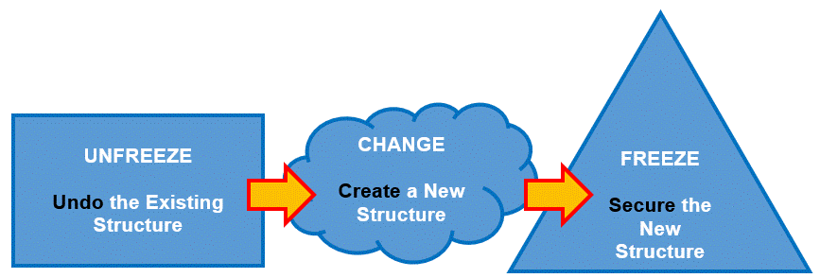

(Consuunt, n.d.)

- Unfreeze: This phase involves throwing the organisation into a state of chaos to bring the organisation to acknowledge that some form of change is needed. Starbucks began to see that it required a shift in strategy to deal with the changing consumer preferences and events in the marketplace. This phase commenced with sensitization of stakeholders by providing details of the critical areas that needed change such as operational performance and customer experience.
- Change: This is where the real shift takes place. It is worth pointing out that this shift is not simple and straightforward, for it actively involves the teacher in the process of change and implies his or her engagement in the creation of new learning experiences. Some strategies that helped Starbucks implement new competitive advantages include the application of advanced technologies for client orders, refitting shop layouts to improve the customer’s experience, and new product offerings to stay relevant. These developments required adaptation of new procedures or steps and intensive training of personnel to successfully implement the changes.
- Refreeze: Reaffirming the state that is formed in the last step is the final step that occurs during transition. This meant that Starbucks had to incorporate these procedures into its organizational structures. It was done in the following manner: Acknowledging the efforts of the staff that have embraced the changes, monitoring their capacity to perform, and providing constant reminders of the changes. It also ensured the sustainability of those modifications that were introduced to the process. (Barnett, 2007)

Application of Kotter's 8-Step Change Model

Kotter’s 8-Step Change Model provides a model to successfully implement change.

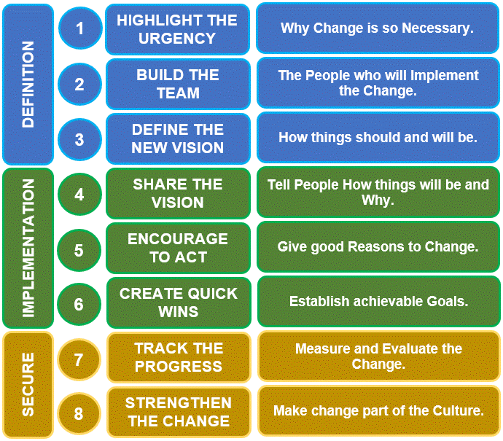

(Consuunt, n.d.)
- Create a Sense of Urgency: Starbucks argued that due to increasing level of competition and shifting consumer interest it is inevitable to make changes.
- Build a Guiding Coalition: A leadership team was consequently put in place to head the change programs at Starbucks.
- Form a Strategic Vision and Initiatives: They set clear guidelines for such a transition, focusing on enhancing the level of customer satisfaction and the efficiency of operations.
- Enlist a Volunteer Army: People were proactive and willing to embrace change across various levels within the organisation.
- Enable Action by Removing Barriers: Companies such as Starbucks were able to identify and remove obstructions in the form of worker resistance and outdated practices hindering the shift.
- Generate Short-Term Wins: To acquire the necessary momentum, they promoted some victories from the start of the plan, such as mobile ordering.
- Sustain Acceleration: The business continued the rate of innovations and sustained the pipelines for new projects to build upon the change.
- Institute Change: International Starbucks ensured that the new behaviours are consistent with the organisational performance to adopt the modifications to their organisational culture. (Pottruck, 2014)

Application of the ADKAR Model
The ADKAR Model emphasises the following five components: This analysis established six common themes that include reinforcement, awareness, desire, knowledge, as well as ability.
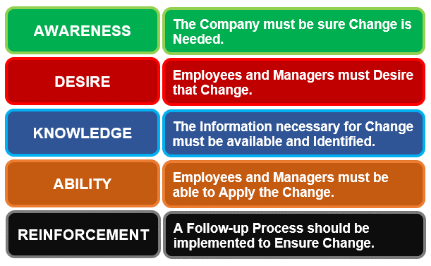
(Consuunt, n.d.)
- Awareness: The reasons why Starbucks decided to transition were communicated through the company’s leadership and organizational documents to inform the employees about the change.
- Desire: To achieve that, Starbucks engaged the staff members in the change process, conducted town meetings, and conducted talks to ensure that people have change consciousness.
- Knowledge: understanding new procedures and technological changes, Starbucks made sure to provide all the information that their employees had to know through the training programmes and other materials.
- Ability: The organisation arranged and supported active-training workshops that would help the workers to improve the ability to implement the changes needed.
- Reinforcement: This was done in Starbucks by applauding and rewarding those staff members who were able to embrace change and, in the process, aiding in the transformation process.

By applying these models, Starbucks effectively managed the change process and ensured the sustainable nature of the changes/enabled a smooth transition of the transformation. From this investigation, therefore, it is possible to greatly appreciate the role of structured change management techniques in achieving the right organisational transformations. (Niaz, 2022)

Advice for Potential Future Change Initiatives:

Several important suggestions may be made for the company's next change initiatives based on the examination of Starbucks' change campaign. Building on strengths, addressing shortcomings, and ensuring effective and lasting change implementation are the goals of these suggestions.

1. Encourage an Open Communication and Employee Engagement Culture:
Starbucks should keep promoting a culture of open communication and employee participation to decrease opposition and raise the chance of a successful transformation. The business may gather insightful information, foster a feeling of ownership, and win support for impending changes by incorporating workers in the change process and respecting their feedback. To make sure that workers feel heard and understood throughout the change process, consistent communication channels should be developed. These might include town hall meetings, questionnaires, and feedback sessions.
2. Invest in thorough training and development initiatives:
To provide staff the abilities they need to effectively adjust to new developments, thorough training and development programmes are vital. Starbucks must make an investment in chances for lifelong learning so that its staff can accept change and flourish in a fluid environment. Different employee groups should have their training catered to their requirements to provide them the tools and resources they need to effectively navigate change. (Jain, 2023)
3. Assessing the effects of changes on customer satisfaction and business performance on a regular basis Starbucks needs to understand the effects of modifications on customer happiness and overall business success through post-implementation assessments. The business may discover areas that need more work through rigorous assessments and make data-driven decisions for ongoing progress. To promote significant and customer-centric improvements, feedback from
consumers and stakeholders should be actively gathered and incorporated into the change management process.
4.Utilise Technology for Enhanced Customer Experiences and Streamlined Processes: Future change projects may greatly benefit from the use of technology-driven solutions. Starbucks should embrace digitalization and use technology to increase operational effectiveness, simplify operations, and improve consumer experiences. By making investments in cutting-edge technology like mobile ordering, contactless payment, and data analytics, the business will be able to remain ahead of the competition and provide outstanding customer service. (Susilo and Mendoza, 2023)
5. Extend sustainability initiatives and localised sourcing strategies:
Starbucks should think about extending its localised sourcing tactics to improve its relationship with regional communities and guarantee more seamless change implementation. The corporation may appeal to regional tastes and cultures by regionalizing its offerings and sourcing methods. Additionally, Starbucks should keep incorporating sustainable practises into all areas of the company while keeping a balanced strategy that takes other crucial factors like product innovation and customer service into account.
6. Establish a Stable Framework for Change Management Using Readiness Assessments: A sound change management strategy is essential for successfully navigating upcoming changes. Starbucks must set up a rigorous change management procedure with detailed change readiness evaluations. Before making changes, the organisation may identify possible problems, reduce risks, and create successful change implementation methods by performing thorough studies.

Finally, by putting these suggestions into practise, Starbucks can improve its ability to adapt, promote a healthy organisational culture, and keep its position as a leader in the world market. Strategic planning, staff involvement, and technological innovation will help Starbucks position itself for long-term success and sustained expansion in the competitive coffee industry. (Li, 2022)

Conclusion:

The critique of Starbucks' change project offers insightful information about the company's strategy for handling transformative change. The justification for the selected adjustment, driven by both internal and external variables including organisational goals and changing consumer trends and competition, exemplifies Starbucks' flexibility in reaction to changing market conditions.

The implementation process emphasises how crucial stakeholder participation and open communication are to the adoption of change. Starbucks addressed employee issues and reduced resistance to change by using a mix of top-down and bottom-up tactics along with frequent communication channels. (Surya Nandan Panwar, Goyal and Prafulla Bafna, 2023)
Improvements in customer satisfaction and brand reputation due to sustainability initiatives are only two examples of how the shift has a beneficial influence on organisational stability and performance. To ensure long-term success, it also identifies possible obstacles, such as employee resistance and transient disturbances, which call for constant monitoring and remedial actions.
The benefits and drawbacks of Starbucks' change management strategy emphasise how crucial employee involvement, education, and technological adoption are for change projects to be successful. Starbucks will become a cutting-edge market leader by utilising technology, localising sourcing methods, and combining sustainability with other corporate goals.
Starbucks should prioritise open communication, make substantial training investments, and carry out frequent assessments of the effects of change to drive future change initiatives. The company's worldwide footprint and community relationships will be further strengthened by utilising technology and localising techniques. By developing a strong framework for change management and conducting readiness evaluations, Starbucks can confidently navigate upcoming changes and maintain organisational stability and performance.

Overall, Starbucks' effective change strategy offers as a role model for companies looking to proactively embrace change, promote a culture of adaptation, and maintain growth and success in a competitive market. (Cassia and Magno, 2022)

Reference list

Azriuddin, M., Kee, D.M.H., Hafizzudin, M., Fitri, M., Zakwan, M.A., AlSanousi, D., Kelpia, A. and Kurniawan, O. (2020). Becoming an International Brand: A Case Study of Starbucks. Journal of The Community Development in Asia, 3(1), pp.33-43. doi:https://doi.org/10.32535/jcda.v3i1.706.

Cárdenas Escorcia, J J., Lopez Perez, C., Montes, R. and Vergara Orozco, W.P. (2018). Use of the Multicriteria Method 'Fuzzy Analytic Hierarchy Process (Fuzzy AHP)' to Locate a Starbucks Franchise in a Barranquilla Mall - Working Paper. [online] papers.ssrn.com.
Available at: https://papers.ssrn.com/sol3/papers.cfm?abstract_id=3142486 [Accessed 5 May
2023].

Consuunt. (n.d.). Kotter’s 8-Step Change Model explained with Helpful Examples. Https://Www.consuunt.com/Kotters-8-Step-Model/. https://www.consuunt.com/kotters-8-step-model/ https://www.consuunt.com/adkar-model/ https://www.consuunt.com/lewins-change-model/

Barnett, M. L. (2007). (Un)Learning and (Mis)Education Through the Eyes of Bill Starbuck: An Interview With Pandora’s Playmate. Academy of Management Learning & Education, 6(1), 114–127. https://doi.org/10.5465/amle.2007.24401709

Cassia, Dr.Fabio. and Magno, Dr .Francesca. (2022). Effects of Ethnocentrism on International Hospitality Brands: A Cross-Country Study of Starbucks. Journal of Hospitality & Tourism Research, p. 109634802211337. doihttps://doi.org/10.1177/1096348022113377
8.

Dierkes, M. (2003). Handbook of Organizational Learning and Knowledge. [online] Google
Books. Oxford University Press. Available at:
https://books.google.co.uk/books?hl=en&l=&id=JRd7RZzzw_wC&oi=fnd&pg=PA327&dg
=Starbucks%27+approach+to+change+management+has+certain+drawbacks.&ots=EXID49CftT&sig=ORSaKmPYCdARRQhno8TkCvnVBxk&redir_esc=y#v=onepage&q&f=false
[Accessed 21 Jul. 2023].

Haskova, K. (2015). Starbucks Marketing Analysis. CRIS - Bulletin of the Centre for Research and Interdisciplinary Study, 2015(1), pp.11-29. doihttps://doi.org/10.1515/

Hidayatulloh, A. (2022). CUSTOMER CLUSTER GROUPING IN STARBUCKS APPLICATION USING -MEANS ALGORITHM AND PRINCIPAL COMPONENT
ANALYSIS. [online] eprints uty acid. Available at: http://eprints.uty.ac.id/11188/ [Accessed
21 Jul. 2023].cris-2015-0002.

Jacoba, J. (2022). Starbucks Strategic Analysis. Honors Theses, University of Nebraska-Lincoln. [online] Available at: https://digitalcommons.unl.edu/honorstheses/490/

Jain, M. (2023). Customer Relationship Management as a Tool to Enhance Customer Loyalty with Respect to Starbucks. [online] papers.ssrn.com. Available at:
https://papers.ssrn.com/sol3/papers.cfm?abstract_id=4387082.

Lewis, A., Thomas, B. and James, S. (2015). A critical analysis of the implementation of social networking as an e-recruitment tool within a security enterprise. Cogent Business & Management, 2(1). doihttps://doi.org/10.1080/23311975.2015.1104904.

Li, C.-Y. (2018). Consumer behavior in switching between membership cards and mobile applications: The case of Starbucks. Computers in Human Behavior, 84, pp. 171-184. doihttps://doi.org/10.1016/j.chb.2017.12.042.

Li, X. (2022). The discursive construction of corporate identity in the corporate social responsibility reports: A case study of Starbucks. Frontiers in Psychology,
doihttps://doi.org/10.3389/fpsyg.2022.940541.

Liu, X. (2022). Exploring the Future Value of Starbucks. [online] www.atlantis-press.com doi https://doi.org/10.2991/aebmr.k.220603.129.

Logan, N. (2016). The Starbucks Race Together Initiative: Analyzing a public relations campaign with critical race theory. Public Relations Inquiry, 5(1), pp.93-113.
doihttps://doi.org/10.1177/2046147x15626969.
researchgate (2020). (PDF) Analysis of Starbucks ' entry strategy into Vietnam market.

Niaz, W. (2022). Designing & Delivering of End-user Training for ChaRM : Change Request Management System. Theseus.fi. http://www.theseus.fi/handle/10024/781871

[online] ResearchGate. Available at:
https://www.researchgate.net/publication/342752547_Analysis_of_Starbucks%27_entry_strategy_into_Vietnam_market.

Sumritsakun, C. (2009). ABSTRACTS 1. INTERNAL AUDIT INNOVATION AND FIRM STABILITY OF THAI LISTED COMPANY: HOW DO IMPLEMENT IN AN
ORGANIZATION? JABE, [online] 9(4). Available at: https://jabe-journal.org/JABE-
JOURNAL/Documents/Abstracts/JABE-9-4_Abstracts.pdf [Accessed 21 Jul. 2023].

Surya Nandan Panwar, Goyal, S. and Prafulla Bafna (2023). Analytical Study of Starbucks Using Clustering. Analytical Study of Starbucks Using Clustering, pp.1013-1021. Doi https://doi.org/10.1007/978-3-031-27409-1_93.

Susilo, D. and Mendoza, C.M.T. (2023). MARKETING MODEL OF STARBUCKS: A SUSTAINABILITY MONETIZATION. Journal Ekonomi, [online] 12(02), pp.1182-1190.
Available at: http://ejournal.seaninstitute.or.id/index.php/Ekonomi/article/view/1862.
van Knippenberg, D., Dahlander, L., Haas, M.R. and George, G. (2015). Information, Attention, and Decision Making. Academy of Management Journal, 58(3), pp.649-657. doi:https://doi.org/10.5465/amj.2015.4003.

Zhaozhe, W. (2023). Analysis of Starbucks in China. Journal of Psychology Research, 13(5). https://doi.org/10.17265/2159-5542/2023.05.005

