Contributing to improving organisational performance

Jodie Barnett

CIPD course number: 5AIOP

CIPD Membership number: 2224083X

Personal statement LO1 - word count: 1,052 words
Personal statement LO2 – word count: 868 words
Personal statement LO3 – word count: 1,295 words

By signing below, I confirm that the work/evidence presented is my own, unaided work. I understand the regulations pertaining to candidate malpractice and the action that may be taken as a result.

Signed: 
Date: 21ST September 2020

Contents page
- Personal statement LO1
- Personal statement LO2
- Personal statement LO3
Appendices
- Managing performance policy (first couple of pages of policy)
- Performance appraisals (first couple of pages of policy)
- Performance plan
- Formal capability procedure
- Recruitment and selection policy and procedure (first couple of pages of policy)
- Induction checklist
- Email to management providing PM advice
- Managing poor performance checklist
- Performance appraisal review form
- Management guidance/advice on extension of probationary period.
- Informal capability meeting letter
- Informal capability meeting notes
- NPTCBC Workforce plan 2018-2022 (first couple of pages)
- NPTCBC corporate performance management cycle
- NPTCBC appraisal cycle
- KPI data for managing performance in NPTCBC





Personal statement for LO1 (including reference list) 750-1000 words
LO1 - Be able to provide information on performance management activities within an organisation.
  - Explain performance management policies and processes in the organisation and the roles and responsibilities of those involved with them.

(Mearns, 2014) argues that performance management commences at the start of the employment relationship. They refer to eight key components to effective performance management:

- Recruitment & Selection
- Induction
- Performance appraisal
- Recognition and reward
- Training and development
- Communication
- Managing poor performance
- Organisational culture

They emphasises that performance management should be a continuous process that links performance, motivation, individual goals, departmental drive and business objectives.

(Trullen, Stirpe, Bonache, & Valverde, 2016) refers to effective implementation of human resource practices (HRP) provides a clear link between HRM and performance. Line managers act as linguists of HRPs to employees and play an influence role in their employees’ responses to these. HR’s role is to ensure that line managers are made fully aware and involved in the implementation of these practices.

Recruitment & Selection

Neath Port Talbot County Borough Council’s (NPTCBC) Human Resource Section has adopted their Recruitment & Selection policy and procedure (appendix 5) which sets out its objectives in order to recruit and retain a skilled and committed workforce. This includes adopting the relevant legislation throughout the process including the Equality Act 2010, promoting Equal Opportunities and the Welsh Language Act 2016.

(Mearns, 2014) highlights that management ability and skills are pivotal in identifying the most appropriate individuals which drives a successful organisation. Managers must have the correct knowledge and skills to enable them to identify the necessary competencies in line with business objectives.

Managing Performance Policy

NPTCBC has implemented two policies and procedures solely related to performance management. The first is “Managing Performance Policy” (appendix 1) and the second is “Performance Appraisal” (appendix 2). Other policies and procedures adopted also link into the performance management cycle.

NPTCBC recognises that the competence and commitment of its employees is fundamental to the achievement of organisational success. NPTCBC is committed to ensuring that all employees have the appropriate skills, knowledge, competence, and aptitude to undertake their roles effectively. This policy provides guidance for those employees who are performing unsatisfactory and includes supportive measures for improving performance, which includes a performance improvement plan using SMART measures (appendix 3).

(Rees & Tymon, 2016) refer to the importance of a performance management process in enabling an organisation to produce greater quality of product or service. Managing employees successfully provides consistency and the requirement to minimise service provision costs.

The policy highlights that it is the employee’s responsibility to take whatever action is necessary to improve performance. The Council’s formal capability stages (appendix 4) may be instigated for those employees who continue to not be able to fulfil their duties effectively.

(Mearns, 2014) states that employees are accountable and should strive to fulfil the strategic business aims as well as personal career goals.

Performance Appraisal

(CMI, 2011) emphasises the importance of business objectives setting out what an organisation wants to achieve. Leaders and line managers play a pivotal role in ensuring the process of setting objectives to ensure that an individual, team or an organisation work to the same values.

They refer to SMART which outlines specific and measurable objectives and how these provide success. Setting achievable and realistic objectives help to engage and motivate individuals and timeframe objectives ensure that all stakeholders agree when it is to be achieved.

The term SMART is now generally used by corporate directors and managers who use SMART to set objectives within appraisal and performance management systems.

NPTCBC’s performance appraisal sets out the role of the manager and employee and emphasises that the importance of a two-way discussion. Employees should take ownership of development and performance, working towards agreed standards and objectives. The manager must set objectives in line with business requirements and regularly review and tackle under-performance constructively and promptly.

Induction process

(Rees & Tymon, 2016) argues that adopting a robust induction process can be instrumental in highlighting organisational performance standards and expectations.

(CIPD, 2019) argues that an induction plays a significant part on an employee’s first impressions of an organisation. An effective induction can have a bearing on turnover and absenteeism rates and play an important role in team integration and job satisfaction.

NPTCBC has introduced an induction checklist (appendix 6) for management guidance and to ensure that key information is passed to all new recruits. This is a very informative, yet easy to follow checklist providing managers with precise information to follow and gives the new employee an understanding of the employer.

1.2 Explain key sources of information, including legislative information, which underpin performance management activities.

(Legislation, 2020) argues that the Employment Rights Act 1996 provides employee with the right to not be dismissed unfairly. The Act covers key aspects of employment including training, termination, as well as protection of wages and covers unfair dismissal claims.

This Act will cover a number of performance related activities such as formal capability ensuring that management follow the correct process to avoid unfair dismissal penalties. (Personnel Today, 2020) states that before dismissing an employee, employers need to ensure that they have a potentially fair reason. These are categorised into five reasons for dismissal being; capability or qualifications, redundancy, conduct and some other substantial reason.

HR retrieves sensitive data on a regular basis through recruitment and selection process. Such data must be stored in line with the General Data Protection Regulation (GDPR) and the Data Protection Act 2018 and it is important that the eight principles of data protection are adhered too.

(GOV, 2020) refers to the Equality Act 2010 which legally protects people from discrimination in the workplace. Discrimination due to age, disability, race, sex, etc is unlawful.

(ACAS, 2020) is an independent public body funded by Government. ACAS gives employees and employers unbiased advice on workplace rights, rules and best practice. It is important that employers adhere to the ACAS Code of Practice on disciplinary and grievance procedures when addressing conduct related performance management issues.

1.3 Provide timely and accurate information to colleagues regarding performance management activities.

Provided advice to a manager on an employee who is currently under performing following a return to work from leave of absence (appendix 7). Advised to meet informally with the employee to discuss concerns and set a review date to monitor. Advised that next step could require instigating formal capability procedures.
Managing poor performance checklist given to management as guidance to ensure that all steps were taken in line with NPTCBC managing performance policy (appendix 8).

References
ACAS. (2020). About us (online) Available at: https://www.acas.org.uk/about-us (Accessed 10 September 2020)
CIPD. (2019). Induction (online) Available at: https://www.cipd.co.uk/knowledge/fundamentals/people/recruitment/induction-factsheet (Accessed 05 September 2020)
CMI. (2011). Setting SMART objective checklist 231. Chartered Management Institute.
GOV. (2020). The Equality Act 2010 (online) Available at: https://www.gov.uk/guidance/equality-act-2010-guidance#equalities-act-2010-legislation (Accessed 10 September 2020)
Legislation.gov.uk (2020). Employment Rights Act 1996 (online) Available at: https://www.legislation.gov.uk/ukpga/1996/18/contents (Accessed 10 September 2020)
Rees, G., & Tymon, A. (2016). Performance management, motivation and reward. In G. Rees, & R. French, Leading, managing and developing people (pp. 253-279). London: CIPD.

Mearns, L. (2014). Constructive performance management. In G. Watson, & S. Reissner, developing skills for business leadership (pp. 257-290). London: CIPD.

NPTCBC. (2018). Recruitment & selection policy and procedure (online) Available at: http://umbraco.npt.gov.uk:700/1996 (Accessed 04 September 2020)
NPTCBC. (2018). Managing performance policy (online) Available at: http://umbraco.npt.gov.uk:700/1964 (Accessed 04 September 2020)
NPTCBC. (2019). Performance appraisal (online) Available at: http://umbraco.npt.gov.uk:700/1964 (Accessed 04 September 2020)
Personnel Today. (2020). Dismissal (online) Available at: https://www.personneltoday.com/employment-law/dismissal/ (Accessed 10 September 2020)
Trullen, J., Stirpe, L., Bonache, J., & Valverde, M. (2016). The HR department’s contribution to line managers’ effective implementation of HR practices. Human Resource Management journal, 449-470.

APPENDIX 1


APPENDIX 2


APPENDIX 3


APPENDIX 4





Appendix 5



Appendix 6


Appendix 7
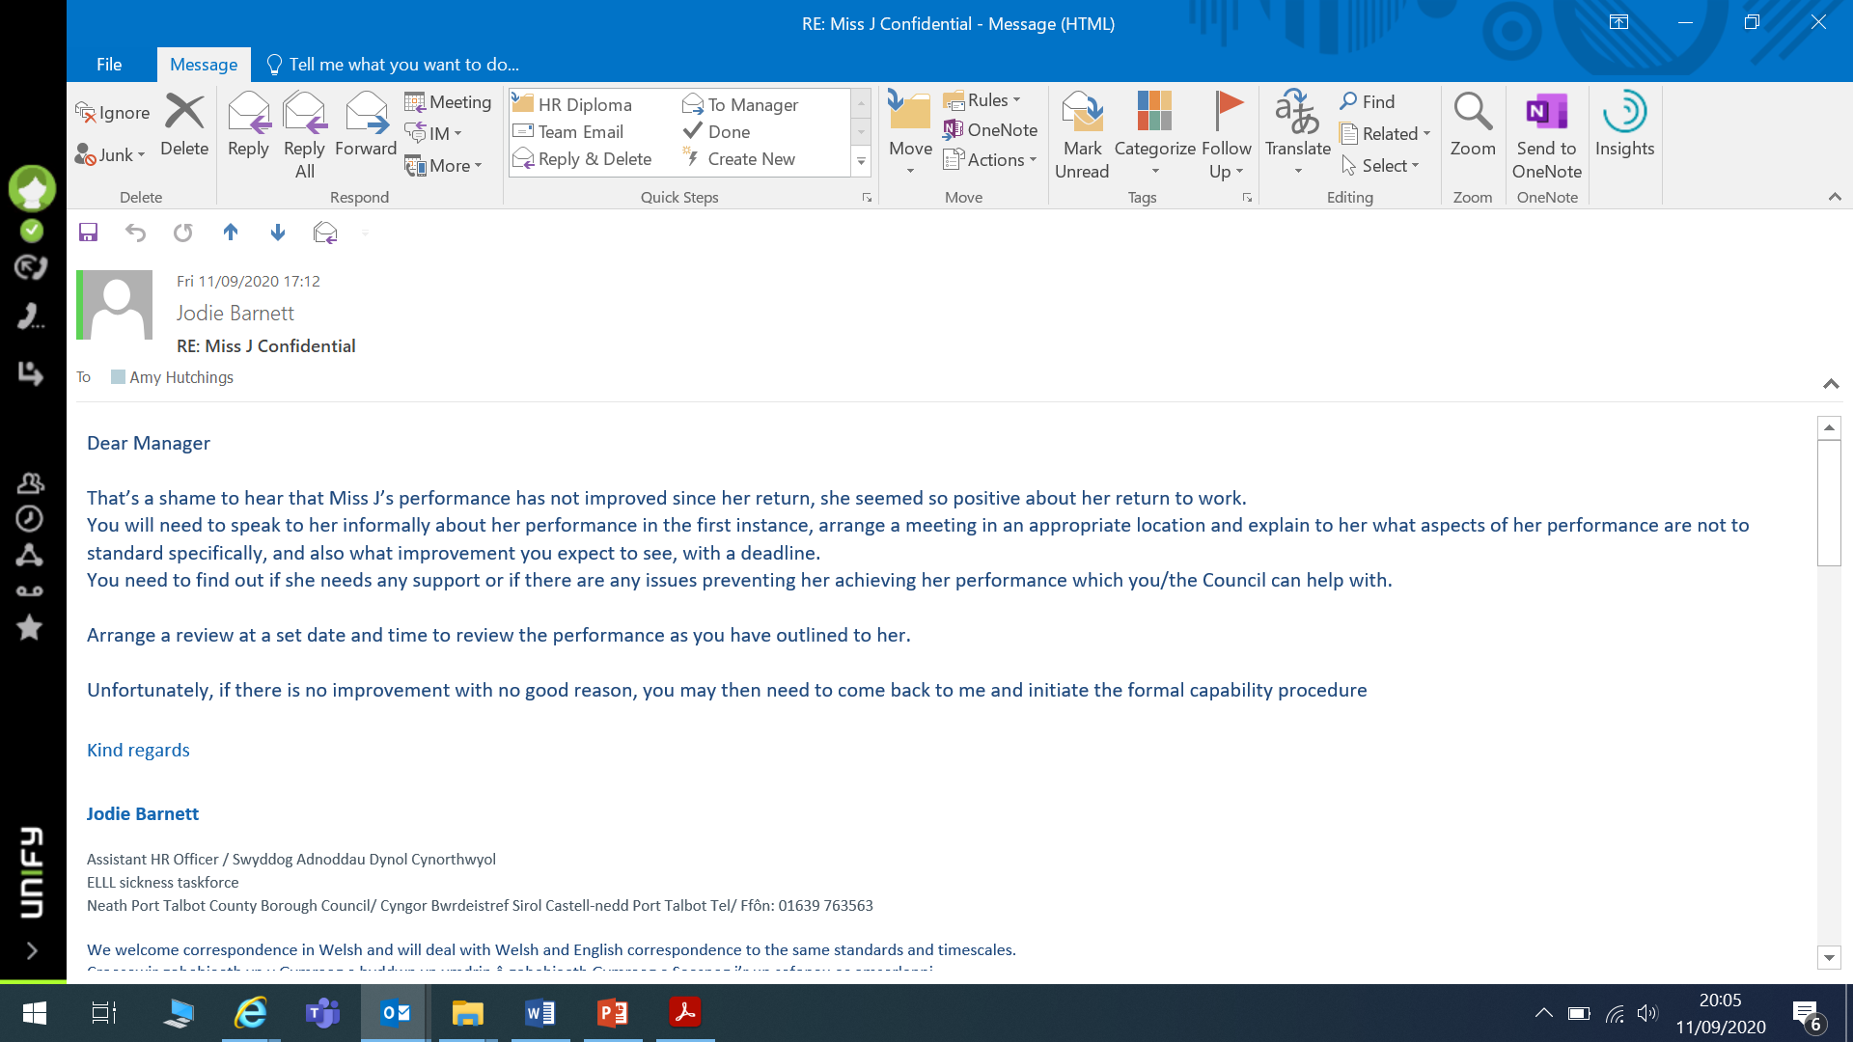


Appendix 8



Personal statement for LO2 (including reference list) 750-1000 words
LO2 - Be able to support line managers to deliver performance management activities within the organisation.
2.1 Analyse the types of support line managers in the organisation need from HR, in relation to performance

(IES, 2016) refers to ten practical tips for managers on performance management (PM) and how HR can implement these in the organisation. They are:
- Be clear about business aims and objectives
- Emphasise the connection between PM and organisational goals
- Awareness of the key steps to achieving PM
- Make the process clear and simple with no adjustments
- Stress the all-year goal of PM
- Recognise various policies/procedures linked with PM
- Encourage ownership/approval from management
- Ensure understanding of aims and process for line managers/employees
- Train managers to manage performance consistently and hold regular discussions with their employees
- Monitor performance processes against aims and management usage.

(CIPD, 2015) employee outlook survey identified that “employees with an appraisal scored higher on clarity of the organisational goals, motivation and organisational commitment, compared with those who have never had a review or have it less often than once a year”.
NPTCBC has developed a user friendly performance appraisal review form for managers which includes a section to identify an employee’s training and development needs. This includes reviewing any requirements identified in the previous twelve months as well as setting achievements for the next year (appendix 9).
(Reid et al, 2004) argue that line managers should accept responsibility for the learning and training of their employees. This includes taking a dynamic interest in their careers, providing opportunities to improve and expand their abilities by using day-to-day tasks as well to encourage learning.
HR must be a pivotal role in ensuring management consistency through the organisation and this involves employees being treated equally and fairly. This includes management’s implementation of HR policies/practices for all employees.
(CIPD, 2019) states that line managers play a fundamental role in implementing and enacting HR policies and practices. Employee’s that feel positive about their relationship with their line managers, are more likely to have greater levels of job satisfaction, loyalty and commitment, which in turn are associated with higher levels of performance.
(CIPD, 2019) refers to there being a growing need for both HR & LD to support people professionals closely with business strategy. This approach will support line manager’s people management skills and in turn develop their responses and solutions on HR related issues. Such relationships, links people and business issues and help build a better understanding and develop long-term strategies and solutions rather than raising these with HR to manage.
This proactive rather than reactive approach offers better support to operations and impact on the whole organisational structure.

2.2 Support line managers’ capability to deliver performance management activities.

(CIPD, 2020) argues that skilled managers are crucial to employee engagement, organisational performance and wellbeing and developing managers is essential to enhancing their skills, abilities and knowledge.
Line managers are responsible for providing their employees with regular feedback on performance management activities, whether positive or negative. How a manager provides feedback could be crucial to employee behaviour.
(Porter, 2017) refers to the importance of proving feedback that will enable someone to improve and learn and requires careful thought and insightful construction. They refer to the following points:
- Big-picture focused
- Organisationally aligned
- Behavioural and specific
- Factual and interpretive
- Both positive and negative
- Focused on patterns
- Linked to impact
- Prioritised
Providing feedback that is useful requires care and attention than is typical invested.
Offering guidance to managers on performance related activities including probationary periods is important as this will provide the employee with constructive feedback and what is required within a given timeframe (appendix 10).

2.3 Work in conjunction with line managers in the provision of employee performance and development reviews.

(Mearns, 2014) refers to performance and development reviews as the main way of managing employee performance as this process should allow an honest and open discussion between the manager and employee and is essential in ensuring effective organisational performance.
It is suggested that appraisals are the most important aspect of people management and achieving organisational goals, as these provide the prospect to motivate, develop and encourage employees on a consistent basis.
Managing employees who are under performing and fail to meet expected targets is equally important and should be addressed at the early stages. This could be for a number of reasons including lack of skill and ability or de-motivation. Addressing poor performance informally could prevent escalation and the potential for disciplinary action, which in turn could provide time consuming and have a negative impact on employee and team performance.
I attended an informal capability meeting with management and the employee concerned. No obvious reasons for poor performance were highlighted during this meeting and the employee was offered support by the means of a designated mentor and offered training and development opportunities. I have attached the informal capability meeting letter (appendix 11) .
I advised a concerned manager with poor employee performance to arrange an informal capability meeting to discuss and address concerns. I advised the manager to make accurate notes during this meeting and highlight concerns with a set timeframe for reviewing. Management were asked to identify any training needs and health concerns that could have contributed to poor performance. The employee was referred to Occupational Health following concerns raised personal issues (appendix 12).

References
CIPD. (2014). Employee outlook – focus on managers 2014-15 (online) Available at: https://www.cipd.co.uk/knowledge/fundamentals/people/development/outlook-managers (Accessed 10 September 2020)
CIPD. (2019). Line manager’s role in supporting the people profession (online) Available at: https://www.cipd.co.uk/knowledge/fundamentals/people/hr/line-managers-factsheet#8029 (Accessed 11 September 2020)
CIPD. (2020). Management development (online) Available at: https://www.cipd.co.uk/knowledge/strategy/development/management-factsheet (Accessed 11 September 2020)
IES. (2016). Performance management (online) Available at: https://www.employment-studies.co.uk/ (Accessed 10 September 2020)
Mearns, L. (2014). Constructive performance management. In G. Watson, & S. Reissner, developing skills for business leadership (pp. 257-290). London: CIPD.

Porter, J,. (2017). How to give feedback people can actually use. Harvard Business Review.
Reid, M.A., Barrington, H., & Brown, M. Human Resource Development – beyond training interventions. London: CIPD.

Appendix 9
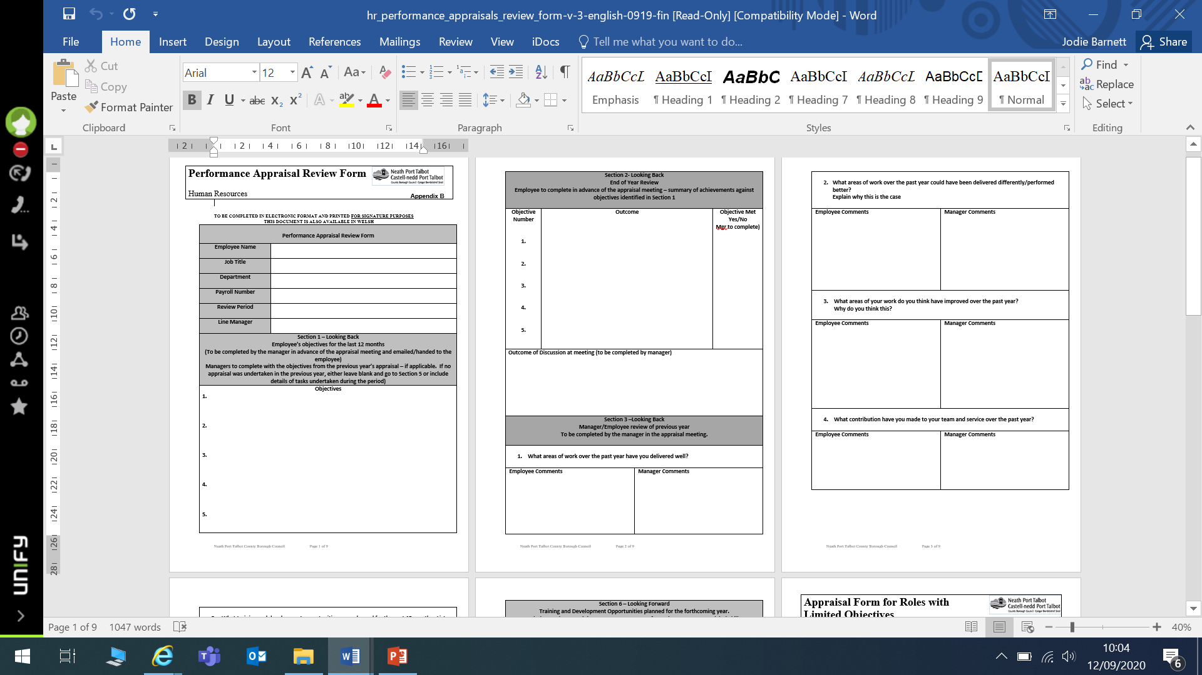



Appendix 10
Manager requesting advice
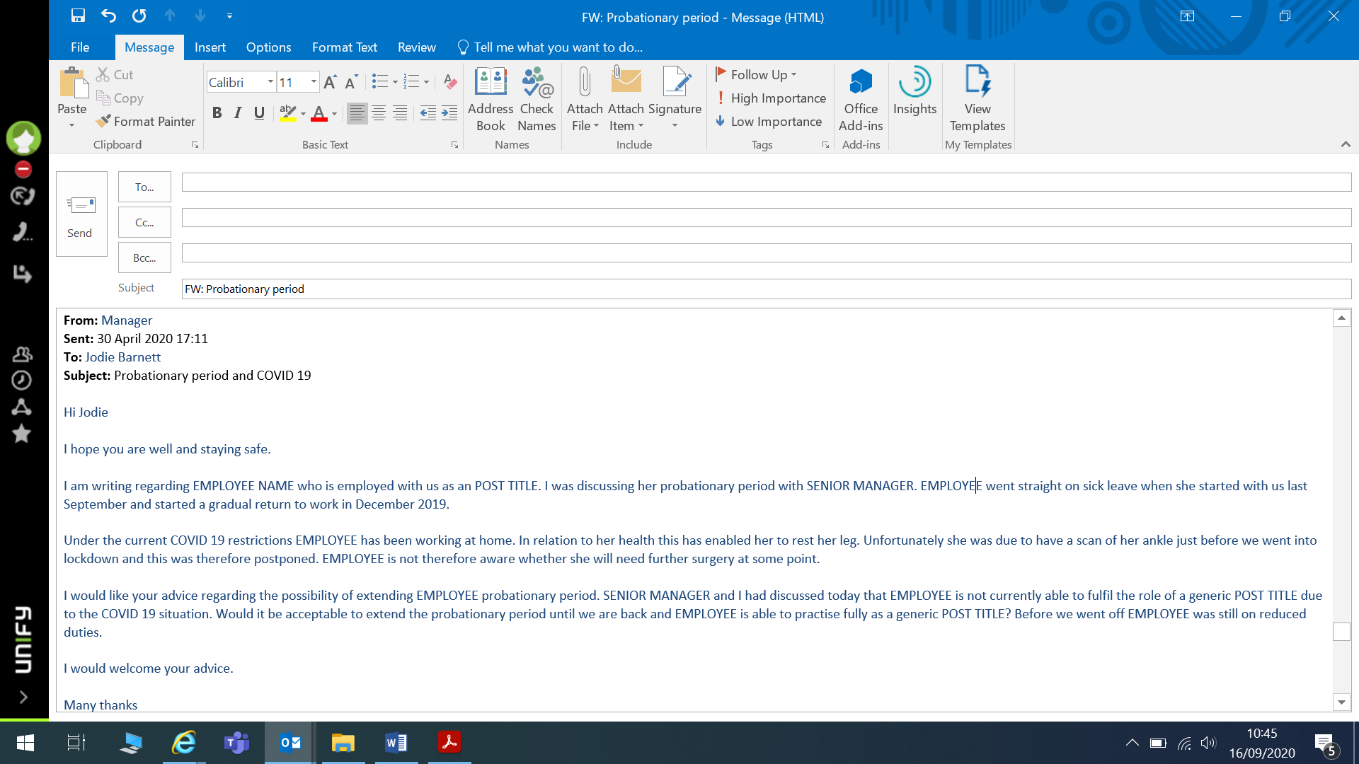
My response
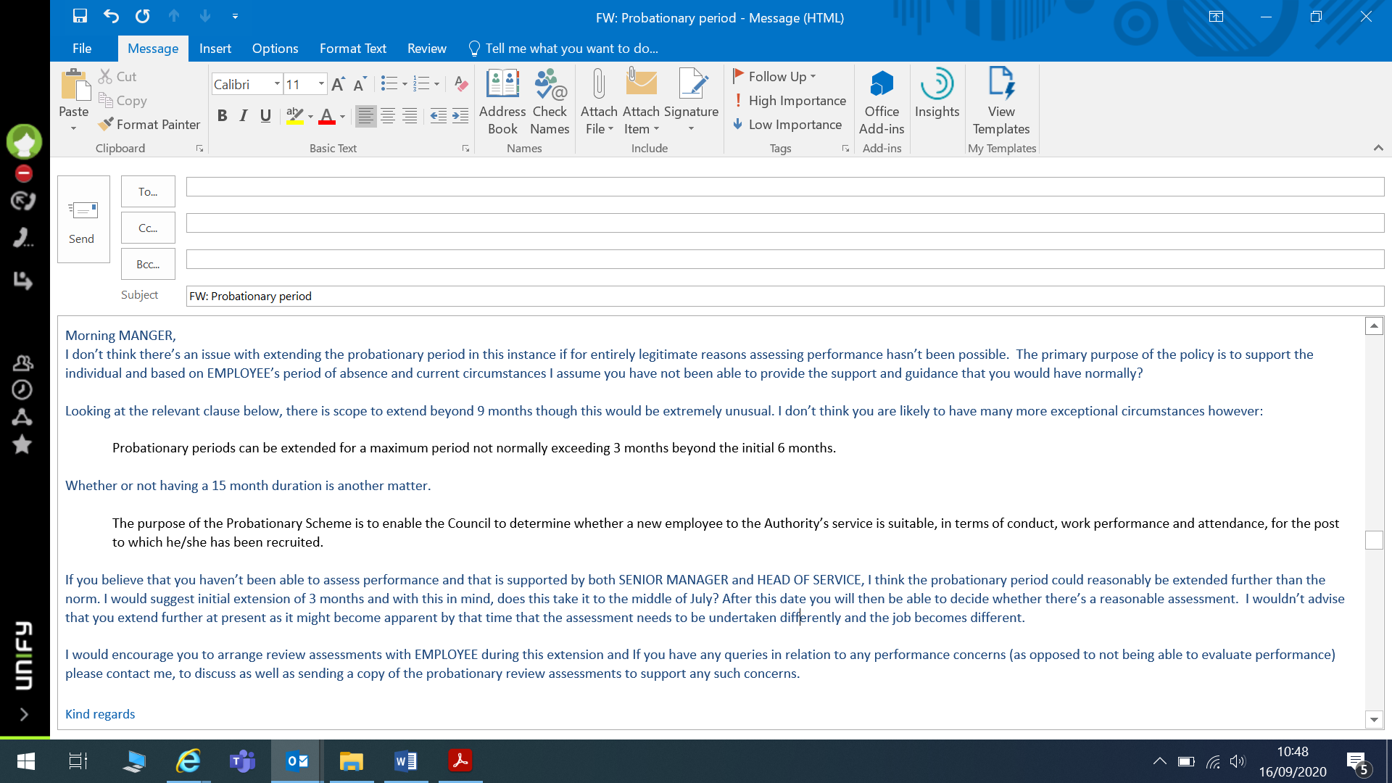

Appendix 11

Appendix 12


Personal statement for LO3 (including reference list) 750-1000 words
LO3 - Be able to assess the impact of performance management activities on organisational performance and make recommendations for enhancement.
3.1 Evaluate the organisation’s approach to performance management, including employee performance and development reviews.
(Mearns, 2014) argues that performance management should be a vital feature for any organisation, whether large or small, and therefore should be a central management task.
It starts with the skills and ability of management to identify the most fitting employees to drive organisational success. It has been recognised that attracting, retaining and effectively managing able employees can provide any organisation with a sustainable competitive advantage.
NPTCBC’s performance management practices and other policies that link in with these activities are regularly reviewed to ensure that they remain current in line with relevant legislation etc.
(NPTCBC, 2018) Workforce Plan 2018-2022 (appendix 13) sets out significant transformational and budgetary challenges and the need to focus resources, particularly employees, on successfully delivering corporate objectives and priorities.
The purpose of the workforce plan is to enable NPTCBC to keep pace with the workforce implications of the Corporate Plan and set out actions to help achieve priorities and objectives. Effective workforce planning enables identification in any gaps between the workforce of today and the workforce needed going forward.

(CIPD, 2020) defines workforce planning as “a core process of human resource management that is shaped by the organisational strategy and ensure the right number of people, with the right skills, in the right place, at the right time to deliver short and long term organisational objectives”.
The Council has a clear structure in place for delivering its objectives, priorities and actions (appendix 14). This provides all members with an understanding of their responsibilities within the performance management cycle. In turn, line managers are also provided with an appraisal cycle to be adopted into performance reviews (appendix 15). This provides all senior leaders, as well as line managers with an understanding of their expected role in performance management.
NPTCBC’s Annual report on corporate plan key performance indicators (KPIs) for 2018/19 sets out how the council has performed using a traffic light coding system – red being poor, amber being moderate and green being good.
(Appendix 16) shows that NPTCBCs performance was deemed as amber (moderate) and therefore, there is potential for improvement.

3.2 Assess the extent to which performance management processes support high performance working (HPW) and contribute to sustained organisational performance.

HPW is defined by the UK Commission for Employment and Skills as ‘a general approach to managing organisations that aims to stimulate more effective employee involvement and commitment in order to achieve high levels of performance. (Belt & Giles, 2009) state that these are designed to enhance the discretionary effort employees put into their work, and to fully utilise ... the skills that they possess’.
A ‘system’ comprised of a coherent bundle of high-performance work practices creates a synergetic effect whereby the impacts of the system exceed those resulting directly from the individual practices being used. The presence of a HPWS is associated with increased profits, sales and profitability; employees report higher job satisfaction, motivation, involvement and commitment and greater opportunities for innovation and creativity, alongside lower staff turnover (Stone, Braidford, Houston, Bolger, 2012)
(Skilbeck, 2019) argues that organisations need to be able to keep their workforce engaged and motivated in order for them to remain efficient and effective in the workplace, to feel inspired by their work, believe in the organisation, feel connected to its vision, values and objectives and become part of high functioning workplaces
Continuous performance management practices allow managers to recognise when employees meet the expectations of their role and assists them to track their progress against the organisation’s aims and objectives. Continuous performance management facilitates an ongoing dialogue between the employee and the organisation which develops trust, support and encouragement, allows exchange of feedback, strengthening the relationship (Hearn, 2018).
Organisations who only carry out performance appraisals on an annual basis may find the employee is not connected to the organisation’s aims and objectives, the employee is disengaged, their morale is low, productivity may be low, and the organisation’s aims and objectives are not being achieved. Performance management processes, however, can fail due to lack of communication, setting ineffective and unrealistic goals, managers not engaging in the process and organisations collecting the wrong data (Hearn, 2018).

3.3 Recommend ways for developing performance management processes to enhance their impact on organisational performance.

In order to develop the performance management process, it needs to be aligned with other HR Systems in the organisation to ensure they are the same that are used for other HR policies including recruitment, staffing and training. This not only ensures that employees are being recruited, trained and appraised on a consistent set of critical job requirements, it also sends a strong message, internally and externally, about what is valued by the organisation (Pulakos, 2004).

In order for the performance management process to be effective, the highest level of the organisation must be persuaded and encouraged to use it properly. Effective implementation of the performance management process is dependent on the top level or management’s commitment, those who have established clear expectations around the process, those who model the process, and those who make the performance management process a priority. In some organisations this may necessitate educating the executive team about the vital role performance management can play in the organisation’s effectiveness and their role being critical in leading the effort (Pulakos, 2004).

A new or revised performance management process should be communicated at the launch of the design process with managers and staff being given a clear and simple explanation to the advantages and rationale for the new process. Opportunities should be given to managers and staff to have an input and provide feedback on desired system features, with comments being addressed or responded to in order for any process to be received positively.

Automating the process can greatly facilitate the performance management workflow and significantly reduce the paperwork associated. Research shows that evaluations of automated performance management processes are viewed positively by managers and employees, decreases workload, ensures widespread access to performance management tools and provide a standardised, structured approach to collating and storing performance data. Decisions regarding the extent of automated performance management processes should consider time, resources, development and maintenance costs as well as information security, archiving and records management.

One or the most crucial factors in ensuring successful implementation, is to pilot the process in a small number of teams prior to roll-out to the whole organisations. Pilot testing indicates if the system functions smoothly and efficiently, whether managers and employees understand.

Effective training for managers and employees enables users to be motivated to use the performance management process effectively. The training format can be flexible, however formal classroom training sends a message of the importance of performance management and if the training content requires hands-on practice or interactive discussions that not easily achieved with other training formats. This can include training managers and employees on how to provide and receive feedback effectively as it allows managers and employees to understand, practice and grow comfortable with their roles in the feedback and development process.

Evaluating feedback is crucial to effectively evaluate and continuously improve the effectiveness of the performance management process. This can include:

Track completion of performance management activities – ensure all documentation is submitted to HR to be signed electronically and stored in the online filing systems, alleviating the requirement to generate and retain paper copies as well as ensuring the performance management process is being conducted with all employees.

Management review – ensures the narrative description match the ratings and they are not positively or negatively biased, they have been properly justified and the evaluation criteria is being systematically applied to supervisors and employees.

Feedback from users – surveys or focus group information can be collected periodically to assess user responses to the process and to modify the system that are more acceptable to users. An effective strategy that gathers useful information as well as promote feedback is to survey managers and employees on the level to which they are seeking, giving and receiving quality feedback. (Pulakos, 2004) believes that reporting these results back to managers and employees can increase the frequency and quality of the performance feedback over time.

References
Belt & Giles (2009). Strategies to maintain employee motivation (online) Avialable at: https://www.forbes.com/sites/rebeccaskilbeck/2019/02/12/six-strategies-to-maintain-employee-motivation/#147b6e711d35 (Accessed 20 September 2020)
Stone, Braidford, Houston, Bolger (2012.) Promoting HPW (online) Available at: https://assets.publishing.service.gov.uk/government/uploads/system/uploads/attachment_data/file/34638/12-1195-promoting-high-performance-working.pdf (Accessed 20 September 2020)

Hearn (2018). https://www.clearreview.com/why-performance-management-important/

CIPD (2015). Big data, Social Media and HPWS for the intelligent office (online) Available at: https://www.cipd.co.uk/Images/big-data-social-media-hpws_2015_tcm18-15586.pdf (Accessed 15 September 2020)

CIPD. (2020). Workforce planning (online) Available at: https://www.cipd.co.uk/knowledge/strategy/organisational-development/workforce-planning-factsheet (Accessed 15 September 2020)

Pulakos (2004). Performance management (online) Available at: https://www.shrm.org/hr-today/trends-and-forecasting/special-reports-and-expert-views/Documents/Performance-Management.pdf (Accessed 20 September 2020)

Mearns, L. (2014). Constructive performance management. In G. Watson, & S. Reissner, developing skills for business leadership (pp. 257-290). London: CIPD.

NPTCBC. (2018). Workforce plan 2018-2022 (online) Available at: http://umbraco.npt.gov.uk:700/1996 (Accessed 15 September 2020)

Appendix 13


Appendix 14
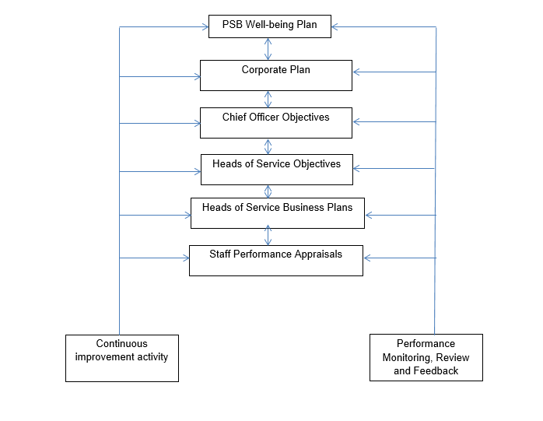

Appendix 15


Appendix 16


