Youth Workers as Advocates
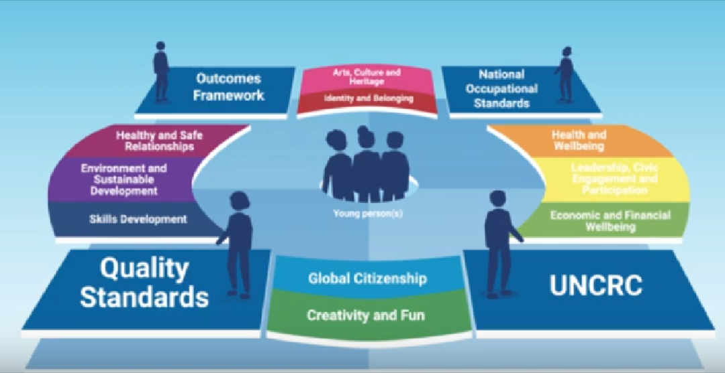
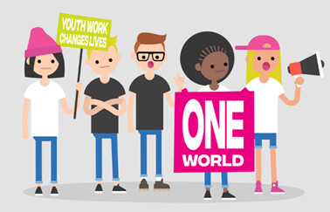
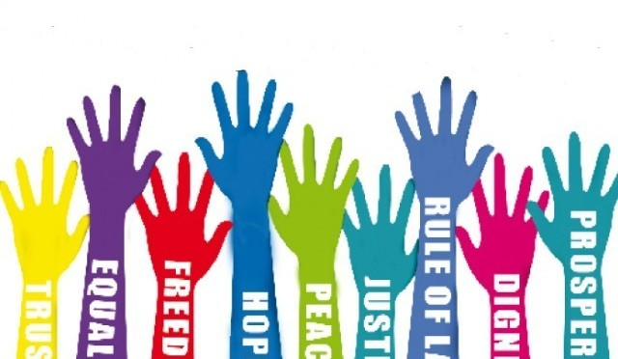
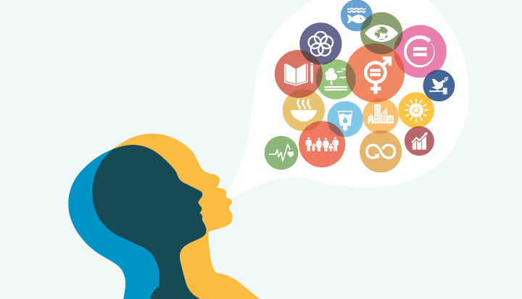

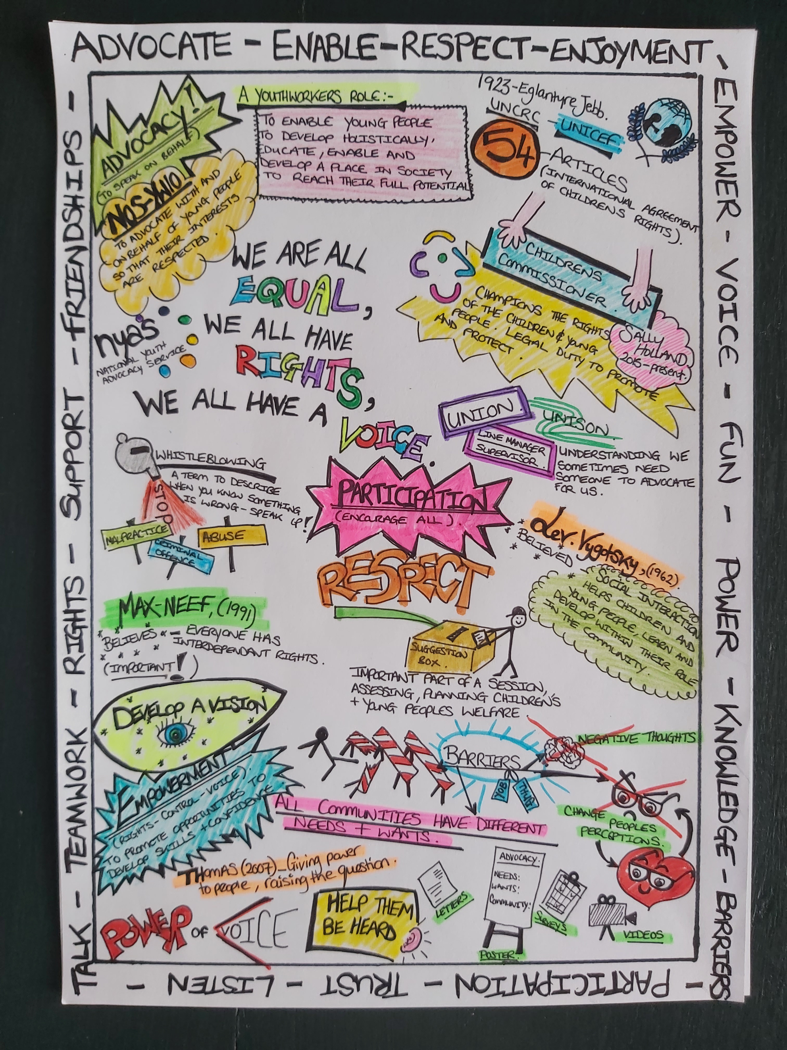

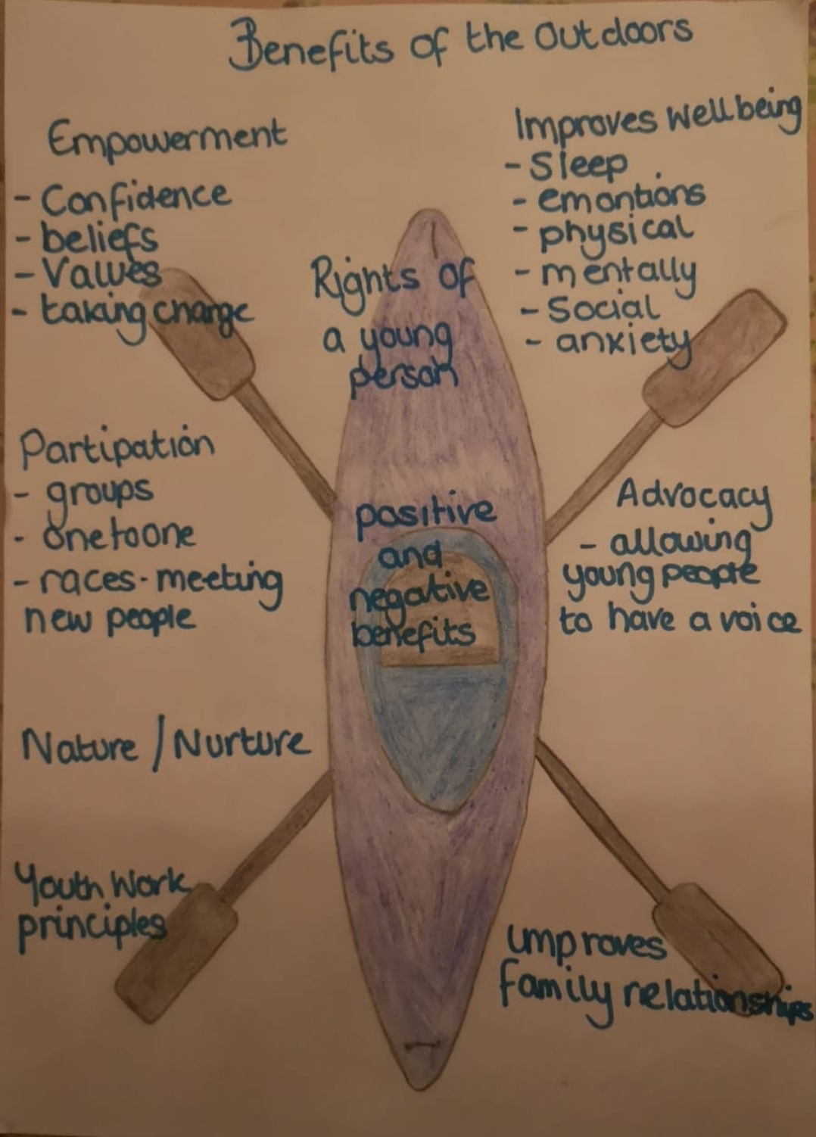

UNCRC
The United Nations Conventions on the Rights of the Child is a global humans right treaty that specifically protects and promotes the rights of children and young people. It is a legally binding international agreement.
(Unicef, 2010)
ADVOCACY
An advocate is there to make sure that the voice on an individual is heard. They help to empower young people to have a say in decisions regarding them and to secure their human rights, enabling access to services and more.
(Justforkidslaw, 2020)

