

University of Wales Trinity Saint David School of Engineering

Analysis Of Student Grades Using Statistical Method In Matlab
Technical Report

Engineering Applications And Study Skills
(ACMA4007)

Mohamed Rithwan Thangeswaran
2313855
28/06/2024

Contents
1. Literature Review 4
2. Introduction 5
2.1 Overview of Statistical Analysis of Student Grades with Matlab 5
2.2 Main objectives 5
3 Data Import and Summary Statistics 6
3.1 Import the dataset into Matlab. 7
a) function table to display the summary statistics in the command window. 14
15
4 Correlation Analysis 16
4.1. Correlation Analysis Procedure 16
4.2. Further details 17
5 Visualization of grouped data for Exam 1, Exam 2, and O/All results 25
Code 29
6 Conclusion 31
7 References 32
8 Appendix 33

Table of figures
Figure 3-1 Matlab Code- Import dataset 7
Figure 3-2 Result 7
Figure 3-3 MATLAB code - Find the mean 8
Figure 3-4 Result of Mean 9
Figure 3-5 MATLAB code - Find the median 10
Figure 3-6 Result of Median 10
Figure 3-7MATLAB code - Find the mode 11
Figure 3-8 Result of Mode 11
Figure 3-9MATLAB code - Find the range 12
Figure 3-10 Result for range 12
Figure 3-11MATLAB code - Find the standard deviation 13
Figure 3-12 result of standard Deviation 13
Figure 3-13 Matlab code to Calculation for Overall_Score column 14
Figure 3-14 Result 14
Figure 4-1 Matlab Code- Correlation matrix 18
Figure 4-2 Result 19
Figure 4-3 Matlab code fpr Correlation matrix visualization 19
Figure 4-4 Graph of Correlation matrix visualization 20
Figure 4-5 Matlab code for analyse the data 21
Figure 4-6 Result 22
Figure 4-7 Matlab code to find Strongly correlated exams 23
Figure 4-8 Result 23
Figure 5-1 Matlab code for determine the frequency 25
Figure 5-2 Result of frequency distribution 26
Figure 5-3 Matlab code for Figure the histograms 27
Figure 5-4 Figure of histogram 28
Figure 5-5 Matlab code for the figure 29
Figure 5-6 figure of the more (in blue) and less (in red) than ogives 30

Literature Review

Histogram and frequency distribution are essential techniques in examining the distribution of data using visuals. The hist function in MATLAB generates a histogram from a data vector [2]. The hist function also involves the bin count, providing and visualizing data for the generation of frequency distribution tables [2]. Naturally, statistical data correlation analysis help in identifying relationships between data [3]. MATLAB provides a function that computes the correlation matrix [3].
The “imagesc” function allows the correlation matrix to be displayed as a heatmap, showing negative or positive correlation using a color scale [1]. Importing data and summary statistics are key to data analysis. In MATLAB, some functions can be used to import data into the environment [4]. These are functions such as load and “importdata”. These functions work by loading data into the MATLAB workspace. MATLAB also provides other functions used in computing statistics such as mean, median, mode, min, maximum, and standard deviation [5].
MATLAB offers various tools for analyzing data such as histograms, correlation analysis, importing data, and summarizing statistics [3]. These tools help researchers and analysts to examine, visualize, and understand variable relationships, enabling them to make well-informed decisions [3].

Introduction

Overview of Statistical Analysis of Student Grades with Matlab

In the current educational environment, it is more crucial than ever to comprehend the variables that impact student achievement. This task focuses on implementing statistical techniques to examine a dataset of student grades, with the objective of obtaining valuable information that can guide educational planning and decision-making.
The "student_grades.csv" dataset includes various details about students, such as their ID numbers, gender, age, attendance history, and performance on two tests. By utilizing the capabilities of Matlab, a popular computational tool, you can explore this data to discover the hidden patterns and connections that influence student academic achievement.

Main objectives
Obtain a Better Understanding of Variables Influencing Student Achievement: By conducting a thorough examination of the data, will delve into the various elements that play a role in students' performance, including gender, age, and attendance. Using statistical methods helps to pinpoint the variables that are most closely linked to test results, offering important insights that can guide educational strategies and actions.
Comprehend Statistical Analysis Methods, this task will provide a practical introduction to different statistical techniques, such as summary statistics, correlation analysis, and data visualization. By becoming proficient in these methods in Matlab, you will gain a more thorough comprehension of the statistical tools and strategies utilized in educational research and data-informed decision-making.
In the end, attention will be directed towards the visual portrayal of the test outcomes, utilizing Matlab's features to calculate the occurrence of grades and generate histograms and ogives. These visual representations will offer a more comprehensive insight into the distribution and trends present in the student performance data.
By finishing this task, you will acquire important knowledge about the factors affecting students' grades and build a solid understanding of applying statistical techniques with Matlab. This knowledge and experience will be extremely helpful as you continue to navigate the world of educational data analysis and help improve student outcomes.

Data Import and Summary Statistics
In order to start the analysis, the initial step is to import the dataset named "student_grades.csv" into MATLAB. Achieve this by utilizing the readtable command.

data_table = readtable('student_grades.csv');

After loading the data into a table, we can calculate the summary statistics for the numerical variables in the dataset: Age, Attendance Percentage, 1st Exam Score, and 2nd Exam Score.
The summary statistics will be calculated using the following MATLAB functions.
- Use mean() function to calculate the average
- Use median() function to calculate the median.
- Use mode() function to calculate the mode value.
- Utilize min() and max() functions for calculating the overall range.
- Use std() function to calculate the standard deviation.
The summary statistics will be saved in a table where the variable names are the row headers and the related statistics are the column values.
The summary statistics table will be shown in the command window, with the variable names listed as the rows and the related statistics as the columns.
The overall score, shown in the "O/All Score" row, is the average of the 1st and 2nd exam scores for every student.
This detailed overview of the dataset will help us understand the distribution and characteristics of student grades, aiding in our future analysis.

Import the dataset into Matlab.
Import
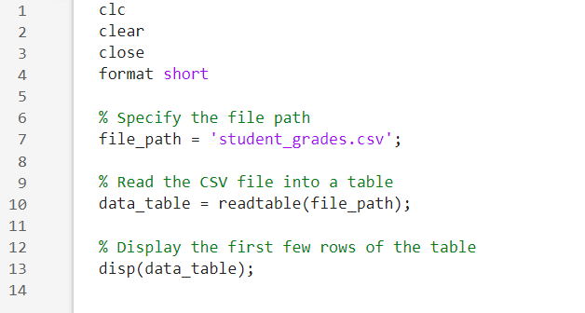
Figure 3-1 Matlab Code- Import dataset

Result
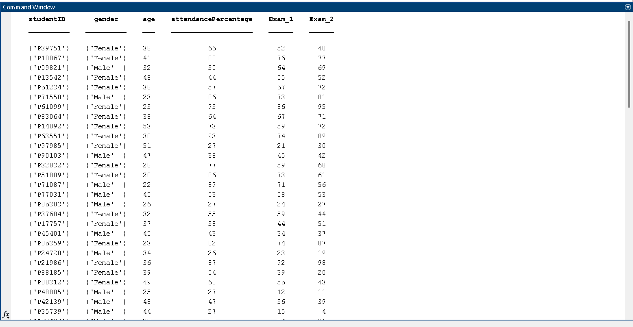
Figure 3-2 Result
Summary statistics for each numerical variable as Mean, Median, Mode, Range, quoting minimum and maximum values, that is, 𝑚𝑖𝑛, 𝑚𝑎𝑥 and Standard Deviation.

Mean
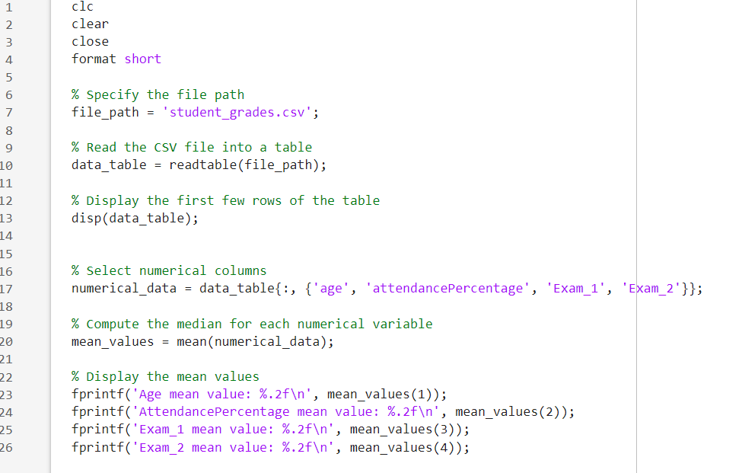
Figure 3-3 MATLAB code - Find the mean
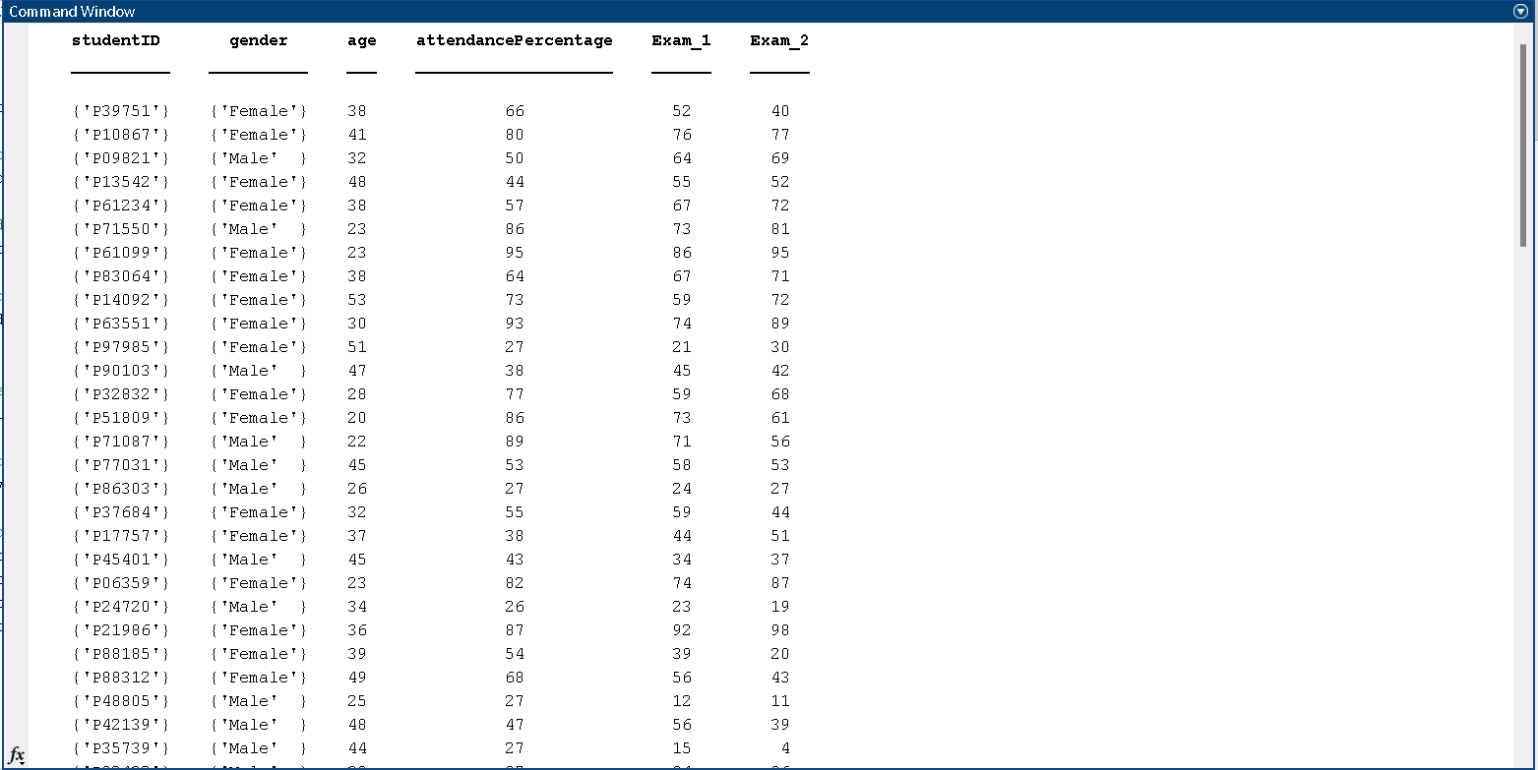
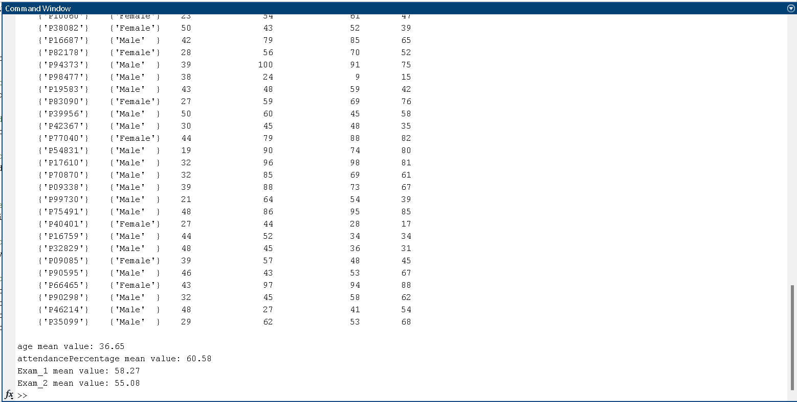
Result
Figure 3-4 Result of Mean

Median
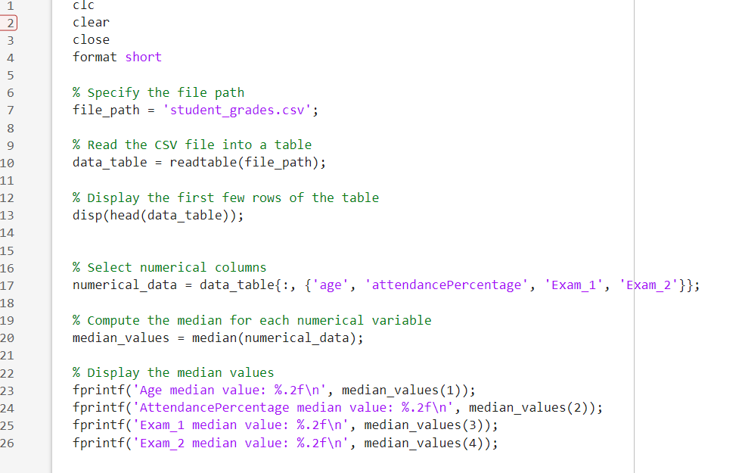

Result
Figure 3-5 MATLAB code - Find the median
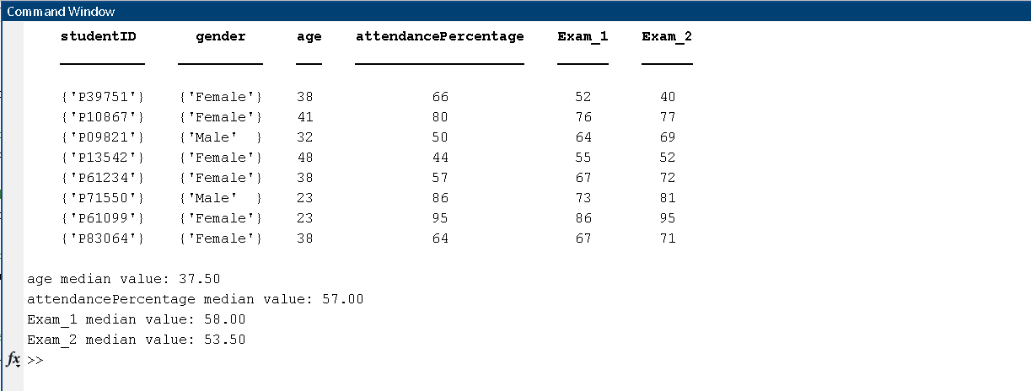
Figure 3-6 Result of Median

Mode
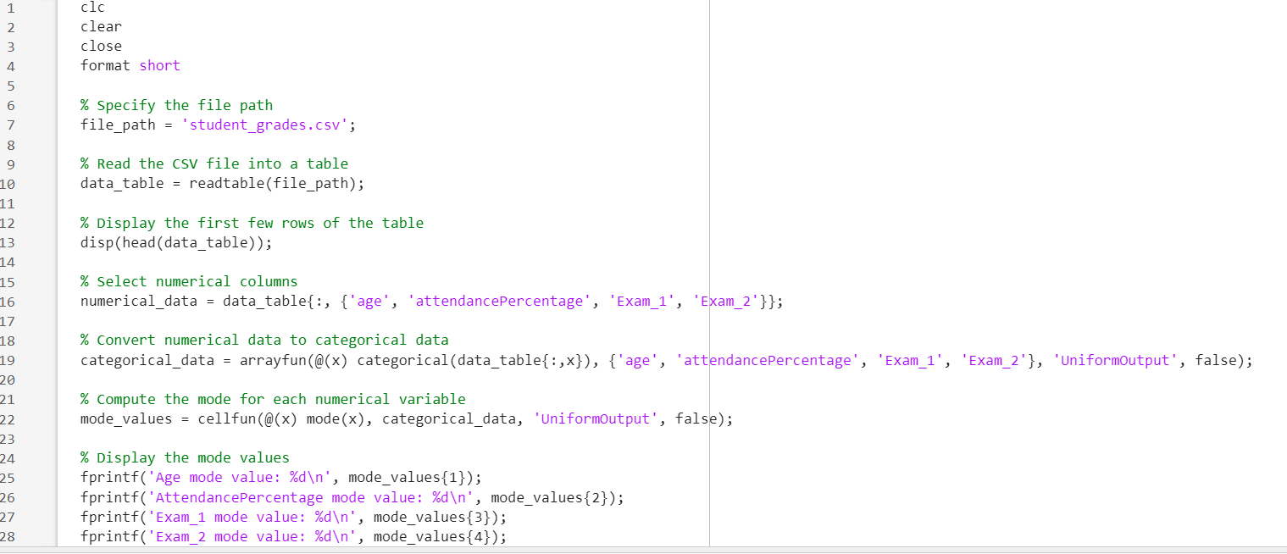
Figure 3-7MATLAB code - Find the mode

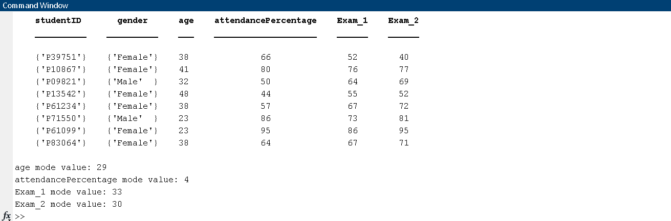
Result
Figure 3-8 Result of Mode

Range

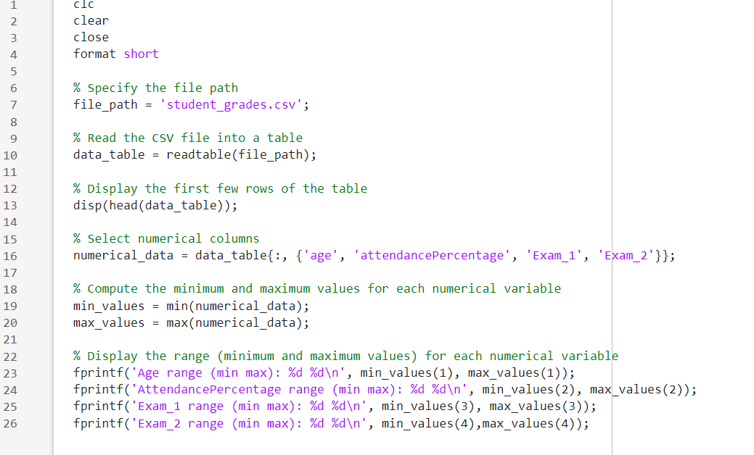
Figure 3-9MATLAB code - Find the range

Result

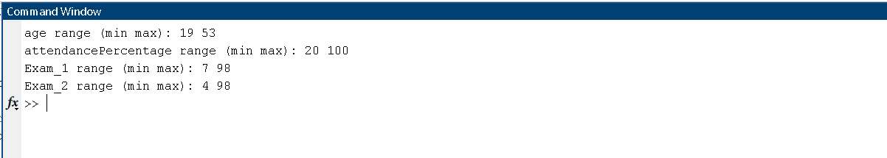
Figure 3-10 Result for range

Standard Deviation
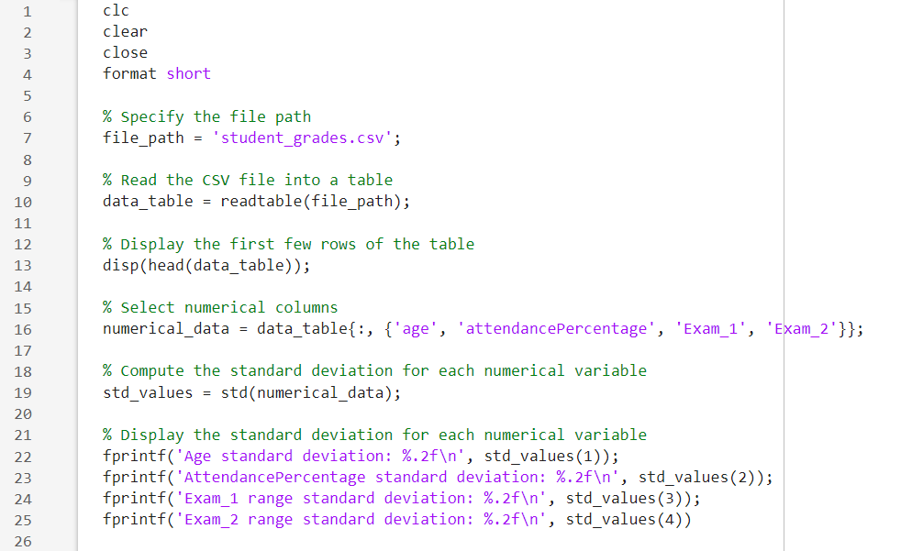
Figure 3-11MATLAB code - Find the standard deviation

Result
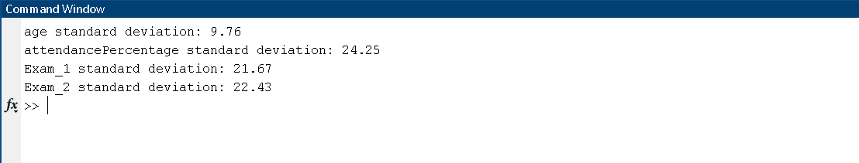
Figure 3-12 result of standard Deviation

function table to display the summary statistics in the command window.

Calculation for Overall Score column
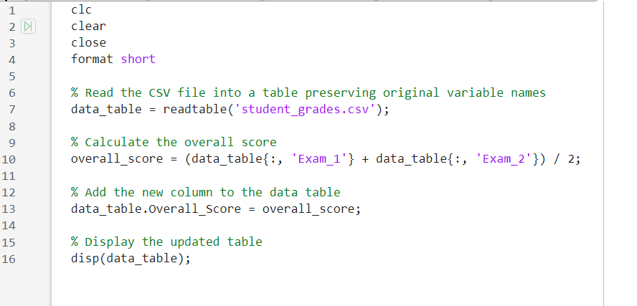
Figure 3-13 Matlab code to Calculation for Overall_Score column

Result

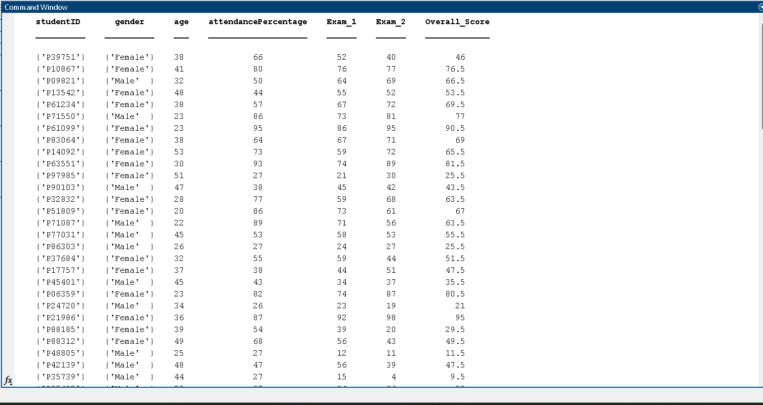
Figure 3-14 Result

Code

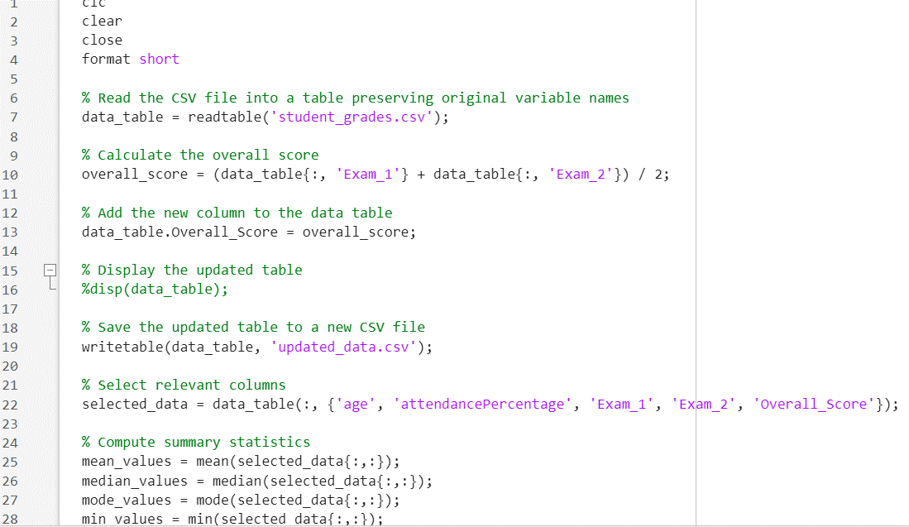
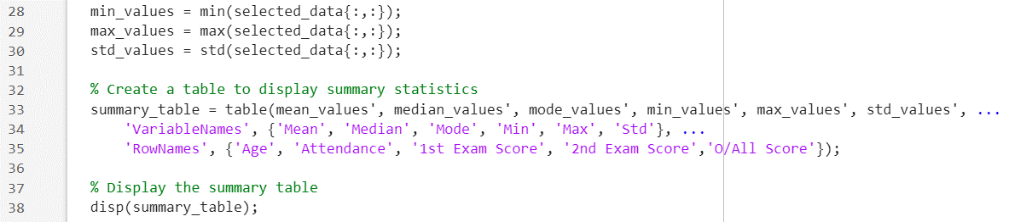

Figure 3-13 Matlab code for Display Summary Table

Result
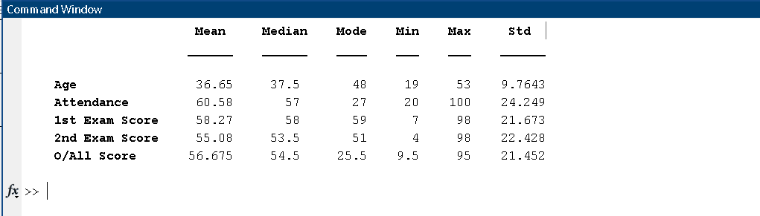
Figure 3-14 Result

Correlation Analysis

The process of Correlation Analysis includes various important stages to investigate connections between variables and comprehend the influence of gender on the final module outcomes through statistical approaches such as hypothesis testing. Below is a thorough analysis of the procedure:

4.1. Correlation Analysis Procedure
Determine the correlation coefficients between pairs of variables using linear relationships.
Use the corrcoef function in Matlab to calculate the pairwise linear correlation coefficients among variables in the dataset.
This stage consists of establishing the intensity and orientation of the connections among various pairs of variables, such as age, attendance rate, test results, and overall course outcomes.
Use corrplot to display the Correlation Matrix graphically.
Once the correlation coefficients have been calculated, display the correlation matrix using the corrplot function in Matlab.
This visualization offers a transparent display of the relationships among variables, aiding in the recognition of patterns and interconnections within the data.
Examine the Connection between Gender and Overall Module Outcomes:
Statistical techniques, such as hypothesis testing, can be utilized to evaluate how gender affects the overall module scores.
One strategy is to perform a hypothesis test, like a two-sample t-test, to see if there is a notable variation in exam scores among male and female students.
By conducting this analysis, you can determine if gender has a statistically significant impact on the overall module results.

4.2. Further details
Regression Analysis: Utilizing regression analysis can also be advantageous in examining the influence of gender on correlation analysis. By including gender as a factor in your analysis, you can evaluate how it impacts the connections between different variables.
Consider using partial correlation analysis to account for the impacts of other variables like age or attendance when studying the association between gender and overall module scores.
Analyzing Results: Accurately interpreting correlation coefficients and statistical test results is crucial to make meaningful conclusions about the impact of gender on student performance.
By utilizing the statistical tools provided in Matlab and adhering to these instructions, you are able to perform a thorough correlation analysis to acquire knowledge about the various factors impacting student grades and to comprehend how gender influences academic results.

- Return in the command window a matrix of the pairwise linear correlation coefficients between the variables age, attendance, 1st Exam Score, 2nd Exam Score and O/All Score using function corrcoef.
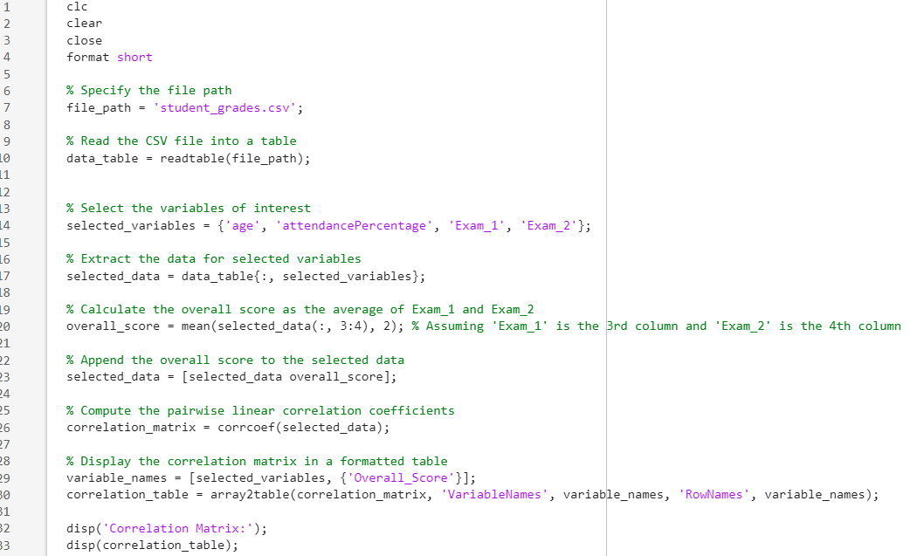

Figure 4-1 Matlab Code- Correlation matrix

Result
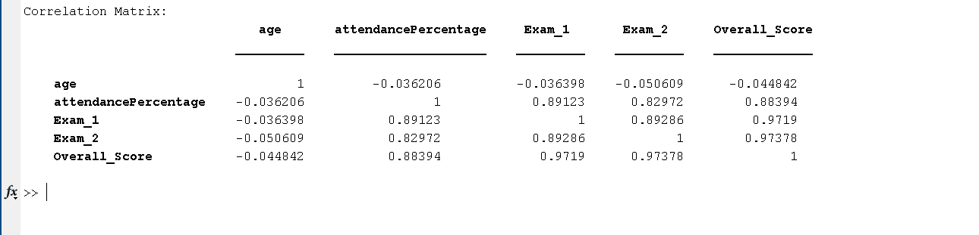
Figure 4-2 Result

- Visualise the correlation matrix using MATLAB’s function corrplot with arguments,
‘VarNames’ to properly names your variables in the correlation’s plot.
‘TestR’ to flag significant correlations in the correlation’s matrix.
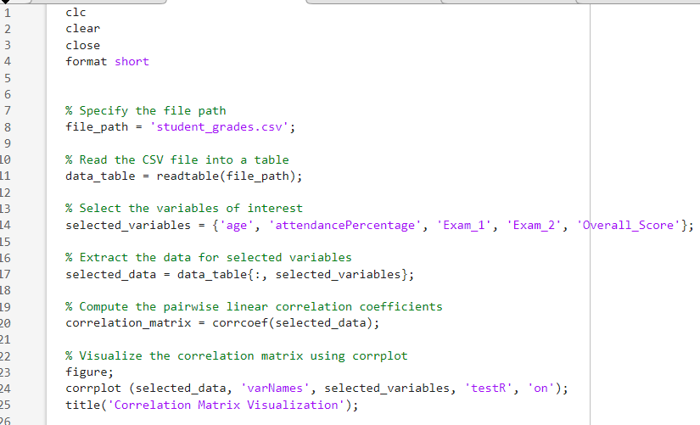
Figure 4-3 Matlab code fpr Correlation matrix visualization

Result
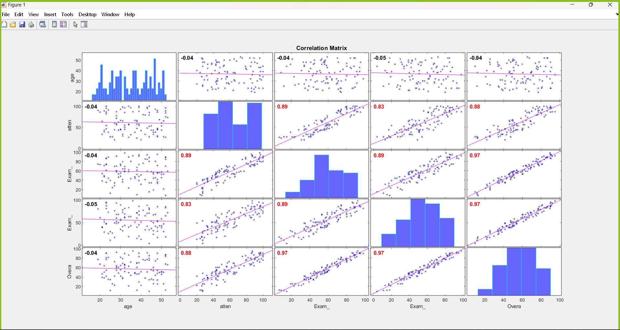
Figure 4-4 Graph of Correlation matrix visualization

- Examine the relationship between the categorical variable gender and the overall module results.
Various statistical methods to assess the association between categorical and numerical variables can be implemented. One common approach is to perform a hypothesis test or a comparison of means between the different groups.
Here's a step-by-step path to how can conduct such an analysis in Matlab:
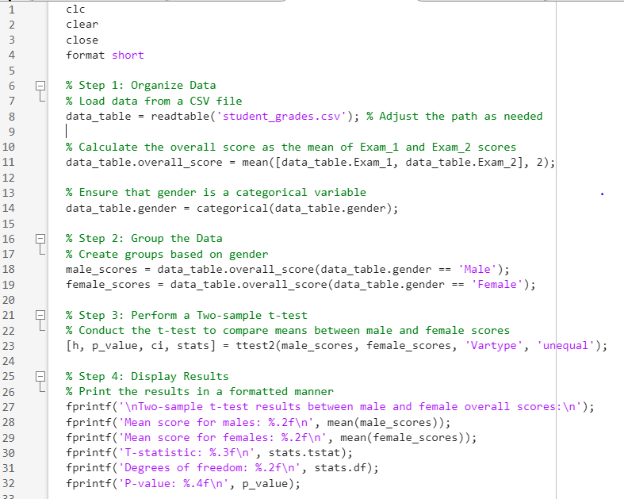
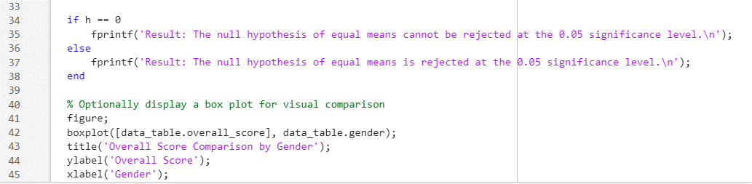

Figure 4-5 Matlab code for analyse the data

Result
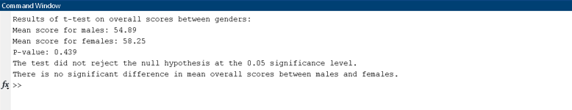
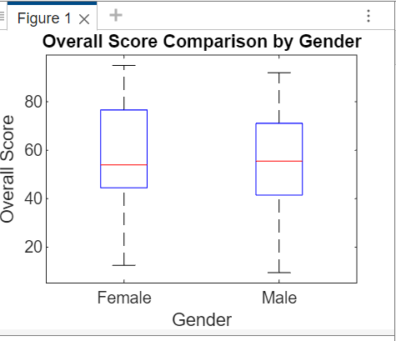

Figure 4-6 Result

- Identify the variables that are strongly correlated with the exams’ score.

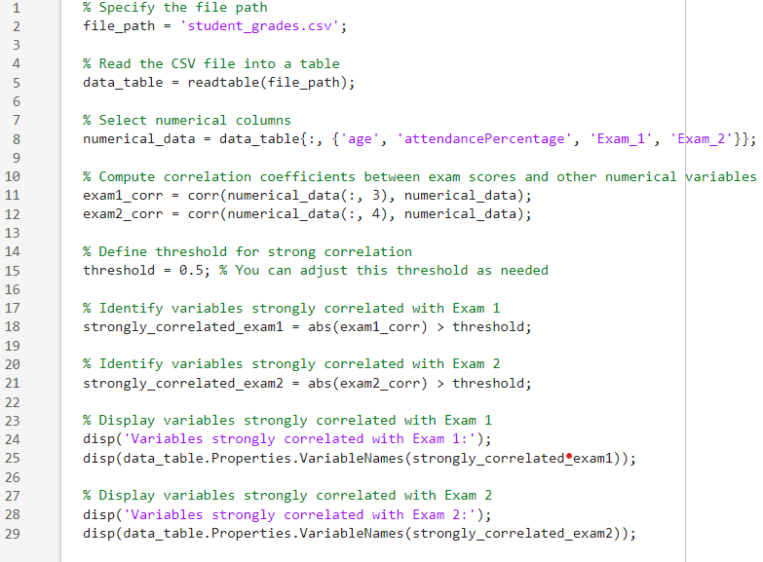
Figure 4-7 Matlab code to find Strongly correlated exams
Result
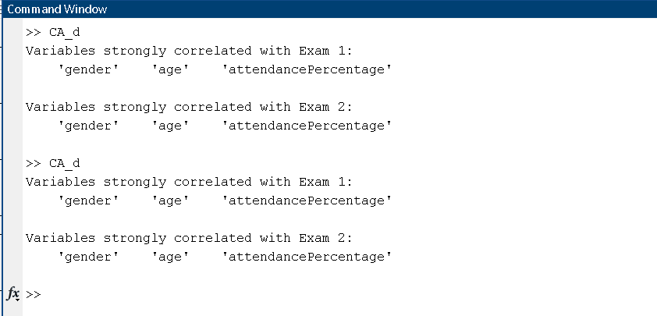
Figure 4-8 Result

- Discuss the findings and potential implications.
The results of the study on the correlation between variables in the dataset, specifically in relation to test scores and other elements, offer important understandings and ramifications. Here are several possible discoveries and the consequences they may bring:
Relationship between variables- Recognizing the relationship between factors like age, attendance percentage, and exam scores can offer a deeper understanding of how they might impact academic success. For instance, a clear positive relationship between attendance rate and exam results implies that increased attendance could result in improved academic achievement.
Determination of key factors: Discovering variables with a strong correlation to exam results, like attendance rate or past exam grades, can reveal elements that have a notable effect on students' academic performance. This data can help determine which interventions or support strategies should be given priority to enhance student performance.
Gender disparities- Analyzing the relationship between gender and exam results can help identify differences in academic performance between male and female students. This could result in more research on possible root causes of these variations and help in creating specific actions to tackle gender inequalities in education.
Possible interventions- Educational institutions can create specific programs to target factors strongly linked to academic achievement, according to the results. For instance, if there is a strong correlation between attendance percentage and exam scores, strategies to enhance attendance rates or assist students dealing with attendance issues can be put into practice.
Implications for educational policies and practices may also be drawn from the findings.
If specific demographic or socioeconomic factors are strongly linked to exam scores, policymakers could think about enacting policies to decrease educational inequalities and guarantee fair access to resources and support for every student.In general, the results of the study can be used as a solid basis for decision-making in education, directing actions, regulations, and methods to enhance student success and support educational fairness.

Visualization of grouped data for Exam 1, Exam 2, and O/All results

The aim in this section of the task is to display the spread of the test scores, such as the 1st and 2nd Exam Scores, as well as the Overall (O/All) Score.

a) determine the frequency.
i. Exam 1 results grouped in classes of ,
ii. Exam 2 results group classes of width 10,
iii. O/All results grouped in classes of width 10.

code
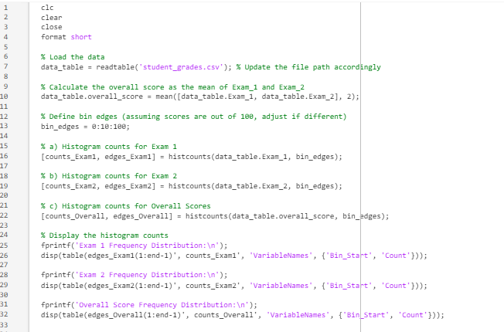

Figure 5-1 Matlab code for determine the frequency

Result
Figure 5-2 Result of frequency distribution
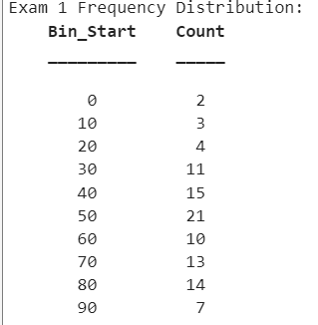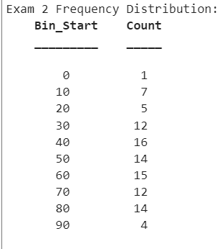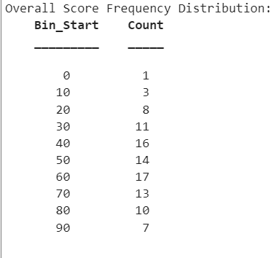

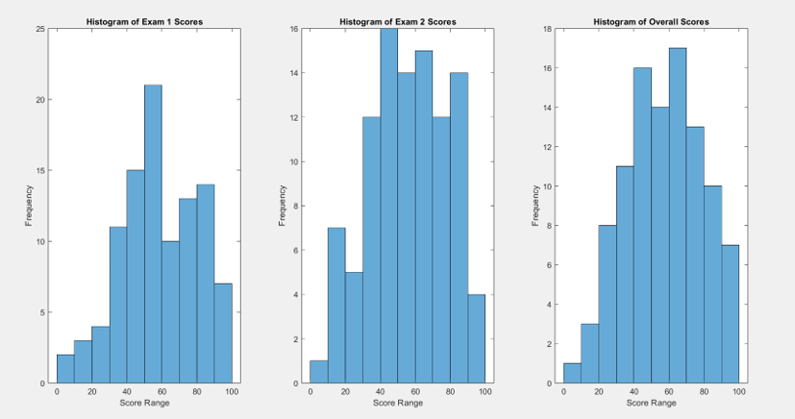

- figure the histograms
- the classified Exam 1 results,
- the classified Exam 2 results,
- the classified O/All results.
Afterwards, we can utilize the histogram function to display the histograms of the three exam result sets.Code

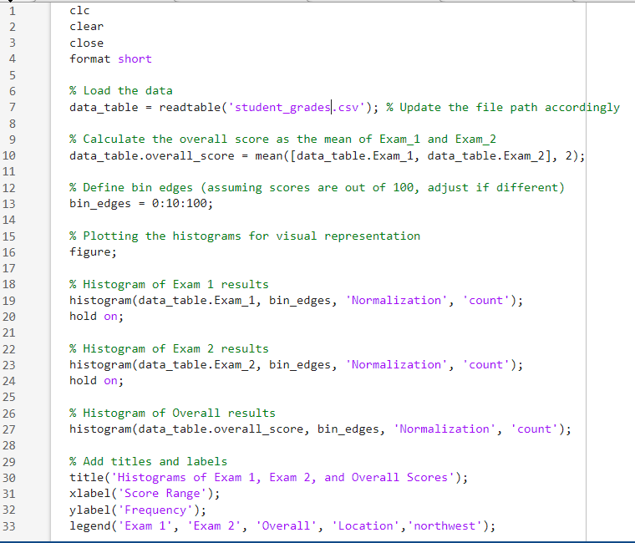

Figure 5-3 Matlab code for Figure the histograms

Result

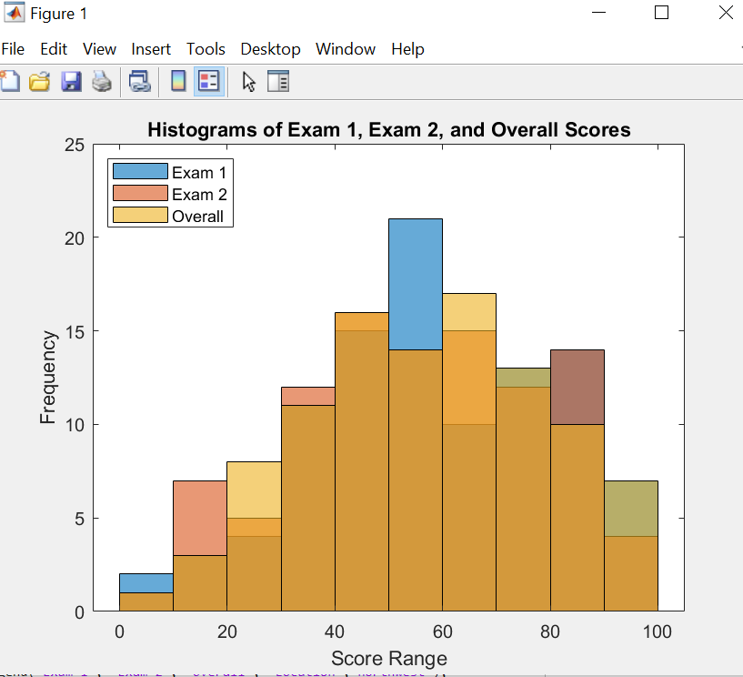
Figure 5-4 Figure of histogram

- Plot in one figure the more (in blue) and less (in red) than ogives
the classified Exam 1 results, the classified Exam 2 results, the classified O/All results.
In order to display the total distribution of exam scores, we can create ogives of values both above (shown in blue) and below (shown in red).

Code
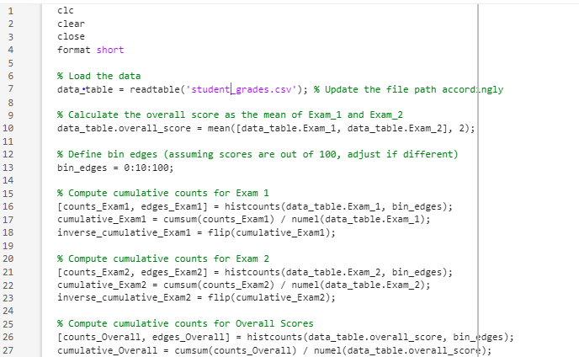
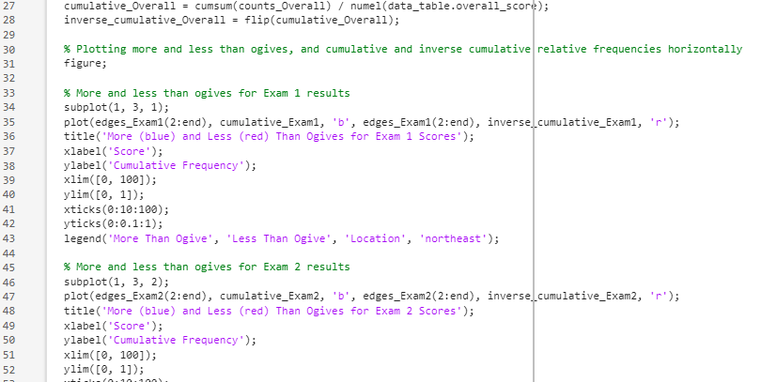
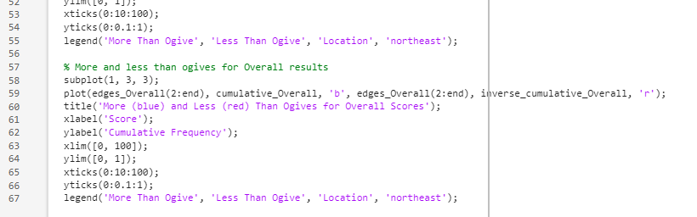

Figure 5-5 Matlab code for the figure

Result
This code will generate a visualization with three subplots, each representing a different set of exam scores and displaying both more than and less than ogives.
By offering these visual representations, can enhance our comprehension of how the exam scores are distributed and the students' overall performance. The frequency of scores within each range can be seen in the histograms, while the cumulative distribution of scores is displayed in the ogives, helping to identify data patterns and trends.
These visual aids, along with the earlier statistical studies, will offer a complete insight into the factors impacting student achievement and the overall academic results of the student group.

Result
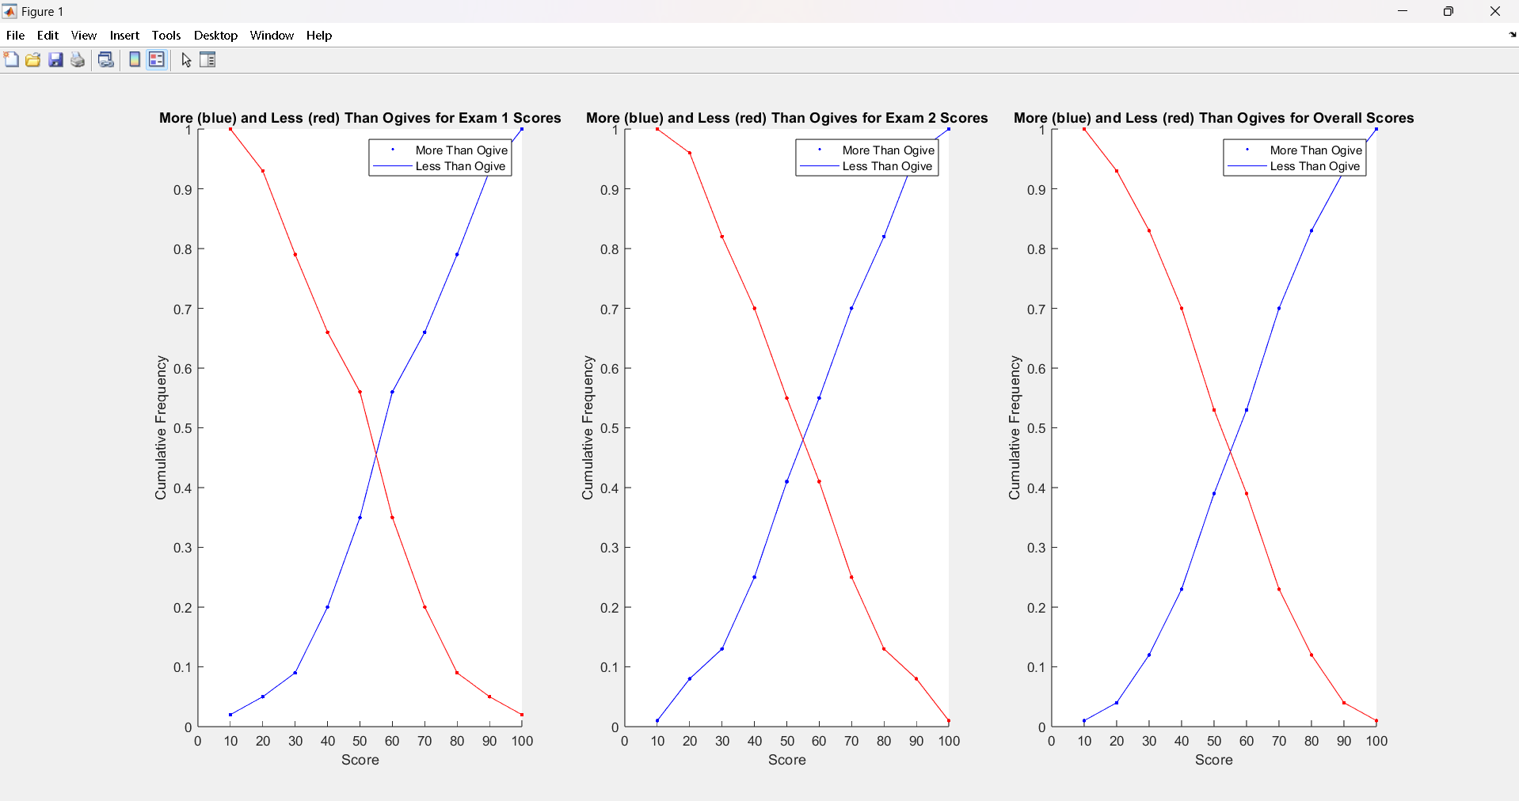
Figure 5-6 figure of the more (in blue) and less (in red) than ogives

Conclusion
In this assignment, the first descriptive statistical analysis was conducted to identify the behaviour.
of those different variables inside the data set. In that analysis, many indicators were calculated such as mean, median, mode, ranges, and standard deviations of those variables. Then using those data,
correlation analysis was conducted. To conduct that analysis, it wanted to use different libraries such as “Statistical and Machine Learning Toolbox” throughout this process.

According to the correlation coefficient analysis results, different factors were identified which,
are effect to the exam results of the students. Attendance percentage, Exam 1 score, Exam 2 score and
overall score correlated to each other. Correlation plots were used to give better idea how the factors are correlate each other. Then the effect of the gender variable for the overall result was checked using
t-test by checking that is there any significant difference between two population means from male and female clusters. From that test, it could have identified that there is no significant different between two means with 0.05 significant level. Therefore, the test concludes that there are no significant effect from
the gender factor.

Then frequency analysis and the histogram were used to identify the outliers and the data
distribution patterns such as skewness and trends. From those representations, identified that there are no such outliers and significant skewness of the data sets. Also, the data sets are normally distributed around the mean.

As the conclusion of this assignments, the attendance percentage of the
Students can be identified, directly effect to the exam results of the students than other factors. Therefore, by using method to increase their attendance, we can have better results for student’s exam results.

References

- MathWorks. (no date) Displaying matrix of correlation coefficients. MATLAB Central. Available at: https://in.mathworks.com/matlabcentral/answers/496872-displaying-matrix-of-correlation-coefficients [Accessed 27 Apr. 2024].

- Stack Overflow. (2010) MATLAB - frequency distribution. Stack Overflow. Available at: https://stackoverflow.com/questions/2597743/matlab-frequency-distribution [Accessed 27 Apr. 2024].

- MathWorks. (2024) Correlation analysis. MathWorks - Documentation. Available at: https://in.mathworks.com/help/matlab/correlation-analysis.html [Accessed 27 Apr. 2024].

- Hunt, B.R., et al. (2019) Data Visualization with MATLAB. Cambridge: Cambridge University Press.

- MathWorks. (2024) imagesc. Available at: https://in.mathworks.com/help/matlab/ref/imagesc.html [Accessed 27 Apr. 2024].

- Attaway, S. (2018) MATLAB: A Practical Introduction to Programming and Problem Solving. 4th ed. London: Pearson Education.

- MATLAB documentation. (n.d.) Summary Statistics. Available at: https://www.mathworks.com/help/matlab/summary-statistics.html [Accessed 27 Apr. 2024].

Appendix
clc
clear
close
format short

% Specify the file path
file_path = 'student_grades.csv';

% Read the CSV file into a table
data_table = readtable(file_path);

% Display the first few rows of the table
disp(data_table);

% Select numerical columns
numerical_data = data_table{:, {'age', 'attendancePercentage', 'Exam_1', 'Exam_2'}};

% Compute the median for each numerical variable
mean_values = mean(numerical_data);

% Compute the median for each numerical variable
median_values = median(numerical_data);

% Convert numerical data to categorical data
categorical_data = arrayfun(@(x) categorical(data_table{:,x}), {'age', 'attendancePercentage', 'Exam_1', 'Exam_2'}, 'UniformOutput', false);

% Compute the mode for each numerical variable
mode_values = cellfun(@(x) mode(x), categorical_data, 'UniformOutput', false);

% Compute the minimum and maximum values for each numerical variable
min_values = min(numerical_data);
max_values = max(numerical_data);

% Compute the standard deviation for each numerical variable
std_values = std(numerical_data);

% Display the mean values
fprintf('Age mean value: %.2f\n', mean_values(1));
fprintf('AttendancePercentage mean value: %.2f\n', mean_values(2));
fprintf('Exam_1 mean value: %.2f\n', mean_values(3));
fprintf('Exam_2 mean value: %.2f\n', mean_values(4));

% Display the median values
fprintf('Age median value: %.2f\n', median_values(1));
fprintf('AttendancePercentage median value: %.2f\n', median_values(2));
fprintf('Exam_1 median value: %.2f\n', median_values(3));
fprintf('Exam_2 median value: %.2f\n', median_values(4));

% Display the mode values
fprintf('Age mode value: %d\n', mode_values{1});
fprintf('AttendancePercentage mode value: %d\n', mode_values{2});
fprintf('Exam_1 mode value: %d\n', mode_values{3});
fprintf('Exam_2 mode value: %d\n', mode_values{4});

% Display the range (minimum and maximum values) for each numerical variable
fprintf('Age range (min max): %d %d\n', min_values(1), max_values(1));
fprintf('AttendancePercentage range (min max): %d %d\n', min_values(2), max_values(2));
fprintf('Exam_1 range (min max): %d %d\n', min_values(3), max_values(3));
fprintf('Exam_2 range (min max): %d %d\n', min_values(4),max_values(4));

% Display the standard deviation for each numerical variable
fprintf('Age standard deviation: %.2f\n', std_values(1));
fprintf('AttendancePercentage standard deviation: %.2f\n', std_values(2));
fprintf('Exam_1 range standard deviation: %.2f\n', std_values(3));
fprintf('Exam_2 range standard deviation: %.2f\n', std_values(4))

% Calculate the overall score
overall_score = (data_table{:, 'Exam_1'} + data_table{:, 'Exam_2'}) / 2;

% Add the new column to the data table
data_table.Overall_Score = overall_score;

% Display the updated table
%disp(data_table);

% Select relevant columns
selected_data = data_table(:, {'age', 'attendancePercentage', 'Exam_1', 'Exam_2', 'Overall_Score'});

% Compute summary statistics
mean_values = mean(selected_data{:,:});
median_values = median(selected_data{:,:});
mode_values = mode(selected_data{:,:});
min_values = min(selected_data{:,:});
max_values = max(selected_data{:,:});
std_values = std(selected_data{:,:});

% Create a table to display summary statistics
summary_table = table(mean_values', median_values', mode_values', min_values', max_values', std_values', ...
'VariableNames', {'Mean', 'Median', 'Mode', 'Min', 'Max', 'Std'}, ...
'RowNames', {'Age', 'Attendance', '1st Exam Score', '2nd Exam Score','O/All Score'});

% Display the summary table
disp(summary_table);

% Select the variables of interest
selected_variables = {'age', 'attendancePercentage', 'Exam_1', 'Exam_2'};

% Extract the data for selected variables
selected_data = data_table{:, selected_variables};

% Calculate the overall score as the average of Exam_1 and Exam_2
overall_score = mean(selected_data(:, 3:4), 2); % Assuming 'Exam_1' is the 3rd column and 'Exam_2' is the 4th column

% Append the overall score to the selected data
selected_data = [selected_data overall_score];

% Compute the pairwise linear correlation coefficients
correlation_matrix = corrcoef(selected_data);

% Display the correlation matrix in a formatted table
variable_names = [selected_variables, {'Overall_Score'}];
correlation_table = array2table(correlation_matrix, 'VariableNames', variable_names, 'RowNames', variable_names);

disp('Correlation Matrix:');
disp(correlation_table);

% Select the variables of interest
selected_variables = {'age', 'attendancePercentage', 'Exam_1', 'Exam_2', 'Overall_Score'};

% Extract the data for selected variables
selected_data = data_table{:, selected_variables};

% Compute the pairwise linear correlation coefficients
correlation_matrix = corrcoef(selected_data);

% Visualize the correlation matrix using corrplot
figure;
corrplot (selected_data, 'varNames', selected_variables, 'testR', 'on');
title('Correlation Matrix Visualization');

% Calculate the overall score as the mean of Exam_1 and Exam_2 scores
data_table.overall_score = mean([data_table.Exam_1, data_table.Exam_2], 2);

% Ensure that gender is a categorical variable
data_table.gender = categorical(data_table.gender);

% Step 2: Group the Data
% Create groups based on gender
male_scores = data_table.overall_score(data_table.gender == 'Male');
female_scores = data_table.overall_score(data_table.gender == 'Female');

% Step 3: Perform a Two-sample t-test
% Conduct the t-test to compare means between male and female scores
[h, p_value, ci, stats] = ttest2(male_scores, female_scores, 'Vartype', 'unequal');

% Step 4: Display Results
% Print the results in a formatted manner
fprintf('\nTwo-sample t-test results between male and female overall scores:\n');
fprintf('Mean score for males: %.2f\n', mean(male_scores));
fprintf('Mean score for females: %.2f\n', mean(female_scores));
fprintf('T-statistic: %.3f\n', stats.tstat);
fprintf('Degrees of freedom: %.2f\n', stats.df);
fprintf('P-value: %.4f\n', p_value);

if h == 0
fprintf('Result: The null hypothesis of equal means cannot be rejected at the 0.05 significance level.\n');
else
fprintf('Result: The null hypothesis of equal means is rejected at the 0.05 significance level.\n');
end

% Optionally display a box plot for visual comparison
figure;
boxplot([data_table.overall_score], data_table.gender);
title('Overall Score Comparison by Gender');
ylabel('Overall Score');
xlabel('Gender');

% Compute correlation coefficients between exam scores and other numerical variables
exam1_corr = corr(numerical_data(:, 3), numerical_data);
exam2_corr = corr(numerical_data(:, 4), numerical_data);

% Define threshold for strong correlation
threshold = 0.5; % You can adjust this threshold as needed

% Identify variables strongly correlated with Exam 1
strongly_correlated_exam1 = abs(exam1_corr) > threshold;

% Identify variables strongly correlated with Exam 2
strongly_correlated_exam2 = abs(exam2_corr) > threshold;

% Display variables strongly correlated with Exam 1
disp('Variables strongly correlated with Exam 1:');
disp(data_table.Properties.VariableNames(strongly_correlated_exam1));

% Display variables strongly correlated with Exam 2
disp('Variables strongly correlated with Exam 2:');
disp(data_table.Properties.VariableNames(strongly_correlated_exam2));

% Compute correlation coefficients between exam scores and other numerical variables
exam1_corr = corrcoef(numerical_data);
%exam1Vage = corrcoef(numerical_data(:, 3), numerical_data(:, 1))
%exam2_cor = corrcoef(numerical_data(:, 4), numerical_data);

% Define threshold for strong correlation
threshold = 0.5; % You can adjust this threshold as needed

% Identify variables strongly correlated with Exam 1
strongly_correlated_exam1 = abs(exam1_corr) > threshold;
exam1_relate = [];
if strongly_correlated_exam1(1,3) == 1
exam1_relate = [exam1_relate, "Age"];
end
if strongly_correlated_exam1(2,3) == 1
exam1_relate = [exam1_relate, "Attendance"];
end
if strongly_correlated_exam1(4,3) == 1
exam1_relate = [exam1_relate, "Exam2"];
end

% Identify variables strongly correlated with Exam 1
strongly_correlated_exam1 = abs(exam1_corr) > threshold;
exam2_relate = [];
if strongly_correlated_exam1(1,4) == 1
exam2_relate = [exam2_relate, "Age"];
end
if strongly_correlated_exam1(2,4) == 1
exam2_relate = [exam2_relate, "Attendance"];
end
if strongly_correlated_exam1(3,4) == 1
exam2_relate = [exam2_relate, "Exam1"];
end

% Identify variables strongly correlated with 2
%strongly_correlated_exam2 = abs(exam2_corr) > threshold;

% Display variables strongly correlated with Exam 1
disp('Variables strongly correlated with Exam 1:');
disp(exam1_relate)
%disp(data_table.Properties.VariableNames(strongly_correlated_exam1));

% Display variables strongly correlated with Exam 2
disp('Variables strongly correlated with Exam 2:');
disp(exam2_relate)
%disp(data_table.Properties.VariableNames(strongly_correlated_exam2));

% Calculate the overall score as the mean of Exam_1 and Exam_2
data_table.overall_score = mean([data_table.Exam_1, data_table.Exam_2], 2);

% Define bin edges (assuming scores are out of 100, adjust if different)
bin_edges = 0:10:100;

% a) Histogram counts for Exam 1
[counts_Exam1, edges_Exam1] = histcounts(data_table.Exam_1, bin_edges);

% b) Histogram counts for Exam 2
[counts_Exam2, edges_Exam2] = histcounts(data_table.Exam_2, bin_edges);

% c) Histogram counts for Overall Scores
[counts_Overall, edges_Overall] = histcounts(data_table.overall_score, bin_edges);

% Display the histogram counts
fprintf('Exam 1 Frequency Distribution:\n');
disp(table(edges_Exam1(1:end-1)', counts_Exam1', 'VariableNames', {'Bin_Start', 'Count'}));

fprintf('Exam 2 Frequency Distribution:\n');
disp(table(edges_Exam2(1:end-1)', counts_Exam2', 'VariableNames', {'Bin_Start', 'Count'}));

fprintf('Overall Score Frequency Distribution:\n');
disp(table(edges_Overall(1:end-1)', counts_Overall', 'VariableNames', {'Bin_Start', 'Count'}));

% Plotting the histograms for visual representation
figure;
subplot(1,3,1); % Adjust the subplot to 1 row, 3 columns, and this is the 1st plot
histogram(data_table.Exam_1, bin_edges);
title('Histogram of Exam 1 Scores');
xlabel('Score Range');
ylabel('Frequency');

subplot(1,3,2); % This is the 2nd plot
histogram(data_table.Exam_2, bin_edges);
title('Histogram of Exam 2 Scores');
xlabel('Score Range');
ylabel('Frequency');

subplot(1,3,3); % This is the 3rd plot
histogram(data_table.overall_score, bin_edges);
title('Histogram of Overall Scores');
xlabel('Score Range');
ylabel('Frequency');

% Calculate the overall score as the mean of Exam_1 and Exam_2
data_table.overall_score = mean([data_table.Exam_1, data_table.Exam_2], 2);

% Define bin edges (assuming scores are out of 100, adjust if different)
bin_edges = 0:10:100;

% Plotting the histograms for visual representation
figure;

% Histogram of Exam 1 results
histogram(data_table.Exam_1, bin_edges, 'Normalization', 'count');
hold on;

% Histogram of Exam 2 results
histogram(data_table.Exam_2, bin_edges, 'Normalization', 'count');
hold on;

% Histogram of Overall results
histogram(data_table.overall_score, bin_edges, 'Normalization', 'count');

% Add titles and labels
title('Histograms of Exam 1, Exam 2, and Overall Scores');
xlabel('Score Range');
ylabel('Frequency');
legend('Exam 1', 'Exam 2', 'Overall', 'Location','northwest');

% Calculate the overall score as the mean of Exam_1 and Exam_2
data_table.overall_score = mean([data_table.Exam_1, data_table.Exam_2], 2);

% Define bin edges (assuming scores are out of 100, adjust if different)
bin_edges = 0:10:100;

% Compute cumulative counts for Exam 1
[counts_Exam1, edges_Exam1] = histcounts(data_table.Exam_1, bin_edges);
cumulative_Exam1 = cumsum(counts_Exam1) / numel(data_table.Exam_1);
inverse_cumulative_Exam1 = flip(cumulative_Exam1);

% Compute cumulative counts for Exam 2
[counts_Exam2, edges_Exam2] = histcounts(data_table.Exam_2, bin_edges);
cumulative_Exam2 = cumsum(counts_Exam2) / numel(data_table.Exam_2);
inverse_cumulative_Exam2 = flip(cumulative_Exam2);

% Compute cumulative counts for Overall Scores
[counts_Overall, edges_Overall] = histcounts(data_table.overall_score, bin_edges);
cumulative_Overall = cumsum(counts_Overall) / numel(data_table.overall_score);
inverse_cumulative_Overall = flip(cumulative_Overall);

% Plotting more and less than ogives, and cumulative and inverse cumulative relative frequencies horizontally
figure;

% More and less than ogives for Exam 1 results
subplot(1, 3, 1);
plot(edges_Exam1(2:end), cumulative_Exam1, 'b', edges_Exam1(2:end), inverse_cumulative_Exam1, 'r');
title('More (blue) and Less (red) Than Ogives for Exam 1 Scores');
xlabel('Score');
ylabel('Cumulative Frequency');
xlim([0, 100]);
ylim([0, 1]);
xticks(0:10:100);
yticks(0:0.1:1);
legend('More Than Ogive', 'Less Than Ogive', 'Location', 'northeast');

% More and less than ogives for Exam 2 results
subplot(1, 3, 2);
plot(edges_Exam2(2:end), cumulative_Exam2, 'b', edges_Exam2(2:end), inverse_cumulative_Exam2, 'r');
title('More (blue) and Less (red) Than Ogives for Exam 2 Scores');
xlabel('Score');
ylabel('Cumulative Frequency');
xlim([0, 100]);
ylim([0, 1]);
xticks(0:10:100);
yticks(0:0.1:1);
legend('More Than Ogive', 'Less Than Ogive', 'Location', 'northeast');

% More and less than ogives for Overall results
subplot(1, 3, 3);
plot(edges_Overall(2:end), cumulative_Overall, 'b', edges_Overall(2:end), inverse_cumulative_Overall, 'r');
title('More (blue) and Less (red) Than Ogives for Overall Scores');
xlabel('Score');
ylabel('Cumulative Frequency');
xlim([0, 100]);
ylim([0, 1]);
xticks(0:10:100);
yticks(0:0.1:1);
legend('More Than Ogive', 'Less Than Ogive', 'Location', 'northeast');

