



ACCA6020 Independent Project - Proposal

Design and Evaluation of an AI-Powered Digital Service Platform for Multi-Service Business, Property Maintenance and Smart Safety Workflows.

Name: Abubarkar Dembele
Student ID: 2128085
Supervisor: Dr Mohamed Ben Farah
Subject Specialist:
Submission Date: 27 May 2026
Prepared for: Independent Project proposal submission and interim viva preparation
Contents
1
1
ACCA6020 Independent Project - Proposal 1
Design and Evaluation of an AI-Powered Digital Service Platform for Multi-Service Business, Property Maintenance and Smart Safety Workflows. 1
1. Introduction 3
1.1 Background and rationale 3
1.2 Problem statement 6
1.3 Aim 8
1.4 Objectives 10
1.5 Research questions 12
1.6 Expected outcomes and deliverables 12
1.7 Methodology summary 13
2. Project Design 14
2.1 Project approach 16
2.2 Platform scope 18
2.3 Data collection methods 18
2.4 Tools and techniques 20
2.5 Proposed prototype features 21
2.6 Data analysis and evaluation 21
2.7 Ethical, legal and professional issues 21
2.8 Risks, limitations and mitigation 22
2.9 Reliability, validity and generalisability 22
3. Resources and Planning 23
3.1 Resources required 23
3.2 Project timeline and milestones 23
3.3 Independent project Grantt Chart 24
4. Literature support summary 24
5. Conclusion 25
6. References 26
Appendix A: Interim Viva Talking Points 27
A.1 One-sentence project explanation 27
A.2 Why this project matters 27
A.3 What I am building 27
A.4 Why it is computing-related 27
A.5 What makes it realistic 27
A.6 What makes it ethical 27
A.7 Likely viva questions and short answers 27
A.8 Final viva summary 28

Figure 1 AI applications in real estate 7
Figure 2 Real estate digital transformation framework 10
Figure 3 Real estate lifecycle framework 12
Figure 4 Building maintenance process 14
Figure 5 AI building maintenance research workflow 18
Figure 6 Real-time real estate system architecture 20
Figure 7 Big data decision architecture 22

1. Introduction

1.1 Background and rationale

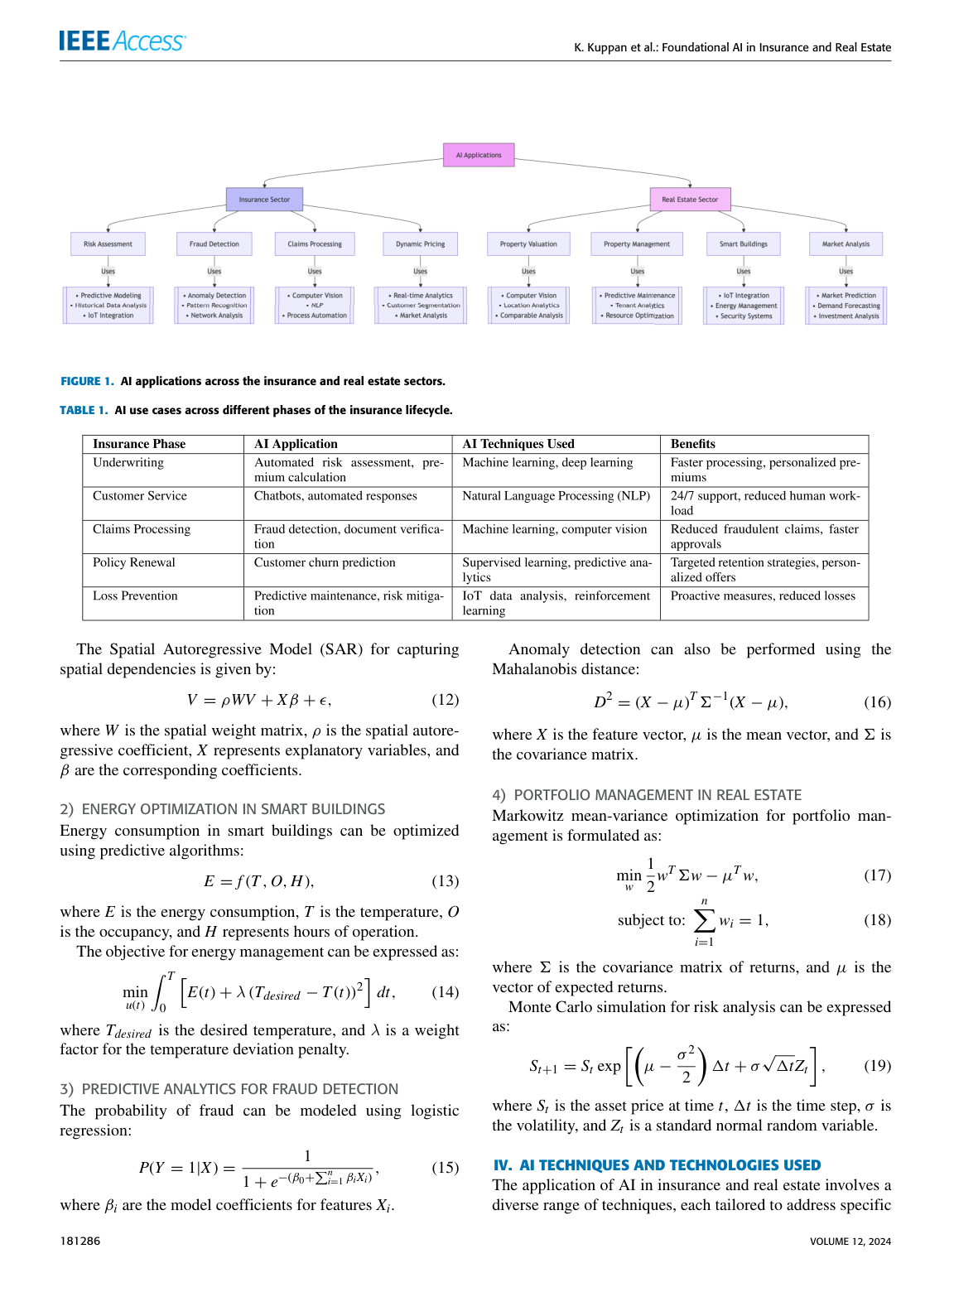
Figure 1 AI applications in real estate

Artificial intelligence (AI), digital platforms and smart property technologies are increasingly changing how organisations communicate with customers, manage enquiries, organise data and make operational decisions. In real estate and property services, research shows that AI, augmented reality (AR) and virtual reality (VR) can improve property marketing, customer engagement, decision-making, transparency and operational efficiency [1]. AI is also being used in real estate for property valuation, customer service, market analysis, smart building management and predictive maintenance, while researchers highlight barriers such as data quality, explainability, regulatory compliance and integration with existing systems [3].
Building maintenance research also supports the direction of this project. Zheng et al. [2] explain that traditional building maintenance often relies on manual inspections and reactive repairs, which can be time-consuming, labour-intensive and dependent on subjective judgement. Their review shows that AI can support predictive maintenance, automated defect recognition, digital twin integration, IoT-based monitoring, energy efficiency and intelligent decision-making [2]. This is important because the proposed platform is designed to begin with customer enquiry and service workflow management, while creating a foundation for future property maintenance and smart safety features.
Oroshimaru Dembele Top Services Ltd is a developing multi-service business. The wider business direction includes AI automation, IT support, phone and device support, repair and reselling, property maintenance, digital business support and future smart safety workflows. These areas may look different, but they share one central operational need: customer enquiries and service requests must be captured, classified, responded to and followed up in a structured way. Without a digital platform, enquiries can become scattered across WhatsApp, social media, email, websites and phone calls. This can lead to missed opportunities, slow replies, repeated manual administration and weaker professional presentation.
Existing research supports the need for a structured platform approach. Smart real estate literature explains that digital transformation connects cyber-physical assets, data connectivity, platform systems, customer service feedback and operational outcomes [4]. The smart real estate framework reviewed for this project includes a cyber-physical asset layer, smart building technologies, data and connectivity, asset performance, a market/platform layer, PropTech systems, transaction logic and customer/service feedback [4]. This links directly to the proposed platform because the project brings customer enquiries, service categories, follow-up records and future property or safety workflows into one organised digital foundation.
Recent Emerald research also strengthens the property management side of the proposal. Oyetunji, Alohan and Edionwe [16] studied the integration of AI in Nigerian real estate practice and found that AI is perceived as useful for improving operational efficiency, property valuation accuracy, fraud reduction and customer service. A further systematic review by Adediran, Aini and Ajibade [17] explains that AI adoption in property management transactions is linked to automation, predictive analytics, intelligent property management and enhanced decision-making, while also raising implementation barriers. These sources are useful because they connect the proposal to current Google Scholar and journal literature, not only older books or general AI theory.
The project is suitable for Applied Computing because it combines requirements analysis, digital platform design, prototype development, AI-assisted workflow, data collection, usability evaluation and ethical reflection. It is not intended to build every long-term business idea at once. Instead, it will design and evaluate a focused prototype that demonstrates how a small multi-service business can manage enquiries, classify service needs, support first-line responses and prepare for future service expansion.

1.2 Problem statement

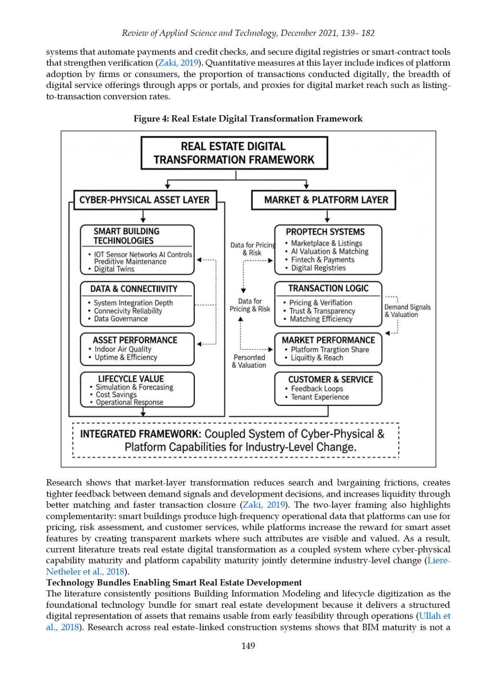
Figure 2 Real estate digital transformation framework

Small multi-service businesses often receive enquiries through several disconnected channels, including WhatsApp, social media, email, websites and direct calls. When information is spread across these channels, it becomes difficult to organise customer details, classify service requests, respond quickly, track follow-up tasks and analyse what services are most in demand. This problem is more serious for a business with several service areas, such as AI automation, IT support, device services, reselling, property maintenance and future smart safety workflows.
Research on AR, VR and AI adoption in real estate shows that digital tools can improve customer engagement, transparency, property visualisation, marketing and operational efficiency, but adoption barriers include cost, infrastructure, training, affordability, safety, data privacy, trust and digital skills [1]. Building maintenance research also identifies the importance of data governance, interoperability, interpretability, risk control and transparent implementation when AI is used in property or facility-related workflows [2]. Furthermore, AI property management research highlights that adoption may improve efficiency and decision-making, but needs responsible governance, data protection and realistic implementation planning [16], [17].
Therefore, the problem investigated in this project is how an AI-powered digital service platform can help a small multi-service business organise enquiries, classify customer needs, support first-line responses and prepare for future service expansion while remaining practical, ethical and suitable for small-business use.

1.3 Aim

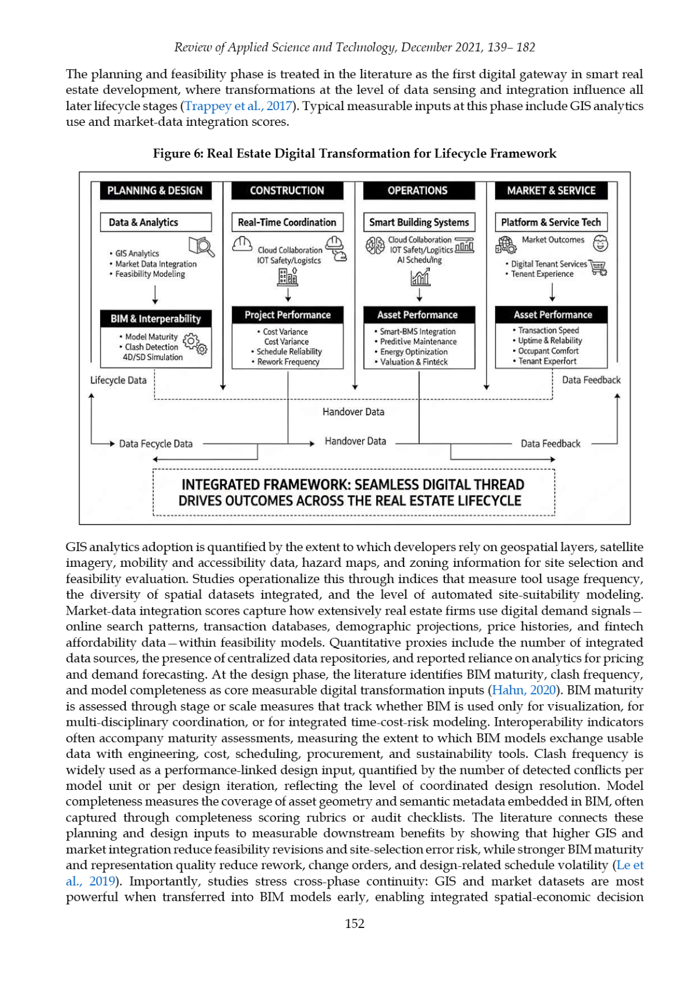
Figure 3 Real estate lifecycle framework

The aim of this project is to design, develop and evaluate a prototype AI-powered digital service platform for Oroshimaru Dembele Top Services Ltd that supports customer enquiry management, service classification, AI-assisted communication, property/service workflow organisation and future smart safety expansion.

1.4 Objectives

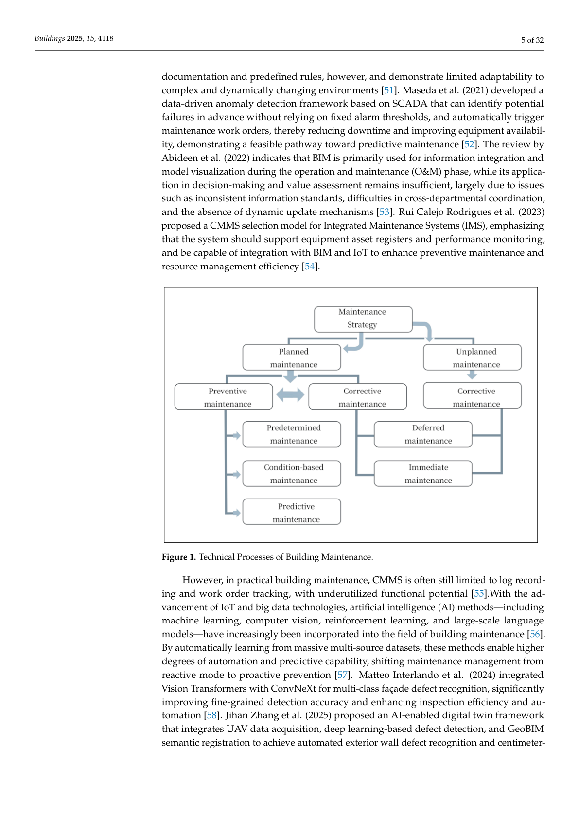
Figure 4 Building maintenance process

Objective 1: To analyse literature on AI adoption, digital service platforms, smart real estate, building maintenance, workflow automation and responsible AI governance.
Objective 2: To identify the functional, technical, ethical and business requirements for a multi-service digital platform supporting AI automation, IT support, device services, property maintenance and future smart safety workflows.
Objective 3: To design and develop a prototype platform that captures customer enquiries, classifies service requests, supports AI-assisted first responses and organises follow-up workflows.
Objective 4: To evaluate the prototype through usability feedback, workflow testing, ethical risk analysis and recommendations for future development.

1.5 Research questions

The project will be guided by the following research questions:
- What customer enquiry and workflow problems are most relevant to a small multi-service business?
- How can AI-assisted classification and response support improve enquiry handling and follow-up?
- What functional, ethical and technical requirements are needed for a practical small-business digital service platform?
- How usable, useful and trustworthy is the proposed prototype when evaluated by potential users or reviewers?

1.6 Expected outcomes and deliverables
- A focused literature review covering AI adoption, smart real estate, building maintenance, digital service platforms and responsible AI.
- A requirements specification for an AI-powered digital service platform.
- A prototype or demonstrator showing enquiry capture, service classification, AI-assisted response support and follow-up workflow.
- A workflow diagram showing how enquiries move through the system.
- A basic evaluation report based on usability, usefulness, clarity, privacy, trust and practicality.
- A risk and ethics analysis covering data protection, AI error, user trust, bias, privacy and human review.
- A final project report and viva presentation.

1.7 Methodology summary
The project will use an applied design-and-evaluation methodology. This is appropriate because the project is not only theoretical; it will produce a prototype and evaluate whether it is useful. The first stage will involve secondary research using academic and professional literature. The second stage will involve requirements analysis based on business needs, typical enquiry scenarios and small-scale feedback. The third stage will involve designing and developing a prototype using accessible tools such as a website or landing page, forms, a spreadsheet or CRM workflow, AI-assisted response templates and service classification logic. The final stage will evaluate the prototype using user feedback, workflow testing and ethical risk analysis.
The methodology is supported by existing software project examples. Inam [6] developed a real-time real estate management system using web technology and AI, including web access, database design, UML diagrams, user dashboards, notifications, AI inference and system evaluation. This supports the decision to use a practical prototype approach rather than a purely theoretical study.
Data analysis will use simple descriptive statistics for questionnaire ratings and thematic analysis for written feedback. Thematic analysis is suitable because it allows qualitative comments to be grouped into patterns such as usability, trust, usefulness, privacy concerns and suggested improvements [13].

2. Project Design

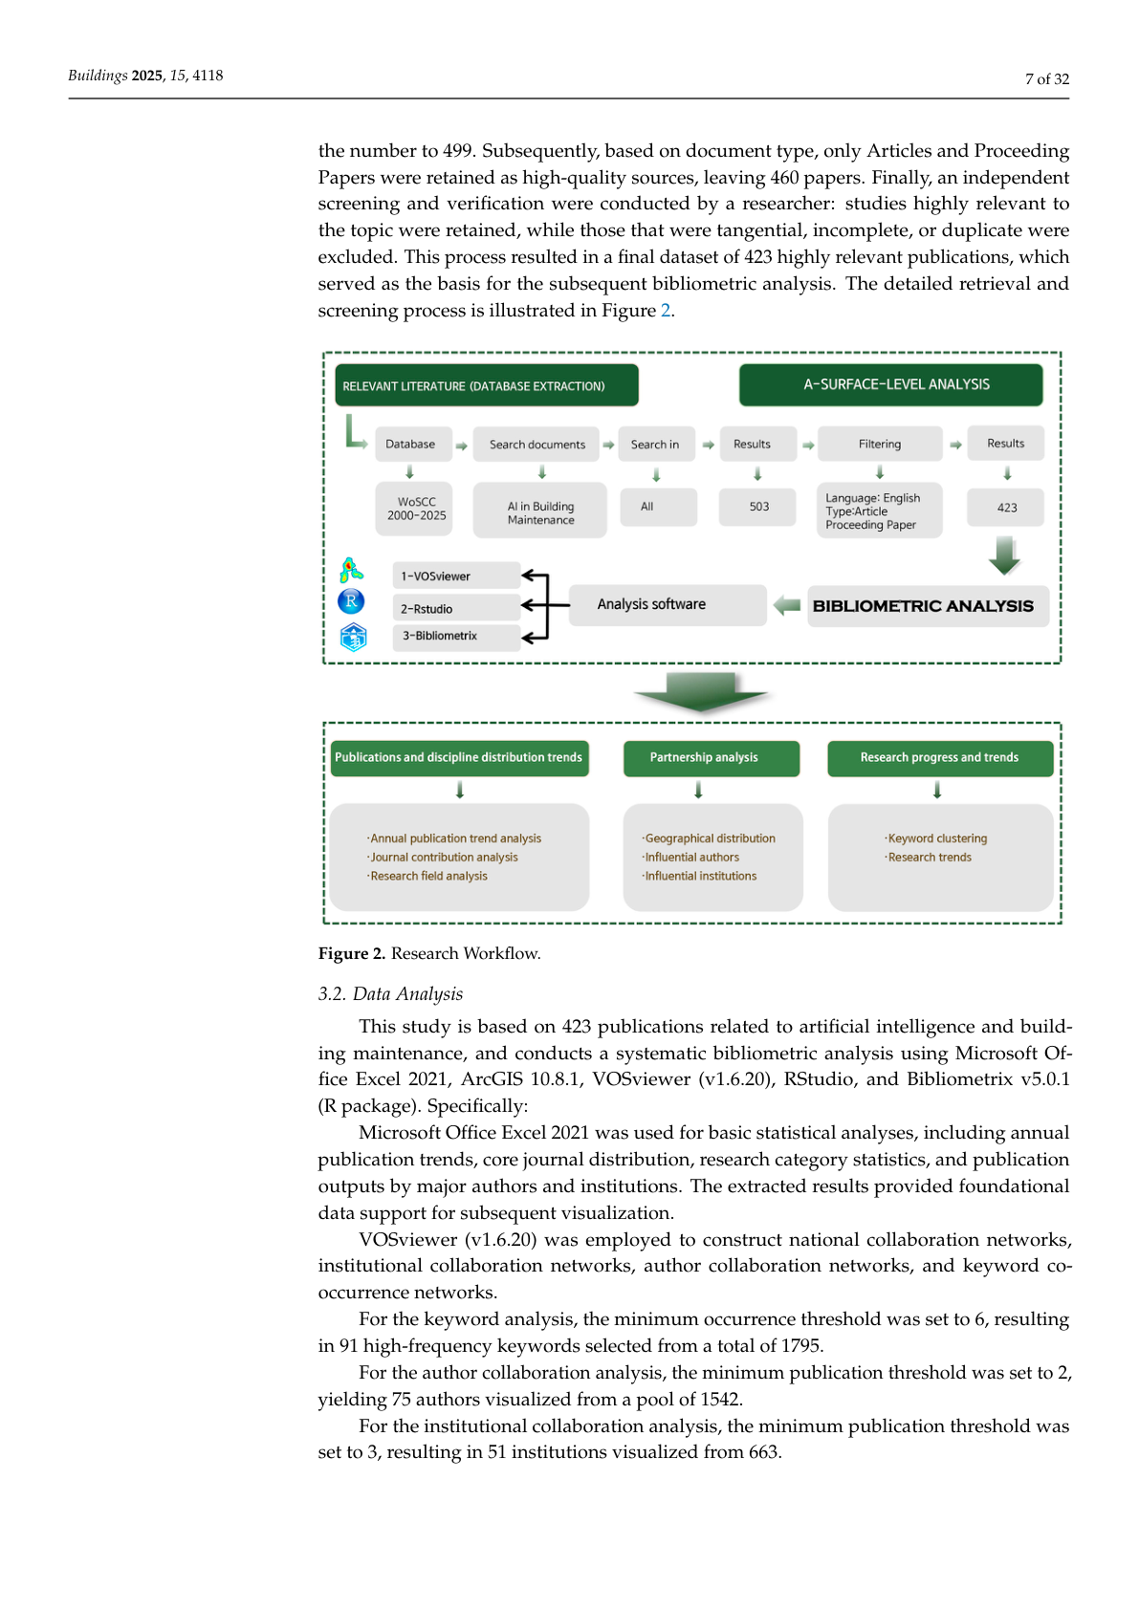
Figure 5 AI building maintenance research workflow

2.1 Project approach

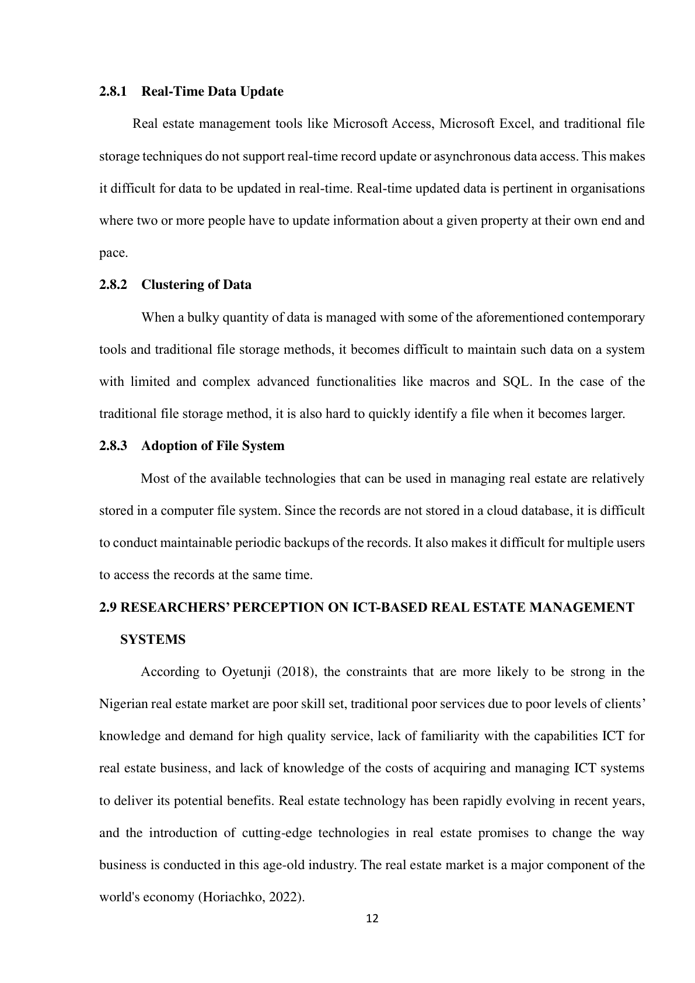
Figure 6 Real-time real estate system architecture

The project will follow a prototype development approach. The prototype will be a digital service platform foundation for a small multi-service business. It will not attempt to build every long-term business idea at once. Instead, it will focus on a realistic system that captures customer enquiries, classifies requests and supports professional first responses.
The proposed workflow is:
- A customer submits an enquiry through a form, website, QR code or digital contact point.
- The system captures basic information such as name, contact method, service type, location, urgency and issue description.
- The enquiry is classified into a service category.
- The system provides an AI-assisted draft response or response template.
- The enquiry is recorded in a tracker for follow-up.
- The business owner reviews the response and decides the next action.
This design reflects research showing that AI can support customer service, lead handling, recommendations, operational decision-making, smart buildings, property management and predictive maintenance when it is connected to clear workflows and human oversight [1], [2], [3], [16].

2.2 Platform scope
The core service categories for the prototype will be:
- AI automation and business support
- IT support and troubleshooting
- Phone or device repair/support
- Device reselling or refurbishing enquiry
- Property maintenance or decorating enquiry
- Smart safety or security enquiry
- General business enquiry
The future expansion areas, such as smart safety, IoT monitoring, cybersecurity awareness and advanced property maintenance, will be included in the design rationale and future development section. They will not all be fully built in the prototype. This keeps the project focused and achievable.

2.3 Data collection methods

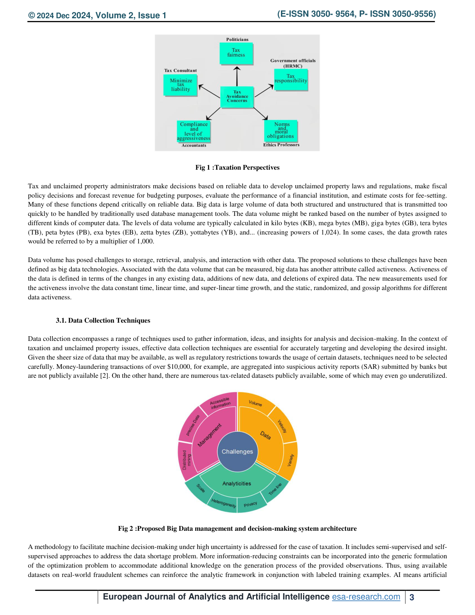
Figure 7 Big data decision architecture

The project will use both secondary and primary data. Secondary data will come from academic papers, dissertations, journal articles, books, professional guidance and official AI/data protection sources. Primary data will be small-scale and low risk. It may include a short questionnaire or feedback form from classmates, potential users, small-business contacts or stakeholders. The feedback will focus on whether the prototype is easy to understand, whether the service categories are clear, whether AI-assisted responses are useful and whether users have concerns about privacy or trust.
Table 1: Data collection linked to objectives
Objective | Data required | Method | Reason
Objective 1 | Literature on AI, smart real estate, building maintenance, property management and responsible AI | Literature review | To justify the project and identify research themes
Objective 2 | User and business requirements | Scenario analysis and feedback form | To define what the prototype needs to do
Objective 3 | Design/development evidence | Workflow diagram, prototype screenshots and design notes | To show how the platform was built
Objective 4 | Usability and risk feedback | Questionnaire, observation and reflection | To evaluate usefulness, limitations and improvements

2.4 Tools and techniques
The final tools may be adjusted after supervisor feedback, but the prototype is expected to use simple and accessible tools. Possible tools include:
- Carrd, Google Sites or another simple website builder for the landing page.
- Google Forms or Microsoft Forms for enquiry capture.
- Zoho CRM, Airtable, Notion or Microsoft Excel for customer/enquiry tracking.
- AI assistant tools for draft response support and service classification logic.
- Canva or Draw.io for diagrams and workflow mapping.
- Microsoft Word and PowerPoint for the report and viva preparation.
The techniques used will include requirements analysis, user journey mapping, workflow modelling, service classification, prompt design, prototype testing and ethical risk review. AI will be used as a support tool rather than an automatic final decision-maker. The system may suggest a service category or draft a response, but a human reviewer will check the output before it is used. This is important because responsible AI guidance highlights the need for transparency, risk management and human accountability [8], [9].

2.5 Proposed prototype features
- Customer enquiry form
- Service category selection
- AI-assisted classification logic
- AI-assisted first response template
- Enquiry tracking table or CRM board
- Follow-up status field
- Basic dashboard or summary view
- Privacy notice or consent statement
- Future expansion notes for property maintenance and smart safety workflows
These features are linked to the literature because real estate and property technology research identifies the value of digital platforms, customer interaction, AI recommendations, virtual support, smart building management and predictive maintenance [1], [2], [4], [6], [16], [17].

2.6 Data analysis and evaluation
The evaluation will test whether the prototype meets the aim and objectives. The main evaluation criteria will be:
- Usability: Can users submit an enquiry without confusion?
- Clarity: Are the service categories easy to understand?
- Usefulness: Does the platform help organise enquiries and follow-up?
- AI support: Are AI-assisted responses useful, clear and professional?
- Trust: Do users feel comfortable with the system?
- Privacy: Does the platform collect only necessary information?
- Scalability: Could the platform support future services such as property maintenance, smart safety and cybersecurity awareness?
Questionnaire ratings will be summarised using descriptive statistics such as averages, percentages and frequency counts. Written comments will be analysed thematically by grouping them into themes. The result will be an evaluation report that explains the strengths, weaknesses and improvements required.

2.7 Ethical, legal and professional issues
The project will follow university ethics requirements. Participants will be told the purpose of the feedback and how their comments will be used. Participation will be voluntary. The project will avoid collecting unnecessary or sensitive personal data. Feedback used in the final report will be anonymised.
The platform design will follow basic UK GDPR principles, including data minimisation, transparency, purpose limitation and secure handling of information. The enquiry form will only request information needed to understand and respond to a customer request. AI-generated responses will be treated as draft support only and reviewed by a human before being used.
Cybersecurity-related services will be framed safely and lawfully. The project will not include harmful hacking instructions or offensive security automation. Any future cybersecurity feature will focus on awareness, device protection, safe support and lawful defensive guidance.

2.8 Risks, limitations and mitigation
Table 2: Risk analysis
Risk / limitation | Level | Impact | Mitigation
Project scope becomes too broad | High | The project may lose focus | Keep the prototype limited to enquiry management, classification and follow-up
AI output may be inaccurate | Medium | Users may receive unclear or incorrect replies | Use AI as draft support only with human review
Limited user testing | Medium | Results may not represent all users | Treat findings as exploratory and state limitations clearly
Data privacy concerns | High | Users may not trust the platform | Use minimal data, privacy notice and anonymised feedback
Tool limitations | Medium | Free tools may restrict features | Use simple tools and document constraints
Time pressure | High | Less time for testing and writing | Prioritise core features and avoid unnecessary extras
Technical integration issues | Medium | Tools may not connect smoothly | Use spreadsheet or CRM workflow as a simple alternative

2.9 Reliability, validity and generalisability
Reliability will be supported by using the same questionnaire and testing process with each participant. Validity will be supported by linking evaluation questions directly to the project objectives. For example, if the objective is to evaluate enquiry management, the feedback questions will ask whether the system makes enquiry submission, classification and follow-up clearer.
Generalisability will be limited because the project is based on one business case study and small-scale feedback. However, the findings may still be useful for similar small multi-service businesses that need affordable AI-assisted customer support and workflow management.

3. Resources and Planning

3.1 Resources required
- Laptop or desktop computer.
- Smartphone for testing mobile access.
- Stable internet connection.
- Microsoft Word and PowerPoint for report and viva preparation.
- Website/form tool for prototype entry point.
- Spreadsheet, CRM or database-style tool for tracking enquiries.
- AI assistant tool for response drafting and classification support.
- Diagram tool such as Draw.io or Canva.
- Access to university library, Google Scholar and uploaded academic papers.
- Small group of users or reviewers for prototype feedback.
- Weekly supervisor meetings for guidance on scope, ethics, methodology and progress.

3.2 Project timeline and milestones
Table 3: Project timeline
Week | Main activity | Output / milestone
Week 1 | Confirm project scope and supervisor feedback | Approved proposal direction
Week 2 | Complete focused literature review | Literature review notes
Week 3 | Define requirements and user scenarios | Requirements specification
Week 4 | Design workflow and platform structure | System workflow diagram
Week 5 | Build first prototype | Prototype version 1
Week 6 | Improve prototype and test service categories | Prototype version 2
Week 7 | Collect user feedback | Feedback dataset
Week 8 | Analyse results and risks | Evaluation findings
Week 9 | Write final report and recommendations | Draft final report
Week 10 | Final editing and viva preparation | Final report and presentation

3.3 Independent project Grantt Chart

Independent_Project_Gantt_Chart.xlsx

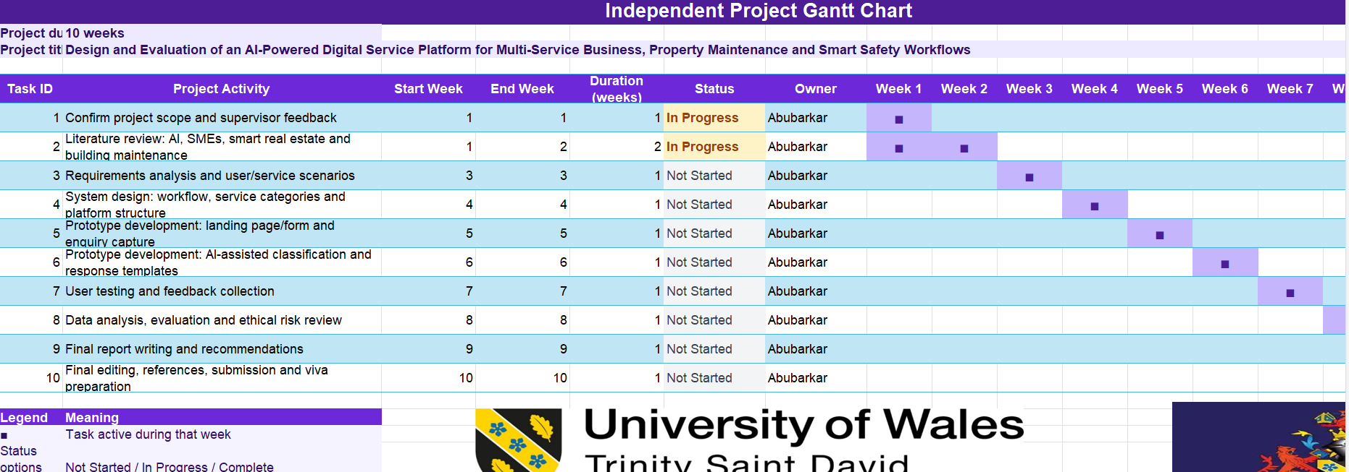

4. Literature support summary
The literature supports this project in six main ways.
First, research on AI, AR and VR adoption in real estate shows that digital technologies can improve customer engagement, property visualisation, decision-making, marketing, sales and operational efficiency [1]. This supports the customer-facing part of the proposed platform.
Second, AI in real estate research shows that AI can support property valuation, customer service, smart building management, predictive maintenance, fraud detection and market analysis, while also requiring attention to explainability, data quality and compliance [3].
Third, smart real estate and PropTech research shows that digital transformation can connect property assets, data, customer service feedback, platform systems and operational outcomes [4]. This supports the idea of treating the MegaPack as one integrated digital service platform, not as separate unrelated ideas.
Fourth, AI building maintenance research shows that the field is moving from passive monitoring to proactive prediction, digital twins, predictive maintenance, energy efficiency and system integration [2]. This supports the future property maintenance and smart safety direction of the platform.
Fifth, real-time real estate management system research supports the use of web technology, dashboards, databases, user requirements, UML diagrams, notification systems and AI recommendation logic for a practical computing project [6].
Sixth, recent AI property management research in Emerald shows that AI is being studied as a practical tool for improving real estate practice, property management transactions, operational efficiency, customer service and decision-making [16], [17]. This strengthens the current academic relevance of the proposal.

5. Conclusion
This proposal presents a focused project to design and evaluate an AI-powered digital service platform for Oroshimaru Dembele Top Services Ltd. The project connects AI automation, IT support, device services, property maintenance and future smart safety workflows into one structured digital foundation. The project does not attempt to build every future idea. Instead, it focuses on a realistic prototype that captures enquiries, classifies service requests, supports AI-assisted first responses and organises follow-up.
The expected contribution is a practical prototype and evaluation that shows how AI-assisted digital workflow can help a small multi-service business become more organised, professional and scalable while considering privacy, trust and responsible AI use.

6. References
[1] Kiran, P. L. V. S. (2025). A Study to Analyze the Adoption of Augmented Reality & Virtual Reality and Impact of Artificial Intelligence on Real Estate Sector in India. Doctor of Business Administration dissertation, School of Business and Management.
[2] Zheng, Y., Sun, B., Guan, Y. and Yang, Y. (2025). Artificial intelligence empowering the transformation of building maintenance: Current state of research and knowledge. Buildings, 15(22), 4118. https://doi.org/10.3390/buildings15224118
[3] Kuppan, K., Acharya, D. B. and Divya, B. (2024). Foundational AI in insurance and real estate: A survey of applications, challenges, and future directions. IEEE Access, 12, pp.181282-181302. https://doi.org/10.1109/ACCESS.2024.3509918
[4] Jahidi, M. S. R. (2021). Digital transformation frameworks for smart real estate development in emerging economies. Review of Applied Science and Technology, 6(1), pp.139-182.
[5] Pamisetty, V. (2024). AI-driven decision support for taxation and unclaimed property management: Enhancing efficiency through big data and cloud integration. European Journal of Analytics and Artificial Intelligence, 2(1), pp.1-20.
[6] Inam, B. A. (2023). Development of Real-Time Real Estate Management System Using Web Technology and Artificial Intelligence. BSc Research Project, Department of Computer Science, University of Uyo.
[7] Raji, A. K. (2024). Smart real estate: Developing an IoT-integrated software solution for sustainable property management. International Journal of African Research Sustainability Studies, 3(2).
[8] National Institute of Standards and Technology (2023). Artificial Intelligence Risk Management Framework (AI RMF 1.0). NIST AI 100-1.
[9] Information Commissioner's Office (2023). Guidance on AI and data protection. ICO.
[10] Davenport, T. H. and Ronanki, R. (2018). Artificial intelligence for the real world. Harvard Business Review, 96(1), pp.108-116.
[11] Russell, S. and Norvig, P. (2021). Artificial Intelligence: A Modern Approach. 4th ed. Pearson.
[12] Davis, F. D. (1989). Perceived usefulness, perceived ease of use, and user acceptance of information technology. MIS Quarterly, 13(3), pp.319-340.
[13] Braun, V. and Clarke, V. (2006). Using thematic analysis in psychology. Qualitative Research in Psychology, 3(2), pp.77-101.
[14] Rogers, E. M. (2003). Diffusion of Innovations. 5th ed. Free Press.
[15] Nielsen, J. (1994). Usability Engineering. Morgan Kaufmann.
[16] Oyetunji, A. K., Alohan, E. O. and Edionwe, O. (2026). Exploring the integration of artificial intelligence in the Nigerian real estate practice. Property Management, 44(2), pp.341-359. https://doi.org/10.1108/PM-09-2024-0101
[17] Adediran, A. O., Aini, A. M. and Ajibade, S. M. (2025). Adoption of artificial intelligence in property management transactions: a systematic review and trend analysis. Property Management. https://doi.org/10.1108/PM-02-2025-0007

Appendix A: Interim Viva Talking Points
This appendix is included because the interim viva is used to check that the project direction is clear, realistic, research-based and suitable for the remaining supervision period. It can be removed from the submitted proposal if the supervisor wants a shorter document.

A.1 One-sentence project explanation
My project is about designing and evaluating an AI-powered digital service platform that helps a small multi-service business organise customer enquiries, classify service requests, support first-line responses and prepare for future property maintenance and smart safety workflows.

A.2 Why this project matters
Small businesses often use too many disconnected communication channels. This can cause missed enquiries, slow replies and poor organisation. My project explores how AI and digital workflow can make this process more structured and professional.

A.3 What I am building
I am building a prototype platform that can capture customer enquiries, classify service requests, support AI-assisted first responses, track follow-up and prepare the business for future services such as property maintenance, smart safety and cybersecurity awareness.

A.4 Why it is computing-related
The project includes requirements analysis, digital platform design, AI-assisted workflow, data collection, prototype development, usability testing, evaluation and ethical risk analysis.

A.5 What makes it realistic
The prototype will use accessible tools such as a website builder, forms, spreadsheet or CRM workflow and AI-assisted response templates. It is not trying to build a full commercial product immediately.

A.6 What makes it ethical
The project will use minimal data, anonymised feedback, clear consent, privacy awareness and human review of AI responses.

A.7 Likely viva questions and short answers
Table 4: Interim viva question preparation
Viva question | Prepared answer
What is your project about? | It is about designing and evaluating an AI-powered digital service platform for a multi-service small business. The system will organise enquiries, classify service requests and support first-line responses.
What problem are you solving? | The problem is that small businesses often receive enquiries through many disconnected channels, which can cause missed leads, slow replies and poor follow-up.
What will you build? | I will build a prototype using accessible tools such as a landing page or form, a tracking system, service categories and AI-assisted response templates.
How will you evaluate it? | I will evaluate it using usability feedback, workflow testing, simple questionnaire ratings, thematic analysis of comments and an ethical risk review.
How does it connect to the MegaPack? | The wider business has different service areas, but the project focuses on one digital foundation that can organise them through service classification and workflow management.
What is outside the scope? | I will not build every future service, a full commercial platform, advanced IoT sensors or a complete cybersecurity system. Those are future development areas.
Why is AI needed? | AI can help draft responses, classify enquiries and support decision-making, but human review will remain part of the process.
What are the main risks? | The main risks are scope becoming too broad, AI errors, privacy concerns, time pressure and limited testing. These are managed through a focused prototype and human review.

A.8 Final viva summary
This project is focused on creating a practical digital foundation for a growing multi-service business. It brings together AI automation, IT support, device services, property maintenance and future smart safety under one organised platform idea. The main goal is to show how AI can help a small business become more professional, efficient and scalable without ignoring privacy, trust and responsible use.

