Student Name: Luke Davies
Student ID number: 1707263
Module Title: CAE and Stress Analysis
Module Code: M5X02064
Date: 19th June 2020
Time: 1 pm

Q1
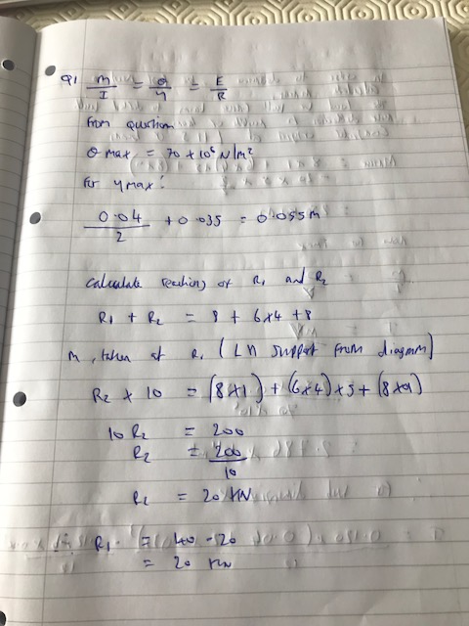

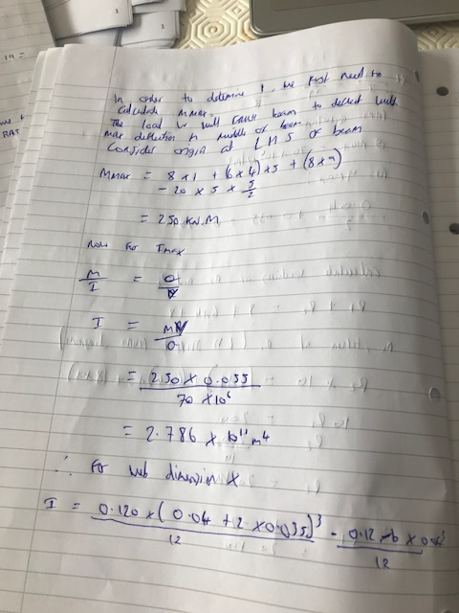

Q2
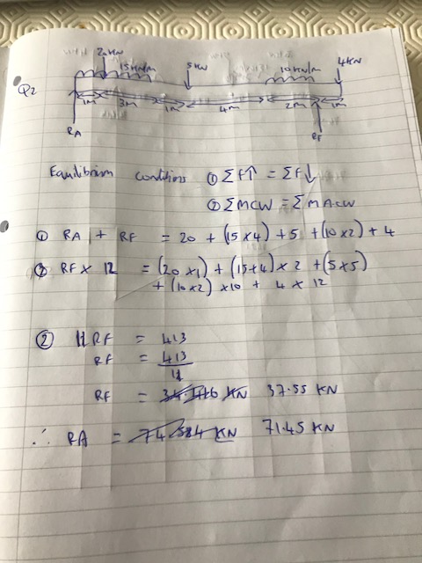

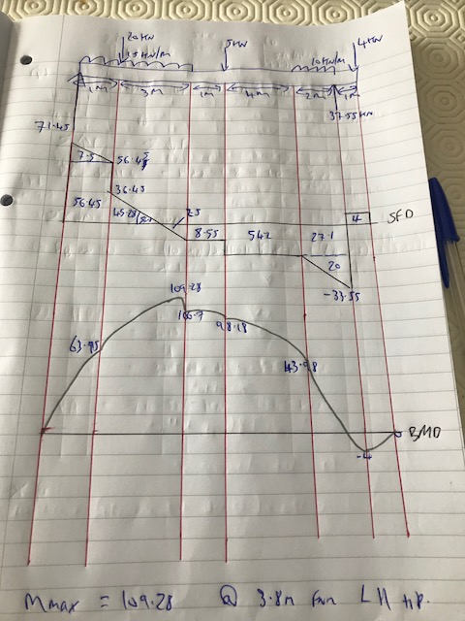

Q3


