

Introducing the

Modern Workplace

The relationship of organisational structure and culture with organisational performance of McDonald’s

ASSESSMENT TYPE: Assignment 1

MODULE CODE: LCBB4003
LECTURER: Nadeem Mirza
PROGRAMME: BA Business Management

Submited by: Stanislava Dimitrova Pehlivanova
Student number: 2011780
Level 4 Term 2 Group 1
2 | P a g e
“In submitting this work, I affirm that my work adheres to the scholarly and intellectual standards of honesty and
integrity. I affirm that this work is my work only and that in the preparation of this work I have not consulted any
person. I affirm that I have not plagiarised or misrepresented the ideas or language of someone else as my own and
that I have fully and accurately attributed any ideas or text of others to the sources and documented each source”.

CONTENT

Introduction ………………………………………………………… 4
McDonald’s Corporation ......…………………………………. 4
Organization structure ……………………………………………... 5
Organizational culture .…………………………………………….. 7
Different levels of culture ………………………………………….. 7
Factors influencing the organizational culture …………………. 8
Influence of culture and organizational structure ……………….. 9
Conclusion …………………………………………………………… 11
Bibliography ………………………………………………………… 11

Introduction

In modern times, business is increasingly characterized by rapid technological development, dynamic competition and changing values. In this fast and dynamic environment, organizations can only be competitive if they manage to be flexible and able to change. That is why in the current development we will pay attention to some of the main factors playing a big role in the success of the organizations – the organizational structures and the need for the existence of an organizational culture.
We will take a closer look at how attitudes, norms, values and way of thinking in organizations form the culture in an enterprise and why they are important to its successes. However, the presence of these features in the organization make it unique in nature and appearance.
We will also pay considerable attention to the organisational structure, because even if we have smart and hardworking employees, there needs to be a logical link between them - a link between management levels and different functional areas - to effectively achieve the objectives of the enterprise. We will also track the need for connectivity between the organizational structure and organizational culture and how this affects the organization and contributes to its success.
In order to be able to focus in detail and analyze these factors, I chose to look at the management of McDonald's.

McDonald’s Corporation

McDonald's is an American company founded by the two Mack brothers and Dick McDonald in San Bernardino, California in 1948. To date, it is the second largest chain of fast-service restaurants with over 38,000 restaurants in over 119 countries worldwide. It is also the world's largest restaurant chain by revenue. Their restaurants are popular for the fun way it presents its products and its practicality.
McDonald's has enjoyed great success and is highly popular worldwide. The main factors influencing this are competitive prices, a wide variety of menus and a focus on customer service.
The company has been set as an example as it expands on the basis of franchise contracts.
There are two sources of revenue:
- sales from the restaurants it manages;
- fees from franchised restaurants;

Organization structure

By their very nature, organisational structures describe how an organisation allocates the communication system, responsibilities, roles, powers and other elements. The organizational structure determines the order and relationship in an organization and depending on the size of the company and its activities, one of the following types of structure may apply:
- Flat Structure
- Functional Organizational Structure
- Market-Based Divisional Structure
- Geographical Divisional Structure
- Process-Based Structure
- Matrix Structure
- Circular Structure
- Network Structure
- Product-Based Divisional Structure

Each company has goals, and in order for them to be successful, employees must be organized in the range of the best structure. By its nature and scale,
McDonald's uses the functional organizational structure. It allows effective management of organizational operations.

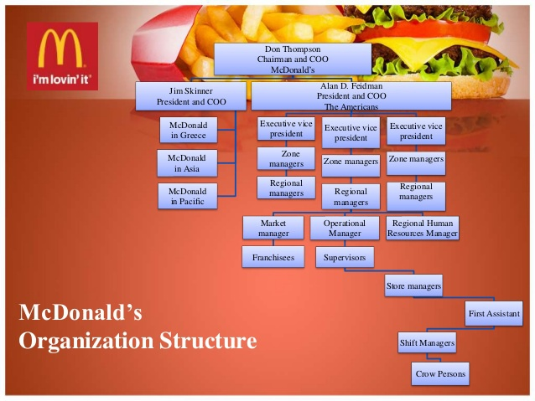
McDonald's Organizational Structure Chart (Figure 1)

Companies that use this type of structure usually categorize posts based on overlap in functions: such as human resources management, supply management, marketing, operations, etc. This is a combination that allows the company to manage geographically and perform both global and regional operations.
As the chart shows, McDonald's has divided its structure based on geographic segments. The main segment for the company is that of the United States.
More than 70% of McDonald's restaurants are run with franchises. Thus, the business does not manage directly, but attaches this right through certain conditions, rules and regulations. The other entities it owns are managed by it. They also serve to train and innovate.
The graph above shows that the structure starts with the CEO and is followed by the operating officer and thus to the lowest level of the structure.
To make it easier for the company to manage at every level of the hierarchy, the company has a control group with a flat structure.
Overall, McDonald's structure is centralized (horizontal), where senior management determines what final decisions will be made and what strategies will be followed. This in turn makes the rules and procedures firm. Usually larger companies have this kind of structure.
With this structure, the company aims to:
- have high control over the company;
- ease to manage the company;
- improving the work of employees;
- atmosphere of cooperation and teamwork;

The process of managing McDonald's restaurants is very organized and clearly structured. This is to ensure an optimal balance of resources and labor. The goal for achieving is also to ensure normal production conditions and a high level of service. Responsibilities shall be allocated in accordance with the delegated authority. Each position has its own job descriptions, which employees are familiar with before starting work. For example:
The director of the restaurant has responsibility for all processes in it – from production to commercial. He is the one who controls the culture, its compliance, compliance with hygiene, safety measures. In a timely manner, it must monitor the proper supply of raw materials, problematic situations at the site, the correctness of the material and technological base. The Deputy Director shall have similar powers as the Director. It shall also be responsible for certain entrusted tasks. The Head of Production shall be responsible for strict compliance with the standards in the production of the products, maintenance of production areas and compliance with all safety measures, as well as timely supply of the necessary raw materials.

Organizational culture

In addition to the most general skills that the manager must possess, such as communication, communion and relationship building skills, there is also a very significant factor in achieving the involvement of people in the goals of the company and it is the creation of the appropriate organizational culture. Each organization has a unique culture. It may have inadvertently been created under the influence of certain events or may have been deliberately formed under the influence of the management of the organisation.
Regardless of the type of organization and its scale, the engine for its productivity and results is precisely the formation of culture. In order to achieve maximum effect, it is important that the designated culture is in line with the objectives of the organization.
Culture is one of the most sustainable and difficult to change organizational entities because it is based on history, on continuity. It occurs after the appearance of all other organizational elements and in comparison changes much less dynamically.

There are different levels of culture in the business and they can develop as follows:
- Culture and nation;
- National culture;
- Organisational culture;
- Corporate culture;
- Professional culture;
- Culture and management;

Factors influencing the organizational culture are:
- The history of the organization;
- Technology;
- The nature of the activity;
- Objectives and tasks;
- The size of the organisation;
- The location of the organization;
- Management;
- The middle;

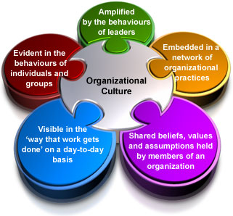
McDonald's Organizational Culture (Figure 2)

McDonald's is a world-renowned fast food brand and its global operations are under the influence of central culture. It is aimed at customer service and their satisfaction – a basic principle on which it has bet.
But since McDonald's is a large company that spreads to different parts of the world, its culture needs to integrate according to the locality and customs of a place. Leaders need to be able to join the organization in relation to meat attitudes in order to achieve the desired business goals.

Mainly, the McDonald's brand stands out from other fast food companies through its culture, which is focused on positivity. The company's goal is to give the highest level of satisfaction to its users. In addition to its clients, the company strives to build cultural values at all levels within the organization itself.
It is important to note that in an organisational environment, high demands aimed at employees and their performance can be undertaken, but this does not necessarily mean that this culture will be correct and acceptable to employees. When the culture is imposed inappropriately and employees are not convinced of the advantages and do not have enough time to accept it, it can be contradictory and the desired effect may not be achieved.
The diligence directed at McDonald's employees is great, as the company knows how important it is to achieving customer satisfaction. Because the company is large, it also means that employees come from different points and spheres of life. But what unites everyone is positivity.
"We know that happy employees help please customers, so we want you to enjoy your work. And we're sure you will."
McDonald’s. (2021)
An important part of the organizational culture is for employees to gain security and motivation. For this, the company also provides opportunities for the development of its employees and encourages them to be flexible – important steps for building a future. In addition to personal work, teamwork is also important. The more cohesive the team is and the higher the level of work there is, of course, and the greater the satisfaction of the user. McDonald's relies heavily on its employees so they can give the best treatment and service to their customers. The better their performance, the less stress for employees at work.
Influence of culture and organizational structure

Generally speaking, organizational culture takes employees and managers to the important things. It is the result of the efforts of everyone in the organization. The functioning of culture influences development mainly in the long term, because this highlights the sustainable orientations of the work of the people in the organization. The organizational culture is exercised on a daily basis through the constant activities of employees, as well as managers. It is transmitted in the form of values, ways of thinking and behavior.
Culture plays an important and essential role in the development of McDonald's and the building of its image around the world. The customer is the most important and is a central principle and as such the purpose of the company is to offer him the best in the best way. That is, a good product, at a good price, with fast service in a welcoming environment. And just when the culture is concentrated on the customer and his satisfaction it helps to attract a larger mass of customers, retaining already existing ones. This in turn leads to an increase in demand for the product and the achievement of the objectives of the organization. McDonald's focus is to create more happiness for both its customers and its employees. In achieving this balance, the success of the company is guaranteed.
To achieve all this and to reach the desired effect of a company is important organization of the whole process. The mere application of all the necessary steps and operations to achieve the final effect speaks to the integral part of the existence of the organisational structure and its effectiveness. The whole concept between the organizational structure and culture at McDonald's leads to increased competitiveness and advantages in the fast food sector.
McDonald’s subdivided organisational structure – marketing, supply, finance, restaurant, legal operations and thus sales – makes each sphere more targeted, with more specific responsibilities and thus facilitates the path to specific goals.

Conclusion

In order to maintain a good position in the market and to be competitive it must have a good organizational culture and structure. McDonald's management has sought to create a favorable environment for its employees and offer its customers one of the best products and levels of service for its customers. The relationship between the two factors – structure and organization – that the management used led to the great success of the company and the retention and at the forefront among the top players in this industry. Management's commitment to create, implement and manage its structures has given the company a boost that will strengthen its position at the forefront in the long term.

Bibliography

- McDonald's (2021) Your Community is Our Community [online]
Available from: https://corporate.mcdonalds.com/corpmcd/home.html
[accessed: 04.2021]
- Shein,E.H,(2004). Organisational culture and leadership. Third education
- McDonald’s. (2021).What is McDonald’s culture like? McDonald’s
Available from: https://www.mcdonalds.com/gb/en-gb/help/faq/18357-what-is-mcdonalds-culture-like.html
[accessed: 06.04.2021]
- McDonald’s. (2021) About McDonald’s
Available from: https://mcdonalds.bg/en/history/
[accessed: 07.04.2021]
- McDonald’s. (2021). What is McDonald’s culture like? McDonald’s. Retrieved 2020
Available from: https://www.mcdonalds.com/gb/en-gb/help/faq/18357-what-is-mcdonalds-culture-like.html
[accessed: 08.04.2021]

