International Meetings Management for the Hotel Industry
BMIH6007
Assignment 2: Event Strategic Planning and Delivery Considerations for an International Meeting.
Report
Student Name:IoanaMonica Chioran
Student Number:2215574
Lecture:Kathryn Flynn

[Word Count: 2500]

AI Use Acknowledgement
I acknowledge the use of Grammarly (https://www.grammarly.com/) on 09 October 2024 to check spelling errors in my work. Grammarly did not require me to key in any prompt but only provided the document for spelling and grammar checks, and I chose what I wanted to change and what I wanted to dismiss from change among the issues it highlighted.
"I confirm that I have not used any AI tools in the research and creation of this assignment. I confirm that I have not presented any AI generated materials as my own work. I confirm I have copies of my drafts, notes, and other resources I used, which I may be asked to provide in evidence."

Table of Contents
1 Introduction 4
2 The Event Cycle 5
2.1 Plan 5
2.2 Organize 6
2.3 Measure 6
2.4 Analyze 6
2.5 Share 6
3 Event Concept 7
4 Aim and Objectives of the Event 8
5 Event Management 9
5.1 EMBOK Model 9
5.1.1 Administration 9
5.1.2 Design 9
5.1.3 Marketing 9
5.1.4 Operations 10
5.1.5 Risk 10
6 Event Budget 10
6.1 A Breakdown of Income and Expenditure 10
6.2 Analysis of Costs, Funding Sources and Income Generation 11
7 Industry Trends 11
7.1 Technological Innovation 11
7.2 Sustainability 12
7.3 Hybrid and Virtual Events 12
8 Situational and Cultural Considerations 12
8.1 SOAR Analysis 13
8.1.1 Strengths 13
8.1.2 Opportunities 13
8.1.3 Aspirations 13
8.1.4 Results 13
9 Conclusion 13
10 References 14

Introduction
TechWinterFest is a winter conference that aims at presenting new technologies to the hospitality industry. The event has been selected for showcasing how technology, especially AI, IoT and VR are assuming significance in transforming client experiences, work processes and services delivery models in the context of hospitality. Since technology is rapidly penetrating the hospitality industry, the event affords an opportunity for players in the sector, technologists, and thinkers to deliberate on the place of hospitality business in the tech-knowledge age (Mercan et al., 2021). The event will happen at the Excel London, a leading venue of its kind which will be designed as a “Tech Winter Wonderland”, thus, making the event more engaging.
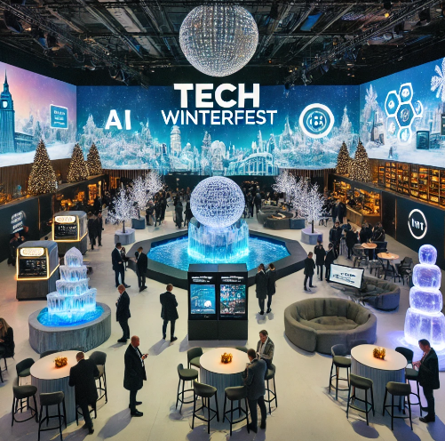
Successful use of thematic elements, such as ice sculptures, virtual snow, as well as the availability of apps and installations influencing creativity and inspiration, all will be improved at the venue. By converting a winter landscape view into design with modern technology, the event aims at giving out an unforgettable backdrop for creativity and cooperation. The reasons to host TechWinterFest depend on the fact that various industries seek unprecedented ideas of how to incorporate technology to sustain market relevancy and fulfill customers’ demands. As clients expect localized and integrated services in the hospitality industry, TechWinterFest provides relevant market space to fulfil these demands.

The Event Cycle
Event cycle is a systematic approach of working in organised manner, in order to plan the event, execute and evaluate it (Van Zelst et al., 2021; Yeshchenko et al., 2021). It involves several key stages: planning, organising, control, evaluation and dissemination. These stages assist in the achievement of objectives, successful deliveries of events and provide information which will be paramount in the realization of future improvements.
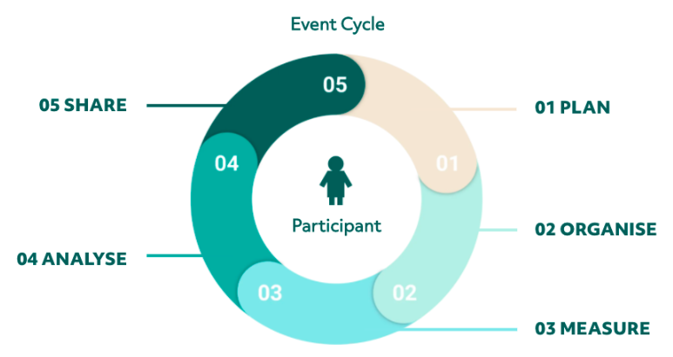
Figure 1: The Event Cycle
(Source: Van Zelst et al., 2021)

Plan
When planning an event, it is important to know its goals, who it is for, how much money have, and any other real needs. AI, IoT, and VR are some of the most cutting-edge digital technologies that will be shown at TechWinterFest (Ameen et al., 2021). Everything about the winter-themed event is set in stone, from the location to the date and the details. For technology demos, the place needs to be big enough, but also cozy enough to create the tech winter wonderland mood with ice statues, fake snow, and interactive displays from the future. Measurable goals, such as the number of people who are expected to show up, how active people are on social media, and the feedback received after the event, may be thought about during planning.

Organize
After the planning phase is over, the managing phase takes over and takes care of the important tasks of the event (Schulenkorf et al., 2024). Part of this job is to plan seminars, panels, and major speeches, as well as do study on and evaluate vendors. The well-planned parts of venue make it easy to get around. They can be used for networking, engaging technology shows, and major talks, among other things. For TechWinterFest to go well, the place needs to be turned into a tech winter wonderland with lots of music. Installing the ice statues, fake snow, and tech displays needs to be done by trained professionals to make sure they are done right (Li et al., 2023). The experienced staff and volunteers are always ready to help, whether it is by answering questions or showing people how to get to the right talks. The marketing and advertising for TechWinterFest must reach the right people if the event is to be a success.

Measure
A lot of information is collected before, during, and after the event to see how well it went. Key success factors for TechWinterFest can include what people say about it on social media, how many people fill out surveys, and how many people attend engaging classes. By keeping an eye on these measures in real time, event planners can make last-minute changes, like improving technology support or fixing problems with logistics, without stopping the event's flow (Lu et al., 2021). One way to judge how well TechWinterFest works is by how well it meets its stated objectives. One of these goals is to help people from the hospitality industry meet each other and work together. Another goal is to give guests hands-on experience with AI, VR, and the IoT.

Analyze
This process seems to involve assessing all the information gathered during an event in a further attempt to assess the event’s effectiveness of achieving the intended goals (Gallego et al., 2020; Kir and Erdogan, 2021). For TechWinterFest, this process is based on attendance data, activity intensity, social media activity, and questionnaires. They should find out which topics were the most effective one and which technologies attracted the highest level of engagement; and the extent to which the setting that resembled winter was helpful in enhancing the experience of the attendees. TechWinterFest's managers will look at how successful the event was by comparing how much it cost to run to how much it made from donations, ticket sales, and partnerships.

Share
The next important step is to let the competitors and donors know what the results are. Putting out a report on the event's highlights, lessons learnt, and suggestions for next year is one way to get the word out about TechWinterFest. In order to keep people excited, organizers can share participation stories, and well-known talks on social media (Rahmani et al., 2021). It can be great if TechWinterFest filmed the main speakers, used graphics to show off the engaging technology booths, and talked about the latest developments in the IT field. This lets people know what is going on and makes them more likely to come back for other events.

Event Concept
Time | Activity | Details
08:00 - 09:00 | - Registration and Welcome Breakfast | - Representatives will arrive at the transformed venue, greeted by the winter-themed tech wonderland.  - Ice sculptures, virtual snow, and a futuristic atmosphere set the tone.  - A continental breakfast will be served as attendees register, network, and explore interactive displays.
09:00 - 09:30 | - Opening Remarks and Event Overview | - The event begins with a short opening ceremony led by the event’s host, giving an overview of the day’s itinerary, key themes, and the significance of tech in hospitality.  - The immersive environment will be introduced, highlighting the tech displays and interactive zones.
09:30 - 10:30 | - Keynote Speech | - A leading expert in AI will discuss the role of artificial intelligence in enhancing guest experiences, streamlining operations, and creating personalized services in hospitality.
10:30 - 12:00 | - Panel Discussion | - Industry leaders will discuss how IoT is reshaping the way hotels operate, with smart rooms, automated services, and enhanced guest personalization.
12:00 - 01:30 | - Interactive Workshops | - Automatic systems in hotels that help guests are run by artificial intelligence.  - Digital tours in virtual reality (VR) and live models of events that you can interact with.  - With the help of Internet of Things apps, hotel rooms can be controlled by computers and less energy can be used.
01:30 - 02:00 | - Lunch Break | - Inside the restaurant's cozy winter eating area, customers can enjoy a hearty meal while using AI-powered machines to get personalised menu suggestions.  - Video screens and interactive ice statues that show off new technologies in the hotel business give guests a casual place to keep networking.
02:00 - 04:00 | - Interactive AI and IoT Showcases | - Big IT companies and new IT companies will show off their newest products in the last session.  - Guests can take a virtual reality tour, use an AI-powered butler service, and make stay more unique with IoT devices.
05:00 - 06:00 | - Farewell Reception and Ice Bar Experience | - Attendees will close the day with a farewell reception featuring an ice bar where drinks are served in ice glasses.  - The winter-themed wonderland continues with virtual snow falling, offering a final opportunity for networking and celebrating the day’s insights and innovations.

Aim and Objectives of the Event
To showcase and explore the latest technological advancements in the hospitality industry, fostering innovation and collaboration among professionals and tech leaders through immersive experiences at TechWinterFest.
- To increase social media engagement by 25% during the event through live updates, interactive content, and attendee participation by the end of the day.
- To secure at least 10 partnerships or collaborations between hospitality businesses and tech companies within one month following TechWinterFest.

Event Management
TechWinterFest needs people with technical, organisational, and marketing skills to make sure it goes smoothly. Making sure the guests are happy is important for the event to go smoothly and reach its goals (Chen et al., 2020). Organising the event's details, making sure everyone shows up, and figuring out how to use technology all require excellent project management skills (Niederman, 2021). The event management team is an important part of the operations team. To set up, manage, and run the VR, AI, and IoT technologies properly during the event, people will need to know how to do it technically. Having professional IT help staff is also important for fixing any technology problems quickly. An event planner needs to be able to organise and lead people well in order to keep all the moving parts, like setting up workshops and calling speakers, on track (Cuskelly et al., 2021; Fonseca et al., 2020). The budget manager and the planning team should work together to make sure that the place, technology, promotion, and staff all get their fair share of the money. Companies need to be good at managing risks in order to deal with unplanned problems like weather delays, broken machines, or cancellations at the last minute.

EMBOK Model
The EMBOK model is the systematic approach to managing events effective for organizing and executing them in the best way (Van Antwerpen, 2023).
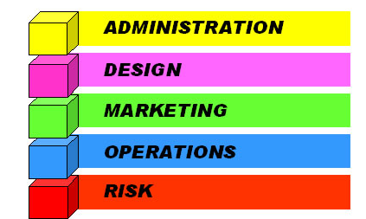
Figure 2: The EMBOK Model
(Source: Van Antwerpen, 2023)

Administration
- Budgeting, scheduling and human resource are the key management success factors for TechWinterFest.
- This domain will look for financing for the events, identifying timelines for events and last but not least, employing staff with technology and hospitality backgrounds.

Design
- Because return on technology experience is a key focus of TechWinterFest, the domain of design is significant (Thomas and Stephens, 2022).
- Through unique themes, attractions in the form of installations, VR shows, and AI-based interactive experiences and demonstrations, EMBOK leads the event.
- Furthermore, the winter theme has to harmonically blend technology and fascination creating a perfect setting for a technologically-savvy audience to get the best experience.

Marketing
- The marketing activities will focus on the technology and hospitality sectors.
- Adverts will focus on showing that TechWinterFest can offer the newest products as well as having links to technology companies and would target a smaller group of customers.

Operations
- Looking at the structural perspective of operations management it will cover all logistical processes.
- Due to dynamics of the event, strict planning and coordination are necessary to avoid multifaceted issues between the participants who attend the event physically and those who join the event online.

Risk
- In several areas, TechWinterFest’s risk management strategy will consist of worst-case-scenario action plans for, say, technological breakdowns, hacking attempts, and social-distance violations.
- The preparation in these areas assures comfort, safety and continuity in experiences to attendees and exhibitors thus improve on TechWinterFest reliability and product differentiation.

Event Budget

A Breakdown of Income and Expenditure
Category | Cost/Income (£)
Income
Sponsorship | £50,000
Ticket Sales | £50,000
Partnerships | £15,000
Merchandise Sales | £5,000
Total Income | £120,000
Expenditure
Venue Hire | £25,000
Technology Setup | £20,000
Event Design and Décor | £15,000
Marketing and Promotion | £10,000
Catering | £12,000
Speaker Fees | £10,000
Staffing | £8,000
Security and Insurance | £5,000
Miscellaneous Costs | £5,000
Total Expenditure | £110,000
Net Income | £10,000

Analysis of Costs, Funding Sources and Income Generation
A winter setting that is interesting and big enough to fit all of gadgets will cost a lot of money. Virtual reality, artificial intelligence, the internet of things, and fake snow and ice are all examples of artistic and technical elements that need a space that is right for them. To show off new technologies in the hospitality industry, the event need special tools like VR stations and IoT gadgets (Mishra et al., 2021). This amount includes the costs of getting the equipment, setting it up, and giving professional help to make sure it works right. Digital snow effects, creative lighting, and moving ice models are some of the unique design elements that an event that accepts the idea of a tech winter wonderland needs. The food and drinks that are brought to an event are important to its success (Berridge, 2020). Each of the guests is sure to have a unique experience because of individual cooking services driven by AI and delicious food.
One way for sponsors to make money is by getting their names and goods out there. Another way is by having their ideas displayed (Dolores et al., 2021). There are different kinds of sponsorship, such as branding during major speeches and class funding. Many things, like food, staff, and promotion, will be paid for by the ticket sales. The event can make more money if people buy things and form relationships. IT companies can be able to get more people to their events and make more money by renting booths or practice areas. During goods sales, tourists can buy branded things and mementos. TechWinterFest wants to make £10,000. This will cover all of its bills. One way to make money is through sponsorships, ticket sales, agreements, and selling goods. With the right partnerships in place, the event's fame could bring in more people and charge more for tickets, so this approach has room for growth.

Industry Trends

Technological Innovation
The lightning-fast growth of digital tools is having an impact on the events business. IoT, VR, and AI are just a few of the new technologies that are changing the way events are planned and attended. These changes in technology make it easier to run events, get more people involved, and create more intense and interesting experiences (Dasaklis and Malamas, 2023).

Sustainability
One of the most important problems the meetings and events business has to deal with is protecting the environment. As more people become environmentally friendly, they do things like recycle more, use less power, and buy from local farms.

Hybrid and Virtual Events
Since the COVID-19 outbreak, there has been a huge rise in the number of mixed and virtual events (Peter, 2024). Because of improvements in digital platforms, more and more events now let people attend online, letting more people take part. This is something that the TechWinterFest uses by live-streaming its group discussions and major talks online, even though it is held in one place.

Situational and Cultural Considerations
An important part of TechWinterFest's success in its complex setting is the culture and historical background of the event. They are important for making sure that a lot of people have a good time and that the event fits with what the IT and hospitality businesses want.
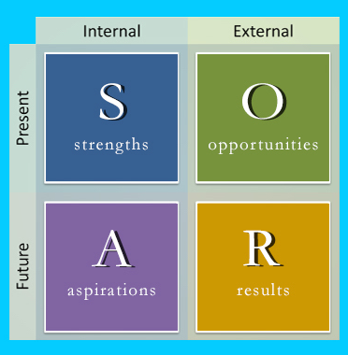
Figure 3: SOAR Analysis
(Source: Bridges et al., 2023)

SOAR Analysis

Strengths
- TechWinterFest's main area of skill is coming up with new ways to use cutting-edge technology in the catering business.
- With its cutting-edge AI, IoT, and VR technologies, the event will be seen as a leader in the digital transformation of the hospitality business.
- People who take part in the winter-themed interactive experience will never forget it.
- People who are interested in IT and people who work in the hospitality business will find this very interesting.

Opportunities
- Businesses in the IT and leisure fields can be able to work together at the event.
- At the event, new ideas can be shown that draw attention to culture trends happening around the world, like sustainable technology and personalised guest experiences.

Aspirations
- TechWinterFest's long-term goal is to become an important annual event that everyone in the hospitality business needs to attend as it continues to go digital.
- People are becoming more tech-savvy and connected online, and businesses need to adapt to this new culture.
- The main goal will be to come up with new ideas that meet the culture and regional needs of all of the members.
- This includes using technology in a good way, being environmentally friendly, and giving each customer a unique experience.

Results
- Assuring ethnic variety is important in the hospitality industries around the world.
- Language hurdles, national norms about how people should communicate to each other, and different views on how to use new tools are all important parts of the event.
- When materials are available in multiple languages and classes are led with a focus on cultural understanding, participants are more likely to be interested, happy, and make connections that last.

Conclusion
Conclusively, TechWinterFest does a great job of demonstrating that hospitality is becoming more reliant on technology moving forward, including VR, AI, and IoT. Through proper event planning and management and targeting quantifiable objectives such as participant satisfaction, social media activation, partnership with tech companies and startups, the foundation for the evolution of hospitality technology is established in TechWinterFest. The event shows how technologies can benefit guests, optimize business processes, and develop the industry.

References
Ameen, N., Hosany, S. and Tarhini, A., 2021. Consumer interaction with cutting-edge technologies: Implications for future research. Computers in Human Behavior, 120, p.106761.
Berridge, G., 2020. Designing event experiences. In The Routledge handbook of events (pp. 378-395).
Bridges, R.A., Rice, A.E., Oesch, S., Nichols, J.A., Watson, C., Spakes, K., Norem, S., Huettel, M., Jewell, B., Weber, B. and Gannon, C., 2023. Testing SOAR tools in use. Computers & Security, 129, p.103201.
Chen, W., Liu, H. and Qi, E., 2020. Discrete event-driven model predictive control for real-time work-in-process optimization in serial production systems. Journal of Manufacturing Systems, 55, pp.132-142.
Cuskelly, G., Fredline, L., Kim, E., Barry, S. and Kappelides, P., 2021. Volunteer selection at a major sport event: A strategic Human Resource Management approach. Sport Management Review, 24(1), pp.116-133.
Dasaklis, T.K. and Malamas, V., 2023. A review of the lightning network’s evolution: Unraveling its present state and the emergence of disruptive digital business models. Journal of Theoretical and Applied Electronic Commerce Research, 18(3), pp.1338-1364.
Dolores, L., Macchiaroli, M. and De Mare, G., 2021. Sponsorship’s financial sustainability for cultural conservation and enhancement strategies: an innovative model for sponsees and sponsors. Sustainability, 13(16), p.9070.
Fonseca, S.T., Souza, T.R., Verhagen, E., Van Emmerik, R., Bittencourt, N.F., Mendonça, L.D., Andrade, A.G., Resende, R.A. and Ocarino, J.M., 2020. Sports injury forecasting and complexity: a synergetic approach. Sports medicine, 50, pp.1757-1770.
Gallego, G., Delbrück, T., Orchard, G., Bartolozzi, C., Taba, B., Censi, A., Leutenegger, S., Davison, A.J., Conradt, J., Daniilidis, K. and Scaramuzza, D., 2020. Event-based vision: A survey. IEEE transactions on pattern analysis and machine intelligence, 44(1), pp.154-180.
Kir, H. and Erdogan, N., 2021. A knowledge-intensive adaptive business process management framework. Information Systems, 95, p.101639.
Li, S., Zheng, P., Liu, S., Wang, Z., Wang, X.V., Zheng, L. and Wang, L., 2023. Proactive human–robot collaboration: Mutual-cognitive, predictable, and self-organising perspectives. Robotics and Computer-Integrated Manufacturing, 81, p.102510.
Lu, Y., Lin, H., Xu, J., Han, X., Tang, J., Li, A., Sun, L., Liao, M. and Chen, S., 2021. Text2Event: Controllable sequence-to-structure generation for end-to-end event extraction. arXiv preprint arXiv:2106.09232.
Mercan, S., Cain, L., Akkaya, K., Cebe, M., Uluagac, S., Alonso, M. and Cobanoglu, C., 2021. Improving the service industry with hyper-connectivity: IoT in hospitality. International Journal of Contemporary Hospitality Management, 33(1), pp.243-262.
Mishra, D.K., Ghadi, M.J., Azizivahed, A., Li, L. and Zhang, J., 2021. A review on resilience studies in active distribution systems. Renewable and Sustainable Energy Reviews, 135, p.110201.
Niederman, F., 2021. Project management: openings for disruption from AI and advanced analytics. Information Technology & People, 34(6), pp.1570-1599.
Peter, A., 2024. The Rise of Virtual Events: Evaluating Marketing Performance in the Post-Covid-19 Era. International Journal of Innovative Studies, 5(1), pp.128-139.
Rahmani, A.M., Babaei, Z. and Souri, A., 2021. Event-driven IoT architecture for data analysis of reliable healthcare application using complex event processing. Cluster Computing, 24(2), pp.1347-1360.
Schulenkorf, N., Welty Peachey, J., Chen, G. and Hergesell, A., 2024. Event leverage: A systematic literature review and new research agenda. European Sport Management Quarterly, 24(3), pp.785-809.
Thomas, K. and Stephens, S., 2022. Understanding the Management Theory in Event Management: A Conceptual Framework. Available at SSRN 4051469.
Van Antwerpen, S., 2023. A proposed integration of the event and project management body of knowledge. International Journal of Applied Sciences in Tourism and Events, 7(2), pp.108-119.
Van Zelst, S.J., Mannhardt, F., de Leoni, M. and Koschmider, A., 2021. Event abstraction in process mining: literature review and taxonomy. Granular Computing, 6, pp.719-736.
Yeshchenko, A., Di Ciccio, C., Mendling, J. and Polyvyanyy, A., 2021. Visual drift detection for event sequence data of business processes. IEEE Transactions on Visualization and Computer Graphics, 28(8), pp.3050-3068.

