During the ninetee
shamsa mir

Introduction to health and social care
Student Name: Shamsa Mir
Student Number: 2525306
Module Code: LCHS4003_BIRM
lecturer: Vivian Osuchukwu
Assignment Title: Residential care home

AMBULANCE SERVICE. Task1


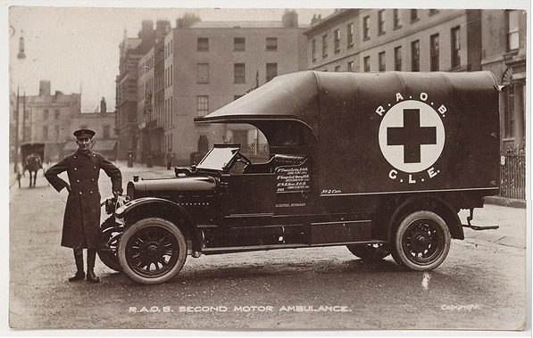

- WHAT IS AMBULANCE SERVICE?
Ambulance service is a vital part of the NHS. They provide urgent medical care, assess and treat patients at the scene and transport them safely to hospital when needed. According to (NHS England.2024).
- Respond to 999 and 112 emergency calls
- Provide life-saving treatment before hospital arrival
- Transport patients safely to healthcare facilities
- Offer advice and support

2. BRIEF HISTORY OF AMBULANCE SERVICE
- 1948- Accordingly, to (NHS ENGLAND 2017). Ambulance services were operated by local authorities and voluntary organisations.
- 1948Ambulance services became part of the newly established NHS.
- 1970s- Development of professional’s paramedics training
- 1990s-Introduction of advanced life- support skills.
- 2017- NHS England launched the Ambulance Response programme (ARP) to improve emergency response times
- Present- Modern emergency and community care

PATIENT JOURNEY
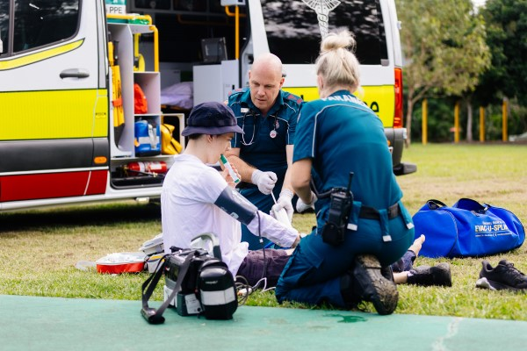

JIJ

WHAT IS AMBULANCE SERVICE?
Ambulance service is a vital part of the NHS. They provide urgent medical care, assess and treat patients at the scene and transport them safely to hospital when needed. According to (NHS England.2024).
- Respond to 999 and 112 emergency calls
- Provide life-saving treatment before hospital arrival
- Transport patients safely to healthcare facilities
- Offer advice and support

2. BRIEF HISTORY OF AMBULANCE SERVICE
- 1948- Accordingly, to (NHS ENGLAND 2017). Ambulance services were operated by local authorities and voluntary organisations.
- 1948Ambulance services became part of the newly established NHS.
- 1970s- Development of professional’s paramedics training
- 1990s-Introduction of advanced life- support skills.
- 2017- NHS England launched the Ambulance Response programme (ARP) to improve emergency response times
- Present- Modern emergency and community care

PATIENT JOURNEY

JIJ


Def
3. HOW DO AMBULANCE SERVICES CURRENTLY FUNCTION
When someone calls 999, trained call handlers assess the situation and prioritise the respond according to urgency. (NHS England, 2024: London Ambulance Services NHS Trust,2024).
Equipment used by ambulance crews-
- Defibrillators
- Oxygen Equipment
- ECG Monitors
- Emergency Medicines
Patient Journey-
- 999 call
- Call Assessment
- Ambulance Dispatched
- Treatment at scene

Zhoy, z. (2016) Predicting Ambulance Demand: Challenges and Methods arxiv. Available at: hhtps://arxiv.org/abs/1606.05383 (Accessed 14 June 2026).
NHS England (21024) Ambulance Respond programme, Available at: https://www.england.nhs.uk/urgent-emergency-care/improving-ambulance-services/arp/ (Accessed 14 June2026).
NHS England (2017) Ambulance Respond Programme: Evaluation of phase 1 and phase 2 Final Report. Available at: https://www.england.nhs.uk/publication/arp-evalution/ (Accessed 14 June 2026).
London Ambulance Service NHS Trust (2024) Ambulance response categories. Available at: https://www.londonambulance.nhs.uk/calling-us/ambulance-response-categories/ (Accessed: 14 June 2026).
4. CHALLENGE 1- INCREASING DEMAND? (zhou,2016)
The number of emergency calls continues to rise because of
AN ageing population
More people living with chronic diseases
Rising mental health emergencies
Greater public demand for urgent healthcare
CHALLENGE 2- HOSPITAL HANDOVER DELAYS? (NHS Digital,2025)
Ambulance crews often experience delays transferring patients to accident and emergency (A&E) departments due to overcrowding.
Longer waiting times for patients
Fewer ambulances available for emergencies
Increased stress and burnout among staff
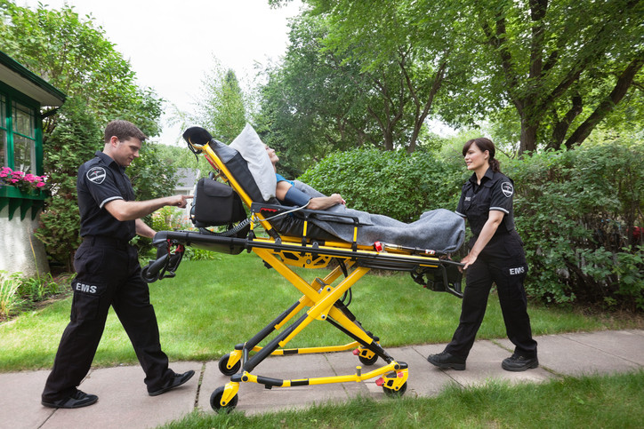


Task-2
Residential care homes: Origins, development and importance in social care.
Residential care homes are a very important part of the United Kingdom’s adult social care service that provides accommodation, personal care, and support for individuals who can no longer live alone, people with disabilities, and individuals with complex personal care needs. Residential care homes aim to provide a safe environment where residents receive quality care.
Origins and historical development
The origins of residential care homes can be tracked back to medieval Britain, where charitable institutions known as alms-houses provided shelter and support for the poor, elderly and the vulnerable people. Historical archives show that one of the earliest alms-houses was. historical records show that the earliest institutions had evolved and established in York in 936 AD. Over time these establishments became care homes for those vulnerable people who were unable to look after themselves.
Throughout the nineteenth century, care for older people was largely given through workhouses. These establishments often offered poor living circumstances that were associated with poverty and social banishment. Following the introduction of welfare reforms the National Health Service (NHS) 1948, local social service providers expanded making residential care homes more accessible for the vulnerable people.
In the twentieth century saw a huge development in residential care. Reports such as the Wagner Report in the 1980s which highlighted the need for an improvement, in standards, regulation and a people- centred approaches to care. This resulted the government to introduce policies and inspection frameworks to ensure quality and safety within care homes (The Guardian,2026).
Today, residential care homes must follow regulated frameworks, with organisations such as the Care Quality Commission (CQC) this body tracks the standards and assuring that residents have a safe and concise effective care.

How Residential Care Homes Function Today
Modern residential care homes enable a twenty-four-hour support, lodging, meals, personal care, social activities, and emotional continues support. Residents can benefit from all round professional care. Staff members help residents with living, including bathing, medication management, dressing and mobility. Many residential homes provide acre for dementia residents with specialist trained staff who are tailored to support those with dementia.
The strengths of any care home are the availability of a constant care and support from professionals. They give a structured routine and plenty prospects for social interaction with other residents which can lower loneliness and could improve the wellbeing. Residential settings provide a sense of belonging and reassures family members who may not be able to provide the same care at home.
Nevertheless, residential care homes have faced multiple challenges. This area has experienced shortages of staff, financial pressures. Underfunding, workforce retention, and fluctuations in service quality. There have been cases where inadequate staffing and poor management have unfortunately resulted in failures in care giving. (The Guardian,2025).
Significance for Service Users Quality of Life
Residential care homes paly an enormous part in improving the quality of life of those who use this supportive environment. Receiving assistant through this method is much safer for the individuals whilst maintaining independence as much as possible. Residents have access to trained staff on the hour whilst gaining independence where possible.
Social interaction is also beneficial for many older adults who have experienced solitude. Residential care homes offer possibilities for them to engage and develop friendships, to take part in group activities slowly involve within their communities, which can have a positive impact on their mental health wellbeing which reduces the feelings of being alone or banished. Recent research has shown that residents who took part in social engagements have given them a positive factor in maintaining a good sense of wellbeing among the care home residents.
Conclusion
Conclusion
Residential care homes have become over the years a charitable alms-house to workhouses into now a highly regulated social care service care that protecting the vulnerable residents. Even with changes relating to funding and staffing, quality promise. By providing safety, personal care, social care and interaction with emotional support. All contributing to improving the wellbeing of the residents.

References
MHA (2025) Our Story: Providing Care and support since 1943.available at: https://mha.org.uk/about-us/our-story ( Accessed:16 June 2026)
The Guardian (2025) How did it get to this? What happens when care in residential home breaks down. Available at; https://www.theguardian.com (Accessed:16 June 2026)
Cousins, C., Burrows, R., Cousins, G Dunlop, E., & Mitchell, G.(2016). An overview of the challenges facing care homes in the UK. Nursing Older People,28, 18, -21. https://doi.org/10.7748/nop.2016.e817 Cited by:31
Johnson, J, Rolph, S., & Smith, R. (2010). Uncovering History: Private Sector Care Homes for Older People in England. Journal of Social Policy, 39, 235-253. https://doi.org/10.1017/s004727940999064x Cited by: 10

