Task 2.

A REPORT THAT DETAILED ON ALL BULLET POINT IN TASK 1 ASSIGNMENT OF PROBLEM SOLVING AND DECISION MAKING (WORK RELATED STRESS).

Title page.

Student Name: Emmanuel Akwasi Le-maire

Student id: 2027297

Module code: BMSW4004

Assignment Title: Write a report that presents on all bullet point in task 1 assignment of problem
Solving and decision making (Work Related Stress).

Lecturer: Nauman M. Ali

Contents Page.

Introduction…………………………………….4

Definition of Problem Solving……………5

Cause and Effect Analysis……………….6-7

PESTLE Analysis………………………………8-9

Decision Making…………………………10-11

Conclusion……………………………………….12

References……………………………………….13

Introduction.

The occurrence of work-related stress is a topic to a big research and concern in the subject appears no hint of diminishing. Currently it is normally obtained that lengthened or severe stress could have a bad effect on people mental and physical health (Health and safety Executive, 2001; Cooper et al, 2001). The National Health Service (NHS) UK has a largest level of work-related stress, of all work areas in the United Kingdom, therefore it is advisable to be discussed as a job stress which destroys workers, organizations and eventually results patient care.

The report will show the meaning of problem solving, the effect of complex problem on employees and the effect of complex problem on organizations. Cause and effect analysis will be discussed with the fish bone diagram, as well as the importance of cause-and-effect analysis of the complex problem. PESTLE analysis will also be discussed and presented, as well as the definition of decision making, and solution implementation plan.

Problem Solving.

Problem solving is the procedure of operating towards an objective when the way to that objective is unresolved (Martinez, 1998). The first step to the problem-solving process is identifying the problem (Whereby a person can identify the prospective of a team). The second step is the Team formation (When a person request for cooperation), the third step is the Plan formation (Where the newly created combined tries to establish a consent link plan, and the fourth step is the execution (Where team members participate in the role, they are all agreed on).

The effect of complex problem on NHS employees.
On developing employee’s wellbeing or health, the stoppage of working and a situation-related sickness as well as administrating absenteeism are problems that has increased remarkably in relevance in the past years, and it is recognized as a general or public health and economic priorities (Baker-McClean, Greasley, Dale, and Griffith, 2010).
Black’s (2008) current analysis of the health in UK’s working age populace, ‘Working for a healthier tomorrow`, propose that the growth of wellness, instead of sickness, customs are necessary to decrease non-attendance and better workstation production. She proposes that such customs will need better line management, assist within the workstation, and change in the viewpoint where job is damaging, exclude for ones who are completely strong.

The effect of complex problem on NHS organizations.
One of the highest sources of productive loss in the UK industry is absenteeism, where minor sickness creating the mass short term absence and stress, as well as mental health problems creating the mass absence over four weeks period (CIPD Survey, 2005).
The value of absence does not only support by administrations, with regards to health-related performance mislaying resulting from employee’s absence, employee’s turnover, depletion of skill base, enrolment, and retraining, but by the overall population throughout value to the NHS (estimated at £5-11 billion a year). Grinyer and Singleton (2000) proposed that directly attempting to decrease absence amount without concentrating on the staffs who were present at work and did not perform, provides less absence rates and unable to develop organizational or personal efficiency.

Cause and effect analysis.
The cause-and-effect analysis allows individual to think throughout the cause of the issue, involving viable root cause, before you begin to plan of a solution. Cause and effect analysis allows those included to obtain a shared intuition to the issue, grow viable solutions, and making a snapshot of the group combined knowledge (Ishikawa, 1968).

Cause and effect (The fishbone diagram).
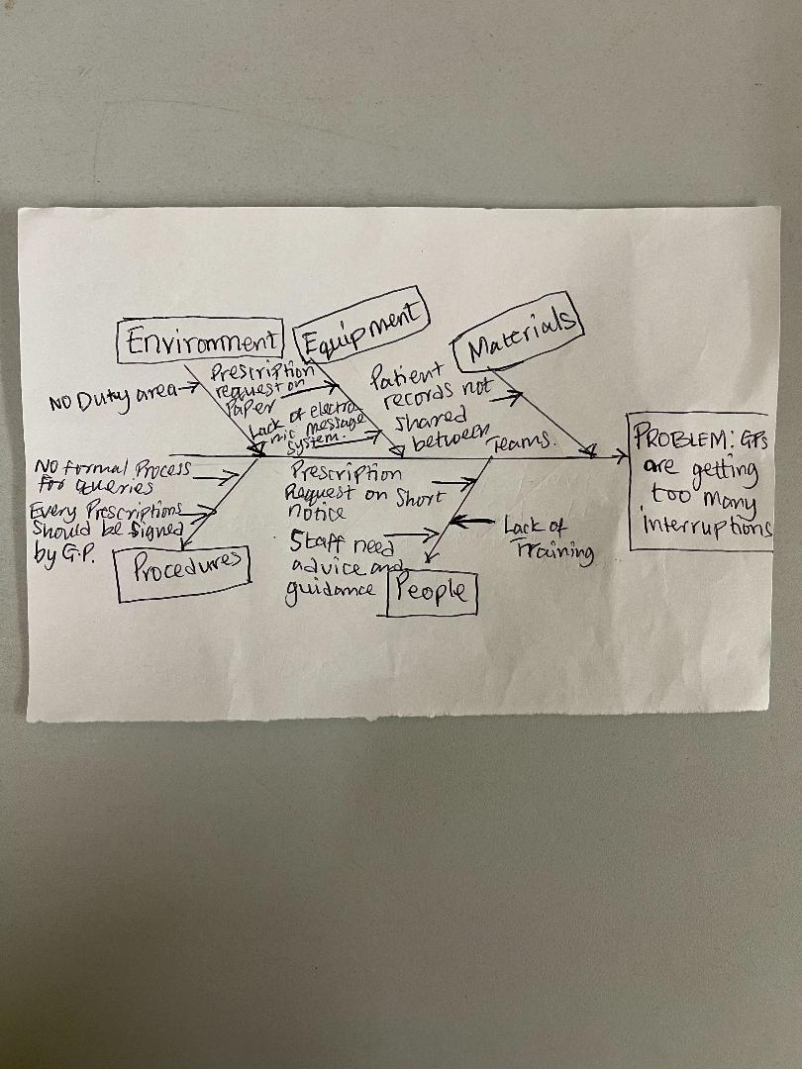

When to use Cause and Effect: This can be used to find out the reason why a certain problem is transpiring. It can also help in apprehending the problem as well as recognizing all the viable causes (Ishikawa, 1968).

How to use cause and effects: 1. Recognize the issue and examine it into details (who is included, when and where it happens). State the problem down and draw a line pointing to it (Ishikawa, 1968).

2. Recognize the main components and draw four or many branches on the big arrow to constitute the main class of ability causes, as well as labeling every line. Classifications can involve (Environment, Equipment, Procedures, and People. Ensuring the categories are pertinent to specific issues (Ishikawa, 1968).

3. Analyze the diagram (Ishikawa, 1968).

Importance of cause-and-effect analysis for the complex problem.
The cause-and-effect analysis is a great tool which help in concentrating on causes no indications subjugating the combined knowledge and encounter of group.
It also helps in supplying the concept of why an outcome/issue is going on.
It can be used to establish an idea base for additional data collecting.
The cause-and-effect analysis also helps in recognizing every area which needs to be approached to produce a constructive effect.
Ishikawa (1968).

PESTLE Analysis.
This is a functional method for comprehending risks related to marketing growth as well as the location, possible and management of organization. The method is mostly used to recognize components associated in change, instead of solutions to any components. To impact a change begins with comprehending the effect of exterior and interior components. PESTLE is frequently used to implement for examining exterior components that affect job environment (Team FME 2013). The acronym PESTLE stands for POLITICAL, ECONOMIC, SOCIAL, TECHNOLOGICAL, LEGAL and ENVIRONMENTAL.
The head of the hospital ward can use this work structure to collect data to recognize chances and threats which can influence change execution. To change hospital ward customs to make sure having breaks can be taken as urgency instead of luxury (RCN 2018), these perceptions can be used to make change occur.

The PESTLE Analysis.

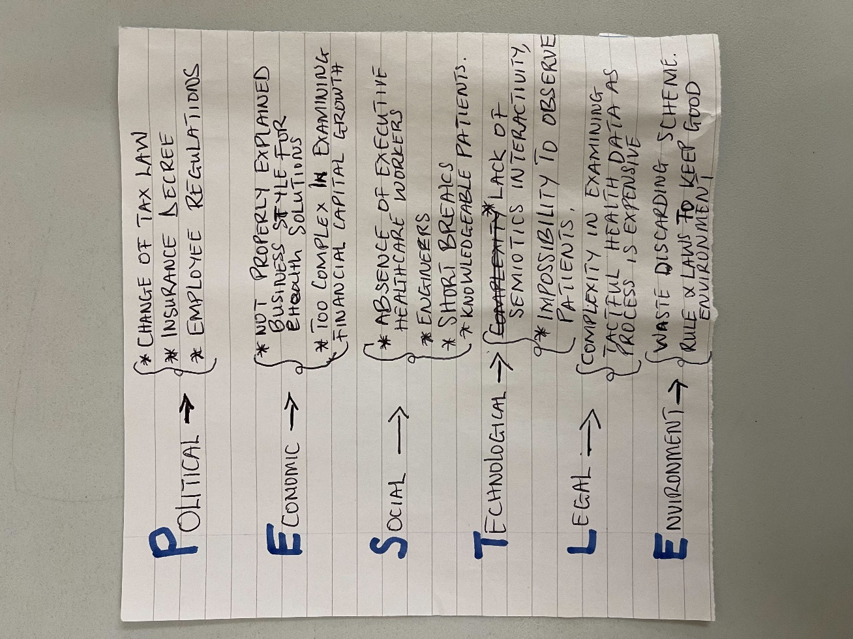
Summary of the PESTLE analysis above.
Political: The National Health Services are regularly on high of government and Media plans. Now the plight in nurse reservations is very important (NHS Employers 2017). Substantial attempt is being enlarged in NHS to get into the elements which affects nurses’ resolutions to remain or quit the career.

Economic: Dehydration as well as bad nutrition’s in a brief and longer-term bases, provides to sick health as well as growth of illness amount with related individual and administrative cost (NHS Digital 2016).

Social: Nevertheless, it is powerful social compulsion to desire a feel you ‘belong’ once working in a group. The outcome of new members (students) replicating how things are done, to be accepted (Cooper and Scammell 2013).

Technological: Staffs such as Lorry drivers are required to take rest after a specific distance, breaks that missing, because of work capacity or insufficient of staff’s cover must be noted down as unfavorable occurrence.

Legal: The health and safety regulation specify workers rights on breaks (Health and safety Executive 2013). Within is obligated in health care institutions to respect the legislation. Hence this does not only means announcing the strategy but ensuring conformance as well.

Environmental: The NHS recruitment administration must develop the intake of breaks to avoid sick-health and making sure patients are safe. The incapacities and warnings to any changes are moreover the verity which the change literally occurs in operation through persons (Tilley and Jones, 2013).

Decision making.
Decision making is the process of recognizing and selecting a different form on the merits as well as choices of the decision maker. This insinuated that different preferences should be taken into consideration, and in that case, is not only to recognize as all the difference, but to select the one that will suit with their goal, aims, wishes, merits, etc. (Harris, 1980).

Solution implementation plan.

Step 1. Define the problem: This procedure helps to recognize the fundamental causes, reducing conjectures, system, and organizational partitions as well as communication, and stakeholder problems. The issue statement should moreover be a brief and clearly written and accepted by every decision maker as well as stakeholders.

Step 2. Requirement: This is situation where any bearable solution of the issue should meet. Requirements explains the solution to the issue should do. For any viable solution must be planed clearly. We can stop the resulting debates by dropping the requirements and how to view them in writing.

Step 3. Goals: This is a large statement of target as well as advantageous programmatic merits, Aims goes over the lowest necessary should have’s (i.e. requirements) to needs and wishes. The aims can be disputing but it is a natural associate of practical decision conditions.

Step 4. Recognize alternatives: This provides contrasting perspective to change the basic situation to the impulse situation. Alternatives must reach the requirement.

Step 5. Define the criteria: This differentiates between alternatives, should build the aims. It is important to define differentiating criteria as impartial procedures of the aims to measure how good all alternative attains the goals.

Step 6. Decision making tool: There are various tools that can be used for solving a decision issue. The choice of a suitable tool is never an easy job and relies on the solid decision issue, and the aims of the decision makers.

Step 7. Assessing alternatives against criteria: All right procedure for decision making requires, process data, the assessment of the differences against the criteria. The chosen decision-making tool can be appealed to classify the substitutes after the assessment.

Step 8. Confirm solutions opposed to problem solving: The chosen substitutes by the appealed decision-making tools are mostly confirmed and opposed to the requirements as well as the aims of the decision issue. In the case of difficult issues, the chosen alternatives might also alert the awareness of decision makers and stakeholders that develop aims.

Conclusion.

In concluding this report, the survey shows that developing employee`s wellbeing or health, the stoppage of working and a situation-related sickness as well as administrating absenteeism are problems that has increased remarkably in relevance in the past years, and it is recognize as general or public health and economic priorities (Baker-McClean, Greasley, Dale, and Griffith, 2010).
The report also shows that, welfare is the main key factor in the NHS, therefore the administrative assistance should make sure regular and sufficient break are taken. Carrying out changed procedures which stops dehydration and bad nutrition in a brief and longer-term bases, must hence be accepted by everyone. Changing of the hospital ward customs to make sure having breaks should be taken as urgency, instead of a luxury (RNC 2018). It also shows that, PESTLE analysis is frequently used to implement for examining exterior components that effects of job environment (Team FME 2013).

Work related stress can differently influence both health workers as well as the larger organization, in the circumstances of health care, it also influences patients’ wellbeing results. The report also reveals, the encounter of stress can be different beyond the whole staff, numerous working state differently affect the occurrence of stress. The four-step model forecast and explains the conditions on which the NHS board of directors can identify the ability of staffs, as well as how their behavior will be, if the conditions appear from trying to form a team, arranging a combined scheme, and behaving like a team.

This report has revealed that, the PESTLE analysis method is mostly used to recognize the components that are associated in change, instead of solutions to any components. Therefore, to impact a change begins with comprehending the effect of exterior components.

References.
Black, C. (2008). Working for a Healthier Tomorrow, http://www.workingforhealth.gov.uk/documents/working-for-a-healthier-tomorrow-tagged.pdf, accessed 18 November 2009.
CIPD Survey (2005). Absence Management, http://www.cipd.co.uk, accessed 18 November 2009.
Cooper K, Scammell J. Professional Culture and Vulnerability. In: Heaslip V, Ryden J. eds. Understanding Vulnerability. Oxford: Wiley-Blackwell; 2013.
Denise Baker-McClearn, Kay Greasley, Jeremy Dale and Frances Griffith, Health Sciences Research Institute, Warwick Medical School, University of Warwick Human Resource Management Journal, Vol 20, no 3, 2010, pages 311-328.
Grinyer, A. and Singleton, V. (2000). ‘Sickness absence as risk-taking behaviour: a study of organizational and cultural factors in the public sector’. Health, Risk and Society, 2: 1, 7-21.
Harris, R. (1998) Introduction to Decision Making, VirtualSalt. http://www.virtualsalt.com/crebook5.htm
HSE (2013) Workplace Health, safety, and welfare. Available at: http://www.hse.gov.uk/pubns/priced/124.pdf Accessed 25/4/18
Ishikawa, K (1968) Guide to Quality Control, JUSE, Tokyo.
Martinez Micheal E. (Apr. 1998) The Phi Delta Kappan, Vol. 79, No. 8, pp. 605-609. Phi Delta International URL: http://www.jstor.org/stable/20439287.
NHS Digital (2017) NHS Sickness and Absence Rates. Available at: http://webarchive.nationalarchives.gov.uk/20180308002408/http://digital.nhs.uk/catalogue/PUB23900 Accessed 25/4/18
NHS Employers (2017) improving staff retention. A guide for employers. Available at: http://www.nhsemployers.org/~/media/Employers/Documents/Retention-Guide.pdf Accessed 25/4/18
RCN (2018) Rest, Rehydrate and Refuel: Resource for RCN members. Available at: http://www.rcn.org.uk/professional-development/publications/pub-006703 Accessed 25/4/18
Team FME (2013) PESTLE Analysis Strategy Skills. Available at: http://www.free-management-ebooks.com/dldebk-pdf/fme-pestle-analysis.pdf Accessed 25/4/18
Tilley, L. and Jones, R.L. (2013) ‘Managing change in health and social care’ in McKian, S. and Simons, J. (eds) Leading, managing, caring: understanding leadership and management in health and social care. London: Routledge.

