BMSW 5005
WORKPLACE CULTURE AND ITS IMPACT ON ORGANISATIONAL EFFICIENCY
LECTURER: ERIC OSEI
Shafia Bibi
1711966

Executive Summary

Nobody is a stranger to the fashion industry. As fashion is forever changing, some organisations try to keep up with this, however some are oblivious to this. Some organisations may not have sufficient funding available to keep up with the latest trend. Al Baraka is a small Asian clothing store in Birmingham, with designer wear to casual wear. To analyse the current situation of any organisations, Al Baraka and others can use Porters Five forces, which looks deeply into the micro and macro environment. McKensy’s 7S Framework is another tool that assesses a business’s strategy and its impact and effectiveness. Workplace culture is vital in any organisation. Al Baraka maintain workplace culture, in order to improve their business performance. It is also to keep their buyers and employees satisfied.

Table of Contents
Executive Summary 1
Table of Figures 4
Introduction 5
Clothing Industry 6
Porters Five Forces 7
McKensy’s 7S Framework 10
Workplace Performance 11
Ethical Stance and Culture 12
Comparison Between Rivalries 13
Recommendation 14
Conclusion 14
References 15

Table of Figures
Figure 1: Elements of the Environment 5
Figure 2: Porters Five Forces 6
Figure 3: 7s Framework 9
Figure 4: Beers Silent Barriers 10
Figure 5: Schein's Model of Culture 12

Introduction

Workplace culture is significant in any organisation. It represents the personality of an organisation. Workplace culture demonstrates the type of setting the people work in, and what the business stands for. It is part of their rules and regulations, which involves the organisations mission, vision, goals and core values. This report assesses the culture and context of Al Baraka, a private limited company. Al Baraka specialises in women’s Indian clothing. They give particular attention to affordability and quality of their products. They also cater designer wear for women.
Also, this report will evaluate the internal and external factors which may contribute to the workplace culture of Al Baraka. Porters Five Forces is a tool that can help analyse the external environment and examine the impacts it can have on the business. McKensy’s 7S framework is another tool that can be used to analyse the internal context of Al Baraka and identify the impact on the performance of the business.
Ethical stance is a major contributor to the health of a business. For it to run smoothly, ethical stance of Al Baraka will need to be pretty good to keep customers as well as employees happy. An analysis on Al Baraka’s ethical stance will be stressed in this report.
Not only does ethical stance play a major part, but the competitive rivalry is also very important. In order to boost sales and make profit, Al Baraka will need to identify their competitors and up their game. Without identifying their competitors, they will not know how to improve their business. Al Baraka will not be aware of what they are up against. This will be discussed more, later in the report. Based on the findings, recommendations will be made to further enhance Al Baraka’s workplace culture.

Clothing Industry

All businesses have internal and external factors affecting the business. As Al Baraka is only a small company, they are more likely to be impacted by this. It can affect their goals or strategy. There are two elements of the environment: microenvironment and macroenvironment. Microenvironment are related to factors directly affecting the business and macroenvironment refers to factors that indirectly affect the business. some examples of these elements are given in the diagram below:

Figure 1: Elements of the Environment
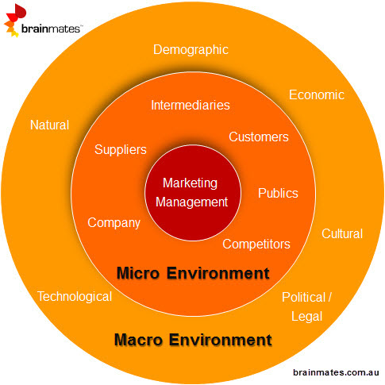

The microenvironment can affect the day to day activities of Al Baraka. They are usually short term and can be controlled, e.g. their competitor has promotion days only during certain times of the year. Al Baraka can identify when that is and have more regular promotion days. Factors in the macro environment are usually longer term and uncontrollable, e.g. laws.
The micro and macro environment of Al Baraka can be analysed through Porters Five Forces.

Porters Five Forces

Porters Five Forces is a business strategy tool created by Michael Porter, professor of Harvard Business School in 1979. It is used to help identify the business’s profitability and competitiveness of its environment (Harvard Business School, 2019). If used correctly, it can aid in the progress of any business. It has been the most used since its existence. Porter acknowledged that rivalries could affect the smooth running of a business, however he suggested that there are other factors that contribute to it.

Figure 2: Porters Five Forces
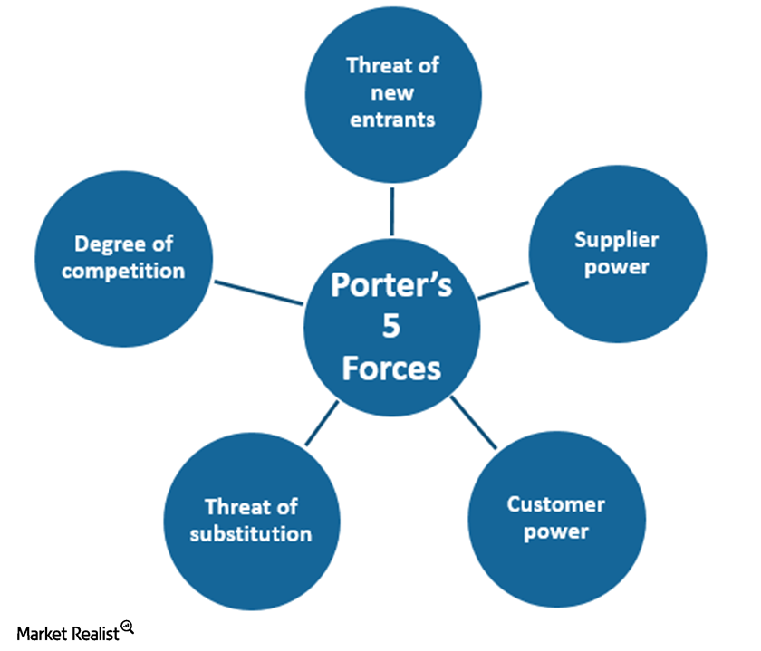
THREAT OF NEW ENTRANTS
The threat of new entrants within an industry can be quite scary. The pressure it has on a business can be high and cause one to reduce profits, if not lost already. They will have to focus more on the customers rather than other areas of their business. The threat level would depend on the level of barriers the business has on the new entrants. This could include other competitors in the same geographical areas or even worse when the threat is further away, but they are well established.
Al Baraka was established several years ago. They have their own brand name. If Al Baraka wants to lower their threat level, they need to invest into a higher information system or IT system. By increasing their costs, a new business may not have enough capital to join Al Baraka at their level. They may not have enough funds to create their own brand or even pay above minimum wage to keep customers and employees happy or hire enough and skilful staff. If a competitive rivalry needed a license for a business property, they could easily get this. It is cheaper to lease a property than to purchase one, as stated by Kluwer (2019). They just need to maintain the payments. However, Al Baraka are protected from this as they own the property. Al Baraka also have very skilful staff, some of whom have been in the clothing industry for over 10 years. A new entrant may need to match this to get their business started and running. Al Baraka have their own distribution channels, which are only known to them. This is part of Al Baraka’s business strategy and that gives them great power over new entrants as they have more knowledge.

SUPPLIER POWER
Many organisations have a link of suppliers where they purchase items that are unique to them, in certain numbers, whether it is big or small. The cost will always differ from different suppliers. Suppliers that have more power can negotiate their terms and costs. To be a powerful supplier, the demand of items must be high from several organisations. An example of this would be Sewport. According to Chinabrands (2019), Sewport is a global manufacturing platform, with 6045 brands and 883 clothing manufacturers available. They have had 335 deals already made since 2017, when they first opened. This would suggest the more businesses approach them, the more power the suppliers would gain. If there are limited organisations, then the supplier will not have much of a say in the pricing. The organisation can bargain with them. However, if changing suppliers is time consuming for the business, then the supplier power is more, and the profitability of the organisation will be low (Harvard Business School, 2019). Al Baraka are aware of this and therefore they purchase items from smaller manufacturing companies. Their suppliers remain a secret from the world, which is to protect their business strategy.

CUSTOMER / BUYER POWER
Customer power is like supplier power. If customers have more power over the business, the business will see less profits or will have to put in more work in order to satisfy the customer. If there is more competition, the customer can negotiate. The clothes that are available at Al Baraka can be distinguished from other companies as they are branded and of high quality. Al Baraka also consider affordability. This is a method for business strategy and aims to keep customer loyalty. If other companies had the same quality clothes at a much lower rate, the customers would not think twice about switching over.

THREAT OF SUSTITUTION
When two very same items provide the same need for a customer and has only one difference, the customer will notice this. For example, two blue dresses. They are exactly the same, however the price is different. The customer will go for the cheaper dress. The same goes with duplicate clothes. Two red dresses, with a slit down the side. The difference here is the quality. Al Baraka’s clothes are of higher quality and have their own brand. The cheaper version of the red dress may be more desirable however the quality cannot be guaranteed. This is why Al Baraka has chosen to have their own brand and suppliers. Their clothes might be more expensive than other alternatives, but they will last longer and provide more comfort. Al Baraka are very much aware of duplicates, but that does not mean they will see high profits. For this reason, they try to maintain very good service, so their customers are not easily swayed by other companies. If their brand was used elsewhere for duplicates, they could take legal action.

DEGREE OF COMPETITION
Competitive rivalry takes place when there are similar organisations, especially with the same business strategy. Depending on the level of competition, this can affect the business profitability. Companies may need to lower their prices to gain more customers or invest in more better materials. When exit barriers are very high, this also leads to business pressure. If an organisation is not able to leave their business due to their high investment, they will have to maintain what they have and improve standards and profits. Al Baraka are quite comfortable with where they are, however, they are always changing their products. They stay in tune with the latest fashion trend and they purchase items that are desirable by customers. Al Baraka advertise their business through social media, which includes WhatsApp messaging. They add numbers of customers who are happy to receive updates. Facebook, Instagram and WhatsApp are used more commonly, as quoted by Statista (2019). It has been noticed that Al Baraka release photos of clothing before ordering from their manufacturer. This gives Al Barak plenty of time to decide on the number of items required. This is part of their business strategy, which in turn aids the business economy and performance.

McKensy’s 7S Framework

Organisational structure is the layout of an organisation. It involves roles and responsibilities. Organisational structures mainly focus on the internal aspects however they are sometimes affected by the external environment. With the environment rapidly changing, businesses need to keep up with those changes. They need to up their game. McKensy’s 7S model was first introduced in 1980s. it is now widely used by many organisations. The purpose of the tool is to identify how each component can relate to one another for a more effective outcome. The most important thing to remember about this model is that if one of the elements is removed or weaker, then this will have great impact on the rest. Below is a model of the 7S framework:

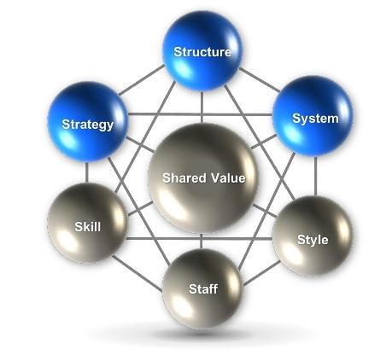
Figure 3: 7s Framework

Strategy, Structure and System are easier to manage however, they are the tough cookies of the organisation. Skill, Staff, Style and Shared Values are soft elements but harder to manage. When carried out correctly, everything will run smoothly and the company will have great advantage over their competitors, cited by Nejad, Behbodi and Ravanfar (2015, p.45).
Al Baraka’s strategy is to maintain their vision, mission and values. Their plan is to stay above their competitive market and not fall behind. Their structure is simple and bottom-up. Systems are about following rules and regulations. Al Baraka have their own code of conduct and all employees must adhere to it. Al Baraka only employ skilled workers. If any volunteers offer to help, then that is up to the individual but suitable training will be given. The staffing level is always monitored. During seasonal changes, depending on the level of special occasions, Al Baraka will increase their staff numbers. For example, during the summer holidays there are more weddings, therefore Al Baraka will employ more staff to help. The company follows a democratic leadership style. They consider employee opinions when it comes to decision making. This gives importance to employees, which leads to better performance. Lastly, shared valued play a major role. From the founder of the company to the employees, everyone must have some shared values for the business to grow.

Workplace Performance

Workplace performance can be affected by a number of factors, as stated by Micheal Beer, cited in Free Management Books (2019). These factors can be seen below:
Figure 4: Beers Silent Barriers
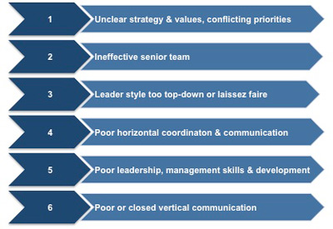

Beer suggests there are six silent barriers, all of which can be managed through high performance teams and senior executives. Close supervision is a key player in maintaining workplace performance. Senior members of staff will need to monitor and asses the performance for it to be more effective. They can do this by using The Organisational Health Index. According to Nair, Kumar and Ramalu (2014, p.147), Brown (1997) states organizational health can be measured through observations of verbal and visual behavioural patterns of internal communication of staff.

Ethical Stance and Culture

Al Baraka have a simple structure for business. The company consists of directors and a team of lower category staff. The team is made up of sales assistants, a tailor, and someone who deals with supplies. The directors manage the finance and social media. They take on higher level tasks. As this is a small company, their activities are easily managed. They communicate directly with the employees to seek knowledge of customer preferences and satisfactory targets. The handling of information is more efficient. This is known as an inductive approach of management. They have more centralised authority. Primary values and ethical rules are better managed too. Ethics are a big part of culture. It helps build strong relationships. Al Baraka are people orientated. They pay close attention to their employees and customers. They are innovative. This shows stability in their business. When sales have been made, employees are praised for their hard work. They are monitored closely. During a festive occasion, the staff are rewarded with an item of their choice. They can choose high end or low-end clothing. This keeps employees satisfied and thus they are able to push themselves further.
Culture can be learned through a socialisation process, which includes pre-arrival stage, encounter stage and metamorphosis stage. Ethical workplace culture is typically created through the invention of a business. When people who share the same values and goals join forces, they maintain the culture. It can grow stronger through reward systems and good leadership. Edgar Schein (1980), a management professor, established a culture model to make culture more evident within an institute.

Figure 5: Schein's Model of Culture

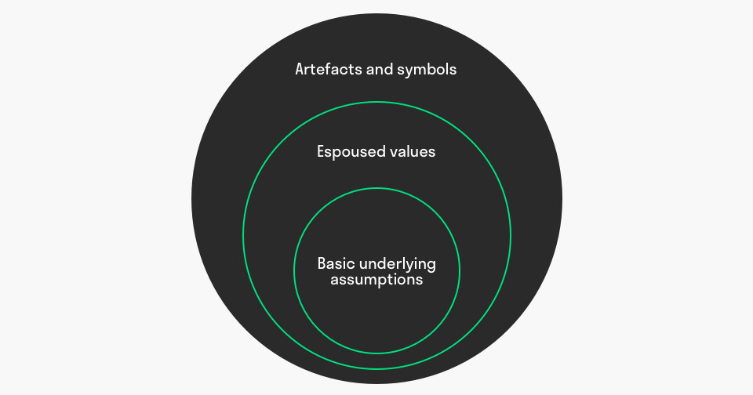

Schein believed artefacts and symbols that include a business’s logo, strategy and processes are visible factors. They are easier to manage. Espoused values, such as values and principles are visible in Al Baraka but if they are not met then problems may arise. Employees can maintain this by adhering to the company rules and regulations. Basic underlying assumptions are not visible or easy to manage. This includes behaviour (Mulder, 2019). Employees can make themselves more approachable, and always stay positive even when time gets tough. A poor management can cause negative impacts on any business. One may be oblivious to their own actions, but the close supervision in Al Baraka helps keep behaviour monitored. Also, the provision of ethical training can help employees at Al Baraka understand what practices are permissible in the workplace.

Comparison Between Rivalries

Al Baraka’s immediate competition is Alpona, another clothing business. They are geographically located together and provide similar clothing. Al Barak has great advantage over Alpona, as they provide more facilities. They offer tailoring, have a fitting room, and advertise more on social media. Alpona does not have branded clothes like Al Baraka. Nor do they specialize in designer wear. Both businesses are of similar size, but Alpona has few staff members. Their service is not as welcoming as the service of Al Baraka. As Alpona lack many important factors, it can be said that their profit rate will not be as high as Al Baraka’s. This will then cause friction between the two companies, and even with its own staff. Their workplace culture may not be as strong either.

Recommendation

For Al Baraka to see a significant change in profits and customer loyalty, they could take more risks. They could purchase items in large bulks before advertising on social media, as this will save delivery time. If orders are placed and delivery is taking long, Al Baraka are at risk of losing their customers to a rival company. Also, they can purchase smaller companies, so they are reducing the risk of them taking over Al Baraka.

Conclusion

Business is like an endless book. There are many factors to research when inventing an idea. So many things can affect the running of a business. There are so many possibilities for success as well as failure. Business isn’t only about the idea, but what comes with it such as culture, goals, employees, strategy and legislation. Al Baraka have proved they are following different frameworks to compete in the clothing industry. With the right frame of mind and employees they can still go further. They could try franchise or buy smaller companies if they wanted to raise the level of barrier to entry. Al Baraka could do a SWOT analysis on their business and potential business, to see if they have room for growth. An analysis makes one think in great detail about a variety of things. Using current research and theories, businesses could ensure the threat level is low. For example, leadership style can bring out the best in people. If this is their weakness, they could change the style to what would meet the company’s best interest.

References

Ahmady, G., Mehrpour, M. and Nikooravesh, A. (2016). Organisational Structure. 3rd ed. Dubai: Elsevier Ltd, pp.455-459.

Chinabrands (2019). Top 11 High quality Clothing Manufacturers for UK Small Businesses. [online] Available at: https://www.chinabrands.com/dropshipping/article-top-11-high-quality-clothing-manufacturers-for-uk-small-businesses-15703.html [Accessed 4th Nov. 2019].

Harvard Business School, 2019. The Five Forces. [online] Available at:
https://www.isc.hbs.edu/strategy/business-strategy/Pages/the-five-forces.aspx [Accessed 4th Nov. 2019].

Kluwer, W. (2019). Deciding Whether to Lease or Buy a Business Facility. [online] Available at: https://www.bizfilings.com/toolkit/research-topics/office-hr/how-to-decide-whether-you-should-lease-or-buy-a-business-facility [Accessed 4th Nov. 2019].

Nair, H., Kumar, D. and Ramalu, S. (2014). Organizational Health: Delineation, Constructs and Development of a Measurement Model. Asian Social Science, 10(14), pp.146-147.

Nejad, D., Behbodi, D. and Ravanfar, M. (2015). Analyzing Organizational Structure based on 7s model of McKinsey. International Journal of Academic Research in Business and Social Sciences, 5(5), pp.43-46.

Statista (2019). Most famous social network sites worldwide as of July 2019, ranked by number of active users. [online] Available at: https://www.statista.com/statistics/272014/global-social-networks-ranked-by-number-of-users/ [Accessed 5th Nov. 2019].

Fig. 1
Digital Environment (2015). Macro and Microenvironment. [online] Available at: http://digitalenvironmentandmarketplace.blogspot.com/2015/02/macro-and-micro-environment.html [Accessed 4th Nov. 2019].
Fig. 2
Prince, S. (2019). Porter’s 5 Forces: KSU’s Position in the US Freight Rail Industry. [online] Available at: https://marketrealist.com/2016/02/porters-5-forces-ksu-position-in-the-us-freight-rail-industry/ [Accessed 4th Nov. 2019].
Fig.3
SlideShare (2019). Mckinsey 7s Framework Template | By ex-McKinsey Consultants. [online] Available at: https://www.slideshare.net/BySlidebooks/mckinsey-7s-framework-template-by-exmckinsey-consultants [Accessed 5th Nov. 2019].
Fig. 4
Free Management Books (2019). Six Silent Barriers to Performance. [online] Available at:
http://www.free-management-ebooks.com/faqld/underperform-04.htm [Accessed 4th Nov. 2019].
Fig. 5
Mulder, P. (2019). Organizational Culture Model by Edgar Schein. [online] Available at: https://www.toolshero.com/leadership/organizational-culture-model-schein/ [Accessed 4th Nov. 2019].

